Professional Career Development

Student name: ……………. Maxim Babin
Student number …………... 1909116
Lecturer name ……………. Malani Gunaratnam
Module title …… Professional Career Development
Module code …………. BMSW4005

Table of Contents
1. Introduction 3
2. Reflection 4
3. Career plan 6
4. What Employers want 7
5. Self-Motivation 8
6. Learning Styles 10
7. Personal Development 11
8. Employment Goals 13
9. Conclusion 14
References 15

1. Introduction
My name is Maxim Babin, and, in this report, I will speak about how I plan to develop my career. It is important to have practise personal skills like decision-making skill, teamwork skill, problem-solving skill, leadership skill and time management skill. Here, I will complete the assignment based on Kolb’s cycle, professional development, personal skills, employment goals and SWOT analysis. Besides, I will also discuss how to implement the experience and how need to plan for developing the career properly (Arnold et al, 2019).

2. Reflection. A personal reflection on the role play and career development planning

Basically, an individual reflection is a chance to evaluate events, feelings and opinions from a new perspective. I can say that I am sure that this role play from task 1 where I took turns playing the role of an interviewee and then the role of an interviewer will help me for be better prepared for an interview in the future or to be better prepared to ask the right questions in an interview.
In addition, self-reflection helps me know the size of my emotional consciousness. Moreover, self-reflection also gives me a better understanding of my emotions, weakness, motor factors and strength. Here, I also follow Kolb's cycle to concretize, reflect and correctly implement my experience (Boissy et al, 2016).
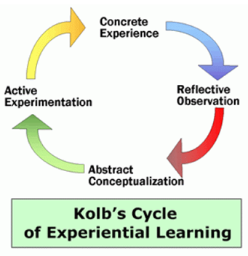
Figure: Kolb’s Reflection Cycle (Cottrell, 2017).
Concrete Experience
As an interviewer, I don't have much experience, but some were good for me and some were challenges, but I learned from the role play that the right questions always give you a way out of the situation.
To be successful, I must first assess whether I have experience in a field before asking questions. For example, as an interviewer, I need to have enough experience on how to recruit the best applicants for the right job and I work hard on myself to achieve that experience. In addition, as an interviewee, I need to have experience how to talk to the interviewer, what topics are most important for him, and how they can satisfy the interviewer. (Custodio et al, 2019).

Reflecting Observation
As an interviewer, when I will ask questions for recruiting the applicants, I need to be careful because most of them are feeling nervous, that’s why they cannot answer the easy question. Besides, as an interview, when the interviewers will ask me any question, sometimes difficult ones, which will put pressure on me, but after I learned from the role play, the correct answers are also a way out of the situation (Dawson et al, 2018).
Abstract Conceptualisation
Fundamentally, experiences teach us a lot, that’s why we can easily handle the same problems at the next time. Here, as an interviewer, I learned many of my experiences, for example, I think that most talent seekers do not do a good job because of the nervousness at the time of the interview. In addition, as an interviewee, I recognize which topics the interviewer is most willing to discuss, and I have learned how to talk to him. (Keevy et al, 2018).
Active Experimentation
According to Kolb’s cycle, after concreting, reflecting and abstracting I need to implement the experience. For example, as an interviewer, when I will ask any question to the applicants, at first, I will need to tell them that not be too nervous so that they can answer the question effectively. Besides, like an interview, I need to read well the important topics also, I need to develop my speaking skill so that I can easily satisfy the interviewers (Mumford et al, 2017).

3. Career plan
Bartfiled et al (2010) stressed that professional development is knowledge to uphold or learn expert credentials e.g. academic grade to formal assignments, presence sessions and informal learning chances located in practice.
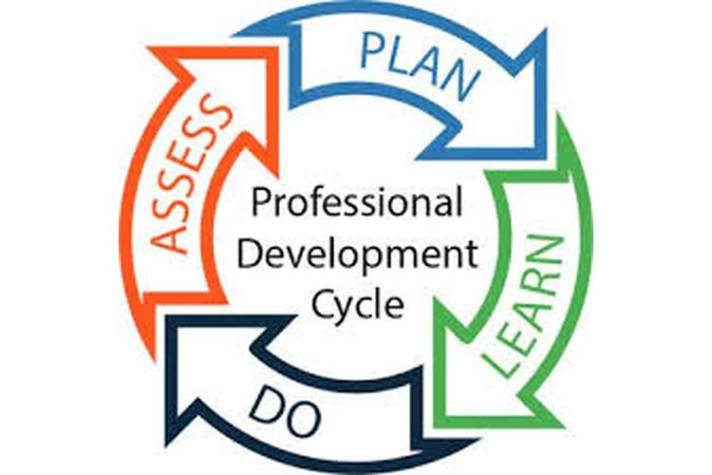
Figure: Professional Development (Dansieh, 2011).
Assess
At the beginning, I must evaluate which things I know better and which I do not. I also must evaluate which part I have better, and which does not. If I can identify my skill and strategy, then I think it will be easy for me to select my best profession. (Kesson et al, 2012).
Plan
After I evaluate myself, I must plan for this profession. For example, at the beginning, I must select the right one, then I must plan how I will act, this will help me to easily achieve my goals. (Mackenzie et al, 2009)
Learn
After planning, I need to acquire knowledge for a suitable profession because if I have proper knowledge then I think I can do my best performance for my development. Without proper knowledge, I cannot do well which is the hinder for my success (Maxwell et al, 2015)

Do
After evaluation, planning and learning, I need to implement them properly so that I can perform the right work, showing me the best performance. I think I can do well in my field of work if I can evaluate myself correctly, I have to plan and learn well so that I can develop my career correctly (Arnold et al, 2019).

4. What Employers want
Employers want to get the work done by the employees according to accomplish their business objectives. To achieve my goals, I need to work with a team because if I work with a team I can solve the problem, making a decision which is very necessary for my act development. Besides, I also have practised problem-solving skill so that I can handle any problem (Maxwell et al, 2015)
For example, the key skills that employer wants include are communication skills, management skills, planning skills, problem-solving skills, team-working etc. So, I need to work for the customer satisfaction, for example, I need to communicate with them all-time, to take their opinion, giving proper information about any products, then they might be satisfied which is highly needed for me to fulfil my goal (Dawson et al, 2018).
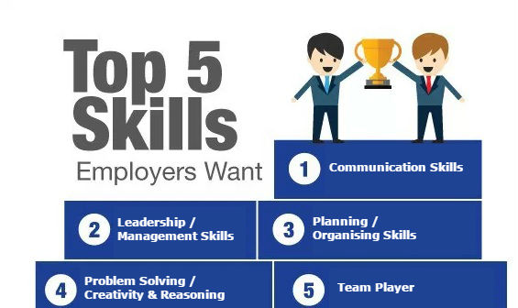
Figure: Employers want (Custodio et al, 2019).

5. Self-Motivation
Motivation is everything for me, because without it nothing will be possible. I need to be motivated when I go to university, when I do my assessments, when I study, and I plan my career. I am a very motivated person because in my mind and in my soul, I feel that I will have a great future and this thing motivates me more. For my future to be strong one I need to include in my motivation a lot of skills, to be sure that I will have an overall understanding on what will happens.
Boissy et al (2016) stated that personal skills are those skills which consider and possess an individual strength. Personal skills are very effective for an individual to progress his performance and his career properly. If the individual has not enough personal skills, it will very hard for him to accomplish goals. I need to practice different kinds of skill to develop my career and in this way accumulating as much knowledge as possible.

Figure: Personal skills (Cottrell, 2017).
Communication skill
Communication is the act of moving data from one place to another place and person to person. Proper communication supports an individual to make an appreciate decision and helps to handle any challenges. For example, if I practise this skill properly, I can able to connect different people and transfer the necessary data which support me to development my performance properly (Custodio et al, 2019).
Teamwork skill
Teamwork is mostly required for making choice, innovation ideas or rules, problem solving etc. Besides, teamwork supports an individual to attain his goals by developing his performance. Here, I need to follow this skill so that I can successfully work together to accomplish my goal (Custodio et al, 2019).
Problem-solving skill
To solve any critical problem within the right time, I highly required to practices problem-solving skills. For example, if I face any business problem at the time working in the business sector, this skill provides me to solve the problem by communicating, decision-making with others (Bartfiled et al, 2010)
Decision-making skill
This skill provides me to solve any hard problem and helps me to innovative the ideas and rules which are most important for me to develop my career. Besides, after following this skill, I will make the right choice at any challenge’s situation, which is most essential for me professionally (Dansieh, 2011)
Leadership skill
Finally, leadership skill helps me to motivate or direct the people successfully which is most important for my professional career. Besides, this skill also provides me to proper communication, innovation, honesty, awareness and relationship building (Kesson et al, 2012).

6. Learning Styles
Learning styles are necessary for me to do well in my personal and professional segments. Career development is the continuing modification or gaining of knowledge, counting job mastery and expert development. Besides, PCD is a two-credit period course intended to stretch an individual a very initial start on the method of professional development and planning. Besides, I also need literacy skill because it will help me to read, write, listen and speak well so that I can communicate effectively (Mackenzie et al, 2009).
Moreover, I need to develop my IT skill as it is very important for career development. Without IT skills, it will create pressure in my job sector which is an obstacle for attaining goals. I also need to self-management because if I can self-management, I also able to self-confidence, tolerance, emotional regulation, perseverance and resilience. Here, I can consider VAK learning styles which denotes visual, auditory and kinaesthetic. For example, according to visual styles, I need to be well in visionary and according to auditory, I need to have the active hearing capability (Boissy et al, 2016).
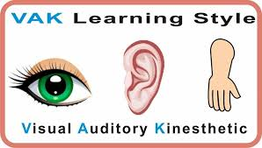
Figure: VAK Learning Styles (Bartfiled et al, 2010)

7. Personal Development
Fundamentally, SWOT analysis is the inspection of an individual condition by observing at weakness, strength, threats and opportunity. The key determination of a SWOT is to endorse the recognized strengths, decrease the weakness, abusing the opportunities and having eventuality plans to diminish the threats. Here, I describe my SWOT analysis that is given below (Bartfiled et al, 2010).
For example, I can consider Self-awareness tools which will be supportive for personal development. Here, I will highly give focus on self-identification, self-awareness, self-regulation and self-development that need to be supportive with confidence, resilience, hope, optimism (Boissy et al, 2016).
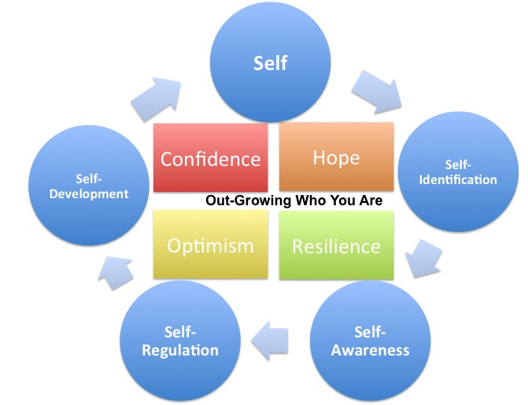
Figure: Self-awareness tools (Maxwell et al, 2015).
SWOT Analysis
Strength  - I have good writing skills and time management and these are strong points for me to develop my professional career.  - I am also a creative thinker and I have an exciting vision and I love to learn that’s why it is also the strength for me for developing the career (Custodio et al, 2019). | Weakness  - The weakest point for me is that I have incomplete technical knowledge.  - I am a poor verbal correspondent and not a communal media person which are the also weakest point for me (Mackenzie et al, 2009).
Opportunity  - When any companies embracing “change”, it has created an opportunity for me for developing my career.  - Networking groups, speech clubs and perceptible audiobooks are also an opportunity for me to attain the goals (Maxwell et al, 2015). | Threats  - At last, some situations are a threat for me to develop my professional career. For example, if there have high unemployment rates, then it creates a pressure for me for a good profession.  - I have limited ability and poor economy which are the threat for me for attaining success (Cottrell, 2017).

8. Employment Goals
Employment goals define the wished outcome of profession development. Here, if I want to achieve my goals, I need to activate various things like proper communication, customer satisfaction, team working and self-management. Besides, I also need to have practised the necessary strategy so that I can easily control any tough situation to achieve the goals. To accomplish my goals, at first, I need to communicate well the customers, the boss and the colleagues. As it supports me in various ways such as proper information about many topics, making decision and problems solve (Arnold et al, 2019).
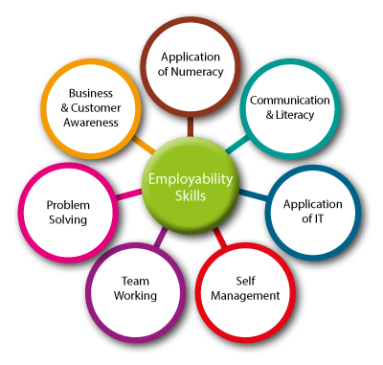
Figure: Employment Goals (Custodio et al, 2019).

9. Conclusion
Thus, skills are highly required for developing a professional career. Without skills, I think it can be very hard for me to complete my destination. Besides, I should follow the Kolb’s cycle so that I can able to how the experiences are concreting, reflecting and implementing. Moreover, I should develop my communication skill which supports me to develop my professional career. I also should create a plan and works according to the plan so that I can attain my goals easily. Besides, I should identify my strength and weakness so that I can improve my performance. Also, I should work for removing my weakness and chase the opportunity so that I can easily development my professional career (Keevy et al, 2018).

References
Arnold, E.C. and Boggs, K.U. (2019). Interpersonal Relationships E-Book: Professional Communication Skills for Nurses. Elsevier Health Sciences.
Bartfeld, E. and Lass, A., Irody Inc. (2010). System and method for real-time management of a drug regimen. U.S. Patent 7,747,454.
Boissy, A., Windover, A.K., Bokar, D., Karafa, M., Neuendorf, K., Frankel, R.M., Merlino, J. and Rothberg, M.B. (2016). Communication skills training for physicians improves patient satisfaction. Journal of general internal medicine, 31(7), pp.755-761.
Cottrell, S. (2017). Critical thinking skills: Effective analysis, argument and reflection. Macmillan International Higher Education.
Custódio, C., Ferreira, M.A. and Matos, P. (2019). Do general managerial skills spur innovation? Management Science, 65(2), pp.459-476.
Dansieh, S.A. (2011). SMS texting and its potential impacts on students' written communication skills. International Journal of English Linguistics, 1(2), p.222.
Dawson, P. and Guare, R. (2018). Executive skills in children and adolescents: A practical guide to assessment and intervention. Guilford Publications.
Keevy, M. and Mare, D.J. (2018). Pervasive skills development for aspirant chartered accountants: Academic versus training programmes. Journal of Economic and Financial Sciences, 11(1), pp.1-9.
Mackenzie, A. and Nickerson, P. (2009). The time trap: The classic book on time management. Amacom.
Maxwell, S.M., Hazen, E.L., Lewison, R.L., Dunn, D.C., Bailey, H., Bograd, S.J., Briscoe, D.K., Fossette, S., Hobday, A.J., Bennett, M. and Benson, S. (2015). Dynamic ocean management: Defining and conceptualizing the real-time management of the ocean. Marine Policy, 58, pp.42-50.

Appendix

Personal Development Plan
Personal Development Plan
 | Short-Term  In the next three to six months | Mid-Term  In the next six months to two years | Long-Term  In the next two to three years
Section 1 - My Goals  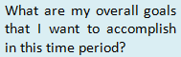 | Communication skills | Analytical skills | Team-working skills
Section 2 - Skills and Knowledge to be Learned  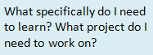 | Communicating effectively | Classifying the best assessment skills | Collaborating in balance work
Section 3 - Next Steps  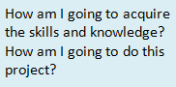 | Considering the best channels | Effective assessment | Engaging effectively
Section 4 - Resources  What resources do I need? | The perfection in channels as I have to face complexities in channels | The assessment tools and mechanisms as I have to face problems in identifying the core fact. | The support from others as I have to face imbalance with each other
Section 5 - Time Schedule  What is my schedule? | Regular & Active | Regular & Active | Regular & Active
When will I start? | 01-10-2020 | 31-03-2021 | 31-03-2023
When do I expect to finish? | 31-03-2021 | 31-03-2023 | 31-03-2024
Section 6 - Completion  When have I completed each step? | □31-03-2021 Date  □31-03-2021 __________  Date  □_31-03-2021 _________  Date | □31-03-2023  __________  Date  □31-03-2023  __________  Date  □31-03-2023  __________  Date | □31-03-2024  __________  Date  □31-03-2024  __________  Date  □31-03-2024  __________  Date

