
Master of Business Administration
International Business pathway
Decathlon's Expansion into the Norwegian Sporting Goods Retail Market: A Strategic Analysis of Market Entry and Internationalisation


Contemporary employability skills
Assessment 1: Individual report. Weight: 100%
Module name: International Business Concepts
Module code: LCMB7034
Lecturer name: Jean Wang
Company Name: Decathlon - Norway
Student name: Henil Rajeshbhai Jasoliya
Student ID: 2532366
Word count: 5351
Submission date: 15/08/2026

AI use acknowledgement
I acknowledge the use of Copilot (https://copilot.microsoft.com/) on 28th July 2026 to obtain some information on Decathlon. I used the prompt:
- Please provide current case studies and information about Decathlon and its business practices.
I acknowledge the use of Grammarly (https://www.grammarly.com/) on 29th July, 2026 to check my work for grammar, spelling, readability, and clarity. I used the prompt:
- Please check the following text for grammar, spelling, readability, and clarity.
I confirm that I did not provide any text written by AI under the pretence of it being my own writing. I can attest that I do have the copies of my drafts, notes, and other materials I had prior to and after I used AI tools, and I could be requested to present them as evidence.

Executive Summary
This report critically reviews Decathlon's business idea on expansion to the Norwegian market in the frame of modern international business theories. Founded in France in 1976, Decathlon has grown into being one of the world's top sports goods retailers, using a vertically integrated business model, where product design, manufacturing, logistics and retail are interconnected. The 2025 performance report from Decathlon reveals that the company reportedly posted Gross Merchandise Volume (GMV) of EUR 20.7 billion. The report initially analysed Decathlon 's organisational strategy, and then it analyses Norway's political, economic, legal and cultural environment to assess the attractiveness of the country to Decathlon as a possible host market. Secondly, contemporary international business literature, stresses that it is now more important for the multinational enterprises to integrate institutional resilience, sustainability and long-term value creation. Then, Dunning's Eclectic (OLI) Paradigm and other entry modes into the foreign market are discussed and analysed to find out the most appropriate strategy that Decathlon can adopt for entering this market. The report suggests the preferred entry mode for Decathlon would be the Greenfield option which would give Decathlon a full control over operations, ensure the continuity of its vertically integrated business model and allow it to gain a long-term competitive advantage. The report ends with recommendations for action targeting sustainable competitive advantage for Norway, and a reflective account which reviews the research and analytical journey of the project.

Table of Contents
1. Introduction 6
2.Organisational Classification and Global Strategy 6
2.1 Strategic Categorisation: Decathlon's International Strategy 6
2.2 Global Configuration: Decathlon's Global Value Chain 7
3. Macro-Environmental Appraisal and Market Attractiveness 8
3.1 Host Country Analysis: PESTLE Analysis of Norway 8
3.1.1 Introduction to Norway 9
3.1.2 Political Environment 10
3.1.3 Economic Environment 11
3.1.4 Legal Environment 12
3.1.5 Cultural Environment 13
3.1.6 Industry & Market Attractiveness 14
3.2 Market Entry: Dunning's OLI Paradigm and FDI Decision 15
4. Entry Mode Strategy and Strategic Synthesis 18
4.1 Historical International Entry Pattern of Decathlon 18
4.2 Strategic Fit and Justification of the Recommended Entry Mode 19
4.3 Conclusion and Recommendations 21
Section 2: Reflective Account (Gibbs' Reflective Cycle) 22
References 25

List of Tables

Table 1: Why Norway is an Attractive Market for Decathlon 8
Table 2: Industry Attractiveness 13
Table 3: Evaluation of Entry Modes for Decathlon's Expansion into Norway 17

List of Figures
Figure 1: Global Value Chain of Decathlon 7
Figure 2: Hofstede Insights of Norway 12
Figure 3: Dunning's OLI Paradigm Applied to Decathlon's Entry into Norway 15

1. Introduction
Decathlon started operations in 1976 in Lille, France and is one of the world's biggest multinational sports goods companies with its research and development, product design, production, provision chain management and retail functions concentrated into one business model (Decathlon, 2025). The report as per Decathlon (2026) estimates that Decathlon had over 102,900 teammates, over 1,902 retail stores in 82 countries and regions, and approximately 1.23 billion products sold in 2025, demonstrating Decathlon's size and reach. The purpose of this report is to critically examine the market of sporting goods retailing in the market of Norway in order to analyse Decathlon's proposed market expansion by analysing the experiences of political, economic, legal and cultural environment prevailing in the country. Uses Dunning's OL (eclectic) Paradigm and then compare other alternative modes of foreign market entry to arrive at the right mode of entry. Finally, the report contains strategic recommendations for sustainable competitive advantage and a reflective account using Gibbs reflective cycle.

2.Organisational Classification and Global Strategy

2.1 Strategic Categorisation: Decathlon's International Strategy
Ghoshal and Bartlett (1989) determine four global strategy orientations involves international, multidomestic, global and transnational, depending on how far they are integrated globally and responsive to local demands. It is appropriate to classify decathlon as having a transnational strategy since it entails both globalisation and accommodation of local market circumstances. The economies of scale are developed through its global brand, product development and supply-chain coordination whereas the retail operations and customer interaction can adapt to the needs of the local market. Thus, the transnational strategy gives a proper ground to explain the international strategic orientation of the Decathlon. Decathlon (2025) designed its products using its own brands in the world, coordinates the entire supply chain and has a centralised quality control which allow it to enjoy economies of scale and efficiency needs. A drawback of Bartlett and Ghoshal's (1989) framework is its applicability to the current multinational enterprise in digitally connected environment. In the face of the COVID-19 pandemic, Verbeke and Yuan (2021) claim it significantly changed the global approach of international businesses in a number of ways, such as hastening digitalisation, probing supply chains and making them more vulnerable, and forcing companies to build organisational resilience’s over efficiency only.
Likewise, Florido-Benítez (2022) states that the competitiveness of the present has to rely upon international business strategy, along with digital marketing skills and multiple approach to customers. In this respect, the Decathlon case is not limited at all to a standard transnational concept, as it is bottom-up with vertical integration, digital commerce, sustainability and innovation for the customer. As such, Bartlett and Ghoshal's model can be used as a useful starting point to categorise Decathlon's global strategy, but current international business literature casts doubt on the company's competitive advantage as a result of its transformation and adaptability, suggesting a more dynamic global strategic orientation than the one planned by Bartlett and Ghoshal (1989).

2.2 Global Configuration: Decathlon's Global Value Chain
Audacious research and development, production and supply chain, logistics and retail assembly makes Decathlon a competitive advantage on a global level. The company has also more than 1,900 stores bought and sold in 82 countries and regions, characterised by global design centres, expert cooperation with production partners and advanced logistics systems, as stated in Decathlon's (2025) corporate publications. Its extensive global reach allows it to take advantage of the economies of scale and be able to meet the needs of the market in the various regions efficiently.
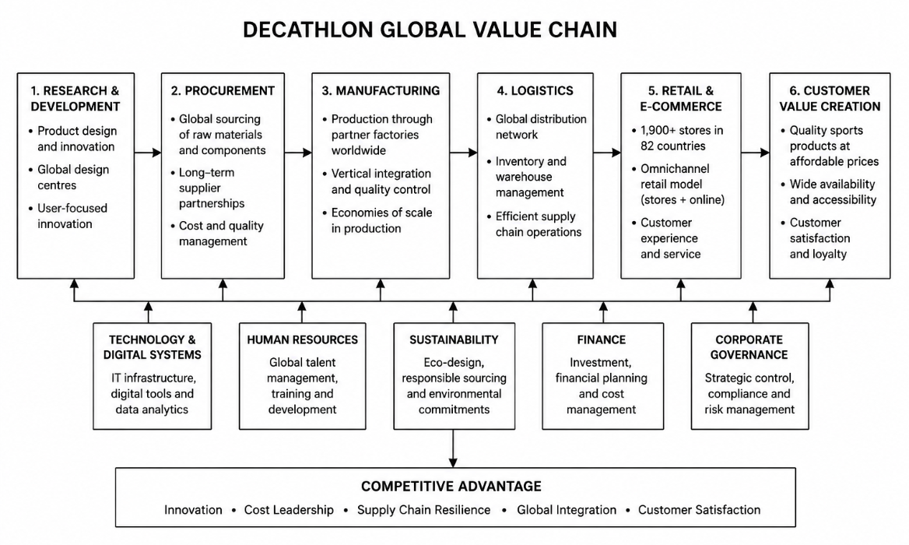
Figure 1: Global Value Chain of Decathlon
(Source- Adapted from Decathlon, 2025; and Kano et al., 2020)
Kano, Tsang and Yeung (2020) explain that today's multinationals are increasingly using Global Value Chains (GVCs)- where creating value will depend on a diverse network of interconnected international value chain participants rather than only on a single national group of participants. Decathlon is one of the companies that perfectly exemplifies this model by coordinating product design, procurement, manufacturing, distribution and retail operations from various locations and having strategic control over the quality, innovation and operational efficiency.

3. Macro-Environmental Appraisal and Market Attractiveness

3.1 Host Country Analysis: PESTLE Analysis of Norway
Factor | Suitable? | Rationale
Political | ✓ | There is no poor governance or high level of corruption in Norway, due to the stable political structure and low corruption rates (World Bank, 2025; Transparency International, 2025).
Economic | ✓ | The country has one of the world's highest GDP per capita, and high purchasing power with consumers which results in favourable demand for quality sporting goods and high-end retail products (World Bank, 2025; IMF, 2025).
Legal | ✓ | Foreign investment is encouraged by transparent regulations, favourable intellectual property protection and membership in the EEA, whilst offering a safe and stable legal framework for foreign suppliers (World Bank, 2025; European Commission, 2025).
Cultural | ✓ | The Norwegian circumstances are very suitable for the market and product rhizome as well as Decathlon's value proposition, since there is a high outdoor culture and prevalence of recreational and sporting activities within Norway, as referred above by Innovation Norway (2025) and Hofstede et al (2010).
Digital | ✓ | Internet penetration and large-scale adoption of internet payments and fast e-commerce development make it easier to implement Decathlon's omnichannel sale concept and e-consumers interactions (World Bank, 2025; Data Reportal, 2025).
Sustainability | ✓ | Responsibility and sustainable consumption are important priorities for Norwegian consumers, aligning with Decathlon's circular economy initiatives and their eco-designed products (Donnelly et al., 2024; Decathlon, 2025).

Table 1: Why Norway is an Attractive Market for Decathlon

3.1.1 Introduction to Norway
Not only is the choice of Norway's next international market expansion location quite logical from a geographical perspective, it also makes perfect sense in terms of the country's impressive macroeconomic performance, its stable institutional environment, and increasing demands for sports and outdoor activities by consumers. The World Bank (2025) estimates that the GDP for Norway is approximately US$530.8 billion and the GDP per capita is more than US$94,500. The internet is also nearly ubiquitous, with the World Bank stating that penetration rates are close to 99%, which means the consumer market is highly digitalised and this opens up opportunities for omnichannel retailing and ecommerce. These features match well with Decathlon's digital transformation and customer focused retail approach. In the context of greater global economic uncertainty, which evaluated the countries' economic conditions in what it described as an ‘economic integral’, the Organisation for Economic Co-operation and Development (OECD) Economic Outlook (2025) pinpointed Norway as a very resilient economy despite its unstable economic frame. In an ‘economic integral' assessment, the Organisation for Economic Co-operation and Development (OECD) Economic Outlook (2025) found that the economy of Norway was very resilient, based on prudent economic policy and stable income of households, despite its unstable economic frame.

3.1.2 Political Environment
Political stability and institutional quality are critical factors for any successful foreign market entry due to significant impact on the investment security and predictability of regulations on the long-term business performances. There has been very little political instability in Norway, with transparent forms of government and low levels of corruption, and a high degree of democracy. Such institutional features greatly mitigate political uncertainty and make the country an attractive investment option for foreign multinational companies wanting to sustain long-term investment.
Again, UNCTAD (2025) notes that Norway offers fair and clear investment climate with effective legal institutions and robust protection of property rights, regular implementation of regulations. Nevertheless, Norway is not part of the European Union, but rather an EEA member country that allows businesses to enjoy access to the EU Single Market and regulatory harmonisation for many trade operations. This arrangement encourages cross-border trade, enhances supply chain efficiency and simplifies regulatory requirements for international retailers in Norway. Multinationals can perform better internationally when they have access to formal institutions aligned with effective governance and regulatory transparency, as Dau et al. (2022) state. Norway's very transparent governance character, combined with strong institutional traditions and investment-friendly business climate is overall a favourable political situation for Decathlon. The positive political backdrop is believed to help the Company gain market access, increase the stability of operation and help put the Company in a long-term strategic competitive position in the sporting goods market in Norway.

3.1.3 Economic Environment
The high purchasing power, macros strong stability, and deep integration into the trading system are some of the reasons for the attractiveness of the Norwegian economic environment for Decathlon. The condition of the economy from an international business point of view is factored into consumer purchases, investor confidence, and long-term market viability—all of which is very important in the decision-making process for entering a foreign market.
Norway's economic structure is very diversified, and its petroleum industry provides significant revenues, which makes the country one of the richness had economies worldwide, as parted by the International Monetary Fund (IMF, 2025). While global energy price volatility has had a slight downside on short-term growth, the IMF anticipates that economic conditions will remain resilient, with a sanguine stance towards fiscal policy, low public debt and good sovereign wealth account assets. Financial uncertainty among multinationals is lowered and Norway becomes a more appealing long-term investment location with such macroeconomic stability.
Likewise, OECD Economic Outlook (2025) predicts moderate economic expansion based on the recovery of domestic demand, rising household consumption and lessening ternary inflationary pressures. Increasing real wages and gains in consumer confidence would help to boost private spending, especially in discretionary retail sectors. From Decathlon's point of view, these are positive conditions: household disposable income is linked closely with the demand for sporting goods, outdoor equipment and for leisure products. In addition, Norway's long-term stable monetary policy and sound financial institutions provide a predictable business climate which allows companies in the Netherlands to pursue strategic investment with relatively small macro economy risk.
At the same time Norway's economic fundamentals are solidified by the World Bank's World Development Indicators (2025). The country has a medium-high level of purchasing power and reasonable living standards, and its GDP per capita is among the highest across the world. Furthermore, meaningful, low unemployment levels and strong participation of the labour force are contributing to consistent consumer expenditure, whilst a high level of online and digital connect supports the rapid expansion of online commerce and omnichannel retailing. These features are especially well suited to Decathlon, which expects to increasingly put in place physical and digital stores that are more accessible to customers and more efficient in operations.

3.1.4 Legal Environment
Multinationals need a legal framework that supports them, ensuring their business is consistent with the law, investments are safe and there is fair competition. The Norwegian legal system is well established, transparent, has a strong rule of law and high legal regulatory quality, which is attractive for retailers like Decathlon.
The International Trade Administration (2026) states that Norway has an open and predictable business environment with little difference in treatment of foreign and domestic investors in general. Foreign capital is allowed in the retail sector, and foreign companies are able to set up wholly owned subsidiaries without there being appreciable restrictions on equity participation. This regulatory openness gives Decathlon more strategic freedom regarding its pricing, brands, supply chain management and decision-making.
Further, Norway, for its membership in European Economic Area (EEA), must put in place a significant number of EU legislation on the free movement of goods, competition policy, consumer protection and product standards. The European Commission (2026) noted that regulatory harmonisation with the EU Single Market helps businesses that are already doing business in Europe minimise legal uncertainty. This harmonisation will ensure that products could flow freely between markets within Europe and that the technical standards, consumer rights standards and environmental laws are met in a consistent manner for Decathlon.
Moreover, the legal environment is very favourable for foreign investment, with Norway implementing a stable investment legislation and respecting international investment agreements as underlined by the UNCTAD Investment Policy Hub (2025). Strong IP enforcement and contract dispute resolution, good contract enforcement boost trust and lower legal risks in foreign markets entry.

3.1.5 Cultural Environment
Cultural features play an important role in multinational enterprises; since consumer preferences in values, spending and purchases are important indicators for the success of entering the markets. Norway is a well-developed and global economy, but the national culture has its own features that Decathlon must understand when developing its market strategy. The Hofstede's cultural dimensions can be helpful in analysing these differences.
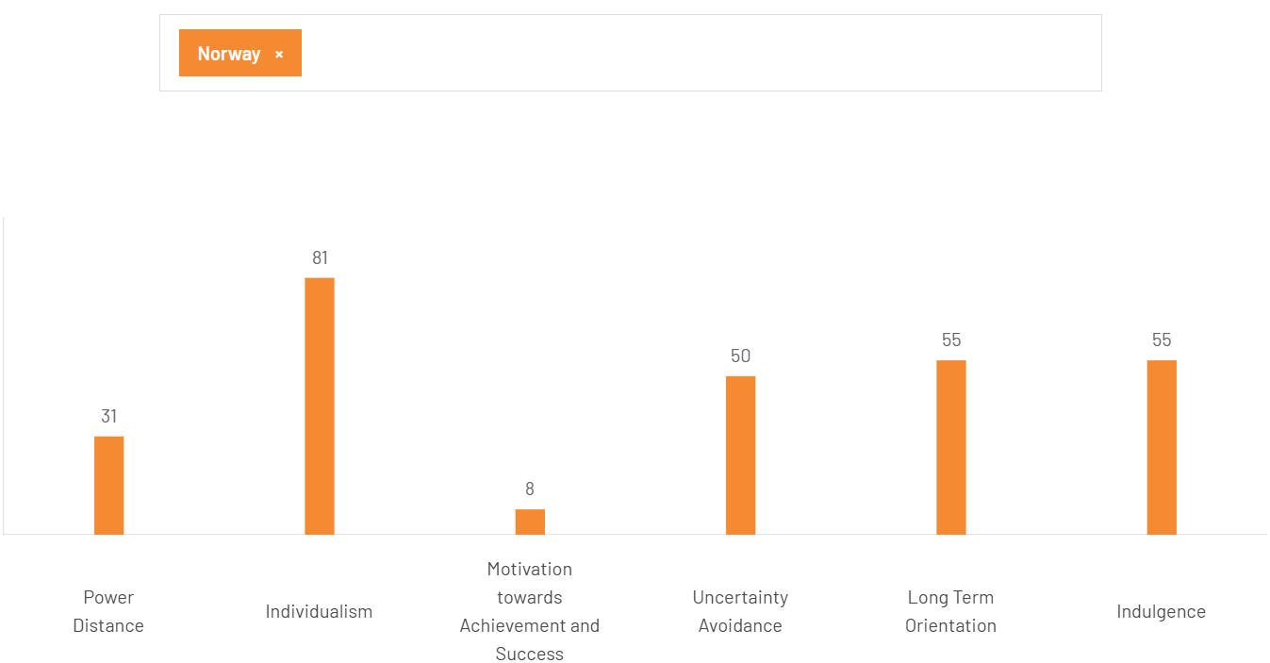
Figure 2: Hofstede Insights of Norway
(Source- Hofstede Insights, 2026)
According to Zhang et al (2022), the PD index for Norway is rather low (PD=31), as suggested by Hofstede Insights (2026), meaning that equality and decentralised decision making, and informal organisational relations, are valued. Consumers are looking for straightforward communication, business ethics, and customer service, and don't want to deal with a hierarchy. Therefore, Decathlon needs to allow the local staff to feel good and feel involved, and needs to implement participative management, typical of the culture of the Norwegian people.
Oslo also exhibits high Individualism, indicating that consumers are interested in their choice, independence and self-expression. In highly individualistic societies, the purchase is made not to accommodate the group nor in reaction to group pressure, but instead in response to the individual's preferences and quality of the product (Hofstede et al., 2010). This is a cultural trait that helps Decathlon diversify its products and offers greater personalisation for its customers, enabling them to choose sport products better adapted to their lifestyle and leisure activities.
Norway is also a culture-empowering country in the sense that it is very feminine and prefers quality of life, social welfare, environmental sustainability and work-life balance over aggressive competition. Hofstede et al. (2010) contend that the ethical production, responsible for the environment and corporate social responsibility factors are more important for buyers in feminine societies. These values are similar to Decathlon's sustainability efforts: ECO-designed products, circular economy and bringing sport to everyone. Effective communication can enhance the consumer trust and brand legitimacy in the Norwegian market by reinforcing these initiatives.

3.1.6 Industry & Market Attractiveness
An important consideration to keep in mind when looking at the Norway's sporting goods retail landscape is the Norwegian consumer's strong spending on health, fitness and outdoor pursuits, all of which provide positive prospects for Decathlon. The demand for high quality sport products still continues to grow as participation in organised sport, recreation and wellbeing courses and events grow. According to Pederzoli et al., 2023, international retailers have greater success if they "enlist price competitiveness, value differentiation (customer value) and innovation and supply chain management (SCM) efficiency". These are precisely the competitive advantages that Decathlon can boast in its vertically integrated business model.

Factor | Key Findings in Norway Market | Implication for Decathlon
Political | Stable democracy, low corruption | Low investment risk
Economic | High GDP, high purchasing power | Strong demand
Legal | Open FDI regime, EEA membership | Easy market entry
Cultural | Outdoor lifestyle, sustainability | High product fit
Table 2: Industry Attractiveness
Despite such favourable market conditions, the competition structure of the sporting goods sector in Norway is relatively high (World Trade Organization, 2026). Competitive local and international retailers are well established and have built a reputation, which means that new brands must offer better customer service and products, and be innovative and cost-effective. Chananets (2023) states that with the advent of the new era, the importance of sustainable competitive advantage in retail has shifted from simply beating the prices to customer analytics and omnichannel capabilities integrated with the digital technologies. Decathlon's bets on digital retailers, inventory optimisation and the technologies that enhance customers' engagement with companies are thus critical strategic skills to successfully enter markets.

3.2 Market Entry: Dunning's OLI Paradigm and FDI Decision
Dunning (1988) formulated the Eclectic (OLI) Paradigm that gives a model to understand the reason why multinational businesses opt to adopt foreign direct investment (FDI) instead of other modes of international market achievement like exporting. It assumes the three following conditions, Ownership advantages, Location advantages and Internalisation advantages (Dunning, 1988). In the case of Decathlon, OLI framework can be applied to evaluate whether the firm specific capabilities coupled with the nature of Norway as a host nation and the advantages of internal control alone give it an adequate reason to make FDI. It is the combination of these three advantages that hence aids in deciding whether it is a strategic decision to make a wholly owned investment in Norway.
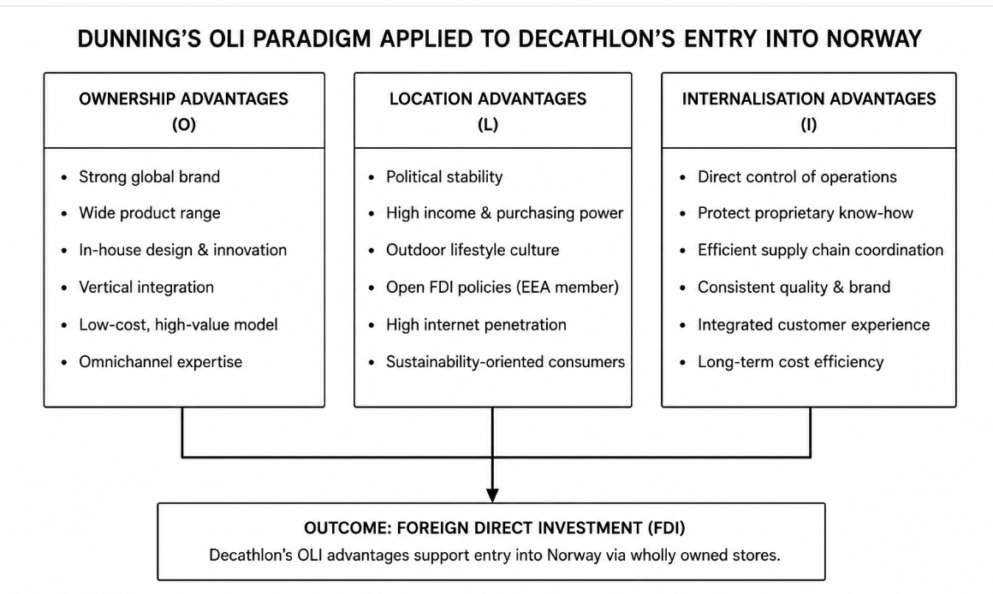
Figure 3: Dunning's OLI Paradigm Applied to Decathlon's Entry into Norway
(Source: Adapted from Dunning, 1988; and Decathlon, 2025)
Ownership Advantages
Ownership assets include the assets and capabilities that make a firm superior in a foreign market (World Trade Organization, 2025). Several factors make Decathlon's ownership so special: it has a brand that is recognized around the world, a vertical supply chain, a huge research and development budget, and it also has a number of private labels. These assets make it possible to achieve high quality of sporting goods at competitive prices, with good quality control and high operational efficiency. For those firms which own valuable and rare resources that are difficult to duplicate, sustainable competitive advantage in foreign direct investment is more likely to be reached than that of firms with only transferable products, according to Brouthers et al. (2022). Thus, Decathlon's technological innovation and sustainability programs as well as its worldwide procurement system offer clear ownership benefits in the Norwegian market.

Location Advantages
Location advantages are associated with host country attributes that contribute to increased profitability of foreign investment. Norway has many attributes that derive from the location that make it an advantage for particular activities. Many complementary situation-specific features make Norway an attractive country for specific activities including political stability, purchasing power and transparency of institutions and outdoor recreation participation (World Bank, 2026). In addition, EEA membership opens the corresponding door to the rest of the European market without any need of changing the framework. Favourable institutional quality, economic stability and market potential plays an important role in shaping the location decisions of multinationals since they create lower investment risk and boost the long-term performance of the business enterprises, it is argued by Li et al. (2022). The properties of these countries make Norway an attractive country in which to continue Decathlon's expansion.
Internalisation Advantages
Internalisation benefits are what makes it attractive to companies to own and manage foreign centres instead of licensing their intellectual property to other companies. For Decathlon, the vertically integrated business strategy relies on the product design, manufacturing, logistics, pricing and customer experience. Wholly owned operations will allow the company to safeguard proprietary knowledge, product quality and ensure consistency in implementation of the sustainability approach. When interest rate transactions introduce greater transaction costs or leakages of interest rate knowledge in the market, internalisation is better, says Hennart (2022). This approach has created direct ownership and thus greater strategic flexibility and operational efficiency for Decathlon.
Critical Synthesis
But, despite being one of the most popular theories of foreign direct investment (FDI), Dunning's Eclectic Paradigm should be read in conjunction with up-to-date FDI theory on digitalisation and institutional changes. Xu et al. (2023) explain that the power of technological assets and digital ecosystems is driving more and more location choices of multinationals in the era of globalization, and sustainability desires and institutional quality are now equal in importance to international competitiveness, as Donnelly et al. (2024) point out. This means that Decathlon's growth in Norway cannot be explained just in terms of the classic OLI framework but also in relation to new strategic skills, digital transformation and sustainable integration for the purposes of obtaining a competitive advantage. Considering them together, the ownership advantages that Decathlon offers, combined with the favourable market location conditions and internalisation aspects in Norway indicates a good theoretical basis for Decathlon's presence in the Norwegian market as a whole.

4. Entry Mode Strategy and Strategic Synthesis

4.1 Historical International Entry Pattern of Decathlon
Decathlon internationalization has progressively taken a linear direction since its establishment in France up to a global retail chain. The move was initiated with the foundation of the company in 1976 and in 1986, the company established its first store in Germany abroad and the initial step towards international expansion (Decathlon, 2025). It subsequently later conflagrated to Europe and beyond to major global markets, including China in 2003, and India, with an indication of slowing growth of the company in the area of geographical diversifications of its operations (Decathlon, 2025; Decathlon Group, 2024).
This development has been facilitated by the fact that, Decathlon favours having a high level of control in the retail business and business verticalisation process. A further demonstration of this is in its manner of investing in markets with a strategic role such as Germany and India which indicates their long-term international growth and not a one off entering the market (Decathlon Group, 2024). By the year 2025, there were more than 1,900 stores all around the world but located in 82 countries and regions, this means that the company has a high presence all over the world (Decathlon, 2025).
Brouthers et al. (2022) insist that companies need to match their entry mode to both internal capabilities and host-country conditions, but Hennart (2022) insists in the power of high-control modes to preserve the proprietary capabilities and consistency of operation. Therefore, the history of the development of Decathlon is leaning towards a 100% Greenfield investment in Norway, in which the company will be able to handle the integrated business model.

4.2 Strategic Fit and Justification of the Recommended Entry Mode
Greenfield investment would help Decathlon to base an all-controlling business in Norway, which is considering its own vertically combined business model (Surdu et al., 2023). It would provide the Decathlon with an excellent amount of managerial control and a hands-on approach to their brand, product and quality, supply chain and customer experience through this method of entry. It also aligns with the Internalisation benefits obtained via the OLI framework since Decathlon would be able to safeguard proprietary knowledge and align their interdependent operations within it. But Green field investment entails colossal start up fees, is a protracted establishment procedure and puts the company under a risk of building market awareness in the process.
Acquisition might offer a quicker market access as Decathlon would obtain an established retail network, customer and local market acquaintances. However, Hennart (2022) reminds the incorporation of an established retailer into the vertically integrated structure of the Decathlon may cause cultural, operational and organisational challenges. The joint venture would also offer a entry point into local knowledge and they will be able to spread the financial and operating risks of entry with a Norwegian partner. The joint ownership, however, would decrease the managerial autonomy of Decathlon and potentially complicate its full control of its integrated business model. Considering the relatively open investment environment and a stable set of institutions in Norway, the advantages of sharing ownership are not so persuasive.
Entry Mode | Decathlon's Historical Experience | Suitability for Norway | Reason
Greenfield Investment | In developed markets, like Germany in the past and other markets, as India (Decathlon, 2025; Decathlon Group, 2024), it was generally the companies store branch where the choice was made, but as known, Indian cases are rare. | Most Suitable | Provides full operational control and supports Decathlon's vertically integrated business model.
Acquisition | Not a strategy which is a priority for Decathlon to pursue internationally. | Moderately Suitable | Provides rapid market entry but creates post-acquisition integration challenges.
Joint Venture | Used on a flexible basis when a partnership within local communities might be needed | Less Suitable | Norway's stable business environment reduces the need for shared ownership.

Table 3: Evaluation of Entry Modes for Decathlon's Expansion into Norway
A joint venture is a means by which companies can share foreign investment costs, local knowledge, and business risk with their local partners. For institutions where uncertainty or complexity in the market prevents foreign companies from entering, collaborative entry modes can be especially beneficial for Xu et al (2023). This is because Norway has clear institutions and low levels of political risk, less requiring local partnership arrangements.
While taking all the above mentioned macro environmental and Strategic analyses into account, a Greenfield investment by Decathlon is suggested as the most suitable mode of entry to this country, Norway (Mao et al., 2022). It aligns with the company's past internationalisation trajectory, the vertical integration of its business, and the company's long-term goal of delivering and maintaining full control over their operation, product quality and customer experience as per Li et al. (2022)

4.3 Conclusion and Recommendations
It shows that Norway offers an interesting market for Decathlon's international expansion due to the political stability of the State, the robustness of the local economy, the transparency of the laws, the high level of digitization of the retail sector and the high degree of sports culture. On the macroeconomic level, the OECD (2025) and the World Bank (2025) describe Norway as having good conditions for long-term foreign investment, both in terms of macroeconomic policy stability and purchasing power. Three strategic recommendations are made.
- First, Decathlon should make a 100% GREENFIELD in the Norwegian market. Whereas, Greenfield investment is suitable when firms are interested in acquiring more managerial autonomy, or when they want to safeguard their firm-specific capabilities, as Brouthers et al. (2022) claim. In Norway, with an institutional structure that is not volatile, and Decathlon's vertically integrated company structure, this use of the two will allow for a steady control over operations and long term competitive edge.
- Secondly, Decathlon needs to enhance its omnichannel retail approach by combining offline shops with e-commerce channels. Pederzoli et al. (2023) explain that digitalisation leads to improvement in the retailer's performance, meanwhile the World Bank (2025) attests to high internet penetration rate in Norway, which makes an omnichannel approach suitable for consumer expectation.
- Third, Decathlon needs to consider sustainability as a key element in its market strategy, focusing on increasing the range of eco-designed products and launching circular business operations. Norwegians value environmental responsibility and improved quality of life, and Donnelly et al (2024) say sustainability is a key element in ensuring international competitiveness over the longer term.
Overall, Greenfield investment can be considered the most appropriate entry mode that will have to be adopted in the event of Decathlon being relocated to Norway. It offers maximum managerial control, safeguards Decathlon proprietary capabilities and upholds the vertically integrated business model of the company.

Section 2: Reflective Account (Gibbs' Reflective Cycle)
Description
The report called for me to critically discuss Decathlon's opportunity of applying the business theory of an international business to a real organisational context in the process of thinking through the idea of expanding to Norway. The task was to provide an overview of Decathlon's internationalisation strategy, to analyse the political, economic, legal and cultural environment in Norway and to identify different methods of entering international markets before suggesting a suitable internationalisation strategy for Decathlon. During the process, I studied papers from academic journals involved in the process, as well as papers from the OECD, the IMF, the World Bank, the WTO, and the UNCTAD to have up to date information that would support my analysis. I also utilized theories such as the different types of mergers and acquisitions from Bartlett and Ghoshal's (1989) typology, and Dunning's (OLI) Paradigm and macro-environmental analysis to help bring theory to practice and make strategic decisions.
Feelings
When I was just starting the assignment, I did not know what to do about combining several international business theories to get an integrated strategic analysis. While I was aware of some theories, I didn't know how to decide which ones were best for analysing the expansion of Decathlon to Norway. Also, it was difficult to explain a real organisation, instead of a textbook example using current economic information. As I worked through my research, I grew more and more confident in my ability to read and analyse academic literature and to compare theoretical points of view (Lim, 2023). Use of practice-based application of the theories made the learning experiences interesting and meaningful with a business situation. At the end of this report, I found myself more confident in my capacity to assess evidence, and to argue the strategic recommendations which I have made, both from academic research and from contemporary organisational data.
Evaluation
There were a few things that went very well with the assignment. My analysis was carried out with academic journal research as well as the research provided by international organisations which have published their reports - this helped the credibility of my analysis. I did not just learn about the business in Norway, but also gained an insight into how political stability, institutional quality and consumer behaviour might affect Decathlon's strategic choices. Using this Dunning's Eclectic Paradigm allowed me to merge in the capabilities of the company and the characteristics of the country where the company will present itself, reinforcing the argument in favor of the suggested entry strategy. The assignment had to have challenges, however. The most challenging aspect of the work was choosing the proper and latest available statistical data and making sure it was consistent from country to country (Hennart and Sutherland, 2022). Economic indicators provided by different organisations were sometimes reported with different time spans and an important comparison had to be done before they could be included in the report. A further difficulty was that of going beyond description into critical analysis. At first I used to clarify theoretical ideas not related to the practical application, later, more and more revisions have been made to combine theory with evidence from the organisation.
Analysis
Overall, facilitating an overview of the learning process shows how theory in the classroom can become more valuable when used as a practical tool in making decisions in international business in practice. Gibbs was a Canadian psychologist who theorised the Gibbs' Reflective Cycle (1988) which stresses the reflective learning of evaluating both successes and failures. During the entire course of this assignment, I felt that there are no theories that can account for international expansion decision. In reality however, strategic analysis demands that more than one perspective is combined to gain an understanding of complex situations within organisations.
For instance, using the framework proposed by Bartlett and Ghoshal, I was able to categorize Decathlon's international strategy, and with foreign direct investment (FDI), using Dunning's OLI Paradigm, it was clear that it was an appropriate form of market entry. But both frameworks were insufficient to capture our understanding of the challenges of sustainability, digitalization and institutional quality in today's business world. Through literature review it was found that international business strategy developed significantly from the theories. Since current researchers generally agree that digital skills are shifting to become critical and equally valuable sources of competitive advantage, there is an increasing shift in focus from responsibility and resilience in institutions to digital skills.
Conclusion
It has helped me understand the concept of international business strategy and foreign market entry decision making in detail. In addition to developing theory, I had the opportunity to become hands-on in assessing a multinational organisation in a truly international business setting. The report proved that to establish a successful strategic recommendation, then there needs to be a balance of academic theory, empirical evidence and critical evaluation rather than 'choking' on a string of one without the other. I also acknowledged the need for the application of current research and sound data from international sources in aiding the managerial decision-making process. I have become more confident in doing independent study, incorporating several theories and developing evidence-based strategies and recommendations for the assignment. Overall, I find I have gotten better at academic writing, and with this I've also been able to improve my analytical skills, which will be useful during my future postgraduate studies and for future employment decisions in an international business environment.
Action Plan
Area of Development | Objective | Action | Timeframe | Expected Outcome
Research Planning | Improve research quality | Begin research earlier and review wider literature | 3 months | Stronger evidence base
Theoretical Integration | Improve theory synthesis | Integrate competing theories more effectively | 6 months | More coherent analysis
Critical Evaluation Skills | Strengthen critical thinking | Practise evaluating evidence and arguments | 6 months | Stronger strategic recommendations

References
Bartlett, C.A. and Ghoshal, S. (1989). Managing Across Borders: The Transnational Solution. Boston, MA: Harvard Business School Press.
Brouthers, K.D., Chen, L., Li, S. and Shaheer, N. (2022). 'Charting new courses to enter foreign markets: Conceptualization, theoretical framework, and research directions on non-traditional entry modes', Journal of International Business Studies, 53(11), pp. 2088-2115. https://link.springer.com/article/10.1057/s41267-022-00521-x
Dau, L.A., Li, J., Lyles, M.A. and Chacar, A.S. (2022). 'Informal institutions and the international strategy of MNEs: Effects of institutional effectiveness, convergence, and distance', Journal of International Business Studies, 53(7), pp. 1257-1281. https://link.springer.com/article/10.1057/s41267-022-00543-5
Decathlon (2025). Annual reports and publications. Available at: https://sustainability.decathlon.com/decathlon-annual-sustainable-development-reports (Accessed: 28 July 2026).
Decathlon (2026). Corporate website. Available at: https://sustainability.decathlon.com/reports-and-documents (Accessed: 28 July 2026).
Donnelly, R., Purkayastha, S., Manolova, T.S. and Edelman, L.F. (2024). 'Institutional distance, slack resources, and foreign market entry', Journal of International Business Studies, 55(2), pp. 194-211. https://link.springer.com/article/10.1057/s41267-023-00647-6
Dunning, J.H. (1988). 'The eclectic paradigm of international production: A restatement and some possible extensions', Journal of International Business Studies, 19(1), pp. 1-31. https://link.springer.com/article/10.1057/palgrave.jibs.8490372
European Commission (2026). Access2Markets. Available at: https://trade.ec.europa.eu/access-to-markets/en/home (Accessed: 28 July 2026).
Florido-Benítez, L. and Aldeanueva-Fernández, I. (2022). 'Fusing international business and marketing: A bibliometric study', Administrative Sciences, 12(4), 159. https://www.mdpi.com/2076-3387/12/4/159
Gibbs, G. (1988). Learning by Doing: A Guide to Teaching and Learning Methods. Oxford: Oxford Polytechnic.
Grøgaard, B., Sartor, M.A. and Rademaker, L. (2022). 'What merits greater scholarly attention in international business?', Journal of International Business Studies, 53(8), pp. 1508-1518. https://link.springer.com/article/10.1057/s41267-022-00539-1
Hennart, J.-F. (2022). 'How much is new in Brouthers et al.'s new foreign entry modes, and do they challenge the transaction cost theory of entry mode choice?', Journal of International Business Studies, 53(11), pp. 2116-2132. https://link.springer.com/article/10.1057/s41267-022-00523-9
Hennart, J.-F. and Sutherland, D. (2022). 'International business research: The real challenges are data and theory', Journal of International Business Studies, 53(10), pp. 2068-2087. https://link.springer.com/article/10.1057/s41267-022-00566-y
Hofstede Insights (2026). Country comparison tool. Available at: https://www.hofstede-insights.com/country-comparison/ (Accessed: 28 July 2026).
Hofstede, G., Hofstede, G.J. and Minkov, M. (2010). Cultures and Organizations: Software of the Mind: Intercultural Cooperation and Its Importance for Survival. 3rd edn. New York: McGraw-Hill.
International Monetary Fund (2025). World Economic Outlook Database. Available at: https://www.imf.org/en/Publications/WEO/weo-database (Accessed: 28 July 2026).
International Trade Administration (2026). Country Commercial Guides. Available at: https://www.trade.gov/country-commercial-guides (Accessed: 28 July 2026).
Kano, L., Tsang, E.W.K. and Yeung, H.W.C. (2020). ‘Global value chains: A review of the multidisciplinary literature’, Journal of International Business Studies, 51(4), pp. 577-622. https://doi.org/10.1057/s41267-020-00304-2
Li, Y., Strange, R. and colleagues (2022). 'Market entry into new export markets: When are firms more likely to imitate their competitors' market presence?', International Business Review, 31(5). https://www.sciencedirect.com/science/article/abs/pii/S0969593122000403
Lim, W.M. (2023). ‘Transformative marketing in the new normal: A systematic review’, Journal of Business Research. https://doi.org/10.1016/j.jbusres.2023.113752
Mao, H., He, C., Huang, X., Wu, B., Chen, Z. and Zhou, L. (2022). 'When to become an electronic business venture after the COVID-19 pandemic? The role of strategic orientation and perceived environmental turbulence in determining online market entry timing', Frontiers in Public Health, 10. https://www.frontiersin.org/journals/public-health/articles/10.3389/fpubh.2022.989264/full
OECD (2025). FDI Regulatory Restrictiveness Index. Available at: https://www.oecd.org/investment/fdiindex.htm (Accessed: 28 July 2026).
OECD (2025). OECD Economic Outlook. Available at: https://www.oecd.org/economic-outlook/ (Accessed: 28 July 2026).
Pederzoli, D., Danese, P. and colleagues (2023). 'Internationalization and digitalization: Their differing role on grocer and non-grocer retailer performance', Journal of Retailing, 99(3), pp. 400-419. https://www.sciencedirect.com/science/article/pii/S0022435923000337
Surdu, I., Mellahi, K. and Glaister, K.W. (2023). 'Institutional unpredictability and foreign exit-reentry dynamics: The moderating role of foreign ownership', Journal of World Business, 58(2), Article 101389. https://www.sciencedirect.com/science/article/pii/S1090951622000803
Swoboda, B. and Sinning, C. (2022). 'Effects of internationalization rhythm and speed on e-commerce firms' growth and the role of institutional distances', Management International Review, 62(2), pp. 169-201. Available at: https://link.springer.com/article/10.1007/s11575-022-00463-4
United Nations Conference on Trade and Development (2025). World Investment Report 2025: International Investment in the Digital Economy. Available at: https://unctad.org/publication/world-investment-report-2025 (Accessed: 28 July 2026).
United Nations Conference on Trade and Development (2026). Investment Policy Hub. Available at: https://investmentpolicy.unctad.org/ (Accessed: 28 July 2026).
Verbeke, A. and Yuan, W. (2021). ‘A few implications of the COVID-19 pandemic for international business strategy’, Journal of Management Studies. Available at: https://doi.org/10.1111/joms.12665
World Bank (2025). World Development Report 2025: Standards for Development. Available at: https://www.worldbank.org/en/publication/wdr2025 (Accessed: 28 July 2026).
World Bank (2026). Global Economic Prospects. Available at: https://www.worldbank.org/en/research (Accessed: 28 July 2026).
World Bank (2026). World Development Indicators. Available at: https://databank.worldbank.org/source/world-development-indicators (Accessed: 28 July 2026).
World Trade Organization (2025). World Trade Statistical Review 2025. Available at: https://www.wto.org/english/res_e/statis_e/wts2025_e/wts2025_e.htm (Accessed: 28 July 2026).
World Trade Organization (2026). Trade Topics. Available at: https://www.wto.org/english/tratop_e/tratop_e.htm (Accessed: 28 July 2026).
Xu, X., Liu, Y. and colleagues (2023). 'Cross-border acquisition or greenfield investment? The role of investor sentiment', Frontiers in Psychology, 13https://www.frontiersin.org/journals/psychology/articles/10.3389/fpsyg.2022.1085286/full
Zhang, S. (2022). 'Why did they get in trouble? The influence of firm characteristics and institutional distance on Chinese firms’ foreign market entry attempt', Frontiers in Psychology, 13. https://www.frontiersin.org/journals/psychology/articles/10.3389/fpsyg.2022.972384/full
Zhang, S., Fang, Y., Zhang, Y. and Zhang, S. (2022). 'The effect of brand internationalization strategy on domestic consumers’ purchase intention: Configuration analysis based on brand authenticity perspective', Frontiers in Psychology, 13. https://www.frontiersin.org/journals/psychology/articles/10.3389/fpsyg.2022.891974/full

