D

MODULE CODE: LCBB4001 ACCOUNTING FUNDAMENTALS

LECTURE NAME: Dr Rexon Nting

STUDENT NAME: Ivan Georgiev

STUDENT ID: 1914979

TASK 1

 |  | LEDGER
 | £ |  | £
 | Dr. |  | Cr. |  |  | In cash
 |  | Entry |  |  |  | Dr | £
 | 300 |  | 300
 |  | Cash / Capital |  |  | 5.4 | Capital | 300
 | 200 |  | 200
 |  | Purchase / Cash |  |  | 8.4 | Loan | 250
 | 250 |  | 250
 |  | Cash / Loan
 | 150 |  | 150 |  | 31.4 | Sales | 350
 |  | Vehicle / Cash |  |  |  | Total | 900
 | 350 |  | 350
 |  | Cash / Sales
 | 50 |  | 50
 |  | Rent / Cash
 | 200 |  | 200
 |  | Loan / Cash
 | 60 |  | 60
 |  | Withdrawal / Cash
 | 1560 | In total | 1560

Loan
Date | Dr | Cr.
29.4 Cash | 200
30.4 balance | 50
28.4 cash |  | 250
In total | 250 | 250

TASK 2

TASK 3

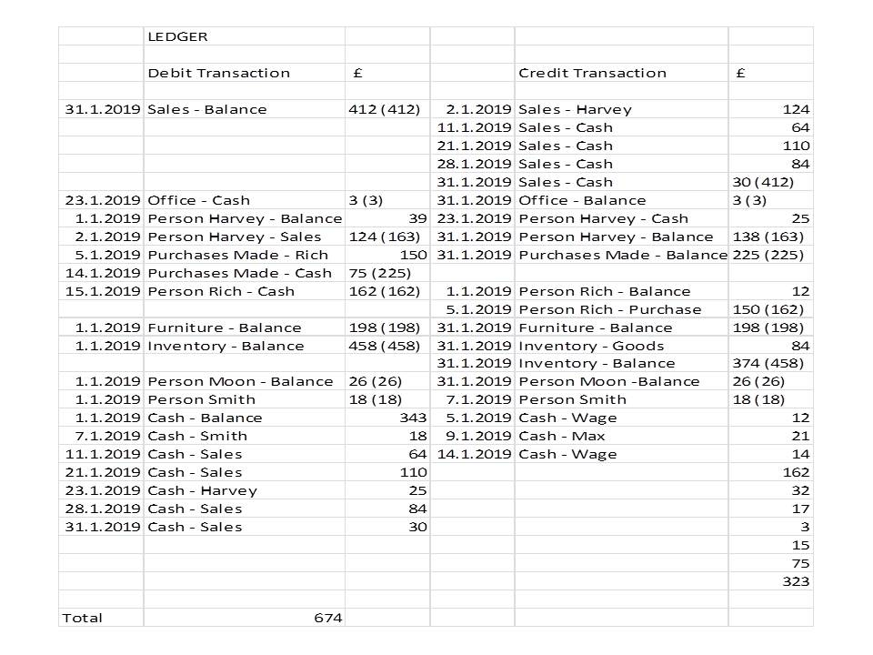

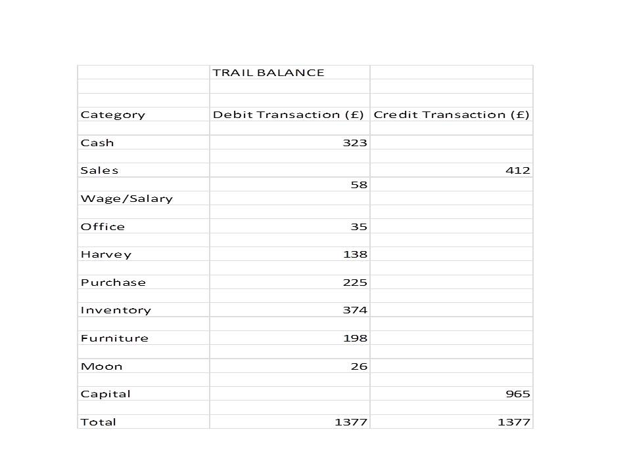

TASK 4



