

Advanced Technological Intervention in Architecture: Is this the Answer to Climate Change in the Built Environment?

Reuben Dutch
Student number: 1907793

Supervisor: Dr. Paul Harries

University of Wales Trinity Saint David
April 2022

Author’s Declaration
I declare that the work in this dissertation was carried out in accordance with the regulations of the University of Wales, Trinity Saint David. The work is original except where indicated by special references in the text and no part of the dissertation has been submitted for any other degree.
Any views expressed in the dissertation are those of the author and in no way represent those of the University of Wales, Trinity Saint David.
The dissertation has not been presented to any other University for examination either in the United Kingdom or overseas.
I hereby give permission for my work, if accepted, to be available for photocopying and inter-library loan, and for the title and summary to be made available to outside organisations.

Signed …Reuben Dutch………………………………………………………………………………………………………
Date ……11/04/2022……………………………………………………………………………………………………….

Copyright statement

The copyright of this dissertation rests with the University of Wales, Trinity Saint David. No information derived from this dissertation shall be published without the prior written consent of the University.

Signature …Reuben Dutch……………………………………………………………………………………………

Date ………11/04/2022……………………………………………………………………………………………….

Abstract
I set out to assess the negative effects that the built environment have on global warming and what can be done within the built environment to combat this. Through the use of two main case studies, demonstrating the approaches of high-tech and low-tech, I assessed the methods of building sustainably in a hot climate. I found that both methods are needed in conjunction with each other.

Acknowledgments
I would like to thank my dissertation supervisor, Dr. Paul Harries for supporting and guiding me through writing this dissertation.
Contents
Author’s Declaration Page 2
Copyright statement Page 3
Abstract Page 4
Acknowledgments Page 5
Chapter 1: Introduction Page 7
Chapter 2: Literature Review Page 11
Chapter 3: Methodology Page 16
Chapter 4: Case Studies Page 19
Chapter 5: Discussion Page 25
Chapter 6: Conclusion Page 29
Bibliography Page 31
Chapter 1
Introduction
The average global temperature is increasing exponentially, and is currently around 1.1°C. In some areas of the globe, it is expected to rise by around 2.5°C by 2050 (Borwankar, 2021). This presents the built environment with a major issue; a large amount of the world’s built environment will not be able to function normally in a hotter climate without the use of significant continued and increased use of likely un-sustainable energy consumption. The aim of this research is to determine whether technological intervention can have a positive effect on climate change, and the feasibility of certain methods in various scenarios. I will be researching into various interlinked subject areas in order to gain an insight into how architecture and the built environment has contributed and will continue to contribute towards climate change and global warming. I intend to identify and assess interventions that can allow buildings to be designed for and constructed in extreme climates. I will address and explore in detail the solutions that are commonly used as well as some lesser-known examples to assist a building in minimising its carbon footprint. The feasibility of achieving or aiming towards ‘net zero’ will be tested via the various interventions. I also hope to investigate the various technological ideas that can be and have been used to combat the ever-worsening global climate crisis. I will also research and gain understanding into the alternative to technological solutions.
Gradually throughout this research, I will be answering three set research questions that the answers of which will amalgamate to address the dissertation title question. The three research questions are as follows;
- To what extent does architecture and the built environment contribute to climate change?
- How can high tech methods and low-tech methods aid the current and future built environment in being more sustainable and dealing with the rising global temperature?
- What is the greater outcome of these two approaches for assisting the built environment to become more sustainable and dealing with the rising global temperature?
These three questions will form an outline structure to the research. They will inform the areas for exploration in the review of literature. The collected data will subsequently remain focused and directly connected to the dissertation title.
Climate change is currently an extremely poignant topic. Climate change refers to long-term changes in weather patterns and temperatures. These changes can be caused naturally, however since the 1800s, the main driver of climate change has been linked to human activities, primarily due to the burning of fossil fuels such as coal, oil, and gas. This produces heat trapping gasses called greenhouse gasses, so named due to the likeness of the effect of a greenhouse, and the effect these greenhouse gasses have on the earth. In-turn, slowly, but exponentially raising the average temperature of the planet.
Global average temperature is rising. This is caused specifically by the increased use of fossil fuels since the industrial revolution. Climate change is the main reason why everyday processes and activities must change, adapt, and aim towards becoming green or more sustainable. Camden Council (2022), on their website, claim that ‘Global temperatures are on track to exceed 2°C’ and that if this is the case, ‘we need to take urgent action’ to eliminate the risk of severely impairing the current climactic situation. Not only is the impact of C0² emissions a concern, but the fossil fuels, when used as fuel, that cause the C0² emissions are a finite resource. The worlds fossil fuel supply will eventually be exhausted; exceptionally quickly if they continue to be burned at the current rate. However, this is a common misconception that this is a major problem. The planet would have far surpassed a point of habitation by the time fossil fuels had been exhausted. The main built environment legislation claims that it is aiming to promote increased sustainability and therefore simultaneously reducing the associated fossil fuel usage across the built environment sector (British Government, 2013).
Amongst a plethora of strategies and mechanisms that aim to achieve a lower carbon emission in the built environment sector, are two opposing umbrella categories ‘High technology’ (abbreviated to ‘high-tech’), and low technology (abbreviated to ‘low-tech’). Essentially these refer to a building relying on intuitive systems (high-tech) and typically basic building strategies (low-tech) respectively. I have selected two case studies that refer to each category separately to analyse within this study.
The selected case study representing the use of high-tech is a large-scale city development based in the UAE, ‘The Masdar City’. This is an example of how advanced materials, methods and technological intervention can react to the detrimental effects of global warming. This project is presented by an exemplar of how global heating is addressed by utilising the most advanced technologies available. This ideology comes from Norman Foster, whose practice designed the city development. The research will focus on the Masdar City, and the effects that the various advanced technologies used have on global warming, and whether the advanced technologies can sufficiently deal with building in a hot climate and thereby coping with a higher global temperature in the future. This case study will be scrutinised in depth to test whether the experimental development could be having an adverse effect on global warming, and not mitigating it. In response to this, I will investigate a potential opposing case study along with supporting literature; the New Gourna Village in Al Qarnah, Egypt by the Architect Hassan Fathy. This case study represents a ‘low tech’ approach to climate change. Utilising various techniques with limited recourses and interventions that deal with the hot climate of Egypt (Fathy, 2010).
Many organisations are aiming towards a concept called ‘net zero’. Net zero refers to a state in which the greenhouse gases going into the atmosphere are balanced by removal out of the atmosphere (Net Zero Climate website of Oxford University, 2020). Specifically in relation to the built environment, this refers to reducing the greenhouse gas emissions to a minimum and offsetting what remains. Offsetting is where carbon dioxide emissions are balanced by means of reducing carbon emissions in other ways to compensate for the emitted carbon (Masud et al., 2015). When aiming for net zero, this process resulting in an overall emission figure of zero or ‘net Zero’ otherwise referred to as ‘carbon neutral’. This aims to counter the original embodied carbon that has been emitted as a product of certain processes. Interventions such as planting trees in order to absorb carbon dioxide, can be used to help offset carbon dioxide emissions. Carbon is the focus as this is the greenhouse gas that, if offset, will have the biggest potential positive impact on climate change. In some instances, the aim is to function as ‘carbon negative’, where more carbon is absorbed than emitted. This idea results in a negative net carbon emission figure.
The construction sector is dominated by residential and commercial buildings with an increasing focus on energy eﬃciency. This energy efficiency focus applies in the design process, the construction process, and the operation of the building after it has been handed over to the client. This emphasis on energy efficiency is heightened by the fact that, according to a document published by the UK Government, the global construction market is forecasted to accelerate over the next 10 years by over 70%. This will drastically increase the pressure and responsibility imposed upon the construction industry (British Government, 2013). In the built environment, energy efficiency is often falsely paralleled with low energy consumption. This assumption can lead to ‘energy performance improvements’ being confused with a ‘mere’ reduced energy consumption (Cody, 2014). The reality is that this is more complex in terms of measuring building performance.
The opposing ideas of ‘high-tech’ and ‘low-tech’ will be introduced and related to two selected case studies, respectively. I aim to examine the case studies and extrapolate the varying processes and technologies used. The ‘high tech’ and ‘low tech’ examples will be compared. These differing approaches will be reviewed using the case studies alongside other sources and examples within various scenarios and contexts.
I will compare polar opposite approaches and ideas of high tech and low-tech interventions which aim towards achieving net zero architecture. Two case studies will showcase each idea. Within each category, I will explore a plethora methods and ideas that can be separated into the two aforementioned opposing approaches. By separating the two approaches of ‘high-tech’ and ‘low-tech’, I intend to form an argument between them and gain insight into which approach is the best method for aiming towards achieving net zero. This will be measured against a multitude of factors including cost, efficiency, and feasibility.
I will also be considering, where possible the inadvertent or otherwise, negligence in calculating carbon emission calculations. In some instances, a calculation might only consider part of a process in order to fix the results in favour of the emitting person, company, or organisation. In some circumstances this would allow companies to claim that they are carbon neutral when in-fact they are not and have missed out crucial parts of their carbon emission calculation. This could be a motive to allow themselves to be eligible for governing body approval, subsequent marketing campaigning, and for certain funding initiatives that may be available (Gourley, 2020). This occurs in other industries like car manufacturing; therefore, this possibility cannot be exempt from the built environment scenario. The carbon emission responsibility is effectively associated to another country.
This research is an investigation into the architectural methods and potential solutions to living in the inevitably hotter global climate of the future, and how different solutions can be applied in varying socio-economic climates. Taking into consideration sustainability and feasibility. Both based on restricting factors such as: cost, the availability of resources and ultimately, carbon emissions. The dissertation is a comparative study considering case study examples of developments that reside in climates that are representative of a typical hotter climate akin to the prospective future global average temperature.

Chapter 2
Literature Review
The built environment sector, as a whole, accounts for almost 40% of annual Greenhouse gas emissions (Taylor, 2021). Arguably, one of the biggest problems is reluctancy to progress in terms of sustainability due to the fact that sustainable methods have a substantially higher cost implication than the typically unsustainable methods. For example, hypothetically, a project using a slate roof may import the materials from abroad because it can be supplied at a lower cost than the considerably nearer slate production facility. This has a significant negative CO² emission implication when compared to sourcing material locally. This is an example of carbon offshoring. According to Forbes, 3% of global carbon emissions are produced by shipping alone, and shipping accounts for 10% of ‘transport-related’ emissions (Scott, 2019). Also, according to Architecture 2030, building materials account for 11% of global carbon emissions (Taylor, 2021).
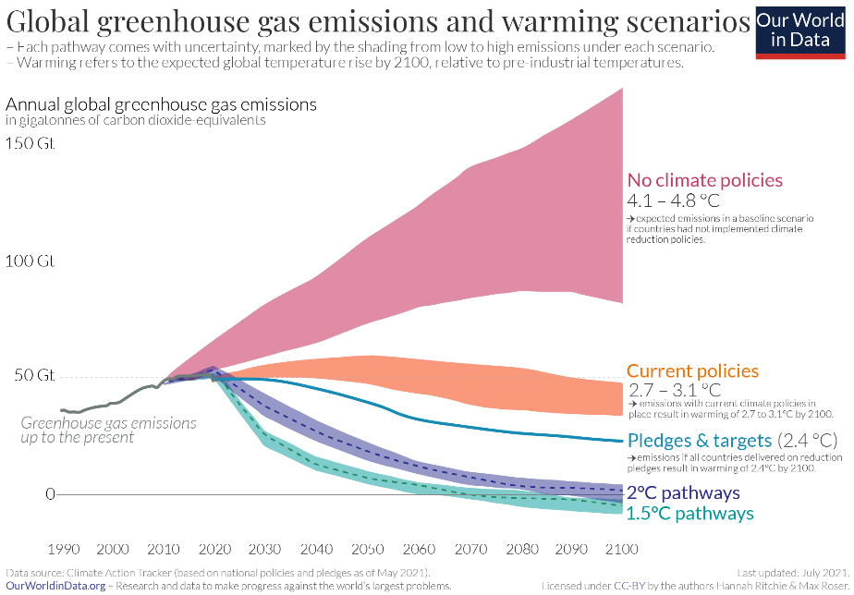
One of the main carbon pollutants in buildings is air conditioning (Plester, 2019). High rise buildings are one of the worst building types in terms of carbon emissions as a direct correlation to the mechanical ventilation systems used to cool the highly inefficiently performing glass megaliths (Plester, 2019). However aesthetically beneficial a glass façade may be, it is extremely detrimental to the environment. Glazing has a substantially lower U-Value than other comparable materials. The ‘U-Value’ is the measure that determines how effective a material performs as an insulator. Jeremy Plester (2019), writing for the Guardian, states that triple glazing is far less insulating than a typical brick construction. Plester also remarks that all skyscrapers ‘guzzle’ energy for this reason. An associated study found that energy consumption in high rise buildings, classed as having 20 storeys or more, is over double the consumption of low-rise buildings, classed as having six storeys or less, per square metre. The article also claims that high-rise buildings use as much as 40% more gas, as well as the total carbon emissions being twice as high when compared to low-rise buildings (Plester, 2019). Largely glazed buildings in effect create their own climate; the internal temperature approaches levels of nearly unbearable discomfort in both winter and summer situations depending on the time of year. The most important consideration is the high temperature summer scenario, as this is where the predicted average global temperature is heading. The effect is also worsened when spaces are populated with heat-producing computers and appliances as well as people. A vast amount of energy is required to provide mechanical ventilation in order to overcome the aforementioned discomfort. If this model were to be used as a precedent for when the global average temperature is significantly higher, this would have a large detrimental effect on the sustainability of the future built environment. The hotter climate will drive up the demand for more mechanical ventilation, thus consuming more energy and polluting the environment further, and exponentially raising the global temperature. This cycle could easily aggressively accelerate without significant intervention or regulation. If this cycle continues, it is in turn, likely to cause the climate crisis to be in an even worse state of uncontrollability than it currently is. One widely used ‘greener’ alternative to the standard mechanical ventilation is mechanical ventilation heat recovery (MVHR). This will be discussed in subsequent sections. The graph below taken from the Our World in Data website (Richie and Rosser 2021), shows the predicted average global temperature reached by 2100 in a scenario without regulation or policy as well as another four policy-guided scenarios with varying degrees of severity. This graph is based on data collected from Climate Action Tracker (2021). The first scenario illustrates the path to an average temperature of between 4.1 and 4.8°C. If current policies are followed and adhered to, the projected average temperature will be around 3°C by 2100. The prediction is vastly improved if pledges and targets are reached. This scenario, denoted by the Climate Action Tracker website as ‘optimistic’, illustrates that if all countries achieve their current targets or pledges set within the Paris climate agreement, it is estimated that the average temperature will reach 2.5 to 2.8°C by 2100. The Paris Agreement is a legally binding international treaty involving 192 countries and the European union. The agreement is renewed every five years with increasingly ambitious climate targets (United Nations, 2022). The Our World in Data website continues to state that the 2°C and the 1.5°C scenarios are possible provided that undisclosed stringent measures are put in place.
(Richie and Rosser 2021)
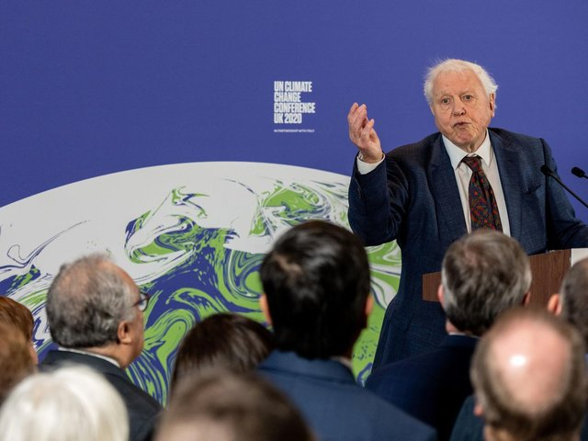
Introducing sustainable methods is not usually in the developers’ interest. This, arguably, is mainly due to the lack of regulation. Sustainability in a new development usually means introducing higher cost implications and therefore less profit for a developer. The Hill Dickenson website (2021) states that a steel manufacture company ‘British Steel’ has ‘closed its order book on structural steel due to 'extreme demand'’. This was due to the recent COVID pandemic, one of the many reasons why construction material prices are cheaper overseas. This in turn leads to a higher carbon output due to a greater transport distance. There are an increasing number of projects that are sourcing materials from abroad because of this. This results in carbon offshoring whereby carbon intensive goods are imported from abroad. Perry Gourley, writing for The Scotsman, claims that a report states that carbon offshoring is ‘hiding the true picture of greenhouse gas emissions’ (Gourley, 2020). There is little regulation apart from project specific planning conditions that incentivises the use of sustainable practices in terms of material sourcing. The article refers to Sir David Attenborough speaking at the 2020 COP26 event and stating that the Centre for Policy Studies were encouraging COP26 to introduce a ‘carbon border tax’ on carbon intensive products. This would aim to reduce global carbon emissions. John Sauven, writing for the Guardian, states that offshoring carbon emissions to China in the past has kept inflation down due to lower labour costs, however this is ‘at the cost of soaring greenhouse gas emissions in China’ (Sauven, 2007).
(Gourley, 2020)
High tech in architecture constitutes the use of the latest technological developments in materials and construction techniques. Typically, high tech building can include various strategies such as lightweight construction utilizing steel, aluminium, and glass (RIBA, 2022). This can allow for high rise construction and parametric forms. Other aspects include software-based interventions, and the use of smart systems. In the context of architecture and the built environment, one constituent design intervention of ‘High Tech’ includes smart buildings and in turn, smart cities. The adjective ‘smart’ associated with describing a person’s intelligence and shrewdness, personifies buildings that are deemed or intended to possess a crude humanised pseudo intellect. The backbone of high tech is based on information and communication technology (ICT) in order to optimise building performance, measured usually in terms of sustainability, energy consumption and socio-economic criteria. This sometimes heightens to an efficiency level that aims to achieve net zero carbon output performance. Essentially, smart buildings envelop an imitation of the human intellect comparable to what is commonly known as artificial intelligence (AI). The employed AI system will monitor, record and relay analytics. This will then allow the building to ‘react’ and make ‘decisions’. This process can then inform other building system functions based on the recorded information to optimise the overall building efficiency and create, in theory, a highly performing building (Cody, 2014). This building model relies on a largely technologically based building infrastructure palette. A popular strategy used when designing high-tech buildings is the use of simulation software in the form of Building Intelligent Modelling (BIM). This simulates the environmental conditions that the building will have to cope with. Based on this information, the design of the building can be modified to mitigate certain contextual environmental issues before the building construction commences.
MVHR is a common alternative to the standard mechanical ventilation systems that could be integrated into a high-tech building envelope. MVHR can be used as a more efficient and sustainable ventilation method; however, this only works where the building air tightness is sufficient. Therefore, in most cases, the design of a building would have to consider this. Existing buildings would have to undergo extensive work to create a sufficient air tightness to make the MVHR system viable. MVHR is based on a typical mechanical ventilation system, however the air entering the building from outside passes through a heat exchanger that is heated by the hot exhaust air expelled from the building. heat is transferred from the exhaust air to the intake air thus significantly reducing heat loss via the ventilation method which otherwise would be a major heat loss area. Marmalade lane, a cohousing development in Cambridge designed by Mole Architects, uses MVHR as a high tech strategy to cool the separate dwellings in a sustainable way. They also utilise air source heat pumps. Combined with the MVHR, this creates a highly efficient heating and ventilation system. This particular example also happens to use some passive techniques to minimise the energy production required to service the dwellings in the first place (Mole Architects, 2018).
Low technology architecture, abbreviated to ‘low tech’ is an ideology and building ethos that has been in use since before the industrial revolution. Low tech is defined as ‘simple, unsophisticated [and] uncomplicated’ (Watson, 2020).
This strategy uses traditional technologies and non-mechanical, non-technological, sometimes earthen, materials. This typically includes materials that in theory do not have an adverse effect on the environment, these include straw, bamboo, raw timber, and earth (Amiti, 2016). Watson also states that Low tech is the direct opposite of the aforementioned high tech (Watson, 2020). Low tech not only does not require human intervention but does not allow it in some instances. Low tech building usually relies on thermal massing for heating and structures that promote natural ventilation for cooling. Thermal massing is a property of a material that has a high thermal resistance whereby the material is capable of, for example, collecting and storing heat energy during the day, and releasing it during the night. Natural ventilation is where air is encouraged to flow without mechanical intervention through a building, sometimes via convection. It is a common misconception that low tech is automatically inferior to high tech (Watson, 2020). This could be a result of certain connotations to the words ‘low’ and ‘high’, however, this is not objective.
A hospital in Satkhira, rural Bangladesh, a predominantly low-tech building, won the acclaimed RIBA (Royal Institute of British Architects) International Prize 2021. This is a prestigious award that declares, from the perspective of the RIBA, the best new building in the world (ArchDaily, 2021). Kashef Chowdhury, the principal Architect of his practice URBANA, is a Bangladesh based Architect who managed to beat the competition of world-renowned architects such as David Chipperfield and WilkinsonEyre in the recent bid for the International Prize in 2021. Chowdhury was also awarded the acclaimed Aga Khan award for the hospital in 2016.
(Wainwright, 2022), writing for the Guardian, claims that the small brick-built hospital is a ‘model of climate conscious design’. Wainwright writes that rising sea levels caused by the climate crisis have meant that the Satkhira, south Bengal site and the surrounding landscape of grain fields has been ‘transformed into shrimp fisheries’, as well as the ground water becoming ‘too saline to use for most purposes’. Reportedly, Chowdhury remarked that there was water ‘everywhere’. As a result, the project used the water theme as a ‘chief’ idea during the conception of the design. The plan is separated by a watercourse that traverses the length of the site in a zig-zag pattern. Chowdhury has designed the eighty-bed hospital to function like a machine for rainwater harvesting. The canal system collects rainwater from every roof and courtyard surface and funnels the water into storage tanks at either end of the site. This was a core design element as, according to Wainwright, the locals put significant effort into collecting rainwater during the wet weather season. The canal also strategically weaves through the site, cooling the adjacent courtyard spaces. Chowdhury uses Deep outdoor colonnades allowing and promoting natural cross ventilation. The whole project was built using locally made bricks at a significant emission saving compared to more standard material sourcing practices. A second major design principal is the strategic placement of building elements to create areas that are in wind shadow or protected from rain. The wards are surrounded by deep colonnades to provide shade. The minority of sections that require mechanical ventilation, like the operating rooms, are positioned in wind shadow (sheltered from the prevailing wind). The colonnades are positioned in such a way that provides the internal spaces with enough natural light during daylight hours, this means no artificial light is needed during the day (ArchDaily, 20…). One of the main achievements of the project is that it was build with a ‘bare minimum of resources’ (Wainwright, 2022).
Another good example of a low-tech building is coincidentally, another hospital; the Tambocounda Hospital wing in Senegal, West Africa designed by German based architecture practice, Manuel Herz Architects. The one hundred and fifty-bed hospital wing also uses techniques to encourage natural ventilation like the implication of perforated walls, and a narrow plan, again, encouraging cross ventilation. The building is a constant seven metres in width to allow for the optimum foundation for effective cross ventilation. The use of U-shaped bricks creates the perforated walls. These walls also allow light to enter the spaces as well as giving the building a unique aesthetic. A secondary roof covers the primary roof of the building. This creates a chimney effect which draws the heat upwards and out from the rooms below. The roof constituted two layers of different material and therefore different properties. The top, secondary corrugated sheet metal layer is reflective and therefore repels the majority of the direct heat from the sun. The lower, internal roof layer is a clay-based material possessing thermal resistant properties. The two layers are separated by a layer of air, protected from direct heat by the top roof layer. Breeze permitting, this cooler air passes across, and cools the lower clay layer. There are also small openings in the lower part of the roof to encourage the venturi effect. Movement of air across the apertures, draws air through the apertures and out of the rooms beneath. These two processes occurring simultaneously together with some other aforementioned interventions are all in aid of promoting as much air movement as possible, furthering the cooling of the building.

Chapter 3
Methodology
I am undertaking secondary research which is the use of published documents, articles, and books. I will be assessing the collected data from existing studies and sources that are in the public domain. I will then collate this information in the form of a meta-analysis. This is the synthesis of different relevant sources, which produces original findings. The research undertaken will incorporate mixed methods of qualitative and quantitative data. Qualitative data is the documentation of non-measurable modes of information like perceptions, experiences, and perspectives. Alternatively, quantitative data is measurable numerically; this can be in the form of statistical information or coded answers which are translated into numerical patterns. Mixed methods which incorporate both approaches will be used to strengthen my findings (Bryman 2015; Gilbert 2001). The research topic is a comparative study focusing on two contrasting approaches to building in extreme climates. The aim is to explore and investigate how each approach is undertaken and in turn, how they aim towards achieving a more sustainable built environment. The scope of the research is two separate case studies representing different approaches to building in an extreme climate. The first is located in North Africa and the second is located in Southwest Asia.
Qualitative and quantitative theoretical values are informed by epistemology, ontology and research strategy. Qualitative research is guided by interpretivist, subjective and inductive values. This means that for example I see data as interpretable, and as a subjective researcher, I can impact on the data I collect. Also as an inductive researcher, I wouldn’t make any assumptions about what I might find, and would let the data speak for itself. An example of this is in the use of post-occupancy evaluations, where clients are interviewed about their in-depth views and experiences of a completed architectural project, and how these experiences relate to an architect’s projected claims (Ahmed, Opoku and Aziz, 2016). Quantitative research is in contrast guided by positivist, objective and deductive values. This means that as a researcher I believe I can find exact proof from the data that is numerical, and as an objective researcher I can measure this without affecting the data I collect. Also, deductive research is where I set a hypothesis, and then test this against the data I collect (Bryman 2015; Gilbert 2001). An example of this is a post-occupancy evaluation which is based on measurements, or else coded views. Recorded measurements are for example building performance, and air movements or U-values, or else predicted targets of for example less energy consumption; coded views are survey evaluations asking clients closed questions requiring a tick-box answer on issues such as customer satisfaction. Such questions do not require in-depth opinion, rather, whether clients are ‘very satisfied’, ‘satisfied’, or ‘unsatisfied’ etc. Methodology is more relevant in qualitative research. For the qualitative part of this dissertation, I have chosen the methodology of interactionism. This means that when analysing the secondary data I collect, I am aware of the background of the increasing issue of worsening global heating and the globally recognised climate crisis. Consequently, we need to understand how buildings can be designed for, and built in hotter climates. The methodology of interactionism is observational and non-judgmental (Bryman 2015; Gilbert 2001). An example of this is observing architects’ own reflections on their design and built project chosen as a case study, and then comparing their views to their counterparts in another case study, and challenging or supporting these with existing literature.
Originally for my dissertation, I planned to conduct partial primary research to support my secondary research layer. I attempted to arrange primary research interviews with selected architects and related professionals associated with the case studies that I selected. Potential participants expressed interest in taking part in my research study. However due to remaining Covid restrictions and also due to time pressures, ultimately none of the potential participants that I contacted or attempted to contact were available to participate. I realised that this study could in fact be conducted as a secondary research dissertation alone, and would remain valid in becoming an original comparative study. The dissertation focuses on building in extreme climates, and focusing on a high tech and low-tech argument meant that the selected case studies had to be situated in extreme climates, based on the contrasting techniques of high tech and low tech. The two case studies also had to represent a clear distinction between high tech and low-tech respectively. Also both case studies had to reside in hot climates, as this is the main test and focus of the dissertation. After shortlisting architectural projects that qualified under this criteria, and discounting others, I selected Masdar City and the New Gourna Village; both representing a clear and distinctive contrasting angle of high tech or low tech while based in a hot climate. From the chosen exemplar case studies to evaluate, I will explore and collate existing case literature, and will look for patterns and differences in the data, leading to an overall analysis (Ahmed, Opoku and Aziz, 2016).
Validity and reliability are means of testing research to establish whether it is high quality and academic. Ensuring that my research is valid will assure that claims that I make are accountable and verifiable. Both qualitative and quantitative research data must be tested. In particular, my qualitative research based comparative case study can be assessed against tools of credibility, transferability, dependability and confirmability (Bryman 2015). I tested for credibility by considering the trustworthiness of the sources I selected for assessing each case study. I have used conservation websites, journalistic articles and interviews, and academic sources that support or challenge those initial sources. Rather than being generalisable and applicable to a wider population (which applies to quantitative research), instead transferability tests whether the results of a qualitative comparative case study are applicable elsewhere, for example in a like-climate such as equatorial South America, or where architects wish to compare high tech and low tech methods. My dissertation research is also tested for dependability. This is conventionally equivalent to reliability in quantitative research. My research is dependable in auditing the claims from the sources I have used. I have also tested for confirmability; this is assessing my own position and ‘interference’ in collecting and testing data and in adopting a relatively impartial position. In assessing the case study literature, as well as in using background literature to challenge and support the findings and overall claims I make, I have to consider my own assumptions, my geographical and climactic position, and my cultural and religious values. That is, as a researcher I bring a bias to my research that I need to reflect on and mitigate. The case studies are located in Abu Dhabi, east United Arab Emirates, and Luxor, southeast Egypt. Growing up in a temperate climate I have not experienced living in an extremely hot country; to an extent this distances the empathy and meaningful understanding I can have about either project. I also do not have a strong faith in a particular direction, which again is a contrast to both case studies, which are based in predominantly Muslim countries. I also begin the dissertation with a solely literature based understanding of high tech and low tech approaches, so my assumptions of these may well be challenged throughout the dissertation (Bryman 2015; Gilbert 2001).

Chapter 4
Case Studies
I have selected two different case studies showcasing the opposing ideas of high tech and low tech separately. Within each category, I will further explore the different technologies and interventions used in the two separate case studies. Each Case study was specifically selected as they both reside in climates that reflect and represent the predicted future global average climate temperature. The ‘Masdar City’, representing the high-tech approach, is located in Abu Dhabi, United Arab Emirates, where the average temp is 37°C during their hottest month (Giusti and Almoosawi, 2017). The New Gourna Village, representing low-tech is located in Al Qarnah, Egypt, where the temperature reaches an average of 34°C during their hottest month (time and date, 2015). These have been chosen as the climactic conditions are representative of the prospective climate that the majority of the rest of the world will have to design for, and build in, for in the future.
The ambitious UAE based city development, ‘Masdar City’ presents an example of how advanced technological intervention can react to the detrimental effects of global warming. The project claims that it is an exemplar for future projects to follow, attempting to prove that the extreme hot climate can be dealt with in a sustainable way. The idea is that the city development will achieve its sustainability and efficiency goals by utilising the most advanced technologies available. This ideology stems from Norman foster, whose practice designed the city development, and this idea comes from of Norman Fosters past tutor, Buckminster Fuller’s ethos that technology is the answer. In response to this, Hassan Fathy’s ‘New Gourna Village’ in Al Qarnah, Egypt represents the low-tech approach to climate change. Built between 1946 and 1952, the village was conceived as a new home for people who were forced to move from Old Gourna Village, which stands in the middle of archaeological sites of the Luxor Necropolis. The New Gourna Village represents various low-tech, potentially replicable, sustainable methods of construction and architecture.

Case Study 1: Masdar City
The Masdar City, located in Abu Dhabi, is an experimental large-scale city development project. The development predominantly aims to use technology to progress towards functioning as a net-zero city. The United Arab Emirates is one of the fastest growing and economically developing areas in the world. This rapid urbanisation has created many detrimental, environmental issues because of the harsh environment, and scarcity of local resources such as food, water, and building materials. This is all exacerbated by the unplanned methods of, and rate of, expansion. The UAE is accordingly judged to be unsustainable, as follows: The UAE is one of the countries in the world with the lowest annual rainfall, and yet it is one of the countries in the world that uses the most water. As a ‘solution’, the UAE desalinates millions of gallons of water per day. The process of desalination where salts and minerals are removed from seawater process of removing salts and minerals from sea water, requires immense energy and causes environmental damage from fossil fuel sources to support such luxurious typical modern lifestyles in the UAE. The water is needed to turn into drinking water and to use in various other applications like swimming pools, green gardens, and construction (The National, 2020). Similarly, the accelerated built environment from the 1970s until the present has significantly contributed to the UAE having ‘the world’s highest environmental footprint per capita’. Included in this is the permanently required, high energy usage air conditioning in buildings as an inefficient means of internally cooling buildings. Other contributing aspects are high levels of waste and air pollution, and land exploitation which can expose carcinogenic chemicals. High proportions of individual sports utility vehicle (SUV) car use also contribute. Another consequent factor is the biodiversity loss (Alexander and Cafiero, 2020).
The Masdar City attempts to overcome a multitude of sustainability related problems such as excessive energy and water consumption and aims to be a precedent for future sustainable cities built elsewhere in the future. Various interventions and initiatives are being implemented in order to mitigate these aforementioned issues. The idea of the Masdar city was conceived in 2006 by the Masdar Future Energy Company, whose headquarters reside in Abu Dhabi. The project was split into multiple phases spanning a target of nineteen years, from 2006 to an anticipated completion in 2025. Phase one of the project covered one million square meters and after being appointed the project in 2007, the acclaimed Foster and Partners’ design engineering firm completed phase one in 2014, according to their website (Foster and Partners, 2022). Throughout the project conception, development, and construction (prior to completion), the project was awarded seven awards from different sustainability focused bodies. The ‘AJ100 Sustainability initiative of the year 2008’ presented by the Architects’ Journal, was one of the awards, amongst other comparable awards (Foster and Partners, 2022; Mark, 2014).
The founding company’s name, ‘Masdar’ translates to ‘source’ in Arabic, the country of Masdar’s founders. This links to the sustainable sources used and provided by the Masdar City development. Journalists have called the development ‘the city of possibility’ and described the city as having ‘an eye for a better future’ (Masdar, 2014). This hopeful attitude is not limited to outsiders. In an interview conducted by Fully Charged’s Robert Llewelyn, the director of operations at the Masdar city explains that “we have to think [about] the future”. This was in response to Llewelyn’s remark at the contrast between the unsustainable source of the funding that built the apparent “oil rich” UAE in the first place, and this new highly sustainable city development built upon sustainability ideals which are opposed to making money directly from a fossil fuel; the very reason that interventions like the Masdar city may need to exist (Llewellyn, 2012). It is ironic that United Arab Emirates, one of the world’s highest energy consuming Countries per capita, should be the location of the Masdar City, a forward-thinking revolutionary project, aiming towards net zero.
One of the main issues that needed vast consideration when developing a concept specifically for the hot, Abu Dhabi climate, is temperature. The city would have to cope with, and counter-act, if possible, the average temperature of Abu Dhabi which is around 37°C (Giusti and Almoosawi, 2017). This large-scale issue has been overcome with a simple and strategic master planning move. The plan of the city is set on a regimented, relatively uniform grid layout. The plan has been rotated 45 degrees so that the streets run mainly parallel or perpendicular to the North-East – South-West direction (Llewellyn, 2012). This is illustrated in the adjacent diagram; The larger arrows show the normal grid pattern, and the smaller arrows show how the highlighted Masdar City is rotated 45°.
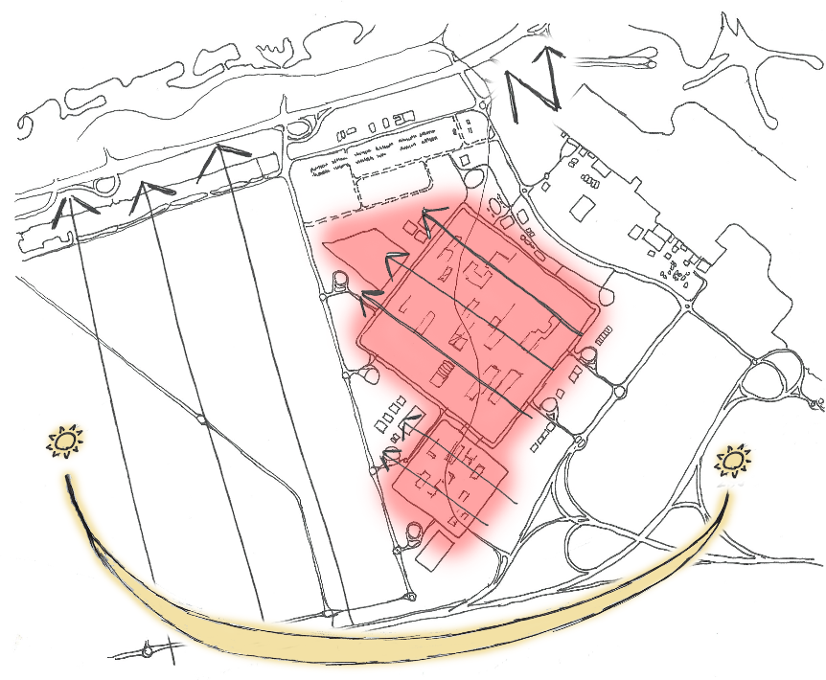
(Author’s Illustration, 2022)
This means that the buildings cast comprehensive shadow in the majority of the public spaces, throughout most of the daylight hours. This rotation also lowers the temperature using the prevailing wind. The plan is positioned in favour of the prevailing wind direction, promoting a substantial breeze through the public spaces. This, in turn means that remarkably, the average temperature of the Masdar City is nearly 15°C cooler than the rest of Abu Dhabi (Khalifa, 2011). This is also helped by the fact that there are no cars permitted within Masdar City, and therefore no emitted hydrocarbons that would otherwise be contributing to a warmer temperature.
Another source, Al Jazeera, co-funded by the Qatari Government, states that there were only around 330 people living in the city by 2011, this included a student population of around 180. This means they needed a large exponential influx of people to reach Masdar’s target population of 40,000 by 2025. Al Jazeera also explain that in order to mitigate the issue of having polluting vehicles within the city, PRT (Personal Rapid Transport) vehicles have been implemented. This means pedestrians leave their vehicles at the edge of the city and get transported within the city using the fleet of driverless electric PRTs (Khalifa ,2011). Upon entry inside the vehicle, a destination is chosen on an interactive display inside. In an interview conducted by Omar Khalifah of Al Jazeera, the director of the Masdar City, Alan Prost, describes the development as a renewable energy initiative. They discuss the existing legacy that C02 emissions have doubled in the United Arab Emirates in the last 30 years. To combat this, one of the main aims of the Masdar City is to reduce energy and water consumption by 40% (Prost, 2011).
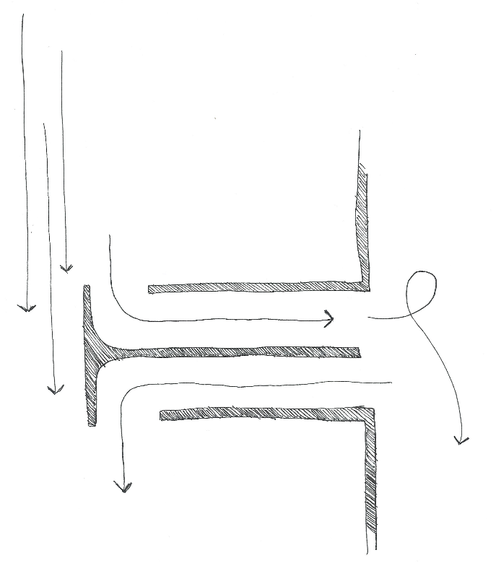
In a second interview conducted by Robert Llewelyn, interviewing Nasar Marzooqui, the Facilities Manager of the Masdar city, they discuss the ‘intelligent’ wind towers. A wind tower is a basic strategy and could be described as a low-tech intervention. A conventional wind tower protrudes above surrounding buildings and collects wind via an orifice at the top. The diagram below illustrated the basic principle of a wind tower.
(Author’s Illustration, 2022)
The wind is directed down the wind tower and used to cool the space below. In the instance of the Masdar City, the wind towers are largely based on the low-tech design, however with high-tech adaptations. The high-tech material used allows a taller structure. The structure it influenced by a triangular shape with three openings facing three different directions at the top of the tower louvres at the top, covering the orifices are remotely controlled to capture the wind from the chosen direction. A water mist is also sprayed at the top to cool the collected air. This, combined with the masterplan being angled in favour of the prevailing wind, according to Christopher Sorensen in a Fully Charged interview, ‘creates a significantly lower temperature compared to downtown Abu Dhabi’ (Sorensen, 2012). Sorensen continues to explain the two experimental methods of utilising the heat energy as a method of cooling buildings. At the time of the Fully Charged interview, there were two different methods of solar energy being compared in practice; concentrated solar power, and Vacuum panels. The concentrated solar power uses a reflective parabola directed at a central pipe with oil running through, directing a concentrated amount of solar heat energy onto the pipe. This system is capable of producing temperatures of over 400°C. The heated oil is stored in large tanks to be used in conjunction with other systems to cool buildings via absorption chillers which act like refrigerators on a larger scale. Polytetrafluorethylene (PTFE) ‘pillows’, on the side of some buildings, are injected with compressed air, acting as insulation from the external heat temperature (Marzooqui, 2012). All of the buildings in phase one of the Masdar City masterplan have photo voltaic Panels on the roof. This is almost enough to provide enough energy to run the buildings. The remaining requirement is supplied via the 22-hectare PV powerplant located on the edge of the Masdar site. This is connected to the main UAE power grid providing enough power for a ‘small city’ (Sorensen, 2012). Masdar acknowledge the extreme temperature, and in response create buildings that perform in such a way that require less reliance on ventilation and cooling strategies. Where energy is needed, it is produced via renewable sources.

Case Study 2: New Gourna Village
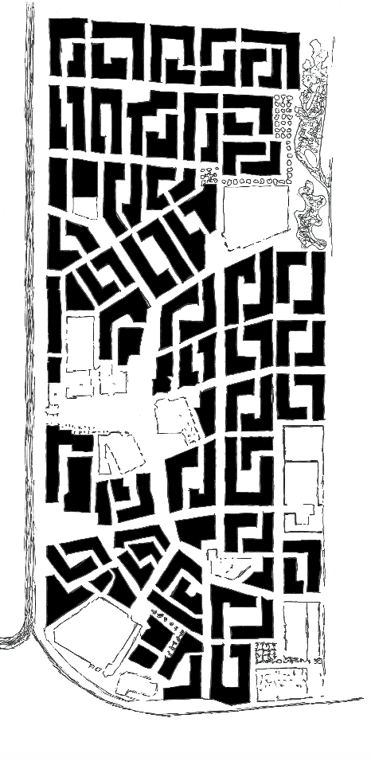
Representing Low-tech, the New Gourna Village was conceived by Egyptian Architect Hassan Fathy, as a new home for the people who had been evacuated from Old Gourna Village. Hassan Fathy, often described as the ‘Architect of the poor’, was born in 1900 and lived to the age of 89. The majority of Fathy’s projects were described as postmodern and vernacular which describes predominantly domestic architecture. In an interview conducted as part of a French documentary entitled ‘It is not Good Enough for God to be With the Poor’, Fathy allegedly described himself as an ‘Arab Architect who [had] lost every point of reference in the Arab society’ he also described that he had ‘lost his arabité’ inferred to mean and said he was searching for an Architecture and an urbanism’ and trying to find his lost arabité’ (Bertini, 2020). The New Gourna village project became known internationally via a book authored by Fathy detailing the story of the Old and New Gourna villages and how the new village was designed to re-house the population of the old village. The publication was entitled ‘Gourna, a tale of two villages’. This was 24 years after the project was completed. The old village resides in the middle of the archaeological sites of the Luxor Necropolis in upper Egypt on the bank of the river Nile. The New Gourna Village is located near Luxor, in Egypt. This project is the most famous of over 170 projects that Hassan Fathy designed. The project was designed and constructed between 1946 and 1952, with a very basic material palette. This was out of necessity due to a very limited resource availability. The aim of this, again experimental project was to use locally sourced materials and to use techniques used in the local area to relocate the people of Old Gourna. Fathy used earthen building materials and construction methods throughout the village. Architectural elements common in the old village, were enclosed courtyards, vaulted ceilings, perforated walls, and utilising thermal massing techniques. Some of these methods are passive techniques, frequently used globally in sustainable building practices currently. The aim of the New Gourna village was not to achieve sustainability, however it utilises a plethora of techniques that suggest that the village could be a model for building sustainably in a hot climate for the future. Below, is a diagram of the plan of the New Gourna Village.
(Author’s Illustration, 2022)
Fathy was however particularly passionate about designing bespoke accommodation for individual members of the local population, while using locally accessible materials, and connecting local needs to an understanding of traditional design, that would be acceptable to residents. All of the houses were therefore unique and individual to the requirements of the resident and their family, and this allowed him to remain truly creative in his endeavours. But when the village was built, the residents refused to move in. This was documented as being due to a complex conflict between villagers and authorities, and villagers not being offered an alternative form of income to previously ‘grave robbing’ and selling artefacts to tourists. Nevertheless, (Steele, 1989) wrote that Fathy’s central focus was ‘to create a culturally and environmentally valid architecture that is sensitive to ethnic and regional traditions’ without forcing his own design on residents for whom his ideals might be irrelevant.
While acknowledging these unprecedented values and circumstances of this time, it is the overall environmental aim that is of particular relevance, and specifically how Fathy dealt with being in an extremely hot climate. The United Nations Educational, Scientific and Cultural Organization (UNESCO) World Heritage Convention highlights New Gourna Village and ‘its extraordinary sensitivity to climatic problems’ (UNESCO, 2015). These are observed as being Fathy’s adherence to the long-term requirements of locally residing villagers, useful local methods of design and construction, and thereby its sustainability. The village was listed by World Heritage in 1979, and in 2009, 30 years later, UNESCO began its safeguarding protection project. UNESCO specifically wished to emphasise Fathy’s holistic respect for the villagers, and his understanding of them as fellow humans, and also of their working use of their dwellings. Fathy knew that using earth as a main building material would be appropriate to local villagers in terms of being accessible and cheap, but also would offer properties of reducing hot temperatures in inside living conditions, utilising the thermal mass properties. If a material has a high thermal mass, this means that it is able to absorb and store heat energy for long periods of time. In practice, thermal mass absorbs the ambient temperate air while being shaded from direct sunlight to help reduce overheating. At night, a building is ventilated to allow excess heat to escape into the cooler night atmosphere. The main intrinsic characteristic of high a material with high thermal mass is that it remains at a constant temperature, either hot or cold, for a long period of time (The New Daily, 2022).

Chapter 5
Discussion
The focus of the dissertation has been to investigate into the different methods and strategies of sustainably building in contexts akin to a prospective globally warmed climate. In response to the title question, climate change can be split into two parts which are cause and effect: the cause relating to issues of sustainability, and the effect being the rising global average temperature. The future built environment will undoubtably have to deal with both intrinsic elements in response to the declared climate emergency (ref…).
The two case studies representing high-tech and low-tech approaches are each located in largely dissimilar contexts. Differing factors include financial capability and allowance, social expectations, and the initial justification and purpose of the concept. There are good reasons to suggest that certain elements and aspects of each case study might not work in the context of the alternative. If each case study is not suited to the other’s context, it is probable that both high-tech and low-tech will either thrive or decline in any wider transferable contextual situations.
Some aspects of each of Masdar City and the New Gourna Village may be a larger detriment than aid to the sustainability of a scheme. An initial goal of Masdar City was to reduce energy and water consumption by 40% (Prost, 2011; Voss, Mussall and O’Donovan, 2013). The New Gourna Village did not need to be a development that aimed to reduce water or energy consumption to the above extent because it did not have the same initial sustainability issues as Masdar City in the first place (Enerdata, 2022). Therefore it is likely that a development akin to Masdar City would not work in this way economically in a setting akin to that of the New Gourna Village. Similarly, this aspect of the rural New Gourna Village model would not work in the setting of Masdar City due to the high energy requirement of the Urban City context. Masdar’s context requires an efficient use of space to the extent that Fathy’s New Gourna Village cannot facilitate. The low-tech nature of the earthen village cannot compete with the space efficiency of the high-tech city development. Earthen materials do not allow large spans or tall structures that would otherwise allow taller buildings. The use of a high-tech material like steel allows for tall structures and multiple floors within buildings, and therefore more living space per unit of area. The Masdar City has a greater land use efficiency than an earthen low-tech development such as the New Gourna Village. In largely populated cities, where site areas are limited, the Masdar model would be more favorable. In contrast to this, the restrictions that come with aiming for energy efficiency do not allow high rise buildings. Therefore, whilst Masdar’s model allows for taller structures (up to six stories), categorized as low rise (Plester, 2019), there is still a compromise when compared to the typical standard practice of a densely populated city whereby high-rise buildings are commonplace. Masdar also utilises taller structures to create shade from the sun, reducing the temperature around the buildings and in the public spaces. The nature of the low-tech materials means that this strategy of shading does not have the potential to be as effective in the New Gourna Village as it is in the Masdar City (Hana, 1999).
Masdar City and high-tech methods in general, notably ‘smart’ buildings, have the ability to adapt to their surroundings. Specifically in Masdar, the wind towers are controlled remotely, whereby louvres on one of three faces can be opened to take advantage of the differing prevailing wind direction. In addition to this, a mist of water is sprayed at the top of the wind tower to cool the warm intake air. A core element of a ‘smart’ building is that in effect, its ‘humanised [intellectual]’ abilities allow buildings to make decisions in favour of aiming towards highly efficient building performance (Cody, 2014). Low-tech methods however, do not allow for adaptability, and therefore could be less efficient. However, certain mechanics and ventilation and cooling strategies of low-tech building methods, are designed to be as efficient and effective as possible. Projects akin to the Tambocounda hospital wing in west Africa, utilizes the natural ‘chimney effect’, which makes use of the prevailing wind direction, and the venturi effect to encourage a draft, which in turn cools the building.
The original intention of Masdar city was to be a forward thinking, sustainable, net zero city which can cope with the hot climate of its residing country, Abu Dhabi. Whereas, the initial aim of the New Gourna Village was to rehouse the population of 7,000 people, moving from the Old Gourna Village (Bertini, 2020). Unlike Masdar city, the aim of the New Gourna Village was not to demonstrate an exemplar for sustainable living. However, the model presents itself as a potential exemplar of how to build sustainably in a temperate climate due to its characteristic properties, especially considering the longevity of the development.
The initial footprint of the New Gourna Village is initially low when compared to the Masdar City. The initial carbon footprint is significantly lower in the New Gourna Village due to the construction methods and materials used, than in Masdar City and its energy demanding processes involved in its construction. The fact that earthen materials can only allow low rise structures, dictates a lower carbon footprint at construction stage (Capriotti and Rowmanowicz, 2013).
Journalists have described the Masdar city as a ‘folly’ and ‘futuristic’, referring to the fact that this experimental sustainable city development has the potential to become a ‘ghost town’ (Goldenberg, 2016). Goldenberg dramatically suggests that Masdar City could become the ‘worlds first green ghost town’. Frederico (2016) supports this notion, in observing that the Masdar City fails somewhat in ….. ***
Watson states in her book ‘lo-TEK design by radical indigenism’, that it is a common misconception that low tech is viewed as inferior to high tech (Watson, 2020). This erroneous belief is perhaps of advocates of high-tech methods. A hospital: the Friendship hospital in Satkhira, rural Bangladesh, a predominantly low-tech building, won the acclaimed (Royal Institute of British Architects) RIBA International Prize 2021 (ArchDaily, 2022). This is a prestigious award that declares, from the perspective of the RIBA, the best new building in the world. This is an indicator that RIBA, a globally known, British Architecture body, recognises low tech architecture; low tech is not disregarded but recognised and celebrated. This is a validation of the worth of low-tech and vindication that high tech is not necessarily superior. Kashef Chowdhury, the principal Architect of his practice URBANA, is a Bangladesh based Architect who managed to beat the competition of world-renowned architects such as David Chipperfield and WilkinsonEyre in the recent bid for the International prize in 2021. Chowdhury was also awarded the acclaimed Aga Khan award for the hospital in 2016 (akdn, 2022).
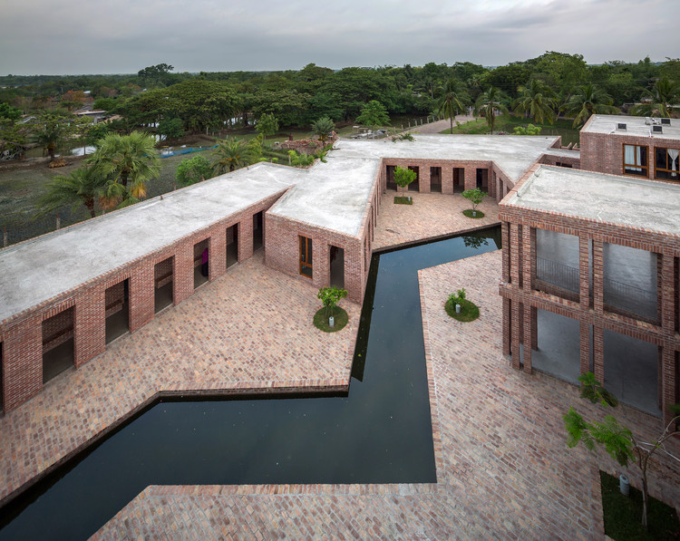
A central feature of the New Gourna Village is that the method of ventilation, also used in other low-tech architectural schemes, which is cross ventilation, requires a narrow plan. Natural ventilation, namely cross ventilation, does not require energy. This means buildings in low-tech schemes must be broken up into smaller sections than high tech methods allow, which is a possible limitation. This does however, create the opportunity and potential for an adroit, interesting architectural experience. An example of this is the aforementioned Friendship Hospital by Kashef Chowdhury depicted above.
(ArchDaily, 2022)
When assessing if an idea works, it must be deconstructed into its constituent parts. While the ultimate aim is to build sustainably in a hot climate, some might argue the architecture must also function how architecture is meant to; an intrinsic element of a designed piece of architecture is to ‘provoke, an emotion or connection, or influence a memorable experience’ (Eyre, 2017). Jim Eyre of the acclaimed WilkinsonEyre architects stated in a short documentary video on the WilkinsonEyre website, that architecture is ‘an art form’ which suggests interesting intuitive design that ensures an enjoyable experience (WilkinsonEyre, 2022). Some people may argue stereotypically that typical low-tech architecture can be uninspiring and plainly serves a basic purpose. This could apply to Fathy’s New Gourna Village, as some people might take the view that Fathy’s New Gourna Village is only functional and not architecturally inspiring (Pyla, 2009). However, Hassan Fathy writes that Egypt does not have an ‘indigenous style’ and ‘the houses of rich and poor alike are without character, without an Egyptian accent (Fathy, 2010; Bertini, 2020). This clearly informed his distinct style that he intentionally used to overcome his belief that Egypt did in fact lack an ‘indigenous style’. Perhaps Fathy was creating a distinct design at an attempt to give Egypt an architectural identity that he felt was missing. This suggests that Fathy’s village is in fact architecturally rousing (Steel, 1988).
The New Gourna Village is potentially highly transferrable to less temperate climates when the less temperate climates like the United Kingdom reach a certain higher average temperature. The low-tech village model could potentially replace typical developments like housing estates where the requirements do not exceed those of low-tech strategies. Masdar City, as a whole entity, is also potentially highly transferrable. The high-tech city development has its own amenities, its own transport system, and its own renewable and sustainable energy production. Therefore, in theory, the city has the potential to work in any context with its own economy. However, social expectations and financial capabilities are potential restrictions. The Masdar City model would have a huge cost for governments or organisations looking to instate the design elsewhere.
The Masdar city is not exclusively high-tech. Along with a plethora of high-tech strategies, the development uses basic low-tech methods in order to reduce the energy needed for cooling strategies. The city makes use of the tall buildings being close together to create shadow and therefore shade from the sun. The plan of the whole development is rotated 45° to the north–south plane in favor of the prevailing wind direction, and to create the most shadow, from the sun throughout the day, as possible. The wind towers in Masdar are also a high-tech interpretation of a typically low-tech intervention. This proves that high tech and low tech can work in conjunction with each other. This suggests that both approaches can be intertwined to create a hybrid entity to suit a specific situation. Certain contexts have differing requirements that would all be fulfilled by differing, aspects from high-tech and low-tech separately. Perhaps these different methods can work in favor of one another to achieve an ultimate hybrid model, and this become a precedent, open to adaptation, of how to build in a globally warmed climate in a sustainable way.

Chapter 6
Conclusion
An assessment of two central exemplar case studies representing high-tech and low-tech respectively, has shown intriguing results, and these have dictated the direction of the dissertation research. At the outset of the dissertation, I laid out the following three research questions, which distinguished aspects of the dissertation title in logical order. These are listed as follows:
- To what extent does architecture and the built environment contribute to climate change?
- How can high tech methods and low-tech methods aid the current and future built environment in being more sustainable and dealing with the rising global temperature?
- What is the greater outcome of these two approaches for assisting the built environment to become more sustainable and dealing with the rising global temperature?

Addressing these throughout has led to succinct and clear answers which are stated below.
- To what extent does architecture and the built environment contribute to climate change?
This question queries the impact that both common construction methods and the way that buildings are serviced have on global warming. The built environment sector, as a whole, accounts for almost 40% of annual Greenhouse gas emissions (Taylor, 2021). Many building and construction processes have a large associated carbon footprint, and many functions of the use of buildings are largely carbon emitting when in operation. Also in some instances, carbon footprint calculations are inaccurate by default due to carbon offshoring whereby materials are sourced overseas, thus associated carbon emission calculations are excluded. High-tech and low-tech are two approaches that have the potential to allow for a sustainable future built environment.
- How can high tech methods and low-tech methods aid the current and future built environment in being more sustainable and dealing with the rising global temperature?
Whilst high-tech methods allow flexibility within the design of certain elements to create ultimate efficiency, it has a high initial carbon cost. The alternative low-tech approach does not have nearly as big an initial carbon footprint, and therefore does not have to work nearly as hard at off setting its initial carbon emissions. However the energy consumption used in the operation of Masdar city relies on its own renewable energy sources. High tech materials like steel can allow larger and more ambitious structures than low-tech, however this has an increased carbon cost that low-tech does not incur. Both methods have differing techniques that work in their favour depending on the context of where these separate approaches are implemented.
- What is the greater outcome of these two approaches for assisting the built environment to become more sustainable and dealing with the rising global temperature?
Different geographical contexts have different requirements from each of high-tech and low-tech approaches. Low-tech is initially less detrimental to the environment and therefore should be seriously considered for implementation. Where low-tech methods alone do not prove to be sufficient, high-tech methods should be added to work in conjunction. High-tech may not be a standalone method as it may use too much energy without being able to offset its initial carbon footprint within an appropriate time frame without implementing some low-tech methods. Strategies from each approach can potentially combine to create a hybrid high-tech and low-tech model that can be adapted to work in conjunction to facilitate the requirements of varying contexts. For example a typical low-tech wind tower has been adapted to high-tech where mechanisms are added and controlled remotely to improve the performance of the low tech system.

According to the research answers, and the emerging findings of the dissertation, I would make the following recommendations for academic research, and for policy and practice. More research is arguably needed in combining high-tech and low-tech method. A research project into a large-scale experimental city development akin to Masdar that balances the implementation of the two methods, is needed. The primary focus would ideally be on the requirements of the surroundings, rather than focusing on the method itself. An implementation of Government policy to limit carbon offshoring would limit the carbon cost of overseas transport and strengthen the existing legislation to have an emphasis on subsidising projects that provide research and insight into developments that focus on building sustainably and dealing with a globally warmed climate akin to that of the near future.

Bibliography: Published Works
Ahmed, V., Opoku, A. and Aziz, Z., 2016. ‘Research methodology in the built environment: a selection of case studies’, London: Routledge.
Alexander, K. and Cafiero, G., 2020. ‘How will the UAE cope with growing environmental insecurity?’ https://www.fairobserver.com [Accessed February 2022].
Amiti, G., 2016. High technology versus low technology. https://www.academia.edu/15301496/High_technology_versus_low_technology_Building?pop_sutd=false [Accessed December 2021]
Bertini, V., 2020. https://www.architectural-review.com/essays/reputations/hassan-fathy-1900-1989
British Government, 2013. Infrastructure 2025 Industrial Strategy: government and industry in partnership (publishing.service.gov.uk) British Government, [Accessed January 2022].
Cody, B., 2014, The Role of Technology in Sustainable Architecture. artikel_cody.pdf (cloud-cuckoo.net) , [Accessed February 2022]
Borwankar, V. 2021 https://timesofindia.indiatimes.com The Times of India, [accessed February 2022].
Capriotti, F. and Rowmanowicz, J., 2013. 'Thermal eco-cities: Green building and urban thermal metabolism', International journal of urban and regional research, 37(6) pp. 1949 - 1967.
Fathy, H., 2010. ‘Architecture for the poor an experiment in rural Egypt’, Chicago: University of Chicago Press.
Frederico, C., 2016. ‘Urban eco-modernisation and the policy context of new eco-city projects: Where Masdar City fails and why’, Urban Studies, 53(11) pp. 2417 – 2433.
Giusti, L. and Almoosawi, M., 2017. 'Impact of building characteristics and occupants', behaviour on the electricity consumption in Abu Dhabi (UAE)' Energy and Buildings, 151 pp. 534 - 547.
Goldenberg, S. 2016 Masdar's zero-carbon dream could become world’s first green ghost town | Greenhouse gas emissions | The Guardian
Gourley, P., 2020. Carbon offshoring 'hides true UK greenhouse emissions', says report | The Scotsman
Hana, T., 1999. ‘Architecture in fact and fiction: The case of the New Gourna Village in upper Egypt’, in Muqarnas: ‘An annual on the visual culture of the Islamic world’, XVI, pp. 169 – 178.
Mark, L., 2014. 'Video: Drone footage of Foster's Masdar City', The Architect's Journal, April.
Masud, M., Al-Amin, A., Akhtar, R., Kari, F., Afroz, R., Rahman, S. and Rahman, M., 2015. ‘Valuing climate protection by offsetting carbon emissions: rethinking environmental governance’, Journal of Cleaner Production, 89, pp. 41 – 49.
Plester, J. 2019. Weatherwatch: glass skyscrapers are worst energy offenders | Energy efficiency | The Guardian The Guardian, Accessed February 2022
Pyla, P., 2009. ‘The many lives of New Gourna: alternative histories of a model community and their current significance’, The Journal of Architecture, 14(6) pp. 715 – 730.
Richie, H and Rosser, M. (2021) Future greenhouse gas emissions - Our World in Data University of Oxford
Sauven, J., Offshoring our carbon problem | John Sauven | The Guardian
Scott, M., Shipping Sector Comes Under Increasing Pressure To Cut Its Carbon Footprint (forbes.com)
Steel, J., 1988. ‘Hassan Fathy: Architectural monographs’, London: Academy Editions.
Taylor, R., Now Is the Time to Reinvest in Local Materials (gensler.com)
The National, 2020. https://www.thenationalnews.com/uae/environment/concerns-for-uae-following-lack-of-regional-rainfall-1.54652
United Nations, 2022. The Paris Agreement | United Nations
Voss, K., Mussal, E. and O’Donovan, J., 2013. ‘Net zero energy buildings: international projects of carbon neutrality’, Munich: Detail Green Books.
Wainwright, O., 2022. World’s best building award won by rainwater-harvesting hospital in rural Bangladesh | Architecture | The Guardian [accessed January 2022].

Bibliography: Un-published Works
akdn.org/architecture, 2022. [Accessed January 2022].
ArchDaily, 2021 "Friendship Hospital Satkhira / Kashef Chowdhury/URBANA" 07 Jan 2021. ArchDaily. Accessed 20 Mar 2022. https://www.archdaily.com/926305/friendship-hospital-satkhira-kashef-chowdhury-urbana ISSN 0719-8884 [Accessed January 2022].
Camden council website, 2022. What is the Climate Crisis? - Camden Council [Accessed January 2022].
Enerdata, 2020. https://www.enerdata.net/estore/energy-market/egypt/ [Accessed January 2022].
Foster and Partners, 2022. www.fosterandpartners.com [Accessed January 2022].
Khalifa, O., 2011. https://www.youtube.com/watch?v=ILlF34KJMJw [Accessed January 2022].
Llewellyn, R., https://www.youtube.com/watch?v=G4ohXTnIxzA [Accessed December 2021].
Llewellyn, R., 2022. (120) Masdar: The City of the Future | Fully Charged - YouTube [Accessed December 2021].
Net zero climate, University of Oxford, 2020 https://netzeroclimate.org/what-is-net-zero/ [Accessed January 2022].
Masdar, 2014. https://www.youtube.com/watch?v=Llzq9YMsPP8 [Accessed December 2021].
Mole Architects website Mole Architects | Marmalade Lane - Mole Architects [Accessed January 2022].
Our World in data – Oxford Uni - Future greenhouse gas emissions - Our World in Data [Accessed January 2022].
Prost, A., 2011. https://www.youtube.com/watch?v=ILlF34KJMJw [Accessed December 2021].
Sorensen, C., 2012, (120) Masdar: The City of the Future | Fully Charged - YouTube [Accessed January 2022].
The New Daily, 2022 https://thenewdaily.com.au/life/home/2017/03/11/cool-house-without-air-conditioning/ [Accessed January 2022].
Time and Date, 2015. Climate & Weather Averages in Luxor, Egypt (timeanddate.com) [Accessed January 2022].
UNESCO, 2015, https://whc.unesco.org/en/activities/637/ [Accessed January 2022].
Wilkinson, R. and Hodges, W. (2021) Materials – unavailability and increasing costs: what is the contractual position? Hill Dickinson (Private International Law Company) [Accessed January 2022].
wilkinsoneyre.com, 2022 [Accessed January 2022].

