

Module name: Introduction To Independent Research Skills
Module code: BMHP5019
Lecturer Name: Bianca Sanfilippo.

Student name: Tania Habib
Student ID: 2336623
Submission Date: 18-04-2026

Word count: 3709

Acknowledgement: I have not used AI to complete this assignment only but Microsoft word’s spelling and grammar checking option.
Table of Contents

Abstract 4
1. Introduction 5
1.1 Definition of Key Concepts 5
1.2 Rationale of the Research 5
1.3 Review Question 5
1.4 Objectives 6
2. Background 6
2.1 NHS Workforce Context (UK) 6
2.2 Policy and Healthcare System Context 6
2.3 Impact on Health Services 7
3. Methods 7
3.1 Research Design 7
3.2 Data Collection 7
3.3 Inclusion Criteria 8
3.4 Exclusion Criteria 8
3.5 Data Analysis 9
3.6 Ethical Considerations 9
4. Results 9
4.1 Overview of Selected Studies 9
4.2 Thematic Analysis (Main Findings) 10
Theme 1: Staffing Levels and Patient Mortality 10
Theme 2: Missed Care and Patient Safety 10
Theme 3: Workforce Shortages and Service Access 11
Theme 4: Staff Burnout and Quality of Care 12
Theme 5: Use of Temporary Staff (Locum Impact) 13
5. Discussion 13
5.1 Interpretation of Findings 13
5.2 Comparison with Existing Literature 14
5.3 Implications for Health and Social Care 15
5.4 Limitations of the Study 15
6. Conclusion and Recommendations 16
6.1 Summary of Key Findings 16
6.2 Recommendations for Policy and Practice 16
6.3 Recommendations for Future Research 17
References 18

Abstract
This research report focuses on analysing the effects of NHS staffing deficiencies on patient care quality in England. The research is concerned with the influence of workforce insufficiency on mortality, safety, access, and care outcomes. The review of the peer-reviewed studies was conducted in a scoping mode. Data were located through databases, such as PubMed, Google Scholar, and ProQuest. The results indicate that understaffing positively correlates with patient death and decreased safety in the medical context. Lack of adequate care and a delay in medical care were frequent when personnel were understaffed. Lack of workforce also added to the waiting time and shortage of access to health care services. Burnout among the staff also lowered the performance and the overall care quality within the NHS. Another aspect of working with temporary staff that the study reveals is that it has an impact on the continuity and coordination of care. These results indicate that the workforce planning and retention processes should be enhanced. The report suggests that more workforce and better staff support should be made to enhance the quality of care. Further studies should employ more data and test long-term solutions for the workforce.

1. Introduction

1.1 Definition of Key Concepts
NHS workforce shortage is a term that is used to describe the deficit of healthcare workers in the services in England. The shortages may be nurses, physicians and support staff at most care facilities. The quality of patient care explains the overall degree to which patient services are effective in satisfying the patient. Safety, effectiveness, and positive patient experiences are achieved through high-quality care in all services. Patient safety is defined as the prevention of the occurrence of harm in the provision of healthcare services and treatment. Safe care minimises errors, complications and avoidable deaths in healthcare systems. Healthcare outcomes are defined as outcomes of care, such as the level of recovery and well-being of patients. The improved results indicate good treatment and good overall healthcare service performance. Patient outcomes and safety are closely associated with the level of nurse staffing (Dall'Ora et al., 2022).

1.2 Rationale of the Research
In recent years, the workforce crisis in the NHS has become one of the most significant issues. The growing patient demand has contributed to a very high pressure on the available resources of the healthcare staff. Service demand remains at an increasing rate, and employee supply is having a hard time keeping up. The shortage of the workforce has led to disequilibrium between service demand and supply in healthcare workers. This disproportion influences the quality of service, efficiency, and patient care outcomes in any setting. The problem of staff shortage has been associated with increased mortality of patients and safety hazards. It has been demonstrated that the reduced staffing leads to higher mortality rates in the hospitals of England (Rubbo et al., 2023). Lack of workforce also causes omission of care and late treatment to patients. Lapsed care decreases patient satisfaction and deteriorates healthcare service efficiency to a great extent. Retention problems and staff burnout are also factors contributing to the NHS workforce crisis (Ratwatte, 2023).

1.3 Review Question
How does staffing shortage within the National Health Service (NHS) affect patient care in the United Kingdom?
The research question used in conducting this review is well-defined and aims at workforce impact. The research question is: What is the impact of staffing shortages on the quality of patient care in the NHS? This question assists of investigating the interconnection between the work force size and the healthcare consequence in practice. It also promotes the knowledge of security, accessibility, and quality in medical care.

1.4 Objectives
- To understand the impacts of NHS workforce deficits on the quality of care.
- To identify the outcome of service worker shortages on patient safety consequence.
- To examine the impact of workforce shortages on healthcare service provision.
- To assess staffing shortages and patient mortality in the literature.

2. Background

2.1 NHS Workforce Context (UK)
The NHS workforce is already experiencing severe shortages in numerous healthcare services. Evidence of shortages occurs in the system amongst nurses, doctors, and general practitioners. Increased patient demand has exerted strain on already scarce healthcare staff resources. The ageing of the workforce has diminished the number of experienced employees in most of the NHS organisations in the current times. The number of older employees who are quitting their jobs is outpacing the number of new employees joining the system. The stress and poor working conditions have also contributed to the problem of retention. Employee burnout has become one of the biggest problems concerning the stability of the working force and service delivery. It has been revealed that retention issues contribute to aggravation of workforce challenges in NHS contexts (Lock and Carrieri, 2022). The level of short staffing is found to increase the workload and decrease the quality of care. The problem of workforce shortage has been struggling both in hospital and primary care services in England.

2.2 Policy and Healthcare System Context
NHS staffing policies are meant to provide effective and safe healthcare delivery. Safe staffing practice is concerned with ensuring that a sufficient number of staff are available to work with the patients. Such policies promote quality care and decrease the risk of a lack of staff. Nevertheless, safe staffing policies are still inconsistent in most NHS environments. There are workforce planning challenges that have led to the mismatch of demand and supply gaps of staff. Along with failure in planning, there is a tendency to a permanent shortage of staffing in the healthcare service. A rapid surge in patient demand has been an issue that policy responses have failed to cope with. It is noted that the policies on staffing are necessitating improvement in planning and heightened strategies of implementing the policies (Ball, 2020). The labour force planning should take into consideration future demand, training, and retention planning. The issue of a shortage of staff will persist in healthcare service performance without proper planning.

2.3 Impact on Health Services
The issue of staff limitation has generated delays in the treatment and service delivery in healthcare facilities. Patients are made to wait longer periods before being attended to and getting the much-needed medical attention. The waiting time also adds to patient satisfaction and the experience of healthcare services. Staffing is also low, which decreases the time spent with each patient. Shortened time impacts communication, standard of care, and patient protection throughout the services. Lack of adequate staffing of the healthcare environments has led to increased missed care. Missed care comprises late care, unfinished care, and less monitoring of the patients. Research indicates that institutional understaffing leads to additional missed care and safety (Griffiths et al., 2018b). Another impact of workforce shortages is on emergency departments and pressure on healthcare systems. As it has been demonstrated, the level of staffing is associated with the quality of care in the emergency department (Drennan et al., 2024). All in all, the shortage of staff is still causing the decline of the quality of care and efficiency of services performed in the NHS.

3. Methods

3.1 Research Design
The paper employed a scoping review to investigate the literature about staffing shortages. A scoping review assists in mapping the evidence, as well as the essential themes in the studies. The method is appropriate when one wants to investigate the general aspects of healthcare and intricate systems. It enables the results of various reports to be summed up and the information gaps to be found. There is an indication that scoping reviews can be applied in fields of healthcare research (Peters et al., 2020). The design assists in grasping the problem of workforce insufficiency and their effect on the quality of care.

3.2 Data Collection
Structured searches through four selected academic databases helped in getting relevant studies. The databases were PubMed, Google Scholar, ProQuest, and UWTSD Library. These databases offer accessibility to trustworthy and peer-reviewed scholarly articles. Keywords were staffing shortage in the NHS, quality of patient care, and workforce implications. Search results were enhanced with the assistance of Boolean operators to make them more relevant. The criteria used in the selection took a systematic course depending on PRISMA guidelines.
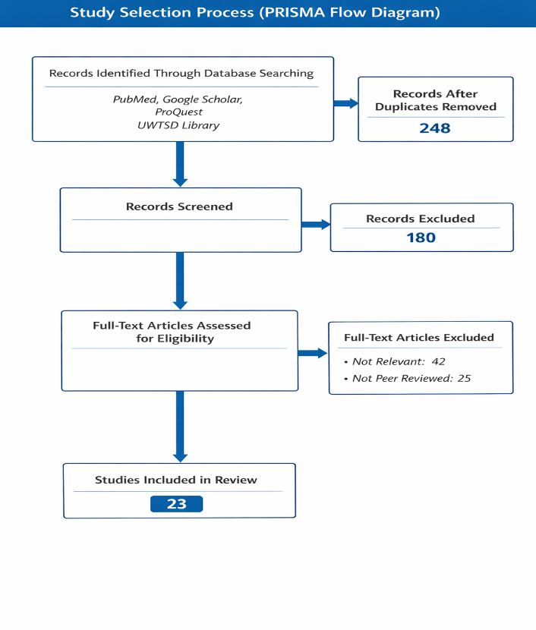
Figure 1: PRISMA Flow Diagram (Study Selection Process)
Source: Adapted from Page et al. (2021)

The PRISMA model facilitates transparent reporting in the identification and screening of studies. The use of updated guidelines enhances the transparency and quality of systematic reviews reporting (Page et al., 2021).

3.3 Inclusion Criteria
Articles were identified using clear inclusion criteria that were relevant to the research. Peer-reviewed journal articles were used to select only quality and reliable articles. Relevant studies were chosen related to the United Kingdom healthcare system. Studies that involved the aspects of staffing gaps and patient health care outcomes were found.

3.4 Exclusion Criteria
Only peer-reviewed sources have been used to ensure credibility and academic standards. Analysis did not entail editorial articles, opinion papers, and reports. The research that was not connected with the issue of staffing shortages or care was eliminated. This was to make sure that the chosen studies appealed to the research goals and questions.

3.5 Data Analysis
The thematic analysis method was implemented to examine the data of the selected learning. The approach assists in the recognition of patterns and universal themes within the findings of the research. Data were grouped under sensible categories through a coding process. The methodology helps to synthesise and interpret research results effectively. The thematic synthesis is best done with methodological guidance during scoping reviews to make it much clearer (Tricco et al., 2018).

3.6 Ethical Considerations
The current research relied on secondary data based on published scholarly studies that did not involve human subjects. No personal and sensitive information was gathered during the research. The sources became well-referenced to ensure academic integrity and prevent any plagiarism. The study was conducted according to ethical standards of research.

4. Results

4.1 Overview of Selected Studies
The section provides the outcome of five chosen peer-reviewed articles on staffing shortages. The studies analysed the interconnection between the service provider levels and patient care after-effect in England. Both studies made use of either a quantitative or mixed-method analysis of large healthcare datasets. The chosen articles concentrated on hospitals and primary care treatment in the NHS. The results were consistent and indicated that physician understaffing influences patient safety and quality of service.
Table 1: Summary of Selected Studies
Study | Aim | Method | Location | Key Findings
Dall’Ora et al. (2022) | Examine staffing and patient outcomes | Systematic review | UK | Low staffing linked to poor outcomes
Rubbo et al. (2023) | Analyse staffing and mortality | Panel study | England | Lower staffing increases mortality
Zaranko et al. (2022) | Study nurse staffing and deaths | Longitudinal study | England | Higher staffing improves survival
Senek et al. (2022) | Explore missed care due to understaffing | Cross sectional | UK | Understaffing increases missed care
Parisi et al. (2024) | Assess GP supply and demand | Retrospective study | England | GP shortages increase waiting times
Source: Compiled from Dall’Ora et al. (2022); Rubbo et al. (2023); Zaranko et al. (2022); Senek et al. (2022); Parisi et al. (2024)

4.2 Thematic Analysis (Main Findings)

Theme 1: Staffing Levels and Patient Mortality
The initial theme demonstrates a close correlation between staffing and mortality in patients. Reduced nurse staffing is linked to increased mortality in hospitals in the NHS context. High staffing rates enhance patient survival and minimise the chances of complications in care. Research shows that sufficient staffing leads to better monitoring and prompt treatment of the patients. Inadequate personnel decrease the capacity to react speedily to patient demands and emergencies. It has been proven that understaffing is a serious risk factor that induces mortality in hospitals (Rubbo et al., 2023). Other studies also affirm the same that an increase in nurse staffing enhances patient outcomes and safety. In general, the volume of staffing is one of the determinants of patient survival and quality of healthcare.
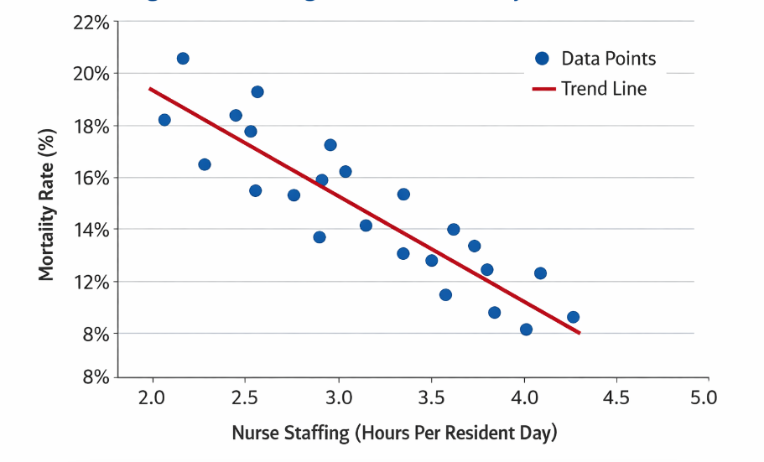
Figure 2: Staffing Levels vs Mortality Rates
Source: Adapted from Rubbo et al. (2023)

Theme 2: Missed Care and Patient Safety
The second concept is in the sphere of missed service and its effects on patient safeguard outcomes. Understaffing is a frequent cause of slow care, incomplete care, and decreased monitoring of the patient. Missed care comprises the inability to administer medication and other needed patient assistance in time. Such problems add to the medical errors and decrease the quality of healthcare services. It has been researched that understaffing contributes to an enhance in the standard of missed care activities (Senek et al., 2022).
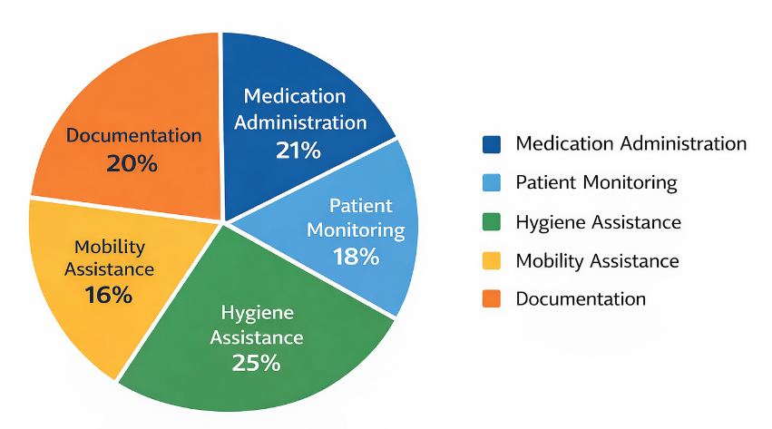
Figure 3: Types of Missed Care Due to Understaffing
Source: Adapted from Senek et al. (2022)

Theme 3: Workforce Shortages and Service Access
The third theme is the impact of the shortages of the workforce on access to healthcare services. The problem of a shortage of general practitioners has raised the number of patients who have to wait to take appointment by far. Patients have to contend with delays in access to primary care and medical services. Lack of access results in dissatisfaction and overstraining emergency healthcare services. It has been demonstrated that shortages of GPs lower service delivery and create a strain in demand (Parisi et al., 2024).
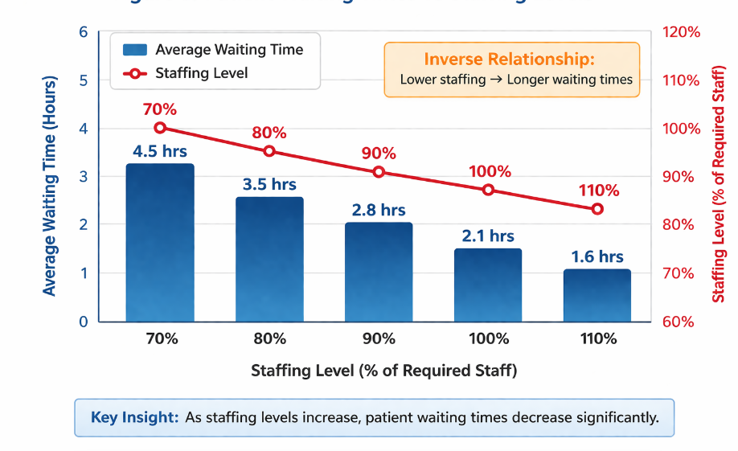
Figure 4: Patient Waiting Times vs Staffing Levels
Source: Adapted from Parisi et al. (2024)

Theme 4: Staff Burnout and Quality of Care
The fourth theme is the correlation between staff burnout and quality of care. Stress and huge workloads are some of the factors that contribute to burnout among healthcare professionals. Burnout decreases the performance of the staff and impacts the quality of healthcare provision in healthcare institutions. Stressed employees are likely to commit mistakes in the provision of care. Burnout has been found to have a deleterious effect on patient safety and service outcomes (Li et al., 2024).
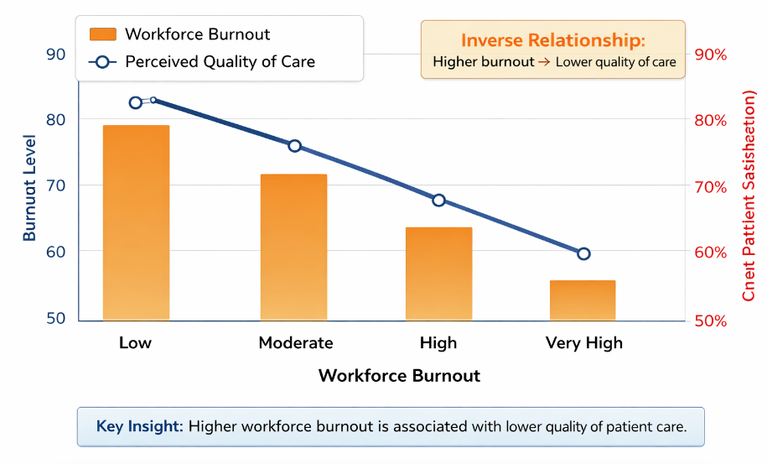
Figure 5: Burnout vs Quality of Care Relationship
Source: Adapted from Li et al. (2024)

Theme 5: Use of Temporary Staff (Locum Impact)
The last theme is on the temporary employees who are brought in to cope with the shortcomings of the workforce. The gaps created by the shortage of permanent staff are usually filled with locum staff. Although temporary employees ensure continuity, they may impact the continuity of care. The unfamiliarity with the systems can diminish the efficiency and cause higher safety risks. The temporary workers are also likely to experience communication and team-related issues in medical institutions. It has been proven that the utilisation of locum doctors might influence the quality of service and its safety consequences (Grigoroglou et al., 2023). Repeated hiring of temporary employees can decrease the consistency in patient care provision. All in all, the use of locum employees indicates a deeper workforce deficit in the NHS system.
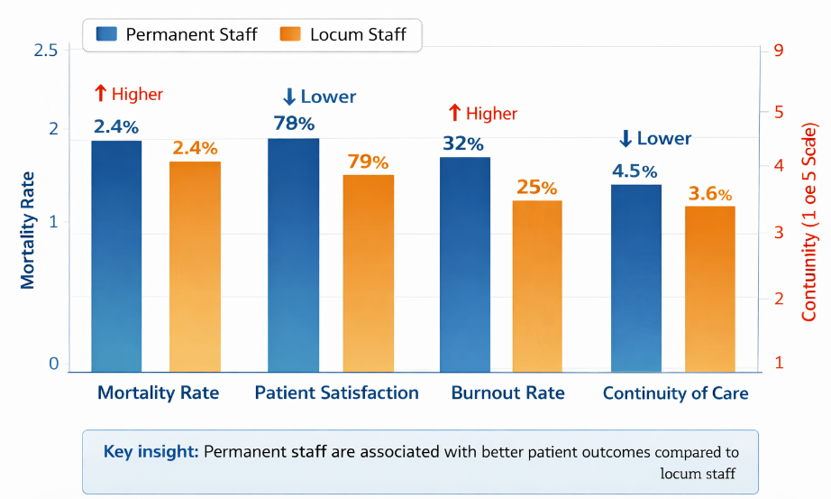
Figure 6: Permanent vs Locum Staff Outcomes Comparison
Source: Adapted from Grigoroglou et al. (2023)

5. Discussion

5.1 Interpretation of Findings
The results indicate that nursing shortages have a significant impact on patient care in the NHS. Poor staffing levels predispose patients to mortality and decrease safety in healthcare facilities. This responds directly to the review question of how shortages have an impact on patient care outcomes. Poor staffing decreases monitoring and response time to the needs and emergencies of patients. It has been proven that insufficient staffing results in missed care more frequently (Griffiths et al., 2018b). Delayed care impairs patient safety and leads to risks of complications and adverse outcomes. Labour shortages also decrease access to services, particularly in a primary care environment. There is a shortage of GPs, which leads to more waiting time and less effective treatment of most patients. It is also evidenced that the staffing shortages put strain on the hospital services and emergency departments. Healthcare staff burnout increases the quality and patient safety outcomes even more. Lack of sufficient working hours and pressure negatively affect staff performance and predispose them to mistakes. It is known that burnout is closely connected to low-quality care and dissatisfaction of patients (Li et al., 2024). Temporary employees assist in sustaining the services at the expense of continuity and coordination. Insufficient knowledge about systems may lead to safety hazards and poor care delivery. In general, the results prove that the shortage of staff directly and indirectly influences the standard of care provided to the patients.

5.2 Comparison with Existing Literature
The results are in line with the broader research on staffing and patient care outcomes. Past research evidences that increased staffing of nurses is better connected with patient survival and safety. The evidence confirms that low staffing is linked to increased mortality rates in the hospitals (Griffiths et al., 2020a). It substantiates the data of the chosen works reporting the correlation between the level of staffing and the outcome of mortality. It is also noted by research that insufficient staffing results in service failure and low quality of services. Research indicates that the gap in the nurturing when the staffing level is limited (Recio-Saucedo et al., 2017). Supplier literature also indicates a hypothesis that staffing shortages influence workforce retention and the sustainability of long-term service. Poor working conditions and high rates of workload are usually associated with retention issues. Through some studies, staffing models can also be used flexibly to cope with shortages. It has been shown that the efficiency of healthcare facilities can be enhanced by means of adaptive staffing strategies (Griffiths et al., 2021). Nevertheless, the use of temporary personnel is still an issue related to patient protection and standard of care. The studies demonstrate that locum employee use may influence the quality and continuity (Ferguson et al., 2024). Other researchers also point out that workforce shortage influences patient satisfaction and service experience (Aiken et al., 2021). Altogether, the results are consistent with the majority of available literature but portray current challenges in the workforce.
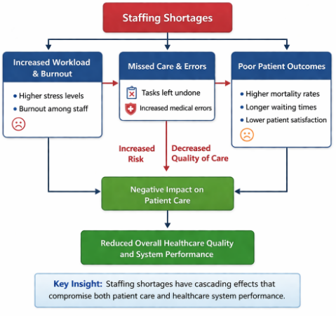
Figure 7: Synthesis Model of Staffing Shortages Impact
Source: Developed by the author based on Dall’Ora et al. (2022)

5.3 Implications for Health and Social Care
The implications of the findings on the health and social care practise in the UK are important. The problem of staffing shortages leads to an augmented threat to patient safety and decreased care provision. Amplified death, lack of care, and postponements give rise to critical issues among healthcare services. Patient satisfaction with healthcare services also suffers due to workforce shortages. Long queues and accessibility problems diminish the confidence in healthcare systems to a great degree. Retention and burnout problems of staff also endanger long-term workforce sustainability. It has been proven that one of the primary factors contributing to the shortage of workforce in the NHS is the retention issues (Ratwatte, 2023). The lack of workforce also puts a strain on finances, as it has to do with the temporary employees. To solve the workforce issues, there is a need for better planning, recruitment, and retention measures. The staff's well-being is a concern in healthcare systems in an attempt to ensure the safety and quality of services.

5.4 Limitations of the Study
Several limitations may limit the findings of this study. The literature studied was also very few and this could have an impact on generalisability. The limited number of studies might not reflect the entire situation of the shortages of staff. The leverage of secondary data restricts control over the data quality and research design. Dissimilarity in study procedures can have an impact on consistency and comparability of results. The implication of the UK-based studies is limited to other healthcare systems across the world. Nevertheless, the emphasis makes it more relevant to the NHS policy and practise background. The limitations notwithstanding, the study offers practical information on the shortage of staff and patient care.
Table 2: Strengths and Limitations of the Study
Strengths | Limitations
Focus on the UK healthcare context. | Limited number of studies
Use of peer-reviewed research | Use of secondary data
Thematic analysis approach | The UK only focuses.
Clear research question | Limited generalisability
Source: Developed by the author

6. Conclusion and Recommendations

6.1 Summary of Key Findings
This study has investigated the impact of NHS staffing shortages on patient care in the different services. The results of the studies indicate that the problems of low staffing contribute to higher patient mortality in hospitals. Understaffing also compromises patient safety and risk in the course of care provision. Delays and neglect of care are more frequent when the staff is under pressure. Shortages in the workforce also decrease the demand for healthcare services and escalate the waiting periods. The lack of general practitioners will interfere with the ability to provide the necessary care promptly. The problem of staff burnout has been a significant concern for the stability of the workforce and quality of care. The workload and stress levels decrease the performance of the staff and contribute to the rise of the risks of clinical errors. It has been proven that staffing shortages have adverse impacts on patients and the standard of healthcare delivery (Dall'Ora et al., 2022). In general, the problem of staffing shortages poses severe problems to patients and healthcare systems.

6.2 Recommendations for Policy and Practice
The first policy is to drive investment in the workforce in the NHS healthcare services. More funding is possible in order to provide recruitment, training and capacity building of the healthcare staff. The second suggestion aims at enhancing retention plans among the current healthcare professionals. Burnout and low job satisfaction may be minimised with improved work conditions and support. The workload, stress, and career development opportunities should be tackled with the help of the retention strategies. The third suggestion is to minimise the utilisation of temporary employees in care institutions. Continuity and consistency in patient care delivery are influenced by the excessive use of locum staff. The fourth proposal is to improve workforce planning within the healthcare services in England. Planning must keep in mind the demand in the future, the training requirements and staff retention policies.

6.3 Recommendations for Future Research
Additional studies must imply bigger number of observations to increase the reliability and generalisability of the results. Long-term impacts of staffing shortage require longitudinal research to study. The cross-country comparisons may offer learning on various processes and systems of health care and strategies in the workforce. Such methods will be helpful in the creation of efficient ways to address staffing deficiencies in the international system.

References
Aiken, L.H., Sloane, D.M., Ball, J., Bruyneel, L., Rafferty, A.M. and Griffiths, P. (2021) ‘Patient satisfaction with hospital care and nurses in England: an observational study’, BMJ Open, 8(1). doi:10.1136/bmjopen-2017-019189.
Ball, J. (2020) ‘Analysing the implementation and effects of safe staffing policies in acute hospitals’, Nursing Management, 27(3). doi:10.7748/nm.2020.e1904.
Dall’Ora, C., Saville, C., Rubbo, B., Turner, L., Jones, J. and Griffiths, P. (2022) ‘Nurse staffing levels and patient outcomes: a systematic review of longitudinal studies’, International Journal of Nursing Studies, 134, 104311. doi:10.1016/j.ijnurstu.2022.104311.
Drennan, J., Murphy, A., McCarthy, V.J.C., Ball, J., Duffield, C., Crouch, R., Kelly, G., Loughnane, C., Hegarty, J., Brady, N., Scott, A. and Griffiths, P. (2024) ‘The association between nurse staffing and quality of care in emergency departments: a systematic review’, International Journal of Nursing Studies, 153, 104706. doi:10.1016/j.ijnurstu.2024.104706.
Ferguson, J., Stringer, G., Walshe, K., Allen, T., Grigoroglou, C., Ashcroft, D.M. and Kontopantelis, E. (2024) ‘Locum doctor working and quality and safety: a qualitative study in English primary and secondary care’, BMJ Quality & Safety, 33(6). doi:10.1136/bmjqs-2023-016699.
Griffiths, P., Ball, J., Bloor, K., Böhning, D., Briggs, J., Dall’Ora, C., Iongh, A.D., Jones, J., Kovacs, C., Maruotti, A., Meredith, P., Prytherch, D., Saucedo, A.R., Redfern, O., Schmidt, P., Sinden, N. and Smith, G. (2018b) ‘The association between nurse staffing and omissions in nursing care: a systematic review’, Journal of Advanced Nursing, 74(7), pp. 1474–1487. doi:10.1111/jan.13564.
Griffiths, P., Maruotti, A., Recio-Saucedo, A., Redfern, O.C., Ball, J.E., Briggs, J., Dall’Ora, C., Schmidt, P.E. and Smith, G.B. (2020a) ‘Nurse staffing, nursing assistants and hospital mortality: retrospective longitudinal cohort study’, BMJ Quality & Safety, 28(8). doi:10.1136/bmjqs-2018-008043.
Griffiths, P., Saville, C., Ball, J.E., Jones, J. and Monks, T. (2021) ‘Beyond ratios: flexible and resilient nurse staffing options to deliver cost-effective hospital care and address staff shortages’, International Journal of Nursing Studies, 117, 103901. doi:10.1016/j.ijnurstu.2021.103901.
Grigoroglou, C., Walshe, K., Kontopantelis, E., Ferguson, J., Stringer, G., Ashcroft, D.M. and Allen, T. (2023) ‘Use of locum doctors in NHS trusts in England: analysis of routinely collected workforce data 2019–2021’, BMJ Open, 13(6), e065803. doi:10.1136/bmjopen-2022-065803.
Li, L.Z., Yang, P., Singer, S.J., Pfeffer, J., Mathur, M.B. and Shanafelt, T. (2024) ‘Nurse burnout and patient safety, satisfaction, and quality of care: a systematic review and meta-analysis’, JAMA Network Open, 7(11). doi:10.1001/jamanetworkopen.2024.43059.
Lock, F.K. and Carrieri, D. (2022) ‘Factors affecting the UK junior doctor workforce retention crisis: an integrative review’, BMJ Open, 12(3), e059397. Available at: https://bmjopen.bmj.com/content/12/3/e059397.
Page, M.J., McKenzie, J.E., Bossuyt, P.M., Boutron, I., Hoffmann, T.C., Mulrow, C.D., Shamseer, L., Tetzlaff, J.M., Akl, E.A., Brennan, S.E., Chou, R., Glanville, J., Grimshaw, J.M., Hróbjartsson, A., Lalu, M.M., Li, T., Loder, E.W., Mayo-Wilson, E., McDonald, S. and McGuinness, L.A. (2021) ‘The PRISMA 2020 statement: an updated guideline for reporting systematic reviews’, BMJ, 372, n71. doi:10.1136/bmj.n71.
Parisi, R., Lau, Y.-S., Bower, P., Checkland, K., Rubery, J., Sutton, M., Giles, S., Esmail, A., Spooner, S. and Kontopantelis, E. (2024) ‘GP working time and supply, and patient demand in England in 2015–2022: a retrospective study’, British Journal of General Practice, 74(747), pp. e666–e673. doi:10.3399/bjgp.2024.0075.
Peters, M.D.J., Marnie, C., Tricco, A.C., Pollock, D., Munn, Z., Alexander, L., McInerney, P., Godfrey, C.M. and Khalil, H. (2020) ‘Updated methodological guidance for the conduct of scoping reviews’, JBI Evidence Synthesis, 18(10), pp. 2119–2126. doi:10.11124/JBIES-20-00167.
Ratwatte, M. (2023) ‘The NHS workforce crisis is a retention crisis’, BMJ, 380, p. p602. doi:10.1136/bmj. p602.
Recio-Saucedo, A., Dall’Ora, C., Maruotti, A., Ball, J., Briggs, J., Meredith, P., Redfern, O.C., Kovacs, C., Prytherch, D., Smith, G.B. and Griffiths, P. (2017) ‘What impact does nursing care left undone have on patient outcomes?’, Journal of Clinical Nursing, 27(11–12), pp. 2248–2259. Available at: https://onlinelibrary.wiley.com/doi/full/10.1111/jocn.14058.
Rubbo, B., Saville, C., Dall’Ora, C., Turner, L., Jones, J., Ball, J., Culliford, D. and Griffiths, P. (2023) ‘Staffing levels and hospital mortality in England: a national panel study using routinely collected data’, BMJ Open, 13(5), e066702. doi:10.1136/bmjopen-2022-066702.
Senek, M., Robertson, S., Taylor, B., Wood, E., King, R. and Ryan, T. (2022) ‘Consequences of understaffing on type of missed community care: a cross-sectional study’, International Journal of Nursing Studies Advances, 4, 100075. doi: 10.1016/j.ijnsa.2022.100075.
Tricco, A.C., Lillie, E., Zarin, W., O’Brien, K.K., Colquhoun, H., Levac, D., Moher, D., Peters, M.D.J., Horsley, T., Weeks, L., Hempel, S., Akl, E.A., Chang, C., McGowan, J., Stewart, L., Hartling, L., Aldcroft, A., Wilson, M.G., Garritty, C. and Lewin, S. (2018) ‘PRISMA extension for scoping reviews (PRISMA-ScR): checklist and explanation’, Annals of Internal Medicine, 169(7), pp. 467–473. doi:10.7326/M18-0850.
Zaranko, B., Sanford, N.J., Kelly, E., Rafferty, A.M., Bird, J., Mercuri, L., Sigsworth, J., Wells, M. and Propper, C. (2022) ‘Nurse staffing and inpatient mortality in the English National Health Service’, BMJ Quality & Safety, 32(5). doi:10.1136/bmjqs-2022-015291.

