Assessment Component One – a written assignment
Critically evaluate a range of voice related concepts, theories, and models that you have recently studied, explaining their relevance to your workplace practice and procedures, and develop a strategy for applying what you have learned to improve your practice and performance.

Classical Singers & Belting

Introduction

Belting is a singing technique that produces a powerful, high intensity, loud vocal sound. It is associated with many genres of singing, with musical theatre being its strongest association.

Throughout my years of working as a classical singer, and subsequently re-training to encompass classical-crossover, I found that a lot of the literature, when it comes to classical singers belting, can be misleading and confusing. The purpose of this study is to analyse a selection of studies and literature, and evaluate their usefulness and effectiveness, plus the difficulties when applying this to my own singing clients.

What is belt singing?

Rachel Lebon describes belting as a “finely tuned relationship” between energetic phonation, support, projection, control and efficiency, which creates optimal vocal technique. She states the objective is to show “vocal endurance” (Lebon, 1999) The definition is too vague and imprecise to be useful in your study, because, although it lists some of the components that contribute to this method of singing, ‘the finely-tuned balance’ is not explained.

Setting the scene, I would like to begin this study by using a scientific explanation of belting.

Belting is created by primarily using the thyroarytenoid muscle to extend the usage of the chest register into the higher registers. In belt production, the thyroarytenoid muscle dominates the action, whilst the cricothyroid muscles supports passively (Jones, 2016).

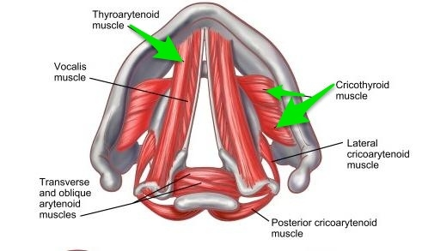
Jones, K. (2016) Vocal Cords Diagram [Illustration]. Available at: https://tinyurl.com/m2s9wd78 (Accessed: 24/04/2022).

Jones (Jones, 2016) identifies the following chest register characteristics during belt production:
- Thyroarytenoid muscle led
- Thick and short vocal folds
- Full fold vibration
- Long quotient phase. This indicates the folds meeting for a longer period

At this point, it’s worth identifying the characteristics employed in head register, as this will be referenced later when discussing the links between belcanto and belt. Again, Jones describes them in a very concise and accurate manor (Jones, 2016).

Head Voice:
- Cricothyroid muscle led
- Thin & stretched folds
- Thin fold vibration
- Short quotient phase (folds meet for a short period)

Now that both registers have clearly been identified, it should be pointed out that belt technique is not utilised in classical singing, as classical singing requires a different type of coordination which does not lead by the thyroarytenoid muscle, and this element is what historically has prevented many classical voices when learning how to belt (Wikipedia, 2008). Working with vocalists I have found that most of my clients struggle with the scientific explanation of belt, thus I have had to amend my ways of working and utilise terms such as colour, placement, and many imagery references.

Differences between belt production and classical voice production

For this I would like to draw inspiration from a very reputable CCM singer and musician – Alicia Keys. Earlier this year, Keys ran a Masterclass clearly identifying these differences (Keys via Masterclass, 2022)
- Articulation: Classical or what sometimes can be referred to as belcanto singing, is singing on legato vowels and singing through the vowels on the breath, and is characterised by rounded sounds. Belters employ a much brighter sound, sometimes referred to as “twang” with more emphasis on articulating consonants.
- Technique: To produce the desired sounds, classical voices use rounder mouths, versus belt singers who use a wider “smile-like” mouth ,which promotes airflow.
- Vocal folds: For classical voice production, folds are long and thin compared to a belter who employs the use of short thick folds.
- Register: Head voice, or as it is sometimes known, head register, is utilised uniformly in a homogenous way for classical singing. – Classical singers blend the chest and head registers to create a unform sound. Belt singers utilise the bottom chest approach, using head voice on when approaching high notes.
- Vibrato: Vibrato in classical singing is consistent and uniform, whilst it can vary when belting.
(Keys via Masterclass, 2022)
Reviewing all of Key’s points of discussion, I find that I use similar vernacular in my own teaching studio. This has proven particularly useful with my clients, especially when referring to registers, articulation, technique, and vibrato. I tend not to discuss folds as this in the past has confused my clients, as many find it exceedingly difficult to visualise the chords and their workings.
Also, when discussing classical singers and Belting, I would like to draw special attention to the tone placement and the differences in each technique, as covered by earlier observations. Vocalist Mary Zimmer, otherwise known as VoiceHacks on YouTube, run a very prolific vocal online studio as it addresses placement in a visual explanatory manner. (VoiceHacks, 2016). VoiceHacks uses two highly effective visual aids to convey placement, and where the singer should direct sound towards – this visual imagery allows for the performer to not have to think about biology and musculature, but instead focus on feeling and tone. VoiceHacks uses the terms “laser beam” and “Joker Line or X-Axis” (VoiceHacks, 2016). The first term “laser beam” is used to describe the placement or position, or where the singer should direct the sound, to which the “Joker line” is the axis which the sound should never go under, i.e., not singing below the “Joker line” or “do not cross line”.
For me, vocal placement utilising imagery such as a laser, finger, or an image of a house with levels, is essential when teaching the different areas for classical and belt production. Many vocalists who are classically trained but have wanted to explore belt, have found having a clear mental image of where the sound should go and how it should feel, have found it extremely helpful, hence my relating to VoiceHacks.

VoieceHacks addresses varying tonal placement by changing the position of her “laser beam”, which can be moved from the X-axis “Joker Line” all the way up to the Y-axis.
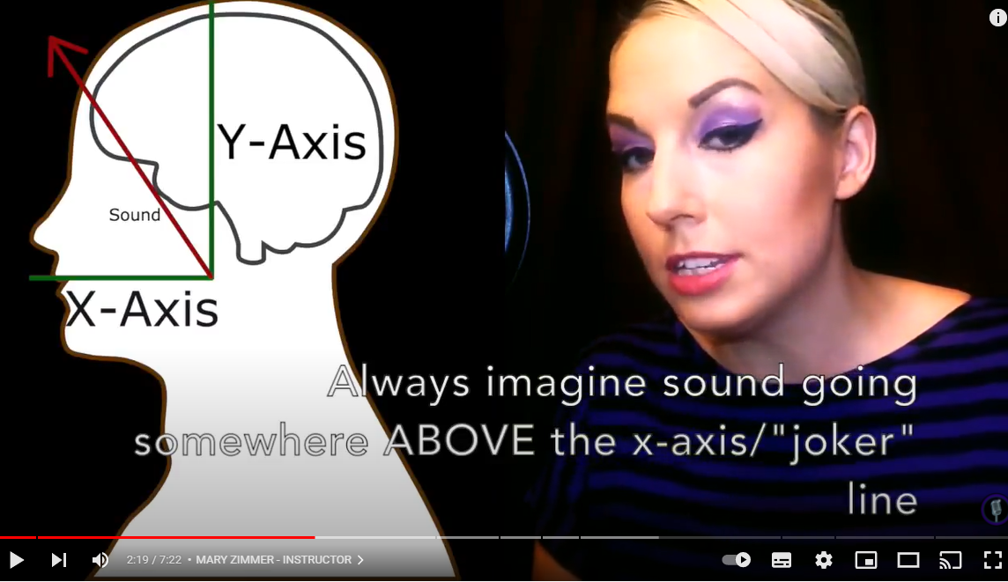
Zimmer, M. (2016) YouTube Screenshot Classical Tone Placement [Photograph]. Available at: https://tinyurl.com/2dcbdy4k (Accessed: 24/04/2022).

Classical Tone placement
As described by VoiceHacks – Classical tone placement sends the sound up vertically across the Y-Axis – imagining the “laser beam” shooting upwards.
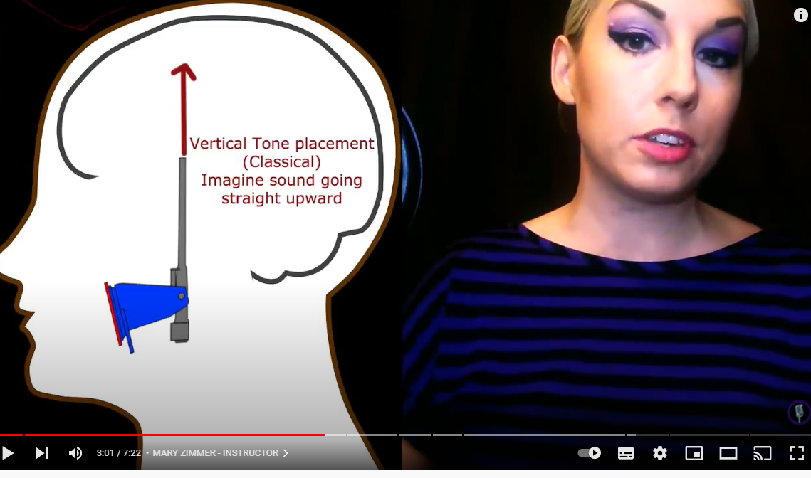
Zimmer, M. (2016) YouTube Screenshot Classical Tone Placement [Photograph]. Available at: https://tinyurl.com/2dcbdy4k (Accessed: 24/04/2022).

Further along in the video, VoiceHacks shows examples of opera singers Juan Diego Florez – Tenor, and Pretty Yende – showcasing vertical tone placement and the relationship between this, the larynx and breath connection.
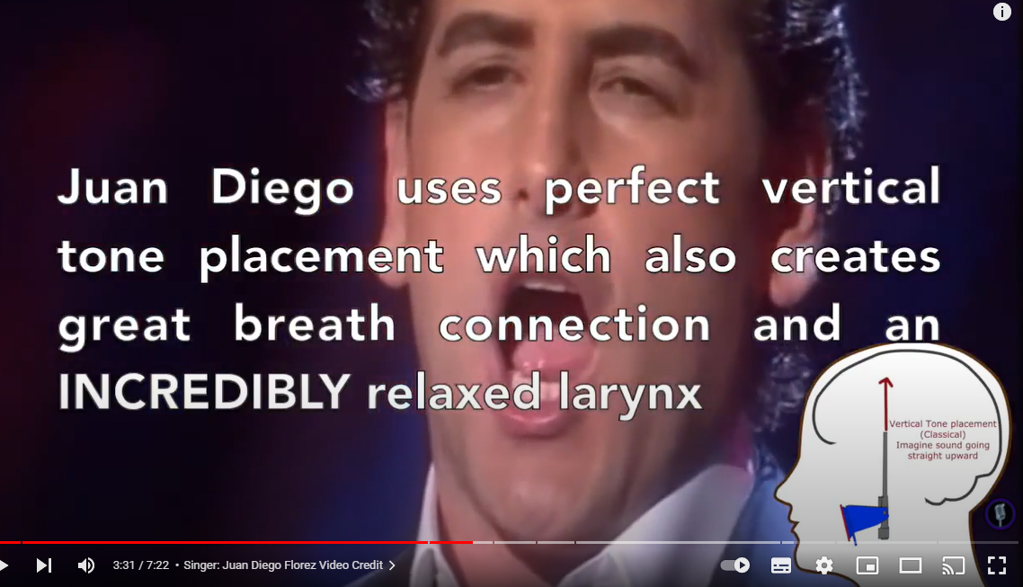
Zimmer, M. (2016) YouTube Screenshot Classical Tone Placement [Photograph]. Available at: https://tinyurl.com/2dcbdy4k (Accessed: 24/04/2022).
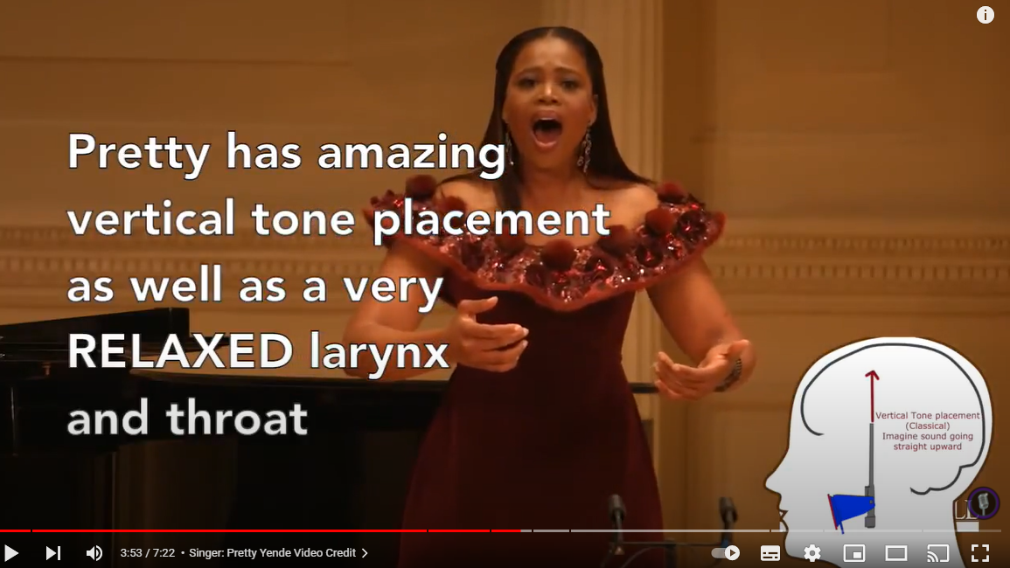
Zimmer, M. (2016) YouTube Screenshot Classical Tone Placement [Photograph]. Available at: https://tinyurl.com/2dcbdy4k (Accessed: 24/04/2022).

Although I do agree with Voicehacks about the sound going up into the head register, not all classical placement is based there, and thus I find her analogy should be employed with caveats, as many of my classical singers would very much disagree with her oversimplification, especially as there is no relationship to singing to the singer’s mask (Hines, 1982).

Belt Placement

For belt placement, VoiceHacks describes the “laser beam” firing just over the “Joker line”, i.e. a very forward placement of the tone which when paired with brighter, wider vowels will create the belt quality desired.
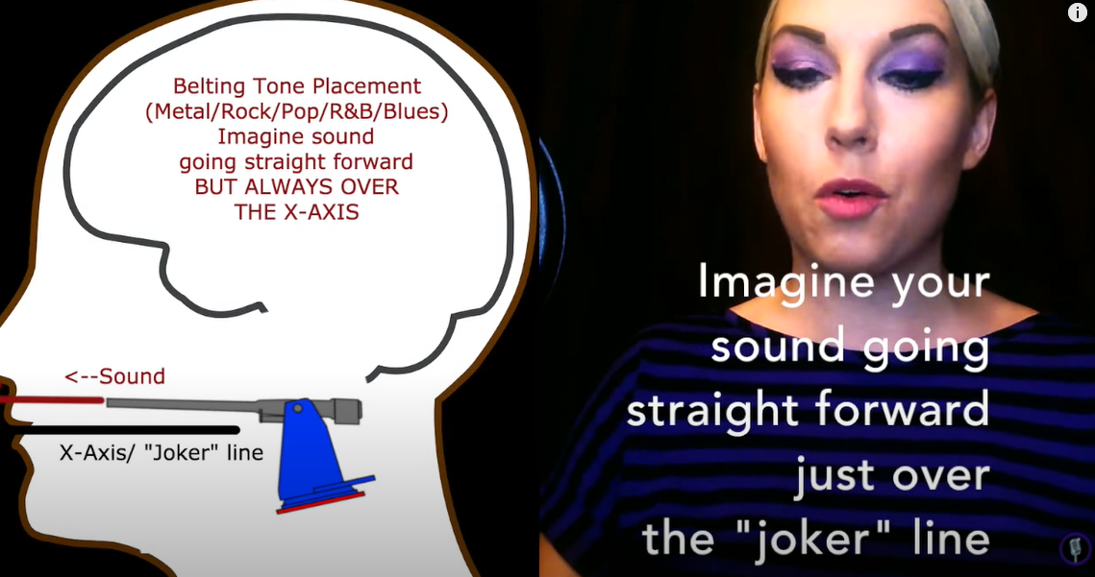
Zimmer, M. (2016) YouTube Screenshot Tone Placement for Belters [Photograph]. Available at: https://tinyurl.com/ydz34xya (Accessed: 24/04/2022).

The examples of belters given are Whitney Houston and Adam Lambert. It should also be noted that the although no examples of musical theatre belters have been mentioned, the premise is the same with a few differences between CCM, Musicals, Rock, covered by Keys, 2022 and Estill, 1988.

I really relate to the imagery of positioning the belt sound using the laser analogy, and, in fact, use a very similar image myself when working with belters. I find this really helps classical voices find the right placement for belt, especially when paired with the ideology that vowels should be wide as if grinning, which is polar opposite to classical vowels.

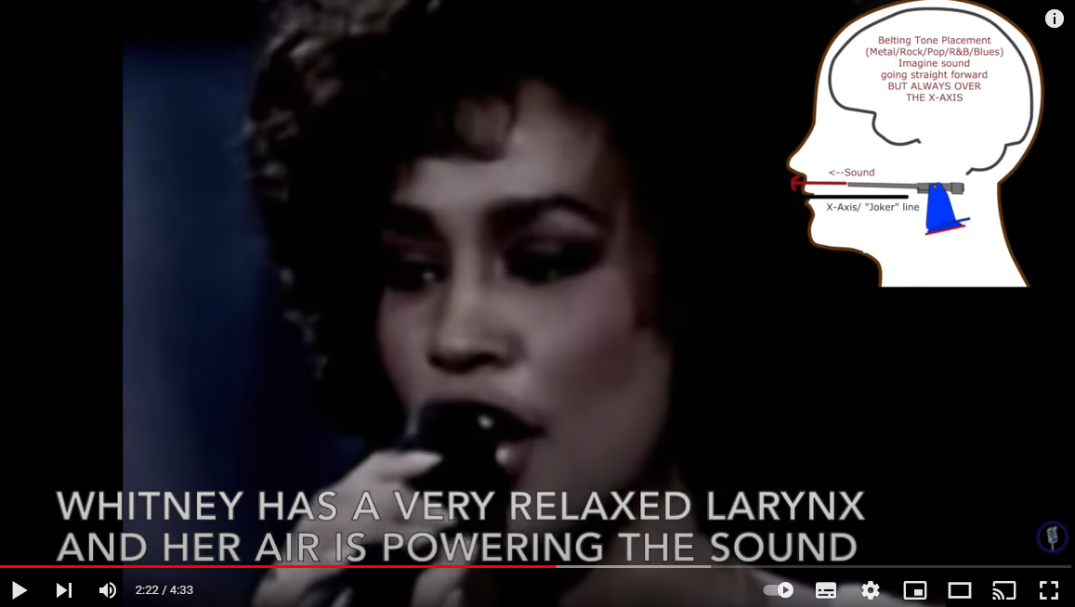
Zimmer, M. (2016) YouTube Screenshot Tone Placement for Belters [Photograph]. Available at: https://tinyurl.com/ydz34xya (Accessed: 24/04/2022).


Zimmer, M. (2016) YouTube Screenshot Tone Placement for Belters [Photograph]. Available at: https://tinyurl.com/ydz34xya (Accessed: 24/04/2022).

In 2007, Scott McCoy, the Associate Editor of the National Association of Teachers of Singing, embarked on an exploration of belting as a classical pedagogue. Scott clearly states throughout his paper that he is a pure, classical technician and indeed, believes he should stay within his “self-designated musical boundaries” (McCoy, 2007), which makes this study all the more interesting. Before working with his subjects, McCoy sought further information on closed quotient timings, raised larynx during belt, and acoustic differences between belt and classical qualities (Sundberg, 1987). With the aid of various designed vocal exercises and various singers of varying ages, McCoy explored glottal closure patterns, laryngeal elevation and acoustics, to determine whether classically trained voices can indeed belt, and whether it is possible to successfully train a classical voice to produce a safe and pleasing belt.

McCoy’s findings echoed the science behind belting, which has been previously referred to, and indeed, re-affirmed, what is already known about belting. These findings reiterate that indeed for belting there is decreased airflow, a longer closure quotient and a narrowing of the larynx. These observations have been made by many pedagogues, most notably Jo Estill, who described belting as an “extremely muscular and physical way of singing” (Estill, 1988). The observations of McCoy’s study were as follows:

- A bottom-up approach was adopted, however, it was not as disconnected and not as bottom heavy as he expected, and the registers were seamlessly connected.
- Belt quality was not as loud as expected, unlike such as a classical / operatic singer. McCoy began to understand the observations made by Robert Edwin with regards to the fact that classical singers “self-amplify through their own formant” (Edwin, 2007), versus a belt singer, who uses electronic amplification.
- Belting, or as McCoy references, “safe belting”, does not manifest physical markers such as jaw clenching, tight neck or an over elevated larynx.

McCoy, in 2016, produced another paper in which he reinforced that although still very much a classical technician, he had adopted the skills explored previously, and now teaches belt, still utilising many classical voice devices (McCoy, 2007). When working with vocalists, McCoy still adopts “tall vowels and comfortable low laryngeal positions” (McCoy, 2007), however, he has learnt to adapt his classical pedagogic approach to encompass a higher larynx and horizontal vowels. McCoy also states that although this he is confident on the knowledge he is imparting on his students, when working with CCM or MT students he recommends that they seek specialist advice to ensure any gaps of knowledge are catered for, thus ensuring the singer is not affected and achieves the best potential.

Reading McCoy’s work has made me reflect a lot about my own early experiences learning to belt, being an opera singer. His findings echo my workings with classical singers when introducing them to belt, however, I found that I was always more open to try things vocally, perhaps due to being a character performer, and used to using my voice in different ways.

Following on from the above study, and the already previously Robert Edwin, I would like to draw attention to his paper in the Journal of Singing titled - Belt is Legit (Edwin, 2007). This study focuses on the differences between belt, faux belt, and he differences faced by male and female voices, and the correlations and differences between CCM, belt and classical.

This study once again reaffirms all the previously mentioned research carried around the indolence of the thyroarytenoid and cricothyroid muscles, which reaffirms belt search, however, it then expands to discuss gender and thus ability for classical singers to utilise belt.
Edwin states that “all male singers, with the exception of pop and classical countertenors, sing with the TA-dominant vocal fold” (Edwin, 2007).

With the above premise, and the fact that male voices do not change register (expectations already stated), he therefore reemphasises the fact that male voices will have greater ease when belting. In order for said voices to belt, the use of “bright, speech-like sounds” (Edwin 2007) employed together with “noncontinuous vibrato” (Edwin, 2007) (Keys 2022) will aid the singer in producing the belt voice. Because of the afore mentioned, male classical voices can therefore be more easily be taught to belt.

Female voices, although having to once again use the dominance of the thyroarytenoid muscle, and as males produce the same type of vibrato, have additional hurdles to overcome when belting. Female voices who already sing with thyroarytenoid muscle dominance tend to find it easy when belting, however, singers who primarily sing with cricothyroid dominant muscles, encounter the different register difficulties. This has been noted by many pedagogues, notably Jo Estill (Estill, 1988)

Edwin’s work very much agrees with the way I work with my vocalists, although I reiterate the comments I previously made as I do not use scientific terms when working, either with classical singers, musical theatre, CCM or cross over, as I find they over complicate my teaching and confuse my clients.

In 1988, Jo Estill explored belting and classical voice, and focussed on the physiological differences between the two categories. Estill observed that the main physiological difference between the vocal qualities is the posture of the larynx, and more specifically the action of two specific cartilages, the thyroid and cricoid (Estill, 1988).

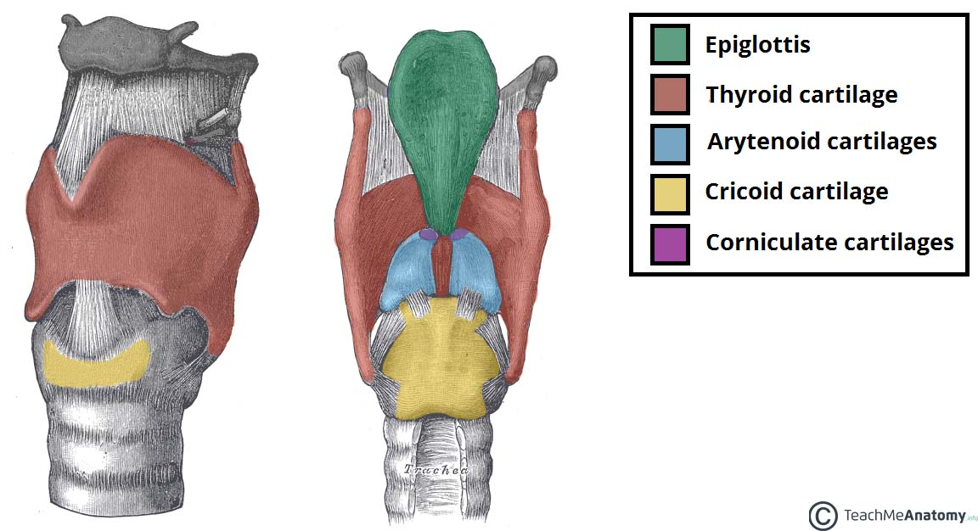
Jones, O. (2020) Laryngeal Cartilages [Illustration]. Available at: https://tinyurl.com/3p4w6kv3 (Accessed: 24/04/2022).

Estill observed that usually, in classical singing, the cricoid cartilage is fixed, whilst the thyroid cartilage tilts “anteriorly”, in other words, towards the front (Estill, 1988). This is opposite to belting, where the cricoid tilts and the thyroid is fixed. Another main observation from this study, which is quite poignant to this review, is that many belters can imitate and achieve a good classical sound, however, many classical singers can injure themselves when attempting to belt, due to the difference in technique required to achieve belt quality. Estill specifically describes the difference between opera singers and belters, as they are polar opposites, and as she derives, “belters can successfully imitate opera singers” The observations made by Estill support many of the already referenced papers where is it stated in a different way the differences between classical and belt.

Estill’s final observation in this study, which is poignant to this paper, encompasses the attitudes towards belting and people’s perceptions of classical singing being more of an “exalted” (Estill, 2008) art form. Vocal prejudice has been around for centuries, where art forms are being compared to each other and discriminated against due to lack of understanding. In the 19th Century ,many composers, including Rossini, discriminated against the early romantic singers, tackling composers such as Verdi, due to the fact that the musical style was to sing with the “band music” (Michotte, 1968), and, in fact, Rossini pointed out that “bel canto was dead and the voices were ruined” (Michotte, 1968). Estill’s observations clearly show that a lack of understanding can cause misinformation.

I personally do not subscribe to the Estill methodology, however, I do agree with her regarding the misconceptions and vocal prejudices. I find many of my hard-core classical students who want to learn how to belt, start their journey with preconceptions and pre-designed ideas of belting being bad for classical singers.

The final literature to be analysed in this study is perhaps the most informative, as it relates to a classical singer trained by Pierre Bernac (Blyth, 2001), named Mary Saunders (Berg, 2011), who is extremely experienced in both classical and musical theatre genres. Saunders created a DVD named “Bel Canto – Can Belto” as a tool to help singers. Saunders states on more than one occasion that “musical theatre vocal technique should first be built on the same fundamentals as one finds in classical singing” (Berg, 2011). Saunders believes that having a solid classical technique, voice qualities such as belt and mix can be explored by the vocalist.

Saunders states that different genres such as opera and musical theatre are still “singing”, and thus “why would they be on separate planets” (Manternach 2014). During an interview with Brain Manternah for Classical Singer Magazine (Manternach 2014), Saunders indicates that she has successfully worked with opera singers and taught them how to belt, and indeed, use belt to their advantage without compromising their own voice and classical vocal technique.

Saunders approaches belt training very differently to many other pedagogues. Rather than focussing on larynx position, she places all interest on vowel shape and resonance. Her studies guided her towards looking at the differences in “self-amplification” (Manternach 2014) with classical voices being much more amplified. Saunders states that it is advantageous for musical theatre singers to learn with a good base classical technique, thus understanding how voices truly resonate and consequently being able to then apply this technique to musical theatre singing and belting.

Saunders main body of approach incorporates identifying where belt and classical qualities occur, and exercise these at various points using vowels. During her research, Saunders identified that belt “occurred” on open vowels in male singers whilst “above the passagio” in female voices. Saunders then devised a series of exercises which can be applied to both classical and musical theatre voices to illustrate and identify the tonal quality and placement required whilst belting. Paired to this, Saunders uses exercises that are designed to make the voice more pliable thus being able to access these qualities as required. Appendix 1 shows a selection of exercises devised by Saunders in 2007.

Like many others, Saunders describes at length the differences between male and female voices and how to work with them to achieve belt. For male voices, she states that the instrument stays on “modal mode” (Manternach 2014) and then goes over to passagio, allowing for other qualities including “mix, belt and classical-mix”. Mix and belt require raising of the larynx and for classical-mix, the larynx lowers to mix the sound otherwise known as voix mixte (Parr, 2018).

It should be pointed out the voix mixte is a technique developed to aid the transition between registers, and smooth / blend the overlap between chest and head registers (Castellengo, 2004).

Interestingly, Saunders states the she does not utilise low chest sounds, as in the bottom up approach, which has been mentioned previously. For her approach, Saunders states that “belt is an acoustic event that happens above the passaggio. In other words, I don’t belt in my low chest” (Manternach, 2014).

Saunders reaffirms her approach by stating the amount of time she spends with male and female singers, ensuring they can identify which sounds above the passagio are belt, and which are not.

Out of all the research that I have conducted, I find that Saunders’ methodology echoes the way I work with my vocalists. Being a classical singer, she has adapted her pedagogic approach when teaching belt, utilising vowels, shape, resonance and imagery. A few years ago I actually started a few of her exercises, as detailed in Appendix 1, and I found singers were able to access the necessary placement, colour and quality when transitioning from classical to belt placement.

2. Assessment Component Two – reflective review
a) Reflect on your recent learning experience, and the value of learning you have acquired. Assess your current competences and identify future development needs in the context of you work place / voice studio/classroom.

b) Devise a detailed personal development plan which incorporates identified areas for development, objectives, activities to be undertaken, methods, resources review periods and timescales.

When I decided to explore the subject of classical singers learning to explore belt quality, I assumed, wrongly, that there would be a lot of clear literature on the subject, with perhaps schools of singing being able to describe the process clearly. I wasn’t looking for a “how to” guide, but was very interested in perhaps finding papers similar to the work by Joshua Whitener in 2016, The German of School of Singing: A compendium of German treatises 1848-1965 where he discusses at length more than 10 different pedagogues and their approach so singing (Whitener, 2016).

What I found is that there is a lot of literature about musical theatre technique & belt, however, there is a distinct lack of literature analysing the process of classical singers learning how to belt.

Much of the literature, including my own research, focusses on the differences between classical placement and belt placement, and the differences in the technique required to achieve each of the qualities. It is also very much reliant on explaining musculature, which, of course, is essential. For me, the difficulties with the above manifest themselves when working with vocalists in the following way:

The research carried by Jo Estill focuses on the relationship between the thyroid and cricoid cartilages (Estill, 1988). When I’m having to describe these to students, I find that every time I launch into a musculature conversation, such as described earlier (Jones, 2016), or I touch on the thyroid and cricoid cartilages (Estill, 1988), I find that my students are unable to grasp the concept, thus, I end up conveying the same information using imagery.

I am very much a practitioner who uses imagery and how it feels, and where to feel, to explain to students the technique, and I would have liked to be able to read research on teaching classical voices on how to belt using these vehicles.

On the subject of imagery and in synergy with my own vocal approach, I found watching the videos created by Mary Zimmer, otherwise known as VoiceHacks of particular interest. Although her approach towards the classical voice has gaps and is rather generalist, her approach towards belt is very interesting. She uses the image of a laser beam, which as we know, is focused, and directed to explain placement. Upon reflection I think this image would be very useful for me, as I have a few vocalists in mind who would benefit from this vernacular. Those that I have in mind are classical mezzos and a tenor who would like to explore belt, and I think this image and placement will work well for them, knowing their learning style as I do. I have already contacted Mary to see if she would mind my using some of her material. I know that the material is on YouTube, thus freely available, however, I do believe it is extremely important to credit other practitioners when one is using their work.

The research that particularly interested me was the work of Mary Saunders and her DVD Bel canto Can Belto work on cross training the 21st Century singer (Saunders 2007). One of the main attractions towards her work is that, like me, Mary Saunders originally trained as a classical singer. She trained with renown French baritone, Pierre Bernac (Blyth, 2011) and more interestingly, she studied French art song, which is notoriously difficult. After that, she carved out a career in musical theatre, and we share many similar beliefs. I know I have mentioned this before but both myself and Saunders are strong believers in the synergy between utilising vowels, shape, resonance, and imagery when teaching belt, especially working with a classical base technique.

I had already come across Saunders’ work in the past, more specifically some of the vocal exercises which I had applied to some of my clients. As I researched her, I actually was able to find more exercises as detailed in Appendix 1, and this for me, has probably been one of the greatest things to learn whilst undertaking this research, as it has given me a lot of food for thought towards a vocal development plan which I believe will improve my understanding of how classical voices adjust to belt and how best to help them learn this quality.

Personal Development

As I’ve been writing this paper, I have been very conscious of creating a development plan which will hopefully fill the gaps that I found during my research, keeping in mind a future pedagogue wanting to undertake the same research.

As I haven’t been able to find a detailed “how to” guide to teach classical voices how to belt, I aim to develop a basic framework which might help practitioners understand some of the techniques required to develop the same belt. I should at this point say that I do not believe there is an exact guide to “how to” sing. All we, as practitioners, can hope, is to identify frameworks and guides that will help vocalists achieve their vocal aims in a safe and constructive conscientious way.

Development Plan

Reasoning for understanding belt & classical singers better | I would like to be able to further understand more in depth, how male and female operatic voices of all ranges approach belt, and eventually develop my own reached experiences in a similar way to those of Saunders, i.e.. an opera singer’s guide to belting. My reason for wanting to understand this topic further is that my final masters aim is to understand better how to work with trans voices in musical theatre. I believe this will help me with my belief to help musical theatre trans voices as it is important to have (a) a base classical technique and (b) how to approach belt as you would approach belt with varying and non-varying registers ,which is the case of cis-male and cis-female belters.
How will this help me | As I am aiming to eventually develop a training plan to help transitioning voices, I feel this study will really aid my journey towards really understanding transitioning musical theatre voices
Practical applications | An in depth understanding of how each classical voice adapts to belt exercises and then how this can be translated into trans voices
Stage 1 | Utilising Saunder’s Exercise framework detailed in Appendix 1 – Select a range of exercises that be utilised on classical voices wanting to develop belt. | Deadline:  BMPF7005: Module 2
Stage 2 | Select 2 subjects per voice type, and work through the selected exercises. This will mean I will have 5 voice types (Sop, Mezzo, Tenor, Bass) totalling 10 subjects. The subjects will all be working opera singers who are keen to develop belt techniques | Deadline:  BMPF7008: Module 3
Stage 3 | Devise a questionnaire / feedback exercise framework and guide to gather feedback from singers which will be paired with final recordings of their exercises | Deadline:  BMPF7008: Module 3
Stage 4 | Selected exercises to be sent to all vocalists and ask them to work through them, recording themselves once mastered, each exercise. Send feedback framework as well together with a guide on how to complete feedback | Deadline:  BMPF7008: Module 3
Stage 5 | Analise feedback and recordings | Deadline:  BMPF7013: Module 4
Stage 6 | Based on feedback, develop a range of exercises and a feedback tool which will be used on trans voices | Deadline:  BMPF7013: Module 4
Stage 7 | Select 5 male presenting trans voices and 5 female presenting trans voices who are wanting to develop a better belt technique | Deadline:  BMPF7013: Module 4
Stage 8 | Selected exercises to be sent to all vocalists and ask them to work through them, recording themselves once mastered, each exercise. Send feedback framework together with guide on how to complete feedback | Deadline  BMPF7013: Module 5
Stage 9 | Analise feedback and recordings | Deadline:  BMPF7013: Module 5
Stage 10 | Incorporate findings into final research | Deadline:  BMPF7010: Module 6

Word Count: 4,582
Reference List

Websites & DVD
Bel canto, can belto (2007). [DVD] University Park, PA : Penn State Media Sales

Blyth, A. (2001) Bernac [Bertin], Pierre. Available at: https://tinyurl.com/5xmdmfp2 (Accessed: 24/04/2022)

Jones, K. (2016) Musical Theatre Resources with Kevin Michael Jones. Available at: https://tinyurl.com/m2s9wd78 (Accessed: 24/04/2022)

Keys, A. (2022) How to Belt When Singing: 4 Belting Exercises to Try. Available at:
https://tinyurl.com/5afaujzb (Accessed: 24/04/2022)

Manternach, B. (2014) Bel Canto Can Belto: Talking Technique with Mary Saunders. Available at: https://tinyurl.com/4v36fa74 (Accessed: 24/4/2024)

Wikipedia (2008) Belting (music). Available at: https://tinyurl.com/3797wrtk (Accessed: 24/04/2022).

Zimmer, M. (2016) "Tone Placement for Belters" (Rock, Pop, Country, modern styles) - Intro Series #3A. Available at: https://tinyurl.com/ydz34xya (Accessed: 24/04/2022).

Zimmer, M. (2016) Tone Placement for Classical & Mixed Voice - Voice Hacks by Mary Z Intro Series #3. Available at: https://tinyurl.com/2dcbdy4k (Accessed: 24/04/2022).

Papers and Journals

Edwin, R. (2007) Belt is legit. Journal of Singing 64, no.2, pp. 213-215.

Estill, J. (1988). Belting and Classic Voice Quality: Some Physiological Differences. Medical Problems of Performing Artists, 3, pp. 37-43.

McCoy, S. (2007). A Classical Pedagogue Explores Belting. Journal of Singing 63, no.5, pp. 545-549

McCoy, S. (2016). The old dog learns a new trick or (Why I now teach belting). Journal of Singing 73, no.1, pp. 45-46.

Parr, S. (2018). Vocal Vulnerability: Tenors, Voix mixte and Late Nineteenth-Century French Opera. Cambridge Opera Journal, 30(2-3), pp. 38-164.

Whitener, J. J. (2016). The German School of Singing: A Compendium of German Treatises 1848-1965. Jacobs School of Music, Indiana University

Books

Lebon, R. (1999) The Professional Vocalist: A Handbook for Commercial Singers and Teachers. Lanham: The Scarecrow Press

Bibliography

Bourne, T. Garnier, M. (2010) Physiological and acoustic characteristics of the female music theatre voice in ’belt’ and ’legit’ qualities. International Symposium on Music Acoustics. Katoomba, Australia.

Edwin, R. (2002) Belting: Bel canto or brutto canto?. Journal of Singing 59, no. 1, pp. 67-68.

Fuchs, V. (1967), The Art of Singing and Voice Technique, Calder and Boyars Ltd.

Hines, J. (2003), Great Singers on Great Singing, Limelight Editions, New York

McCoy, S. (2013) Why I don’t teach belting. Journal of Singing 70, no.2, pp.181-182

Reitemeier, G. (2015) Health and Aesthetics in Singing: A brief Examination of Classical and Musical Theatre Vocal Technique. Honors Projects.

Sundberg, J (1987), The Science of the Singing Voice DeKaIb, IL: Northern Illinois University Press.

Appendix 1


