NAME- Varsha Chaudhary
STUDENT NUMBER- 2133119
MODULE- LCMB7001
LECTURER- Tushara Balendran
COURSE- MBA
SUBMISSION DATE- 09- Sept-22

A report on Amazon

Table of Contents
A report on Amazon 1
1. Introduction 3
1.1 mission and early growth 3
2. Discussion and analysis 4
2.1 Organizational structure 4
2.2 Business operations 5
2.2.1 Philosophy of business 5
2.3 Communication 5
2.4 Communication models 6
2.4.1 Aristotle’s persuasion model 7
2.4.2 Newcomb’s inter-personal communication model 7
2.4.3 Hove land’s persuasion model 8
2.4.4 Thayer’s organizational communication model 8
2.5 Integrated Marketing Communications 9
2.6 Promotional strategies to raise awareness of the brand 9
2.7 Brand and Brand equity 10
2.8.1 The advantages of the Keller’s Brand Equity Model 12
2.8.2 Disadvantages of Keller’s brand equity model: 13
3. Conclusion 14
References 15

1. Introduction
In the 90’s the .com boom drastically develop the communications landscape, culture & business with no signs of reversion. For new associations, effective offered innovations offered great potential through the WWW (world wide web). The popularity that is growing of internet access makes a logistical inspiring niche advanced popularized as electronic commerce, proving to be a successful means of product purchasing through the web. The founder of Amazon, Inc. is Jeff Bezos would the first to innovate profitability in this market that is emerging and becoming the world’s retailer of largest online (Keung et al., 2020). Bezos realized the chances presented by the revolution of the web, whereas becoming an industry to be established was the only means to profitability for the long term. In 1994, Bezos left the position of vice-president at D.E. Shaw, a firm on wall street, to march forward with the idea of a business that would soon become Amazon.com. before the end of the year, Bezos incorporated his company of electric commerce as “Cadabra”. Later, Bezos rebrand the association as Amazon for two different reasons: theadvantage when listed in metaphorically& directors representing the river Amazon in terms of the company’s size. Piloted right out of the garage Bezos’s. Amazon became a success in an instant and acquired soon a warehouse for operations in continuations.They planned their chain of supply strategically from the first day, placing the headquarters of the company in Seattle near a largedistributor of the book in Oregon (Keung et al., 2020).

1.1 mission and early growth
By 1995, the company quickly became the globe’s top-selling website for online books (Keung et al., 2020). Twoweb portals that are quite popular Netscape and Yahoo placed it in their list ofwebsites. Two practices of business correlated with the company’s immediate success are that is scalable, it would capable of adjusting to the demand rapid of productswhile maintaining customer to be satisfied. Amazon’sstatement and missions still reflect these concepts in the present time:
To be earth globe’s most customer-attracting company, where consumers could find and discover anything they may want to buy online, and endeavors to offer their consumers the possible lowest costs (Umar, 2022). Amazon makes a chain of supply based on relation tothe inventory they didn’t have, acting as the mediator in the process of shipping because it still only hasitsSeattle warehouse. With this design which is logistical, they were able to ship to over 50states and 45 countries in July of 1995. Bezos’s degree of bachelor in electrical engineering &computer science from Princeton provided him with interface insight, database capabilities, and information systems. Amazon relied on leveraging these three competitive factors that technically allowed consumers to easily found the books they wanted and simplified the process of purchasing (Umar, 2022).
They make the balance between low operations, capability, and performance in the delivery and selling of books. This is supplemented by their culture of consumer-oriented; not just a task that is necessary but also a value they believe creates profit for Amazon. According to Bezos “focus of customer is anissue of culture” and they express it as anAmazon differentiator (Umar, 2022). when amazon releases a new service, it was directed at innovating within itspresent customer base or exploiting the market for new ones. In July of 1996, they launched theirprogram “Associates”, allowing websites to be independent to receive revenue on commission at 3 to 8% per sale. Specifically, this would perform by amazon titles by inline linking and would be one of their first moves of vertically integrated. The reach is dynamic and individual sellers should achieve at the level of niche producing a source of great revenue for Amazon(Barth-Obi, 2022).
The success of the program took hold in 1977 when large associations at the time such as Yahoo and online America became the associates with top grossing in the program. The process of information to be shared between people within the office place and outside the company (Barth-Obi, 2022). Theassociation of America marketing is a process designed to assure that all contacts of brand received by aconsumer or proposed for an organization, product, or service are relevant to that consistent person over time.Brand equity shows a value premium that anassociation makes from a product with a recognizable name when compared to an equivalent of a generic.

2. Discussion and analysis

2.1Organizational structure
Amazon had developed the reputation for being an “everything store.” Their diversity of productscontinues to grow through attainments ofinnovations into fresh markets niche &successful competitors. In Washington and Seattle, the headquartered of Amazon operate on a scale globally (Barth-Obi, 2022). Beyond the offices of corporations, customer service, their fulfillment, data, software development centers, and fulfillment are located in different countries.Products of Amazon, divisions, and servicesare integrated vertically to make internal synergies so names of departments, anddevelop often (O'Connor, 2022).
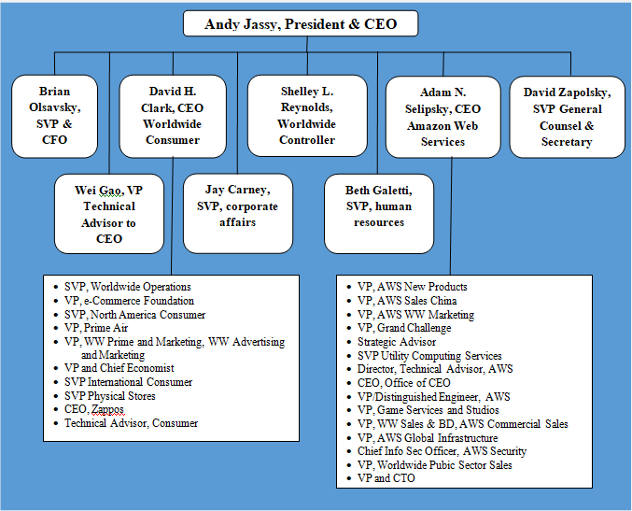
Figure 1: Amazon organizational Structure
Source:

2.2 Business operations

2.2.1 Philosophy of business
Amazon communicates thier commerce and philosophy of operating through the vision of their CEO Jeff Bezos. Their mission statement loosely defines the services and products sold by Amazon, instead discussing the service of customers as being critical for their success. As an outcome (Barth-Obi, 2022). It is clear that Amazon doesn’t prefer to label themselves as the producer or seller of any one service or product. Firstly, they recognize markets that could compete for their consumer in that are underserved by competitors which are existing. Secondly, they strategically innovate by new market development through improved methods of delivery or combinations that are synergetic with another unitof strategy. Each venture of the market always ties back into their capabilities that arelogistical & distribution, represented clearly in their products that are most profitable and their services (O'Connor, 2022).

2.3 Communication
Business communications involve continuous flows ofinformation, and feedback is part of internal business communication. Associations these days are very huge and mix with a number of people. There are different levels of grading in an association. Greater the levels, the harder is the job of considering the association. Communication there play a vital role in procedure of controlling & directing the people in the association (O'Connor, 2022). Feedback could be Immediate obtained and misunderstanding also is obtained immediatelyif any of these could be avoided. There would be communication and that should be effective between subordinates&superiors in an association, between society & organizationat large. It is important for the growth & success of an organization. Gaps in communication would not occur in any association. Communication of business is orienting goals (Ali et al., 2021).
The regulations, policies, and rules of an association had to be communicated to the member within and outside the association. Communication in business is regulated by certain norms & rules. In early times, communication of business would be limited to the telephone, calls, paperwork, etc. but now with technological advent, they had satellite, video, cell phones, emails, conferencing communication to business communication support. Business communication that effectively helps in making goodwill of an association (Ali et al., 2021).
It is of two types:
Written communication- written means of business communication includes – reports, manual, agenda, etc.
Oral communication -is communication that can be informal or formal. Generally,communication in business is a formal means ofcommunication, like interviews, meetings, speeches, group discussions, etc (Ali et al., 2021). A sample of informal communication in business would be Grapevine.

2.4 Communication models
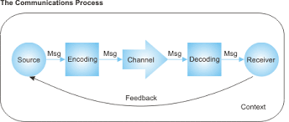
Figure2: types of models of communication
Source: (Ali et al., 2021)
In a commerce there is no particular communication model that contains all the elements of a specific situation of communication. the theories of communication have developed different models of communication till date (Yang et al., 2018). some of the communication models that are important are discussed below:

2.4.1 Aristotle’s persuasion model
The communication of business model was produced by Aristotle the Greek Philosopher is known popularly known as the Aristotle persuasion Model (Yang et al., 2018). according to them when any leader of political or a teacher delivers a speech in a gathering and in a classroom respectively, their style of doing it is included in the persuasion model.
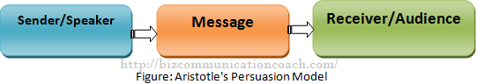
Figure 3: Aristotle’s persuasion model
Source:(Yang et al., 2018)

2.4.2 Newcomb’s inter-personal communication model
This is one of the models that is simplest in business communication. in this model, there are three parties to affect the process of communication (Seguin, Tian and Zalesky, 2020). there may be a third party between the sender and the receiver and that third party could operate the process of communication.
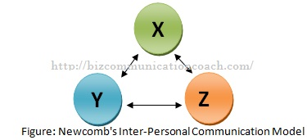
Figure 4: Newcomb’s inter-personal communication model
source: (Seguin, Tian and Zalesky, 2020)

2.4.3 Hove land’spersuasion model
This model is the same as Aristotle’s persuasion model but there are basic differences between them that in this communication model the audience stays in a certain situation and hears the speech and the audience’s feedback response is returned to the speaker (Seguin, Tian and Zalesky, 2020).
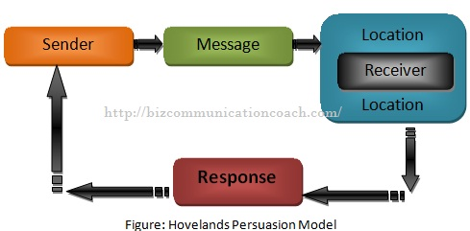
Figure 5: Hove land’s persuasion model
Source: (C. Sofia and M. Mendes, 2019)

2.4.4 Thayer’s organizational communication model
This model makes a link between structure of organization and personal communication in business (C. Sofia and M. Mendes, 2019). it has shown that the attempt to accomplish any task through communication in personal greatly influences the organizational communication process.
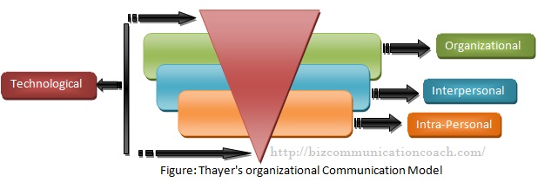
Figure 6: Thayer’s organizational communication model
Source: (C. Sofia and M. Mendes, 2019)

2.5 Integrated Marketing Communications
IMC could be defined as the process used to unify elements of marketing communication, such as social media, relations with public, development of business,advertising, and analytics of audience into an identity of a brand that remain continue across distinct channels of media (Schultz, 2020). It allows private & public businesses & organizations to deliver an engaging and seamless experience forcustomersfor a product or/and service and forthe organization’s picture optimization and stakeholder relationship.professionals with a background in communications in marketing that is integrated may pursue employment throughout the industries of communications and marketing, in areas such as digital media, social media marketing, consulting, journalism and market research, non-profit and government, relations to the public, radio, and television (Schultz, 2020).
Integrated marketing communication is a multi-disciplinary field that mixes new media practices &traditional. As itsuggestsa name, communications, communications of integrated marketing arean approach to holistic marketing that consider the strategy of marketing within the huge context of the aims of associations, the development of business, and needs in maintenance (Schultz, 2020). in other words, rather than having advertising, marketing, and analytics of audience/customer, relation with the public, and social media be separated terms or effects within an association, integrated marketing communication encourages the integration of these disciplines to make a more powerful approach that is concerted.

2.6 Promotional strategies to raise awareness of the brand
Brand awareness is the extent to which a brand is known by correctly associated & customers that are potential with their particular service or product (Ebrahim, 2020). to increase brand awareness following are some strategies:
i) native advertising to be used
Native advertising of employing is one of the most effective ways for brand awareness to be increasedand win over new consumers (Ebrahim, 2020). since they fit right into their surrounding content and credibility to be borrowed from their sites of publishing by the host, native advertisements help them reach new people.
ii) ads should run on social media
Their client’s brand already had a presence on social media probably, but they had troubledeveloping their engagement metrics and followings. they want strategies of content advertising that launch ads on social media. the best example of this isInstagram and Facebook (Ebrahim, 2020).
iii) partner with influencer to review their brand
If they are having trouble connecting with their audience target, they might need to try reaching them though their favorite influencers &creators (Ai-Zyoud, 2018). customers recommendations of trust are from influencers more than traditional advertisement or even endorsements from celebrities. brands earned an average of $6 for every $1 spent on the market of influencers.
iv) runs ads on Twitter
On Twitter, they could launch awareness of their brand campaigns by promoting their tweets and paying for impressions instead of engagements. they set their amount of bid per 1,000 impressions and it optimizes their campaign for the best reach (Ai-Zyoud, 2018).

2.7 Brand and Brand equity
Branding is a process that creates a strong and positive perception of a company and the company’s product and services in the consumer’s mind, such as logo, structure, design, and a consistent theme throughout all marketing communications. A good and effective company helps it to differentiate itself from its competitors, and branding also helps to create a loyal customer base (Sandhe, 2020). This means the customer can expect the company’s voice tone to be the same as the entire process, such as the website, the customer’s services, and their product structures in the business. The process of branding is complex, but it requires careful planning and a calculated approach. In the case of Amazon, in today’s time, the company has a strong brand value, but the company also focuses on its branding to reach maximum customers. Maybe, the in-store branding can be different from the online process of branding because in-store branding can worry because of the product positions and props that can affect the customer experience (Sandhe, 2020).
Brand equity is a term of value that generates the company from its product with a recognizable name when compared to a normal equivalent. Companies create brand equality to make the product memorable and superior in quality. Different companies try different ways to build positive and strong brand equity (Sandhe, 2020). Mass marketing campaigns also help to build brand equity. If the company has strong and positive brand equity, then the customer easily pays the high price for the company’s product to know that the same product can get from competitors at a lower price. Consumers can pay a price premium to do business with the company the customer knows and admire. The brand equality of a company helps to make a higher profit on each scale. Brand equity includes some basic components such as customer perception, the negative and the positive effects, and the resulting values (Sandhe, 2020).
2.8 The Keller’s brand equity model
Keller’s brand equity model, also known as the customer base brand equity model, was developed by Kevin Lane Keller in his textbook ‘Strategic Brand Management. The concept of this model is so simple (Diego and Holanda, 2022). It defines that to build a strong brand, it is needed to shape the customers thinking and feeling about the product. It is needed to build the right experiences around the brand, so the consumers have proper thoughts, thinking, feelings, and opinions about it (Diego and Holanda, 2022).
If a company has strong brand equality, the customer will encourage to buy more products, and also it recommends to other people and also it is loyal (Diego and Holanda, 2022). In amazon, this model helps to identify the customer’s desires and make them aware of the customers for the company’s brand (Diego and Holanda, 2022).

Judgment | Feeling
Performance | Imagery
Salience

4. Relationship Resonance
3. Response

2. Meaning

1. Identity
Figure 7: The Keller’s Brand Equality Model
source:
The four sections of the pyramid tell the fundamental questions of the customers that ask about the brand (Kovachevski, Petrovska and Handjiski, 2019). In these four sections also contain the 6 blocks of the building that should be in place to reach to the top of the pyramid and to develop a successful brand. Amazon can use this model to target its ideal audience (Kovachevski, Petrovska and Handjiski, 2019).
Aaker’s Brand Equity Model
There are different theories to identify and measure the company’s brand including Aaker’s brand model. It is named David Aaker, a California university formal professor that introduces this concept in the 1990s (Kovachevski, Petrovska and Handjiski, 2019). This model explains brand equality in the combination of brand awareness and quality, this helps the companies to increase the product and service values and that have several profits for the customers. Amazon can easily generate revenue after putting a positive and affordable approach in the customer’s mind. According to this model, it can (Kovachevski, Petrovska and Handjiski, 2019).
Help to re-received the information This model said that brand equality helps the consumers to identify and understand the information about the brand.
Influence the decisions of purchasing This model believes that brand equality builds customer confidence in their decisions to purchase (Prachaseree, Ahmad and Isa, 2022).
Build customer satisfaction Brand equality builds confidence in the customers of the brand’s quality, and it also increases consumer satisfaction.

2.8.1 The advantages of the Keller’s Brand Equity Model
1. Identity
It starts with the brand identity. Keller’s brand equity model focuses on themselves. Keller’s brand equity model focuses on customer awareness (Prachaseree, Ahmad and Isa, 2022). It explains the customer thinking about the brand and also tells the customer’s feelings about the company. If the targeted customers are relevant and useful, then there are strong possibilities to grow in the future (Prachaseree, Ahmad and Isa, 2022).
2. Relevant information
This model also provides that the information shown in the advertisement is correct. This focuses on the accuracy of the information (Prachaseree, Ahmad and Isa, 2022). It shows that the product is able to complete its job in an effective way or able to fulfill the customer’s desires. This also focuses on identifying the brand value because if the company acts upon its brand value, then the company easily targets the relevant audience (Palomba, 2022).
3. It tells the feelings of the customer
Keller’s brand equity model is one advantage is that it tells the customers’ feelings and desires. This includes the customer’s judgments, their intention, and their awareness of the brand (Palomba, 2022).
4. It gives a way to understand the customer relations
Keller’s brand equity model provides a term to identify and discovers customer relations. It focuses on better and positive relationships between the customer and the company (Palomba, 2022). This includes loyalty programs and building emotional connections (Palomba, 2022).

2.8.2 Disadvantages of Keller’s brand equity model:
1. It’s difficult to resonate with consumers in the information-overloaded market
Creating the brand identity may be easy, but with Keller’s brand equity model, it is difficult because it needs to realize the real competition (Chakraborty, 2019). In this market, there is an unlimited source of information, so it is difficult to measure each customer’s needs to know that the customer’s needs change at any time (Chakraborty, 2019).
2. It’s a time-consuming process
Keller’s brand equity model is a time-consuming model because it is divided into steps and every step, takes a particular time (Chakraborty, 2019). From brand identity to brand relationships, it is difficult to measure every process in this advanced technology time. In this large era of the competitive market, it is difficult to apply this model in practical life (Chakraborty, 2019).
3. It is difficult to measure the customer relationship
This model also focuses on customer relationships (Chakraborty and Bhat, 2018). Identifying each customer relations, it is a difficult process because the relationship between the company and the customer depends on many factors, and every customer that buys the product doesn’t mean being satisfied with the product or the services (Chakraborty and Bhat, 2018).

2.9 Stages in the customer journey
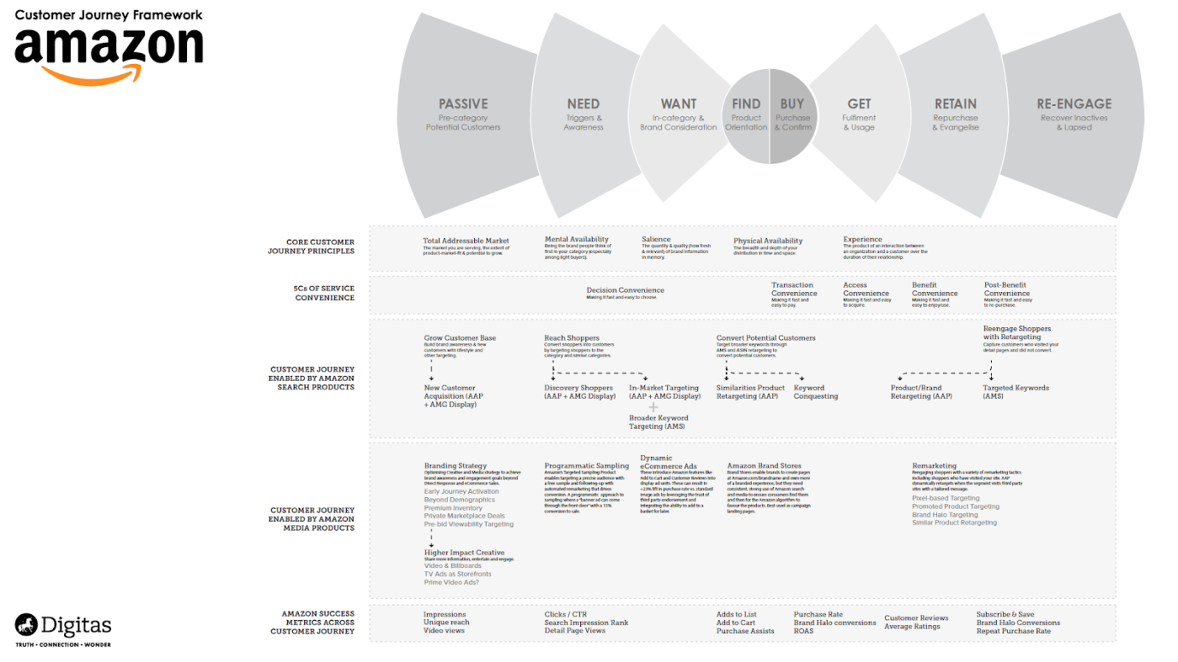
Figure 1: Amazon customer journey map
Source: (Venkatesan, 2018)
1. Awareness phase
Most consumers usually begin in the understanding phase, when they have an issue or requirement and seek a resolution. Customers are now looking for informative material regarding businesses that will help them address their concerns. Because these people wanted instructional innovative solutions over advertising or product-oriented information, firms should refrain from constantly pushing items on them. Alternatively, sales managers may demonstrate how their services can meet the demands of customers by providing advantages. Online adverts and instructional offers, such as white sheets and e-books, are popular advertising tactics at this stage (Venkatesan, 2018).
2. Consideration phase
Customers evaluate one institution's capabilities to those of its counterparts during the awareness stage. Blog material, inspiring stories, mail fostering programmes, and seminar or conference registrations may all help firms keep their audience members engaged.
3. Decision/purchase phase
The very first two parameters place a great burden on marketing teams, who must constantly collect and cultivate customers. When someone interacts with a brand and progresses to the decision – or buy – stage of evolution, they become such a brand management lead ready to communicate with selling or support workers (Venkatesan, 2018).
4. Advocacy phase
Customers who have high satisfaction with a company's goods or services might become outspoken brand champions. Organisations should grasp their new buyers' aspirations for a service or a product before hiring and training them.
5. Retention phase
During the retention stage, businesses might develop a loyalty programme or an information retrieval FAQ, as well as convey corporate or technology accomplishments to consumers on a regular basis.

3. Conclusion
In this report, Amazon company’s mission statement is explained in a clear and proper way. The company’s background and fundamental structure are explained clearly. In this include, the company’s infrastructure, its working process, its market strategy, and customer satisfaction include properly. Amazon’s end goal and vision are described in a simple way so can be easily understood the company’s financial position and its market value. The communication strategy and standards are clearly mentioned in this, so the readers are easily aware of the communication strategy of the company. Also, the communication model is explained with the use of a diagram, so the information is easily delivered and also easy to understand. In Amazon, this communication models help to identify the customer’s desires and needs that can be fulfilled. Integrated marketing communication is explained in this report. With the help of integrated marketing communication public relations, the principles of business development, and the identity of the brand are easily known. The promotional strategies are mentioned in this report to spread awareness of the brand.
These strategies help to increase the brand value in the customers, and by this step, the company’s revenue automatically increases. The strategies are explained in this report in an easy way that can be understood. The branding and the brand equity are explained in this report in a clear and positive way so are easily understood, and both definitions (branding and brand equity) are explained separately. The ‘Keller’s brand equity model’ and ‘Aaker’s brand equity model’ are mentioned in this report and explained, so both brand equity models’ pros and cons understand in a comparable way. In Keller’s brand equity model, the model diagram is explained in the pyramid structure. Both (Keller’s and Aaker’s) model working processes are explained in this report. This equity model provides an outline to measure the brand value, the customer desires, and the awareness that requires of the customers. To reach the maximum number of customers, especially in developing countries (there is no awareness of the Amazon company), these models and techniques are very helpful, and there are more possibilities to grow in the future. However, the growth factor depends on the cultural practices, the environment of the particular country, and the customers purchasing patterns so these factors should be considered.

References

Keung, P., Lu, Y., Szarvas, G. and Smith, N.A., 2020. The multilingual Amazon reviews corpus. arXiv preprint arXiv:2010.02573.
Umar, A., 2022. Evaluation of management effectiveness in the organization (On the basis of Amazon Inc.) (Doctoral dissertation, Private Higher Educational Establishment-Institute “Ukrainian-American Concordia University”).
Barth-Obi, C., 2022. Crisis management: prevention, diagnosis, and intervention On basis of Amazon Inc (Doctoral dissertation, Private Higher Educational Establishment-Institute “Ukrainian-American Concordia University”).
O'Connor, D., 2022. All of the Products, None of the Liability: Examining the Supreme Court of Ohio's Decision in Stiner v. Amazon. com, Inc. University of Cincinnati Law Review, 90(4), p.10.
Ali, B.J., Anwar, G., Gardi, B., Jabbar Othman, B., Mahmood Aziz, H., Ali Ahmed, S., Abdalla Hamza, P., Burhan Ismael, N., Sorguli, S. and Sabir, B.Y., 2021. Business communication strategies: analysis of internal communication processes. Ali, BJ, Anwar, G., Gardi, B., Othman, BJ, Aziz, HM, Ahmed, SA, Hamza, PA, Ismael, NB, Sorguli, S., Sabir, BY (2021). Business Communication Strategies: Analysis of Internal Communication Processes. Journal of Humanities and Education Development, 3(3), pp.16-38.
Yang, S.B., Lee, H., Lee, K. and Koo, C., 2018. The application of Aristotle’s rhetorical theory to the sharing economy: an empirical study of Airbnb. Journal of Travel & Tourism Marketing, 35(7), pp.938-957.
Seguin, C., Tian, Y. and Zalesky, A., 2020. Network communication models improve the behavioral and functional predictive utility of the human structural connectome. Network Neuroscience, 4(4), pp.980-1006.
C. Sofia, R. and M. Mendes, P., 2019. An overview on push-based communication models for information-centric networking. Future Internet, 11(3), p.74.
Schultz, D.E., 2020. From Advertising to Integrated Marketing Communications. In A Reader in Marketing Communications (pp. 10-40). Routledge.
Ebrahim, R.S., 2020. The role of trust in understanding the impact of social media marketing on brand equity and brand loyalty. Journal of Relationship Marketing, 19(4), pp.287-308.
Al-Zyoud, M.F., 2018. Social media marketing, functional branding strategy and intentional branding. Problems and Perspectives in Management, (16, Iss. 3), pp.102-116.
Sandhe, A.A., 2020. A descriptive study of brand equity of india's popular online shopping sites. Independent Journal of Management & Production, 11(2), pp.324-342.
Diego, L. and Holanda, F.S.R., 2022. Consumer perception of brand equity based on environmental sustainability in the Amazon: development and validation of a scale.
Kovachevski, D., Petrovska, I. and Handjiski, V.K., 2019. Measuring Brand Performance: From Customer Based Brand Equity to Brand Financial Value. Innov. Eur, pp.117-130.
Prachaseree, K., Ahmad, N. and Isa, N.M., 2022. Reviews of Brand Equity for Online Retailers. ABAC Journal, 42(1), pp.52-72.
Palomba, A., 2022. Building OTT brand loyalty and brand equity: Impact of original series on OTT services. Telematics and Informatics, 66, p.101733.
Chakraborty, U., 2019. The impact of source credible online reviews on purchase intention: The mediating roles of brand equity dimensions. Journal of Research in Interactive Marketing.
Chakraborty, U. and Bhat, S., 2018. Online reviews and its impact on brand equity.
Venkatesan, R., Petersen, J.A. and Guissoni, L., 2018. Measuring and managing customer engagement value through the customer journey. In Customer engagement marketing (pp. 53-74). Palgrave Macmillan, Cham.

