

Student name: Valerie Bays
Student ID:2311095

Module name: Independent Project
Module code: BMHP 6020
Supervisor’s name: Banica Sanfilippo

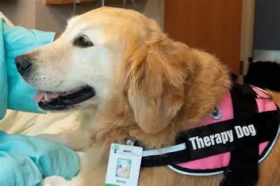 (USA Health, n.d.) |  | Title or Heading Here  My project title: Impact of pet therapy on adult mental health in health and social care in the UK.  Aim  To examine how pet therapy (Animal-Assisted therapy and Animal- Assisted interventions) influences the physical, psychological and social well-being of adults, and to evaluate which of these interventions contribute to improved health outcomes and overall quality of life. (O’Loughlin, M. et al. 2024).  Objectives  - To discuss different models of pet therapy and assess their relative benefits and limitations for adults in the UK.( Jojo Joseph, Natasha Thomas, & Aneesha Thomas, 2016).  - To systematically analyse existing research evidence on the impact of pet therapy on adult mental health outcomes within UK health and social care settings.  - To evaluate the effectiveness of pet therapy interventions on key mental health indicators such as anxiety, depression, loneliness, emotional wellbeing, and quality of life.  - To develop evidence‑based recommendations for practitioners, service managers, and policymakers on the integration, implementation, and future development of pet therapy interventions in UK health and social care. | T | 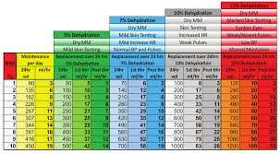(VetAPedia, 2025)
METHODOLOGY |  |  | T
This study will adopt a systematic review approach using secondary research( Amerine, J.L. and Hubbard, G.B. 2016)  Keywords  “pet therapy”  “animal‑assisted therapy”  “therapy animals”  “companion animals”  “mental health”  “adult mental health”  (NIH, 2024) |  |  | T | Data analysis  Thematic analysis is used to find common similarities among the articles ( Braun and clark,2010)  Title or Heading Here  Ethical considerations for secondary research include:  (Çaksen, H. 2024).  - Accurate reporting of data  - Reference all the sources used.  - Using reliable sources.
 |  | Inclusion and Exclusion  Write about your Data Collection method.  Inclusion criteria  This research will therefore follow up on  Primary research studies published in peer-reviewed journals  Inclusion Criteria  - Published between 2016 and 2026 (within the last ten years)  - Primary research studies published in peer‑reviewed journals  - Focus on adults aged 18 and over  - Conducted within the United Kingdom  - Investigate pet therapy or animal‑assisted interventions  - Examine mental health outcomes (e.g., stress, anxiety, depression, wellbeing)  Exclusion Criteria  - Focus on children or adolescents  - Examine other forms of therapy not involving animals  - Are based on secondary data, reviews, books, reports, or grey literature  - Were published before 2016  - Are conducted in countries outside the UK | T

References

Amerine, J.L. and Hubbard, G.B. (2016) “Using Animal-assisted Therapy to Enrich Psychotherapy,” Advances in mind-body medicine, 30(3), p. 11
(Accessed 10 May 2023)

Çaksen, H. (2024) “Use of animals in clinical practices beyond animal-assisted therapy,” Progress in health sciences, 14(2), pp. 1–5.
(Accessed 10 May 2023)

NIH (2024). National Institutes of Health (NIH). [online] National Institutes of Health (NIH). Available at: https://www.nih.gov/.
(Accessed 10 May 2023)

USA Health. (n.d.). USA Health - The Region’s Only Academic Medical Center. [online] Available at: https://www.usahealthsystem.com/(Accessed 10 May 2023)

‌

. VetAPedia. (2025). Home - VetAPedia. [online] Available at: https://vetapedia.com.au/ [Accessed 16 Mar. 2026].
O’Loughlin, M. et al. (2024) “Animal‐assisted interventions in adult hospital rehabilitation settings: A scoping review,” Nursing & health sciences, 26(3), pp. e13138-n/a. Available at: https://doi.org/10.1111/nhs.13138. (Accessed 10 May 2023)

‌

‌

