KHURAM
Assignment 1 Reflective Review of
Learning Journey
Khuram Khan
Student Number
1808278

Assignment 1-Reflective Review of Learning Journey

1. Introduction

Professional career development is important and a key element for successful professional life.

A proper career development strategy is important. It makes an individual learn new skills and understand the demands of employer and have a better understanding about the industry they are working in also up to date information and employability skills that are required by employers is a key element to progress in career.

It also helps to develop competence and helps you to understand the dynamics of his or /her subject area. Below are some examples why professional Career development is important to be successful in any profession.

It increases chances for a person to get a desired job and it opens more opportunities for an individual.

There are many skills that are important to work effectively and being employment ready. Below are few skills that play a major role in having a successful career.

4. FINDINGS

4:1 part 1
- Learning styles questionnaire applied to me
- My personal SWOT
- My Go MAD

  - My Learning styles

Learning style is a way how a student responds and learns new things and information

There are seven learning styles.
- Visual
- Aural
- Verbal
- Physical
- Logical
- Social
- Solitary

Learning styles have a great impact on a student’s learning journey. As a student It is important for me to know about my learning style as it will play a big part in my study and in my professional life. In order to know my learning style. I was giving different learning style questioners in my class. I have used Vark and Honey and Mumford. After answering the questioners knowing my results and I agree with most of it however I don’t agree with some answers.

My VARK Result

My vark result has showed me that I am kinesthetic type of learner and I completely agree with that.

Rest of the result I don’t agree at all as much I know my personal abilities and level of my own personal learning skills my learning style is Kinesthetic,Visual and Aural.

My Honey and Mumford Results

Based on my answers to questionire

My Personal SWOT Analysis
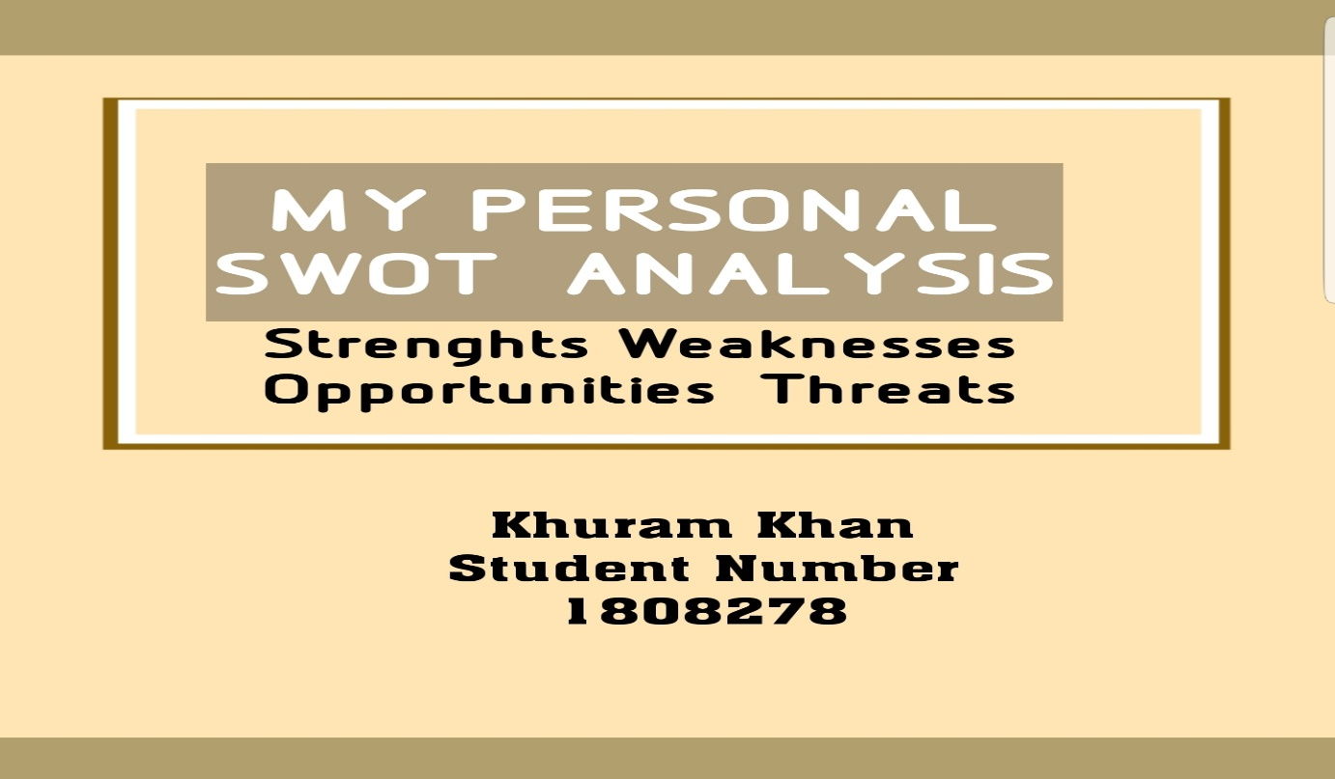
I have conducted a personal SWOT analysis on myself. It was a great way to understand my strengths, weaknesses, and areas where I need improvements to better myself and turn my weaknesses into opportunities. The SWOT test …..

My Strengths
After I analysed myself using SWOT, I have become more aware of what my strengths are. My confidence has increased, and I can now see myself doing things I never thought I would have been able to achieve. A few strengths I noticed and listed were:

- Bilingual
- Problem solving skills
- Helpful
- Committed
- Easy going
- Respectful
- Good leadership skills
- Good communication skills
- Self confidence
- Strong willpower
All these strengths listed above are key to be a successful individual in any profession. I can use my strengths to achieve anything I want and be successful in my future careers/businesses.

My Weaknesses
While noticing my strengths, I also noticed a few weaknesses.
- Being too straightforward
- Writing skills
- Credulous (trusting)
My weaknesses can be very costly in professional and day to day life.
My writing skills are not up to standard I need to work on it

Opportunities

Because I am bilingual it gives me a huge advantage on other people. I speak 5 languages which is a great strength. It is also great opportunity that will benefit me and will give me a clear advantage that on many other people.
being bilingual gives me many opportunities as communicating with other people from different nationalities and cultures is key to success in modern day professional life.
I am a very helpful and very understanding person.
I do have good problem solving skills and its opens a wide number of advantages is the key to be successful in any field of life I'm very confident person being respectful to others n easy going open for me I can play I've got part of team or I can use my leadership skills who's my experience that I have in my previous jobs I believe I can have any job confidence.

My Threats
By the help of personal SWOT analysis, I am able to see the threats that I might face in future due to personal and health reasons.
- Biggest threat I see is my problem with my short-term memory. due to the health problems I had in past and am still experiencing.
- My writing skills are not very good I do struggle with writing I can see this as another threat.

However, I do believe that by the help of my self-confidence and strong will power that has always helped me I will be able to overcome this threat and I will tackle these issues with confidence that I am gaining by studying and improving my mental health.

Part 1.2
GO MAD frame work to myself
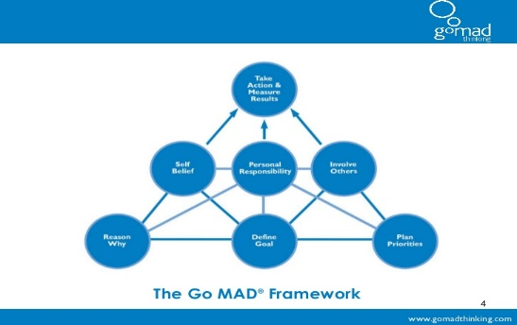

During my study I have understood The Go MAD Framework. It did help me and gave me confidence to do a personal analysis using The Go MAD framework.
The Go MAD is a great tool to understand and be clear about my personal reasons of doing things that I want to do in my life. By knowing the reasons why, I want to study and improve myself has given me a great confidence.
First time in my life, after years of disappointment and struggle and running behind things that were never important for me finally, I feel I know what I wants to do with my life.
I can define my goals and plan my priorities and by doing this I am able to know about my personal responsibilities.
I can define my goals and plan my priorities. first time in my life I ask myself a question are my goals are achievable what the reasons are I want to my goals what I want to achieve in my life and am I doing everything in a right way. I was also able to question myself that are my goals are realistic how clear I am about defining my goals what help is available what my priorities and personal responsibilities are. After this GO MAD analysis, I have a clear Idea that what I want in my life what are my reason and what are the obstacles that I will have to tackle in order to be where I want to be, I have listed results of my analysis below.

My Reasons

- I want gain knowledge
- I want to be successful in my life and in my future career

- I want to open my own business
- Better I and improve financial situation.
- Buy my own house and get my kids good education so they can also be able to benefit and help others.
- Bring a positive change to myself and world.

My Goals
Like other people I also have many goals in my life
- I want to start my own business
- I want to be successful in my life
- I want to complete my study
- I want I want my kids to study and be successful be successful
- Improve my quality of life and my financial situation
- I would like to help others who are less fortunate than me
- I would like to build a hospital in a poor country
I want to gain knowledge Andy successful in my life boating professional and in my personal life I would like I would like to help others so can be successful in life
Are you I want who give my kids good education and give them best of the social skills that I have I would like I would like to see my kids becoming successful in the life and also one Google a good citizen off this planet I would like damn M people around me do you have mutual respect and understanding off the print blah blah blah blah show
Part 2 Assignment 1-Reflective Review of Learning Journey

I have started this course last month because I saw a good opportunity for getting back in to higher education and gain the right qualification to make myself ready for employment market. Since I have started this course, I feel that at the end of this study I will be able to have more chances to get my desired job and I will be able to improve myself and get a better understating of work place skills. Before this I was thinking that it was impossible for me get a desired job or start my own business and to be successful in my life.

During this short time in university I am confident to say that I have more self-awareness and now I have a clear vision about myself.

I have erudite about different analysing tools and frame works to asses myself and now after carrying out self-assessment I know what kind of learner I am and what style of learning is suitable for me.

Also, being able to use tools and frame work like SWOT and GO MAD and now I feel that I am exploring new horizons and my knowledge is improving, and I am accepting my and exploring new ideas and right now for me things are getting clearer and better every day. more and more awareness and knowledge about my strengths and weaknesses that I have no idea before is started this course.

By using VARK and Honey and Mumford I had more idea about my learning style. I have learnt lots of new methods about analysing my potential by using SWOT and GO MAD. Since I have started this course, I am more optimistic about my future and I am also getting more understanding about my abilities.

Conclusions

Since I have started n this cause I have learnt a lot about professional career development and needs a requirements from employment industry I have learned new ways To do personal assessment analysis using SWOT and go mad framework I have also learnt that what kind of learner and what is the most appropriate learning style for me during You're in my study in a very short time I am able to see what are my goals what are you want in my life also what obstacles I might face in my life however it has given me I'm great confidence after the self-analysis that I have many advantages and strength that what many other people have I am much more clear about view recent why I am studying n also I can see clearly C Michaels and are you also can see what are the obstacles and what are did problems face during this journey I can clearly see what help is available day what are the people organisations on networks I can get help from Google my study also I am able to see many areas where I live hello going to school and

Also with the help of my study any information and knowledge that I have gain during the short time in University I am confident that I will be able to go for that in higher education to complete my master’s degree and hopefully I would be able to start my own business n would be able to improve myself achieve my goals and also will help Argos do stand-up n get most outlook this life in a positive way I believe the best thing dad happened to me is coming back to University and started where I left 18 years ago

APPENDICES

REFERENCES/BIBLIOGRAPHY

