Worksheet 3
NTFS permissions
I created a new folder on the C:\ Drive so that all accounts would have access to it then set the NTFS permissions for two different accounts giving one full access which allows the user to view, modify, delete or change who has permissions to the folder. The other only read and execute which will allow the user to view the folder and its files in it but not make any changes or delete the file.
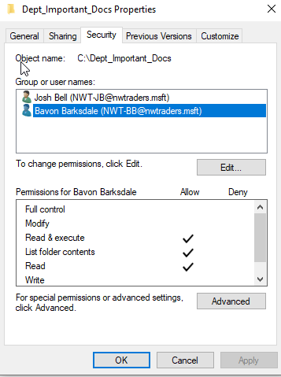
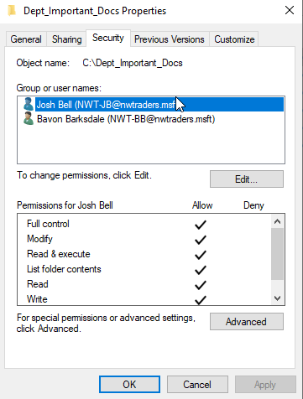

The first bit of the test was from the account with full access which saved successfully but the second account had the error message below as expected.
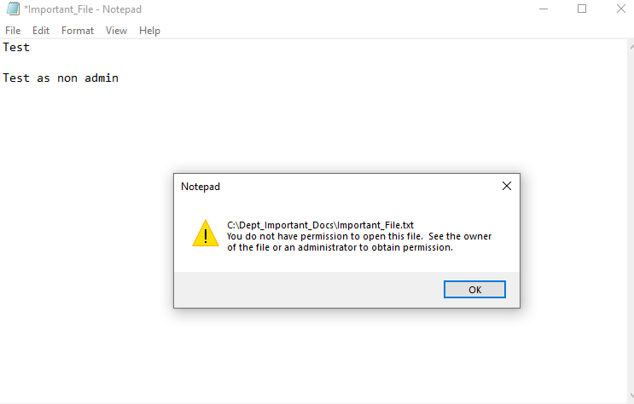

Share permissions
Similar to the NTFS permissions I created a folder that both accounts would be able to see to test the permissions that can be set. Share permissions are slightly different, however, as it must be on the network it can’t be done locally. I created the folder by creating the share on my server 1.
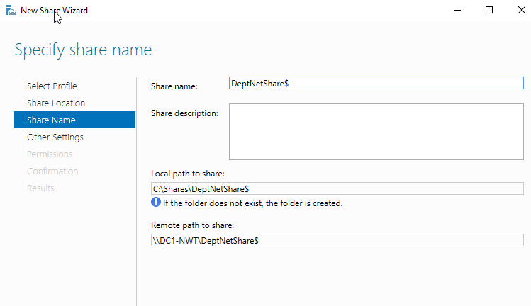

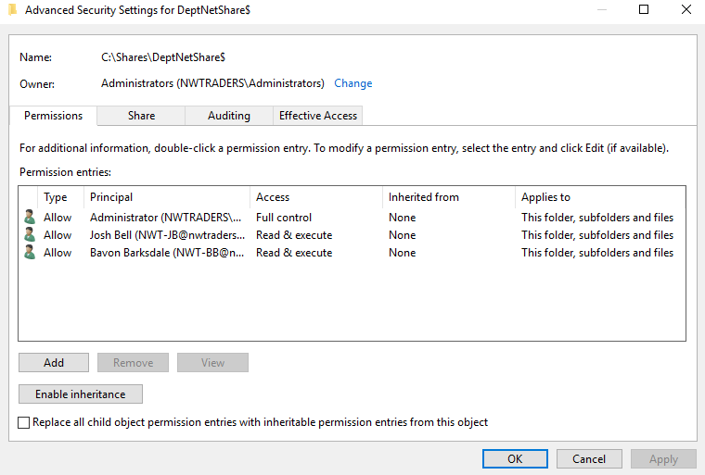
I set the permissions for two different accounts giving one full control and one read and execute the same as I did for the NTFS permissions. Allowing the account with full control the ability to read, modify or delete and the account with read and execute the ability to view the file but not modify it or delete it.

Confirmation of the share being created and showing the file path that the users will have to go to be able to access this folder. This can also be done automatically in active directory so the users do not have to browse to the file location or map the drives themselves.
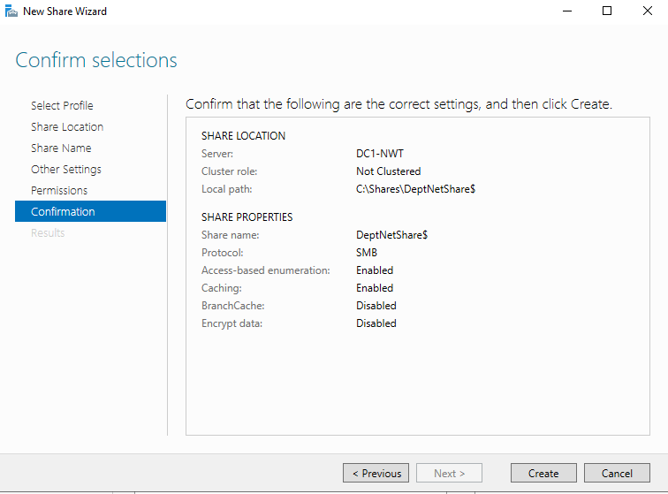

The drive has been mapped on client 1 for both users.
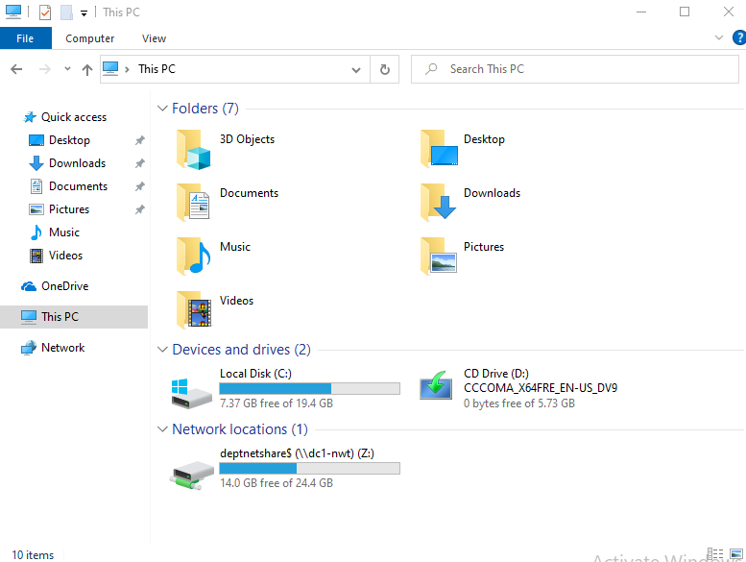

Group policy management
I created a new user in the new OU I created called ‘Non Admin Users’ to test the group policies I was about to create.

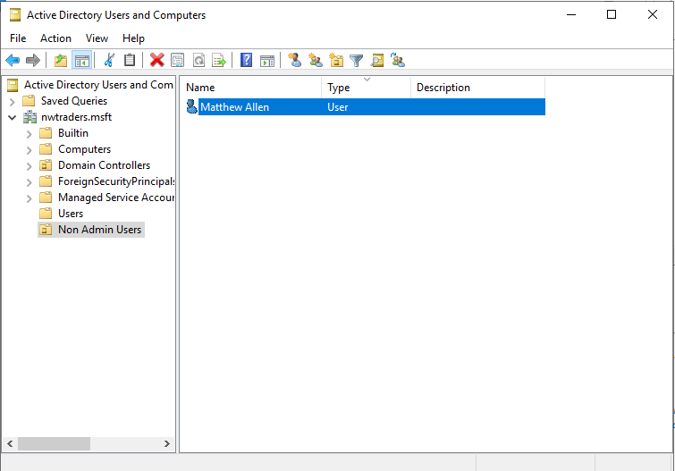

I created three user policies that will apply to all users in the ‘Non Admin Users’ OU the next time that they log in.
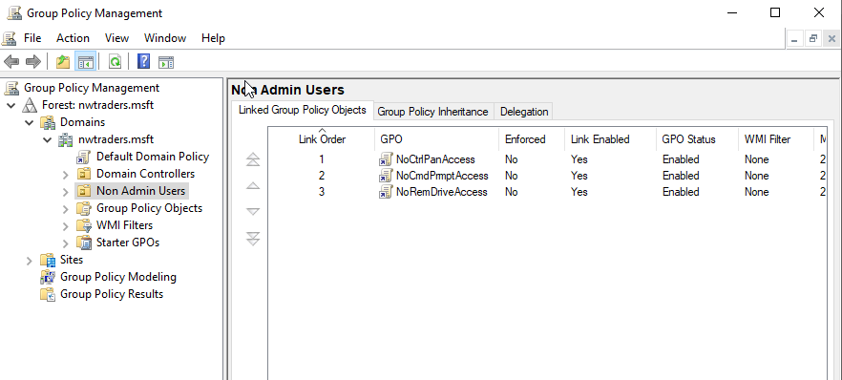

The group polices that I wanted to apply were already created so it was just a matter of finding the group policies in their folder. As you can see below the screenshot is for the ‘prohibit access to Control Panel and PC settings’ but this was the same method for the other two group policies.
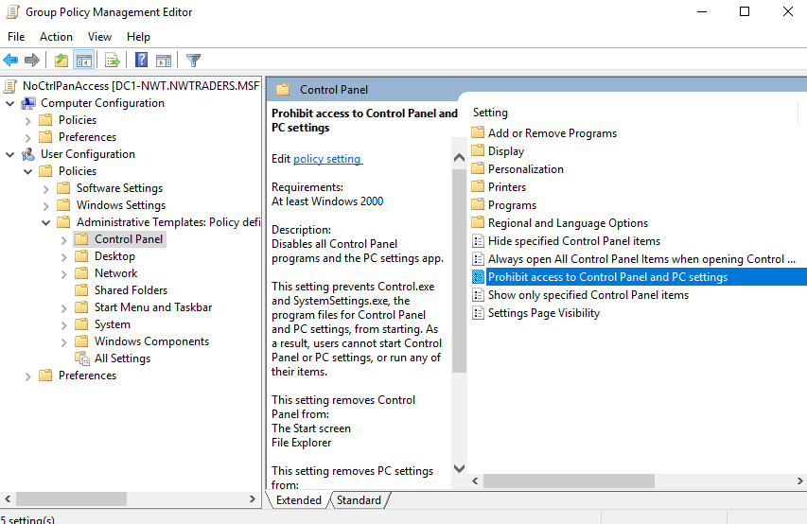

Once I found the policies that I wanted to enable I click on each of them and changed it from ‘Not configured’ to ‘Enabled’ and all three of the policies.
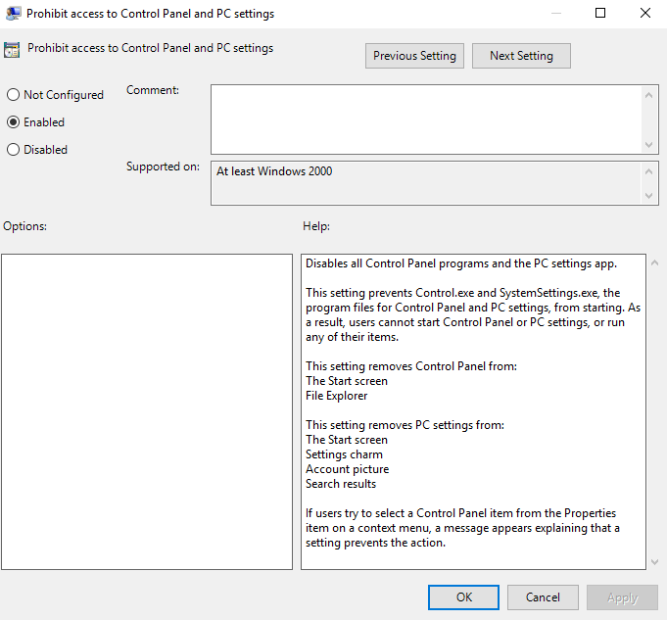

Preventing access to the command prompt – enabled.
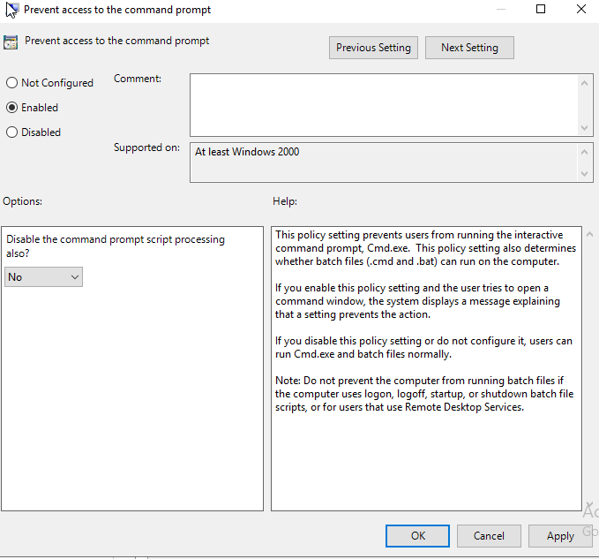

All removable storage classes: Deny all access – enabled.
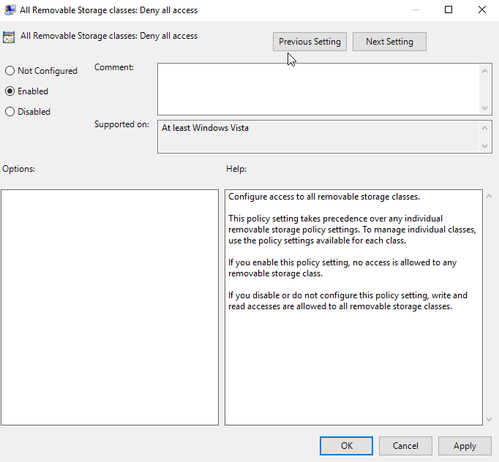

Screenshots showing all three policies working correctly.

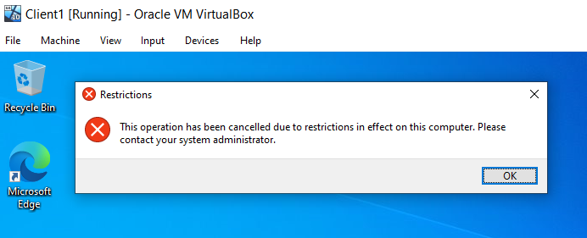
Trying to access the control panel.

Trying to open the command prompt.
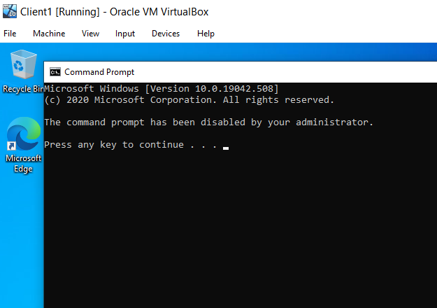

Trying to open a removable disk.

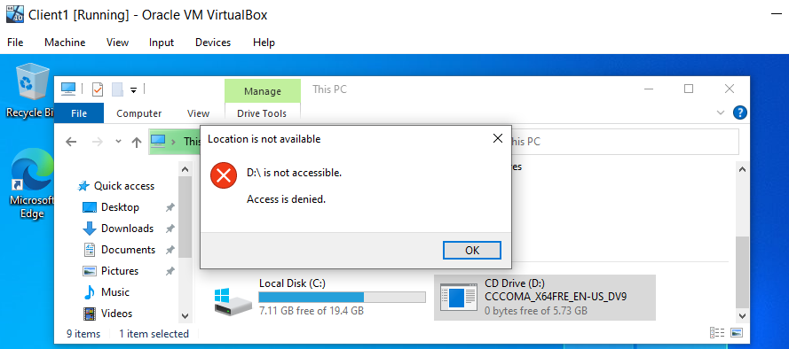

I created a new OU called ‘NWClient Computers’ and added client 1 to it so that I could test machine-based policies rather than user-based.

I created a policy to stop all users from installing any software unless their account has administrative privileges.
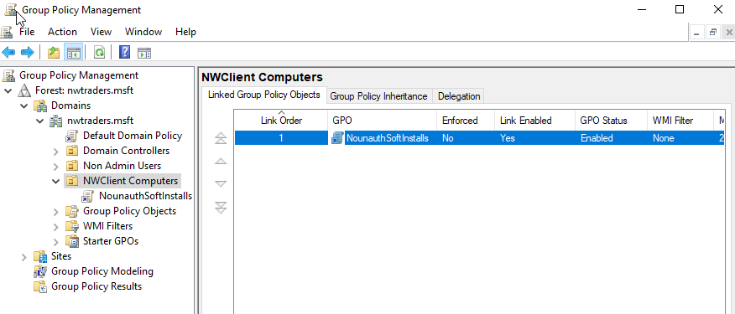

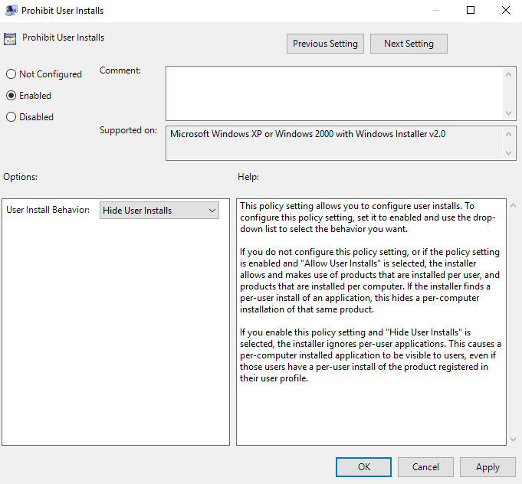
Prohibit User Installs – enabled.

Trying to install google chrome.
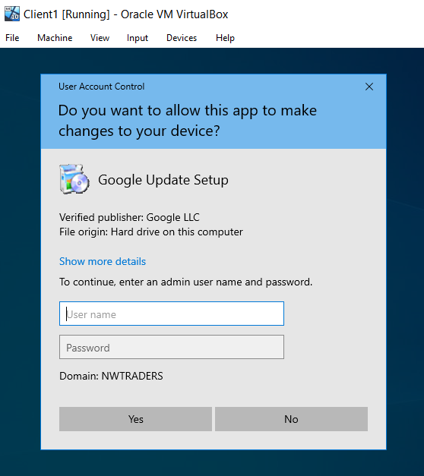
As the VMs are not connected to the internet it was not as simple as installing google chrome from the internet I had to use the ‘Insert Guest Additions CD’ and download google chrome onto my own laptop then create a shared folder that my VM could see.
Enforcing Password Policy
I set the password requirement policy for all users to improve the security of accounts so that they are less likely to be cracked by an attacker. The more complicated the password is then the less likely it is to be breached.
I set it so that users can’t use the same password again until they have used 8 different passwords.
I set the maximum password age to 31 days so that it must be updated every 31 days.
I set the minimum password length to 10 characters so that users can’t have a password shorter than 10 characters.
I set the password complexity requirements to enabled so that passwords must contain an uppercase, lowercase, number and special character to be accepted.
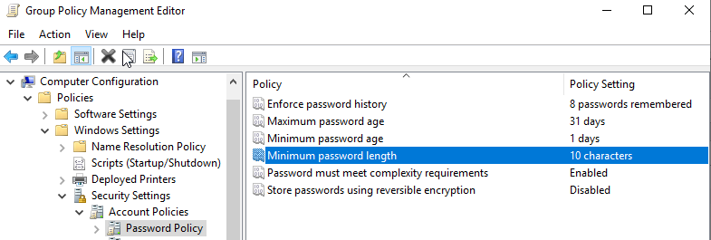

I tried to set the password as ‘abc123’ which was denied as it does not meet the password requirement that I set as expected.
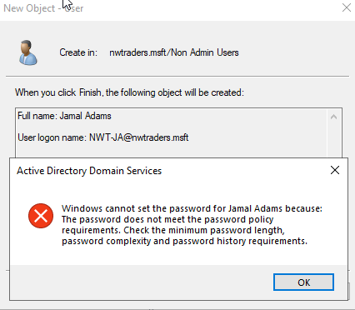

Task 3: Observational Tasks
3 a) Explain the main differences between local permissions and file shares.
Both NTFS permissions and share permissions shame the same purpose of preventing unauthorised accessing folders they are not supposed to access, however, there are some critical differences between the two.
New Technology File System (NTFS) is used to manage data stored on NTFS file systems. NTFS permissions apply to data stored in NTFS file systems, they affect both network and local users. There are two different types of NTFS permissions which are advanced and basic. Permissions are set to either allow or deny for any user to which there are a few options to choose from. Full control gives the user the ability to add, change, move and delete files. Users with full control can also set the permissions to other users such as give full access to another user or take their access away. The next permission option is modify, this allows users to view and modify files such as edit them or delete them. However, they can’t give full access to other users. The next is read and execute, this allows users to read files and run executable files such as scripts but they can’t modify files. The next set of permissions is read, this allows users to read or view files, properties and directories but not make any changes. Lastly, write allows users to write to a file or add files to a directory [1].
Share permissions are for managing the access to folders shared over a network, if a user is logged in locally and not on the network share permissions will not apply. Share permissions apply more generally to files and folder with three levels of access. Full control is the same as NTFS it allows users to read and modify files but also change the permissions on files to allow other users to access the file or folder. Change allows users to change data within the files such as adding new files or folders and delete them. Read only allows users to view and read files but not make any changes to them or delete them [1].
Share permissions are much simpler to manage especially on a large network but NTFS permissions give the ability to give more specific control to users. NTFS permissions only apply to users logged in locally but share permissions can be applied across networks. Share permissions also have the ability to restrict users to only access files or folders a certain number of times which could be useful for certain situations such as if inspectors need to have access to the network for a short amount of time [1].
It is possible to have both NTFS and share permissions enabled at the same time however, it isn’t best practice to do this as it can get confusing. If they are both enabled then the stricter access will take place, if the NTFS permissions are set to full control but share permissions are set to read then the user will only have read access.
The most important reason to pick between NTFS and share permissions is the security they provide. Data protection is vital to a company as almost all aspects of most businesses in the modern age rely on computer systems so if important files ended up in the wrong hands it could be detrimental to business. This is also important for customer trust and for legal compliance reasons, there would be large fines or legal action for not complying with data protection laws [1].

Best practices to follow using NTFS and share permissions: [1]

Assign permissions to groups rather than users – This makes it much easier to track who has what permissions especially if there are a large number of users on the network
Users should only have permissions to what they need and should have access to – It is very important that users do not have administrator access if they are not meant to have it as they will be able to do and see things on the network that they are not authorised to do. Also, users should only have access to the files that they should be working on, staff in finances shouldn’t have access to HR’s documents.
Do not allow users to use everyone folders to save any sensitive information as all users on the network will have access to this folder.

Summarised NTFS permissions provide more granular access controls but are more difficult to apply and manage compared to share permissions. NTFS permissions give the ability to control access to both network and local users, whereas share permissions will only apply to network users. Share permissions also allow you to limit the number of concurrent logons to a shared folder which will help to eliminate data misuse. NTFS is better at setting permissions for small groups but with shared permissions, it is easy to set permissions for large groups of users across the network making it much easier to manage [2].

3 b) Describe the role of Group Policy Management in the network environment, you can use example policies in your answer.
The primary role of Group Policy Management is for organisational security, group policies which are commonly referred to as Group Policy Objects make it so that IT professionals can effectively apply necessary cybersecurity controls across the network from a centralised location. This allows network administrators to push group policies that contain best practice procedures to users devices across the network based on specific organisational needs without having to individually apply this to each device on a regular basis. This saves hours of time that can be used in other areas to help improve the network [3].
An example of a group policy that can be forced to improve the network is to disable any external device a user plugs in such as a USB drive or CD disk drive. This will help protect the network as it can stop users inflicting malware onto the network by plugging in a storage device that has been infected into their PC or it can stop users from stealing data from the company. Another Group Policy Management tool that can be enforced is to mandate password requirements that meet complexity standards which will lower the chances of a user’s account getting their password breached as they will not be able to set it to a password that is easy to crack. By applying these sorts of GPOs organisations can easily make the entire network more secure and do it in a quick that is easy and efficient [3].

Group Policy Management is also used in Active Directory, the most common way to set this up is by using the Group Policy Management Console. GPMC simplifies group policy security functionalities and makes it easier to backup. Restore, import and copy GPOs with its easy to use interface. It also improves reporting for specific GPO settings and Resultant Set of Policy data while permitting access to preceding GPO operations. Programmatic access through the GPMC now includes the new Microsoft Management Console snap-in and additional programmable interfaces. With GPMC in Active Directory administrators have an overview of their GPOs, organisational units, domains and sites. This makes viewing, editing and settings new group policies much easier [3].

3 c) Give some examples of sound ‘password’ principles in modern network environments.

One example of a good password principle in modern network environments is by using multi-factor authentication. If this has been set up then a second factor will be required before a user is able to sign in, this is can be a code in a text message, phone call or more common recently is a code generated by an app or fob. This makes for a much more secure network as if a user’s password is breached by an attacker then without the second authentication device, they will not be able to do anything with the password they have obtained. Although it would make for a more secure network it is not required to have this authentication method on all devices and systems, in the office this would not be required as an attacker would have to enter a building and have direct access to the device to gain access to it. However, remote services such as remote desktops do require multi-factor authentication as they are much more prone to attacks [4].

Another example is using account lockout, this locks a user’s account out after a certain amount of incorrect credential attempts. A good amount of these to set is five giving the username multiple chances to get it right before having to contact their IT department to unlock their account. This stops the ability for attacks to try breaching an account using brute force which will attempt a load of different passwords combinations, this will not be possible with this enabled as you can’t sign into an account that is locked out. Although this can be susceptible to denial of service attacks it is worth the risk as it is more secure. Another problem with this is that legitimate users can get locked out of their accounts but they are able to contact their IT department to get them unlocked or some companies have ways in which users can unlock their accounts themselves with methods such as using a two-factor authentication method to sign in [4].
In addition, there are other methods for detecting and preventing the misuse of accounts that work alongside account lockout. Security monitoring can be used to detect malicious or abnormal behaviour such as login attempts that fail the second step of the multi-factor authentication, brute-forcing of account passwords, login attempts from unexpected geographical areas and reports of unusual account behaviour from users [4].

Another example is setting password requirements, this is very important to user’s having secure passwords. By implementing a password deny list it will prevent user’s setting simple and easy to crack passwords such as having their name in the password or ‘abc.123’ and it will not let users have the same password that they have previously had. Furthermore, complexity requirements can be set to improve passwords such as it must be 8 characters long contains and uppercase, lowercase, number and a special character. As well as these passwords can be set so they must be changed after a certain number of days so that if a password is breached then an attacker will only have access to the account for a certain number of days if they go unnoticed and it also makes cracking the password harder. Although this does improve security some organisations are opting for a different approach requiring users passwords to be at least 15 characters long and with uppercase, lowercase, numbers and special characters. This is because although it will be hard for users to initially remember what the password is once they know it will not have to be changed again and it will be much harder for a password of that complexity to be breached. It has also been found that when users change their passwords after a certain number of days they just add a number to the end of the password which is not very secure [4].

Another good use is protecting all passwords. One way of doing this by protecting passwords in transit as passwords can be intercepted while in transit so to protect them all corporate web apps should require authentication use HTTPS. Another way to protect passwords is to ensure that any passwords as never stored as plain text, all passwords stored must be encrypted using a hashed format so they are unable to be read without decrypting them [4].

Lastly, it is important to prioritise important accounts. Accounts that have administrator privileges should have a different password to that user’s normal account and should also require a more complex password so that it is harder for an attacker to breach as if an account which administrative privileges was breached it could be destructive to the entire network. These accounts should not be used for day to day tasks such as browsing the internet or using emails and only used when they are required to do a job that requires an elevated account. This is to lower the risks of that account being the victim of a cyberattack as it would be much worse than if a basic user account was breached [4].
References
[1]"NTFS vs. Share Permissions: What’s the Difference? - DNSstuff", Software Reviews, Opinions, and Tips - DNSstuff, 2021. [Online]. Available: https://www.dnsstuff.com/ntfs-vs-share-permissions

[2]D. Murphy, "What’s the Difference Between Share and NTFS Permissions?", Lepide Blog: A Guide to IT Security, Compliance and IT Operations, 2021. [Online]. Available: https://www.lepide.com/blog/whats-the-difference-between-share-and-ntfs-permissions/

[3]"What is Group Policy Management? Understanding GPO | N-able", N-able, 2021. [Online]. Available: https://www.n-able.com/blog/group-policy-management#:~:text=The%20primary%20use%20of%20Group,business%20from%20a%20centralized%20location.

[4]"Password policy: updating your approach", Ncsc.gov.uk, 2021. [Online]. Available: https://www.ncsc.gov.uk/collection/passwords/updating-your-approach

