Name: Kalpana Chiranjilal Mahawar
Student number: 2133406
Module: Human Marketing Management (LCMB7001)- Term 1
Lectures’ name: Tushara Balendran
Date of Submission: 6th September 2022
Word count: 3953



Introduction (Anon., n.d.) : “Maybelline New York trading as Maybelline is an American Multinational Cosmetics, Skin care, Fragrance and Personal Care Company based in New York. It was founded in Chicago in 1914 and has a Subordinate of French Cosmetics Company Loreal since 1996. Maybelline company was founded by Pharmacist Thomas Lyle Williams based in Chicago. Williams observed his older sister who use to apply a mixture of Vaseline and Coal dust to give her eyes darker and fuller look. He adapted the technique and used the same in Chemistry and made a product and sold it in the local market called Lash-Brow-Ine. William named this eye beautifier as “ Maybelline” in honour of her sister. In 1917, the company produced Maybelline Cake Mascara which was the First Modern eye Cosmetic for everyday use.

Background: In 1967, Maybelline was sold by Williams to Schering Plough in Memphis, Tennessee. The entire company was shifted from Chicago to Memphis. Schering Plough sold Maybelline to New York investment firm; Wesserstrein Perella & co. Maybelline headquarters remained in Memphis until its acquisition by Loreal 1996. The Headquarter was then moved to New York in 1996 and factory to Broklyn in 2000”.

Contents:

Introduction________________________________________________________3
Communication model________________________________________________4
Integrated Marketing Communication____________________________________6
Branding and Brand Equity_____________________________________________6&7
Customer Journey______________________________________8
- Strengths in Customer Journey for Maybelline______________________9
- Weakness in customer Journey for Maybelline______________________10

Customer’s Touchpint_________________________________________________10 to 11
- Touchpoints before purchase
- Touchpoints during purchase
- Touchpoints after purchase
Customer Journey Map___________________________________________16
Total Engagement Model__________________________________________17

Communication: A communication is a process by which information is exchanged between a sender and a received through a medium either verbally, by symbols, signs or behaviour.

Laswell Communication Model (Laswell, 1948):

American Pychologist, Harold Lasswell developed his communication model in the year 1948.

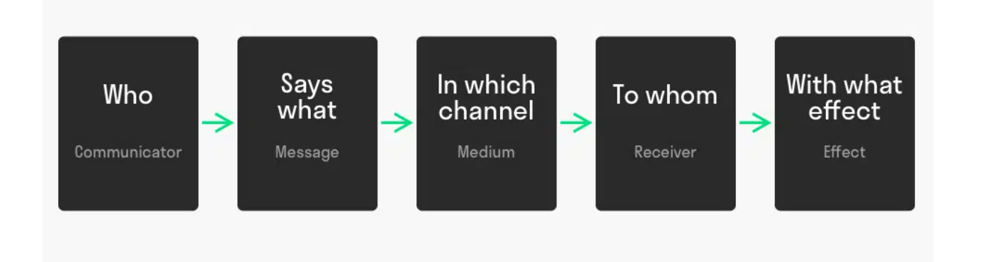
Source: https://www.toolshero.com/communication-methods/lasswell-communication-model/

The Laswell Communication Model describes verbal communication with five elements as described below:
- Who?
It is about the sender who sends the message to other end.

- What?
It is the content of the message or the message that a sender sends.

- Which channel?
This is the medium of communication. It can be digital, verbal and written.

- To whom?
It is the receiver at the other end.

- With What effect?
This is about how accurate the message is conveyed from one end to the other end. It depends on the language known whether it is verbal or written communication.

IMC (Integrated Marketing Communication) (Farooq, 2022) :

Integrated Marketing Communication is the marketing Strategy that links all the medium of Advertising or Promotion like social media (Instagram, Facebook, Twitter) and offline media like Newspapers, Magazines, Television, Radio, Cinema and outdoor. Its approach is to achieve maximum brand awareness among consumers through this channel combined.

Below are the tools for Integrated Marketing Communication:

- Advertising:
Advertising is making use of multiple platforms to create a brand awareness. By Advertising a brand can convey a message across various audience. This is the most expensive method; however, it is the most effective one.

- Sales Promotion:
It is a method for short term branding success. The sole purpose of this method is to draw attention towards a particular product or a brand.

- Personal Selling:
By this methos the interaction between the salesperson and the customer can be maximized which will help customers with the simple queries as well which won’t be possible in Advertising or Sales Promotion.

- Public Relations:
This is the method in which workshops, seminars are conducted to raise the brand awareness.

- Direct Marketing:
This is the online way of communicating directly to the customer. It includes emails, text messages or phone calls.

IMC for Maybelline (Shashtri, 2022) :

Maybelline being in a Beauty Industry can use all the forms of IMC, however the most effective one would be Advertising, sales promotion and Personal selling.

Advertising: Advertising it through the celebrity is the most common method in beauty industry, but Maybelline should endorse common women with average looks rather than celebrities to advertise just like Dove is doing. This way the consumers can relate themselves and will be more influenced to buy the products rather than thinking that it is a fake publicity.

Sales Promotion: Promoting Maybelline at Workplaces, Colleges and Universities can prove effective to raise the brand awareness. This is because nowadays women are more working and independent and they are conscious about their looks. They can display tester products at those places and even offer them a goodies or reward to influence them to use the products and that will create a image in their mind and they will go for a purchase later on. Even offers like buy 2 get 1 free or a free product on the shopping of some amount though digital marketing proves fruitful because this will help to advertise other products as well which customers might not have thought of or not have heard about.

New Promotional Strategies that Maybelline can use to raise awareness of the brand:

Though Maybelline has already established itself in global market but still any company that is established has a loophole which open up the gate for the barriers for the competitor. Apart from the existing strategies that Maybelline uses there are few suggestions that I would like to recommend to raise the awareness.

- Maybelline can provide some free gifts or products at discounted rates other than Cosmetics like Handbags or Footwear to the existing customers or to new customers. They can either make their customized products or purchase form other brands. This will not only increase the sale but will also help to increase the brand awareness because there are very rare brands who follow this promotional strategy.

- Maybelline can provide some free tickets for the couple or family movie or a free trip, because majority of the customers are young women who can be motivated to buy new products or more products so that they get a chance to win free tickets to spend some time with their partner or family. This will not only increase the sale but also the brand awareness.

- Maybelline can also promote by giving some discount coupons for the grocery shopping at minimum order like many businesses do, because grocery is the basic need for any household, hence women who shop at Maybelline will have a chance for some discounts at local groceries and this will again motivate them to buy more products.

Branding and Brand Equity (Anon., 2022) :

Branding is a logo name that a company uses for its identity in the market.

Brand Equity refers to the value premium that a company generates from a product or a range of products. Company can create their Brand Equity by making them memorable, easily recognizable and better in quality and reliability. A company with good brand name can claim higher price for those products which are available at lower price from competitors because they have developed trust with the customers.

There are three components in Brand Equity: Consumer Perception, negative and positive effects. Consumer perception is about the knowledge and experience. The perception that consumer holds directly impacts positive or negative impact. These factors can turn into either Tangible or intangible value.

Keller’s Brand Equity Model:

Keller’s Brand Equity model is a pyramid structure which gauge the Company’s identity, Its Identification and uniqueness, The customer’s response and the relationship between customer and the brand.

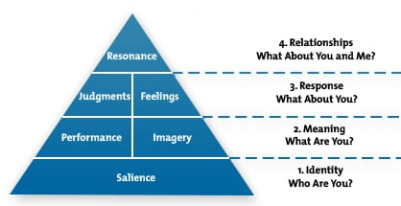

Keller’s Brand Equity Model for Maybelline (Kasi, 2022) :

- Identifying: Maybelline New York is one of the recognised cosmetic brands in the world, available in 120 countries. Its products ranges from Cosmetics like Foundation, Concealers, Primer, Colour corrector, Highlighter, Kajal, Mascara, etc to Fragrances and hair care. Maybelline focuses on realistic picture of the brand rather than just the celebrity looks. Majority if customers are happy that Maybelline has around 32 shades of Foundation which other brands lack which is one of the USP. Apart from that the easy availability of products in different is another USP. Maybelline uses Competitive positioning Strategy and Celebrity Endorsement.

- Meaning: Maybelline meets customer needs on a large scale. The products have long lasting effect and does not cause harmful effects on skin until in a scenario where customer’s skin is too sensitive. These qualities are also provided by other brands like Mac, Estee Lauder and Revlon however the price for the same range of product is less in case of Maybelline. Maybelline has met the psychological need of the customer because women with different skin colour feels valued that they are able to get the product which suites their skin colour and texture rather than an image of a fair complexed beauty which existed in the market for long time.

- Brand Response: Maybelline has received mixed response from consumers, but that will be the case for every brand. But on the positive side, Maybelline provides great customer service. There was a campaign launched called “B2me” which goals to educate customer about choosing and using the product according to their requirement. Maybelline has also introduced a colour studio Tour that treated customer like VIP. This studio provided customers with makeup consultations because makeup without a correct way can damage the look.

- Brand Resonance: This is at the top of the Pyramid because it is the most difficult stage to reach and many brands fail to do so. The average rating for Maybelline has increased from 2.7 to 4.4 starts and the number of reviews above 4 stars has risen by 35%. Hence this factor is fulfilled to a certain extent but not to the fullest because Maybelline has still not reached the Maturity stage in its Product Life Cycle. Maybelline uses all social media platforms like Facebook, Instagram, twitter and Pinterest.

Advantages of Keller’s Brand Equity Model:
- Keller’s Brand Equity Model helps to identify the uniqueness of the brand and the brand image compared to competitors
- It also helps to gauge the relationship between brand and its customers

Disadvantages of Keller’s Brand Equity Model:
- Keller’s brand equity model does not take into consideration the detailed market share and the profit.
- The topmost Stage of Resonance is difficult to achieve and only few brands have achieved the same.

Customer Journey
Customer Journey is a path of interaction between a customer and brand. Customer play role right from evaluating a brand to making a decision to purchasing to Feedback. In order to read a customer journey, a company should think from the customer’s point of view rather than as an entrepreneur. Customer journey mapping is a common strategy to understand the customer journey, which will provide the sum of the experience the customer has with the brand. This will help the brand to improve their Marketing strategy which will ultimately benefit brand and the customer both (Spiller, 2022) .

The Stages in the Customer Journey Map:

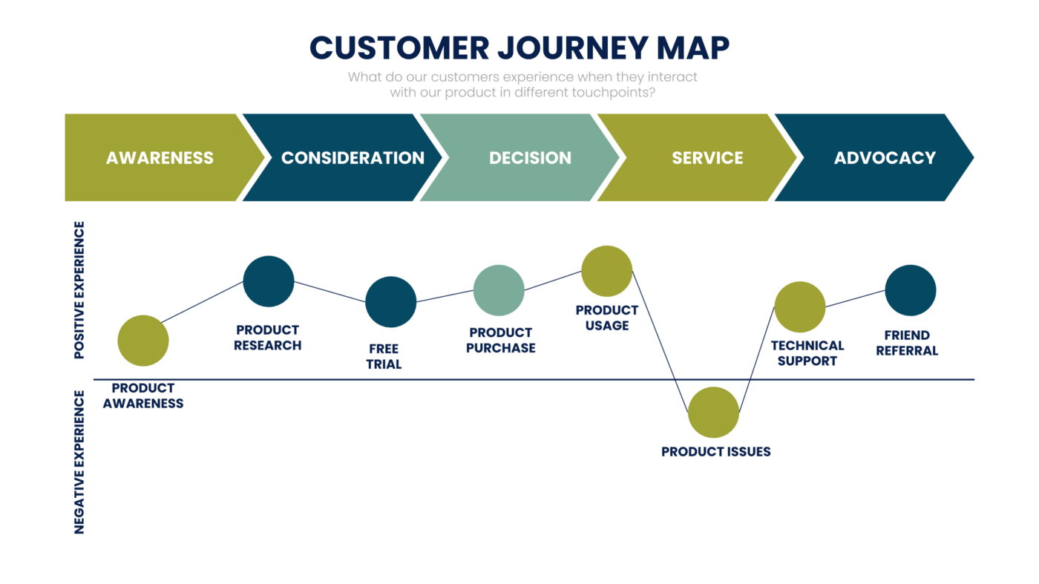

- Awareness: The Awareness stage is where a potential buyer becomes aware of your brand, through google, social media, or from a website or a reference.
- Consideration: The Consideration stage is where a potential customer has decided the product but wants to do more evaluation for other options in the market. In this stage they compare your brand with other brands.
- Decision: This is the stage where customer buys the product or sign up for the service.
- Retention: This stage is where the brand retain their customer by involving them to purchase the product on regular basis.
- Advocacy: This is the stage where customer shops with you and spreads the word about your product or service, by online reviews or to friends through word of mouth.

Maybelline’s Customer Journey:
Maybelline primary focus is on digital but offline conversations has soared in recent times according to data from Engagement Labs. Its Integrated Marketing Strategy is increasing brand sharing, which is the extent to which people are sharing or talking about brand’s marketing.

Strengths of Maybelline in Customer Journey Map (Gilliland, 2017)s :
- Give Customer to talk about: Maybelline’s strategy is to focus both on online and offline, they allow customer’s to share the reviews on social media and website and also to review offline directly with the salesperson. Maybelline has increased its offline brand sharing since July 2017, and reached its highest point in February 2018. This was 75% jump for this period compared to the previous 6 month period. Also online Branding increased 8% during the same period. The Visual content of Maybelline is so attractive that the customers has shared it face to face to friends as well.
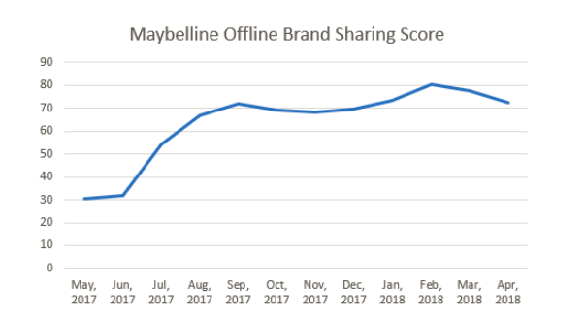

- Leverage an Integrated Marketing Strategy: Celebrity Partnership are another pillar of Maybelline’s Marketing strategy. Maybelline’s collaboration with supermodel Gigi Hadid has given the required limelight to be in the market. She has also advertised on her Instagram page about the new collection. This activities has created Favourable impact on the brand image.

- Harness the power of Everyday Influencers:
Maybelline also understand that celebrities are not the only one catching customer’s eye.
They have also collaborated with the the paid influencers like Shayla Mitchell. Apart from paid, they also go for unpaid influencers like customers who are also everyday influencers.
The offline referencing rose to 10.3% in the six months ending January 2018.

Weaknesses in the Customer Journey for Maybelline:
- Poor Social Media Presentation: Maybelline do not have that attractive social media presence like its rivals Revlon, Mac, Estee Lauder which does not leaves a great access for options
- Chemicals in Makeup: Maybelline has been alleged with the presence of too many chemicals in their makeup range. However this can be the case with any cosmetic Brand whether it has global recognition.

Recommendations:
Maybelline can go all vegan and Herbal products like many brands has already switched to. People nowadays are shifting more towards vegan diet and herbal products. This is difficult to achieve because being in a cosmetic industry the products will not have that effective and long lasting effect and might stand out form other brands like Revlon, Mac, Estee Luder, etc.

Customer Touchpoints (Anon., 2022) :
Customer Touchpoints are the various stages where the brand interacts with customers from start to end. Customer touchpoints are divided into three areas:
- Before Purchase: This Includes Online Marketing like social media, digital marketing, Referrals, Company events, etc
- During Purchase: This includes interaction with the salesperson, can be in the form of product catalogues, product reviews, website, etc.
- After Purchase: This can be in the form of Thank you letters, Feedback forms, Subscription renewals, etc.

Maybelline’s Touchpoints before Purchase (Gilliland, 2017) :
Maybelline uses social media platform like instagram, Facebook and Twitter to advertise online for its products. It also has its website and other retailers like Amazon and Flipkart for the online market where customers can check the detailed description about the products. Maybelline has also conducted many online events like “Maybelline sky high to challenge the limit livestream” in July 2007, “Maybelline Vinyl shine Livestream Festival” on July 2017 and many other events like ”It’s Shiny not Messy” in July 2016 on facebook.
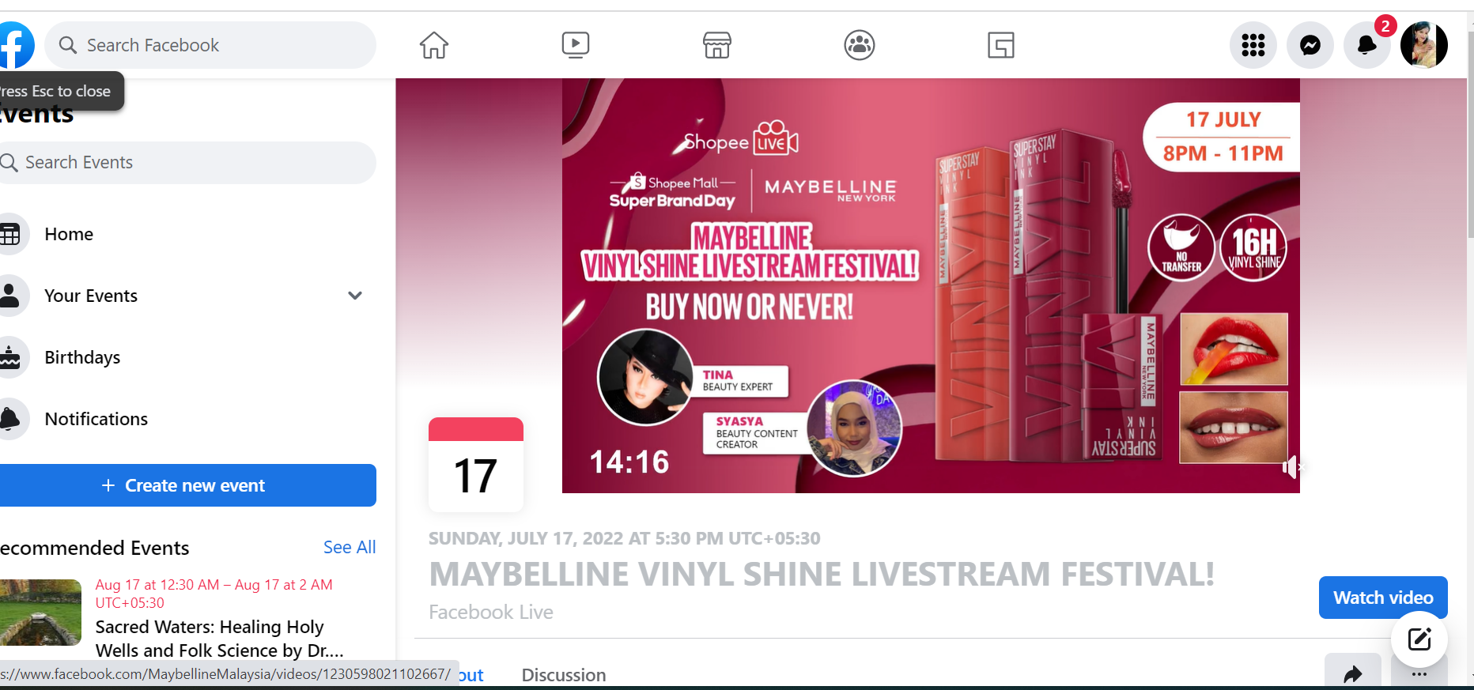

Maybelline’s Touchpoints during a purchase (Gilliland, 2017) :
Maybelline provides the facility of one-to-one conversation with the salesgirl, not only they sell the products but they also assist customers to choose the right products that suites their requirement and skin at the stores. All the Maybelline stores has a tester product so that it becomes easy for the costumers to check what suites them the most.
Below is one of the catalogue for Maybelline which is the most attractive catalogue seen, it display women of different geography with different skin colour.
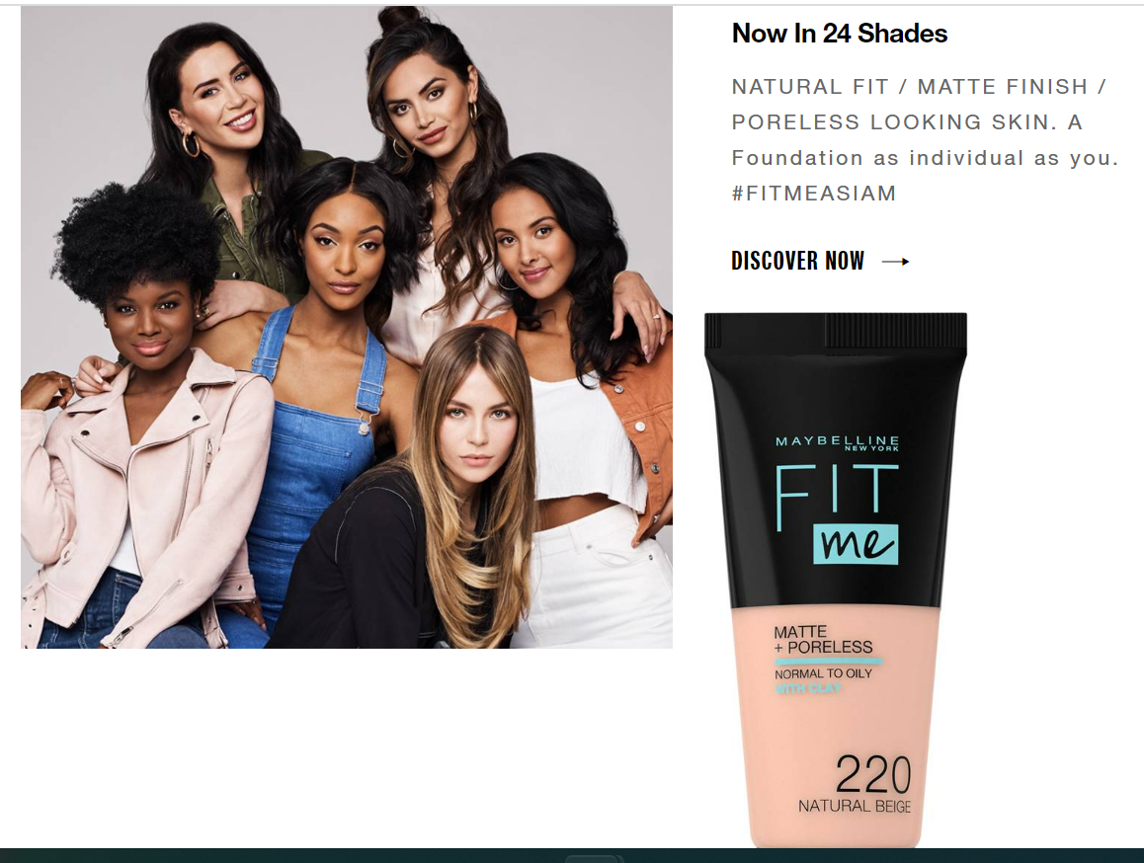

Maybelline’s Touchpoint after purchase (Gilliland, 2017) :

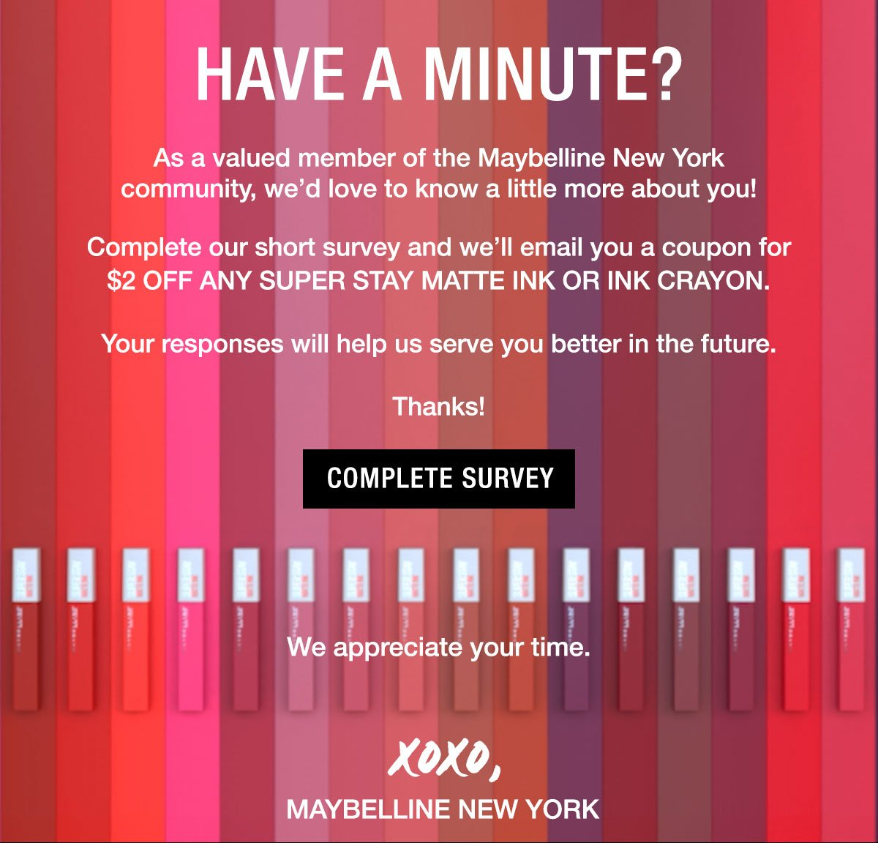

Source: https://milled.com/maybelline/your-feedback-is-important-to-us-kyoZrg8nrDRKvYmQ
Maybelline provides an option for the feedback of the products purchased on various sites like sitejabber, Amazon and its own website as well. Also they send regular emails for the new offers to the customers.

Customer Journey Map
Customer Journey Map is the visual representation of the steps a customer takes to complete a particular action throughout the customer journey in terms of customer touchpoints.

Benefits of Customer Journey Map:

- Evaluate the overall performance: Customer journey map makes it easy to visually identify the areas of attention.
- Understand Customer needs: Ease the customer experience that might be difficult in the past.
- Improve Decision making: Helps to determine the next step based on the customer’s actual experience.
- Improve the customer Experience: Customer journey map is like an easy navigator where a brand can quickly understand and implement and improve the customer experience.

Customer Journey Mapping for Maybelline (Current State):

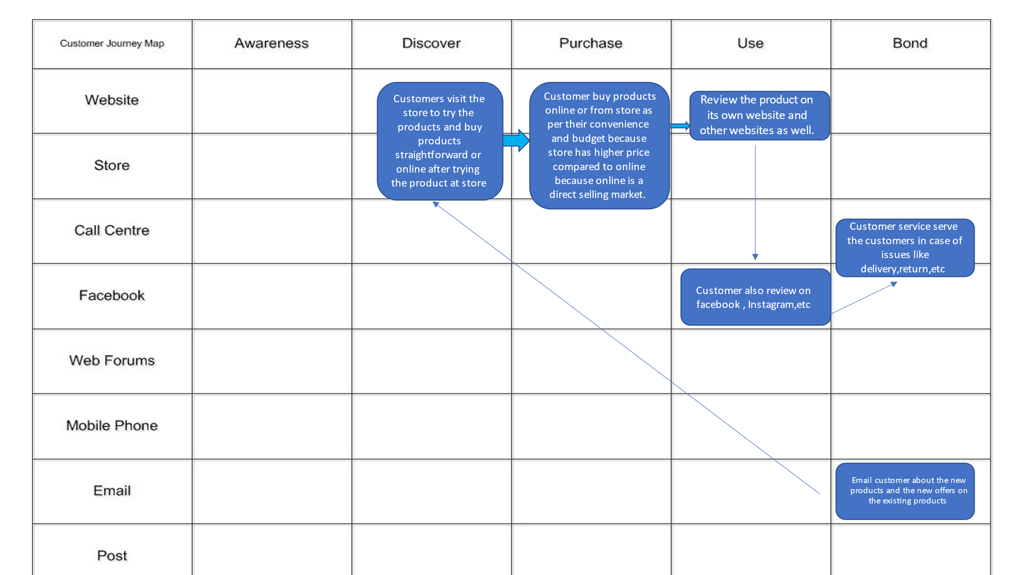

Total Engagement Model (Roberts, 2010)
The Success of a business is driven largely by whether customers decide to purchase its products. If the organization makes attempt beyond just one time purchase and attempts to engage the customers with the brand, helps to improve the business performance and the sales.

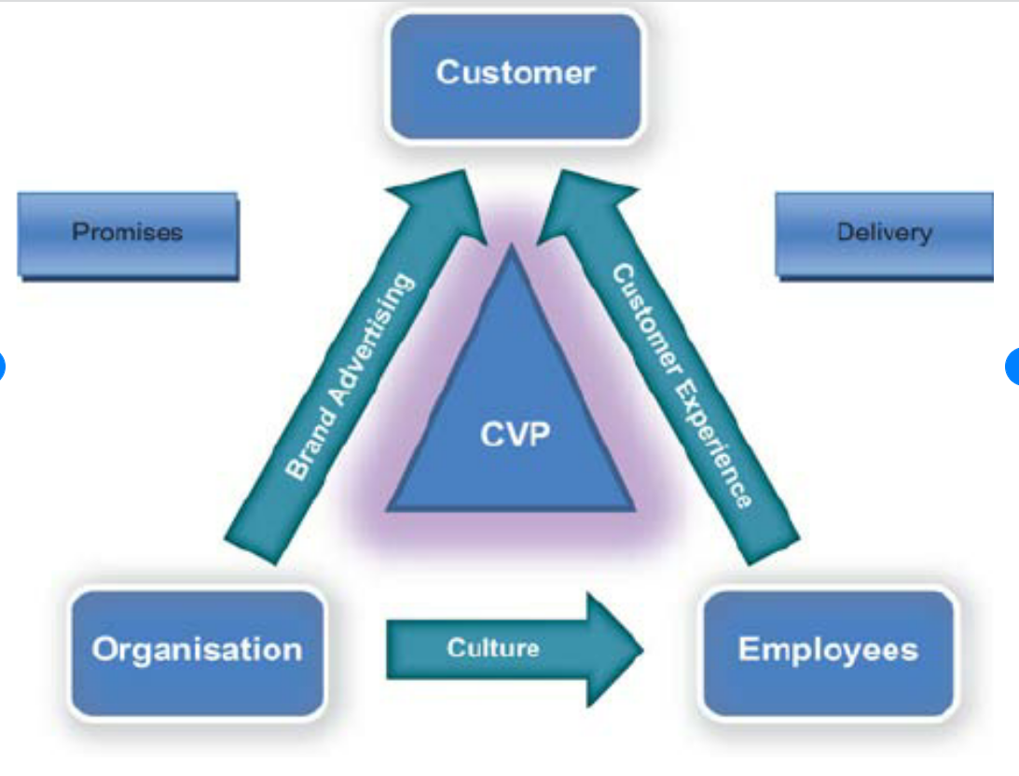

There are 5 different degrees of engagement levels for the customers for any brand:

- Level 1: Where customer purchase a product or service.
- Level 2: Where customer is loyal to a product or service.
- Level 3: Where customer readily buys other products.
- Level 4: Where customer recommends the product or brand to others.
- Level 5: Where customer becomes an advocate for the brand and promotes the same.

The Survey has proven that brands with more engaged customers are more successful than the brands with one-time customers. Examples include Apple, Adidas, Nike, Cadbury, etc. The question is how to create engaged customers? Though looks simple but is not.
There are key strategic elements that are designed to create engaged customers.
- Customer Value Proposition
- Brand
- Internal Culture elements
- Customer Experience
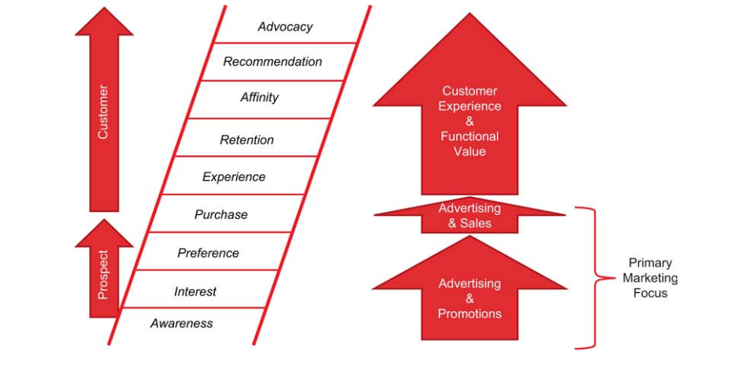

If a brand acknowledges to deliver a distinct value proposition and customer experience to create engaged customers, there should also be other two elements that needs to be aligned along with the other two. This includes brand and second one is internal culture as this is the key factor in delivering a distinct value proposition.

1. Brand: Brand Is not just the name or the logo, it is the total of who the company is and what they stand for. Majority of the companies have a logo and name but they lack brand name and brand loyal customers
2. Culture: Culture refers to the way things are done in an organization, values and internal behaviour. The Beliefs that the employees and employer have.
3. Customer Experience: Customer Experience is a combination of physical and emotional experience. Or in other words what a company actually deliver when they interact with their customers.
4. Customer Value Proposition: This refers to the value a brand offers to the customers. In simple word, the reason why a customer should buy from your brand compared to competitors.

To Create Engaged Customers an organization should implement the following steps:
- Develop a Unique Value Proposition on the basis of strong customer insights.
- The Brand should convey the Value proposition to its customers in its advertising.
- The Staff should deliver the promise by understanding the importance of their role in making it a success.
- This Cultural foundation results in the delivery of great customer experience.

How to Implement the Total Engagement Model (Roberts, 2010) :
The organization that is customer focussed has aligned their customer value proposition, brand, culture, and customer experience. The total engagement model can be explained for the below diagram:

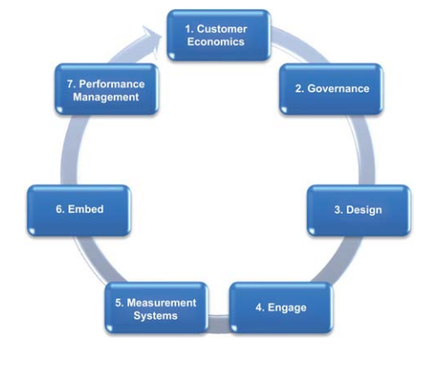
- Customer Economics: This can be done by defining engaged vs non engaged customers and comparing them in terms of loyalty and wallet share.
- Governance: By creating a customer programme committee where all key functional areas of the customers are represented.
- Design: Designing all the key strategic elements of the total engagement model. Can start with the vision.
- Engage: Engaging the employees of the organization in the creation of engaged customers. Not just employees but also the leaders.
- Measure: Measuring customer engagement level in terms of consideration, recommendations and Loyalty.
- Embed: Encouraging the employees and leaders to develop innovative initiatives.
- Performance Management: Managing, recognizing and rewarding in terms of values.

Total Engagement Model for Maybelline:
According to a survey shared by ShareIQ in 2017, Maybelline has encountered highest number of engagements for a cosmetic brand across social media platforms in the same year.
It has generated nearly 60m likes on Instagram which is 49 times the amount of the rival brand Revlon. Also Maybelline has over 100,000 followers on Instagram until 2017 compared to just 60,000 for Estee Lauder and Covergirl.

What is Maybelline doing to engage its customers?
Maybelline has a rigorous social media strategy. Being in an industry that relies heavily on social media and media, Maybelline has always been able to engage its audience on social media. Not just staying top on the trend but also focusing on improving the pages to improve the customer experience. Maybelline send free samples of its products to consumers in order to encourage and engage them to post reviews on social media about the product or the brand.
These consumers do not always have a large online presence, which means they don’t necessarily count as ‘influencers. Maybelline recognises the power of everyday consumers in this sense, specifically when it comes to promoting the brand to a larger audience. While influencers can promote the glossier, perhaps slightly more high-end aspects of the brand, user-generated content tends to be more authentic, showing others that it can be accessible and affordable for everyone.
Not just the online speaking that Maybelline uses to engage its customers but the most important thing that has made Maybelline stand odd out is it reach to different countries. It has understood the value of different culture and beliefs. Hence the respect for values has always been there when it comes to Maybelline.

How is Maybelline engaging the customers?
Maybelline uses sampling campaign to collect reviews on 200 products by selecting a squad with members. Once Maybelline identifies right members for the campaign the brand ships the product along with a thank you message and a detailed explanation for the guidance. They also send emails to customer with the invite link to share the feedback.

Not just collecting their reviews but Maybelline creates a real impact of the consumers’ review by enriching the pages with authentic content. The brand has already responded to 75% of its consumer’s review which is a huge number to achieve for any brand.

Conclusion:
Maybelline has fulfilled its customer’s needs and demands not just financially but also Culturally.
It has always been a customer centric brand focusing on the costumer social demands and values rather than just the market share. It has focused on the market which was ignored on longer run, because traditional cosmetic industry has always focused on women with fair complexion and has ignored the dark-complexioned women, Maybelline has broken that barrier and has set a new trend that “everyone is beautiful”

References
Anon., 2022. Investopedia. [Online]
Available at: https://www.investopedia.com/terms/b/brandequity.asp
[Accessed July 2022].
Anon., 2022. QuestionPro. [Online]
Available at: https://www.questionpro.com/blog/customer-touchpoints/
[Accessed July 2022].
Anon., n.d. wikipedia. [Online]
Available at: https://en.wikipedia.org/wiki/Maybelline
[Accessed July 2022].
Farooq, U., 2022. Marketing Tutor. [Online]
Available at: https://www.marketingtutor.net/integrated-marketing-communication/
[Accessed July 2022].
Gilliland, N., 2017. Ecoconsultancy. [Online]
Available at: https://econsultancy.com/a-close-up-look-at-maybelline-s-brow-raising-success-with-visual-content-on-social-media/
[Accessed July 2022].
Kasi, 2022. Marketing Mixx. [Online]
Available at: https://marketingmixx.com/brand-equity-of-maybelline/
[Accessed July 2022].
Laswell, H., 1948. Toolshero. [Online]
Available at: https://www.toolshero.com/communication-methods/lasswell-communication-model/#:~:text=The%20Lasswell%20model%20of%20communication,what%20effect%20the%20message%20has.
[Accessed July 2022].
Roberts, C., 2010. Total Customer Engagement. 2022: Research Gate.8e;ll
Shashtri, A., 2022. The Digital School. [Online]
Available at: https://iide.co/case-studies/marketing-strategy-of-maybelline/
[Accessed July 2022].
Spiller, L., 2022. GetApp. [Online]
Available at: https://www.getapp.com/resources/customer-journey-stages/
[Accessed July 2022].

