Task 1:
#include <16F877A.h>
#use delay(crystal=4MHz)

// array containing 7 segment configurations
char digits[] = { 0xC0, 0xF9, 0xA4, 0xB0, 0x99, 0x92, 0x82, 0xF8, 0x80, 0x90 };

int main (void) {
// program loop
while (1){
// iterating through numbers to display
for (int i=0; i<10; i++) {
output_d(digits[i]); // outputting configuration to port
delay_ms(2000);
}
}
return 0;
}

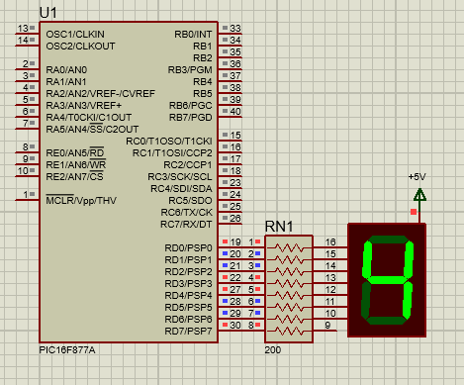

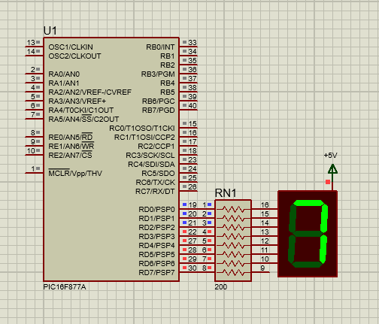

Task 2
#include <16F877A.h>
#use delay(crystal=4MHz)

int main (void) {
// Program loop
while (1) {
// Testing if button has been pressed
if (!input_state(pin_C1)) {
output_b(0xFF); // turn on LEDs
}
// If it hasn't
else {
output_b(0); // turn off LEDs
}
}
return 0;
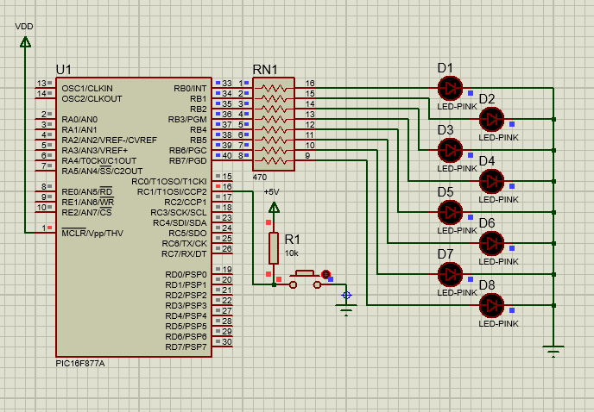
}

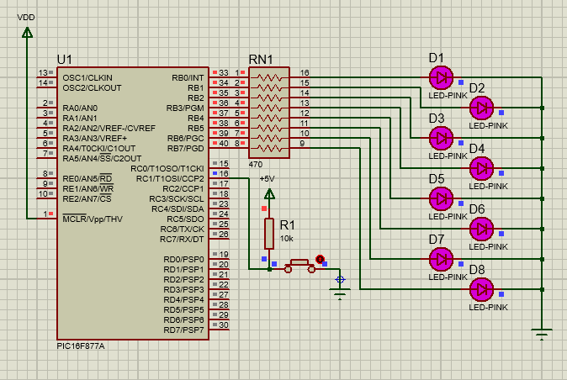

Task 3
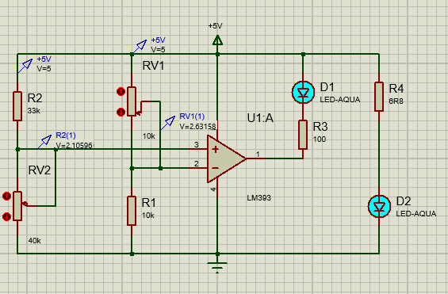
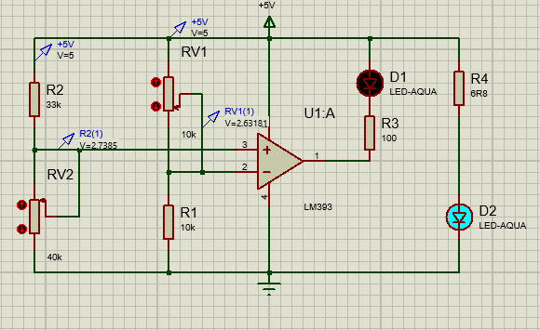

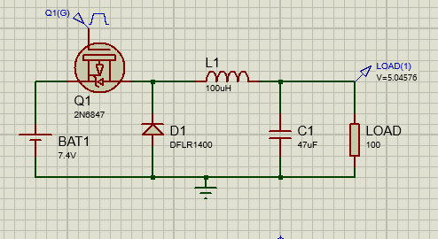
Task 4

