A REPORT ON HOTEL STANDARDS, REPUTATION MANAGEMENT, BUILDING AND RETAINING CUSTOMER LOYALTY
BY
Proshanto Kumer Ghosh
ID Number: 2208057
Module title: Hospitality & Guest Services in the Hotel Industry
BMIH4003
Name of the lecturer: Kathryn Flynn

Executive Summary
The industry research provides a comparison of the various international hotel players around the world. This study also emphasises the Hotel Standards and the goal of brand consistency criteria. It has been acknowledged that hotels skilfully manage their reputations. The value of managing customer reviews well is assessed. In order to provide suggestions to improve the product, the impact of unfavourable reviews is examined. This study focuses on examples and case studies from the hotel and hospitality sectors. The topic of hotel customer loyalty building and retention as well as hotels' goals in relation to market changes is covered. This industry research conveys the challenges that certain businesses face after adopting reasonable and pertinent recommendations for the hotel sector.

Table of Contents
Introduction 3
Main Findings 3
Analysis 3
Comparing different global hotel players 3
The purpose of brand consistency standards 3
Hotels maintaining reputation management effectively 4
The importance of effective guest reviews management 4
The impact of negative reviews 5
Discussion 6
Examples and case studies from the hotel and hospitality industry 6
Hotels building and retaining customer loyalty 6
The purpose of hotels regarding market trends 7
The obstacles facing certain businesses 7
Conclusion 7
Recommendations 8
Reference 9

Introduction

The comparison of various international hotel players from around the world is included in the industry study. In this study, the Hotel Standards and the goal of brand consistency criteria are also underlined. Hotels that efficiently manage their reputation have been recognised. The significance of managing customer reviews effectively is assessed. The impact of unfavourable reviews is examined in order to provide suggestions for how to make improvements. In this study, the hotel and hospitality industry's examples and case studies are highlighted. The discussion includes how hotels establish and maintain client loyalty as well as their goals with reference to market trends. This industry research communicates the challenges that certain organisations face after implementing sensible and pertinent advice for the hotel sector.

Main Findings Analysis

Comparing different global hotel players
The global hotels are compared on the basis of the three-star rating system. The 5-star, 4-star, 3-star, 2-star and 1-star are given in general to the hotels. Nowadays 7 stars are also available. The reported organisation recognises the hotels based on AA, AAA, Forbes travel guide, Australian Auto clubs and Hostess. Hotels providing 24/7 room service, wifi, tv, food, laundry, jacuzzi etc from high-rated hotels come under 5 tart or 4 stars with fewer exceptions and privileges (Latif et al. 2020). And the reduction of certain technologies or facilities brings down the ratings one by one to 1 star. Apart from these, a Hospitality quality award is organised for the hotels. This also encompasses mystery shopping that is offered by hotels.

The purpose of brand consistency standards

Consumers often rely on brand price as a key commercial cue when making decisions. A comparative cost is essentially any cost incurred during earlier acquisition transactions, including costs paid by other customers for comparable goods or services. The strategy of ensuring client satisfaction by offering them a setting, high-quality services, high-quality products, and fair prices boosts the reputation of brand names in the hotel sector (Guan et al. 2021). The perceived service quality and important characteristics of a global brand play a significant role in determining its value. Owing to their pre-notion view, many buyers make purchases from reputable and well-known companies or industries. By doing this, the consumer demonstrates their strength and raises their social position. Customers who investigate renowned trademarks specifically connect their pleasant demeanour to the purchasing power of prestigious and well-known brands.

Hotels maintaining reputation management effectively

One of the key factors that determine a company's prosperity is preventing divergence from a narrow perspective. A company must create the required assets and build a strong reputation in order to effectively communicate to consumers what it is that the brand stands for. It is possible to grasp the methods that a respectable firm employs to retain its professional image throughout time (Priyoet al. 2019). This has trained numerous hotel staff members to be able to overcome obstacles in their attempts to uphold the hotel's reputation. To enhance the reputation of a hotel globally, the influences through social media help a lot in grabbing the attention of more tourists and customers (Fernandes Sampaio et al. 2020). Apart from that, the TripAdvisor website works a lot in helping customers find the best hotels. Also, digital management responses are equally useful for the reputation management of the hotel and lastly, the reviews by the guests already visited to the hotel help the hotel to gain more reputation.

The importance of effective guest reviews management

A company needs to follow a constant course if it wants to flourish. The investigation of the Hotel has demonstrated how the business has preserved its level of customer service while remaining true to its goals over time. Depending on their experiences with a company or brand, customers may behave, act, as well as react in unexpected ways (Alkitbiet al. 2021). The brand's producer must be aware of the needs and preferences that customers have. The effective reviews of the guest help the company to follow “The Service Recovery Model” - Learn which is abbreviated from listen, empathise, apologise, resolve and Never Repeat. Aso, complaint management is handled properly by the hotel’s ager the guest reviews. Thus, this enhances the overall performance of the hotels in order to grab more customers.

Figure 1: Guest Feedback
(Source: Marinakou and Giousmpasoglou, 2019)

The impact of negative reviews
When a new hotel venture begins, the threat is probably present. When hotels take a bold stance in an area with a wide variety of other hotels, competitiveness is likely to rise. The external and interior decoration of a hotel, like a magnificent hotel in the UK, as well as superb hospitality and first-rate availability, can help it stand out in a crowded location (Marinakou and Giousmpasoglou, 2019). Although technological advancements are accelerating and making it more difficult for hotels to modify their surroundings for a better visitor experience, The attitude of hotels in the UK has improved with the rise of virtual and digital meetings and gatherings, keeping the motel within the 10 most popular hotels worldwide. At times when a new hotel opens, competitions increase (Rather and Camilleri, 2019). As different hotel components provide the tourist with identical services, competitive strength erodes over time.

Discussion

Examples and case studies from the hotel and hospitality industry
The branded hotels as per the case study follow Marriots’s Acquisition of Starwood for brand consistency. Apart from this, hotel franchising is seen that is important to maintain brand values (Khan et al. 2022). This proves trust, increases competition outdoors and harnesses emotions and mowers. Moreover, empowerment is needed to make strong decisions and increase customer relationships. The Service Recovery Paradox (SRP)

Hotels building and retaining customer loyalty
A company's success depends on its ability to satisfy its customers. It should be far more important to the company than growth. The word "customer experience" refers to the viewpoint and feelings a customer develops when purchasing something from a brand or using its services. A firm cannot manage or have any control over the experiences a customer has, according to Amponget al. 2021. The company should take into account what its customers think of its products or services. The purpose of organising loyalty programs for customers helps the hotels to identify their potential visitors who can help them in increasing their brand image and reputation (Anabilaet al. 2022). Also, the loyalty programs for the customers help in enhancing the existing customer's loyalty to increase along with engaging new customers too for the growth and development of the hotels.
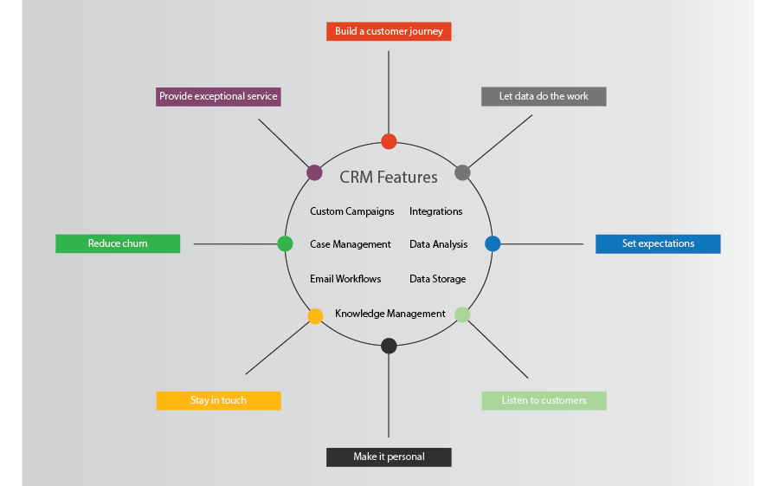
Figure 2: Customer Retention
(Source: Marinakou and Giousmpasoglou, 2019)

The purpose of hotels regarding market trends
The hotels are built and run for quality assurance and mystery shopping audits overdosing on the market tends. The purpose of the hotels based on market trends evaluates customer service and increases the experience of the customers (Alketbiet al. 2020). The improvement in competitive analysis and competitive advantage is also observed in such scenarios. In addition to this, the delivery of optimal service to the guests supports the employees by increasing the guest's expectations.

The obstacles facing certain businesses
The pitfalls and operational flaws can be big obstacles for hotel businesses. Also, expensive items or rooms, along with a lack of ROI can be an obstacle. False premises, lack of staff awareness, Unnatural service, lack of authenticity, Lack of privatisation, heavy workload, not enough data, and lack of time sensitivity are also certain factors that can be great obstacles faced by the hotel and hospitality industry.

Conclusion
The industry report summarises the comparison of different global hotel players all across the world. The Hotel Standards along with the purpose of brand consistency standards are also highlighted in this study. Hotels maintaining reputation management effectively have been recognised. The importance of effective guest reviews management is evaluated. The impact of negative reviews is analysed to give an insight into the fact of providing suggestions to improve the same. Examples and case studies from the hotel and hospitality industry are focused on in this study. Hotels building and retaining customer loyalty along with the purpose of hotels regarding market trends are discussed. The obstacles facing certain businesses following realistic as well as relevant recommendations to the hotel industry are conveyed in this industry report.

Recommendations
Realistic recommendations to the industry
- The engagement of workers in decision-making, problem-solving, and strategy development is a hallmark of effective quality management.
- Stability in quality: Quality control guarantees long-term continuous improvement in the services in addition to standard performance for a contemporary product (Kim and Han, 2022).
- Profitability: The company's ability to produce items with a focus on the needs of the client and reduce wattage has helped it become more profitable.
- Growth administration: Quality Assurance gives businesses a competitive edge by setting them apart from rivals, which in turn promotes market expansion.
- Dedicated management: Leadership is essential to total quality management because it enhances the effectiveness of other organisational activities. One of the first established businesses in the UK, hotels have a sizable workforce (Sen and Bhattacharya, 2019). In order to maintain process quality in such a setting, the business would need to concentrate on leadership.
- Procedure mapping: The order of the interactions would be specified, identifying the specific person in charge of each task (Chi et al. 2020).
- The aim of the organisation would be to serve the best excellence to the consumers after the quality policy had been set.

Reference
Alketbi, S., Alshurideh, M. and Al Kurdi, B., 2020. THE INFLUENCE OF SERVICE QUALITY ON CUSTOMERS'RETENTION AND LOYALTY IN THE UAE HOTEL SECTOR WITH RESPECT TO THE IMPACT OF CUSTOMER’SATISFACTION, TRUST, AND COMMITMENT: A QUALITATIVE STUDY. PalArch's Journal of Archaeology of Egypt/Egyptology, 17(4), pp.541-561.
Alkitbi, S.S., Alshurideh, M., Al Kurdi, B. and Salloum, S.A., 2021. Factors affect customer retention: A systematic review. In Proceedings of the International Conference on Advanced Intelligent Systems and Informatics 2020 (pp. 656-667). Springer International Publishing.
Ampong, G.O.A., Abubakari, A., Mohammed, M., Appaw-Agbola, E.T., Addae, J.A. and Ofori, K.S., 2021. Exploring customer loyalty following service recovery: a replication study in the Ghanaian hotel industry. Journal of hospitality and tourism insights, 4(5), pp.639-657.
Anabila, P., Ameyibor, L.E.K., Allan, M.M. and Alomenu, C., 2022. Service quality and customer loyalty in Ghana’s hotel industry: The mediation effects of satisfaction and delight. Journal of Quality Assurance in Hospitality & Tourism, 23(3), pp.748-770.
Chi, C.G.Q., Wen, B. and Ouyang, Z., 2020. Developing relationship quality in economy hotels: the role of perceived justice, service quality, and commercial friendship. Journal of Hospitality Marketing & Management, 29(8), pp.1027-1051.
Fernandes Sampaio, C.A., Hernández Mogollón, J.M. and de Ascensão Gouveia Rodrigues, R.J., 2020. The relationship between market orientation, customer loyalty and business performance: A sample from the Western Europe hotel industry. Tourism and Hospitality Research, 20(2), pp.131-143.
Guan, J., Wang, W., Guo, Z., Chan, J.H. and Qi, X., 2021. Customer experience and brand loyalty in the full-service hotel sector: the role of brand affect. International Journal of Contemporary Hospitality Management, 33(5), pp.1620-1645.
Khan, R.U., Salamzadeh, Y., Iqbal, Q. and Yang, S., 2022. The impact of customer relationship management and company reputation on customer loyalty: The mediating role of customer satisfaction. Journal of Relationship Marketing, 21(1), pp.1-26.
Kim, J.J. and Han, H., 2022. Saving the hotel industry: Strategic response to the COVID-19 pandemic, hotel selection analysis, and customer retention. International Journal of Hospitality Management, 102, p.103163.
Latif, K.F., Pérez, A. and Sahibzada, U.F., 2020. Corporate social responsibility (CSR) and customer loyalty in the hotel industry: A cross-country study. International Journal of Hospitality Management, 89, p.102565.
Marinakou, E. and Giousmpasoglou, C., 2019. Talent management and retention strategies in luxury hotels: evidence from four countries. International Journal of Contemporary Hospitality Management.
Myo, Y.N., Khalifa, G.S. and Aye, T.T., 2019. The impact of service quality on customer loyalty of Myanmar hospitality industry: the mediating role of customer satisfaction. International Journal of Management and Human Science (IJMHS), 3(3), pp.1-11.
Priyo, J.S., Mohamad, B. and Adetunji, R.R., 2019. An examination of the effects of service quality and customer satisfaction on customer loyalty in the hotel industry. International Journal of Supply Chain Management, 8(1), pp.653-663.
Rather, R.A. and Camilleri, M.A., 2019. The effects of service quality and consumer-brand value congruity on hospitality brand loyalty. Anatolia, 30(4), pp.547-559.
Sen, K. and Bhattacharya, A., 2019. Attracting and managing talent, how are the top three hotel companies in India doing it?.Worldwide Hospitality and Tourism Themes, 11(4), pp.404-417.

