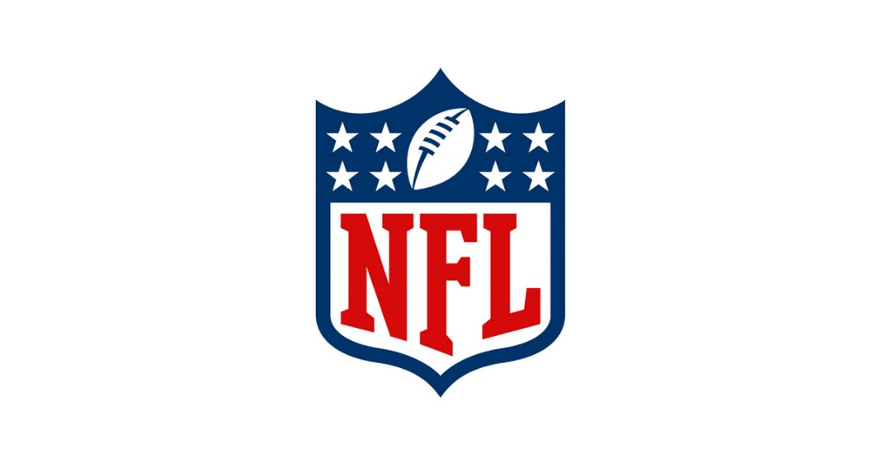



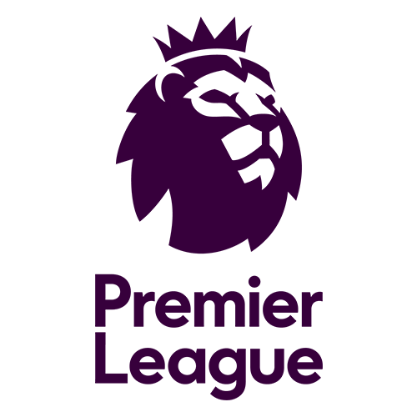



The International Sports Market

Professional Team Sport – US vs UK model

James Prosser

Alice Surgy, p147900
Contents
Introduction 2
National Football League (NFL) 3
History 3
League 3
Teams 3
English Premier League (EPL) 4
History 4
League 4
Teams 4
Partners/Stakeholders 5
Club Ownership between NFL vs EPL 5
Premier League 5
National Football League 6
Club Relocation 6
League Structure 7
Competitive balance 7
TV Broadcasting and Sponsorship 8
NFL 8
EPL 9
Overview 10
Conclusion 11
References 13
Appendix 16
(1) Premier League fixtures as of 20/03/18 according to Sky Sports (2018) 16
(2) Premier League fixtures for 2016/17 taken from Sky Sports (2017) 17
(3) EPL Main Partners overview 18

Introduction
In this report the author will look in depth into two major leagues, one in the United Kingdom (UK) called the English Premier League (EPL) and one in the United States (US) titled National Football League (NFL). The author will analyse current trends impacting the two leagues that define their beliefs and league structure to try and understand if the two leagues are getting closer, the author chose three major emerging themes which are outlined below:
- Club ownership and the impact on a league being utility maximisation and profit maximisation.
- League structure and how being an “open” or “closed” league affects the spectators, clubs and players.
- TV Broadcasting rights and the influence various TV deals and sponsors have on the players and teams in both the major leagues.
The author will critically analyse the topics mentioned above whilst always answering the question of whether the US model is getting close to the UK model and if not how different they really are.

National Football League (NFL)

History
NFL history dates back to 1869 when modern football started getting developed from rugby, but it was not until 1876 that the first official American football rules were created, in this year the father of American football, Walter Camp, got involved with the game (NFL Record and Fact Book, 2013, p.353).
The rules and the NFL were developed and in 1935 the NFL adopted the proposal of holding an annual draft for the college players to get into the NFL, however the teams would select in inverse order of finishing (NFL Record and Fact Book, 2013, p.356).
In 1967 the first ever Super Bowl was player, firstly known as the AFL-NFL World Championship Game but the name changed the following year. (NFL Record and Fact Book, 2013, p.360).
The first ever NFL game hosted in the United Kingdom (UK) was in 2008 and the NFL owners have agreed to keep staging regular season games in the UK (NFL Record and Fact Book, 2013, p.371).

League
The NFL is made up for 32 fixed teams who play 16 regular season games, play offs and lastly the Super Bowl where the winner gets selected (Foster, O’Reilly and Davila, 2016),

Teams
As said previously the NFL is made up by 32 team of which only 12 have never won the championship, the Pittsburgh Steelers have the most wins as of the present, the Patriots are the team with the most Super Bowl appearances, as they lost 5 and won 5. (Langone and Johnson, 2018).

English Premier League (EPL)

History
The EPL as it is today started in 1992 with 22 clubs participating, the clubs were: Arsenal, Aston Villa, Blackburn Rovers, Chelsea, Coventry City, Crystal Palace, Everton, Ipswich Town, Leeds United, Liverpool, Manchester City, Manchester United, Middlesbrough, Norwich City, Nottingham Forest, Oldham Athletic, Queens Park Rangers, Sheffield United, Sheffield Wednesday, Southampton, Tottenham Hotspur and Wimbledon. (Premier League, 2018). The reasoning behind starting the English Premier League according to the English FA was to release the pressure on the national teams and improve their chances on European and World Cup success by reducing the amount of elite teams resulting in less games and therefore the players would be less exhausted for international games. (Rodrigues, 2012)

League
The EPL is a league that consists of the best 20 teams in a certain year from England and Wales, in the EPL there is a straightforward way of establishing a winner, every team players 38 matches and gets 3 points for each game they win, 1 for drawing and zero for loosing. (BBC, 2017).
At the end of the season the bottom three teams get relegated to the league beneath the English Premier League which is called Championship and the top three teams from the Championship qualify for the EPL, furthermore the top four teams in the EPL qualify for another very good competition called the Champions League. (BBC, 2017)

Teams
A total of 47 teams have competed in the EPL since 1992, with Arsenal, Chelsea, Everton, Liverpool, Manchester United and Tottenham Spurs being the only six teams to have played every single season since the start of the EPL. (Premier League, 2018). In the most recent EPL 2016/17 Chelsea came first with a 7 points different between Chelsea and Tottenham Spurs, with Hull City, Middlesbrough and Sunderland getting relegated and replaced by Brighton and Hove Albion, Huddersfield and Newcastle in the current EPL season 2017/18 (Sky Sports, 2018) The most up to date league tables and teams from 2017/18 and 2016/17 can be found in Appendix 1 and 2 respectively.

Partners/Stakeholders
The EPL used to be sponsored by Barclays as of last season the Premier League became a sponsor – free league after being sponsored by Barclays for 15 years. (Mceleny, 2015)
The EPL has various partners with EA sports being their lead partner, the other partners are as follow according to their website (Premier league, 2018)
- Barclays – Official Bank
- Cadbury – Official Snack
- Carling – Official Beer
- Nike – Official Ball
- TAGHeuer – Official Timekeeper
- SportingiD – Official Licensee
- Topps – Official Licensee
- SkySports – Official UK Broadcast Partner
- BT Sport – Official UK Broadcast Partner
- BBC Sport – Official UK Broadcast Partner
- Radio 5 live – Radio Broadcast Partner
- talkSPORT – Radio Broadcast Partner
A more in depth into the official main partners can be found in Appendix 3.
Alongside with the partners the 20 football clubs in the Premier League are also shareholders of the league, the annual general meeting happens at the end of the season and the 3 relegated clubs transfer their shares onto the promoted clubs. (Premier League, 2018)

Club Ownership between NFL vs EPL

Premier League
Most of the clubs in the Premier League are owned by billionaires as for example Sheikh Mansour who owns Manchester City, he also owns other sporting clubs in America. (Dawson, 2017)
The problem with billionaires owing the Premier League clubs is that they could buy the clubs for profit which could result in a divide on the supporters, as for example the owner of Arsenal Stan Kroenke who also owns the Lo Angeles Rams an NFL team, has caused controversy amongst the supporters due to stating that he did not buy Arsenal to win trophies, (Benge, 2016) which goes hand in hand with the question posed in this report, because if more owners in the PL become more like the Arsenal owner it could result in the teams becoming more like a business and not a sports team.

National Football League
The NFL teams are privately owned by very wealthy business people, with the richest being Paul Allen the owner of the Seattle Seahawks who co-founded Microsoft, his net worth is between $20.7 billion and $22.7 billion as of 2017. (Huddleston Jr, 2017).
The only exception is the Green Bay Packers which are the only team to be publicly-owned and for non-profit unlike all the other 31 teams, as for 2017 the team was owned by 361,060 individuals which are all invited to an annual shareholder meeting and this method has worked for the NFL team as their value is $2.55 billion. (Huddleston Jr, 2017). This team has also won 4 Super Bowls which makes the author think if perhaps this one team is more like the Premier League then the NFL as it is not for profit but it still wins a lot of competitions meaning it could be more interested in winning than making money.

Club Relocation
Within the NFL it is rather common for the NFL teams to move, as for example the NFL team owned by the Arsenal owner Stan Kroenke has moved from St. Louis to Los Angeles, transforming the club into a very profitable club, making them the 3rd wealthiest team in the NFL (Tankersley, 2016) which obviously is the prime reason for moving as stated above the main interest of the NFL and PL team owner is to make a profit as it will help move up financially as relocating teams has proven to be very financially successful, (Belson, 2017) which once again suggests that perhaps this profit maximisation is the way that more teams in both leagues could go.
Within the Premier League clubs do not move in between cities, the furthest they go is if they build new facilities and stadiums, as for example Arsenal which moved 12.5 miles in total for its new stadium which compared to the lengths the NFL teams go it is insignificant. (Arnett, 2014)
Conversely, Stan Kroenke states that he realises how much dedication the fans have for the clubs and that he could see the players moving and commuting to watch their favourite team, he eves uses the example of a person that regularly travels by helicopter from Cape Town to London to watch Arsenal matches proving per Kroenke that the fans are willing to make the trip to watch Arsenal play. (Benge, 2016). However, no PL team has ever moved and if there was to be a team moving it could probably be a team that is owned by someone that also owns a American sports team as for example Arsenal or Liverpool, which once again could indicate that American and English leagues could be becoming similar.

League Structure

Competitive balance
The NFL has a closed league approach which means that the same 32 teams play every year with no change in the teams, conversely the EPL has an open league approach which has been mentioned previously which means that 3 teams get relegated at the end of the season and 3 new teams make the cut and join the EPL and for the top 4 teams they get entered to the Champions League.
To keep competitive balance which is the essential of a sporting contest, the team that finishes last on the season gets first pick on the college drafts, with the second to last team getting second pick and so on up until the winning team gets last pick, which can be subject to change as draft picks are valuable and can be traded to players or different draft picks. (Sandy, Sloane and Rosentraub, 2004). This season, the Cleveland Browns came last in the competition and received the first pick in the upcoming season.
For the EPL relegation and financial fair play are the leagues competitive balance strategies as the teams that loose get relegated to a lower league with less money invested and sponsorship, and therefore less attractive to player, the winning team receives a prize money as for example in 2017 Chelsea FC received £38 million in prize money alone. (Davis, 2017). Conversely, regardless of performance which means that the bottom teams receives almost 8 times more than the winner of the EPL. (Weinstein, 2017)

TV Broadcasting and Sponsorship

NFL
As it can be seen the NFL is a league primarily for profit and the lengths that the stakeholders and owners go to make profit is beyond anything that the Premier League goes through, as for example “Thursday Night Football” which is a financial idea to make more money by showing Thursday Night games on TV. The usual “Sunday Night Football” and “Monday Night Football” which are broadcasted normally in NBC and ESPN respectively are not the problem as the broadcaster remains the same, however the “Thursday Night Football” is a way of getting more TV deals to an already very wealthy league, for 2018 this broadcaster is going to be Fox from week 4 to 15 which is worth an average of more than $660 million per year. (Rovell, 2018). Conversely, this tactic is only there to make money as players complain that they do not have enough time to recover from the weekend games to then play again resulting in most injuries in 2017 being from the “Thursday night games instead of the Saturday, Sunday and Monday combined as it can be seen in the figure below which was released from the NFL (Nathan, 2018)
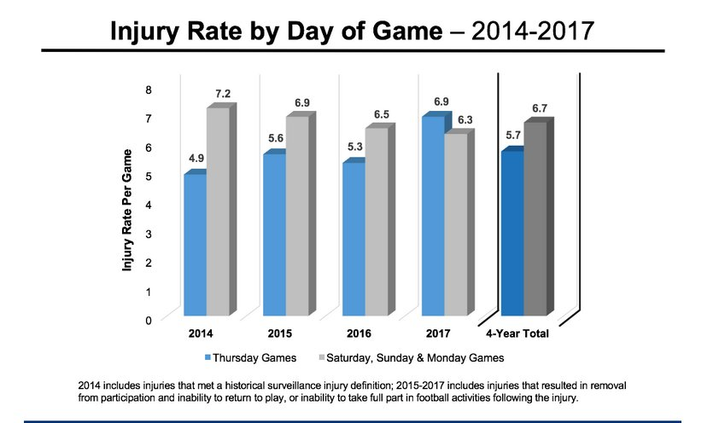

The problem is that even the players realise the hypocrisy and the thirst for money as the Seattle Seahawks cornerback states that “Thursday Night Football is just another example of the NFL’s hypocrisy: The league will continue a practice that diminishes the on-field product and engenders its players, but if the dollars keep rolling in, it couldn’t care less.” (Nathan, 2018).
This deal just proves how dedicated to money the NFL league is that it even endangers the players just so the people behind the scenes can get a very large pay check. Perhaps this is the stage the Premier League would not reach however if the globalisation of the sport and the ownership of the teams keeps shifting it could potentially result, however football is not as physically demanding as it is American football and the PL teams already play in various tournaments and competitions throughout the year so perhaps the PL is not as far the author firstly anticipated.

EPL
As said previously Barclays is not the sponsor of the English Premier League as of next year due to the PL wanting to clean up the brand and follow suit to the NFL strategies by becoming sponsor-free, this arrangement dwarfs any sponsorship income releasing the pressure of the need to have a sponsor. (Mceleny, 2015)
Furthermore, continuing the point made above the EPL is further from injuring and endangering players than the NFL is as talks for creating a winter break are in the process of being accepted resulting in all teams having a 13-day break in between matches, this will not affect the competition itself at it will stagger the fixtures resulting in 5 PL games on one weekend and 5 on the next (Sky Sports, 2018) but this strategy will provide a chance for the players to rest and therefore have a higher chance of winning matches just proving once again this utility maximisation that the PL sustains, it is in the league best interest to win and make profit from winning and not the other way around.
However, there is still a large amount of money being invested into the PL, as for example Sky is paying £1.193billion per year (£3.579bn per 3 years) to broadcast the premier league games, this figure is relatively small compared to the past package of £4.1bn (Conn, 2018), which is still smaller than the money invested into the NFL just to broadcast one day of the 4 days of games, the ESPN is paying $1.9 billion a year just to showcase the “Monday Night Football”. (Sandomir, 2011). Which once again suggests that there is more money invested into promoting and driving money out of the NFL as there is in the PL, however football is so globally known and loved that perhaps these figures could potentially change, conversely the NFL is branching out of America and has for the last 11 years played various games in London, with 4 games being held for the upcoming season in Wembley and the Spur brand new stadium, by bringing the sport internationally the NFL is increasing their fan base and once again making a very large amount of profit. (Independent, 2018)

Overview
Advertising revenue is a highly profitable section of the NFL as it can be seen in the graph below the amount of money invested just keep increasing, however the number of people that watch the advertising has decreased. (Tran, 2017)
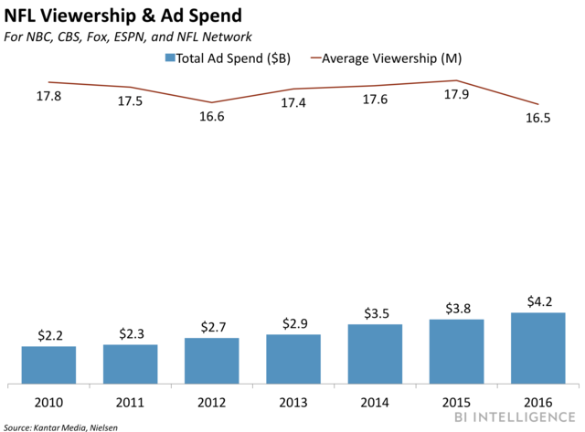
Badenhausen (2016) states in Forbes website that the CBS set the 30 second advertisement rates at $5 million for 2016 Super Bowl which is highest yet proving how much advertisement impacts the NFL and how dependant of it NFL is, once again suggesting that the whole league is profit driven.
The EPL is slightly different to the NFL as each club as their individual advertisement but it comes nowhere near the advertisement for the NFL as for example Bournemouth in 2016 the club received only £4 million through advertising per season which is less than a 30 second Super Bowl Ad. (Conn, 2017)

Conclusion
Overall, it is clear to see from the points and observations made in the report that the NFL is highly profit driven and that the EPL is slowly becoming more about profit but still driven by winning.
Firstly, as seen on the club ownership section of this report if the teams keep getting bought by multi-millionaires that own other sports team across the globe it could potentially represent an increase on profit maximisation within the PL to match the money and the success of the NFL, however it seems that the fans and supporters are not entirely interested in this profit driven league as it would destroy the nature and reputation of the game resulting in less people interested in the league and ultimately resulting in neither utility maximisation neither profit maximisation.
The PL clubs and owners need to be careful about how they approach a more profit driven attitude because it would be a brand-new idea and initiative and the NFL has been doing it for years so therefore the fans and supporters are already used to their strategies. Conversely, the PL fans have a lot of input on the teams’ decisions, as in football fans can drive managers and owners away from their clubs if the plans do not agree with how they are managing their clubs as for example Newcastle United owner Mike Ashley is not in the process of selling out his club after fans have driven him out. (Edwards, 2018)
Secondly, competitive balance is highly important to the PL as there are relegation rules that do not exist in the NFL, however the NFL maintains their competitive balance by providing the last team in the league the first pick on the draft of college players and limiting the number of funds available for players’ salaries unlike the EPL. The EPL has no limit on either salary neither the amount a club spends on transfers if they do not break financial fair play which could once against justify that for the EPL is willing to spend the necessary money on a player to win but it does not necessarily mean than either league is entirely focused on either just winning or just making money there is a balance to it.
Thirdly and lastly, sponsorship seems to paint NFL in bad lighting as broadcasting companies are willing to pay and create events to maximise profits even if it damages and endangers the players which realistically are the main focus on the match day so perhaps the NFL should reconsider their Thursday night games even if it means losing the sponsorship money but the fact that they have not makes the author believe that the NFL is highly profit driven and that they are willing to go to great extremes for profit, a place where the PL is nowhere near yet as the winter break could start from next season onwards.
The cost of advertisement is increasing at a higher rate in the NFL compared to the Premier League, however the cost of broadcasting rights is rising even higher alongside the advertisement, justifying once again what has been said numerous of times throughout this report, the NFL league is a business not a sports league, and the PL is still to an extent a sports league.
Overall, the author does agree that these two leagues are slowly becoming more like each other but the development of the NFL throughout the years on sponsorship and advertisement makes the author think about the path the PL is going to have to take to become more like the NFL, however the fans and supporters will not allow drastic changes which could result in the EPL maintaining their utility maximisation views. So, in conclusion the two leagues have proven that they are similar in various ways but way too different to be compared and the author concludes with that no the leagues are not becoming like each other, the EPL is just changing with the rest of the world to meet the globalisation of the sporting industry.

References
BBC (2017). How does the Premier League work? - CBBC Newsround. [online] Bbc.co.uk. Available at: http://www.bbc.co.uk/newsround/40891247 [Accessed 30 Mar. 2018].
Conn, D. (2018). Sky and BT Sport retain grip on Premier League rights but TV frenzy cools. [online] the Guardian. Available at: https://www.theguardian.com/football/2018/feb/13/sky-bt-sport-premier-league-tv-rights [Accessed 30 Mar. 2018].
Davis, C. (2017). Premier League 2017 prize money: How much your club is in line to earn this season?. [online] The Telegraph. Available at: https://www.telegraph.co.uk/football/2017/05/16/premier-league-2017-prize-money-much-club-line-earn-season/ [Accessed 30 Mar. 2018].
Edwards, L. (2018). Exclusive: Mike Ashley will renew efforts to sell Newcastle United as soon as Premier League safety assured. [online] The Telegraph. Available at: https://www.telegraph.co.uk/football/2018/03/29/exclusive-mike-ashley-will-renew-efforts-sell-newcastle-united/ [Accessed 30 Mar. 2018].
Independent (2018). NFL announce 2018 London games. [online] The Independent. Available at: https://www.independent.co.uk/sport/us-sport/national-football-league/nfl-london-games-2018-philadelphia-eagles-seattle-seahawks-raiders-a8153941.html [Accessed 30 Mar. 2018].
Mceleny, C. (2015). Premier League to drop title sponsorship from 2016-2017. [online] Campaignlive.co.uk. Available at: https://www.campaignlive.co.uk/article/premier-league-drop-title-sponsorship-2016-2017/1350215#BfKArsWbYLjw3XU1.99 [Accessed 30 Mar. 2018].
NFL (2018). NFL.com History. [online] Nfl.com. Available at: http://www.nfl.com/history [Accessed 30 Mar. 2018].
NFL Record and Fact Book (2013). NFL Record and Fact Book 2013. [online] Scribd. Available at: https://www.scribd.com/document/198870750/NFL-Record-and-Fact-Book-2013 [Accessed 30 Mar. 2018].
Novy-Williams, E. (2017). NFL Teams Split Record $7.8 Billion in 2016, Up 10 Percent. [online] Bloomberg.com. Available at: https://www.bloomberg.com/news/articles/2017-07-12/nfl-teams-split-record-7-8-billion-in-2016-up-10-percent [Accessed 30 Mar. 2018].
Premier League (2018). Premier League History, Origins & List of Past Champions. [online] Premierleague.com. Available at: https://www.premierleague.com/history [Accessed 30 Mar. 2018].
Richards, H. (2017). Would relegation be better than making up the numbers in the Premier League?. [online] the Guardian. Available at: https://www.theguardian.com/football/when-saturday-comes-blog/2017/oct/09/relegation-premier-league-championship-swansea-city [Accessed 30 Mar. 2018].
Rodrigues, J. (2012). Premier League football at 20: 1992, the start of a whole new ball game. [online] the Guardian. Available at: https://www.theguardian.com/football/from-the-archive-blog/2012/feb/02/20-years-premier-league-football-1992 [Accessed 30 Mar. 2018].
Sandomir, R. (2011). ESPN Extends Deal With N.F.L. for $15.2 Billion. [online] Nytimes.com. Available at: https://www.nytimes.com/2011/09/09/sports/football/espn-extends-deal-with-nfl-for-15-billion.html [Accessed 30 Mar. 2018].
SKy Sports (2018). Premier League happy in principle with two-week winter break plan. [online] Sky Sports. Available at: http://www.skysports.com/football/news/11095/11269453/premier-league-happy-in-principle-with-two-week-winter-break-plan [Accessed 30 Mar. 2018].
Tran, K. (2017). NFL ad revenue is rising amid a ratings decline. [online] Business Insider. Available at: http://uk.businessinsider.com/nfl-ad-revenue-rises-amid-ratings-decline-2017-12 [Accessed 30 Mar. 2018].
Weinstein, A. (2017). Report: NFL teams shared $7.8 billion in revenue last year, up 10 percent. [online] Sporting News. Available at: http://www.sportingnews.com/nfl/news/nfl-teams-shared-8-billion-2016-10-percent-increase/xq0olewhxo2d1a5mmrll4w4fz [Accessed 30 Mar. 2018].

Benge, J. (2016). Stan Kroenke: I didn't buy Arsenal stake to win trophies. [online] Available at: https://www.standard.co.uk/sport/football/stan-kroenke-i-didnt-buy-arsenal-stake-to-win-trophies-a3202046.html [Accessed 30 Mar. 2018].
Dawson, A. (2017). The 15 richest billionaire football club owners in England — and how they made their fortune. [online] Business Insider. Available at: http://uk.businessinsider.com/the-15-richest-billionaire-football-club-owners-in-england-2017-5 [Accessed 30 Mar. 2018].
Huddleston Jr, T. (2017). How Does Every NFL Owner Rank as a Businessperson?. [online] Fortune. Available at: http://fortune.com/2017/09/27/nfl-owners-business-rankings/ [Accessed 30 Mar. 2018].
Langone, A. and Johnson, D. (2018). These NFL Teams Have the Most Super Bowl Wins. [online] Time. Available at: http://time.com/5099429/nfl-most-super-bowl-wins/ [Accessed 30 Mar. 2018].
Nathan, A. (2018). Fox Lands TV Rights Deal for NFL's Thursday Night Football Games. [online] Bleacher Report. Available at: http://bleacherreport.com/articles/2756904-fox-reportedly-nearing-tv-rights-deal-for-nfls-thursday-night-football-games [Accessed 30 Mar. 2018].
NFL (2017). 2017 Injury Data - NFL Play Smart, Play Safe. [online] NFL Play Smart, Play Safe. Available at: https://www.playsmartplaysafe.com/newsroom/reports/2017-injury-data/ [Accessed 30 Mar. 2018].
Rovell, D. (2018). Fox gets Thursday Night Football through '22. [online] ESPN.com. Available at: http://www.espn.co.uk/nfl/story/_/id/22273473/fox-broadcast-thursday-night-football-next-five-seasons [Accessed 30 Mar. 2018].

Appendix

Premier League fixtures as of 20/03/18 according to Sky Sports (2018)
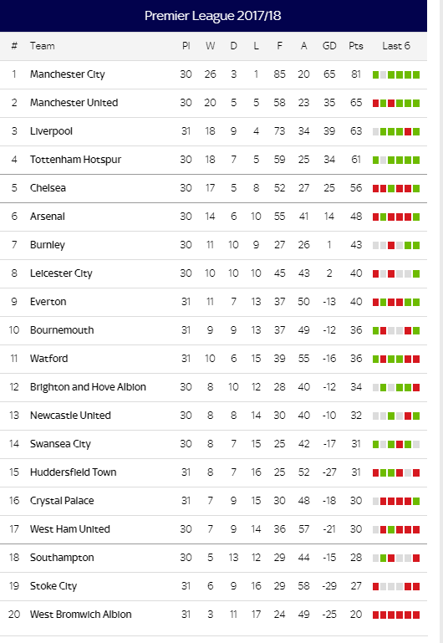

Premier League fixtures for 2016/17 taken from Sky Sports (2017)
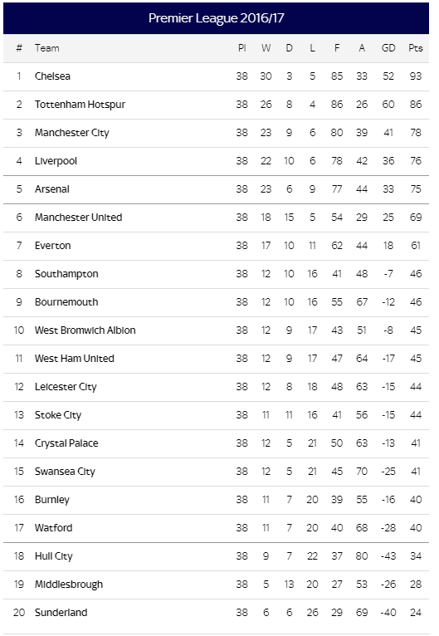

EPL Main Partners overview
Adapted from Premier League (2018) available at: https://www.premierleague.com/partners#
Partners/Licensees | Brief description of involvement between partners and the EPL
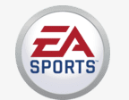  EA sports – Lead Partner | - League’s Lead Partner for the three seasons from 2016/17  - Partnership includes on-screen branding on all the League’s global broadcasts, sponsorship of the official Player of the Month and Season Awards  - EA Sports integration in stadia pre-match  - EA Sports sponsorship of Fantasy Premier league  - FIFA game series  https://www.premierleague.com/partners/ea-sports
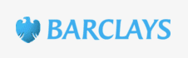  Barclays – Official Bank | - Over a century of support to football  - Banking Partner until the end of the 2018/19 season  - Bank Strategy is now focused on being a transatlantic consumer, corporate and investment bank offering products and services across personal, corporate and investment banking, credit cards and wealth management, with a strong presence in the UK and the US.  https://www.premierleague.com/partners/barclays
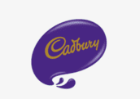  Cadbury – Official Snack | - Brand new partner starting this season 2017/18  - Builds on brand history of iconic partnerships including the London 2012  - Offering fans the chance to win match day tickets  - Presenting the Golden Boot award  - Supporting Premier League Primary Stars to encourage healthy and active lifestyles  https://www.premierleague.com/partners/cadbury
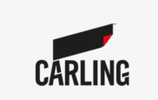  Carling – Official Beer | - Deal running from June 2016 until the end of the 2018/19  - Growing portfolio of iconic British partnerships, including Universal Music Group and Sky  - Carling was the first ever sponsor of the Premier League (1993-2001)  - Tittle sponsor of the Carling Cup for nine seasons from 20013-2012  https://www.premierleague.com/partners/carling
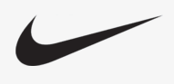  Nike – Official Ball | - Nike has been the Official Ball Supplier since 2000/01  - The Ordem 4 is designed to keep pace with and facilitate this constant evolution in football.  - Nike also works alongside the EPL to support a range of initiatives such as community projects and the PL School’s kit scheme.  https://www.premierleague.com/partners/nike
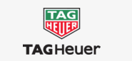  TAG Heuer | - Official Timekeeper since 2016  - All teams are on TAG Heuer time, both on pitch and on TV broadcasts across the globe in 185 countries,  - TAG Heuer branding and its brand motto #DontCrackUnderPressure is on all digital platforms such as website and social media  - TAG Heuver is part of the LVMH group  https://www.premierleague.com/partners/tag-heuer

