Financial Management for the Hotel Industry
Student name:Tatiana Raileanu
Student ID:2211942
Modul Lead:Tristan Hawkins

Executive summary
This particular study has focused on developing an effective understanding regarding the difference between two hotel businesses which are Corinthia Hotels and Ibis Hotels. These hotels mainly run their business by providing two different segments of services which are luxury as well as budget services. Therefore, the presentation has included the total amount of revenue that has been earned by both the businesses along with their growth potential, shared within the marketplace. The identification of the way both businesses have been able to develop their CSR strategies has also been highlighted. Moreover, there have been recommendations addressed to both businesses on the basis of the explanation with the aim of guiding the entities in developing their activities.
Table of Contents
Introduction 4
Presenting a detailed comparison of Corinthia Hotels and Ibis Hotels 5
Identifying the total revenue of Corinthia Hotels and Ibis Hotels 5
Analysing the market position of Corinthia Hotels and Ibis Hotels 7
Addressing the growth potential of Corinthia Hotels and Ibis Hotels 10
Determining the CSR operation of Corinthia Hotels and Ibis Hotels 13
Recommendation for Corinthia Hotels and Ibis Hotels with the aim of further development 15
Conclusion 16
References 17
Appendix 21

Introduction
It is essential for every business to manage their finance-related activities in an effective manner for the sake of achieving organisational aims, and objectives and getting success in the marketplace for a long-term period. Therefore, the below study is aiming in developing a comparison of ascertaining the performance of two reputed hotel businesses which are Corinthia Hotels and Ibis Hotels. The headquarters of both the hotel business is presented in separate countries of the world. Therefore, to establish the comparison it is going to consider total revenue, market position, CSR activities along growth potential. Further information is going to be collected from annual reports of both the business entities as well as using various authentic sources.

Presenting a detailed comparison of Corinthia Hotels and Ibis Hotels

Identifying the total revenue of Corinthia Hotels and Ibis Hotels
Corinthia Hotels

Figure- Revenue of Corinthia Hotels
Source- by author
Revenue Analysis: The revenue of the Corinthia Hotel Group on the basis of the past few years has faced a rollercoaster trend. On the basis of the above bar diagram, it can be seen that in 2019, the entity earned around $5,119 million, which increased to $75,649 million in the year 2020. This particular surge may be attributed in order to undertaking strategic initiatives, and acquisitions. Moreover, the year 2021 witnessed a substantial degrowth, with a plummeting of the revenue to $30,328 million. It is the indicative factor of the profound influence of global events, including the pandemic (Walker, 2021).
Sources of Revenue: The overall revenue streams of the specific hotel business are basically streams from hotel room bookings, beverage and food services, conferences, along events. However, the peak of 2020 may have been impacted by a surge in demand for travel, significant strategies of marketing, or even unique offerings (corinthia, 2024).
Factors earning revenue trends: There are some external factors, that consist of the global pandemic, restrictions on travel, as well as changes in the behaviour of the consumer. All these play an essential role in the fluctuations of the hotel’s revenue (Jagels, 2007). Moreover, the ability of the particular hotel in order to adapt towards changing circumstances, innovate services, as well as implement effective strategies of marketing will be essential for the future growth of the revenue.
Ibis Hotels

Figure- Revenue of Ibis Hotels
Source- by author
Revenue Analysis: On the basis of the information which has been collected from the annual report of Ibis Group it can be said that the revenue trajectory diverges in comparison to the other hotel business Corinthia Hotel Group (Seal et al., 2008). Now, in 2019, it has earned around $6,491 million, which will effectively increase in the upcoming year to $84,322 million. It has mainly happened due to the enhanced demand for accommodations as well as the successful implementation of the strategies of the entity. Moving ahead, in the year 2021 the specific hotel has experienced a notable fall, with the contraction of the revenue to $43,983 million (accor, 2024).
Sources of Revenue: The process of acquiring revenue of Ibis Group is very similar to Corinthia Hotel Group. Therefore, the revenue is mainly acquired from hotel bookings, services of food and beverage, conferences, as well as events (Guilding, 2014). However, in 2020 the mentioned business may have implemented effective strategies related to the marketing initiatives, or capturing a larger segment of the share of the hotel industry.
Factors Driving Revenue Trends: Ibis Group's revenue in the year 2021 has been effectively impacted due to the restrictions related to travel and the global pandemic (Wild, 2018). Hence, the subsequent rebound in the next year 2022 also suggests that the business has been able to effectively adapt strategies, and resilience, along with potential changes in the behaviour of the consumers (Tranter et al., 2014).

Analysing the market position of Corinthia Hotels and Ibis Hotels
Corinthia Hotels
Market Share: Corinthia Hotel’s market share is basically separated by its presence in premium as well as luxury segments, which is the key evidence for the portfolio of high properties. Hence, the company's annual report mainly suggests the amount of the capital is around €615 million as well as an asset valuation of €1.544 billion. Apart from this, the above image is also presenting the share of the mentioned in each country where the highest share can be seen in Corinthia Hotel London with €512990 in 2022 which was €533156 in 2021 (corinthiagroup, 2022).
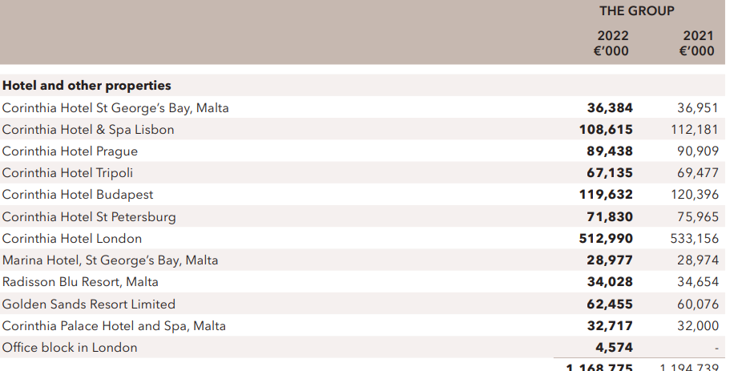
Figure- Market share of Corinthia Hotels
Source- (corinthiagroup, 2022)
Customer Demographics: The particular hotel mainly caters to a high-end segment of the demographic, appealing to luxury consumers searching for elevated experiences. Hence, the entity's commitment towards global luxury is also compiled with a base of customers that mainly value opulence, personalized services, as well as exclusive amenities (Nikolskaya et al., 2020).
Brand Perception: The brand perception of Corinthia Hotel is very synonymous with sophistication, and luxury as well as a commitment for the sake of delivering unparalleled hospitality services (Bhimani, 2006). Moreover, the specific brand is also compiled with iconic famous including Corinthia Hotel London as well as Corinthia Hotel Budapest increasing global reputation.
Ibis Hotels
Market Share: Ibis Group is basically one of the parts of the Accor portfolio, this mainly holds a substantial share in the market within the segment of the economy hotel. Therefore, with a worldwide presence presenting in 70 countries as well as a reported 1,218 hotels as of December 2019, the mentioned hotel has become one of the key players in serving budget-friendly accommodation (Sampaio et al., 2021).
Customer Demographics: Ibis mainly caters to a wide and diverse range of customer demographics, initially targeting budget-conscious visitors searching for comfortable as well as affordable lodging. Hence, the global presence of the particular brand allows it to gather a large range of travellers, which includes business travellers to tourists. All these individuals basically prioritise value-driven experiences. In addition to this, the diverse structure of ownership, which includes shareholders such as CPHCL Company Limited as well as Istithmar Hotels FZE, reflects a mix of local along international investment (Nain, 2018).
Brand Perception: The mentioned company is perceived as a reliable as well as cost-effective choice of decision for travellers searching for quality accommodations. Therefore, the modernisation efforts of the brand, digital marketing concentrate, as well as the strategies of expansion contribute to a positive factor within the competitive economy segments of the hotels (Kunst, 2023). In addition to this, Ibis's commitment towards eco-friendly as well as sustainability practices is also aligned with the constantly changing preferences of the consumers. Furthermore increasing its image of the brand as a socially responsible as well as forward-thinking preference in the sector of budgeted hospitality.
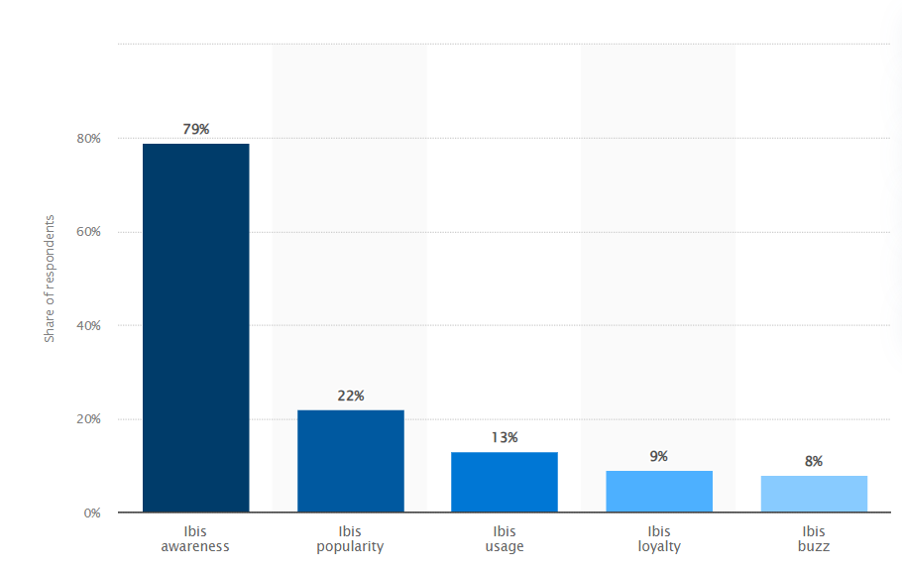
Figure- Ibis brand awareness
Source- (Kunst, 2023)

Addressing the growth potential of Corinthia Hotels and Ibis Hotels
Corinthia Hotels
Expansion Strategies: The growth of the mentioned entity mainly relies on the potential of growth by undertaking a strategic concentration on establishing itself as one of the most reputed and global hotel brands of luxury. Hence, the acquisition, upgradation, ownership, as well as operation of Corinthia hotels, on the other side handling properties properly on behalf of investors and investors. It mainly reflects a diversified method in order to expand the business itself. Moreover, the intention to move towards a second listing within the liquid market, including raising effective funds, highlights an aggressive strategy of growth (Tan and Despotis, 2021).
Market Opportunities: The market opportunities of the mentioned entity Corinthia Hotel are dependent on the segment of luxury, providing high-end visitors searching for exclusive experiences (Atrill and McLaney, 2021). Therefore, the global demand for premium types of rooms or accommodations serves as avenues for expansion within the most essential markets. The diverse properties of the portfolio of the mentioned company, involving iconic locations such as Corinthia Hotel London, mainly position the specific group to capitalise for the sake of appealing to renowned destinations.
Potential Barriers to Growth: Despite the rapid growth prospects of the mentioned entity it is facing, some potential barriers. On the basis of the research, it has been identified that this particular segment can be considered more sensitive at times of economic downturns, impacting the spending of consumers on high-end experiences (Seal, 2019). Moreover, the achievement of expansion methods relies on various aspects including geopolitical stability, compliance with regulations, as well as the capability for the sake of maintain the high standards compiled with luxury branding.
Ibis Hotels
Expansion Strategies: The Accor portfolio company Ibis Group has made a concerted effort to grow internationally, particularly in the low-cost hotel industry. The strategy employed by the brand centres on diversifying its hotel portfolio, with a focus on emerging countries and regions that are witnessing a surge in travel demand. Ibis's commitment to environmental projects aligns with the interests of modern consumers, which could enhance its market position as well as add to its future expansion (accor, 2024).
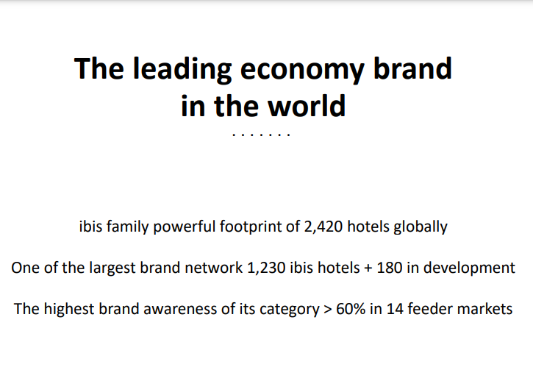
Figure- Ibis Hotels
Source- (accor, 2024)
Market Opportunities: The Ibis Group's growth prospects are based on the ongoing demand for trustworthy as well as competitively affordable hotel options. Due to its global presence, the brand is well-positioned to profit from new travel trends, especially in the Asia-Pacific region as well as additional quickly developing regions (Drury, 2021). The economy segment, which caters to budget-conscious tourists, presents a stable market with significant development opportunities. Ibis can address the requirements of various consumer segments within the budgetary range by using its diversified portfolio, which includes Ibis Styles as well as Ibis Budget.
Potential Barriers to Growth: Ibis has successfully expanded throughout the world, but there may be challenges ahead, including rivalry from different brands of inexpensive hotels and other lodging options. The budget travel industry can be impacted by both economic uncertainty and disruptions to travel, as seen by the worldwide outbreak of the pandemic. For future development to be ensured, consideration must be given to overcoming legislative obstacles and adapting to changing customer demands, especially those tied to the environment (Tan and Despotis, 2021).

Determining the CSR operation of Corinthia Hotels and Ibis Hotels
Corinthia Hotels
With a strong financial commitment to CSR, Corinthia Hotel Group aggressively incorporates sustainability into its business processes to support environmental accountability. by a variety of social programmes, the organisation seeks to produce beneficial results by active participation in the community. Corinthia prioritises ethical corporate conduct by placing a high value on openness and accountability in operations. Corinthia's financial commitment to CSR is demonstrated by its ongoing efforts to foster sustainability, charitable campaigns, and continual dedication to ethical standards. This money commitment goes above simple compliance (corinthiagroup, 2024).
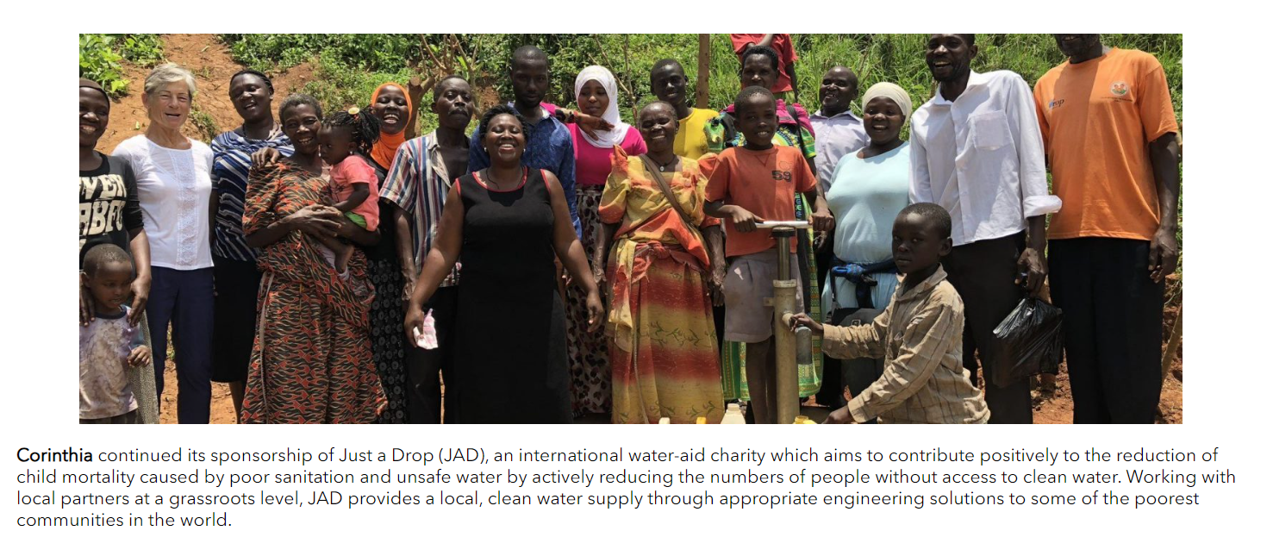
Figure- CSR of Corinthia Hotels
Source- (corinthiagroup, 2024)
Ibis Hotels
Ibis Hotels, a member of Accor, exhibits a strong financial awareness. The brand prioritises resource efficiency as well as protecting the planet by integrating environmentally friendly habits throughout its organisational framework. One of the main priorities is outreach to the community, and Ibis actively supports regional development programmes. Ethical company practices, such as equal pay for employees along with transparency operations within the supply chain, highlight how much money is dedicated to social responsibility. The incorporation of ethical ideals into the company's operating model, community relationships, as well as ongoing conservation programmes are all examples of Ibis Hotels' all-encompassing policy regarding responsibility for the environment and society (accor, 2024).
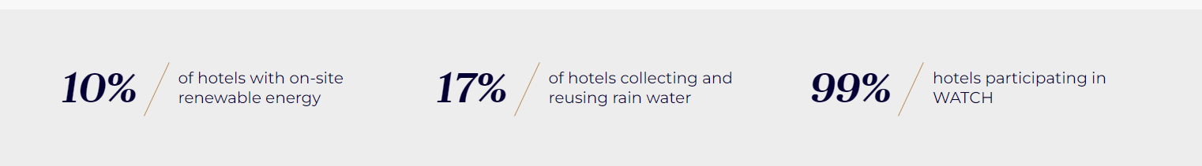
Figure- CSR of Ibis Hotels
Source- (accor, 2024)

Recommendation for Corinthia Hotels and Ibis Hotels with the aim of further development
Corinthia Hotels
The Corinthia Hotel Group might profit from branching out into other markets in order to better manage revenue swings. Examining boutique or mid-range possibilities could draw in more clients which will allow the particular business in encouraging further expansion in volatile markets.
Ibis Hotels
Apparently, in order to maintain its competitiveness in the evolving tourism sector, Ibis Hotels ought to concentrate on improving its online presence. Making investments in cutting-edge online reservation platforms by prioritising the digital media will help the particular business in enhancing the customer support. This will more open up new markets, as well as fortify the brand's position in the low-cost lodging sector.

Conclusion
The above context has critically shed light on the market position, revenue earned, and activities related to the CSR factors along with the opportunities which are related to the growth of two reputed hotel businesses which are Corinthia Hotels and Ibis Hotels. On the basis of the analysis, it has been identified that both the companies serve different types of services which is Corinthia Hotels is basically focuses on providing luxurious services while Ibis Hotels presents comparatively cheap services. Moving ahead, the explanation has included the discussion of further development that requires to be considered by both business entities.

References
accor, (2024). Environment & CSR. [Online] Available at: https://group.accor.com/en/hotel-development/Optimise-your-costs/Environment-and-CSR [Accessed 17 January 2024].
accor, (2024). VIBRANT HOTELS, CARING PEOPLE.. [Online] Available at: https://all.accor.com/brands/ibis.en.shtml [Accessed 17 January 2024].
Atrill P and McLaney E (2021) Management Accounting for Decision Makers, FT Prentice Hall
Bhimani A, (Ed) (2006) Contemporary Issues in Management Accounting , Oxford
corinthia, (2024). CORINTHIA Our Story. [Online] Available at: https://www.corinthia.com/?utm_source=RTM%20Media,%20PPC%20&amp;%20Media%20Buying&utm_medium=affiliate&utm_campaign=Affilired&_affclk=adn:3817::Cj0KCQiAwbitBhDIARIsABfFYIIwUl3YnF74x7wpQ3RQN74UG0Dj_-hGZaguhMVxxOr_x_tPCln-OfAaAovCEALw_wcB:8002y1&utm_source= [Accessed 17 January 2024].
corinthiagroup, (2022). 2022 ANNUAL REPORT& Financial Statements. [OnlineAvailable at: https://www.corinthiagroup.com/wp-content/uploads/2023/06/37547-CORINTHIA-ANNUAL-REPORT-2022_WEB-min.pdf [Accessed 17 January 2024].
corinthiagroup, (2024). OVERVIEW OF OUR RECENT CSR ACTIVITIES. [Online] Available at: https://www.corinthiagroup.com/insider/overview-of-our-recent-csr-activities/ [Accessed 17 January 2024].
Drury C (2021) (11th Ed) Management and Cost Accounting, London, Prentice Hall
Guilding,C.(2014) (3rd Edition) Accounting Essentials for Hospitality Managers, London, Routledge
Jagels,M. (2007) Hospitality Management Accounting, London, Wiley.
Kunst, A., (2023). Ibis brand awareness, usage, popularity, loyalty, and buzz among hotel customers in the UK in 2022. [Online] Available at: https://www.statista.com/forecasts/1335566/ibis-hotels-brand-profile-in-the-uk [Accessed 17 January 2024].
Nain, A., (2018). A study on major challenges faced by hotel industry globally. International Journal of Creative Research Thoughts, 6(1), pp.561-571.
Nikolskaya, E.Y., Romanova, M.M., Pasko, O.V., Uspenskaya, M.E. and Saadulaeva, T.A., (2020). Formulation of development strategy for tourism and hospitality industry. International Journal of Management (IJM), 11(3), pp.467-474.
Sampaio, C.A., Rodrigues, R.G. and Hernández-Mogollón, J.M., (2021). Price strategy, market orientation, and business performance in the hotel industry. Journal of Global Information Management (JGIM), 29(1), pp.85-102.
Seal W (2019) (6th Ed) Management Accounting, London, McGraw Hill
Seal W, Garrison RH, Noreen E (2008) Management Accounting, McGraw Hill
Tan, Y. and Despotis, D., (2021). Investigation of efficiency in the UK hotel industry: a network data envelopment analysis approach. International Journal of Contemporary Hospitality Management, 33(3), pp.1080-1104.
Tranter,K. Stuart-Hill,T. Parker,J. (2014) Introduction to Revenue Management for the Hospitality Industry, London, Pearson
Walker J (2021) Introduction to Hospitality, Harlow, Pearson
Wild J (2018) Fundamental Accounting Principles, New York, McGraw Hill

Appendix
Corinthia Hotels income statement
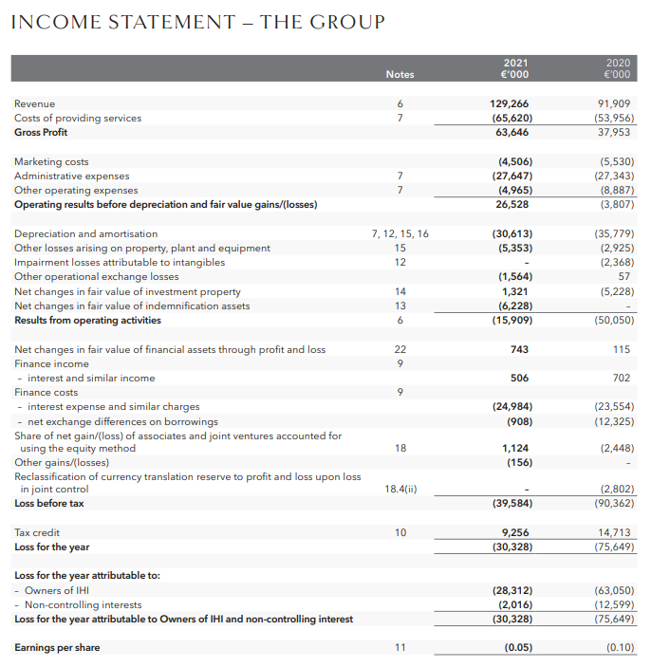
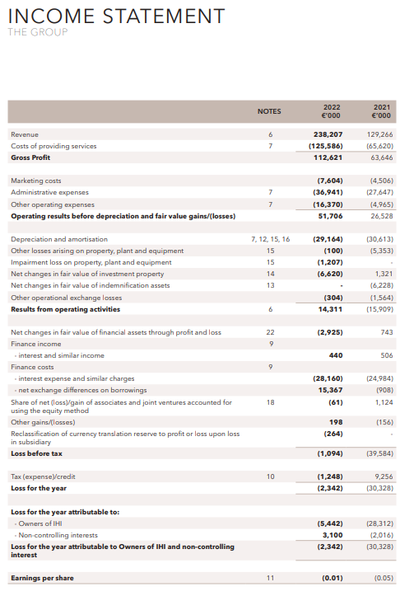
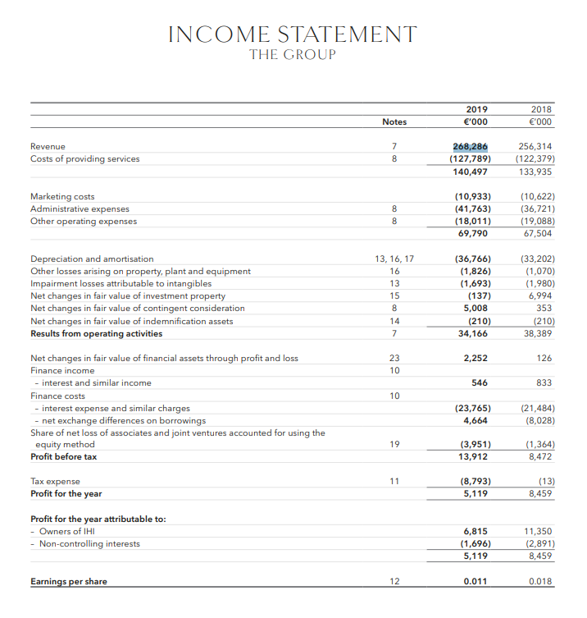
Ibis Hotels income statement


