Academic Scrapbook Student number - 1602217
Educational Theories

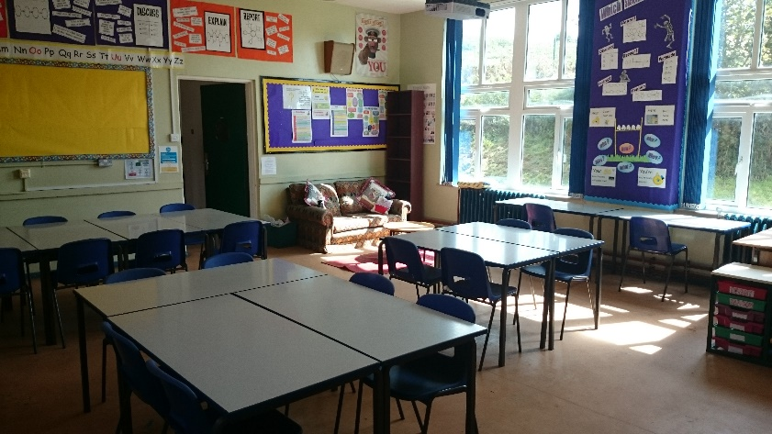
My educational setting is an uncommon situation. As part of our ALN department, we have identified a need for a setting that caters for children who are unable to access mainstream schooling. The setting is in place to provide an environment that concentrates on nurture and well-being as a first priority in order that the individuals allocated to the setting can access their learning Photograph of educational setting, by Lisa Wilkinson
via an alternative route.
The setting also serves a purpose for the children who unfortunately come from an underprivileged background, where there may be difficulties in the home, resulting from poor/low income families, single parent families, Looked after children (LAC) or Young carers. It is a fact that there a number of factors that can contribute to the health and well-being of the children in our learning environments. We aim to readdress the balance, by offering some of the comforts that are sadly missing from the lives of our young people. For example, breakfast, a warm meal, appropriate/clean clothing, nurture/care, counselling and social skills to list a few. The children rely on us as responsible adults and we have a duty of care to ensure that their needs are met in the best and most complete way that we possible can.
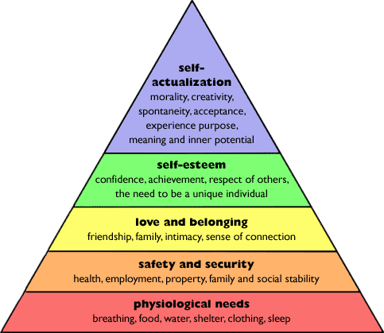
The pupils access their core subjects with additional support in a mainstream environment, in order for them to link with mainstream education in a stepping stone fashion. The main function of the allocated classroom is to provide a safe haven serving as a ‘home base’ for the children to return to if they are feeling unsure, nervous, unhappy, insecure or out of control out in the mainstream system.
Maslow’s Hierarchy of needs pyramid.
The children take ownership of their setting and develop a genuine feeling of safety towards this environment. As with Maslow’s Hierarchy of Needs, if the basic need of the child are not met, they are not ready to fulfil their academic, developmental potential and therefore, this has to be our starting point.
We have a policy in place that is centred around pupil voice, this is quite self-explanitory and allows the child to voice how they feel, what is going well? What could be made better? And how can we best help and support their learning? Every word that the child has to say, is documented and incorporated into their Individual Development Plan (IDP). This is then circulated to all members of staff associated or who come into contact with the child, so that everyone has the same information and is able to ensure that what they provide is directly in line with what the student needs.
Developing a secure and trusting relationship with the pupils in the setting is essential and it must exist with all members of staff. Sharing good practice of what works and is suited to the needs of the children in this environment is key to the success and future development of these children.
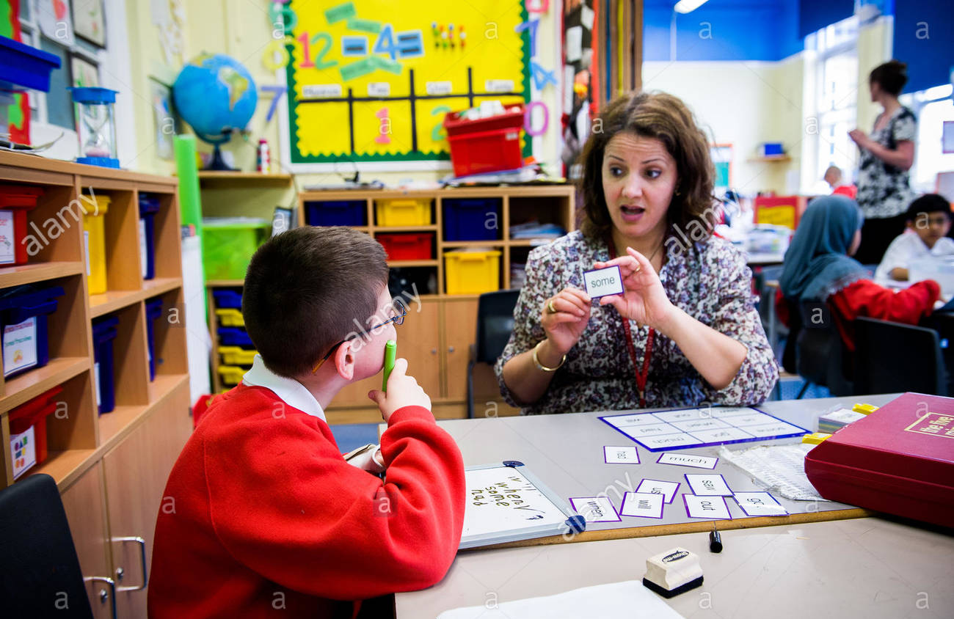
With a relaxed and content environment created and sustained, we are in a position to embark upon a learning journey tailored towards the specific needs and abilities of the children in the setting. Each child is an individual and employing a child-centred approach, a full and varied cross-curricular education is delivered. Although the children in our learning environment have specific learning differences, this does not mean that they are not needing to be challenged. In fact the children enjoy to be challenged and this instills a real sense of achievement. Preparing and delivering challenging and engaging lessons to inspire the children and promote their feelings of exploration and hunger, whilst scaffolding and supporting their learning appropriately to achieve and develop further. Vygotsky’s theory on scaffolding is that the education provider should endeavour to challenge the child with lessons that are not easy enough that they can just do them unassisted. But to create a learning journey that relies upon the Learning support in the classroom, alamy.com support and scaffolding that a practitioner can walk them through as they construct the building blocks of their learning until they reach the Zone of Proximal Development. Only then will the education provider know to move on to a more challenging concept.

Psychologist Lev Vygotsky developed the principle of ZPD

The zone of proximal development, commonly referred to as ZPD, is an important principle of Vygotsky's work. ZPD is defined as the range of tasks that a child can perform with the help and guidance of others but cannot yet perform independently.
Part – lesson transcript by Melissa Hurst – study.com

Within my learning environment, as mentioned before, the pupils are all individuals and learn with very different styles. Alongside these learning styles are individual characteristics, which indeed we all possess. However, there are instances where the individual characteristics are translated into behaviour traits and at times those traits can be negative behaviour traits.

As a whole school we have invested in an online rewards and sanction scheme, which is accessible to staff, children and
parents/guardians. The resource is called ClassCharts and is developed by a company called Edukey. As well as a tool for positive and negative behaviours, the resource also has the facility to allocate seating plans and hold records and information for those children with Additional Learning Needs. This has shown itself to be a tremendous resource and has been instrumental in changing behaviour patterns with dramatic effect. B.F. Skinner tells us his theory on how you can positively reinforce behaviour with praise and that once this is observed by other children, they will then follow suit, wanting the satisfaction of positive praise for themselves.
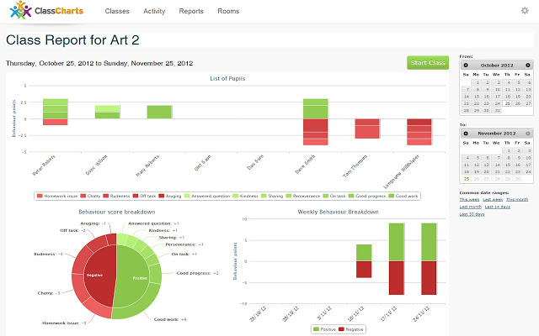
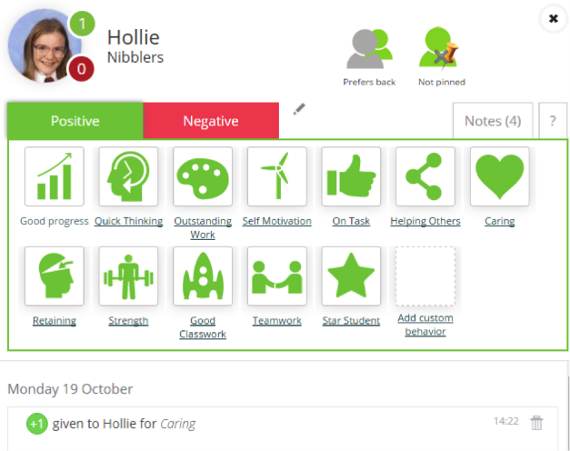
Stock photo – teachertoolkit.co.uk

stock photo – google.com/webstore

With positive praise on Classcharts, there are points to be collected. Each time the child receives positive praise, they will collect a certain amount of points and similarly, with negative behaviour, points are deducted from their score. Staff and parents are able to track progress and manage behaviour by monitoring the site on a daily basis. When a certain amount of classchart points have been collected, the pupil can exchange them for items in the ‘swap shop’, these items increase in value and can be accessed by any child, providing they have achieved the alloted amount of points. The children enjoy this aspect and there has been a noteable change in negative behaviour traits. Skinner believed that behaviour was changeable and that with incentive to change, i.e. rewards and santions in place, that the behaviour would change it’s course. With this in mind it is also essential to acknowledge that we should celebrate and positively show when children make a conscious choice to behave in a positive way, children who want to be seen in positive way. Too often we can be found guilty of concentrating our attentions on those children who’s behaviour is blantantly negative, we strive to help and support them to reach their potential and to endeavour to reverse negative behaviour and we forget at times that there are children who may be suffering underprivilege but who still make the choice to behave in a manner that should be championed and recognised with positive praise and reward.
Skinner showed how positive reinforcement worked by placing a hungry rat in his Skinner box. The box contained a lever on the side, and as the rat moved about the box, it would accidentally knock the lever. Immediately it did so a food pellet would drop into a container next to the lever.
The rats quickly learned to go straight to the lever after a few times of being put in the box. The consequence of receiving food if they pressed the lever ensured that they would repeat the action again and again.
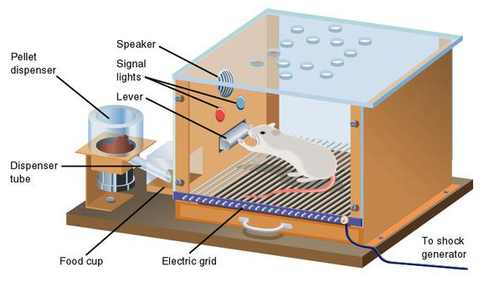
Saul McLeod – Simply Psychology (updated 2015)

The ‘Skinner Box’ – Simply Psychology.org

An interesting viewpoint is that of Skinner’s as he has a theory that it is not necessarily the case that a child will choose to behave in a positive manner, more that they will simply discover a way of not getting themselves into trouble.
A person who has been punished is not thereby simply less inclined to behave in a given way; at best, he learns how to avoid punishment.
B.F.Skinner

In our learning environments, there are so many factors that effect the children within them, a well trained educational provider will be able to acknowledge difficulties for a child or observe differences in behaviour, where upon they are duty bound to step in and support the learner in making the changes they need to progress further on their learning journey. Without addressing these issues, it is simply impossible to expect the learner to bypass their difficulties or obstacles and just ‘get on with it’. In an ever changing climate of development, we as educational practitioners have to evolve and meet the changes head on. Offering the learner an alternative route, to acessing their learning, whilst we provide the support and care they need.


Stock photo – support in the classroom – google.co.uk
Word count 1511

References
http://www.researchhistory.org/2012/06/16/maslows-hierarchy-of-needs/
http://www.alamy.com/stock-photo-learning-support-worker-with-child-with-special-needs-in-classroom-78267160.html

http://study.com/academy/lesson/zone-of-proximal-development-and-scaffolding-in-the-classroom.html

https://www.classcharts.com/

https://chrome.google.com/webstore/detail/class-charts/pjmmpemannlahkbibemdmhglliakbkbl

https://www.teachertoolkit.co.uk/2015/10/30/classcharts-1/

https://www.simplypsychology.org/operant-conditioning.html

https://quotes.thefamouspeople.com/b-f-skinner-785.php

https://www.google.co.uk/search?q=support+in+the+classroom&source=lnms&tbm=isch&sa=X&ved=0ahUKEwiV9ZT17bfXAhUIKsAKHStpDccQ_AUICigB&biw=1440&bih=746#imgrc=KP2fGlIywsImFM:&spf=1510449250363

