HTML & CSS Web Development

Emyr Jones (1701036)
BSc/HND Computing (All Streams)
L4 - Introduction to Web and Database Concepts
Contents
Introduction 2
Requirements 3
Implementation 4
Evaluation 11
References 15
Appendices 16

Introduction
For this report we will be exploring HTML concepts and best practices. We will be building a website using HTML and CSS using these concepts and practices. I will be looking into core principles, evaluating my website and two further webpages.

Requirements
For this website it will be targeted to Swansea city football fans, the aim is to provide information about the history of the club, upcoming fixtures, directions to the stadium and events such as gathering before home games and away games.

Implementation
WCAG principles
In this section we will look at some of the WCAG accessibility principles and how to apply them to my website.
WCAG are a set of technical standards that are used in the digital world to make things accessible to people with disabilities. WCAG has four main principles: Perceivable, Operable, Understandable and Robust.
The principle perceivable is to ensure that information is perceivable to people using only one of their senses and can understand all content.
Operable is the principle that users can interact with the webpage, for example being able to use the website using only a keyboard not just a mouse.
Understandable is the principle that ensures that users understand the content on the webpage and functionality information.
The principle robust ensures the website communicates effectively the information to all users and remains compatible with evolving technology and users needs.[1]

Creation of my web page
For my website I focused on layout of each page and making each page looks consistent, so the users knew they were on the same website but going through different pages of the website. Each page has the same background, header, footer and navigation with only the content of the page changing. Keeping the same theme on the website throughout with a Black and white styling with grey accents creating a modern feel to the website but also keeping to the theme of the Swansea city football club so it is obvious to the users this is a page for Swansea city football fans.
Keeping with the operable principles of the WCAG you are able to use the web pages using a mouse to click through but also able to use your keyboard to navigate through each page.

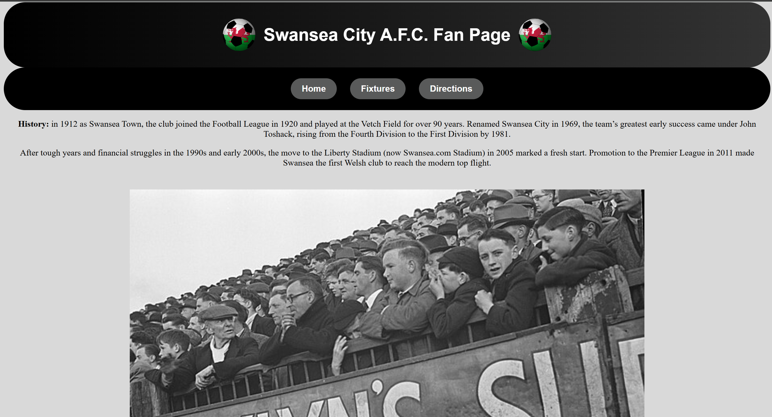
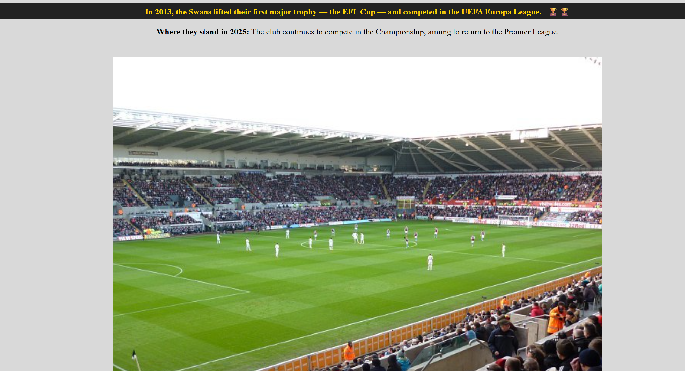
On the Home page of the website, I have included the history of the club and notable achievements and modern success braking up the information with images sourced from wiki commons.
I have made some of the information bold so it is easier for the user to find the information they are looking for with an addition of making it so when you hover over the achievements the background changes colour and text turning yellow, so it draws attention of the user to the information to understand the importance of the achievement.
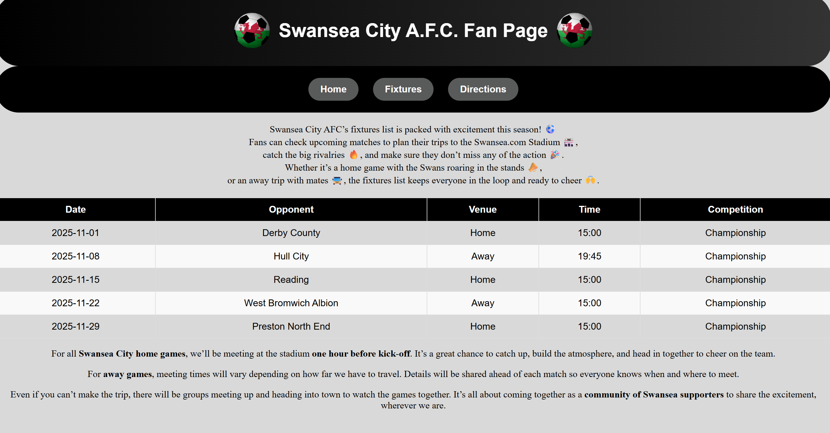
On the second page of my website I have included a fixtures page, this page gives the user information of what to expect for the upcoming fixture.
To layout the information better for the users I have included a table keeping the theme of black white and grey throughout, this table shows the upcoming fixture including date, opponent, where the fixture will take place, time of kick off and what competition the fixture will be playing, I made this table large for it to stand out to the user so they are able to see the information clearly and draw their focus to the information.
When hovering over the fixture the background changes colour from white to grey to make the webpage more interactive and draw more attention of the user.

Creating the table was the most difficult part of this project as there was a lot of different lines of code and it took a lot of troubleshooting to make sure all the information was laid out correctly.
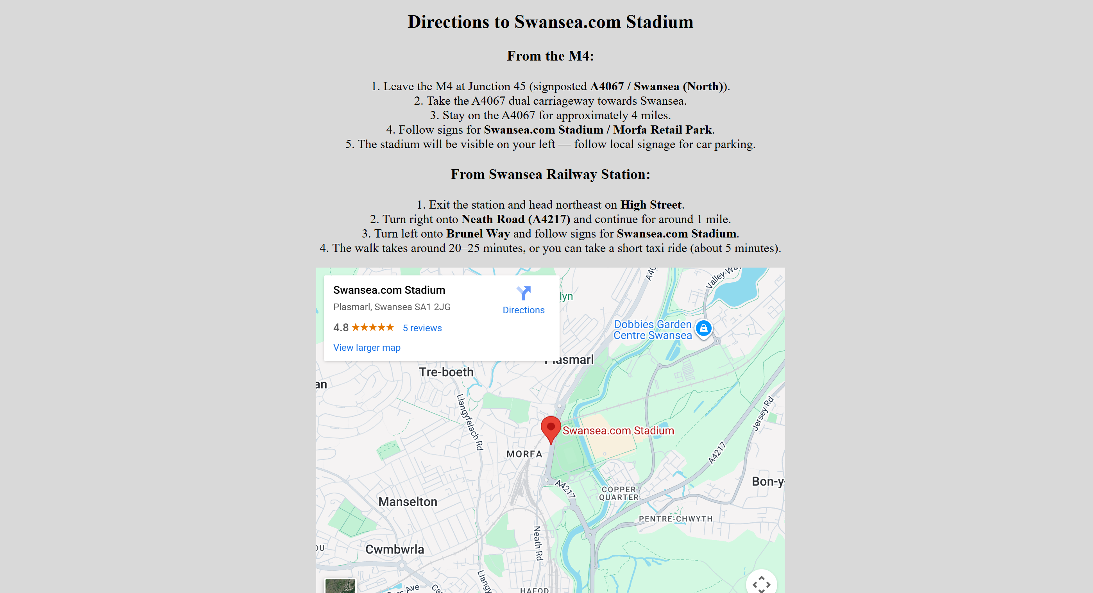

On my third and final page of the website I have included a direction page for the user to find out more information on how to get to the stadium. On this page there are two clear sections, on is showing direction on how to get to the stadium from the M4 with easy-to-follow step for the user. The second section gives the users direction from the train station as another option as a lot of fans may be travelling to the stadium by train, this give the user information how to get to the stadium from the train station.

This page also included an embedded map using the HTML iframe provided by google maps. By using the share option on google maps and selecting share this gave me a snippet of imframe code to include on my webpage. I placed this beneath the direction to give the user another option on getting directions to the webpage as they may need further direction to get to the stadium.

W3C CSS Validator. [2]

To ensure that I have writer my CSS code correctly and followed correct coding standards I have submitted my styling sheet to the W3C CSS validator to review. After uploading my styling sheet and running through the validator it came back confirming that there were no errors in my coding, I am pleased to see this as it showing that my CSS code was written correctly following the procedures and standards that are expected when writing CSS code. This has given me confidence that my webpage is robust and compatible with improving technologies.

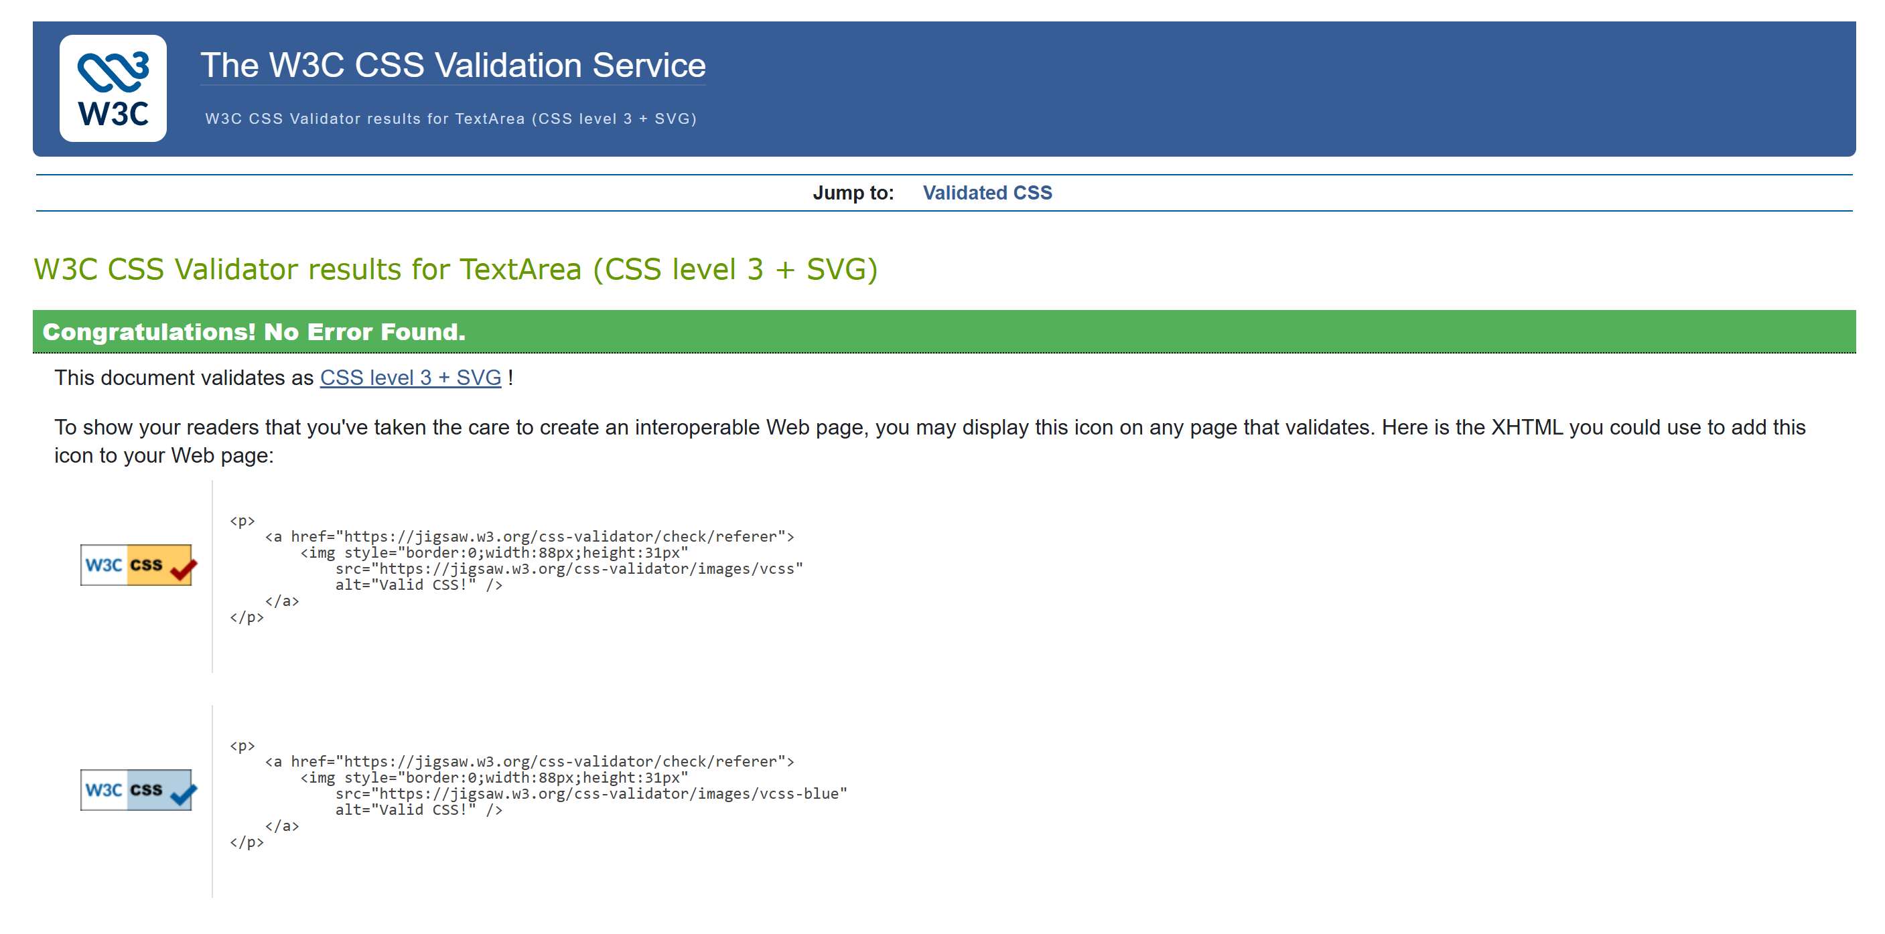

W3C HTML Validator. [3]
To ensure that my HTML code is well written and follows best practices I submitted my HTML code through the W3C HTML validator. After submitting my HTML code, it unfortunately came back with 10 errors.
A lot of these errors were caused by 3 main errors.
The first error was not putting “.” Infront of the /images on line 14 which made it so the code couldn’t retrieve the image from the correct file.
On line 43 I entered imgsrc which is an error, to correct this I entered it again as img src which solved that error.
The final error was on line 55 where I had <p></p> which made the text after invalid, to correct this code I removed the </P> and made sure it only appeared after the text I was intending to appear on my web page.
After correcting these errors, the validator showed that there was no more errors to my code, this practice helped me gain more knowledge on best practice in HTML coding.

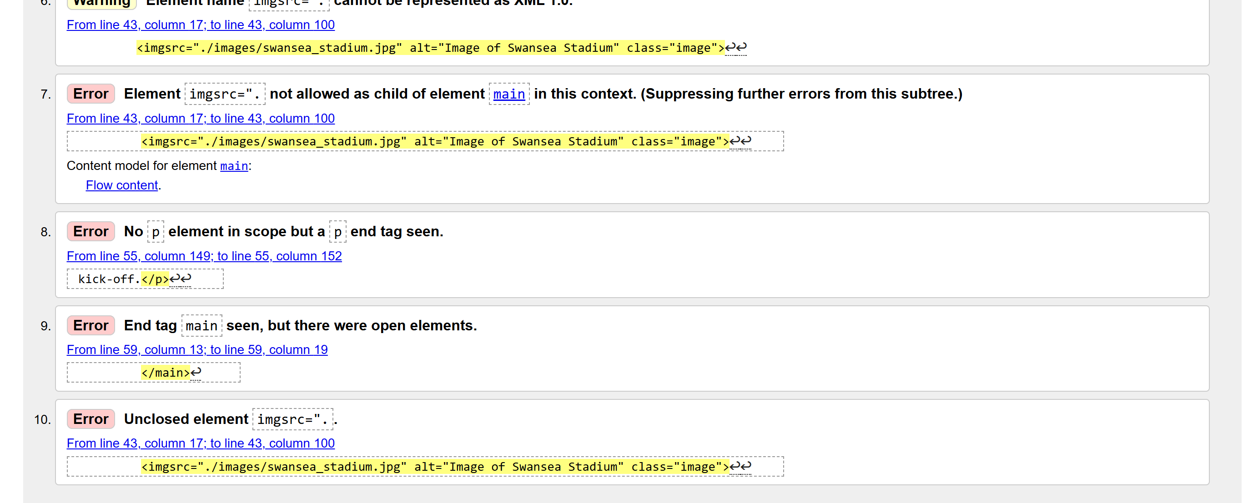

Evaluation

Usability
Useability in web design means that websites are well-organized, easy to navigate, informative and useful. [4]Users with visual impairments may not be able to understand images, using an “alt” tag in the HTML code and giving a description of the image will help the user understand the content of the web page better, this is something I have used while creating my web page to make it user friendly.
Accessibility
Web accessibility are tools and technologies designed to help people with disabilities to use the web pages, the web page should be designed so the user can easily navigate the webpage. [5] This can be done by the user using their keyboard instead of their mouse to navigate the webpage.
Search engine optimisation
“Search Engine Optimization and helps search engines understand your website’s content and connect it with users by delivering relevant, valuable results based on their search queries.”[6] To make your website effective you need to have the correct tags to drive users to your webpage.

Now we will be evaluating the completed webpage that I created.

Usefulness
The webpage has all the content laid out so the user can easily understand what each page is about with heading and key information being bold to draw the attention of the user. It may be more beneficial to have created a fourth page so I can move the information I put on the home page to another page and use the home page as an overview of the whole website having each page have a brief section each on the home page.

Search Engine Optimisation
I believe that I haven’t used this to its full effect as the tag used on the web page are brief, if I were to re make this website, I would use more tags to make the SEO more effective.
Accessibility
The website I have created I believe matches with the four principles of accessibility, as the website includes “alt” tags for images making the website perceivable for users who have disabilities. The website is operable by keyboard using “page up/down” and using the tab button to navigate the website. The website is understandable with each page being clear with what the purpose and content of the page is. Finally, the page is robust being able to use the website on mobile and desktop with the content resizing to fit the screen.

Using the contrast checker, I can see that the theme of the page and styling is appropriate and making the page easy to view.
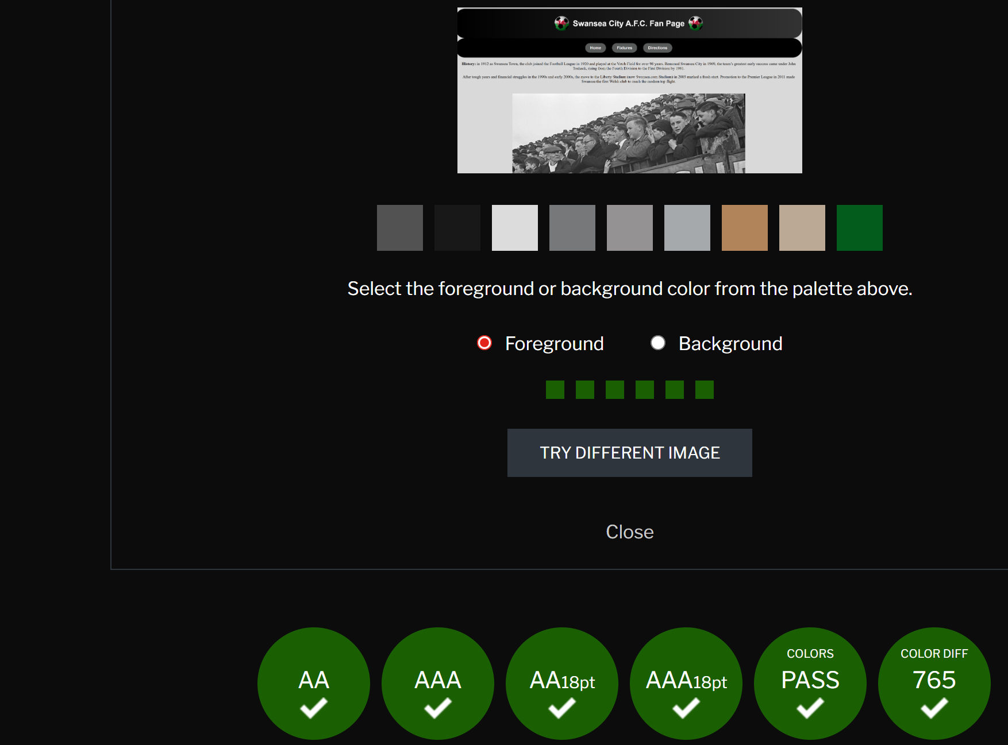
We will now be looking at similar web pages and evaluate them. For this I have chosen the Swansea city official website and a Manchester united fan website and i will be looking at the pros and cons of these websites.

Firstly, we will look at the Swansea City official website.[7]
Usability- The layout for this website is very pleasing and user friendly having the home page have a brief overview of most of the other webpages. The navigation of this website is easy to use with a heading type navigation with a drop-down menu for more options for extra web pages. The readability of the website is good with appropriate background colours and text colours. However, when going onto the store section on the navigation there isn’t an easy way to return to the home page.
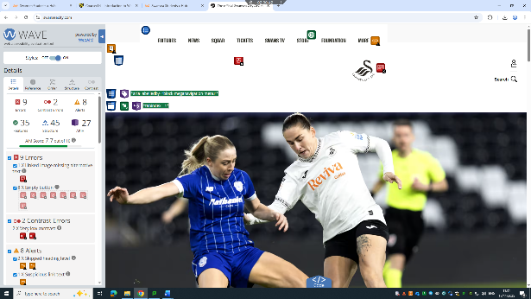
Accessibility: While using the wave tool to review the website it shows that there is several features however it is showing errors like a button with no text value which should be fixed.

SEO: This website has appropriate tags and heading making the website meet the SEO criteria and be optimized for search engines to show as one of the top searches when searching Swansea football.

Mobile friendliness: This website follows the mobile first principles and automatically resizes to adjust for the screen size or device you are using with images and text automatically adjusting to the appropriate size.
Now we will be looking at the Manchester united fan page (redcafe.net).[8]

Usability- The layout to this website is more basic than the Swansea website being plain white background with a red text which isn’t appropriate as it makes the text harder to read. The navigation is simple to use with appropriate heading to each webpage however, the content of each page isn’t explained i.e the forum section could use an explanation at the top. The home page of the website hasn’t been laid out thoughtfully as the forum takes up the entire screen with the latest results and news tiles being off to the side.
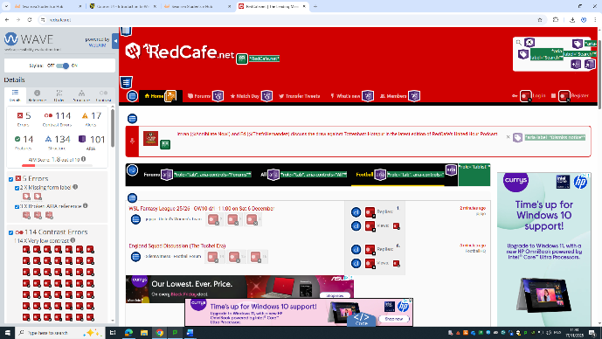
Accessibility: While using the wave tool this website is showing a large number of contrast errors compared to the Swansea website, the redcafe website having a AIM score of 1.8 compared to the Swansea website having a score of 7.7

SEO: The heading and tags used on this website are relevant but could benefit by having more details heading and tags to optimize the website better for search engines.

Mobile friendliness: This website does show its mobile friendliness when by auto adjusting the text to appropriately fit the screen and the navigation turning into a burger menu when the screen is reduced to a certain size making it easy to use on all devices.

In conclusion the Swansea official website is a far better website being more usable and having appropriate contracting colour making it user friendly and more readable then the redcafe website.

References
[1] M. Gudhka, "WCAG 101: Understanding the Web Content Accessibility Guidelines", WCAG, https://www.wcag.com/resource/what-is-wcag/ (accessed Nov 15, 2025).
[2] "The W3C CSS Validation Service," Accessed: Nov 15, 2025, [Online]. Available: https://jigsaw.w3.org/css-validator/
[3] "The W3C Markup Validation Service," Accessed: Nov 15, 2025, [Online]. Available: https://validator.w3.org/
[4] "Website Usability Best Practices (Backed By Research) – Baymard." https://baymard.com/learn/website-usability (accessed Nov 15).
[5] W. W. A. Initiative (WAI). "Introduction to Web Accessibility." https://www.w3.org/WAI/fundamentals/accessibility-intro/ (accessed Nov 15).
[6] "What Is SEO - Search Engine Optimization?", Search Engine Land, https://searchengineland.com/guide/what-is-seo (accessed Nov 15, 2025).
[7] "The official Swansea City AFC website | Swansea," Accessed: Nov 15, 2025, [Online]. Available: https://www.swanseacity.com/
[8] "Home." https://www.redcafe.net/ (accessed Nov 15).

Appendices
body {
background-color:#d9d9d9;
color: black; /* Use black text for readability */
font-family: 'Arial', sans-serif;
}

/* Header styling */
header{

color: white;
padding: 20px;
text-align: center;

}

.header {
background: linear-gradient(to right, black, #333333);
border-radius: 40px;
display: flex;
align-items: center;
justify-content: center; /* centers the logo+text */
gap: 15px;
padding: 20px;
text-align: center;
color: white;
}

.logo {
width: 60px;
height: auto;
}

/* NAV styling */
nav {
background-color: #000000; /* black background */
padding: 20px 0; /* vertical padding */
width: 100%; /* full width */
border-radius: 40px;
}

nav ul {
list-style-type: none;
padding: 0;
margin: 0;
text-align: center; /* centers the inline-block <li>s */
}

nav ul li {
display: inline-block;
margin: 0 10px;
}

nav ul li a {
display: inline-block;
color: white;
text-decoration: none;
border-radius: 20px;
padding: 10px 20px;
background-color: #595a5a; /* button background */
transition: background-color 0.3s ease;
font-weight: 600;
}

nav ul li a:hover {
background-color: #777; /* hover effect */
}

main{
text-align: center;
font-family: 'Times New Roman', Times, serif;
}

.image {
display: block;
width: 70%;
max-width: 100%;
height: auto;
margin: 40px auto; /* vertical space above and below */
padding: 0 20px; /* horizontal gap from screen edges */
box-sizing: border-box; /* ensures padding doesn’t expand image size */
border-radius: 20px; /* optional: soft rounded corners */
}

.highlight-line {
transition: all 0.3s ease;
position: relative;
cursor: pointer;
}

/* Hover effect for better contrast */
.highlight-line:hover {
color: #ffd700; /* bright gold text */
background-color: #222; /* dark grey/black background for contrast */
font-weight: bold;
padding: 4px 6px;
border-radius: 6px;
}

/* Trophy emojis appear on hover */
.highlight-line::after {
content: "";
opacity: 0;
transition: opacity 0.3s ease, transform 0.3s ease;
margin-left: 8px;
transform: translateY(-2px);
}

.highlight-line:hover::after {
content: " 🏆🏆"; /*The trophy emojis show when you hover over the text */
opacity: 1;
transform: translateY(0);
}

.fixture-table {
width: 100%;
border-collapse: collapse;
margin-top: 20px;
font-family: Arial, sans-serif;
}

.fixture-table th, .fixture-table td {
border: 1px solid #ddd;
padding: 10px 15px;
text-align: center;
}

.fixture-table thead {
background-color: #000;
color: white;
}

.fixture-table tbody tr:nth-child(even) {
background-color: #f9f9f9;
}

.fixture-table tbody tr:hover {
background-color: #ddd;
}

.image-fixture-container {
display: flex; /* Align children horizontally */
gap: 10px; /* Space between images */
justify-content: center; /* Center images horizontally */
align-items: center; /* Align images vertically if heights differ */
}

/* Footer at the bottom of the page content */
footer {
text-align: center;
width: 100%;
background: linear-gradient(to right, black, #333333);
color: white;
padding: 20px 0;
text-align: center;
transform: translateY(100%); /* hide initially */
transition: transform 0.3s ease-in-out;
}

/* Slide in when user reaches bottom */
footer.show {
transform: translateY(0);
}
<!DOCTYPE html>
<html lang="en">

<head>
<meta charset="UTF-8">
<meta name="viewport" content="width=device-width,initial-scale=1.0">
<link rel="icon" type="image/x-icon" href="images/Football_logo.png">
<link rel="stylesheet" href="style.css">
<title>Home</title>
</head>
<body>

<div class="header">
<img src="./images/Football_logo.png" alt="swans logo" class="logo">
<h1>Swansea City A.F.C. Fan Page</h1>
<img src="./images/Football_logo.png" alt="swans logo" class="logo">
</div>

<div>
<nav>
<ul>
<li><a href="Home.HTML">Home</a></li>
<li><a href="Fixtures.HTML">Fixtures</a></li>
<li><a href="Directions.HTML">Directions</a></li>
</ul>
</nav>
</div>

<div>
<main>

<p><strong>History:</strong> in 1912 as Swansea Town, the club joined the Football League in 1920 and played at the Vetch Field for over 90 years. Renamed Swansea City in 1969, the team’s greatest early success came under John Toshack, rising from the Fourth Division to the First Division by 1981.</p>

<p>After tough years and financial struggles in the 1990s and early 2000s, the move to the Liberty Stadium (now Swansea.com Stadium) in 2005 marked a fresh start. Promotion to the Premier League in 2011 made Swansea the first Welsh club to reach the modern top flight.</p>

<img src="./images/Swansea_history.jpg" alt="Image of Swansea fan in the old swansea Stadium" class="image">

<p class="highlight-line">In 2013, the Swans lifted their first major trophy — the EFL Cup — and competed in the UEFA Europa League.</p>

<p><strong>Where they stand in 2025:</strong> The club continues to compete in the Championship, aiming to return to the Premier League.</p>

<img src="./images/swansea_stadium.jpg" alt="Image of Swansea Stadium" class="image">

<p><strong>Ownership update:</strong> In November 2024 a new ownership group led by Andy Coleman, Brett Cravatt, Nigel Morris, and Jason Cohen took majority control, injecting funds and signalling a new strategic direction.</p>

<p>In April 2025, football legend Luka Modrić became part-owner, bringing his global profile to the club.</p>

<p>And in July 2025, entertainer Snoop Dogg joined as a high-profile co-owner and investor.</p>

<p><strong>Today:</strong> Swansea City AFC remain proud ambassadors of Welsh football, built on community spirit, youth development, and the famous “Swansea Way.”</p>

<img src="./images/Fan_zone.jpg" alt="Image of fan Fan zone" class="image">

<p>Before home games, the fans get together for a bit of banter, snacks, and a few drinks, building up the buzz before kick-off.</p>

</main>
</div>

<div>
<footer>
<h6>Swansea City A.F.C. Fan Page</h6>
</footer>
</div>

</body>
</html>

<!DOCTYPE html>
<html lang="en">
<head>
<meta charset="UTF-8" />
<meta name="viewport" content="width=device-width,initial-scale=1.0">
<link rel="icon" type="image/x-icon" href="images/Football_logo.png">
<link rel="stylesheet" href="style.css">
<title>Fixtures</title>
</head>
<body>

<div class="header">
<img src="./images/Football_logo.png" alt="swans logo" class="logo">
<h1>Swansea City A.F.C. Fan Page</h1>
<img src="./images/Football_logo.png" alt="swans logo" class="logo">
</div>

<div></div>
<nav>
<ul>
<li><a href="Home.HTML">Home</a></li>
<li><a href="Fixtures.HTML">Fixtures</a></li>
<li><a href="Directions.HTML">Directions</a></li>
</ul>
</nav>
</div>

<main>

<p>
Swansea City AFC’s fixtures list is packed with excitement this season! ⚽️<br>
Fans can check upcoming matches to plan their trips to the Swansea.com Stadium 🏟️,<br>
catch the big rivalries 🔥, and make sure they don’t miss any of the action 🎉.<br>
Whether it’s a home game with the Swans roaring in the stands 📣,<br>
or an away trip with mates 🚍, the fixtures list keeps everyone in the loop and ready to cheer 🙌.<br>
</p>

<table class="fixture-table">
<thead>
<tr>
<th>Date</th>
<th>Opponent</th>
<th>Venue</th>
<th>Time</th>
<th>Competition</th>
</tr>
</thead>
<tbody>
<tr>
<td>2025-11-01</td>
<td>Derby County</td>
<td>Home</td>
<td>15:00</td>
<td>Championship</td>
</tr>
<tr>
<td>2025-11-08</td>
<td>Hull City</td>
<td>Away</td>
<td>19:45</td>
<td>Championship</td>
</tr>
<tr>
<td>2025-11-15</td>
<td>Reading</td>
<td>Home</td>
<td>15:00</td>
<td>Championship</td>
</tr>
<tr>
<td>2025-11-22</td>
<td>West Bromwich Albion</td>
<td>Away</td>
<td>15:00</td>
<td>Championship</td>
</tr>
<tr>
<td>2025-11-29</td>
<td>Preston North End</td>
<td>Home</td>
<td>15:00</td>
<td>Championship</td>
</tr>
</tbody>
</table>

<p>For all <strong>Swansea City home games</strong>, we’ll be meeting at the stadium
<strong>one hour before kick-off</strong>. It’s a great chance to catch up, build
the atmosphere, and head in together to cheer on the team.
</p>

<p>
For <strong>away games</strong>, meeting times will vary depending on how far we
have to travel. Details will be shared ahead of each match so everyone knows
when and where to meet.
</p>

<p>
Even if you can’t make the trip, there will be groups meeting up and heading into
town to watch the games together. It’s all about coming together as a
<strong>community of Swansea supporters</strong> to share the excitement, wherever
we are.
</p>

</main>
</div>

<div class="image-fixture-container">
<img src="./images/image_of_bus.png" alt="Image of the away days bus" class="image">
<img src="./images/Fan_Zone_.jpg" alt="Image of the fans coming together to watch the game" class="image">
</div>

<div>
<footer>
<h6>Swansea City A.F.C. Fan Page</h6>
</footer>
</div>

</body>
</html>

<!DOCTYPE html>
<html lang="en">
<head>
<meta charset="UTF-8" />
<meta name="viewport" content="width=device-width,initial-scale=1.0">
<link rel="icon" type="image/x-icon" href="images/Football_logo.png">
<link rel="stylesheet" href="style.css">
<title>Contact</title>
</head>
<body>

<div class="header">
<img src="./images/Football_logo.png" alt="swans logo" class="logo">
<h1>Swansea City A.F.C. Fan Page</h1>
<img src="./images/Football_logo.png" alt="swans logo" class="logo">
</div>

<nav>
<ul>
<li><a href="Home.HTML">Home</a></li>
<li><a href="Fixtures.HTML">Fixtures</a></li>
<li><a href="Directions.HTML">Directions</a></li>
</ul>
</nav>

<main>

<!-- Directions Section -->
<section class="directions">
<h2>Directions to Swansea.com Stadium</h2>

<h3>From the M4:</h3>
<p>
1. Leave the M4 at Junction 45 (signposted <strong>A4067 / Swansea (North)</strong>).<br>
2. Take the A4067 dual carriageway towards Swansea.<br>
3. Stay on the A4067 for approximately 4 miles.<br>
4. Follow signs for <strong>Swansea.com Stadium / Morfa Retail Park</strong>.<br>
5. The stadium will be visible on your left — follow local signage for car parking.
</p>

<h3>From Swansea Railway Station:</h3>
<p>
1. Exit the station and head northeast on <strong>High Street</strong>.<br>
2. Turn right onto <strong>Neath Road (A4217)</strong> and continue for around 1 mile.<br>
3. Turn left onto <strong>Brunel Way</strong> and follow signs for <strong>Swansea.com Stadium</strong>.<br>
4. The walk takes around 20–25 minutes, or you can take a short taxi ride (about 5 minutes).
</p>

<iframe src="https://www.google.com/maps/embed?pb=!1m18!1m12!1m3!1d9903.638316941358!2d-3.9517503196880317!3d51.643180998735744!2m3!1f0!2f0!3f0!3m2!1i1024!2i768!4f13.1!3m3!1m2!1s0x486ef568d162c367%3A0x4b6f1dad0a0e0dbe!2sSwansea.com%20Stadium!5e0!3m2!1sen!2suk!4v1762696740946!5m2!1sen!2suk"
width="600" height="450" style="border:0;" allowfullscreen="" loading="lazy"
referrerpolicy="no-referrer-when-downgrade"></iframe>

</section>
</main>

<footer>
<h6>Swansea City A.F.C. Fan Page</h6>
</footer>

</body>
</html>

