

BMHP5015 – Changemakers:
Building Your Personal Brand for
Sustainable Employment
Lecturer Name: Caroline Salami

Component 1: Online Portfolio
Student Name: Rosangela Maria De Sousa Rodrigues-Varkucs
Student ID: 2336619

Date:

Table of Contents
Introduction 3
Task 1 – Reflection on Unit 1: Brand You 3
Task 2 – Reflection on Unit 2: It’s a Small World 4
Task 3 – Reflection on Unit 3: Opportunity Knocks 5
Task 4 – Reflection on Unit 4: The Pursuit of Happiness 6
Conclusion 8
References 9

Introduction
This assignment will consist of a reflective analysis of what I have acquired throughout the course of the module, Changemakers: Building Your Personal Brand to Sustainable Employment. The following portfolio is intended to examine the key knowledge and skills gained during the module and how these results can be relevant to my area of professional development to operate in the health and social care sector. The modern healthcare environment is characterised by the presence of professionals who possess not only technical but also effective interpersonal, cultural, and reflective capabilities (Marmot, 2015).
The module was based on the four major areas of learning, i.e. personal branding, global awareness in health and social care, recognition of professional opportunities, and wellbeing. These areas are interconnected with employability and sustainable career development. Developing professional identity and awareness of the issues in healthcare worldwide is required to become successful in the current health systems (Kickbusch, 2015).
Under the Moodle Virtual Learning Environment (VLE), I have been involved in various tasks, and these activities included discussion forums, reflection activities and self-assessment activities. These exercises encouraged me to reflect on my strengths, increase my knowledge regarding professional identity, and develop my future career opportunities in the long-term (Marmot, 2015). The following portfolio reflects on every learning unit and how my experiences would relate to the academic literature in relation to the way these insights would be applied in my future career in health and social care.

Task 1 – Reflection on Unit 1: Brand You
Unit 1, titled Brand You, was dedicated to the idea of personal branding and its impact on the field of employability and professional development. Personal branding refers to the process where individuals introduce themselves to others regarding their competencies, values and career self. The modern labor markets provide the representatives of the professions with the task of actively informing about their skills and demonstrating their personal contribution to their sphere (Swain, 2024).
One of the primary concepts that was covered in this unit was self-awareness. Self-awareness is a significant part of emotional intelligence and one of the factors that predetermine an individual's professional success. Emotional intelligence allows the person to understand their emotions and the emotions of other people, which is particularly important within the context of health and social care, where communication and empathy are essential (Kotsou et al., 2019). Through the Moodle self-assessment, I managed to reflect on my strengths and areas of weakness. I have gained such strengths as empathy, communication abilities, and teamwork, which are highly significant in the healthcare professions.
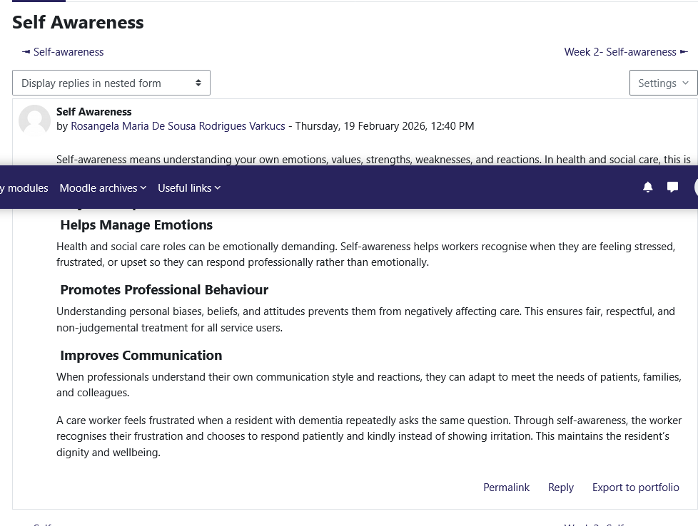
Figure 1: Forum about Self-Awareness
In the concept of ambition, it proves that ambition is a strong desire to achieve success or accomplish a particular goal. It involves determination, motivation, and the willingness to work hard in order to reach one’s objectives. Ambition often drives individuals to improve themselves, pursue opportunities, and overcome challenges (Resta, Ellenberg, Kruglansk, Pierro, 2023). Most people are moved by ambitions at one point in life, because without ambitions, you can't evolve in your career or life.
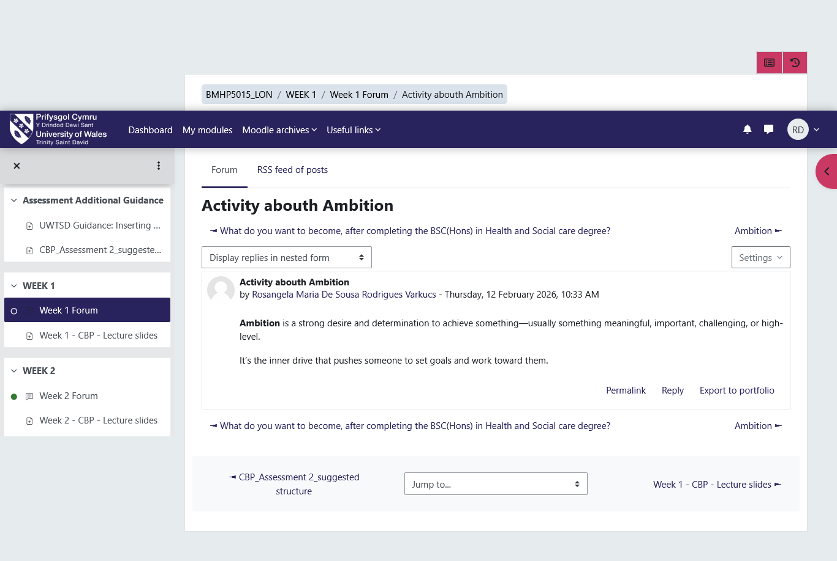
Figure 2: Forum about ambitions
Another concept that was addressed in this unit was professional identity. Professional identity refers to how individuals perceive themselves within the career that they have chosen and how they communicate the same to others (Yates, 2017). The aspect of professional identity is good in terms of health and social care because it is the responsibility of professionals to provide ethical, safe and effective care. The process of the discussion in the form of the forum enabled me to think about what I would like to be a responsible and caring healthcare professional.
The other point that the unit discussed when the personal branding in professional communication was discussed is the aspect of personal branding. Branding is not only used in business but also by individuals. As soon as the professionals form a clear personal brand, they will be capable of articulating their values and competencies in a more effective way to employers and other professionals (MacInnis and Folkes, 2017). Networking and career development can also be achieved through the establishment of a professional online presence via sites such as LinkedIn.
In most cases, Unit 1 taught me that personal branding has a strong correlation with self-awareness, communication, and professional identity. The factors mentioned above play a crucial role in building trust and credibility within a health and social care setting.

Task 2 – Reflection on Unit 2: It’s a Small World
Unit 2, titled It’s a Small World and the theme of the unit was the international character of health and social care and the influence international relations have on health care systems. The healthcare sector is no exception, as globalisation has led to the increased knowledge, technology, and professionalism exchange at the international level (Kickbusch, 2015).
One of the issues in this unit was global health inequality. The reasons behind the existence of health disparities between different countries and populations are the social, economic, and environmental factors. Marmot (2015) also highlights the role of social determinants such as education, income, housing, health access and others, which significantly influence health. The online activity experience made me ponder how health workers ought to be aware of such disparities and work towards assisting vulnerable populations.
Another concept that was addressed was cultural competence. Cultural competence is the ability of healthcare professionals to understand and recognise cultural differences in healthcare delivery. It should be culturally sensitive because patients represent various backgrounds, and they may have an alternative approach to health, illness, and treatment (Abrishami, 2018). Research also proposes that culturally competent healthcare is also observed to enhance patient satisfaction and outcomes (Jongen et al., 2017).
I applied the Moodle discussion forum in a way that allows me to reflect on how I can improve communication between healthcare workers and patients using cultural competence. Miscommunication, likely to rise due to the cultural differences, can lead to misunderstanding or low-quality care. In such a way, cultural awareness and cultural sensitivity should be the focus of medical workers.
The other aspect of this unit was the realisation of how the world cooperation can be applied to fight some of the greatest health problems, such as pandemics, climate change, and disease outbreaks. International organisations and healthcare professionals ought to work together in an effort to address these issues with governments.
Overall, this unit has helped me to understand that the practice of health and social care is influenced by global factors. The problem of turning culturally competent and globally conscious will enable healthcare professionals to even provide more inclusive and effective services.
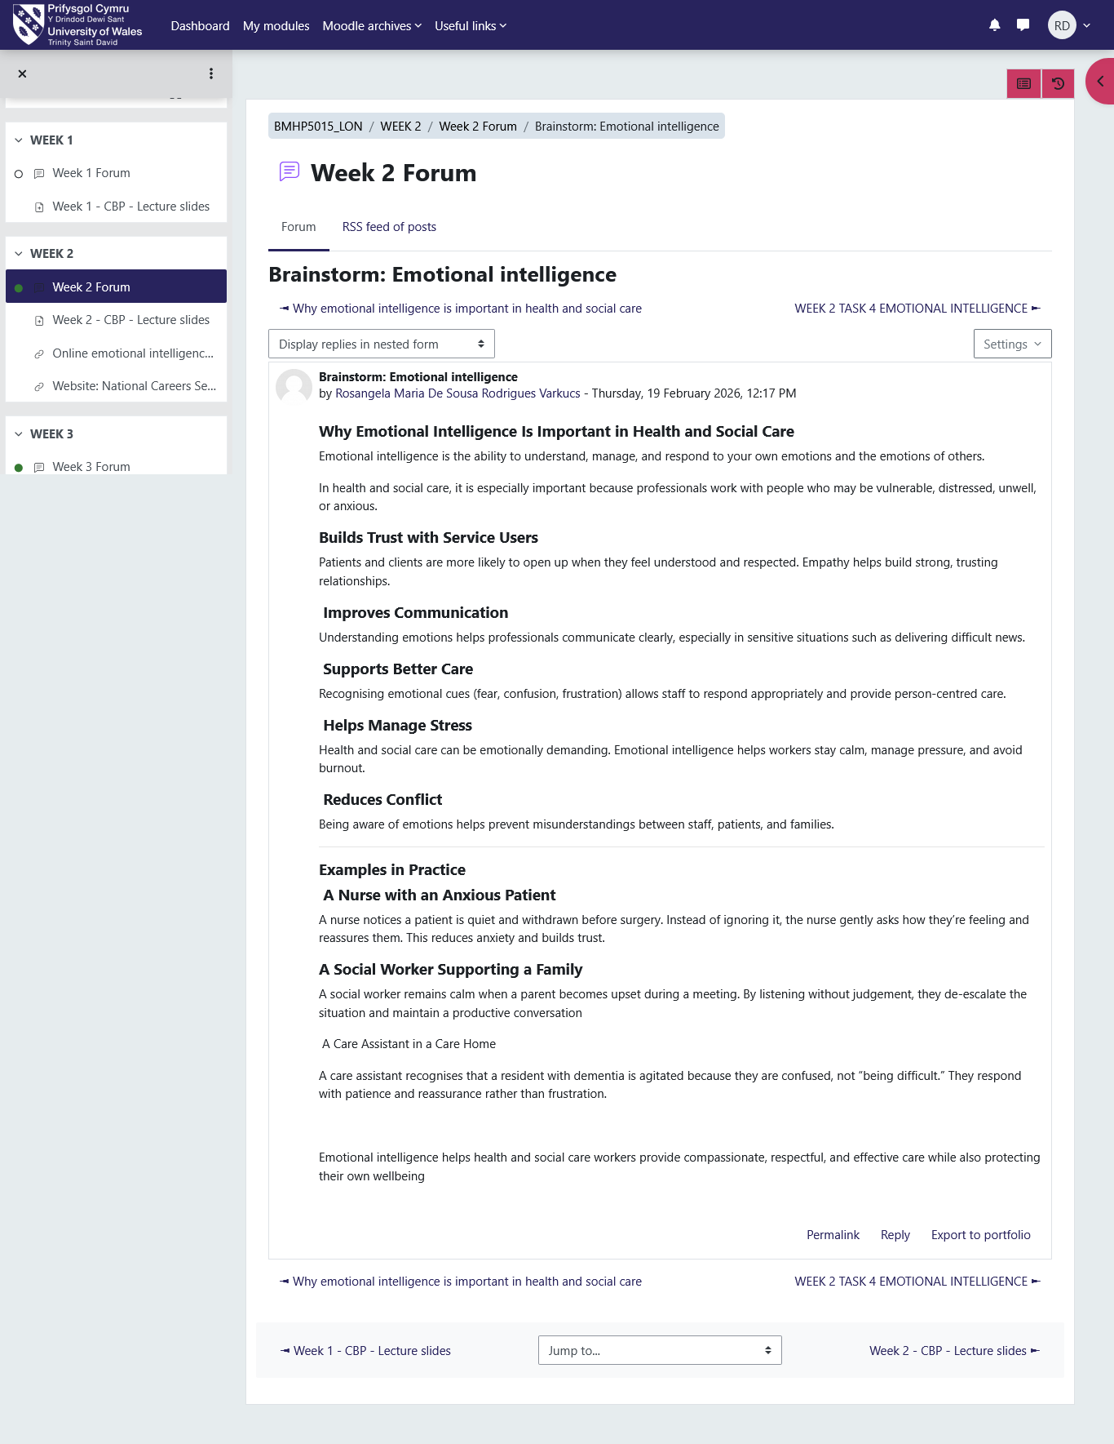
Figure 3: Forum about Emotional Intelligence

Task 3 – Reflection on Unit 3: Opportunity Knocks
Unit 3, titled Opportunity Knocks, was focused on the discovery of career development opportunities and improvement of employability. This unit also stressed that one has to always plan the future and continuously upgrade professional competencies. The professionals in the health and social care industry have the responsibility of being aggressive in identifying opportunities, which can be exploited to support personal and professional growth.
Among the concepts that were mentioned in this unit was career development. The process of career development is a lifelong process, which assumes learning, experience, skills acquisition, and adaptation to the new professional challenges (Vondracek et al., 2019). Moodle career planning activity helped me consider my long term objectives in career and put to mind my competencies that I should develop to become a competent worker in the sphere of health and social care. The task made me reflect on my abilities and see what possible areas of future training or education need to be addressed.
The second theory that was brought up in this unit was the social cognitive career theory. This theory also claims that career decisions and professional behavior depend on individual interests, competencies, and environmental factors (Lent, 2020). According to this theory, human beings would have a tendency to pursue career choices when they are sure about their ability and when they are certain that they can produce positive outputs. The reflection of this thought helped me to understand the value of self-confidence and interest in career choices.
Networking is another important aspect of professional development that was observed. Creating connections with professionals, mentors and organisations can result in learning, working and collaborating. Networking allows individuals to get information about different career options and get good guidance about the same due to skilled workers (Vondracek et al., 2019). Networking in health and social care would facilitate the individual to establish relationships with other workers, managers and organisations that would help them to pursue future career opportunities.
Flexibility and resistance were as well emphasised during this unit. The healthcare environments are always in a state of change due to the transformations in technology, policy as well as the development of new challenges to the health of the population. Because of this, professionals ought to be able to adapt to new circumstances that have never been encountered and be hard when necessary. The development of these qualities will assist healthcare professionals in embracing change and offering quality care.
Unit 3 enabled me to reflect on the fact that opportunities are not always on a silver platter. Instead, he or she needs to strive towards developing his or her talent, building professional contacts and being open to new experiences. This is how they will have a greater chance of securing sustainable jobs in the health and social care field and continue to develop their careers (Vondracek et al., 2019).
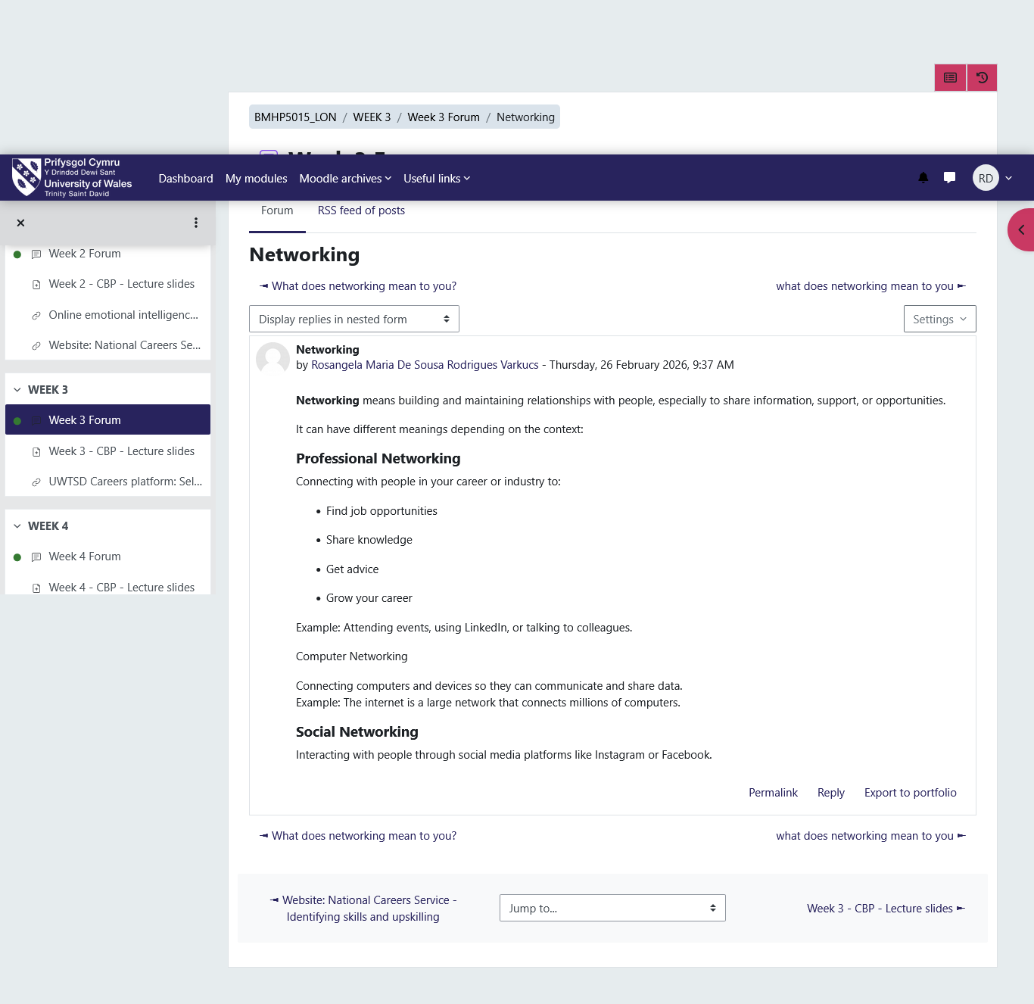
Figure 4: Forum about Networking

Task 4 – Reflection on Unit 4: The Pursuit of Happiness
Unit 4, titled The Pursuit of Happiness, dealt with well-being, job satisfaction, and healthy work-life balance. The problems are particularly pronounced among health and social care professions in which employees are required to work under pressure and stressful environments much of the time. The unit stressed that individual well-being is the challenge of determining performance in the profession and the subsequent sustainability of the career.
The term psychological well-being is one of the ideas that were extensively debated during this unit. Psychological well-being is the overall mood of a person in terms of emotional and psychological well-being and also includes feelings of satisfaction, motivation and positive functioning. The results of positive psychology show that well-being and happiness result in improved productivity, high mental health, and improvement in professional performance (Sharma, 2016). The reflection of this concept helped me to understand that not only personal well-being but also my professional performance can be boosted through a positive attitude.
Another issue that is mentioned in this unit is burnout among medical workers. Burnout is an outcome of over-stress, emotional drainage, and absence of motivation and alienation from the job in people. According to Leiter and Maslach (2016), burnout can negatively affect healthcare workers and the quality of their work as they attend to their patients. The high levels of stress are bound to lessen job satisfaction and professional practice errors. Therefore, medical professionals need to know the signs of burnout and take precautions that will enable them to overcome stress.
The other area of interest that was explored by the unit is the importance of purpose and motivation in professional life. The health and social care workers draw the attention of a lot of people because they want to do something good in society and to assist people in order to better themselves. A sense of purpose is another aspect that can lead to improved job satisfaction and the desire of professionals to remain committed to their job (Sharma, 2016).
Based on the Moodle reflection activities, I evaluated the need to balance work and life as one of the solutions that could be used to improve the performance and well-being of the profession. Some of the measures that could help professionals balance the work-related issues and be physically/mentally fit include stress management, time management and regular self-care.
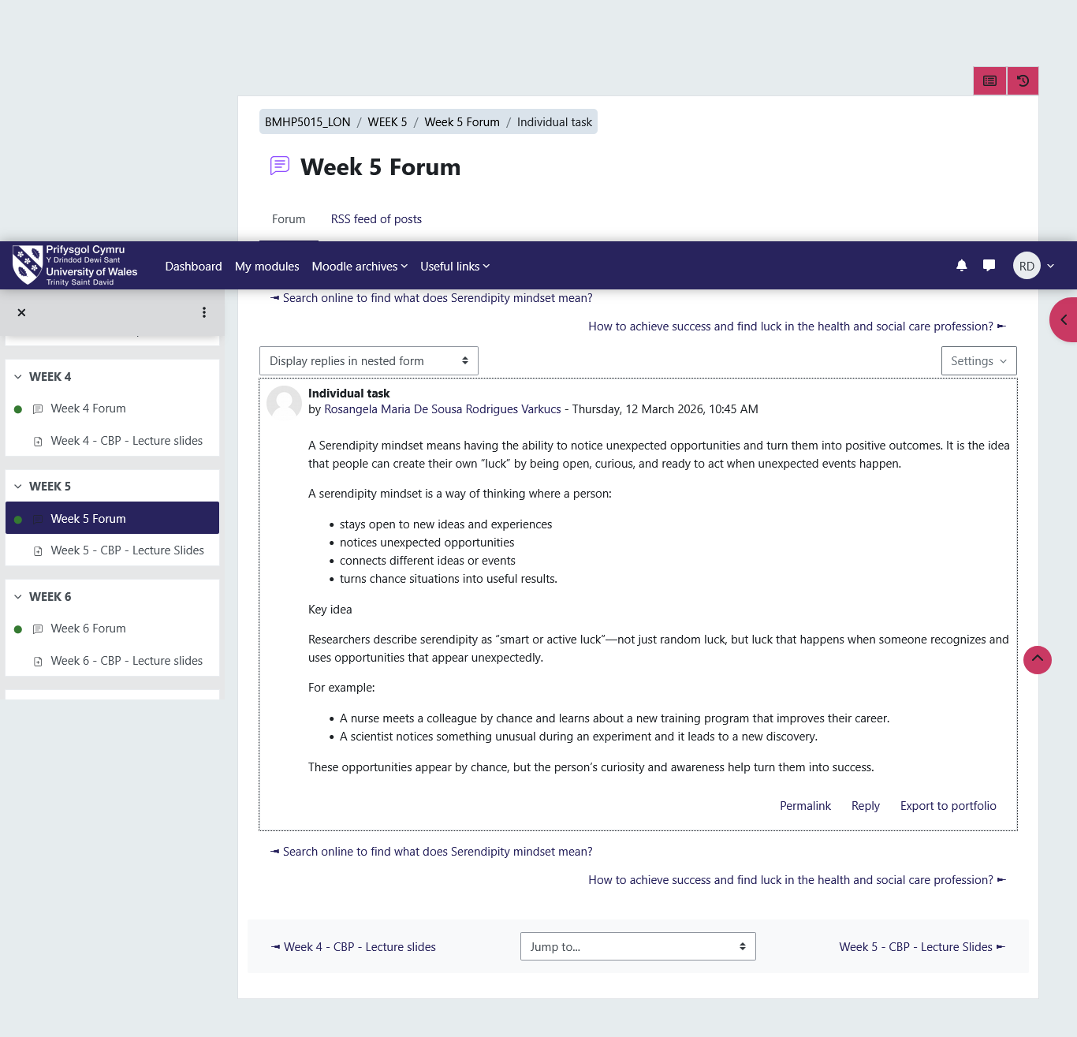
Figure 5: Forum about individual task

Conclusion
It is a reflection of what has been learned and gained in the Changemakers: Building Your Personal Brand to Sustainable Employment module, as reflected in this portfolio. Each of the units provided valuable data on diverse aspects of professional development and employability within the context of the health and social care sector.
Unit 1 focused on the importance of personal brand, self-awareness and professional identity in creating a sound professional reputation. Unit 2 has given me exposure to seeing how the global healthcare issues and the importance of cultural competence in the delivery of effective care. Unit 3 noted the significance of opportunity identification, career plan development and networking. Finally, Unit 4 was related to well-being and work-life balance, which is required to achieve long-term professional motivation and burnout prevention.
Overall, this module has helped me develop a better understanding of why personal development, world consciousness, and wellbeing are vital to the sustainable working life in the health and social service sector. Reflective processes allowed me to think about my strengths and the aspects that I should work on to improve. The skills and experience that I will receive during this module will help me grow further professionally and become a responsible and efficient healthcare professional.

References
Abrishami, D. (2018). The need for cultural competency in health care. Radiologic Technology, 89(5).
Hunt, A.N. and Rhodes, T.D. (2021). Expanding the life-span, life-space approach using critical race theory and intersectionality. Journal of College Access, 6(3), p.8.
Jongen, C., McCalman, J., Bainbridge, R. and Clifford, A. (2017). Cultural competence in health: A review of the evidence. Springer.
Kickbusch, I. (2015). The political determinants of health—10 years on. BMJ, 350.
Kotsou, I., Mikolajczak, M., Heeren, A., Grégoire, J. and Leys, C. (2019). Improving emotional intelligence: A systematic review of existing work and future challenges. Emotion Review, 11(2), pp.151–165.
Leiter, M.P. and Maslach, C. (2016). Latent burnout profiles: A new approach to understanding the burnout experience. Burnout Research, 3(4), pp.89–100.
Lent, R.W. (2020). Career development and counseling: A social cognitive framework. In: Career Development and Counseling: Putting Theory and Research to Work, p.129.
MacInnis, D.J. and Folkes, V.S. (2017). Humanizing brands: When brands seem to be like me, part of me, and in a relationship with me. Journal of Consumer Psychology, 27(3), pp.355–374.
Marmot, M. (2015). The health gap: The challenge of an unequal world. The Lancet, 386(10011), pp.2442–2444.
Resta E., Ellenberg M., Kruglansk A., and Pierro A., (2023). Ambition and extreme behaviour: relative deprivation leads ambitious individuals to self-sacrifice https://pmc.ncbi.nlm.nih.gov/articles/PMC10370493/
Sharma, K. (2016). Flourish: A visionary new understanding of happiness and well-being by Martin EP Seligman – A Book Review.
Swain, T. (2024). Branding: The Fast & Easy Way To Create a Successful Brand That Connects, Sells & Stands Out From The Crowd. Thomas Swain.
Vondracek, F.W., Lerner, R.M. and Schulenberg, J.E. (2019). Career development: A life-span developmental approach. Routledge.
Yates, J. (2017). A social identity approach to career development: Possible selves and prototypical occupational identities. Doctoral dissertation, University of East London.

