

BSc (Hons) Professional Police Practice

LEVEL 5 - 40 Credits

Workbook title: Competency Based Workbook 2 (PCDA)

(SOUTH WALES POLICE, GWENT POLICE AND UWTSD)

Learner name: Michael Gutierrez

Learner’s University Registration Number: 2134525

FACULTY OF BUSINESS AND MANAGEMENT
PUBLIC SERVICE PROGRAMME

Module title: Professional Police Practice 2 (PCDA) BMPP5000D

Workbook Guidance

Please read these notes carefully; they provide essential information.

What is the workbook for?

The purpose of this workbook is to enable learners to demonstrate and provide evidence of how they meet the learning outcomes set by the College of Policing, for the BSc programme. Essentially, you are being asked to outline your experiential learning based upon your theoretical understanding in a range of operational situations.

- Wellbeing and Resilience
- Decision-making and Discretion
- Vulnerability and Risk
- Public Protection
- Maintaining Professional Standards
- Leadership and Team-working
- Policing the roads
- Information and intelligence
- Conducting Investigations

You may wish to use the same incidents as you’ve outlined in the Occupational Competence Portfolio.

How should the workbook be presented?

Blank electronic copies can be found on Moodle of this workbook. You must submit this document electronically therefore it is important that you save your work regularly and upload the final typed version through Turnitin on Moodle.

Word count policy can be found in chapter 7 of the Academic Quality under section 7.7 (this applies to presenting work above and under the specified word count).
(https://www.uwtsd.ac.uk/media/uwtsd-website/content-assets/documents/academic-office/aqh-chapters/chapters---en/Chapter_07_Assessment_Taught_Programmes_Pages_72-79-UPDATED-05-11-2019.pdf)

Reflective practice is a core aspect for your workbooks and although there is a variety of useful resources on Moodle, there is one particular book, that is specifically based on reflective practice in policing, here is a link to one chapter from Selina Copley’s Reflective Practice for Policing Students:
https://moodle.uwtsd.ac.uk/pluginfile.php/298870/mod_resource/content/1/Reflective%20Practice%20for%20Policing%20Students%20-%20Selina%20Copley%20Chapter5.pdf

How is the workbook assessed?

Advice and support about the completion of this workbook will be provided by university staff as part of your initial training day. Your tutor constable and in-force training staff will not be involved in assessing or marking your workbook after it has been submitted.

Dates of workbook submission will be made available during the initial training day and posted on Moodle.

Once submitted your workbook will be assessed and marked independently.

Confidentiality

It is important that no individual can be identified either directly or indirectly from the information in the workbook. Therefore, you must:

- adhere to guidance in the Student Handbook about unfair practice and plagiarism.
- not identify individuals including witnesses, victims or offenders by name.
- not write information that enables any individual to be identified indirectly through the description you provide. This includes references to names, colleagues, places (including hospitals, schools, town, villages, streets) specific incidents which were high profile and could be identified due to past publicity, other professionals or any other personal information including medical or other conditions.
- take personal responsibility for adhering to confidentiality rules.
- not include any dates of any incidents or anything that specifically identifies an actual incident.

Please be aware that any content that is deemed to be inappropriate, disrespectful, or abusive will not be tolerated. Following review of any content of this nature the information will be shared with the employer of the student responsible.

Should any health and wellbeing concerns be raised because of disclosures made by the student within this workbook, the employer of the student will be informed.

NOTE

Your workbook will be submitted electronically via Turnitin on Moodle. Guidance on this is in the Student Handbook.

Remember that the workbook is YOUR responsibility you must not rely on the assessor or anyone else to pick up any confidentiality breaches as this is your work and you must accept full responsibility for confidentiality. Meeting all the confidentiality requirements is very important.

Dyslexia and other special circumstances

If you have any condition that you feel may affect your ability to deal with any part of the programme, please see the Student Handbook for further guidance. The University has a Student Services Unit that may be able to help but it is the learner’s individual responsibility to contact them.

Guidance:

- Your workbook must contain the items specified in the table below (clearly identified and in the order given);
- You should use this particular document to insert your text / answer within each section of this workbook;
- You should upload your completed document as a saved pdf file of this workbook; if this is not possible then a Worddoc file is acceptable. Do not send a scanned file from a photocopier, an apple.dot file or a Microsoft publisher file as Turnitin will not be able to assess them, despite you being able to upload them.

Contents

Workbook | Area of Professional Practice | Word count
Task 1 | Wellbeing and Resilience | 1250
Task 2 | Decision-making and Discretion  Vulnerability and Risk  Public Protection | 1750
Task 3 | Maintaining Professional Standards  Leadership and Team-working | 1750
Task 4 | Policing the roads  Information and intelligence  Conducting investigations | 1750
Task 5 | Individual Learning Plan | 1500 equivalent
 | Total | 8000
 | Bibliography

Task 1

Relevant areas of the National Policing Curriculum:
Wellbeing and Resilience

Having achieved Independent Patrol Status, reflect on the impact of organisation culture within policing on your wellbeing and resilience (organisation change, retaining personal values in a wider organisational culture).

Consider the risks of conforming to organisational culture.

Illustrate your strategies for maintaining wellbeing and resilience.

1250 words (+/- 10%: include your actual word count at the end of each section)

ANSWER:

Independent patrol status is the point at which I have completed my initial six months six months training in a classroom environment and my three months tutorship once allocated to a shift. This now means that I am able to respond to calls regardless of their gradings and deal with them as a Police Officer on my own. I am able to make all decisions myself. It is important to note that I am not left on my own and am not expected to make a decision about something I do not know. I always have my peers and response shift sergeant to ask for help. The time I have spent in the job means that I have made a number of contacts with a varying level of experience and knowledge and am able to turn to them for help as well.

Whilst all this is the short-term end goal for me at this stage in my career, It does not come without it’s challenges. There is a level of added stress to this given the demand on the Police as well as the demand of managing my own workload. I am responsible for ensuring that the jobs I am investigating are done so not only in timely manner, but that the victims are regularly updated as to how the investigation is progressing. There can often be a misconception from members of the public as to how long it takes for outcomes to be arise from an investigation and their realistic expectations should be managed also. All this comes with, in my experience, a high level of stress and anxiety specifically around the victim’s perception of weather you are delivering a good service to them as well as having to balance and juggle other outstanding work on threat of risk and harm basis. The levels of stress and anxiety are heightened when you have a challenging day, needing to compose yourself before leaving for home and trying to not take your work worries with you as well as preparing yourself for having to complete university work.

As well as the aforementioned, there is also the balance in work of ensuring that you do not fall into what has been defined as “organisational culture”. This term can be interpretated in many different ways however, to summarise “organisational culture” you can say that culture is the way in which organisations do things (Dr.Watkins, 2017). There have been multiple reports published on the findings from investigating this which have been summarised in an article by The Police Foundation’s Director stating that the reports have identified a pattern of behaviours by a minority margin of officers that are contrary to the way in which officers are expected to behave which have been highlighted in the “Code of Ethics” by the college of policing in 2014. Whilst identifying these issues it has also been highlighted that the wider proportion of officer whom may not agree or support the behaviours displayed by this minority, there is a “wall of silence” built where the behaviours are not challenged or reported. The “wall of silence” has also been referred to as “the blue wall of silence” or “the blue code of silence” and is effectively the willingness of officers to report their colleagues for misconduct behaviours (Parry and Benoit, 2021). This has been especially prevalent being highlighted in some recent cases of identified in Gwent Police regarding inappropriate behaviours and comments in a WhatsApp group conversations (BBC News, 2023).

During my time as a response officer to date I have had to deal with some of the more challenging sides of society, as well as seeing some things that you would not see in the majority of other professions. Attending incidents such as serious road traffic collisions as well as sudden deaths on behalf of the coroner can be somewhat traumatic given the condition in which you are seeing some people. Having family members that are not in this profession or that of a similar nature and not being able to speak with them about what you have seen can leave you feeling isolated. The only outlet you have is to speak with your colleagues about what you have experienced whilst also being mindful of how they are feeling about certain incidents that they have experienced and being mindful of the demands on you as an officer. These factors make it even more prevalent to ensure that you are not taking your work home with you, focusing on keeping a work – home life balance.

Being placed onto a shift where the officers I work with are all relatively new, I have not been exposed to any behaviours that have been observed within other forces including Gwent Police itself previously. The main basis for this I believe is that they have been highlighted within the media and new officers are all to aware of the possible repercussions for behaving in such a manner as well a massive forward step in the behaviours of society in general all be it these behaviours can still be seen within certain communities or from certain backgrounds.
The risks of not conforming to the behaviours identified by The College of Policing with the mentioned “Code of Ethics” have been highly publicised and are outlines within force policies for misconduct hearings following reports to the professional standards department within the Police. The IOPC (Independent Office for Police Conduct) is also in place to ensure that all complaints are dealt with proportionately and without bias helping to further reduce the behaviours previously seen and attributed to the “the blue wall of silence” as they are an independent organisation from the Police itself, in turn, helping to boost the publics perceptions of the Police and their ability to deal with matters fairly (IOPC, N.D)

Whilst progressing with my work and trying to keep up my standards of work, I have been attempting to maintain my commitment to activities outside of work. I have been, for some time committing to engaging with youths within my local community at a local rugby club as well as pursuing activities of refereeing rugby games which in turn has been helping me to maintain my fitness levels which is essential for my role as a Police Constable.
These are aspects of my life and critical to my wellbeing and resilience that I have found increasingly difficult to maintain. The demand on me as a Police officer increases daily and can be even more challenging when my supervisor is on annual leave or when there have been instances where I have had not direct supervisor due to staff re allocations. Working shift patterns that are different to close of my closet friends who are both in the job or those who work a regular working pattern making it again difficult to find the time to catch up with them especially when I have the added pressures of completing additional work within the curriculum set out by the university.

Word Count: 1165.
Task 2

Relevant areas of the National Policing Curriculum:
Decision-making and Discretion, Vulnerability and Risk, Public Protection.

You must choose an incident, for example a domestic related incident, and reflect on how you made decisions in complex and unpredictable circumstances using dynamic risk assessment.

Give a brief description of the problem including social and legislative contexts and any relevant cultural, ethnicity and language issues.

Evaluate decisions made during the incident and your use (or otherwise) of the National Decision Model. Explain the rationale behind your decisions and your considerations when recording details of the incident. Consider your ethical approach to the decision. Outline the consequences of your decision making.

1750 words (+/- 10%: include your actual word count at the end of each section)

ANSWER:

Within this essay I will be discussing the decisions I made at an incident focusing on those made revolving around the vulnerability, risk factors focusing on the protection of the public, specifically where immediate protection was required in what was a domestic incident. This essay will provide a brief description of the circumstances and I will then evaluate my performance around the decisions made.

I have recently attended an incident where it had been reported by a female that her partner had been “smashing the house up”. The female had reported her partner had sent her a video of himself in the home with an array of damaged property around him. The female had stated on the 999 recording that there was no violence used toward her and she left as he was getting angry. The female had named the person, she states she is in a current relationship with and has children with him. This incident had been graded as an emergency call as it was reported to be a live incident. I have attended this incident with a colleague as per Gwent Police policy when attending domestic related incidents.

My decision making when attending this incident has been done so whilst closely observing the Nation Decision Making Model (College of Policing, 2014). The decision-making model is a tool developed to help Police officers with their decision making ensuring that all aspects are encompassed. The National Decision-Making Model holds the Code of Ethics (College of Policing, 2014) at its core.
The combination of the two tools and frameworks set out as standard operating procedures helps to ensure that, all information and intelligence is gathered, collated, and only acted upon in conjunction with powers, policies, and legislation available whilst also simultaneously ensuring that cultural factors are observed. This ensures the whole approach is both lawful and ethical.
Ethical Policing has been defined most notably in relation to this incident as providing a public service working in their interest (College of Policing, 2024). During this incident, I have not been faced with any cultural and language factors or issues. The following diagram can assist with following the National-Decision making Model:
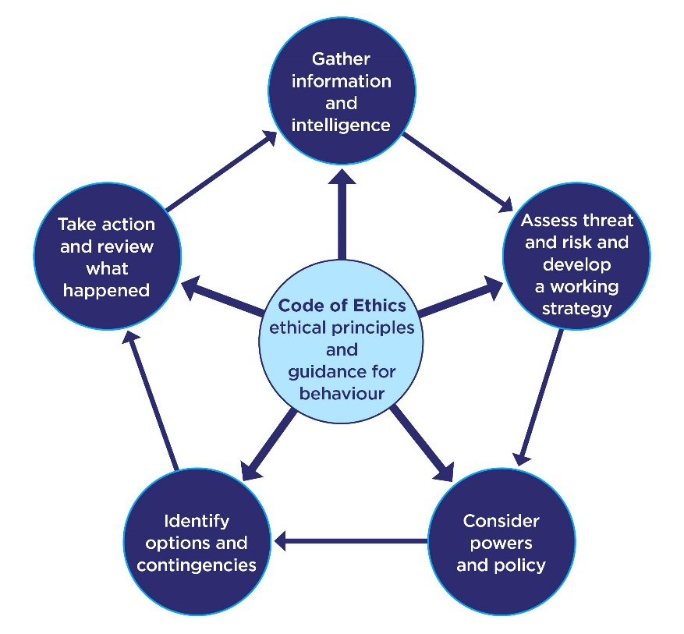
(College of Policing, 2013).

Whilst the National-Decision Making Model provides the officers with the ability to apply legislation to any information obtained, it also allows them to consider policies, procedures, and options available. One of the options available is an officer’s use of their discretion. This is referred to by the College of Policing as “professional discretion in decision making” (College of Policing, 2022). Discretion is defined as “the right or ability to decide something” (Cambridge University, N.D). Whilst in this instance there is a report of an incident, nothing of an evidential value was obtained or provided. As the attending and investigation officer, it was my role to corroborate the initial report provided by the person reporting the offence. In this instance, as will be explained later, this option was one available all be it not utilised during this incident. As part of the initial report to the Police it was mentioned that the male was under the influence of alcohol as well as possible controlled substances. This has added to the possible risks posed not only to attending officers but also members of the public, due to the unpredictable manners in which persons under the influence can behave.

The national decision model as stated can assist officers in the decision-making process with the first being to gather information and intelligence. Having been completed with the initial report the next stage is to assess the risk to persons involved and the public. Given the indecent has taken place within a private dwelling the risk posses to members of the public were low. The risk to the reporting person and victim was also low as they had stated they were at an alternative address, the risk to attending officers was low whilst in possession of PPE (Personal Protective Equipment – in the form of appointments and protective vests). There was no reported use/threat of violence toward any person and no weapons mentions supporting this risk threat. The decided upon approach was to attempt entry to the property in order to locate, detain and arrest the suspect.
Upon my attendance at the scene, prior to attempting to gain entry to the property in question or engaging with anyone in relation to this incident I had activated my body worn camera. This being a tool which is provided to Police officers specifically in Gwent (used in other Police services also) can assist them with their routine duties. The use of body worn video is protected lawfully under common law as it’s intended purpose is to protect life and property, bring offenders to justice among a few other factors. This is stipulated in principle 1 in the National Police Chiefs’ Council portfolio on body worn video usage (Page 8, Police Chiefs’ Council, 2023). The reason for highlining the two mentions is the use of body worn in this instance was to bring possible offenders to justice and to protect property.
This use whilst not mandatory assists officers to obtain video which can provide an evidential value in some instances such as documenting offences contrary to public order and more specifically in this instance, documenting the condition of the property within the females home and damages that may have been caused by the possible offender.
Entry to the property was gained through an unlocked rear door following a number of knocks to the front door and noise being heard from within the property at that time. There are many different powers available to a Police Constable allowing them to gain entry to a property which can include causing damage eg, breaking down the door. Although no damage was needing to be caused in this instance, reports of items being damaged not belonging to the suspect amounted to an offence of Criminal Damage. With Criminal Damage being an offence that is “indictable” this comes with a conveyed power of entry under Section 17 (b) Police and Criminal Evidence Act 1984 (Legislation.Gov, 2024). This power is also applicable when entering a property to prevent serious damage. As the extent of damage was unknown and reported to be ongoing this aspect has further enhanced and justified the power of entry in order to locate the suspect.
Once inside the property there was significant damage to furniture within the property as well as food items thrown around. Whilst searching the property, officer safety was paramount as the only other person reported to be within the property was the suspect as the children were in a different property. The risk to officers and the suspect remained low at this time. A comprehensive search of the property was conducted by the attending officers within the stated Section 17 power to enter and search.
The suspect not having been located at the property, further information has been provided that he may have gone to his mother’s house which is located approximately five minutes from the incident address. This has led the risk to members of the public (including the suspects family) to be medium as it was unknown how he has travelled whilst under the influence and whilst no violence has been used or threatened, the damage to property was substantial and was possibly in an aggressive manner. With risk to officers wearing PPE carrying appointments remaining low. Due to the damage within the property and possible location for the offender, officers have attended the address where the suspects mother has allowed officers to enter and search the premises where he was located and arrested. The arrest was carried out utilising Section 24 Police and Criminal Evidence Act powers (Legislation.Gov, 2014) for the offence of Criminal Damage.

Further to my attendance at the address, I have returned to obtain a statement and collect the video that the victim had stated was sent to her. This has assisted in the preparation for interviewing the suspect.
Whilst preparing the file to send to the Crown Prosecution Service (CPS), the victim has contacted stating she wished for to withdraw her complaint. This withdrawal statement has been obtained where she has been informed that the conditions for which the suspect was released with would remain in place and the case sent to the CPS for their consideration of an Evidence Led Prosecution (College of Policing, 2022).

Whilst at the address initially knocking the front door attempting to gain entry, with the noise that could be heard within leading me to believe that the suspect was still there. Containment was not applied to the rear of the property meaning the suspect may have been able to leave prior to rear entrance being located.

Overall, my performance has been to a standard of what would be expected of an officer during an incident of this nature. The safety of the victim, their family, the suspects family, and wider public have been prioritised and a successful detainment of the suspect for the offence for which he was suspect of carrying out. Following transporting the suspect to custody where he was detained so as to prevent further damage to property and allow a prompt and effective investigation. Strong focus on the protection of vulnerable victims as well as utilising powers policies and professional discretion appropriately particularly when using my discretion to proceed with an ELP for the offence with suitable and substantial evidence of the offence.

Word Count: 1575

Task 3

Relevant areas of the National Policing Curriculum:
Maintaining Professional Standards, Leadership and Team-working

Evaluate theories of team dynamics as a means of developing team cohesion (reasons why some teams cannot function, theories and models relating to team dynamics, ways to improve team cohesion).

Consider why inter-personal conflict can occur within a team and outline what strategies can be adopted to enhance individual and team performance.

Consider how team dynamics within the police service can result in failing to comply with professional standards requirements (Code of Ethics, policies, procedures, protocols or legislation).

1750 words (+/- 10%: include your actual word count at the end of each section)

ANSWER:

Within this essay I will be evaluating different theories of team dynamics as well as considering how conflict can occur whilst considering strategies that cam be implemented to enhance performances. Finally, I will be looking into how team dynamics could have a negative impact on the individuals in terms of complying with the forces policies as well as possible breaches of the Code of Ethics.

There are a number of theories in relation to the topic of team dynamics and cohesion of the members. Whilst you could apply any model depending on your approach or perspective toward the dynamic identified. I will be looking at two which I have find following my research are prevalent within the Police service. These models are, “The Tuckman Team Model” and “GRIP Model” (BP Campus, N.D).

“The Tuckman Team Model” highlighted in his paper “Developmental Sequence in Small Groups” (B.Tuckman, 1965) (MIT, N.D) outlines the process in which teams form, and brain storm ideas as well as making these practices or idea the norm and then these members or others performing the model. This model was developed by Bruce Tuckman in a paper titled “Developmental Sequence in Small Groups” in 1965. This paper has helped to highlight the path taken for teams to make strides toward performing at a high level (Mind Tools, N.D). This model as stated is broken down into four stages where a fifth was added following the model’s development. These stages can be described as follows:
- The Forming Stage
  - This is the stage where, depending on the individuals place within the organisations system of hierarchy, they establish boundaries of their interpersonal relationships with other team members or team leaders and establish behaviours towards goals and tasks. This can also be where higher-ranking members could establish any preexisting standards being considered.
- The Storming Stage
  - This is where you are most likely to encounter conflict with the group. This stage is the point at which members of the team and team leaders would brainstorm to help design the process to be followed or the changes they would like to make to any preexisting polices / procedures. Different members of the team with individualistic outlooks on how things should be done can clash at this point creating the conflict that has the potential to occur.
- Norming
  - At this stage, any resistance of conflict that has arisen can be overcome by the group now implement the penultimately agreed upon approach or changes to follow and make.
Whilst this stage may not be where all team members work together closely during to them have independent roles or responsibilities, they are more than likely to check in on each others progress as they are working toward the same end result. This is enhanced in the proceeding stage of Performing.
- Performing
  - This stage is often only reached once teams have worked together on multiple projects having developed a strong cohesion and having identified any weakness in the agreed upon process to streamline the process. Having completed the tasks many times, the streamlining of the process helps reduce time taken and can boost the efficiency of the team and in some circumstances the wider organisation where multiple teams work together.
This can be seen particularly within the Police when you consider the investigation into serious offences where Response have deployed in the first instance and the incident passed overt to CID (Criminal Investigation Department) and finally on the FMU (File Management Unit).
- Adjourning
  - As stated, this was added later on as it has been identified that not all team members or teams will work together throughout the process and some leave at different stages as their role or responsibility as been completed.
The following diagram helps to depict the process in which this model is followed and occurs within a team setting.
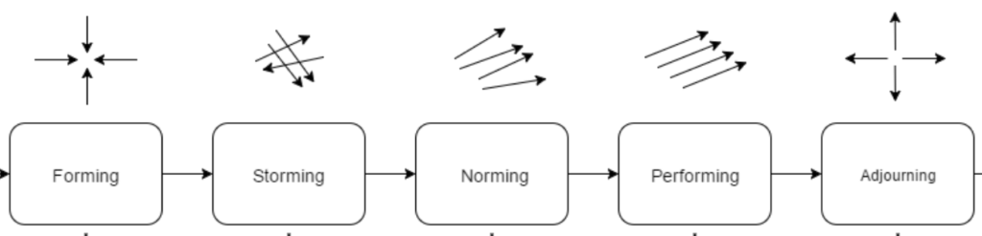
(BP Campus, N.D).

The second theory that I have identified titled as the “GRIP Model” was developed by Richard Beckhard in 1972. Whilst this has been seen to be used within sporting context this can be easily applied to that of Police given the organisations structure. (BP Campus, N.D)
- Goals
  - Everyone is expected not only understand what is expected of them in their role but to also, commit to these goals set out by the organisation. Regular monitoring of their progress and Performance can help to ensure this is being achieved and implemented.
- Roles
  - Tying back to first stage of the framework, this part ensures the individual within the team is fully aware of their responsibilities and or their roles where they can be held accountable for their actions and performance within their role.
- Interpersonal
  - The importance of people communicating and working together helps to build the relationships between team members and leaders which can in turn lead to people with different roles and responsibilities assisting other team members. This in turn can enhance the performance of the team and organisation in whole.
- Process
  - This is where the goal is defined and how any issues arisen in the preceding elements can be tackled. It identifies everyone’s roles and how to tackle in conflict or challenges encountered within the preceding elements.
The following diagram helps with to illustrate the highlights of each element of this model.

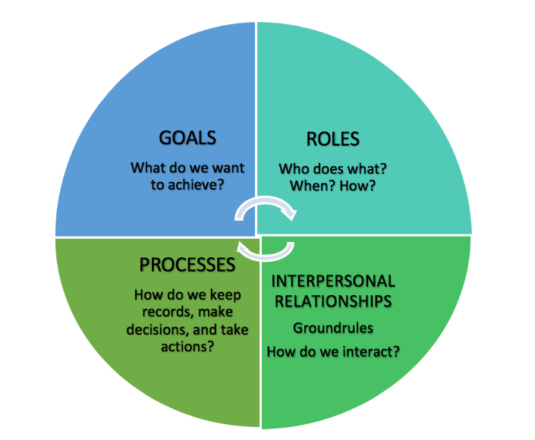
(BA Campus, N.D).

As you can see from the two models explored, there are some similarities. Whilst The Tuckman Team Model is somewhat a little more detailed in developing strategies, theories, goals and the penultimate implementation, The GRIP Model focuses more on the latter changes of The Tuckman Model focusing on stages three and four with an aspect of the fifth which can be easily incorporated into The GRIP Model.
Whilst neither model is perfect, they both focus on identifying team members responsibilities and focusing on everyone working toward the same goal. As seen in The Tuckman Model, resistance can be met when at the second stage as well as the latter stages. Although these latter stages are where the goals are agreed upon, some members who did not agree with the process in the first instance may not be motivated. The following strategies can be used to ease this tension and bring team members on board with the process to achieve the shared goals.

Before discussing the strategies, it is important to highlight some of the difficulties and frictions that could be expected in a team environment. There can often be clashing of personalities, a difference in opinion of the way in which process’ should be run or implemented and often the notion that some members may not be working to the fullest of their potential.
With the above mentioned, it can be often be a conflict on an interpersonal level regarding the process due to a simple misunderstanding which is know as a “Pseudo conflict” (C.Cassata, 2023). There is often the potential for what can be described as an “Ego conflict” where two people having each a strong personality and neither being willing to accept they may be wrong (C.Cassata, 2023).
Both possible conflict types can be avoided by either “withdrawing” where you would be removing yourself from the argument and simply accepting that you may not see eye to eye with person you are arguing with. Be accommodating to the others views and try to see things from their perspective instead of being oppressive toward their feelings on the topic. Healthy relationships often have an element of give and take. This can be tied in with “competition” where you force your ideas on someone often wanting to be the one to win an argument or have your way. Compromising and collaborating your ideas can often help to come up with a solution. This can be achieved by following The Tuckman Model first and second stage often having an external influence such as a moderator to help prevent a discussion becoming an argument and sometimes better explaining the other persons point of view.

While these models help to keep everyone on the same page, they can have the effect in a wider and larger organisation where the goal is sometimes lost or re interpreted and often not identified early enough to prevent an issue arising. Issues arising within the Police can often lead to the individuals either not following the policies and procedures of the Police service and in some circumstances breaching the Code of Ethics (College of Policing, 2014).
This as been especially prevalent within the Police recently where interpersonal relationships have developed so strong that they are friend ships in turn enhancing what has been researched and described as “the blue code” of silence (Westmarland, L., & Conway, S. (2020). This is where the people within this team having developed the friendship are less likely to report incidents of any breaches to policing or behaviour which amounts to misconduct. This is managed by the standards department within the Police service but can only be done so when aware of the incidents as explained can often go unreported or unidentified.

Word Count: 1510.

Task 4
Relevant areas of the National Policing Curriculum:
Policing the roads, information and intelligence and conducting investigations.

Explain how information and intelligence can be used in the disruption of the more prevalent criminal activity (e.g. drug smuggling, human trafficking, child sexual exploitation, counterfeit goods, organised crime groups and ‘county lines’) by effective policing of the roads.

Outline how ANPR can be used as investigative resource when disrupting criminal activity.

1750 words (+/- 10%: include your actual word count at the end of each section)

ANSWER:

Policing the roads can hold a vital role in the disruption of on-going criminal activity. Within Gwent Police there are a number of what are referred to as major trunk roads, those being the A465 linking the midlands with the top of the valleys and the M4, linking London with the bottom of the valleys and the three major cities within South Wales. Having a dedicated resource to this within Gwent Police has proven and continues to prove to be effective is disrupting those who use these roads for the purposes of criminal activity. I have been involved in an incident where a person who has been at risk of Criminal Exploitation has been picked up within the area I work by person from England. The person was reported as missing by his care staff as he was a child in care, the care staff able to provide the registration for the vehicle has helped officers to identify the routes being travelled by the vehicle using the ANPR (Automatic Number Plate Recognition) system (Police.UK, N.D).

By conducting active patrols based on the information retained on Police systems, active stop checks of suspect vehicles and the people driving them. There are multiple pieces of legislation allowing you to conduct these stop checks and/or searches with the two most common being:
- Section 1 – Stop and Search – Police and Criminal Evidence Act 1984 (Legislation.Gov, 2022).
- Section 23 – Power to search a person and/or vehicle suspected of contravening the act – Misuse Drugs Act 1971 (Legislation.Gov, 2011).
With having these options available to you, the power for a constable to stop a vehicle is outlined within the Section 163 of the Road Traffic Act 1985 (Legislation.Gov, 2006). Whilst this power is available to all Police Constables, not all within Gwent Police are able to then declare what is a referred to as a pursuit should a vehicle “fail to stop” as there is specific training required in order to so this.

As mentioned here, stop and search, especially within the guidance of Section of PACE has been and still is heavily criticized. This criticism comes from decades of media publications and as well as reports into the statistics of stop and search identifying that those of an ethnic background are more likely to be subject to stop and search. An article published as detailed the significant increase in the amount of stop and search being conducted in 2021 with those of an ethnic background being 7 times more likely to be subject to a stop and search (Fair Trials, 2021).
Recent statics from the ONS (Office of National Statistics) published by the Home Office have shown that these figures to be a true reflection of the publication. The publicity around these findings is often widespread and can lead into some difficulties when carrying out you role as a constable. Despite the hardened focus, in my experience around issues of this nature to ensure constables base all decisions on the information and intelligence that is present to them. As seen in all aspects of policing, this is not always the case or the way in which some officers conduct themselves, a recent article from the BBC details the findings of the IOPC quoting "decision-making based upon assumptions, stereotypes and racial bias." (BBC News, 2022).

The same statistics also show that 77% percent of stop searches recorded have resulted in an arrest being made. This being said it could be perceived in many ways. There could be the element present that is reported in the media of officers behaving in an unethical or even criminal manner by stop searching people on a racist or bias manner. Better scrutiny on the source and quality of information provided to the police for them to base their decisions on to conduct a stop and search as well as better preventative measures made so as to prevent people from becoming subject to stop and search.

With all this in mind, it crucially important that the policing of the roads is done so legitimately for it to not only be effective but to also prevent policing of these means is not compromised and to also ensure the continued pr active approach to disrupting organised crim that inevitably targets vulnerable people and communities.

Sources of the information can vary from members of the public, which is gathered and developed by intelligence officers as well as the intelligence coming from sources within positions of trust such as prison services when speaking about people who are being released from a custodial service back into the public. Such information is often gathered, developed and then the people it is about are managed by specially trained teams such as MOSOVO (Managing of Sexual Offenders and Violent Offender) (College of Policing, 2023) under guidance from MAPPA (Multi-agency Public Protection arrangements) (Gov.uk, 2023).

Specially trained officers mentioned earlier are members of what is referred within Gwent Police as RPSO (Roads Policing Specialist Operation) officers. The ANPR system works on a nationally accessible secure site. This system is accessible within RPSO vehicles whilst conducting patrols by means of a built-in camera allowing the driver and passengers to be made aware of any activations whilst driving. It will alert the driver who can check with the FCR (Force Control Room) the details surrounding the activation. Details of the information can be accessed and passed to the officer, so they are able to decide the appropriate course of action. RPSO officers again have specialist training to be able to stop the vehicle through what are called pre-emptive tactics should the user of the suspect vehicle “fail to stop”.

Whilst conducting the above operations and patrols, the use of shared information and intelligence on local systems as well as the ANPR system can assist in a targeted approach. Any vehicles of interest or, persons of interest attributed with a vehicle will flag a notification on the system which can be monitored by trained operatives. This will help the officers to identify patterns followed by these people and provide information to them about what they are suspected or reported to be involved in, so the officer reviewing can decide upon the most appropriate course of action.

While the information sharing is imperative to disrupting this form of criminal activity, it is equally as important to limit the sharing of the intelligence where possible to:
- Protect the identity / source of those providing the information.
- Not disclosing the locations of the cameras so as to protect the infrastructure and to prevent the cameras being avoided by the criminals.
The use of ANPR cameras can also be utilised while investigating criminal activity as mentioned to track the movements of people of interest. The above points, specifically point B are especially important at this stage when interviewing these people. There is specific guidance around using activations on the ANPR system.

Whilst ANPR systems are able to detect the registration plates on vehicles, it can sometimes not provide a true reading of the registration plate due to a few factors. There are items that can be purchased do disrupt the reading of number plates as well as number plates that do not conform to the regulations as set out under the highway code and BSEN regulations due to their letter and number arrangement as well as font.

With ANPR systems providing a national cover as previously stated, they are often focused on main trunk road routes. With this assisting the Police in disrupting the criminal activity on a cross border basis, it does come with it’s limitations in that some criminals who operate on a local area basis may not be detected or those who know how to avoid the infrastructure. This is then combated by the use of ANPR technology built into RPSO vehicles to assist with catching these criminals.

Word Count: 1307.

Task 5
Individual Learning Plan

The second learning outcome identified in the accompanying module descriptor (BMPP 5000D) asks that you create an individual learning plan to meet your identified needs through reflection upon your continuing practice. This shows confidence in your ability to manage your own learning in response to evolving circumstances in the workplace.

This task differs from the PDPs that you have completed in your previous workbooks in that this learning plan allows you to assess what level you believe you are in key knowledge, skills and experience against where you believe you (and the force) consider you should be – now and in the coming 6 to 12 months of your placement. This should then be used to target future development need.

1500 words equivalent. Please note that this is not the actual number of words used in completing the table, the count reflects the thought and research behind it.

It will count towards the overall equivalent word count of 8000 words expected from this module.

ANSWER:

Knowledge, Skills and Experience Assessment

 | REQUIRED |  |  | RATING |  |  | DEVELOPMENT NEED
KNOWLEDGE | Low  1-4 | Med  5-7  7 | High  8-10 | Low  1-4 | Med  5-7  5 | High  8-10 | With the knowledge basis for a response officer being vast. I am still within my probation period as an officer and still developing my knowledge around legislation as well how to appropriately deal with incidents. Being a response officers essentially means you are “the jack of all master of none” although you may have a better understanding of knowledge of certain aspects you have an interest in, for example, traffic legislation.  Being a response officer, there are officers who are specially trained in certain aspects of policing whom I can speak with to ensure that I am dealing with incidents appropriately and further developing my knowledge of the legislation around certain aspects.  With the above mentioned, the requirement for me to be higher than that of “7” would be simply unattainable, my progress of late and feedback from supervisors as well as piers I am confident that I have entered the Medium score range but most certainly at the lower end especially considering I am still within my second year of policing.  Further policing in the role as a response officer is essential in order to enhance my knowledge with some refreshing and further reading on legislation.
SKILLS | Low  1-4 | Med  5-7  5 | High  8-10 | Low  1-4  3 | Med  5-7 | High  8-10 | With the skill set of a response officer again being quite vast, and such a short time into the role, it is difficult to justify my abilities or standards being higher than what they are stated here.  My skills within the role will only develop in line with the other two categories discussed within this development plan.  My basic skills within the role such as effecting arrests have been monitored and signed off in terms of professional development and work placed CPD. There are other elements which require some enhanced focus to improve on such as utilising work based systems more effectively and learning to use others.
EXPERIENCE | Low  1-4  3 | Med  5-7 | High  8-10 | Low  1-4  4 | Med  5-7 | High  8-10 | With the stated knowledge development needed, my experience in the role as a response officer will only develop in time. I will be able to expedite this gain in experience by completing attachments with other departments.  Response policing can be restrictive in your progression of experience in areas you feel you are lacking as you are not always able to develop when you would like to given your requirement to respond to emergency incidents and often dealing with the same of similar type of incident.

Bibliography
The bibliography should only include sources referenced within the workbook using the Harvard referencing system. Information about referencing in written assignments and how to avoid plagiarism can be found on Moodle. It is important that you are aware of the importance of ensuring that the work submitted is your original work.

BBC News (2022). Stop and search: Ethnic minorities unfairly targeted by police – watchdog, BBC News, 20th April 2022. Available at: https://www.bbc.co.uk/news/uk-61167875 (Accessed on: 12th January 2024).

BBC News, (2022) ‘Gwent Police: Nine officers investigated over offensive messages’. BBC News 19th April 2023. Available at: https://www.bbc.co.uk/news/uk-wales-65324637 (Accessed on 20th January 2024).

BC Campus (N.D) ‘4.2 Five Models for Understanding Team Dynamics’ Availablt at: https://pressbooks.bccampus.ca/technicalwriting/chapter/understandingteamdynamics/ (Accessed on: 18th January 2024).

Bruce Tuckman Model (1965). ‘DEVELOPMENTAL SEQUENCE IN SMALL GROUPS’. B.Tuckman [page 396]. Available at: https://web.mit.edu/curhan/www/docs/Articles/15341_Readings/Group_Dynamics/Tuckman_1965_Developmental_sequence_in_small_groups.pdf (Accessed on: 17th January 2024).

Cambridge Dictionary (N.D). ‘Meaning of discretion in English’. Available at: https://dictionary.cambridge.org/dictionary/english/discretion (Accessed on: 22nd January 2024).

College of Policing (2014). Code of Ethics. Available at: https://assets.college.police.uk/s3fs-public/2021-02/code_of_ethics.pdf (Accessed on: 6th January 2024).

College of Policing (2022). ‘Supporting professional discretion in decision making’ Available at: https://www.college.police.uk/guidance/effective-supervision/supporting-professional-discretion-decision-making (Accessed on: 22nd January 2024).

College Of Policing (N.D) ‘Identification of MOSOVO offenders’ Available at: https://www.college.police.uk/app/major-investigation-and-public-protection/managing-sexual-offenders-and-violent-offenders/identification-mosovo-offenders (Accessed on: 18th January 2024).

College of Policing (2014). Code of Ethics. Available at: https://assets.college.police.uk/s3fs-public/2021-02/code_of_ethics.pdf (Accessed on: 20th March 2023).

College of Policing (2014). Ethical policing principles. Available at:
https://www.college.police.uk/ethics/code-of-ethics/principles (Accessed on 09th February 2024).

College of Policing (2014). Investigation Development. Available at:
https://www.college.police.uk/app/major-investigation-and-public-protection/domestic-abuse/investigative-development (Accessed on 09th February 2024).

College of Policing (2014). National Decision-Making Model 2014. Available at: https://www.college.police.uk/app/national-decision-model/national-decision-model (Accessed on: 20th January 2024).

Fair Trials (2021). ‘New data shows more than three quarters of stop and searches in England and Wales do not lead to arrest’ 18th November 2021. Available at: https://www.fairtrials.org/articles/news/new-data-shows-more-three-quarters-stop-and-searches-england-and-wales-do-not-lead-arrest/#:~:text=This%20year%20there%20were%20695%2C009%20stop%20and%20searches%2C,%2877%25%29%20of%20cases%2C%20no%20further%20action%20was%20taken. (Accessed on: 14th January 2023).

Gov.Uk (2021). ‘National statistics Update to stop and search and arrests statistics using 2021 Census estimates’ 2nd March 2023. Available at: https://www.gov.uk/government/statistics/update-to-stop-and-search-and-arrests-statistics-using-2021-census-estimates/update-to-stop-and-search-and-arrests-statistics-using-2021-census-estimates (Accessed on: 12th January 2024).

Gov.Uk (2023) ‘Multi-agency public protection arrangements (MAPPA): Guidance’ Available at: https://www.gov.uk/government/publications/multi-agency-public-protection-arrangements-mappa-guidance (Accessed on: 20th January 2024).

Healthline (2020). ‘How to Handle Interpersonal Conflict Like a Pro’ 13th October 2023, C.Cassata. Available at: https://www.healthline.com/health/interpersonal-conflict (Accessed on: 18th January 2024).
https://www.legislation.gov.uk/ukpga/1984/60/section/1 (Accessed on: 10th January 2024).

IMD Research & Knowledge (2017). What is organizational culture? And why should we care? Available at: https://www.imd.org/research-knowledge/leadership/articles/what-is-organizational-culture-and-why-should-we-care/#:~:text=%E2%80%9CCulture%20is%20how%20organizations%20%E2%80%98do%20things%E2%80%99.%E2%80%9D%20%E2%80%94%20Robbie,and%20deemphasizes%20what%20people%20feel%2C%20think%20or%20believe (Accessed on: 6th January 2024).

Independent Office For Police Conduct (IOPC) (N.D). Available at: https://www.policeconduct.gov.uk/ (Accessed on: 15th January 2024).
Legislation.Gov (2011). Misuse of Drugs Act 1971. Available at: https://www.legislation.gov.uk/ukpga/1971/38/section/23 (Accessed on: 10th January 2024).

Legislation.gov (2023). Police and Criminal Evidence Act 1984. Available at:
London Business School, Think (2021) ‘What 'the blue wall of silence' means for police reform’ Available at: https://www.london.edu/think/what-the-blue-wall-of-silence-means-for-police-reform (Accessed on: 25th January 2024).

Legislation.Gov.Uk (2024). Section 17 Police and Criminal Evidence Act 1984 Available at: Police and Criminal Evidence Act 1984 (legislation.gov.uk) (Accessed on: 21st January 2024).

Legislation.Gov.UK (2006). Section 24 Police And Criminal Evidence Act 1984. Available at: https://www.legislation.gov.uk/ukpga/1984/60/section/24 (Accessed on: 20th January 2024).

National Police Chiefs’ Council (2023). ‘Body-Worn Video’. Available at: https://www.npcc.police.uk/SysSiteAssets/media/downloads/publications/publications-log/local-policing-coordination-committee/2023/national-guidance-2023-final.pdf (Accessed on: 22nd January 2023).

Police.Uk (N.D) Automatic Number Plate Recognition (ANPR). Available at: https://www.police.uk/advice/advice-and-information/rs/road-safety/automatic-number-plate-recognition-anpr/ (Accessed on: 10th January 2024).

Sage Journals (2020), ‘Police ethics and integrity: Keeping the ‘blue code’ of silence’. 27th August 2020. Available at: https://doi-org.ezproxy.uwtsd.ac.uk/10.1177/1461355720947762 (Accessed on: 19th January 2023).

