Qualification: CIPD Diploma in Applied Human Resources

Module Name: Investigate a Business Issue

Student Name: Amanda Glanville

Student Number: 1810229

CIPD Membership Number: 53072713

Word Count: 6667

By signing below, I confirm that the work/evidence presented is my own, unaided work. I understand the regulations pertaining to candidate malpractice and the action that may be taken as a result.

Signed:

Date: 23/05/2022


Are current training and development opportunities equitable and accessible within Hywel Dda University Health Board?

Acknowledgements

I would like to thank Hywel Dda University Health Board for allowing me to complete this research report and in particular Lisa Gostling, my manager for her guidance and encouragement in carrying out this research but provided me opportunities to challenge my own thinking.
I want to also show appreciation to all the staff that participated in this study. Without their contribution, this research would not have been possible.
I am lucky that I manage such an amazing Education and Development Team, who supported the collation of data, recognising the challenges of ensuring that the deskless workforce had access to the research questionnaire.
I would personally like to thank Cheryl Raymond, who supported me as a colleague and a friend and whom whilst writing this report allowed me to reflect on the journey we had been on together.
Finally, a special thank you to my husband and son, Paul and Rhys, and my friends who as always showed me patience and personal support whilst I completed this report.

Abstract

This report investigates whether development opportunities within Hywel Dda University Health Board (HDdUHB) are equitable and accessible. Literature outlines barriers preventing access from a personal and organisational perspective and research identifies these barriers are evident within the Health Board. It highlights significant inequalities within HDdUHB, resulting in inconsistencies in access depending on workforce and personal demographics. In addition, analysing financial data identified that training spend highlights further inequity with significant variance by staff group.
The main barriers for accessing training within HDdUHB, highlighting 40% of the workforce do not feel they have an opportunity to develop and 41% can’t complete mandatory training within their role.
The research recognises the scale of inequity that exists from a training perspective and highlights four recommendations. The first three relate to improving the financial inequity of development opportunities, creating equitable application processes and improving how the organisation promotes development opportunities. The fourth recognises the first three recommendations are long and medium term, therefore the provides a short-term recommendation, identifying quick wins to improve the overall learning culture. This will provide assurance to the workforce that the employee voice has led to improvements in the Education and Development provision .
Glossary of Terms

ADD - Attention Deficit Disorder
ADHD - Attention Deficit Hyperactive Disorder
ALN - Additional Learning Need
BAME - Black and Minority Ethnic
CSTF - Core Skills Training Framework
CPD - Continual Professional Development
DfE – Department for Education
ESR - Employee Staff Record
HCSW - Health Care Support Worker
HDdUHB - Hywel Dda University Health Board
IT - Information Technology
KPI - Key Performance Indicators
L&D - Learning and Development
NHS – National Health Service
PADR – Performance Appraisal Development Review
PODCC - People and Organisational Development Culture Committee
ROI - Return on Investment
SROI - Social Return on Investment

Table of Contents
Contents
Acknowledgements 2
Table of Contents 5
1.0 Introduction and Rationale 7
1.1 Background and Overview 7
1.2 Business Case 7
1.3 Research Aims 8
1.4 Methodology 9
1.5 Personal Drivers 9
2.0 Literature Review 9
2.1 Defining Equitable Access to Training 10
2.2 Providing Learning 11
2.3 Barriers to Accessing Training 12
2.3.1 Personal barriers 12
2.3.2 Disability or Additional Learning Need (ALN) 13
2.3.3 Demographic, Social and Cultural Barriers 13
2.3.4 Financial 15
2.3.5 Communication and Commitment 15
2.3.6 Technology 16
2.4 Reducing barriers 16
2.4.1 Content and Communication 18
2.4.2 Widening Participation 19
2.5 Financial Spend 20
2.5.1 Study Leave 20
2.5.3 Organisational Spend 23
2.6 Summary of Literature Review 25
3.0 Research Design and Methodology 26
3.1 Research Philosophy 26
3.2 Sampling 29
3.3 Ethical Considerations 30
3.4 Questionnaire Design 30
3.5 Reliability, Validity and Limitations 32
3.6 Data Analysis 33
4.0 Results and Analysis 34
4.1 Profile of Respondents 34
4.2 Opportunity to Develop 37
4.3 Barriers to Accessing Training 40
4.3.1 Digital Support 41
4.3.2 Cost, Time & Workforce Pressures 42
4.3.4 Management Interventions 43
4.3.5 Access to Mandatory Training 44
4.3.6 Awareness of Training and Development Processes 45
4.4 Thematic Analysis of Qualitative Data 47
6.0 Recommendations 50
6.1 Recommendation 1 – Training Spend 51
6.2 Recommendation 2 Equitable Application Processes 52
6.4 Recommendation 4 – Develop Digital Capacity 53
6.5 Recommendation - Quick Wins 53
7.0 Reflective statement 54
8.0 Bibliography 56
9.0 Appendices 65
9.1 Final Questionnaire 65
9.2 Global Advertisement 71
9.3 Thematic Analysis 72
9.4 Action Plan for Recommendations 0

1.0 Introduction and Rationale

1.1 Background and Overview
As a public sector employer, Hywel Dda University Health Board (HDdUHB) provide NHS services to the population of Pembrokeshire, Carmarthenshire and Ceredigion. The current workforce supply crisis not only impacts the care provided to service users but the well-being of our existing workforce (HDdUHB, 2022c). This has provided greater pressure on HDdUHB to attract and retain a workforce (NHS Federation, 2021), with the skills to transition to a social model for health (HDdUHB, 2021f).

This report provides a critical evaluation of the extent of which Learning and Development (L&D) opportunities are equitable and accessible within HDdUHB, focussing on understanding the barriers and experiences relating to opportunities. It considers the results by department and staff level, recognising the impact this could have on results of a multi-professional workforce of 10,654 staff.

1.2 Business Case
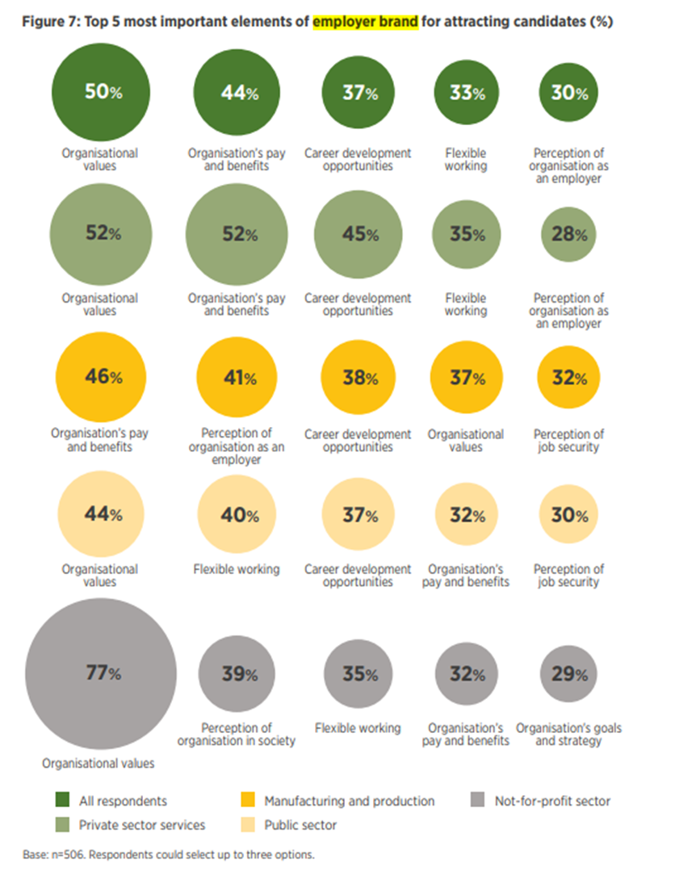
Previous research demonstrates that investing in developing the workforce is in the long-term, cost-effective as this will support retention and employer brand (Business Matters, 2021). A CIPD survey identified that 37% of individuals were attracted to an organisation based on career development (Figure 1). Furthermore, of the actions taken to improve retention, increasing L&D opportunities is the most popular with 58% of organisations adopting these interventions (Figure 2), with five of the top eleven actions relating to L&D activities (CIPD, 2020).
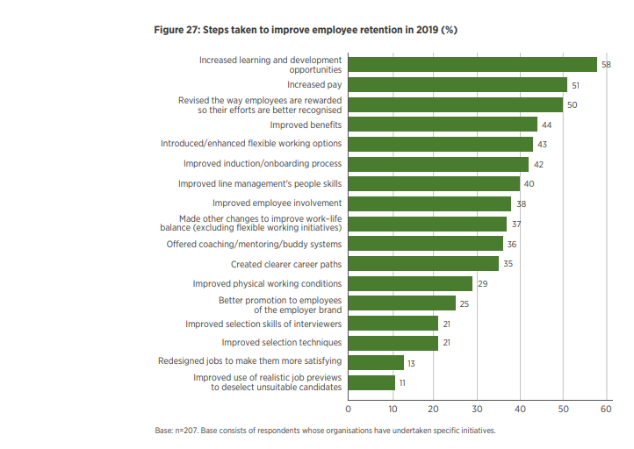
Figure 1: Top five elements for attracting candidates (CIPD, 2020)
Figure 2: Steps taken to improve employee retention 2019 (CIPD, 2020)
A range of staff surveys undertaken during 2020, suggested access to L&D opportunities were inconsistent for staff within HDdUHB, which was reinforced in the Staff Experience Report 2020-2021, identifying a large proportion of employees wanted greater access to more opportunities for training and upskilling, as well as opportunities to complete the Core Skills Training Framework (CSTF) mandatory training (HDdUHB, 2021e). Recognising the organisation has consistently been in special measures for CSTF compliance, being lower than the Welsh Government 85% target (HDdUHB, 2022a), staff feedback suggests this is not as a result of staff engagement, but lack of access to L&D opportunities.

Recognising that successful research projects identify incomplete knowledge or understanding that needs to be identified (Booth, et al., 2003), previous studies have not identified if current L&D opportunities are equitable and accessible within HDdUHB, but ad-hoc/informal feedback is indicative of significant inequality.

1.3 Research Aims

The overall aim of the research is to critically evaluate if L&D opportunities are equitable and accessible within HDdUHB. The objectives are to:
- Review current literature to identify barriers and best practice in creating fully equitable training
- Use secondary and primary data on training budgets and spend within the departments to identify proportionality by service/role
- Identify the barriers to accessing L&D opportunities within HDdUHB, identifying trends
- Make recommendations to address inequalities in accessing L&D opportunities

1.4 Methodology
Data will be collected through a mixed method survey, inviting all employees to participate. Due to the need to understand trends, significant emphasis will be to identify workforce characteristics of respondents in addition to obtaining individual perspectives. This will be discussed later in chapter 3.

1.5 Personal Drivers

My particular interest in this research is the determination to improve the learning culture as Head of Education and Development. Despite greater opportunities being available, I want to understand more about why participation has not increased.

2.0 Literature Review

Continuing Professional Development (CPD) in healthcare is fundamental to sustaining person-centred, safe and effective care (Manley, et al., 2018) . Health and social care have the responsibility to provide CPD opportunities to both registered and non-registered staff, updating skills and competencies to deliver the changing healthcare needs of the population (Welsh Government, 2019). The principles outline CPD interventions should benefit service users, improve the quality-of-service delivery and be recorded, showing the effect on individuals’ area of practice (The Interprofessional CPD and Lifelong Learning Group, 2019).

To understand if current L&D opportunities are equitable and accessible, a review will identify current literature, identifying barriers and best practice in creating fully equitable training. Using secondary and primary data on training budgets and spend will then identify proportionality by service/role, identifying financial inequalities.

2.1 Defining Equitable Access to Training

Equitable access refers to being able to access formal and informal learning opportunities, regardless of race, gender, disabilities, background, financial situation, working patterns or learning styles (OECD, 2021). The ability to provide inclusive and culturally responsive learning opportunities (Minor, 2020), should consider accessibility of on-the-job mentoring, online/instructor led and online/self-paced learning (Hogle, 2021).

To be fully accessible, learning should suit individual needs, abilities and preferences (Hogle, 2021), including access to:
“Acquire the same information, engage in the same interactions, and enjoy the same services as a person without a disability in an equally effective and equally integrated manner, with substantially equivalent ease of use” (AEM, 2018).

In the UK, education and training is a key area where inequality is recognised by the Equality and Human Rights Commission (2010), with the 2018 report identifying that despite inequality reducing in many areas there is an increased gap for ethnic, disability and the socio-economically disadvantaged (Equality and Human Rights Commission, 2018).

2.2 Providing Learning

Where organisations consider accessibility from an L&D perspective, this supports attraction, retention and employee engagement (Deloitte, 2016). Employees accessing learning results in 36% increased knowledge, 29% improved skills and 23% increased confidence, which increases productivity and motivation at work by 13% (TES,2020). Effective learning improves individuals’ attitudes, overcomes skills shortages and can positively impact personal situations, especially mental health and well-being (Union Learn, 2012). Employees require organisations to invest in them to feel appreciated, and when engaged within an organisation, they are 87% less likely to leave (Deloitte, 2016).

Adult learning creates a sense of identity, contributes to positive mental health and develops self-esteem. It promotes community engagement, interpersonal and social trust, whilst developing social connections (Government Office for Science, 2017).

The Learning and Skills at Work Survey 2021 identified the pandemic resulted in organisations reducing investment in learning, with approximately 33% reducing their L&D budget, 32% reducing L&D staffing and 31% reducing the use of external suppliers to access L&D provision (CIPD, 2021h). These findings reflect the budget within HDdUHB, with a constant reduction in the centralised training budget being reported over the last five years (HDdUHB, 2021). This increases the importance of every learning opportunity being accessible for all (Green & Young, 2020).

2.3 Barriers to Accessing Training

The barriers to accessing training will depend on individual circumstances and where these exist, are often multiple barriers (Pennacchia, et al., 2018):

2.3.1 Personal barriers

Personal barriers can vary significantly and is recognised as one of the largest reasons for not accessing development opportunities (Pennacchia, et al., 2018). Low confidence and lack of self-esteem are two barriers which significantly increase in adult learners (Pennacchia, et al., 2018). This includes fear of failure, which is worse in men (LSDA, 2013). Negative poor experience also reduces the willingness to participate in training (TUC, 2020), as does poor mental health, unstable personal circumstances, abuse or bullying. Childcare and caring responsibilities also limits accessibility, impacting women more, which is attributed to the start/end times of training or days of the week (Union Learn, 2012).

Learning styles are impacted by social, physical, environmental and emotional factors (Valamis, 2020). Where employees do not feel a learning intervention meets their learning style and preferences in learning, they are less likely to engage in future learning (Beevers, et al., 2020).

2.3.2 Disability or Additional Learning Need (ALN)

Disabilities affect 20% of the UK population, being 50% less likely to gain employment. Those employed are likely to be in unskilled, part-time roles, reducing access to development opportunities (Union Learn, 2012). Due to lack of training and support, they are 17% more likely to leave their role within the first year (Pennacchia, et al., 2018) and 86% more likely to face multiple barriers (Equality and Human Rights Commission, 2018). Recognising within HDdUHB 3% of the workforce have a disability, with a further 5% stating they would not like to disclose (HDdUHB, 2022b), this potentially could mean that 813 employees could be impacted by barriers as a result of a disability.

In the UK 1.5 million people have an Additional Learning Need (ALN) including dyslexia and autism, impacting their ability to read, write, communicate, retain information and learn new skills (TUC, 2020). Although not a learning difficulty, Attention Deficit Disorder (ADD) and Attention Deficit Hyperactive Disorder (ADHD) significantly impact concentration and ability to process information (Minor, 2020). Despite 1% of the workforce having ALN (HDdUHB, 2022b), the current provision within HDdUHB does not differentiate L&D activities to support these individual needs (HDdUHB, 2021).

2.3.3 Demographic, Social and Cultural Barriers

Peer pressure from friends, families and social groups is significantly higher where individuals come from different cultures. Where social connections do not engage in learning, this will impact individuals (TUC, 2020).

Black and Minority Ethnic (BAME) workers have reduced opportunities for development due to unconscious bias (Nath, 2016), lacking role models and facing exclusion not only in development opportunities, but career advancement (Ethnic Dimension, 2014). S BAME employees account for 7% of the overall workforce, with a further 7% prefer not to disclose (Barnes, 2022), this could potentially account to approximately 1,500 staff. It should be noted, where these reduced development opportunities exist, this reduces the aspirations of BAME individuals, which reduces productivity and a talent pipeline (Pennacchia, et al., 2018). This could also impact retention. Where language is a barrier, this increases the potential of disengagement from L&D activities significantly (Minor, 2020).

Low paid, part time, temporary or agency workers are often excluded from development opportunities (Union Learn, 2012). As these vulnerable workers often work shifts, this further reduces access. Low skills levels reduce engagement in training (TUC, 2020). The OECD reported where individuals do not deem themselves to be academic or have low levels of education, 80% will be reluctant to take part in L&D interventions (OECD, 2021).

Older employees are less likely to voluntarily engage in development opportunities due to personal commitment and low confidence, and research suggests that employers are less likely to promote training to older employees which leads to greater inequalities (Union Learn, 2012). Recognising that workers are going to stay in work longer, this not only limits their development and self-esteem, but over time will reduce the skills levels of the overall workforce (Government Office for Science, 2017).

2.3.4 Financial

Recognising that the current HDdUHB only funds 75% of any higher award applications and the limited places available (HDdUHB, 2022), many staff self-fund development opportunities. Whilst financial barriers do exist, research suggests that in many cases, this is a screen to hide other barriers that may not be as socially acceptable to verbalise (LSDA, 2013). Although financial barriers are seen to be a factor in the educational sector, this is less likely within workplace learning, with employees placing the expectation of financial commitment on the employer (CIPD, 2021h). Acas (2020) outlines where an employee needs to undertake training required for their role, this should be paid (ACAS, 2020).

Ensuring L&D have a responsibility to assess accessibility of learning and manage training expenditure and budgets provides the ability to produce metrics in relation to ROI and KPI’s Full accountability is not given to L&D within HDdUHB.

2.3.5 Communication and Commitment

Training opportunities should be visible, accessible and provide information to allow employees to self-select (OECD, 2021). Poor communication of opportunities is often a major barrier to training, with individuals failing to understand the relevance to them and the benefits of attending (TES,2020).

Time off, access, shift work, backfill of shifts, and lack of consistency for releasing employees will prevent employees accessing learning (TES,2020) (TUC, 2020) and where employees feel resistance, this will prevent engagement, even if training is mandatory (Aldridge, 2020). Not only is time to deliver training a barrier from an employer’s perspective, but time also to release staff is the most significant challenge (Atkins, 2019).

2.3.6 Technology

It is not only having the IT skills that is seen as the challenge. Other issues identified causing barriers include accessing virtual events, dealing with IT technical issues, losing the thread of the session due to connectivity and access to IT hardware (Aldridge, 2020).

Digital/online learning significantly increased the ability to widen access, providing the flexibility to manage training around personal commitments, where otherwise attendance would have not been possible (Aldridge,2020). This does not consider research that suggests that digital learning widens social exclusion due to the lack of IT equipment and skills to access full content (Knightley, 2007).

2.4 Reducing barriers
For an employee to engage in learning, they manage perceptions against individual benefits and personal costs of learning, known as the tipping point (Department for Education, 2018).
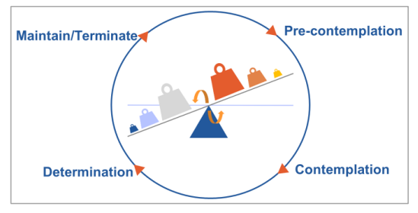
Figure 3: Tipping point for learning (Department for Education, 2018)

The challenge this represents is dependent on the attitudinal typology of the individual (Figure 4), recognising if they are life-long, defiant or outcome focussed, it will be easier to reach the tipping point. Many emotional barriers can be overcome by creating new experiences, which makes the way in which development opportunities are promoted vital to widening participation (Knightley, 2007). One solution to overcome these barriers is to create champion roles within L&D, which include representatives from disadvantaged groups including those with disabilities, BAME, learning needs, older learners and carers. Once L&D champions are embedded, they can not only support inclusive marketing, but promote opportunities (Pennacchia, et al., 2018). In addition, the use of media demonstrates positive outcomes with disadvantaged groups, removing barriers relating to confidence and self-esteem (Union Learn, 2012).
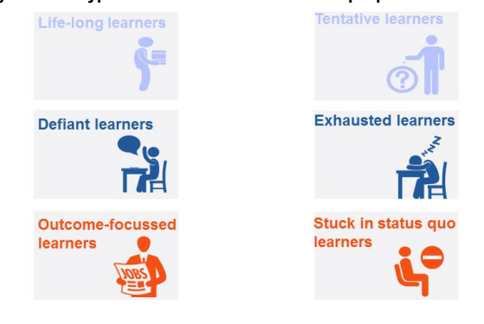
Figure 4: Attitudinal typology of learners (Department for Education, 2018)
Ability to overcome barriers easily,
Lack purpose for learning, requiring targeted intervention and support
Recognising barriers to low confidence and self-esteem can be due to multiple barriers, it is important that staff build relationships, embedding a psychologically safe space to question programmes and support with self-selection (Equality and Human Rights Commission, 2018).

2.4.1 Content and Communication

Marketing should avoid complex language (LSDA, 2013). Outlining opportunities to build social relationships is particularly important where individuals lack engagement in social activities (LSDA, 2013), although critics suggest introverts may see this as a barrier (Minor, 2020). Where individuals understand the potential impact of training and outcomes, this encourages learning, supporting the tipping point, especially where multiple barriers are present (Pennacchia, et al., 2018).
Recognising differing personal commitments and organisational barriers relating to staff release, creation of multimodal opportunities will not only accommodate learning styles and preferences, but it will also increase engagement and allow employees the opportunity to access resources at a time to suit them (Hogle, 2021). This could include online quizzes, podcasts, webinars which are pre-recorded, bitesize learning, infographics and reading materials (CIPD, 2021h)..

2.4.2 Widening Participation

Recognising the difficulty in attracting senior role models, ways of overcoming these barriers relate to creating diversity and inclusion strategies (Ethnic Dimension, 2014), however it is argued that creating a strategy on its own will not show positive impact as it is how this is embedded into daily practice that has the biggest impact (Pennacchia, et al., 2018). Another challenge raised is that due to embedded culture within the BAME communities, it is as important to ensure development opportunities are inclusively marketed as BAME communities have self-esteem/confidence barriers, which are passed down through generations due to precedents over the decades (Equality and Human Rights Commission, 2018).

To overcome geographical barriers, face to face learning should be accessible geographically for all staff, providing equity for all workers (LSDA, 2013). Within HDdUHB, local training is a significant challenge due to the lack of accommodation, which impacts access to training opportunities, especially within Ceredigion.

2.5 Financial Spend
Prior to identification of financial data, it is important to recognise that due to the complexities as to how training spend is currently recorded within the organisation and despite there being a study leave and higher awards process to allow for capturing of this data, research suggests that this is not used widely to monitor, evaluate and control all training and development opportunities (HDdUHB, 2021f). In addition, services use a combination of central training funds and their own allocated budgets (HDdUHB, 2021). Only by collating and analysing this data can HDdUHB truly identify trends and draw conclusions. As there is a plethora of data available in the public domain, the following data has been extracted from published reports to provide a more succinct representation.

2.5.1 Study Leave
Study leave approvals are funded by charitable funds, specific directorates or the generic L&D budget. Taken from the statement of accounts 20/21 (HDdUHB, 2021) and Figure 5 shows the spend over a two-year period. In addition, Figure 6 highlights that other than three directorates that approved 100% of applications in both years, all other study leave approvals decreased from 84% to 73%.
Figure 5: Approved Study Leave Spend 20/21 & 21/22
Figure 6: Study Leave Approval Rate 20/21 & 22/22

2.5.2 Higher Awards Spend
Figure 7 shows extracts from annual higher awards data (HDdUHB, 2021) which shows that the overall spend varies significantly with nursing spend being significantly higher. When considering headcount (Figure 8), it shows that the spend within the AHP services is significantly higher, which is not reflective of other clinical professions.
Figure 7: Higher Award Spend by Directorate

Figure 8: Higher Awards Spend Per Headcount
To truly understand the variances, data has also been extracted in terms of the course costs (Figure 9). Although this shows that the AHP courses are on average slightly more per course, this is insignificant when considering overall spend.
Figure 9: Average Cost of Courses

2.5.3 Organisational Spend

When analysing the data available for the higher award and study leave spend in 20/21, this equates to £443,720, compared to an overall training spend of £1,306,370. Whilst all directorates do not use the L&D processes, the total training spend by directorate is highlighted in Figure 10 and no further detail to understand how this spend is calculated could be identified. The workforce and OD spend is significantly higher, however this includes the costs attributed to leadership development, higher awards, study leave and corporate training costs (HDdUHB, 2021).

Figure 10: HDdUHB Training Spend

2.6 Summary of Literature Review
Literature demonstrates not only the importance of removing barriers to accessing training, but also the importance for this in terms of retention, attraction and employee engagement (CIPD, 2021h). It highlights the individual barriers; noting that in most cases, multiple barriers exist. Research identifies that when considering interventions where this is the case, organisations must work hard to reach the tipping point where individuals want to engage in learning (Hogle, 2021).

This report seeks to understand which barriers exist within the organisation, identifying if this is consistent. It will identify if an individual’s access to training is dependent on their salary band, their service area and barriers identified in this chapter.

In summary, significant barriers can impact engagement in development opportunities, which relate to the individual involved, organisational resources or organisational culture. HDdUHB need to understand the extent to which some or all these barriers impact their workforce, allowing them to consider recommendations to minimise their impact. Having now considered accessibility from a wider context, primary research will identify the barriers to accessing L&D opportunities within HDdUHB, identifying trends.

3.0 Research Design and Methodology
The research intends to critically evaluate if opportunities are equitable and accessible. Primary research will identify barriers that exist within HDdUHB, identifying trends. The literature review identified key themes that need to be considered both in terms of barriers and the effectiveness of L&D processes. Financial data showed significant inequality, however, will not form part of the primary research, but discussed in chapter 5 and 6. The purpose was to determine if employee perception was reflective of the general research and whether any other barriers existed within the organisation.

3.1 Research Philosophy

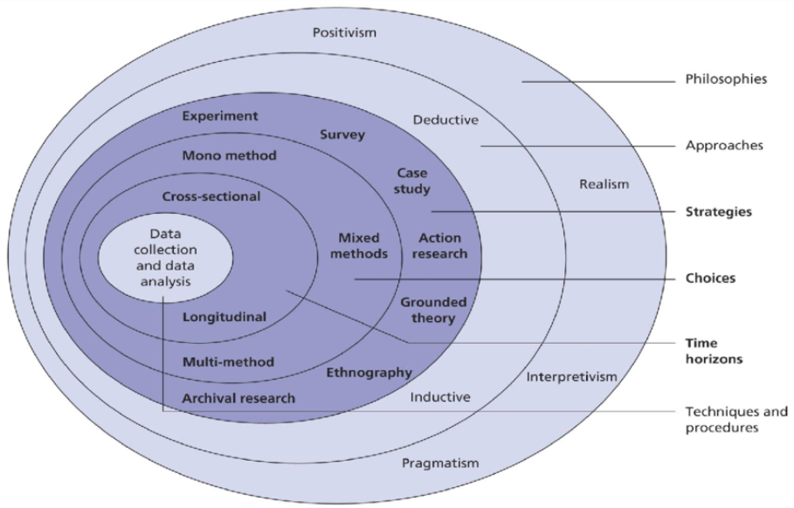
Clearly identifying the philosophical approaches and methodology will increase validity, providing an opportunity to critically plan data collection (Walliman, 2017). The Research Onion (Figure 11 (Saunders, et al., 2019)) provides a framework to consider the data collection and analysis options, increasing credibility
Figure 11: The Research Onion (Saunders, et al., 2019)
Data will be collected using cross-sectional, mixed methods survey with a design that will gather qualitative and quantitative data simultaneously (Saunders, et al., 2019). Mixed methods have increased in popularity, reducing the limitations of solely using quantitative or qualitative analysis (Bell & Waters, 2018). Qualitative data will provide depth and a greater understanding of perception, which is one of the biggest drawbacks in quantitative research (Creswell & Creswell, 2018). Where the researcher has limited expertise, this provides additional challenges of managing and using the data as well as being time intensive to interpret data collected (Anderson, 2009).

Recognising mixed method data collation, it is difficult to assign to either a positivist or interpretivist paradigm, with this research taking a pragmatic approach, focused on improving practice. Pragmatic research recognises the broader scope of research and using an abductive approach, whilst collating qualitative and quantitative data.
A range of research methods were considered as outlined in Table 1.

Research Method | Advantage | Disadvantage | Outcome
Focus Groups | Depth of understanding and richness of data (Thomas, 2017)  Allows for discussion and challenging individual beliefs, providing group agreement. (Powell & Single, 1996) | Suitable for small scale of participants (Anderson, 2013)  Geographical limitations (Powell & Single, 1996) | Minimal Sample size
Interviews | Structured or unstructured, providing flexibility for depth and understanding  Provides rich data and increases understanding.  Builds trust and confidence if one-to-one interviews (Bloch, et al., 2011) | Suitable for small scale of participants  Time consuming  Interviewer bias could impact outcome (Bloch, et al., 2011) | Minimal Sample size
Observation | Depth of understanding and richness of data  Greater understanding of emotions | Suitable for small scale of participants  Can lead to ethical dilemmas (Saunders, et al., 2019)  Observer bias due to self-beliefs (Thomas, 2017) | Minimal Sample size
Case Studies | Depth of understanding and richness of data (Saunders, et al., 2019) | Suitable for small scale of participants | Minimal sample size
Surveys | Allows large data collection, increasing the validity (Anderson, 2013),  Allows participants to remain anonymous, increasing likelihood of participation (Thomas, 2017).  Low cost, easy to make changes.  Free software supports analysis (Saunders, et al., 2019).  Limited resources and time commitment for respondent and researcher (Wolf, et al., 2016)  Allows for pilot, checking for bias or leading questions  Wider reach, especially if using online and paper copies (Patten, 2016) | Can lack depth  Risk of not collating all surveys, impacting participant voice (Bryman, 2016)  Survey Fatigue, especially in large public sector organisations (Thomas, 2017)
Table 1: Advantages and Disadvantages of Research Methods

Using a questionnaire, to create depth of understanding and richness of data, limitations will be mitigated by using a mixed methods survey, making it more quantifiable (Saunders, et al., 2019).

One disadvantage is limited response (Bryman, 2016); however, it would not be practical to collect and analyse data from entire workforce. Neuman (2011) suggests a 10% sample is sufficient. Anderson (2013) agrees sufficiency up to a sample size of around 10,000 staff (Anderson, 2013), reflects the workforce of HDdUHB.

3.2 Sampling

The objective was to obtain as many respondents as possible, ensuring the sample is representative of the organisation, multi-stage sampling was used, with one of the main limitations being the increased time needed (Valliant, et al., 2018). Commencing with volunteer self-selection, publicising the survey, collating data and analysing if this meets the broad representation. Following this, stratified random sampling was used, analysing groups not represented in the first stage and dividing staff into location, service and pay band ensuring representation (Saunders, et al., 2019). Researchers rely on stratified sampling when a population’s characteristics are diverse and they want to ensure that every characteristic is properly represented in the sample (Anderson, 2013), thus making the sample more representative (Kumar, 2014).

A limitation of volunteer sampling is that respondents can often have a strong view, either opposing or supporting the topic (Neuman, 2011), however the benefit of providing exploratory research means this limitation will be accepted, also recognising multi-stage sampling will also reduce this (Bell & Waters, 2018).

3.3 Ethical Considerations
Ethical research protects the dignity, rights, safety and well-being of participants (Thomas, 2017). Prior to this research, ethical approval was sought. As this was identified as Service Evaluation, it did not require formal Research and Ethics Committee approval (HDdUHB, 2019).

The purpose of the research was explained to all participants, and therefore consent obtained. Assurance of anonymity and compliance to data protection legislation was given and where small samples within a demographic criterion may have compromised anonymity, these combined in the other section, protecting identity. Questionnaires were also available in both English/Welsh, recognising individuals rights to access information in a language of their choice and Microsoft Teams also provided options for additional language options.

3.4 Questionnaire Design

NHS employees are encouraged to complete numerous surveys, which can cause survey fatigue (Mckinsey, 2021). To overcome this, the questionnaire needs to adopt a new questioning style, encouraging thought and providing a personal benefit to individuals (Thomas, 2017).

Recognising the need to analyse trends for a large data set, questions will identify characteristics and demographics, understand barriers including those identified in the literature review and their understanding of L&D processes to support development.
Due to the sample size, surveys will be designed using Microsoft Forms, consisting of self-completion questionnaires. Phase one opened for 6 weeks following good practice (Saunders, et al., 2019), allowing questionnaires to be available outside the organisations IT security from multiple devices, using internet, intranet, hyperlinks, QR codes and forwarded by respondents via mobile devices. Whilst phase two was carried out face to face over ten weeks, widening participation and removing IT barriers.

To ensure attractiveness, a short, meaningful title was used (Loughborough University, 2019). Closed questions elicited quantitative data, supported literacy and simple analysis. Open questions provided qualitative data, encouraging thoughts and broadening understanding (Anderson, 2013), however could reduce participation due to literacy levels and time taken to complete (Thomas, 2017). Meeting the needs of the academic research and organisational need, although it is suggested 10 questions, with less than 20 words (Saunders, et al., 2019), this was not possible to meet HDdUHB needs.

The first section confirmed consent and anonymity. Closed questions then provide workforce demographics and finally open questions to gain qualitative feedback from individuals and managers.

3.5 Reliability, Validity and Limitations
Reliability refers to the dependability of research and ability to reproduce similar results (Chapman & McNeil, 2005), with similar outcomes, whereas validity refers to the relevance or responses and how they reflect reality (Thomas, 2017). The questionnaire was anonymous, which also improves reliability of the research as respondents can be honest (Anderson, 2013), however Thomas (2017) does argue that it does depend of the agenda of the participant.

To increase the reliability and validity, piloting the questionnaire tested interpretation of questions (Saunders, et al., 2019). One limitation of questionnaires is the inability to probe or revisit responses (Loughborough University, 2019), highlighting the importance of a pilot and effective preparation (Bell & Waters, 2018). Data was analysed to identify ineffective questions, making changes (Anderson, 2013).

Providing training to the research assistants supporting the collation of paper-based questionnaires ensured minimal impact on the outcome as any contamination of respondents impacts the reliability of the data due to personal bias (Saunders, et al., 2019).

Limited timescales meant that although a short window was ideal to provide greater time for analysing the results, this impacted the number of respondents and therefore impact reliability, so timescales were extended. Having online and paper-based questionnaires did allow coverage of a greater geographical area, however for those without IT access in Ceredigion, they would not have as much opportunity to participate.
The main research limitation will be work pressures and time for staff to have checked their email and to complete the questionnaire, recognising the significant pressured the NHS is under due to Covid-19 (HDdUHB, 2021e).

3.6 Data Analysis
Using a mixed-method approach, the quantitative data was analysed using Microsoft Forms, identifying main themes, providing an insight into trends. Thematic analysis, known for its theoretical flexibility was used to examine the qualitative data, with themes being actively generated by the researcher (Saunders, et al., 2019). Using the six phases of thematic analysis, a recursive approach to interpret data was used, recognising the complexities, but creating a framework (Braun & Clarke, 2022).

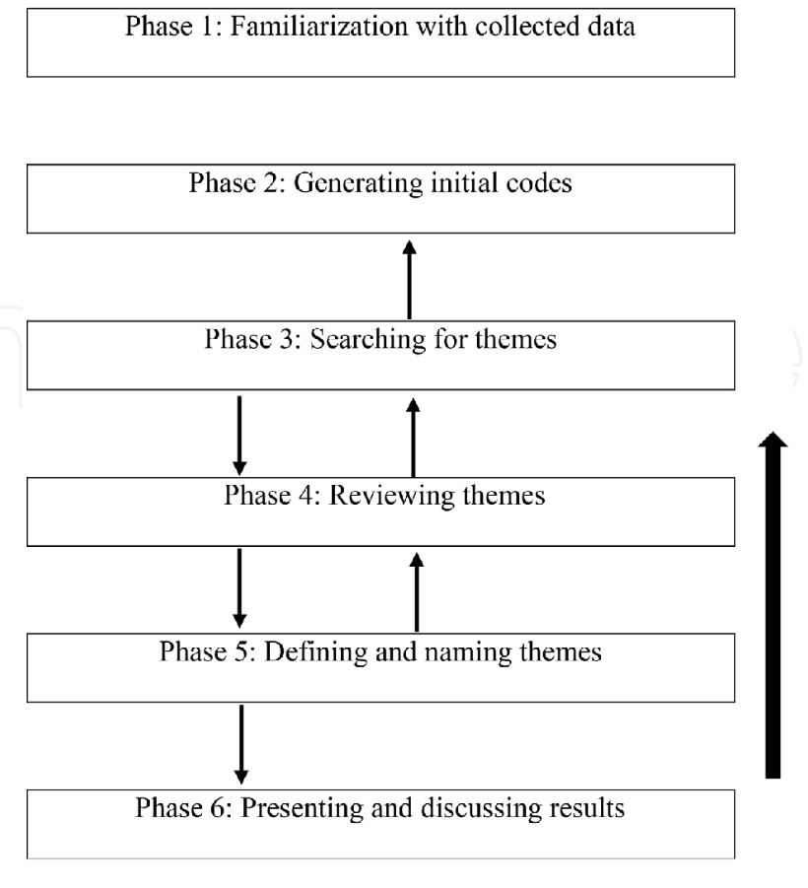
Figure 12: Braun & Clarke (2006) Six Phases of Thematic Analysis
adapted by (Labra, et al., 2019)

As the researcher leads the L&D function, there is a need to consider bias, making ontological assumptions based on information collected and epistemological assumptions as the research is built around human perceptions (Saunders, et al., 2019).

4.0 Results and Analysis

Released on 13/08/2021, the questionnaire was open for six-weeks, recognised as good practice (Thomas, 2017). Use of global emails identified that the questionnaire itself was inequitable and timescales were extended to allow the deskless workforce the opportunity to participate. A paper-based questionnaire allowed targeted intervention to underrepresented demographics, resulting in genuine gratitude from participants. Recognising the manpower required, the closing date was extended, generating a response rate of 11%, deemed acceptable to make generalisations (Anderson, 2013).

4.1 Profile of Respondents
The research centred around understanding if L&D opportunities were accessible within HDdUHB, with most data relating to workplace demographics. Responses typically represented the breadth of the workforce, with some under/over representations as outlined below (Figure 13: Workforce Demographics). It should be noted that WF &OD is significantly higher at 59% as this was used as a pilot. Where data impacted anonyminity, these were identified within the other category. Recognising the medical workforce have their own Medical Education Department, this may have led to the reduced 2% representation.

Age and county match overall organisational profiles. The number of respondents was significantly higher with BAME employees, likely attributed to the promotion of the survey through disadvantage group networks. Recognising that 18 respondents did not disclose their ethnicity, this may impact the reliability of data comparing ethnic demographics.

On closing the online questionnaire advertised through global email, the pay bands 1, 2 and 3 employees were significantly underrepresented, demonstrating lack of access/engagement of online research. By using the multi-stage research, stratified random sampling ensured representation, resulting in positive engagement. With the exception of band 1 workers, who represent 0.01% of the workforce, all other pay scales were represented, recognising over representation of the band 4, 7 and 8 workforce.
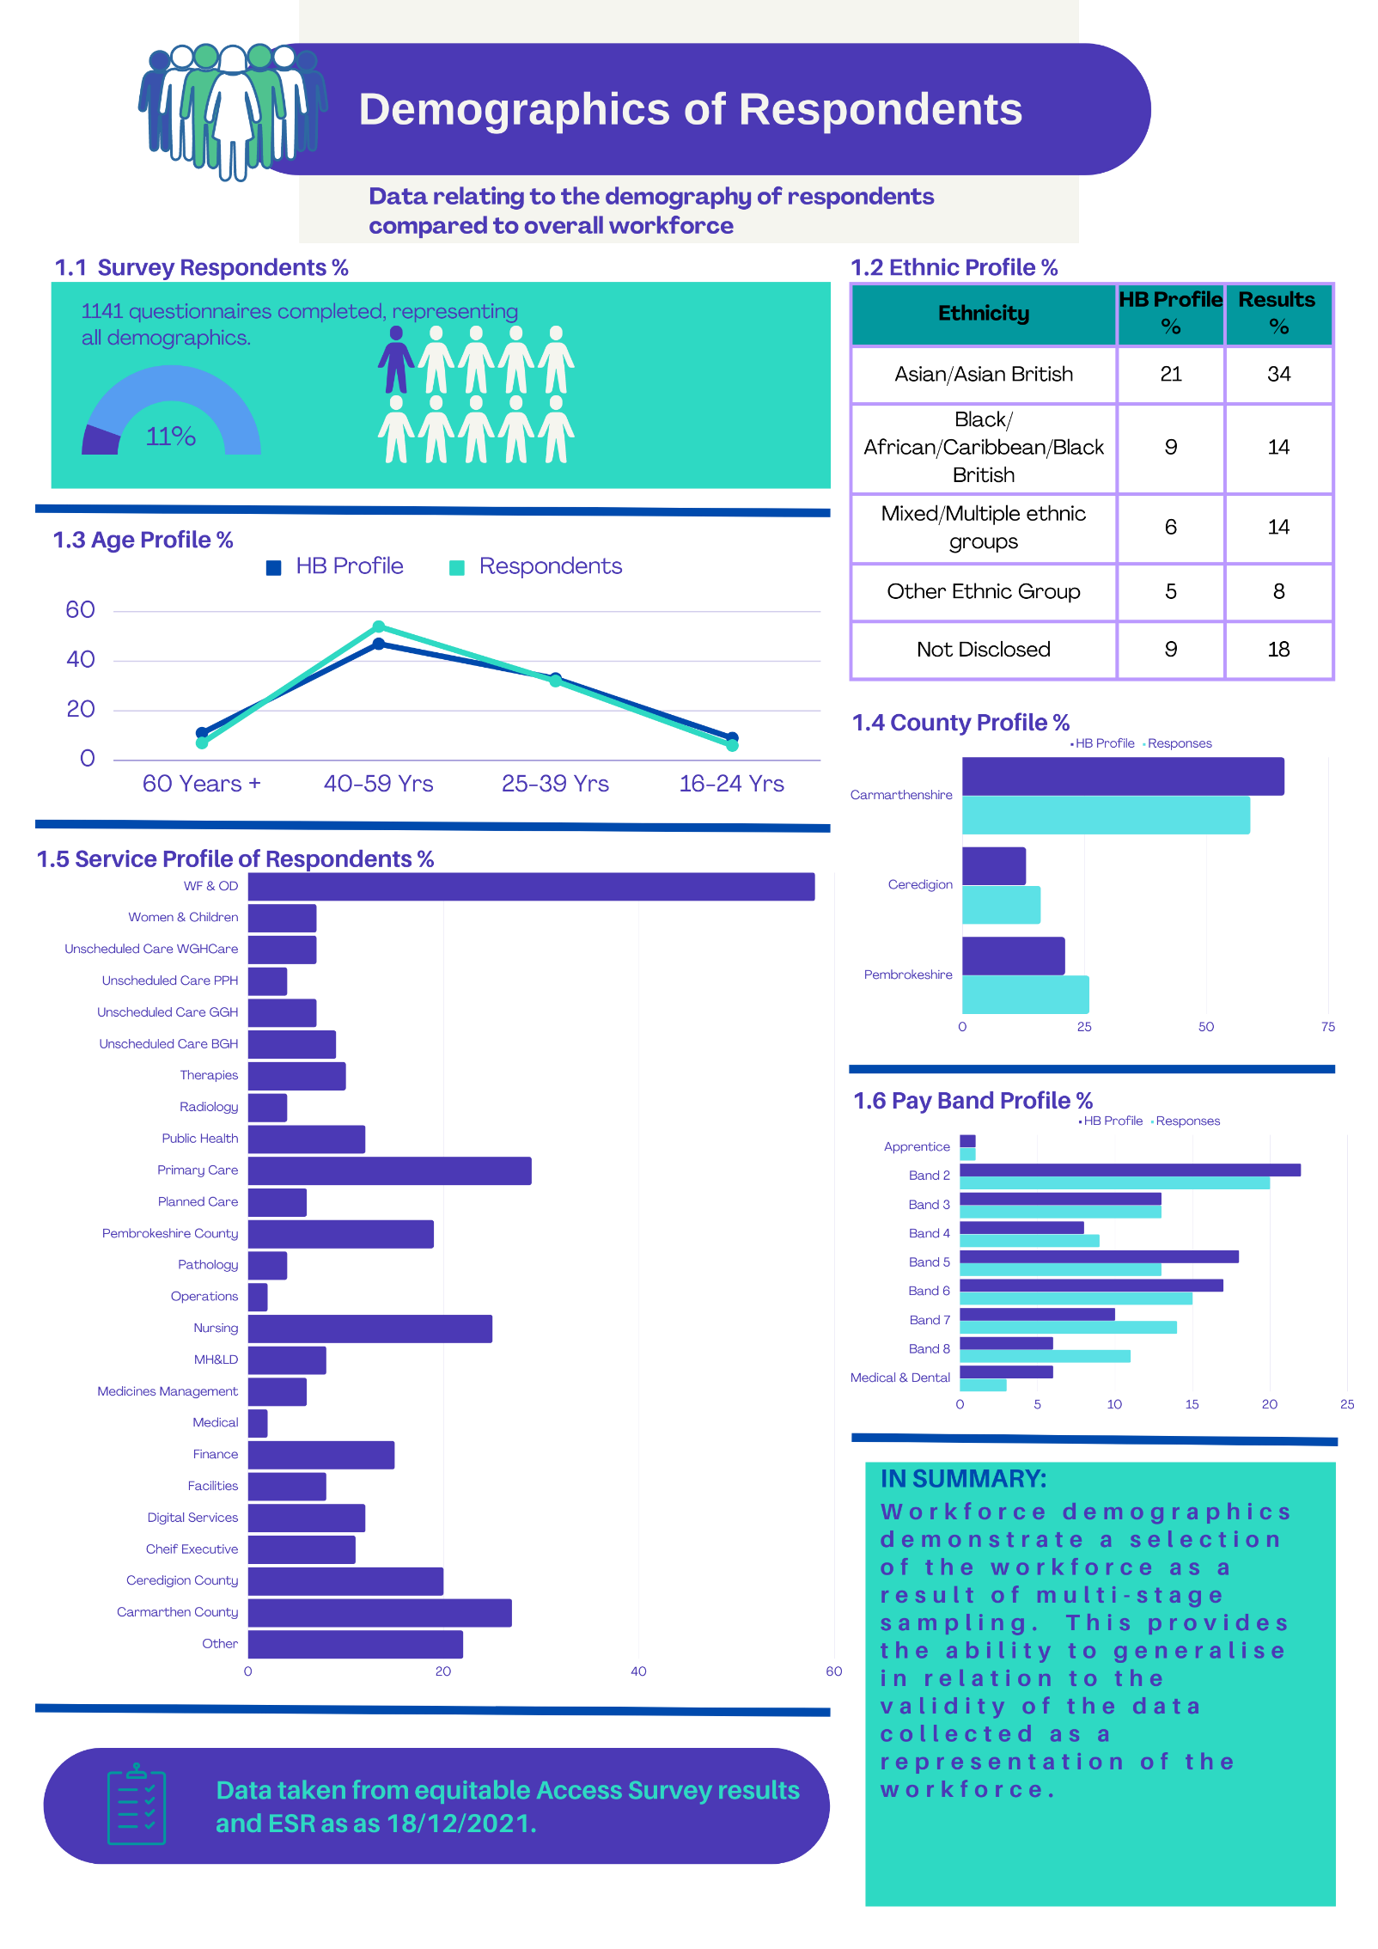
Figure 13: Workforce Demographics

4.2 Opportunity to Develop
The data was broken down to identify trends in workforce demography, recognising that on average only 60% of the workforce feel they have the opportunity to develop. Data highlights significant variances in responses (Figure 14). When considering the opportunities to develop, by separating management and staff, this shows 72% of managers stating they had development opportunities, however this was 55% for non-managers.

Data shows clear variances within different services, with only 38% of facilities employees having the opportunity to develop, 12% below other services. Staff in higher pay bands identified greater opportunities to progress, with lower pay bands (bands 2,3,4,5) falling well below the average trendline. This reflects the socio-economic climate, with lower economically stable backgrounds having more barriers and reluctant to source development opportunities (Hogle, 2021). The workforce in Ceredigion has less opportunities to develop than other counties with 27% of Ceredigion staff commenting on the lack of local training provision.

Considering the age profile from a development perspective, 80% of 16–24-year-olds feel they have the opportunity to develop, which increases the overall average as all other age groups vary between 55-59%. Literature review identified that older workers were less likely to engage in L&D opportunities (Department for Education, 2018), however research suggests age does not seem to be a barrier with the older workforce suggesting they did not have the opportunity to progress.

Other than mixed/multiple ethnic groups being at 43% in relation to having opportunity to progress, there were no significant variances in the result, with the range of responses from other ethnic groups being between 60-64%. Literature outlined that despite inequity reducing within L&D overall, this was still evident in disadvantaged groups (Minor, 2020), Validity of this data is questionable as 55% of respondents preferred not to disclose their ethnicity, which usually suggests lack of confidence of anonymity (Neuman, 2011).

Employment status impacts opportunities significantly, with all bank workers stating this prevents development. Fixed-term staff were also below average (51%), showing significant variance. This was evident as 82% of all respondents commented that their contract status impacted development, which confirms Union Learn (2012) views that temporary and part time workers have less development opportunities.
This supports the findings outlined in chapter 2, outlining that pay band, contract type and other workforce demographics.

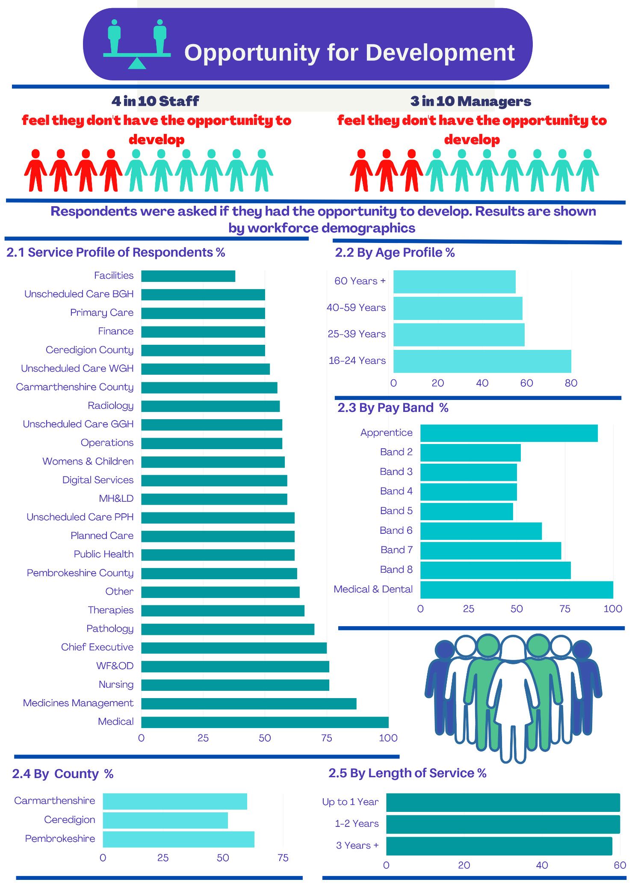
Figure 14: Opportunities to Develop

4.3 Barriers to Accessing Training
The primary research identified that there were significant barriers to accessing training and development opportunities, with time, cost and unawareness of options being the most common barriers Figure 15: Barriers to Accessing Training. This does not reflect the literature review which identifies those personal barriers are recognised as the most significant reason for accessing training, (Pennacchia, et al., 2018). Recognising the impact of Covid-19 on the NHS workforce, this may have impacted the overall results (Kings Fund, 2021).

Where an individual faces barrier, multiple barriers usually exist (Pennacchia, et al., 2018). This was evident through primary research, with 72% of respondents identified with two or more barriers.

This report outlines the spend reported through L&D processes is attributed to 33%, providing the risk that 67% of overall spend is not reported and therefore does not reflect the full effort to upskill the workforce and show overall return on investment.
IT creates opportunities to widen access, although firstly staff must have the access to digital equipment and have the capability to use it (Aldridge,2020).

The need to create psychological safety in clear, both in the way a course is advertised and during design of the course and materials, recognising significant barriers result in fear, low self-esteem and confidence (Pennacchia, et al., 2018).
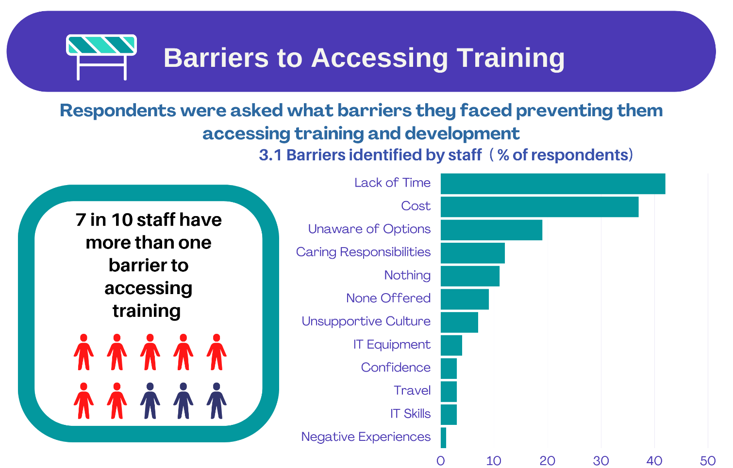
Figure 15: Barriers to Accessing Training
The thematic analysis on qualitative data provided a greater insight into barriers to accessing training, providing greater similarities with the secondary data collected. The barriers:

4.3.1 Digital Support
Despite lack of IT skills or equipment not being identified in the quantitative data with only 6% identifying this as a barrier, the qualitative data provided greater depth and when comparing the lower paid workforce (Bands 2 and 3), this is significantly higher. Qualitative data also suggests the need to return to face to face teaching as opposed to adopting virtual/online as their preferred style. The fear of IT and the lack of access for the deskless workforce was the driver of these comments, and if developed, would impact the need for face-to-face delivery, thus providing the ability to deliver a blended approach.

4.3.2 Cost, Time & Workforce Pressures
The two main barriers within the organisation relate to lack of time and cost and in many cases, these are interrelated as a result of workforce pressures. Managers not being able to release staff for training or provide protected study time not only impacts individual development opportunities, but staff morale (HDdUHB, 2021e). Where staff have been considered for training, lack of training/department funds and the 75% funding of higher awards also means that study leave is declined. As a large proportion of training requests bypasses L&D processes, this means this is impossible to quantify as to the scale of the barrier.

Despite finance being identified as a barrier to accessing L&D and cost being the second highest barrier from the research (LSDA, 2013), it is not conclusive if this relates to cost from a personal or organisational perspective as the thematic analysis suggests this is related to organisational commitment to funding,

Beavers, et al (2020) identifies the importance of L&D being able to report ROI, however as the financial data shows (HDdUHB) the Education and Development function is currently unable to monitor spend ROI or provide metrics.

4.3.3 Accessing Information
Lack of awareness of options was identified as the third largest barrier, however, the thematic analysis identified this is not just about how to access information, it also relates to information about how to apply, access funding and awareness of the L&D processes including Study Leave and Higher Awards.

Lack of awareness of training was identified as a major barrier in the literature review, reinforced by this being within the top three barriers impacting 19% of the HDdUHB workforce.

4.3.4 Management Interventions

Figure 16 shows that 28% of staff do not discuss development as part of their Personal Appraisal Development Review (PADR) and of those, 72% identified development opportunities, only 41% have planned or completed the training. These figures reflect less emphasis on development discussion through the PADR process although data presented from managers states 93% actively discuss development as part of the process.

The workforce that has been refused training represents 22% of respondents, with the main reason being attributed to staffing pressures, cost, training not relevant to current role and other staff being given priority. Research also identified that only 40% of managers are unaware of how to access training, 70% are unaware of how to access funding and the thematic analysis identified a significant proportion of managers lack confidence and skills in how to develop their teams.
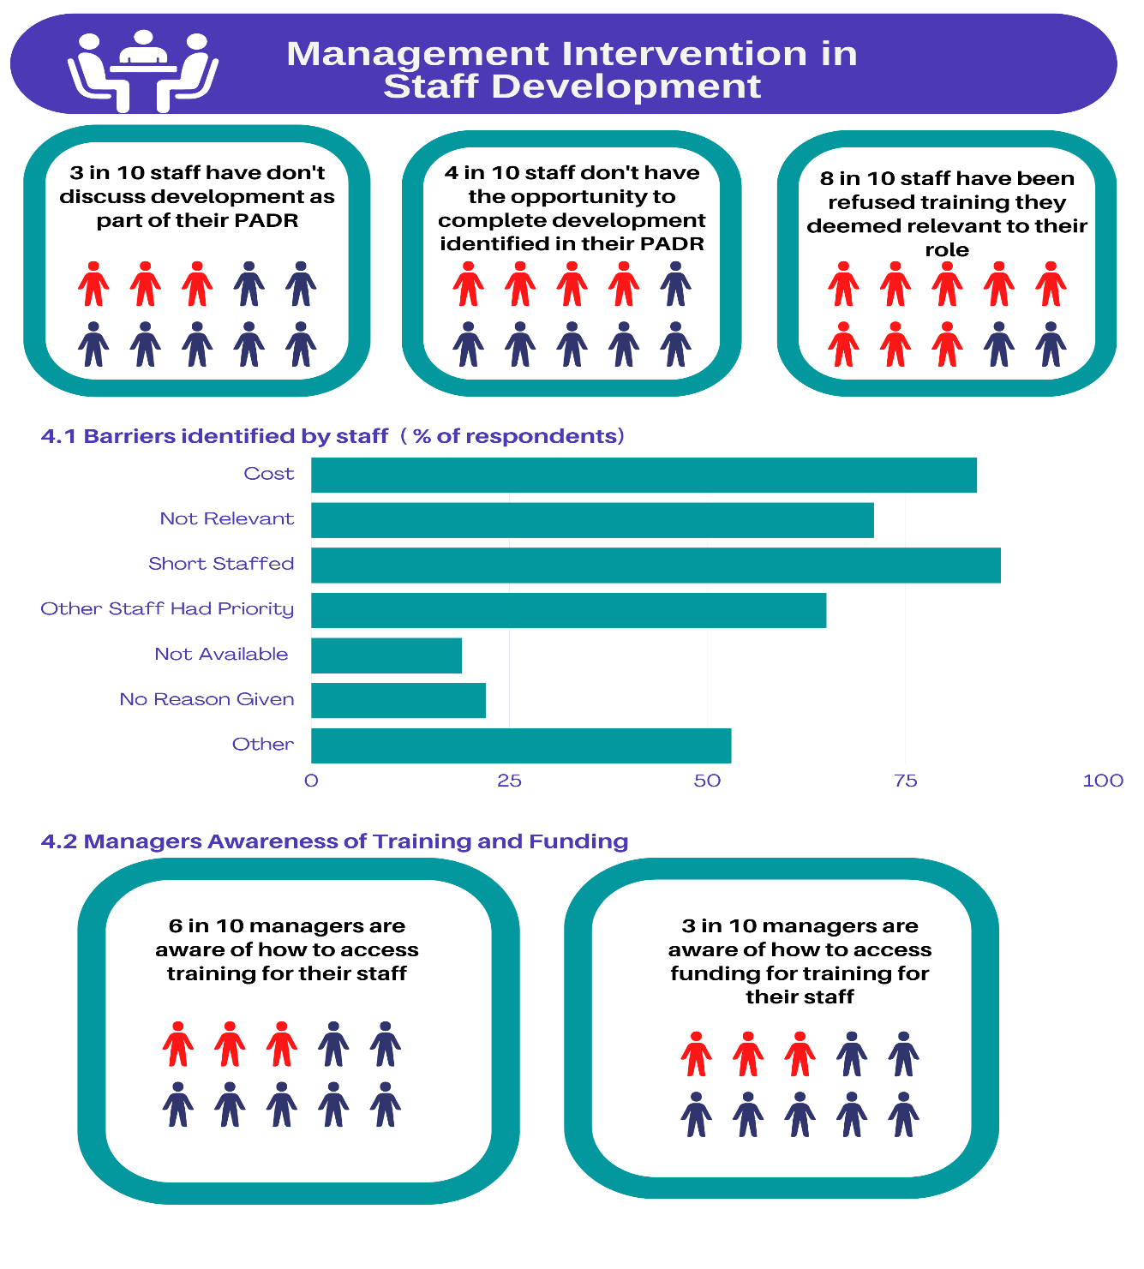
Figure 16: Management Intervention in Training

4.3.5 Access to Mandatory Training
The release in work time to complete mandatory training varies significantly depending on service/directorate, with only 59% being able to complete during working hours. Of those who are unable to complete mandatory training as part of their role, 79% complete this in their own time, unpaid. The allocation of time to complete mandatory training is inconsistent throughout the organisation despite payment for mandatory training being a requirement (ACAS, 2020).
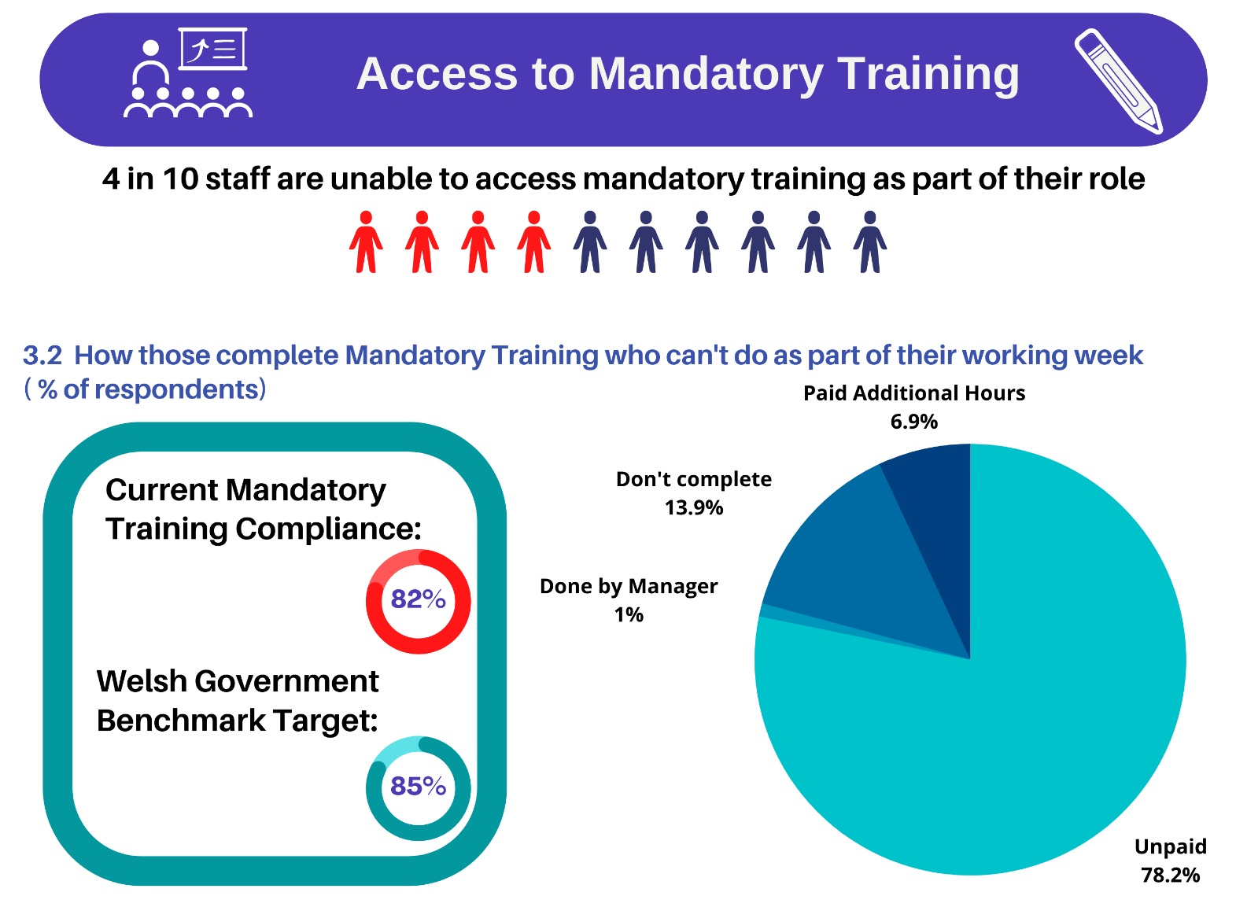
Figure 17: Mandatory Training

4.3.6 Awareness of Training and Development Processes
21% of staff are aware of the study leave process which is significantly lower than the 79% of managers who are aware of the process. Awareness of the higher awards process is significantly lower with 20% of staff being aware and 41% of managers (Figure 18).

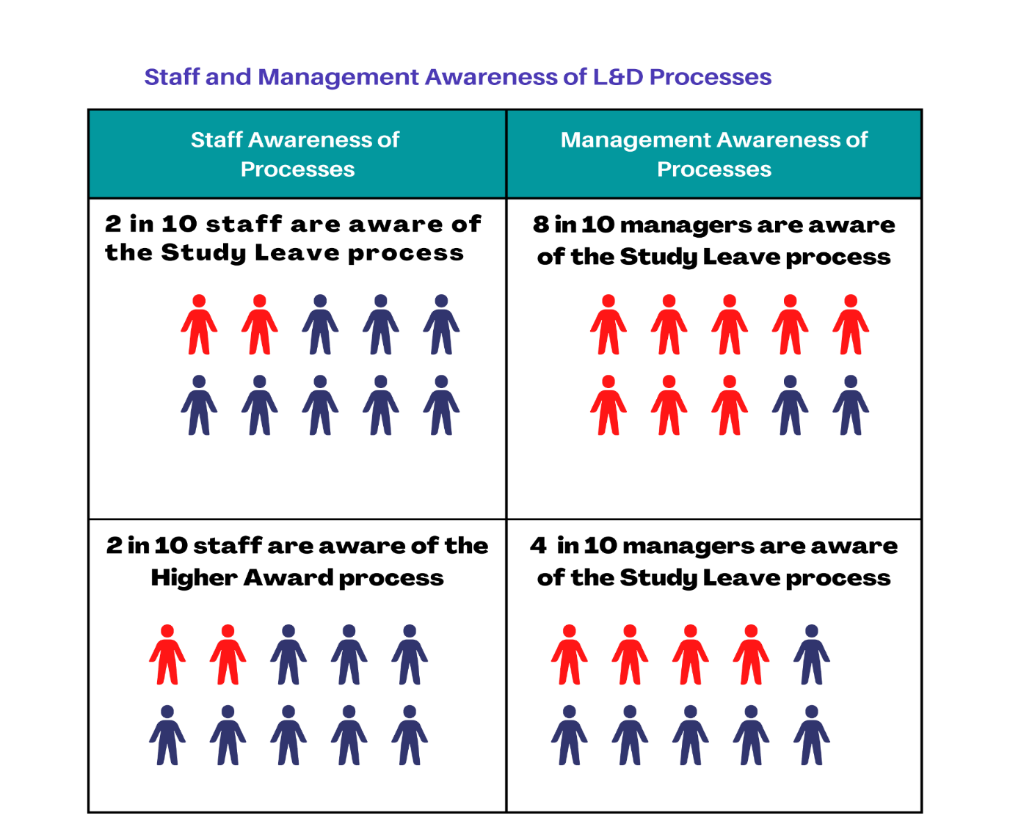
Where staff manage a team, 62% are aware of how to access training which is significantly higher than those managers who know how access to funding, which equates to 32% (Figure 16).
Figure 18: Awareness of L&D Processes

4.4 Thematic Analysis of Qualitative Data

Managers were asked to provide information around the challenges in relation to training/;. A thematic analysis (Appendix 8.5) identifies themes, including barriers to training, how opportunities are promoted, lack of resources, systems and process issues and availability of training opportunities. Of these themes, those with a frequency of 20 or more include inequalities identified in relation to:

- 75% funding of higher awards (21)
- Global not for deskless workforce (29)
- Lack information of training (47)
- Need to clarify study leave & higher award process for funding (21)
- Staffing pressures/can't release staff (67)
- Don't have computers to access eLearning, managed on compliance (21)
- Lack of training/department funds (55)
- Protection of study time (21)
- eLearning platform too complicated (24)
- Want management training - lack confidence and skills (39)
- Training in IT packages needed (20)

5.0 Conclusion

Secondary research outlined the importance of investing in the development of the workforce, which in turn improves employer brand, attraction, retention and productivity (Deloitte, 2016). In addition, recognising the skills shortages within HDdUHB and the impact of Covid-19 on the workforce, it was recognised that development opportunities can positively impact mental health and well-being (Union Learn, 2012), thus demonstrating the need to overcome barriers to training.

As identified, from the secondary research, inequality can foster poor working conditions and damage relationships, and the thematic analysis identified examples of where inequity exists as a consequence of poor management and inconsistent processes, which in turn impact motivation and creates negative past experiences. Secondary research identified common barriers relating to how to create equitable access and where multiple barriers exist, there is a need to implement positive action to reach the tipping point. Barriers relate to technology, management and employer commitment, financial, demographic, social and cultural barriers, disability, ALN and personal barriers. All barriers identified as part of the literature review existed within HDdUHB, however due to the NHS staffing levels, this provides greater challenges.

Data collated on training budgets helped to understand the disproportionate allocation of finance by service/role, not only outlining the inequality, but identifying the lack of adherence to L&D processes, resulting in the inability to truly monitor training spend and evaluate ROI.

Considering the barriers in the wider context of training spend, the primary research provided a deeper level of understanding, identifying that cost of training was one of the most identified barriers within HDdUHB, along with time, which thematic analysis links to finance for staff release. It is evident that the current process to manage training spend is ineffective, with a need to identify how financial spend will be allocated in the future.

The current processes to access opportunities is ineffective, with a significant proportion of the workforce not being aware of how to access them. This was evident when promoting the questionnaire through global emails, which despite being recognised as a key communication strategy and used to promote training opportunities, the deskless workforce were unaware and therefore unable to participate. This demonstrates the current method of promoting opportunities limits access and alternative strategies need to be adopted. In addition, recognising that the Band 2 and 3 workforce and facilities are groups significantly below average for development opportunities, the lack of global email access is likely to be a contributory factor.

With barriers being overcome by creating new experiences, finding new ways of promoting opportunities would widen participation (Knightley, 2007). Research identified how promoting opportunities can support the tipping point and demonstrated the ineffectiveness of the current methods to promote development opportunities and career pathways.

With 40% of the overall workforce not feeling like they have development opportunities, increasing to 55% for non-managers, action is needed to make staff feel they are invested in. This is vital as staff are 87% more likely to leave, impacting the stability of the workforce.

Due to lack of published literature within NHS settings in relation to equitable access, this made it difficult to understand how to create equitable access to training within an NHS setting recognising the unique challenges faced however, the following recommendations are based on the above conclusions

6.0 Recommendations

The findings of this report highlight many areas for improvement, with three main areas being identified that will have the biggest impact on the equitability and accessibility of development opportunities. A fourth will focus on providing smaller milestones and reassurance to the workforce that action has been taken as a result of the research, which is vital to maintain confidence in their voice being heard.

The following recommendations form a summary of the detailed action plan outlined in appendix 9.4. The overall cost of these recommendations is outlined below (Table 2), with a more detailed analysis contained in the action plan. Although the cost is a significant investment, some of the cost will be absorbed through existing staffing and where this is not, the cost of doing nothing should also be considered, recognising the cost savings as a result of retention and reduced recruitment costs.
Table 2: Overall Cost of Recommendation | £
Recommendation 1 | £3,758
Recommendation 2 | £4,564
Recommendation 3 | £5,763
Recommendation 4 | £253,730
Quick Wins | £6,892
Total Cost | £274,707

6.1 Recommendation 1 – Training Spend
HDdUHB need to identify a way to manage training spend more effectively and recognising the complexities, a Training and Finance Task and Finish Group will need to be created to:
- Validate the contents of the training spend in the report, recognising the limitations of data collected with available resources.
- Identify a model for the equitable allocation and identification of a reoccurring funding stream to not only support a 100% Higher Award funding model, but reducing the financial barriers and inequity for higher education opportunities.
- Identify a funding mechanism to allow funding establishment to provide all staff a minimum of two days paid study leave to complete their mandatory training in addition to development days to upskill and reach their full potential.
- Identify how L&D can report and manage training spend and allocation, demonstrating return on investment, evaluation of training spend and monitor education and development provision
This recommendation will not only increase equity and remove barriers, but will allow greater evaluation, reduce duplication of efforts and provide metrics.

6.2 Recommendation 2 Equitable Application Processes
An application processes is needed whereby the Education and Development Team can monitor those approved and declined by departments, providing transparency, identify trends and reducing significant barriers. This will recognise trends and provide metrics in relation to the reasons applications are declined, in what areas and other workforce demographics.

6.3 Recommendation 3 – Promoting Opportunities
As a lack of information in relation to training opportunities is seen as one of the three main barriers, a new promotion strategy is needed including creation of literature and career pathways. This should also include the development of a communication plan to promote opportunities, recognising limitations of global email as well as development of resources, embedding in wider training and other practices. Recognising success stories support overcoming negative past experiences, case studies and testimonials should also be used to promote positive experiences.

6.4 Recommendation 4 – Develop Digital Capacity
Recognising HDdUHB workforce covers community, various locations and those who do not access IT as part of their role, a Digital Accessibility Access and Training programme. This should consider staff access to licences, a full training programme including implementation and a consider an alternative Learning Management System widening access.

6.5 Recommendation - Quick Wins

It is important following a research questionnaire, that employees are aware of how the findings were used to improve the current situation (Thomas, 2017). The action plan also considers ‘Quick Wins’, allowing celebration of milestones, improving trust and relationships and improving the learning culture.

7.0 Reflective statement

The completion of this report has provided one of the steepest learning curves throughout my academic career due to having such an interest in the topic, I completely underestimated the impact the research would have on the organisation and the interest it has generated in the wider context of attracting and retaining our workforce. As the Head of Learning and Development, once I started the research and identified the inequity in training opportunities, I wanted to fix it immediately, impacting my motivation to finish the report, as it was within my gift to start making changes. The main learning experience was that ‘Rome wasn’t built in a day’ and that to strategically lead L&D, I need to slow down and allow processes to happen in their natural order. The second learning experience was that once an aim and objective has been set, I need to be firm when additional factors are identified.

The main strength of my report was the research to meet the overall aim to identify if the training offer was accessible and equitable. The weakness was the amount of data captured and the need to revisit this to create a deeper dive into the qualitative data to meet organisational needs.

Professionally, this research has allowed me to benchmark current training opportunities and has given me a platform to develop the education and development function. In addition, the use of thematic analysis and the creation of infographics will mean I can produce reports of a higher standard. I never dreamed I would be able to be able to produce infographics as I did for this research and this has really developed my presentation skills.

Personally, I have reflected on my time management and how I prioritise work for others over my own deadlines, impacting the pressure I then put on myself to deliver.
If I was to do a similar research report again or I was giving advice to forthcoming students, the advice/action I would take would be to make sure you complete a project plan and keep referring back to this, having reminders in your diary to maintain focus and secondly agree the project scope with your University and work Supervisor and no matter what happens, try to stick to the original plan.

8.0 Bibliography
ACAS. (2020). Getting Paid for Mandatory Training.
Available at: https://www.acas.org.uk/getting-paid-for-mandatory-training
(Accessed 18 December 2021).
AEM. (2018) What is Accessibility?.
Available at: https://aem.cast.org/get-started/defining-accessibility
Anderson, V. (2009) Research Methods in Human Resource Management. London: Chartered Institute of Personnel and Development.
Anderson, V (2013) Research Methods in Human Resource Management Investigating a Business Issue. London: CIPD.
Union Learn. (2018) Common barriers to learning.
Available at: https://www.unionlearn.org.uk/common-barriers-learning
Atkins, J. (2019) What are the current barriers to training and learning provision in the UK?.
Available at: https://www.bcs.org/articles-opinion-and-research/what-are-the-current-barriers-to-training-and-learning-provision-in-the-uk/
(Accessed 20 January 2022).
Barnes, S. (2022) Staff in Post , s.l.: ESR.
Beevers, K., Rea, A. & Hayden, D. (2020). Learning and Development Practice in the Workplace. London: Kogan Page.
Bell, J. & Waters, S. (2018). Doing your research project. UK Higher Education OUP Humanities & Social Sciences.
Bell, J. & Waters, S. (2018). Doing Your Research Project: A Guide for First-time Researchers. 7 ed. London: Open University Press.
Bloch, A., Phellas, C. and Seale, C. (2011). Structured methods: Interviews, questionnaires and observation. In: Researching Society and Culture.. 3 ed. London: Sage Publications Ltd.
Booth, W., Colomb, G. and Williams, J. (2003) The Craft of Research. 2 ed. Chicago: University of Chicago Press.
Braun, V. and Clarke, V. (2022) Thematic Analysis: A Practical Guide. London: Sage.
Bryman, A. (2016). Social Research Methods. 5 ed. Oxford: Oxford Press.
Business Matters. (2021). 7 Benefits of upskilling your employees.
Available at: https://bmmagazine.co.uk/business/7-benefits-of-upskilling-your-employees/
(Accessed 14 January 2022).
Chapman, S. and McNeil, P. (2005) Research Methods. 3 ed. London: Routledge.
CIPD. (2020) Resourcing and Talent Planning Survey 2020.
Available at: https://www.cipd.co.uk/Images/resourcing-and-talent-planning-2020_tcm18-85530.pdf
(Accessed 20 December 2021).
CIPD. (2021h) Learning and Skills at Work Survey 2021.
Available at: https://www.cipd.co.uk/Images/learning-skills-work-report-2021-1_tcm18-95433.pdf
(Accessed 01 February 2022).
Collis, J. and Hussey, R. (2014) Business Research: A Practical Guide for Undergraduate and Postgraduate Students. 4 ed. Palgrave: Macmillan.
Creswell, J. W. and Creswell, J. D. (2018). Reserch Design: Qualitative, Quantitative and Mixed Methods. 5 ed. London: Sage.
Dawson, D. C. (2019). Introduction to reseach methods: A practical guide for anyone undertaking a research project. 5 ed. London: Robinson.
Deloitte. (2016) Engaging the workforce.
Available at: https://www2.deloitte.com/content/dam/Deloitte/us/Documents/human-capital/us-cons-engaging-the-workforce.pdf#:~:text=Deloitte%20Employee%20Engagement%20Perspectives%20%2F%20Engaging%20the%20workforce,level%20and%20to%20help%20sustain%20engagement%20over%2
Department for Education. (2018). Decisions of Adult Learners.
Available at: https://assets.publishing.service.gov.uk/government/uploads/system/uploads/attachment_data/file/742108/DfE_Decisions_of_adult_learners.pdf
(Accessed 18 January 2022).
Equality and Human Rights Commission. (2010). How fair is Britain? Equality, Human Rights and Good Relations.
Available at: https://www.equalityhumanrights.com/sites/default/files/how-fair-is-britain.pdf
(Accessed 18 Match 2022).
Equality and Human Rights Commission. (2018). Is Britain Fairer?.
Available at: https://www.equalityhumanrights.com/sites/default/files/is-britain-fairer-accessible.pdf
(Accessed 30 March 2022).
Ethnic Dimension. (2014). Identifying and Removing Barriers to Talented BAME Staff Progression.
Available at: https://assets.publishing.service.gov.uk/government/uploads/system/uploads/attachment_data/file/417250/Ethnic_Dimension_Blockages_to_Talented_BAME_staff_Progression_in_the_Civil_Service_Final_16.12.14__1_.pdf#:~:text=Whilst%20some%20BAME%20staff%20intervi
(Accessed 10 December 2021).
Golden, R., 2020. How to improve equity in advancement, training and talent development.
Available at: https://www.hrdive.com/news/how-to-improve-equity-in-advancement-training-and-talent-development/579913/
Government Office for Science (2017). What are the wider benefits of learning across the life course?.
Available at: https://assets.publishing.service.gov.uk/government/uploads/system/uploads/attachment_data/file/635837/Skills_and_lifelong_learning_-_the_benefits_of_adult_learning_-_schuller_-_final.pdf
(Accessed 10 January 2022).
Green, M. & Young, J. (2020). Coronavirus and the workforce: learning in a COVID world.
Available at: https://www.cipd.co.uk/news-views/changing-work-views/future-work/thought-pieces/coronavirus-workforce-learning
HDdUHB. (2019) Ethical Approval Guidance, Carmartheshire: Hywel Dda University Health Board.
HDdUHB. (2021) Annual Accounts & Financial Summary. Hywel Dda University Health Board.
HDdUHB. (2021e) Understanding the Staff Experience in Hywel Dda University Health Board during the 2020-2021 Covid-19 Pandemic, West Wales: Rest, Recovery and Recuperation Reference Group.
HDdUHB. (2021f) Workforce Annual Plan (Including Workforce Technical Document), Carmarthen: HDdUHB.
HDdUHB. (2021) Workforce Equality and Annual Report April 2020 - March 2021, s.l.: Hywel Dda University Health Board.
HDdUHB. (2022a) Senedd Committee Report, Carmarthen: Hywel Dda University Health Board.
HDdUHB. (2022b) Workforce Dashboard, Carmarthen: Hywel Dda University Health Board.
HDdUHB. (2022c) Workforce Profile PODCC Update, Carmarthenshire: Hywel Dda Universerty Health Board.
HDdUHB. (2022) Higher Awards SBAR, Hywel Dda University Health Board.
Hogle, P. (2021) Better Results Start with Accessible Training.
Available at: https://learningsolutionsmag.com/articles/better-results-start-with-accessible-training
Kings Fund (2021). Visualising Reform in the NHS.
Available at: https://www.kingsfund.org.uk/publications/reforming-nhs-within/visualising-reform
(Accessed 19 March 2022).
Knightley, W. (2007) Adult learners online: students’ experiences of learning online. Australian Journal of Adult Learning, 47(2), pp. 264-288.
Kumar, K. (2014) Research Methodology: A step by step guide for beginners. 4 ed. London: Sage.
Labra, O., Castro, C., Wright, R. and Chamblas, I. (2019) Thematic Analysis in Social Work: A Case Study. In: Social Work Education. Quebec: Intech Open, pp. 1-20.
Loughborough University. (2019) Questionnaire Design.
Available at: https://www.lboro.ac.uk/media/wwwlboroacuk/content/library/downloads/advicesheets/Questionnaire%20Design.pdf
(Accessed 2022 January 2022).
LSDA. (2013). Learner Motivation and Barriers to participation in post-16 learning, Harrow: Learning and Skills Development Agency.
Manley, K., Martin, A., Jackson, C. and Wright, T. (2018) A realist synthesis of effective continuing professional development (CPD): A case study of healthcare practitioners' CPD. Nurse Education Today, Octoner, pp. 134-141.
Mckinsey. (2021) Survey fatigue? Blame the leader, not the question.
Available at: https://www.mckinsey.com/business-functions/people-and-organizational-performance/our-insights/the-organization-blog/survey-fatigue-blame-the-leader-not-the-question
(Accessed 10 March 2022).
Minor, D. (2020). Equitable Instructional Practices to Engage All Learners.
Available at: https://ncte.org/blog/2020/11/equitable-instructional-practices-engage-learners/
Nath, V. (2016) Are opportunities still limited for black and minority ethnic staff in health care leadership?, s.l.: The Kings Fund..
Neuman. (2011) Social Research Methods: Qualitative and Quantitative Approaches. Pearson. 7 ed. University of Wisconsin, Whitewater: Pearson.
NHS Federation. (2021) Staff Shotages.
Available at: https://nhsfunding.info/symptoms/10-effects-of-underfunding/staff-shortages/#:~:text=The%20King%E2%80%99s%20Fund%20updated%20report%20into%20NHS%20workforce,to%20be%20recruited%20from%20overseas.%20More%20items...%20
(Accessed 30 January 2022).
Nursing Times. (2021) The UK nursing crisis – 2021 and beyond.
Available at: https://www.nursingtimes.net/clinical-archive/healthcare-it/the-uk-nursing-crisis-2021-and-beyond-28-04-2021/
(Accessed 03 February 2022).
OECD. (2021) The OECD Skills Outlook 2021.
Available at: https://www.oecd-ilibrary.org/sites/0ae365b4-en/index.html?itemId=/content/publication/0ae365b4-en
Patten, M. (2016) Questionnaire Research. London: Routledge.
Pennacchia, J., Jones, E. & Aldridge, F., 2018. Barriers to learning for disadvantaged groups.
Available at: https://assets.publishing.service.gov.uk/government/uploads/system/uploads/attachment_data/file/735453/Barriers_to_learning_-_Qualitative_report.pdf
Powell, R. and Single, H. (1996) Focus Groups. International Journal for Quality in Health Care, 8(5), pp. 499-504.
Saunders, M., Lewis, P. and Thornhill, A. (2019). Research Methods for Business Students. 8 ed. Harlow: Pearson.
The Interprofessional CPD and Lifelong Learning Group. (2019) Principles for Continuing Professional Development in Lifelong Learning in Health and Social Care, Bridgewater: College of Paramedics.
Thomas, G., 2017. How to do your research project: A guide for students. 3 ed. s.l.:Sage.
TUC. (2020) Union Learn: Common Barriers to Learning:
Available at: https://www.unionlearn.org.uk/common-barriers-learning
(Accessed 11 March 2022).
Union Learn. (2012). Breakthrough the Barriers: Access to learning for all.
Available at: https://www.unionlearn.org.uk/sites/default/files/publication/breaking_through_the_barriers.pdf
(Accessed 18 January 2022).
Valamis. (2020) Adult learning theories.
Available at: https://www.valamis.com/hub/adult-learning-theories
(Accessed 19 June 2021).
Valliant, R., Dever, J. and Kreuter, F. (2018). Practical Tools for Designing and Weighting Survey Samples: (Statistics for Social and Behavioral Sciences. 2 ed. Michigan: Springer International Publishing.
Walliman, N. (2017) Research Methods: The Basics. 2 ed. Abingdon: Routledge.
Welsh Government, 2019. A Healthier Wales: A Plan for Health and Social Care.
Available at: https://gov.wales/sites/default/files/publications/2021-09/a-healthier-wales-our-plan-for-health-and-social-care.pdf
(Accessed 23 January 2022).
Wolf, C., Joye, D., Smith, T. and Fu, Y. (2016). The SAGE Handbook of Survey Methodology. s.l.:Sage Publishing Ltd.

9.0 Appendices


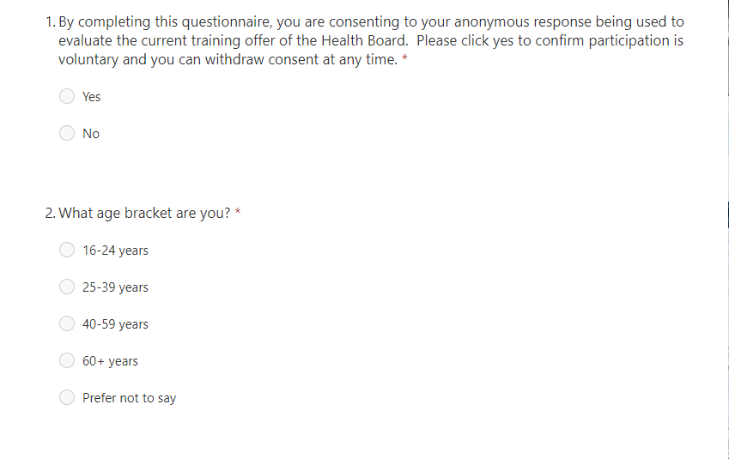
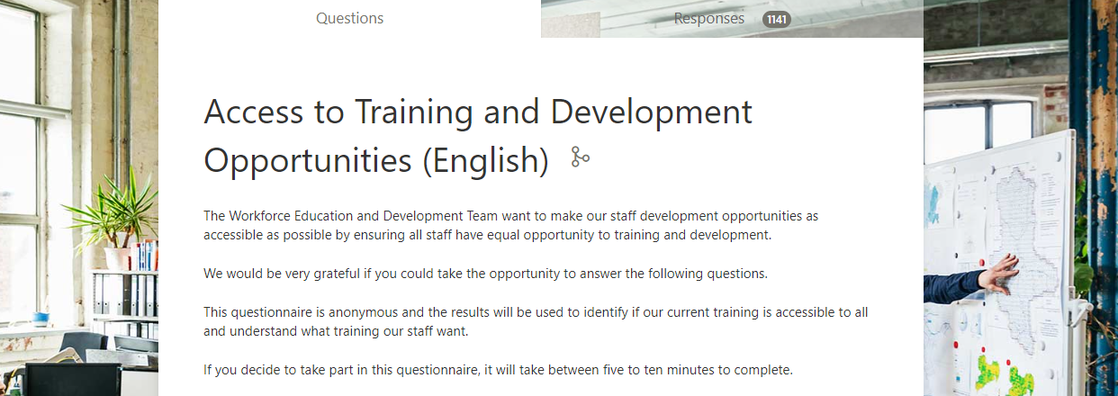
9.1 Final Questionnaire
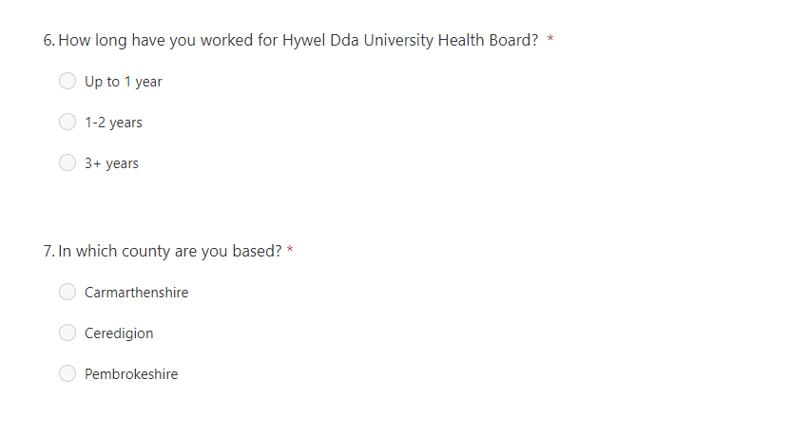
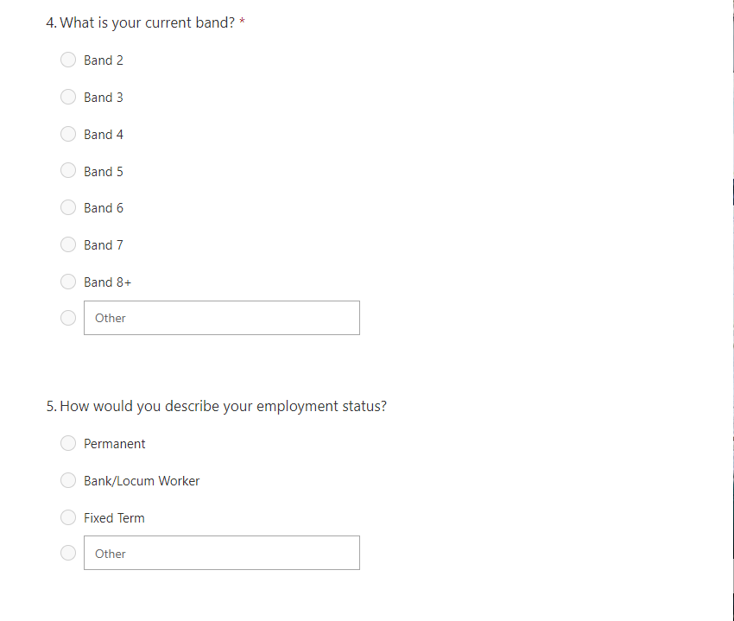
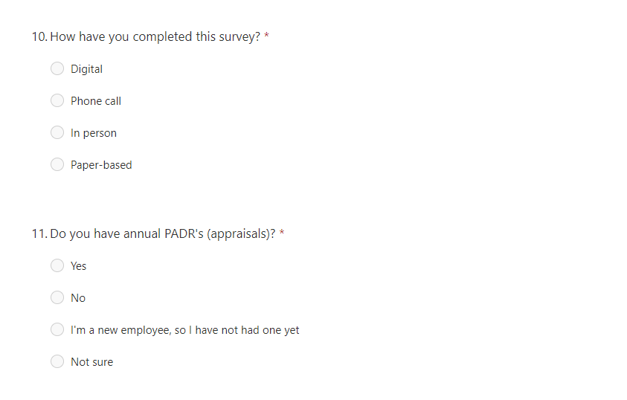
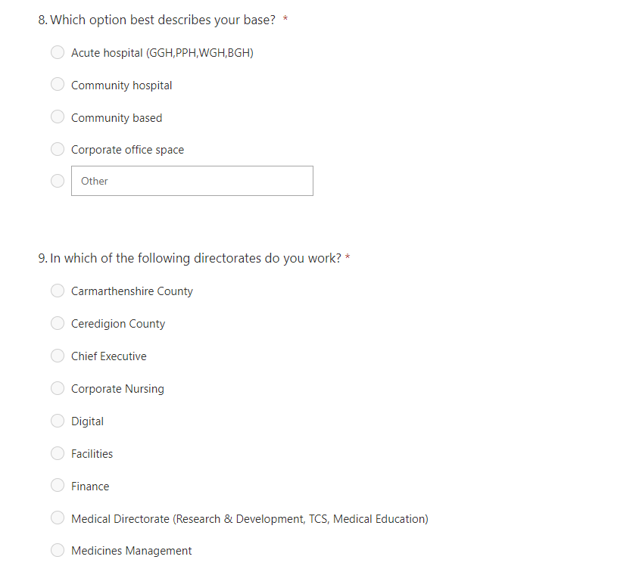
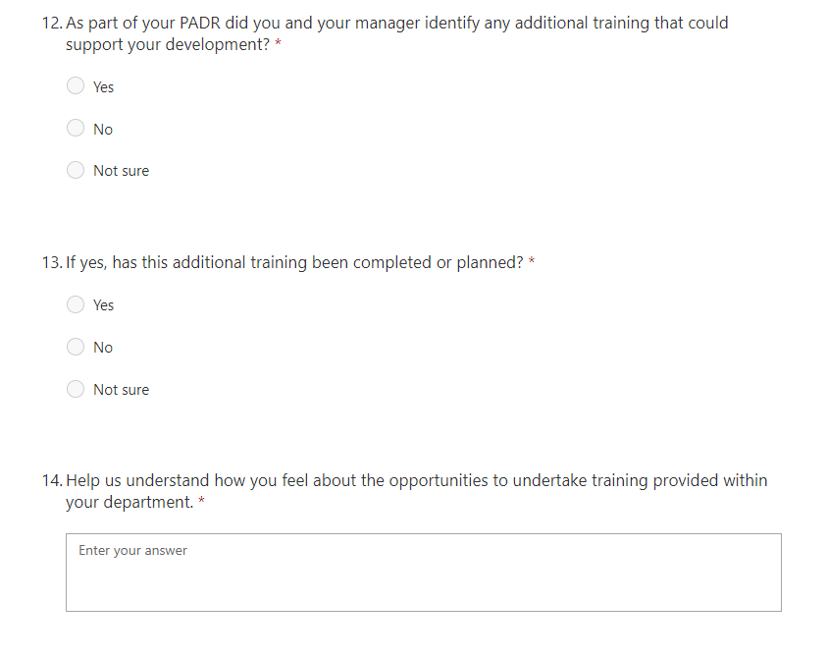
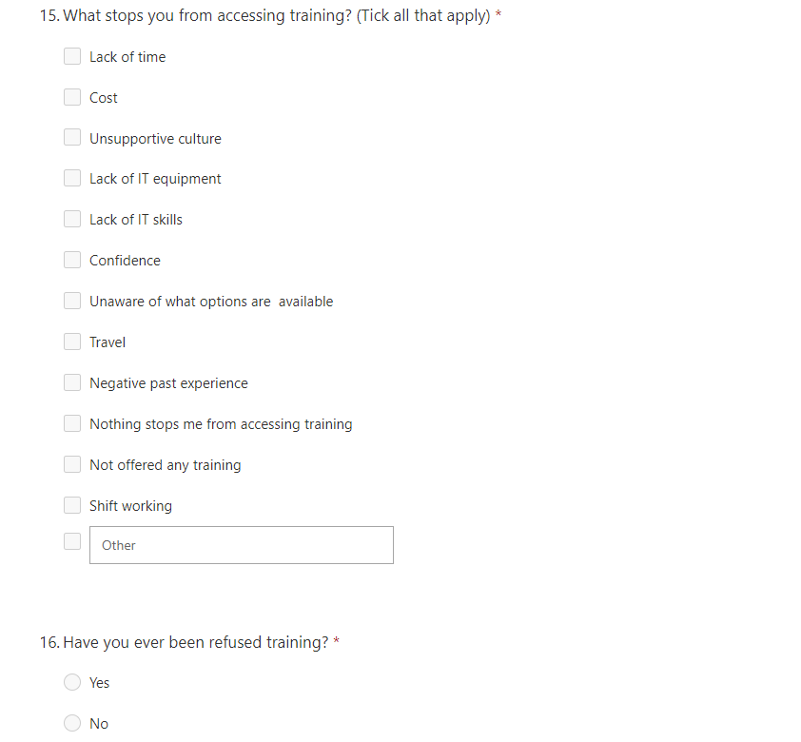
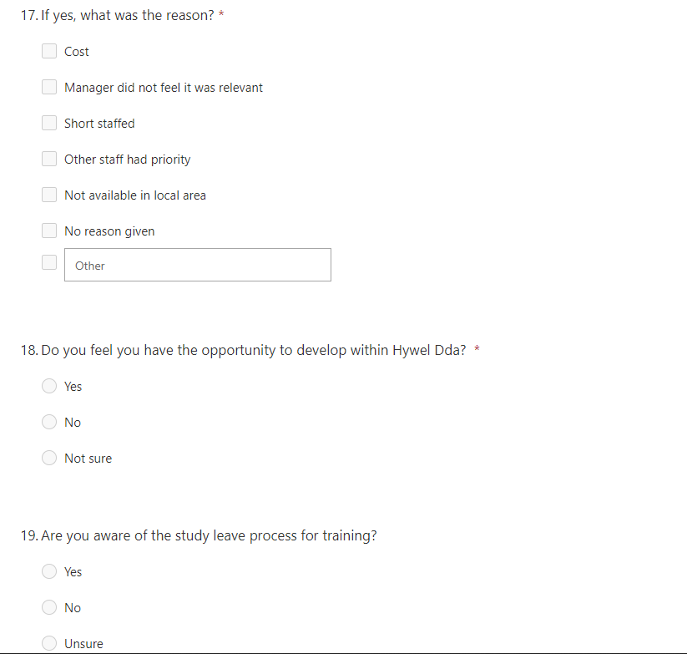
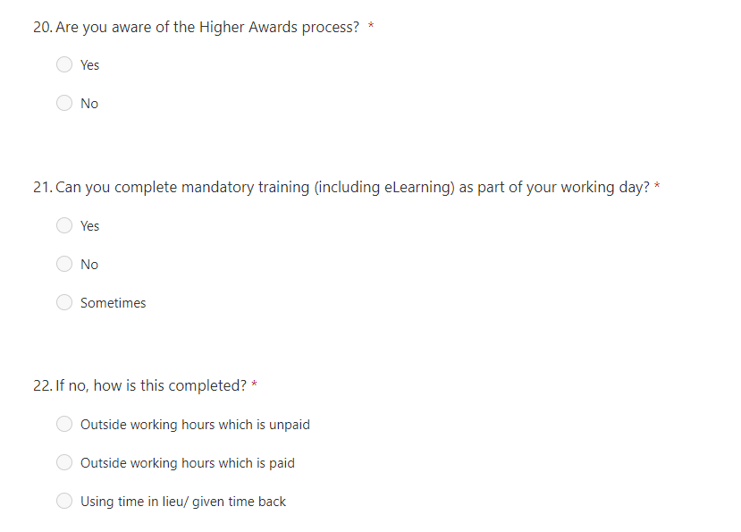
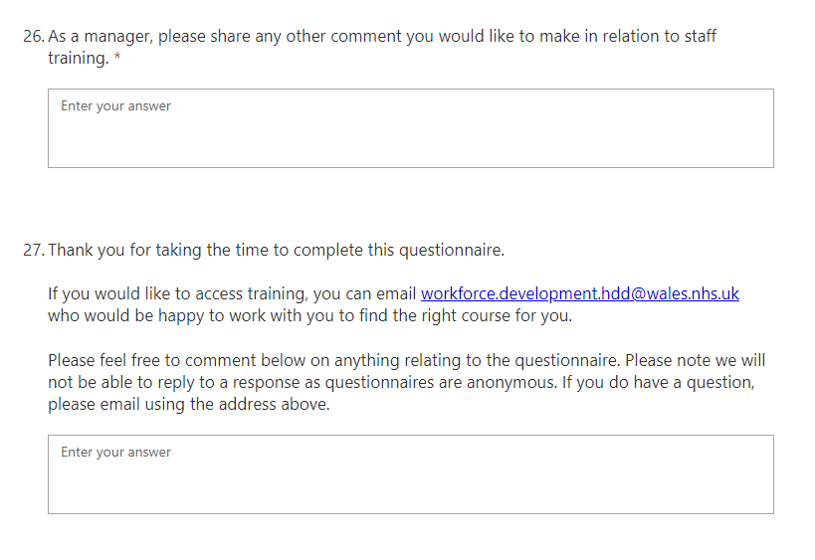
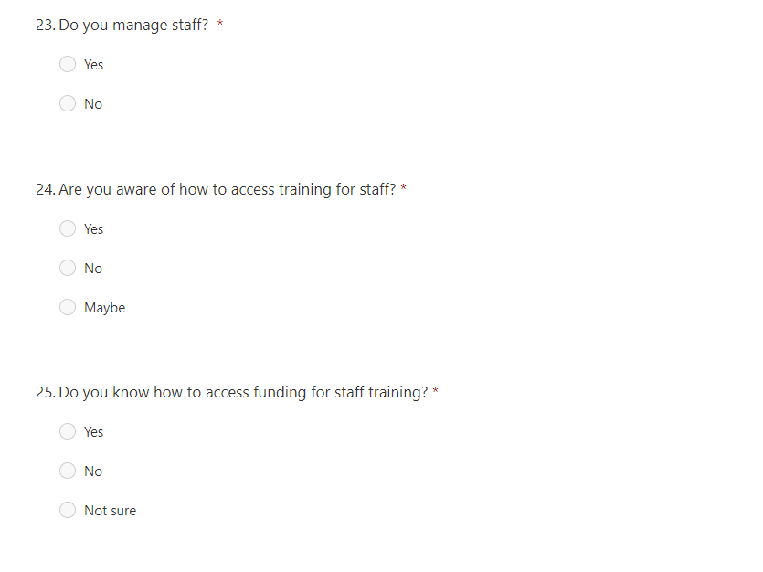

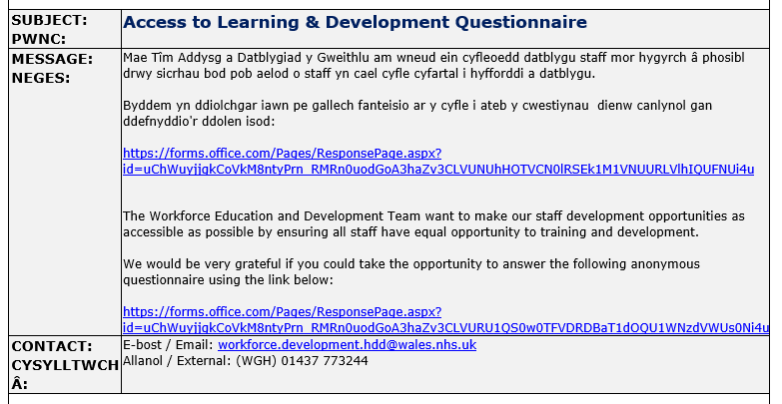
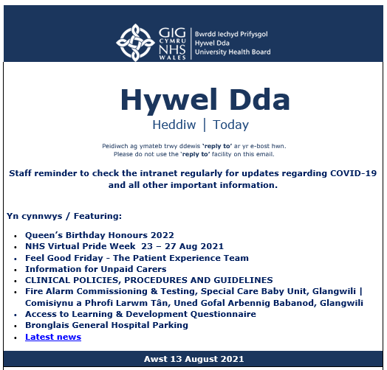
9.2 Global Advertisement

9.3 Thematic Analysis
Overall Area | Theme | Coding
Barriers to Training | Delivery Style | Face to face needed (16)
Barriers to Training | Planning | Need lead time due to shift management (9)
Barriers to Training | Training Approvals | Autonomy to sign off training (6)
Barriers to Training | Funding | 75% Higher award not equitable (21)
Barriers to Training | Funding | Budget for external specialist training (4)
Barriers to Training | Funding | Lack of commitment for non-clinical staff (9)
Promoting Opportunities | Access to Information | Global not for deskless workforce (29)
Promoting Opportunities | Access to Information | Lack information of training (47)
Promoting Opportunities | Access to Information | Needs to be more transparent (8)
Promoting Opportunities | Access to Information | Training not relevant - needs to suit needs not (3)
Promoting Opportunities | Funding | Need to clarify study leave & higher award process for funding (21)
Promoting Opportunities | Funding | Understanding funding opportunities (18)
Resources | Staffing Pressures | Staffing pressures/Can't release staff (67)
Resources | IT Resources | Don't have IT access eLearning, managed on compliance (21)
Resources | Accommodation | No venue/means we can’t even do team training (11)
Resources | Cost Pressures | Lack of training/department funds (55)
Resources | Cost Pressures | Investment needed for band 5 nurses/AHP (3)
Resources | Cost Pressures | L&D should manage funds to make it fair (2)
Resources | Cost Pressures | Lack of backfill budget to allow training (18)
Resources | Study Time | Protection of study time (21)
Systems & Processes | Study Leave/Higher Awards | Processes too complicated (16)
Systems & Processes | Study Leave/Higher Awards | Should be submitted before manager approval, more equitable (19)
Systems & Processes | Study Leave/Higher Awards | Application windows more flexible (8)
Systems & Processes | Study Leave/Higher Awards | Takes too long (19)
Systems & Processes | ESR/LMS | eLearning Platform too complicated (24)
Systems & Processes | ESR/LMS | Better understanding of mandatory training
Systems & Processes | ESR/LMS | eLearning support online (12)
Systems & Processes | ESR/LMS | eLearning support face to face sessions (13)
Systems & Processes | ESR/LMS | ESR Problems meaning downtime (4)
Systems & Processes | CPD | How can ESR record CPD (3)
 | CPD | How can ESR capture mentoring/on-the-job training (2)
Overall Area | Theme | Coding
Training Opportunities | Training Needs Analysis | Identify Training Needs service specific and then a timetable (4)
Training Opportunities | Management Training | How to promote training to staff (6)
Training Opportunities | Management Training | Want management Training - lack confidence and skills (39)
Training Opportunities | Management Training | Management: Human Resource Management, Financial Management, Payroll, NHS Pensions, Accounting, leadership, recruitment
Training Opportunities | Management Training | Lack of people management tools (16)
Training Opportunities | Training Delivery | use alternative methods (podcasts, flowcharts, videos, face to face, virtual, quiz) (9)
Training Opportunities | Mandatory training | Mandatory training not fit for process, not relevant to the role and it is difficult to access, the quality of the units is inconsistent, and I think the whole process needs to be overhauled and made easier to access and more relevant. Now it is a tick box exercise which adds nothing of value. That time would be better spent on training that is more focussed on the needs of the service. (3)
Training Opportunities | MDT training | Greater focus on MDT delivery (5)
Training Opportunities | PADR Training | Link to PADR - Greater focus on development
Training Opportunities | Retention | More training available for lower band roles for development and improve retention
Training Opportunities | Specialist Training | Admin: Triaging, summarising, read coding, Repeat Prescriptions, workflow management, customer service
Training Opportunities | Specialist Training | - Clinical: Basic Life support, safeguarding (children & adults), chronic disease management, immunisations, wound care.
Training Opportunities | IT Training | training in IT packages needed (20)
Training Opportunities | IT Training | Advanced IT skills will increase productivity (2)
Barriers to Training | Equitable Access | Balance and Fairness with pressures (3)
Barriers to Training | Equitable Access | Courses offered to some and not others (8)
Barriers to Training | Equitable Access | Need transparent application process (4)
Barriers to Training | Positive Feedback | Improved learning culture in recent years (9)
Barriers to Training | Positive Feedback | Example of self-worth and belonging in a team because of training
Barriers to Training | No interest | Staff not interested in progression as close to retirement
Barriers to Training | Motivation | Staff lack motivation for training (6)
Barriers to Training | Retention | Lost staff due to lack of training (6)

9.4 Action Plan for Recommendations
Recommendation | Rationale | Action | By Whom | By  When | Resources  Including Cost
Training, Workforce Planning and Finance Task and Finish Group to improve the inequity as a result of training spend and processes. | Revisit data from a finance perspective, highlighting any anomalies and validating findings | Validate the contents of the training spend in the report, recognising the limitations of data collected with available resources. | Finance Business Partner | 08/22 | Finance Business Partner (B8a @ 15 hours)  £465.30
 |  | Identify a model for the equitable allocation and identification of a reoccurring funding to not only support a 100% Higher Award funding model but reducing the financial barriers and inequity for HE opportunities. | L&D Manager  Programme Development Coordinator | 10/22 | 15 Hours options paper L&D manager (B8a @ 15 hours)  £465.20  Research (B6 @ 20 Hours)  £455.60
 |  | Identify a funding mechanism to allow funding establishment to provide all staff a minimum of two days paid study leave to complete their mandatory training in addition to development days to upskill | Finance Business Partner  Head of E&D  Operations representative  Education & Compliance Paper | 03/23 | 15 Hours options paper (B8a @ 15 hours)  £465.20  20 Hours options paper (B8b @ 15 hours)  £725.40  20 Hours options paper (B8b @ 15 hours)  £725.40  Collating T& F Group Options (B6 @ 20 Hours) £455.60
 |  | Identify how L&D can report and manage spend, ROI investment, evaluation of L&D spend and monitor provision |  | 03/23
Overall Cost |  |  |  |  | £3757.70
Recommendation | Rationale | Action | By Whom | By  When | Resources  Including Cost
Design an application process in relation to accessing courses, study leave, higher awards and other | System to report programmes, with the ability to report the number of rejected opportunities, recognising trends and being able to identify areas that need managing. | Design software – Forms, | Digital Learning Coordinator | 06/22 | (B6 @ 20 Hours) £455.60  Cost of time
 |  | Pilot process – Time including opportunity to evaluate pilot, make changes and re-pilot | Digital Learning Coordinator | 10/22 | (B6 @ 20 Hours) £455.60  Cost of time
 |  | Communicate processes | L&D Manager | 01/23 | 15 Hours options paper (B8a @ 15 hours)  £465.20
 |  | Embedded in all training, globals, leadership, ODRM, FB group, ESR Pay Slips | L&D Manager | 01/23 | Cost to create animation for staff social media group £1,500  15 Hours options paper (B8a @ 15 hours)  £465.20
 |  | Identify reporting models metrics, how to capture, specific data collation through T&F Group | L&D Manager | 04/23 | 15 Hours options paper (B8a @ 15 hours)  £465.20  Infographics additional license £340
 |  | Create a process to identify trends, with clear process of how to deal with data that does not meet the threshold and other metrics that may influence outcomes. ODRM, (disciplinaries, vacancy rates, etc | L&D Manager  Relationship Manager (ODRM)  Education & Compliance Officer | 04/23 | 1.5 Hours options paper (B8a @ 15 hours) £46.52  2 Hours options paper (B8b @ 15 hours) £72.54  2 Hours options paper (B8b @ 15 hours) £72.54  Collating Options (B6 @ 10 Hours) £225. 30
Overall Cost | £4564
Recommendation | Rationale | Action | By Whom | By  When | Resources  Including Cost
Develop a promotion strategy to promote recognising success stories support overcoming negative past experiences, which also widens participation | Reduce the personal barriers by developing mechanisms to break down perceptions | Creation of literature to promote training and development opportunities and career pathways | Programme Development Coordinator | 02/23 | (B6 @ 20 Hours) £455.60  Cost of time
 |  | Developing a communication strategy to promote opportunities, recognising limitations of global | L&D Manager | 03/23 | 15 Hours options paper (B8a @ 15 hours)  £465.20
 |  | Promoting success through case studies and testimonials. | L&D Manager | 08/23 | Cost to create video for staff social media group £1,200  15 Hours options paper (B8a @ 15 hours) £465.20
 |  | Develop an awareness resource for to highlights the benefits of staff training to the individual, their managers and the organisation. Changing behavior | L&D Manager | 10/23 | 15 Hours options paper (B8a @ 15 hours)  £465.20  Software additional license £340
 |  | Providing a toolkit to support the development of individuals to reach their full potential, along with training on how to use the toolkit. Practical application | L&D Manager  Relationship Manager (ODRM)  Education & Development Officer | 12/23 | 15 Hours options paper (B8a @ 15 hours) £465.20  20 Hours options paper (B8b @ 15 hours) £725.40  20 Hours options paper (B8b @ 15 hours) £725.40  Collating T& F Group Options (B6 @ 20 Hours) £455.60
Overall Cost |  |  |  |  | £5763
Recommend-ation | Rationale | Action | By Whom | By  When | Resources  Including Cost
Improve Digital Accessibility Access and design a Training programme. | Recognising HDdUHB workforce covers community, various locations and those who do not access IT as part of their role, | Consider staff access to licenses, a full training  and a consider an alternative Learning Management System widening access. | L&D Manager  Head Of Digital Services | 10/22 | License cost assuming use of Microsoft or new LMS £250,000 – Based on greatest cost option  15 Hours options paper (B8a @ 15 hours)  £465.20  20 Hours options paper (B8b @ 15 hours)  £725.40
 |  | Design a Digital Induction Training Package to deliver as part of the induction and to roll out to all non-desk staff | L&D Team Delegates | 02/23 | 15 Hours options paper (B8a @ 15 hours)  £465.20 20 Hours options paper (B8b @ 15 hours) £725.40  20 Hours options paper (B8b @ 15 hours) £725.40  Collating T& F Group Options (B6 @ 20 Hours) £455.60
 |  | Create a roll-out plan as to how this will be implemented across HDdUHB | L&D Manager  Digital Learning Coordinator | 04/23 | 2 Hours options paper (B8b @ 15 hours) £72.54  2 Hours options paper (B8b @ 15 hours) £72.54  Collating Options (B6 @ 1 Hours) £22.50
Overall Cost |  |  |  |  | £253,730
Recommend-ation | Rationale | Action | By Whom | By  When | Resources  Including Cost
Quick Wins | Recognising barriers to participation for those with childcare responsibilities, impacting 12% of the workforce | Evaluate course start/finish times, considering shift and school times. Initial resources will require staff resource to identify timings of current provision. This it may have impact on staff release if there is a need to shorten days to accommodate as well as need to consider capacity. | L&D Coordinator  L&D Manager  Head of Education & Development | 07/22 | 2 Hours options paper (B8b @ 15 hours) £72.54  2 Hours options paper (B8b @ 15 hours) £72.54  Collating Options (B6 @ 1 Hours) £22.50
Quick Wins | Training provision is not assessed to the suitability for those with a disability or learning difficulty | Evaluate all training programmes using an equality impact assessment to consider the L&D from a disability or learning difficulty perspective.  Update assurance and governance processes for all new training interventions to include an Equality Impact Assessment | L&D Coordinator  Programme Development Coordinator  L&D Manager  E,D&I Manager | 08/22 | 2 Hours options paper (B8b @ 15 hours) £72.54  2 Hours options paper (B8b @ 15 hours) £72.54  Collating Options (B6 @ 1 Hours) 22.50  2 Hours options paper (B8b @ 15 hours) £72.54  2 Hours options paper (B8b @ 15 hours) £72.54
Quick Wins | IT Resource Suite and Laptop Loan Service | IT facilities to enable the workforce to gain access and support to complete mandatory training, access virtual training events. | L&D Manager  Head of E&D  Band 2 0.25 WTE | 09/22 | 2 Hours options paper (B8b @ 15 hours) £72.54  2 Hours options paper (B8b @ 15 hours) £72.54  Band 2 to manage room bookings including laptop loan service 0.25 WTE  £6,267
Total Cost |  |  |  |  | £6892.32

