DIGITAL SKILLS AND RESEARCH METHODS

Gina-Mariana Vlaicu
(1908797)

University of Wales Trinity Saint David

Username: 1908797gv@gmail.com

Password: gv1908797

TASK NR.4- WEBSITE DESIGN

Because the website is online it communicates and it is essential to convey the messages I want, positive, credible, clear and effective, perceived by the visitor either voluntarily or through the subconscious.
When I created the website, I wanted it to be a professional presentation for my business. Everybody knows that a picture is worth a thousand words. By communicating through relevant images, I wanted to define SUNNY CAKES’s activity and letting visitors know that my business is alive.
While it is always an important part of the design, the colors can be used to make a website stand out and attract attention. And because I want to make the visitors to take action and to come to visit my SUNNY cakes, I put more colors for the website and I used light colors like light blue, green, pink, purple because using the wrong colors can confuse the visitor, and will send him an ambiguous message.
For the SUNNY cakes poster I used the red and white color because it means the excitement
for opening my small business. Red is a color of power being associated with energy, passion and love. It is used to attract the customers, to draw attention when visitors came by and make them to buy the cakes. The white color is for putting the SUNNY cakes in the spotlight, in the center stage of a clean and modern cake shop. The stability and the tradition it is resulted from the brown color which conveys warmth. I used for the background a mix of blue and red, a mix of intelligence, responsibility with the power and the passion of a trustworthy cake shop.
Like the name, SUNNY cakes, symbolizing the sun, yellow it means happiness, enthusiasm, more confidence on what I’m doing and lots of optimism, a friendless place where you combine your ideas with my passion to enjoy the dessert you deserve.
The colors, the design, the all images what I used, the content, all these aspects matters in my web design because I want to convey a positive and effective message to my visitors.
With the questionnaire created I tried to obtain feedback from my customers, to ensure I am on the right path. By obtaining their feedback it helps me improving my business and see if the result will have an impact on my “SUNNY” cake. The qualitative data from the questionnaire helps my marketing and sales team attract and engage customers.
The purpose of any product is to help customers accomplish a goal. If customers are succeeding with my cakes, they're more likely to remain loyal to my traditional shop. .
With the questionnaire created, I wanted to put myself in the "skin" of the client and to think about the satisfaction of the one who is ready to enjoy the best cakes. By knowing the customer feedback it will influence my business in order to be able to improve my products according to consumer expectations.

PAGE 1- SUNNY CAKES

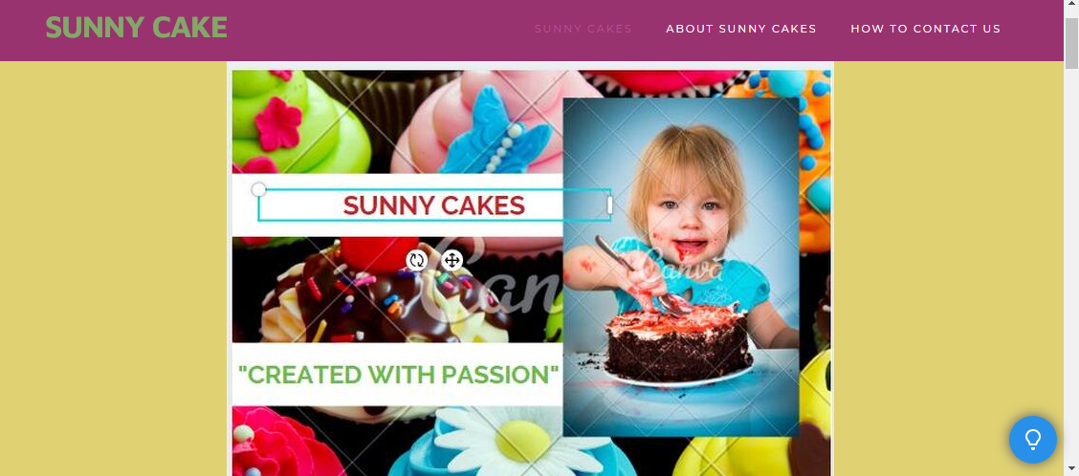
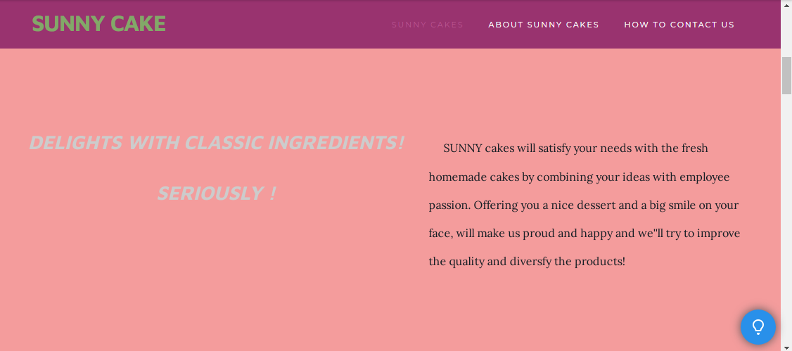
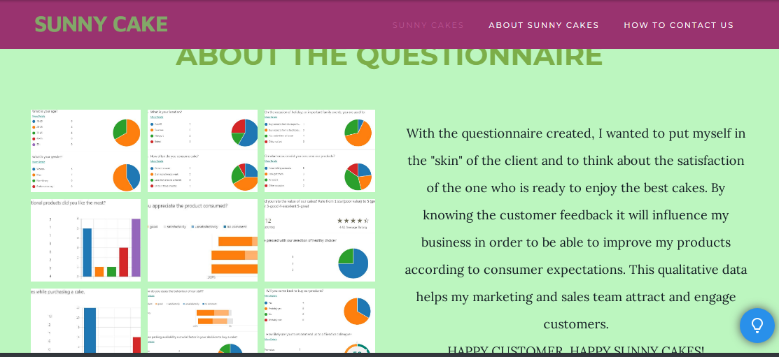
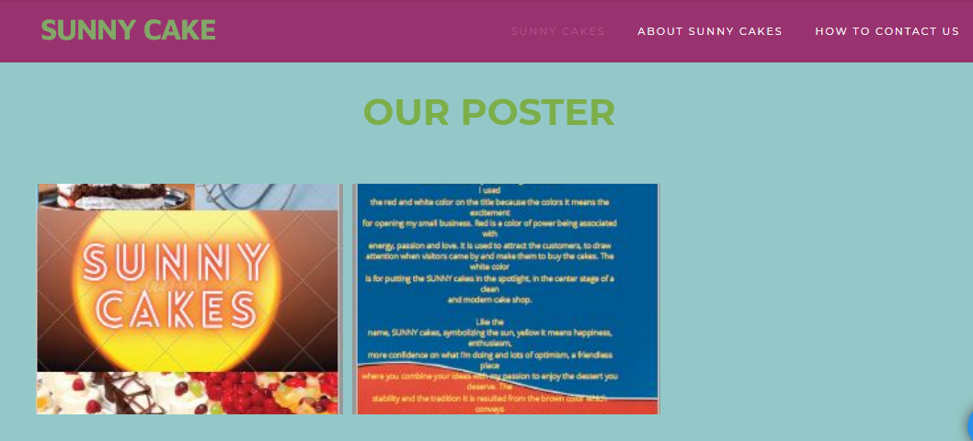
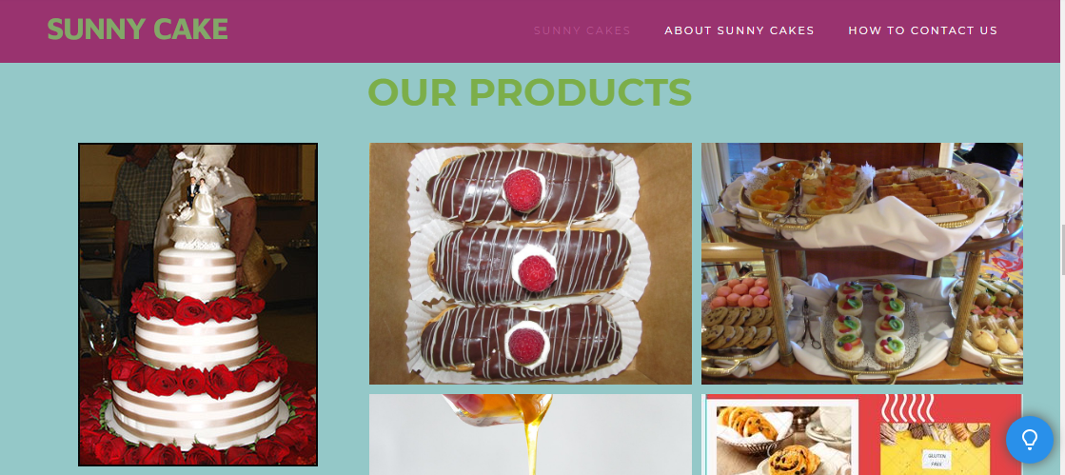
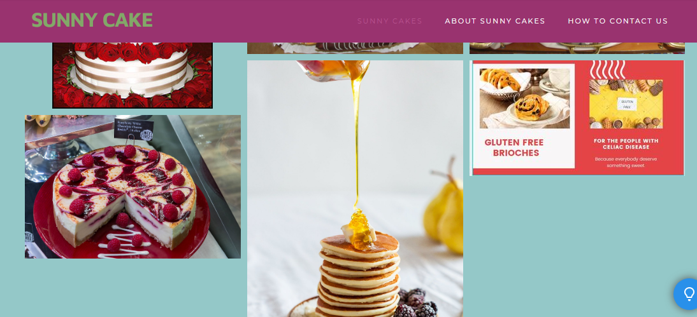

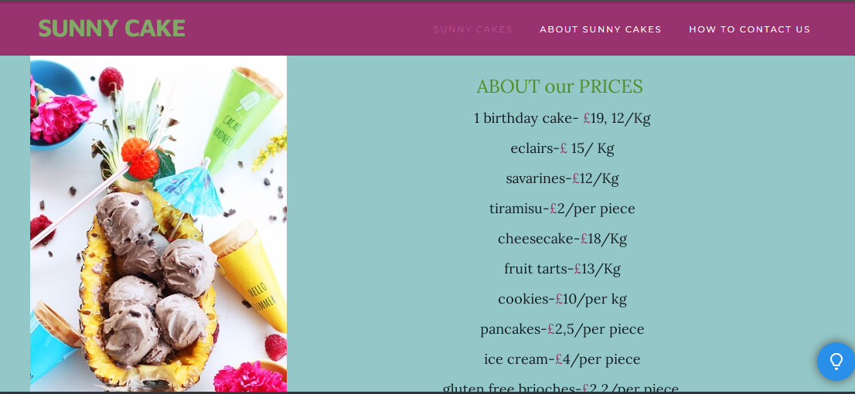
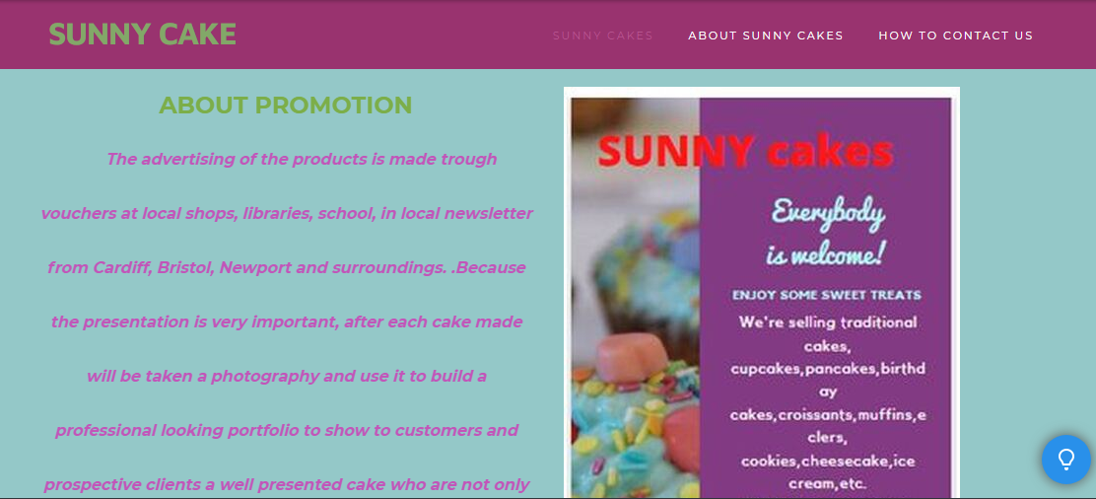
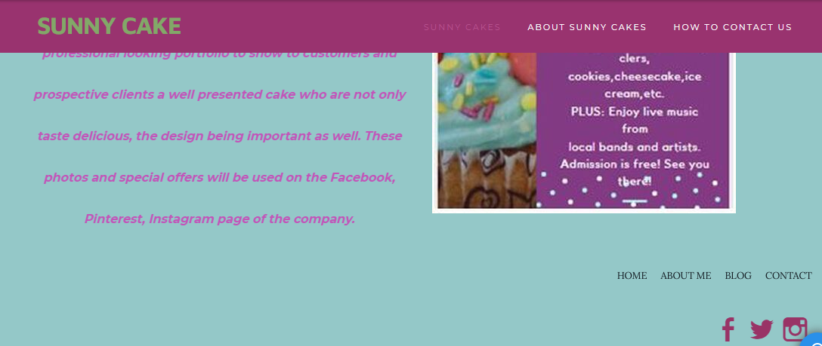
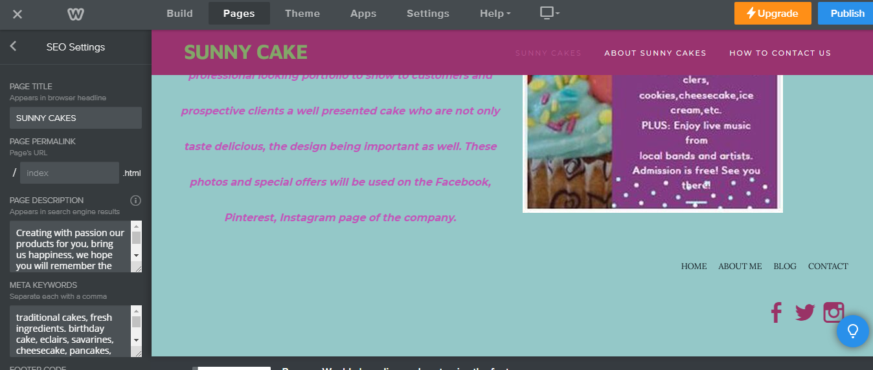

PAGE 2- ABOUT SUNNY CAKES

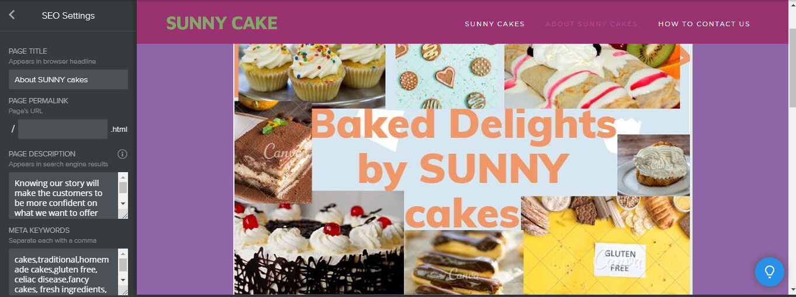

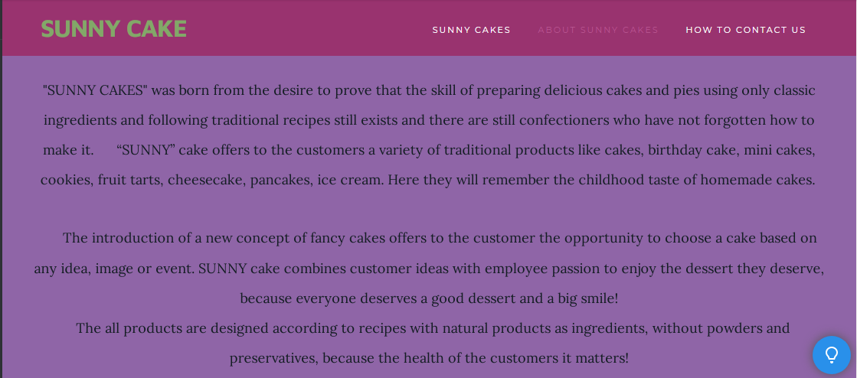
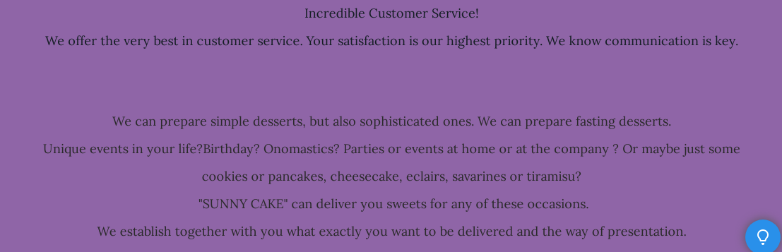
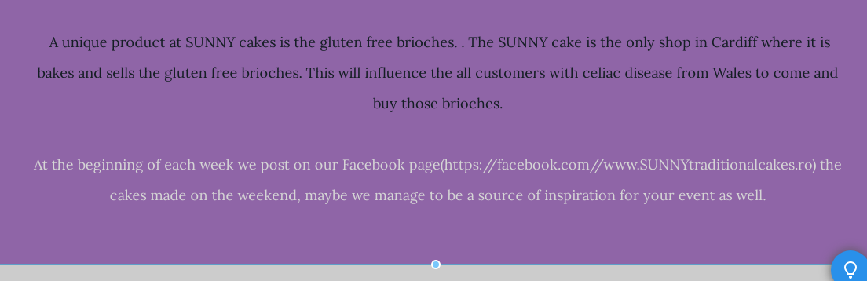

PAGE 3- HOW TO CONTACT US

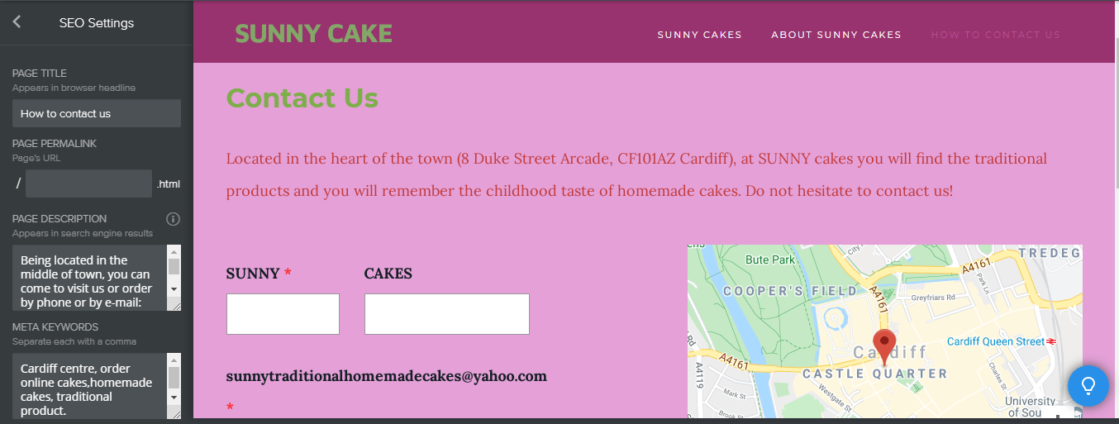
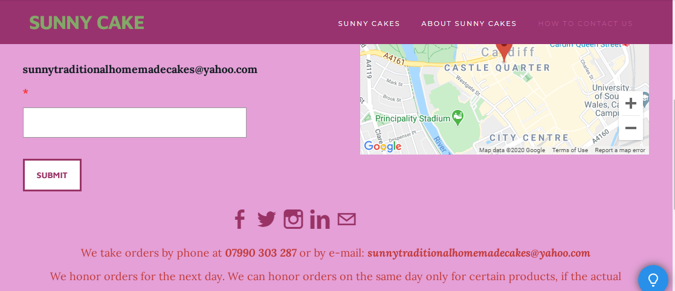
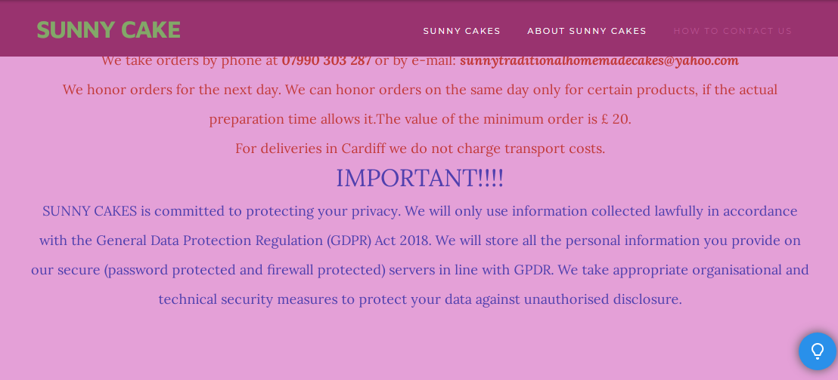

REFERENCES:

1. [Gary B. Shelly, H. Albert Napier, Ollie N. Rivers, (2008), Web Design: Introductory Concepts and Techniques, Cengage Learning, 2 Jul 2008 - Computers, pages: 178-181, Accessed date: 4.07.2020]
2. [Lisa Pecunia, (2011), The Small Business Website Design Guide, Avarra Solutions, 2011, page13, Accessed date: 03.07.2020]

