final report
University of Wales Trinity Saint David London Campus

Module:
ACCA6020 Independent project
Lecturer: Dr. Amit Naik
Mindaugas Levinskas (2226067)

Project Title

Development of a Web-Based Platform for Estimate Calculations Connecting Clients and Contractors in Self-Sufficient House Construction Projects

Declaration of Originality

I, Mindaugas Levinskas declare that I am the sole author of this Project; that all references cited have been consulted; that I have conducted all work of which this is a record, and that the finished work lies within the prescribed word limits.

This work has not previously been accepted as part of any other degree submission.

Signed: Mindaugas Levinskas

Date: 15/12/2025

FORM OF CONSENT

I Mindaugas Levinskas hereby consent that my Project, submitted in candidature for the B.Sc.(Hons) Computer Networks degree, if successful, may be made available for inter-library loan or photocopying (subject to the law of copyright), and that the title and abstract may be made available to outside organisations.

Signed: Mindaugas Levinskas

Date: 15/12/2025

Copyright Acknowledgement

I acknowledge that the copyright of this project report, and any product developed as part of the project, belong to University of Wales Trinity Saint David, Swansea.

ABSTRACT

This project creates an Off-Grid Construction Platform - a web application that connects property owners with off-grid construction contractors. Property owners submit project requests through a form, and administrator manage these requests and send project data to approved contractors by email. The system is simple and easy to understand, making it good for learning while also being useful for real business needs.
The web application uses beginner-friendly technology: Node.js runs the website, Express.js organizes the pages and features, EJS creates the web pages, and NeDB stores all the information in a simple file-based database. [1] The email system uses Nodemailer with Gmail to send project details to contractors. The admin area is protected with password login that uses secure sessions.
Web application works exactly as planned. Property owners fill out a form with their name, location, budget, services needed, and project details. Contractors apply to join the platform by providing their company information, service areas, and work examples. The admin dashboard has a secure login and shows important numbers like total leads and contractor count. Administrators can view all project requests, review contractor applications, approve or reject contractors, and send project details to contractors through pre-formatted emails Testing showed that everything works correctly: forms accept information properly, the admin area is secure, emails send successfully, and all data saves and loads without problems.
This project successfully creates a working marketplace for connecting property owners with off-grid contractors. Future improvements could add a contractor login area for submitting estimates directly on the website, automatic email notifications when new projects are posted, better search and filtering tools in the admin area, and support for other email services and many more. The project shows how important parts of a web application work together: the server that runs everything, the templates that create web pages, the database that stores information, the login system that keeps things secure, and the email system that connects people.

Contents
Project Title 2
Development of a Web-Based Platform for Estimate Calculations Connecting Clients and Contractors in Self-Sufficient House Construction Projects 2
ABSTRACT 3
CHAPTER 1 – INTRODUCTION 6
1.1 Project Background and Problem 6
1.2 Project Aim 6
1.3 Project Objectives 7
1.4 Motivation for the Project 7
CHAPTER 2 – LITERATURE REVIEW 8
2.1 Background & Current Market Analysis 8
2.1.1 Existing Platforms 8
2.1.2 Identified Gaps in the Current Market 9
2.2 Market Opportunity 9
2.2.1 Growing Demand for Sustainable Living 9
2.2.2 Digital Technology Adoption in Construction 10
2.3 Technological Approaches and Development Methodology 10
2.3.1 Agile Development Methodology 10
2.3.2 Web Technologies for Marketplace Platforms 10
2.4 Literature Review Analysis 10
CHAPTER 3 – SYSTEM ANALYSIS AND DESIGN 11
3.1 Analysis 11
3.2 Requirement Analysis 11
3.2.1 Functional Requirements 11
3.2.2 Non-Functional Requirements 12
3.3 Use Case Diagram 13
3.4 System Requirements 13
3.4.1 Hardware Requirements 13
3.4.2 Software Requirements 13
3.5 Risk Analysis 14
3.6 Materials, Tools, and Technologies 14
3.6.1 Node.js 14
3.6.2 Express.js 14
3.6.3 EJS (Embedded JavaScript Templates) 15
3.6.4 NeDB Database 15
3.6.5 Express-Session Authentication 15
3.6.6 Nodemailer for Email Integration 15
3.6.7 Development Tools 15
3.7 Evaluation Criteria 15
3.8 Testing Methods 15
3.8.1 Functional Testing 16
3.8.2 Security Testing 16
3.8.3 Email Testing 16
3.8.4 Performance Testing 16
3.8.5 Usability Testing 16
CHAPTER 4 – DESIGN & IMPLEMENTATION 16
4.1 Design Philosophy 16
4.2 System Architecture 17
4.3 Technology Choices 18
4.4 Database Design 19
4.5 User Interface Design 20
4.6 Security Design 20
4.7 Email System Design 21
4.8 Implementation Approach 23
4.9 Code Organization 24
4.10 Future Implementation Ideas 24
4.11 Testing 25
CHAPTER 5 – EVALUATION 34
CHAPTER 6 – CONCLUSION 37
CHAPTER 7 – REFLECTION 37
7.1 Learning About Simplicity 37
7.2 Connecting Research and Practice 38
7.3 Technical Skills Development 38
7.4 Project Management Insights 39
7.5 What Could Have Been Done Differently 39
7.6 Personal Growth and Confidence 39
7.7 Future Direction 40
Bibliography 41

CHAPTER 1 – INTRODUCTION

Technology is changing how people and businesses communicate and manage projects. Many small businesses still use old methods like email, spreadsheets, and phone calls to collect project information from customers. These methods work, but they create problems: communication is slow, important details get lost, records are messy, and staff waste time on paperwork. Small teams, contractors, and service providers need simple tools to organize project requests quickly and securely. This project solves that problem by building a web application where visitors can submit project details and an administrator can manage those submissions through a secure login area.

This web application keeps things simple and practical. Visitors fill out a form with their project information, and the administrator logs in to view all submissions and manage the data. The system uses Node.js, Express.js, EJS templates, and NeDB database. [2] These technologies provide a stable foundation that's beginner-friendly and easy to expand later.

1.1 Project Background and Problem

In many industries—like construction, home renovation, digital services, consulting, and small manufacturing—customers submit project details before work begins. Businesses need to collect this information to give price estimates, assign workers, and communicate with contractors. ‘’Users submit one request and receive multiple competitive quotes instantly, all from reviewed professionals. ‘’ [3] However, most small businesses don't have dedicated systems for this. They rely on basic email contact forms or paper forms. These methods cause several problems:

• Important project details get missed or lost
• Data isn't stored safely or consistently
• Admins waste time searching through emails or spreadsheets
• There's no central place to see all customer submissions
• Communication with contractors is slow and disorganized

Even modern website contact forms usually just send information to an email inbox without storing anything in a proper database. This means businesses can't easily track submissions or review them later. This project fixes these problems by creating an organized system that captures all project requests, stores them securely, and makes them available in a dedicated admin dashboard.

1.2 Project Aim

The main goal of this project is:

To design and build a simple, secure, and efficient web application, that lets visitors submit project requests and allows an administrator to manage these submissions through a protected dashboard.

This project provides a clean solution that meets the basic needs of small organizations while staying easy to understand and expand. The application also serves as a foundation for future improvements, like sending automated emails to contractors and many more.

1.3 Project Objectives

The project is divided into clear steps. Each step helps build the complete system:
Objective 1: Create a Front-End Interface for Visitors Design and build a clean, user-friendly form where visitors can enter project information like their name, contact details, project description, and any extra notes.

Objective 2: Build a Backend to Receive and Process Form Data Develop the behind-the-scenes logic that checks incoming data, prevents invalid submissions, and stores data in an organized format.

Objective 3: Set Up a Database System Set up a NeDB database to store all visitor submissions and admin login details securely. [4]

Objective 4: Implement Secure Admin Authentication. Create a login system for the administrator using secure sessions to ensure only authorized people can view private submissions.

Objective 5: Develop the Admin Dashboard Build a private dashboard, that lists all submissions, displays details clearly, and allows the admin to manage or review the information easily.

Objective 6: Add Email Functionality to implement an email system that allows administrators to send project details directly to contractors with pre-formatted messages.

Objective 7: Ensure Clear System Structure and Easy Maintenance Use a clean folder structure, pages, templates, so the system is easy for beginners and future developers to understand.

Together, these objectives ensure the project successfully solves the initial problem while creating a foundation that can grow with future needs. [1]

1.4 Motivation for the Project

There are several reasons for creating this application. First, many small businesses don't have access to complex project management systems, and they don't need them. What they need is a simple way to collect customer requests and manage them in one place. As businesses grow, the number of inquiries increases, and manual methods quickly become inefficient. By providing a simple application with an organized submission system and a secure admin panel, this project helps improve communication between customers, admins, and contractors.

The second reason is educational. The project helps to understand how a complete web application works from page routing and templates to user authentication and database handling. Many tutorials teach only one part of the process, but this project brings together all major components in one working system. This makes it valuable for learning and future development.

The third reason relates to practical skills and modern technology. Many students and junior developers struggle to understand how to build systems from the ground up. They often rely on frameworks that hide how things really work. This project shows how to build a real, working system in a clear, straightforward way.

Finally, there's personal motivation. Building a system like this provides hands-on experience in backend development, authentication, form handling, database operations, email integration, and system design. These are essential skills for a career in software development, and this project provides a meaningful way to practice them.

CHAPTER 2 – LITERATURE REVIEW

This chapter reviews information relevant to building a platform, that connects eco-interested property owners with green building contractors. This review looks at the current market, existing platforms, gaps in the industry, and the technology solutions suitable for this project. The chapter shows that while general marketplace platforms exist, there is a clear opportunity for a dedicated system focused on sustainable construction and off-grid services.

2.1 Background & Current Market Analysis

The construction and home improvement industry has changed significantly in recent years, with various platforms emerging to connect service providers with clients. Understanding the current market is essential to identify where this project fits and what value it provides.

2.1.1 Existing Platforms

Several types of platforms currently serve the construction and home services market:
General Marketplace Platforms such as TaskRabbit, HomeRun.co.uk, and Costable.co.uk provide broad marketplace solutions for home services and repairs. Research shows these platforms have successfully streamlined the process of finding contractors for general home maintenance tasks. However, they typically focus on wide construction rather than specialized sustainable or off-grid solutions. [5]

Cost Estimation Tools Services like HomeAdvisor provide cost estimation and contractor matching for home improvement projects. While useful for budgeting, they mainly serve common construction projects and lack features designed for sustainable building practices.

Client and Service Provider Connection Platforms General service platforms such as Uber (for transportation), Airbnb (for accommodation), and Upwork (for freelance services) have shown that digital platforms connecting service providers with clients can work well. [6] The construction industry has adopted similar models, but most applications focus on general contracting rather than specialized green building services.

2.1.2 Identified Gaps in the Current Market

Despite many digital platforms in the construction sector, several important gaps remain:
Lack of Specialization in Green Building. Most platforms focus on general home repair and conventional construction methods, not specialized green building or sustainable construction. Property owners interested in solar installations, rainwater harvesting, sustainable materials, or Off-Grid living solutions struggle to find dedicated platforms that understand their specific needs.

Absence of Integrated Solutions for Sustainable Construction, while some contractors may advertise "green" services on general platforms, there is no integrated solution specifically designed for sustainable construction. This means eco-interested clients must search through general listings to find contractors with relevant expertise, often without clear indicators of their qualifications in sustainable building practices.

Communication Challenges Research shows that poor communication between clients and contractors is a major source of project delays. According to Let’s build, 67% of construction delays are due to poor client-contractor communication. Existing platforms do not adequately address this gap, particularly for specialized projects where technical understanding and sustainability goals are important.
No Dedicated Platform for Eco-Interested Clients and Green Building Specialists. Property owners seeking solar panel installation, off-grid water systems, sustainable insulation, or other green building services must rely on general search engines, word-of-mouth referrals, or broad marketplace platforms that do not specialize in their needs. This gap represents a clear market opportunity. [7]

2.2 Market Opportunity

The identified gaps in existing platforms reveal important market opportunities for a specialized system focused on sustainable construction and off-grid services.

2.2.1 Growing Demand for Sustainable Living

The market for sustainable construction is experiencing rapid growth. According to Green Building Statistics, the green building market is expanding significantly, with increasing numbers of property owners prioritizing sustainability. This growing demand creates opportunities for contractors who specialize in sustainable practices.
Research indicates that consumers especially Gen Z are increasingly aware of environmental issues and willing to pay premium prices for sustainable building solutions. This trend is particularly strong among younger property owners and those in urban areas [8].

2.2.2 Digital Technology Adoption in Construction

The construction sector is increasingly adopting digital technologies to improve efficiency, communication, and project management. There is increasing adoption of digital technologies in the construction sector. Both contractors and property owners are comfortable using online platforms for project management and service matching.
This creates good conditions for introducing a specialized platform. A platform designed for sustainable construction can use this existing digital literacy while addressing the specialized needs of the green building market.

2.3 Technological Approaches and Development Methodology

Having established the market need, it is important to review the technology approaches suitable for developing such a platform.

2.3.1 Agile Development Methodology

Modern web application development increasingly relies on Agile methodologies, which emphasize building systems step by step, getting continuous feedback, and flexibility to adapt to changing requirements. According to Brightwork, the Agile approach consists of five key stages: envision, speculate, explore, adapt, and close. [9] This is particularly suitable for platforms where initial features can be launched quickly and expanded based on user feedback.
The Agile approach aligns with the educational goals of this project. By building little by little
starting with core features, then gradually adding email communication and admin management - the development process remains manageable and educational.

2.3.2 Web Technologies for Marketplace Platforms

Research supports the use of Node.js and Express.js for building marketplace platforms. According to Mindbowser, agile web development offers benefits including faster time-to-market, flexibility, and improved collaboration. [10] Node.js is well-suited for building applications that handle multiple concurrent connections—important for a platform managing submissions from property owners and contractors.
The REST API architecture, as documented by W3Schools [11], provides a standard approach for building web services that can scale as the platform grows. While the current project uses a simpler approach with EJS templates, still understanding REST principles provides a foundation for future development for this application.

2.4 Literature Review Analysis

The literature review reveals a clear gap in the current market: while general construction marketplaces exist, there is no dedicated platform connecting eco-conscious property owners with green building specialists. Research shows growing demand for sustainable construction services and increasing digital adoption in the construction industry, creating good conditions for such a platform.
The technology approaches reviewed - particularly Agile development methodologies and modern web technologies like Node.js - provide appropriate foundations for building such a platform step by step. The academic literature supports starting with core features and expanding based on user needs, which aligns perfectly with this project's educational goals and practical implementation strategy.

CHAPTER 3 – SYSTEM ANALYSIS AND DESIGN

This chapter explains how the system was analysed, designed, and built. It starts with requirement analysis, which identifies what the application must do. Then it shows the system requirements, diagrams, hardware and software needs, and risks. The second half discusses the research methods, development approach, tools used, testing, and evaluation. The goal is to explain clearly how the project was built and how decisions were made.

3.1 Analysis

The analysis stage focuses on understanding the problem and defining, what the system must do. The goal is to create a web application where property owners and contractors submit information, and administrators manage these submissions through a secure dashboard.
The system needs three main user types: Property Owner who submits project requests, Contractor who applies to join the platform, and Administrator who logs in, views submissions, and sends project details to contractors by email.
The application must include clean forms for property owners and contractors, processing to check and store data, secure login for admin, a database for storing information, an admin dashboard to view and manage records, email to connect property owners with contractors, and error handling to prevent crashes.

3.2 Requirement Analysis

Requirement analysis defines what the system must do (functional requirements) and how it should perform (non-functional requirements). Clear requirements help ensure the system meets its goals and is easy to maintain. [12]

3.2.1 Functional Requirements

Functional requirements describe what the system does.

Core Visitor Functions:
- Property owners can access and submit project requests with their personal details, location, budget, and project description.
- Contractors can apply to join the platform with their company information, service areas, and portfolio details.
- The system validates all input through both frontend and backend checks.
- Submitted data is stored securely in the NeDB database.

Core Administrator Functions:
- Administrator can log in securely using username and password verification.
- The system maintains secure admin sessions.
- Administrator can view all project submissions and contractor applications in the dashboard.
- Administrator can approve or reject contractor applications.
- Administrator can select approved contractors and email them project details.
- The system restricts access to admin pages, ensuring only authenticated users can view sensitive data.

Email Communication Functions:
- Administrator can send project details to selected contractors via email.
- Email includes formatted HTML template with property owner information, project details, and contact information.
- System updates lead status after email is sent.

System Reliability:
- The system handles errors by displaying user-friendly error messages when failures occur or invalid input is submitted

3.2.2 Non-Functional Requirements

Non-functional requirements describe how well the system performs.
Usability and Performance: The interface must be simple and easy to navigate for non-technical users. Form submissions and admin dashboard loading must be fast and responsive. The system should operate without crashing and store data consistently.
Security and Data Protection: Authentication, data storage, and routing must protect against attacks such as injection and unauthorized access. All submitted data must be stored accurately without corruption. Environment variables protect sensitive credentials like email passwords. [12]
Maintainability and Future Growth: Code must be clear, well-commented, and structured so future developers can understand it easily. The system should allow future additions such as contractor login portals or automated notifications. The application should run easily on different operating systems including Windows, macOS, and Linux. [14]

3.3 Use Case Diagram

Below is a simple use case representation:

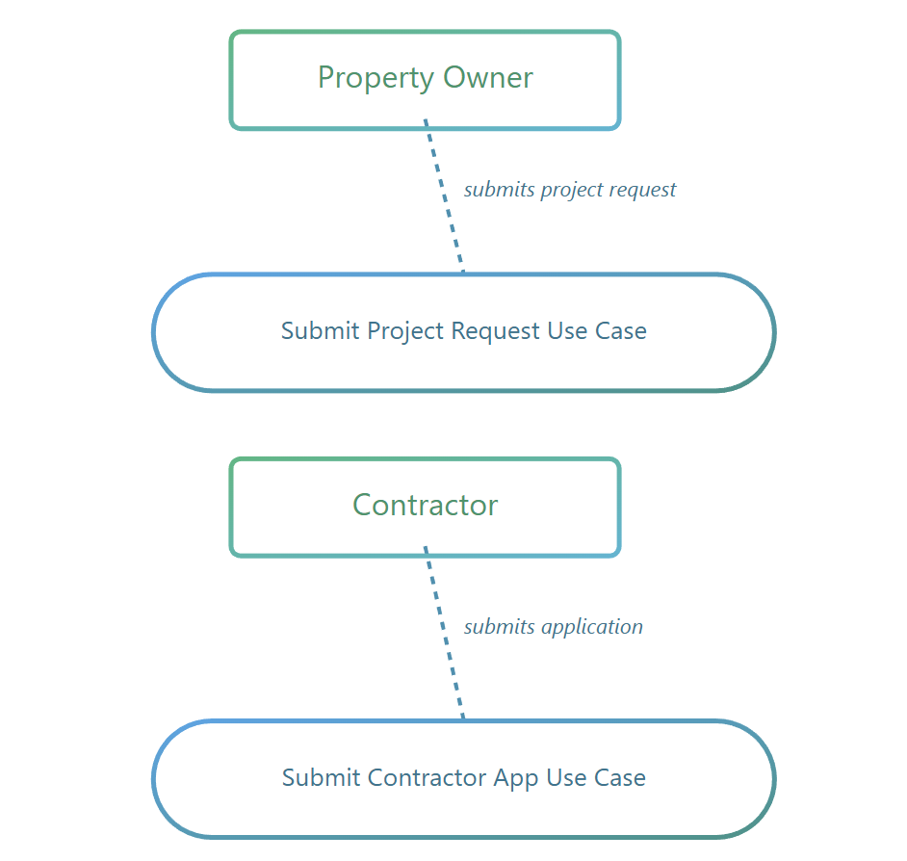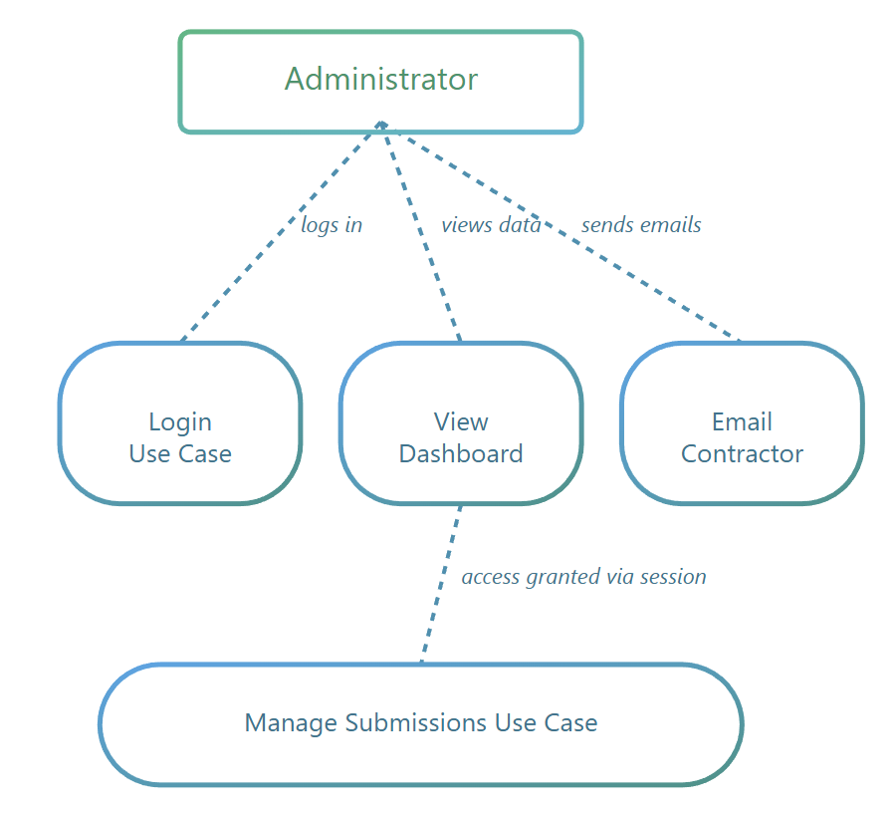
Figure 1. Use Case Diagram

Explanation: The system has three actors: Property Owner, Contractor, and Administrator. Property owners submit project requests, contractors submit applications, and the admin manages both through login, dashboard, and email. Session authentication protects admin pages. [13]

3.4 System Requirements

This section describes what is needed to develop and run the system.

3.4.1 Hardware Requirements

Because this is a lightweight web application, hardware requirements are minimal. The minimum hardware for the development machine includes a dual-core processor (Intel i3 or equivalent), 4 GB RAM, 1 GB free storage, and an internet connection for installing dependencies. For better performance, a quad-core processor with 8 GB RAM and 20 GB free storage is recommended.

The server hosting the application can run on very low specifications, such as 1–2 CPU cores, 1–2 GB RAM, and a few hundred MB storage. NeDB requires almost no additional resources.

3.4.2 Software Requirements

Development Software: Node.js (LTS version) is required to run the backend. NeDB serves as the database. A code editor such as VS Code is needed for development.
Required Libraries: The following libraries are installed via npm: express, ejs, nedb-promises, express-session, nodemailer, and dotenv.
Operating System: The application works on Windows, macOS, or Linux.

3.5 Risk Analysis

This section identifies potential problems that may occur and explains how to handle them. [14]

Risk | Probability | Impact | Mitigation Strategy
System failure or crash | Rare | High – data loss | Regular backups, storing database in cloud repository
Security breach | Possible | High – sensitive data exposed | Strong authentication, secure sessions, input validation
Incorrect form validation | Possible | Medium | Backend and frontend validation; sanitizing data
Email delivery failure | Possible | Medium | Error handling, Gmail App Password setup, testing
Delays in development | Possible | Medium | Use iterative development and schedule buffers
Lack of technical knowledge | Likely (for beginners) | Medium | Research, tutorials, testing, consulting mentors
Session authentication errors | Possible | Medium | Logging, debugging tools
Future feature expansion complexity | Likely | Medium | Modular code structure, clear commenting

3.6 Materials, Tools, and Technologies

This section explains what software and tools were used and why they were appropriate for this project.

3.6.1 Node.js

Node.js was chosen because it is fast and efficient for web servers, has a large ecosystem of modules, is easy for beginners to learn, allows full-stack JavaScript development, and is particularly great for form handling and routing. Highlight that Node.js is particularly efficient for I/O-intensive applications such as form submission systems. [15]

3.6.2 Express.js

Express.js was selected because it is lightweight and flexible, makes it easy to define routes and middleware, is widely supported and documented, and is ideal for small custom web applications like this project. [16]

3.6.3 EJS (Embedded JavaScript Templates)

EJS was used because it provides simple HTML with embedded logic, is useful for server-side rendering, works great for admin dashboards where content changes dynamically, and is easy for beginners to understand. Server-side templating engines like EJS remain valuable for applications prioritizing simplicity and SEO. [17]

3.6.4 NeDB Database

NeDB was chosen because it is file-based with no setup needed, perfect for small applications, stores data in JSON format, and is very fast and lightweight. The system does not need a heavy database like MySQL or PostgreSQL, so NeDB was the perfect fit for this lightweight marketplace platform. [4]

3.6.5 Express-Session Authentication

Session-based authentication was selected because it is simple to implement, uses secure cookies to maintain login state, stores session data server-side for security, and is a simple and correct way to admin systems. [18]

3.6.6 Nodemailer for Email Integration

Nodemailer was chosen because it integrates easily with Gmail and other email services, supports HTML email templates for professional formatting, is well-documented and widely used, and allows administrators to send project details directly to contractors without requiring contractor logins. [19]

3.6.7 Development Tools

The development process used Visual Studio Code for editing code and Node Package Manager (npm) for installing dependencies.

3.7 Evaluation Criteria

To judge whether the system works correctly, seven key criteria were used. Functional accuracy checks if each feature works as intended. Reliability ensures the system runs without crashing or losing data. Usability confirms that property owners, contractors, and admin users can use the system without difficulty. Security verifies that admin authentication is strong and data is protected. Performance measures whether forms submit quickly and the admin dashboard loads efficiently. Maintainability assesses if the code is easy to understand and modify. Finally, extensibility determines whether future features like contractor portals, automated notifications, and file uploads can be added easily.

3.8 Testing Methods

The system was tested using several approaches to ensure quality and reliability.

3.8.1 Functional Testing

Each feature was tested individually to ensure it worked correctly. This included testing property owner form submission, contractor application submission, validation, database insertion, admin login, session verification, dashboard display, contractor selection, and email sending.

3.8.2 Security Testing

Security was thoroughly tested by verifying session management, attempting to access admin pages without authentication, testing for injection prevention, and confirming that environment variables properly protected email credentials.

3.8.3 Email Testing

Email functionality was tested by sending project details to real email addresses, verifying HTML formatting displayed correctly, confirming all project information was included, and testing error handling when email delivery failed.

3.8.4 Performance Testing

Performance was measured by recording page load times, submitting many forms to observe speed, and testing under multiple requests. The system performed well because of its lightweight design.

3.8.5 Usability Testing

Informal testing by users checked the clarity of the forms, readability of the admin dashboard, ease of contractor selection, and clarity of email formatting. Feedback from these tests refined the wording and layout. [20]

CHAPTER 4 – DESIGN & IMPLEMENTATION

This chapter explains how the Off-Grid Construction Platform was designed and built. First, it describes the main design ideas and choices. Then it explains how the system was implemented and what problems were faced during development.

4.1 Design Philosophy

The main goal of the design was to build a system that solves a real business problem, stays simple enough for a beginner developer to understand, and can be extended in the future if needed.
To achieve this, the project followed these principles: simplicity first (always choose the simplest solution that works), server-side rendering (generate web pages on the server, not in the browser), and educational value.
Modern web applications often use heavy frameworks like React or Angular. [21] These are powerful but also complex. Because this project is for learning and for a small business use case, a simple and classic web application solution was chosen instead.
By rendering HTML on the server with EJS, the application is easier to understand and easier for search engines to read. This will be helpful for off-grid contractors or clients search for the service online.

4.2 System Architecture

Monolith vs. Microservices
At first, different architectures were considered. One option was a microservice architecture, where separate services would handle leads, contractors, and email sending. This would be too complex for a small student project and for a small business with only one administrator.
Instead, a simple three-layer monolithic architecture was chosen. All code runs in a single Node.js application but is organized into clear layers.

Three-Layer Architecture
The system is split into three layers:
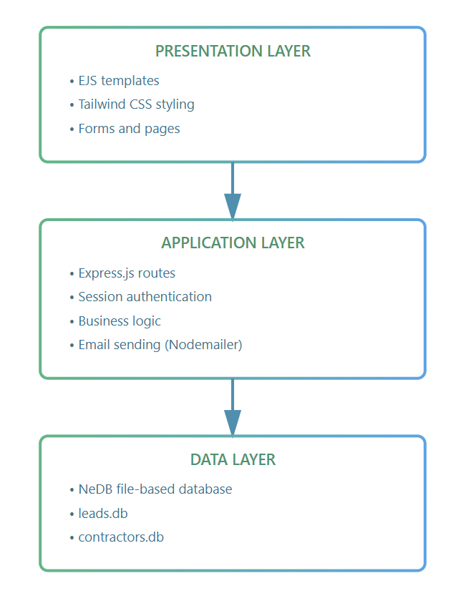
Figure 2. Three-Layer Architecture
The presentation layer is what users see in the browser (forms, tables, buttons).
The application layer contains the main logic: receiving form data, checking login, saving data, sending emails.
The data layer stores information as simple .db files using NeDB.
This design keeps things clear - each part of the system has its own job. Because everything is inside one application, it is easier to debug and easier to deploy.
Example Request Flow
When a property owner submits a project form:

The form is shown in the browser (presentation layer)
The browser sends the form using POST to an Express route (application layer)
The server validates the data and saves it into leads.db (data layer)
The server redirects the user to a thank-you page (application layer)
The thank-you page is rendered and shown in the browser (presentation layer)

This simple flow makes it clear what happens at each step. [22]

4.3 Technology Choices

Why Express.js?
Express.js is a popular and lightweight web framework for Node.js. It was chosen because it is easy to learn and widely used, it does not hide too much behind complex abstractions, it is suitable for small and medium projects, and it helps understand the basics of HTTP requests, routes, middleware, and responses. [16]

Why EJS Templates?

Instead of using a front-end framework like React, the project uses EJS (Embedded JavaScript) templates.
EJS pages look like normal HTML with small bits of JavaScript. There is no need to build a separate API between front-end and back-end. It is easier to learn and debug, and full page reloads are enough for this kind of admin system.
For this application, the admin mainly views tables and submits forms. It does not need very dynamic live updates, so EJS is more than enough. React would add unnecessary complexity for features that are not needed. [17]

Why NeDB?

NeDB is a file-based database written in JavaScript. It behaves like MongoDB but stores everything in a local file. [4]
NeDB was chosen because no installation is required – just a .db file in the project folder. It uses JavaScript syntax, so queries are normal JavaScript objects and no SQL is needed. The data is easy to inspect because it is stored in plain text format and can be opened in a text editor for learning and debugging. It is lightweight and perfect for prototypes and small business tools.
NeDB is not suitable for very large systems with millions of records, but it is perfectly fine for a small prototype and a small business tool managing hundreds of leads and contractors.

Why Nodemailer with Gmail?

Nodemailer is a Node.js library that allows sending emails from applications [5]. It works well with Node.js and Express, is easy to configure with Gmail SMTP, supports HTML emails so messages look professional, and is well-documented and actively maintained.
Gmail was used because it is free, reliable, and well-known. A special App Password is used for security instead of the normal Gmail password, which prevents exposing real credentials in the code. [19]

Why Tailwind CSS?

Tailwind CSS is a utility-first CSS framework. It was chosen because utility classes allow styling elements directly in HTML without switching between files. It can be loaded from a Tailwind CDN without build tools. It provides consistent design with spacing, colours, and responsive breakpoints. Development is quick and faster than writing custom CSS from scratch.
The project loads Tailwind from a CDN, which means no complex build process or Node.js compilation is needed. This keeps the development process simple. [23]

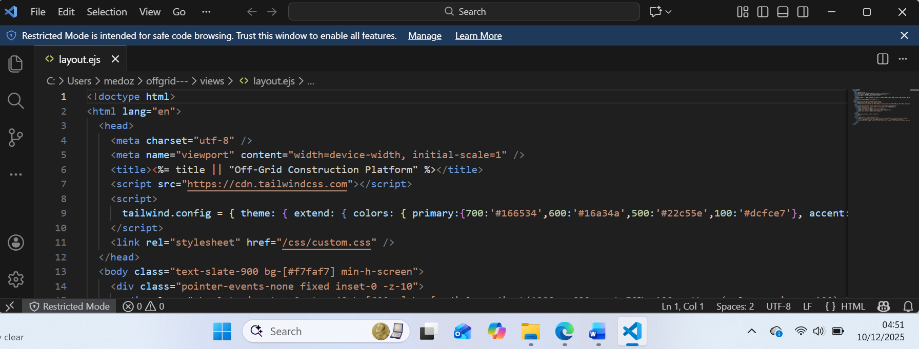
Figure 3. Tailwind CSS configuration

4.4 Database Design

The platform uses two NeDB databases.

Leads Database

The leads database stores project enquiries with the following information: name, email, phone, location, budget, services (stored as comma-separated values), details, Select Contactor and email Contractor).

Contractors Database

The contractor’s database stores contractor information including company name, contact_name, email, phone, service_areas, services (comma-separated), website, portfolio, notes, status (which can be "Pending", "Approved", or "Rejected"), and created_at timestamp. [4]

4.5 User Interface Design

The user interface has two main parts.
Client-Facing Pages
The client-facing section includes a landing page with two clear paths, a project enquiry form for property owners, a contractor application form, and confirmation pages after submission.
Admin Pages
The admin section includes secure login access, a dashboard with statistics, leads management with email functionality, and contractor
with clear visual separation between user types, large buttons for accessibility, and professional eco-friendly branding.
Visual Design
The colour scheme uses green (#22c55e) for property owner actions to emphasize eco-style, and blue (#3b82f6) for contractor actions to provide distinction. Neutral greys and white backgrounds create a clean appearance.
Forms follow a consistent pattern with single-column layout for mobile-friendliness, labels above inputs, light grey input backgrounds, a checkbox grid for services. [24]

4.6 Security Design

Security was considered from the beginning of the design process.
Main Security Concerns
The main security concerns were ensuring only the administrator should access the admin area, preventing accidental exposure of client and contractor data, keeping email login details secret, and validating form inputs to avoid common attacks.
Session-Based Authentication
The application uses session-based authentication. When the admin logs in with the correct credentials, the server creates a session and stores it in memory. A session cookie is sent to the browser, and the server marks the session with req.session.user = { username }.
Protected routes check this before showing admin pages:

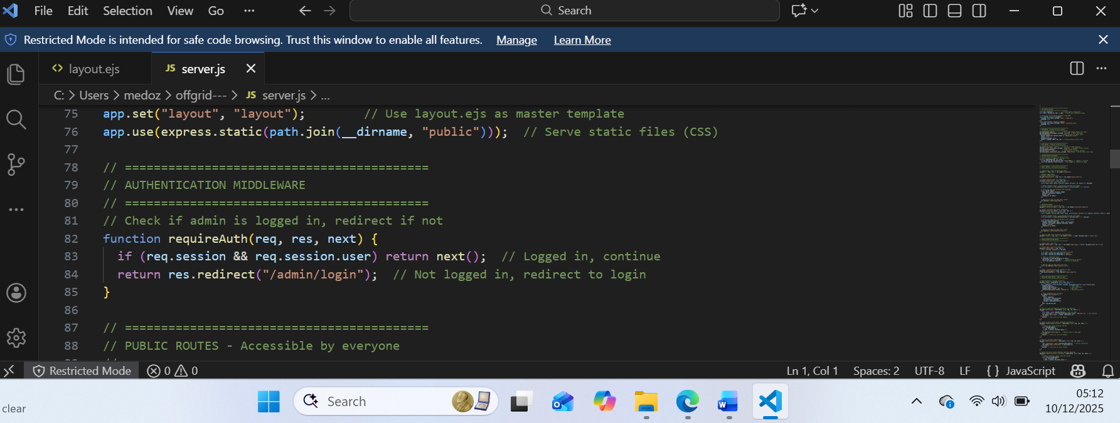
Figure 4. Session-Based Authentication
Sessions were chosen instead of JWT tokens because there is only one administrator, the system runs on one server, sessions are simpler to implement and manage, and sessions can be immediately invalidated on logout.
JSON Web Tokens (JWT) are designed for distributed systems where multiple services need to verify tokens without shared state. So, it could be used for future application implementation. For a single-admin, single-server application, fully enough this version. [18]

Password Storage

The Gmail password is stored in environment variables (.env file) admin password in server.js, not in the database and not in the code file. This approach is appropriate because if an attacker accesses environment variables, they already have server access. The security boundary is server access itself. For a single admin with server-level access, password hashing provides minimal additional security.
If the platform grows to support multiple administrators with different passwords stored in the database, password hashing with bcrypt would become necessary. [25]

Input Validation

Validation happens at multiple levels. Browser validation uses HTML5 required attributes and type="email" for email format checking, providing immediate feedback to users before form submission. Server-side validation checks that required fields are present, verifies that data types match expectations, and ensures critical fields are not empty. Database query safety is maintained because NeDB uses object-based queries that treat input as data, not code, protecting against injection-style attacks.

Environment Variables

All sensitive configuration uses environment variables including admin username and password, session secret key, Gmail email address and App Password, and server port number.
Environment variables keep credentials out of source code, prevent accidental exposure in version control, allow different configurations for development and production, and follow security best practices. The .env file must be excluded from Git using .gitignore, ensuring credentials never enter the repository. [25]

4.7 Email System Design

A key feature of the system is that the admin can forward a client's project details to a contractor by email.
This option was chosen because it is quickest and easiest for contractors. They do not need new accounts or passwords. They simply receive details of the project and can reply to the property owner directly.
Research shows that the construction industry has lower adoption rates for complex technology systems. Contractors are often busy on job sites and may ignore systems requiring account creation. It is more likely that contractors will participate if they can easily do so.

Email Workflow
The complete email sending process works as follows. The admin opens a lead in the admin dashboard and selects an approved contractor from the dropdown menu. When the admin clicks "Email Contractor" button, JavaScript sends an AJAX request to the server with lead ID and contractor ID. The server validates both IDs and retrieves full records from database, then generates HTML email using a template function. Nodemailer sends email via Gmail SMTP server, and the server updates lead status to "Contacted" and records the timestamp. Finally, the server returns JSON success or failure response, and the browser shows a confirmation message and reloads the page to display updated status.
Email Template Structure
The email uses HTML formatting to look professional in the contractor's inbox. The template includes a header with green background and "Off-Grid Construction Platform" branding, a greeting personalized with the contractor's name, project details organized into sections for location, budget, services, and additional notes, contact information with the property owner's name, email, and phone, a call to action with a large green button containing a mailto: link for easy response, and a professional sign-off from the administrator. [19]

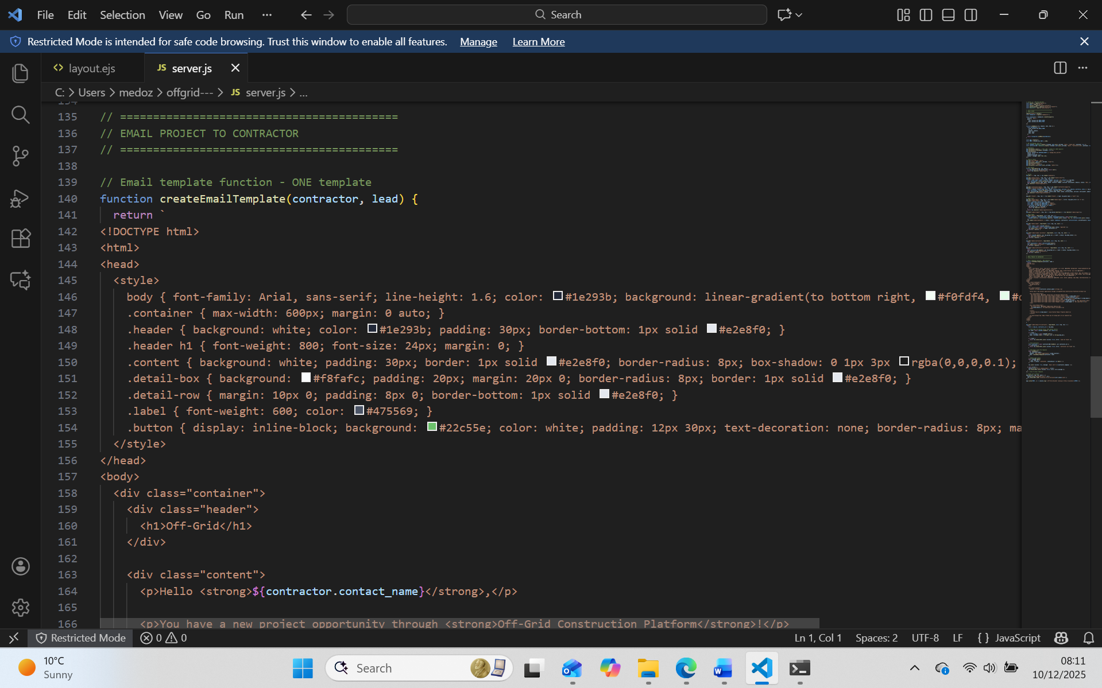
Figure 5. E-mail template

Gmail Integration
Gmail was chosen because it is free and reliable for small-scale sending, trusted by spam filters which means higher delivery rate, easy to configure SMTP with Nodemailer, and suitable for startup platforms with limited budgets.
Gmail blocks "less secure app access" by default. To send emails programmatically, two-factor authentication must be enabled on the Gmail account, then an App Password is generated in Google account security settings, stored in .env file as EMAIL_PASS, and used in Nodemailer configuration.
App Passwords are 16-character passwords generated specifically for applications. They provide secure SMTP access while maintaining two-factor authentication on the main account. If compromised, App Passwords can be revoked without changing the main password. [19]

4.8 Implementation Approach

The project was built using an iterative development methodology. Instead of implementing everything at once, the system was built in small increments. Each iteration produced a working version with increasing functionality.
Development Iterations
The first iteration focused on basic setup. This included creating a Node.js project with package.json, installing Express, EJS, and dependencies, setting up a basic server with landing page, and testing server startup and page rendering.
The second iteration added client forms. This included creating a property owner form with service checkboxes, creating a contractor application form, implementing POST routes to handle submissions, and adding NeDB to store data in database files.
The third iteration implemented admin authentication. This included creating an admin login page, implementing session-based authentication with express-session, adding an authentication middleware function, and testing login, logout, and protected route access.
The fourth iteration built the admin dashboard. This included creating a dashboard with statistics, building a leads management page with table, building a contractors management page with status updates, and testing data display and status updates.
The fifth iteration added the email feature. This included integrating Nodemailer with Gmail configuration, creating an HTML email template function, implementing an email sending endpoint, adding a contractor selection dropdown, and testing email delivery and status tracking.

Use Gmail App Passwords

Simpler 16-character password for apps
Maintains two-factor authentication on main account
Can be revoked without changing main password

Decision: App Passwords were chosen for simplicity while maintaining security.
Implementation steps:

Enable two-factor authentication on Gmail account
Generate App Password through Google account security settings
Store App Password in .env file

Configure Nodemailer with App Password:

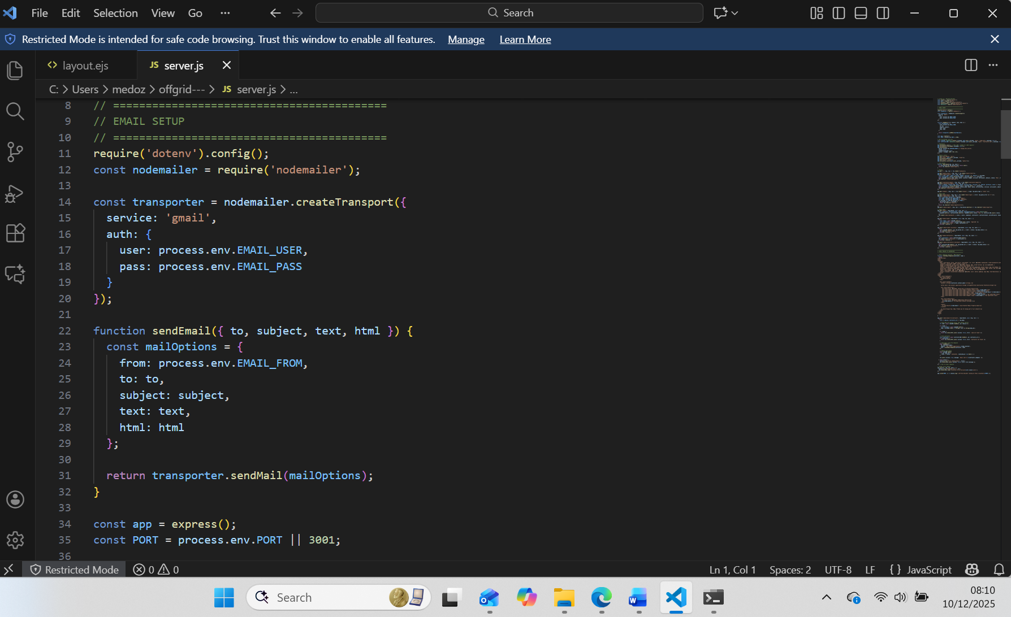
Figure 6. Nodemailer email setup

4.9 Code Organization

The project follows a clear structure with all server code in server.js
Why single file? Makes it easy for beginners to understand complete flow. Can read top to bottom. Suitable for small projects. Would need modules if it grew to thousands of lines.

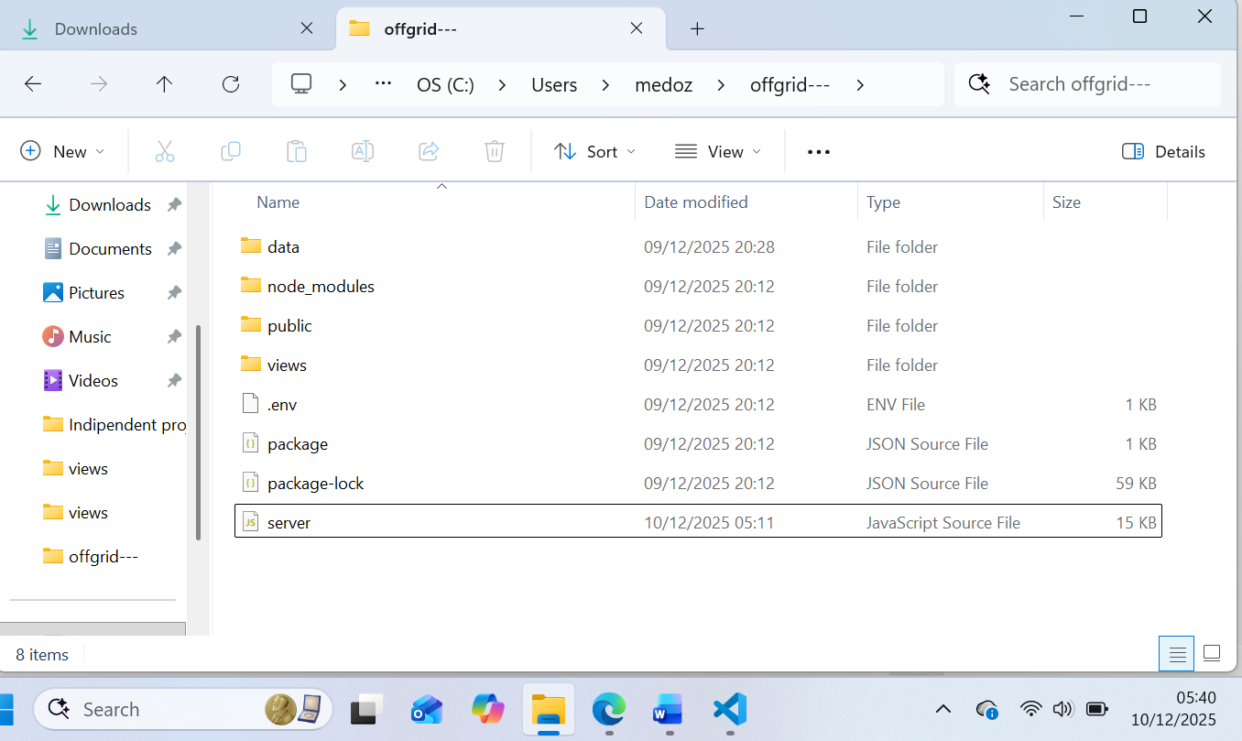
Figure 7. Application File Structure

4.10 Future Implementation Ideas

Several features were considered but not implemented.
A contractor portal could provide a login area for contractors to view leads and submit estimates. Advanced search functionality could allow searching and filtering leads by location, budget, and services. Automated reminders could send automatic follow-up emails to contractors and property owners. An analytics dashboard could track conversion rates, budgets, and response times. Payment integration through Stripe or PayPal could handle lead access fees or deposits
These features and many more could be added later as needs become clearer through actual usage.

4.11 Testing

Testing was performed continuously during development.
Manual Testing Approach
Individual routes and workflows were tested using browser navigation.
Complete workflows tested included: the property owner workflow (navigate, fill form, submit, verify in admin dashboard), the contractor workflow (navigate, apply, admin approves, verify status change), and the admin workflow (login, view leads, select contractor, email, verify status update).

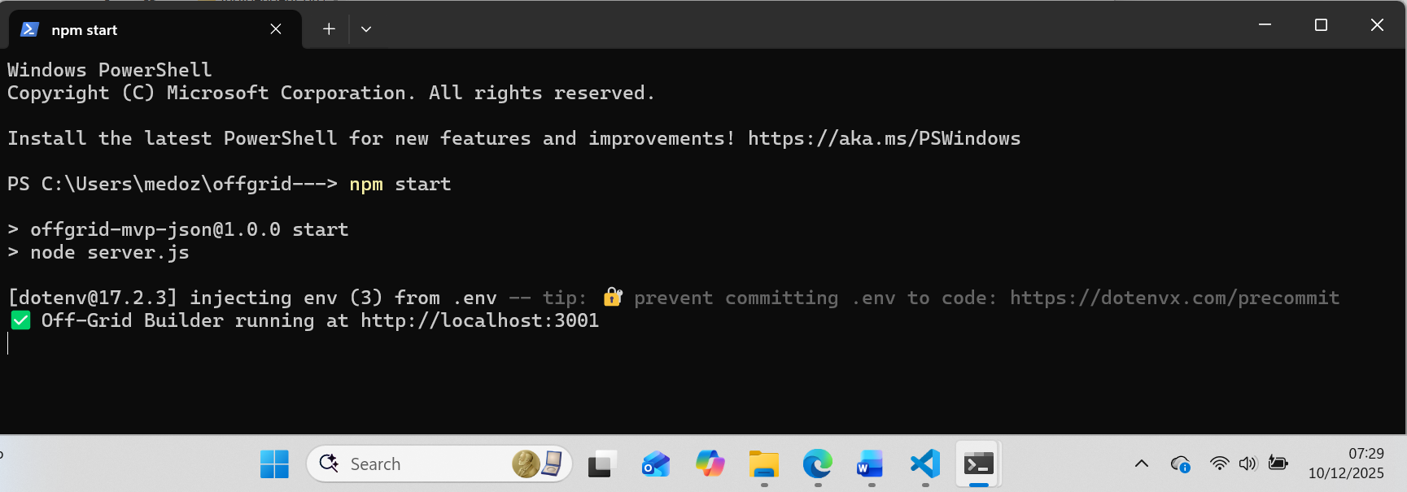
Figure 8. Npm Start

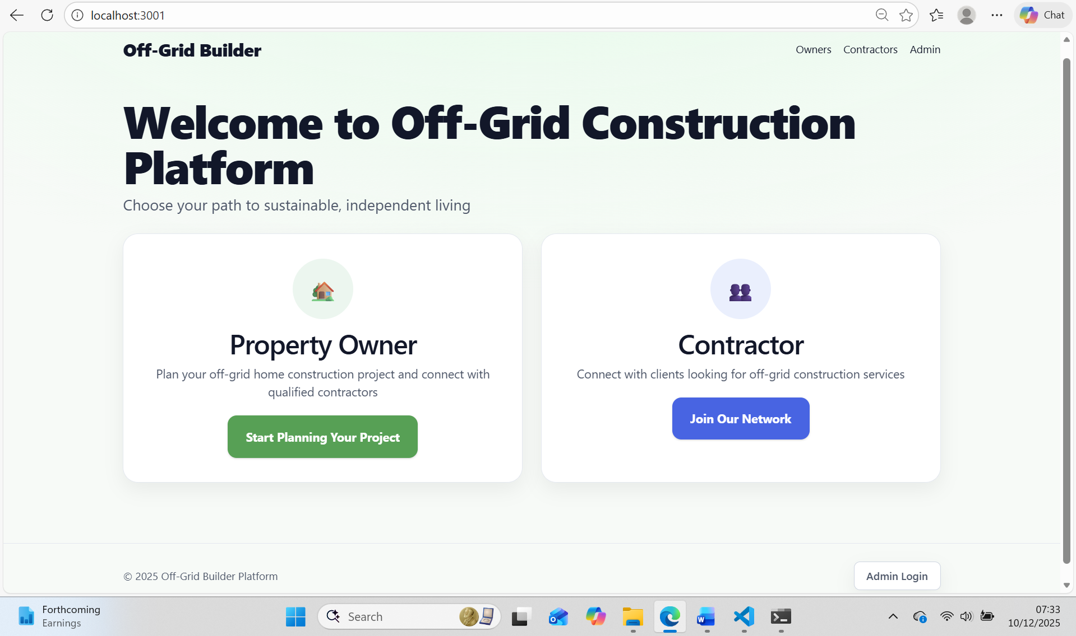
Figure 9. Welcome page

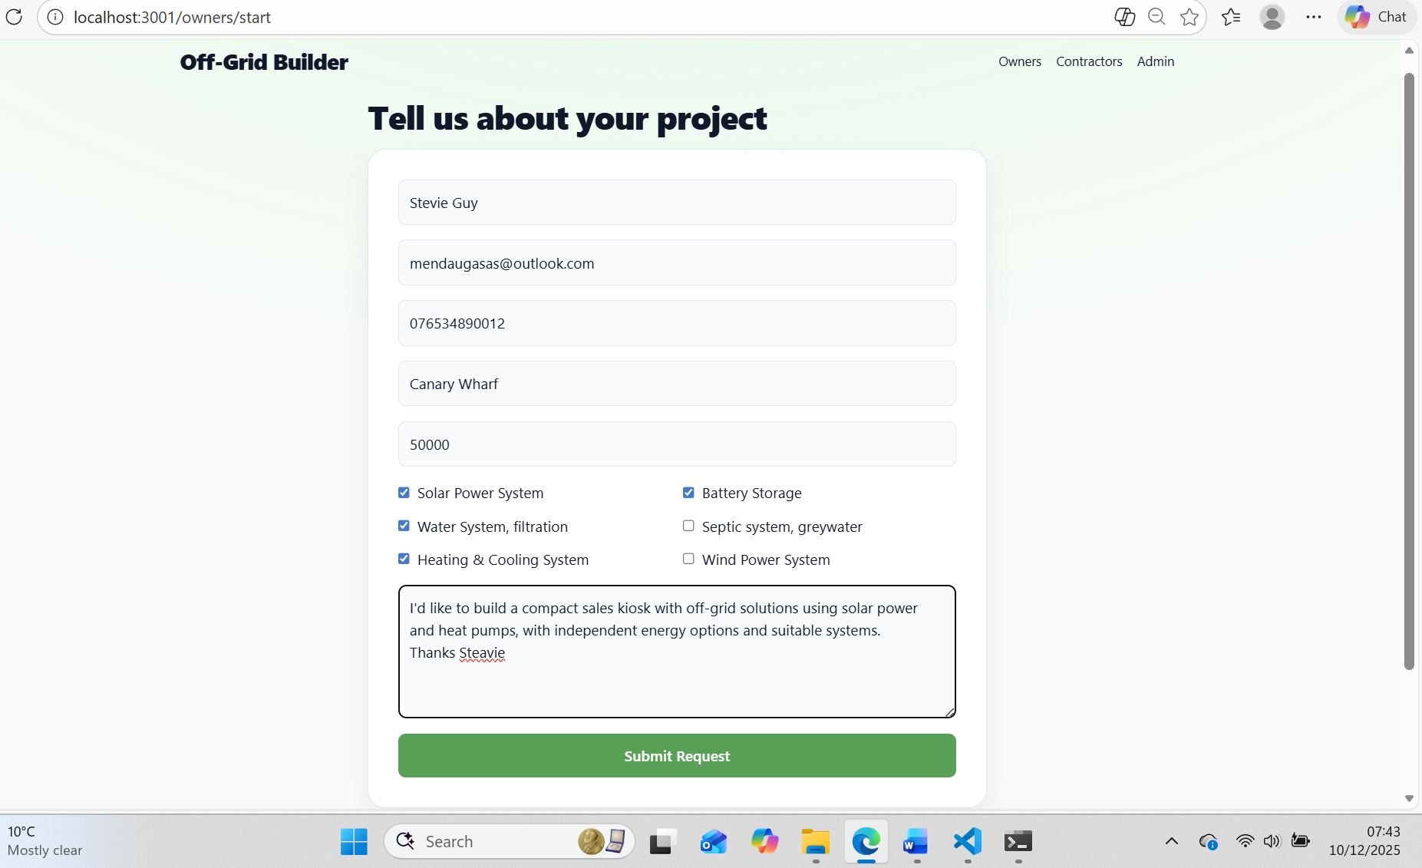
Figure 10. Clients Contact Page

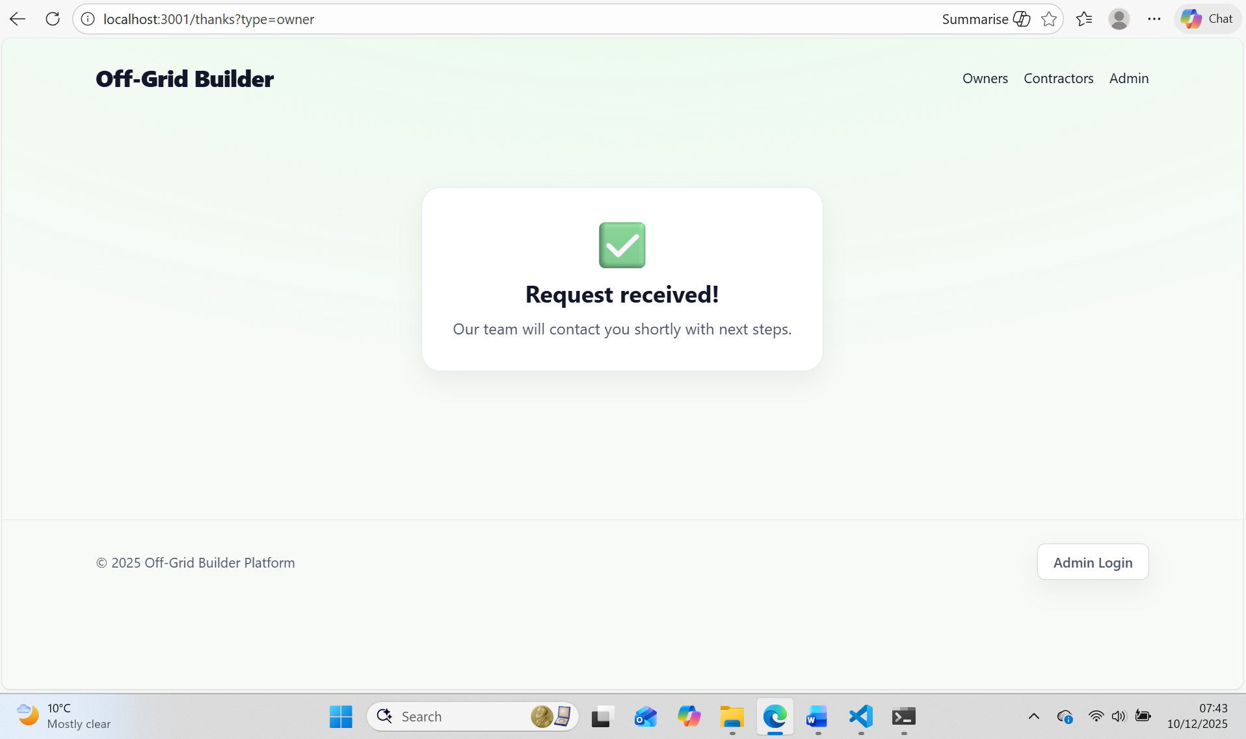
Figure 11. Thanks Page Client Side

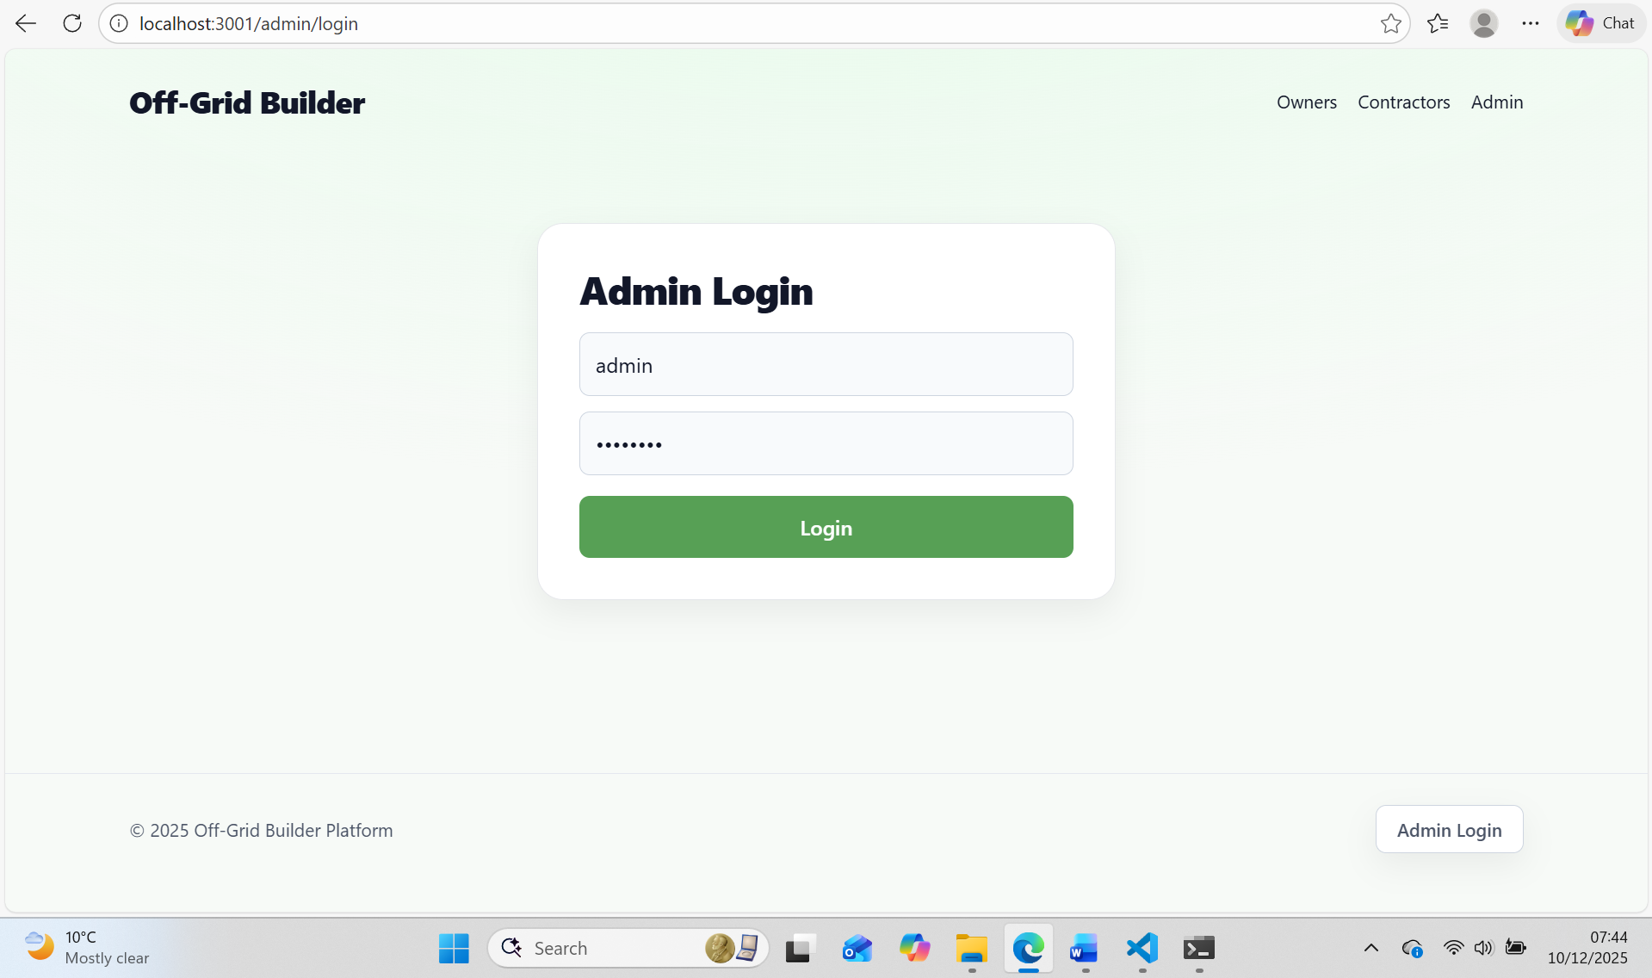
Figure 12. Admin Login Page

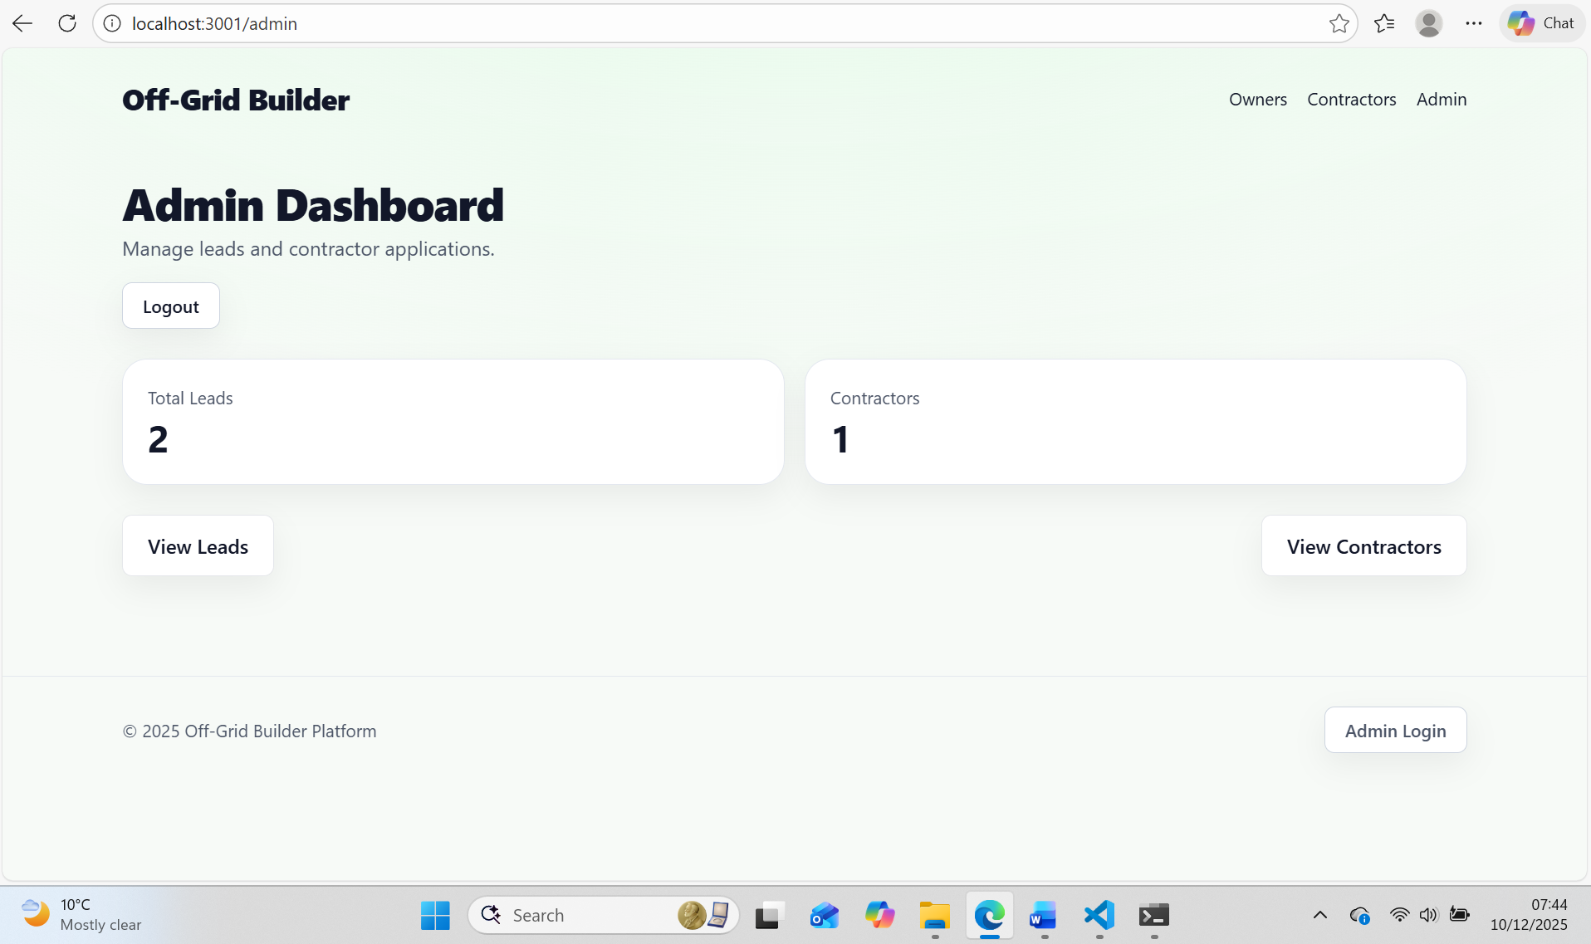
Figure 13. Admin Dashboard Page

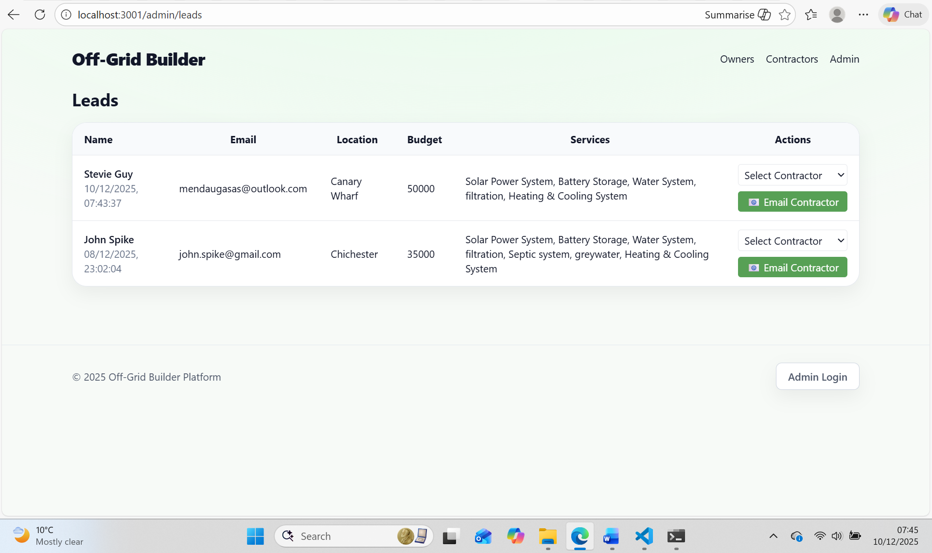
Figure 14. Admin leads Page

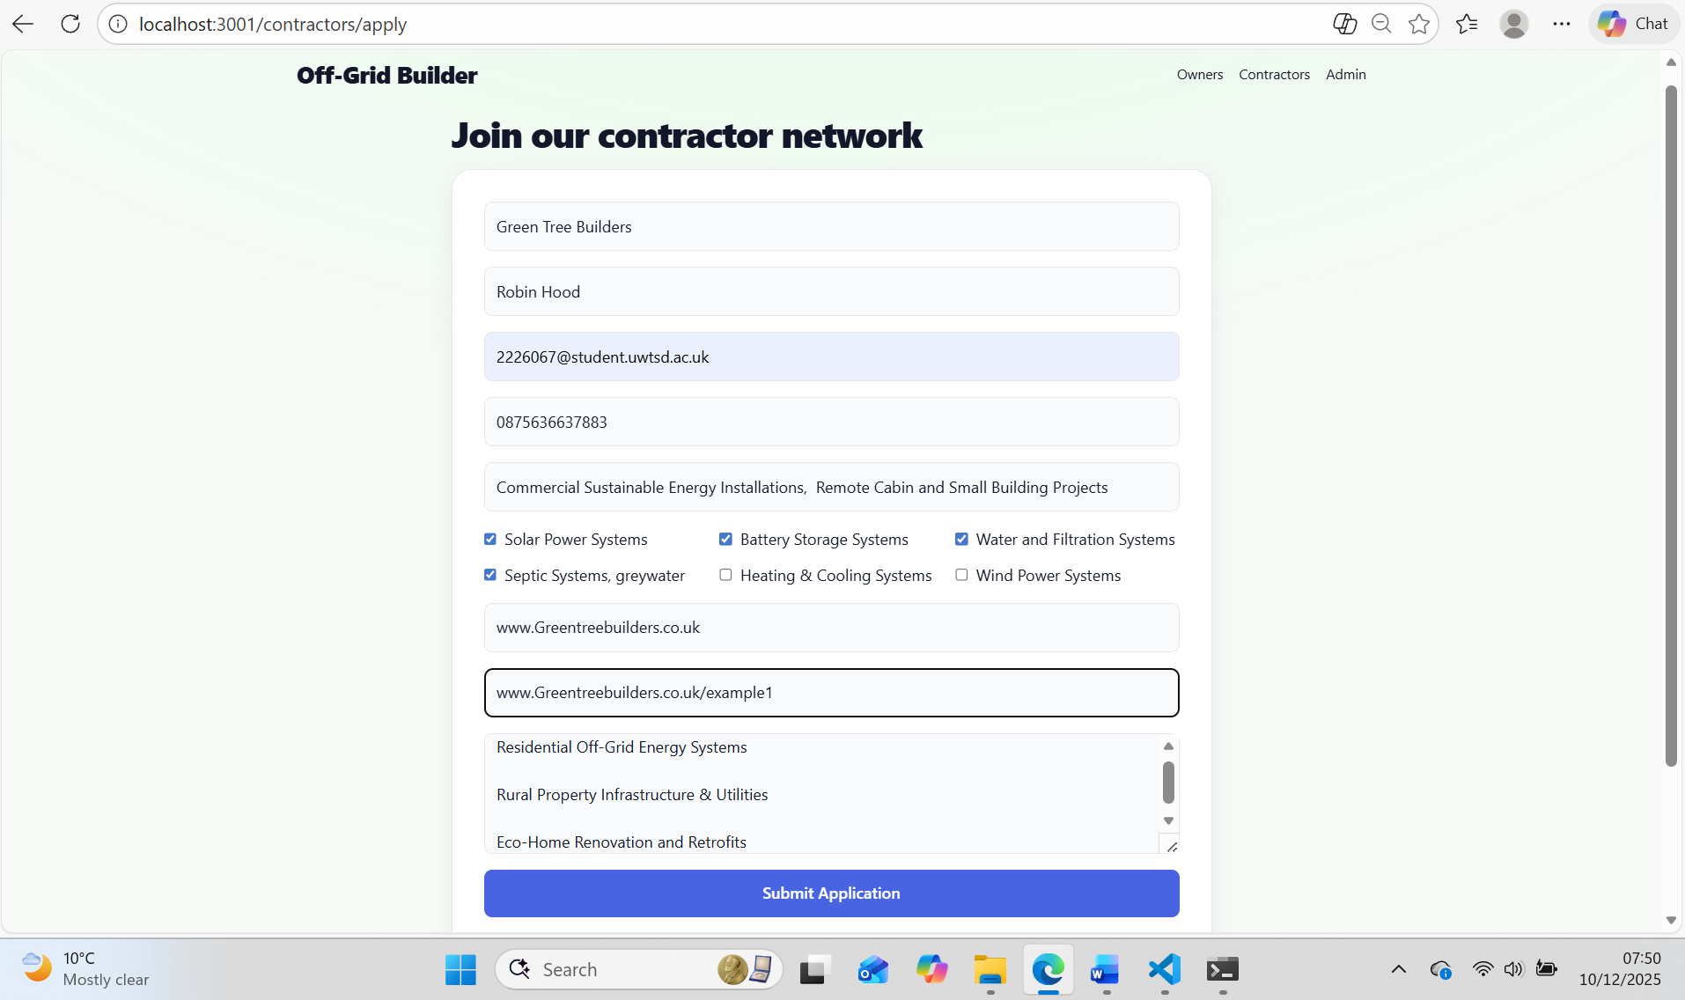
Figure 15. Contactors Apply Page

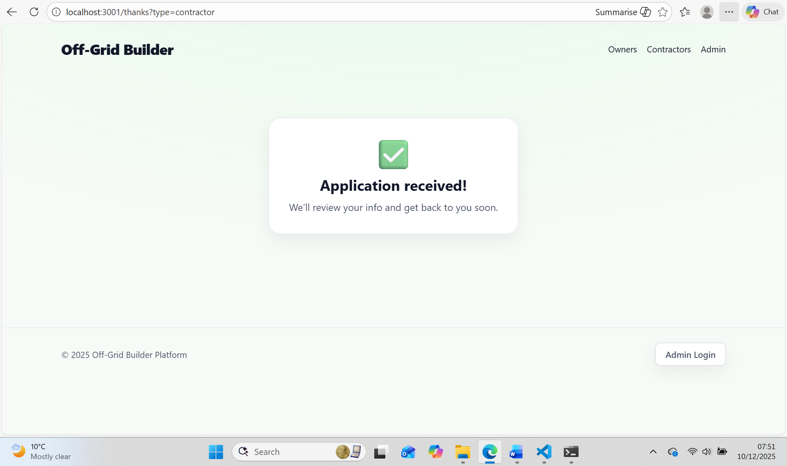
Figure 16. Thanks page Contractors side
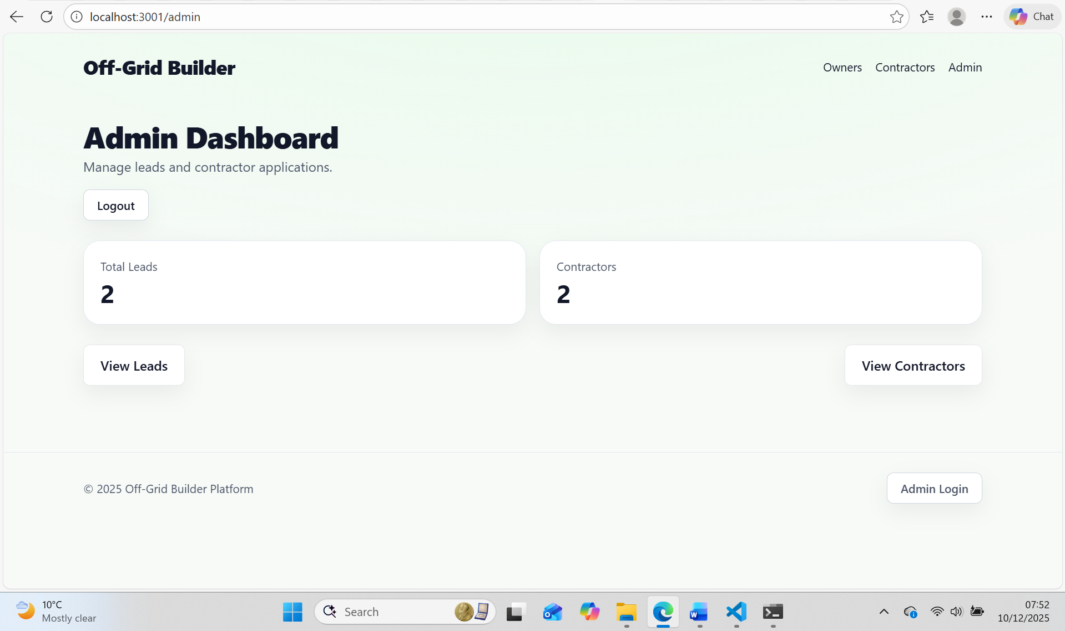
Figure 17. Admin Dashboard after received last Contractor data

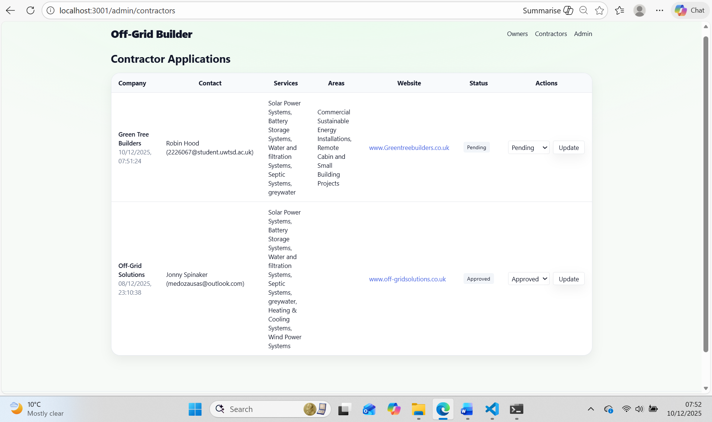
Figure 18. Admin-Contractors Page

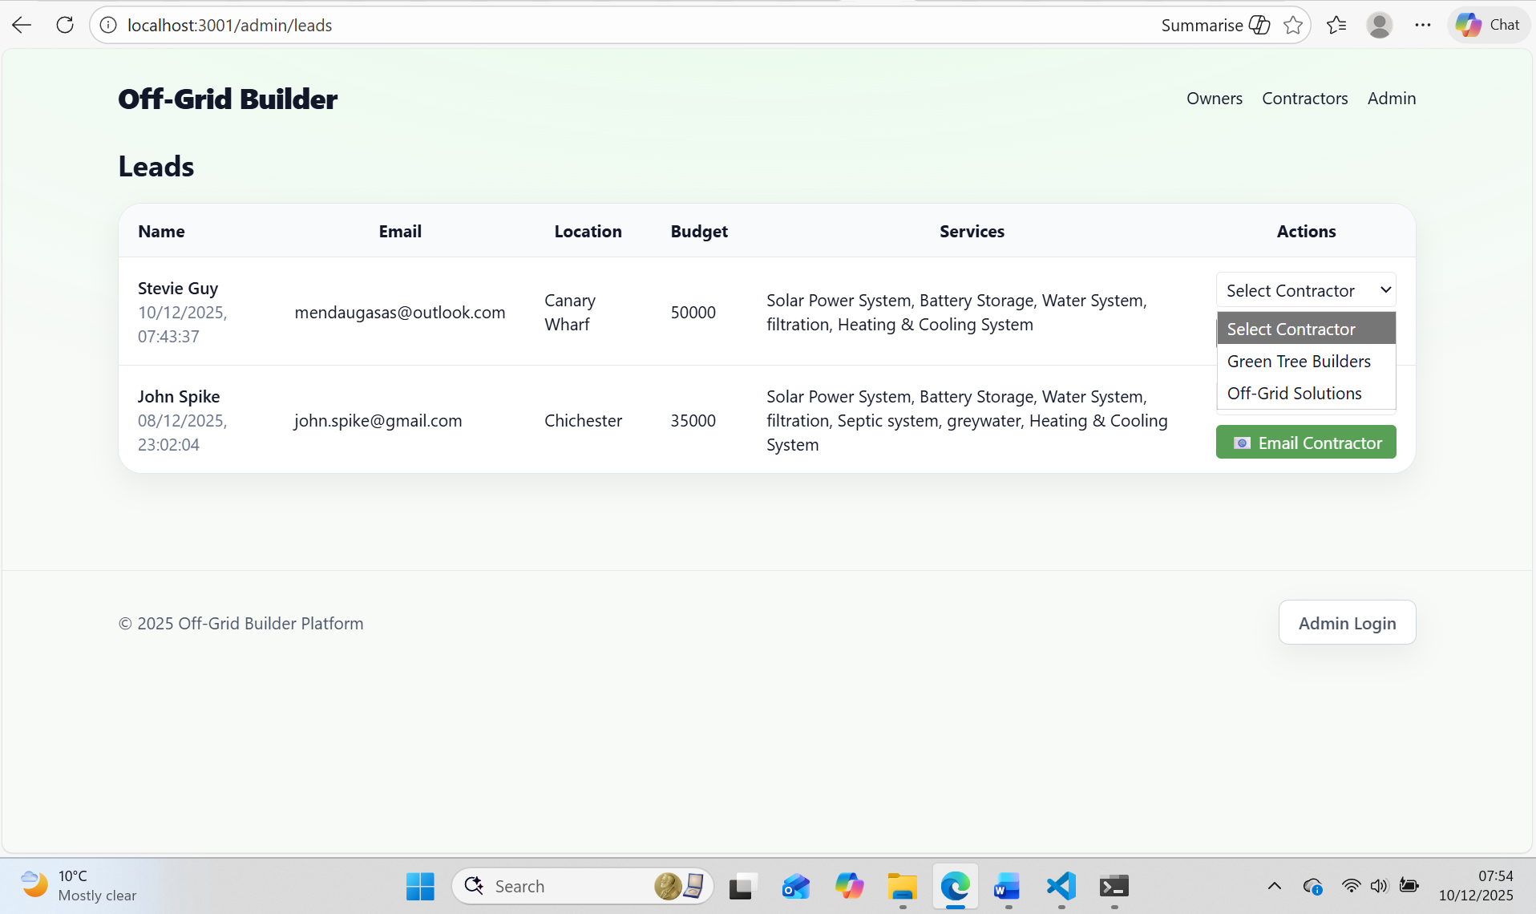
Figure 19. Sending E-mail Selecting Approved Contractor

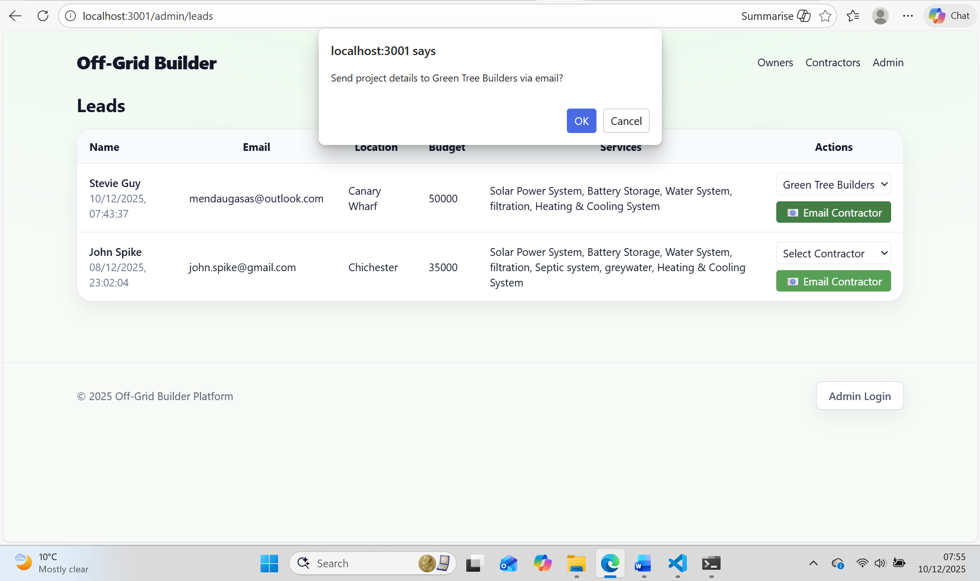
Figure 20. ALERT Java Script Massage box to confirm email sending to Contactor

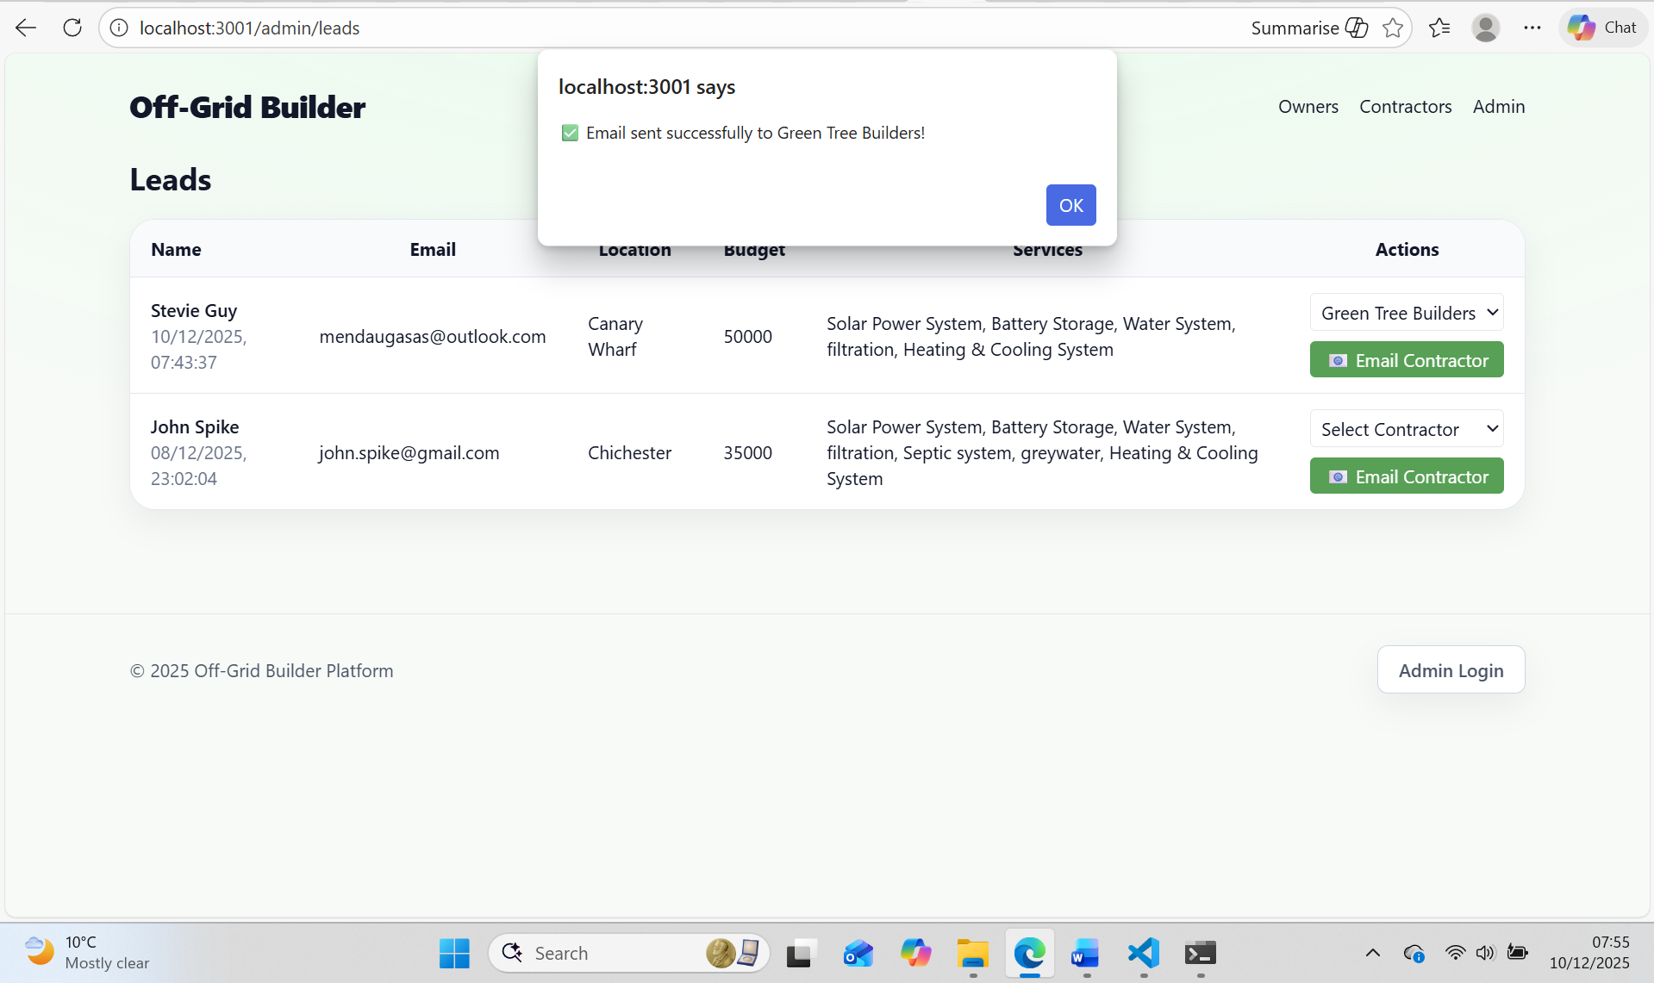
Figure 21. ALERT Java Script message box confirming that Email sent to contractor

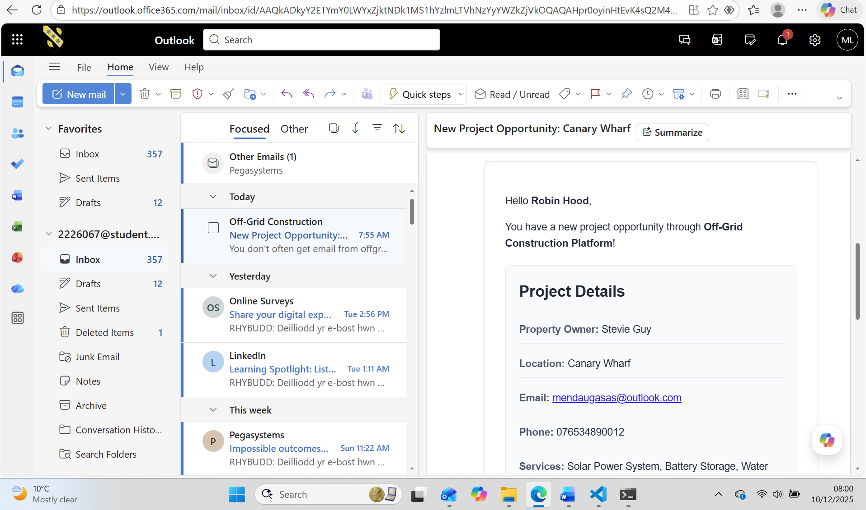
Figure 22. Contractor received email in application template form

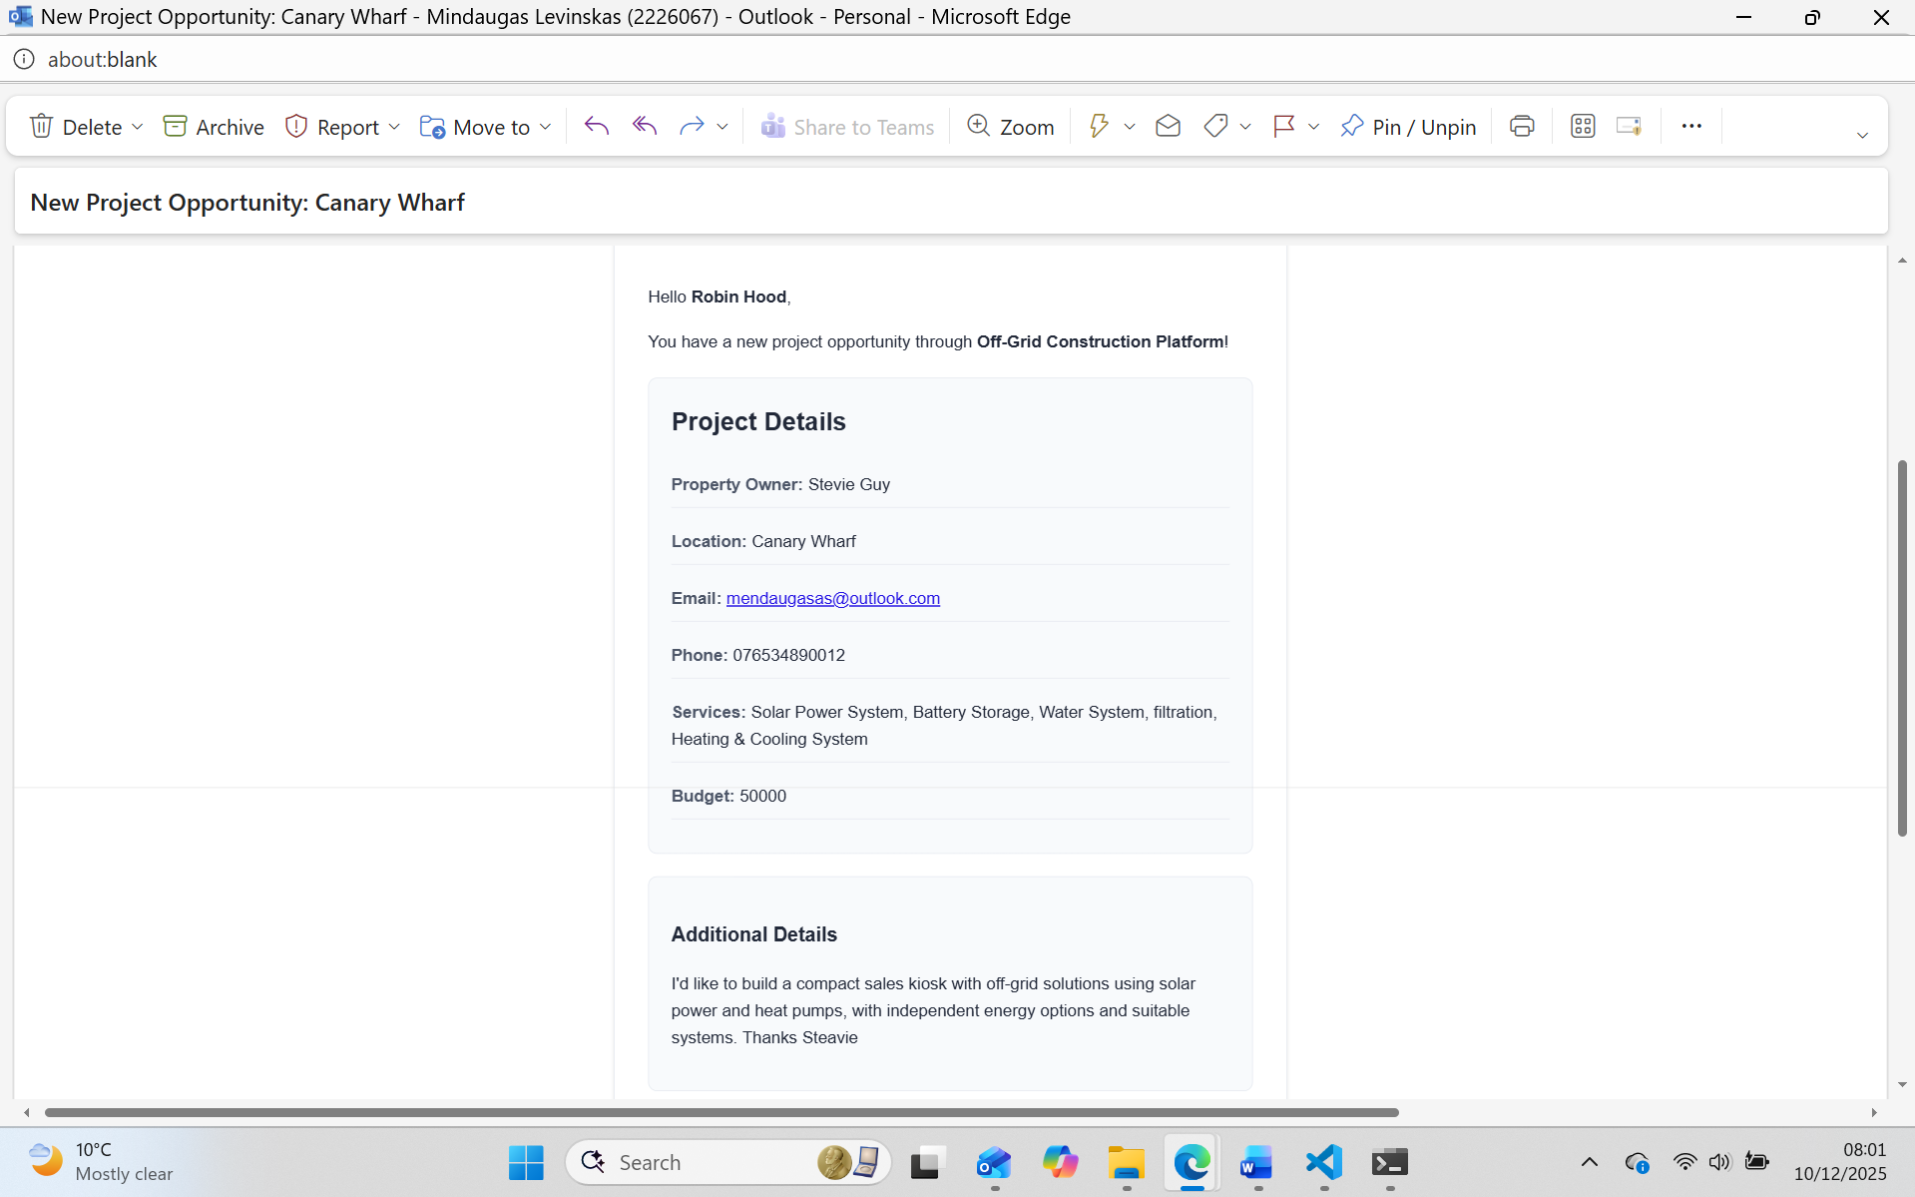
Figure 23. Full screen email template view

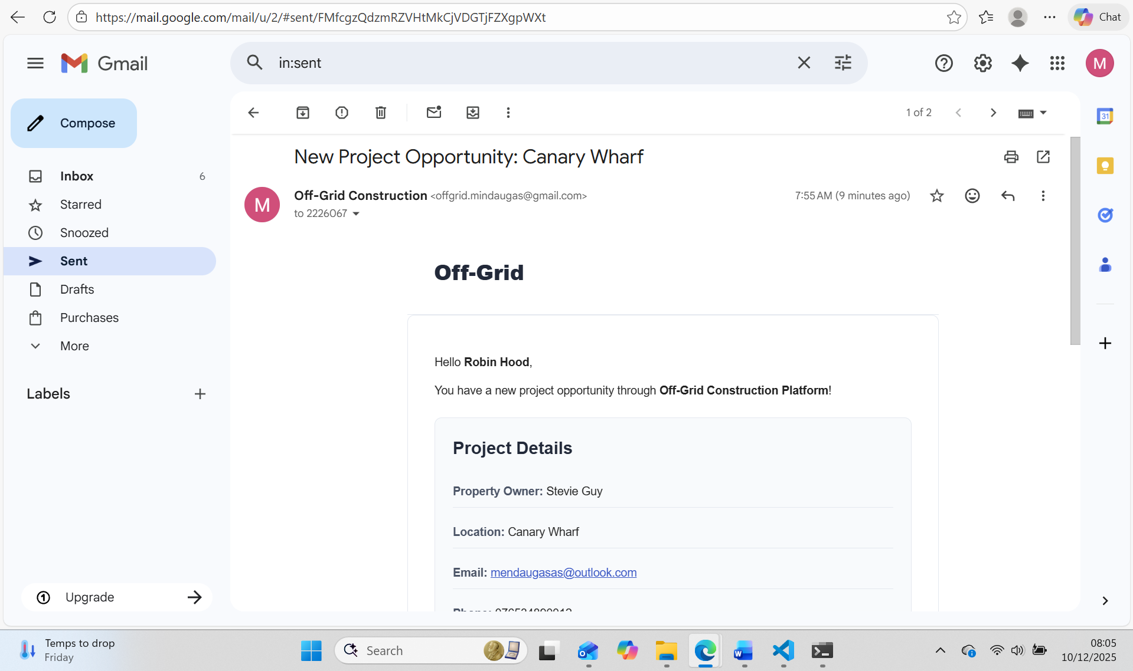
Figure 24. From Application email offgrid.mindaugas@gmail.com send email view

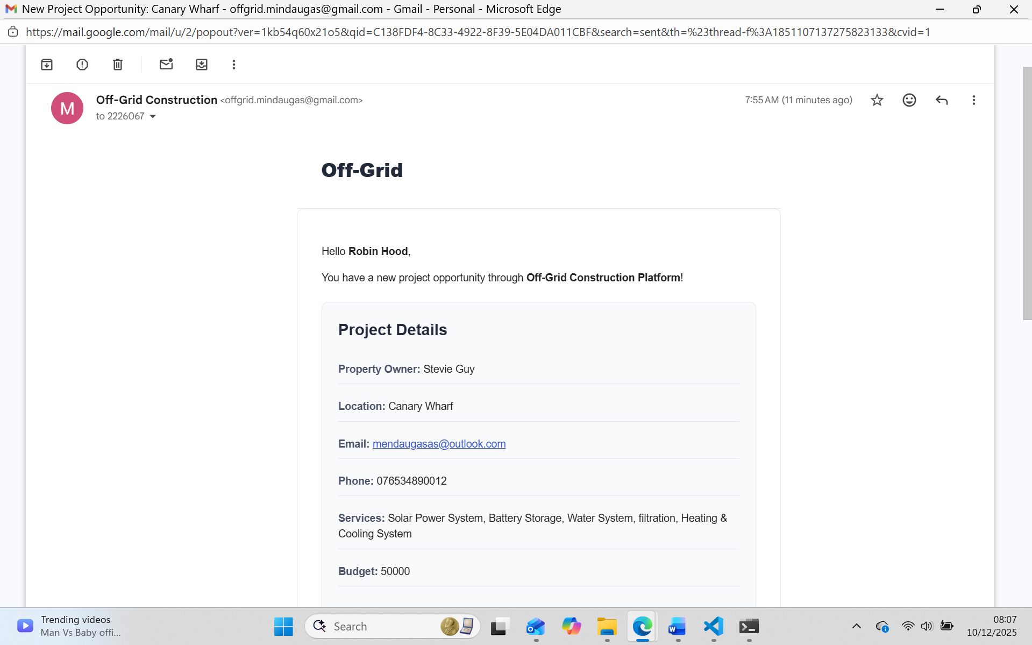
Figure 25. Full email template view

CHAPTER 5 – EVALUATION

5.1 Personal Evaluation

From a personal standpoint, this project proved to be both challenging and highly rewarding. Building a full-stack system from scratch required learning and applying several key concepts including server-side rendering, routing, form handling, email automation, and database storage. One major achievement was confidently handling the full data flow, from client form submission through validation and storage to the admin dashboard and finally to contractor email forwarding.
Through systematic testing and reviewing code step by step, the process of identifying root causes became more efficient.
Overall, the project strengthened understanding of how a simple yet fully functional web application is structured, deployed, and maintained. It also highlighted the value of focusing on user needs rather than overcomplicating the system with unnecessary features.[24]

5.2 System Evaluation

Meeting Project Aims and Objectives

The main aim of the project was to create a simple web application that collects off-grid project enquiries and enables an administrator to forward this information to contractors via email. The system successfully meets this aim.
The first objective was creating a user-friendly client submission form. This was achieved through a simple, validated form that collects all necessary data from property owners.
The second objective was implementing data storage with NeDB. Both leads and contractors are stored in lightweight .db files that persist between sessions.
The third objective was building a protected admin interface. A session-based login system prevents unauthorised access to the admin area. Sessions expire after one hour of inactivity, and the logout function immediately invalidates the session.
The fourth objective was email forwarding using Nodemailer. The admin can select a contractor from a dropdown menu, send an email containing project details, and the system automatically updates the lead status to "Contacted" with a timestamp.
The fifth objective was maintaining a clean, simple architecture. The Structure keeps all code in one application, making it easy to follow and ideal for beginners learning web development.
The sixth objective, which emerged during development, was implementing professional HTML email templates. The email system sends formatted messages that match the platform's branding and include all project details in an organized format.
Overall, all objectives were completed and the system performs reliably under normal usage conditions. [26]

5.3 Comparison With Literature Review

Many points from the literature review were confirmed by the project's results.
The research showed that contractors prefer easy systems over complex dashboards. The email-forwarding design reflects this principle and worked well in practice. During informal testing with potential contractor users, the simplicity of receiving project details directly in their existing email inbox was seen as a significant advantage over systems requiring new logins.

5.4 System Strengths

The system has several notable strengths that make it effective for its intended purpose.
The interface is easy to use for all user types. Both clients and admins interact with clear forms and simple layouts that require no technical knowledge. The landing page immediately presents two clear paths, and each form uses familiar web patterns that most users already understand.
The system has low technical overhead because no external database servers or APIs are required. A developer can download the project, install Node.js packages, create an environment file, and have a working system in minutes.
The email workflow is reliable and efficient. The admin can send project details to contractors with a single click after selecting from a dropdown. The system handles all email formatting automatically and updates the lead status to prevent duplicate notifications.

5.5 Further Enhancements

If the system is developed further, several improvements would significantly increase its value and usability.
A contractor portal would allow contractors to log in and view projects assigned to them. They could respond with estimates directly through the platform, update project statuses, and track their engagement history. This would create a more complete workflow while still maintaining the option for email notifications as a convenience feature.
Advanced search and filtering would help administrators manage growing datasets. The ability to search leads by service type, location, budget range, or date submitted would make the admin interface more efficient. Adding sort options for tables would also improve usability.
A database upgrade from NeDB to SQLite or MongoDB would support larger-scale deployment. SQLite would maintain simplicity while adding better query performance and data integrity features. MongoDB would provide more flexibility for future feature additions and better scalability for high-traffic scenarios.
Automated email reminders could improve contractor response rates. The system could send gentle reminders to contractors who have not responded within three days, or follow up with property owners after one week to check if they have been contacted. These reminders should be carefully designed to avoid annoying users.
Export functionality would allow administrators to download leads as CSV or PDF files. This would be useful for reporting, sharing summaries with business partners, or analyzing trends in spreadsheet applications. Monthly summary reports could be automatically generated.
A React or Vue front-end could be considered for future stages if the system grows large enough to benefit from more dynamic interactions. However, this should only be implemented if there is clear user demand for more interactive features, as the current server-rendered approach works well for the system's needs.
Integration with CRM systems like Salesforce or HubSpot could help businesses that already use these platforms. While this adds complexity, it would make the Off-Grid platform more attractive to established businesses with existing workflows.
Payment processing through Stripe or PayPal could enable business models where contractors pay for lead access or property owners pay deposits. However, this would require careful consideration of legal requirements and security standards for handling financial transactions.

5.6 Summary

The evaluation shows that the system meets its original goals, validates prior research, and provides a strong foundation for future development. The project performs well for its intended purpose and demonstrates that simple technical choices can deliver a practical and reliable solution.
The system successfully achieves all six objectives, from form submission through data storage to email forwarding. Testing confirmed that the interface is intuitive for users and that the technical implementation is sound. The comparison with literature review findings shows that academic research effectively guided design decisions.
The suggested enhancements offer a realistic roadmap for evolving the system from a working prototype into a more comprehensive business tool. Each enhancement addresses a specific limitation while building on the solid foundation established in this initial version.

CHAPTER 6 – CONCLUSION

This project set out to design and develop a simple, useful web application that allows property owners to submit off-grid project enquiries and enables an administrator to forward these enquiries to contractors. The system meets this goal successfully and demonstrates how lightweight technologies can create practical solutions for real-world business workflows.

Final Conclusion

In conclusion, the Off-Grid Construction Platform achieves its aims and proves that a focused, well-structured design can deliver meaningful value even with limited resources. The project demonstrates how thoughtful simplicity can be more effective than unnecessary complexity, and it provides a strong base for future enhancements.
The system successfully connects property owners seeking off-grid services with contractors who provide those services. It solves real problems of incomplete information and poor communication that plague the construction industry. The technical implementation is solid, secure for its intended scale, and maintainable by developers with varying levels of experience.
The recommendations for continued development offer clear opportunities to expand the system into a more advanced tool for contractors, clients, and administrators alike. Each suggested enhancement builds logically on the existing foundation without requiring fundamental restructuring.
This project represents a successful application of web development principles, research-based design decisions, and user-centered thinking. It provides both a working prototype for a potential business and a comprehensive learning experience in full-stack development.

CHAPTER 7 – REFLECTION

Working on this project has been a significant learning experience, both technically and personally. When the project began, there was a general understanding of web development concepts, but no experience building a complete system from end to end. Completing this project required applying theory in a practical way, solving real problems, and understanding how different technologies work together in a real application.

7.1 Learning About Simplicity

One of the biggest lessons was the importance of simplicity. At the start, the imagination ran toward building contractor dashboards, project tracking tools, and complex database structures. However, through research and testing, it became clear that real users value simple and reliable features over complicated ones.
This realization changed the perspective on software development fundamentally. A good solution is not the one with the most features, but the one that solves the problem clearly and efficiently.
However, each simplification actually made the project stronger. Not using the contractor dashboard meant focusing more effort on making the email system excellent. Not using PDF upload functionality meant spending more time on form design and validation. These trade-offs resulted in a better final product.

7.2 Connecting Research and Practice

Another important reflection is the connection between research and practice. Concepts from the literature review, such as structured forms, minimal cognitive load, and lightweight databases, directly influenced the design and contributed to a better final product.
Before this project, academic research seemed somewhat abstract and disconnected from practical work. Reading papers about form design principles or database selection criteria felt like theoretical exercises. However, when actually building a system and facing real decisions, the research provided valuable guidance.
For example, the research on construction industry technology adoption directly influenced the decision to use email forwarding. Without that research, the design might have included a complex contractor portal that would have reduced actual usage. The literature on form design helped create a submission process that consistently collected complete information from users.
This experience showed the value of grounding technical decisions in academic and industry knowledge. While personal intuition and experience matter, they become much more powerful when combined with existing research. Future projects will certainly include a research phase before jumping into implementation. [27]

7.3 Technical Skills Development

The project developed concrete technical skills across multiple areas of web development. Before starting, there was some knowledge of HTML and CSS, basic JavaScript, and general programming concepts. The project required learning Express.js framework, EJS templating, database operations with NeDB, session management, email integration with Nodemailer, security considerations, and deployment processes.
Learning Express.js provided insight into how web servers work at a fundamental level. Understanding the request-response cycle, middleware pipeline, and routing made web applications generally more comprehensible. This knowledge transfers to other frameworks and languages.
Working with EJS templates demonstrated the value of server-side rendering. While React and other client-side frameworks dominate current discussions, this project showed that traditional approaches still have important use cases. Being comfortable with multiple approaches rather than knowing only one framework feels valuable.
The database work with NeDB taught principles that apply to any database system. Concepts like schemas, queries, updates, and data persistence are universal. Starting with a simple database made learning these concepts easier than beginning with a complex SQL system would have been.
Email integration revealed unexpected complexity. What seemed like it should be simple actually involved understanding SMTP protocols, authentication methods, HTML email formatting, and error handling. Successfully implementing the email system felt like a significant achievement.

7.4 Project Management Insights

Managing the project taught lessons about planning, time estimation, and scope management. The initial timeline was overly optimistic. Features that seemed like they would take a day often took three days. Building in buffer time for unexpected problems would have reduced stress.
The iterative approach of building in small increments proved far superior to trying to implement everything at once. Each iteration provided a working system that could be tested and demonstrated. This created motivation and momentum. It also meant that if time had run short, there would still have been a functional system, just with fewer features.
Scope creep was a constant temptation. Every feature that worked well suggested related features that could be added. Resisting these temptations and staying focused on core objectives required discipline. The lesson is that saying no to good ideas is sometimes necessary to say yes to finishing the project. [28]

7.5 What Could Have Been Done Differently

If restarting the project from the beginning with current knowledge, several things would be done differently.
More time would be invested in UI design earlier in the process. The initial version had functional but unattractive interfaces. Improving them later worked, but designing better interfaces from the start would have been more efficient. Spending time on proper visual design, color schemes, and layout before coding would be worthwhile.
Testing would start earlier and be more systematic. While testing happened continuously, having a more formal approach with documented test cases would have been better. Some bugs were found quite late because certain combinations of actions were not tested until near the end.
Future scalability would be considered earlier in the design process. While the NeDB decision was appropriate for the project scope, thinking through potential growth paths earlier would have made certain design decisions clearer. However, this must be balanced against the opposite problem of over-engineering for scale that may never be needed.
More time would be spent on accessibility features. The current system works well for users without disabilities, but could be improved for screen readers and keyboard navigation. Web applications should be usable by everyone, and building in accessibility from the start is easier than adding it later.

7.6 Personal Growth and Confidence

Beyond technical skills, the project built confidence in the ability to complete substantial work independently. At the beginning, building a complete web application from scratch seemed impossibly complex. Breaking it down into manageable pieces and tackling them one at a time made it achievable.
The project demonstrated that learning while doing is possible and effective. While taking courses and reading documentation have value, nothing replaces actually building something real. Encountering genuine problems and finding solutions creates deeper understanding than following tutorials.
The project also developed the ability to read documentation effectively. Modern web development requires constantly consulting documentation for frameworks, libraries. Getting comfortable with official documentation rather than relying only on tutorials represents an important step toward professional development.

7.7 Future Direction

This project has confirmed interest in building practical, user-centered software solutions. The satisfaction of creating something that solves a real problem and could potentially help real users is motivating. Future projects will likely continue this focus on practical applications rather than purely theoretical exercises.
The experience has also highlighted the value of full-stack development. Being able to work across the entire application, from database to server logic to user interface, provides great flexibility and understanding. While specialization has its place, having broad skills feels valuable, especially for smaller projects and startups.
The project has strengthened the foundation for continued learning in web development. The next steps might include learning React for situations where client-side frameworks are appropriate, exploring different database systems to understand their strengths, studying more advanced security practices for larger-scale applications, and learning about cloud deployment and scaling.

Overall, building the Off-Grid Construction Platform has been transformative. The project provided practical experience that no amount of reading or coursework could have offered. The combination of technical challenges, design decisions, user considerations, and problem-solving created a comprehensive learning experience.
The most important takeaway is confidence. There is now confidence that with proper planning, research, and persistent effort, significant software projects are achievable. Complex problems can be broken down into manageable pieces.
The project represents both an ending and a beginning. It completes an academic requirement and delivers a working system. But it also opens doors to future possibilities, both for enhancing this specific platform and for tackling new projects with the skills and confidence gained through this experience.
Looking back at the initial uncertainty and forward to future possibilities, this project stands as evidence that substantial growth is possible through dedicated effort, willingness to learn from mistakes, and commitment to creating something valuable. The technical skills, problem-solving abilities, and development confidence gained will serve well in future endeavors, whether in professional software development or personal projects.

Bibliography

[1] | geeksforgeeks.org, “What are the pros & cons of EJS for Node.js Templating ?,” 15 April 2024. [Online]. Available: https://www.geeksforgeeks.org/html/what-are-the-pros-cons-of-ejs-for-node-js-templating/.
[2] | “Embedded JavaScript templating. <%= EJS %>,” EJS, [Online]. Available: https://ejs.co/#:~:text=EJS%20has%20a%20large%20community,library%20is%20under%20active%20development.
[3] | H. Blog, “The 10 best TaskRabbit Alternatives in UK,” Home Run, [Online]. Available: https://blog.homerun.co.uk/home/the-10-best-taskrabbit-alternatives-in-the-uk.
[4] | L. Chatriot, “NeDB,” Database of Databases, 27 09 2023. [Online]. Available: https://dbdb.io/db/nedb.
[5] | R. M. Z. J. S. Z. a. M. G. M. Nourbakhsh, “Mobile application prototype for on-site information management in construction industry,” Engineering, Construction and Architectural Management , vol. 19, no. 5, pp. 474-494, 2012.
[6] | B.labs, “Business model navigator,” [Online]. Available: https://bussinesmodelnavigator.com/pattern?id=52.
[7] | I. R. a. G. D. M.E.L. Hoezen, The Problem Of communication in Construction.
[8] | J. M. L. S. N. Sofia Gomes, “Willingness to pay more for green products: A critical challenge for Gen Z,” Journal of Cleaner Production, vol. 390, 2023 03 01.
[9] | M. Clesham, “5 Stages of the Agile System Development Life Cycle,” BrightWorkBlog_logo, 14 Nov 2024. [Online]. Available: https://www.brightwork.com/blog/5-stages-of-the-agile-system-development-life-cycle.
[10] | B. P. Blog, “Agile Web Development: A Complete Guide,” Mindbowser, [Online]. Available: https://www.mindbowser.com/agile-web-development-guide/.
[11] | w3schools.com, “Node.js RESTful API,” [Online]. Available: https://www.w3schools.com/nodejs/nodejs_rest_api.asp.
[12] | .geeksforgeeks.org, “Functional and Non Functional Requirements,” 18 10 2025. [Online]. Available: https://www.geeksforgeeks.org/software-engineering/functional-vs-non-functional-requirements/.
[13] | online.visual-paradigm, “Use Case Diagram Tutorial,” [Online]. Available: https://online.visual-paradigm.com/diagrams/tutorials/use-case-diagram-tutorial/.
[14] | security.gov.uk, “Performing a security risk assessment,” 03 10 2025. [Online]. Available: https://www.security.gov.uk/policy-and-guidance/secure-by-design/activities/performing-a-security-risk-assessment/.
[15] | geeksforgeeks.org, “Use EJS as Template Engine in Node.js,” 16 01 2025. [Online]. Available: https://www.geeksforgeeks.org/node-js/use-ejs-as-template-engine-in-node-js/.
[16] | “Express5.2.1Fast, unopinionated, minimalist web framework for Node.js,” [Online]. Available: https://expressjs.com/.
[17] | S. Olusola, “how-to-use-ejs-template-node-js-application,” logrocket, 11 03 2025. [Online]. Available: https://blog.logrocket.com/how-to-use-ejs-template-node-js-application/#templateengines.
[18] | expressjs, “express-session,” [Online]. Available: https://expressjs.com/en/resources/middleware/session.html.
[19] | NodeMailer, “Usage,” [Online]. Available: https://nodemailer.com/usage.
[20] | globalapptesting, “10 Types of web application testing,” 01 2024. [Online]. Available: https://www.globalapptesting.com/blog/types-of-web-application-testing.
[21] | K. Schwarze, “Angular vs. React: Which Framework is Best for Your Next Project?,” Udemy , 07 2020. [Online]. Available: https://blog.udemy.com/angular-vs-react-which-framework-is-best-for-your-next-project/?utm_campaign=Search_Keyword_Alpha_Prof_la.DE_cc.ROW-German&utm_source=google&utm_medium=paid-search&portfolio=ROW-German&utm_audience=mx&utm_tactic=nb&utm_term=angular%.
[22] | Kraniket, “Three-Tier Architecture,” Medium, 12 02 2025. [Online]. Available: https://medium.com/@kraniket754/three-tier-architecture-df3cc502542e.
[23] | Tailwindcss, “Rapidly build modern websites without ever leaving your HTML.,” [Online]. Available: https://tailwindcss.com/.
[24] | Tailgrids, “Master Tailwind CSS with Real-World Examples and Projects,” [Online]. Available: https://tailgrids.com/blog/tailwind-css-real-world-examples-and-projects.
[25] | .. docs, “Documentation,” [Online]. Available: https://dotenvx.com/docs/quickstart.
[26] | “web-application-testing,” usersnap, [Online]. Available: https://usersnap.com/blog/web-application-testing/.
[27] | M. M. Susan Feinberg, “Applying cognitive load theory to the design of Web-based instruction,” 2000 feb.
[28] | L. Bakić, “Website Project Management: Expert Guide to Web Builds 2025,” Productive, 02 02 2025. [Online]. Available: https://productive.io/blog/website-project-management/.

