Dashboard
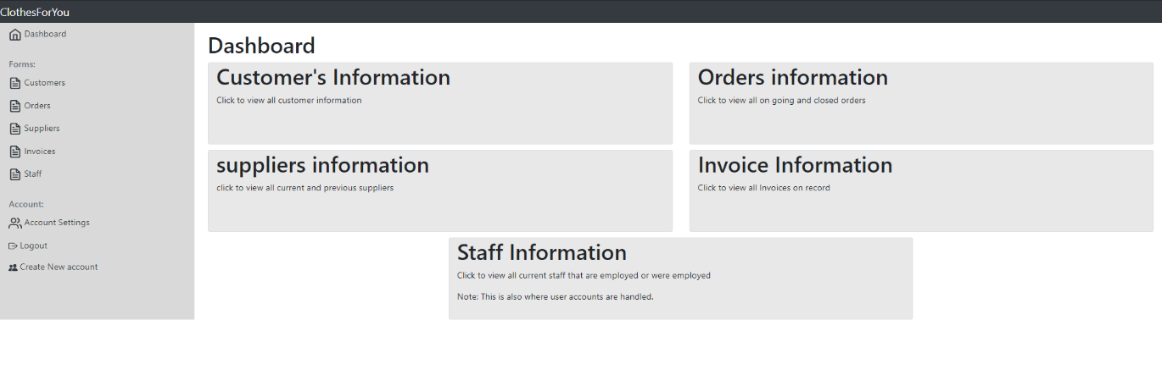
The image above shows the dashboard this is the starter page once the user has logged in, it can direct to all forms with a description of what the form is used for. You can also see the side heading here as well. In this screenshot, the account logged in as an admin. However, if someone lower than manager was logged in or a security level higher than 1 this is what it would look like
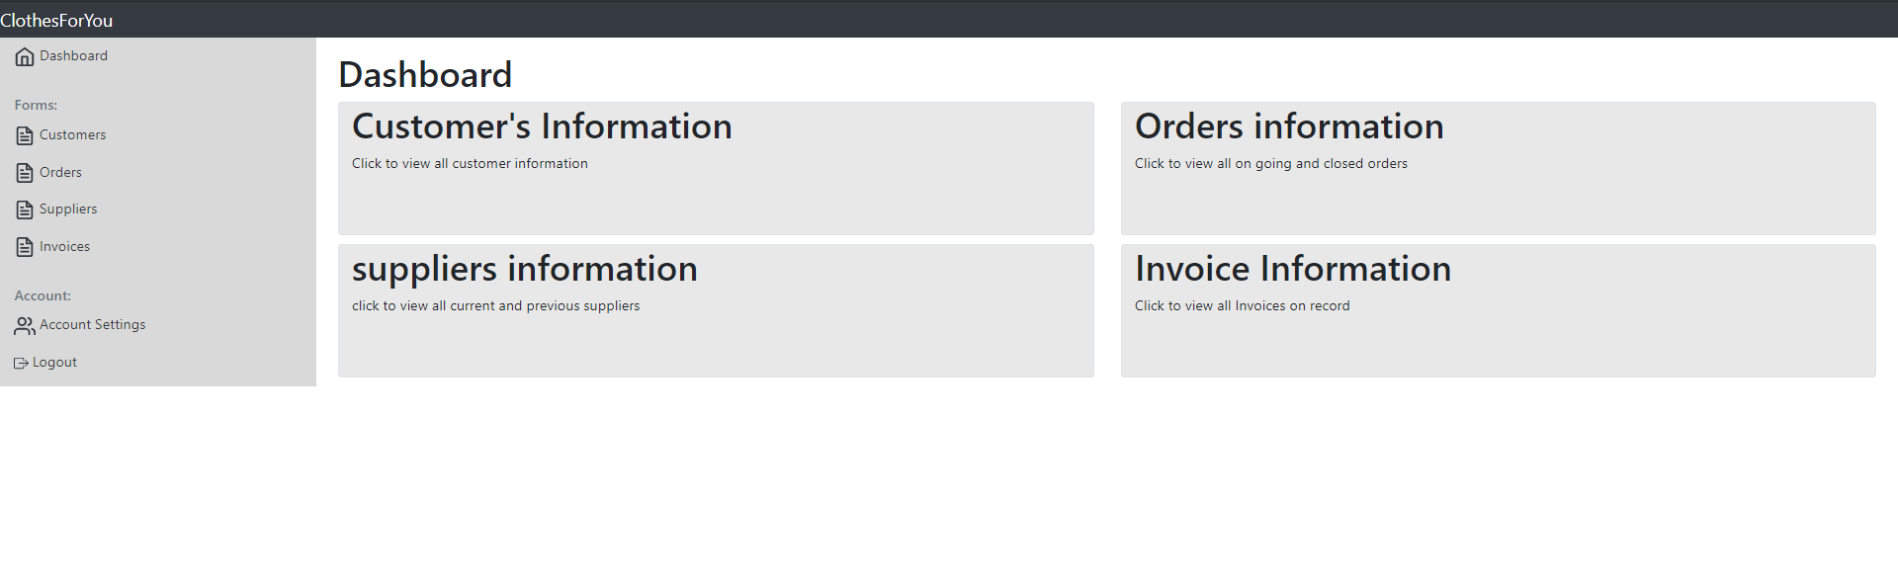

Customers
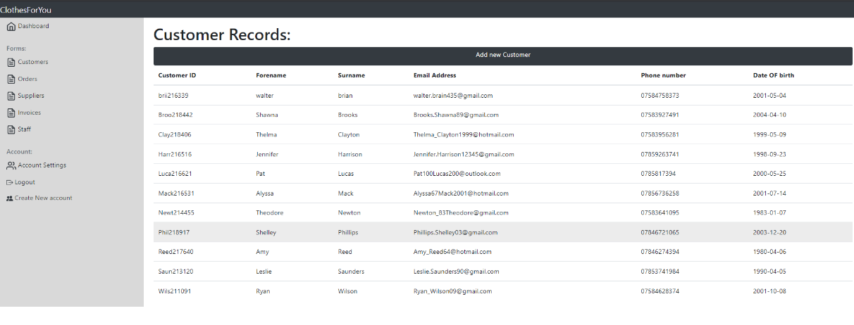
If the user was to navigate to the customer records, this is the first page they will see, on it is all the customer records with some simple information.
There is a button at the top that allows them to create a new customer if they do so it will take them to another page.
All the record rows are also linked and if the user clicks on a row a page will load up with a more detailed view of the customer's information.
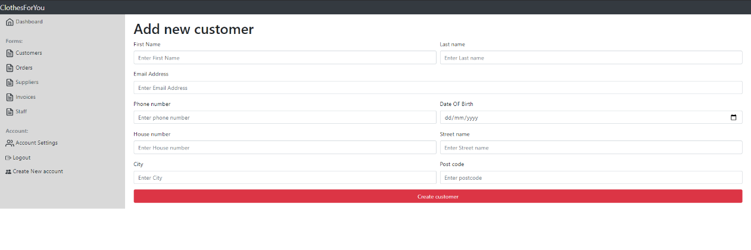
This is where a customer is added, all the forms inputs are checked with validation once the user submits the data. Below there are examples of the users breaking validation.
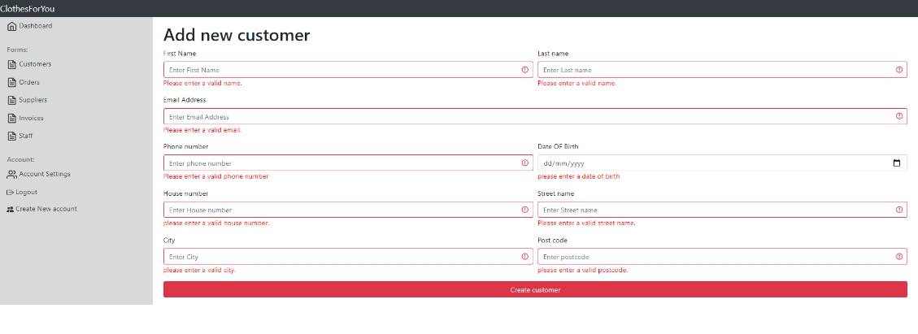
If the user doesn’t enter something into a field.
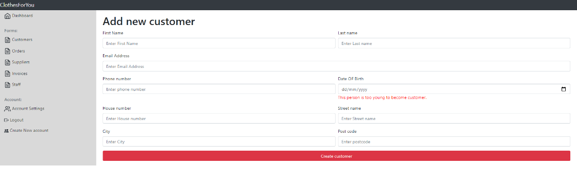
If the customer is younger than 15.
Below is an example of the user following the validation requirements and adding a new customer.
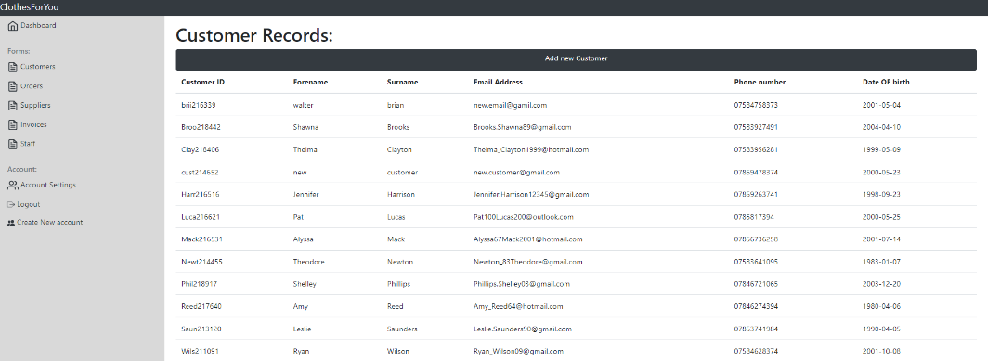
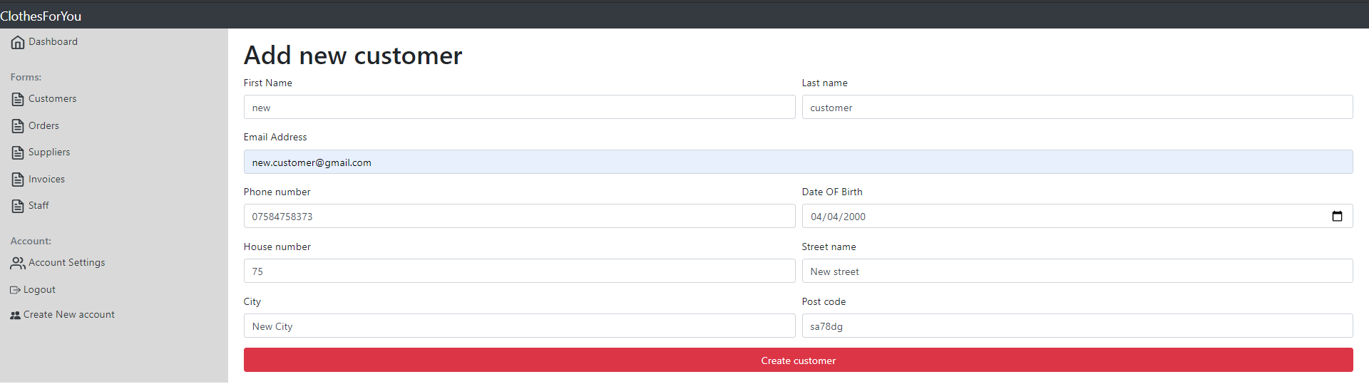

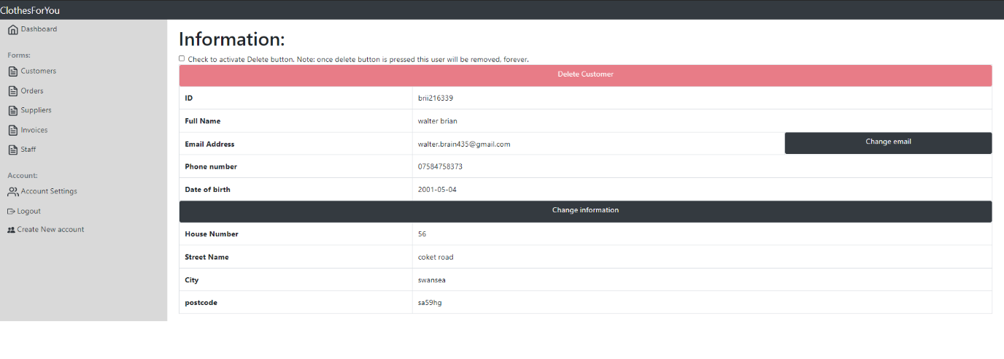
When the user views the customer in more detail, this is what they see, they change the customer's email, address and delete the customer. But to protect against accidental deleting, they must first click the check box before the button is enabled.
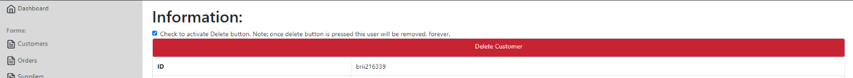

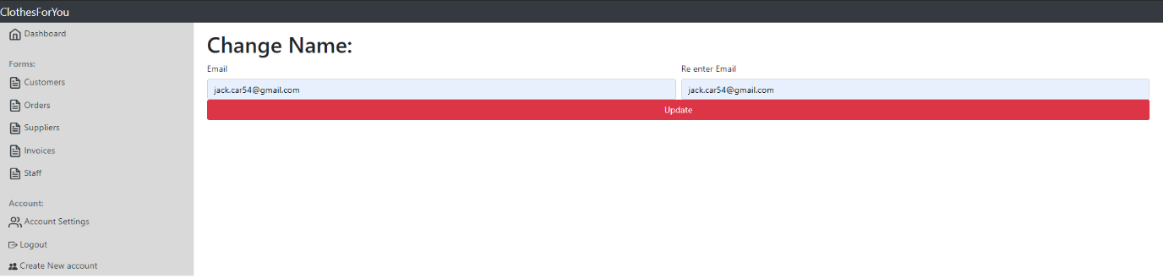
When they choose to change the email, they will be taken to this page, these inputs are also protected with validation. however, they will display a validation problem on a blank page and the user will have to use the browser navigation to get back to the point they need.
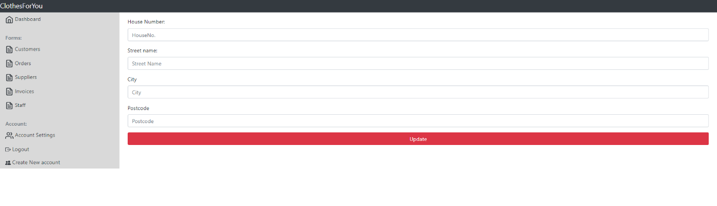
When the user presses edit address, they are sent to this page, these inputs are also protected with validation. however, they will display a validation problem on a blank page and the user will have to use the browser navigation to get back to the point they need.
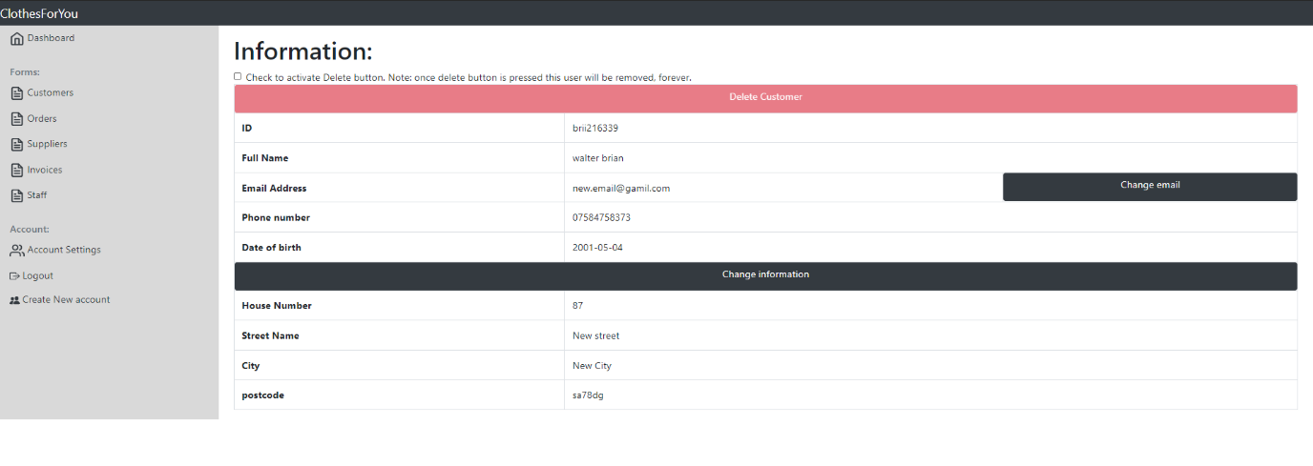
The changes are done separately, however here is an example of a change in data using the website.

Orders
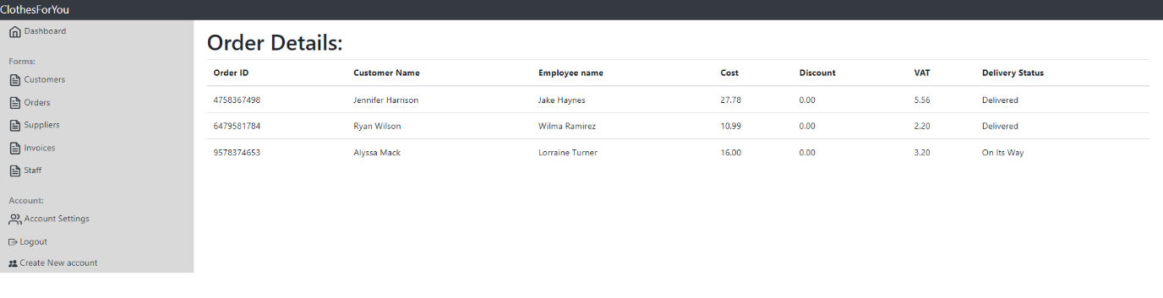
When the user navigates to the order records, they first see this page, as like the customers it lists all orders on the database. However, there is currently no feature to add a new order. There is also no way to delete an order, however, I didn’t want there to be a way to delete an order. All rows are linked and when clicked will load a more detailed view an example is shown below.
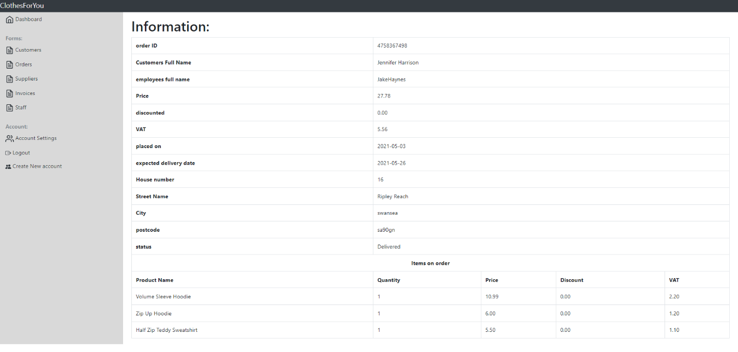

Suppliers
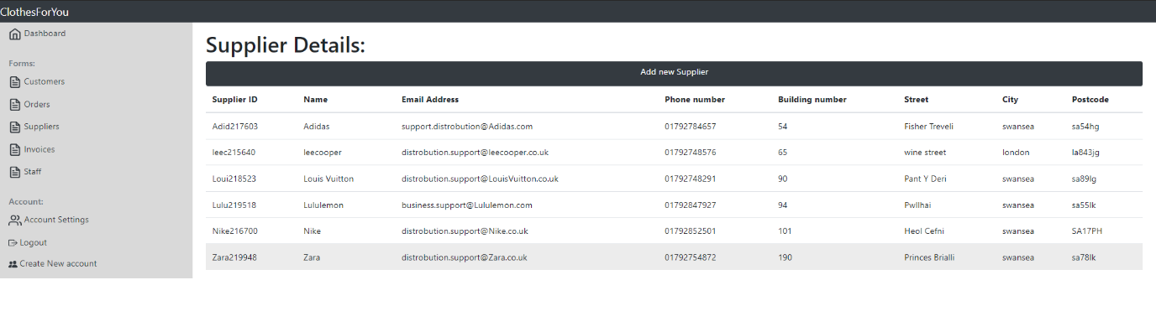
Once again, if the user navigates to see supplier details, they are sent to this page, which loads all supplier details. They can navigate to add a new supplier and all rows are linked so to view more details about the supplier they click on the row. The only people allowed to add new suppliers are users with security levels below 3. This is also the same for editing details.
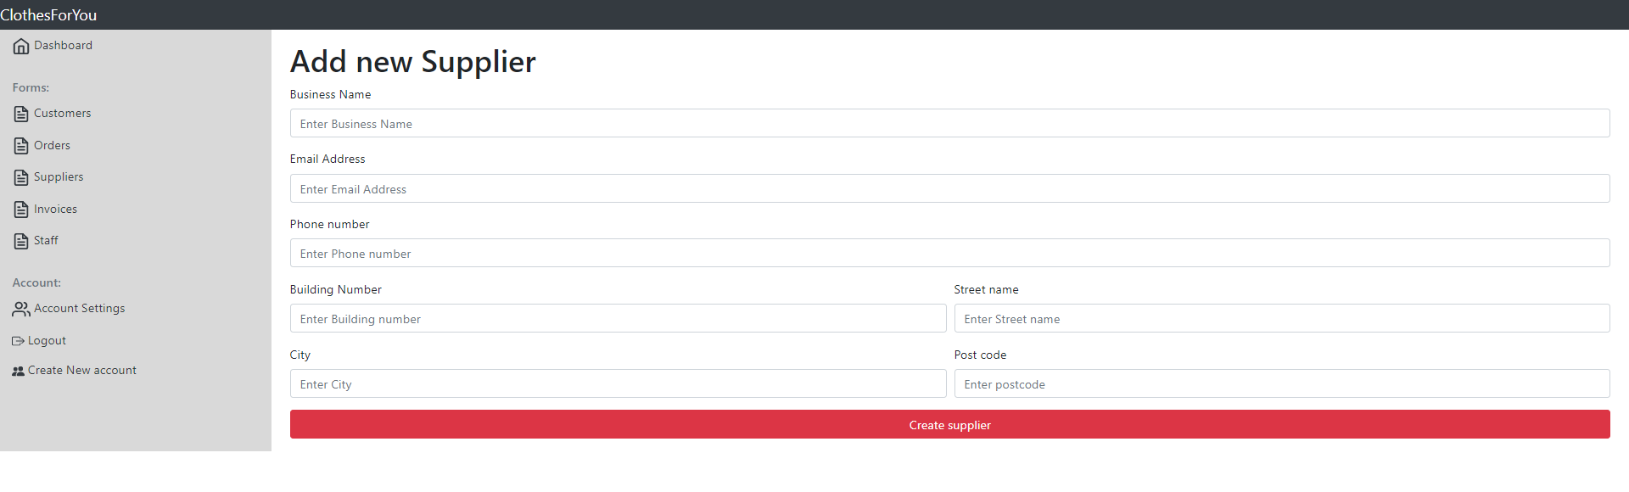
This is the page where the user can add a new supplier all of the inputs are protected with validation and are trigged when the user submits the form.
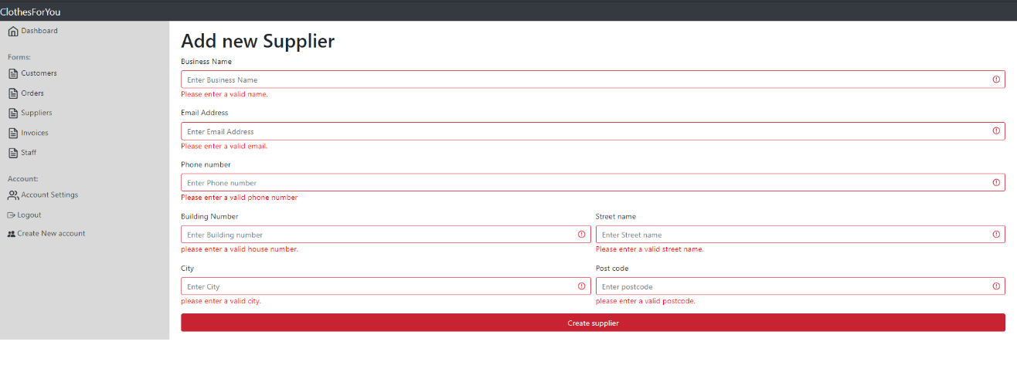
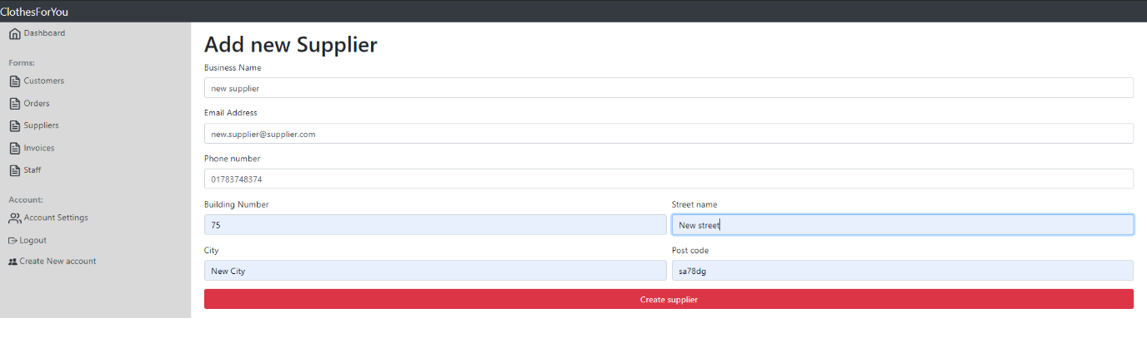
If the user follows the validation requirements, then the user will be added to the database.
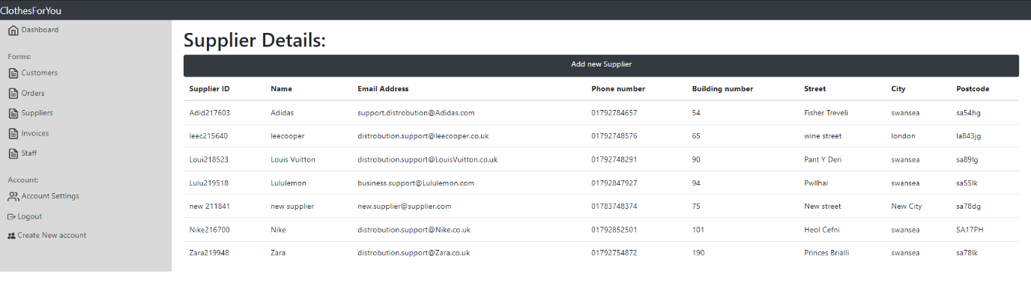

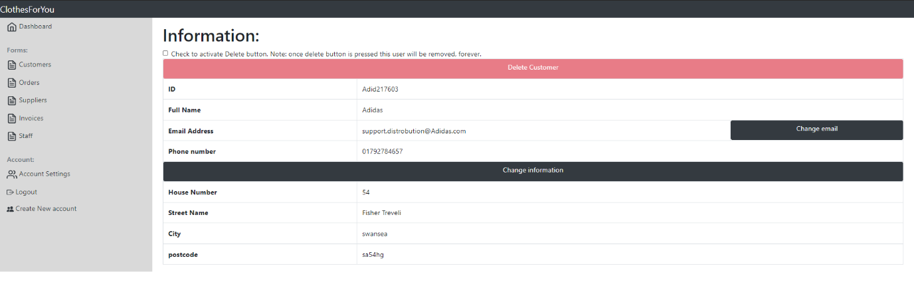
When the user views the supplier in more detail, this is what they see, they change the supplier email, address, and delete the supplier. But to protect against accidental deleting, they must first click the check box before the button is enabled.
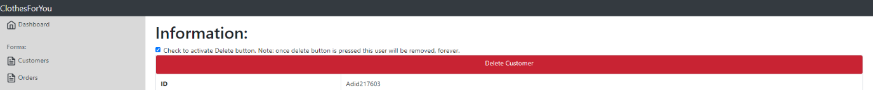
The editing of data works the same way as the editing of the customer data.

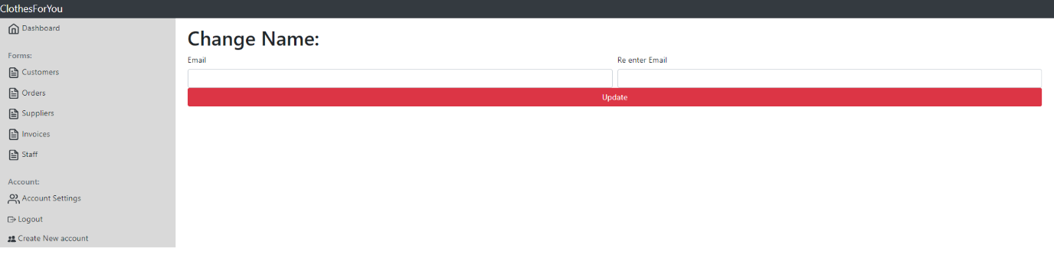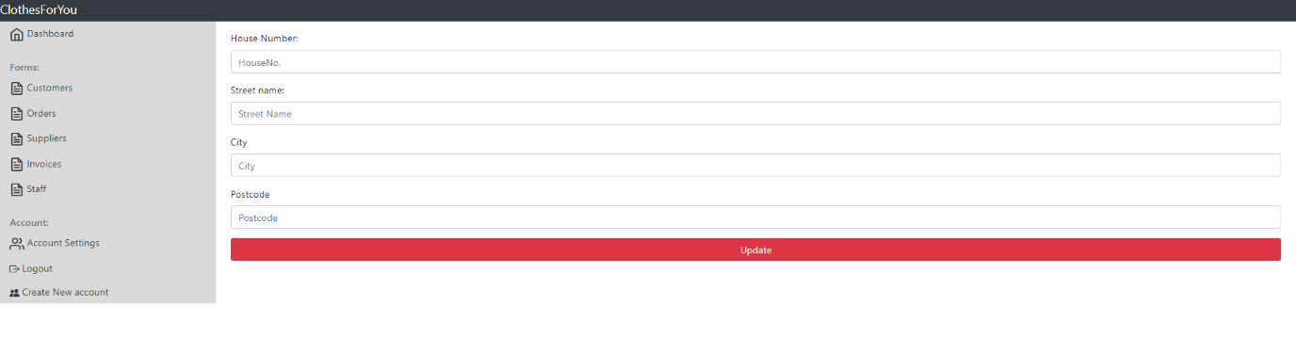

Invoices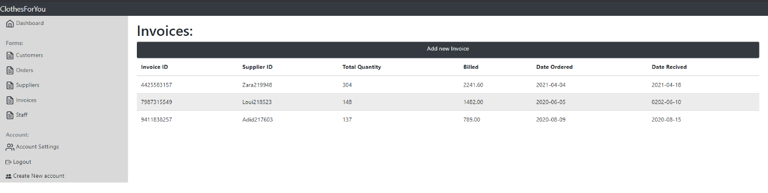
When the user navigates to invoice records, they will be shown all the invoice records. From here they can add a new invoice and view more details of the invoices.

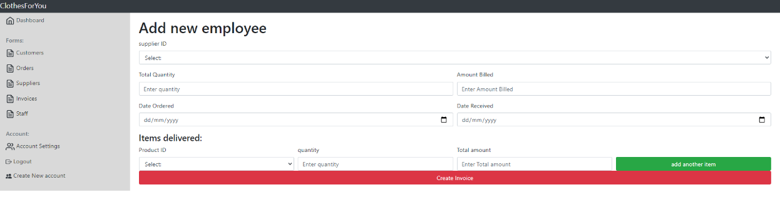
They will see this form, most of this form has inputs of dropdown boxes, the first drop-down box will display all the supplier IDs. The supplier IDs are designed to have the first 4 letters of the supplier's name so it will be easy to select the supplier ID.

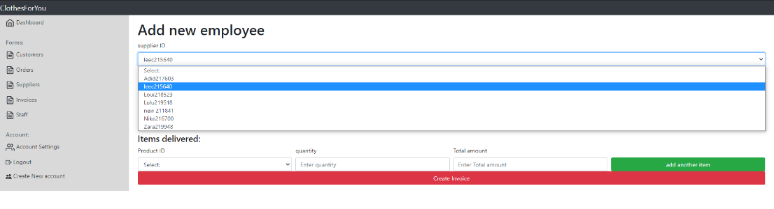
From there they can add a product using the product dropdown box, this can be difficult as the user will have to refer to the product listings if they are not familiar with the product IDs.

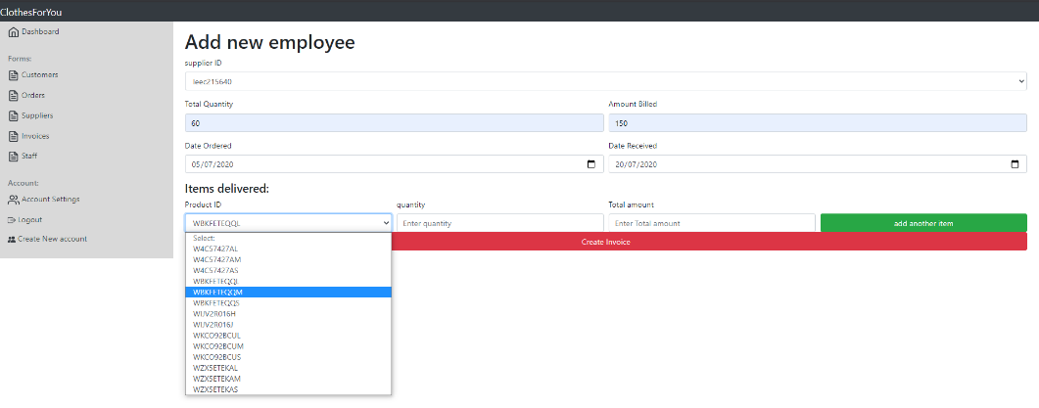

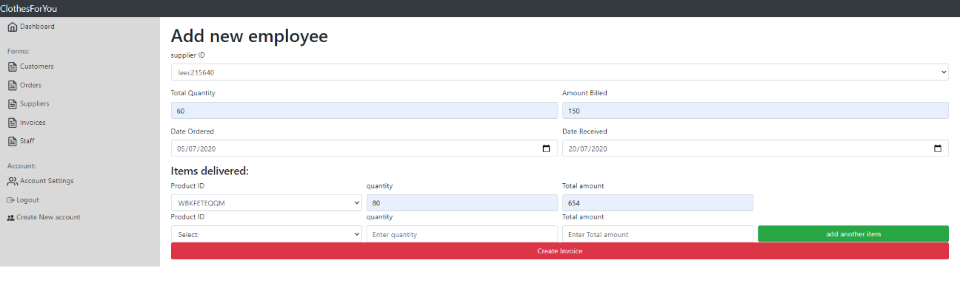
If the invoice has more than one item, they can add it below and it will work exactly like the first one. They can do this as many times as they need. Below are examples of this process.

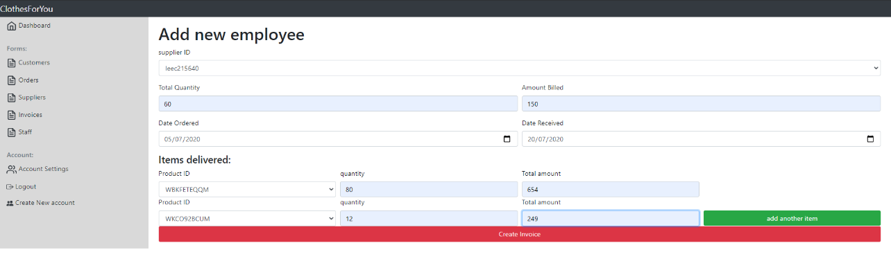
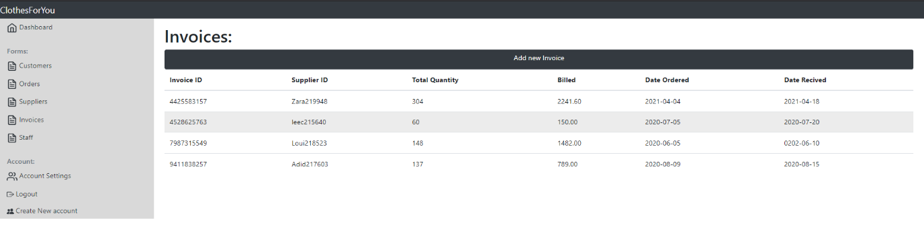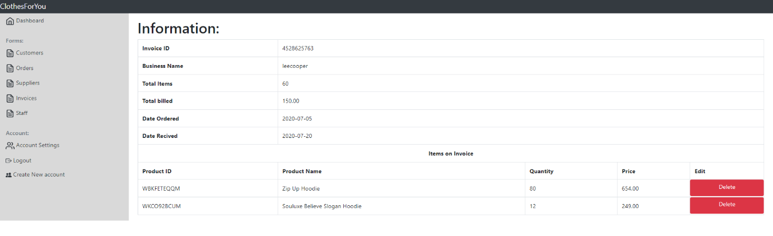
The user is limited to what they can do on an invoice, and they can only delete an item on the invoice. This is only in place in case the user added that item by accident. There is no way to delete the invoice itself at this moment.
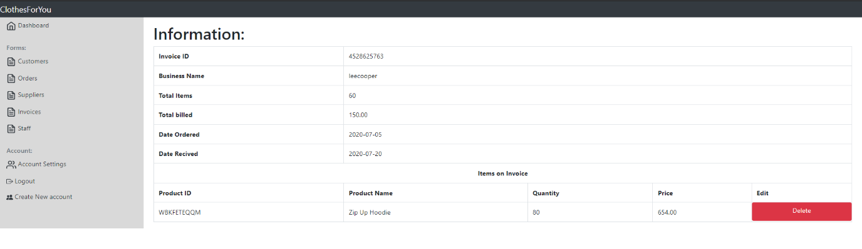

Staff
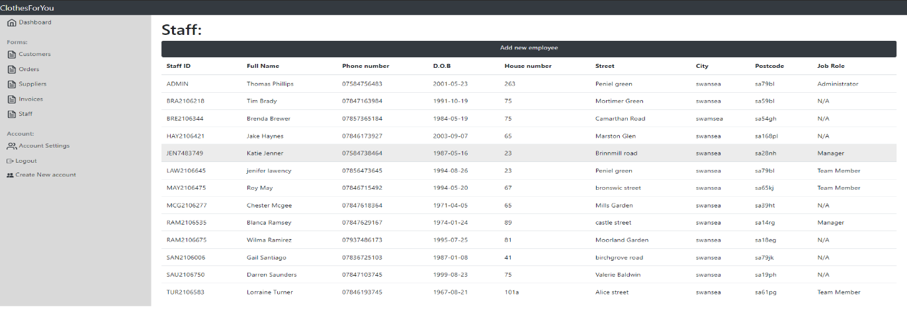
When the user navigates to the staff records they will first see this page. It loads all the records the database has on staff. All the rows are linked and will take the user to more details about the employee. Or they can add a new employee. This page can only be accessed by security level 1 or 0
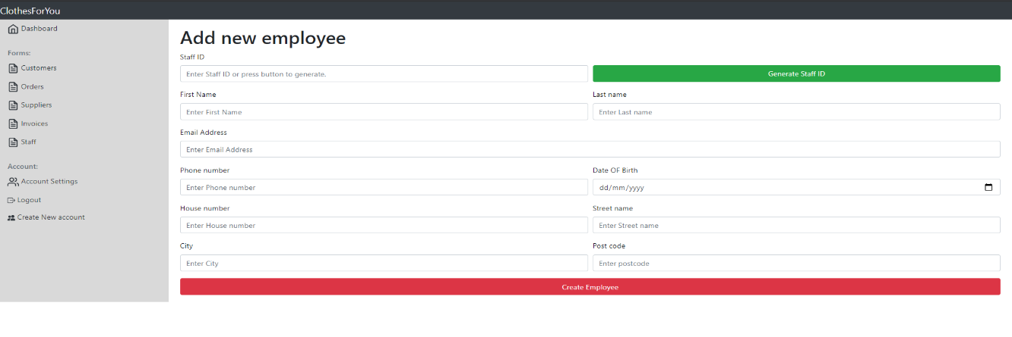
This is where a user adds a new staff member, all these fields are protected by validation. The user can choose to enter a custom ID or after filling out the form they can generate an ID using the button. If they use generate ID, then it will use the first 3 letters from the last name the year and month of the current data and 3 random numbers. (E.G. LLLYYMMNNN PHI2105758). Below you can see some validation triggers.
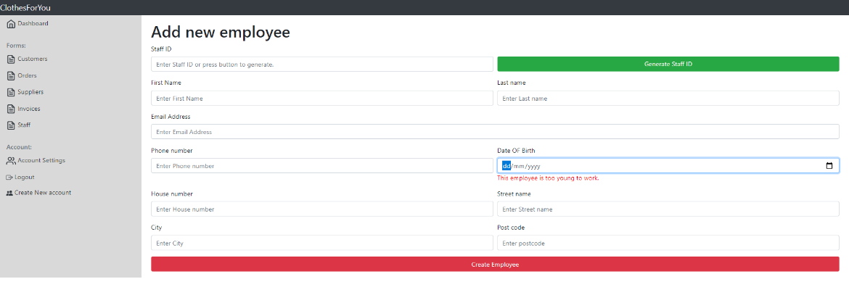
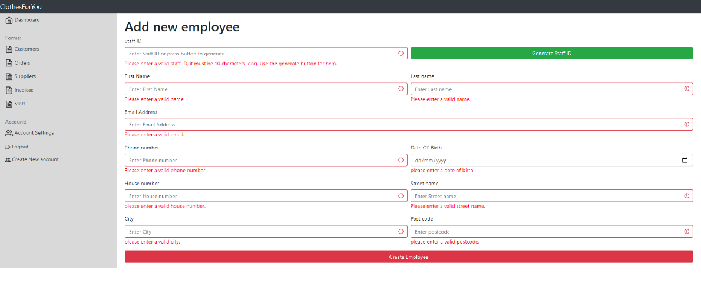

Below is an example of the user not breaking any validation and adding the user
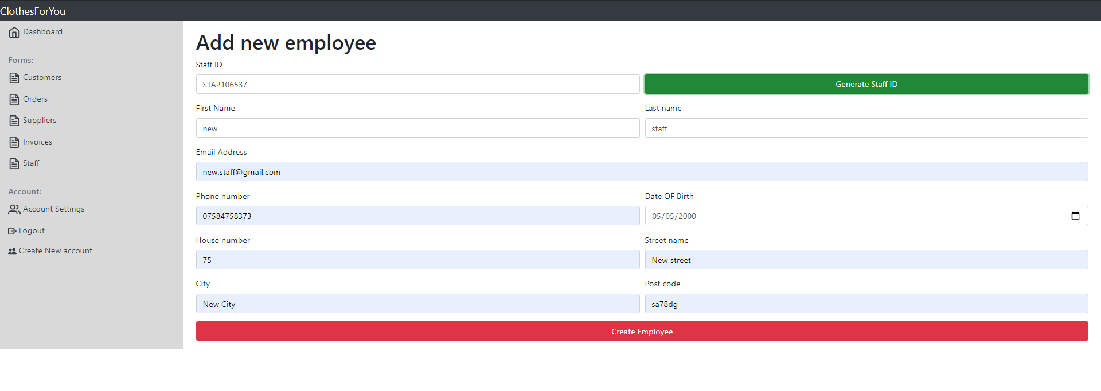
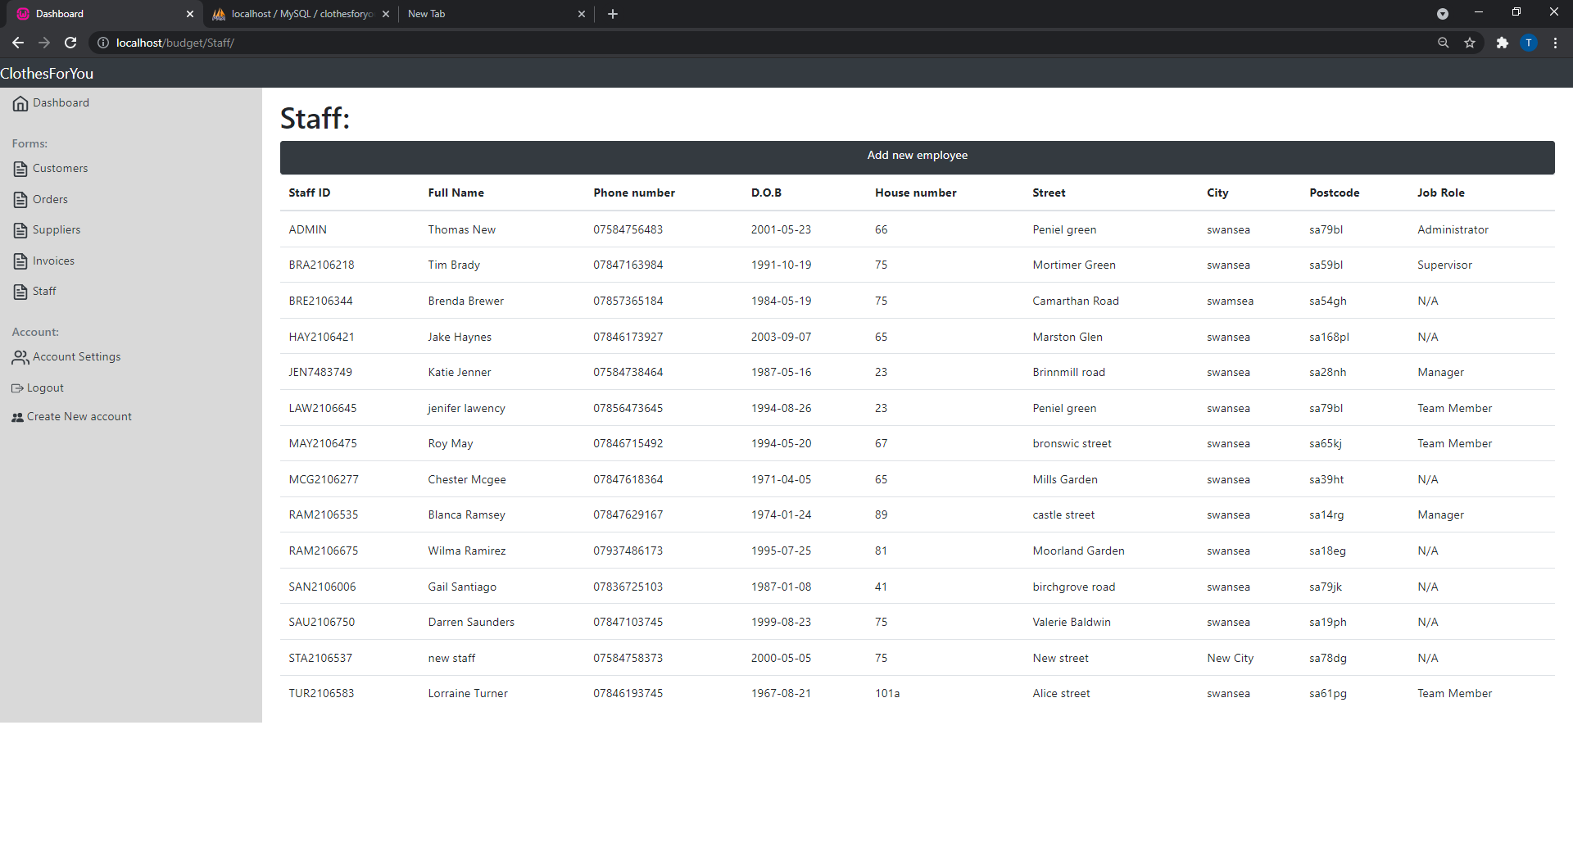

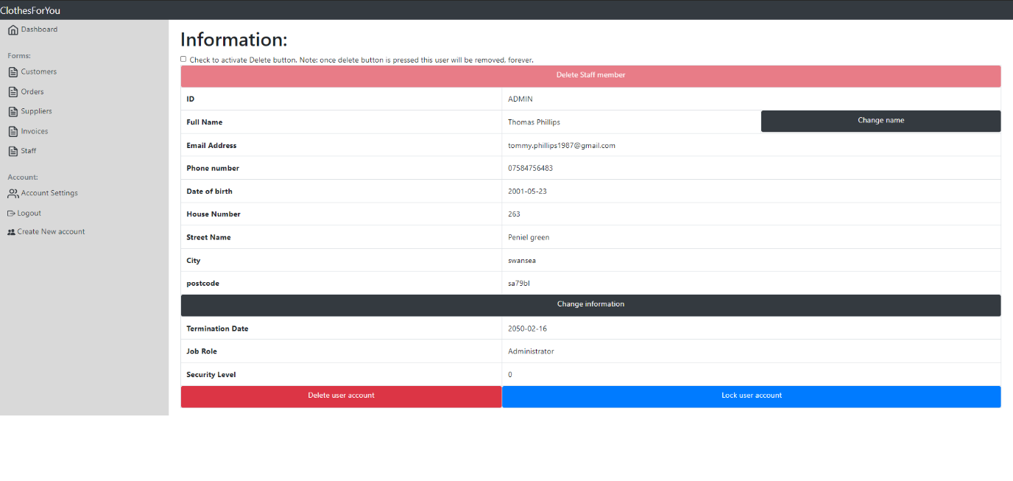
This is the display of all the details that the database has on the staff members. There are a couple of features as the user account information is also located here. It starts with a delete button this will delete the staff record. However, to use it they must check the checkbox to enable the button. There isn’t a way to change the employee’s email phone number, and address as this is the employee’s responsibility to change. However, they can change the name of the employee and account setting. There are also features to lock user accounts if the staff member has a user account. Below are some examples of these features below:
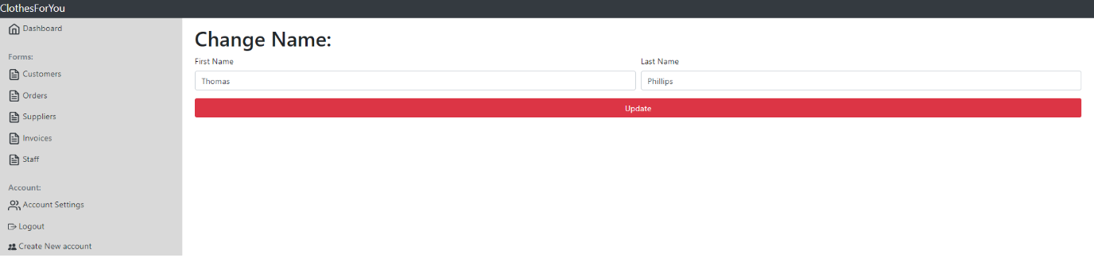
Changing employee name.
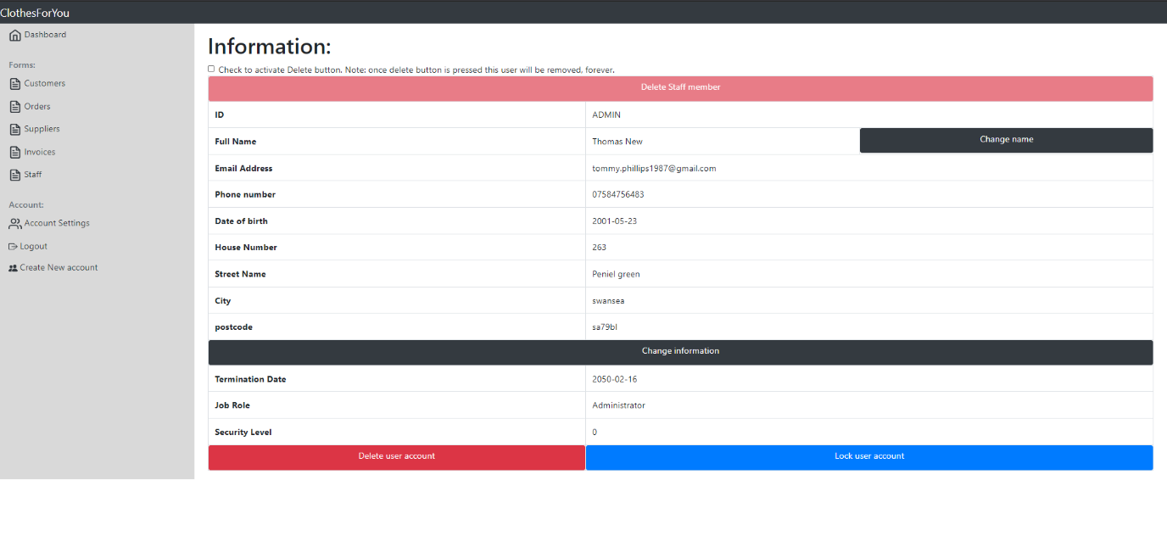
These are the account settings for the employee. This will only update if the employee has a user account created.
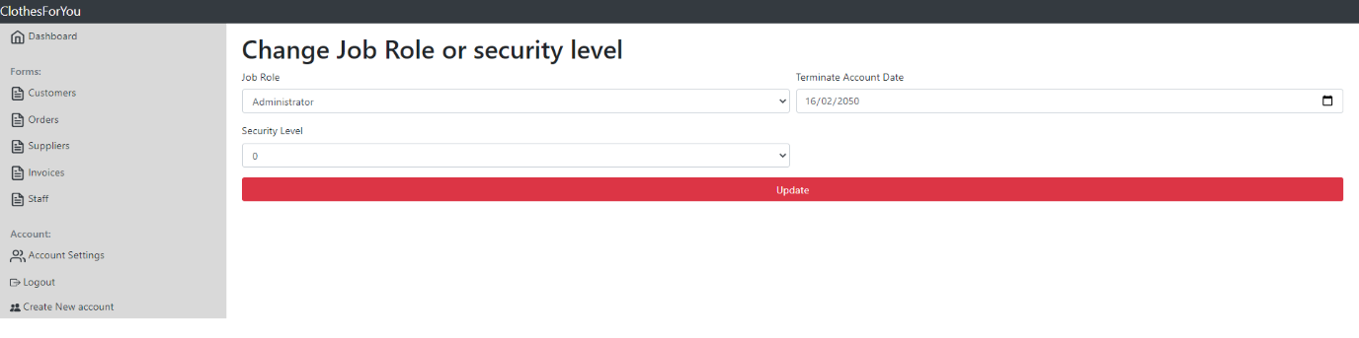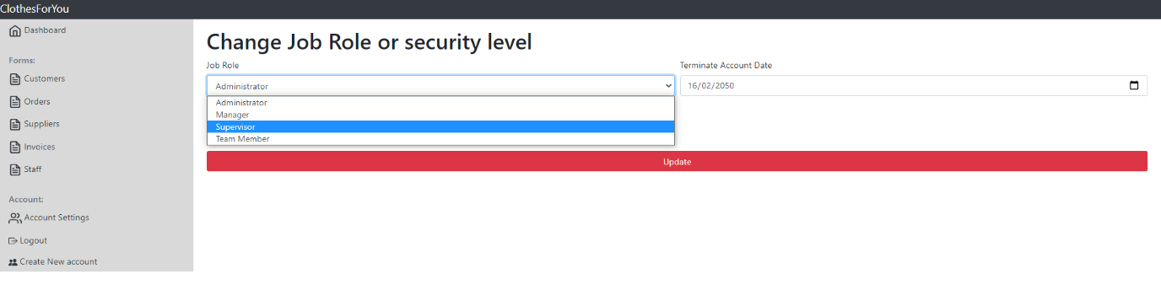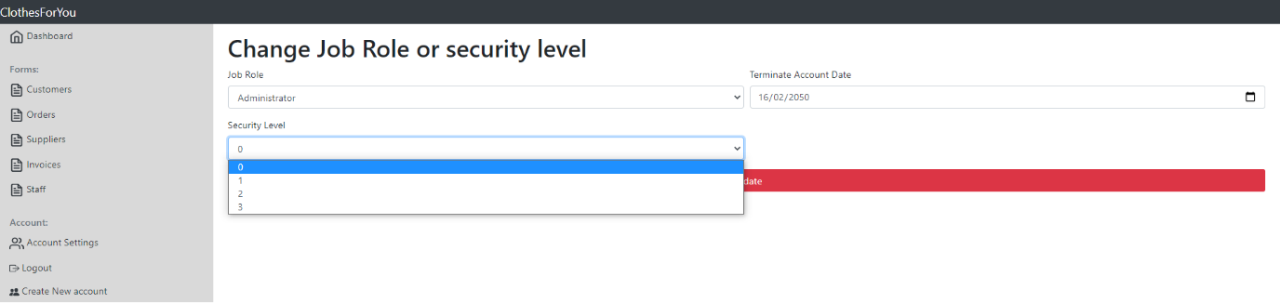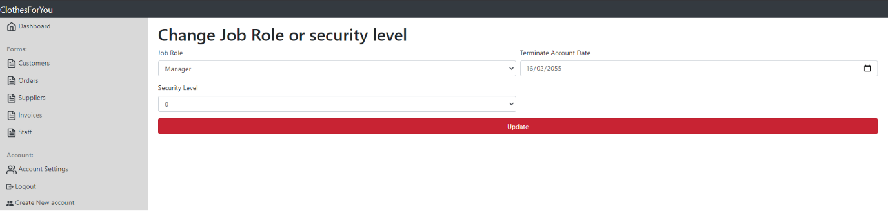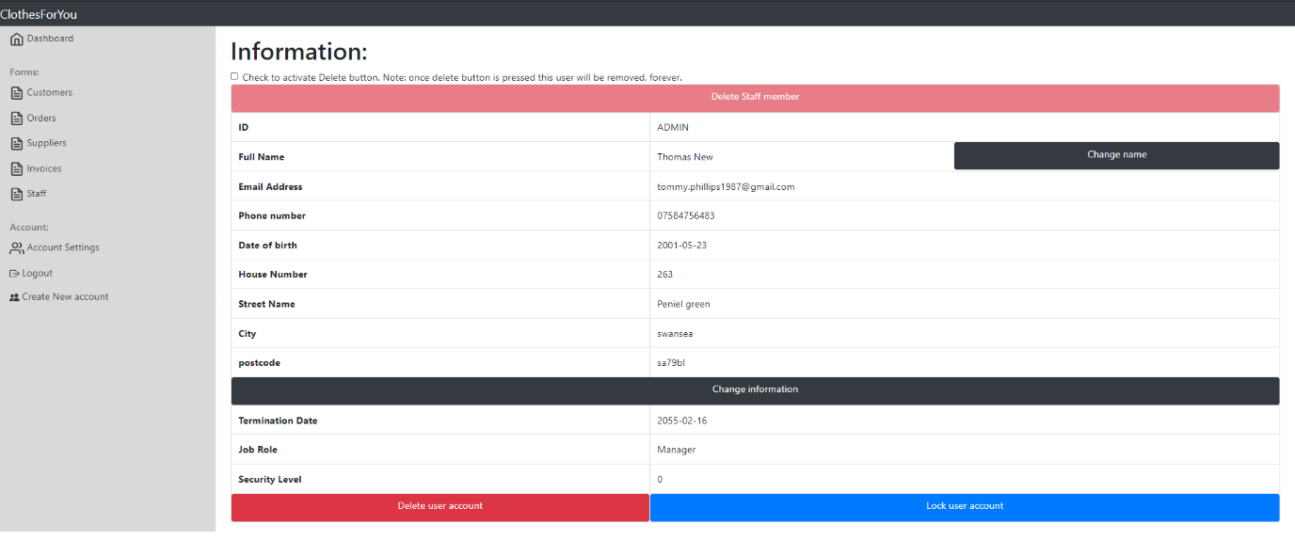

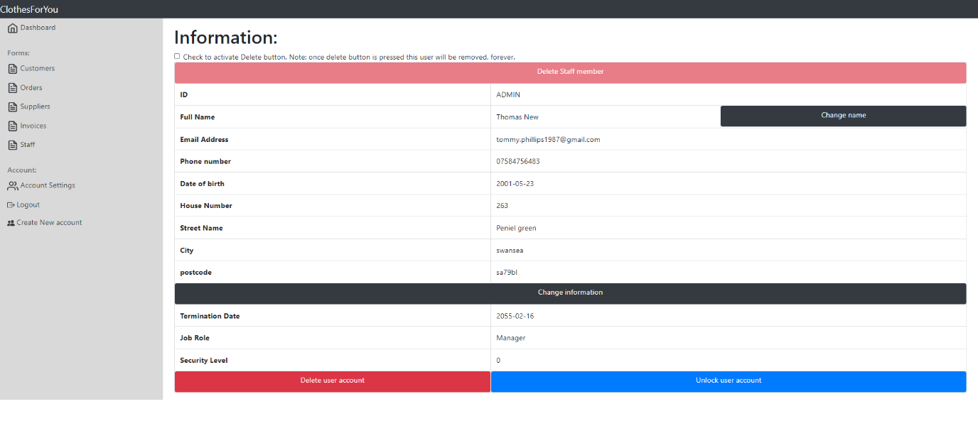
If the lock button is pressed then this will be the new display. This also means the account is now locked and when the user next tries to log in, it will not allow them.
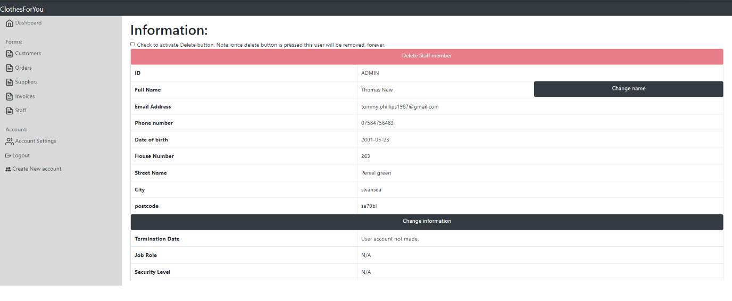
If the user account is deleted or if the user doesn’t have a user account then this is the display.

Creating a new user account
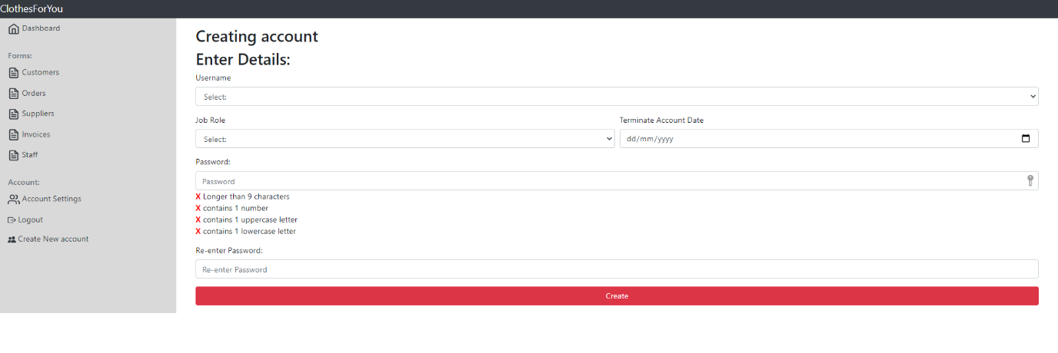
Creating a user account is a feature that only users with a security level of 0 or 1 can do. If they navigate to this they will be presented this form, this forms inputs are protected with validation as well as on the go password conditions which will update as the user types in the password.
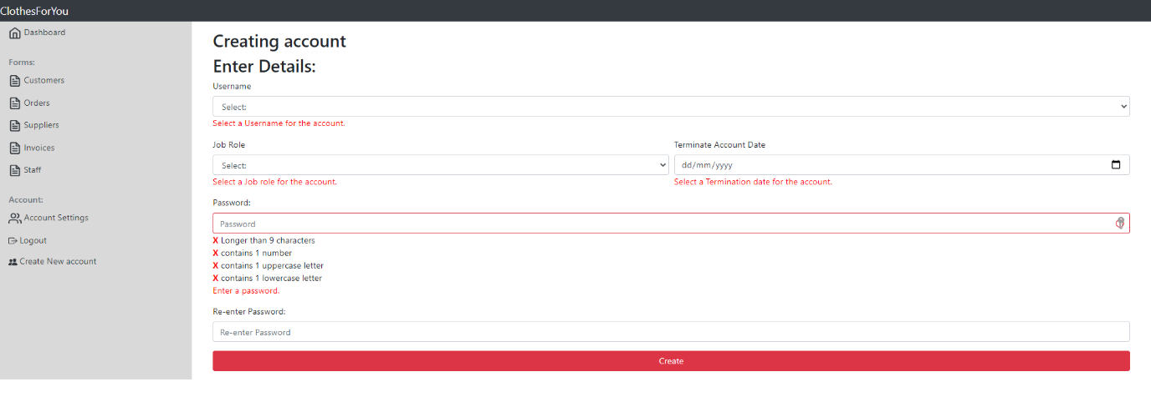
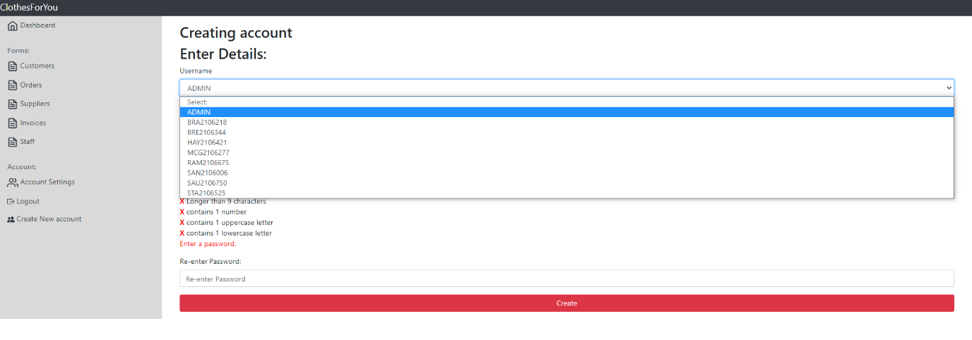
To make an account the employee that the account is for must be at the staff table. They select the user ID from a dropdown box. This will only show users that don’t already have a user account.
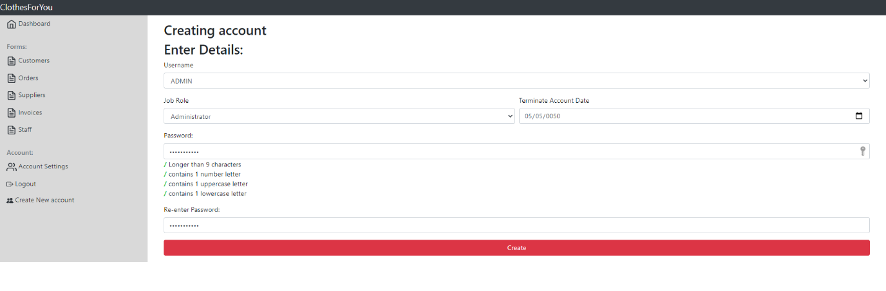
From there they will also select a job role from a dropdown, this will automatically assign a security level. However, later on, can be changed. And then a termination date for the account and a password.

Account settings
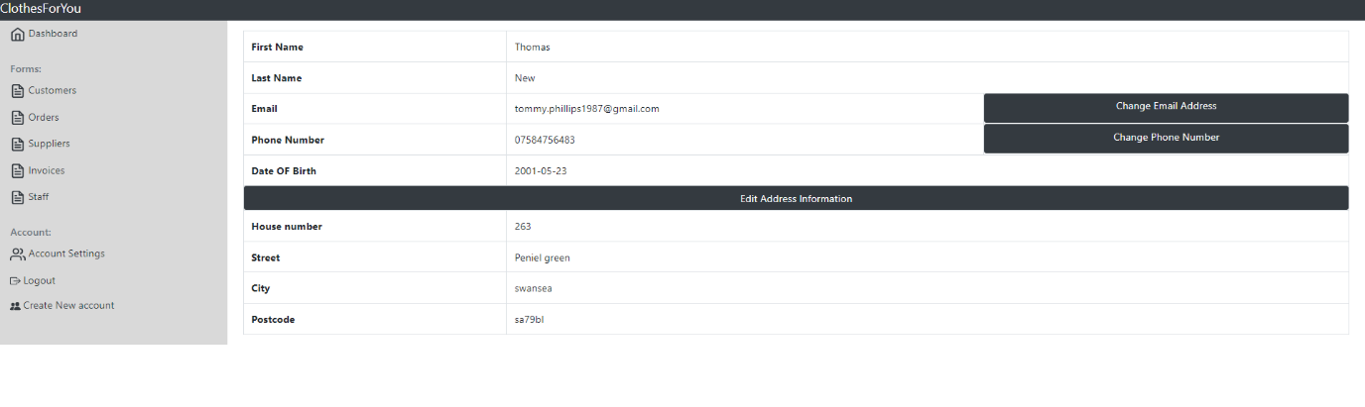
Every user account can access their data at any time. They can change basic information as can see above. The only item they can’t edit is their name and date of birth. For changing their name, it must be done by a manager through the staff records.
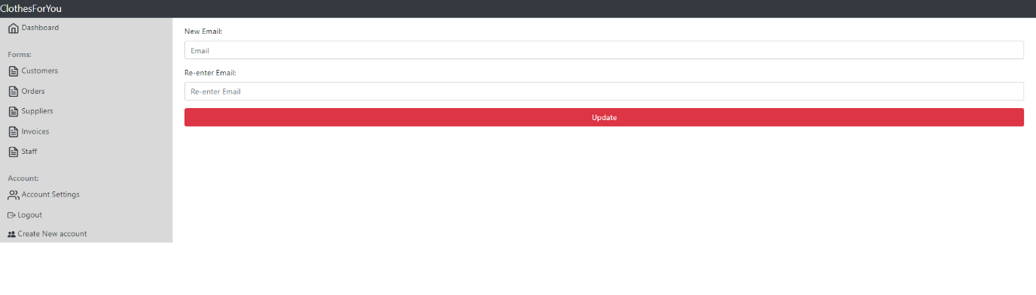
This is the edit email feature, it is protected with validation here are some examples:
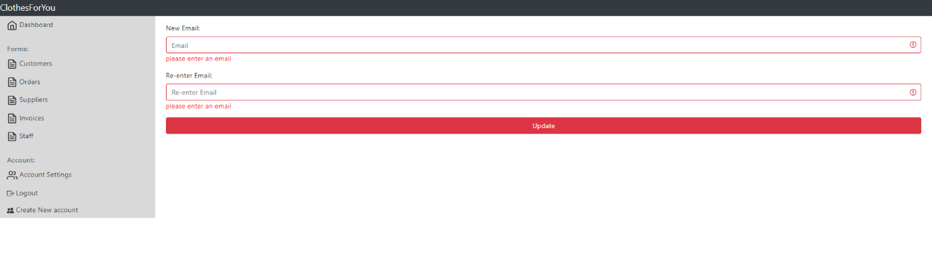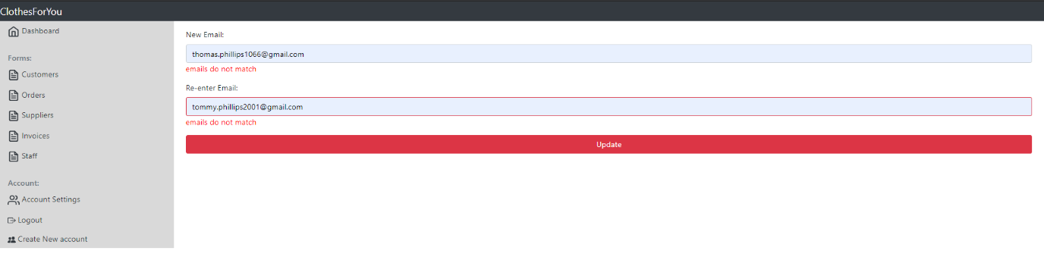
Below I also show examples of editing phone numbers and address, these are also protected with validation.
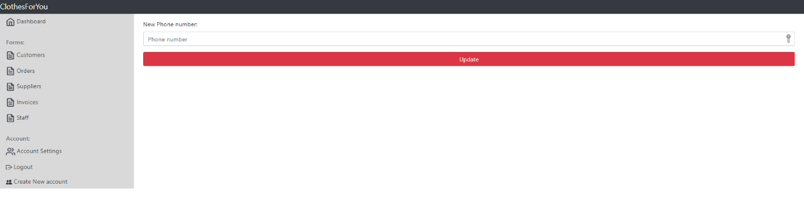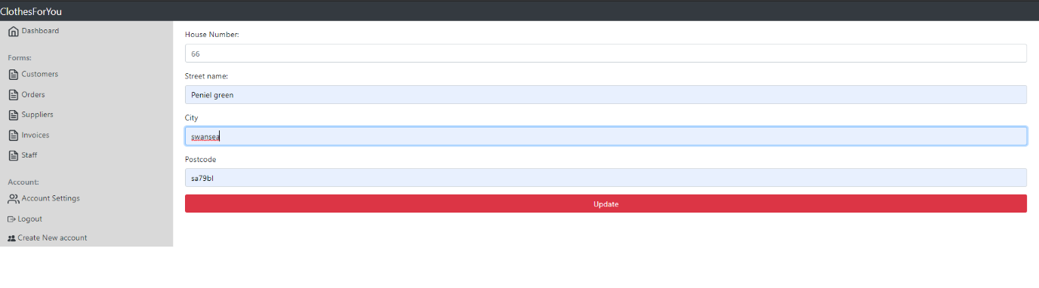
The updated record: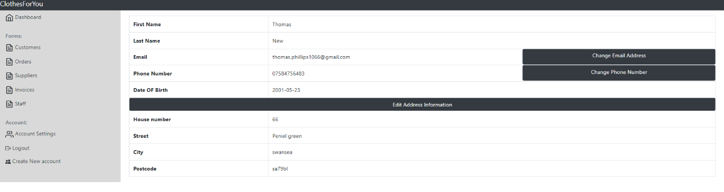

Login
Before the user can access the rest of the website, they must first log in. Here are examples of functions below
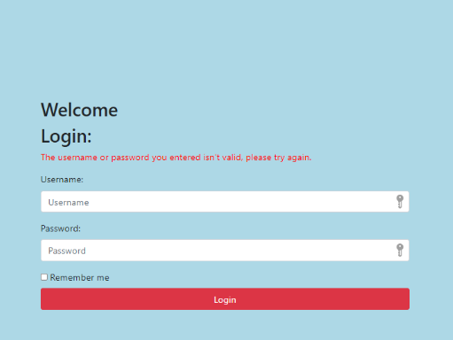
If the user enters either the username or password wrong, it will display this message.
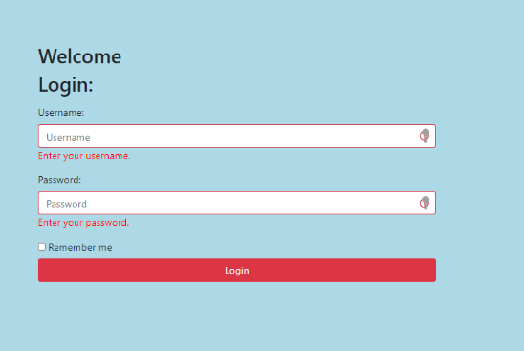
If they don’t enter anything

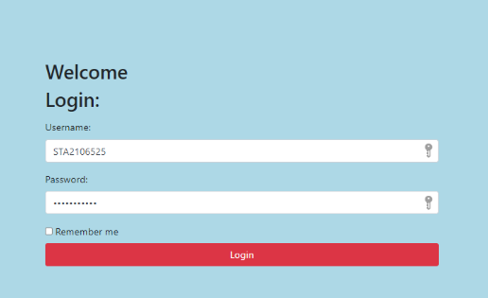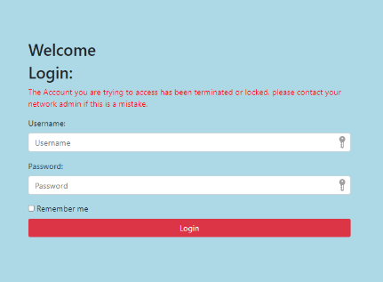
This first example is of an account that has passed its termination date. This will override the error username or password is wrong and will display if the username is right.

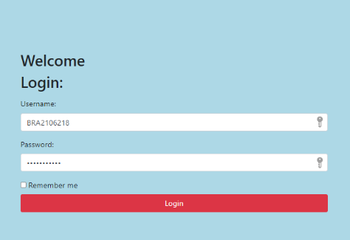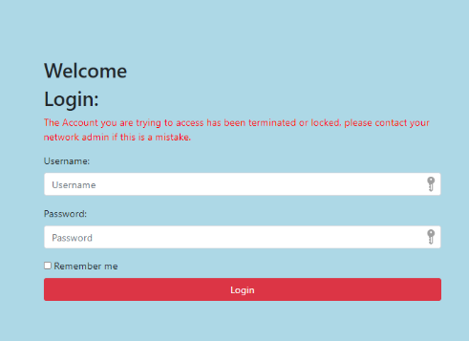
This second account is an example is of an account that is locked. This will override the error username or password is wrong and will display if the username is right.

