

Assignment 2: REPORT

Student Name: VICTORIA CHILIANU
Student ID Number: 2208500
The Module Title: Sustainable Hospitality and Tourism Management BMIH5006
Lecturer’s Name: THOMAS HUW
Submission Date: 3rd June 2024
Word count: 2176

Executive Summary
The hospitality industry embraces sustainability to address environmental issues and meet consumer demands. Sustainable accreditation is essential for hotels to showcase eco-commitment and maintain competitiveness (Haski-Leventhal, 2018).
This report thoroughly examines sustainable hotel accreditation, covering its importance, standards, procedures, benefits, and challenges. It offers practical advice for integrating sustainability into hotel operations and predicts future industry trends. Key accreditation elements include resource management, waste reduction, sustainable purchasing, and social responsibility, with a process involving self-assessment, implementation, external audit, certification, and ongoing monitoring for compliance (EarthCheck, 2021).
Notable sustainable hotels such as Grootbos and Six Senses Zighy Bay exemplify various sustainability strategies, inspiring eco-conscious travel and setting positive examples for the industry (Weeva Earth, 2024).
Integrating sustainability into hotel operations yields financial, environmental, and social benefits yet entails challenges like investment costs and regulatory compliance (Legrand et al., 2022). Overcoming these strategically is vital for long-term success.
Future hospitality trends include tech-driven personalised experiences, sustainability focus, hyper-personalisation for differentiation, wellness journeys, and social media's influence on customer interactions (Díaz de la Lastra, 2024).
In conclusion, sustainable accreditation is crucial for hotels to showcase environmental and social responsibility. By meeting rigorous standards and addressing challenges strategically, hotels can thrive in an eco-conscious market. Recommendations include prioritising certifications, conducting audits, investing in staff training, embracing technology, collaborating with suppliers, educating guests, and staying updated on industry trends. These steps are essential for hotels to excel in the evolving landscape of eco-conscious tourism.

Table of Contents
Executive Summary 1
List of Tables 3
1. Introduction 4
2. Sustainable Accreditation for Hotels 5
3. Benefits and Challenges of Integrating Sustainability 9
4. Future Trends in the Hotel and Hospitality Industry 12
5. Conclusion 14
6. Recommendations 15
References 16
Appendices 20
Appendix 1: Analysis of Sustainability Certification According to GSTC Criteria (% compliance). 20
Appendix 2: Grootbos, South Africa. 20
Appendix 3: Bohinj ECO Hotel, Slovenia 21
Appendix 4: Six Senses Zighy Bay, Oman 21
Appendix 5: Cempedak, Indonesia 22
Appendix 6: SUJÁN, India 22

List of Tables
Table 1: Requirements for Accreditation. 5
Table 2: Processes of Accreditation. 7
Table 3: Benefits of Integrating Sustainability. 9
Table 4: Challenges of Integrating Sustainability. 10

Introduction
In response to growing environmental concerns and consumer demands, sustainability has become a focal point for the hospitality sector (Han, 2021). Hotels are increasingly adopting eco-friendly practises to meet the expectations of environmentally conscious guests. Sustainable accreditation is crucial for hotels to demonstrate their dedication to environmental responsibility, enhancing their image and standing in the competitive market (EU Ecolabel, 2021).
The report delves into sustainable hotel accreditation, examining its importance, standards, processes, benefits, and challenges. It offers actionable insights for hospitality stakeholders to embed sustainability into hotel operations. Furthermore, it forecasts emerging trends in the industry, emphasising evolving guest preferences, technological advancements, and sustainability initiatives.
This report offers a comprehensive view of sustainable hotel accreditation, drawing from various sources, including literature, scholarly articles, industry reports, and case studies concerning sustainable hotel accreditation. Providing a balanced perspective aims to guide hotels in successfully implementing sustainable practises through rigorous research and analysis.

Sustainable Accreditation for Hotels
Sustainable accreditation is not just a trend but a crucial way for hotels to demonstrate their commitment to sustainability and environmental responsibility (Haski-Leventhal, 2018). Currently, over 100 hotel certifications focus on various aspects of sustainable tourism, each with its certification programme and level of compliance (Spenceley, 2019). According to the Sustainable Hospitality Alliance (2021), the most well-known certifications include Earth Check, Green Globe, Green Key, Travelife Sustainability, and the EU Ecolabel, with the GSTC (Global Sustainable Tourism Council) Criteria serving as a global standard for sustainable certification (see Appendix 1). These certifications primarily emphasise the processes implemented in hotel operations. To achieve sustainable accreditation, hotels must meet various criteria and standards that ensure their operations are environmentally friendly and sustainable:
Table 1: Requirements for Accreditation.
Resource Management  (EU Ecolabel, 2021) | - Energy efficiency: Implementing renewable energy sources (e.g., solar panels) and efficient lighting and energy management systems.  - Water Conservation: Installing water-saving equipment such as showers and low-flow taps and using water recycling technologies.
Waste Management  (EarthCheck, 2021) | - Recycling: Implement a comprehensive recycling programme for paper, glass, plastic, and food waste.  - Waste reduction: Minimise waste using biodegradable packaging and implement food waste reduction programmes.
Environmental Quality  (Green Globe, 2021) | - Air quality: Using environmentally friendly building materials and efficient ventilation systems to ensure quality indoor air.  - Green spaces: Maintaining and protecting the green spaces surrounding the hotel and promoting local biodiversity.
Sustainable Purchasing Practises  (Green Key, 2021) | - Local suppliers: Preference for products and services from local suppliers that meet sustainability standards.  - Organic and local food: Promoting a menu based on organic and local products to reduce the carbon footprint and support the local economy.
Social Responsibility  (Travelife, 2021) | - Community involvement: Participating in local sustainable development projects and supporting community initiatives.  - Fair working conditions: Ensuring employees' safe and fair working conditions, respecting their rights.
Source: Author Analysis
By adopting these measures, hotels not only help protect the environment and promote sustainability but also improve their public image and customer satisfaction, thus preparing for the future demands of the hotel industry.
To meet these requirements, hotels must implement various Measures and Policies, including:
- Regular audits and reports to monitor resource consumption and environmental impact (Sustainable Hospitality Alliance, 2022);
- Training staff to be aware and competent in sustainable practises (Varga, 2023);
- Strict internal policies on saving resources and waste management (GSTC, 2022).
These steps are essential for ensuring that hotels operate sustainably, minimise their environmental impact, and contribute positively to the global effort towards sustainability in the hospitality industry.

The Accreditation Process for hotels seeking sustainability accreditation involves several key steps:
Table 2: Processes of Accreditation.
Self-Assessment | Identifying strengths and areas that need improvement. | This step is crucial to understand the current level of compliance with sustainability standards and to plan the necessary measures for improvement.
Implementation | Completion of a formal application to the accreditation organisation. | This includes providing detailed information about the sustainability practises and policies implemented by the hotel and the documentation necessary to demonstrate compliance with the established requirements.
External Audit | A third party conducts an audit to verify compliance with established standards. | This audit involves a detailed assessment of all operational aspects of the hotel, from resource and waste management to environmental quality and sustainable purchasing practises.
Certification | If all requirements are met, the hotel receives sustainability certification. | This attests to the hotel's compliance with international sustainability standards and has implemented sustainable practises in all its operations.
Continuous Monitoring | Periodic review of compliance to maintain accreditation. | This includes regular audits and updating sustainability practises to ensure continued compliance with standards and identify new opportunities for improvement.
Source: Author Analysis based on Legrand et al. (2022)
These steps ensure that hotels not only achieve sustainability certification but also maintain a constant commitment to sustainable practises, thereby helping to protect the environment and increase customer satisfaction.
In the recent special article (Weeva Earth, 2024) explores the rising trend of sustainable practises in the hospitality industry. It emphasises the importance of eco-friendly hotels, which reduce their environmental impact, make positive social contributions, and support economic sustainability. The article outlines notable sustainable hotels worldwide:
- Grootbos, South Africa (see Appendix 2): Focuses on conservation and community development, certified as carbon-negative, and supports sustainable agriculture and education.
- Bohinj ECO Hotel, Slovenia (see Appendix 3): Known for energy efficiency, using eco-friendly materials and renewable energy sources, and promoting sustainable tourism.
- Six Senses Zighy Bay, Oman (see Appendix 4): Promotes water and energy efficiency, waste management, and community engagement with initiatives like an Earth Lab and extensive recycling programmes.
- Cempedak, Indonesia (see Appendix 5): An eco-resort using recycled materials and renewable energy, focusing on waste reduction and local sourcing.
- SUJÁN, India (see Appendix 6): Operates luxury camps with solid sustainability principles, supporting local communities, wildlife protection, and education initiatives.
(Weeva Earth, 2024)
These hotels showcase various sustainability strategies, including energy efficiency, waste reduction, community support, and conservation initiatives. Their diverse approaches set a positive example for the industry and inspire eco-conscious travel.
Sustainable accreditation is vital for hotels to showcase their environmental and social responsibility commitment. Meeting rigorous standards minimises ecological impact and boosts local economies, fostering a brighter future for the hospitality industry and the planet.

Benefits and Challenges of Integrating Sustainability
Integrating sustainability into hotel operations offers many benefits that can enhance financial performance, improve guest satisfaction, and contribute to broader environmental and social goals (Duric et al., 2021). Integrating sustainability into hotel operations is not just a trend but a strategic imperative that offers substantial long-term benefits:
Table 3: Benefits of Integrating Sustainability.
Financial | Cost Savings: | - Energy Efficiency  - Water Conservation  - Waste Reduction
Financial | Increased Revenue: | - Attracting Eco-Conscious Guest  - Enhanced Occupancy Rates
Marketing and Brand | Brand Differentiation: | - Competitive Edge  - Positive Publicity
Marketing and Brand | Customer Loyalty and Satisfaction: | - Meeting Guest Expectations  - Enhanced Experience
Environmental | Reduced Environmental Impact: | - Lower Carbon Footprint  - Resource Conservation
Environmental | Biodiversity and Ecosystem Protection: | - Sustainable Landscaping  - Eco-Friendly Construction
Operational and Compliance | Regulatory Compliance: | - Proactive Adaptation  - Certification and Recognition
Operational and Compliance | Operational Efficiency: | - Streamlined Processes  - Innovation and Improvement
Social and Community | Employee Satisfaction and Retention: | - Pride and Morale  - Attracting Talent
Social and Community | Community Engagement: | - Local Partnerships  - Corporate Social Responsibility
Source: Author Analysis based on Legrand et al. (2022)
As sustainability becomes increasingly important for travellers and stakeholders, hotels prioritising sustainable practises will likely see continued growth and success.
Integrating sustainability into hotel operations, while beneficial, comes with several significant challenges.
Table 4: Challenges of Integrating Sustainability.
Initial Investment Costs: | - High Upfront Costs  - Budget Constraints
Operational Changes: | - Disruption to Existing Processes  - Staff Training and Adaptation
Supply Chain Management: | - Sourcing Challenges  - Vendor Relationships
Measurement and Reporting: | - Data Collection and Management  - Complex Reporting Standards
Customer Perception and Behaviour: | - Educating Guests  - Balancing Expectations
Regulatory and Compliance Issues: | - Navigating Regulations  - Certification Processes
Technological Barriers: | - Adoption of New Technologies  - Maintenance and Upkeep
Market Dynamics: | - Competitive Pressures  - Short-Term Focus
Source: Author Analysis based on Sakshi et al. (2020)
These financial and operational barriers can delay the implementation of sustainable practises, particularly for smaller hotels, and hinder the realisation of long-term economic benefits.
By addressing financial, operational, and market challenges strategically, hotels can successfully integrate sustainability into their operations. This involves seeking financial incentives, phasing in changes, training staff, building strong supplier relationships, investing in data management, educating guests, complying with regulations, adopting new technologies, and leveraging sustainability as a competitive advantage (Pan et al., 2018). Overcoming these obstacles enhances environmental responsibility and ensures long-term financial and reputational benefits, positioning hotels for success in an increasingly eco-conscious market.
Here are examples of hotels that have experienced both benefits and challenges in integrating sustainability:
Benefits:
- Four Seasons Hotel, Toronto (Canada): Achieved Energy Efficiency and Cost Savings through LED lighting (Suzuki, M, 2024).
- Hotel Indigo, Shanghai (China): Gained Positive Publicity and Brand Differentiation by implementing sustainable initiatives, positioning the hotel as a leader in sustainable hospitality (IHG, 2023).
Challenges:
- Burj Al Arab Jumeirah (Dubai): Encountered Regulatory Compliance and Certification Processes complexities for sustainability accreditation. They lag in environmental practises, prioritising superficial green gestures over substantive measures. The carbon footprint of the wealthiest people, who attend luxury hotels and indulge in extravagant lifestyles, far exceeds that of the less affluent majority (Reid, 2023).
These examples highlight hotels' diverse experiences when integrating sustainability, demonstrating the importance of overcoming challenges to realise the long-term benefits of sustainable practises.

Future Trends in the Hotel and Hospitality Industry
Hotels must be adaptable to meet guest expectations, attract and retain employees, and drive revenue (Ghani et al., 2022). Trends that drive short-term popularity play an essential role in the evolution of their expectations.
As the hospitality sector evolves, technology, sustainability, and hyper-personalisation revolutionise guest experiences and operational strategies. According to Carlos Díaz of Lastra, global CEO of Les Roches (One of the world's leading hospitality schools), the key trends driving this transformation are (Díaz de la Lastra, 2024):

- Technology at the Core
The Oracle Hospitality Report (2022) highlights a shift towards personalised, sustainable experiences driven by technology. Key developments include:
- Service Automation: Chatbots and AI for improved guest interactions.
- Business Management Systems (BMS): Enhanced resource management.
- Robotic Assistance: Robots for tasks like cleaning and luggage handling.

- Emphasis on Sustainability
According to Booking.com's ‘‘Sustainable Travel Report’’ (2024), 79% of modern travellers seek greener options. Hotels respond by:
- Adopting Renewable Energies: Optimised energy use.
- Centralised Software and BMS: Improved energy efficiency.
- Economic and Socio-Cultural Considerations: Promoting local employment and products.

- Hyper-Personalisation for Differentiation
71% of customers desire personalised experiences, achieved through:
- Digital Tools: AI, machine learning, and data analytics.
- Dynamic Pricing and Loyalty Programmes: Customising prices and rewards.
- Collaborations: Strategic partnerships enhancing service value (e.g., Hotel MEET and Isola restaurant (METT Hotels and Resorts, 2024)).

- Experiential Journeys Focused on Health and Wellness
Travellers seek holistic experiences, favouring wellness and active tourism over traditional activities. Key aspects include:
- Health and Wellness Tourism: Sports tourism, especially golf.
- Virtual Tours: Boosting booking confidence through pre-travel virtual experiences. Panomatics.com (2024) reports a 50% increase in clicks and an 87% rise in views for hotels with virtual tours, with 75% of consumers positively influenced by VR in their purchasing decisions.

- Impact and Influence of Social Media
Social media shapes travel decisions and customer interactions. Strategies include:
- Inspiration and Engagement: Using platforms like Instagram and TikTok.
- Authentic Reviews: Managing and responding to customer feedback.

The future of hospitality depends on merging technology, sustainability, and personalised health experiences, catering to modern travellers’ preferences. Utilising social media is critical to staying competitive. This holistic strategy meets evolving traveller expectations, ensuring operational efficiency and sustainable progress.

Conclusion
In conclusion, sustainable accreditation is now essential for hotels, demonstrating their commitment to eco-conscious hospitality. By adhering to rigorous standards covering resource management, waste reduction, and social responsibility, hotels can reduce their environmental impact while enhancing their reputation. The accreditation process ensures ongoing commitment to sustainability through self-assessment, audits, and continuous monitoring.
The rise of sustainable hotels globally, like Grootbos and Six Senses Zighy Bay, highlights the industry's shift towards sustainability. While integrating sustainability brings benefits such as cost savings and brand differentiation, it poses challenges like initial investment costs and operational changes.
Addressing these challenges strategically is crucial for long-term success. Looking ahead, technology, sustainability, and personalised experiences will shape the industry's future, emphasising the need for hotels to adapt and leverage social media for sustainable growth.

Recommendations
Prioritise Sustainable Certifications: Obtain recognised certifications such as Earth Check, Green Globe, Green Key, Travelife Sustainability, and EU Ecolabel to validate commitment to sustainability and guide eco-friendly practises.
Conduct Regular Audits: Establish audits and reports to track resource use, environmental impact, and compliance with sustainability standards, facilitating ongoing improvement toward sustainability objectives.
Invest in Staff Training: Offer thorough training programmes to boost staff awareness and skills in sustainable practises, essential for effective initiative implementation.
Embrace Technology: Leverage technology for energy-efficient lighting, water-saving systems, and centralised resource management to enhance efficiency and minimise environmental footprint.
Collaborate with Suppliers: Collaborate with suppliers for sustainable products, prioritise local sourcing, and forge strong relationships for a sustainable supply chain.
Educate Guests: Share sustainability efforts, promote responsible behaviour, and offer eco-friendly activities to raise awareness and support environmental conservation.
Stay Updated on Industry Trends: Stay updated on sustainable hospitality trends to adapt and stay competitive in the evolving eco-conscious tourism industry.

References
Booking.com (2024) Sustainable Travel Report 2024. [online] Available at: https://news.booking.com/download/aecf3f81-73df-42eb-a8a1-f4bdc8809af4/booking.comsustainabletravelreport2024.pdf (Accessed: 24 May 2024).
Díaz de la Lastra, C. (2024) ‘2024 Hospitality Revolution: Tech, Sustainability, and Personalization Drive Industry Transformation’, Hospitality Technology. Available at: https://hospitalitytech.com/2024-hospitality-revolution-tech-sustainability-and-personalization-drive-industry-transformation (Accessed: 24 May 2024).
Duric, Z. and Potočnik Topler, J. (2021) ‘The role of performance and environmental sustainability indicators in hotel competitiveness’, Sustainability, 13(12), p.6574. Available at: https://doi.org/10.3390/su13126574 (Accessed: 23 May 2024).
EarthCheck (2021) Certification standards for sustainable tourism. Available at: https://earthcheck.org/what-we-do/certification/earthcheck-certified/
EU Ecolabel (2021) The EU Ecolabel for sustainable tourism services. Available at: https://environment.ec.europa.eu/topics/circular-economy/eu-ecolabel/eu-ecolabel-tourist-accommodation_en#:~:text=The%20EU%20Ecolabel%20guarantees%20that,for%20consumers%20and%20tourism%20professionals. (Accessed: 22 May 2024).
Ghani, B., Zada, M., Memon, K.R., Ullah, R., Khattak, A., Han, H., Ariza-Montes, A. and Araya-Castillo, L. (2022) ‘Challenges and strategies for employee retention in the hospitality industry: A review’, Sustainability, 14(5), p.2885. Available at: https://doi.org/10.3390/su14052885 (Accessed: 24 May 2024).
Green Globe (2021) Sustainability certification for the travel and tourism industry. Available at: https://thegbi.org/greenglobes/ (Accessed: 22 May 2024).
Green Key (2021) International eco-label for tourism establishments. Available at: Green Key — Green Key Programme (Accessed: 22 May 2024).

GSTC (2022) ‘SOCOTEC’s ‘Sustainability Management System for Hotels’ Announced as a GSTC-Recognized Standard’, Global Sustainable Tourism Council, 18 October. Available at: https://www.gstcouncil.org/socotec-sustainability-management-system-gstc-recognized/ (Accessed: 23 May 2024).
Han, H. (2021) Sustainable Consumer Behaviour and the Environment. 1st edn. London: Routledge.
Haski-Leventhal, D. (2018) Strategic corporate social responsibility: tools & theories for responsible management. London: SAGE.
IHG (2023) ‘Hotel Indigo debuts largest marketing campaign in brand history, delivering a beautiful perspective of neighborhoods across the world’, 26 September. Available at: https://www.ihgplc.com/en/news-and-media/news-releases/2023/hotel-indigo-debuts-largest-marketing-campaign-in-brand-history (Accessed: 23 May 2024).
Legrand, Willy, Joseph S. Chen, and Gabriel CM Laeis. (2022) Sustainability in the hospitality industry: Principles of sustainable operations. 4th edn. London: Routledge.
METT Hotels and Resorts (2024) Dine & Play. Available at: https://www.metthotelsandresorts.com/marbella/dine-play/ (Accessed: 24 May 2024).
Oracle Hospitality (2022) Hospitality in 2025: AUTOMATED, INTELLIGENT… AND MORE PERSONAL. 12 July. Available at: https://www.oracle.com/a/ocom/docs/industries/hospitality/hospitality-industry-trends-for-2025.pdf (Accessed: 24 May 2024).
Pan, S.Y., Gao, M., Kim, H., Shah, K.J., Pei, S.L. and Chiang, P.C. (2018) ‘Advances and challenges in sustainable tourism toward a green economy’, Science of the total environment, 635, pp.452-469. Available at: https://doi.org/10.1016/j.scitotenv.2018.04.134 (Accessed: 23 May 2024).
Panomatics.com (2024) Statistics. [online] Available at: https://panomatics.com/index.php/statistics (Accessed: 26 May 2024).

Reid, C. (2023) ‘These Eco 5-Star Hotels Prove That Greenwashing Doesn’t Have To Be The Standard’, Forbes, 9 January. Available at: https://www.forbes.com/sites/carltonreid/2023/01/09/these-eco-5-star-hotels-prove-that-greenwashing-doesnt-have-to-be-the-standard/?sh=25da8f3c6f88 (Accessed: 23 May 2024).
Rodríguez-García R, Ferrero-Ferrero I and Fernández-Izquierdo MÁ. (2023) ‘Analysis of integration of sustainability in sustainability certifications in the hotel industry’, Frontiers in Sustainability, 4,1116359. Available at: https://doi.org/10.3389/frsus.2023.1116359 (Accessed: 23 May 2024).
Sakshi, Shashi, Cerchione, R. and Bansal, H. (2020) ‘Measuring the impact of sustainability policy and practices in tourism and hospitality industry’, Business Strategy and the Environment, 29(3), pp.1109-1126. Available at: https://doi.org/10.1002/bse.2420 (Accessed: 23 May 2024).
Spenceley, A. (2018) ‘Sustainable tourism certification in the African hotel sector’, Tourism Review, 74(2), pp.179-193. Available at: https://doi.org/10.1108/TR-09-2017-0145 (Accessed: 22 May 2024).
Sustainable Hospitality Alliance (2021) Hotel Sustainability Certifications. Available at: https://sustainablehospitalityalliance.org/wp-content/uploads/2021/06/Certifications-factsheet.pdf (Accessed: 22 May 2024).
Sustainable Hospitality Alliance (2022) Reporting in line with the Taskforce for Climate-related Financial Disclosures (TCFD). Available at: https://sustainablehospitalityalliance.org/wp-content/uploads/2022/11/Reporting-in-line-with-TCFD-recommendations.pdf (Accessed: 23 May 2024).
Suzuki, M. (2024) ‘FOUR SEASONS HOTEL TORONTO IN YORKVILLE ELEVATES LUXURY EXPERIENCE WITH NEWLY REDESIGNED ROOMS AND SUITES’, Four Seasons Press Room, 14 May. Available at: https://press.fourseasons.com/toronto/hotel-news/2024/renovated-rooms-and-suites/ (Accessed: 23 May 2024).
Travelife (2021) Sustainability certification for hotels and accommodations. Available at: https://travelifestaybetter.com/ (Accessed: 22 May 2024).
Varga, P. (2023) ‘Implementing sustainability training sessions for hotel personnel’, EHL, 14 February. Available at: https://hospitalityinsights.ehl.edu/implementing-sustainability-training-sessions-hotel-personnel (Accessed: 23 May 2024).
Weeva Earth (2024) Sustainable Hotels Around the World. 13 May. Available at: https://weeva.earth/article/sustainable-hotels-around-the-world/ (Accessed: 23 May 2024).

Appendices

Appendix 1: Analysis of Sustainability Certification According to GSTC Criteria (% compliance).
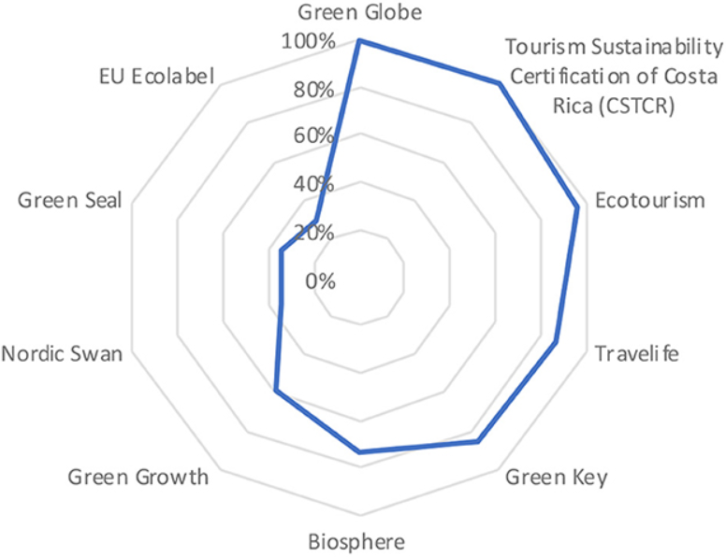
Source: Rodríguez-García et al, 2023

Appendix 2: Grootbos, South Africa.

Source: Weeva Earth, 2024

Appendix 3: Bohinj ECO Hotel, Slovenia
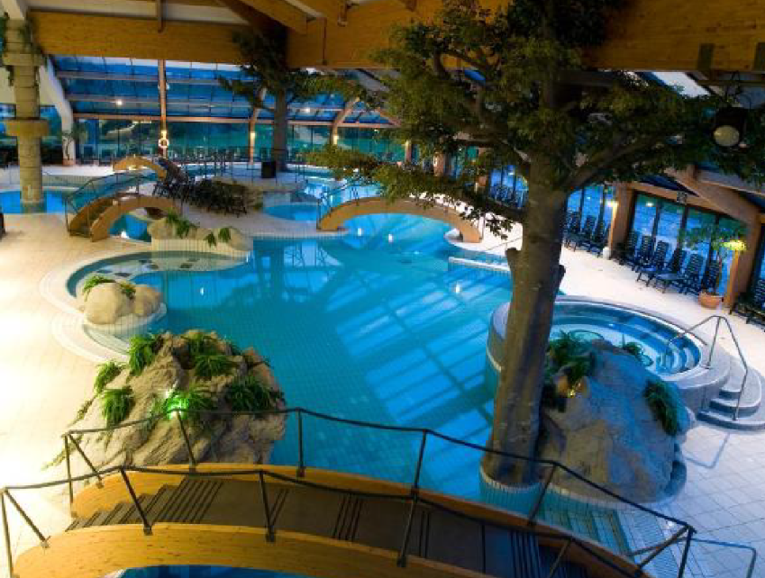
Source: Weeva Earth, 2024

Appendix 4: Six Senses Zighy Bay, Oman
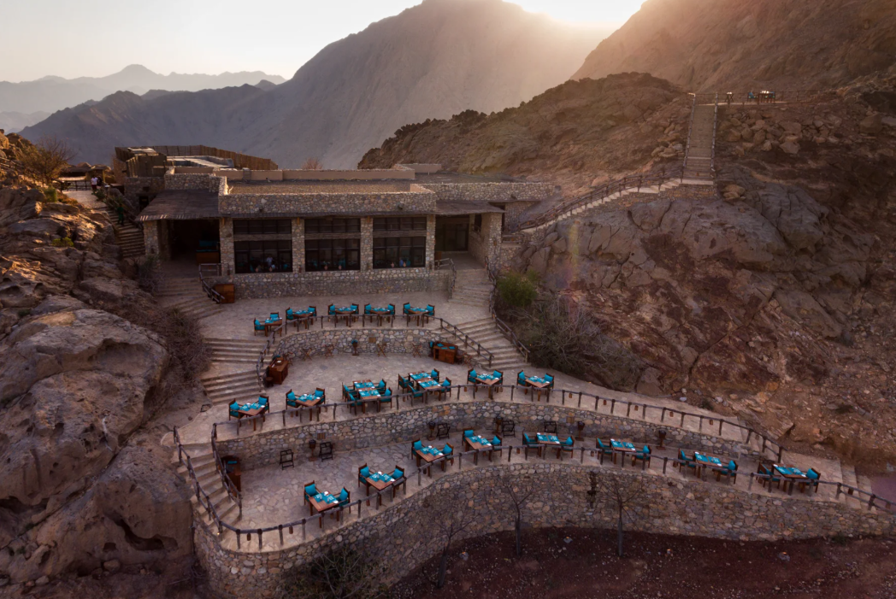
Source: Weeva Earth, 2024

Appendix 5: Cempedak, Indonesia

Source: Weeva Earth, 2024

Appendix 6: SUJÁN, India
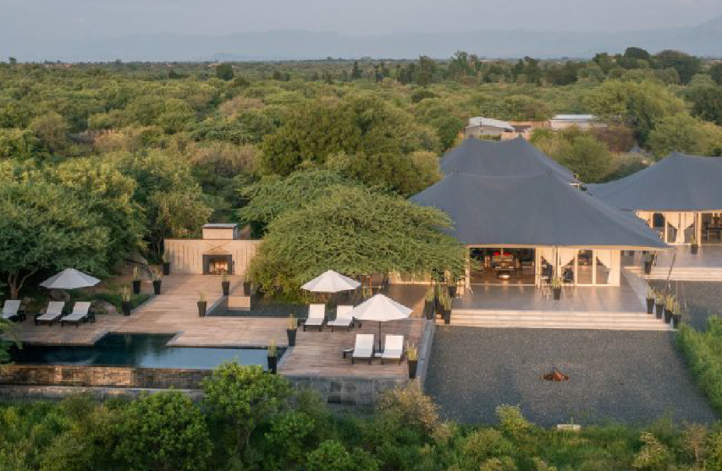
Source: Weeva Earth, 2024

