

Institute of Inner-City Learning Birmingham Campus

BSc (Hons) Health and Social Care
DISSERTATION

Disclaimer
This document was correct at the time of publication. The Module Coordinator reserves the right to modify any statement if necessary, make variations to the content or methods of delivery of programmes of study, to discontinue programmes, or merge or combine programmes if such actions are reasonably considered to be necessary by UWTSD. Every effort will be made to keep disruption to a minimum, and to give as much notice as possible. An electronic copy of this handbook can be found on the Moodle page for the module.

DECLARATION
This work has not previously been accepted in substance for any degree and is not being concurrently submitted in candidature for any degree
Signed………M.ARSHAD……………………………………
Date……………25/07/2026…………………………………
STATEMENT 1
This dissertation is being submitted in partial fulfilment of the requirements for the degree of BSc.
Signed…………M.ARSHAD ………………………………….
Date……………25/07/2026…………………………………
STATEMENT 2
This dissertation is the result of my own independent work/investigation, except where otherwise stated. Other sources are acknowledged by footnotes giving explicit references. A bibliography is appended.
Signed…………M.ARSHAD…………………………………
Date……………25/07/2026…………………………………
STATEMENT 3
I hereby give consent for my dissertation, if accepted, to be available for photocopying and for interlibrary loan, and for the title and summary to be made available to outside organisations.
Signed……………M.ARSHAD…………………………………
Date………………25/07/2026…………………………………
STATEMENT 4
I hereby give consent for my dissertation, if accepted, to be available on the university’s IT system to those who have consent to use the system.
Signed……………M.ARSHAD…………………………………
Date………………25/07/2026…………………………………

Evaluating Early Intervention for Children Aged 0–5 with Autism and Social Communication Skills in the UK

Name: Mehwish Arshad
2312904

Dissertation submitted as part of the requirements for the award BSc (Hons) Health and Social Care

ACKNOWLEDGEMENTS
I would like to express my sincere thanks to my lecturer, Chloe Harries, for her expert guidance, thoughtful feedback, and consistent support throughout this dissertation. Her advice and encouragement have been invaluable in helping me develop and complete this work.
I am also deeply grateful to my family for their endless patience, understanding, and unwavering belief in me. Their constant encouragement and support have made this journey possible, and I could not have finished this without them.

ABSTRACT
This dissertation evaluated the effectiveness of early intervention programmes in improving social communication skills among children aged 0–5 years with Autism Spectrum Disorder (ASD) in the United Kingdom. The study aimed to critically examine the evidence surrounding early intervention, identify the factors influencing its effectiveness, and explore the challenges affecting access to services. This research is important within health and social care because early intervention has the potential to improve developmental outcomes, support families, and reduce long-term inequalities through timely, evidence-based support.
A desk-based secondary research approach was adopted, using thematic analysis to examine published literature relevant to the research aim. A systematic search strategy was conducted using academic databases and reputable health sources. Studies were selected according to predefined inclusion and exclusion criteria, evaluated using the CRAAP test, and analysed following Braun and Clarke's thematic analysis framework. Three themes emerged from the analysis: the importance of early timing of intervention, parent-mediated interventions as a core effective model, and systemic barriers to access within UK services.
The findings suggested that appropriately designed early intervention is associated with improvements in social communication, adaptive functioning and developmental outcomes, particularly when delivered during early childhood. Parent-mediated interventions were found to enhance children's learning within everyday routines while increasing parental confidence and involvement. However, workforce shortages, diagnostic delays, regional inequalities and limited service capacity reduced timely access to evidence-based support, creating a gap between policy recommendations and routine practice.
The study was limited by its reliance on secondary research, the relatively small number of selected studies, variation in research designs and outcome measures, and the inclusion of some international evidence alongside UK literature. Recommendations include strengthening early identification pathways, expanding flexible parent-mediated intervention programmes, and addressing systemic inequalities through improved workforce planning, equitable service provision and greater accountability to improve outcomes for autistic children and their families.

Table of Contents
Disclaimer 1
CHAPTER 1 8
1.1 Introduction 8
1.2 Definitions and Terminology 8
1.3 Background and current context 9
1.4 Rationale for Research 11
1.5 Aim and Objectives 12
1.6 Conclusion 12
CHAPTER 2 – Background Information and Analysis 13
2.1 Introduction 13
2.2 Historical Background 13
2.3 Theoretical Background 14
2.4 International Context 16
2.5 National/Local UK Context 17
2.6 Conclusion 19
CHAPTER 3 – Methods and Search Strategy 20
3.1 – Introduction 20
3.2 – Search Strategy 20
3.3 – Searching for Information 21
3.4 – Research Validation 21
3.5 - Inclusion and Exclusion Criteria 22
3.6 – Analysing Research 22
3.7 – Ethical Considerations 23
3.8 – Chapter Conclusion 24
CHAPTER 4 – Findings and Discussion 25
4.1 – Introduction 25
4.2 – Thematic Analysis 25
4.3 – Theme 1 (Importance of Early Timing of Intervention) 25
4.4 – Theme 2 (Parent-Mediated Interventions as a Core Effective Model) 29
4.5 – Theme 3 (Systemic Barriers to Access in UK Settings) 32
4.6 – Chapter Conclusion 36
CHAPTER 5 – Conclusion and Recommendations 37
5.1 – Overall Conclusion 37
5.2 – Recommendations 37
5.2.1 – Recommendation 1 37
5.2.2 – Recommendation 2 38
5.2.3 – Recommendation 3 39
CHAPTER 6 – References and Appendices 40
6.1 – References 40
6.2 – Appendices 56

CHAPTER 1

1.1 Introduction
Autism Spectrum Disorder (ASD) is a lifelong neurodevelopmental condition characterised by persistent difficulties in social communication and interaction alongside restricted and repetitive patterns of behaviour (National Institute for Health and Care Excellence, 2021). Over recent decades, criteria and increased awareness have contributed to rising ASD prevalence (Green et al., 2022). In the United Kingdom, approximately one in 100 children is diagnosed with ASD, increasing demand for health, education and social care services and placing pressure on diagnostic pathways and early intervention (NICE, 2021).
Early childhood, particularly from birth to five years, is a critical period of brain development during which intervention may improve social communication, language, adaptive functioning and developmental outcomes (Daniolou et al., 2022; Sandbank et al., 2023). However, despite evidence supporting early intervention, there is limited consensus regarding which approaches are most effective. Differences in programme design, intensity, delivery methods and family involvement contribute to inconsistent findings across the literature.
This dissertation critically evaluates early intervention programmes for children aged 0–5 years with ASD in the United Kingdom. The study aims to identify interventions that improve social communication and inform future policy, practice and service development.

1.2 Definitions and Terminology
Defining key terminology is essential to ensure clarity and conceptual consistency throughout this dissertation. The following terms are central to the study
Autism Spectrum Disorder (ASD): A lifelong neurodevelopmental condition characterised by persistent difficulties in social communication alongside restricted and repetitive behaviours (Lord et al., 2020). This dissertation focuses on children aged 0–5 years.
Early Intervention: Evidence-based support provided during the first five years of life to improve communication, social and adaptive development (Ribeiro et al., 2022). In this study, the term refers to interventions designed to improve social communication outcomes among young children with ASD within UK health and social care services.
Social Communication Skills: Verbal and non-verbal communication used to interact with others, understand social cues and build relationships (World Health Organization, 2022). Improving these skills represents the primary outcome examined within this dissertation.
Adaptive Functioning: Practical, social and communication skills needed for everyday living and independence (Lord et al., 2020). Improvements in adaptive functioning are frequently used as indicators of successful early intervention.
Acronyms and Abbreviations
- ASD: Autism Spectrum Disorder
- NHS: National Health Service
- NICE: National Institute for Health and Care Excellence
- UK: United Kingdom
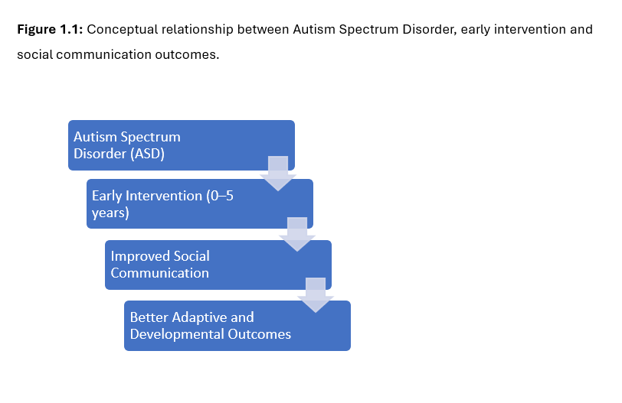
Adapted from Daniolou et al. (2022), Sandbank et al. (2023) and Lord et al. (2020).

1.3 Background and current context
Autism Spectrum Disorder (ASD) has historically been under-recognised within healthcare and educational settings, particularly during the late twentieth century. During the 1990s, limited public awareness and significant stigma surrounding neurodevelopmental conditions contributed to delayed identification and restricted access to support services (Russell et al., 2021). Consequently, many children missed opportunities to receive intervention during critical periods of neurological development, potentially affecting their long-term social communication, adaptive functioning and educational outcomes.
A significant shift occurred during the early 2000s through policy initiatives such as Every Child Matters (HM Treasury, 2003), which promoted earlier identification, multi-agency collaboration and preventative approaches to supporting children's development. These reforms shifted services towards earlier intervention and greater collaboration between health, education and social care. However, variation in service availability, local commissioning and workforce capacity continues across the UK, meaning that families do not always receive timely or consistent support.
Within the current UK context, ASD assessment and intervention are primarily delivered through the National Health Service (NHS) in accordance with National Institute for Health and Care Excellence (NICE) guidance. Although these frameworks provide evidence-based recommendations for assessment and intervention, increasing demand has placed substantial pressure on diagnostic and therapeutic services (NICE, 2021). Consequently, many families experience lengthy waiting times for diagnosis and support (Crane et al., 2016), reducing opportunities to access intervention during periods of heightened developmental plasticity. Access to early intervention also remains influenced by wider systemic factors, including workforce shortages, regional variation in service provision and socioeconomic inequalities (Russell et al., 2021). Therefore, while national policy promotes early, needs-led intervention, implementation remains inconsistent across different parts of the UK.
This context is directly relevant to the present study because programme effectiveness depends not only on intervention design but also on the healthcare systems within which interventions are delivered. Understanding this relationship is essential for evaluating UK early intervention programmes and identifying ways to improve equitable access and developmental outcomes for young children with ASD.

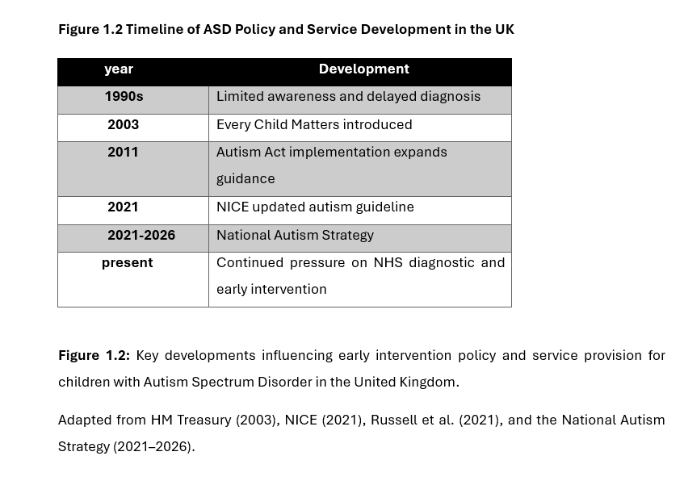

1.4 Rationale for Research
This research is justified by the increasing prevalence of Autism Spectrum Disorder (ASD) in the United Kingdom and the growing demand for effective early intervention services (Issac et al., 2025; Russell et al., 2021). ASD affects children's social communication and behaviour during early childhood, highlighting the importance of timely, evidence-based intervention (Lord et al., 2020). Although the National Autism Strategy (2021–2026) and National Institute for Health and Care Excellence (NICE, 2021) promote early identification and intervention, implementation remains inconsistent across UK health and social care services. While evidence supports the benefits of early intervention, there is limited consensus regarding which approaches are most effective for improving social communication outcomes among children aged 0–5 years (Sandbank et al., 2023). This dissertation critically evaluates current evidence to identify the strengths and limitations of existing interventions and provide evidence-based recommendations for future policy, professional practice and service development (Daniolou et al., 2022; Knapp et al., 2024). A limitation is the reliance on secondary research.

1.5 Aim and Objectives
Research Aim:
This study aims to critically evaluate the effectiveness of early intervention programmes for children aged 0-5 years with autism spectrum disorder in the UK, focusing on factors influencing improvements in social interaction and communication across health and social care settings.
Research Objectives:
- To critically define autism spectrum disorder and the significance of early intervention in children aged 0-5 years within the UK.
- Critically examine UK research evidence on how early intervention influences social communication outcomes in children aged 0–5 years with ASD.
- To critically evaluate the effectiveness and limitations of current early intervention approaches used within UK health and social care services for this age group.
- To develop evidence-based recommendations for policymakers, practitioners, and caregivers to optimise early intervention access and impact.

1.6 Conclusion
This chapter introduced Autism Spectrum Disorder (ASD) as a complex neurodevelopmental condition affecting communication, social interaction and behaviour (World Health Organisation, 2025). It highlighted the importance of early intervention during the first five years of life, when appropriately designed support is associated with improved social communication and developmental outcomes (Daniolou et al., 2022; Sandbank et al., 2023). The chapter also identified challenges within the UK, including diagnostic delays, regional inequalities and inconsistent service provision, which may limit timely access to support despite national policy commitments (Russell et al., 2021; National Institute for Health and Care Excellence, 2021). Chapter 2 critically reviews the relevant literature.

CHAPTER 2 – Background Information and Analysis

2.1 Introduction
This chapter critically reviews the literature relating to early intervention for children aged 0–5 years with Autism Spectrum Disorder (ASD). It establishes the theoretical and empirical foundation for the study by examining current evidence on the effectiveness of early intervention programmes in improving social communication outcomes. The chapter explores the historical development of autism, key theoretical perspectives, and the UK policy and practice context influencing service delivery. Although evidence suggests that early intervention is associated with improvements in communication, social interaction and adaptive functioning (Daniolou et al., 2022; Sandbank et al., 2023), findings vary according to intervention type, intensity, family involvement and implementation. Wider factors, including workforce capacity, diagnostic delays, funding and regional inequalities, may also influence access and outcomes. By critically synthesising research evidence, policy documents and professional guidance, this chapter identifies key debates and knowledge gaps, providing the conceptual foundation for the methodology, thematic analysis and discussion presented in the following chapters.

2.2 Historical Background
The understanding of Autism Spectrum Disorder (ASD) has evolved considerably, reflecting advances in scientific knowledge, changing societal attitudes and developments in diagnostic practice. Early descriptions by Leo Kanner and Hans Asperger during the mid-twentieth century distinguished autism from other childhood psychiatric conditions and laid the foundation for contemporary autism research (Jackman and Zwaigenbaum, 2023; Vicedo, 2024). However, these early classifications were based on limited scientific evidence and narrow diagnostic criteria, resulting in inconsistent recognition and understanding of ASD.
During the latter half of the twentieth century, misconceptions such as the "refrigerator mother" hypothesis incorrectly attributed autism to emotionally detached parenting. Although unsupported by empirical evidence, this theory contributed to stigma, parental blame and inappropriate clinical practice (Lang, 2025). The later shift towards neurological and genetic explanations marked a major advancement in autism research and encouraged more evidence-based approaches to diagnosis and intervention.

The introduction and revision of diagnostic frameworks, particularly the Diagnostic and Statistical Manual of Mental Disorders (DSM), broadened autism from a narrowly defined condition to a spectrum disorder recognising diverse presentations and support needs (Lang, 2025; Vicedo, 2024). While these changes improved diagnosis and access to services, they also generated debate over diagnostic consistency and whether rising prevalence reflects greater awareness, broader diagnostic criteria or a genuine increase in autism diagnoses.
Recognition of early childhood as a critical period of neurodevelopment has increased the emphasis on early intervention. Research consistently demonstrates that timely intervention improves social communication and developmental outcomes (Towle et al., 2020; Fuller and Kaiser, 2020). These findings are supported by McGlade et al. (2023), who argue that intervention effectiveness varies according to programme design, study quality and individual child characteristics. Together, the evidence suggests that early intervention is beneficial, but its success depends on the type, timing and quality of intervention delivered.
Behavioural approaches, particularly Applied Behaviour Analysis (ABA), became widely used because of their structured and measurable outcomes. However, concerns regarding behavioural conformity, limited individualisation and autistic perspectives have encouraged more naturalistic and person-centred approaches (Schuck et al., 2022). Similarly, neurodiversity-informed perspectives view autism as a natural variation in human development rather than solely a disorder requiring normalisation (Cherewick and Matergia, 2024). Overall, the historical development of ASD demonstrates a shift towards more evidence-based and person-centred practice, while continuing debate highlights the need to critically evaluate early intervention programmes for young children with ASD.

2.3 Theoretical Background
This research is underpinned by a range of theoretical perspectives that explain how early intervention may influence social communication outcomes in children with Autism Spectrum Disorder (ASD). These include developmental, behavioural, and social learning approaches, alongside the integration of person-centred care within contemporary healthcare practice.
A central framework is Developmental Theory, which emphasises early childhood (0-5 years) as a critical period for cognitive and social development due to heightened neural plasticity. This perspective is widely reflected in ASD research, where early intervention is prioritised to maximise developmental outcomes. For example, Sandbank et al. (2023) conducted a meta-analysis demonstrating that early interventions are associated with improvements in social communication, although outcomes vary significantly depending on intervention characteristics. Similarly, Daniolou et al. (2022) highlighted that earlier intervention is linked to more favourable developmental trajectories. Green et al. (2022) extend this argument by emphasising that current autism service pathways remain largely reactive and diagnosis-led, highlighting the need for earlier, integrated and proactive intervention systems aligned with developmental principles. However, while developmental theory effectively justifies the importance of early timing, it has been criticised for adopting a generalised view of development that may not fully account for the heterogeneity and individual variability seen in children with ASD.
In addition, Social Learning Theory provides a framework for understanding how children acquire social and communicative behaviours through observation, imitation, and interaction. This theory has been applied extensively in early intervention research, particularly in parent-mediated and naturalistic developmental behavioural interventions (NDBIs), where caregivers model and reinforce communication behaviours. Research suggests that such approaches can improve joint attention and social engagement in young children with ASD. Alkinja and Pereira (2022) further support this by demonstrating that structured interventions incorporating modelling and social stories can improve social communication skills in children with ASD, highlighting the practical effectiveness of social learning–based approaches. However, critics argue that social learning theory may have limitations in this context, as children with ASD may experience difficulties with attention, imitation, and social reciprocity, which can reduce the effectiveness of observational learning compared to typically developing peers.
Furthermore, Behaviourism underpins structured interventions such as Applied Behaviour Analysis (ABA), which utilises reinforcement to increase desired behaviours. More recently, Naturalistic Developmental Behavioural Interventions (NDBIs) have been proposed as a bridge between behavioural and developmental approaches, aligning structured intervention techniques with a neurodiversity-informed perspective that emphasises quality of life and individual strengths (Schuck et al., 2022). Behaviourist approaches have been widely implemented and evaluated within ASD research, with evidence indicating measurable improvements in communication and behavioural outcomes (Sandbank et al., 2023). Despite this, ABA and similar approaches have been subject to ongoing debate, with some researchers highlighting concerns regarding their repetitive nature and potential lack of individualisation. These criticisms suggest that while behaviourism provides a clear and measurable framework for intervention, it may not fully address the complex and diverse needs of children with ASD.

Figure 2.1 Theoretical Framework Underpinning Early Intervention
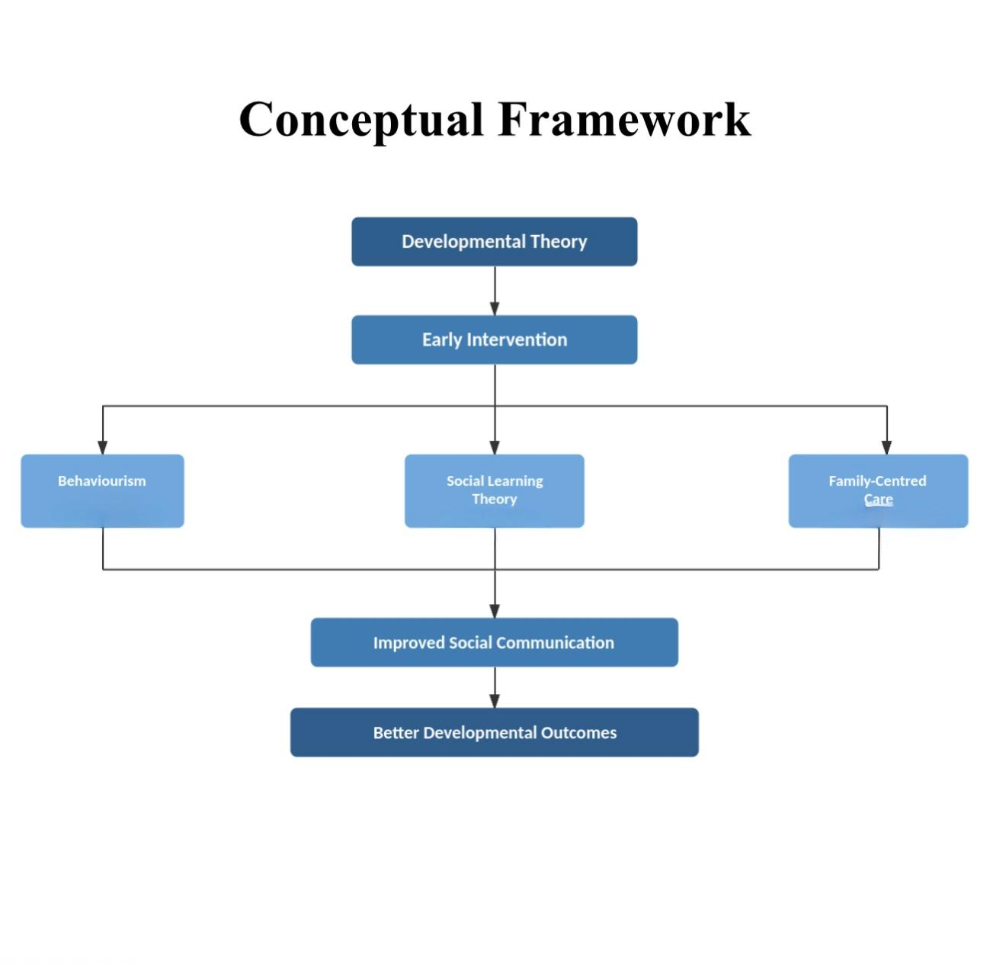
Developed by the researcher and adapted from Bandura (1977); Daniolou et al. (2022); Sandbank et al. (2023); Schuck et al. (2022).

2.4 International Context
Global Perspective
Autism Spectrum Disorder (ASD) and early intervention for children aged 0–5 years are increasingly recognised as global public health priorities because early childhood is a critical period of development. During this stage, heightened neuroplasticity may enable appropriately designed intervention to improve social communication, cognitive development and adaptive functioning. The World Health Organization (2025) identifies autism as a developmental condition requiring early identification and timely access to appropriate support services.
Evidence from systematic reviews suggests that early intervention is associated with improvements in developmental outcomes, particularly when delivered during the preschool years (Franz et al., 2022; Daniolou, Pandis and Znoj, 2022). Maksimović et al. (2023) similarly reported that earlier intervention may contribute to improved language and communication outcomes. However, differences in intervention models and healthcare systems indicate that effectiveness varies with programme quality and service delivery rather than with intervention timing alone (Franz et al., 2022; World Health Organization, 2025).

Comparative Analysis
Comparative evidence demonstrates that healthcare systems influence access to early intervention. In the United States, a mixed public–private healthcare system contributes to fragmented provision, with access often influenced by socioeconomic status despite national early intervention legislation (Vilches et al., 2023). Canada's publicly funded healthcare system aims to provide universal access, although workforce shortages and geographical inequalities continue to affect service delivery. Similarly, Australia's National Disability Insurance Scheme (NDIS) has expanded individualised support, but families continue to report challenges relating to system complexity and variation in service quality (Jha and Jha, 2025). Collectively, these examples suggest that policy alone does not ensure equitable access where workforce and service capacity remain constrained.

Case Studies
International case studies further illustrate both progress and continuing challenges. In the United States, parent-mediated interventions have been associated with improvements in children's social communication, although socioeconomic, racial, and geographical inequalities continue to influence access to services (Deniz et al., 2024; Shenouda et al., 2022). In Australia, the NDIS has improved access for many families, but implementation challenges remain (Gavidia-Payne, 2020). In India, community-based and parent-led interventions demonstrate that effective support may be delivered in lower-resource settings, although long-term sustainability depends on continued workforce development and policy investment (Dey et al., 2024). Collectively, this international evidence provides supporting insight rather than direct evidence of UK services, highlighting that the effectiveness of early intervention is influenced by both intervention design and healthcare system capacity.

2.5 National/Local UK Context
Within the United Kingdom, Autism Spectrum Disorder (ASD) in children aged 0–5 years is increasingly recognised as an important area of early childhood development and public health (World Health Organization, 2025). Early identification and intervention are prioritised because the first five years of life represent a period of heightened developmental plasticity, during which appropriately designed support may improve social communication and adaptive functioning (Sandbank et al., 2023; Daniolou et al., 2022). The UK adopts a multidisciplinary, family-centred approach involving health, education and social care professionals working together to support children and their families.
Although early intervention is widely recognised as beneficial, increasing demand for autism services has placed considerable pressure on diagnostic and intervention pathways. Evidence indicates that many children continue to experience delays in assessment and access to support, reducing opportunities to receive intervention during the early developmental period (Russell et al., 2021).

Policy and Regulation

Early intervention is supported by national legislation and clinical guidance. The National Institute for Health and Care Excellence (NICE, 2021) provides evidence-based recommendations for autism identification, diagnosis and early support, promoting a needs-led approach that encourages intervention based on developmental concerns rather than waiting for a formal diagnosis. The Autism Act 2009 established statutory responsibilities for improving autism services, while the NHS Long Term Plan (2019) and the National Autism Strategy (2021–2026) aim to improve diagnostic pathways and reduce waiting times (NHS England, 2023).

Despite these policy commitments, implementation remains inconsistent. NHS England (2023) reported that by July 2022 more than 125,000 people were waiting for autism assessment, reflecting increasing demand and continued pressure on NHS services. These findings suggest that workforce capacity, funding and service availability continue to influence timely access to early intervention.

Local Context
At the local level, early intervention services vary across the UK because commissioning arrangements differ between local authorities and Integrated Care Systems. This has contributed to regional inequalities, often described as a postcode lottery, where access to assessment and intervention may depend on geographical location rather than clinical need (Smith, 2023). Workforce shortages, funding constraints and variation in local service provision continue to influence the availability of parent support programmes and specialist services (Babalola et al., 2025).
Furthermore, devolved healthcare systems in Scotland, Wales and Northern Ireland introduce additional variation in policy implementation and service organisation (Warnock, 2025). While the principles of early intervention are shared across the UK, differences in local delivery mean that families' experiences and access to services may vary considerably. These findings highlight that the effectiveness of early intervention depends not only on intervention design but also on the capacity of health and social care systems to deliver timely and equitable support.

2.6 Conclusion

In conclusion, this chapter critically reviewed the literature relating to early intervention for children aged 0–5 years with Autism Spectrum Disorder (ASD). The evidence suggests that appropriately designed early intervention is associated with improvements in social communication, language development and adaptive functioning, particularly when provided during the preschool years (Fuller and Kaiser, 2020; Franz et al., 2022; McGlade et al., 2023). However, outcomes vary according to intervention type, implementation quality and access to services. Within the UK, diagnostic delays, workforce pressures and regional variation continue to limit timely access despite national policy commitments (Green et al., 2022; NHS, 2026). The literature also highlights increasing recognition of neurodiversity-informed and family-centred approaches that support individual strengths and needs (Cherewick and Matergia, 2024). These findings provide the theoretical and empirical foundation for Chapter 3, which outlines the methodology used to identify, evaluate and analyse the evidence included in this dissertation.

CHAPTER 3 – Methods and Search Strategy

3.1 – Introduction
This chapter outlines the systematic, desk-based secondary research methodology used to explore the effectiveness of early intervention programmes in improving social and communication skills for children aged 0–5 years with Autism Spectrum Disorder (ASD) in the UK. The study relies entirely on existing literature and does not involve primary data collection. It expands on the academic methodology poster, detailing the search strategy, inclusion and exclusion criteria, validation process, and thematic analysis. These methods were selected because they provide a transparent, rigorous, and replicable approach to identifying and synthesising existing evidence relevant to the research question (Saunders and Lewis, 2017). This methodological approach enables the critical analysis of literature that underpins the thematic findings presented in Chapter 4, ensuring the evidence directly addresses the study's aims and objectives.

3.2 – Search Strategy
The search strategy was systematically developed from the research question, focusing on key concepts including Autism Spectrum Disorder (ASD), early intervention, and early childhood development (0-5 years).
• Developing Keywords:
Terms included autism spectrum disorder, early intervention, 0–5 years, preschool, UK, effectiveness and outcomes. Synonyms included early support and developmental intervention.
• Boolean Operators:
Boolean operators were used to refine the search strategy, as outlined by Aveyard (2014) and Cottrell (2017). For example, the search string ("Autism Spectrum Disorder" OR ASD) AND ("early intervention") AND ("United Kingdom" OR UK) AND ("social communication") was used to identify studies relevant to the research aim. AND combined key concepts, OR included synonyms, and NOT excluded irrelevant populations such as adults or non-ASD developmental conditions, improving the precision and relevance of the search results.
• Structured Search Plan:
This approach is supported by Aveyard (2014, pp.143–156). These methods informed the thematic findings presented in Chapter 4.

– Searching for Information

• Databases and Platforms:
Literature and evidence were retrieved from databases selected for their relevance to child development and UK policy. These included Google Scholar, the UWTSD Library database, Social Care Online, and NICE Evidence/NHS Evidence. These sources provide access to peer-reviewed research, clinical guidelines and policy documents on early intervention for children with ASD in the UK. The CRAAP Test was used to evaluate the credibility of all sources. Searches prioritised peer-reviewed journals, including SAGE Journals, European Psychologist, Child and Adolescent Psychiatry and Mental Health, Journal of Intellectual Disabilities, and Journal of Child Psychology and Psychiatry (Aveyard, 2014), ensuring the evidence was current, reliable and academically robust.

• Using Filters:
Search filters were applied to improve relevance and quality. These included publication dates between 2016 and 2026, peer-reviewed articles only, English-language publications, and studies focusing on children aged 0–5 years. Priority was given to UK-based research to ensure relevance to the NHS and UK social care systems.
• Search Process:
Search terms were refined iteratively where initial results were too broad or irrelevant. Adjustments included adding synonyms and narrowing key terms to improve specificity. All search outcomes were recorded in a Source Tracking Table (Appendix 1), creating an audit trail and improving reproducibility.

– Research Validation
• Skimming Techniques:
Each article was initially screened by reviewing its title, abstract, introduction and conclusion to assess relevance. This enabled irrelevant studies to be excluded before applying the CRAAP Test to evaluate the quality and credibility of the remaining sources (Aveyard, 2014; Chalkley, 2024).
• CRAAP Test Application:
Currency: prioritised recent publications (2016-2026), though key reviews from 2018 were retained where still widely cited in current guidance.
Relevance: checked direct link to early intervention for children with ASD aged 0-5 years.
Authority: confirmed authors were qualified researchers, and journals were peer-reviewed and recognised in the field.
Accuracy: assessed clarity of methods, data support and consistency with wider evidence.
Purpose: ensured research was objective, free from commercial bias or advocacy agendas.
The CRAAP test was applied to all selected sources to assess their Currency, Relevance, Authority, Accuracy, and Purpose. All articles achieved high scores, with particular attention given to Currency, Relevance, and Authority to ensure the literature was current, credible, and directly related to the research topic.
• Decision-Making:
Zhu et al. (2026) and the National Autistic Society (2026) met all CRAAP criteria and were included because they provided recent, authoritative and relevant evidence supporting this study.

- Inclusion and Exclusion Criteria
• Inclusion Criteria:
Peer-reviewed journal articles published between 2016 and 2026, written in English, and focusing on Autism Spectrum Disorder, early intervention, and children aged 0–5 years were included. UK-based studies were prioritised to ensure relevance to health and social care practice.
• Exclusion Criteria:
Non-peer-reviewed sources, studies published before 2016, non-English publications, research involving adults or older children, and studies not directly related to ASD or early intervention were excluded.
• Justification:
These criteria ensured that only current, high-quality and relevant evidence was included while reducing the risk of bias from outdated or unreliable sources. Restricting studies by publication date, participant age, language and relevance to ASD strengthened the credibility of the review and ensured the selected evidence remained closely aligned with the research aim.

– Analysing Research

• Thematic Coding Approach:
Thematic analysis was selected because it provides a flexible and systematic approach for identifying, organising and interpreting patterns across multiple studies. This method is widely used in health and social care research and was appropriate for synthesising evidence on early intervention for children with ASD, following Braun and Clarke (2006).

• Developing Themes:
Each study was coded to identify recurring concepts and key findings. Similar codes were grouped using colour coding to identify patterns across the literature. This process resulted in three themes: the importance of early timing of intervention, parent-mediated interventions, and systemic barriers to access in UK settings.
• Organisation:
A Results Summary Table (Appendix 2) compared study methodology, strengths, limitations and findings. The coding process and Results Summary Table informed the development of the three themes presented in Chapter 4, providing a clear link between the methodology and study findings.

– Ethical Considerations

• Secondary Research Ethics:
This study was based entirely on existing, publicly available, published research sources. No new data collection took place, and no contact with participants, service users or professionals was required, so there was no risk of harm, privacy breach or consent issues related to primary research.
Despite the absence of primary data collection, the research adhered to the principles of the General Data Protection Regulation (GDPR) and the Data Protection Act 2018. As all data used were publicly available, no personal or sensitive data were processed or stored (National Data Guardian, 2024)

• Academic Integrity:
All sources were accurately cited and referenced consistently using the Harvard referencing style, ensuring no plagiarism or misrepresentation of others' work.
• Transparency and Credibility:
Literature was selected, analysed and presented fairly, without bias, and limitations of each study (including the UK context) were clearly noted to ensure an objective review of evidence.

3.8 – Chapter Conclusion

• Summary:
This chapter outlined the methodology used to identify, evaluate and analyse the selected literature. It described the search strategy, inclusion and exclusion criteria, validation using the CRAAP Test, and the thematic analysis process used to identify recurring patterns across the evidence. The Results Summary Table and colour coding provided a transparent and systematic approach to developing the three themes presented in Chapter 4, ensuring the research was rigorous, credible and replicable (Braun and Clarke, 2006; Aveyard, 2014). Ethical considerations, including compliance with GDPR principles, further supported the integrity of the research process.
• Link to Next Chapter:
The five selected articles provided a reliable evidence base, combining UK-specific research with relevant international evidence. Chapter 4 builds on this methodology by critically examining the three themes to evaluate the effectiveness of early intervention programmes for children aged 0–5 years with ASD in the UK.

CHAPTER 4 – Findings and Discussion

4.1 – Introduction

This chapter presents and critically discusses the key findings from the desk-based secondary research using thematic analysis of the selected literature, in response to the research question: How effective are early intervention programmes in improving social and communication skills for children aged 0–5 years with Autism Spectrum Disorder in the UK? It draws on the method of thematic analysis outlined in Chapter 3, exploring three core themes: the critical early window for intervention, the effectiveness of parent‑mediated models, and systemic barriers to access. Findings are compared across studies, linked to UK policy and practice, and signposted to the implications discussed in Chapter 5 (Sandbank et al., 2023; Vivanti et al., 2018; NHS England, 2023).

4.2 – Thematic Analysis

• Definition of Thematic Analysis:
Thematic analysis is a systematic method for identifying, organising, and interpreting patterns of meaning across synthesised data (Braun and Clarke, 2006). For this secondary research study, this approach was used to draw together consistent concepts, conflicting evidence, and UK‑specific insights from the selected literature, following the process outlined in Chapter 3.

• Link to Coding/Results Table:
Initial open coding identified 5 distinct concepts, which were refined into three overarching themes: Timing and the Critical Early Window, Parent‑Mediated Interventions as a Core Effective Model, and Systemic Barriers to Access in UK Settings. Full details of the coding process, colour‑coded grouping, and theme development are provided in the Results Summary Table (Appendix 2). This method enabled a structured comparison of evidence, ensuring the discussion remained grounded in the data while directly addressing the research question.

4.3 – Theme 1 (Importance of Early Timing of Intervention)

The timing of intervention is widely recognised as one of the most important factors influencing developmental outcomes for children with Autism Spectrum Disorder (ASD). Early intervention delivered during the first five years of life can improve social communication, language development and adaptive functioning by taking advantage of the increased neuroplasticity that characterises early childhood (Lord et al., 2020). In the UK, the National Institute for Health and Care Excellence (NICE, 2021) recommends that children with suspected or diagnosed autism should have timely access to appropriate support and interventions based on their individual needs. This theme critically examines the importance of initiating intervention as early as possible by comparing evidence from the selected studies and considering its implications for UK health and social care practice.

Definition
Early intervention for Autism Spectrum Disorder (ASD) refers to structured, evidence-based support delivered during the first five years of life to enhance communication, social interaction, adaptive functioning, and long-term developmental outcomes. NICE (2021) recommends that children should receive timely, individualised support based on developmental needs, while Lord et al. (2020) explain that early intervention is underpinned by neuroplasticity, whereby the developing brain is particularly responsive to environmental experiences during early childhood. Within this dissertation, early timing is therefore conceptualised as an important factor influencing intervention effectiveness because earlier intervention may take advantage of heightened developmental plasticity, although children can continue to benefit from appropriate support beyond the early years.

Background Information
Historically, autism interventions were often introduced only after a child had received a formal diagnosis, with support commonly beginning during the early school years. However, advances in autism research and developmental neuroscience have shifted professional practice towards providing intervention as early as possible to maximise children's developmental potential (Lord et al., 2020; NICE, 2021).
The first five years of life represent a critical period of rapid brain development, particularly in language acquisition, social communication and cognitive functioning (Lord et al., 2020; French and Kennedy, 2018). Earlier intervention may take advantage of this heightened developmental plasticity, although children can continue to benefit from appropriate support beyond the early years.
Evidence suggests that timing alone does not determine intervention success. Whitehouse et al. (2019) reported improvements in social communication and engagement among children who received intervention before diagnosis. However, Han et al. (2026) found that outcomes varied by intervention type, intensity, and methodological quality. This indicates that effectiveness depends not only on when support begins but also on how intervention programmes are delivered, implemented and sustained.

Impact on Research Question
This theme is central to the research question because it demonstrates that the effectiveness of early intervention programmes cannot be separated from the timing of support. The literature consistently indicates that interventions introduced during the first five years of life are associated with greater improvements in social communication, language development and adaptive functioning than those delivered later (Whitehouse et al., 2019; Lord et al., 2020). However, the evidence also suggests that timing alone does not determine effectiveness. Han et al. (2026) argue that differences in intervention quality, intensity and implementation contribute to variations in outcomes across studies. Similarly, Hosozawa et al. (2020) found that delayed diagnosis limits access to early intervention, reducing opportunities to achieve optimal developmental gains. Therefore, timing should be considered a key analytical factor when evaluating the effectiveness of interventions, alongside the quality and accessibility of support provided to children aged 0–5 years with ASD.

Connections to Other Themes
This theme underpins the dissertation by establishing the importance of early timing in intervention effectiveness. It links directly to Theme 2, as parent-mediated interventions depend on early identification to support families during critical stages of child development. It also connects to Theme 3, where diagnostic delays, workforce shortages and regional inequalities limit timely access to services. Together, these themes demonstrate that intervention effectiveness depends not only on the support provided but also on timely and equitable access to evidence-based services within the UK (House of Commons Library, 2025; NHS England, 2023).

Statistical Information
Evidence highlights a clear mismatch between the recommended timing of early intervention and actual service delivery. Using data from the UK Millennium Cohort Study, Hosozawa et al. (2020) reported that approximately 79% of children with ASD received their diagnosis after the age of five. As a result, many children may miss the developmental period during which early intervention is considered most beneficial (Lord et al., 2020).
However, this finding should be interpreted cautiously because the study did not distinguish between delays in parental recognition of developmental concerns, referral waiting times, or the diagnostic assessment process. Despite this limitation, the findings suggest that delays occur at multiple stages of the care pathway.
Hosozawa et al. (2020) also identified socioeconomic disadvantage, limited parental awareness and restricted diagnostic capacity as important factors associated with delayed diagnosis. These findings indicate that access to early intervention is influenced by wider structural factors rather than individual circumstances alone. Similar concerns are reported in recent national evidence highlighting increasing referrals and continued pressure on autism assessment services across England (House of Commons Library, 2025; NHS England Digital, 2025).

Theories, Policies, and Legislation
The theoretical foundation for early intervention is grounded in neuroplasticity and developmental theory. Neuroplasticity proposes that the developing brain is particularly responsive to environmental experiences during early childhood, meaning intervention delivered during sensitive developmental periods has greater potential to improve social communication and adaptive functioning (Dawson, 2008; Lord et al., 2020). Han et al. (2026) support this perspective, reporting that interventions initiated before the age of two were often associated with greater improvements in communication and adaptive behaviour. However, the review also found that outcomes varied according to intervention type, intensity, implementation quality and individual child needs. However, their review also found considerable variation in outcomes between studies, indicating that the quality, intensity and implementation of interventions are equally important in determining effectiveness.
From a policy perspective, NHS England (2023) guidelines recommend that support should begin as soon as developmental needs are identified, regardless of diagnostic confirmation. Similarly, the Early Help and Think Family frameworks promote early, preventative intervention. However, there is a clear implementation gap, as workforce shortages, long diagnostic waiting times, and service constraints mean that access to early intervention is often delayed in practice, limiting policy effectiveness. Recent policy developments also emphasise improving SEND provision and strengthening early intervention pathways through integrated health and education services (Department for Education, 2026; Powell et al., 2021).

Implications
The evidence demonstrates strong positive implications of early intervention when delivered at the appropriate developmental stage. Whitehouse et al. (2019) provide high-quality experimental evidence through a randomised controlled trial of infants aged 9–14 months, showing improved social communication and engagement following pre-diagnostic intervention. While this supports causal inference, the short follow-up period limits understanding of long-term sustainability.
Similarly, Han et al. (2026) synthesise multiple studies and confirm that earlier intervention, particularly before age two, is associated with the strongest developmental gains. However, they also highlight heterogeneity in intervention design and outcome measures, limiting comparability across studies.
Conversely, Zhu et al. (2026) identify systemic barriers such as delayed referral pathways and service capacity limitations, demonstrating that although early intervention is effective in controlled settings, real-world implementation is constrained. This highlights a key distinction between efficacy (what works in research) and effectiveness (what works in practice).
Overall, the evidence indicates that earlier intervention improves outcomes, but systemic constraints limit equitable access during the critical developmental window.
Furthermore, Vivanti et al. (2018) argue that future improvements in outcomes depend not only on developing effective intervention models but also on ensuring consistent implementation, workforce training and evaluation within routine clinical practice.

Examples from Your Articles
Whitehouse et al. (2019) provide experimental evidence from a randomised controlled trial showing that intervention delivered between 9 and 14 months improved early social communication compared with standard care, supporting intervention before formal diagnosis. Han et al. (2026) similarly found that intervention before two years of age was associated with greater improvements in communication and adaptive functioning. However, variation in intervention design reduced comparability across studies. Hosozawa et al. (2020) reported that approximately 79% of autistic children in the UK are diagnosed after five years of age, reducing opportunities for timely intervention. Together, these studies highlight the gap between research evidence and routine clinical practice.

4.4 – Theme 2 (Parent-Mediated Interventions as a Core Effective Model)

Definition
Parent-mediated interventions refer to structured, evidence-based approaches in which parents or primary caregivers are trained to deliver therapeutic strategies within everyday routines, enabling children with autism spectrum disorder (ASD) to practise communication, social interaction and adaptive skills in natural environments (Dawson-Squibb et al., 2018; Oono, Honey and McConachie, 2016; Althoff, Dammann and Ausderau, 2019).Unlike clinician-led interventions delivered solely within healthcare settings, parent-mediated approaches position caregivers as active partners in intervention delivery. This reflects a family-centred model of care that recognises parents as the individuals who spend the most time with their child during the critical period of early neurodevelopment.
Naturalistic Developmental Behavioural Interventions (NDBIs) represent one of the most widely used parent-mediated approaches, integrating behavioural and developmental principles into everyday activities to enhance communication, play and social engagement (Minjarez et al., 2020).

Background Information
Parent-mediated approaches have developed alongside a shift from clinic-based autism interventions towards more family-centred models. Historically, early ASD interventions were delivered mainly by professionals in structured settings. However, recognition of the importance of generalising skills to everyday life has increased emphasis on caregiver involvement. Schertz et al. (2018) showed that coaching parents to use responsive communication strategies during daily interactions improved toddlers' social communication, supporting early caregiver involvement (Deniz et al., 2024; Oono, Honey and McConachie, 2016; Althoff, Dammann and Ausderau, 2019).
In the UK, programmes such as EarlyBird Plus and other parent-training models were introduced to improve early access to support while responding to increasing service demand. Palmer et al. (2020) found that families participating in the National Autistic Society's EarlyBird programme reported improved parental confidence, understanding of autism and ability to support their child's communication. This reflects a wider policy shift towards supporting parents to reinforce agreed strategies within everyday routines under professional guidance, particularly as demand for ASD services continues to increase (Dawson-Squibb et al., 2018; Dillenburger, 2026).

Impact on Research Question
This theme directly addresses the research question by demonstrating that parent-mediated intervention represents one of the principal mechanisms through which effective early intervention can be delivered during the first five years of life. Across the included studies, involving parents consistently increased opportunities for children to engage in therapeutic interactions within familiar environments, thereby promoting greater intervention intensity and continuity than clinic-based approaches alone (Conti et al., 2026; Althoff, Dammann and Ausderau, 2019).

However, the evidence also demonstrates that parent-mediated intervention should not be viewed as universally effective in isolation. Instead, its success is dependent upon the quality of parent education, ongoing professional coaching and timely access to services. Consequently, the effectiveness of parent-mediated intervention is shaped not only by intervention design but also by the wider healthcare system responsible for supporting families throughout the intervention pathway.

Statistical Information
Evidence from Dawson-Squibb et al. (2018) demonstrates the widespread implementation of EarlyBird and EarlyBird Plus across the UK, with over 27,000 families participating. Reported outcomes included improved parental confidence, greater understanding of autism, and enhanced parent-child interaction and children's social communication (Dawson-Squibb et al., 2018; Dillenburger, 2026).
Similarly, Whitehouse et al. (2019) found that infants receiving the iBASIS-VIPP parent-mediated intervention showed greater improvements in early social communication and autism-related behaviours than those receiving usual care. However, Han et al. (2026) reported variation across studies, concluding that although parent-mediated interventions generally improve adaptive behaviour and social communication, evidence for language development and behavioural regulation remains inconsistent. This suggests that effectiveness depends on implementation quality as well as the intervention model (Han et al., 2026; Conti et al., 2026).

Theories, Policies, and Legislation
The theoretical foundations of parent-mediated intervention are supported by social learning theory and transactional models of child development, both of which emphasise that development occurs through repeated interactions between children and their caregivers. Within these frameworks, improving parental responsiveness and communication strategies can positively influence children’s developmental trajectories by providing consistent opportunities for learning embedded in everyday routines (Pickles et al., 2016; Conti et al., 2026).
These theoretical perspectives align closely with current UK policy. NICE (2023) recommends that autistic children receive personalised, family-centred intervention as early as developmental concerns are identified, while the SEND Code of Practice (Department for Education and Department of Health, 2015) advocates collaborative working between professionals and families throughout assessment and intervention planning. Despite these recommendations, the included studies suggest that implementation remains inconsistent due to workforce shortages, regional variation in service provision, and limited professional capacity.

Implications
The evidence indicates that parent-mediated interventions can improve children's social communication while increasing parental confidence and understanding of autism (Althoff, Dammann and Ausderau, 2019; Conti et al., 2026). Whitehouse et al. (2019) provide strong evidence from a randomised controlled trial showing improved social engagement following pre-emptive parent coaching. Similarly, Pickles et al. (2016) found sustained improvements in parent-child social communication and reduced autism symptom severity. Long-term follow-up showed these benefits continued into mid-childhood, suggesting early parent-mediated intervention may have lasting developmental effects (Carruthers et al., 2024). Together, these findings suggest caregiver involvement during infancy may positively influence developmental outcomes.
However, important limitations remain. Han et al. (2026) found that intervention outcomes varied across developmental domains, with stronger evidence for social communication than language development or behavioural regulation. This indicates that parent-mediated intervention should not be viewed as a universal solution (Han et al., 2026; Sandbank et al., 2023).
Furthermore, Zhu et al. (2026) argued that effectiveness depends on continued professional support. Although parents can develop intervention skills through structured training, maintaining intervention quality requires ongoing coaching and specialist guidance (Dillenburger, 2026). In addition, work commitments, caring responsibilities, parental wellbeing, language needs and access to professional support may affect participation. These findings highlight the difference between intervention efficacy under research conditions and its implementation in everyday practice.

Examples from Your Articles
Whitehouse et al. (2019) provide strong experimental evidence for parent-mediated intervention, reporting improved social communication among infants receiving iBASIS-VIPP compared with usual care. Their findings suggest intervention before formal diagnosis may positively influence development during periods of heightened neuroplasticity.
Dawson-Squibb et al. (2018) support these findings by demonstrating the successful implementation of parent-mediated programmes in the UK. Although methodological limitations remain, the widespread use of EarlyBird programmes suggests caregiver training is feasible within routine services (Dawson-Squibb et al., 2018; Dillenburger, 2026).
Han et al. (2026) reported consistent improvements in adaptive functioning and social communication across intervention models, while acknowledging variation between studies. Zhu et al. (2026) identified workforce shortages, funding constraints and fragmented services as barriers to implementation. Together, these studies suggest parent-mediated interventions can be effective, but their success depends on the wider healthcare system supporting families.

Connections to Other Themes
This theme is closely linked to Theme 1, as early identification enables families to access parent-mediated interventions during critical stages of child development. Delays in recognising autism reduce opportunities for early caregiver involvement.
It also links to Theme 3, as workforce shortages, funding constraints and regional inequalities affect access to parent programmes and ongoing professional support. Consequently, the effectiveness of parent-mediated interventions depends not only on the intervention itself but also on the wider health and education systems delivering autism services.

4.5 – Theme 3 (Systemic Barriers to Access in UK Settings)

Definition
Systemic barriers refer to structural, organisational and resource-related factors that prevent individuals from accessing healthcare services regardless of clinical need (Zhu et al., 2026). Within autism spectrum disorder (ASD) services, these barriers influence every stage of the care pathway, including early identification, referral, diagnostic assessment and access to intervention. These barriers arise from the organisation and capacity of health, education and social care systems and determine whether children receive timely evidence-based intervention.
The findings of this review indicate that although effective early intervention models are increasingly available, access to these interventions remains inconsistent (Han et al., 2026; Zhu et al., 2026). Therefore, understanding systemic barriers is essential to answering the research question, as intervention effectiveness depends not only on the quality of the intervention itself but also on whether services are able to provide timely and equitable access.

Background Information

Over the past two decades, awareness of ASD has increased substantially, leading to greater demand for diagnostic and early intervention services across the United Kingdom (Lord et al., 2020; Hosozawa et al., 2020). While this has improved recognition of developmental differences, service capacity has not expanded at the same pace. As a result, diagnostic teams, community paediatric services and specialist early intervention providers have experienced increasing pressure, contributing to lengthy waiting times and variation in service provision across regions (House of Commons Library, 2025; NHS England, 2023).
Historically, many families have experienced pathways in which access to specialist intervention was closely linked to obtaining a formal diagnosis. More recent UK guidance has shifted towards a needs-led approach, encouraging professionals to provide support when developmental concerns are identified rather than waiting for diagnostic confirmation (NICE, 2021; NHS England, 2023). Despite this policy direction, the evidence reviewed in this dissertation suggests that many families continue to experience delays between recognising developmental concerns and receiving appropriate intervention (Hosozawa et al., 2020; House of Commons Library, 2025). A gap remains between policy recommendations and everyday clinical practice.

Impact on Research Question

This theme is central to the research question because it demonstrates that intervention effectiveness cannot be considered independently from service delivery. While Themes 1 and 2 establish that early intervention and parent-mediated approaches can improve developmental outcomes, Theme 3 explains why many children do not receive these interventions during the period when they are likely to be most beneficial.
Across the included studies, there is consistent agreement that delays in diagnosis, workforce shortages, limited funding and inconsistent service provision reduce opportunities for children to access evidence-based support (Hosozawa et al., 2020; Zhu et al., 2026; Han et al., 2026). Consequently, the key challenge is ensuring effective interventions are delivered early enough to improve developmental outcomes, highlighting the gap between intervention efficacy and implementation.

Statistical Information

Hosozawa et al. (2020) provide the strongest UK evidence regarding diagnostic access by analysing data from the Millennium Cohort Study. Their findings indicate that approximately 79% of children with ASD received their diagnosis after five years of age, meaning that many children missed the developmental period during which early intervention is believed to be most effective. Diagnostic timing was associated with socioeconomic disadvantage, showing that access to early intervention is influenced by wider social inequalities (Hosozawa et al., 2020). Kelly et al. (2019) similarly identified socioeconomic inequalities affecting autism diagnosis among UK children, suggesting that children from disadvantaged backgrounds continue to experience reduced access to assessment and early intervention services.
These findings are consistent with the wider literature demonstrating substantial variation in waiting times and access to specialist services across the UK (House of Commons Library, 2025; NHS England Digital, 2025). Although parent-mediated programmes such as EarlyBird have reached thousands of families (Dawson-Squibb et al., 2018), national availability remains inconsistent, limiting equitable access. Sapiets et al. (2022) similarly reported that 75.5% of families identified an unmet need for early support, highlighting a substantial mismatch between service availability and demand for early intervention.

Theories, Policies, and Legislation

From a theoretical perspective, systems theory and implementation science frameworks explain how structural factors influence service delivery outcomes. These models emphasise that effectiveness is dependent on system capacity, not just intervention design (Vivanti et al., 2018; Zhu et al., 2026).
Policy frameworks such as NICE (2023) and the SEND Code of Practice (Department for Education and Department of Health, 2015) advocate early, needs-led intervention. However, the literature consistently demonstrates a gap between policy and practice, as waiting lists, workforce shortages, local commissioning arrangements and limited specialist provision continue to restrict timely access to services (NHS England, 2023; Department for Education, 2026).
Han et al. (2026) further highlight that despite strong evidence supporting early intervention, there is no consistent national infrastructure ensuring equitable delivery, reinforcing systemic inconsistency across regions.

Implications

The most significant implication of this theme is that systemic barriers reduce the real-world effectiveness of interventions that have already demonstrated clinical benefit. Sandbank et al. (2023) showed that early intervention can improve developmental outcomes, while Dawson-Squibb et al. (2018) demonstrated the benefits of parent education programmes within UK services. However, these benefits cannot be realised if families experience prolonged waiting times or limited access to specialist support. These findings are reinforced by Sapiets et al. (2022), who argued that limited access to timely services continues to prevent many families from receiving the level of support they require despite clear evidence of intervention effectiveness.
Zhu et al. (2026) identified workforce shortages, inadequate funding and fragmented multi-agency collaboration as major barriers preventing consistent implementation of early intervention. These findings suggest successful intervention depends on sustained organisational support. Han et al. (2026) also found that inconsistent implementation reduces effectiveness in routine practice.
Importantly, the evidence indicates that systemic barriers disproportionately affect disadvantaged populations. Hosozawa et al. (2020) found that children from socioeconomically disadvantaged families were more likely to experience delayed diagnosis, reducing opportunities to access early intervention during critical developmental periods. This raises important questions regarding equity within UK autism services. If access to evidence-based intervention varies according to socioeconomic circumstances or geographical location, developmental outcomes may reflect inequalities in service provision rather than differences in intervention effectiveness.
Consequently, improving autism outcomes requires investment beyond intervention programmes themselves. Workforce development, earlier referral pathways, coordinated multi-agency working and equitable service provision are all necessary to ensure that evidence-based interventions reach children when they are most likely to be effective (Powell et al., 2021; Department for Education, 2026; NHS England, 2023). Without addressing these structural barriers, improvements in intervention design alone are unlikely to produce substantial population-level change.

Examples from included Articles

The included studies provide complementary evidence demonstrating the influence of systemic barriers on early intervention access. Hosozawa et al. (2020) offer nationally representative UK evidence showing that diagnostic delays remain common and are associated with socioeconomic disadvantage. These findings help explain why many children fail to receive intervention during the developmental period identified as most beneficial in Theme 1.
Zhu et al. (2026) extend these findings by identifying organisational barriers that limit implementation, including workforce shortages, insufficient funding and poor communication between services. Although conducted internationally, the identified challenges closely reflect those reported within UK autism services.

Dawson-Squibb et al. (2018) demonstrate that evidence-based parent education programmes have achieved widespread implementation across the UK, but also acknowledge considerable variation in local availability. Meanwhile, Han et al. (2026) highlight that positive intervention outcomes reported in research studies are often difficult to replicate consistently within routine practice because implementation quality varies substantially between settings. Collectively, these studies demonstrate that intervention effectiveness depends upon both the availability of evidence-based programmes and the healthcare systems responsible for delivering them.

Connections to Other Themes

This theme provides the structural explanation underpinning the findings presented in Themes 1 and 2. Theme 1 demonstrated that intervention delivered during the first five years of life yields the greatest developmental benefit. Yet, Theme 3 explains why many children fail to access intervention during this critical period due to delayed diagnosis and service constraints (Hosozawa et al., 2020). Similarly, Theme 2 established that parent-mediated interventions are effective when families receive appropriate training and ongoing professional support (Dawson-Squibb et al., 2018). However, the systemic barriers identified in this theme directly influence whether those programmes are available, accessible and sustainable within routine practice (Zhu et al., 2026; Han et al., 2026).
Together, the three themes show that improving developmental outcomes requires timely, equitable and family-centred services. Where access varies by geography or family circumstances, outcomes may reflect inequalities in service provision rather than intervention effectiveness (Sandbank et al., 2023; Zhu et al., 2026).

4.6 – Chapter Conclusion

This chapter critically synthesised evidence from the selected studies to evaluate the effectiveness of early intervention programmes in improving social and communication skills among children aged 0-5 years with autism spectrum disorder (ASD). Three key themes emerged: the importance of intervention timing, the effectiveness of parent-mediated interventions, and the impact of systemic barriers on access to services. Collectively, the findings demonstrate that early intervention delivered during the preschool years can significantly improve children's social communication, adaptive functioning and developmental outcomes, particularly when interventions are individualised and evidence-based (French and Kennedy, 2018; Sandbank et al., 2023). Parent-mediated approaches further enhance these outcomes by enabling caregivers to reinforce learning within everyday routines, strengthening child development and family engagement (Dawson-Squibb et al., 2018).

However, the review also highlights that the effectiveness of early intervention is influenced by wider service delivery factors. Delays in diagnosis, workforce shortages, inconsistent service provision and socioeconomic inequalities continue to limit timely access to evidence-based support across the UK (Hosozawa et al., 2020; Zhu et al., 2026). Therefore, improving outcomes requires not only effective intervention models but also coordinated policies, sufficient resources and equitable service provision to ensure that all autistic children can access appropriate support during the critical early years of development (NICE, 2021; NHS England, 2023).

CHAPTER 5 – Conclusion and Recommendations

5.1 – Overall Conclusion
This dissertation critically evaluated the effectiveness of early intervention programmes for children aged 0–5 years with Autism Spectrum Disorder (ASD) in the UK, with a specific focus on social communication outcomes. Across the literature, there is consistent evidence that early intervention, particularly when delivered before the age of two, is associated with improved developmental trajectories, including enhanced social communication, joint attention, and adaptive functioning (Whitehouse et al., 2019; Sandbank et al., 2023; Han et al., 2026).
The findings also demonstrate that parent-mediated interventions represent a highly effective and developmentally appropriate model, particularly within early childhood contexts where learning is embedded in daily caregiver-child interactions (Pickles et al., 2016; Dawson-Squibb et al., 2018; Carruthers et al., 2024).
Crucially, the research highlights a persistent gap between evidence and practice within the UK. Although policy frameworks such as NICE (2023) and the SEND Code of Practice (DfE, 2015) promote early, needs-led intervention, systemic barriers, including diagnostic delays, workforce shortages, and regional inequalities, continue to limit timely access.
Overall, the evidence suggests that appropriately designed early intervention can improve social communication and related developmental outcomes, although effectiveness varies according to intervention type, delivery quality and access. Nevertheless, its real-world impact remains constrained by structural limitations in service delivery and unequal access across the UK.
This dissertation has several limitations. As a desk-based secondary research study, the findings depend on the quality and availability of existing literature rather than primary data. The review was based on a relatively small selection of studies, some of which were conducted outside the UK and therefore may not fully reflect UK service provision. Differences in study design, intervention approaches, outcome measures and follow-up periods also limited direct comparison between studies. Furthermore, ongoing changes in autism policy and service provision mean that evidence and practice may continue to evolve.

5.2 – Recommendations

5.2.1 – Recommendation 1 (Improve Early Identification Pathways (0–5 years)

A key recommendation is the strengthening of early identification systems to reduce diagnostic delay and ensure earlier access to intervention. The evidence from Hosozawa et al. (2020) demonstrates that the majority of children in the UK are diagnosed after the critical developmental window of five years, significantly limiting intervention effectiveness.

To address this, NHS services should expand developmental surveillance programmes in early years settings, including routine developmental monitoring within health visiting services, GP consultations and early years education. Earlier recognition of developmental concerns should prompt timely referral for assessment and enable access to appropriate pre-diagnostic support in line with NICE (2021) guidance (Green et al., 2022). Early identification should therefore be viewed as the first step towards assessment and support, rather than a formal diagnosis.

However, implementation may be constrained by workforce shortages and assessment capacity. This could be mitigated through task-shifting approaches, where trained early years practitioners and SENCOs are supported to identify early developmental concerns, reducing pressure on specialist diagnostic services.

The success of this recommendation could be evaluated by monitoring the average age at first referral, the time between developmental concerns and assessment, waiting times for early intervention services, access to pre-diagnostic support and family satisfaction with the referral process.

5.2.2 – Recommendation 2 (Expand and Standardise Parent-Mediated Intervention Programmes)

The evidence strongly supports parent-mediated interventions as an effective and scalable approach for children aged 0–5 years (Dawson-Squibb et al., 2018; Whitehouse et al., 2019). However, findings from Zhu et al. (2026) highlight significant variability in access, follow-up support, and training quality.

It is therefore recommended that the UK implement a nationally standardised parent-mediated intervention framework, ensuring that families have access to consistent training, structured follow-up and ongoing coaching while allowing flexibility to meet individual family needs. Programmes such as EarlyBird Plus should be embedded within statutory early intervention pathways rather than offered inconsistently depending on locality (Dawson-Squibb et al., 2018; Palmer et al., 2020). The framework should also support family choice, cultural and language adaptation, and alternative approaches where parent-mediated intervention is not appropriate.

A key barrier to implementation is service capacity; however, this could be addressed through blended delivery models combining face-to-face training with digital coaching platforms. This may increase service reach while reducing pressure on clinical teams. However, digital delivery should complement rather than replace face-to-face support, as some families may experience digital exclusion or prefer in-person intervention.

Standardisation is essential to reduce the “postcode lottery” identified in Theme 3 and ensure that intervention effectiveness is not determined by geographical location or service availability. Evidence from long-term PACT follow-up studies further supports the importance of consistent parent-mediated intervention pathways (Pickles et al., 2016; Carruthers et al., 2024).

5.2.3 – Recommendation 3 ( Address Systemic Inequalities in ASD Service Provision)

The final recommendation focuses on reducing systemic barriers that limit equitable access to early intervention. The evidence consistently shows that socioeconomic disadvantage, regional variation, and workforce shortages significantly influence access to diagnosis and support (Hosozawa et al., 2020; Kelly et al., 2019; Zhu et al., 2026).

To address this, Integrated Care Boards (ICBs) should be required to publish transparent waiting-time and access data for ASD assessment and early intervention services. These data should be used to inform local improvement plans, support accountability, guide funding decisions and workforce planning, and monitor regional inequalities in access to early intervention services.

In addition, targeted funding should be allocated to underserved areas to reduce inequalities in service provision. Workforce expansion strategies, including specialist ASD training for early years professionals and increased recruitment of speech and language therapists, are also essential (Sapiets et al., 2022; Babalola et al., 2025).

However, financial constraints within the NHS may limit rapid implementation. Therefore, phased implementation supported by long-term workforce planning is recommended. Progress could be monitored through indicators such as regional waiting times, age at first access to support, availability of parent-mediated programmes, workforce vacancy levels and family-reported unmet need. These measures would help evaluate whether inequalities in access are reducing over time.

Addressing systemic inequality is critical because it underpins all other findings: without equitable access, even the most effective interventions cannot produce consistent population-level outcomes.

CHAPTER 6 – References and Appendices

6.1 – References

Althoff, C.E., Dammann, C.P. and Ausderau, K.K. (2019) ‘Parent‑mediated interventions for children with autism spectrum disorder: a systematic review’, American Journal of Occupational Therapy, 73(3). Available at: https://doi.org/10.5014/ajot.2019.030015 (Accessed: 10 July 2026).
Alkinja, I. and Pereira, A. (2022) ‘The effects of an educational program based on modeling and social stories on improvements in the social skills of students with autism ’,Heliyon, 8(5).Available at: https://doi.org/10.1016/j.heliyon.2022.e09289 (Accessed: 1 April 2026).
Aveyard, H. (2014) Doing a literature review in health and social care: a practical guide. Maidenhead: Open University Press, pp. 143–156.
Babalola, T.T., Dipper, L. and Botting, N. (2025) ‘Barriers and facilitators of healthcare access for autistic children in the UK: a survey of parents and healthcare professionals’, International Journal of Developmental Disabilities, pp. 1-11. Available at: https://doi.org/10.1080/20473869.2025.2554819 (Accessed: 2 April 2026).
Bashir, A., Rana, K.S., Murphy, J. and Drozd, M. (2026) ‘Tier 1 evaluating the implementation of the Oliver McGowan Mandatory Training in learning disabilities and autism across interdisciplinary health-related courses at Aston University’, Frontiers in Medicine, 13. Available at: https://doi.org/10.3389/fmed.2026.1672094 (Accessed: 2 April 2026).
Braun, V. and Clarke, V. (2006) ‘Using thematic analysis in psychology’, Qualitative Research in Psychology, 3(2), pp. 77–101.
Carruthers, S., Pickles, A., Charman, T., McConachie, H., Le Couteur, A., Slonims, V., Howlin, P., Collum, R., Salomone, E., Tobin, H., Gammer, I., Maxwell, J., Aldred, C., Parr, J., Leadbitter, K. and Green, J. (2024) ‘Mediation of 6-year mid-childhood follow-up outcomes after pre-school social communication (PACT) therapy for autistic children: randomised controlled trial’, Journal of Child Psychology and Psychiatry, 65(2), pp. 233–244. Available at: https://acamh.onlinelibrary.wiley.com/doi/full/10.1111/jcpp.13798 (Accessed: 12 July 2026).
Cefalo, R., Rose, M. and Jolly, A. (2023) Social Policy Review 35: Analysis and Debate in Social Policy. Bristol: Policy Press. Available at: https://doi.org/10.51952/9781447369219 (Accessed: 2 April 2026).
Chalkley, A. (2024) ‘Making the most of libraries, part 5: evaluating information using the CRAAP Test’, British Journal of Healthcare Assistants, 18(7), pp. 284–286. Available at: https://www.magonlinelibrary.com/doi/abs/10.12968/bjha.2024.18.7.284 (Accessed: 9 June 2026).
Cherewick, M. and Matergia, M. (2024) ‘Neurodiversity in practice: a conceptual model of autistic strengths and potential mechanisms of change to support positive mental health and wellbeing in autistic children and adolescents’, Advances in Neurodevelopmental Disorders, 8, pp. 408–422. Available at: https://link.springer.com/article/10.1007/s41252-023-00348-z (Accessed: 1 April 2026).
Conti, E., Ieri, F., Calderoni, S., Apicella, F., Chericoni, N., Costanzo, V., Marchi, V., Guzzetta, A. and Colombi, C. (2026) ‘Parent-mediated early intervention in infants and toddlers at elevated likelihood for autism: a systematic review of randomized controlled trials’, Frontiers in Psychiatry, 17. Available at: https://doi.org/10.3389/fpsyt.2026.1676968 (Accessed: 11 July 2026).
Cottrell, S. (2017) Critical thinking skills: effective analysis, argument and reflection. 3rd edn. London: Bloomsbury. Available at: https://ebookcentral.proquest.com/lib/trinity/detail.action?docID=6234915 (Accessed: 9 June 2026).
Crane, L., Chester, J.W., Goddard, L., Henry, L.A. and Hill, E. (2016) ‘Experiences of autism diagnosis: a survey of over 1000 parents in the United Kingdom’, Autism, 20(2), pp. 153–162. Available at: https://doi.org/10.1177/1362361315573636 (Accessed: 26 March 2026).
Daniolou, S., Pandis, N. and Znoj, H. (2022) ‘The efficacy of early interventions for children with autism spectrum disorders: A systematic review and meta-analysis’, Journal of Clinical Medicine, 11(17), pp. 5100. Available at: https://doi.org/10.3390/jcm11175100 (Accessed: 26 March 2026).
Data Protection Act 2018, c. 12. London: The Stationery Office. Available at: https://www.legislation.gov.uk/ukpga/2018/12/contents (Accessed: 9 June 2026).
Dawson‑Squibb, J.J., Davids, E.L. and de Vries, P.J. (2018) ‘Scoping the evidence for EarlyBird and EarlyBird Plus, two United Kingdom‑developed parent education training programmes for autism spectrum disorder’, Autism, 23(3), pp. 765–777. Available at:https://doi.org/10.1177/1362361318760295 (Accessed: 17 May 2026).
Deniz, E., Francis, G., Torgerson, C. and Toseeb, U. (2024) ‘Parent-mediated play-based interventions to improve social communication and language skills of preschool autistic children: a systematic review and meta-analysis’, Journal of Autism and Developmental Disorders. Available at: https://link.springer.com/article/10.1007/s40489-024-00463-0 (Accessed: 2 April 2026).
Department for Education and Department of Health (2015) Special educational needs and disability code of practice: 0 to 25 years: statutory guidance for organisations which work with and support children and young people who have special educational needs or disabilities. Available at: https://assets.publishing.service.gov.uk/media/5a7dcb85ed915d2ac884d995/SEND_Code_of_Practice_January_2015.pdf (Accessed: 1 April 2026).

Department for Education (2026) SEND reform: putting children and young people first. Closed consultation. London: Department for Education. Available at: https://www.gov.uk/government/consultations/send-reform-putting-children-and-young-people-first/send-reform-putting-children-and-young-people-first-html-version (Accessed: 11 July 2026).
Dey, I., Chakrabarty, S. and Chakrabarti, B. (2023) ‘Autism community priorities in diverse low-resource settings: a country-wide scoping exercise in India’, Autism, 28(1), pp. 187-198. Available at: https://doi.org/10.1177/13623613231154067 (Accessed: 2 April 2026).
Dillenburger, K. (2026) ‘It takes a village to raise a child: parent‑mediated intervention for families with profoundly autistic children’, in Matson, J.L. (ed.) Handbook of treatments for autism spectrum disorder. 2nd edn. Autism and Child Psychopathology Series. Springer, pp. 167-190. Available at: https://doi.org/10.1007/978-3-032-01237-1_9 (Accessed: 11 July 2026).
Fletcher‑Watson, S., Adams, J., Brook, K., Charman, T., Crane, L., Cusack, J., Leekam, S., Milton, D., Parr, J.R. and Pellicano, E. (2019) ‘Making the future together: Shaping autism research through meaningful participation’, Autism, 23(4), pp. 943–953. Available at: https://doi.org/10.1177/1362361318786721 (Accessed: 7 July 2026).
Franz, L., Goodwin, C.D., Rieder, A., Matheis, M. and Damiano, D.L. (2022) ‘Early intervention for very young children with or at high likelihood for autism spectrum disorder: An overview of reviews’, Developmental Medicine & Child Neurology, 64(9), pp.1063-1076. Available at: https://doi.org/10.1111/dmcn.15258 (Accessed: 01 April 2026).
French, L. and Kennedy, E.M.M. (2018) ‘Annual Research Review: Early intervention for infants and young children with, or at‑risk of, autism spectrum disorder: a systematic review’, The Journal of Child Psychology and Psychiatry, 59(4), pp. 444-456. Available at :https://acamh.onlinelibrary.wiley.com/doi/10.1111/jcpp.12828 (Accessed: 17 May 2026).
Ferreira, H.A., Pacheco, P.M., Santos, T.H.F. and Molini‑Avejonas, D.R. (2025) ‘Early speech therapy intervention in children with Autism Spectrum Disorder’, Codas, 37(4), p. e20240245. Available at: https://doi.org/ 10.1590/2317-1782/e20240245en (Accessed: 17 May 2026).

Fuller, E.A. and Kaiser, A.P. (2020) ‘The effects of early intervention on social communication outcomes for children with autism spectrum disorder: a meta-analysis’, Journal of Autism and Developmental Disorders, 50, pp. 1683-1700. Available at: https://link.springer.com/article/10.1007/s10803-019-03927-z (Accessed: 1 April 2026).
Galliver, M., Gowling, E., Farr, W., Gain, A. and Male, I. (2017) ‘Cost of assessing a child for possible autism spectrum disorder? An observational study of current practice in child development centres in the UK’, BMJ Paediatrics Open, 1(1), p. e000052. Available at: https://doi.org/10.1136/bmjpo-2017-000052 (Accessed: 17 May 2026).
Gavidia-Payne, S. (2020) ‘Implementation of Australia’s National Disability Insurance Scheme: experiences of families of young children with disabilities’, Infants & Young Children, 33(3), pp. 184-194. Available at: https://doi.org/10.1097/IYC.0000000000000169 (Accessed: 2 April 2026).
Gellert, B.M., Osiadło, A., Religioni, U., Pinkas, J. and Ostrowski, J. (2025) ‘Autism spectrum disorders – a historical overview’, Wiedza Medyczna, 7(2), pp. 1-11. Available at:https://www.wiedzamedyczna.pl/index.php/wm/article/view/183 (Accessed: 2 April 2026).

Grant, A., Williams, G., Williams, K., and Woods, R. (2023) ‘12: Unmet need, epistemic injustice and early death: how social policy for Autistic adults in England and Wales fails to slay Beveridge’s Five Giants', In Social Policy Review 35. Bristol, UK: Policy Press. Available at:https://doi.org/10.51952/9781447369219.ch012 (Accessed: 26 March 2026).
Green, J., Leadbitter, K., Ainsworth, J. and Bucci, S. (2022) ‘An integrated early care pathway for autism’, The Lancet Child & Adolescent Health, 6(5), pp. 335-344. Available at: https://doi.org/10.1016/S2352-4642(22)00037-2 (Accessed: 1 April 2026).
Grey, I., Brennan, D. and Cody, B. (2024) ‘Outcomes for children with autism spectrum disorder and their families after two years of school based early intensive behavioural intervention’, Journal of Intellectual Disabilities, 29(4), pp. 512–530. Available at: https://doi-org.uwtsd.idm.oclc.org/10.1177/17446295241231039
(Accessed: 17 May 2026).
Han, D.G., Lee, Y.J., Kim, H.S., Suh, H.W., Lee, J.G., Shin, S.H., Yang, M.B., Choi, H.M., Kim, T.H., Kang, J.G., Ko, E., Lee, J. and Park ,M. (2026) ‘Effectiveness and experiences of early intensive behavioral and naturalistic developmental behavior interventions for autism spectrum disorders: a mixed-methods systematic review and meta-analysis’, Child and Adolescent Psychiatry and Mental Health, 20(1), p. 14. Available at: https://doi.org/10.1186/s13034-025-00997-z
(Accessed: 16 May 2026).
HM Treasury (2003) Every Child Matters. London: The Stationery Office. Available at: https://www.gov.uk/government/publications/every-child-matters (Accessed: 30 March 2026).

Hosozawa, M., Sacker, A., Mandy, W., Midouhas, E., Flouri, E. and Cable, N. (2020) ‘Determinants of an autism spectrum disorder diagnosis in childhood and adolescence: Evidence from the UK Millennium Cohort Study’, Autism, 24(6), pp. 1524–1536. Available at: https://doi.org/10.1177/1362361320913671 (Accessed: 17 May 2026).
House of Commons Library (2025) Autism diagnosis and support in England. Research briefing. Available at: https://commonslibrary.parliament.uk/research-briefings/cbp-7647/ (Accessed: 11 July 2026).
Issac, A., Halemani, K., Shetty, A., Thimmappa, L., Vijay, V.R., Koni, K., Mishra, P. and Kapoor, V. (2025) ‘The global prevalence of autism spectrum disorder in children: a systematic review and meta-analysis’, Osong Public Health and Research Perspectives, 16(1), pp. 3–27. Available at: https://doi.org/10.24171/j.phrp.2024.0286 (Accessed: 26 March 2026).
Jackman, A. and Zwaigenbaum, L. (2023) ‘The history of autism spectrum disorder’, in Neurodevelopmental Pediatrics. Springer Nature, pp. 215–226. Available at: https://link.springer.com/chapter/10.1007/978-3-031-20792-1_12 (Accessed: 2 April 2026).
Jha, P. and Jha, A. (2025) ‘Global best practices in early childhood education: Comparative analysis of India and countries with advanced ECE systems’, Journal of Early Childhood Research, 24(1), pp. 125–141. Available at: https://doi.org/10.1177/1476718X251363723 (Accessed: 1 April 2026).
Kelly, B., Williams, S., Collins, S., Mushtaq, F., Mon-Williams, M., Wright, B., Mason, D. and Wright, J. (2019) ‘The association between socioeconomic status and autism diagnosis in the United Kingdom for children aged 5–8 years of age: findings from the Born in Bradford cohort’, Autism, 23(1), pp. 131–140. Available at: https://journals.sagepub.com/doi/abs/10.1177/1362361317733182 (Accessed: 12 July 2026).
Knapp, M., Cyhlarova, E., Salehi, N., Stubbs, E., Walbaum, M., Jadoolal, S. and Shah, M. M. (2024) The economic case for prioritising autism in policy and reform: Care Policy and Evaluation Centre (CPEC), London School of Economics and Political Science. Available at: https://doi.org/10.21953/lse.qmmctio4css8 (Accessed: 2 April 2026).
Lang, H.M. (2025) ‘History of the autism diagnosis – how the perspectives have changed’, Health Care Analysis, 33, pp. 337–348. Available at: https://link.springer.com/article/10.1007/s10728-025-00527-0 (Accessed: 1 April 2026).
Lord, C., Brugha, T.S., Charman, T., Cusack, J., Dumas, G., Frazier, T., Jones, E.J.H., Jones, R.M., Pickles, A., State, M.W., Taylor, J.L. and Veenstra-VanderWeele, J. (2020) ‘Autism spectrum disorder’, Nature Reviews Disease Primers, 6, 5.Available at: https://doi.org/10.1038/s41572-019-0138-4 (Accessed: 26 March 2026).
MacDuffie, K.E., Estes, A.M., Harrington, L.T., Peay, H.L., Piven, J., Pruett Jr, J.R., Wolff, J.J. and Wilfond, B.S. (2021) ‘Presymptomatic detection and intervention for autism spectrum disorder’, Pediatrics, 147(5). Available at: https://doi.org/10.1542/peds.2020-032250 (Accessed: 7 July 2026).
Maksimović, S., Marisavljević, M., Stanojević, N., Ćirović, M., Punišić, S., Adamović, T., Đorđević, J., Krgović, I. and Subotić, M. (2023) ‘Importance of early intervention in reducing autistic symptoms and speech-language deficits in children with autism spectrum disorder’, Children, 10(1), p. 122. Available at: https://doi.org/10.3390/children10010122 (Accessed: 1 April 2026).
McGlade, A., Whittingham, K., Barfoot, J., Taylor, L. and Boyd, R.N. (2023) ‘Efficacy of very early interventions on neurodevelopmental outcomes for infants and toddlers at increased likelihood of or diagnosed with autism: a systematic review and meta-analysis’, Autism Research, 16(6), pp. 1145–1160. Available at: https://doi.org/10.1002/aur.2924 (Accessed: 1 April 2026).
Minjarez, M.B., Bruinsma, Y.E.M., Stahmer, A.C. and Schreibman, L. (2020) Naturalistic developmental behavioral interventions for autism spectrum disorder. Baltimore, MD: Paul H. Brookes Publishing Company. Available at: https://products.brookespublishing.com/Naturalistic-Developmental-Behavioral-Interventions-for-Autism-Spectrum-Disorder-P1142.aspx (Accessed: 12 July 2026).
National Autistic Society (2026) What is autism? Available at:https://www.autism.org.uk/advice-and-guidance/what-is-autism (Accessed: 18 June 2026).
National Data Guardian (2024) National Data Guardian 2023-2024 report. London: GOV.UK. Available at: National Data Guardian 2023-2024 report - GOV.UK (Accessed: 9 June 2026).
National Health Service (2026) How to get an autism diagnosis. Available at: https://www.nhs.uk/conditions/autism/getting-diagnosed/how-to-get-diagnosed/ (Accessed: 1 April 2026).
National Institute for Health and Care Excellence (2017) Autism spectrum disorder in under 19s: recognition, referral and diagnosis. Available at: https://www.nice.org.uk/guidance/cg128 (Accessed: 11 July 2026).
National Institute for Health and Care Excellence (2017) Autism spectrum disorder in under 19s: recognition, referral and diagnosis factors and neurodevelopmental disorders that increase the likelihood of a diagnosis of autism spectrum disorder. Available at: https://www.ncbi.nlm.nih.gov/books/NBK551529/ (Accessed: 11 July 2026).
National Institute for Health and Care Excellence (2021) Autism spectrum disorder in under 19s: support and management. Available at: https://www.nice.org.uk/guidance/cg170 (Accessed: 30 March 2026).
National Institute for Health and Care Excellence in collaboration with the Social Care Institute for Excellence (2021) Autism spectrum disorder in under 19s: support and management. Available at: https://pubmed.ncbi.nlm.nih.gov/34283415/ (Accessed: 11 July 2026).
NHS England (2023) A national framework to deliver improved outcomes in all-age autism assessment pathways: guidance for integrated care boards. Available at: https://www.england.nhs.uk/publication/a-national-framework-to-deliver-improved-outcomes-in-all-age-autism-assessment-pathways/ (Accessed: 11 July 2026).
NHS England (2025) Autism statistics, October 2024 to September 2025. Available at: https://digital.nhs.uk/data-and-information/publications/statistical/autism-statistics/october-2024-to-september-2025 (Accessed: 25 July 2026).
Okoye, C., Obialo-Ibeawuchi, C.M., Obajeun, O.A., Sarwar, S., Tawfik, C., Waleed, M.S., Wasim, A.U., Mohamoud, I., Afolayan, A.Y. and Mbaezue, R.N. (2023) ‘Early diagnosis of autism spectrum disorder: A review and analysis of the risks and benefits’, Cureus, 15(8), e43226. Available at: https://assets.cureus.com/uploads/review_article/pdf/169662/20240724-319105-o1fch0.pdf (Accessed: 30 March 2026).

Oono, I.P., Honey, E.J. and McConachie, H. (2016) ‘Parent‑mediated early intervention for young children with autism spectrum disorders (ASD)’, BJPsych Advances, 22(3), pp. 146-146. Available at: https://doi.org/10.1192/apt.22.3.146 (Accessed: 11 July 2026).
Palmer, M., San José Cáceres, A., Tarver, J., Howlin, P., McConachie, H., Slonims, V., Leadbitter, K. and Charman, T. (2020) ‘Feasibility study of the National Autistic Society EarlyBird parent support programme’, Autism, 24(1), pp. 184‑196. Available at: https://journals.sagepub.com/doi/abs/10.1177/1362361319851422%20 (Accessed: 11 July 2026).
Pickles, A., Le Couteur, A., Leadbitter, K., Salomone, E., Cole‑Fletcher, R., Tobin, H. et al. (2016) ‘Parent‑mediated social communication therapy for young children with autism (PACT): long‑term follow‑up of a randomised controlled trial’, The Lancet, 388(10059), pp. 2501–2509. Available at: https://doi.org/10.1016/S0140-6736(16)31229-6 (Accessed: 11 July 2026).
Powell, T., Gheera, M., Bolton, P., Foster, D., Long, R., Kennedy, S., Parkin, E. and Loft, P. (2021) Early intervention: policy and provision. Research briefing CBP-7647. London: House of Commons Library. Available at: https://commonslibrary.parliament.uk/research-briefings/cbp-7647/ (Accessed: 11 July 2026).
Ranzato, E., Bianquin, N., de Diego-Lázaro, B., Esposito, R., Lüke, T., Muscat, L., Siddiqui, Z., Pecini, C., Polychroni, F., Sormunen, K., Steiner, T.M., Tabin, M. and Gómez-Merino, N. (2026) ‘From policy to practice: a comparative study on inclusive and special education for students with SEND across Europe’, European Journal of Special Needs Education. Available at:https://doi.org/10.1080/08856257.2026.2649544 (Accessed: 01 April 2026).

Ribeiro, M. F., Barreto, J. B. M., and Sousa-Gomes, V. (2022). Early intervention in autism spectrum disorder: An integrative literature review. European Psychologist, 27(4), pp. 338-351.Available at: https://doi-org.uwtsd.idm.oclc.org/10.1027/1016-9040/a000475 (Accessed: 26 March 2026).
Russell, G., Stapley, S., Newlove-Delgado, T., Salmon, A., White, R., Warren, F., Pearson, A. and Ford, T. (2021) ‘Time trends in autism diagnosis over 20 years: a UK population-based cohort study’, Journal of Child Psychology and Psychiatry, 63(6), pp. 674-682. Available at: https://doi.org/10.1111/jcpp.13505 (Accessed: 26 March 2026).
Sandbank, M., Bottema-Beutel, K., Crowley LaPoint, S., Feldman, J. I., Barrett, D. J., Caldwell, N., Dunham, K., Crank, J., Albarran, S. and Woynaroski, T. (2023) ‘Autism intervention meta-analysis of early childhood studies (Project AIM): updated systematic review and secondary analysis’, the BMJ, 383, pp. e076733. Available at: https://doi.org/10.1136/bmj-2023-076733 (Accessed: 26 March 2026).
Sapiets, S.J., Hastings, R.P., Stanford, C. and Totsika, V. (2022) ‘Families’ access to early intervention and supports for children with developmental disabilities’, Journal of Early Intervention, 45(2), pp. 103‑121. Available at: https://journals.sagepub.com/doi/full/10.1177/10538151221083984 (Accessed: 12 July 2026).
Saunders, M., and Lewis, P. (2017) Doing Research in Business and Management. (2nd ed.) Pearson.
Schuck, R.K., Tagavi, D.M., Baiden, K.M.P., Dwyer, P., Williams, Z.J., Osuna, A., Ferguson, E.F., Jimenez Muñoz, M., Poyser, S.K., Johnson, J.F. and Vernon, T.W. (2022) ‘Neurodiversity and autism intervention: reconciling perspectives through a naturalistic developmental behavioural intervention framework’, Journal of Autism and Developmental Disorders, 52, pp. 4625–4645. Available at: https://link.springer.com/article/10.1007/s10803-021-05316-x (Accessed: 1 April 2026).
Schertz, H.H., Odom, S.L., Baggett, K.M. and Sideris, J.H. (2018) ‘Mediating parent learning to promote social communication for toddlers with autism: effects from a randomized controlled trial’, Journal of Autism and Developmental Disorders, 48, pp. 853‑867. Available at: https://link.springer.com/article/10.1007/s10803‑017‑3386‑8 (Accessed: 12 July 2026).
Shenouda, J., Barrett, E., Davidow, A.L. et al. (2022) ‘Disparities in early intervention program participation by children with autism spectrum disorder in a US metropolitan area, 2006 to 2016’, JAMA Pediatrics, 176(9), pp. 906-914. Available at: https://doi.org/10.1001/jamapediatrics.2022.2366 (Accessed: 2 April 2026).
Smith, D.L. (2023) A district level population-based study of structural inequalities in autism pathways. D.Clin.Psychol thesis, University of Leeds. Available at: https://etheses.whiterose.ac.uk/id/eprint/33763/ (Accessed: 2 April 2026).
Towle, P.O., Patrick, P.A., Ridgard, T., Pham, S. and Marrus, J. (2020) ‘Is earlier better? The relationship between age when starting early intervention and outcomes for children with autism spectrum disorder: a selective review’, Autism Research and Treatment, 2020. Available at: https://doi.org/10.1155/2020/7605876 (Accessed: 1 April 2026).
Vicedo, M. (2024) ‘Moving beyond the search for the first discoverer of autism’, Frontiers in Psychiatry, 15. Available at: https://doi.org/10.3389/fpsyt.2024.1266486 (Accessed: 1 April 2026).
Vilches, S. L., Pighini, M. J., Stewart, M. J., Rossa-Roccor, V., and McDaniel, B. (2023) ‘Preparing early childhood educators/interventionists: Scoping review insights into the characteristics of rural practice’, Rural Special Education Quarterly, 42(1), pp. 17-29. Available at: https://doi.org/10.1177/87568705221150514 (Accessed: 01 April 2026).
Vivanti, G., Kasari, C., Green, J., Mandell, D., Maye, M. and Hudry, K. (2018) ‘Implementing and evaluating early intervention for children with autism: where are the gaps and what should we do?’, Autism Research, 11, pp. 16–23. Available at: https://doi.org/10.1002/aur.1900 (Accessed: 11 July 2026).
Warnock, R. (2023) ‘Relational legacies and relative experiences: austerity, inequality and access to special educational needs and disability (SEND) support in London, England’, The Geographical Journal, 189(4), e12536. Available at: https://doi.org/10.1111/geoj.12536 (Accessed: 2 April 2026).
World Health Organisation (2025) Autism spectrum disorders. Available at: https://www.who.int/news-room/fact-sheets/detail/autism-spectrum-disorders (Accessed: 30 March 2026).

Whitehouse, A.J.O., Varcin, K.J., Alvares, G.A., Barbaro, J., Bent, L., Boutrus, M., Evans, E., Green, J., Hudry, K., Maybery, M.T., Pillar, S. and Dissanayake, C. (2019) ‘Pre‑emptive intervention versus treatment as usual for infants showing early behavioural risk signs of autism spectrum disorder: a single‑blind, randomised controlled trial’, The Lancet Child & Adolescent Health, 3, pp. 605-615. Available at: https://doi.org/10.1016/S2352-4642(19)30184-1 (Accessed: 17 May 2026).
Zhao, X., Kuo, F., Chen, X., Li, D. and Duan, H. (2025) ‘Parent-mediated interventions for ASD under 3 years: A systematic review, meta-analysis, and moderator analyses’, Journal of Autism and Developmental Disorders. Available at: https://doi.org/10.1007/s10803-025-06845-5 (Accessed: 7 July 2026).
Zhu, H., Ho, K.Y., Wu, V., Ye, J., Lin, X., Li, Y., Yu, Z., Wang, X. and Li, X. (2026) ‘Facilitators, barriers, and strategies in implementing early intervention for children with autism spectrum disorder aged 0–6 years: A multicenter qualitative study using the consolidated framework for implementation research’, Autism, 30(4), pp. 1028-1046. Available at: https://doi-org.uwtsd.idm.oclc.org/10.1177/13623613261422944 (Accessed: 16 May 2026).

6.2 – Appendices
Appendix 1
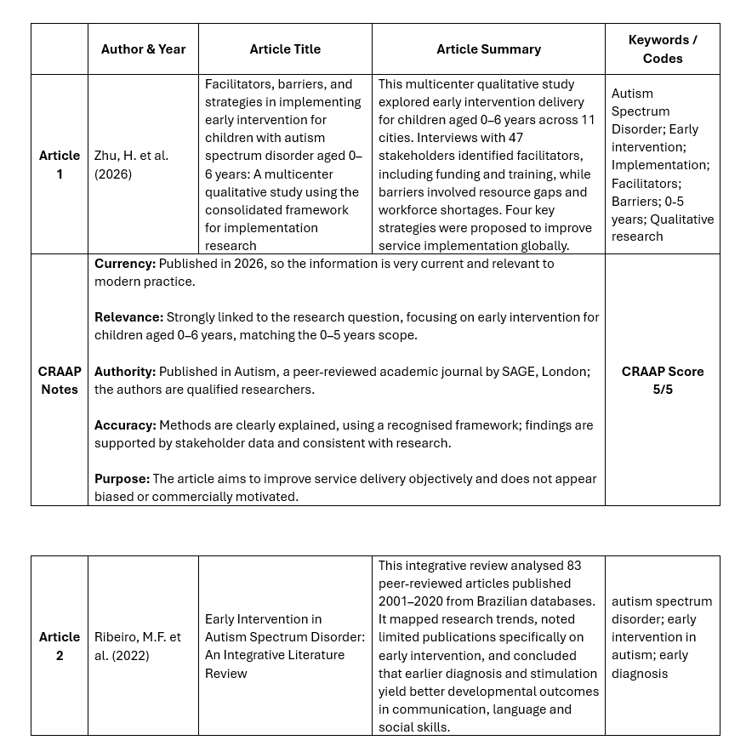

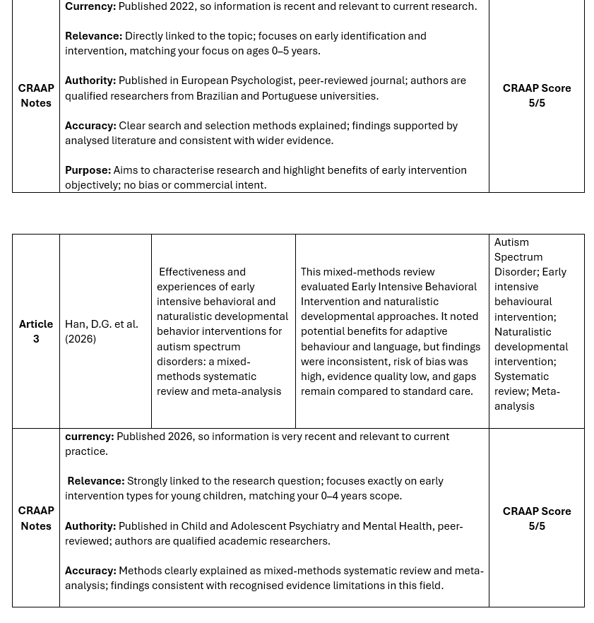

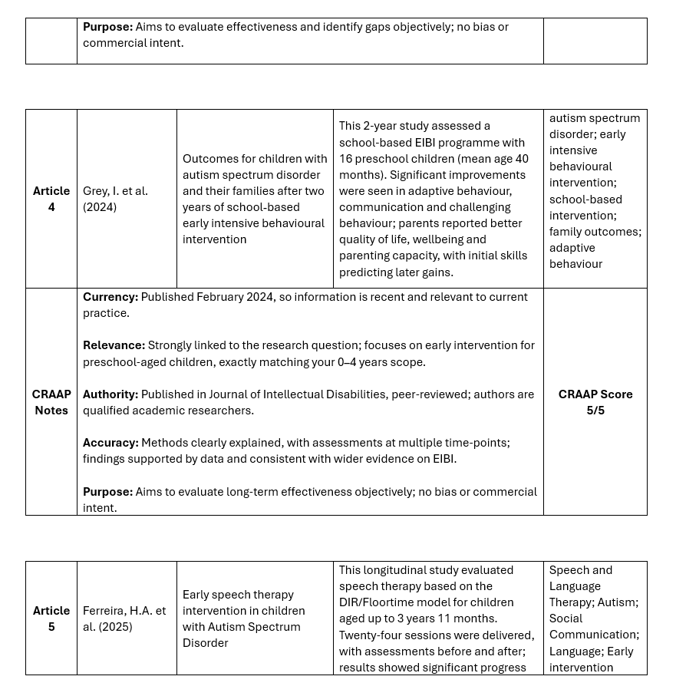
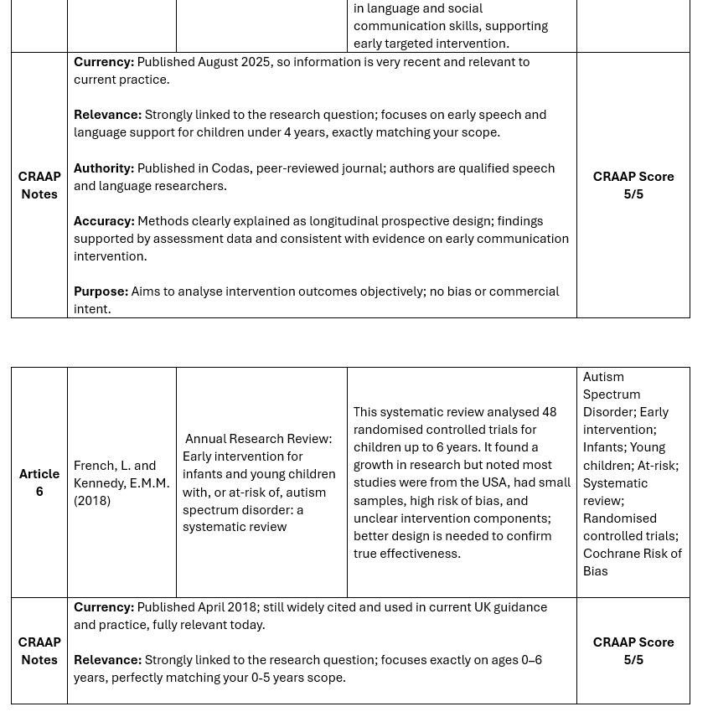

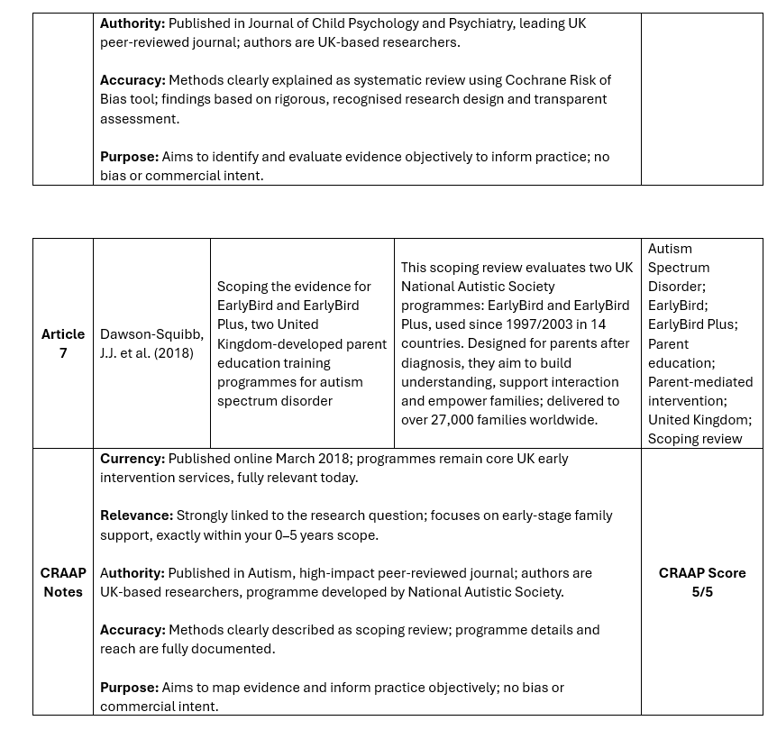

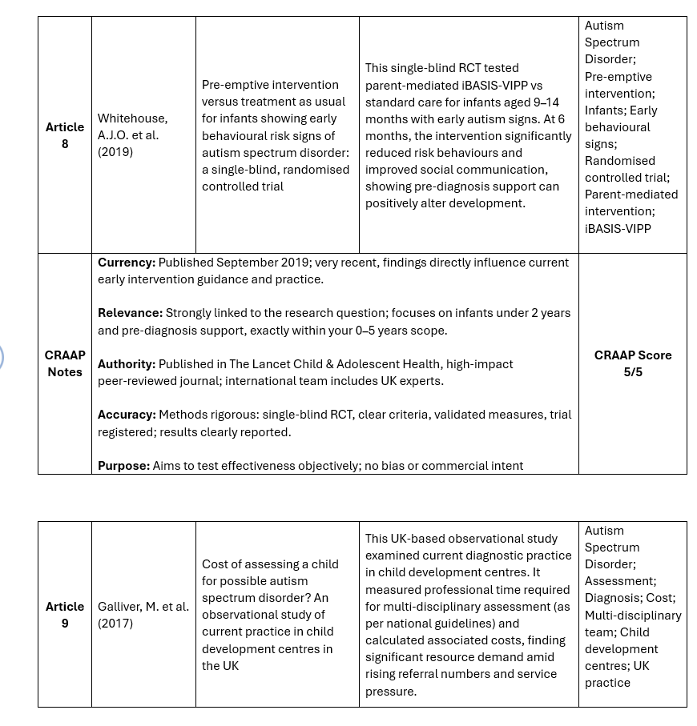
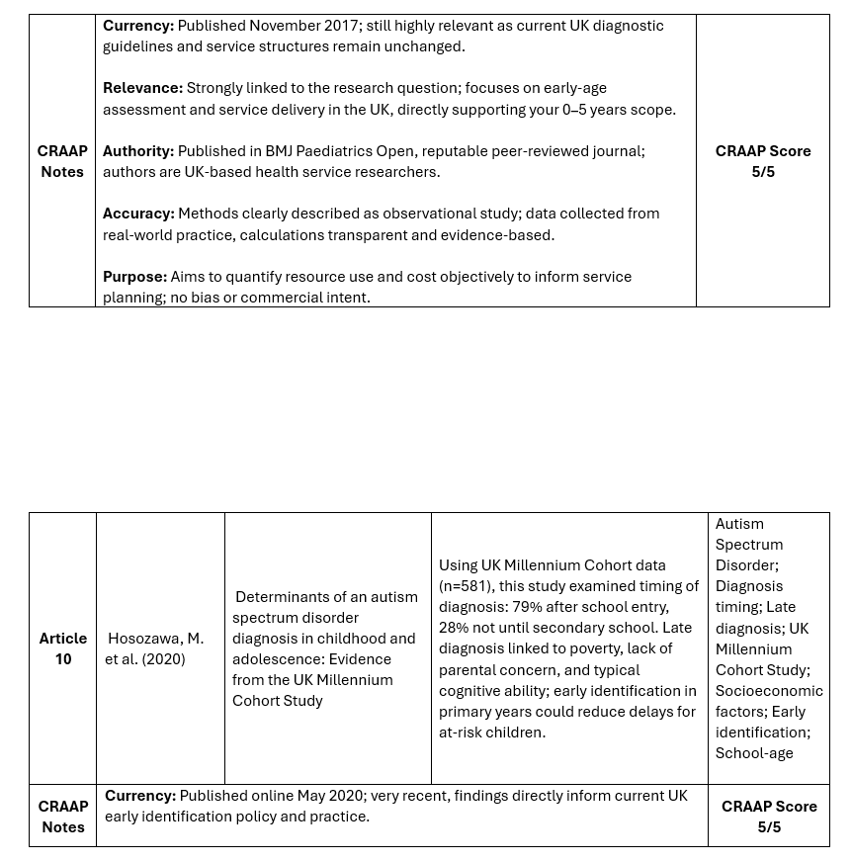
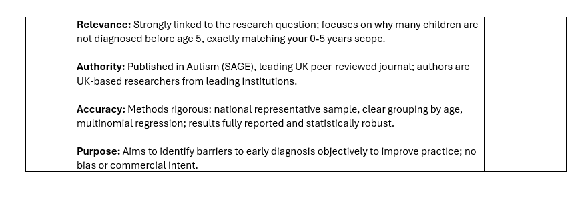

6.2 – Appendices

Appendix 2




