

MODULE: LEADERSHIP AND MANAGEMENT THEORY AND PRACTICE
MODULE CODE: LCBB6003

STUDENT NAME: ELENA ALINA GRIGORAS
STUDENT ID: 2112864

LECTURER NAME: DR PIYUMIKA GAMAZE
INDIVIDUAL REPORT
ASSESSMENT 2

INTRODUCTION
A study of leadership using the case-study method with prominent business personalities should give a fresh perspective on the theory and practice of successful management. In this report we will analyze the leadership styles of Walt Disney and Henry Ford from 20th century, with Steve Jobs and Elon Musk from current times.
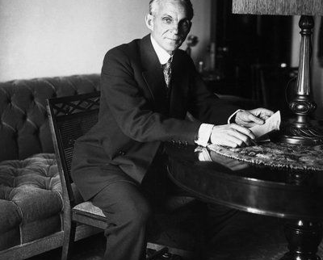

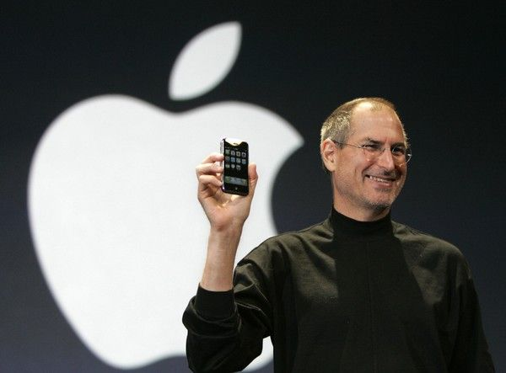
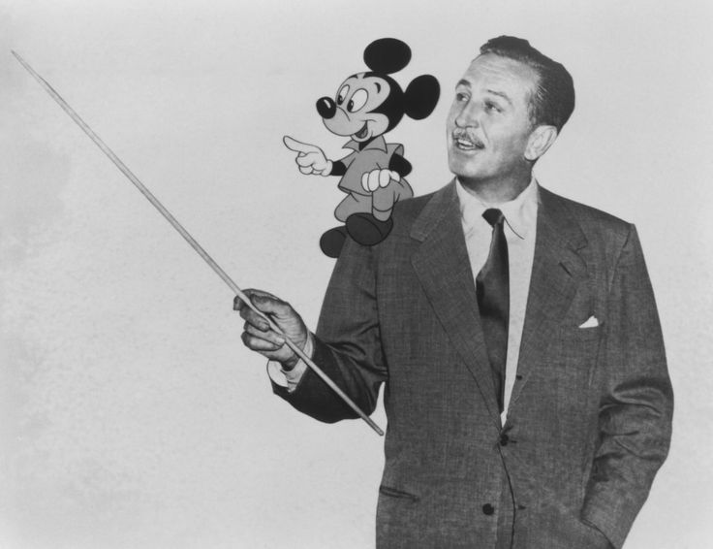
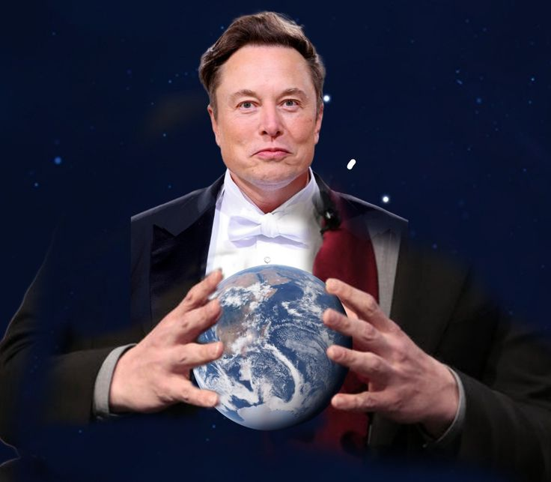

LESSONS FROM WALT DISNEY
Leadership Lessons I Learnt from Walt Disney, Especially in Transformational leadership. His exceptional talent for conveying a bright vision of the future is what made Disney such great. It was his focus on creativity and innovation that made employees comfortable sharing their ideas, he said. Leadership at Disney highlights the importance of building a strong corporate culture which is based on mission and vision (Iger, 2019).
One of the leadership lessons from Disney that is not commonly considered is their ability to tell stories. Disney was able to motivate his team and audience by telling a story that inspired them all, creating momentum towards the next stage in the company's evolution.

LESSONS FROM HENRY FORD
The key point proven out with vehicle manufacturing by Ford introducing the assembly line, illustrating how process innovation drives productivity gains leading to cost downs. His transactional leadership, which emphasized clarity of task goals and processes as well as rewards, demonstrates how organizational design practices can be a key contributor to operational excellence (Drucker, 2013).
Another crucial lesson that Ford's leadership exemplifies is the importance of perseverance and resistance to adversity. His mission to provide affordable cars for everyone was easier said than done, as juanmonino at Pixabay discovered both technically and financially somewhat tougher. This resilience is a vital teaching for all leaders seeking to move the dial. Ford's example serves as a reminder that long-term success is borne of an obsession with efficiency, standardization, and continuous improvement.

LESSONS FROM STEVE JOBS
There are countless examples of charismatic, visionary leadership; and amongst them the most prominent one is Steve Jobs at Apple Inc. This goes to show that as Jobs preached, it matters little if a company makes money or not, what is of utmost importance is the constant drive for innovation and an intuitive user experience. It was his ability to see things and make products no one even knew they wanted, inventing whole new industries. The most significant insight from Jobs' leadership perspective is linked towards delivering innovation with passion and vision consequently the enabling creation of a loyal customer base (Isaacson, 2012).
Those factors, as well as the concept of resilience and risk taking are epitomised through Jobs' leadership role (Grint, 2011). Such as his tenure with Apple, through successes and failure (before being fired), then invited back to turn the company around. Lessons From Jobs Leadership This element of Jobs leadership serves as a reminder to never give up, adjust and don’t ever settle for less than perfection.

LESSONS FROM ELON MUSK
Elon Musk exemplifies the power of setting lofty, 10-year-plus goals with his ambitious plans for a future dripping in sustainable energy and space exploration. So, the way he was able to both inspire and motivate teams towards these huge targets show how transformational leadership (Khan, 2021) is such an effective technique.
Moreover, Musk highlights servant leadership question of greater societal contribution. Likewise, Musk's approach to solving grand challenges like climate change through clean energy reminds us of the importance for leaders to align their business pursuits with larger societal demands. This approach shows that leadership is about more than just winning-you have to also leave the world a bit better off.

CONCLUSION
Walt Disney, Henry Ford, Steve Jobs and Elon Musk all have different styles of leadership which are worthy lessons for any leader to learn. All of these leaders have a different take on what makes them successful ranging from Disney's focus on vision and creativity, Ford's efficiency and resilience to Job passion for innovation & risk-taking or Musk ambition but also societal impact.



REFERENCES

1. Drucker, P.F. (2013). HENRY FORD Success and failure. Henry Ford: Critical Evaluations in Business and Management, 1(1166), p.36
2. Grint, K. (2011). A history of leadership. Handbook of leadership, pp.1-14
3. Iger, R. (2019). The ride of a lifetime: Lessons in creative leadership from 15 years as CEO of the Walt Disney Company. Random House.
4. Isaacson, W. (2012). The real leadership lessons of Steve Jobs. Harvard business review, 90(4), pp.92-102.
5. Khan, M.R. (2021). A critical analysis of Elon Musk’s leadership in Tesla motors. Journal of Global Entrepreneurship Research, 11(1), pp.213-222.

