Financial Management for the Hotel Industry
Business Report - Comparison of Two Hospitality Organisations

Student name: Alina Cristina Ionita
Student ID: 2246123
Lecturer: Tristan Hawkins

Table of Contents
Introduction 3
Comparison 4
Total Revenue 4
Market Position 5
Growth Potential 7
Financial Commitment to CSR (Corporate Social Responsibility) 8
Recommendations 8
Conclusion 10
References 11
Appendix 13

Introduction
This report will compare two significant hospitality organisations including Shangri-La Hotels and Premier Inn. The report will compare the hotels on the basis of revenue, growth potential, market standing and financial commitment to CSR actions. The objective of the report is to point out the areas of development and suggest the measures the firms should take to strengthen their competitive positions in the hospitality business.

Comparison

Total Revenue
Revenue | Pre Covid (Values in millions) |  | Post Covid (Values in millions)
 | 2018 | 2019 | 2021 | 2022 | 2023
Shangri-La Hotels | £3099.55 | £3046.51 | £945.44 | £1114.42 | £1632.43
Premier Inn Hotels | £2007.4 | £2049.1 | £589.4 | £1,703.4 | £2,625.2
Table No.1: Revenue
(Source: Created By learner)
In the pre Covid duration, the revenue of the firm i.e. Shangri-La hotels were £3099.55m and £3046.51m meanwhile, the revenues in the post Covid period were £945.44m, £1114.42m and £1632.43 (Shangri-la.com, 2023). In contrast, the revenue of Premier Inn was £2007.4m and £2049.1m in the pre Covid era while it was £589.4, £1,703.4 and £2,625.2 in the post Covid duration in the market (PremierInn.com, 2023). The growth in the revenue of the Premier Inn hotel was 54% in the period of 2023 in relation to the previous year while, the growth in the revenue of Shangri-La hotels was 46% in the duration of 2023 as related to 2022. There is a 8% higher revenue growth in the Premier Inn hotels in comparison to the Shangri-La hotels which demonstrates that the Premier Inn has performed better in the marketplace than Shangri-La. The higher growth also means that Premier Inn gained more demand and exploited more margin through operations than Shangri-La in terms of revenue. Furthermore, it shows that the management of Premier Inn has been able to pursue financially sound strategies that placed it in a stronger position in the hospitality sector.
Cost | 2022(Values in millions) | 2023(Values in millions)
Shangri-La Hotels | £1200.1 | £1474.96
Premier Inn Hotels | £1605.8 | £2133.7
Table No.2: Cost
(Source: Created By learner)
The total cost of the Shangri-La hotels for the period of 2022 and 2023 was £1200.1m and £1474.96 (Macrotrends, 2024). On the other hand, the total cost of the Premier Inn hotels for the same duration was £1605.8m and £2133.7 (AnnualReports.com, 2023). The cost of the Shangri-La hotels has increased by 22.90% while the cost of the Premier Inn has increased by 32.875 in the period of 2023. Due to the difference of business models and market strategies, Premier Inn experienced a higher increase in cost compared with Shangri-La in the duration of 2023. The management of Premier Inn has increased the scale of its operations at a faster pace and experienced commensurate higher operational costs, whereas Shangri-La, being a luxury brand has increased its costs at a slower pace. Both firms witness cost pressures from inflation and demand recovery post Covid; however, the aggressive expansion of Premier Inn contributes to the higher cost uplift.
Shangri-La Hotels main sources of revenue are selling hotel rooms, food and non-alcoholic beverages, conference and banquets (Shangri, 2024). There is an upward revenue trend in the business after the Covid period mainly due to leisure travelling and corporate gatherings. Furthermore, factors such as brand recognition, and customer loyalty mechanisms contribute to the revenue growth of the firm. On the other hand, Premier Inn generates their revenue from several areas such as selling of budget accommodation spaces, food and beverage and other extra services like meeting and event services (PremierInn.com, 2024). Revenue trends for the Premier Inn are also on an upward trend owing to a strong recovery led by domestic stays and competitive pricing. Some of the drivers which have led to the increase in revenue for Premier Inn are the expansion of more hotels and the closeness to their clientele base. While both hotel groups receive a lift from the restoration of travel, their revenue sources and strategies differ because of their position in the market.

Market Position
Market Position of Shangri-La Hotels
Market Share: Shangri-La Hotels has a small presence in the UK so they have a smaller market share as compared to Premier Inn in the hotel industry of the UK. The hotel group mainly serves the high-income group and business people, giving them prestige in the industry.
Customer Demographics: Shangri-La targets its services at the higher-end clientele such as, business travellers from different countries and other enriched tourists (Shangri, 2024). The targeted guest services and differentiated accommodations make the appeal wider than merely the necessity of lodging; it targets a market that favours luxury as well as exclusivity.
Brand Perception: The Shangri-La Hotels are most commonly associated with values such as luxury, elegance, high quality and superior service within the context of the hospitality market. This perception implies an image which favours lucrative travellers in search of elite holidays and close treatment. The supply and demand theory is applied at Shangri-La through the use of high-end pricing for better quality products to increase additional revenues. They limit empty rooms and offer special packages that create demand while retaining their brand association with luxury at the same time. They use the theory by ensuring that they set reasonable prices, while ensuring that they offer quality products (Jumayeva, 2023).
Market Position of Premier Inn
Market Share: Currently Premier Inn enjoys a commented position in the UK hotel market having the share of 12% (Akers, 2024). This presence is primarily a result of them being cost-conscious, durable and easy to access which makes them suitable for virtually every individual who is travelling.
Customer Demographics: The management of the firm mainly targets the customers such as families, business people, leisure travellers and so on. The brand targets its consumers who are willing to pay for quality products at a cheaper price, especially during periods of a recession or economic downturns.
Brand Perception: Premier Inn is especially famous for its durable quality and the best budget hotel which will be well suited for the people who are looking for the cheap hotels (PremierInn.com, 2024). The brand is linked to value and comfort as well as convenience for people looking for economical accommodation, families, business travellers, and people seeking leisure and fun. To increase their revenue, Premier Inn uses economic theory in their business operation especially the price elasticity of demand. On one hand, they set low prices and organise special offers to attract the price-sensitive guests, and on the other hand they keep high quality to increase guest returns which lead to high occupancy rates. They use this theory by changing the prices to match the uptimes in an effort to increase the consumption (Schumpeter and Swedberg, 2021).
Henceforth, Premier Inn has a better market position than Shangri-La hotels in the hotel industry of the United Kingdom.

Growth Potential
Growth Potential: Shangri-La Hotels
Shangri-La Hotels have significant growth opportunities which are largely due to its focus on growth initiatives that leverage strategic growth on international markets. The brand plans for the growth by targeting the rising need for the luxury hospitality services in the developing economies of Asia-Pacific and Middle East region. The main expansion strategies are putting up new properties in strategic markets, increasing their presence and offering investment to appeal to high end travellers. Moreover, the market opportunities are also present in partnerships with local businesses and tourism boards, which can produce novelty experiences for present customers (Guimarães et al., 2021).
Nevertheless, there are threats that could limit the growth of Shangri-La such as high competition in the global market of luxury hotel chains, economic upheavals, and geopolitical risks in some parts of the world (Benabed and Moncea, 2024). Other issues include escalating operating expenses and issues of sustainability which are becoming more and more popular with the clients. The key challenge of growth is to offer luxury without compromising on the brand image while catering for the mass market can defeat the purpose of the luxury appeal.
Growth Potential: Premier Inn
Premier Inn reveals the benchmark of the company and its expansion strategies which is a good sign of growth in the hotel business primarily due to its large position in the budget hotel industry. The brand aims at increasing its penetration in the UK and they have a market opportunity in contemplating global markets especially in Europe where there is growing need for budget accommodation (Page and Connell, 2020). Moreover, expansion programmes will be extended to existing sites to upgrade them through renewed interiors and technologies that will boost guest’s satisfaction and convenience as well as the chain's internal functions.
However, there are several limitations affecting growth of the organisation which includes high saturation level in some regions and economic recession reduced the expenditure on the organisation's products and services, and changing customer’s preferences, especially on short term rental properties (Fila et al., 2020). Furthermore, the price positioning of Premier Inn needs to be dynamic in nature to counter new economy hotel brands and maintain its brand image.

Financial Commitment to CSR (Corporate Social Responsibility)
Shangri-La Hotels has a clear sighted financial commitment when it comes to CSR by spending £4 million in charitable donations and sustainability. The organisation has put its goal to cut down the emission level to 15% till 2025 (Shangri, 2024). This obligation not only is in line with environmental objectives at the global level but can also be seen as a well-considered business decision in order to positively influence brand image and customer satisfaction. CSR is a strategic investment area of Shangri-La as the organisation seeks to improve the welfare of the communities it touches besides encouraging accountability within the business entity. On the other hand, Premier Inn is also equally committed in its financial aspect towards CSR. The hotel chain has pledged €30,000 to the Health Foundation by 2027 to help children with chronic pain and is committed to fighting social problems. Moreover, Premier Inn has announced a goal of reaching the net-zero carbon emission level by 2040 in its sustainability policy (Premierinn, 2024). Besides, this strategic initiative is a manifestation of Premier Inn’s duty as a responsible company in regards to future generations, as well as a response to a market that is becoming ever more sensitive to the impact of consumers’ decisions on the environment.
In the context of their corporate strategy, both organisations appreciate the compliance to CSR standards to improve their corporate image and their sustainability (Alam and Islam, 2021). Shangri-La Hotels and Premier Inn invest a lot of money into social and environmental projects not only for the development of the society but also for the company’s leadership in the hotel business. It is their intention to meet their CSR obligations through financial contributions which should improve customer retention and achieve long-run firm profitability.

Recommendations
Shangri-La Hotels: For its continued development and effective sustainability management, the management of Shangri-La Hotels should adopt a full-fledged digital transformation strategy (Sundaram et al., 2020). With the help of artificial intelligence and data analytics, the brand gets opportunities to enhance the guest satisfaction, effective pricing policy and innovations in organisational management. This investment on technology can help grab the attention and engagement of their clients and this leads to revenue drive, especially in developing markets (de-Lima-Santos et al., 2022). Moreover, incorporating sustainability to their digital marketing plan can help support the company’s objective to cut emissions and also strengthen the brand’s image as being friendly to the environment (Gursoy et al., 2020). The effective marketing also offers a competitive edge on their rivals in the marketplace.
Premier Inn: Premier Inn should diversify their revenue streams and consider branching out into the wellness tourism market. Furthermore, by introducing new services, for instance, health retreats, fitness classes and healthy eating, Premier Inn is poised to tap a new market of customers with regard to their overall well-being. It not only complies with the antidote of current trends associated with the orientation towards a healthy lifestyle, but also creates a competitive advantage for a brand compared to its rivals in terms of the affordable price segment. Wellness tourism is on the rise currently, and customers are willing to spend their hard-earned money to improve their health (Khan, 2020). In this way, Premier Inn can benefit from the existing trend and improve customer loyalty which in turn enhances their revenue levels in the marketplace.

Conclusion
The comparison of Shangri-La Hotels and Premier Inn demonstrates or indicates the differences in market segments, revenues and growth opportunities. Shangri-La is a hotel that incorporates luxury and sustainable development concepts while carrying out business activities it pays attention to social justice and addressing the needs of the wealthy clients. On the other hand, Premier Inn is a budget segment player and has posted high revenues and increased its market standing. Moreover both firms have sound plans for their growth and socially responsible programmes that foster their image. In order to sustain the competitive advantage, Shangri-La must pursue digitalisation, and on the other hand, Premier Inn could expand the offer to the wellness segment, guaranteeing further continued success and the fulfilment of shifting consumers demands.

References
Akers, C. (2024) It’s time to check in with this hotel leader, Specialist. Available at: https://www.investorschronicle.co.uk/content/675c9c9b-98a6-5614-a382-cb1f75a13b32 (Accessed: 07 October 2024).
Alam, S.S. and Islam, K.Z., 2021. Examining the role of environmental corporate social responsibility in building green corporate image and green competitive advantage. International Journal of Corporate Social Responsibility, 6(1), p.8.
AnnualReports.com (2023) Premier Inn, AnnualReports.com. Available at: https://www.annualreports.com/Company/whitbread-plc (Accessed: 07 October 2024).
Benabed, A. and Moncea, M., 2024. Slowbalization: Rising Trends for the Global Economy and Business. In Proceedings of the International Conference on Business Excellence (Vol. 18, No. 1, pp. 283-294).
de-Lima-Santos, M.F., Mesquita, L., de Melo Peixoto, J.G. and Camargo, I., 2022. Digital news business models in the age of industry 4.0: Digital Brazilian news players find in technology new ways to bring revenue and competitive advantage. Digital Journalism, pp.1-25.
Fila, M., Levicky, M., Mura, L., Maros, M. and Korenkova, M., 2020. Innovations for business management: Motivation and barriers.
Guimarães, L.G.D.A., Blanchet, P. and Cimon, Y., 2021. Collaboration among small and medium-sized enterprises as part of internationalization: A systematic review. Administrative Sciences, 11(4), p.153.
Gursoy, D., Buttle, F. and Bowie, D., 2022. Hospitality marketing: Principles and practices. Routledge.
Jumayeva, Z., 2023. THEORY OF MARKET EQUILIBRIUM, SUPPLY AND DEMAND. Modern Science and Research, 2(10), pp.740-743.
Khan, M., 2020. The Eat Pray Love Tour: Rethinking International Intellectual Property Rights in Global Tourism. Conn. J. Int'l L., 36, p.143.
Macrotrends (2024) Shangri-La Asia Financial statements 2011-2024: Shaly, Macrotrends. Available at: https://www.macrotrends.net/stocks/charts/SHALY/shangri-la-asia/financial-statements (Accessed: 07 October 2024).
Page, S.J. and Connell, J., 2020. Tourism accommodation and hospitality services. In Tourism (pp. 216-241). Routledge.
Premierinn (2024) Net zero carbon emissions, Net zero carbon emissions | News | 2021 | Premier Inn. Available at: https://www.premierinn.com/gb/en/news/2021/net-zero-carbon-emissions.html#:~:text=Our%20pledge%20to%20reach%20net,proud%20to%20lead%20the%20charge. (Accessed: 07 October 2024).
PremierInn.com (2023) FY23 results. Available at: https://cdn.whitbread.co.uk/media/2023/04/Final-FY23-RNS-Final-Combined.pdf (Accessed: 07 October 2024).
PremierInn.com (2024) Premier Inn Hotels: Book Direct, Premier Inn hotels | Book direct. Available at: https://www.premierinn.com/gb/en/home.html (Accessed: 07 October 2024).
Schumpeter, J.A. and Swedberg, R., 2021. The theory of economic development. Routledge.
Shangri (2024) Luxury escape at best rate: Shangri-La Hotels and Resorts, Shangri. Available at: https://www.shangri-la.com/ (Accessed: 07 October 2024).
Shangri (2024b) Shangri-La Kuala Lumpur’s Commitment, Shangri. Available at: https://www.shangri-la.com/kualalumpur/shangrila/about/corporate-social-responsibility/shangrila-kuala-lumpur-commitment-to-corporate-social-responsibility/#:~:text=Shangri%2DLa%20Kuala%20Lumpur's%20annual,children%20through%20this%20charity%20project. (Accessed: 07 October 2024).
Shangri-la.com (2023) 2023 Annual Report - Sitecore - Shangri-La Hotel. Available at: https://sitecore-cd.shangri-la.com/-/media/Project/Shangri-La-Group/Investor/Files/Public-Disclosures/Latest-Top-Publications/2023_Annual_Report_E.pdf (Accessed: 07 October 2024).
Sundaram, R., Sharma, D.R. and Shakya, D.A., 2020. Digital transformation of business models: A systematic review of impact on revenue and supply chain. International Journal of Management, 11(5).

Appendix
Reports of Shangri-La Hotels
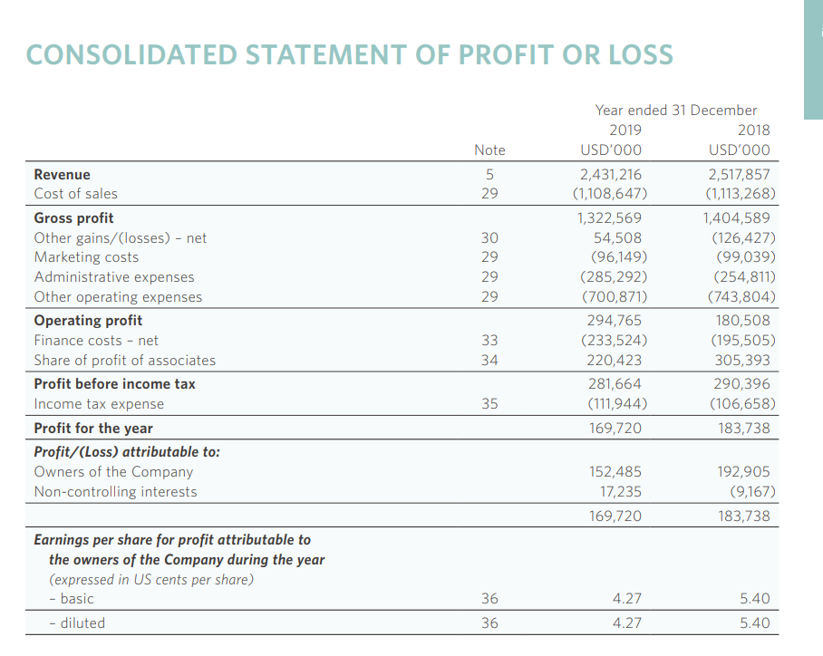
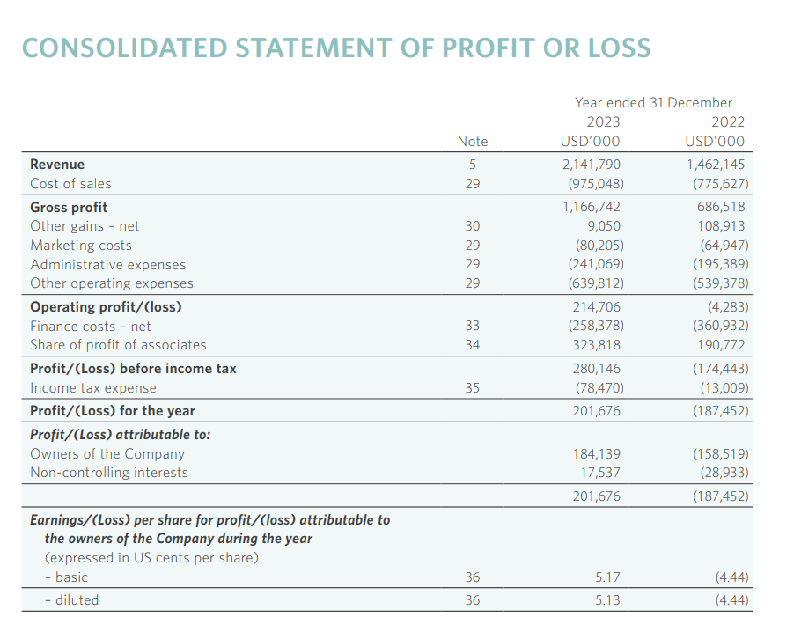

Reports of Premier Inn


