

LEVEL 7 ASSESSMENT SPECIFICATION

Programme: | MBA- Masters of Business Administration
Module: | Marketing Management – Assessment 2
Module code: | LCMB7001 | Contribution to Overall Module Assessment (%): | 25%
Lecturer: | Tushara Balendran | Internal Verifier: | Gladius Kulothungan

Student name: Jaimish Sureshbhai Gujarati
Student ID: 2106724
Module name: Marketing Management – Assessment 2
Module code: LCMB7001
Lecturer: Tushara Balendran

EXECUTIVE SUMMARY

A well-known brand like Tesco has a long history. In the state of the United Kingdom, this company is extremely popular. Grocery and general merchandise have become extremely popular in the retail market due to the popularity of this brand.
The following research article presents a comprehensive study of Tesco's marketing strategies, educating readers about all strategies, plans and all what girl that nightclub must complete in study. The study also informs readers on how Tesco plans to build steps to achieve future success and expand its territory into the global market. With all the steps and strategies explained in detail, this report explains how Tesco secures its position in the global market.

Contents

Introduction 2
Discussion 2
PESTLE Analysis 4
SWOT Analysis 7
Conclusion 16
Reference 17

Introduction
This article mainly describes the business strategy of a basic business marketing, mainly described in this article as customer satisfaction. It defines metrics to determine how happy customers are with the company's products and ability to satisfy customers. Process is mainly used in marketing as an indicator of marketing management. If the customers are satisfied with the company's products as the business grows day by day, they are mainly described in this article. Businesses have long focused on the touchpoints also described in this document. assignments and how they affect the company's business. Critically evaluate Tesco's innovative marketing strategies and how the brand is progressing for itself, as well as manage and evaluate the customer journey, to ensure customer and stakeholder expectations. Customers are satisfied with certain rules and listen to customers (Sreenivasan et al. 2018)
Discussion
Customer satisfaction
Customer satisfaction is part of marketing management, and it is a very important part. Tesco mainly provides the social network with specific and detailed queries to customers. This mainly contributes to business growth and earnings. Consistency is one of the most important parts of customer satisfaction. Customer satisfaction mainly defines several key categories. The first is very dissatisfied, satisfied, dissatisfied, and naturally, very satisfied. Offer omnichannel, this mainly improves customer satisfaction; it mainly contributes to customer happiness. Tesco mainly provides practical services on company products to add knowledge (Lomoio et al. 2020)
This is the most important part for developing projects and also for increasing projects. The second role is research Theoretical Product Research, which in theory tests mainly determines the main research direction. This is mainly done by theoretical experimental research. It is mainly useful when a research map helps to develop a research paper over time.The number of the research questions is the best methodology for answering the questions. A new conceptual model or a new theory building a literature review. The third one is Brand and campaign development is also important to agency capabilities. Tesco primarily educates and coaches its clients for teamwork. Because great and strong teams always work first and they also achieve their goals and healthy communication is mainly provided by this company. On the other hand, respect for all team members is either: Leadership is the most important component of the business as well as good leadership, as it is very important for employees to manage a group (Kim et al., 2019). This primarily contributes to the development of the business for the use of communication and acquisition data, which primarily contributes to the development of the company's business (Rosnizamet al.2020).
PESTLE Analysis:
The PESTEL evaluation device can examine the unpredictable placing inside which Tesco PLC operates with the aid of using discussing the elements which have an impact on Tesco overall performance and operation. Tesco PLC is not completely supplying retail merchandise but conjointly dealing in broadband, cell networks and coverage services. Here we're going to talk properly the PESTLE evaluation of Tesco.
Political Factor
This organization is running in twelve nations collectively with Asia and Europe. It is uncovered to numerous political elements so as to have an impact at the practical output of Tesco. These elements encompass yearly income related fees rates, modern & near handy legislator aspects, political matters; which are not stable, pct, the repute of the nations anyplace it is operative. For example, price lists on merchandise usually made an overall effect on Tesco because of it imports a few stocks from outdoor GB like south East Asia.
Tesco Chairman is an outspoken person who stated that which political influences can have an impact at the business. The tax created bylocal big supermarkets cited as “Tesco Tax” become deliberate with the aid of using the local aspects but GB authorities refused this factor mostly to keep away from cost hikes.
Economic Factors
Labor rate is a completely critical monetary trouble so one can have an impact on GB supermarkets. as an example, its annual salary invoice is amounting GBP 4 in 5 billion. In 2018 GB salary hikes are gathered with the aid of using 4% for 25 years preceding and onward. This upward shift created a effect on Tesco in a huge way.
Diversification and presence in the global marketplace location unit the two essential techniques in beyond years and motives for the fulfilment of the corporate.it is price bringing up that Tesco stays obsessed on the GB marketplace with a twenty-seven. 7% proportion in the GB grocery marketplace.

Social Factors
For many years to come, consumers' searching habits will be constantly changing. Although this is not a major upgrade, it is still a whole new bag of fun for some of the most popular phones. People have strong schedules and want equal-day and brief transport with flexible return policies. The new G7 Plus will do what they only want: to avoid searching. Tesco is hoping for great British clients and has to understand and deliver the offerings to fulfill those troubles. This can go on the top of the digital officers, who'll include Tesco's different referral partners and regional open agents. Tesco has been worried that it is a few stages behind in retail and is now exploring new development procedures, including guidelines for at home. Tesco has been the first to apply scanning among its stores, but some observe it isn't heading far enough.

The call for products and offerings is related to the purchaser's ideals and attitudes; this is like any other targeted difficulty. The solution to this bit of the challenge is to introduce a far more common and entire world-opinion kind of approach. Obesity is like any other social problem, and clients are dealing with a variety of health issues. Tesco has to ponder its dynamic conduct and call for natural food. The same is valid for any consumption centre.
Technological Factors
A few years later, Tesco began going through troubles like terrible patron knowledge and the horseflesh scandal. To adjust, the company encouraged working in small teams to develop plans through team problem-solving. Technological development has opened new possibilities for Tesco to regain the patron's trust. However, the measures usually fail due to the lack of cooperation between workers. Tesco embraces technological development as a hazard with the aid of adopting available trial technologies. They delivered RFID technology to increase patrons' in-shop knowledge. It routinely counts inventory and takes it away as soon as sales occur.
Environmental Factors
Many organisations are under intense pressure from government agencies to solve environmental issues. Tesco now encourages customers to shop online at tesco.com. Tesco is the fourteenth largest marketer in the United Kingdom. Tesco Van Drivers may not always take the most efficient routes, but they do collect and recycle unwanted plastic bags from customers. Tesco's plans to avoid the use of plastic bags by charging customers £1 per carrier bag regardless of whether they use them or not.
Tesco is committed to using renewable resources and plans to generate 100 percent of its energy by 2030. The corporation intends to cut its carbon footprint by up to 5 cm by 2020. Clothing retailer H & M has pledged to donate 100 million crowns in Sweden to help victims of the disaster.
Legal Factors
In a business criminal context, don't undermine important areas whenever legislation changes that allow achieving your aims; you need to have an effect on your commercial organization's overall performance. If you do, your organization may find itself excessively involved in public relations and burdened with critical matters to be dealt with. These are just a few of the pitfalls to consider when executing an organization's executive management. In 2016, seventeen Tesco employees filed a complaint against the CEO on the grounds of historical and gender discrimination. Tesco countersued them for unfair competition among its employees. Tesco also sweet-faced a movement for embezzlement and misleading investors, sooner or later agreeing to pay GBP 12 million to settle the intervention.
SWOT Analysis of Tesco
Tesco’s Strengths
1. Leading marketplace proportion – Amongst the massive 4 supermarkets, is lately turn out to be the most well-preferred marketplace in Eire.
2. Geographically heterogeneous – Tesco has a thriving global footprint, with over 6800 stores in sixteen different countries.
3. A developing kind of shops – From three,751 shops in 2008, Tesco presently operates six,966 grocery retail shops worldwide.
4. Diversified shops – Tesco has released absolutely exclusive sorts of shops.
Weakness of Tesco
1. Failed actions in the United States of America (USA) and Japan – Tesco needed to go out from the American and Japanese markets in 2012.
2. Fraud Trial and Accounting Scandal – Tesco was fined in 2017 for inaccurate financial assertions and profitability misreporting.
3. Earnings from functions are down. – Tesco's % expenses fell in October 2018 compared to September 11 due to a decrease in intelligence agent revenues.
4. Financial blunders – Tesco's fiscal earnings cylindrical degree was severely impacted as a result of its unsustainable debt and American Express liability.
Tesco’s Opportunities
1. Expansion of Jack's business – Tesco recently introduced Jacks, a model merchant home that has shown significant growth.
2. Strategic partnerships with option brand – Forming strategic alliances with relevant stakeholders will provide an excellent chance. Tesco.
3. Collaborations –The local organizations will provide profound marketplace statistics which can also additionally facilitate up overall performance in such areas.
4. Online looking – Tesco will take the risk by expanding and modernizing its online ordering company as well as national international shipping.
Tesco's Risks
1. Competition for Christmas commercial breaks – Tesco has long faced public backlash after releasing its Christmas advertisement in 2017.
2. 'Fake Farm' prison possibility – Tesco has been accused of deceiving customers with fictitious farm titles and helping to promote its lunches merchandise under the guise of "Woodside Farms."
3. Eu referendum vote – With the jurisdiction no longer a member of the EU, the substitute offers and price topics have revealed a possibility for Tesco.
4. Compete with global market behemoths – With Walmart's increasing popularity and overall performance (with ASDA acquisition).
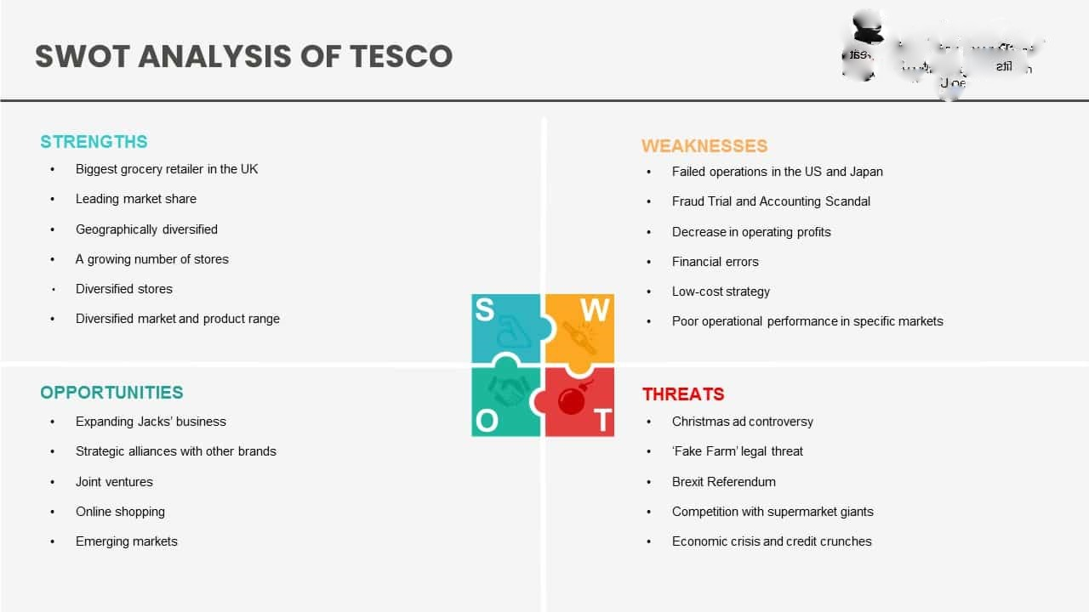

The Tesco brand is a corporate marketing strategy that is known to be very stable, recognizable and every little thing helps. Marketing strategy is basically the process of describing an organization's relationships as well as limited resources as the biggest opportunities and growth in company sales. Business agility also helps get groceries delivered first, and it also helps customers respond to grocery deliveries. The company helps its customers provide fast experiences and fast learning. Because it is important for businesses to adapt their products to the needs of their customers and markets. The market's emergency business solutions are part of business agility. There are many types of business agility, but the most important is business agility. Above all, organizational culture is changing. This is important for the needs of our customers because the organizational culture is not aligned with the market. This culture must change (Peeroo, 2019). Development is an important part of a culture of innovation. Digital champions who embody designs that are also critical to the digital readiness of culture and enhance members and teams. Employee satisfaction is very important in this area. Because when the customer is satisfied with using these products, the company and the project are also renewed. It is mainly a set of achievements that determine a person's various abilities, understanding, and personality. Tesco mainly helps to improve innovative communication strategies and is an important part of the group. Fresh ideas and good conversations help improve the company. Innovative communication strategies are an important part of the group (Teerawatnapong and Fernando, 2018).

Business Environment
The business environment is one of the most important parts of business development and is basically a marketing term for maintaining successful customer relationships. He mainly explained the social, government, client and cultural parts. Tesco sells the brand most often, and some issues, such as climate change, western food, deforestation, sustainable nutrition, exposure to the marine environment, and various types of environmental factors, most often hinder the company's brand. Design is also critical to the digital readiness of a culture that is a digital leader that enhances members and teams. Employee satisfaction is very important in this area. Because when the customer is satisfied with using these products, the company and the project are also renewed. On the other hand, the business environment strategy is the economic environment that occupies the most important part in business development. Economic growth is very important. This economic environment primarily determines domestic production, income and employment (Awadari and Kanwal, 2019). Employability is a set of achievements that primarily determine an individual's diverse skills, interests, and personality. This is the main overview of this project. Various social media service companies and their pros and cons are very useful in collaborating with employees and team leaders. Promotion is a very important part because it helps you expand your business and gives your company's employees access to applications that primarily manage administration. It is very important to evaluate and hire a project manager who must have experience in the

How Tesco fulfils the expectations of a customer on his journey
Tesco creates value for its customers through lifetime loyalty. Some items mainly meet customer needs. This is 1. Knowing your employees and audience is a very important strategy for meeting customer needs. 2. Customer needs are very important to the development of the company's business, and customer satisfaction is very important to the sale of our products. A clear project schedule encourages team collaboration. Roommates in a team are one of the important parts of dividing a team into parts, they are very useful for performing all kinds of tasks, and good communication with team members is important for a good and strong team (DarócziSzabó and Bartosiewicz, 2018).
3. A clear standard generally supported by the entire Tesco team. 4. A culture of innovation is an important part of a culture of digital readiness. Fresh ideas and good conversations help improve the company. An innovative communication strategy is an important part of the group. Fresh ideas and good conversations help improve the companyWith regard to project implementation, it is very important that the vision of the financial goals of these projects is very conducive to the development of the company's business (Wooyoung et al. 2020). 5. Employee satisfaction is very important in this area. Because when the customer is satisfied with using these products, the company and the project are also renewed. Employability is a set of achievements that primarily determine an individual's diverse skills, interests, and personality. Customer reviews are also important (Nurwidayat et al. 2019).

Segmentation, targeting and positioning strategies Of Tesco

Criteria for Features Extraction
Means changes - The sector's size, power, or profiles can all be analysed (Philip, OK 2008). The goal marketplace of Tesco Additional Cheras has a little over five hundred thousand electors and its average economic advantage is on top of different residential districts or nations. New materials purchasing is not in excess of 38%, although dietary consumption has developed quite a bit.
Handy-The marketplace phase could be effective in reaching and serving customers (Philip, 2008). There is a need to overcome the problems that come with the loss of focus of local governments in delivering services resulting from privatization. Tesco Additional aspects will definitely reach its goal customers via mistreatment flyers, television commercials, brochures, catalogues, spam and, therefore, the cutting-edge one is SMS. To achieve this goal, it expresses the importance of sending an SMS will certainly be a phone number within the advert flyer.
Big- The market segment is massive and profitable to serve (Philip, OK 2008). To capture these markets, we are looking to expand our product line and increase our production capability as a result of business development efforts In line with the sure internet site, we generally tend to know that the capability client of Tesco has additional factors. Many belonging to the buyers send unique photographs for important purposes, for instance birthday greeting cards, thank you keyed messages, wedding particular frame messages and pics.
Differentiable- The section ar conceptually distinguishable and respond otherwise to absolutely special promoting mixed part and applications (Philip, okay 2008). Tesco additional Cheras mistreatment one promoting combines to achieve the entire marketplace that is supplied cheaper charge and its place that settled in dense space encircled by means of housing area.
Focused on
Tesco Extended Cheras is an excellent example of targeted mass selling. The mass selling strategy is a method of ignoring specific group of customers and targeting the marketplace with a single vehicle. It needs to focus on what would be similar in purchasers' desires or what is absolutely new (Philip, OK 2008).

Tesco won't discriminate against the group of customers they served in this manner; they included in the many users as possible. As a result, rather than making a distinction the buyers, Tesco, as a limited providing, aims at fulfilling a varied range of customer who express a glamorous desire.
Targeting
Positional sense is the enabled the development the contractor's visual identity in the minds of the customers in order to occupy a designated place in their minds. The goal is to implant the full in the minds of customers in order to maximize the company's competitive advantages (Philip, okay 2008). Inside this case, this has managed to complete a truly intelligent activity. We may see that Tesco positions itself as an espresso well worth distributer by using exploitation the promotion “cheapest well worth each day” for hand-picked product in its keep (discuss with appendix). This method is pretty productive within the alternate and attracts sufficient clients that come lower back to these lower value products. Therefore, a perception like “Tesco sells lower fee product every day” can embedding into the consumer thoughts.
Tesco's Distribution Strategy
An Influential Mindset Tesco clearly transforms its ideal customer with a specially tailored brand image. Tesco offers a wide range of objects and relationships in a variety of business districts in a non-psychographic way with specific sectors. Therefore, the Tesco Genuine Market is a visionary people who are passionate about their approach and planning and worth working with (AlSuraihi, 2020). In order to adapt to the changing social conditions, it was initially organized as a low-cost large retailer, but in the late 1990s, it changed its status to a company that promoted Tesco value items at low prices, but the surrounding premium is highlighted. on things. Within the Tesco Finest line (Peeroo, 2019). With this fix, Tesco tried to work with the sweet spot by offering something close to the standard with a "best" range. They remembered that they generally required corner stores to sell everything they needed to buy, at the price they chose to pay, without any classification of reality (AlSuraihi, et al 2020).
Tesco's Advertising Strategy
Tesco is based on customer acquisition through an unprecedented, low-cost methodology. Tesco uses print and media publishing as effective channels for sending time-limited messages to current and prospective customers. Alliances rely heavily on unprecedented customer acquisition and retention planning (Singh, 2021). They continue to offer “get one” deals and discounts both online and in-store. Without having to set up a customer forever, Tesco can choose which club card it supports. Club card holders receive a restorer able focus for added benefit and clipping focus. This is how Tesco develops several methodologies to keep itself best as a market leader with smart things while ensuring integrity and quality (Peeroo, 2019). Moreover, it stands out in their propaganda philosophy. We can check it out. Tesco's advertising structure for limited time and displays is reflected in the process.
Product strategy of Tesco
Tesco is usually associated from the beginning and a little later offers a variety of things in the classroom including Food, Equipment, Prosperity, Books, Clothes, Home & Style, Party & Gifts, Prosperity & Sports, Kids Goods, and Improvements. , meaning, etc.Tesco is a retailer, meeting the diverse needs of customers in different sectors (Singh, 2021). Tesco has its own brand for this diagram. Some of the varieties available in Tesco stores are: Pet Ideas, Food, Frozen Foods, Beverages, Baked Goods, Play Tools, Crafts, Household Appliances, Nurseries and Homes & Stuff. Yourself. (DIY), Toys, Car Supplies, Entertainment and Sporting Goods, Baby Products, Gifts and Party Supplies, Brightness, Health, Jewelry, Clothing, Books and Entertainment.
Tesco Pricing Strategy
At a very basic level, Tesco has a convincing shareholder association that rewards them for leveraging economies of scale and behavior. At Tesco, we don't think of quality as inspiration. They communicate confidently with their customers and try to cut costs negligibly to keep them down. Tesco also adheres to the principle of “sustainability” (Singh, 2021). This provides the lowest estimated inventory without forgetting the value (Bărbulescu, 2018). Tesco works with its suppliers to improve the quality of network deployments and reduce costs. Tesco offers stable and affordable prices as soon as we receive customer feedback. Tesco made unprecedented cost savings to cut costs. Tesco's amazing warranty program allows suffering customers to get a lower value for items lost elsewhere. Tesco will match value by expecting customers to buy a dozen or so, so you can trust your customers will pay the least at Tesco. Tesco actually translated a new low-cost food brand (AlSuraihi, et al 2020). Tesco copied the work to find the best ideas for its customers. In order to serve customers during the pandemic, the store has based its sales on three things written below the main ones.
Marketing Strategies:
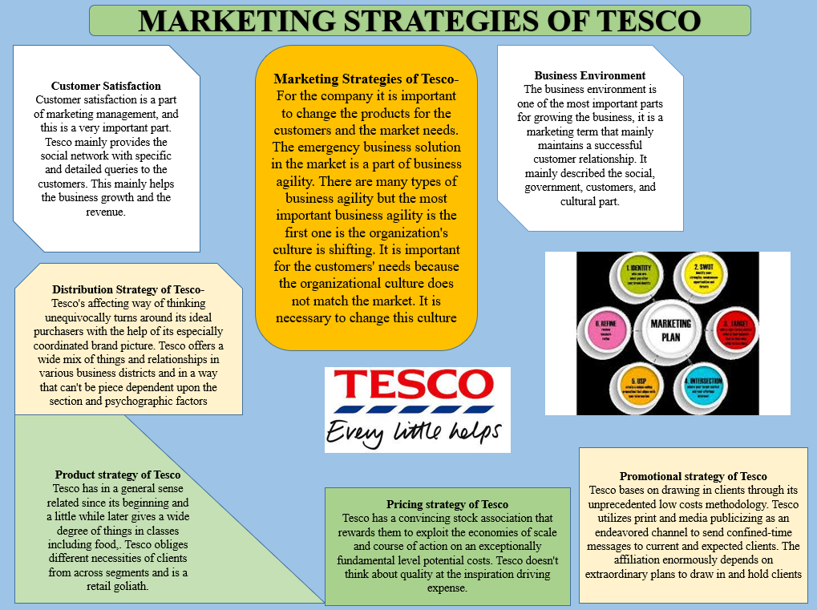

Conclusion
Tesco's enterprise view is the most basic level of spending privileges with added availability, procedures and customer support. Tesco stands out in the UK and around the world for value, comfort and intelligence.
With a customer-centric mindset, Tesco has built a very stable customer base and a one-stop brand. The undeniable quality rests on the image of a productive and intelligent chain. Retailers promote consumer consented movements on their websites and in stores to ensure that every purchase is as smooth and rewarding as possible. The Tesco brand is very stable and recognizable and corporate marketing strategies generally known to everyone help to reinforce this. Marketing strategy is basically the process of describing an organization's relationships as well as a company's maximum opportunities and limited resources with increased sales. Customer satisfaction is part of marketing management and is a very important part. Tesco mainly provides social networks with specific and detailed customer requests described in this section (Fachmi and Utami, 2018).

Reference

Rosnizam, M.R.A.B., Kee, D.M.H., Akhir, M.E.H.B.M., Shahqira, M., Yusoff, M.A.H.B.M., Budiman, R.S. and Alajmi, A.M., 2020. Market Opportunities and Challenges: A Case Study of Tesco. Journal of the Community Development in Asia (JCDA), 3(2), pp.18-27.
Singh, P., Ranjith, P.V., Fathihah, N., Kee, D.M.H., Nuralina, N., Nurdiyanah, N. and Nursyahirah, N., 2021. Service Quality Dimension and Customers' Satisfaction: An Empirical Study of Tesco Hypermarket in Malaysia. International Journal of Applied Business and International Management (IJABIM), 6(3), pp.102-114.
Bărbulescu, O., 2018. MARKETING STRATEGIES USED BY RETAILERS ON THE INTERNATIONAL WINE MARKET. Bulletin of the Transilvania University of Brasov.Economic Sciences.Series V, 11(2), pp.9-14.
Al-Suraihi, W.A., Al-Suraihi, A.H.A., Ibrahim, I., Al-Tahitah, A. and Abdulrab, M., 2020. The Effect of Customer Relationship Management on Consumer Behavior: A Case of Retail Industry in Malaysia. International Journal of Management and Human Science (IJMHS), 4(3), pp.32-40.
Bărbulescu, O., 2018. MARKETING STRATEGIES USED BY RETAILERS ON THE INTERNATIONAL WINE MARKET. Bulletin of the Transilvania University of Brasov.Economic Sciences.Series V, 11(2), pp.9-14.
Peeroo, S., 2019.Customer-initiated conversations on Facebook pages of Tesco and Walmart. In Information Systems Design and Intelligent Applications (pp. 43-51). Springer, Singapore.
Yunus, N.K.Y., Abdullah, H.H., Wahid, H. and Rahman, R., The Relationship Between Promotional Mix And Display Strategies With Sales Performance Of Hypermarkets In Malaysia. Strategic Alliance Between AGBA, Millikin University (USA), IIM-Rohtak (India) and Gift Society (India), p.403.
Sreenivasan, R., Ludbrook, L., Fisher, B., Declosmenil, F., Knower, K.C., Croft, B., Bird, A.D., Ryan, J., Bashamboo, A., Sinclair, A.H. and Koopman, P., 2018. Mutant NR5A1/SF‐1 in patients with disorders of sex development shows defective activation of the SOX9 TESCO enhancer. Human mutation, 39(12), pp.1861-1874.
Lomoio, S., Willen, R., Kim, W., Ho, K.Z., Robinson, E.K., Prokopenko, D., Kennedy, M.E., Tanzi, R.E. and Tesco, G., 2020. Gga3 deletion and a GGA3 rare variant associated with late onset Alzheimer’s disease trigger BACE1 accumulation in axonal swellings. Science Translational Medicine, 12(570).
Kim, W., Hallsworth, A. and Kim, H., 2019. On being local and being successful in Korea: Tesco and E‐mart. Area, 51(3), pp.461-469.
Rosnizam, M.R.A.B., Kee, D.M.H., Akhir, M.E.H.B.M., Shahqira, M., Yusoff, M.A.H.B.M., Budiman, R.S. and Alajmi, A.M., 2020. Market Opportunities and Challenges: A Case Study of Tesco. Journal of the Community Development in Asia (JCDA), 3(2), pp.18-27.
Peeroo, S., 2019.Customer-initiated conversations on Facebook pages of Tesco and Walmart. In Information Systems Design and Intelligent Applications (pp. 43-51). Springer, Singapore.
Tirawatnapong, R. and Fernando, M., 2018.Factors Influencing Bangkok People Purchase Intention towards Tesco Lotus House Brand Products.International Research E-Journal on Business and Economics, 4(2), pp.15-29.
Lin, C. and Peng, J., 2018. Analysis and Solution of the Problems in the Distribution of Suning Tesco.Transportation Management, 1(1).
Awadari, A.C. and Kanwal, S., 2019. Employee participation in organizational change: A case of Tesco PLC. International Journal of Financial, Accounting, and Management, 1(2), pp.91-99.
Foabeh, P.A. and Achaleke, H.F., 2020. ATTITUDES AND PERCEPTIONS OF SHOPPERS’GROCERY SUPERMARKET CHOICES: A COMPARATIVE ANALYSIS BETWEEN BIG C AND TESCO LOTUS. International Journal of Research-GRANTHAALAYAH, 8(7), pp.67-79.
Jonah, U.I., 2018. The Influence of Transaction Costs on the Business Performances of Tesco Supermarket.International Journal of Business and Social Science, 9(5).
Daróczi-Szabó, M. and Bartosiewicz, L., 2018. Horse-dog burials from preventive excavations at Dombóvár TESCO. DissertationesArchaeologicae, pp.243-256.
Woohyoung, K., Kim, H. and Hwang, J., 2020. Transnational corporation’s failure in China: Focus on Tesco. Sustainability, 12(17), p.7170.
Nurwidayat, A., Sudarsono, B., Pratiwi, K. and Havity, M.D., 2019.Implementation of Information System in Submitting Employees’ Annual Leave at PT. Tesco Indomaritim.Sinkron: jurnaldanpenelitianteknikinformatika, 3(2), pp.97-103.
Fachmi, A.H.N. and Utami, D.S.M., 2018. ETIKA PROFESI AKUNTAN DAN PERMASALAHAN AUDIT STUDI KASUS SKANDAL TESCO DAN KAP PwC. UNEJ e-Proceeding, pp.189-195.

