Jemmesha Larman
BMSW4004
Problem Solving & Decision Making
Nauman Ali
Task 2
Student number: 2028351

Introduction

Problem solving is a very common problem within the work place. It can be caused by a number of things and can lead to things such as a lack of productivity, a negative attitude towards your given role and health problems such as stress etc. It is essential for companies to take the necessary steps to ensure that their employees are not subjected to any unnecessary stress. It is common for work related stress to arise in situations such as one where an employee feels as if the demands of they’d job are greater than what they can comfortably manage. Other sources of work related stress could include things such as conflict with co-workers, continual change and threats to the security of ones job.

In this report the way in which work related stress affects employees at Tesco will be explored. Tesco is a famous UK supermarket chain that currently operates in 11 different countries resultantly becoming one of the worlds largest retailers. Tesco carries out business through multi-format stores as well as online.

Section 1

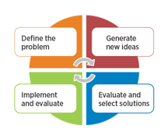
Problem solving is the process in which a problem is firstly defined, followed by the cause of the problem being determined, identifying, prioritising and selecting alternatives for a solution and implementing a solution.

The impact of work related stress on the employees depends purely on what the source of the stress is. As previously mentioned work related stress can be caused by a number of things and because of this the source/sources of the stress would need to be identified in order to act accordingly. For external factors such as problems with their family life it is not really possible for the employer to eliminate the stress factor but what they could do is offer support to the employer that could possibly help to relieve the stress of even better so eliminate It. If the stress factor is internal (within the company) it is extremely important that the employer acts fast and eliminates the issue as quickly as possible to allow the work place to be a positive environment for allow employees. Overly stressed employees are much less productive, healthy and happy. Statistical figures indicate that stress is a bigger problem than what people give it credit for (Ornealas and Kleiner, 2003).

Many organisations have realised that one of the main reasons for unwanted expenditures of the organisation originate from stress. The Health & Safety executive in the UK stated that work related stress, depression and anxiety accounted for an estimated 13.5million lost working days in Britain between 2007-2008. This will of course greatly impact the business financially. The estimated figure for loses due stress was a whopping £370 million per year due to the stress. This is one of the reasons why organisations spend so much money trying to ensure that stress in the workplace is prevented or at least controlled. It is important that organisations regularly develop new ways to properly deal with stress within the workplace.

Section 2

Cause and effect analysis is a technique that helps you to identify all the probable causes that are causing a problem. It works by helping you to find and fix the main cause of the problem, without any unnecessary work. This is because it allows you to identify the main cause the first time around and resultantly prevent it from remaining an issue.
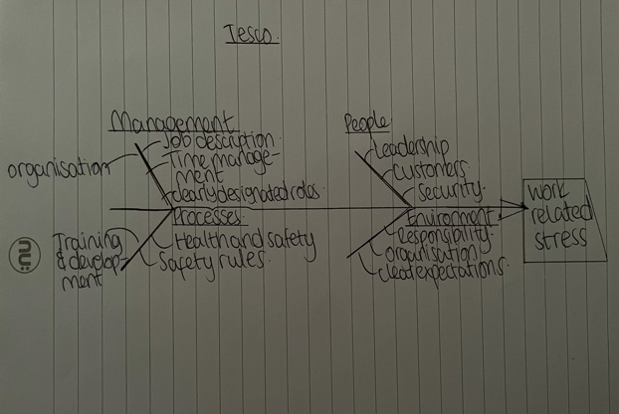
A cause and effect analysis is a method in which the causes of a minor problem are identified. From looking at the diagram shown above you will be able to see that the causes have been grouped into 4 categories, management, people, processes and environment. All of the identities problems fall under one of the given categories. Having these separate categories allows you to identify if the cause is environment for example. A fish bone diagram is a very efficient way to quickly resolve a problem as it allows you to clearly identify the causes of a problem and resultantly plan what exactly needs to be done to combat the given cause. A fish bone diagram is a visual way to look at both the causes and effect, many different causes can be brainstormed on a fish bone diagram.

A fish bone diagram is a more structured approach than some other tools available for brainstorming the causes of a problem. The problem is displayed at the ‘head’ of the fish and the causes are displayed on the on the various ‘bones’ under their various categories as shown above. A fishbone diagram can be very helpful when it comes to identifying possible causes for a problem that might not he otherwise considered by directing the team to look at each category and carefully thing of possible causes.

A fishbone diagram should be used in the following way in order to get the best results from it:

- The team should agree on the effect (problem) and write this at the head of the diagram.
- It should then be agreed up on as to what the main categories of causes of the problem are. Major categories often include things such as equipment and environmental factors etc.
- The team will then need to brainstorm what all the possible causes are and look into what the problem is caused by e.g an environmental issue. Of the cause relates to several categories it can be written in multiple places.
- Teams should then explore why each cause is a cause and continue to offside he reasoning under sub-categories. Doing so will also allow you to identify the root causes of problems and preventing them from being recurrent.

Section 3

PESTLE analysis is a concept within marketing principles. This concept is commonly used within businesses in order t assist them with tracking the environment that they are either operating or planning or planning on operating in the near future.
PESTLE is an acronym. P for political, E for economic, S for social, T for technological, L for legal and E for environmental. It gives a birds eye view of the whole environment from a number of angles that can be used to help keep track whilst need ideas are still being brought to the table.

By analysing these factors, organisations are able to assess any risks which are specific to they’d industry and organisation. It can also highlight the potential for additional costs, and prompt further research to be built into the future plans.

Below I will attach a PESTLE analysis which was used in order to allow companies to look at the external factors that are affecting their organisation. PESTLE analysis is very important as it shows a number of factors that can impact a company therefore effecting the employees.
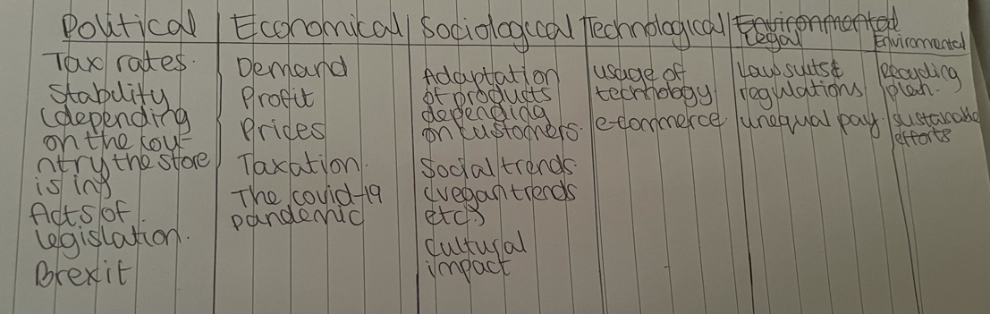
In the PESTLE analysis shown above you will be able to identify the 6 categories which I previously mentioned. This PESTLE analysis was used to look at external factors which would affect Tesco. Doing this analysis was very important as it allows Tesco to look at a number of factors that will effect their company resultantly effecting their employees, this all ties in such so work related stress as analysing issues which may arise allows you to play way in advance what will be done if these problems ever arise which is extremely vital especially when so many people could bd negativity effected.

Section 4

Decision making is a process in which decisions are made to identifying a decision, gathering necessary information, and then assessing alternative solutions.

Using a step by step decision making process enables you to make more deliberate and thou go tuck decisions by organising relevant information and coking up with alternative options. Decision making increases the chance that you will choose the best possible choice.

Management is basically a big decision making process. Decision making is one of the most important components of an employers activities. It plays the most omitting role in the planning process within a business. Employers plannings involves them deciding on various things. Such as the goals for the company, what resources will be needed and who the tasks will be performed by etc.

In the presentation it was identified that as there were multiple factors which could lead to employees being stressed there would also be multiple possible solutions. The chosen solution would end up being dependent on what exactly was causing the stress. This is because the solution for dealing with a technological factor for example might not be the same as a solution for dealing with an environmental factor. Taking this into consideration it was decided that there were four main things that could be done in order to combat the issue. They will be inserted below:
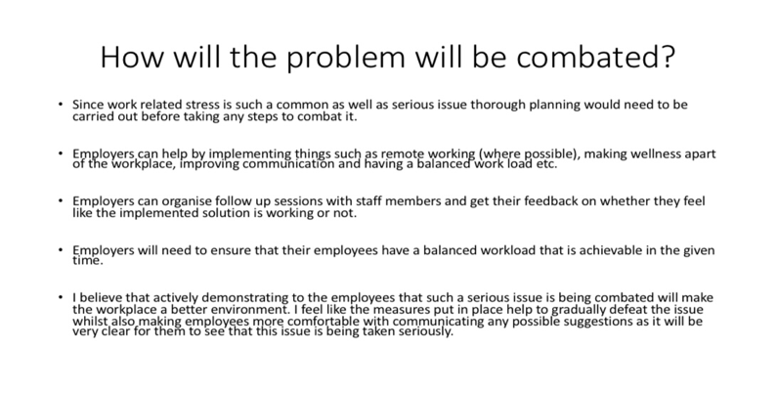
The solutions identified are shown above. After much research and analysts it was decided that these things being implemented would be the best thing to do as they allow employers to demonstrate the importance of such a big issue being combated by them which will most definitely encourage to come to them for support when/if it is needed. It allows a kind of openness within the work place by allowing employees to freely voice his they are affected (if yet are) whilst also giving honest feedback on whether or not they believe the implemented measures are making a difference.

The chosen decision, shown above, was chosen as taking into consideration all analysis and research it which was conducted it was identified that one solution could not be given to solve such a vast problem so looking at 4 makes it possible to solve the issue depending on what the triggering factor. Being able to identify that there are a number of things which lead to work-related stress demonstrates that multiple perspectives have been explored which is essential as different staff members faced different struggles and not all staff members stress issues can be dealt with in the same way.

Section 5

Baring this decision in mind it is still important to explore alternatives. In places in which classroom learning is not possible there are a few things that can be done in order to greatly improve the quality of the teaching/learning such as the following:

- Various technology option can be made is of. In regards to online learning it is vital that technology is used in order to maximise success. There are many ways that lecturers can implement these things when they are primarily connecting with their online students. Implemented technology needs to be properly explained to students so they have a good idea of how to use it to help maximise their learning.
- Lecturers can also make the effort to connect to their students individually. Online learning prevents teachers from being in that classroom setting and seeing what students are doing daily so interacting with them privately on a regular basis will ensure that any questions do not go unanswered and that they can speak to lecturers more openly. Lecturers will also be able to assess how their students are doing academically.
- Teachers should also try developing new learning methods. There are many different learning styles that different students have and a wide variety of teaching methods lecturers can utilise will be beneficial to students. Similarly, an inquiry based learning model where teachers act more as facilitators for learning rather than an authoritative figure helps to encourage students what things they would like to learn about with the support of their lecturers.

Students should come into class where possible as it’s a much more effective way of learning. Students are able to interact more freely, ask questions then and there and learn in a number of different learning styles so their quality of education will be much higher meaning they will be much more likely to succeed in comparison into an online student. Online learning should be a last result if students are unwell etc. This is because it can greatly reduce the way in which information is absorbed. Interacting with other people has also proven to be quite effective in helping learners to organise their thoughts (Sandra Y. Okita, 2012).

References-

- Mind tools, 2020 ‘Cause and effect analysis’ https://www.mindtools.com/pages/article/newTMC_03.htm
- ASQ, 2021 ‘Fish bone diagram’ https://asq.org/quality-resources/fishbone
- The balance careers ‘What are problem solving skills?’ https://www.thebalancecareers.com/problem-solving-skills-with-examples-2063764
- CIPD ‘PESTLE analysis’ https://www.cipd.co.uk/knowledge/strategy/organisational-development/pestle-analysis-factsheet#gref 2020
- The university of Sydney ‘PESTLE analysis’ 2020 https://libguides.library.usyd.edu.au/c.php?g=508107&p=5994242
- Lucidchart, 2020 ‘7 steps of decision making process’ https://www.lucidchart.com/blog/decision-making-process-steps
- Project manager, 2021 ‘What is an implementation plan?’ https://www.projectmanager.com/blog/implementation-plan
- Nicholas Morphus, 2021 ‘Creating the perfect implementation plan’ https://www.google.co.uk/amp/s/www.fool.com/the-blueprint/amp/implementation-plan/

