



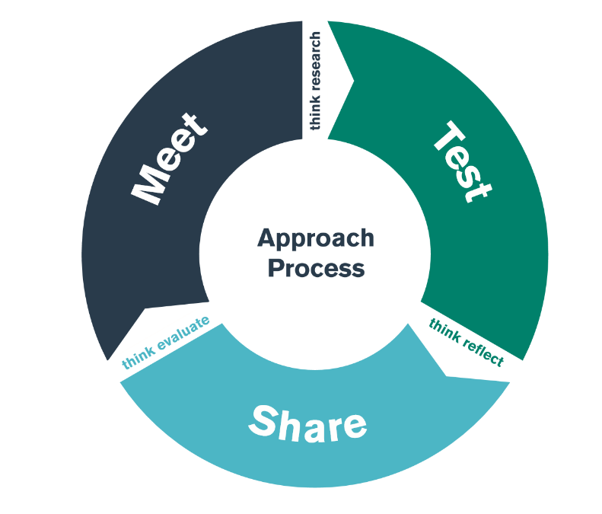

Bridging
PGCE Module ECAD7003 / BA3 Module ECAD6009
Leading the learning: Where am I teaching?

SCHOOL IMPROVEMENT:
School Development Plan

MEET day: 10th January 2024 Lead Schools
TEST days: 11th–23rd January 2024 Placement Schools
SHARE day: 24th January 2024 Lead Schools

Student-Teacher Enquiry Evidence Record

11th -25th November 2020

What is the purpose of this bridging activity?

Through this bridging experience, you will develop an understanding of how school improvement works on a practical level, by focussing on an action point of your Lead School’s School Development Plan.

MEET DAY: Wednesday 10th January 2024
During the MEET day you will develop an understanding of school improvement.

By looking at a specific focus area that your Lead School is looking to improve, you should gain an understanding of how your Lead School:
- identifies action points for its SDP,
- implements the actions, and
- measures the impact of the actions.

TEST phase: 11 January – 23rd January 2024

- Present a presentation on your findings and reflections. You should provide an overview of:
How has your school developed its SDP? What approach has it taken, and why?
- What have you chosen to focus on, and why?
- What have you learned about the development of this aspect of the plan? You are welcome to make use of the headings in the table on page 4
- Which of the standards have you chosen to link this learning to?
- Remember to include a degree of criticality by making links to any research, reading, or theory you have encountered.
- You can provide a summary of your presentation in the first two sections of an experience template.

SHARE: Wednesday 24th January 2024

- Your presentation should discuss your findings and reflections from this bridging experience
- You must use the Experience Template format in a word document
- Remember to include a degree of criticality by making links to any research, reading, or theory you have encountered.

Reading

Essential linked reading are located on this Padlet:

https://padlet.com/jessicaroberts4/e04tfqe8jmln73vb



TEST PHASE - OBSERVATION NOTES

From your placement school’s School Development Plan

Self-evaluation | Data analysis | Stakeholders | Strategic planning | Measuring Impact
How did the school identify this as an area for development? | What qualitative and/or quantitative data did the school use to identify this area of need? | Who needs to be involved?  Who needs to be consulted?  Who will lead it?  Who will “operate” it on a daily basis? | What’s the target?  What’s the success criteria?  What needs to happen?/What’s the strategy?  What’s the time scale?  How much will it cost? | When will it be reviewed?  How often?  By whom?  How will they know if it’s been effective?

EXPERIENCE TEMPLATE
SHARE DAY PRESENTATION

- What did you do and why?
Describe your professional experience. You may wish to refer to your role or involvement, why you had engaged in this experience and the intended outcomes. You can also mention any particular professional standards you had chosen to focus on.

- What have you learned?
You might want to consider some of the following: why is this experience important or relevant? How does it relate to your overall learning, development and/or use of the standards? Did it meet the intended outcomes? Any lessons learned? What are the implications for colleagues and learners? How will you share what you’ve learned?

- What Next?
Is there anything you intend to do as a result of this experience? You might want to consider some of the following questions: Are there any specific actions that you will take? What would you do in similar circumstances in the future? Is there anything you intend to change? Do you have plans for any further learning or development opportunities? If so, who or what can help - using the standards, people, written resources, online materials, workshops etc? How will you share what you’ve learned?

TARGET

What area do you want to develop in your own practice?
TIMESCALE

When do you want to achieve this by?
RESOURCES

What do you need to help you achieve this? Who do you need to talk to/observe? What do you need to research?
SUCCESS CRITERIA/
OUTCOME

How will you judge whether it has been successful or not? What impact do you hope to see in teaching and learning? What research/literature is this based on?
MONITORING/
EVALUATION

How will you check that you have successfully achieved your target? Lesson observation? Book scrutiny? Pupil voice?

How does the bridging activity support the module assessment for ECAD7003/6009?

EAD7003/6009 Assessment Component 2:

How a school develops one aspect of its SDP: a report that critically reflects on the actions, impact and evidence base. (2500 words).

Using the information and materials you gather on the Bridge 4, prepare a written report based on one action point taken from the School’s strategic targets. The report should demonstrate how this target was/is addressed and impact measured within an evidence-based framework.

Possible structure (Word counts are suggested; they are not compulsory)

Introduction (200 words)
In the introduction you need a very brief summary of the task you have been given and the aspect you have chosen to write about. You also need to give a brief outline of the context of the school.

Literature review (800 words)
Your literature review needs to show your understanding at a theoretical level of the school development process but it also need to show your understanding of the aspect you have chosen as your focus, e.g. provision for EAL learners.

Developing an action point (800 words)
In this section you need to discuss the School Development Plan (SDP), demonstrating your knowledge and understanding of the processes such as self-evaluation, data analysis, involving stakeholders, strategic planning, measuring impact, that the school will have used. You should constantly be applying a degree of criticality here.

Reflection and evaluation (500 words)
This section needs to be a review of the development in which you reflect and evaluate what the school has done. It is important that you also make practical suggestions based on your knowledge of theory and practice as to how things could be done differently.

Conclusion (200 words)
As in component 1, you need to briefly summarize the assignment, explain what you have learnt from it and how this is going to influence you professionally in the future.

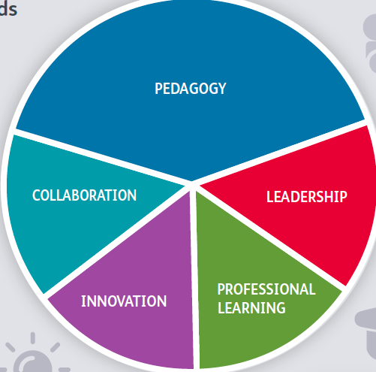
PLP AND LINKS TO PROFESSIONAL STANDARDS

Your bridging experience will support your development of the Professional Teaching Standards. Consider how you might use the experience to create an Experience Template for Tab 7 (standards).

Bridging gives you the opportunity to exemplify standards across all areas.

Your share day presentation will be written in the format of an experience template and should be uploaded to your PLP after the bridging experience.

The assignment linked to this bridging experience can be used as an asset for your PLP.

 |  | Standard Title | QTS Descriptor
Pedagogy |  | Pedagogy - Refining Teaching
Pedagogy | Refining Teaching | Managing the learning environment | The teacher understands the importance and demonstrates the  effective establishment and on-going management of the learning  environment, in promoting positive learning habits and behaviours  that meet the four purposes and are understood by learners in that  context.
Pedagogy | Refining Teaching | Assessment | The range of purposes and practices for assessment is understood and articulated.
Pedagogy | Refining Teaching | Differentiation | The teacher demonstrates knowledge, understanding and  experience of high expectations and effective practice in meeting  the needs of all learners, whatever their different needs.
Pedagogy | Refining Teaching | Recording and reporting | The teacher produces appropriate, timely and accurate records and reports and gives feedback to facilitate a deeper understanding of learning and enhance the learning experience.
Pedagogy | Refining Teaching | Involving partners in learning | The importance of positive involvement of parents/carers and other  partners is understood and opportunities are taken to observe and  evaluate processes.
Pedagogy |  | Pedagogy - Advancing Learnings
Pedagogy | Advancing Learning | Four purposes for learners | The teacher demonstrates a knowledge and understanding of the  needs of all learners in planning, preparation and teaching, ensuring  that the four purposes are the drivers for learners’ experiences.
Pedagogy | Advancing Learning | Exploiting subject disciplines in areas of learning | The teacher demonstrates a knowledge and understanding of  relevant pedagogies and disciplines within and across subject  content, areas of learning and cross-curricular themes, and plans  appropriately.
Pedagogy | Advancing Learning | Blended learning experiences | The teacher understands the selection, use and justification of a range  of imaginative teaching approaches for the benefit of each learner.
Pedagogy | Advancing Learning | Real life, authentic contexts | The teacher demonstrates an understanding of the use of real life,  authentic contexts for learning being provided as a natural part of  the learning experience. This extends the learner’s cultural, linguistic,  religious and socio-economic experience and illustrates applications  of concepts and abstracts in practice.
Pedagogy | Advancing Learning | Progression in learning | The teacher demonstrates an understanding of how learning  develops incrementally and tangentially, building on prior experience  and learning, and plans for progress in learning based on this.
Pedagogy | Advancing Learning | Cross-curricular themes | The teacher knows, understands and engages with the principles  of curriculum design and innovation, with development of crosscurricular themes relevant to areas of learning and justifies decisions.
Pedagogy |  | Pedagogy - Influencing Learners
Pedagogy | Influencing Learners | Challenge and expectations | The teacher provides appropriate levels of challenge and  expectations for the range of student abilities and characteristics,  motivating learners to achieve.
Pedagogy | Influencing Learners | Listening to learners | The teacher demonstrates a willingness to seek, listen to and take  account of the views of learners in order to engage and encourage  them as active participants in their own learning.
Pedagogy | Influencing Learners | Learners leading learning | In planning and delivery, the teacher demonstrates an awareness  of the importance of encouraging learners to reflect upon their own  learning.
Pedagogy | Influencing Learners | Sustained effort and resilience in learners | The teacher promotes and secures learners’ self-motivation and  self-direction in their learning.
Pedagogy | Influencing Learners | Reflection on learning | In planning, the teacher demonstrates awareness of the importance  of encouraging learners’ reflection and evaluation around  behaviours and outlooks for learning.
Pedagogy | Influencing Learners | Learning outcomes and well-being | The teacher raises awareness of how high-quality learning  experiences and performance outcomes lead to improved learning  and a heightened sense of well-being.
Collaboration |  | Collaboration
 |  | Seeking advice and support | The teacher actively seeks and engages with support from a range of formal and informal sources. This includes observation and team teaching, whilst demonstrating increasing levels of independence.
 |  | Working with in-school colleagues | Organised and constructive work with a range of colleagues to enhance learners' experience is a consistent feature of the teacher's practice. Reflection on developing expertise is structured as a personal or a collaborative process, as appropriate.
 |  | Supporting and developing others | The teacher develops high quality relationships with colleagues in order to have a positive impact on learners' experiences within the school.
 |  | Enabling improvement | There are examples of improvement in outcomes following the teacher's seeking and adoption of advice.
Professional Learning |  | Professional Learning
 |  | Wider reading and research findings | The teacher demonstrates increasingly confident understanding of the theories and research about assessment, pedagogy, child and adolescent development and learning relevant to planning and day-to-day practice.
 |  | Professional networks and communities | The teacher has an informed understanding of the contribution of research, including small scale action research, to the development of practice.
 |  | Continuing professional learning | The Professional Learning Passport influences the ongoing critical reflection and learning of the teacher and is developmental in prompting further professional growth.
 |  | Welsh language skills | There is a commitment to incremental development of personal skills in the use of the Welsh language.
Innovation |  | Innovation
 |  | Offering expertise | The teachers models an increasing repertoire of teaching techniques, as expertise emerges and flourishes, in order to inform and enhance the development of others.
 |  | Developing new techniques | Research on cognitive, social, emotional and physical development has a positive impact on pedagogy. The teacher can demonstrate how professional discernment and critical analysis are brought to bear in shaping developing practice.
 |  | Evaluating the impact of changes in practice | The teacher actively seeks support and advice from colleagues in developing innovative approaches within the classroom so that their impact can be evaluated, analysed and shared.
Leadership |  | Leadership
 |  | Taking responsibility for self | The teacher demonstrates professional attitudes and behaviours, developing positive relationships with learners, parents/carers and coleagues which illustrate a personal commitment to the fundamental principles of equity and of maximising the potential of all learners.
 |  | Exercising corporate responsibility | Contractual, pastoral, health and safety, legal and professional responsibilities are known and understood by the teacher.
 |  | Leading colleagues, projects and programmes | The teacher's understanding of, and commitment to, leading learning is demonstrated through collaborative experiences in school and other contexts.
 |  | Supporting formal leadership roles | The teacher demonstrates an understanding of the nature of responsibilities within and across teams and of the contributions individuals make towards the school's ethos and the successful fulfilment of the school's vision.

BRIDGING – CHECKLIST

 | What to do? | When? | Notes
1 | - Ask your Senior Mentor to arrange a meeting with whomever is in charge of your school’s improvement plan AND/OR departmental improvement plan.  - Request a copy of the plan if possible.  - Find out what process the school goes through to self-evaluate, identify targets, develop strategies and evaluate impact.  - Find out if and how the school is working with the Schools as a Learning Organisation (SLO) model.  - Identify one aspect that you would like to explore for your ECAD7003 assignment and arrange additional meetings to generate further evidence and information as necessary. | Between 11th– 23rd January 2024
2 | Prepare a presentation on your findings and reflections to share with the Network Leader, Curriculum Tutor and peers on the SHARE day.  When you are not taking part in your groups' presentations on the SHARE day, you should take part in meaningful activity. This could be completing your experience template for your PDP, reading/writing time for your assignment or school work (including teaching). | By Wednesday 24th January 2024 | This will be in your Lead School.  - A 10 minute presentation. If you are using PPT, a maximum of 3 slides.  - Experience Template format must be followed (first two questions - see STEER document)  - Your presentation should discuss your findings and reflections from this bridging experience  - Remember to include a degree of criticality by making links to any research, reading, or theory you have encountered.
3 | Complete your personal target in the STEER booklet. |  | Complete question 3 of experience template.
4 | Upload your completed experience template to your PLP. |  | Ensure that your impact statements (questions 2 and 3) are specific to the standard you are exemplifying.

