Prepared By: Mohammed S Ahmed (1605853), Junior Richard (1605599), Arry Jaffa (1605600), Vadym Kozlov (1703901), Ewart Rose (1703899)
Lecturer: Molly Jack
Project Management Plan
EMPL4009

Table of Contents
Background 2
Objective 2
Project Deliverables 3
Overall Approach to the project 3
Work Activity 1 Conceptual Development: 3
Work Activity 2 Reallocation: 3
Work Activity 3 Launch: 4
Feasibility assessment and contingency plans 4
Project schedule and milestones 4
Project Roles and Responsibilities 6
Project Scope Management 7
Project Cost Management 7
Time line of Project Management Plan 8
Quality Assurance 9
Quality Control 9
Human Resources Acquisition 9
Project Risk Assessment 10
Project issues 11

Overview of project

Background
AZ Interior senior management have come together with stakeholders and decided to relocate to the Kennington area due to the organization needing to expand to fulfil their customers’ requirements.

Objective
The Objectives of Project Ps is to:
Project PS’s aim is to relocate from Hackney site to Kennington site. Within the Kennington site there is going to be two separate buildings with a car park. 1st building will be the showroom from kitchen designs as well as living room designs, 2nd building will consist of bathroom designs and also bedroom designs. Project PS have looked at several objectives as well as considering SMART goals to see if the business relocation is feasible as well as various aspects of a project will be evaluated using SMART objectives. SMART objectives ensure applicability of this project in a real sense. The use of control plans, interviews, and resources will be used by PROJECT PS to deliver the scope of the project.

- Specific: A to Z Interior Designs will be reallocating to a larger premise in Kennington to suit the requirements of expansion.
- Measurable: The use of interviews and surveys to the stakeholders helped determine whether the project was viable. PROJECT PS considered the social impact the project will have in the area and 75% of the local population contacted were happy with the news of a company coming into the Kennington area. PROJECT PS determined the value of the environmental impact coupled with renewable energy and recycling goals would be advantageous to the A to Z Interior Designs.
- Achievable: It is achievable as PROJECT PS have been given a sufficient budget of £150,500 for running the project. Due to the surveys and interviews of the residents, PROJECT PS have found this project achievable because of the high level of positive feedback.
- Realistic: Due to the larger premises, high demand and inexpensive rent in the new location, including positive feedbacks should gain clients and build a solid reputation.
- Timely: AZ required a timeline of the project plan and the project planned a 4-week schedule to complete the project. Commencing 1st December 2018 until 30th December 2018. Due to the festive season, PROJECT PS have taken on board the benefits of less traffic and roadworks as well as the disadvantages of unexpected transports issues.

Project Deliverables
PROJECT PS understands that each project scope is limited to some specification, we have a scope that outlines the planning, design, development and testing of materials to fulfill the stakeholder’s requirements.
The project deliverables are:
- Showroom (3000 square foot).
- Kitchen designs (3 x kitchens units 900 square foot).
- Bathroom designs (3 x Bathrooms units 600 square foot).
- 2 offices (300 square foot).
- Welcome desk store front garden.
- Car park.

Overall Approach to the project
The project is divided into three work sectors, all to be controlled by the Project Manager (Junior Richard):
- Work Activity 1: Theoretical Development, Stakeholder Examination and formation of User Focus Groups
- Work Activity 2: System Development, transportation to the Kennington site.
- Work Activity 3: A launch and testing of the new premises.

Work Activity 1 Conceptual Development:
- In focus groups, originals ideas will be discussed and developed as a team.
- Stakeholders and Sponsors will be acknowledged of any changes and ideas that have been discussed.
- KPI’s (Key Performance Indicators), as well as quality assurance tools will be developed.

Work Activity 2 Reallocation:
- Dismantling and packing from Hackney Site.
- Maintenance System will be developed.
- Development plan for the Kennington site.
- Formulating a Car Park for the clients and colleagues.

Work Activity 3 Launch:
- Stake holder acceptance testing.
- Clients approval.
- Store launch.

Feasibility assessment and contingency plans
Profit and loss will be accounted for by PROJECT PS. Firstly, PROJECT PS have assessed the market by using a critical analysis of the competitiveness of other organizations for a service or a product. Secondly, reviewing the technical requirements and understanding the needs of the stakeholders. Thirdly, PROJECT PS have made a contingency plan:

Project schedule and milestones
- Dec 1 – Shop is officially closed. Starting to package materials and equipment.
- Dec 2 – Two hired vans are arriving to be loaded with the stuff already packaged.
- Dec 5 – Vans are starting to arrive at new location to be unloaded, some of the stuff will be stored at temporarily acquired storage.
- Dec 6 – Dec 8: Packaging, moving to be continued.
- Dec 11 – Last day of clearing of the old premises. Closing of the premises and key handover to the estate agent.
- Dec 12 – Dec 22: 10 days of refurbishment of the new premises to be commenced, with some unpacking where and when possible.
- Dec 21 - Dec 29: Continuing with unpacking and installation.
- Dec 30 – Last day of unpacking and installation, shop officially opens.

Project Roles and Responsibilities

PROJECT PS have identified the key project stakeholders are:
Local council – Provide appropriate parking facilities, permits, business permits.
A to Z Interior Design – To support by giving the budget.
Financial intuitions – To support financially and give advice.
Local residence – To ensure that they are fully aware of the ongoing relocation, they do not obstruct entry to the premises and observe all the notices from PROJECT PS and local authorities.

Stakeholder | Interest / stake | Importance
AZ Interior Design | Project creator. | High
Clientele | Opportunities for developing potential clients. | High
Local community | Opportunities for discussion and association and the distribution of good practice, awareness within our project. | Medium
Other projects | Lessons learned | Low

Project Scope Management
PROJECT PS project scope can be accurately mapped and defined using the scope management techniques, which will assist the project manager (Junior Richard) and supervisors (Arry Jaffa) involved in the project. To manage requirements, PROJECT PS will use the following 3 processes: planning, controlling, and closing. Firstly, PROJECT PS will use the planning process to capture and define the work that needs to be done within the project. Secondly, PROJECT PS will be controlling and monitoring procedures focusing on documenting tracking and disapproving/approving project changes, so decision-making will be imperative throughout the project. Lastly, PROJECT PS closing includes an evaluation of the project deliverables and an assessment of the outcomes against the original plan of the project.

Project Cost Management
A budget of £150,500 is given to complete the project. £150,500 was developed due to the £12,000 per annum rental property lease as well as more than £4,000 for the council fees. The table below shows our cost analysis:
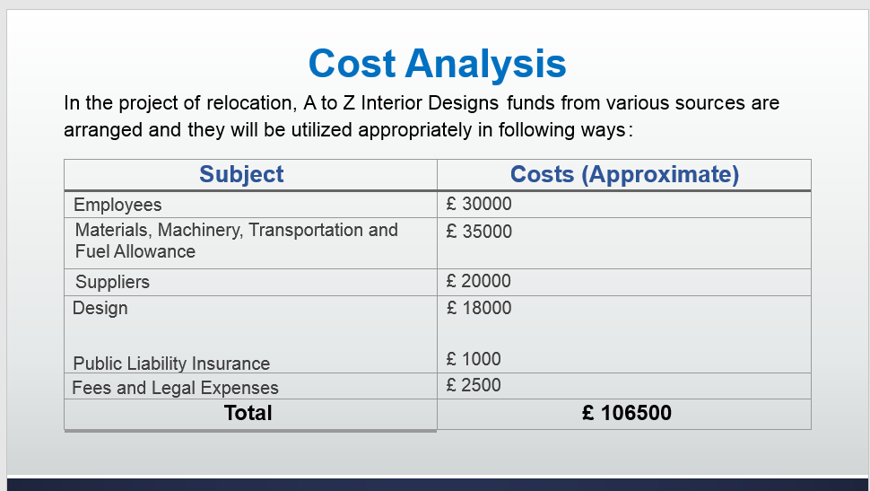

Time line of Project Management Plan

Quality Assurance
PROJECT PS have determined which procedures ought to be used to accomplish the project requirements and to guarantee they are accomplished professionally and effectively, the implantation we involve in the quality assurance will be carrying out methodical quality activities and using quality audits. Two of the main tools PROJECT PS have used the following tools to manage the quality assurance of the project are quality audits and process analysis. PROJECT PS Project team members, project manager and the stakeholders are all accountable for the quality assurance of the project, but the Junior Richard will have the utmost impact on the quality of the project. The inputs PROJECT PS have used to the quality assurance process are likely to include the following: Quality management plan, Process improvement plan, Work performance information, Approved changes as well as quality control measurements.

Quality Control
PROJECT PS will use quality control process involving the project and product deliverables that have been considered and use it throughout the project life cycle. PROJECT PS will use a statistical sampling process rather than looking at each output individually, as it will allow PROJECT PS to control the project. PROJECT PS will use quality control by the assisting of inspection to ensure results of the work are what they need to be. PROJECT PS will use this method ensuring that everything, which is produced, meets the quality standards within PROJECT PS. We will perform this process at the beginning with the production of the first product deliverable and remains until all the deliverable have been acknowledged. The quality control department within PROJECT PS have their duties of measuring the performance of the project from the start of planning to the projects end against the Policies, standards, plans as well as procedures.

Human Resources Acquisition
Human resources required for the roject:
Laborer’s to do moving, packing, unpacking and general help during the project – 15, Drivers – 2, Drivers mates – 2, Electricians – 2, Plumbers – 2, Carpenters – 2.

Project Risk Assessment
The majority of the team members have previously worked together in other successful projects. To ensure that the project is successful, majority of the staff have been put in place for work to commence. Evaluation and user testing will be regularly used to make sure that the project does not go off course.

Risks | Probability  (1-5) | Severity  (1-5) | Score  (P x S) | Action to Prevent/Manage Risk
Slips and Trips | 3 | 4 | 12 | Health and Safety training has to be carried out No loose cables on the floor, use of PPE for staff. Cleaning the spillages, keep the floor clean and tidy. An accident report should be signed by the people involved and the Project Manager and Supervisor should be informed immediately. In severe situations, an Ambulance and First Aider should be called to the scene.
Electrical Shock/Fire hazard | 2 | 5 | 10 | All staff handling electrical equipment require certified training and a fire warden will be ensuring the fire precautions are in place. The fire warden, fire services and Project Manager should be informed straight away in any circumstance.
Falling Objects | 3 | 3 | 9 | Staff training on how to handle objects. Health and Safety training. Use machinery or trolleys if possible and do not lift over 25KG. Manager and First Aid should be informed straight away in case of any accidents. An accident report should be signed by the people involved.
Failure to complete deliverables | 2 | 5 | 10 | Regular communication between the team within the project to ensure tasks are getting met on time. Managers will be informed of any delays within the project.

Project issues
Our Project can be affected by the following issues:
- Weather: December period, snow is a possibility and could be hazardous.
- Finance: Current financial climate, PROJECT PS have taken on board that Brexit could have a great impact within our budget due to materials needed for the project
- Transport: Adequate transport may not be available, for example, removable Lorries could breakdown, causing unexpected delays within the project.
- Employers: Appropriate number of staff required may not be available upon request.
- Stakeholders: Contingency plans have been carried out just in case we have to make key alternative decisions within our project.

