

Student name: Jadesola Oluwatomi Hilda Tompson
Student ID: 2219412

Module name: Independent Project
Module code: BMHP6020_LON
Supervisor’s name: Jolly Nwankwo

  IELTS Reading Practice: The Impact Of Social Media On Teen Mental Health |  | Exploring the Impact of Social Media on Mental Health Among UK Adolescents:  To explore and synthesise the lived experiences and perceptions of UK adolescents regarding the impact of social media use on their mental health and wellbeing through a qualitative meta-synthesis of existing research.  1. Explore how UK adolescents experience the connection between social media use and anxiety.  2. Identify key themes from research on adolescent and social media use.  3. Provide recommendations to family/educators for promoting healthy digital engagement.  4. Examine how social media influences adolescents’ views and how social media impacts their mental health.  NHS Digital (2022) reports one in six children aged 5–16 in England likely have a mental health disorder, underscoring the need for understanding digital impacts. |  | 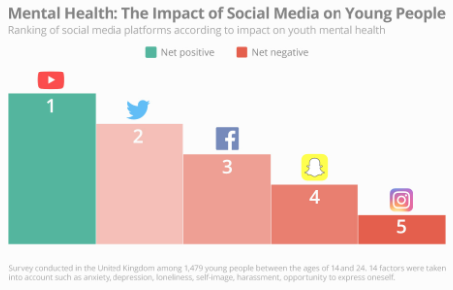  United Kingdom - statistics & facts | Statista
  Methodology  This study will adopt a qualitative meta-systematic approach to review and integrate findings from existing qualitative studies systematically. The literature review will be based on 10 literature studies (sample size), which will review peer-reviewed studies from the past decade.  A systematic search strategy will be used across multiple academic databases, including PubMed, PsycINFO, UWTSD Library/ProQuest, and the British Education Index. Relevant studies published within the last ten years will be identified using keywords such as “social media,” “adolescents,” “mental health,” and “UK,” combined.  Clear inclusion and exclusion criteria will be applied to ensure relevance and quality. The methodological quality of selected studies will be assessed using the CASP qualitative appraisal to ensure credibility and accuracy.  Conclusion  - Social media has both positive and negative impacts  - Experiences vary depending on use and context  - Need for balanced, healthy engagement |  |  |  | Data Analysis  A thematic synthesis approach will be used to analyse the data.  This will involve:  - Reading and reviewing findings from selected studies  - Identifying common patterns and key ideas  - Grouping similar findings into main themes  - Interpreting these themes to understand adolescents’ experiences  This approach allows for a clear and structured summary of how social media impacts the mental health and well-being of UK adolescents, without the use of detailed coding.    Ethical considerations  As this study is based on secondary data (published research), it does not involve direct interaction with participants and therefore poses minimal ethical risk. However, several ethical considerations remain vital.  - All sources will be properly referenced  - Findings will be reported honestly and accurately  - Sensitive handling of participant quotes from original studies  - Clear and transparent research processes.  - Ethical approval was given by UWTSD ethics team.

Data Collection Method
Data will be collected through a systematic literature search of peer-reviewed qualitative studies rather than primary data collection.
The process will involve:
- Conducting full-text reviews based on inclusion and exclusion criteria
- Extracting key data from selected studies, including participant experiences, themes, and authors’ interpretations
Only studies focusing on UK adolescents aged 13–18 and their experiences of social media and mental well-being will be included.
This ensures the data is contextually relevant and aligned with the research aim.
- I was able to summarise, analyse and organise my research using Scholarcy, which was supplied by the DSA for my Vision Impairment.

References

Best, P., Manktelow, R., and Taylor, B. (2014) ‘Online communication, social media and adolescent wellbeing: A systematic narrative review’, Children and Youth Services Review, 41, pp. 27–36. [Accessed 27 October 2025].
NHS Digital (2022) ‘Mental health of children and young people in England, 202:
NHS Digital (2022) Mental health of children and young people in England, 2022’. Leeds: NHS Digital. [Accessed 27 October 2025].
IELTS Reading Practice: The Impact Of Social Media On Teen Mental Health – Accessed 24/02/2026
United Kingdom - statistics & facts | Statista – Accessed 24/02/2026

