4/24/2026
Word Count: ~ 2,580 (excluding Table of Contents, References, and Appendices)
Student: Federico Mossa
ID:2314622
Lecturer: Dr. Balan Kandasamy
University of Wales, Trinity Saint David

Data Warehousing & Data Mining
Assignment 02 – Data Mining


Table of Contents
1.1 Purpose and Practice of Data Mining 3
1.2 Dataset Description and Exploration 4
Dataset Overview 4
Attributes and Data Types 4
Missing Values 5
Summary Statistics and Class Distribution 5
1.3 Data Preparation and Final Processing 6
Managing Null Values 6
Outlier Treatment 6
Feature Cleaning and Standardisation 6
Encoding Categorical Variables 6
Feature Engineering 6
Handling Class Imbalance - SMOTE 7
Post-processing 7
1.4 Sample Runs and Analysis Methods 8
Classification Approach 8
J48 Decision Tree 8
Random Forest 9
Logistic Regression 9
Evaluation Metrics 9
Top Performing Model 9
Clustering Analysis - SimpleKMeans 10
1.5 Strategic Business Actions 11
1.6 Reflective Commentary 12
Model Performance 12
Strengths of the Analysis 12
Limitations 12
What Would Be Done Differently 13
References 13
Appendix A: Weka Preprocess - Attribute Distributions 14
A-1: Gender_Distribution 14
A-2: Age_Distribution 15
A-3: Hypertension 15
A-4: Heart_Disease 16
A-5: Ever_Married 16
A-6: Work_Type 17
A-7: Residence_Type 17
A-8: Avg_glucose_level 18
A-9: BMI_Distribution 18
A-10: Smoking_Status 19
A-11: Age_Group (Engineered) 19
A-12: BMI_Category (Engineered) 20
A-13: Glucose_Category (Engineered) 20
A-14: Risk_Score (Engineered) 21
A-15: Stroke_Class_Distribution 21
Appendix B: Tableau - Individual Chart Views 22
B-1: Stroke Class 22
B-2: Age Distribution by Stroke Result 22
B-3: Avg Glucose Level by Stroke Result 23
B-4: Risk Score Distribution by Stroke Outcome 23
B-5: Stroke by Age Group 24
B-6: Model Accuracy Comparison 24
B-7: ROC AUC Comparison by Model 25
Appendix C: SMOTE Parameter Comparison 25
C-1: J48 Results - SMOTE 100% (Insufficient Balancing) 25
C-2: J48 Results - SMOTE 1836% (Final Setting) 26
Appendix D: Weka Classifier and Cluster Results 26
D-1: J48 Decision Tree - Key Results 26
D-2: Random Forest - Key Results 27
D-3: Logistic Regression - Key Results 27
D-4: SimpleKMeans Clustering - Key Parameters 27

1.1 Purpose and Practice of Data Mining

Data mining can be described as the use of computational methods to analyse large volumes of data in order to identify valuable patterns, relationships, irregularities, and practical insights by applying statistical models, mathematical approaches, and machine learning algorithms [1]. It sits at the convergence of database management, statistics, and artificial intelligence, enabling organisations to transform raw data into structured knowledge that supports evidence-based decision-making [2].

Within the healthcare sector, data mining has become an indispensable tool for clinical decision support, epidemiological surveillance, and resource planning. By applying predictive models to patient records, healthcare providers can identify individuals at elevated risk of conditions such as stroke, diabetes, and cardiovascular disease before symptoms manifest, enabling timely preventative intervention [3]. Classification algorithms can analyse demographic and clinical variables to generate risk scores that assist clinicians in triaging patients most in need of proactive care [1].

Beyond direct clinical applications, data mining supports broader business and public health objectives. Healthcare organisations employ clustering techniques to segment patient populations by risk profile, facilitating the targeted allocation of resources such as screening programmes and community health initiatives [4]. Payers and insurers use predictive analytics to forecast hospitalisation rates and model cost trajectories. Public health bodies leverage association rule mining to identify behavioural and environmental risk factors at a population level [2].

Two principal paradigms underpin the analysis conducted in this study. Supervised learning encompasses classification models trained on labelled past data to generate a defined outcome, in this case, stroke occurrence. Unsupervised learning, by contrast, requires no pre-labelled outcomes and instead identifies latent structures within the data; K-Means clustering is applied here to segment patients into clinically distinct risk groups without reference to the known stroke label [5].

Weka (Waikato Environment for Knowledge Analysis) serves as the primary analytical platform for this study, providing a graphical interface for preprocessing, classification, and clustering workflows [6]. Tableau is employed for exploratory visualisation, enabling examination of attribute distributions and relationships prior to modelling. Full attribute-level visualisations from Weka's Preprocess tab are provided in Appendix A.

1.2 Dataset Description and Exploration

Dataset Overview
The Stroke Prediction Dataset, retrieved from Kaggle [7], includes health-related data for 5,066 individuals following preprocessing. The dataset comprises 11 original attributes alongside a binary outcome variable indicating stroke occurrence. After preprocessing (detailed in Section 1.3), four engineered features were added, bringing the final attribute count to 15. Full Weka attribute visualisations are provided in Appendix A; individual Tableau charts are provided in Appendix B.

Attributes and Data Types
Attribute | Type | Description
gender | Nominal | Female / Male (2,979 / 2,087)
age | Numeric | Range: 1–82, Mean: 43.59, StdDev: 22.36
hypertension | Nominal | 0 = No (4,568), 1 = Yes (498)
heart_disease | Nominal | 0 = No (4,790), 1 = Yes (276)
ever_married | Nominal | Yes (3,353) / No (1,713)
work_type | Nominal | Private (2,924), Self-Employed (819), Govt (657), Children (644)
residence_type | Nominal | Urban (2,573) / Rural (2,493)
avg_glucose_level | Numeric | Range: 55.12–240.75, Mean: 106.13
bmi | Numeric | Range: 10.3–53.08, Mean: 28.89
smoking_status | Nominal | Never smoked (3,393), Formerly (884), Smokes (789)
stroke | Nominal | Target: 0 = No (4,817), 1 = Yes (249)
age_group * | Nominal | Categorised age bands
bmi_category * | Nominal | Standard BMI groups
glucose_category * | Nominal | Clinical glucose groups
risk_score * | Numeric | Composite score 0–5 (Mean: 0.976)

Missing Values
The original dataset contained 201 missing values in the BMI attribute (3.97% of instances). These were imputed using the median value during preprocessing. Following cleaning, the final dataset contains zero missing values across all 15 attributes, as confirmed in Weka’s Preprocess tab (see Appendix A-9).

Summary Statistics and Class Distribution

Attribute | Min | Max | Mean | Std Dev
age | 1.0 | 82.0 | 43.59 | 22.36
avg_glucose_level | 55.12 | 240.75 | 106.13 | 45.06
bmi | 10.3 | 53.08 | 28.89 | 7.40
risk_score | 0 | 5 | 0.976 | 1.037
A critical characteristic of this dataset is a pronounced class imbalance: only 249 individuals (4.92%) experienced a stroke compared to 4,817 (95.08%) who did not, producing a 19.3:1 imbalance ratio. The Tableau Data Exploration Dashboard below provides a comprehensive view of the dataset's key distributions.
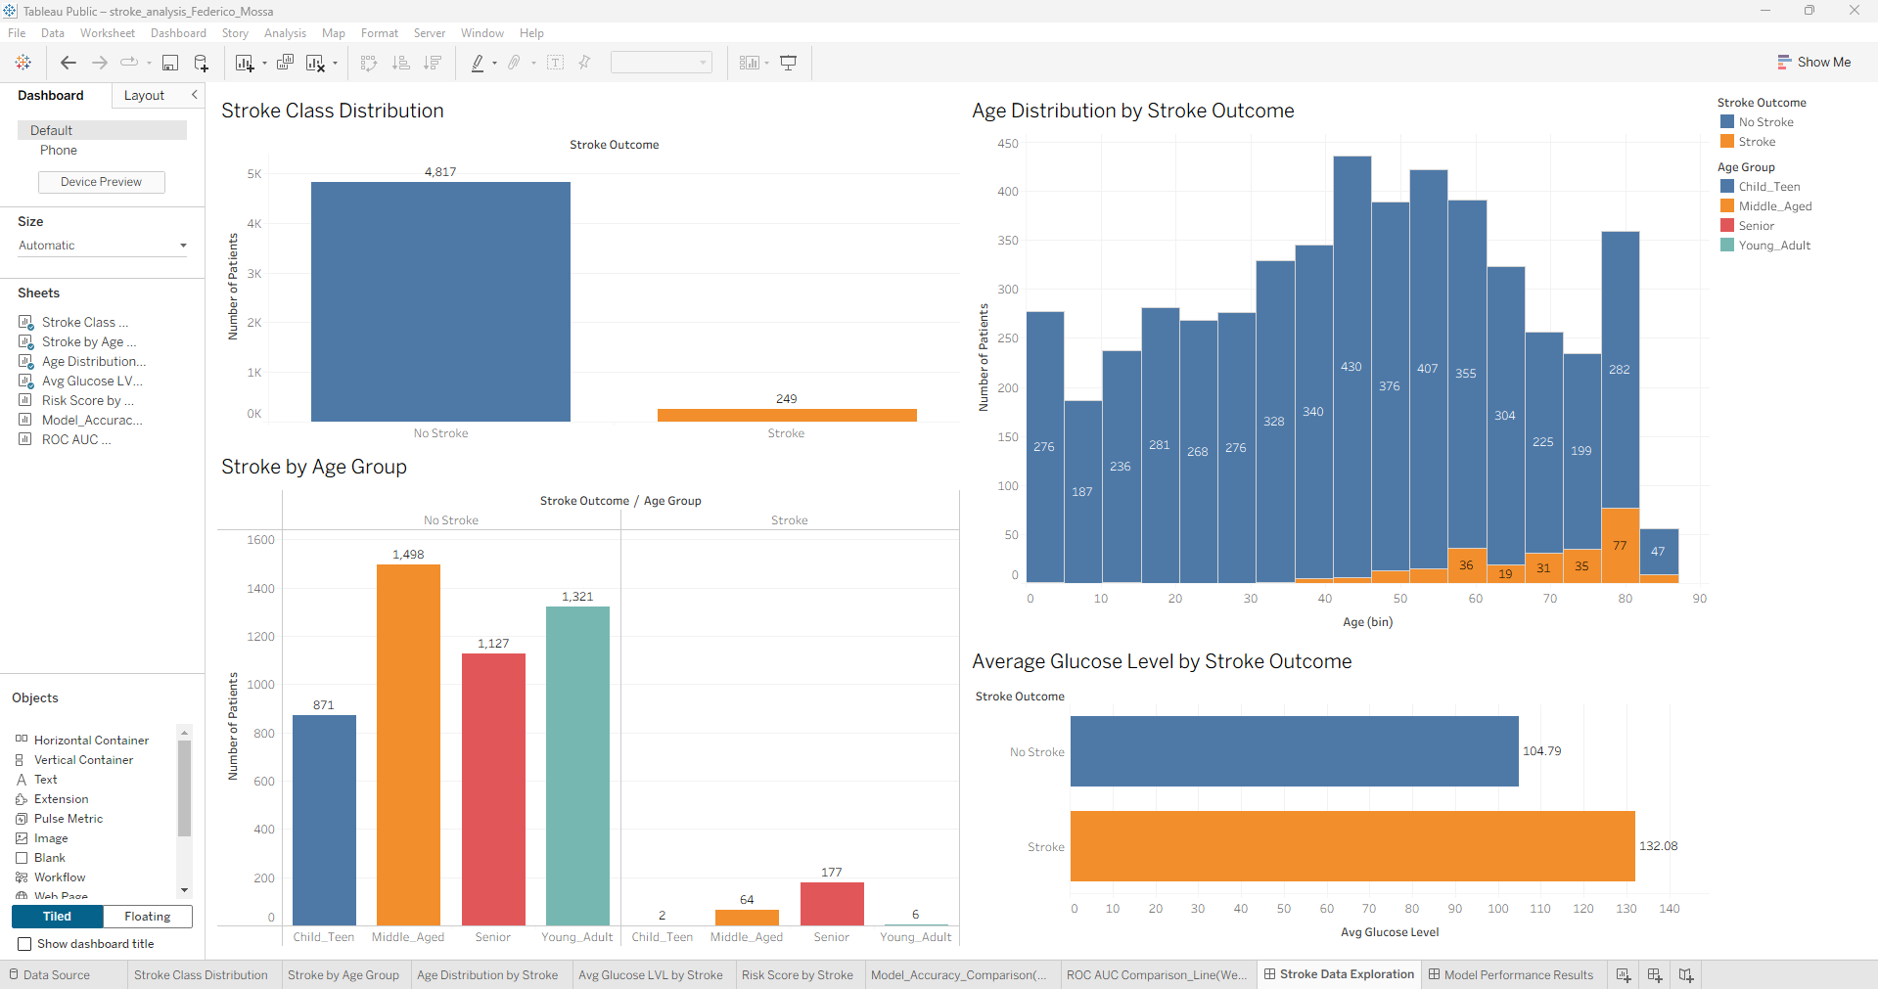
The age distribution confirms that stroke cases concentrate in patients aged 40–85, with virtually no occurrences under age 40. Individuals with stroke show a notably higher average glucose level (132.08 mg/dL compared with 104.79 mg/dL). The Senior age group accounts for the largest share of stroke cases (177), followed by Middle-Aged (64) and Young Adult (6). Individual Tableau charts are provided in Appendix B.

1.3 Data Preparation and Final Processing

Managing Null Values
The original dataset had 201 BMI entries missing. Complete case deletion was avoided as it would reduce the dataset by 4% and risk introducing selection bias [8]. Missing values were imputed using the median BMI (28.1), a robust strategy less sensitive to outliers than mean imputation. All 5,066 records were retained.

Outlier Treatment
BMI values reached 97.6 and glucose reached 271.74 in the raw data, values that are clinically implausible and likely represent data entry errors. Both attributes were capped at their respective 99th percentile values (BMI: 53.08; glucose: 240.75) to reduce the influence of extreme observations without removing records [1].

Feature Cleaning and Standardisation
The id column was removed as it carries no predictive value. All categorical values were standardised to remove spaces, hyphens, and special characters for Weka ARFF compatibility (e.g., ‘formerly smoked’ -> ‘formerly_smoked’, ‘Self-Employed’ -> ‘Self_Employed’). Column naming was also standardised to lowercase with underscores throughout.

Encoding Categorical Variables
Categorical variables were defined as nominal attributes within the ARFF file. Weka handles nominal encoding internally: J48 and Random Forest split directly on nominal values, while Logistic Regression applies binary dummy encoding automatically during model building. This approach negated the need for manual one-hot encoding and is consistent with established Weka best practice [6].

Feature Engineering
Four features were engineered to capture clinically meaningful thresholds and improve model interpretability:
age_group: Patients were divided into four age groups: Child_Teen (0-18), Young_Adult (19-40), Middle_Aged (41-60), and Senior (61+), based on commonly recognised stroke risk age ranges. [3].

bmi_category: BMI scores were grouped into standard clinical ranges: Underweight (<18.5), Normal (18.5-24.9), Overweight (25.0-29.9), and Obese (>=30). Analysis in Weka showed that 1,892 patients, representing 37.3% of the dataset, were classified as Obese.

glucose_category: Glucose levels classified using standard clinical thresholds: Normal (<100), Pre_diabetic (100-125), Diabetic (>=126 mg/dL). This identified 974 diabetic-range patients (19.2%) and 987 pre-diabetic patients (19.5%).
risk_score: A composite integer score (0-5) summing five binary risk indicators: hypertension, heart disease, age >60, glucose >126 mg/dL, and BMI >30. Mean score: 0.976; maximum: 5.

Handling Class Imbalance - SMOTE
The 19.3:1 class imbalance required correction before classification. Without balancing, preliminary tests demonstrated that classifiers achieved approximately 95% accuracy by predicting the majority class for every instance, producing near-zero recall for stroke cases, the clinically critical outcome [9]. SMOTE (Synthetic Minority Oversampling Technique) was applied in Weka (filters > supervised > instance > SMOTE, P=1836%, k=5), creating synthetic stroke records by estimating new minority-class examples between existing stroke cases and their nearest neighbours [9]. The resulting dataset contained 9,637 balanced instances.
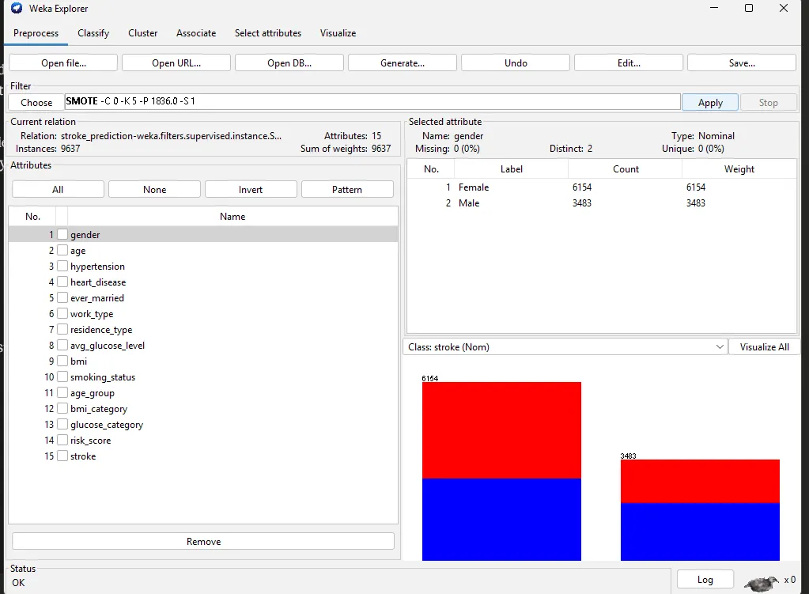.
A key limitation of SMOTE in this context is that synthetic patient records do not correspond to real individuals, and interpolated feature combinations may not always be clinically plausible. SMOTENC, designed specifically for datasets with mixed numerical and categorical features, would be more theoretically appropriate and represents an area for future improvement [9].

Post-processing
Following model runs in Weka, results were exported as text files and compiled into a structured comparison table. Cluster centroids from SimpleKMeans were interpreted against clinical benchmarks to assign descriptive labels to each patient segment. Tableau visualisations of the original dataset were produced for exploratory analysis, with screenshots incorporated into this report and its appendices.

1.4 Sample Runs and Analysis Methods

Classification Approach
Three classification algorithms were selected to address the supervised learning objective of predicting stroke risk. J48 provides an interpretable decision tree baseline; Random Forest offers a powerful ensemble benchmark; Logistic Regression provides a linear statistical baseline enabling assessment of whether predictor-outcome relationships are fundamentally non-linear. All models were trained on the SMOTE-balanced dataset (9,637 instances) using 10-fold stratified cross-validation.

J48 Decision Tree
J48 implements the C4.5 algorithm, recursively selecting the attribute maximising information gain to build a pruned decision tree [10]. Its structure is inherently interpretable: clinicians can trace the decision path for any patient and understand which risk factors drove the classification. The model identified age as the primary root split, with risk_score, glucose_category, bmi_category, and hypertension as key sub-branches, all clinically established stroke risk factors. The pruned tree contained 345 leaves and 589 nodes, indicating moderate complexity.
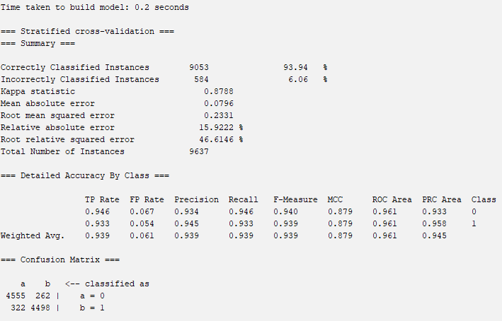

Random Forest
The Random Forest algorithm created multiple decision trees from resampled training data, with each node split determined using a random selection of predictor variables. Model performance was then assessed using 10-fold cross-validation [11]. This architecture makes it robust against overfitting and generally the strongest classifier for tabular healthcare data, as confirmed by its performance in this study [5].

Logistic Regression
Logistic Regression models stroke probability as a linear combination of predictors, providing interpretable odds ratios [12]. The model estimated that hypertension carries an odds ratio of 17.05, confirming its strong predictive weight. However, the linear log-odds assumption limits its ability to capture complex feature interactions, explaining its comparatively weaker performance on this non-linear dataset.

Evaluation Metrics
Model selection prioritised recall (sensitivity) for the stroke class and ROC AUC over overall accuracy. In clinical stroke screening, a false negative, predicting no stroke in a patient who subsequently experiences one, is far more costly than a false positive. A model maximising recall minimises missed stroke cases, which is the clinically paramount objective [13].

Top Performing Model

Model Type | Accuracy (%) | Precision (%) | Recall | F1-Score | ROC AUC | False Negatives
J48 Decision Tree | 93.94 | 0.945 | 0.933 | 0.939 | 0.961 | 322
Random Forest | 95.84 | 0.961 | 0.956 | 0.958 | 0.991 | 212
Logistic Regression | 82.65 | 0.807 | 0.858 | 0.832 | 0.914 | 684
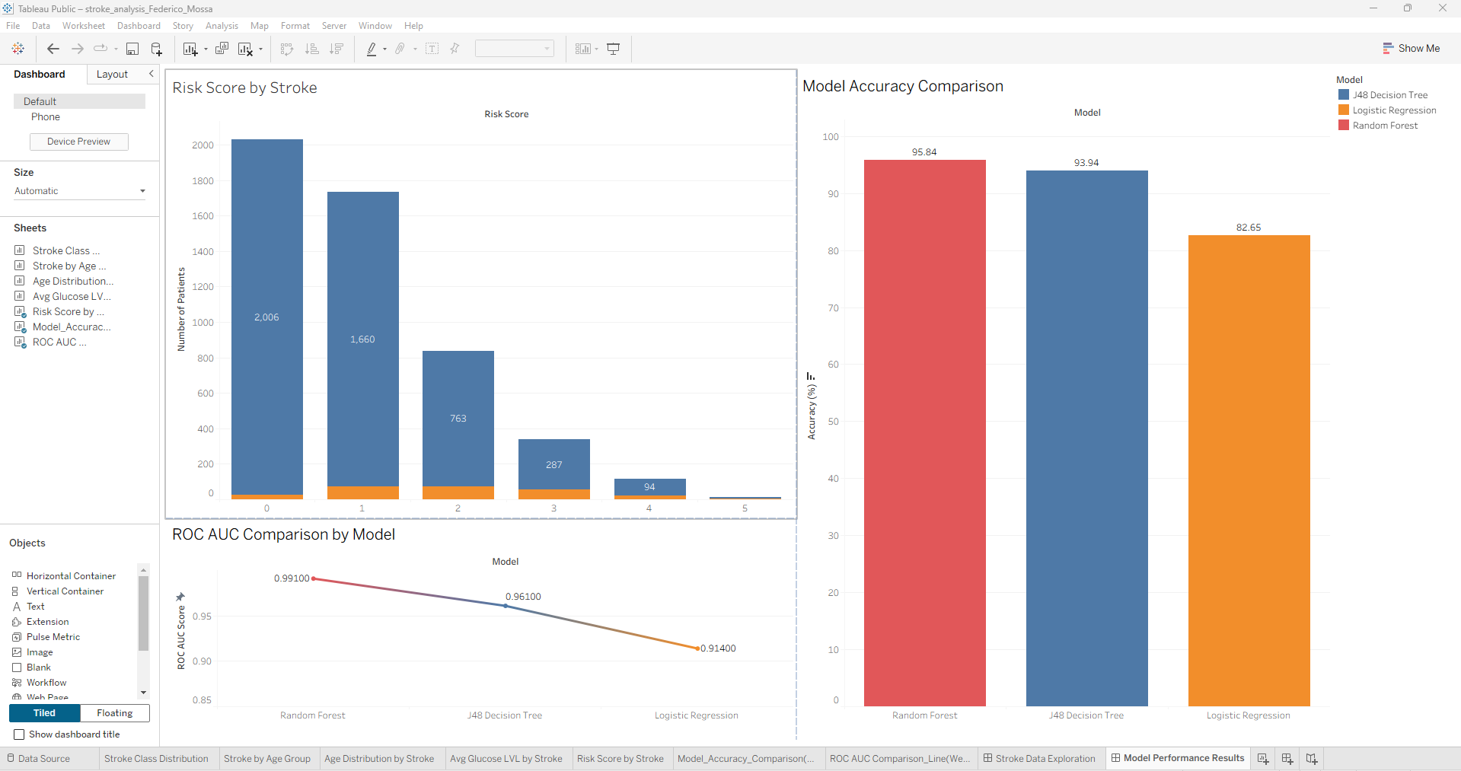
Random Forest achieved the highest performance across every metric. Its ROC AUC shows the best result, and its false negative count of 212 represents 472 fewer missed stroke cases than Logistic Regression in a population of equivalent size, a clinically significant difference [14]. Logistic Regression’s underperformance (82.65% accuracy, 684 false negatives) reflects the inherently non-linear relationships between predictors and stroke risk, which tree-based methods handle more effectively [12].
While Random Forest is the strongest performer, J48 offers a meaningful complementary advantage through its interpretable rule structure. Deployed in a clinical decision support system, the choice between these models involves a trade-off between predictive power (Random Forest) and transparency (J48).

Clustering Analysis - SimpleKMeans
SimpleKMeans clustering was applied as an unsupervised technique to identify natural patient groupings independent of the known stroke outcome. Three clusters (k=3) were specified following exploratory testing, and the algorithm converged after 10 iterations using Euclidean distance. The stroke label was withheld during clustering and used only for post-hoc evaluation via classes-to-clusters assignment.

Attribute | Cluster 0 (38%) | Cluster 1 (41%) | Cluster 2 (21%)
Size | 3,640 | 3,978 | 2,019
Avg Age | 43.96 | 59.82 | 66.68
Avg Glucose (mg/dL) | 105.13 | 97.42 | 184.48
Avg BMI | 31.17 | 26.32 | 31.96
Age Group | Middle_Aged | Senior | Senior
BMI Category | Obese | Overweight | Obese
Glucose Category | Normal | Normal | Diabetic
Risk Score | 1.03 | 1.16 | 2.71
Dominant Gender | Female | Female | Male
Stroke Cases | 1,134 | 2,304 | 1,382

Cluster 0 represents middle-aged, obese female patients with normal glucose and a low-risk score of 1.03. Cluster 1 captures older female patients with overweight BMI and normal glucose, the largest cluster but with elevated age driving stroke risk. Cluster 2 is the highest-risk segment: older male patients with diabetic-range glucose (184.48 mg/dL), obesity, a history of smoking, and a risk score of 2.71, more than 2.5 times that of Cluster 0. Despite being the smallest cluster (21%), it contains 1,382 stroke cases, representing a disproportionately high stroke prevalence and the most critical population for targeted intervention.

1.5 Strategic Business Actions

- Deploy Random Forest as an automated stroke risk screening tool
The model’s ROC AUC of 0.991 and recall of 0.956 make it clinically viable for integration into electronic health record systems. High-risk patients could be automatically flagged during routine consultations, enabling proactive referral to neurology or preventative care pathways. Deployment should be accompanied by regular revalidation as the patient population evolves [3] [4].

- Target Cluster 2 patients for intensive monitoring programmes
Older male patients with diabetic glucose levels, obesity, and smoking history represent the highest-risk segment identified through clustering. Healthcare providers should establish dedicated monitoring protocols for this profile, including regular blood pressure checks, HbA1c testing, and structured smoking cessation support [3].

- Implement the composite risk_score as a rapid triage indicator
The engineered risk score (0-5) provides a interpretable metric combining five established risk factors. Patients scoring 3 or above account for a disproportionate share of stroke cases, as visualised in the Tableau Risk Score chart (Appendix B-4). This score can be calculated manually by clinical staff without requiring algorithmic tools.

- Launch targeted glucose management and diabetes screening campaigns
The 27.3 mg/dL difference in average glucose between stroke and non-stroke patients confirms hyperglycaemia as a primary differentiating factor. Public health programmes promoting dietary intervention, blood sugar monitoring, and early diabetes diagnosis, particularly in the Senior age group, could yield meaningful reductions in stroke incidence [3].

- Expand the dataset with additional clinical variables for future modelling
The current dataset lacks cholesterol level, physical activity data, medication history, and family history of stroke, all established risk factors. Incorporating these variables in future iterations would likely improve model recall and reduce the false negative rate, which remains the primary clinical concern [3].

1.6 Reflective Commentary

Model Performance
Overall, the models performed well, particularly Random Forest, which achieved strong results across all metrics. The application of SMOTE was critical: without it, preliminary tests showed high overall accuracy (~95%) that masked near-zero stroke recall, as classifiers defaulted to predicting the majority class. The balanced dataset enabled all three models to learn meaningful patterns for the minority class [9].

Strengths of the Analysis
The feature engineering phase added genuine analytical value. The composite risk_score proved an effective predictor, appearing prominently in the J48 decision tree and clearly differentiating cluster profiles. Four engineered features alongside the original attributes provided richer representational capacity without introducing multicollinearity concerns. Using 10-fold cross-validation throughout ensured generalisable performance estimates rather than artefacts of a single train-test split.

Limitations
Several limitations merit acknowledgement. First, SMOTE generates synthetic records through interpolation across mixed continuous and categorical attributes, which may produce clinically implausible combinations. SMOTENC, designed for mixed data types, would be more theoretically appropriate [9]. Second, the dataset lacks key clinical variables including cholesterol, medication history, and family history, all established stroke risk factors whose absence limits the clinical completeness of the models [3]. Third, the clustering analysis produced 50.09% incorrectly clustered instances, reflecting the overlapping characteristics of real-world patient populations and suggesting that the natural cluster boundaries in this dataset are not sharply delineated. A single dataset was used to train and evaluate each model, and external validation on an independent population would be essential before any clinical deployment [5].

What Would Be Done Differently
With additional time, hyperparameter tuning of the Random Forest, to further improve stroke recall [11]. SHAP (SHapley Additive exPlanations) analysis would provide individual-level feature importance, valuable in clinical contexts where model transparency is a regulatory and ethical requirement. Additionally, testing alternative balancing strategies such as SMOTENC or a combined oversampling-undersampling approach would provide a more comprehensive assessment of balancing method sensitivity [9]. Finally, exploring deep learning approaches may yield further performance gains, though at the cost of interpretability.

References

[1] | M. K. a. J. P. Jiawei Han, Data Mining: Concepts and Techniques, 3rd ed., Waltham, MA: Elsevier / Morgan Kaufmann, 2011.
[2] | G. P.-S. S. Usama Fayyad, “From Data Mining to Knowledge Discovery in Databases,” AI Magazine, vol. 17, no. 3, p. 37–54, 1996.
[3] | H. W. C. S. N. N. J. B. V. D. J. Soumyabrata Dev, “A predictive analytics approach for stroke prediction using machine learning and neural networks,” Healthcare Analytics, vol. 2, 2022.
[4] | N. R. &. H. A. H. Mohammed Badawy, “Healthcare predictive analytics using machine learning and deep learning techniques: a survey,” Journal of Electrical Systems and Information Technology, no. 1, p. 40, 29 August 2023.
[5] | R. T. ,. J. F. Trevor Hastie, The Elements of Statistical Learning: Data Mining, Inference, and Prediction, New York, NY: Springer, 2009.
[6] | E. F. G. H. B. P. P. R. I. H. W. Mark Hall, “The WEKA Data Mining Software: An Update,” ACM SIGKDD Explorations Newsletter, vol. 11, no. 1, pp. 10-18, November 2009.
[7] | F. Soriano, “Stroke Prediction Dataset,” 2021. [Online]. Available: https://www.kaggle.com/datasets/fedesoriano/stroke-prediction-dataset. [Accessed 10 April 2026].
[8] | D. B. R. Roderick J. A. Little, Statistical Analysis with Missing Data, 3rd ed., Hoboken, NJ: John Wiley & Sons, 2019.
[9] | K. W. B. O. H. P. K. N. V. Chawla, “SMOTE: Synthetic Minority Over-sampling Technique,” Journal of Artificial Intelligence Research, vol. 16, pp. 321-357, 1 June 2002.
[10] | J. R. Quinlan, C4.5: Programs for Machine Learning, San Mateo, CA: Morgan Kaufmann Publishers, 1993.
[11] | L. Breiman, “Random Forests,” Machine Learning, vol. 45, no. 1, pp. 5-32, October 2001.
[12] | S. L. R. X. S. David W. Hosmer Jr., Applied Logistic Regression, 3rd ed., Hoboken, NJ: John Wiley & Sons, 2013.
[13] | T. Fawcett, “An Introduction to ROC Analysis,” Pattern Recognition Letters, vol. 27, no. 8, pp. 861-874, June 2006.
[14] | A. P. Bradley, “The Use of the Area Under the ROC Curve in the Evaluation of Machine Learning Algorithms,” Pattern Recognition, vol. 30, no. 7, pp. 1145-1159, July 1997.

Appendix A: Weka Preprocess - Attribute Distributions
The following screenshots from Weka Explorer’s Preprocess tab show the distribution of each attribute in the cleaned dataset (5,066 instances, 15 attributes). Blue = No Stroke (class 0), Red = Stroke (class 1).

A-1: Gender_Distribution
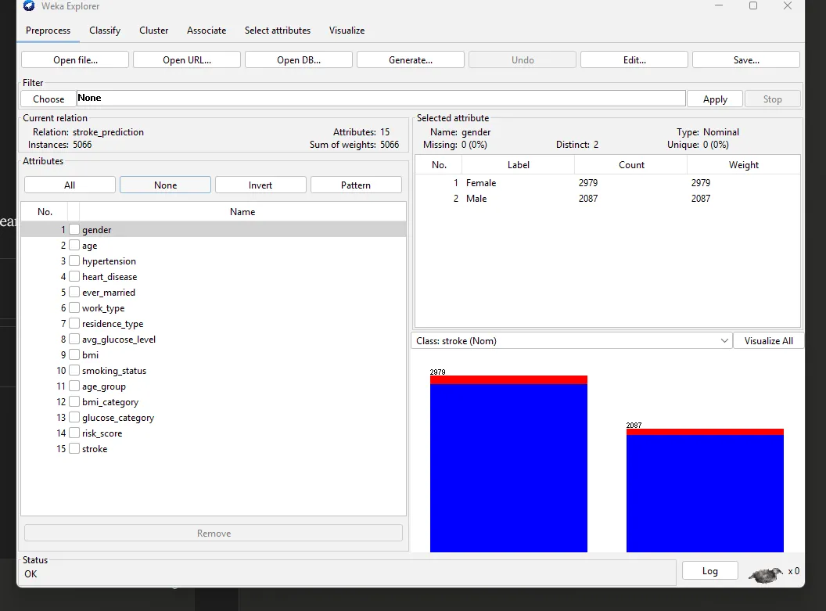

A-2: Age_Distribution
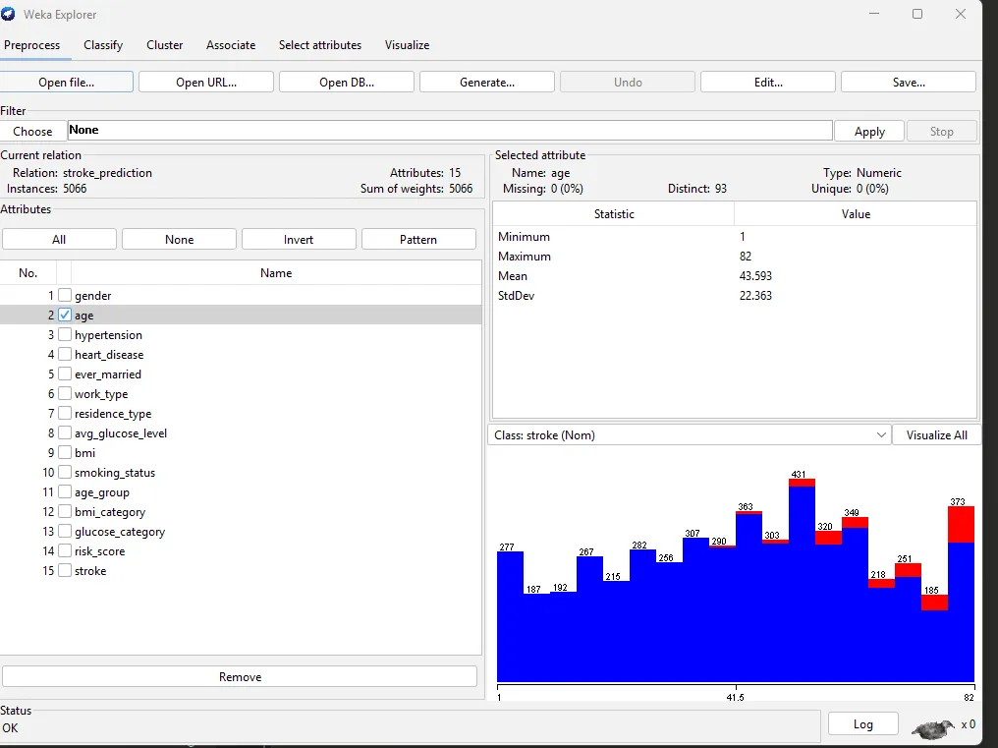

A-3: Hypertension
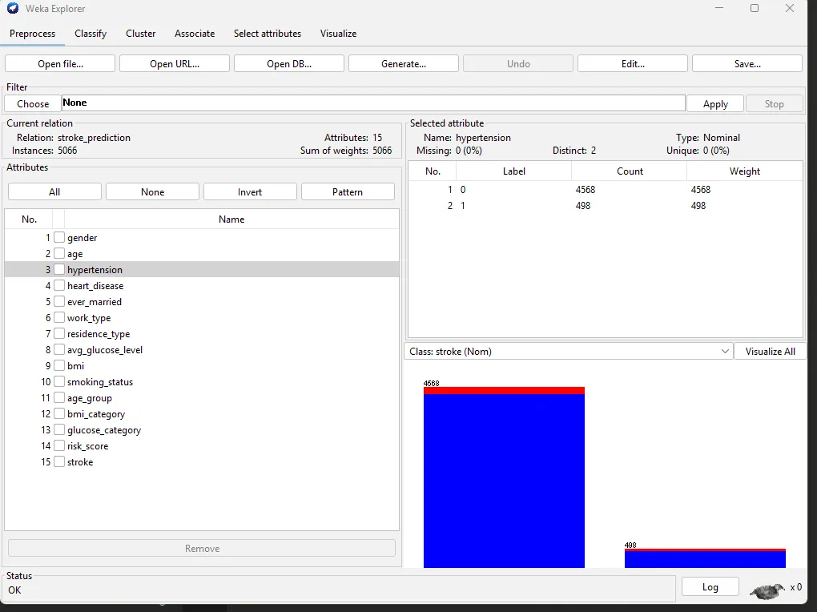

A-4: Heart_Disease
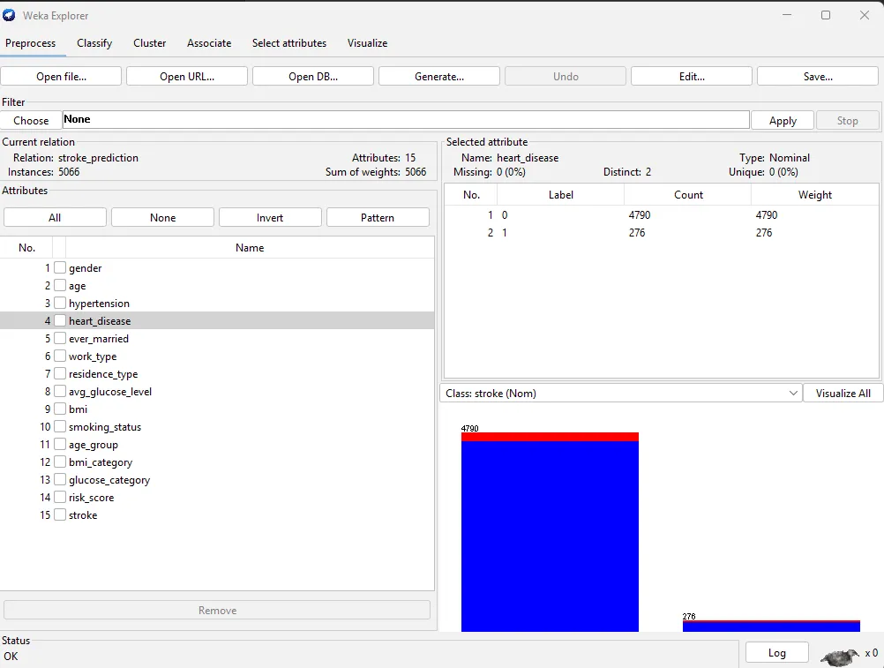

A-5: Ever_Married
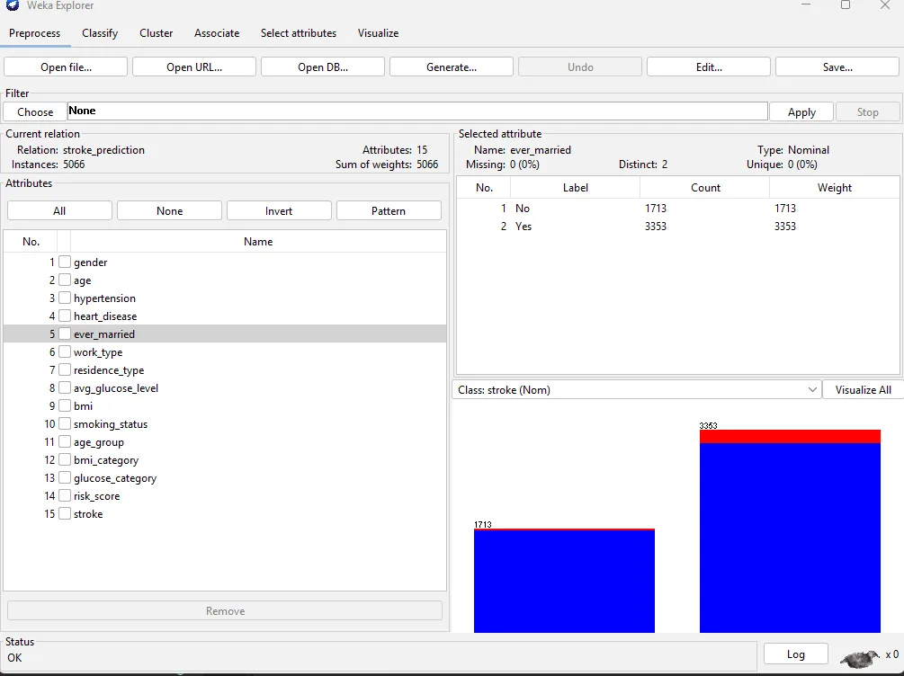

A-6: Work_Type
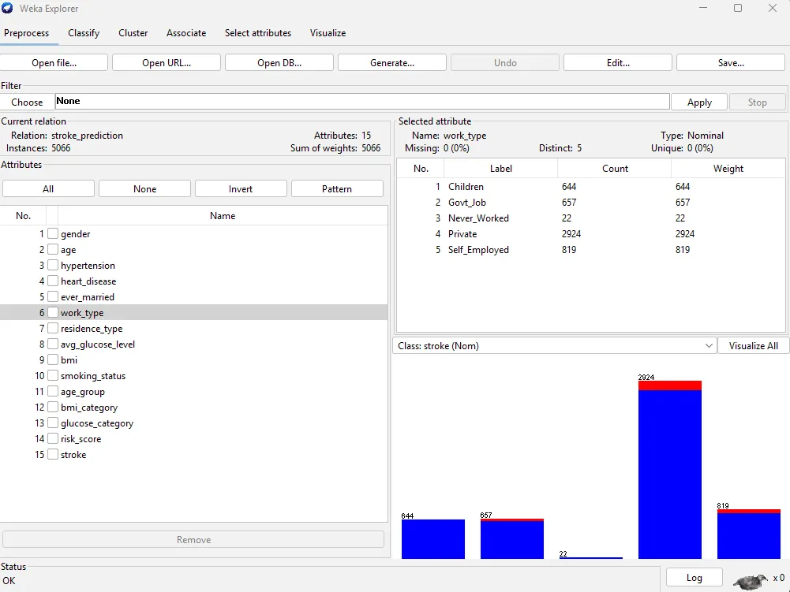

A-7: Residence_Type
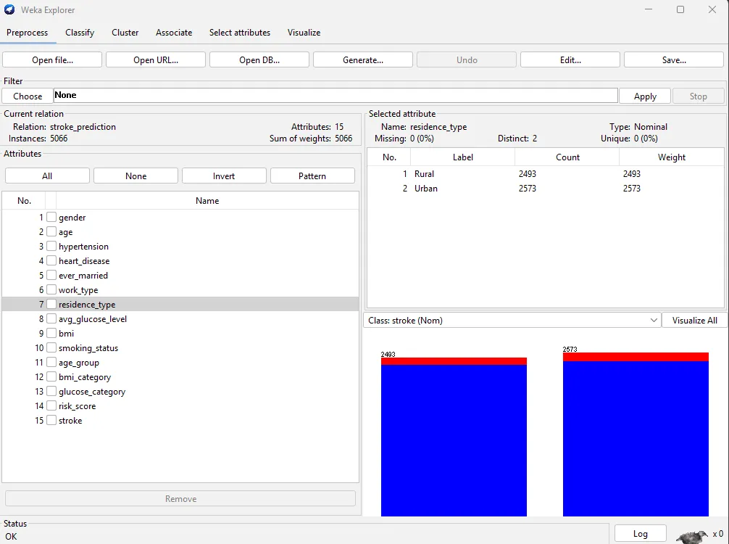

A-8: Avg_glucose_level
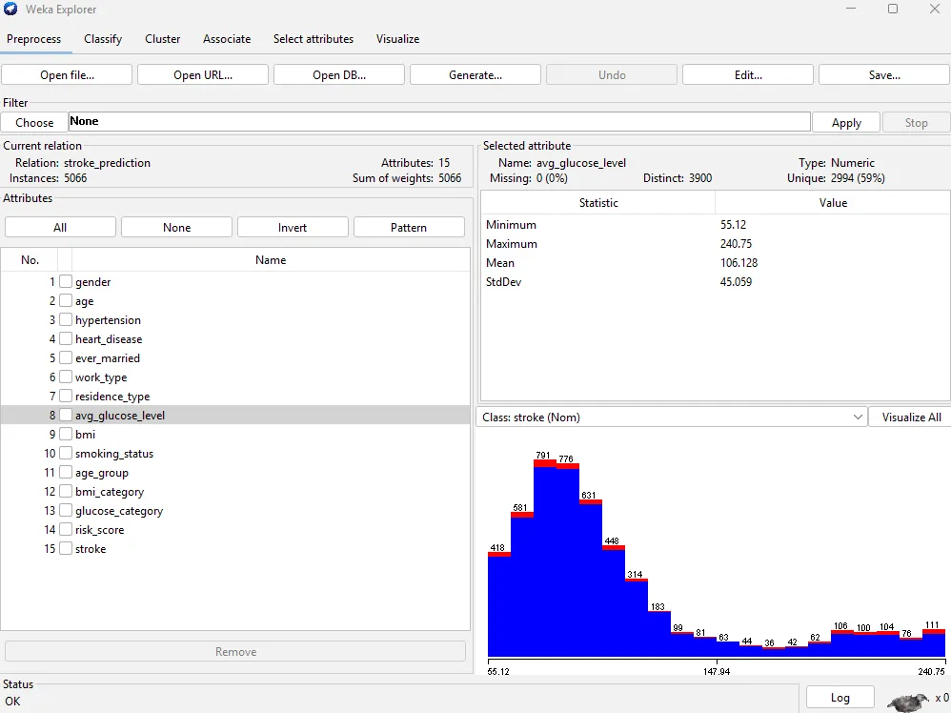

A-9: BMI_Distribution
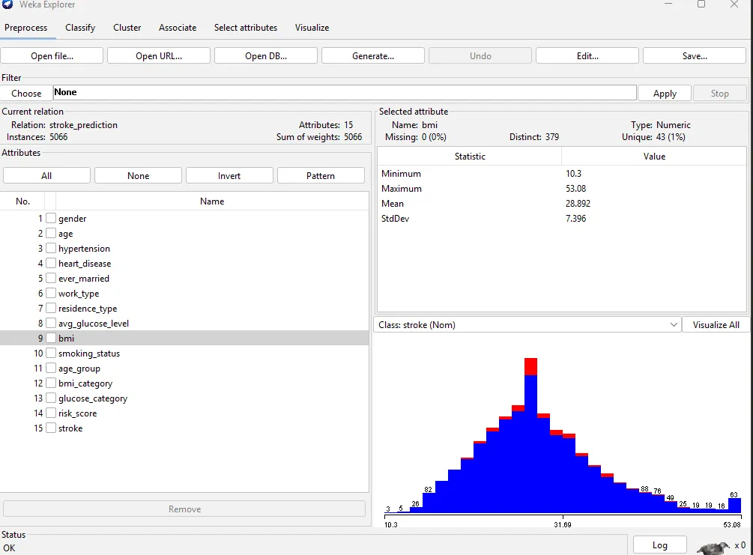

A-10: Smoking_Status
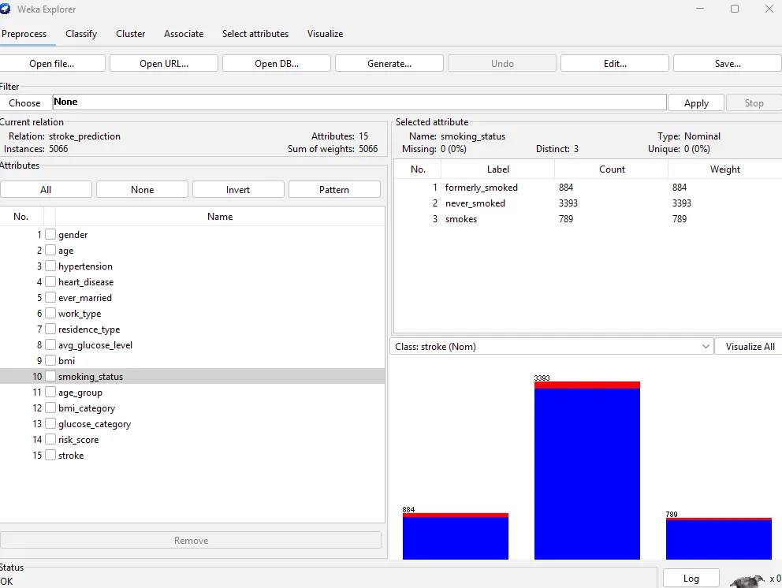

A-11: Age_Group (Engineered)
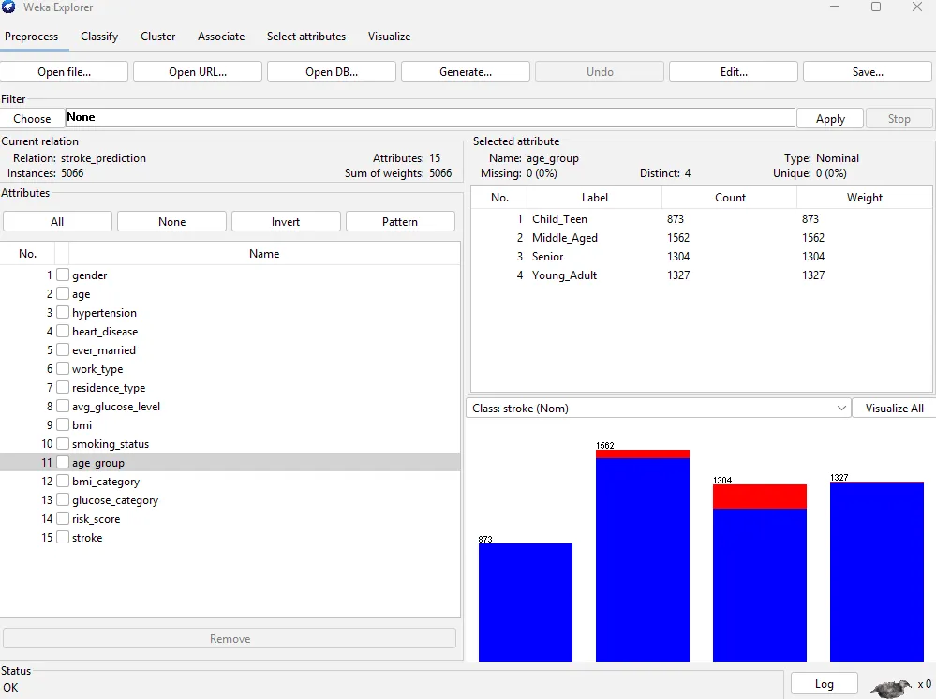

A-12: BMI_Category (Engineered)
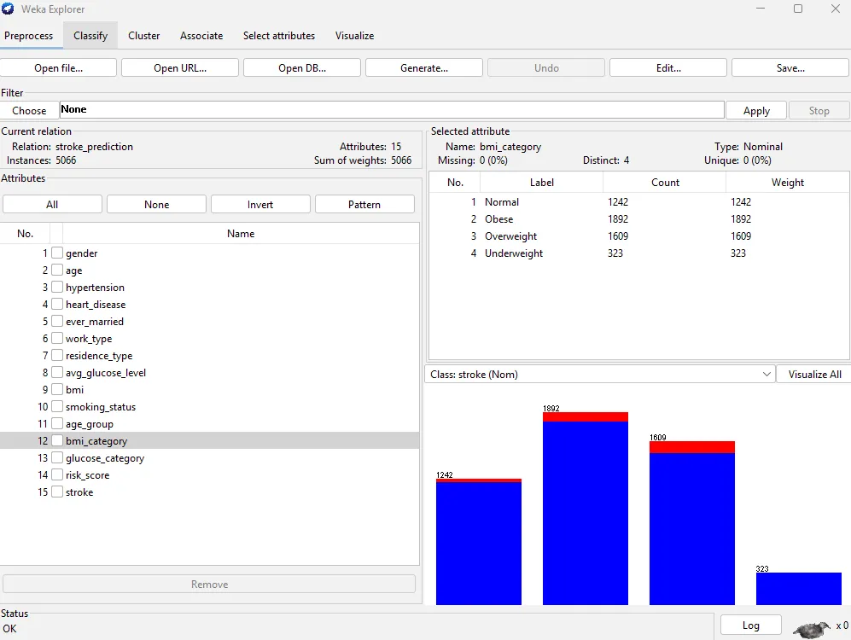

A-13: Glucose_Category (Engineered)
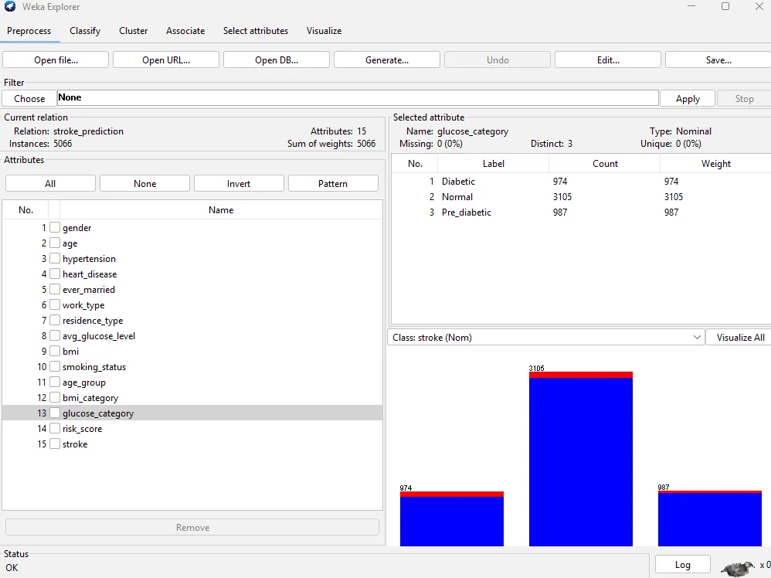

A-14: Risk_Score (Engineered)
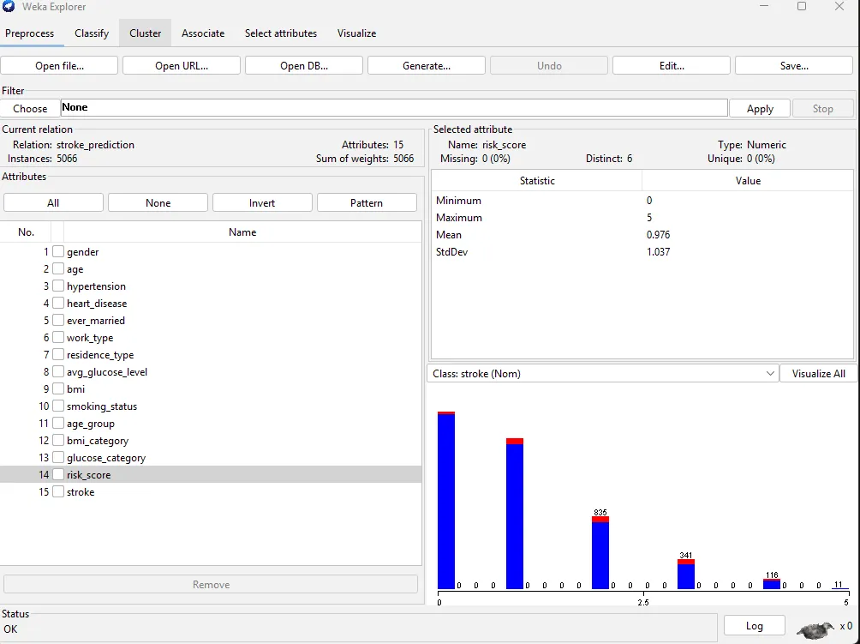

A-15: Stroke_Class_Distribution
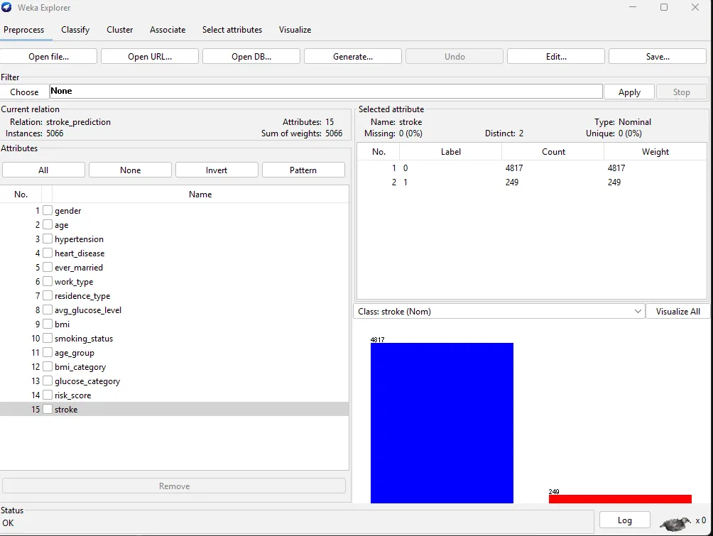

Appendix B: Tableau - Individual Chart Views
The following Tableau worksheets were produced from the cleaned stroke dataset (stroke_cleaned.csv, 5,066 rows). Charts are presented individually for detailed examination.

B-1: Stroke Class
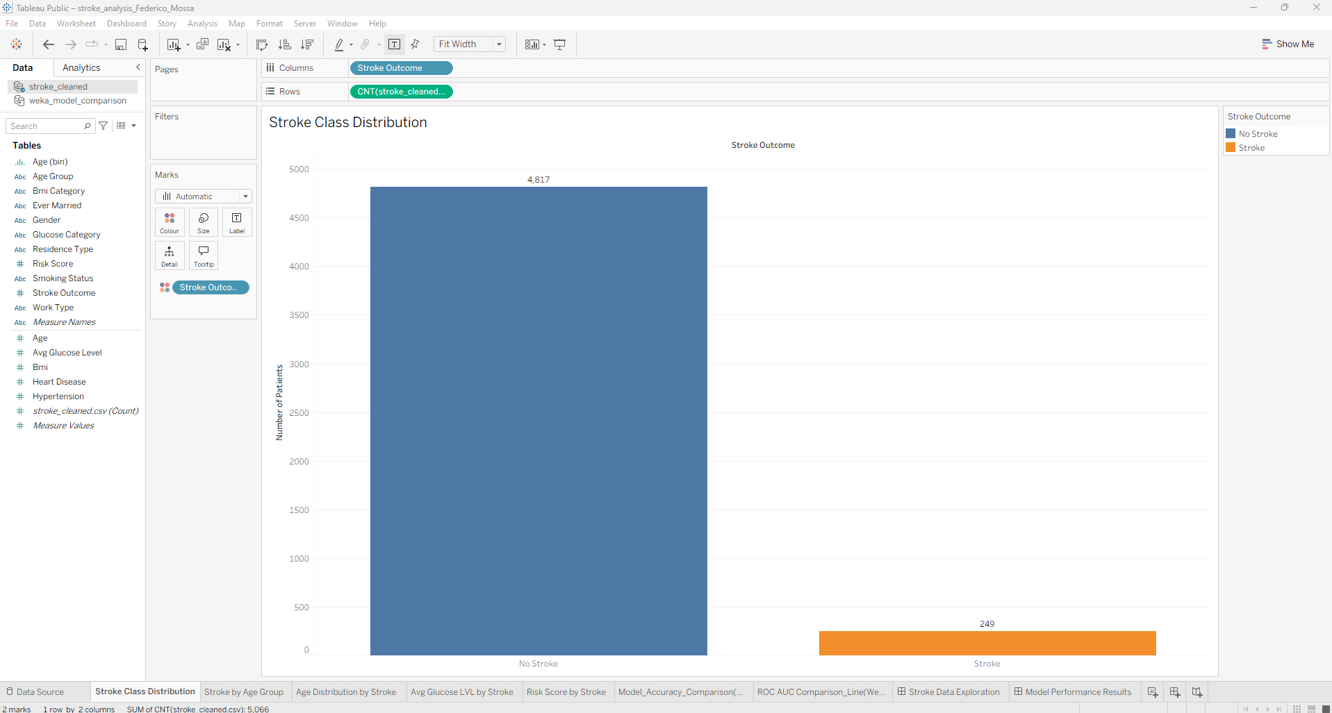

B-2: Age Distribution by Stroke Result
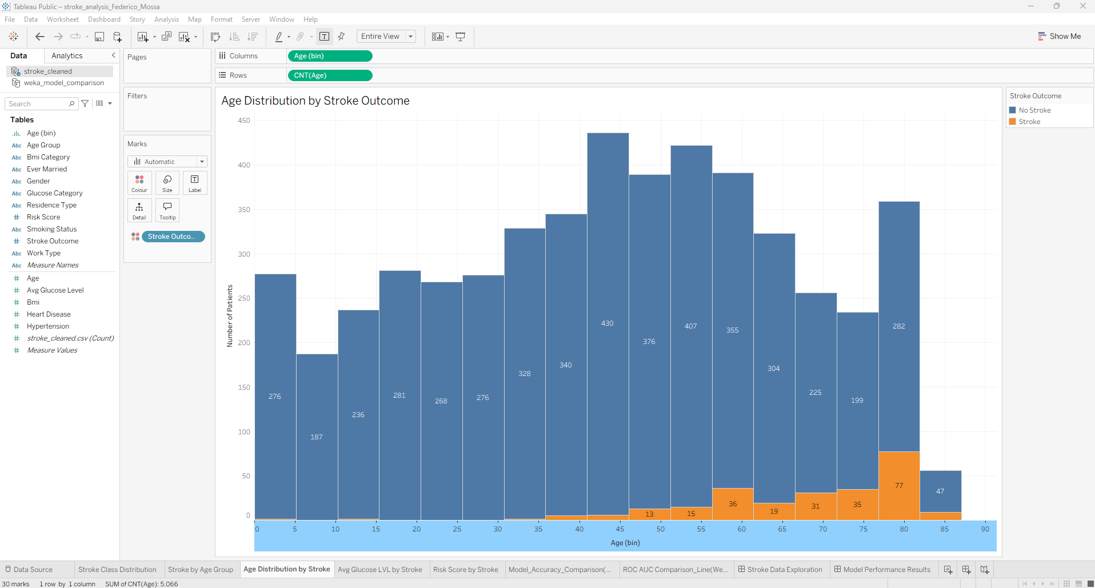

B-3: Avg Glucose Level by Stroke Result
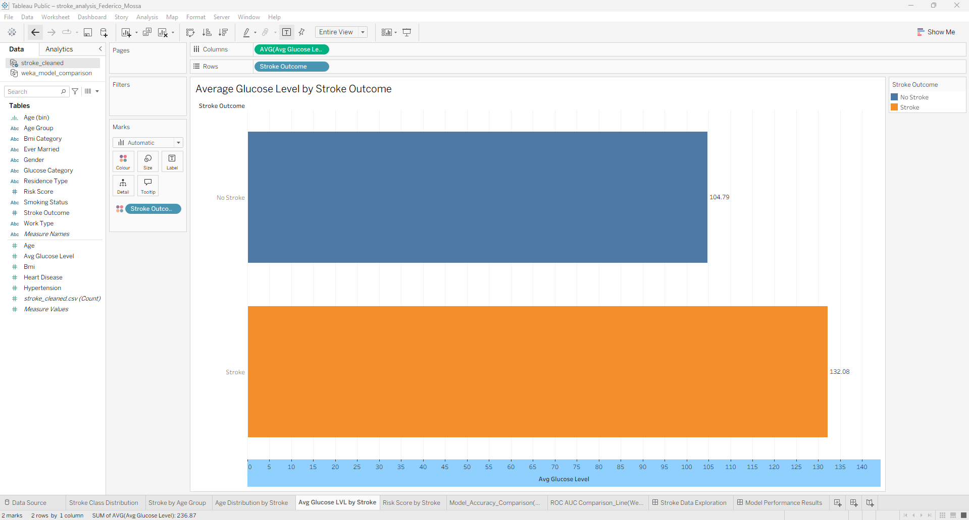

B-4: Risk Score Distribution by Stroke Outcome
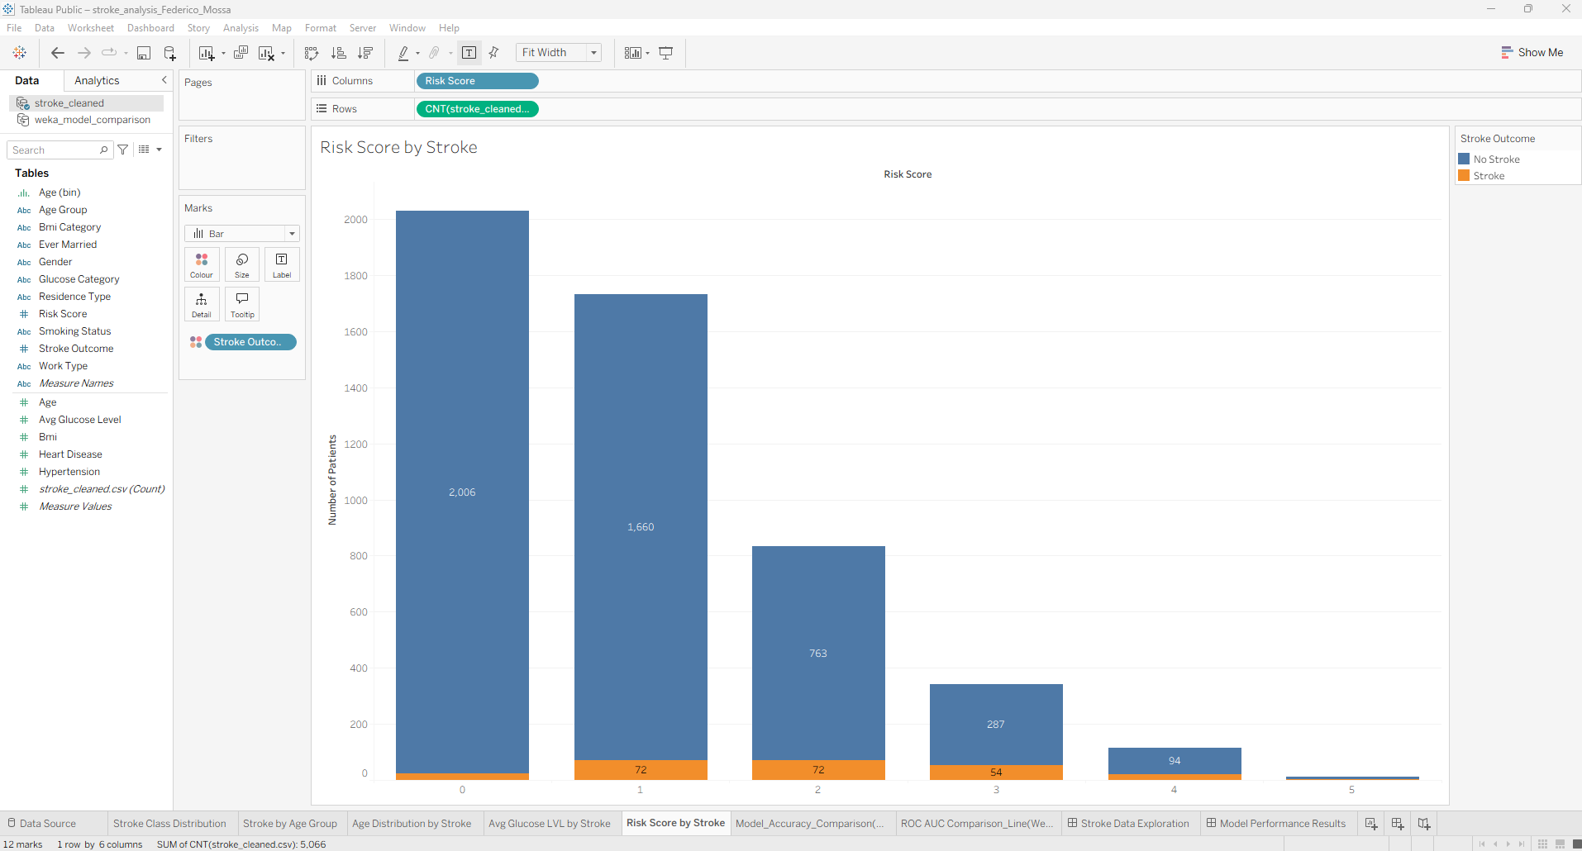

B-5: Stroke by Age Group
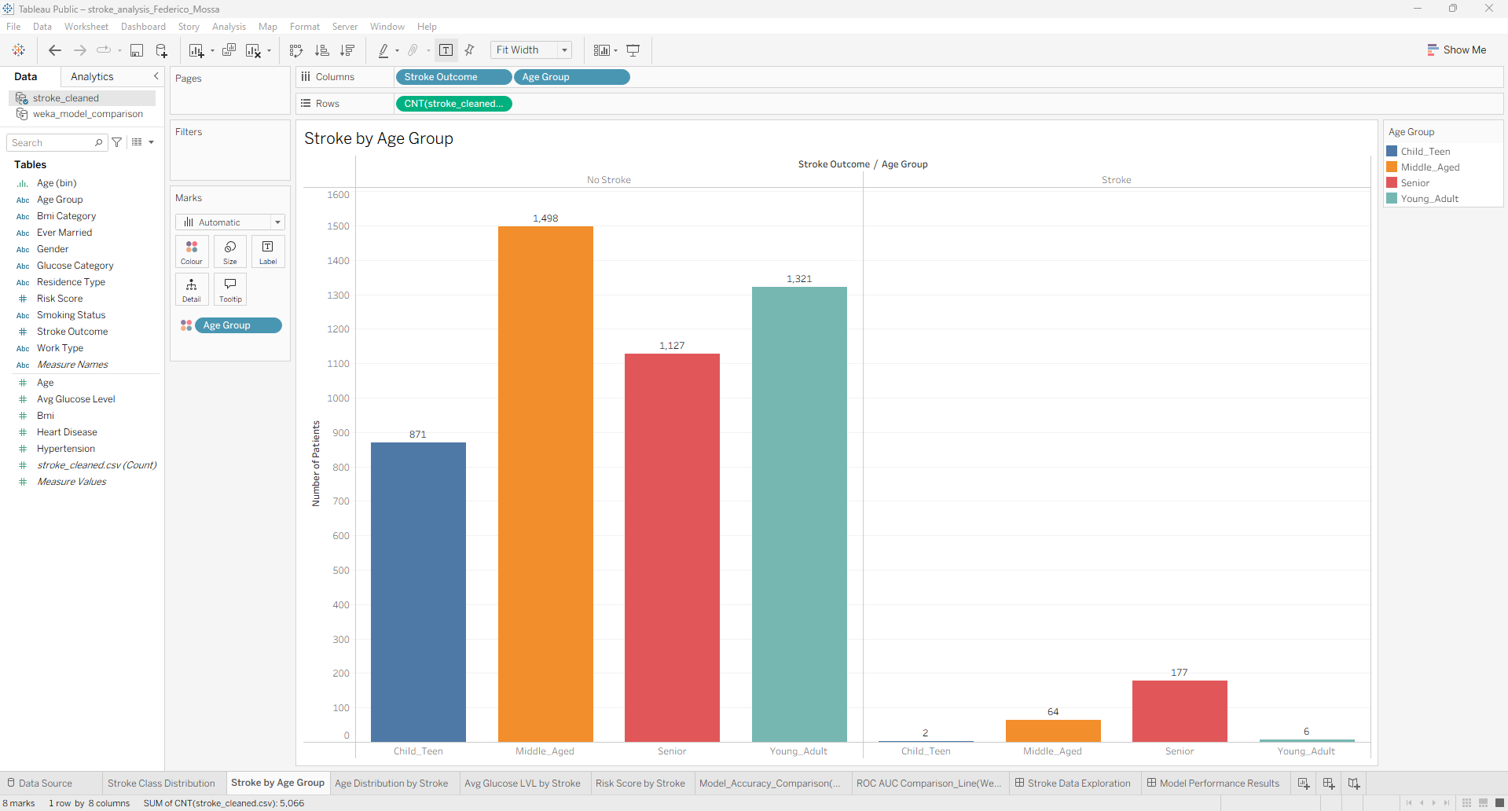

B-6: Model Accuracy Comparison
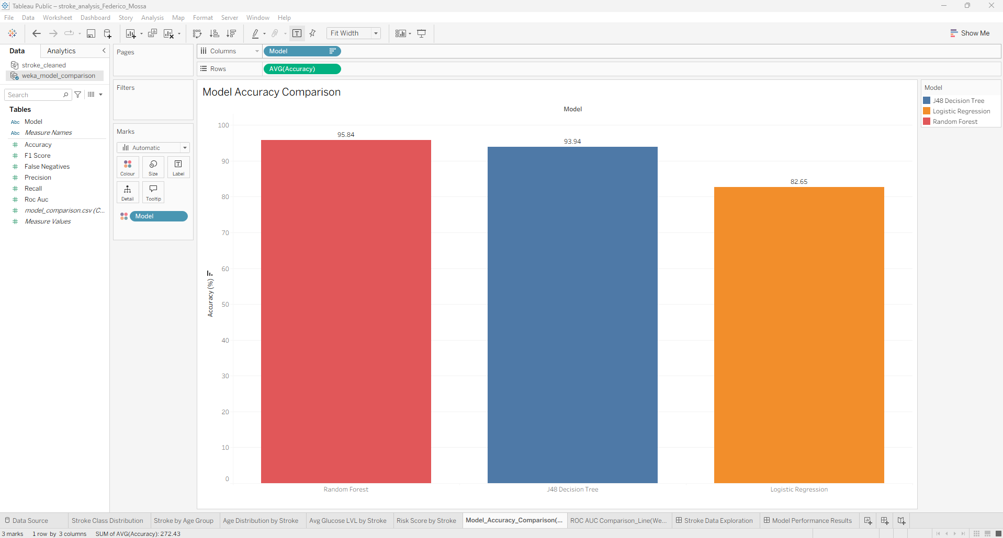

B-7: ROC AUC Comparison by Model
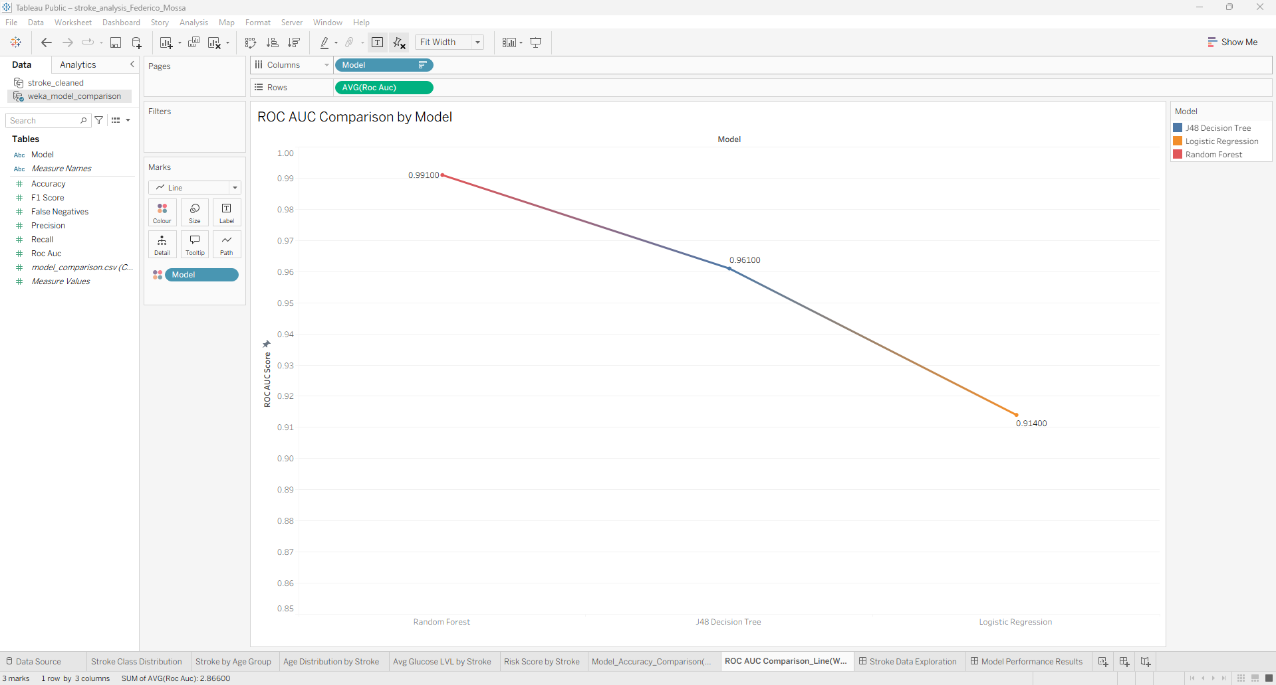

Appendix C: SMOTE Parameter Comparison
The following screenshots compare J48 performance with SMOTE at the default 100% setting versus the 1836% setting used in the final analysis, demonstrating the impact of the balancing parameter on model recall for the stroke class.

C-1: J48 Results - SMOTE 100% (Insufficient Balancing)
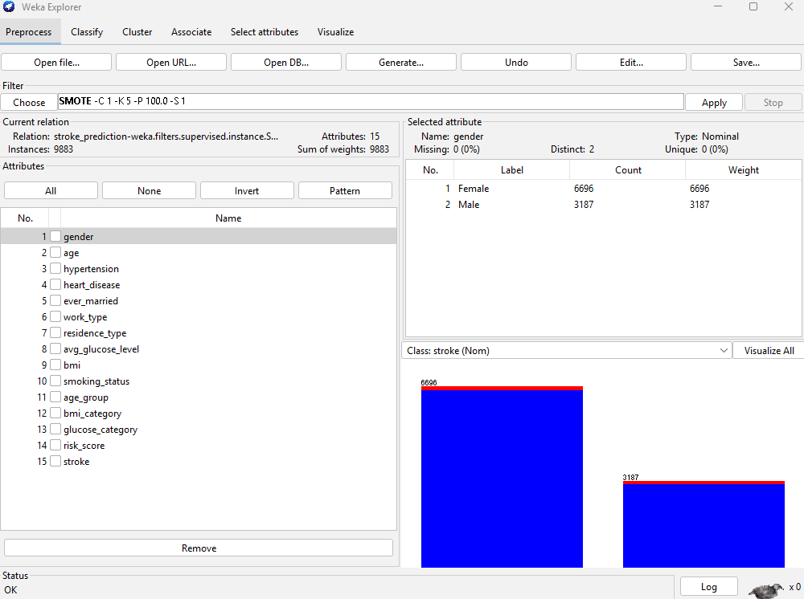

C-2: J48 Results - SMOTE 1836% (Final Setting)

Appendix D: Weka Classifier and Cluster Results
Full text outputs from Weka for all three classifiers and the SimpleKMeans clustering algorithm are summarised below. All runs used the SMOTE-balanced dataset (9,637 instances) with 10-fold stratified cross-validation for classification.

D-1: J48 Decision Tree - Key Results

Metric | Stroke=0 | Stroke=1
TP Rate (Recall) | 0.946 | 0.933
FP Rate | 0.067 | 0.054
Precision | 0.934 | 0.945
F-Measure | 0.940 | 0.939
ROC Area | 0.961 | 0.961

D-2: Random Forest - Key Results
Metric | Stroke=0 | Stroke=1
TP Rate (Recall) | 0.961 | 0.956
FP Rate | 0.044 | 0.039
Precision | 0.956 | 0.961
F-M | 0.958 | 0.958
ROC | 0.991 | 0.991

D-3: Logistic Regression - Key Results
Metric | Stroke=0 | Stroke=1
TP Rate (Recall) | 0.795 | 0.858
FP Rate | 0.142 | 0.205
Precision | 0.848 | 0.807
F-Measure | 0.821 | 0.832
ROC Area | 0.914 | 0.914

D-4: SimpleKMeans Clustering - Key Parameters
Parameter | Value
Number of clusters (k) | 3
Distance metric | Euclidean distance
Iterations to convergence | 10
Within-cluster sum of squared errors | 25,991.52
Total instances | 9,637 (SMOTE-balanced)
Incorrectly clustered | 4,827 (50.09%)
Cluster 0 size | 3,640 (38%)
Cluster 1 size | 3,978 (41%)
Cluster 2 size | 2,019 (21%)

