Phoebe Richards
2306489

Produce a realistic portfolio that will allow an organisation to gain funding for an advocacy service within a local area

ECED7008
Word Count: 4041

Portfolio Piece 1 - Service Overview
At the Welsh National Advocacy Service (NYAS Cymru) we are applying for funding to launch a project working with young carers in South West Wales and nationally. The project will provide non-statutory advocacy support for young carers, develop self-advocacy skills, and work with young carers to identify important issues and campaign for change to policy and practice. This service overview will outline who NYAS Cymru are and the work we do, who young carers are and the problems they face, what advocacy support is currently available and where gaps exist, and how the proposed service will address this.
NYAS Cymru is a well-established organisation, working with young people and families across Wales (NYAS, 2025). We have four aims that make up our charity strategy: championing rights, influencing change, working collaboratively, and inspiring trust (NYAS, 2025). Therefore, we aim to integrate the communities we work with into the design and development of our services and empower communities to self-advocate, as well as providing case advocacy. Our values are informed by the UN Convention on the Rights of the Child (1989): every child has the right to have their voice heard, to be safe, and to be involved in decisions made about them (NYAS, 2025). Currently, we successfully advocate for care-experienced children and young people and their families (NYAS, 2025), but we wish to expand our support to more children and young people across Wales by launching the NYAS Cymru Young Carer’s Service.
Young carers are defined as children and young people who provide care to a relative with a mental or physical health condition, a disability, or an addiction (Lacey, Xue, & McMunn, 2022). Young carers provide varied support including domestic tasks, medical or intimate care, and emotional support (Becker, 2007; Dharamapal & Ani, 2020). Early definitions specified care must be provided on a regular basis and be substantial (Aldridge and Becker, 2003; Becker, Aldridge, & Dearden, 1998). However, concerns regarding the subjectivity of these terms led to modern definitions focusing on the impact of caring on the young person’s life (Aldridge, 2018; Cheesbrough et al., 2017; Warren, 2007). Definitions of young carers vary in age range (Lacey et al., 2022). For example, some definitions begin as early as 5 years (Cheesbrough et al., 2017; Tseliou et al., 2018) whilst others begin at 8 or 10 (Cohen et al., 2012, Lakman & Chalmer, 2019). Some research highlights early years young carers, who take on responsibilities before the age of 5, however literature is limited (Ellicott et al., 2025). Despite this, it is agreed that at 18, young carers become young adult carers (Aldridge, 2018; Becker & Becker, 2008). This project will work with those aged between 5 and 17, as this is the age range used in the 2021 Census (ONS, 2023). However, we would be open to early years carers, were they referred to our service.
The 2021 Census identified 8,200 young cares in Wales (ONS, 2023). However, this is likely a significant underestimation as research demonstrates a large hidden population of young carers who do not self-identify (Joseph et al., 2020; Smyth, Blaxland, & Cass, 2011; Warren, 2023). There are many reasons for this including not recognising responsibilities as extraordinary and fear of social services intervention, particularly in situations where a parent has a mental illness or substance abuse issue (Joseph et al., 2020; Gray & Robinson, 2009; Smyth et al., 2011; Warren, 2023). Research estimates 10% of the UK’s children are young carers, equivalent to approximately 3 in every classroom (Joseph et al., 2019; Warren, 2023). We hope our project will raise awareness of the role and support available and break down stigma by working with identified young carers to campaign for better support and produce resources for the hidden population.
When considering young carers, it is crucial to consider intersectionality (Crenshaw, 1989, 1997). Intersectionality refers to interactions between multiple identities, particularly marginalised identities, and how the combination of identities creates unique experiences (Cho, Crenshaw, & McCall, 2013; Evans and Lépinard, 2019). For example, in Wales 11.5% of carers live in the 20% most deprived areas in the country (ONS, 2023). As young carers are likely to live in areas of deprivation, services must ensure they are accessible. For instance, young carers may not be able to access online content, due to not having digital equipment or having poor or no internet access (Brimblecombe et al., 2024). They may also be unable to travel far, due to inability to afford transport or time constraints due to their responsibilities (Brimblecombe et al., 2024). Therefore, we will offer services flexibly, online and in-person to accommodate the needs of a variety of young carers. We will also offer a transport fund to support young carers attending in-person events.
In addition to these issues, young carers also experience a plethora of other difficulties. One area where young carers experience inequalities is within education (Stamatoppulos, 2018; Lakman et al., 2017; Wong, 2016). For example, Becker and Sempik’s (2019) qualitative research found young carers felt their role impacted their ability to engage with education due to increased absence, leaving early, and frequent interruptions. This is also evidenced quantitatively as young carers perform worse than their peers at GCSE level (Gough & Guillford, 2020; Moloney et al., 2023; Wong, 2016), obtaining on average 9 grades lower (Wong, 2016). Furthermore, young carers are significantly less likely to progress to further or higher education and are at greater risk of being not in education, employment, or training (NEET) at 16 (Moloney et al., 2023). Currently, school support for young carers is inconsistent (Kaiser et al., 2024; Stevens et al., 2024). Whilst some schools offer support such as ‘time out’ cards, a designated member of staff, and the ability to leave early when required, this is not always offered, and even in schools where this is available young carers report experiencing resistance from some staff to meet their needs (Kaiser et al., 2024; Stevens et al., 2024). Therefore, we wish to offer advocacy support to young carers to ensure their needs are met in every school and develop their self-advocacy skills to give them confidence to voice their needs in the face of resistance.
Young carers are also at greater risk of mental health problems including anxiety and depression (Bowman-Grangel et al., 2024; Alfonzo et al., 2022; Majeed et al., 2018). Therefore, we will provide advocacy support, signposting young carers to mental health services and offering support in meetings with healthcare providers. However, the young carer mental health experience is not homogenous (Janes, 2022) and it is important not to adopt a deficit model (Heyman, 2016). For instance, many young carers do not experience mental health problems, and instead experience benefits including increased compassion, competency, and resilience (Janes, 2022; Wepf, Joseph, & Leu, 2021; Wepf & Leu, 2022). Wepf and Leu’s (2022) study of 2525 young carers found recognition of the caring role and social support predicted better mental health. Whilst this study was based in Switzerland and may not be transferable to our Welsh community due to differences in policy and support, we believe the findings are useful. Therefore, we will provide young carers with the opportunity to engage in general-issue advocacy to help them develop a support network and improve recognition of their roles in the community, improving wellbeing.
Young carers can access some statutory advocacy support (Social Care Wales, 2025; Social Services and Wellbeing (Wales) Act, 2014). The Social Services and Wellbeing (Wales) Act (2014) outlines that all carers are entitled to a carers assessment to evaluate their needs, and that advocacy support must be offered to young carers and their families to help them participate in these discussions. The act also stipulates that information provided to carers must be accessible, and so they may be provided with an advocate to support their understanding. Additionally, young carers would be provided with an independent professional advocate if they wished to make a complaint. However, young carers are not able to access statutory advocacy for difficulties outside of the realm of social services, including educational difficulties and mental health. Our service will address this gap with a mixture of offerings. A key service will be one-to-one advocacy appointments to provide young carers with information about mental health or educational support and support young carers to have their voices heard in meetings with schools or healthcare providers. We will also provide self-advocacy workshops. Online workshops will be delivered monthly and accessible nationally. We will also run a summer holidays programme ‘Self-Advocacy Summer School’. This will offer weekly half-day self-advocacy workshops for the six-week holiday period. These workshops will take place in 3 regions of South West Wales: Carmarthen, Pembroke, and Swansea. These regions have been selected as they include many postcodes in the 40% most deprived areas in Wales (Welsh Government, 2022), support for young carers is inconsistent across them, and we believe the comparison between rural and city areas will be beneficial when considering upscaling the programme. The self-advocacy workshops will work to empower young carers. In Weberian theory, power stems from one’s ability to influence others (Weber, 2011). Therefore, some workshops will develop skills to help young carers present their views in conversations that affect them, such as assertiveness and confidence building. In Bourdieu’s capital theory, however, power originates from economic capital, social capital, and cultural capital, in which cultural capital refers to the knowledge and norms of the dominant group (Bourdieu, 1977). Therefore, workshops will also provide information specific to the caring role, for example, rights of carers and young people, or how to present themselves to healthcare professionals involved in the care of their relative or themselves. Additionally, in line with our aims of working collaboratively and influencing change (NYAS, 2025), we will also work with groups of young carers in schools and community centres to work towards goals that are important to them, for example, raising awareness of the caring role, or campaigning for changes in policy and practice to better support young carers in education.
Overall, we believe the service addresses an important gap in young carer support in Wales. We suggest it will be beneficial, not only to the identified young carer community, but also hidden young carers who feel stigmatised or afraid to seek support. Furthermore, we believe it will benefit schools by developing better processes for supporting carers, and reduce pressure on social services, as by providing young carers will self-advocacy skills, they are less likely to reach crisis point. We will ensure our service is relevant by making it community-led, flexible, and accessible, and we will regularly evaluate services to ensure they meet the community’s needs.
Word Count: 1768

Portfolio Piece 2 – Funding Bid
People and Places: Large Grants Application (National Lottery Community Fund, 2025)
For a summary of what the grant will fund, please see Appendix 1. For the guidance provided alongside the long-answer questions in Section 1, please see Appendix 2.
Section 1 - Your project
Please tell us about your project in this section. This is the most important section when it comes to making a decision about whether you will receive funding.
Question | Answer
What is the name of your project? | NYAS Cymru Young Carers’ Service
Where will your project take place? | South West Wales (Carmarthen, Pembroke, Swansea)  Online offerings available nationally
What is the postcode where your project will take place? | CF5 1JH  (NYAS Cymru Office)
Tell us the total cost of your project | £401,000  See Portfolio Piece 4 for cost-analysis.
How much money do you want from us? | £401,000
Tell us when you’d like to get the money, if you’re awarded funding? | 01/05/2025
How long do you need the money for? | 2 years
What would you like to do? | The NYAS Cymru Young Carers project will work with the young carer community across South West Wales and nationally to provide independent advocacy support and develop self-advocacy skills. This will be provided through a combination of one-to-one case-based support for young carers, self-advocacy workshops, and group-led, general-issue advocacy working with young carers to achieve community goals.  For this project, young carers will be defined as young people between the ages of 5 and 17 who provide care to someone in the home who has a mental or physical health condition, a disability or learning difficulty, or an addiction (ONS, 2023). We will aim to work with at least 100 young carers per region across all activities.  Currently, under the Social Services and Wellbeing (Wales) Act (2014), young carers are entitled to statutory advocacy in cases where they need to make a complaint, they are not deemed to have capacity to participate in discussions alone, or discussions relate to their care or wellbeing. However, young carers experience difficulties in areas outside the remit of social services including education and health (Bowman-Grangel et al., 2024; Gough & Guillford, 2020; Moloney et al., 2023). These difficulties are detailed in the service overview (Portfolio Piece 1). Our service will address disparities by supporting carers to have their needs met and address issues important to them and developing self-advocacy skills, empowering young carers to make their voices heard.  Currently, non-statutory support predominantly offers respite through youth groups and trips away (Janes, 2022). Therefore, this service provides a new angle and will complement existing services.
How does your project involve your community? | NYAS Cymru currently works with children and young people in care and their families with the aims of safeguarding and keeping families together wherever possible (NYAS, 2025). Introducing a project working with the young carer community builds on these aims as providing advocacy support helps protect young carers’ wellbeing and developing self-advocacy skills enables them to voice their needs to social services and ensure they are fully supported, helping families stay together.  We have spoken to schools, social services, and other charity organisations to identify gaps in existing services. We will also incorporate the community into the development of the project by orchestrating focus groups with young carers from each region at the beginning of the project to discuss their needs. We will collaborate with the community throughout the project through meetings with young carers in schools to identify issues impacting the community and campaign for change. We will also obtain meaningful evaluation data so we can modify services to better support the community.  Young carers are a resilient community (Janes, 2022). We wish to build on their existing skills through self-advocacy workshops to enhance confidence in presenting their rights and views.  We want to make our service as accessible as possible. Therefore, we have allocated funding support for carers travel to in-person events. Additionally, as NYAS Cymru is a Welsh organisation, we will ensure our services are compliant with the Welsh Language (Wales) Measure (2011) by developing bilingual resources and recruiting bilingual staff where possible.  To ensure we reach young carers we will develop a marketing package, advertise the project on our webpage and social media, communicate with local schools, colleges, health boards, charities, and community centres, and produce posters and leaflets.
How will you deliver your project? | To run the project, we will need to hire several new members of staff:  - A project manager who will oversee the project, manage advocates, develop organisational relationships, and manage safeguarding concerns in line with the safeguarding policy (NYAS, 2025).  - 3 full-time advocates and 3 part-time advocates who will work regionally. They will work one-to-one with young carers to signpost and support and attend meetings regarding their education and healthcare. They will plan and deliver self-advocacy workshops in-person and online. They will also meet with young carers in schools to work on advocacy projects.  - 1 part-time administrative assistant to help with data analysis, record keeping, marketing, the webpage, and social media.  We are also requesting funds to cover equipment and operational costs. This is outlined in the cost analysis (Portfolio Piece 5).  We appreciate the service must be delivered flexibly and accessibly. Therefore, we will offer:  - 1 online self-advocacy workshop per month.  - A 6-week ‘Self-Advocacy Summer School’ held in a central community centre in each region for 1 half-day per week.  - Fortnightly general-issue advocacy meetings with groups of young carers in multiple schools per region.  We will also ensure we gather meaningful evaluations.  - For one-to-one case advocacy we will ask young carers questions about how they feel and their confidence before and after the case is closed to assess if there is a difference. We will also ask their satisfaction level.  - For online self-advocacy workshops, we will ask attendees to complete a short online evaluation questionnaire.  - For the ‘Self-advocacy Summer School’ we will take measures of confidence, knowledge of rights etc. upon arrival at the first workshop, and at the end of the programme. We will also note how many days participants attended to allow comparisons between those who attended all sessions and those who only attended some. We will also ask questions about how we could improve.  - For general-issue advocacy work, we will ask participants to engage in a focus group at the end of the school year.  We have reviewed our safeguarding policy (NYAS, 2025) and believe it is appropriate for this project.  We would like to extend the project beyond the 2-year funding period. We would also like to expand the in-person services to a national remit in future.
How will you consider your project’s impact on the environment. | To reduce the environmental impact of our project we will:  - Encourage staff to walk or cycle to destinations close to their homes and encourage bus travel for further journeys.  - Use the transport fund to purchase tickets for sustainable transport e.g. bus or train.  - Produce digital resources where possible. If schools and community centres have digi-screens and Teams pages, we will use these to share advertising material, rather than flyers.  - Ensure recyclable materials are used when printing resources e.g. not printing on glossy materials.  - Purchase resources from local businesses.  - Conduct background checks on suppliers to ensure we use the greenest options.

Section 2 – Your Organisation
Please tell us about your organisation, including legal name and registered address. This helps us understand the type of organisation you are.
Question | Answer
What is the full legal name of your organisation? | National Youth Advocacy Service Cymru
Does your organisation use a different name in its day-to-day work? | Yes  No
Organisation Website | The National Youth Advocacy Service | NYAS
What is the organisation’s postcode? | CF5 1JH
Building and street name | Canton House, Suite E1435-451, Cowbridge Road
Town or city | Cardiff
When was your organisation set-up | 1992
What type of organisation are you? | If you're both a charity and a company - just pick ‘Not-for-profit company’ below.  - Unregistered voluntary or community organisation  - Not-for-profit company  - Registered charity (unincorporated)  - Charitable Incorporated Organisation (CIO or SCIO)  - Community Interest Company (CIC)  - Faith-based group  - School  - Statutory body  - College or University
Companies House Number | 02722134
Charity Registration Number | 1012485
What is your accounting year end date? | 31/03 (Charity Commission for England and Wales, 2024)
What is your total income for the year? | £10,774,395 (Charity Commission for England and Wales, 2024)

Section 3 – Senior Contact
Provide the details of your senior contact. They’ll be legally responsible for the funding. They can’t be married to, in a civil partnership with, in a long-term relationship with, living with, or related to the main contact or through a long-term partner
Question | Answer
What is the role of the senior contact? | Unregistered voluntary organisation  - Chair  - Vice-Chair  - Secretary  - Treasurer  Company  - Company Director  - Company Secretary  Registered Charity  - Trustee  Charitable Incorporated Organisation (CIO or SCIO)  - Trustee  - Chief Executive Officer  Community Interest Company (CIC)  - Company Director  - Company Secretary  School  - Head Teacher  College or University  - Chancellor  - Vice-chancellor  Statutory Bodies Parish Council  - Parish Clerk  - Deputy Parish Clerk  Town Council  - Elected Member  - Chair  Local Authority  - Chair  - Chief Executive  - Director  NHS Trust/Health Authority  - Chief Executive  - Director  Faith-based group  - Chair  - Vice-Chair  - Secretary  - Treasurer  - Religious leader (eg. rabbi, imam, vicar)  Registered Charity and Not-for-profit Company  - Company Director  - Company Secretary  School or educational body and Charity  - Trustee  School or educational body and Company  - Company Director  - Company Secretary
First Name | Sharon
Last Name | Lovell
Senior Contact Date of Birth | 30/03/1980
Senior Contact’s Postcode | CF5 9TF
Building and Street | 12 St David’s Road
Town or City | Cardiff
Senior Contact Email address | s.lovell@NYAS.Cymru.net
Senior Contact Telephone Number | 01792333444
Have they lived at the address, for the last three years? | - Yes  - No
What language should we use to contact the senior contact? | - English  - Welsh

Section 4 – Main Contact
Please provide details for your main contact. This will be the first person we contact if we need to discuss your project.
Question | Answer
First name | Phoebe
Last name | Richards
Date of birth | 30/04/2001
Postcode | SA11 4DG
Building and Street | 5 Edwards Terrace
Town or City | Resolven
Have they lived at the address for the last 3 years? | - Yes  - No
Email address | 2306489@student.uwtsd.ac.uk
Telephone number | 07922375590
What language should we use to contact the main contact? | - English  - Welsh

Section 5 – Supporting Documents
We need some additional financial information to help us assess your application. Please attach the following documents to this form.
Question | Answer
Upload a copy of your latest financial accounts | THE NATIONAL YOUTH ADVOCACY SERVICE - 1012485 (Charity Commission for England and Wales, 2024)
Upload a copy of your proposed budget | (Portfolio Piece 5)

Section 6 – Declaration
In order to submit your application, you will need to agree to our terms and conditions.
Question | Answer
You have been authorised by the governing body of your organisation (the board or committee that runs your organisation) to submit this application and accept the declaration on their behalf. | I agree
You have been authorised by the people named as the Main Contact and Senior Contact to include them in this proposal and to submit their details in this form to us. | I agree
You understand that if a grant is offered to your organisation it will be subject to our terms and conditions. | I agree
All the information you have provided in your application is accurate and complete; and you will notify us of any changes. | I agree
You understand that we will use any personal information you have provided for the purposes described under our Data Protection and Privacy notice | I agree
You accept that if information about this application is requested under the Freedom of Information Act, we will release it in line with our Freedom of Information policy. | I agree
If your project is being delivered in Wales, you will enable people to engage in both Welsh and English. Welsh speakers must be able to access information and services in Welsh and all materials must be produced bilingually. | I agree
You understand that what you tell us in this form will be shared with the main and senior contact. | I agree
You have not shared any personal data in the project questions. These are the questions where we ask what you’d like to do. | I agree
Full name of person completing this form | Phoebe Richards
Position in Organisation | Programme development officer

Section 7 – Extra details about your project
We want to understand more about where our funding is going.
Question | Answer
Which one category best describes your project? | - My project brings people together and encourages social connections  - My project helps children or young people thrive  - My project supports people of all ages to live healthier lives  - My project supports communities to be environmentally sustainable  - Other, I want to describe a different category for my project
What other categories could describe your project? | - My project brings people together and encourages social connections  - My project helps children or young people thrive  - My project supports people of all ages to live healthier lives  - My project supports communities to be environmentally sustainable
Which one sub-category best describes what your project will do? | - My project provides or improves places for people to come together (this includes meeting online or in person)  - My project delivers activities or events (this includes meeting online or in person)  - My project enables people to make a positive difference to their community  - My project gives people a sense of safety, belonging and trust  - My project improves connections and relationships with others  - My project connects children or young people with trusted adults  - My project improves people’s wellbeing, physical health or mental health  - My project improves access to nature for people  - These options are not relevant to my project
Which one sub-category best describes what your project will do? | - My project gives babies or children a good start in life  - My project helps children or young people develop social and emotional skills  - My project connects children or young people with trusted adults  - My project supports young people to thrive as adults  - My project provides or improves places for children or young people to come together (this includes meeting online or in person)  - My project delivers activities or events (this includes meeting online or in person)  - My project enables children or young people to make a positive difference to their community  - My project gives children or young people a sense of safety, belonging and trust  - My project improves connections and relationships with others  - My project improves wellbeing, physical health or mental health  - My project enables children or young people to improve their community’s impact on the environment  - These options are not relevant to my project
Which one sub-category best describes what your project will do? | - My project provides or improves places that support health and wellbeing  - My project delivers activities or events that help health and wellbeing (this includes meeting online or in person)  - My project enables people to improve community health and wellbeing services  - My project improves people’s wellbeing, physical health or mental health  - My project helps to reduce health inequalities  - My project improves connections and relationships with others  - My project gives babies or children a good start in life  - My project helps children or young people develop social and emotional skills  - My project enables people to improve their community’s impact on the environment  - My project improves access to nature for people  - These options are not relevant to my project
Which one sub-category best describes what your project will do? | - My project helps community organisations to have a better impact on the environment  - My project enables people to improve their community’s impact on the environment  - My project helps communities to adapt to changes in the climate  - My project improves access to nature for people  - These options are not relevant to my project
Which other sub-categories are relevant to your project? | - My project provides or improves places for people to come together (this includes meeting online or in person)  - My project delivers activities or events (this includes meeting online or in person)  - My project enables people to make a positive difference to their community  - My project gives people a sense of safety, belonging and trust  - My project improves connections and relationships with others  - My project connects children or young people with trusted adults  - My project improves people’s wellbeing, physical health or mental health  - My project improves access to nature for people
What other sub-categories are relevant to your project? | - My project gives babies or children a good start in life  - My project helps children or young people develop social and emotional skills  - My project connects children or young people with trusted adults  - My project supports young people to thrive as adults  - My project provides or improves places for children or young people to come together (this includes meeting online or in person)  - My project delivers activities or events (this includes meeting online or in person)  - My project enables children or young people to make a positive difference to their community  - My project gives children or young people a sense of safety, belonging and trust  - My project improves connections and relationships with others  - My project improves wellbeing, physical health or mental health  - My project enables children or young people to improve their community’s impact on the environment
What other sub-categories are relevant to your project? | - My project provides or improves places that support health and wellbeing  - My project delivers activities or events that help health and wellbeing (this includes meeting online or in person)  - My project enables people to improve community health and wellbeing services  - My project improves people’s wellbeing, physical health or mental health  - My project helps to reduce health inequalities  - My project improves connections and relationships with others  - My project gives babies or children a good start in life  - My project helps children or young people develop social and emotional skills  - My project enables people to improve their community’s impact on the environment  - My project improves access to nature for people
What other sub-categories are relevant to your project? | - My project helps community organisations to have a better impact on the environment  - My project enables people to improve their community’s impact on the environment  - My project helps communities to adapt to changes in the climate  - My project improves access to nature for people

Section 8 – Equity, Diversity, and Inclusion (EDI) monitoring information
We want to hear more about the people who’ll benefit from your project and your organisation.
Question | Answer
Is your project aimed at a specific group of people or is it open to everyone? | - My project is aimed at a specific group of people  - My project is open to everyone
Who is your project for? | - Communities experiencing ethnic or racial inequity, discrimination or inequality  - Faith communities  - People who emigrate  - Disabled people  - Older people (65 and over)  - Younger people (under 25)  - Women and girls  - LGBTQ+ people  - People who are educationally or economically disadvantaged  - Specific groups that are not included already
Which specific group (that you have not included already) is your project for? | Young carers (age 5-17)
Will your project work with people living in Wales? | - Yes  - No
How many people that will benefit from your project speak Welsh? | - All  - More than half  - Less than half  - None
Do most of your leadership team self-identify as belonging to a specific group of people? | - Communities experiencing ethnic or racial inequity, discrimination or inequality  - Faith communities  - People who emigrate  - Disabled people  - Older people (65 and over)  - Younger people (under 25)  - Women and girls  - LGBTQ+ people  - People who are educationally or economically disadvantaged  - Specific groups that are not included already  - No

Portfolio Piece 3 - SWOT Analysis
Strengths

- Specialist Expertise – NYAS Cymru is a well-established organisation with existing community partners (NYAS, 2025). We employ 200 advocates, 600 volunteer advocates, and 300 self-employed advocates with knowledge that can be shared with new staff (NYAS, 2025). Our in-house training options provide a cost-free means to train new staff (NYAS, 2025).
- Addresses a Gap in Service - The project addresses a gap in advocacy support for young carers as statutory advocacy only covers issues involving social services (Social Services and Wellbeing (Wales) Act, 2014). The project addresses pertinent issues young carers face (Bowman-Grangel et al., 2024; Gough & Guillford, 2020; Moloney et al., 2023). We will monitor services and address feedback to ensure we meet young carers’ needs.
- Community-Led Project - The project will involve young carers in general-issue advocacy projects, ensuring the service is community-driven. Focus groups with young carers will be held at the beginning of the project to identify areas they would value support.
- Accessibility – The service will use a flexible model, offering self-advocacy workshops online and in-person at suitable times. Venues will be accessible and known to young carers e.g. schools and community centres. All materials will be bilingual. We will employ Welsh-speaking staff wherever possible.
- Benefits to other organisations and services - By developing young carers’ self-advocacy skills, they will be better equipped to advocate for support they need before they hit crisis point, reducing pressure on social services. By developing partnerships with schools and health boards, we hope to support them to improve their work with young carers.

Weaknesses

Weaknesses will be addressed in greater detail in the risk assessment (Portfolio Piece 4).

- Reliant on funding – The funding will only last two years.
- Staffing constraints – If engagement with the service is high, advocates may face burnout, due to high case-load (Edú-Valsania, Laguía, & Moriano, 2022).
- Challenges reaching young carers – As many young carers are ‘hidden’ and do not self-identify they may not see the project as something they can use.
- Dependence on Partner Organisations – We will rely on other services to refer young carers. We will also rely on schools to allow us to hold after-school meetings in their buildings.

Opportunities

- Expansion – If evaluation data demonstrates the pilot phase is successful, we could receive additional, long-term funding, allowing us to expand the project and deliver all elements nationally.
- Unique Opportunities – General-issue advocacy campaigns could provide young carers with unique opportunities such as taking part in meetings with local authorities or presenting at conferences. These experiences are valuable, as due to their responsibilities restricting their ability to engage in extracurriculars, young carers often feel they have nothing to discuss when applying for further or higher education (Joseph et al., 2020; Stamatopoulos, 2018). Additionally, many young carers are NEET post-16 (Moloney et al., 2023), and so opportunities to develop employability skills are useful.
- Catalyst for change – General-issue advocacy campaigns could result in greater recognition of young carers needs. This could impact policy and practice and benefit young carers regionally and nationally.
- Improved referrals – Developing relationships between young carers, NYAS, schools and colleges, community and youth groups, and healthcare services could lead to service integration and an improved referral process.
- Digital Expansion – In addition to online self-advocacy sessions, part of the general-issue advocacy could be developing online resources to help hidden young carers learn about the role, their rights, support, and the community.
Threats

Threats will be addressed in greater detail in the risk assessment (Portfolio Piece 4).

- Funding is not renewed – Funding may not be renewed after the 2-year period. If funding is not renewed, we may be unable to continue the service, which could be detrimental to the community.
- Competing organisations – We may receive push-back from other organisations offering services to young carers, such as the YMCA, who may think our service is competing with theirs.
- Competing priorities – Schools may be slow to engage due to other commitments
- Geographical barriers in rural areas – Carmarthenshire and Pembrokeshire are rural areas and so transport limitations may make it difficult for young carers to engage in-person.

Portfolio Piece 4 – Risk Assessment
Risk | Likelihood | Impact | Mitigation Strategy
Recruitment delays | Medium | High | Start recruitment as early as possible.  Partner with agencies for referrals.  Inform applicants that they will need a DBS early in the application process. Suggest they gather the documents upon applying.
Low engagement with service | Medium | High | Work with schools, youth groups, community centres, and social services to inform them of the new service.  Develop a referral process.  Develop a marketing package.  Involve young carers in developing the service to ensure it is relevant.
Gaps in funding beyond pilot phase | Medium | High | Begin funding renewal proposals early.  Keep high-quality records of cases and evaluations and develop case studies to evidence effectiveness.
Difficulty accessing young carers due to commitments | High | High | Offer flexible engagement options – online and in-person workshops.  Run workshops and meetings at accessible times e.g. summer holidays, afterschool
More young carers take up service than expected | Medium | Medium | Apply for additional funding to increase staffing.  Employ volunteer advocates to manage demand.  Ensure existing advocates in relevant regions are trained to be able to step in to manage demand where possible and appropriate.
Staff burnout due to high case-load | Medium | High | Provide ongoing supervision, mental health support, and manage case-load distribution.
Staff illness impacts service delivery | Medium | High | There are 2 advocates per region.  Volunteer advocates or advocates working on other projects can be employed to cover sickness.
One-to-one meetings between advocates and young carers | High | High | Ensure all staff are DBS checked.  Train all staff in safeguarding.  Ensure staff meet with young carers in public spaces or protected environments e.g. schools.  Provide staff with work phones ensuring communication between advocates and young carers have boundaries.  Adhere to NYAS safeguarding policy.
Challenges delivering bilingual services | Low | Medium | Translation fund allocated to translate resources.  Employ Welsh-speaking staff where possible.
Pushback from other organisations working with young carers | Low | Low | Service has been designed to address a gap in current services. Therefore, we will not be competing with other organisations working with young carers.
Lone working for advocates | Medium | High | Lone working risk assessment will be written.  Advocates will have work phones.  Advocates will be asked to message in the Teams group when they arrive at a location, and when they leave.

Portfolio Piece 5 - Cost-analysis
Staffing
Role | No. of staff | Annual Salary | Employer Pension Contribution (5%) | Year 1 Total | Year 2 Total | Final Total
Project Manager | 1 | £30,000 | £1,500 | £31,500 | £31,500 | £63,000
Full-time Advocates | 3 | £25,000 | £1,250 | £78,750 | £78,750 | £157,500
Part-time Advocates (60%) | 3 | £15,000 | £750 | £47,250 | £47,250 | £94,500
Part-time Administrative  Assistant  (40%) | 1 | £8,800 | £440 | £9,240 | £9,240 | £18,480
Marketing Officer (1 month salary only) | 1 | £2,100 | £105 | £2,205 | N/A | £2,205
Staff DBSs (8 x £40) |  |  |  | £320 | N/A
Total Cost |  |  |  | £169,265 | £166,740 | £336,005

Equipment
Equipment | No. required | Cost | Total Cost
Laptops | 8 | £600 | £4,800
Phones | 7 | £300 | £2,100
Phone Contracts (Cost = per year) | 7 | £180 | £2,520
Total Equipment Cost |  |  | £9,420

Travel
Expense | Cost | No. of staff in category or regions | Total cost (2 years)
Full-time advocates travel expenses (per month) | £150 | 3 | £10,800
Part-time advocates travel expenses (per month) | £90 | 3 | £6,480
Project Manager travel expenses (per month) | £150 | 1 | £3600
Train tickets to 2 x induction days in Cardiff office | £20 | 8 | £160
Young Carer’s Transport Fund for attending in-person events (Cost = per week of summer school) | £100 | 3 | £7,200
Total Travel Costs |  |  | £28,240

Operational Costs
Expense | Cost | No. of events (per year) | Regions | Total Cost (2 Years)
Venue Hire for summer school sessions* | £60 | 6 | 3 | £2,160
Materials | £50 | 12 | 3 | £3,600
Welsh translation services |  |  |  | £1,500
Total Operational Costs |  |  |  | £7,260
*Based on average of costs of 2-hour hire of spaces in The Environment Centre Swansea (The Environment Centre, no date), Carmarthen Library (Carmarthenshire County Council, no date), and St John’s Community Hall Pembroke (St John’s Community Hall, 2025).
Total Cost Year 1
Category | Cost
Staffing | £169,265
Equipment | £9,420
Travel | £14,200
Operational Costs | £3,630
Contingency (3%) | £5,895
Total Cost (to nearest £100) | £202,400

Total Cost Year 2
Category | Cost
Staffing | £166,740
Equipment | £1,260
Travel | £14,040
Operational Costs | £3,630
Inflation (4% increase on Y1 costs) | £7,427
Contingency (3%) | £5,793
Total Cost (to nearest £100) | £198,900

Overall Cost (rounded to nearest £1000) - £401,000

Portfolio Piece 6 – Gantt Chart
Year 1
Tasks | Apr-25 | May-25 | Jun-25 | Jul-25 | Aug-25 | Sep-25 | Oct-25 | Nov-25 | Dec-25 | Jan-26 | Feb-26 | Mar-26
Staff recruitment (interviews, DBS, right to work, references)
Review policies & risk assessments (safeguarding, lone working)
Staff induction
Staff training (safeguarding, GDPR, advocating for children & young people)
Marketing material development
Website updates
Social media accounts
Referral process development
Project manager meetings with schools and health boards
Advocates to attend events in local community venues and schools to advertise services
Focus groups with young carers
One-to-ones with advocacy partners
Meet with schools to plan young carer groups
General-issue advocacy meetings
Online
self-advocacy workshops
Planning for 'Self-advocacy Summer School'
Self-advocacy summer school
Monitoring and evaluation of services
Finance meetings
Team meetings
End of year report

Year 2
Tasks | Apr-26 | May-26 | Jun-26 | Jul-26 | Aug-26 | Sep-26 | Oct-26 | Nov-26 | Dec-26 | Jan-27 | Feb-27 | Mar-27
Review policies and risk assessments
Website review
Referral process review
Project manager meetings with schools and health boards | .
Advocates to attend events in community venues and schools to advertise services
Focus groups with young carers
One-to-ones with advocacy partners
General-issue advocacy sessions with schools
Online workshops
Planning for 'Self-advocacy Summer School'
Self-advocacy summer school
Monitoring and evaluation of services
Finance meetings
Team meetings
End of year report
Conduct case studies with service-users
Reapply for funding
Put together plans for expansion

References List
Aldridge, J. (2018) ‘Where are we now? Twenty-five years of research, policy and practice on young carers’, Critical Social Policy, 38(1), pp.155-165. https://doi.org/10.1177/0261018317724525
Aldridge J., and Becker S. (2003) Children caring for parents with mental illness: Perspectives of young carers, parents and professionals. Bristol: The Policy Press
Alfonzo, L.F., Singh, A., Disney, G., Evan, J., and King, T. (2022) ‘Mental health of young informal carers: a systematic review’, Social Psychiatry and Psychiatric Epidemiology, 57, pp.2345-2358. https://doi.org/10.1007/s00127-022-02333-8
Becker, S. (2007) ‘Global perspectives on children’s unpaid caregiving in the family: research and policy on “young carers” in the UK, Australia, the USA, and Sub-Saharan Africa’, Global Social Policy, 7(1), pp.23-50. https://doi.org/10.1177/1468018107073892
Becker, S., Aldridge, J., and Dearden, C. (1998) Young carers and their families. Oxford: Wiley Blackwell.
Becker, F., and Becker, S. (2008) Young Adult Carers in the UK. Essex: The Princess Trust for Carers. Available at: Layout 1 (Accessed: 05/02/2025).
Becker, S. and Sempik, J. (2019) ‘Young adult carers: The impact of caring on health and education’, Children & Society, 33(4), pp.377-386. https://doi.org/10.1111/chso.12310
Bourdieu, P. (1977) Outline of Theory and Practice. Translated by Nice, R. Cambridge: Cambridge University Press. https://doi.org/10.1017/S0364168600001985
Bowman Grangel, A., McMahon, J., Dunne, N. and Gallagher, S. (2024) ‘Predictors of depression in young carers: a population based longitudinal study’, International Journal of Adolescence and Youth, 29(1), pp.1-16. https://doi.org/10.1080/02673843.2023.2292051
Brenner, C.A., Smith, E., and Farragher, T.M. (2013) ‘Poor Educational Outcomes for Young People with Caring Responsibilities’, Journal of Epidemiology Community Health, 67(1), pp.29. https://doi.org/10.1136/jech-2013-203126.60
Brimblecombe N, Stevens M, Gowen S, Moriarty J, Skyer R, Bauer A, Bou C. (2024) ‘Types and aspects of support that young carers need and value, and barriers and enablers to access: the REBIAS-YC qualitative study’, Health and Social Care Delivery Research, 12(36). https://doi.org/10.3310/ ABAT6761
Carmarthenshire County Council (no date) Hire a Room. Available at: Hire a Room - Carmarthenshire County Council (Accessed 13/02/2025)
Charity Commission for England and Wales (2024) The National Youth Advocacy Service. Available at: THE NATIONAL YOUTH ADVOCACY SERVICE - 1012485 (Accessed 12/02/2025)
Cheesbrough, S., Harding, C., Webster, H., Taylor, L., and Aldridge, J. (2017) The lives of young carers in England: Omnibus Survey Report, January 2017. London, Department for Education. Available at: Lives of young carers in England: Omnibus research report (Accessed: 05/02/2025)
Cohen, D., Greene, J.A., Toyinbo, P.A. and Siskowski, C.T. (2012) ‘Impact of family caregiving by youth on their psychological well-being: A latent trait analysis’, The Journal of Behavioral Health Services & Research, 39, pp.245-256. https://doi.org/10.1007/s11414-011-9264-9
Companies House (2025) The National Youth Advocacy Service. Available at: THE NATIONAL YOUTH ADVOCACY SERVICE overview - Find and update company information - GOV.UK (Accessed 12/02/2025)
Crenshaw, K. (1989) ‘Demarginalizing the Intersection of Race and Sex: A Black Feminist Critique of Antidiscrimination Doctrine, Feminist Theory and Antiracist Politics’, University of Chicago Legal Forum, Vol.1989, Article 8. Available at: https://chicagounbound.uchicago.edu/uclf/vol1989/iss1/8 (Accessed: 07/02/2025)
Crenshaw, K. (1997) ‘Mapping the margins: Intersectionality, identity politics, and violence against women of colour’, in Maschke, K. (ed.) The Legal Response to Violence Against Women. New York: Garland Publishing Inc, pp.91-151.
Dharampal, R., and Ani, C. (2020) ‘The emotional and mental health needs of young carers: what psychiatry can do’, Developmental Psychopathology, 44(3), pp.112-120. https://doi.org/10.1192/bjb.2019.78
Edú-Valsania, S., Laguía, A. and Moriano, J.A. (2022) ‘Burnout: A review of theory and measurement’, International journal of environmental research and public health, 19(3), pp.1-27. https://doi.org/10.3390/ijerph19031780
Ellicott, C., Rubab, S.U., McGowan, A., Neale, B., Bidaran., A., Dewsbery, F., Norman, A., and Lloyd, H. (2025) ‘Young Carers in Early Childhood – How are Young Carers Represened in Broader Literature and What Factors Influence Dominant Representations of Young Carers in Early Childhood in the UK?’, Healthcare, 13, pp.1-19. https://doi.org/10.3390/healthcare13030280
Gough, G., and Gulliford, A. (2020) ‘Resilience amongst young carers: investigating protective factors and benefit-finding as perceived by young carers’, Educational Psychology in Practice, 36(2), pp.149-169. https://doi.org/10.1080/02667363.2019.1710469
Gray, B., and Robinson, C. (2009) ‘Hidden Children: Perspectives of Professionals on Young Carers of People with Mental Health Problems’, Child Care in Practice, 15(2), pp.95-108. https://doi.org/10.1080/13575270802685369
Heyman, A. (2016) Young and Young Adult Carers' Transitions to Adulthood: The Impacts of Intergenerational Mutuality, Unequal Reciprocation and Intergenerational Inequality (Doctoral dissertation, University of Sunderland). Available at: PHD final document (Accessed 07/02/2025)
Janes, E. (2022) ‘Young Carer Perceptions of Control: Results of a Phenomenology with a Mixed Sample of Young Carers Accessing Support and Unknown to Services’, International Journal of Environmental Research and Public Health, 19(10), pp.1-16. https://doi.org/10.3390/ijerph19106248
Joseph, S., Kendall, C., Toher, D., Sempik, J., Holland, J., and Becker, S. (2019) ‘Young carers in England: Findings from the 2018 BBC survey on the prevalence and nature of caring among young people’, Child: Care, Health, and Development, 45(4), pp.606-612. https://doi.org/10.1111/cch.12674
Joseph, S., Sempik, J., Leu, A., and Becker, S. (2020) ‘Young Carers Research, Practice, and Policy: An Overview and Critical Perspective on Possible Future Directions’, Adolescent Research Review, 5, pp.77-89. https://doi.org/10.1007/s40894-019-00119-9
Kaiser, S., Siegemund-Johannsen, S., Schulze, G.C., and Spittel, A. (2024) ‘Basic Conditions for Support of Young Carers in School: A Secondary Analysis of the Perspectives of Young Carers, Parents, Teachers, and Counsellors’, Healthcare, 12(11), pp.1-22. https://doi.org/10.3390/healthcare12111143
Lacey, R.E., Xue, B. and McMunn, A., (2022) ‘The mental and physical health of young carers: A systematic review’, The Lancet Public Health, 7(9), pp.e787-e796. https://doi.org/10.1016/S2468-2667(22)00161-X
Lakman, Y. and Chalmers, H. (2019) ‘Psychosocial comparison of carers and noncarers’, Child & Youth Services, 40(2), pp.200-219. https://doi.org/10.1080/0145935X.2018.1553614
Lakman, Y., Chalmers, H. and Sexton, C. (2017) ‘Young carers’ educational experiences and support: A roadmap for the development of school policies to foster their academic success’, Alberta Journal of Educational Research, 63(1), pp.63-74. https://doi.org/10.11575/ajer.v63i1.56226
Majeed, M.H., Khokhar, M.A., Abid, M., Raza, A., Qaisar, M.N., Ali, A.A. and Waqas, A. (2018) ‘Frequency and correlates of symptoms of anxiety and depression among young caregivers of cancer patients: a pilot study’, BMC research notes, 11, pp.1-6. https://doi.org/10.1186/s13104-018-3740-8
Moloney, B., Lafferty, A., Mucheru, D., Kroll, T. (2023) ‘An exploration of young carers’ experienced in secondary school and their perceptions regarding their future career: a scoping review’, International Journal of Care and Caring, 7(3), pp.544-562. https://doi.org/10.1332/239788221X16765406552182
National Lottery Community Fund (2025) People and Places: Large Grants. Available at: People and Places: large grants | The National Lottery Community Fund (Accessed: 07/02/2025)
National Lottery Community Fund (2025) People and Places: Large Grants – Application Summary. Available at: People and Places: large grants - Application Questions - The National Lottery Community Fund (Accessed: 07/02/2025)
National Youth Advocacy Service (2025) Executive Management Team. Available at: Executive Management Team | Leadership Team | NYAS (Accessed: 13/02/2025)
National Youth Advocacy Service (2025) Our Charity Strategy. Available at: Our Strategy | Strategic Plan | NYAS (Accessed 05/02/2025)
National Youth Advocacy Service (2025) Our History. Available at: Our History | NYAS Charity History | NYAS (Accessed 05/02/2025)
National Youth Advocacy Service (2025) Our Missions and Values. Available at: Mission and Values | Values Statement | NYAS (Accessed: 05/02/2025)
National Youth Advocacy Service (2025) Our Partners. Available at: Who We Work With | Children's Charity Partners | NYAS (Accessed 05/02/2025)
National Youth Advocacy Service (2025) Safeguarding and Protecting Children and Young People’s Policy. Available at: Nyas IT Template (Accessed 12/02/2025)
National Youth Advocacy Service (2025) Supporting People in Wales. Available at: Supporting People in Wales | Children's Rights in Wales | NYAS Cymru (Accessed: 05/02/2025)
National Youth Advocacy Service (2025) Training. Available at: Training | Specialist Child and Family Training | NYAS (Accessed 05/02/2024)
National Youth Advocacy Service (2025) Who We Are. Available at: Who We Are | NYAS (Accessed 05/02/2025)
ONS (2023) Unpaid care by age, sex and deprivation, England and Wales: Census 2021. Available at: Unpaid care by age, sex and deprivation, England and Wales - Office for National Statistics (Accessed 05/02/2025)
Parsons, T. (2014) ‘Family Structure and the Socialization of the Child’, in Bales, R.F., and Parsons, T. (eds.) Family: Socialization and Interaction Process. London: Routledge, pp.35-131.
Social Care Wales (2025) Young carers and young adult carers. Available at: ​Young carers and young adult carers | Social Care Wales (Accessed 10/02/2025)
Social Services and Wellbeing (Wales) Act 2014, a.4. Available at: https://www.legislation.gov.uk/anaw/2014/4/contents (Accessed 05/02/2025)
Smyth, C., Blaxland, M., and Cass, B. (2011) ‘“So that’s how I found out I was a young carer and that I actually had been a carer for most of my life’: Identifying and supporting hidden young carers’, Journal of Youth Studies, 14(2), pp.145-160. https://doi.org/10.1080/13676261.2010.506524
Stamatopoulos, V. (2018) ‘The young carer penalty: Exploring the costs of caregiving among a sample of Canadian youth’, Child & Youth Services, 39(2), pp.180-205. https://doi.org/10.1080/0145935X.2018.1491303
Stevens, M., Brimblecombe, N., Gowen, S., Skyer, R. and Moriarty, J. (2024) ‘Young carers’ experiences of services and support: What is helpful and how can support be improved?’, Plos one, 19(3), pp.1-33. https://doi.org/10.1371/journal.pone.0300551
St John’s Community Hall (2025) Main Hall. Available at: Main Hall | St Johns Community Hall (Accessed: 13/02/2025)
The Environment Centre (no date) Room Hire to Suit Your Needs. Available at: Room Hire — Environment Centre Swansea (Accessed 13/02/2025)
Tseliou, F., Rosato, M., Maguire, A., Wright, D. and O’Reilly, D. (2018) ‘Variation of caregiver health and mortality risks by age: a census-based record linkage study’, American journal of epidemiology, 187(7), pp.1401-1410. https://doi.org/10.1093/aje/kwx384
United Nations (1989) Convention on the Rights of the Child. Available at: https://www.unicef.org.uk/what-we-do/un-convention-child-rights/ (Accessed: 05/02/2025)
Warren, J. (2007) ‘Young carers: Conventional or exaggerated levels of involvement in domestic and caring tasks?’, Children and Society, 21, pp.136–146. https://doi.org/10.1111/j.1099-0860.2006.00038.x
Warren, J. (2023) ‘Young Carers’ Needs and Changing Experiences during an Era of Austerity’, International Journal of Environmental Research and Public Health, 20, pp.1-18. https://doi.org/10.3390/ijerph20043418
Weber, M. (2011) ‘Class, Status, Party’, in D. Grusky (ed.) The Inequality Reader. New York: Routledge, pp.56-67. https://doi.org/10.4324/9780429494468
Welsh Government (2022) Welsh Index of Multiple Deprivation. Available at: Welsh Index of Multiple Deprivation | GOV.WALES (Accessed 14/02/2025)
Welsh Language (Wales) Measure 2011, n.1. Available at: Welsh Language (Wales) Measure 2011 (Accessed 15/02/2025)
Wepf, H., and Leu A. (2022) ‘Well-Being and Perceived Stress of Adolescent Young Carers: A Cross-Sectional Comparative Study’, Journal of Child and Family Studies, 31(1), pp.934-948. https://doi.org/10.1007/s10826-021-02097-w
Wong, S. (2016) ‘Young carers in schools: How many do you know?’, British Journal of School Nursing, 11(8). https://doi.org/10.12968/bjsn.2016.11.8.380

Appendix 1 – National Lottery Community Fund – People and Places Large Grant – The Projects We Fund
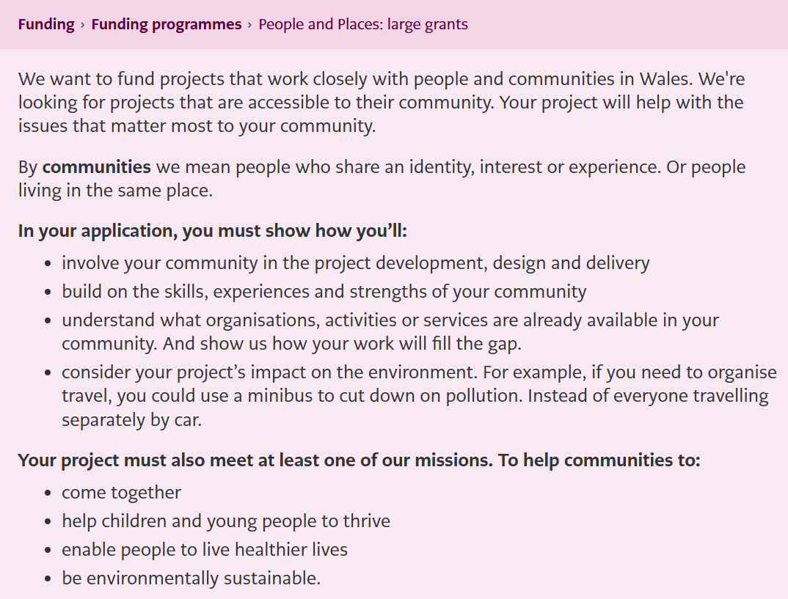
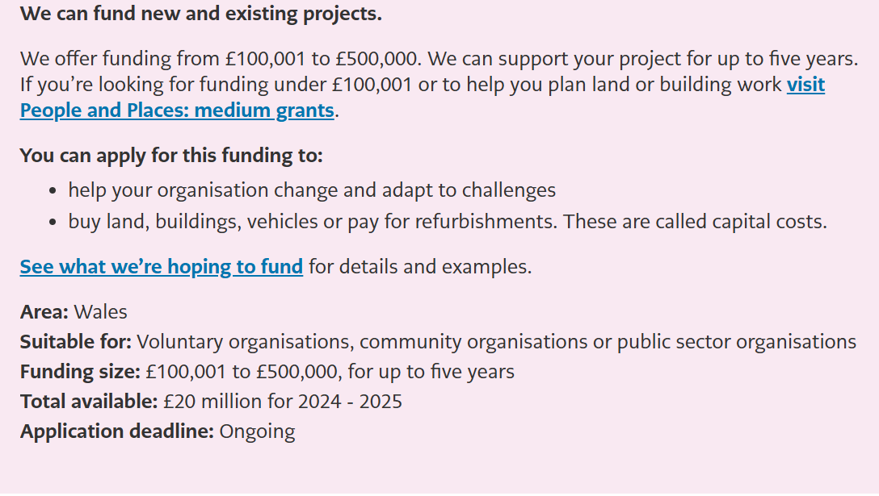
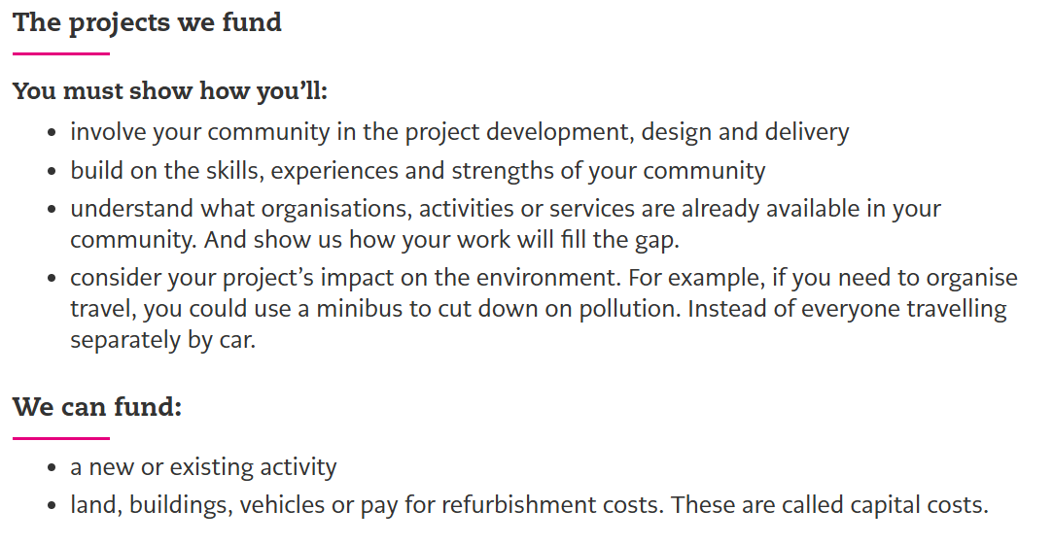
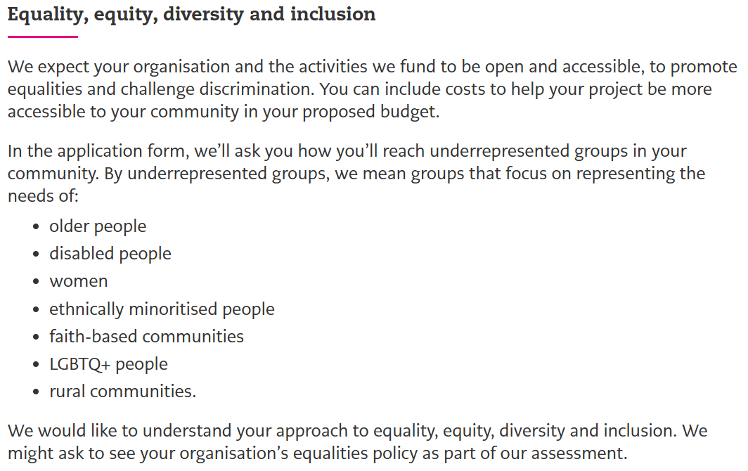
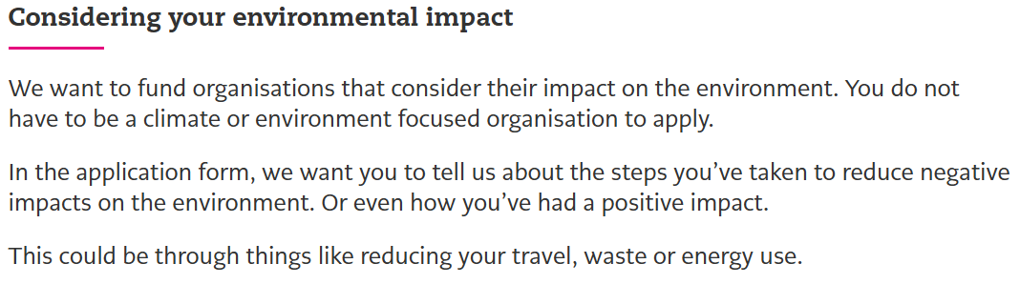
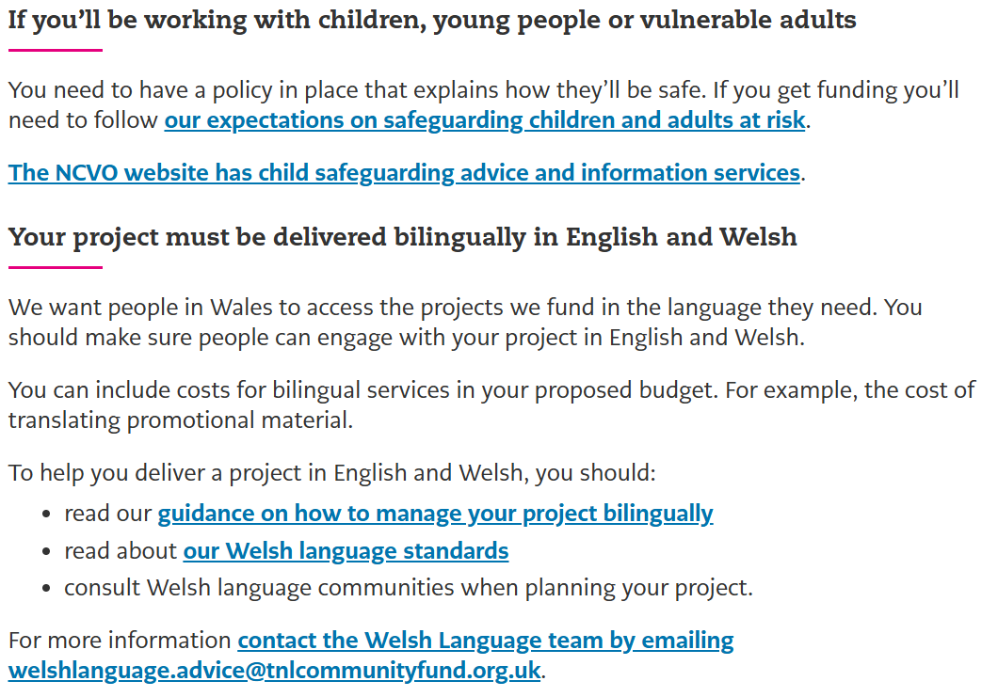

(National Lottery Community Fund, 2025)

Appendix 2 – National Lottery Community Fund – People and Places Large Grant – Guidance Provided for Long-answer Application Questions
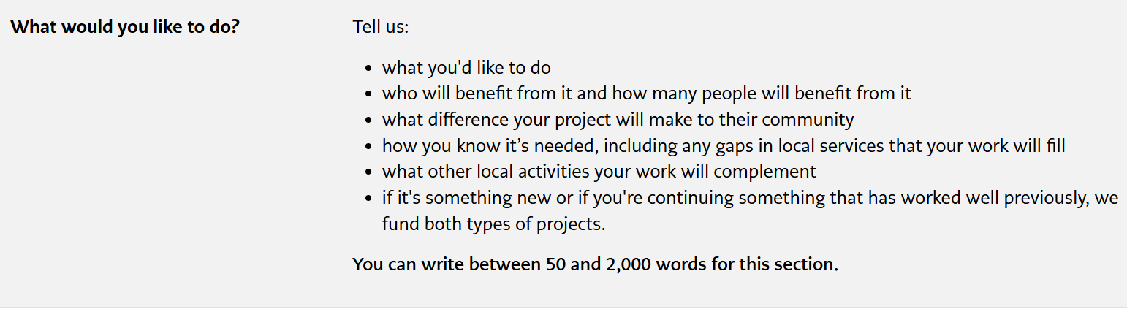
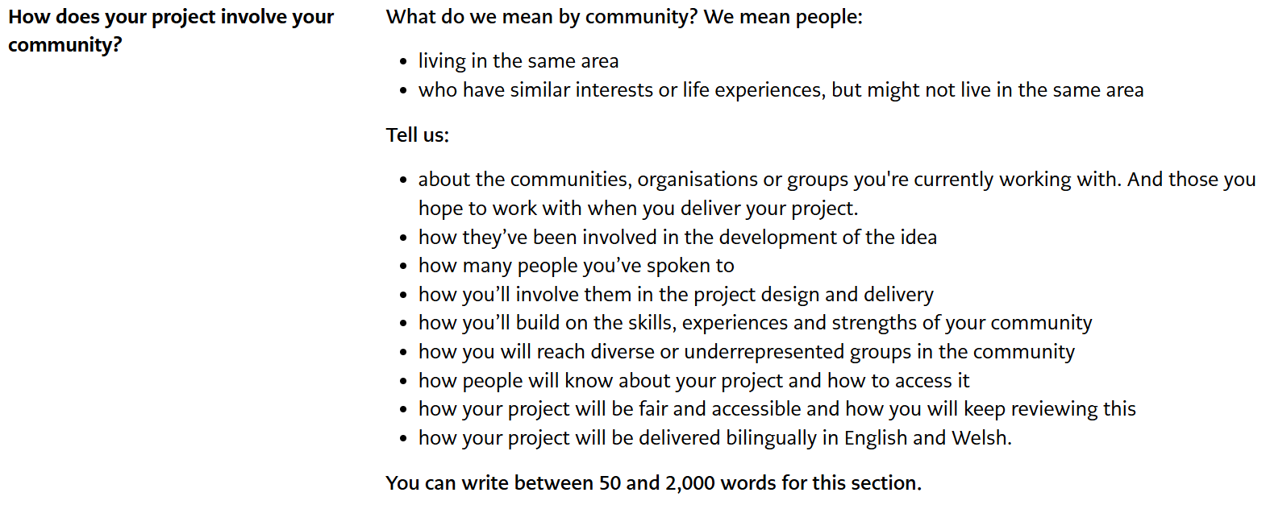
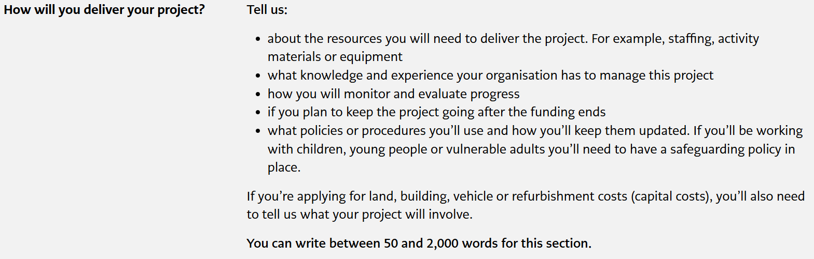
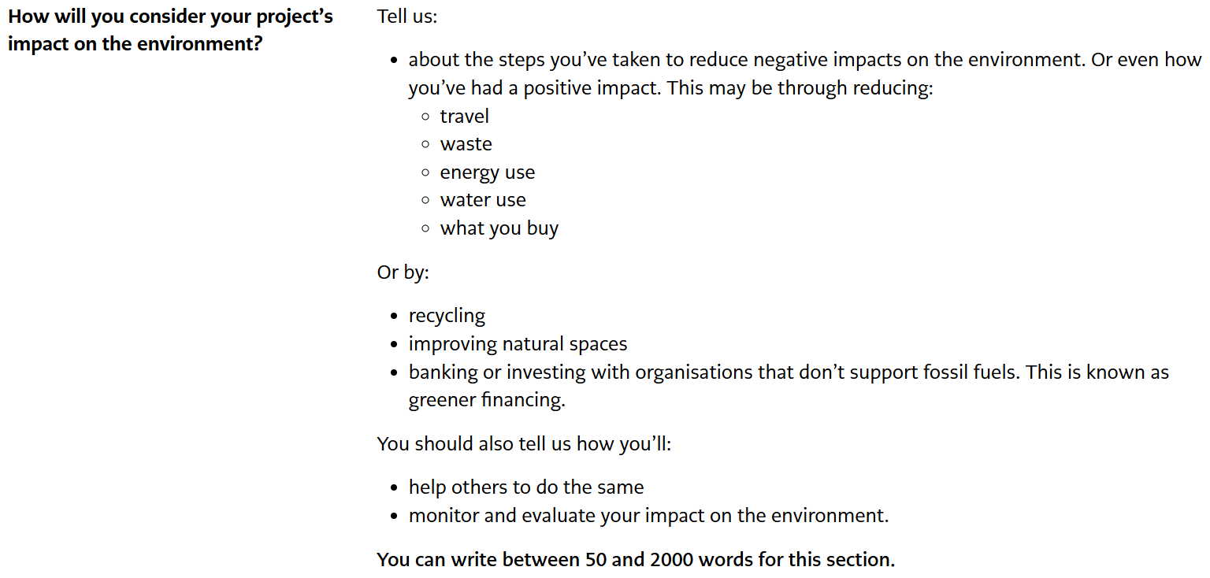

(National Lottery Community Fund, 2025)

