Community Engagement Assignment 2 2018



April 2018
MODULE NAME: Community Engagement M4X00799
NAME: Michalina Bujak
STUDENT NUMBER: 1709707

TABLE OF CONTENTS

EXECUTIVE SUMMARY……………………………………………………….……3
LIST OF FIGURES…………………………………………………………….………4
- INTRODUCTION………………………………………………………..…….5
  - Report remit………………………………………………………...…..5
  - Domino’s Pizza Inc. General informations.............................................5
  - Domino’s Problems…………………………………………………….5
- PROBLEM SOLVING TECHNIQUES……………………………………..…7
  - Solving the problems of Domino’s company with the help of formal techniques for problem solving………………………………………...8
  - Problem solving implementation………………………………...……..10
- CONCLUSION…………………………………………………..……………..11
- REFERENCES………………………………………………. ………………...12

EXECUTIVE SUMMARY

This report contains an analysis of the problems of Domino's Pizza Inc. Using formal problem solving techniques such as 5-WHY and Ishikawa Diagram, possible solutions and steps to deal with the existing problem were proposed.

The report states that the main problems of Domino's Pizza Inc. are: organizational culture, delays in delivery, poor quality of goods and services offered to customers and growing interest of the healthy food.

As a reason, a weakly qualified team of employees was indicated, lack of investment in employee training and health problems resulting from unhealthy food such as fast-food.

In the future, the company should focus on taking precise actions to provide employees with the right qualifications and thus better value for money and services. The report cites the scandal of 2009, in which employees posted videos promoting inappropriate, unsanitary behavior at the workplace.

According to the report, the company should also focus on introducing healthy supplements to its offer and minimizing the amount of fat in the products offered.

This report positively assesses the possibilities of solving problems in the company when taking the appropriate steps.

LIST OF FIGURES

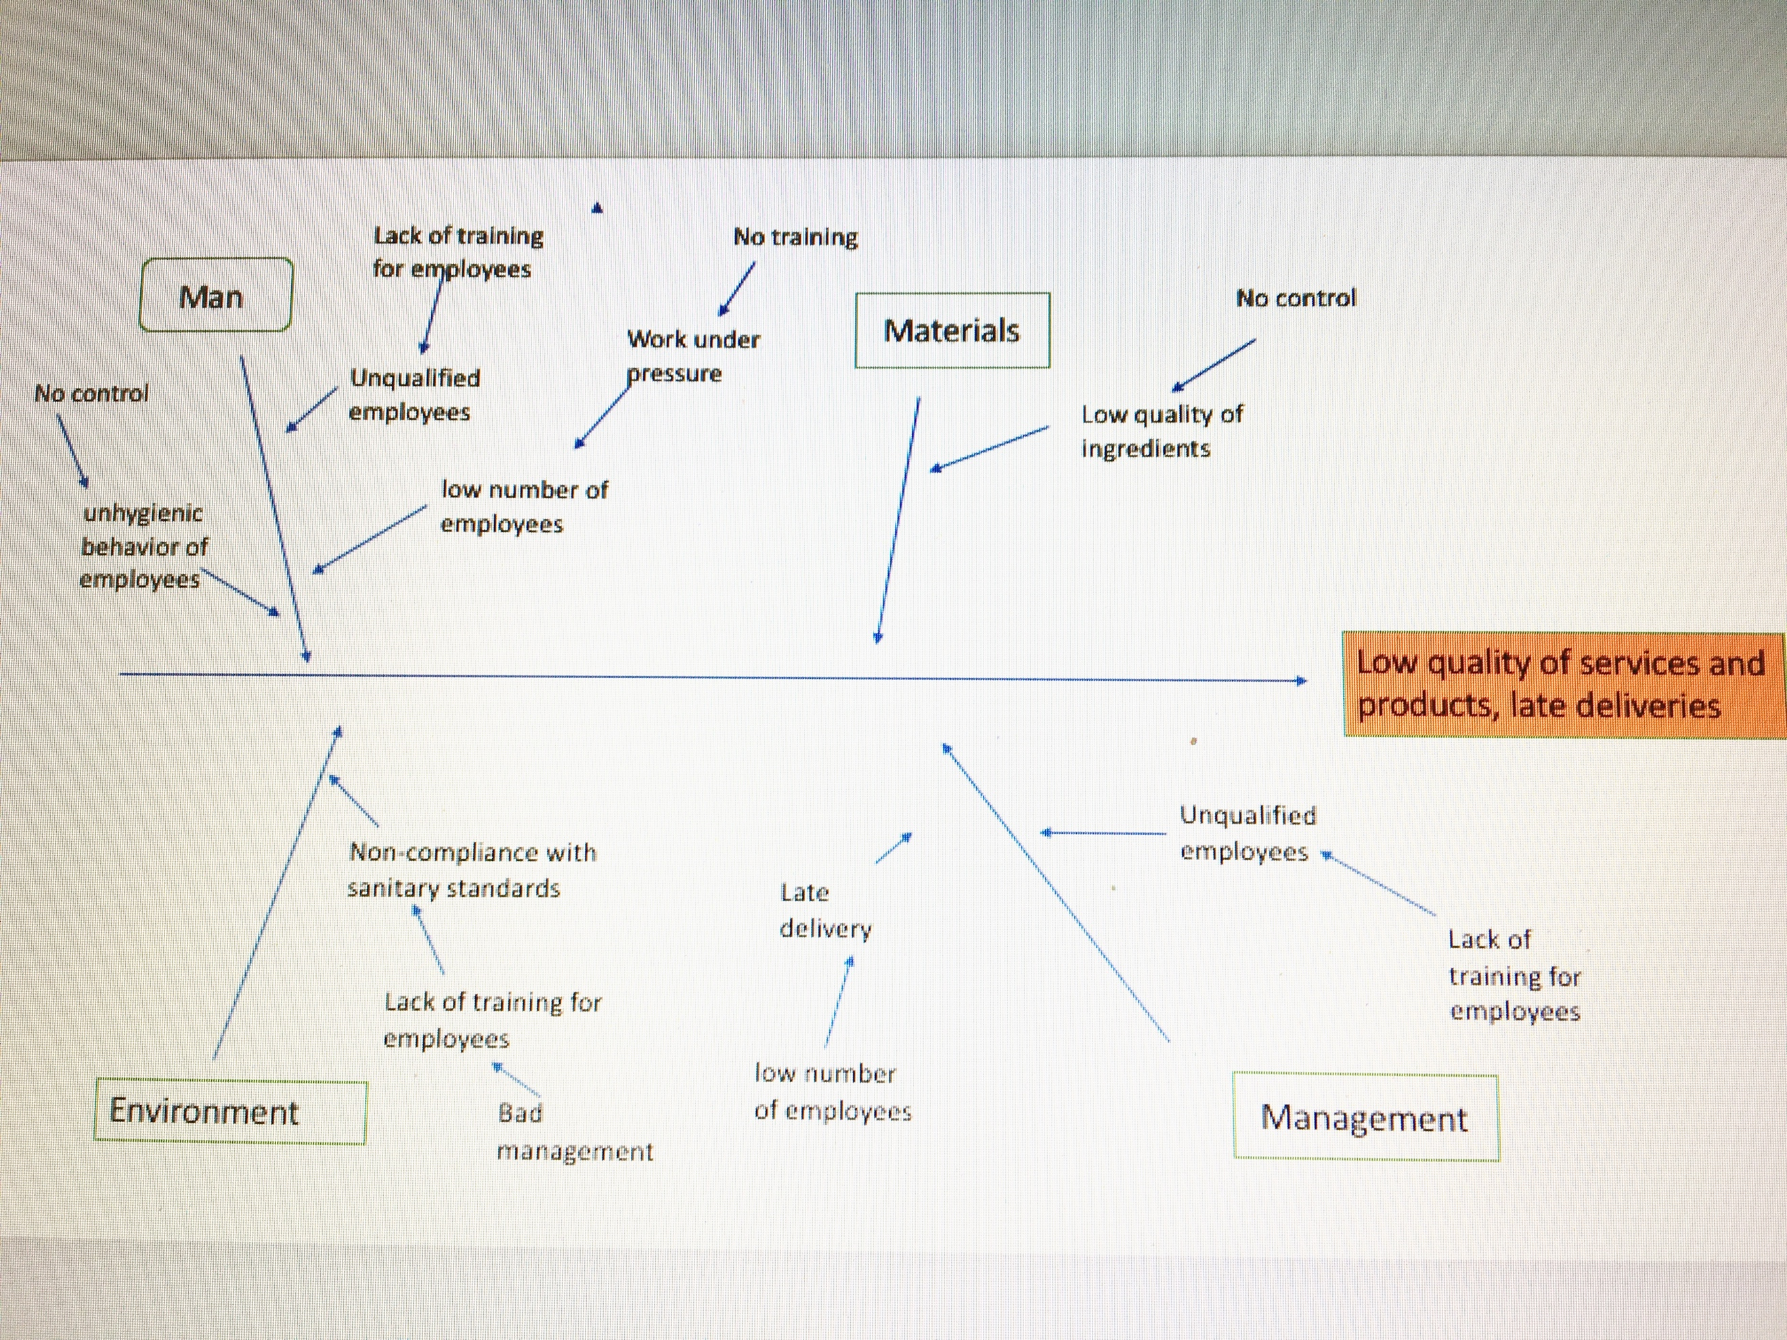
Fig.1. Causes of Domino's problems based on Ishikawa diagram analysis. Source: Own development.

- INTRODUCTION

This report was created as a result of an analysis of the problems existing at Domino's Pizza Inc. Instructions and recommendations were put in it to solve these problems with the help of formal problem solving techniques. The report consists of 7 chapters. The first chapter describes the purpose of the report. The second chapter presents basic information about Domino's Pizza Inc. The third chapter details and analyzes the problems of Domino's. The fourth chapter is a detailed description of formal problem solving techniques such as Ishikawa and 5whys. The fifth chapter discusses possible solutions to problems. The sixth chapter describes the actions and steps to be taken to solve the problem. The last chapter is the chapter summarizing the report.

  - REPORT REMIT

The purpose of the report is to use formal problem solving techniques and issue stipulated recommendations for Ishikawa and 5 whys models to solve the problems of the Domino's Pizza brand.

  - DOMINO’S PIZZA INC. GENERAL INFORMATIONS.

Domino's pizza is one of the most recognizable and popular not only in the UK, but also around the world. Its history dates back to 1960, when Tom Monaghan and his brother James bought the pizzeria "DomiNick's" in Ypsilanti, Michigan. A year later James sold his part to his brother in exchange for a Volkswagen Beetle. In 1965, Tom, as the only owner, changes the name of the company to "Domino's Pizza, Inc.". Two years later, the first franchise Domino's pizza in Ypsilanti was created. Pizzeria Domino's has over 1,000 stores within United Kingdom, employing over 35,000 employees. Domino's sells over 94 milions pizza a year and have over a million fans on facebook.

  - DOMINO’S PROBLEMS

Domino's is struggling with the problems related to the size of the organization. The culture of the organization is the main one. Employees who do not have advanced training have a problem with working under pressure. The problem is also a small number of people on the change. The huge number of orders, their implementation and the number of obligations in connection with the operation of the store is transformed into delayed deliveries to customers and the collapse of the quality of products. For this reason, new employees can not adapt to the conditions and quickly change jobs. Low requirements for uneducated managers also affect the company's image and the quality of the offered goods and services. The managers can not control the employees, which is why the company is exposed to various types of scandals. An example of such a situation is the scandal of April 2009, when it was discovered that two employees of Domino's posted videos on the Internet, on which they showed unhygienic and inappropriate behavior in the workplace. In order to prevent the reputation of the company from falling, Domino's employees had to quickly identify the perpetrators and make efforts to keep the current movies disappearing from the web, while new ones never appeared there. If the scandal widened on the world scale, the huge Domino's corporation would be able to lose not only customers but also franchisees and employees. The battle with employees continues to this day. Domino's is still not properly recruiting employees and does not provide them with adequate training. By looking at customer reviews, you may come across complaints about delayed deliveries and poor pizza quality. In addition, customers are disgusted with unhygienic behavior of employees and ensure that they will not be longer Domino's customers. That's why Domino's spent millions to create the Pizza Turnaround campaign, during which they offered customers a new, better dimension of pizza. Domino's started cooperation with the FORD car brand in order to innovate the delivery department, in which products will be delivered by means of self-propelled vehicles. Currently, research is underway to assess of the idea.
Another problem of the Domino's brand is the growing trend of healthy food, outdoor eating and sports. People are more and more aware of the impact of nutrition on their lives. In general, families focused on healthy children's food and their better future decide on radical dietary changes in their lives. People are increasingly turning to healthy food that can be just as tasty as fast-food and thus less caloric. Y Prabhavathi, N T Krishna Kishore, M. Ramesh Kumar in their publication provided data according to which 55% of respondents want to change their eating habits to healthy. These results were supported by similar results observed in South Africa by Steyn and Marais (2010) among young consumers who found that 78% of all consumers in the sample indicated that they would choose a healthier option if it is available in the fast food menu. In addition, less and less often they have the desire to order food with home delivery and will go out to the air to sit down on the occasion and eat a meal outside the home. This is a bad news for the Domino's network, because it is mainly focused on deliveries. There is just a few Domino's stores which offering eat-in option.

- PROBLEM SOLVING TECHNIQUES.

In this report, tips to solve the problems faced by the Dominos corporation were developed using formal techniques to solve the problems of 5-why and Ishikawa diagram. Solving the problem must focus on removing its cause. Otherwise, the problem may appear again.
One of the methods for determining the cause is the 5-WHY method. The creator of this method is Sakichi Toyoda. Taiichi Ohno, the architect of the Toyota Production System in the 1950s, describing the method in his book The Production of Beyond Large-Scale Production as the basis of Toyota's Scientific Approach. problem as well as solution becomes clear. " It covers two aspects: Why the problem arose? Why did not we notice this?
First, you need to collect information about the problem. We answer the questions: What happened? When? What is the scale of the problem? What are the risks and consequences of the problem for the customer, the user, the employer ?. The second step is to define a person (working group) that would help us define this problem. After these two steps, the problem should be precisely described. Then we start to ask the question "Why?" and after receiving the answer we ask the next question "Why?". We ask these types of questions about 5 times. It is assumed that the answer to the fifth question determines the cause of the problem. That's why the method is called the 5-why method. After finding the immediate cause of the problem, you can develop specific actions to eliminate it.
Another formal method of solving the problem is the Ishikawa diagram, or the Fishbone Diagram. The name comes from the name of the creator of the Kaoru Ishikawa method. It is a tool that allows for graphical presentation and identification of the causes of problems or results. In contrast to the 5-WHY method, this method first requires precise formulation of the "effect", and then through a detailed analysis of the definition of its "category of causes" and "causes".
The most common proposed categories of causes are 5M + E, which correspond to the words (Bachman, 2017, p.48):
1. Man
2. Materials
3. Machine
4. Methods
5. Management
6. Environment
The chart consists of the reasons and sub-sections. Each arrow means "contributes to ...". Only after identifying all possible causes of the problem, you should select the most important and issue recommendations to solve them. The disadvantage of this method of solving problems is the difficulty in classifying individual causes to the right groups or subgroups.

  - SOLVING THE PROBLEMS OF DOMINO'S COMPANY WITH THE HELP OF FORMAL TECHNIQUES FOR PROBLEM SOLVING.

5-WHY
Healthy food is becoming more and more popular. This is one of the biggest hurdles for currently existing fast food chains. Most of the UK's population for years has been eating mainly fast-food. The result is excessive obesity in young people and even children. In addition to obesity, unhealthy nutrition increases the risk of heart attack, pressure problems and other ailments. Using the 5-WHY method, you can refer to the problem that Domino's is struggling with.

QUESTION 1: Why is the popularity of fast-food going down?
ANSWER 1: Because there is the trend for healthy food.

QUESTION 2: Why is there a trend for healthy food?
ANSWER 2: Because people want to feed themselves healthy.

QUESTION 3: Why do people want to feed themselves healthy?
ANSWER 3: Because the majority of the population suffers from obesity and other diseases related to unhealthy eating.

QUESTION 4: Why do people suffer from obesity and nutrition-related diseases?
ANSWER 4: Because they are eating fast foods that are not healthy.

QUESTION 5: Why are fast food not healthy?
ANSWER 5: Because they have a high fat content and low content of vitamins and healthy ingredients.

According to the above analysis, it can be concluded that currently the population is no longer as interested in fast food as in previous years. Health problems make people show their willingness to introduce changes into their eating habits. In a similar situation was McDonald's which a few years ago was considered a source of unhealthy food. However, after the introduction of healthy ingredients, maintaining their freshness and quality allowed to refute these opinions once and for all. Domino's could go as an example of McDonalds and focus on offering people healthier ingredients as additions to pizzas or other forms of food. In addition, if Domino's will offer the option of eating meals in the local, people would move more to counter the obesity. Such changes, however, adversely affect the image, history and traditions of the brand.

ISHIKAWA DIAGRAM
Another problem of the Domino's brand is the unqualified team of employees and the culture of the organization. The result is scandals and low quality of the offered goods and services, which leads to the loss of reputation and image as a fast-food leader in the world. Delayed deliveries discourage customers from ordering home meals because meals came often cold. Employees who are not properly trained are not able to offer high quality goods and services to clients. The problem was found using the Ishikawa diagram below.

Fig.1. Causes of Domino's problems based on Ishikawa diagram analysis. Source: Own development.

On the basis of the developed diagram, it can be concluded that the main reason for poor quality of rendered goods and services are poorly qualified employees who are not provided with advanced training. The management team does not sufficiently control the work of employees, while employees deprived of the right to training are not able to cope with the tasks entrusted to them. The solution in this situation would be to provide appropriate training in hiring an employee and focus on audits. However, it would be associated with additional costs that the company would have to cover. However, thanks to changes, the company could achieve better performance from its employees, and thus offer customers better quality of goods and services.

  - PROBLEM SOLVING IMPLEMENTATION

After analyzing the problems that Domino's is currently facing, several solutions can be proposed that would improve the company's coordination. In the first row, it would be necessary to introduce routine employee training, on which they would acquire the ability to work under pressure (time management) and to fill higher positions with educated employees with qualifications. Thanks to this, new employees would be more willing to apply for permanent employment. It would also pay attention to the culture prevailing in the organization, which is a necessary factor for its proper functioning. The employer should open up to the needs of his employees so that they can thus offer better services to clients. Following the trends of healthy food, Domino's should focus on offering "new products" in its offer, in the form of healthy supplements. They could work on limiting the amount of fat in making their dishes and offer their customers the desired healthy food. An additional advantage would be to provide customers with the possibility of eating at the premises as an alternative to deliveries. Thanks to this, the number of delays in deliveries would be reduced and the desire to eat outside the home by the customer would be satisfied. The problem of delivering a cold pizza could be solved if Domino's took over McDonald's strategies. McDonald's had a problem with delivering fries in a hot form and was usually delivered in a mushy form. Ever since the company began to deliver products via UberEats Uber Technologies Inc. The problem disappeared "alone". The maximum delivery time was set at a maximum of 30 minutes, and before the meal was packed, every effort was made to make it fresh and hot. If Domino's followed McDonald's, the problem of delaying delivery and delivery of cold products could also be eliminated.

- CONCLUSION

Each company is struggling with problems, but not every company can find its causes and solutions. By using formal troubleshooting techniques, you can easily find the cause and solution. The upside is that every person is able to analyze the problem on their own without additional costs. The companies are profit oriented, so the ease of using techniques like 5-WHY and the Ishikawa diagram allows them to skip the additional costs they would be exposed to if they had to hire specialists to find the cause. To sum up, Domino must work on his employee system as well as on the offer. This will keep your reputation and maintain a high position in the fast growing food industry.

REFERENCES
- Bachman, P. (2017). Problemy inżynierii bezpieczeństwa i nauk o pracy. Zielona Gora: Wydawnictwo Instytutu Inżynierii Bezpieczeństwa i Nauk o Pracy Uniwersytetu Zielonogórskiego.
- ConsumerAffairs. (2018). Top 465 Reviews and Complaints about Domino's Pizza. [online] Available at: https://www.consumeraffairs.com/food/dominos.html [Accessed 4 May 2018].
- Dominos.co.uk. (n.d.). Domino's Pizza: Pizza for Delivery or Takeaway Near You. [online] Available at: https://www.dominos.co.uk [Accessed 10 Apr. 2018].
- Hospitality Technology. (2017). Domino's and Ford Begin Consumer Research of Pizza Delivery Using Self-Driving Vehicles. [online] Available at: https://hospitalitytech.com/dominos-and-ford-begin-consumer-research-pizza-delivery-using-self-driving-vehicles [Accessed 21 Apr. 2018].
- Illie, G. and Ciocoiu, C. (2010). APPLICATION OF FISHBONE DIAGRAM TO DETERMINE THE RISK OF AN EVENT WITH MULTIPLE CAUSES. MANAGEMENT RESEARCH AND PRACTICE, [online] 2(1), pp.1-20. Available at: https://www.researchgate.net/profile/Carmen_Ciocoiu/publication/46567642_Application_Of_Fishbone_Diagram_To_Determine_The_Risk_Of_An_Event_With_Multiple_Causes/links/572afd7408aef5d48d30d6dd/Application-Of-Fishbone-Diagram-To-Determine-The-Risk-Of-An-Event-With-Multiple-Causes.pdf?origin=publication_detail [Accessed 20 Apr. 2018].
- Investors.dominos.co.uk. (2016). The Domino's Difference. Annual report and accounts 2016.. [online] Available at: http://investors.dominos.co.uk/system/files/uploads/financialdocs/dominos-pizza-group-plc-annual-report-accounts-2016.pdf [Accessed 23 Apr. 2018].
- Jacques, A. (2009). Domino’s Delivers During Crisis: The Company’s Step-by-Step Response After a Vulgar Video Goes Viral. [online] PRSA. Available at: http://apps.prsa.org/Intelligence/TheStrategist/Articles/view/8226/102/Domino_s_Delivers_During_Crisis_The_Company_s_Step#.Wuy2kGaBhmB [Accessed 21 Apr. 2018].
- Nance, A. (2015). Domino's Pizza: A Case Study in Customer Feedback | Randall-Reilly. [online] Randall-Reilly. Available at: https://www.randallreilly.com/dominos-pizza-a-case-study-in-customer-feedback/ [Accessed 21 Apr. 2018].
- Patton, L. (2018). McDonald's says it's solved delivery problem: Keeping fries hot - BNN Bloomberg. [online] BNN. Available at: https://www.bnnbloomberg.ca/mcdonald-s-says-it-s-solved-delivery-problem-keeping-fries-hot-1.984369 [Accessed 23 Apr. 2018].
- Prabhavathi, Y., Krishna Kishore, N. and Ramesh Kumar, M. (2014). Problems and Changing Needs of Consumers in Fast Food Industry: The Indian Perspective. International Journal of Scientific and Research Publications, [online] 4(2). Available at: http://www.ijsrp.org/research-paper-0214/ijsrp-p26115.pdf [Accessed 21 Apr. 2018].
- Price, D. (2009). The principles and practice of change. Basingstoke: Palgrave Macmillan.
- ProductReview.com.au. (2016). Domino's Pizza review by simon4222. [online] Available at: https://www.productreview.com.au/r/dominos-pizza/885235.html [Accessed 21 Apr. 2018].
- Serrat, O. (2009). The Five Whys Technique. DC: Asian Development Bank. [online] Available at: https://www.researchgate.net/publication/239823665_The_Five_Whys_Technique [Accessed 20 Apr. 2018].
- Smith, D. (2016). How to Eat Healthy at McDonald's | Eat This Not That. [online] Eat This Not That. Available at: https://www.eatthis.com/what-diet-experts-eat-mcdonalds/ [Accessed 21 Apr. 2018].
- Taylor, D. (2018). Long shifts without breaks and pressure from management, Domino's employee speaks out. [online] ABC News. Available at: http://www.abc.net.au/news/2018-01-27/dominos-employee-speaks-out-on-pressure-from-management/9365904 [Accessed 21 Apr. 2018].
- Verduin, P., Agarwal, S. and Waltman, S. (2005). Solutions to obesity: perspectives from the food industry. The American Journal of Clinical Nutrition, [online] 82(1), pp.259S–261S. Available at: https://academic.oup.com/ajcn/article/82/1/259S/4863410 [Accessed 21 Apr. 2018].
- Yach, D., Khan, M., Bradley, D., Hargrove, R., Kehoe, S. and Mensah, G. (2010). The role and challenges of the food industry in addressing chronic disease. Globalization and Health, [online] 6(1), p.10. Available at: https://globalizationandhealth.biomedcentral.com/articles/10.1186/1744-8603-6-10 [Accessed 21 Apr. 2018].
- Young, C. and Flowers, A. (2012). Fight Viral with Viral: A Case Study of Domino’s Pizza’s Crisis Communication Strategies. Case Studies in Strategic Communication, [online] 1, pp.93-106. Available at: http://cssc.uscannenberg.org/wp-content/uploads/2013/10/v1art6.pdf [Accessed 18 Apr. 2018].

