

Student Name: AMINUR ISLAM
Student ID: 2437199
Module Name: Human Capital Management
Module Code: LCMB7023
Assignment Title: The Influence of National and International Labour Markets on HRM and IHRM Strategies

Lecturer’s Name: Dr.Hoang Nguyen
Work Count: 2609 (main body)

Term 1

Table of Contents
Introduction 3
Q.1: The Digital Revolution Changeing the Face of Labour Markets 4
Q.2: Demographic and Geopolitical effects on the Employment markets 7
Q. 3: Strategic HRM Response to Slips in Skills and Deficits in Talent 10
Q.4: Reflective Report: International Employability Capabilities 13
Conclusion 15
References 16

Introduction
Labour markets are driven on both national and international basis, which determine employment pattern, wage structure, and mobility of individuals. The institutional system of interaction between the demand and supply of labour can be referred to as a labour market (OECD, 2020). Domestically, employment and skills supply policies, as well as labour regulation, set the dynamics of the labour force, and the international labour markets are defined by regional mobile labour and international talent competition (Berg and Hayter, 2015).
The fast-paced digital technologies, demographic trends, and geopolitical changes have redefined the manner in which organisations acquire, nurture, and maintain the talents across borders (Balwant Singh Mehta and Singh, 2024). In this regard, Human Resource Management (HRM) that is defined by the Harvard Model as the strategic management of the people in order to attain organisational goals, is moving towards an international orientation (Armstrong and Taylor, 2023). International Human Resource Management (IHRM) refers to management of individuals in multinationals to strike a balance between globalisation and local sensitivity.
Such changes require HR professionals to shift away the administration to strategic workforce planning, talent development, and management of digital capability (Syed and Kramar, 2017). The interaction between the global labour market patterns and the HRM/IHRM strategies constitutes the core of the given report backed by the recent theoretical insights and organisational practices, including the global HR strategy at Amazon (Alderfer, 2025).

Q.1: The Digital Revolution Changing the Face of Labour Markets
The digital revolution has altered the organisation and operations of the labour markets in national and international levels (Cohen and Zaidi, 2019). With the introduction of advanced technologies like artificial intelligence, robotics, and automation, the nature of work has been transformed, providing new types of work, but minimizing the need to rely on manual and repetitive work (Malik and Budhwar, 2023). This change has made the shift to high-skilled over low-skilled labour with adaptability, creativity and digital competence to be the primary demands in employability.
Academically, technological development is not only about efficiency, but strategic change in the management of workforce can be triggered by technological development (Meçik, 2024). Companies are being forced to invest in lifelong learning and digital reskilling in order to be competitive. The concept of human capital is also emphasised by the evolution of work as the knowledge and technological skills of employees are useful strategic inputs to increase the performance of an organization (Raynus, 2016).
In HRM, this digital transformation entails the process of moving past the conventional personnel management to strategic human resource planning. Recruitment, performance management and training are among the functions that are underpinned by digital platforms and decisions that are made based on data (Ratten, 2025). Remote teams can be active all over the world with the help of virtual collaboration tools that require a high level of digital leadership and cross-cultural communication. The HR managers will now have a bigger obligation to make sure that there is fairness, transparency, and ethical application of digital tools, including automated hiring technology and AI-driven performance assessments (Armstrong and Taylor, 2023).

IHRM in the global setting is challenged with complicated concerns of dealing with global digital workforces. The variations in national laws on employment, data protection and cultural anticipations demand that international HR professionals strike a balance between globalization and localization (Otto, 2016). Remote and hybrid employment setup require a comprehensive digital-based infrastructure, management styles that are elastic, and robust cyber-security consciousness.
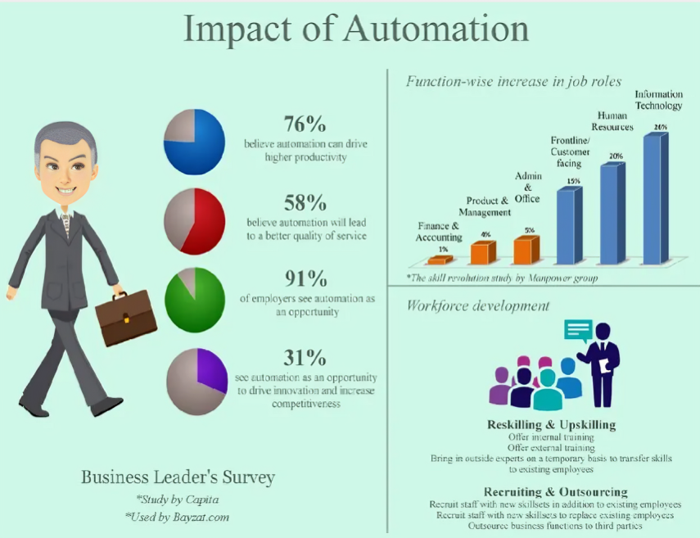

Figure 1: Impact of automation
Source: (Wassily Leontief and Duchin 2016)
The practical example of this change can be found in world technological-oriented organisations (such as Amazon) (Goodman and Dingli, 2013). Most companies have digitized their logistics and administrative processes substituting regular functions with online solutions and generating new data analyst, cloud computing, and cybersecurity roles (Ouaissa et al., 2022). These transformations indicate the continued transition of labour intensive processes to knowledge-based employment models.
The STARA model offers a useful framework to comprehend this online development. It describes that replacing human work with machines, openness to technological change (Armstrong and Taylor, 2023), expansion of human capacity, ethical use responsibility and adjustment via perpetual learning are crucial aspects of HRM in the future. Those organisations utilising these dimensions are in a better situation to overcome technological disruption, facilitate resilience and sustainability of workforces and ensure sustainability performance in the digital era (Elsmore, 2020).

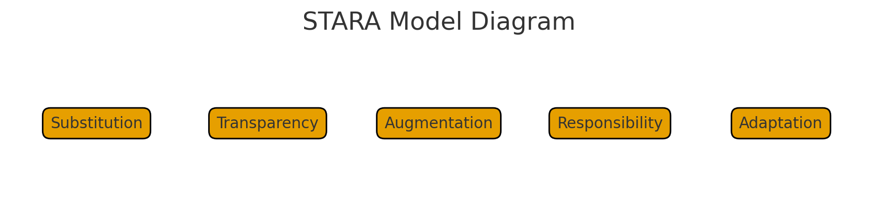
Source: Author

Q.2: Demographic and Geopolitical effects on the Employment markets
The performance and structure of labour markets in the world are being influenced by the dynamics of demographic and geopolitics. The forces that have a significant impact on the supply and demand of workforce include population ageing, migration changes, and political turmoil (Guglielmo Meardi, 2024). The ageing population of economies creates declining labour forces, and increasing pension liabilities and deficits in areas of essential needs and demands, such as health services and education. Conversely, the young population areas find it difficult to generate adequate quality jobs leading to underemployment and skills emergence (Isidorsson and Kubisa, 2018).
The lack of equilibrium between the regions that have excess labour and those with deficit has increased the world talent competition. The restrictive immigration policies and the geopolitical tensions have led to the disruption of migration which was traditionally a stabilising mechanism (Berg and Hayter, 2015). The conditions restrict the free movement of skilled labor and bring about ambiguity to multinational firms that depend on international labour force. The global companies are now required to incorporate risk management and workforce planning to ensure performance in the face of unforeseeable environments (de Koning, 2024).
To HRM, these geopolitical and demographic changes require dynamic approaches. Through planning, organisations need to foresee workforce trends by ensuring that there is the right balance between the mature and young talent (Berg and Hayter, 2015Stoe). The redesign of jobs, flexible work and lifelong learning is very important to sustain productivity as the workforce is aging. In younger labour markets, the HR policies that can enhance training, apprenticeship, and entrepreneurship opportunities can enhance employability and minimise skills gaps (Parry and Mccarthy, 2017).
IHRM is further complicated by the fact that the political ties and the international economic situation directly influence the international operations. The human resource policies should be in line with the local laws, standards of safety, and local culture standards without sacrificing uniformity of the corporate standards on a global basis (Mitchell, 2013). Cultural competence to work with multinational teams has emerged as one of the major competencies of the international HR practitioner. Organized diversity and inclusion programs increase inter-boundary collaboration and innovation as well as reducing the conflicts that come about as a consequence of culture differences (Kodama, 2015).
The participation of gender and generational diversity also have additional effect on contemporary HR practices. The older employees can be retained with the help of the family-friendly policies, flexible schedules, and hybrid work model, which can promote more women engaging in the labor market (Ferdous, 2025). Such initiatives make organisational reputation stronger and leading to social sustainability. The success of labour markets in the long term relies on the capability to absorb different groups into the workforce.
Geopolitically, the continuous wars, inflation, and trade disruptors affect the distribution of talents in the world. Organisations need to be responsive with the help of scenario planning and workforce analytics that can be used to react to rapid shifts in political or economic conditions (Sparkman, 2018). International HRM thus serves as a stabilising and strategic role, which guarantees continuity of business and the security of the employees.
Finally, demographic and geopolitical factors are forcing organisations to consider HRM as a dynamic system that balances the workforce capacity to suit long term economic and societal change (Singh et al., 2023). The key to a strong labour market is the ability of HRM and IHRM to balance effort in localising and globalising, which develops strategies that will ensure productivity in a progressively turbulent world.
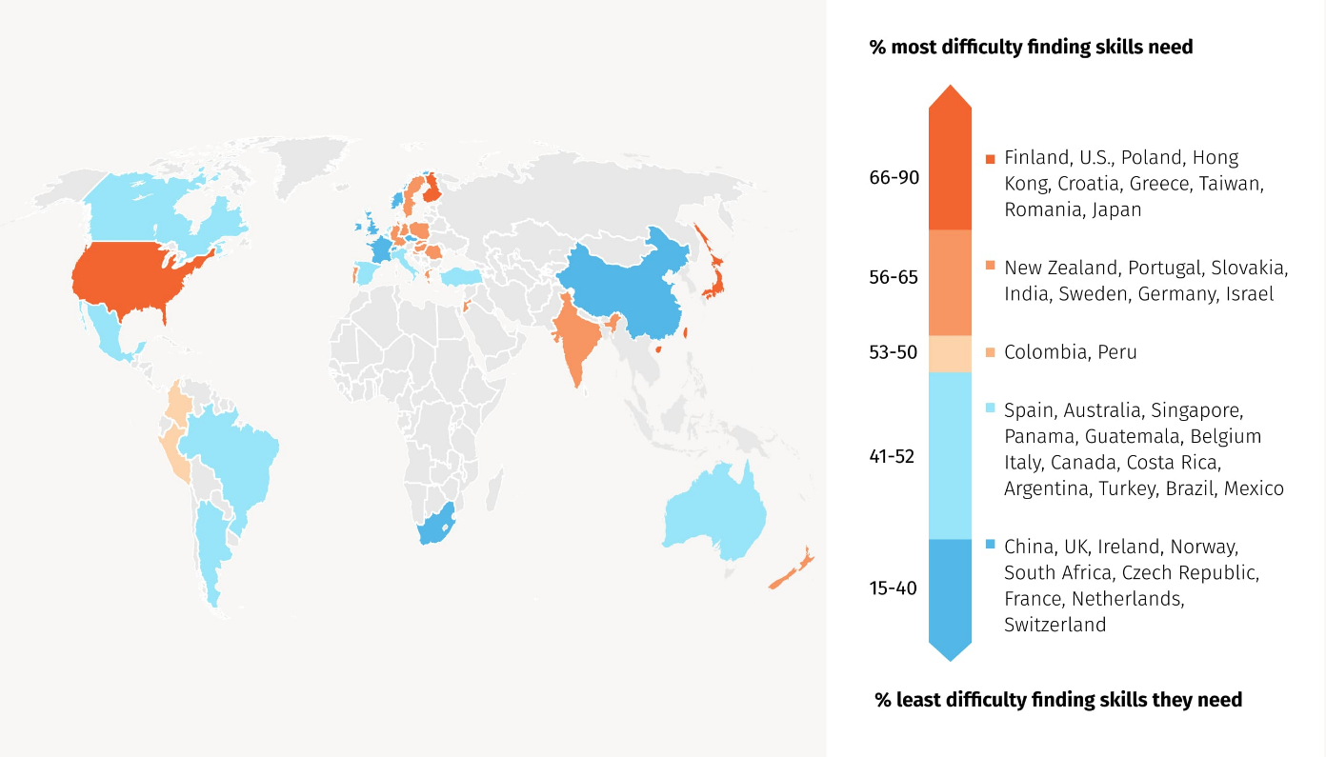

Figure 3: Global Skills Shortage Map
Source: (Cohen and Zaidi 2019)

Q. 3: Strategic HRM Response to Slips in Skills and Deficits in Talent
The skills gaps are rising in most sectors. Technology positions demand high levels of digital skills that most employees are unable to acquire at a high rate. The problem with healthcare systems is that they do not have trained nurses and specialists due to ageing populations and complicated patient needs (Isidorsson and Kubisa, 2018). High turnover and lack of training opportunities are a challenge to the hospitality businesses. The lack of talent decreases the productivity and delays organisational development. HRM needs to retaliate with powerful initiatives to attract and nurture talented individuals.
Talent pipelines are used to train future leaders and specialist workers at the company. These pipelines are used to recognize employees who have potential and provide them with specific development (Armstrong and Taylor, 2023). Succession planning cushions firms when there is unexpected change of job. The talented employees are waiting to take up major positions without wasting time. Collaboration with higher learning institutions and training agencies aids in the identification of early talents (States. 2013). Students have the real experience and are better equipped to work.
Training through online learning is easier and quicker. Continuous learning programs can help the employees to acquire digital skills. Multi-skilling enables the workers to do various jobs and this is good to relieve pressure in short-staffed areas (Walter 2014). Internal mobility opens new career opportunities to the employees and promotes their long term commitments. The strategies enhance flexibility in workforce and retain of good talent.
Employer branding is significant in competitive labour markets. Good branding indicates an organisation that is concerned with the wellbeing of employees and developing their careers (Mosley and Lars Schmidt 2017). Effective branding ensures that skilled employees are drawn, who have numerous job choice alternatives. Businesses require messages on values, culture and development opportunities.
The hospitality industry is where Marriott gives a good example. Talent academies are used by the company to train employees and curb the turnover. The skilled hospitality employees are recruited through organized programs. Promotion within the company is also encouraged (Elshaer 2019). There are visible promotion avenues to employees and this is an encouragement to the retention of employees. The plan assists Marriott to stay competitive in an industry that is renowned by the shortage of labour.
The questions concerning HR responses are critical. In some firms, the companies attempt to recruit skilled staff members directly off the competitors. The approach is quick and raises the amount of salaries. Talent acquisition poses a risk to the organisation in case of a high turnover rate (Edna Breinig Chun and Evans 2014). It may also damage the industry reputation. Development of skills within the organisation is more difficult to achieve but it helps in enhancing performance in the long run.
The use of temporary or contract workers provides short term flexibility. But such a strategy may decrease loyalty and impact organisational culture (Elsmore 2020). The temporary employees can quit when superior opportunities show up leading to recurrent gaps. A middle ground must be maintained to achieve stability.
According to the Resource-Based View (RBV), talent is one of the sources of competitive advantage. The competitors cannot easily replicate the competent employees. The HR strategies should be aimed at nurturing and safeguarding this resource (Ferdous 2025). The Ulrich HR Business Partner model assists the HR in business result creation. HR departments collaborate with the leaders to strategize the availability of staff and enhance the ability of the employees.
Strategic HRM has to include both in-house development and picky hiring (Gollan 2016). Investing in people has made organisations better placed in future labour problems and talent shortages.

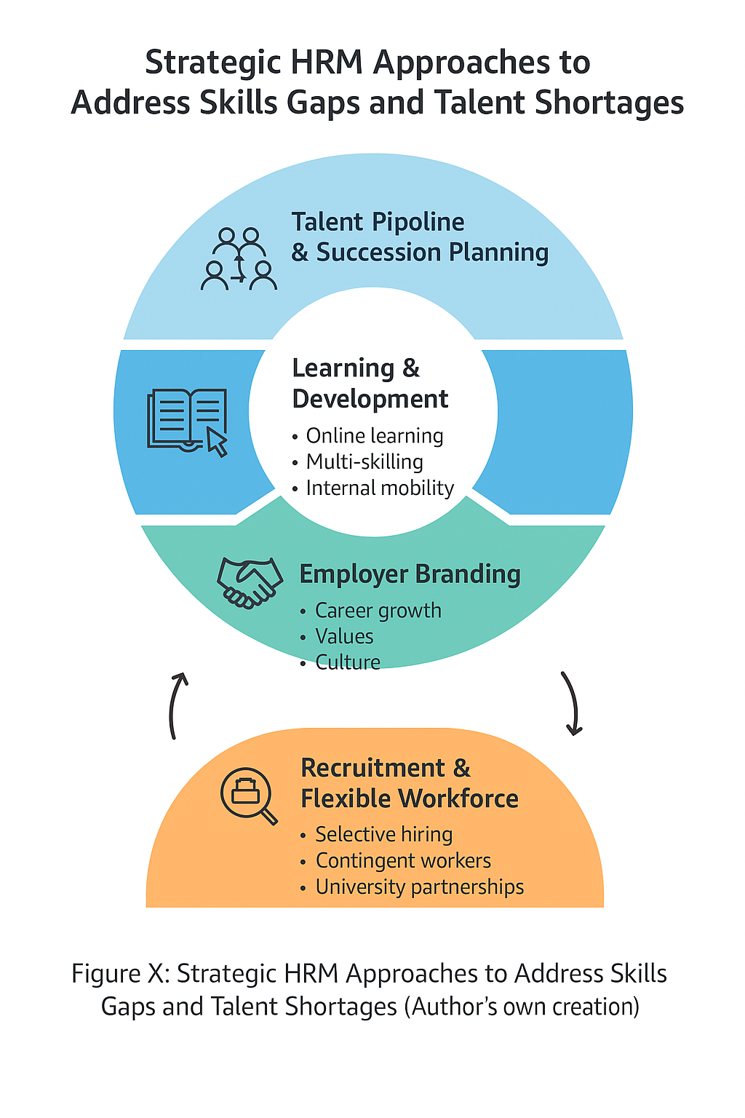
Source: Author

Q.4: Reflective Report: International Employability Capabilities
I am training to operate in a global business world. Numerous organisations recent times work in more than one country and resort to digital working and performance tools. This involves good technological, teamwork, leadership, communication, and self-directed- learning skills (Musa 2024). There is already some improvement in these aspects, as reflected in my current capabilities, but further career success can be achieved by making significant improvements.
Technology is an important aspect in contemporary employment. I am not afraid of using conventional business programs and web-based teamwork tools. I have the ability to operate within virtual office environments and handle assignments electronically (Kock 2018). Nevertheless, I should also improve skills in high-tech systems, including HR analytics systems and AI-oriented applications. These skills will be improved and enable me to fit in the new technology at the workplace more quickly.
The experience of interacting with individuals of other cultures has made me aware of other communication styles. I also attempt to listen attentively and respect the people during group work. I also like working in a team and I am able to generate ideas to resolve issues (Annika Lantz Friedrich, Ulber and Friedrich 2019). My weakness is manifested in complicated conversations as I have difficulties with formulating ideas in a multi-ethnic group. Professional practice of the English language and training in cross-cultural communication will aid in improving my situation (Sven Janitschke 2014).
Another career development area is leadership. I am able to facilitate the members of the group and assist in task organisation, but I tend to remain on the back burner (Giuliani 2022). I would like to gain more confidence in assuming leadership positions particularly where decisions must be made promptly. Mentoring and leadership seminars will assist me in developing.
One of my strengths is the ability to engage in self-directed learning. I prefer to be goal-oriented and do things within deadlines (Dalcher 2022). I am receptive to criticism and ready to acquire new competencies. Regular reflection also enables me to realise errors and be better at performance.
Summary of Reflection
Capability Area | Current Strengths | Areas of Improvement | Development Actions
Digital Skills | Good basic digital skills | Limited advanced HR tech skills (Marlene de Koning 2024). | Online courses and at the workplace.
Communicating | Team oriented; respectful | Having problems with complex group conversations | Language development and cultural training.
Teamwork | Mutual and helpful | Dependence on others to guide us more actively and role responsibility.
Leadership | Planning skills and positive attitude | Low confidence on leading tasks | Mentorship and leadership exercises (Morgan and AI 2025).
Self-led Learning | Very much motivated and disciplined | Clear career planning should be more long-term in nature | Career guidance and setting personal goals.
Future Goal | Details
Career Vision | I would like to become a powerful international worker who is capable of changing and collaborating with different teams (Armstrong and Taylor, 2023). With the help of enhanced communication, digital skills and leadership, I will be better prepared to leverage international opportunities and make international business successful.

Conclusion
The world in labour markets is undergoing significant change in technology, demographics as well as global politics. Such upheavals have an impact on the supply of talent and heightens competition on talents both nationally and internationally (Deb 2015). HRM/IHRM functions have now been pushed to become increasingly strategic through the emphasis on talent management, flexibility of workforce, ethical use of technology and good risk management (Chorafas 2011). To avoid being left behind by automation and digital innovation, organisations have to invest in unceasing learning. Some of the effective responses would be to create talent pipelines, embrace diversity, enhance employer branding, and establish motivating career pathways (Kubowitz 2013). There must be a balance between outside and internal capability in recruiting skilled workers in the market. Organizations that use strategic HRM practices stand higher chances to attain sustainable competitive advantage. Adaptation will be necessary at all times since global labour markets are uncertain and dynamic (Wilkinson 2013). Enhancement of global employability skills also helps in enhanced performance in global employment.

References
Alderfer, C.P. (2025) The Practice of Organizational Diagnosis: Theory and Methods. New York: Oxford University Press.
Annika Lantz Friedrich, Ulber, D. and Friedrich, P. (2019) The Problems with Teamwork, and How to Solve Them. Milton Park: Routledge.
Armstrong, M. and Taylor, S. (2023) Armstrong’s Handbook of Human Resource Management Practice. 16th ed. London: Kogan Page.
Balwant Singh Mehta and Singh, B. (2024) Technology and the Future of Work. Abingdon: Taylor & Francis.
Berg, J. and Hayter, S. (2015) Labour Markets, Institutions and Inequality. Cheltenham: Edward Elgar Publishing.
Chorafas, D.N. (2011) Risk Management Technology in Financial Services. Oxford: Elsevier.
Cohen, M.S. and Zaidi, M.A. (2019) Global Skill Shortages. Cheltenham: Edward Elgar Publishing.
Dalcher, D. (2022) Rethinking Project Management for a Dynamic and Digital World. Milton Park: Routledge.
Deb, T. (2015) A Conceptual Approach to Strategic Talent Management. New Delhi: Indus Publishing.
Edna Breinig Chun and Evans, A. (2014) The New Talent Acquisition Frontier: Integrating HR and Diversity Strategy in the Private and Public Sectors and Higher Education. Sterling, VA: Stylus Publishing.
Elshaer, A.M. (2019) Labor in the Tourism and Hospitality Industry. Boca Raton, FL: CRC Press.
Elsmore, P. (2020) Organisational Culture: Organisational Change? London: Routledge.
Ferdous, S. (2025) Advanced Human Resource Management. London: Kogan Page.
Giuliani, R. (2022) Leadership. New York: Hyperion.
Gollan, P. (2016) Strategic HRM. London: Sage Publications.
Goodman, M. and Dingli, S.M. (2013) Creativity and Strategic Innovation Management. London: Routledge.
Isidorsson, T. and Kubisa, J. (2018) Job Quality in an Era of Flexibility. London: Routledge.
Kock, N.F. (2018) E-Collaboration in Modern Organizations: Initiating and Managing Distributed Projects. Hershey, PA: IGI Global.
Kodama, M. (2015) Collaborative Innovation. London: Routledge.
Kubowitz, D. (2013) Employer Branding. Munich: Grin Verlag.
Malik, A. and Budhwar, P. (2023) Artificial Intelligence and International HRM. Abingdon: Taylor & Francis.
Marlene de Koning (2024) HR Tech Strategy. New York: Business Expert Press.
Meçik, O. (2024) Reskilling the Workforce for Technological Advancement. Hershey, PA: IGI Global.
Mitchell, C. (2013) A Short Course in International Business Culture: Building Your International Business Through Cultural Awareness. Petaluma, CA: World Trade Press.
Morgan, L. and AI, A. (2025) Leadership Training. Oslo: Publifye AS.
Mosley, R. and Schmidt, L. (2017) Employer Branding. Hoboken, NJ: John Wiley & Sons.
Musa, A. (2024) Digital Tools Every Manager Needs. New York: Recorded Books.
OECD (2020) OECD Skills Studies: Raising the Basic Skills of Workers in England, United Kingdom. Paris: OECD Publishing.
Parry, E. and McCarthy, J. (2017) The Palgrave Handbook of Age Diversity and Work. London: Palgrave Macmillan.
Ratten, V. (2025) International Encyclopedia of Business Management. Oxford: Academic Press.
Raynus, J. (2016) Improving Business Process Performance. Boca Raton, FL: CRC Press.
Sparkman, R. (2018) Strategic Workforce Planning: Developing Optimized Talent Strategies for Future Growth. London: Kogan Page.
Syed, J. and Kramar, R. (2017) Human Resource Management: A Global and Critical Perspective. 2nd ed. London: Palgrave.

