Secondary Source Commentary
The Waning of the Middle Ages: A Study of the Forms of Life, Thought and Art in France and The Netherlands in the XIVth and XVth Centuries by Johan Huizinga– Chapter XI: The Vision of Death
In this chapter, Johan Huizinga explores the various aspects that surrounded death in the middle ages. He focuses on the later middle ages, from the twelfth to the fifteenth centuries. The chapter is broken into three distinct sections, which Huizinga distinguishes as three motifs of death: Where are all those who once filled the world with their splendour? The frightful spectacle of human beauty gone to decay, and the death-dance. Throughout these three sections, he recognises that there are many aspects of death that one might not think about today, because in this modern age, we shun death as ugly and something that should be put to the back of our minds. However, throughout the middle ages, death was everywhere, and it became part of people’s lives. In this chapter review, I have picked out some key points that Huizinga makes regarding the three motifs of Death.
Where are all those who once filled the world with their splendour?
Huizinga describes this motif as “a graceful and elegiac sigh”. Huizinga notes that there are a lot of poems that are written in an elegiac style, that lament for the loss of someone, or something. It is seen in Erudite poetry, Franciscan poetry, we see it in Deschamps, Gerson, Denis the Carthusian, and in many other works of poetry. Huizinga notes that there is a “New accent of soft tenderness” which is especially seen in Villon’s Ballade des Dames du Temps Jadis, with the line ‘Mais ou song lex neiges d’antan?” Which translates to ‘But where are the snows of yesteryear?’. There is a distinct lack of brutality and gore in these poems. Perhaps this is because there was a beautiful juxtaposition between the beautiful language used in the poems and the harsh reality of death. Another reason could be that the intended audience might have been women, or those who were considered to have more of a delicate disposition. However, this form of poetry and view of death is quickly challenged by Huizinga who states: “The wistfulness of remembrance … [does] not satisfy the need of expression, with violence, the shudder caused by death.” With this quote, Huizinga is suggesting that death is gruesome and that needs to be remembered because we’re all going to experience it one day. Writing wistful and tender poetry about such a gory subject does not give Death the justice it deserves. However, to counter Huizinga’s argument, death may be too gory a subject to talk about either in front of certain people, or as a young person, and to take away some of the horrible details and remind people that it can be a peaceful subject can be helpful to some people.
The frightful spectacle of human beauty gone to decay.
Another aspect of death that Huizinga picks up on is the rapid rise of death being depicted as increasingly gruesome and gory. “To render the horrible details of decomposition, a realistic force of expression is required.” Here, he is talking about Transi tombs, which were an increasingly popular form of memento mori, a reminder of death. There would be a calm, soothing depiction of the person on top of the tomb, while underneath, a worm-infested, half-decayed visage of the person lay.
Huizinga notes that the “pious exhortations to think of death and the profane exhortations to make the most of youth almost meet” in many forms of artwork. For example, in a painting in the monastery of the Celestines in Avignon:
“Once I was beautiful above all women
But by death I became like this”
With this quote, Huizinga is demonstrating that many of these forms of memento mori not only remind one of death, but many are specifically created to remind those who view the art that beauty will fade, and we will all decay in death. Perhaps this is a nod to the seven deadly sins, in particular, Pride, which states that “an excessive view of oneself” will lead to your downfall. This form of memento mori reinforces Huizinga’s earlier statement that the shudder of death is what should be remembered.
One thought that caught my attention is that “A thought which so strongly attaches to the earthly side of death can hardly be called truly pious.” Huizinga makes a very good point, in that too many of the memento mori focus on what happens to the body after we die, and that more emphasis should be placed on your soul and what happens to it once it departs from the body. To be truly pious, one should consider the soul’s journey, and not place so much emphasis on the body. However, it can be argued that all memento mori encourage one to focus on their soul because they reinforce that the body will decay just like everyone else’s, therefore giving the individual peace of mind, and telling them to focus on the afterlife.
The death-dance, death dragging along men of all conditions and ages.
Huizinga notes that towards the fifteenth century a “new and vivid shudder was added to the great primitive horror of death.” He proposes that the macabre vision seen in memento mori rose from a “deep psychological strata of fear”, in other words, a blanket of the fear of death that covered the populace. It was during this time that works such as The Three Living and the Three Dead, and the Danse Macabre begin to appear. Huizinga is rightfully stating that people will want to read about something that scares them, a tactic still used by the media today. If you have the ability to know and understand a little more about something that frightens you, you will read it, or go and see it performed. One of the most influential aspects of memento mori is the theatre, as Huizinga notes. The ability to set the tone of the room with lighting and scary noises, that instil a sense of fear into the person, only enhances the effectiveness of the message being conveyed by the works being performed. “The dancing person whom we see coming back forty times to lead away the living, originally does not represent Death itself, but a corpse: the living man such as he will presently be.” This is an especially important aspect of this motif because once the audience can understand that the person leading them is not Death, but a dead counterpart of the person being led, the audience will begin to understand that they too will eventually die. This aspect of memento mori is important because by encouraging the populace to think about their death, in such a vivid way, they are in turn thinking about how to make their visit to purgatory shorter, and in turn will lead a better life.
This chapter of the book makes some particularly good arguments for what shaped and moulded the minds of the medieval person, regarding their death. The facts that Huizinga raises by criticising the attitudes towards making death gentler and kinder in works of poetry, gives more insight into the attitudes towards death. By establishing that there were people attempting to make death seem less scary and more beautiful, the effects of plays such as the Danse Macabre and The Three Living and the Three Dead suddenly become ghastlier and more shudder-inducing. However, the chapter does leave out such crucial information such as what might happen after one contemplates their death, such as those who go on to lead a better life by being more charitable. It also leaves out the ever-burning candle that is purgatory, and what can be achieved in one’s life to make your stay there as short as it can be, to get to Heaven as soon as possible. However, Huizinga does make a good argument that death should be something that is feared and goes a long way to explain why such introductions as transi tombs are created. Of course, the idea of memento mori was not to be scared of death, it was to prepare you for what was to come, and to make you feel safe in the knowledge of what happens to one’s body once you are gone, therefore leaving one with more time to contemplate how they can improve their life, and make it both the best for themselves, while making it a good life for those that are around you too. This is a crucial piece of information that I feel Huizinga could have included in the chapter.

Image Commentary

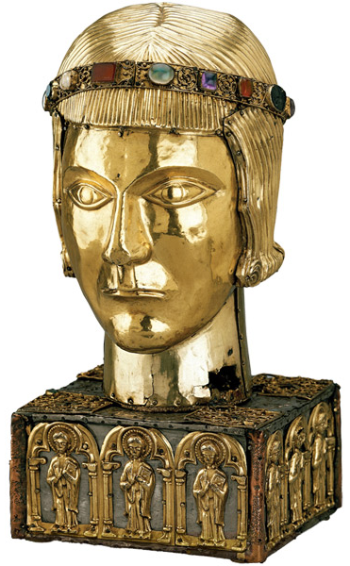
Figure 1: Reliquary of St. Eustace, c. 1210
Silver gilt over wood with rock crystal, chalcedony, amethyst, carnelian, pearl, and glass.
London, The British Museum

Figure 1 shows the reliquary head of Saint Eustace, who lived during the first century. Eustace was one of the Fourteen Holy Helpers, who are a group of saints that were especially popular during the black plague because they warded off sudden death. Eustace was once a Pagan Roman soldier who became a Christian after receiving a vision of “Christ on the cross standing between the antlers of a stag.” After hearing that his wife had received the same vision, they converted to Christianity. While in the Roman army, he was made to offer incense to the Gods after battles to thank them for their guidance. However, he did not and was fed to the lions. The lions did not eat him however and so he and his wife were burnt alive. Due to this, he is invoked for protection against fires.
The reliquary of his head was created between 1180 and 1200 AD. The head of Saint Eustace sits upon a wooden box, that is delicately adorned with the twelve gold figures of the Apostles, each standing in arcading, which is “a succession of contiguous arches, each supported by columns.” The actual head is composed of a wooden carving that is covered with a “silver-gilt repoussé shell”. The head has been carved out on a lathe and contained the relics of St. Eustace, nine fragments of his skull. There were also relics from different saints, including the bishops of Trier and Myra, the abbot of Monte Cassino and the Holy Virgins.
Adorning the head is a headband that holds sixteen stones of various materials. The materials include chalcedony, amethyst, cornelian, pearl and glass. During the middle ages, and particularly around the time that this reliquary was created, glass was becoming a more common material, but it was not yet mass produced like it is today. Paintings from around the time, indicate that glass was common but at a dinner party, people still had to share glasses for drinking from. From this, we can infer that glass was an expensive material, but due to the sheets of silver and other gems that adorn this reliquary, it can be assumed that the cost was not of issue. Chalcedony was sacred to Diana and was connected to victory in arguments and battles, which may have indicated a reference to his life as a soldier in the Roman army. Pearl is used to symbolise purity and power. On Eustace’s headband, it demonstrates the purity of his relationship to Christ, and how strong his belief in Christianity was. Amethyst is the stone of intellect and wisdom. It is considered to have a calming effect and is a good stone for clarity. It is also used to protect against sorcerers and thieves. Cornelian, or Carnelian, was one of the most common stones in the medieval period, alongside lapis lazuli, which became associated with priests, and religious uses. Cornelian, on the other hand, was usually used in context with kings and royalty. It was also used to wish luck upon those who saw it, so perhaps the cornelian in Eustace’s headband was to symbolise luck and good fortune, both to himself and to those who viewed the reliquary.
The reliquary is designed in the shape of St. Eustace’s head. This could have been for a number of reasons. Firstly, the relics inside included parts of Eustace’s skull, and therefore, it only makes sense that they should be kept secure in his head. Another reason could be that the skull is closest to Heaven, and is the place where the halo rests, and therefore by displaying his head, they are encouraging the greatest amount of saintly power to emanate from the head. Another reason could be that when one would pilgrimage to a relic or was shown a reliquary, the fact that you could see Eustace’s head made it all the more special because you would have been sure that it was indeed Eustace and not the bone of another saint.
The makers of this reliquary could have just carved a cylinder to hold the relics, however, they instead went to the effort of carving a likeness of Eustace. This shows just how important he was during the late eleventh century to the early twelfth century.
Of course, as with all reliquaries, the question of reliability should be called into play, because Eustace was martyred in the first century. It is unlikely that the skull fragments inside did, in fact, belong to Eustace. However, it is not required that they contain the exact pieces. The power of belief is enough to give authenticity to the reliquary.

Key Theme Commentary - Resurrection
And I saw the dead, great and small, standing before the throne, and books were opened.
Also another book was opened, the book of life. And the dead were judged according to their works, as recorded in the books.
And the sea gave up the dead that were in it, Death and Hades gave up the dead that were in them, and all were judged according to what they had done.
The above quote is taken from the Book of Revelation, 20:11-20:13. It describes the moment of the apocalypse that the bodies of those who have died are resurrected into their mortal forms once more and await judgement for their sins. This was a widely held belief during the middle ages and is one that influenced a lot of how the dead are both prepared for death and are presented in their death.
One key aspect of the resurrection was that you would be resurrected with the body you inhabited during your lifetime. This is important because it allows us to call into question whether or not the body had to be buried whole, or could parts be missing? If upon the resurrection you are judged with the body you inhabited during your life, what would happen if once you were dead, someone removed part of you?
On one hand, we can see that the people of the middle ages did not believe this, because often, body parts were removed from saints to become saintly relics. If the people of the middle ages believed that the body had to be whole when buried, they would not have removed the body parts, less the saint come back with a grudge against the person and condemn them to hell. However, we can see that it was considered important to the saints, or at least to the church that their body parts be spread among the people, to spread the saint’s message. This would suggest then that the belief was that your body would become whole upon the resurrection, regardless of how they appeared in life.
Another important question of the resurrection is why people were buried with such lavish adornments. Especially seen in saints and kings, who were usually buried with their crown, a sceptre, an orb and a ring, as well as their clothes that they would have worn in their life. Looking at this from an angle of inheritance and familial importance, it would make sense that the family of the deceased should keep the materials to remember their family or at least to be passed down to the next generation. This can be explained by examining a number of artistic representations of the resurrection, such as Figure 2, where the resurrected are shown wearing nothing at all, rising nude from the ground.
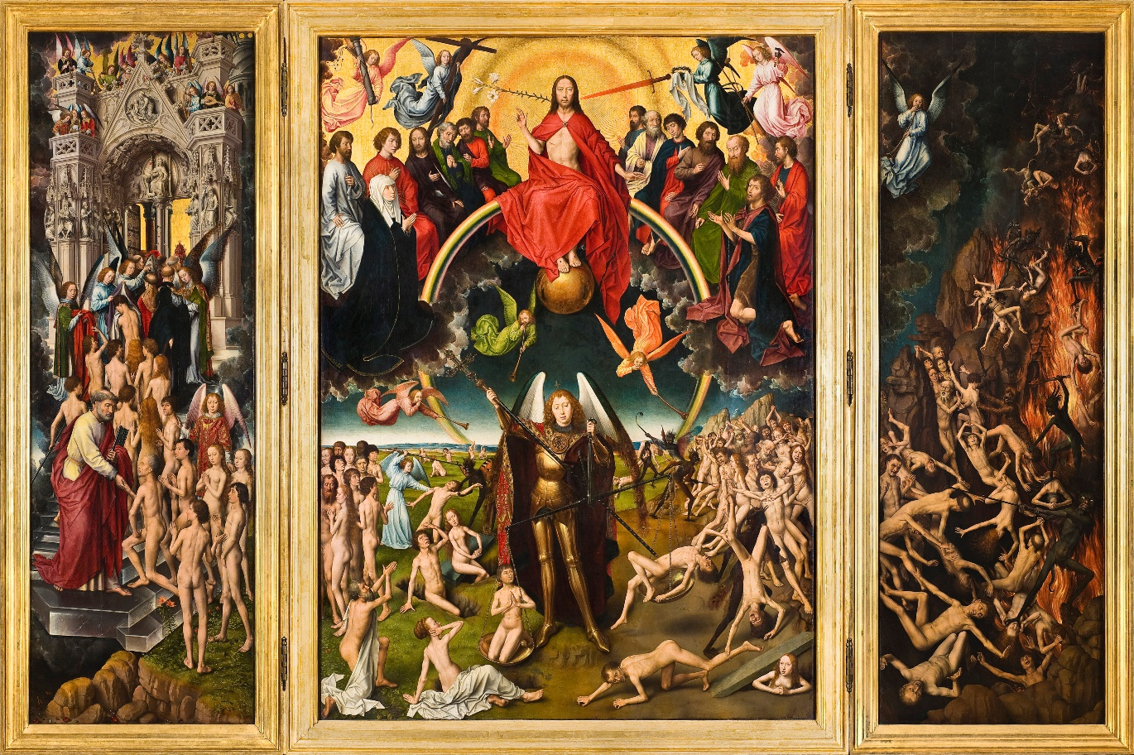
Figure 2: The Last Judgement
Indeed, nudity played a large part in the resurrection of the dead. Paul Binski writes that nudity played a large part in the decoration of the transi tomb, “indicating both the exposure of the private to the public, and the separation from the sphere of culture embodied in the exterior signs of worldly station, dress, ornament and regalia that could be buried with the corpse in hope of the Resurrection” with this quote, he is indicating that the dead were indeed buried with the clothes they wore during their life. He also implies that the dead wore clothing to retain their dignity, lest they awake with no clothes. This combines both the idea that the dead would rise nude from their graves, but also that they were buried with their clothes to indicate both their position in life and to protect their modesty upon their resurrection.
As Caroline Walker Bynum suggests: “What is and must be redeemed is [a person], fully individual both in its physicality and its consciousness. … Without its body, [the soul] was incomplete.” From this quote, Walker Bynum is suggesting that the body must be present during the resurrection, and therefore it must look as it did in life. This reinforces the idea that the dead should be dressed as they were in life. For if they are not, the soul might not recognise them. This, of course, goes against the idea of saintly relics, because that would mean that the soul and the body could not be reconnected. However, saints are closer to God than the average person, and therefore they might not need their body, just their soul when the resurrection comes.

Text Commentary – The Vision of Thurkill c. 1206
This extract from the Vision of Thurkill was most likely written around the middle of the thirteenth century and is from a manuscript written by Ralph of Coggeshall in St. Albans. At the time, there was another vision that was popular at the time: the vision of Tundale. This was written in the thirteenth century, and contains some similar themes, which I will explore later in this commentary.
The extract of the vision of Thurkill begins as Thurkill and St. Julian are arriving near a church. They note that the church contains a long corridor, with a wide-open space between the entrance and the inner chamber of the church, where a congregation is being held. The corridor acts like a version of purgatory where people come to atone for their sins and suffer for them. We know that it is purgatory because Thurkill notices that beginning at the entrance of the church and going back further and further away from the church are spirits marked with black and white spots. While it is not noted what the spots represent, we can assume that the black spots represent sins, and the white spots represent the good deeds one has accomplished in their life. The spirits that are most heavily covered in black spots are noted to be deformed and very far away from the church. Therefore, they have committed the most sins, and are furthest from God and heaven. Upon entering the corridor, Thurkill notices an entrance to the pit of hell, which is exhaling “smoke of a most foul stench” This can be understood to be sulphur, a smell associated with brimstone which is abundant in hell. Here we learn that Thurkill has committed sins, and therefore he becomes a more relatable character. His withholding of tithes indicates that he is not a saintly figure or a monk, but instead is just a local farmer.
Continuing further into the corridor, Thurkill is met with a strange clash of temperatures. Immediately in the corridor is a large space that contains “the sort of flame seen in a fiercely-heated oven” This flame burns away some of the black spots and is similar to the grill in Tundale’s vision. The fire is immediately followed by a lake, colder and saltier than any Thurkill has seen before. While similar to the punishment for thieves in Tundale’s vision, the spirits must pass through intense heat and then intense cold. However, it is worth noting that the spirits of those who have committed many sins sink to the bottom, therefore getting colder than those who seemingly float across the lake, with the water barely reaching the arches of their feet. This could allude to Jesus walking on water because if you have committed no sins, you are also walking on water, and therefore are closer to him.
The long bridge which hangs over a lake of fire is a direct link to Tundale’s story, which had influenced many pieces of art at the time. Although in Tundale’s story, one crosses the bridge if one had stolen something, in Thurkill’s you must cross the bridge regardless of your sins. It is here that the effects of those who remember you on earth can be seen. If you pass the bridge quickly, it is because masses are being said for you, and you have done charity for the poor. This references the seven charitable acts that a good Christian should carry out in their life. To attain masses that are said for you, you must either ask for them in your will or be a memorable person who has completed lots of charitable acts.
What is interesting about Thurkill’s vision of hell and purgatory, is that you are not subjected to one specific torture and one way to atone for your sins, instead everyone is subjected to the same tortures, and what affects how long you are subject to them is how many sins you have committed in your life, so much so that if you have committed so many sins, you are not even allowed near the church.
Thurkill’s vision of hell and purgatory is staged like a pilgrimage. Indicating that purgatory was a journey that one must undertake in order to reach heaven. A Pilgrimage was seen as the holiest of journeys that one could take because you were journeying from far away to see something that you believe in so strongly that you are willing to go through great strife and struggles to see. Purgatory is exactly that, something you are must struggle through to atone for your sins.

Bibliography
“A History Of Pearls - Pearls - Sustainable Pearls", Sustainablepearls.Org, 2012 <http://www.sustainablepearls.org/pearls/a-history-of-pearls/> [Accessed 27 January 2019]
“All About Glass | Corning Museum Of Glass", Cmog.Org, 2011 <https://www.cmog.org/article/about-medieval-glass> [Accessed 27 January 2019]
“Arcade (Architecture)", En.Wikipedia.Org, 2018 <https://en.wikipedia.org/wiki/Arcade_(architecture)> [Accessed 27 January 2019]
Braid, Fara, "Carnelian Symbolism And Legends - International Gem Society", International Gem Society <https://www.gemsociety.org/article/history-legend-carnelian-gems-yore/> [Accessed 27 January 2019]
Gardiner, Eileen, Visions Of Heaven And Hell Before Dante (New York: Ithaca Press, 1989), pp. 221-223
Huizinga, Johan, The Waning Of The Middle Ages (New York: Anchor Books, 1989), pp. 138-151
Kelly, Brian, "The Fourteen Holy Helpers", Catholicism.Org, 2016 <https://catholicism.org/the-fourteen-holy-helpers.html> [Accessed 27 January 2019]
Kinch, Ashby, "Image, Ideology, And Form: The Middle English "Three Dead Kings" In It's Iconographic Context", The Chaucer Review, 1 (2008), 48-81
Memling, Hans, The Last Judgement (Gdansk: The National Museum, 1466)
“Oremus Bible Browser : Revelation 20:11–20:13", Bible.Oremus.Org, 2018 <http://bible.oremus.org/?passage=Revelation+20:11%E2%80%9320:13&version=nrsv> [Accessed 28 January 2019]
Speakman, Naomi C., "Reliquary Head Of St. Eustace - Treasures Of Heaven", Projects.Mcah.Columbia.Edu, 2010 <http://projects.mcah.columbia.edu/treasuresofheaven/relics/Reliquary-Head-of-St-Eustace.php> [Accessed 27 January 2019].
“St. Julian The Hospitaller", Catholicnewsagency.Com<https://www.catholicnewsagency.com/saint/st-julian-the-hospitaller-145> [Accessed 28 January 2019]
Steiber, Ellen, "About The Stones, Mythology And History Of Gemstones, Minerals, Crystals", Ellensteiber.Com <http://www.ellensteiber.com/thestones.htm> [Accessed 27 January 2019]
“Tithe", En.Wikipedia.Org, 2019 <https://en.wikipedia.org/wiki/Tithe> [Accessed 28 January 2019]
Walker Bynum, Caroline, "Death And Resurrection In The Middle Ages: Some Modern Implications", Proceedings Of The American Philosophical Society, 142 (1998), 589-596
Ward, H. L. D., "The Vision Of Thurkill, Probably By Ralph Of Coggeshall, Printed From A MS. In The British Museum", Journal Of The British Archaeological Association, 31 (1875), 420-459 <https://doi.org/10.1080/00681288.1875.11904357>
“What Are The Seven Deadly Sins? | Bibleinfo.Com", Bibleinfo.Com<https://www.bibleinfo.com/en/questions/what-are-seven-deadly-sins#pride> [Accessed 29 January 2019]

Johan Huizinga, The Waning Of The Middle Ages (New York: Anchor Books, 1989), p. 139.
Ibid, p. 140
Ibid
Ibid.
The translation from original medieval French can be found in the footnotes of The Waning of the Middle Ages, p. 141.
"What Are The Seven Deadly Sins? | Bibleinfo.Com", Bibleinfo.Com<https://www.bibleinfo.com/en/questions/what-are-seven-deadly-sins#pride> [Accessed 29 January 2019].
Huizinga, p. 141.
Ibid, p. 144.
Ibid.
Ibid, p. 146.
Brian Kelly, "The Fourteen Holy Helpers", Catholicism.Org, 2016 <https://catholicism.org/the-fourteen-holy-helpers.html> [Accessed 27 January 2019].
Ibid.
Ibid.
"Arcade (Architecture)", En.Wikipedia.Org, 2018 <https://en.wikipedia.org/wiki/Arcade_(architecture)> [Accessed 27 January 2019].
Naomi C. Speakman, "Reliquary Head Of St. Eustace - Treasures Of Heaven", Projects.Mcah.Columbia.Edu, 2010 <http://projects.mcah.columbia.edu/treasuresofheaven/relics/Reliquary-Head-of-St-Eustace.php> [Accessed 27 January 2019].
Ibid.
"All About Glass | Corning Museum Of Glass", Cmog.Org, 2011 <https://www.cmog.org/article/about-medieval-glass> [Accessed 27 January 2019].
"A History Of Pearls - Pearls - Sustainable Pearls", Sustainablepearls.Org, 2012 <http://www.sustainablepearls.org/pearls/a-history-of-pearls/> [Accessed 27 January 2019].
Ellen Steiber, "About The Stones, Mythology And History Of Gemstones, Minerals, Crystals", Ellensteiber.Com <http://www.ellensteiber.com/thestones.htm> [Accessed 27 January 2019].
Fara Braid, "Carnelian Symbolism And Legends - International Gem Society", International Gem Society <https://www.gemsociety.org/article/history-legend-carnelian-gems-yore/> [Accessed 27 January 2019].
"Oremus Bible Browser : Revelation 20:11–20:13", Bible.Oremus.Org, 2018 <http://bible.oremus.org/?passage=Revelation+20:11%E2%80%9320:13&version=nrsv> [Accessed 28 January 2019].
Hans Memling, The Last Judgement (Gdansk: The National Museum, 1466).
Ashby Kinch, "Image, Ideology, And Form: The Middle English "Three Dead Kings" In It's Iconographic Context", The Chaucer Review, 1 (2008), 48-81.
Caroline Walker Bynum, "Death And Resurrection In The Middle Ages: Some Modern Implications", Proceedings Of The American Philosophical Society, 142.4 (1998), 589-596.
H. L. D. Ward, "The Vision Of Thurkill, Probably By Ralph Of Coggeshall, Printed From A MS. In The British Museum", Journal Of The British Archaeological Association, 31.4 (1875), 420-459 <https://doi.org/10.1080/00681288.1875.11904357>.
Gardiner
Ibid.

