Introduction
A proposal for a new hospital is to be funded by Rosko Pension Group and constructed with the intent to sell after completion and make a sizable profit for members of the investment group. As one is to undertake the role of project manager all factors that will affect the project must be clearly explained throughout the report and solutions to said factors. Reasons and explanation regarding decisions will be outlined, in order to give a better understand as to why certain methods were recommended along with the decisions that have been made. Choice of procurement method, project team structure, projects stages and key resources are will be highlighted throughout the report. As Rosko Pension Group are an investment group is it vital that profit is maximised while the quality of the project is kept to a high standard. Therefore, the chosen of procurement method should follow a strategy that is effective in achieving the goals and objectives of the project.
Aims
- To provide a suggest procurement strategy, that considers the clients goals.
- Justification, as to why procurement strategy has been recommended.
- Outline structure of project team and organisation.
- Evaluate expenditure and logistics for the project.
- Explain key stages that will be involved in getting the project to the pre-construction stage.
- Describe key resources at each stage.

Recommendation for procurement method

First before deciding on the best choice of procurement, it must be noted that in the context of this report that procurement is considered to be. The process of identification, selection and commissioning of the contributions that are required to carry out the construction of a project.
Also when deciding on a strategy various procurement methods available reflect important variations in terms of allocation of risk and responsibility that match characteristics of different projects. Therefore, when selecting the procurement strategy it is vital that each option is given carefully consideration based upon the client goals. This will be reflected in my choice of procurement method.
As the client does not seem to have prior involvement in the industry, It would therefore be recommended that Design and build approach would best suit the goals of the client. The reason is because design and build, appoints one contractor to carry out the works, this is a single source of responsibility, the client doesn’t have to deal with two separate contracts, one for design and one for construction. It partners the right team, as is made up of people who have already worked together. Greater communication between design and construction team as it unities them together as a design build team, which is not present in other methods like traditional route. This allows for the architect to devote additional time to the project, this eliminates the blaming between groups when something goes wrong. As there is a shared responsibly for budget and design, which focusing on solving the problem as a group. Efficacy over is vital as it speeds up the process, in turn will allowing Rosko Pension Group a quicker turn over on profits. Another benefit would be the tender would go to a contractor that specialises in constructing medical facilities. Therefore, they know the process and design as they would have previously built this type of project. It also allows for greater cost saving, as the design team and contractors are unified. This allows communication on decisions, which result in efficient planning that can save thousands one cost. This also minuses financial risk, as typically construction is to be completed for a lump sum. Therefore, the contractor takes on the responsibility for design and constructions for a fixed price, as long as the design is not altered. This can be beneficial for a invertor such as Rosko Pension Group, as labour and material costs are likely to rise over the life ccl of the project.

Project governance
The implementation of a governance system will be a vital component, in ensuring that the project is accomplished to the standards of the organisation, by allowing all project actions to be transparent and ethical. A governance system aims to grasp control over a project, by creating reporting system that outlines roles and responsibilities for everyone involved. This can aid in safeguarding objectives and that the overall goal of the organisational on track. Therefore by monitoring project governance, it enables the project to stay in tune with expectations.

Organisation and Control
The organisational structure will set out to clearly outline in detail, how each party involved in the project are to perform their tasks in relation to each other. It will identify producers and arrangements that monitor and control the relevant administrative details. This will be updated as the project evolves and circumstances change, however, it will still allow the projects objectives and success criteria to be communicated and agreed by everyone involved. Everything from the procedure that cover the relationship, courses of action for record keeping, monitoring progress, time and cost control, risk management, project control and administration of the project are to be created with the assistance of all parties involved for all stages of the project. Therefore, the organisational structure needs to identify clearly, involvement and responsibilities of the client and the organisational back up. Refer to table 1.0 for the organisational structure

Client

Project Manager
Design & Build Contrctor

Architect
Engineers
Subcontractors

(Figure1.0)

Project structure

As the role of a project manager overseas the overall direction of the project, the project team carry out the fundamental elements that make the project possible. The project team will consist of:
- Project Manager
- Design Team ( Architect and engineers)
- Consultants ( Quantity surveyor, Health and Safety Officer)
- Contractors ( Subcontractor and suppliers)

Below is figure 1.1, this represents what the structure of the project team will be like. Note that this may be likely to change based of variations of the project.

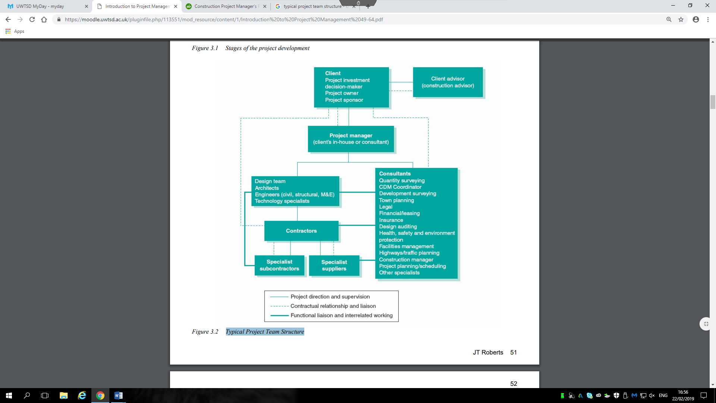
(Figure 1.1: Flemming, S. (2014). Code of practice for project management for construction and development)

Selecting the project team is a task of great importance, as this could be the making or breaking of the project. Many skills will be needed in order to achieve a project of this size, the flowing factors should be considered in great detail.
- Able to communicate effectively
- Able to work as part of a team
- Available for the full duration of the project
- Full time availability
- Relevant experience to the project
- Qualified in their role
- Able to meet and discuss project objects on a regular basis
- Have a creative/innovative ability
- Level of available supporting resources

Cost planning
A project of this size will need a considerable planning in term of expenditure, as vital factors like total cost and expected return need to be determined. Therefore, a cost plan needs to be prepared as is will include all construction and other items such as professional fees and contingency budget. This will all be included in the development budget, along with developer’s returns, project insurance ad agent fee’s. Note: this project is also likely to have specialist fees, due to its type. The cost plan will allows us to see what the money is going be spent on and when. This aim of cost control is to produce the best possible building that falls within the budget. As current expenditure and future expenditure is able to be predicted using graphs, it allows adjustments to be made in accordance with the project budget. This serves as a reference point and allows monitoring and control over costs. Come Backk!!!!

Project progressive through to stage 4

Inception
To determine whether the strategic aspirations of the client or organisation can be achieved by executing a programme of works.
The outcomes that the inception stage should achieve are:
- Classification of project management structure
- Selection of a project manager
- Statement of key goals, project mandate and restrictions
- Outline BIM strategy
- Approval for the proceedings to the feasibility stage

Feasibility

Throughout this stage the client will establish the objectives and review the numerous options that will be aid in achieving these objectives. It begins with a brief understanding of the client’s image, therefore, it aims to achieve in defining and developing the client requirements. By identification and evaluating all the options. It then concludes with a decision on the client’s part to advance with a firm course of action.
The outcomes that the feasibility stage should achieve are:
- Clear definition of clients objectives
- Evaluation of numerous options
- Recommend course of action based off objectives.
- Establish financial feasibility
- Confirm a project brief
- Decision to proceed

Strategy

The strategy stage allows for a project manager to take a client’s preferred option which has received approval at the end of the feasibility stage and develops it into a frim proposal which will define how the project will be executed. This is a fundamental element of the role of a project manager. Project infrastructure is to be established, by defining ways of managing and control the project, it will involve assembling a team to carry out the project. Collecting and combining all information to elucidate the client’s detailed requirements.
The outcomes that the Strategy stage should achieve are:
- Application of project strategy
- Definition of project and procedures
- Selection and appointment of project team
- Employers requirement document
- Facility management approach

Pre -construction
At this stage plans that have be developed during the strategy stage will be implemented this ensures that all aspects that are necessary for starting of work have be completed. It involves implementation of the design process, gaining all required stator and legal consents and then the selection and employment of a contractor or contractors.
The outcomes that the pre construction stage should achieve are:
- Completed deign information
- Completed tender documentation
- Design freeze
- The tender process
- Health and safety plan and file to be updated
- Selection and appointment of contractor0r contractors
- Completion of development of site logistic

BIM

Building Information Modelling is a method for creating, sharing and managing of information and data on projects. It provided a digital description of every aspect of a building, it allows for information sharing between stakeholders and participants throughout the life cycle of the project and aids in smart decision making at all stages of the project.
BIM can have great impact on a project a benchmarking for data costs, procurement, product libraries and information about similar or related projects. This will aid greatly during each stage as comparison between projects is vital as it can clear up any question during the feasibility stage. This can aid in decision making by identifying the best way to take the project forward. It can speed productivity and everyone has a direct link to this information, improving collaboration. Collaboration on a design build procurement route is vital to its success, and BIM ensures that everyone has an input by sharing complex project models etc. It also resolves conflict at later stages, by modelling out factors that may affect the construction and cause costs to rise, this can be very beneficial to a project ensuring thing go as smoothly as possible.

Key resources at each stage

Project manager
A key resource at this stage is the appointment of a project manager, as he will be acting on behalf of the client and representing them. A project manager will offer and provide a cost effective and an independent service. This role may be taken on by the client team or member of the organisation or can be externally sourced. They key role is to manage, motivated and coordinate the project. This is a vital role in securing the success of the project, this is beneficially to all parties involved. As the project manager has an obligation to respect professional codes of practice.

Client team

(R, 2018)
(builidngs, 2019)

Reference list
https://www.designingbuildings.co.uk/wiki/Procurement_route

https://uk.practicallaw.thomsonreuters.com/8-383-6084?transitionType=Default&contextData=(sc.Default)&firstPage=true&comp=pluk&bhcp=1

(CIOB)
(Kristin, 2016)
Construction Project Manager's Pocket Book

http://dlib.scu.ac.ir/bitstream/Ebook/20858/2/9780415732390.pdf

Flemming, S. (2014). Code of practice for project management for construction and development (5th ed.).
Walker, A. (2002). Project management in construction (4th ed.). Oxford: Blackwell Science.
Levy, S. (2006). Project management in construction (5th ed.). New York : London: McGraw-Hill Professional ; McGraw-Hill [distributor].
Superior Project Management Make a Difference. (2018). Commercial Construction & Renovation, 17(5), 132-133.
https://www.constructionglobal.com/equipment-and-it/bim-and-its-effects-construction-industry

Cartlidge, Duncan P. Construction Project Manager's Pocket Book. Routledge, Taylor & Francis Group, 2015

