

PAPUR ARHOLIAD / EXAMINATION PAPER

LLEOLIAD / LOCATION: | ABERTAWE / SWANSEA
CYFNOD ARHOLIADAU / EXAMINATION PERIOD: | MAI 2025 / MAY 2025
LEFEL / LEVEL: | 6

MODIWL / MODULE: ACDA6004
Power Electronics & Drives

AMSER / TIME: | 2 HOURS
CYFARWYDDIADAU / INSTRUCTIONS: | answer all questions

Adnoddau neu ddefnyddiau sydd eu hangen / Equipment or materials required:
Dewiswch o'r canlynol os gwelwch yn dda / Please select from the following:
Cyfrifiannell / Calculator
Llyfr Agored / Open Book
Llyfr Fformiwla / Formula Book
Arall nodwch os gwelwch yn dda / Other please specify …………………………
Office Use Only:
Author: |  |  | Semester:
Internal Verifier: |  |  | R Y/N? | Yes / No (Please delete as applicable)
Contribution to Overall Module Assessment (%):

DO NOT change Margins/Headers/Footers/Layout of Cover page
Font: Arial
Headings: 14px and BOLD
Body text: 12px
ANSWER ALL QUESTIONS

- Compare and contrast the working principles of a three-phase synchronous motor, and a three-phase induction motor.
[10 Marks]
Description should include:
- Rotating magnetic field in stator produced by three coils 120° apart.
- Induction motor uses squirrel cage. Voltage induced in squirrel cage by RMF.
- Squirrel cage forms closed circuit so current flows.
- Currents in squirrel cage create magnetic field opposing RMF.
- Forces generated between RMF and squirrel cage turn rotor.
- Induction motor relies on slip and does not run at fixed speed.
- Speed of induction motor is dependent on load
- Synchronous motor starts as induction motor using squirrel cage.
- Near full speed induced currents in the squirrel cage are low and torque is now from forces between field from rotor windings and RMF.
- Synchronous motor speed governed by line frequency.

- A large industrial process is run using a delta connected three phase 250 kVA induction motor with a terminal voltage of 6 kV. The motor has 12 pole pairs and is to run at speeds from standstill to 1000 rpm using a switching speed of 20 pulses per cycle. Suggest a transistor technology that would be suitable for this application and show in a circuit diagram how they would be connected to the motor.
[25 Marks]
$$I=\frac{P}{V}=\frac{250000}{6000}=41.666 A$$

Four poles = 2 pole pairs.
$$f=\frac{ωp}{60}$$

$$f=\frac{1000×12}{60}=200 Hz$$

V = 6000 V, I = 41.666 A, f = 0 to 200 Hz Assuming the PWM signal contains 20 pulses per cycle the gate switching frequency of the driving transistors would be between 0 Hz and 4 kHz.

Characteristic | Power bipolar | Power MOSFET | IGBT
Voltage rating | High <1kV | High <1kV | Very high >1kV
Current rating | High <500A | Very High > 500A | Very High >500A
Input drive | Current ratio h_{FE}  20-200 | Voltage V_{GS}  3-10V | Voltage V_{GE}  4-8V
Input impedance | Low | High | High
Output impedance | Low | Medium | Low
Switching speed | Slow (µs) | Fast (ns) | Medium
Cost | Low | Medium | High

Power bipolar transistors would not be suited to this application as the load voltage is too high for this type of device. Power MOSFET transistors could not be used in this application as the voltage is too high, therefore the transistor technology best suited to this application would be insulated gate bipolar transistors (IGBT) as they can withstand very high voltages, high currents and switch at the required frequency. The transistors would be connected in a push pull configuration on each phase. This would allow each phase to be connected to either the positive supply or the ground return path.

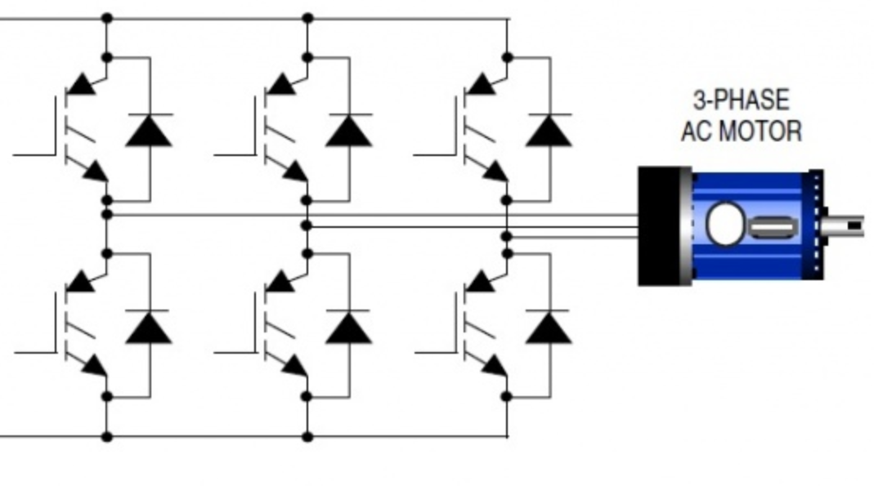
The gate drives for the transistors would be derived from a sinusoidal waveform encoded as PWM. The top transistors would be pulsed on when the associated phase output is positive, and the bottom transistors would be pulsed on when the associated phase output is negative.
The diodes fitted across the collector and emitter of the transistors protect the transistors from the back EMF produced when the coils of the motor are de-energised.

- Describe how a thyristor could be used to provide over voltage protection for a DC power supply. Give a circuit diagram showing how it would be connected.
[15 Marks]
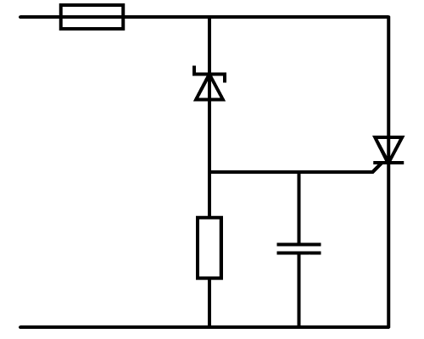
Zener
diode
R
C
F
Thyristor
+V
0 V
Power supply
output voltage

Under normal conditions, the Zener diode will not conduct. There is an effective open circuit between the anode and cathode of the thyristor. If the output voltage exceeds its maximum value, the Zener diode will conduct and turn on the thyristor. When the thyristor conducts, the current is large enough to blow the fuse. This prevents damage to any device operating from the power supply.

- Describe the working principles of a dynamo
[5 Marks]
Description of a dynamo to include:
- Stator field produced by usually permanent magnets
- Rotor coil rotated inside stator by prime mover
- Rotor coil cuts magnetic field produced in stator inducing voltage in rotor coils
- Current in rotor coils transferred from rotor via commutator and brushes
- Current drawn from brushes not true DC – smoothness depends on number of coils in rotor / segments on commutator.

  - Design a simple circuit which will generate PWM encoded sinusoidal waveforms to drive output transistors in a variable frequency drive. Show the signal waveforms at relevant points within the circuit.
[15 Marks]
  - Explain how it is possible to control torque and speed of a synchronous AC motor using a variable frequency drive
[10 Marks]

- PWM can be generated using a comparator fed with a triangle waveform at the PWM frequency and a sinewave at the desired output frequency. The comparator will output a square wave with pulse widths modulated by the amplitude of the sinewave. When the amplitude of the triangle wave is lower than the amplitude of the sinewave the comparator’s output will be high and when the amplitude of the triangle wave is higher than the amplitude of the sinewave, the comparator’s output will be low. The comparator’s output can then be used to drive a power transistor to control the load.

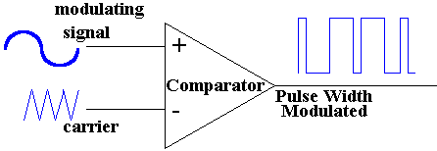
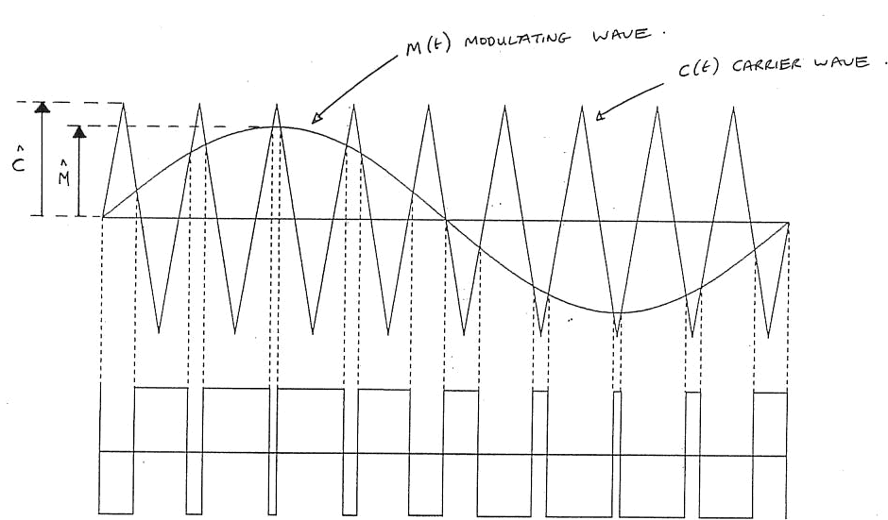
- The torque of a synchronous AC motor connected to a variable frequency drive can be controlled by changing the relative amplitudes of the sinewave and triangle wave entering the comparator. This will have the effect of reducing the average voltage recovered from the PWM signal and hence reducing the RMS voltage supplied to the load.
The rotational speed of a synchronous AC motor connected to a variable frequency drive can be controlled by varying the frequency of the sinewave it produces. This change in frequency produces a change in rotational speed as the speed of a synchronous AC motor is governed by the frequency of its power supply.

- A six-pole alternator is required to operate at 50Hz. What is the required rotation speed in r.p.m?
[2 marks]
6 poles = 3 pole pairs
$$\frac{50}{3}=16.66667 Hz$$
$$16.66667×60=1000 rpm$$

- A coil of 1600 turns with a coil of width 150mm and active depth of 250mm rotates in a uniform magnetic field between the poles of a magnet with an air gap flux density of 0.75T. If the coil rotates at a speed of 3000rpm calculate:

- The maximum e.m.f. induced in the coil.
[4 Marks]
$$A=150×{10}^{-3}×250×{10}^{-3}=0.0375 m^{2}$$
$$f=\frac{rpm}{60}=\frac{3000}{60}=50 Hz$$
$$E_{Max}=1600×0.75×0.0375×2×π×50=14137.16694 V$$

- The maximum amount of flux cutting the coil.
[4 Marks]
Maximum flux cuts coil when coil is at 90°
$$Φ_{Max}=BA=0.75×0.0375=0.028125 Wb$$
$$=28.125 mWb$$
- Control of several operational parameters of an induction motor may be achieved by an inverting motor controller. Assuming a controller is using PWM as its control mechanism:

  - Provide a block diagram of an inverting motor drive and give a brief explanation of the operation of each of the sections.
[4 Marks]
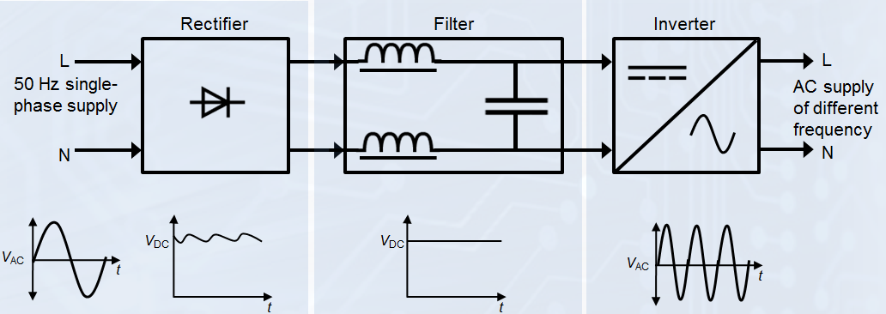
The rectifier converts the incoming AC to DC
The filter is used to smooth the previously rectified DC.
The inverter is used to convert the previously rectified and smoothed DC back into an AC form at a frequency and amplitude required by the motor.

  - Describe the operation of an inverting motor controller to accelerate and decelerate a motor while maintaining torque.
[6 Marks]
An inverting controller may control the acceleration/deceleration of an induction motor by manipulating both the speed of the motor (by AC power frequency variation) and torque of the motor (by AC power amplitude variation) simultaneously.
Acceleration is achieved by ramping up of the frequency to the desired level whilst deceleration is achieved by ramping down of the frequency to the desired level. The torque when producing drive or braking may be controlled by controlling the voltage/current applied to the motor.
Diwedd / End

