Student Name: Mary Bath
P Number: 1802660
Program of Study: Illustration
Module: ADAD4018
Ways of Thinking Lecturer’s name: Jonathan Pugh

Tasks in order I received them:
Task 1: Observational Writing = 454
Task 2: Manifesto Writing = 521
Task 3: Practice-based writing = 456

Task 1: Observational writing
This text exhibits how Banksy confronts ethical issues through his art by his use of semiotics, the term used for the use and interpretation of symbols and signs. I will also discuss Banksy’s controversial work and influence, specifically in his famous piece ‘Festival (Destroy Capitalism)’.

Banksy, a renowned artist merges both the fine art and graffiti world (Lexa, 2019). Themes of dark humour, political satire, as well as controversial images are not uncommon (Lexa, 2019). He juxtaposes icons of western imperialism with familiar icons of western capitalism (Brassett, 2009). Bansky’s work has been found in streets worldwide showcasing his political views, whilst encompassing the prospects of change (Lexa, 2019). Banksy’s work is carried by semiotics and the use of iconic symbols, whether religious or political, to carry his messages of ethical issues (Wicaksono and Yanuartuti, 2020).
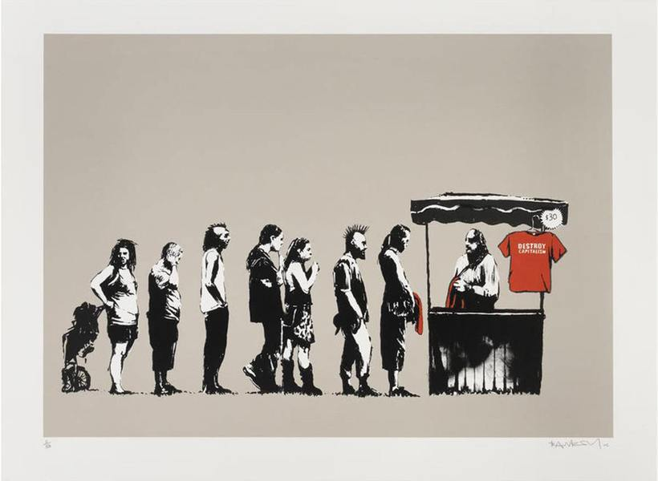Fig 1. Festival, Banksy, 2006

In 2006 Banksy created his iconic exhibition ‘Barely Legal’, which took place in an La warehouse and included famous pieces such as ‘Trolleys’, ‘morons’ and ‘Festival (Destroy Capitalism)’ (MyArtBroker, 2021). One of his screen prints ‘Festival (Destroy Capitalism)’ illustrates a queue of people in black and white leading to a merchandise booth that is selling $30 bold red t-shirts that states, “Destroy Capitalism”. The people in the queue look as though they belong to alternative subcultures, a variation of stereotypical freegans, leftists, hippies and punks, presented by their hair, clothes and attitudes (MyArtBroker, 2021). Such individuals are not those that one would necessarily consider would give into conventional capitalism, yet capitalism manages to entrap them.
The irony does not end there. Banksy sold prints for $500 each during his exhibition (HexagonGallery, 2017), and in 2013 Walmart, the hart of capitalism (HexagonGallery, 2017) sold a number of ‘Destroy Capitalism’ posters without Banksy’s permission (Liljas, 2013). Creating this paradox of exactly what the image stands against renders the hypocrisy of the message even more powerful.
The red of the T-shirt often the colour of danger (colour matters, 2020), also used as a signal colour in advertising, can also be perceived as a sign of resistance (Blanché, 2016), it draws in your attention making you read “Destroy Capitalism” before you look down the line of people, standing almost like prisoners, all in order, brainwashed by contemporary capitalist society.

The piece challenges multiple conventions including dress, social status and beauty standards that you would not normally find in art. It showcases the ‘stereotypical’ image of the new generation that makes up the majority of Banksy’s fanbase, and with whom they can identify. Banksy explicitly shows his loathing for modern capitalism, which he demonstrates in the majority of his work (Lexa, 2019). Of course, like many of Banksy’s other pieces it is left to the viewers interpretation this is just my semiotic analysis.

Bibliography
Blanché, U. (2016). Banksy: Urban Art in a Material World. Tectum Wissenchaftsverlag. Available at: http://library.oapen.org/handle/20.500.12657/26020 (Accessed: 7 January 2021)

Brenner, L. (2019). THE BANSKY EFFECT: REVOLUTIONIZING HUMANITARIAN PROTEST ART. Harvard International Review, 40(2), pp. 34-37.

Colour matters. (2021). The Meanings of Red. Available at: https://www.colormatters.com/the-meanings-of-colors/red (Accessed: 8 January 2021)

Hexagon Gallery. (2017). Festival (Destroy Capitalism). Available at: https://hexagongallery.com/catalog/artist/banksy/festival-destroy-capitalism/ (Accessed: 7 January 2021)

Liljas, P. (2013). Oh the Irony: Walmart Sells Banksy Piece 'Destroy Capitalism'. TIME USA LLC, p 1-2.

MyArtBroker. (2021). BANKSY PORTFOLIO. Available at: https://www.myartbroker.com/artist/banksy/festival/ (Accessed: 7 January 2021)
Wicaksono, P, S. Yanuartuti, S. (2020). ‘Visual Strategies of Contemporary Art: The Study of Banksy’s
Artworks’. JOURNAL OF URBAN SOCIETY’S ARTS, 7 (1), p. 12-13. DOI: https://doi.org/10.24821/jousa.v7i1.3924

List of Figures:

Figure 1. Banksy. (2006) Festival [Screen Print]. Accessed from: https://www.myartbroker.com/artist/banksy/festival/ (Accessed: 9 January 2021)

Task 2: Manifesto Writing

- Gender and race equality should be represented in the art world more
- I will not endorse in art that has hurtful or bad intentions
- We should not value art just because of the name
- Art is a beautiful form of expression that should make you happy
- People should be able to enjoy art without knowing its back story
- Break artistic and gender norms
- There’s no such thing as ‘bad art’ it is all subjective
- Art can change the world

3 areas of exploration:
Gender and race equality should be represented in the art world more
The art world should celebrate women and ethnic minorities, it is however, a white, and a male dominated profession. According to Chad.M.T, et all(2019) ‘85% of artists in major U.S. museums were white and 87% were men’. ‘Only 13.7% of living artists represented by galleries in Europe and North America were female’ (Halperin, 2017). It has been reported in 45 countries had a 47.6% gender discount auction prices for paintings, even though no evidence suggested women produce less pleasing art (Adams et al, 2020). Atkinson (2020) and Chad.M.T (2019) highlighted research from the top eighteen museums in America that, ‘1.2 percent of collections were created by black artists despite being 13% of the population, Asian artist created 9% of collections and Hispanic and Latinx artists had 3%, despite occupying 18% of the population’. Nothing seems to have changed in the last 40 years. Women are more likely to be in the paintings not creating them. The statistics shows casual racism and sexism exists at a subconscious level, not realising they are being biased towards minorities. Many artists are being underrepresented due to its domination by white males.

Break artistic and gender norms
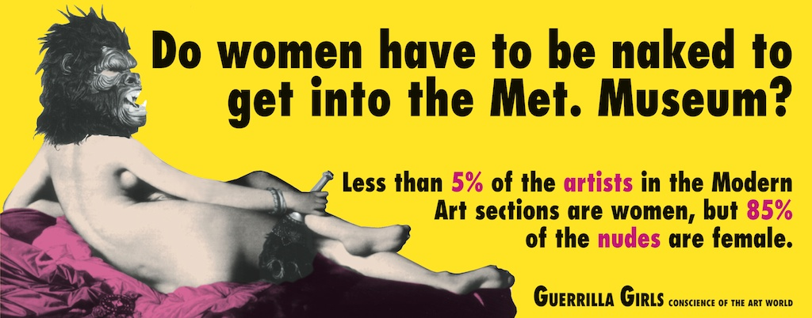

Fig 1. Do Women Have To Be Naked To Get Into the Met. Museum?, Guerrilla Girls, 1989

We live in an age where people express themselves more in art. This is truly inspiring when people go against social expectations and question stereotypical depictions of gender in art. Kim Leutwyler (2021), is a woman well known for her diverse paintings of LGBTQ+ and allied people celebrating the beauty in body art, androgyny, gender and gender confirmation. Leutwyler hints towards objectification, glorification and modification, as well as exploring gender, identity and beauty. I find the lack of diversity in galleries disappointing; the majority of paintings are female nudes painted by men. A piece ‘Do women have to be naked to get into the Met.Museum?’ Guerrilla Girls (1989) highlights, “less than 5% of the artists in the modern art sections are women, yet 85% of the nudes are female”. Also, most are painted to be the ‘ideal body type’. This ‘idealistic body type’ displayed in art is driven by consumerism and advertising, sexualizing this particular body type to sell products (Hannam, 2007). According to June Hannam (2007, p.142) “women are expected to conform to particular ideals of femininity” which she says feeds onto women’s anxieties compelling them to buy products. Joe Hesketh’s rebellious work consists of strong women demonstrating that there is not one ‘ideal’ body-type. I want to see the art world take pride in representing different bodies and gender types, defying the norm.

Art can change the world
To me art is a form of expressional communication. I believe it has the power to impact culture and society, bringing important issues into the spotlight and sparking emotional responses (Olafur Eilasson, 2016). Whether it is a painting, a book or a song, it creates a connection that normal data cannot (Olafur Eilasson, 2016). People can feel motivated in the topic’s such as, climate, LGBTQ+ and racial issues. People need to notice the constant impact of art. “Immanuel Kant defined art as a kind of representation that has no external purpose, that exists only for itself, though it has the power to communicate and stimulate our minds” (Winner, 2018, p 4).

Bibliography
Adams, B, R. Kräussl, R. Navone, A, M. Verwijmeren, P. (2020). Is gender in the Eye of the Beholder? Identifying Cultural Attitudes with Art Auction Prices. Z11

Atkinson, R, j. (2020). Diversity in the art world: Where are we at now and what’s being done?. Available at: https://untitled-magazine.com/diversity-in-the-art-world-where-are-we-at-now-and-whats-being-done/ (Accesed: 9 January 2021)

Eliasson, O. (2016). Why art has the power to change the world. Available at: https://www.weforum.org/agenda/2016/01/why-art-has-the-power-to-change-the-world/ (Accessed: 10 January 2021)

Guerrilla Girls (2020). DO WOMEN STILL HAVE TO BE NAKED TO GET INTO THE MET. MUSEUM?.
Available at: https://www.guerrillagirls.com/naked-through-the-ages (Accessed: 10 January 2021)

Halperin, P. (2017). The 4 Glass Ceiling: How Women Artists Get Stiffed at Every Stage of Their Careers. Artnet News: Available at: https://news.artnet.com/market/art-market-study-1179317 (Accessed: 8 January 2021)

Hannam, J. (2007). Feminism. Harlow: Pearson Education.

Hesketh, J. (2021). Joe Hesketh. Available at: http://www.joehesketh.co.uk/info.html (Accessed: 10 January)

Leutwyler, K. (2021). Kim Leutwyler bio. Available at: https://kimleutwyler.com/page/1-BIO.html (Accessed: 8 January 2021)

Topaz, C, M. Klingenberg, B. Turek, D. Heggeseth, B. Harris, P, E. Julie, C. Blackwood, C. Chavoya, O. Nelson, S. Murphy, K. (2019). Diversity of artists in major U.S. museums. DOI: doi.org/10.1371/journal.pone.0212852 Available at: https://journals.plos.org/plosone/article?id=10.1371/journal.pone.0212852 (Accessed on 8 of January 2021)

Winner, E. (2018). ‘Can This Be Art?’. How Art Works: A Psychological Exploration, p. 4. DOI:10.1093/oso/9780190863357.003.0002

List of Figures:

Figure 1. Guerrilla Girls, (1989) Do Women Have To Be Naked To Get Into The Met. Museum?. Accessed from: https://www.guerrillagirls.com/naked-through-the-ages (Accessed: 9 January 2021)

Task 3: Practice-based Writing:
I take inspiration from everything, many ideas come from dreams, music, media and what I see around me. Ideas can be sparked at any time by opening your eyes to the world around you. A lot of my work consists of character design. I love to express myself through creating a visual narrative. Maslej, et al (2017, p.487) stated ‘to make the story more interesting by making the reader relate and envision themselves as the character’. I like to create characters that people can relate to; my work is heavily influenced by the emotions I feel that day. According to Ellen Winner (2018) “Artworks are emotional, as is the experience of perceiving these works”. I like to try and pass these feelings we have all felt before like happiness, sadness and loneliness to the viewer by the use of colour. Depending on the piece, colours can mean different things such as blue for sadness or calmness and red for anger or passion, and it can be a really powerful tool to express emotions through art. An article called ‘Effects of colour and emotion in illustration’ by Chen, CY, et al. (2013, p.6) discovered that warmer colours like yellow and orange are viewed to be optimistic, cheerful and excitable whereas the less vivid colours like blue and black can be seen as depressing or stressed. I like to create a new world of beauty through my art as a form of escapism. It gives me the power to create a surreal and beautiful spaces from my imagination.

Audra Auclair is a surrealist artist who has been a big influence on my work since I first discovered her in 2016. She brings awareness to the complexities of mental illnesses as well as current issues through a mixture of surrealism and fantasy (Auclair, 2020). Auclair also uses her emotions and expresses it though her work. Her work usually consists of the female form mixed with fantasy, in mediums such as gouache, oil paints, watercolour and digital.
I either sketch or use procreate to conceptualise my idea, whatever I have at hand once inspiration strikes. Like Audra Auclair (ImagineFX, 2020) I create number of thumbnail sketches to decide on layout and size. Once that is done, I decide on a medium. Most of my work consists of digital paintings but I also like to use pencil, ink, watercolour and gouache. I work well in a comfortable environment where I can focus on the task at hand, listening to 00s punk rock to get motivated and start drawing. When drawing I relax and become part of the piece I move with the pencil and at the end I am presented with a piece of art that I can call my own.

Bibliography
A, Audra. (2021). Audra Auclair. Available at: https://www.audraauclair.com/aboutmain (Accessed: 12 January 2021)

A, Audra. (2020). Traditional art skills and Procreate: LOOSE YOURSELF IN ILLUSTRATION. ImagineFX, vol. 192, p 57-61.

Chen, CY. Li, D. Cassidy, T. Cheung, V. (2013). Effects of colour and emotion in illustration. Great Britain: The Colour Group.
Maslej, M, M. Mar, A, R. Oatley, K. (2017). ‘Characters: The Role of Experience, Personality, and Social Processes’. Psychology of Aesthetics, Creativity and the Arts. American psychology Association: Vol. 11, No. 4, 487–499. DOI: http://dx.doi.org.ezproxy.uwtsd.ac.uk/10.1037/aca0000094
Winner, E. (2018). How Art Works: A Psychological Exploration. Oxford Scholarship Online. DOI:10.1093/oso/9780190863357.001.0001

