University of Wales Trinity Saint David

Individual Report
Problem Solving and
Decision Making
BMSW4004_LON

Student : Adriana Racu (2010779)

Tutor : Yajesh Kumar

London 2020/21

Table of Content :
Page

1. Introduction………………………………………………………………. 3
2. Complex problems in workplace ……………………………………… 3
3. Problem solving tools and techniques ………………………………... 4
3.1 Brainstorming …………………………………………………………… 4
3.2 Mind mapping …………………………………………………………… 5
3.3 Fishbone diagram ………………………………………………………. 6
4. Solutions to the complex problems ………………………………….. 7
- Alternate Solutions ……………………………………………………….. 7
- Evaluation of the best alternatives …………………………………… 7
6.1 PMI Technique …………………………………………………………. 8
- Implement the solutions …………………………………………………. 8
- Monitoring and Control …………………………………………………. 9
- Communicate with the stakeholders …………………………………… 9
- Recommendations …………………………………………………………. 10
- Conclusion …………………………………………………………………. 10
- References ………………………………………………………………….. 11

- Introduction :
The purpose of this report is to identify the main problem that happened in my own experience at workplace .I will apply recognised problem solving tools and techniques to identify the solutions to work based problem. It will include an evaluation of recognized solutions and find alternative solutions. And to make sure that the best solution will be implemented .
In my previous job I was working as supervisor in sales industry at a big department store. All our team was working very well ,only with one person we did not had good relationship ,because she was thinking that is the best and knows everything and we had lack with communication with her. One day I wanted to discuss with all our team how we can organize better our job. Only this person was a little bit away and she saw that we was discussing something but she did not participate . Suddenly she became very furious and started to shout to all of us that we was saying something bad about her . We was trying to ensure her that we was discussing about work but she did not believed us . In this situation the main problem was lack of communication between us. And in this report I will apply recognized problem solving tools and techniques that will help me to find best solutions to the problem that occurred.
- Complex problems in the workplace:
Problem solving at workplace can be described as one of the key activities regularly performed by professionals in any workplace. Every business and job role has it’s problems. Some of them are :
- Lack of training.
- Lack of communication
- Lack of motivation and no job satisfaction.
- Discrimination.
- Conflicts between staff members.
- Payroll issues etc.
That’s why employers must hire people with problem solving skills . Generally, problem solving refers to a person’s ability that successful manage and find solutions for complex and unexpected situations .Some of problem solving skills are :
- Listening skills.
- Analytical thinking skills.
- Creative thinking skills.
- Communication skills.
- Decision making skills.
- Teamwork.
Problem solver can observe ,judge ,and act quickly when problems arise. It is important for every employers and employee to understand the problem solving process and to develop problem solving skills.
- Problem solving tools and techniques :
Problem solving and decision making tools and techniques can be used to help in gathering the right information to make the best decision and learn from those decision. Some of this tools and techniques are :
- Brainstorming.
- Mind mapping.
- SWOT Analysis.
- PESTLE Analysis.
- Fishbone diagram.
- Porter’s five forces.
- ADKAAR model of change management.
As I mentioned in the beginning the main problem in our team was lack of communication that caused issues between all our teamwork.
In this report I will use Brainstorming ,Mind mapping and Fishbone diagram to find the best solution.
3.1 Brainstorming :
Brainstorming is a conference technique by which a group attempts to find a solutions for a specific problem in my case was lack of communication between all team members.
Brainstorming technique steps are :
- To discuss with all team member who want to participate in problem solving.
- Present the problem to all members.
- To encourage all members to propose solutions.
- To evaluate all solutions and to identify the best one.

3.2 Mind mapping :

Problem solving is a key skill which can help to succeed. Problems comes all the time and it is very important to provide quick and imaginative solutions. For this mind mapping technique can be very useful.
Mind mapping contain all elements of the problem in visual map , it prioritise all aspects of problem focusing the mind .

When will be done meetings to have good conversations with all
To make sure that all members are treat the same level
To explain how was the situation

In my mind mapping technique I used the following steps:
- I made the problem the central idea of mind map .
- I added the main branches with all aspects that caused the problem, this way I can realize why problem occurred and what can I do to improve the situation.
- After I made another subbranches to focus on solutions and to understand better how to solve the problem.
- Final subbranches outline the most suitable solutions for the problem and wrote in detail how I can implement this solutions.

3.3 Fishbone diagram :

Fishbone diagram was developed by Kaoru Ishikawa in 1968. This diagram is an effective tool used for cause and effect analysis which allows to see all possible causes for certain problem. Fishbone strategy is one of the most progressive. This graphical technique helps to identify possible causes of problem ,to set the right goals .After reviewing all causes and facts I can easily find right solutions.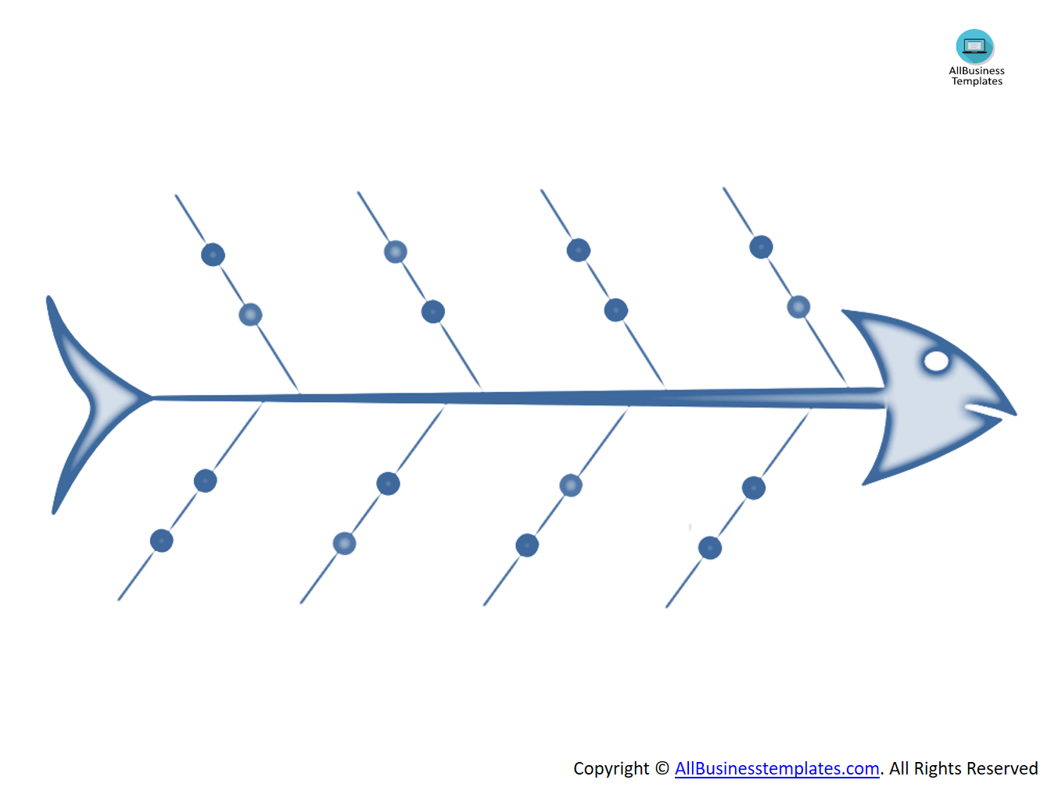
misunderstandings
No friendship relation
Negative thinking
Lack of training
Lack of professionalism
dissatisfaction
Limited collaboration
Different expectations
Unclear objectives
Poor leadership
Stress situation
Poor communication
Lack of communication
confusion

4.Solutions :
Before starting to find solutions I need to ask by myself and all team members why this situation occurred? And answers on this questions will help us to find solutions.
- I will ask all team members to think about solutions after assessing together all solutions we will try to find the best one.
- Schedule regular time to communicate with all team members ,even the person is very difficult
- I will try to identify and share effective and ineffective behaviour . I need to focus to behaviours to all team members .When I will identify them next step is to communicate. First I will start to myself after I will evaluate each person and I will motivate my team to do the same.
- And last stage we will have a team meetings where we will discuss all our agreement and dis agreement to each other and find solutions how we can consolidate our team work .
- To try to be more friendly with all team members and to listen carefully.

5. Alternative solutions :

- To be positive and to ensure all team members are doing a great hard job.
- To understand why this person did not came to our discussion maybe she didn’t heard me.
- To make one by one meeting with her to apologise for creating situation, to repeat all information that was discussed with other team members about work.
- To ensure she misunderstand the situation that we was discussing about work and not something bad about her.
- To ensure her that she is very good employee and all team members appreciate a lot her work
- To ensure that this things won’t happened in the future and when will be Team meetings I will make sure to be all members at this meeting to make sure to avoid misunderstandings .

6. Evaluation of the best alternatives solutions :

The process of analysing and evaluating alternative solutions is a way to facilitate decision-making .
First step of evaluation alternative solutions is to find an ideal solution . I think all alternative solutions are very good. But the best one is to make face to face meeting ,because if are some misunderstandings it should be discussed face to face. In this case the person can openly discuss her concerns.
Next step is to evaluate the remaining alternatives they are good as well but I can implement them through this face to face meeting . As well I need to assess the all risks maybe in this face to face meeting this person won’t be honest and maybe she won’t believe me , in this case ensure her that I will try to control and monitor all my action in the future.

PMI Technique :

PMI technique is a thinking technique to find Plus point , Minus point and Interesting points .Is a weighting of pro and cons of a decision.

Plus |  | Minus |  | Interesting
better relationship |  | risk to not be understand |  | To communicate more
(+5) |  | (-2) |  | (+4)
More professionalism
(+5)
Better team work
(+10)
Total = +20 |  | TotaL= -2 |  | Total = +4

7. Implement the solutions :

Implementing mine solutions is the culmination of all my work in solving the problem and requires careful attention to detail .
First I need a good planning that will help me to prepare to implement the solutions.
Next step is implementing and monitoring the action.
And last step is to review and analyse the success of the action .

8. Monitoring and control :

Monitoring and control is an important step of problem solving and decision-making process. I need to make sure and continuously to measure progress. To ensure that my decision works. Communicate all the time with team members and asking them the feedback of chosen solution. In this way I can understand if solution is really good . If I feel that solution doesn’t work as planned ,then I will return to alternative solutions and will implement a new plan .

9. Communicate with stakeholders :

For the good running of an organization it is very important to have a good communication with stakeholders . In my case stakeholders are employee with whom I am working .The complex problem affects all us, that’s why with an effective communication together we can solve it successful.
Moore suggests :
“ The key to effective approaches to tackling wicked problems is creating a shared understanding between the stakeholders about the problem and shared commitments to the possible solutions. This does not necessarily mean that there is complete agreement about the nature of the problem ,but that the stakeholders understand each other’s positions well enough to have intelligent dialogue about the different interpretations of the problem and to exercise collective intelligence about how to solve it .”
To create a good communication with my stakeholders for problem solving and decision making process I will implement three important steps :
- Schedule meetings with all my team members
- Schedule face to face meeting with employee that misunderstood us.
- Organize lunch meetings with all our team members will help to know each other better and to be more friendly .

10. Recommendation :

I would recommend for problem solving and decision-making at workplace :

- To communicate more with all team members.
- If a problem occur to take immediately action to find best solution.
- To use problem solving and decision-making tools and techniques
- To make sure that best chosen solution is implemented ,monitoring and are in a good control.
- If the chosen solution didn’t show the best result than is better to return to the alternative solution and implement a new plan.
This action steps can have positive effect in good running of an organisation and teamwork will work smoothly.
11. Conclusion :
In this report I identified the complex problems in the workplace and complex problem from my own experience in the workplace : lack of communication . I applied recognising problem solving tools and techniques: brainstorming .mind mapping ,fishbone diagram that helped me to identify the cause of problem that occurred and to find best solutions .As well I found solutions and alternative solutions to the main problem and tried to implement monitor and control it.

References
12. References : Top of Form

Angouri,J.&Bargiela -Chiappini,F.(2011)So what problems bother you and you are not speeding up your work? Problem solving talk at work .Discourse and communication.[Online]5(3),209-229

How to Use Mind Maps for Problem Solving.[Online]Available at: https://www.ayoa.com/imindmap/articles/how-to-use-mind-maps-for-problem-solving/(Accessed : 15 August 2021 )

How To Use the PMI Technique to Think Better.[Online]Available at: https://sourcesofinsight.com/avoid-the-intelligence-trap/#:~:text=Overview%20of%20the%20PMI%20Technique%201%20Consider%20the,of%20the%20Situation.%20...%204%20Make%20Your%20Decision(Accessed: 16 August 2021)

Jaarsma,T.et al.(2018) To guide or to follow ? Teaching visual problem solving at the workplace. Advances in health science education: theory and practice.[Online] 23(5)

Seven Steps for Effective Problem Solving in the Workplace.[Online] at : https://www.mediate.com/articles/thicks.cfm#:~:text=Seven%20Steps%20for%20Effective%20Problem%20Solving%20in%20the,...%205%20Select%20an%20option%20or%20options.%20.(Accessed : 14 August 2021)

What is a Fishbone Diagram? Ishikawa Cause & Effect Diagram.[Online]Available at: https://asq.org/quality-resources/fishbone(Acessed : 16 August 2021)

