FULL INTERFACE AND TESTING
Ana Chicaiza Asimbaya (2115194)
Module: Usability Engineering (ACCB6017) University of Wales Trinity Saint David London Campus

Table of Contents
INTRODUCTION 2
Full-colour Design Storyboard 3
Overview of the Final Storyboard Set 3
Visual Design: Colour and Graphics 4
Navigation and Interaction Design 6
Feedback Collection and Evaluation 10
10
Feedback Collection Process 10
Participant Selection and Persona Coverage 11
Summary of Usability and Emotional Feedback 12
Data Collection in a Working Version of the Game 13
13
Types of Data to Be Collected 13
Methods of Data Collection 13
Using Data to Inform Future Design Iterations 14
Usability Versus User Experience in the Storyboard Design 15
15
Designing the Game from a Pure Usability Perspective 15
Usability and User Experience Trade-offs in the Design Process 15
Reflection on the Design Process 16
CONCLUSION 17
References 18
APPENDIX 20

Introduction
This report presents the second stage of designing and evaluating a mobile cooperative digital board game inspired by Cluedo. Players collaborate to solve a mystery by navigating campus locations, selecting characters, and gathering clues through a structured investigation. This assessment directly builds on the personas, usability requirements, and low-fidelity wireframes from the first assignment, advancing the design into full-colour storyboards of the intended final interface [1].
The purpose of this report is to demonstrate the application of usability engineering and user experience (UX) theory to the visual and interactive refinement of the prototype. Usability is understood as the extent to which specified users can achieve specified goals with effectiveness, efficiency, and satisfaction in a particular context of use [2]. Accordingly, design decisions regarding layout, navigation, feedback, and visual hierarchy are grounded in established interaction principles and accessibility standards rather than aesthetic preferences alone [3].
The report details how evaluation feedback from the initial wireframes informed interface changes, illustrating an iterative, user-centred design process. It emphasises the balance between usability and engaging gameplay, as well as the role of both quantitative usage data and qualitative user feedback in guiding future development and refinement [10].
Overall, this report aims to demonstrate a systematic, reflective design process informed by usability theory, accessibility guidance, and the inclusion of representative users, resulting in a coherent, academically justified interactive system.

Full-colour Design Storyboard

Overview of the Final Storyboard Set
The full-colour storyboards shown here are a direct visual update of the black-and-white sketches made for Assessment 1. Their goal is to show how the Cluedo-style mobile game would look and work when adding design basics such as colour, font, and layout, while preserving the original layout and the user's movement through the game. Storyboards are often used in usability testing to illustrate how the interface works and how users navigate it. They do this simply, so both designers and reviewers can understand them without needing a real system [1].
The storyboard set consists of four screens: the main menu, character selection screen, investigation board, and end-of-game screen. These screens match the wireframes exactly and cover all major stages of user interaction in the game. The designs are intentionally simple and schematic, reflecting an academic prototype created using presentation software such as PowerPoint rather than a commercial game engine. This ensures that the focus remains on usability, clarity, and interaction logic rather than visual polish or realism [5].
You can see the whole storyboard set in Appendix A. This section discusses a few main frames to illustrate key design choices and how they follow usability principles.

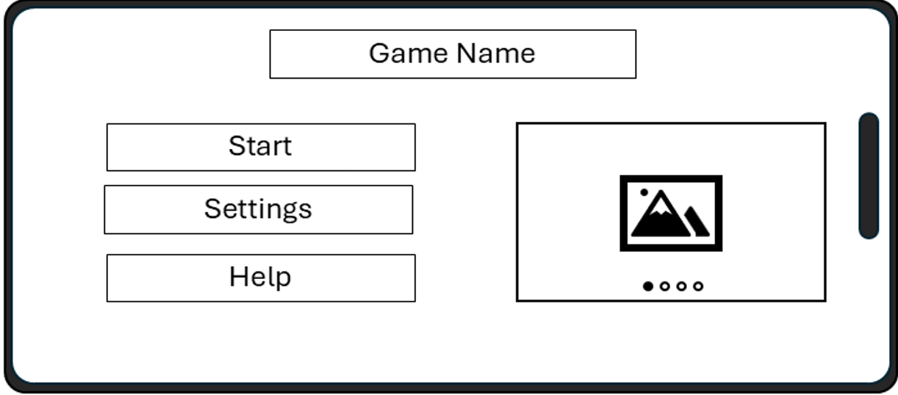
Figure 2.1 – Main Menu Screen

Visual Design: Colour and Graphics
The visual design of the storyboards was guided by two primary considerations: alignment with the traditional Cluedo aesthetic and adherence to usability and accessibility principles. A limited colour palette based on dark green, burgundy, and cream tones was selected to evoke the visual identity of the original Cluedo board game, supporting genre recognition and familiarity. Leveraging familiar visual conventions helps users quickly understand the nature of the game, reducing the learning curve [7].
At the same time, colour choices were constrained to ensure sufficient contrast between text, backgrounds, and interactive elements. Buttons and interactive areas are clearly distinguished by both colour and border outlines, ensuring that information is not conveyed solely through colour. This approach aligns with accessibility guidance that emphasises perceptual clarity and inclusivity for users with visual impairments or colour vision deficiencies [8]. Decorative imagery is minimal and schematic, reinforcing the impression of a prototype created in PowerPoint rather than a commercial game interface.
The investigation board screen uses simplified room shapes (basic outlines representing rooms), icons (small graphical symbols representing functions or objects), and labels (text descriptions), instead of detailed illustrations. This reduces visual clutter and supports rapid information scanning, particularly in time-limited gameplay scenarios. Such simplification is consistent with usability research showing that unnecessary visual detail can increase cognitive load (the mental effort required to process information) and hinder task performance [6].

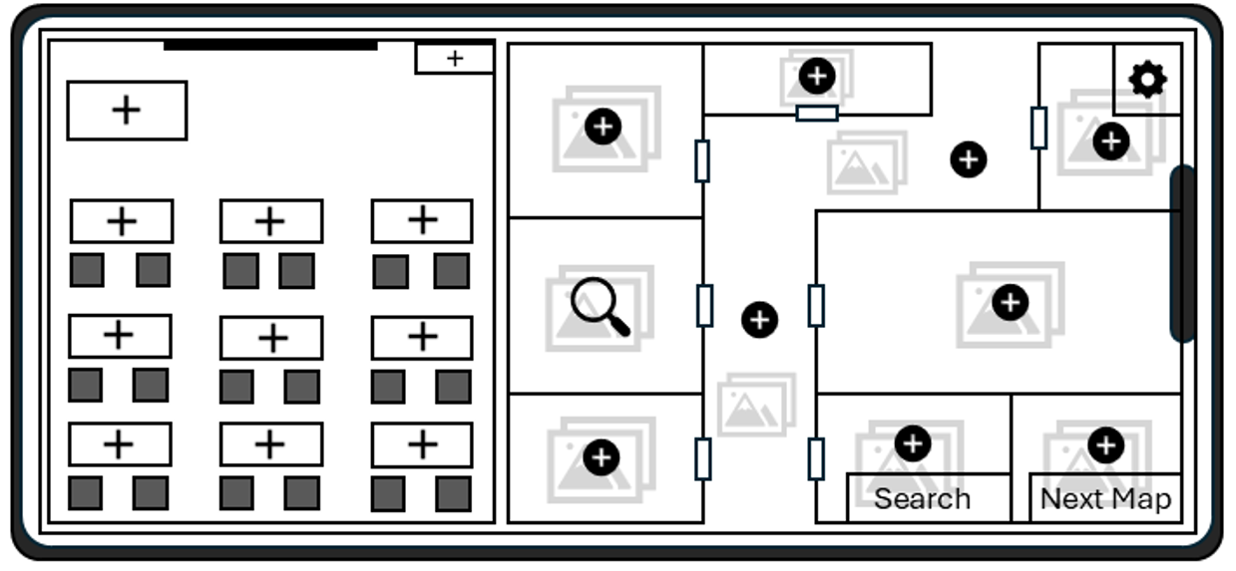
Figure 2.2 – Investigation Board Screen

Navigation and Interaction Design
The storyboard design uses a shallow, explicit navigation structure to minimise user confusion and memory load. Primary actions are represented by clearly labelled buttons that are consistently placed across screens. Users can start the game, select a character, search a room, or move to the next map using these buttons. By supporting the principle of recognition rather than recall, this approach ensures that users identify available actions without needing to remember previous instructions. Interactive elements are sized generously to accommodate touch interactions on mobile devices, in line with established mobile usability guidelines. Immediate visual feedback is provided for user actions, such as highlighting a selected character or confirming a search, ensuring users are always aware of the system’s current state. Visibility of system status is a core interaction principle, particularly important in cooperative games where users must coordinate actions and decisions [9].
The character selection screen demonstrates this approach by displaying characters as clearly separated cards with labels and distinct selection states—meaning visual indicators, such as highlighted borders or different colours, show which card is chosen. This layout mirrors the logic of physical Cluedo character cards, which are used in the board game to represent each character, and remains legible on a small screen. By preserving the original wireframe structure—meaning the basic visual and functional layout—and enhancing it with colour and spacing, the storyboard clarifies user interactions without changing the underlying functionality [11].

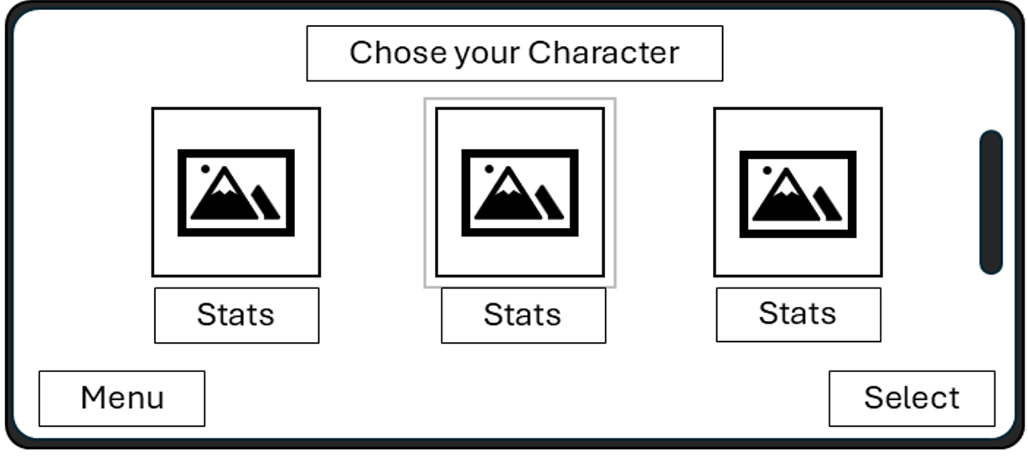
Figure 2.3 – Character Selection Screen
Changes from Wireframes and Design Rationale
While the storyboard designs retain the structure of the original wireframes, several refinements were introduced to address usability considerations identified during the earlier design stage. One notable change is the clearer visual hierarchy established through colour and contrast. In the wireframes, all elements appeared visually similar, whereas the storyboard versions more clearly distinguish primary actions from secondary options. This helps guide user attention and supports efficient decision-making [10].
Another change concerns the end-of-game screen. In the wireframe, the success message and navigation options were presented with minimal differentiation. In the storyboard version, the “You Solved the Case” message is visually emphasised, providing clear feedback and a sense of closure. Effective feedback at the end of an interaction sequence has been shown to positively contribute to user satisfaction and perceived usability [4].
These changes are modest and incremental, supporting an iterative usability process rather than a full redesign. By keeping the original layouts and refining visuals, the storyboards show how to improve usability without adding complexity or development work.

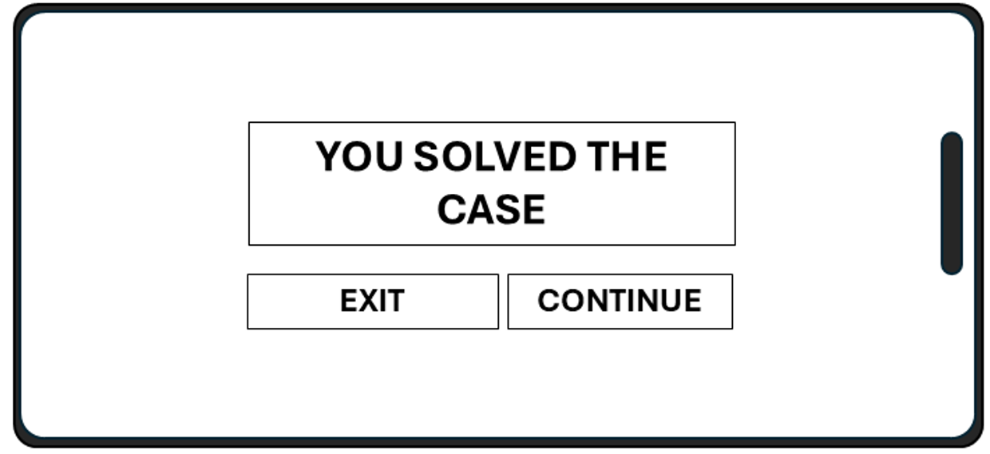
Figure 2.4 – End-of-Game Screen

Feedback Collection and Evaluation

Feedback Collection Process
We collected feedback on storyboard prototypes using formative usability evaluation methods suited to early-stage interface design. Because we evaluated static storyboards rather than a working application, we prioritised qualitative methods to explore user understanding, expectations, and emotional responses. Formative evaluation at this stage helps identify usability issues early, before major development resources are committed [12].
The primary method used was a moderated walkthrough evaluation, in which participants were shown the storyboard screens in sequence and asked to explain what they believed each screen represented and what actions they would take next. This approach enabled the identification of breakdowns in clarity, navigation, and feedback without requiring participants to perform real interactions. Walkthrough-based methods are particularly effective for evaluating conceptual designs and storyboards, as they reveal mismatches between designers' intentions and users' interpretations [13].
In addition, participants were encouraged to verbalise their thoughts using a light think-aloud approach. This provided insight into cognitive processes, such as decision-making, confusion, and confidence, during interface interpretation. Notes were taken during each session, focusing on points of hesitation, misunderstanding, and positive reactions to the design. These qualitative data formed the basis for identifying strengths and weaknesses in the storyboard designs [14].

Participant Selection and Persona Coverage
Participants were selected to reflect the range of personas defined in Assessment 1, ensuring that feedback represented different user needs, levels of technical confidence, and perspectives within the university context. The sample included undergraduate and postgraduate students and academic staff. This diversity was important to ensure that the design was not optimised solely for a single user group but instead supported a broad audience consistent with the intended game setting [15].
Each participant was informally mapped to a defined persona. Undergraduates reflected student personas with high familiarity with mobile apps but limited patience for complex instructions. Academic staff reflected personas with low ambiguity tolerance and a preference for clear structure and feedback. This mapping linked feedback to persona goals and constraints, strengthening the findings' validity [16].
Though participant numbers were limited, this aligns with usability research showing small samples can reveal most usability issues in formative testing. The aim was to identify recurring patterns and critical design problems, not statistical generalisation [17].

Summary of Usability and Emotional Feedback
Overall, feedback on the storyboard designs was largely positive, particularly regarding clarity and thematic consistency. Participants reported that the connection to the traditional Cluedo board game was immediately recognisable, which helped them understand the game's objective without extensive explanation. The main menu and character selection screens were consistently described as clear and easy to interpret, suggesting that the visual hierarchy and labelling were effective [18].
Several usability issues were also identified. Some participants initially struggled to understand the functions of certain icons on the investigation board, suggesting that additional textual labels or tooltips would be beneficial. Others suggested that the transition between the investigation board and the end-of-game screen could be made more explicit to reinforce the sense of progression and completion. These issues were largely anticipated and reflect common challenges in translating physical board game mechanics into digital interfaces [19].
For emotional response, participants called the design “engaging,” “familiar,” and “appropriate for a university context.” They felt the restrained colour and simple graphics were serious enough for an academic setting, yet still enjoyable. This balance between usability and engagement aligns with research showing that positive emotions can improve how usable a system feels, even in work-focused systems [20].

Data Collection in a Working Version of the Game

Types of Data to Be Collected
If a fully functional version of the Cluedo-inspired game were released, collect data on usability, user experience, and overall effectiveness. Divide these into quantitative usage data and qualitative user feedback. Use both, since behavioural metrics alone cannot fully explain user satisfaction or frustration [2].
Quantitative usage data would include session duration, the number of games completed, the time taken to solve the case, and the frequency of incorrect accusations. Additional metrics could capture navigation behaviour, for example, how often users return to the main menu, how many locations are searched during a game, and whether certain rooms or characters are consistently ignored. Such data can reveal patterns of use and highlight areas where users may be confused or disengaged [4].
Error-related data would also be valuable. This could include instances where users attempt invalid actions, abandon a game before completion, or repeatedly access help or settings screens. These indicators can signal usability problems that may not be immediately apparent through observation alone. Collectively, these usage data would provide an objective view of how the system is used in practice. [21]

Methods of Data Collection
System logging can collect most quantitative data automatically, with no extra effort from users. Automatic data collection captures interaction frequency, timing, and navigation paths, minimizing bias and providing consistent data. Designers can evaluate real-world use, not just lab results [22].
However, not all relevant data can be gathered automatically. Qualitative data on user satisfaction, emotional responses, and perceived enjoyment would require direct user input. This could be collected through short post-game questionnaires, optional in-app surveys, or follow-up interviews. Such methods are essential for understanding how users feel about the experience, a core component of user experience that cannot be inferred reliably from interaction logs alone [23].

Using Data to Inform Future Design Iterations
Data collected from a working version of the game could guide iterative improvements to usability and user experience. For example, if usage data showed that players frequently abandon games at a particular stage, this would suggest a potential usability barrier or a breakdown in engagement. Designers could then revisit the relevant screen or interaction flow to improve clarity or reduce cognitive load [7].
Emotional response data can assess whether challenge and enjoyment are properly balanced. If users report frustration or stress rather than engagement, it signals that time limits, information density, or feedback methods need refinement. Conversely, reports of boredom imply a need for greater complexity or variety. These findings support evidence-driven design choices rather than assumptions [25].
Crucially, collecting and using user data must be ethical and transparent. Users must know what data is collected and how it is used, and personal data must be anonymised whenever possible. Ethical data practices form the foundation of responsible usability engineering, especially for educational systems.

Usability Versus User Experience in the Storyboard Design

Designing the Game from a Pure Usability Perspective
If the Cluedo-inspired game had been designed purely from a usability perspective, the resulting interface would have prioritised efficiency, clarity, and error prevention above all other considerations. Visual design would likely have been minimal, with neutral colours, limited decorative elements, and a strong emphasis on text labels and explicit instructions. Such an approach would reduce ambiguity and support rapid task completion, particularly for novice users or those unfamiliar with board games [2].
From a strict usability standpoint, interaction flows would be optimised to minimise the number of steps required to complete tasks. For example, character selection and investigation actions could be consolidated into fewer screens, and confirmation dialogues might be removed to speed up interaction. While this would improve efficiency, it could also reduce the sense of progression and engagement that is central to the Cluedo experience. This highlights a key limitation of designing solely for usability: systems may become functionally effective but experientially flat.

Usability and User Experience Trade-offs in the Design Process
In practice, the storyboard design balanced usability and user experience, not just one or the other. One clear example is the visual styling inspired by the traditional Cluedo board game. A highly neutral interface would arguably be clearer in terms of usability. However, Cluedo-like colours, layouts, and iconography increase user engagement and emotional connection by building on familiarity and genre expectations [18].

Another example is the investigation board. A purely usability-driven design might present investigation options as a simple list of rooms and actions, which would be efficient but abstract. Instead, the storyboard retains a board-like layout that visually represents rooms and movement, enhancing immersion and supporting the mental model of investigation. While this may slightly increase visual complexity, it enhances the overall experience and aligns with users’ expectations for a Cluedo-style game [19].
These decisions show that usability and user experience support each other. Good usability builds a positive experience, while narrative, familiarity, and visual style keep users engaged and enjoying the game [23].

Reflection on the Design Process
Reflecting on the overall design process, the inclusion of usability theory and user feedback was critical in shaping balanced design decisions. Early wireframes ensured that core functionality and interaction flow were sound before visual refinement began. Subsequent storyboard development demonstrated how visual design could enhance clarity without compromising usability. Feedback collected during formative evaluation helped identify where experiential elements—such as engaging animations or playful interactive features—risked undermining clarity and where additional structure was required.
This process matches user-centred design, which relies on constant iteration guided by theory and real users. We intentionally joined usability and user experience, knowing good interactive systems must be usable, accessible, and engaging. This reflective approach shows we understand the complexity and balance required in interaction design, especially for systems blending tasks and play [1].

CONCLUSION
This report traces the iterative development of a Cluedo-inspired mobile game prototype, evolving from low-fidelity wireframes to detailed, full-colour storyboards shaped by usability engineering theory and user feedback. Key takeaways include successfully maintaining core interaction structures while refining visual design, navigation, and feedback mechanisms to significantly improve usability and the overall user experience.
The storyboard process revealed two key takeaways: first, anchoring design choices in proven principles rather than personal taste leads to more effective, efficient, and satisfying results. Second, integrating formative usability evaluation ensures that designs reflect users' perspectives rather than designer assumptions. Together, these highlight the importance of early, iterative testing in user-centred design.
A key learning outcome from this process was the importance of balancing usability and user experience. We found that clear navigation and minimal cognitive load enhance usability, while incorporating familiar Cluedo visual conventions increases engagement and comprehension. Ultimately, the process showed that usability and user experience support each other, especially in interactive systems combining tasks with play.
Overall, this project demonstrates a structured, reflective approach to usability engineering, integrating theory, practice, and user involvement. The resulting storyboard designs provide an academically justified foundation for future development and cultivate transferable skills essential to professional practice in interaction and user experience design, highlighting the lasting value of rigorous usability engineering for professional growth.

References

[1] | Y. S. H. &. P. J. Rogers, Interaction Design: Beyond Human–Computer Interaction, Wiley, 2023.
[2] | International Organization for Standardization., “Ergonomics of human-system interaction — Usability: Definitions and concepts,” International Organization for Standardization, 2018.
[3] | International Organization for Standardization, “Interaction principles,” International Organization for Standardization, Geneva, 2020.
[4] | J. &. L. J. Sauro, Quantifying the User Experience., Burlington, MA: Morgan Kaufmann, 2022.
[5] | J. B. C. &. V. A. Tidwell, Designing Interfaces., Sebastopol, CA: O’Reilly Media, 2020.
[6] | J. A. P. &. K. S. Sweller, Cognitive Load Theory., New York: Springer , 2019.
[7] | D. Norman, The Design of Everyday Things., Basic books, 2013.
[8] | World Wide Web Consortium, “Web Content Accessibility Guidelines (WCAG),” Princeton Architectural Press, New York, 2023.
[9] | International Organization for Standardization, “Usability: Definitions and concepts.,” International Organization for Standardization, 2018.
[10] | M. Hassenzahl, “User experience and experience design.,” Foundations and Trends in Human–Computer Interaction, vol. 15, no. 1, 2022.
[11] | J. Nielsen, “Usability Engineering.,” Morgan Kaufmann, 1994.
[12] | J. &. C. D. Rubin, Handbook of Usability Testing., Indianapolis, IN: Wiley, 2008.
[13] | C. R. J. L. C. &. P. P. Wharton, “The cognitive walkthrough method.,” Human–Computer Interaction, vol. 7, no. 2, pp. 137-171.
[14] | K. A. &. S. H. A. Ericsson, Protocol Analysis: Verbal Reports as Data., Cambridge, MA: MIT press.
[15] | A. R. R. C. D. &. N. C. Cooper, About Face: The Essentials of Interaction Design., Indianapolis, IN: Wiley, 2014.
[16] | J. &. A. T. Pruitt, “The Persona Lifecycle.,” San Francisco, 2006, Morgan Kaufmann.
[17] | J. &. L. T. Nielsen, “A mathematical model of the finding of usability problems.,” ACM.
[18] | D. Norman, Emotional Design., New York: Basic Books, 2004.
[19] | T. Fullerton, “Game Design Workshop.,” CRC Pres, 2018.
[20] | M. &. T. N. Hassenzahl, “User experience – a research agenda.,” Behaviour & Information Technology., vol. 25, no. 2, pp. 91-97, 2006.
[21] | J. Nielsen, “Usability metrics: Tracking interface improvements.,” EEE Software, vol. 12, no. 1, pp. 12-13.
[22] | T. &. A. B. Tullis, Measuring the User Experience., Morgan Kaufmann, 2013.
[23] | M. Hassenzahl, Experience Design: Technology for All the Right Reasons., Morgan & Claypool, 2010.
[24] | J. W. &. P. C. V. Creswell, Designing and Conducting Mixed Methods Research., Sage, 2018.
[25] | P. &. H. P. Desmet, “Framework of product experience.,” nternational Journal of Design., vol. 1, no. 1, pp. 57-66, 2007.

APPENDIX

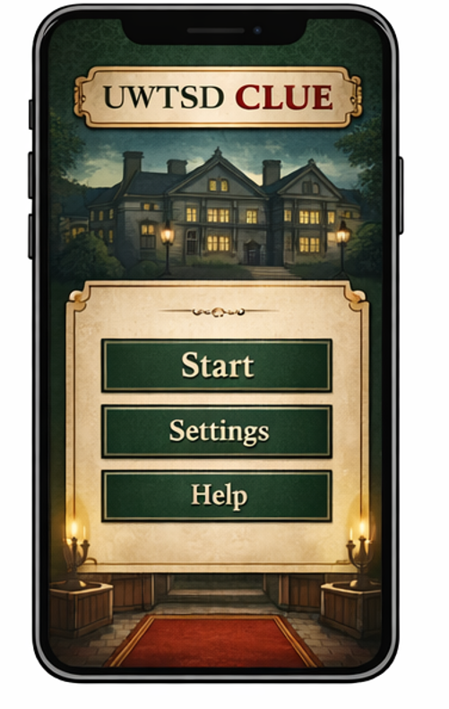

Figure A1: Full-colour main menu screen showing the game title and primary navigation options.

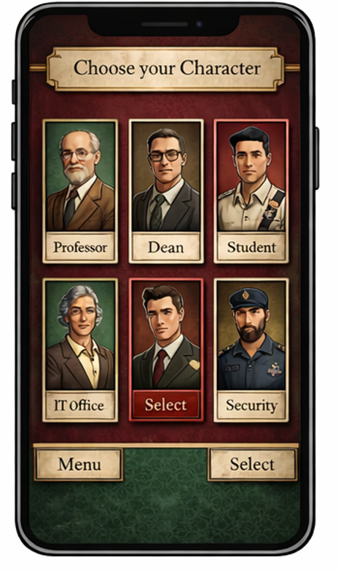

Figure A2: Character selection screen allowing players to choose a Cluedo-style character before starting the game.

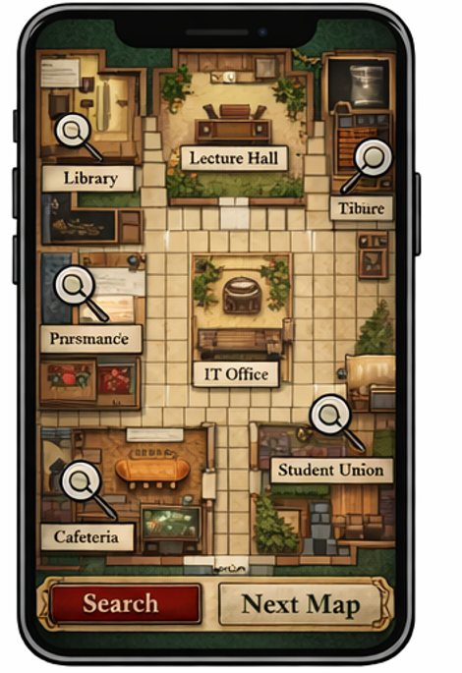
Figure A3: Investigation board screen representing campus locations using a Cluedo-inspired board layout.
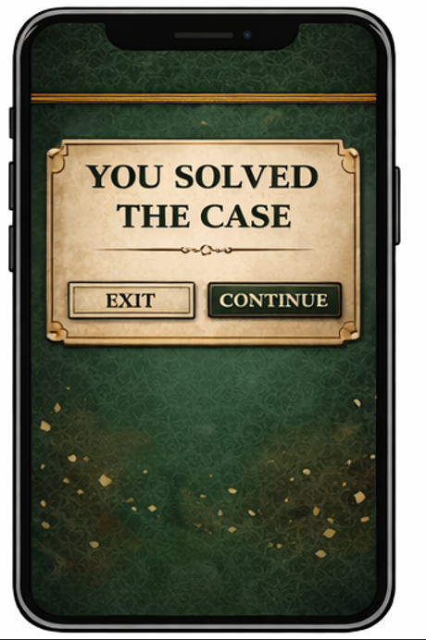
Figure A4: End-of-game screen providing feedback after the case has been solved.

