Reflective Report Personal Career Development
BMSW4005
Valentin Gotsev
Student number: 1912864
Lecturer Melanie Squire
21/02/2020

Executive summary

The purpose of this reflective report is to identify my learning and development needs and barriers. After analysing VARK and Mumford questionnaires I have identified the positives and negatives of learning styles that apply to me. By collecting feedback from friends and colleagues I have created a personal SWOT analysis, to highlight areas for further development. The report highlights two SMART learning objectives which I need to further develop. The SMART goals are the base of two action plans which show step by step how to improve the areas for further development and monitor the progress

Contents

Executive summary 2
1.0 Terms of reference 4
2.0 Procedure 5
3.0 Main findings 6
3.1 Background – 6
3.2 Learning styles questionnaires and development needs. 7
3.2.1 Learning style questionnaires – 7
3.2.2 SWOT analysis and conversion strategy. 8
3.3 Learning and development barriers. 10
3.3.1 External barriers – 10
3.3.2 Internal barriers – 10
3.4 Addressing development needs 11
3.4.1- Learning and development options 11
3.4.2 Support mechanisms – 12
3.4.3 – Personal development plan 13
4.Conclusion – 16
5.0 Recommendations 17
6.0 Acknowledgements – 18
7.0 Reference list 19
8.0 Bibliography – 20

1.0 Terms of reference

This report is requested by Melanie Squire, lecture in UWTSD. It was requested on 17/01/2020. The purpose of this report is to identify my learning preferences and development needs and create personal development plan on two employability skills where I need further development. The report was compiled by me. The main problems which I highlighted are my struggle in timekeeping and report writing. The date of submission is 21/02/2020.

2.0 Procedure

To prepare this report I used:
- Two learning styles questionnaire: Honey and Mumford and VARK.
- TED talk videos.
- Student books.
- Books.
- Journals.
- Graphics.

3.0 Main findings

3.1 Background –
In an article published in Forbes Peart (2019) highlights 12 skills that are necessary to succeed in work. In the article she points out that the critical skills needed to be successful in 21st century are the soft skills: The following skills have been identified by Peart (2019).
- ‘’Learnability’’
- ‘’Resilience’’
- ‘’Agility’’
- ‘’Collaboration’’
- ‘’Verbal Communication’’
- ‘’Written communication’’
- ‘’Empathy’’ -
- ‘’Creativity’’
- ‘’Problem solving’’
- ‘’Leadership’’
- ‘’Technology’’
- ‘’Negotiation’’

The self-awareness or knowing your learning and development areas is essential for communication with the others and reaching our highest effectiveness. To be self-aware does not mean to know only your strengths, it means knowing your weaknesses. In order to be successful, you need to be able to identify weak areas that need development, these points were identified by Sparks (2018). Creating an action plan to develop those skills is essential for me to be competitive on the employment marked.

3.2 Learning styles questionnaires and development needs.

3.2.1 Learning style questionnaires –
3.2.1.1 Honey and Mumford learning questionnaire -. After filling Honey and Mumford learning style questionnaire two learning styles applied to me: Pragmatic – 16 points and Activist – 14 points.
According to Neugebauer, J. and Evans – Brain, J. (2016) pragmatist are people who like to innovate and invent. They always look for new ideas and are trying implement them in the real life. The pragmatic learners are learning by connecting the information that they have lust learned with the information from the real-world practise.
The activists like to get involved in different projects. They learn from activity-based courses. The best way for to attract their attention is by involving in team project or different role plays Jon Roswell (2005).

3.2.1.2 VARK learning style questionnaire After filing VARK learning styles questionnaire the learning styles that applied to me were Kinaesthetic – 9 points , Aural – 8 points.
In Ted talk Kuczala (2015) explains that ‘’the best way for people to naturally create nerve cells is through different activities’’. In another Ted talk about kinaesthetic learners Halrow (2015) says: “The kinaesthetic needs to be thought in understandable manner”. The kinaesthetic learners assimilate the information through activities such as Movement, Role-play, Drama Leopold (2012).
In his book Learning Styles B. Ryam (2013) compares the Aural learning to listening. He suggests that this is preferable method for learning by many people because of how easily accessible the information is. He describes that the learning preferences of aural learners are with tutorials, face-to face discussion, web chat rooms. Hawk and Shah (2007, p8) suggests that the aural learners learn best in debates, audio, video and conversations.

3.2.2 SWOT analysis and conversion strategy.
Preparing SWOT personal analysis is essential for me to analyse my Strengths, Weaknesses, Opportunities and Threats in achieving the SMART goal. Analysing my weaknesses and threats will help me taking steps into converting them in strengths and opportunities. This two tables are showing my SMART goal and its SWOT analysis.
Specific | Graduating from University with BA degree and becoming Area Manager, or Operations manager in Amazon.
Measurable | Finish education within 3 years. Becoming Team leader after 1st year.
Achievable | Working together with my manager to develop my skills. Collecting feedback from colleagues. Using student support at university.
Realistic | To finish my Higher Education degree in Skills for the workplace course in 1-year time and continue with 2 more years in Management and Leadership skills for the workplace. Working together with my manager to develop my skills. Collecting feedback from colleagues.
Timebound | My goal to be achieved in 3 years.

Strengths  - Collaboration.  - Learnability  - Verbal communication.  - Leadership.  - Agility.  - Empathy.  - Creativity. | Weaknesses  - Bad habits.  - Impatience.  - Mistrusting.  - Emotional.  - Easy distracted.  - Not enough qualifications.  - Low knowledge in Essay and Report writing.  - Bad written communication.  - Basic primary school degree.  - Bad time management.  - Negotiation skills.
Opportunities  - The company that I want do develop my career with is the world fastest growing retailer. Every year in UK Amazon opens new fulfilment centres, which opens a lot of Managers and Team leads positions.  - Being a Manager in Amazon is opportunity to work with cutting edge technology. | Threats  - People with HE or BA degrees are preferred by Amazon for Team Leads and Managers. For the experienced workers without higher education is extremely hard to get a position.  - According to Erin Winick (2017) with robotization in Amazon, the human work is replaced by robots or artificial intelligence.
In his book Seven Habits of Highly Effective People, Covey (2004) compares the habits to a gravity pool. The pull of the bad habits may put you away from your career aims. If we change our habits, we can be more effective in our lives. Covey defines the habit as collision between Knowledge, Skill and Desire. Knowledge about what are your bad habits. The Skill is the knowledge of how to change the habit. The Desire is the will, unless there is no desire there is no habit.
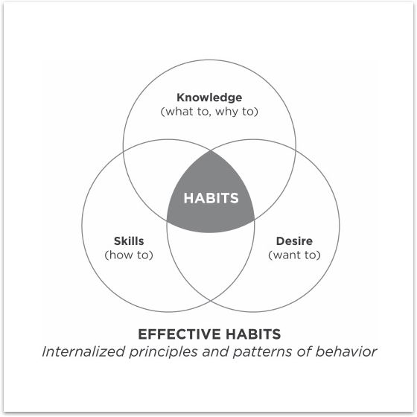
In this report I am going to put a focus on creating personal development plan on how to overcome my difficulties in report writing and resilience or ‘’timekeeping’’.

3.3 Learning and development barriers.

3.3.1 External barriers –
The external barriers that exist Infront of me are that I must study and work at the same time to be able to maintain myself and support my family abroad. My determination to success is what guides me. To be able to overcome and balance that. I will go from 40 hours full-time to 30 hours part-time contract which will perfectly help me to balance between university and work. With the 30 hours part time I will still be able to help my parents abroad.

3.3.2 Internal barriers –
One of the internal barriers for me is that I do not have enough knowledge in essay writing and referencing. At school I have always had problems with report and essay writings. Being active learner, I have always been good at exact science like maths for example. Studying in university is a big opportunity for me, to overcome this barrier. Another barrier in front of me is the language barrier. I live in the UK from only three years and studying in different language is a big challenge for me. I have studied English as second language back in my country, but that is not enough. To ‘’catch up’’ started watching more English-speaking movies and television which helped me a lot.

3.4 Addressing development needs

3.4.1- Learning and development options
Being pragmatic in my studies I will put focus on spending more time in reading practical books from which I can put everything I have learned into practise. I will involve myself into more practical process, like linking the information that I have learned from University into my work. As Pragmatic I have always struggled to learn when there is no clear construction of the activities, I need to take. I also struggle to learn in situations, that points different emotions or feelings. Focusing only on the practice can easily distract me and sometimes, I can miss some important things in the theory.
As activist learner, I will look forward to learning new information in group projects and consistently going to classes. My weaknesses as an active learner are that I want the job to be done no matter what the cost is. I can sometimes take high risk in my wish to success. Being activist, I spend more time in thinking what I have done and will rarely think about the quality of the job I have done.
Being kinaesthetic learner, I will focus on acquiring information using my senses visual touch, smell, taste. As young student I have always preferred to learn by linking what I have learned with the real life. Every time I start new job, I struggle to understand the information during the training until I start doing the job in practice.
When I first came in the United Kingdom my English level was very low. Knowing that I learn better by listening (aural) I started watching English TV that significantly increased my English level. In my studies I will look forward to study from videos. For the purpose of this report I have used several videos as references.

3.4.2 Support mechanisms –
To overcome my difficulties in report writing I will visit regularly the classes in university where I can get support in detail from lectures. Another supportive mechanism is to arrange 1:1 meeting with the student support. Being pragmatic learner, I struggle to learn when there is no clear construction of activities, meeting lectures and student support will help me organise my report better. Collecting feedback after every assignment I will significantly improve my writing skills.
Difficulties in time keeping I will improve by applying on practice what I have learned from the ‘’Seven Habits of Highly Effective People’’. Covey (2004) puts ‘’first things first’’ as 3rd habit from the ‘’private victory’’. To improve my timekeeping at work I will ask my manager for feedback on that.

3.4.3 – Personal development plan

3.4.3.1 – Personal development plan for overcoming difficulties in report and essay writing.

Skill/behaviour | Action Needed. | Resources needed. | Dates for action. | Date for review. | SMART goal. | Met?
To improve Reflective report writing. | 1:1 meeting with lectures and student support.  Collect feedback from lectures | Lectures  Student support.  Free time from work.  Online resources. | Every day after work.  4-5 hours per day when not at work. | 19/02/20  1:1 meeting with student support | I want to be able to write reports without help of student support before the end of course. I will use the feedback from my reports and make significant advantage in 1st three months. | After meeting with lecture and student support have significant improvement.

Roswell (2005) suggest a link between Honey and Mumford and Kolb. They suggest that Honey and Mumford learning styles are connected to Kolb`s learning model. I am going to apply this theory to my work. To improve my Report writing skills I will use Kolb’s learning model. Completing every step from the Kolb`s learning model is important to improve learning.
- Experiencing - Being activist learner as identified from my questionnaire I learn the best from experience. I will make 1:1 meeting with student support and lectures. After my reflective report is marked, I will ask for feedback.
- Reviewing – After my first reflective report I will spend time with other students to review it and see what I have missed. I will ask for 1:1 meeting with the lecture for detailed feedback. After filling the Honey and Mumford questionnaire the lowest points I received was as reflector. I will use that, and I will put more attention on reviewing the results of my reflective report.
- Reflecting – After receiving the feedback for my report I will examine it in detail. I will reflect on what happened and why. I will use my research skills and make research of what I can improve.
- Planning – As pragmatic I will apply all the theory, review and experience into practise. I will make clear construction of the activities I need to take for better results next time.

3.4.3.2 - Personal development plan for improving timekeeping ability. –

Being process guide and proxy team lead in Amazon is big challenge for my timekeeping abilities. Although I am good timekeeper in life, I have problems with that at work. As a kinaesthetic learner I researched information that I can put into practice. For the purpose I bought ‘’The Seven Habits of Highly Effective People’’ Covey (2004). In my research in the book I found ‘’The time management matrix’’. This matrix separates the activities in four sections: Urgent, Important, Not Important-Urgent and not important-not urgent. In his book Covey (2004) points that focusing on the section with Urgent-Important too much can put you into stress situation. Spending a lot of time in Urgent Not important activities, thinking that they are Urgent can cause crisis in management. People that spend the most time in Not important and Not urgent are the most irresponsible people. Covey (2004) concludes, that the most effective people spend their times in Important – Not urgent quadrant. The effective people can see the problem coming from far away and put it into Important – Not urgent quadrant.
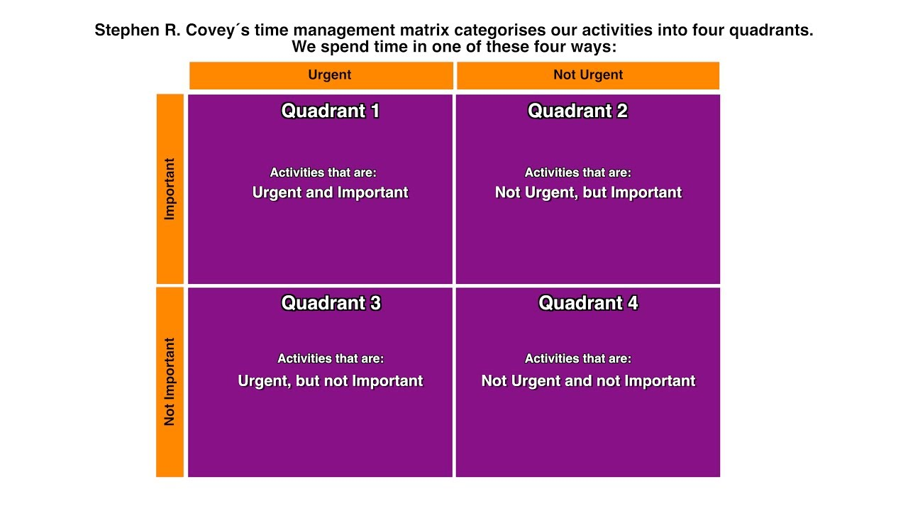

Skill/behaviour | Action Needed. | Resources needed. | Dates for action. | Date for review. | SMART goal. | Met?
To improve timekeeping ability at work. | Create time management matrix.  Ask managers for feedback. | ‘’The seven habits of highly effective people’’.  Ted videos. | Every day at work. | Review time management matrix daily. | I want to improve my timekeeping ability at work. To be able to organise better my work on daily basis. By creating action plan and applying ‘’time management matrix’’. Achieve that goal by the end of 1st modules at university.
In TED video Aeon (2017) mentions research which shown that people that were told that ‘’time is money’’ are more likely to neglect their closest and use the time to make money. He points that from the time you realise that you are not going to live forever the ‘’time is money’’ will lost its sense. He concludes that knowing the philosophy of time can help us understand what to prioritise.

4.Conclusion –
In this report I reviewed key employability skills and learning preferences. Knowing my learning preferences helped me understand which are the best ways for me to understand new information. Analysing the different learning styles also helped me to understand which are the possible weaknesses on my learning styles and what I can miss during my studies.
Establishing SMART employment goal is important to set up clear direction of my life and employment. Based on feedback from friends and colleagues I created personal SWOT analysis to identify in which employability skills, I need further development. This helped me to become more self-aware and see what the obstacles towards my SMART goal are.
Creating personal development plan significantly increased my report writing skills. After the student support and lecture meetings I am now able to create reports on my own. Knowing how to write essays and reports is essential for me to acquire HE and BA certificates which is big step in achieving my SMART goal.
Knowing how to manage my time at work better helped me become more organised in my thoughts. Knowing how to better structure my time made me more effective at work. I am now able to structure my activities in the fast-phased environment that I work.

5.0 Recommendations

- Improve report and essay writing by collecting feedback from lectures and analysing the marks I receive from every report.
- Watch more relevant videos and read more practical books to improve report writing.
- Start reading references in more detail, as an active learner I can skip important details.
- Improving timekeeping ability at work by organising priorities by using Covey`s time management matrix.
- Improve timekeeping ability by collecting daily feedback from my managers and team leads.

6.0 Acknowledgements –

Writing this report, I was advised by Beth Downing student support in UWTSD and Melanie Squire lecture in UWTSD.

Reference list

- Byram, R (2013). Learning styles. Amazon.com: Amazon.com. p1-13.
- Covey, S. (2004). The 7 Habits of Highly Effective People. Croydon: CPI Group (UK) Ltd. p46-50 p145-183.
- Hawk, K and Shah, A. (2007). Using Learning Style Instruments to Enhance Student Learning. Decision sciences. 5 (1), p1-19.
- Jon Rosewell. (2005). Learning styles. Available: https://www.open.edu/openlearn/ocw/pluginfile.php/629607/mod_resource/content/1/t175_4_3.pdf. Last accessed 10/02/2020.
- Leopold, L. (2019). Prewriting tasks for Auditory, Visual and Kinaesthetic Learners. In the classroom. 29 (2), p96 - 101.
- Neugebauer, J. and Evans – Brain, J. (2016). Workplace Learning and Development. In: Maund, A. Schriek, M. and Tinkler, P. Certificate in Higher Education: Skills for the Workplace Student Yearbook. London: SAGE Publications ltd. p336-355.
- Peart. (2019). The 12 Most Important Skills You Need To Succeed At Work. Available: https://www.forbes.com/sites/nataliapeart/2019/09/10/the-12-most-important-skills-you-need-to-succeed-at-work/#4cce4c671c6a. Last accessed 5/02/2020.
- TEDx Talks (2018). The power of self-awareness.[online video] Available at [https://www.youtube.com/watch?v=R9qVa4LoJx8] [Accessed 6/02/2020]
- TEDx Talks (2015). The Kinaesthetic classroom: Teaching and learning though movements.[online video] Available at [https://www.youtube.com/watch?v=41gtxgDfY4s] [Accessed 6/02/2020]
- TEDx Talks (2015). Kinaesthetic learners [online video] Available at [https://www.youtube.com/watch?v=diMJhM8Y1N4] [accessed 10/02/2020].
- TEDx Talks (2017) The philosophy of time management [online video] Available at: [https://www.youtube.com/watch?v=WXBA4eWskrc] [Accessed 16/02/2020]
- Winick, E. (2017). Amazon investing in robots is eliminating human job. Available: https://www.technologyreview.com/f/609672/amazons-investment-in-robots-is-eliminating-human-jobs/. Last accessed 01/02/2020.

8.0 Bibliography –

- Morgan, P (2017). The Business Student’s Guide To Study And Employability. London: Sage Publications Ltd. p18-47 p49-68 p134-156.
- VARK a guide for learning preferences (2020) VARK strategies Available at: https://vark-learn.com/ (Accessed on 02/02/2020)
- Drago, W and Wagner, R. (2004). Vark Preferred Learning Styles and Online Education. Management Research News. 27 (7), p1-13
- Hawk, K and Shah, A. (2007). Using Learning Style Instruments to Enhance Student Learning. Decision sciences. 5 (1), p1-19.

