Therapy Assistant Practitioner:
Demonstrating Practice Logbook



This logbook was completed by:

Mentor’s name: ………Emily Lewis………………………… Mentor’s signature: …Emily Lewis…………………… Date: ………15/02/2026………

Learner’s name: ……Carly Pook……………………………. Learners’ signature: Carly Pook……………… Date: …12/02/25…………….

The content page includes a list of evidence to be collected as part of your portfolio:

- Log of supporting documents: | Details to include (including criteria): | Date of completion: | Mentors signature: | Appendix / page
- An observation of your practice | A supporting document from your mentor of your compliance with person centred practice (1.2 & 4.3). | 16/07/2025  16/12/2025 | Emily Lewis | Appendix A /P.5-15
- Evidence of reading and learning related to role | A minimum of 2 examples of your engagement with researching and learning on topics related to your role (8.4). | 10/07/2025  28/08/2025 | Emily Lewis | Appendix B/P.16-18  Appendix C/P.19-22  Appendix K-K4//P70-91
- Log of a wide range of assessments. | A minimum of three anonymised assessments completed by you, demonstrating a range of skills and tools (1.2). | 19/06/2025  19/11/2025  19/12/2025 | Emily Lewis | Appendix D1/P.23-26  Appendix D2/P.27-29  Appendix D3/P.30-32
- Copy of a recent Personal Development Appraisal Review (PDAR). | A copy of the most recent PDAR document completed with supervisor / mentor (8.1 & 8.3). | 20/02/2025 | Emily Lewis | Appendix E/P.33-38
- Copies of your recent supervision records. | A minimum of two supervision records, demonstrating attendance and contribution to supervision and agreement to actions (4.2). | 27/01/2026  17/12/2025 | Emily Lewis | Appendix F/P.39-43  Appendix G/P.44-49
- A copy of a risk assessments you have undertaken | A formal or informal risk assessment that you have completed. This can be a case note entry, DATIX, incident report or an assessment completed due to risks (such as a falls risk assessment) (4.3) | 18/06/2025  19/11/2025  11/03/2025  27/03/2025 | Emily Lewis | Appendix H1/P.50-52  Appendix H2/P.51-55  Appendix H3/P.56-57
- Examples of any training you have participated in or delivered | A minimum of five examples of evidence that you attended or delivered training within the last 12 months (8.4). | 15/07/2025 | Emily Lewis | Appendix I/P.58  Appendix I2/P.59-63  Appendix I3/P.63-66  Appendix K-K4/P.70-91
- Evidence of your compliance with mandatory training | A minimum of 5 examples of your mandatory training compliance over the past 12 month (4.1). | 12/02/2026 | Emily Lewis | Appendix J/P.69

Professional Values and Practice Statement

This portfolio evidences my development and practice as a Therapy Assistant Practitioner working within an integrated community and reablement-focused service. My approach is grounded in person-centred, enablement-led practice, with a consistent focus on supporting individuals to maximise independence, safety, and participation in meaningful daily activities.
Across my role, I apply occupationally focused assessment, positive risk-taking, and graded intervention principles, working within scope of practice and in alignment with local governance, reablement standards, and professional codes of conduct. I actively seek supervision, reflect on practice, and use feedback and evidence-informed learning to improve the quality and consistency of my interventions.
In addition to delivering assessment and intervention, I contribute to workforce development and service improvement through peer support, staff teaching, competency resource development, and quality improvement activity. My CPD activity demonstrates a commitment to ongoing learning, critical reflection, and translating theory and evidence into measurable changes in practice.
This portfolio demonstrates not only competence in role requirements but also growing capability in clinical reasoning, collaborative working, governance awareness, and service development contribution. My practice is consistently aligned with person-centred, enablement-focused, and governance-led community therapy standards.

Appendix 1 (to be completed by your mentor) - Supporting document:

Give a brief description of your relationship with the learner and a typical activity that you have overseen the learner complete:
I have been supervising Carly since her appointment as a Band 4 Therapy Technician in summer 2024 and am currently supporting her as a mentor on her TAP course.
Carly is an active and valued member of the team and also works within the Reablement service and plays a key role in providing therapy support. She attends Reablement MDT meetings whenever possible and consistently contributes in a meaningful and constructive manner. Carly takes the time to understand each individual receiving Reablement support — even when they are not directly known to her — ensuring she has a clear understanding of the rationale for Reablement involvement, as well as the person’s social background and medical history. She uses this insight to support the team in progressing individuals’ goals on a weekly basis.
Where Occupational Therapy input is required, Carly appropriately identifies when this can be managed at Therapy Technician level and takes ownership of these interventions in a timely manner. This proactive approach helps to optimise the Reablement period and ensure individuals receive the right support at the right time. Carly also liaises effectively with other lead professionals, following up for updates where necessary to prevent avoidable delays in care progression.
Carly demonstrates a strong passion for Reablement and is committed to its ongoing development. Together, we co-produced a Reablement starter checklist to support new patients commencing the service. This resource has been shared with service leads as part of ongoing service development work. In addition, Carly has delivered a presentation on Reablement as part of her current course, further demonstrating her enthusiasm for service improvement and quality enhancement.

One particular example of Carly working with a patient on reablement was a lady who Carly worked with over several months. Carly worked on enabling independence in a wide range of occupations including being able to make herself her own drinks and meals to enabling her to access the upstairs of the property and the bath to complete bathing.
This lady specifically came to us initially via the reablement team who was supporting this lady following recent hospitalisation. She was deconditioned and was going through a very difficult time following her husband leaving her. This lady had become very dependent on the reablement team and her family and was barely moving out of her bed. This is when Carly became involved.
Carly focused on small tasks that were important to the patient first, this was to ensure that she did not become overwhelmed and built up on small tasks to work towards being able to complete bigger tasks. Part of this was to become more independent in the kitchen as this lady was relying on her son popping over from work daily to make her meals and drinks. This was highlighted as a potential ‘quick win’ that would enable this lady’s independence and boost her confidence and mood. Carly utilised a graded approach to ensure that this lady did not get overwhelmed with the change in routine and support and enabled her to see changes in her abilities.
Myself and Carly caught up regularly about this case and Carly worked very well with this lady to increase her independence and enable her to regain independent living skills, enabling her to live independently and negate the need for care support.

Overall, Carly shows initiative, accountability, and a clear commitment to both patient outcomes and service development within Reablement.

Signed – E.Lewis Band 6 Occupational Therapist and Supervisor of Carly Pook 16/02/2025
E
Does the learner demonstrate the following performance in their day to day practice: | - Yes | - No | - N/A | Signature
- Person-Centred Practice
- Actively listens to patients/carers to understand goals and concerns | x |  |  | Emily Lewis
- Adapts communication style to meet patient needs (such as cognitive, language, sensory) | x |  |  | Emily Lewis
- Respects patient dignity, respect, and personal preferences | x |  |  | Emily Lewis
- Involves patients in decision making and provides clear explanations | x |  |  | Emily Lewis
2. Professionalism & Accountability
- Arrives prepared, punctual, and appropriately presented for the clinical task. | x |  |  | Emily Lewis
- Follows organisational policies, procedures, and scope of practice | x |  |  | Emily Lewis
- Accurately reports and escalates clinical concerns to qualified therapists | x |  |  | Emily Lewis
- Accepts responsibility for actions and learns from feedback | x |  |  | Emily Lewis
- Maintains appropriate boundaries and therapeutic relationships | x |  |  | Emily Lewis
3. Safe & Competent Clinical Practice
- Delivers treatment sessions as prescribed by supervising clinicians | x |  |  | Emily Lewis
- Demonstrates safe handling, mobility, and equipment use | x |  |  | Emily Lewis
- Uses standardized assessments correctly and ethically | x |  |  | Emily Lewis
- Identifies and reports risks (falls, safeguarding, deterioration, environmental hazards) | x |  |  | Emily Lewis
- Documents interventions and outcomes accurately and timely | x |  |  | Emily Lewis

Appendix A
Please find attached two observations of practice demonstrating communication skills and person-centred practice and a second observation of practice demonstrating equipment.

This observation demonstrates my ability to undertake holistic, person-centred assessment and intervention within my scope of practice. I applied the PEOP model to consider the interaction between the individual’s abilities, environment, and occupational goals, ensuring that assessment and recommendations were meaningful and relevant. I consciously adapted my communication to ensure the service user remained central to decision making despite communication difficulties and family dynamics. This strengthened my confidence in managing complex interpersonal situations while maintaining ethical and professional standards. The observation also reinforced the importance of positive risk-taking to support independence rather than risk avoidance. This demonstrates structured application of an occupational performance model (PEOP) within an enablement and positive risk-taking framework.

Occupational Therapist: Observation of Practice

Name of individual OTSW being observed: Carly Pook

Date of observation: 26/07/25

Standard - did the individual OT? | Yes | No | N/A | How did they do this- give examples- include any clinical reasoning
Preparation- Did the OT prepare for the assessment / intervention?  Consider how they:  - Gather information from a range of sources  - Consider and address risk factors  - Identify resources /equipment required and availability  - Choose a suitable environment for the activity to take place.  - Explain the nature and reason for the assessment / intervention to the service user  - Gain consent (assumes capacity / if capacity is an issue, discuss the situation with other members of the team and the service user’s carers | Y |  |  | - Read patient case file, referral and discussed with patient on the phone in advance to discuss needs being assessed/explored.  - Introduced OT, purpose of visit and outcomes effectively.  - Gained consent, ensured patient (stroke – dysphasia) addressed and involved in decisions as wife had tendency to speak for him.
Assessment- Did the OT select and use assessments matched to the needs of the service user and considering social, environmental, physical, emotional, and occupational contexts?  Consider how they:  - Use standardised and non-standardised assessments that are accepted and recognised within the area of clinical practice?  - Use only assessments that are relevant and necessary.  - Use the assessment in the way that it was designed including test protocols  - Explain the assessments and link them to the service user’s context | Y |  |  | - Informal initial assessment as per service norm, written up and considered in form of PEOP, all areas considered, questioned and discussed in the assessment.  - No formal assessments used.
Planning: Did the OT identify and work towards service user occupationally focused goals  Consider how they:  - Analyse assessment and works collaboratively with the service user to identify a further course of action including positive and achievable goals  - Have a clear direction and focus for their work with the service user and use the goals to shape all the work they do  - Recognise the difference between goals and OT actions | Y |  |  | - Discussed What Matters to the patient, and what they feel they are struggling with and would like support with, ensured both patient and wife had a say and found logical comprise.  - Advised fatigue management in form of focusing on what’s important, reframing discussion in terms of focusing on What Matters, goals in the context of what is achievable.
Interventions: Did the OT select and use interventions that match the occupational goals of the individual  Consider how they:  - Select activities that are meaningful and person-centered  - Adapt grade + sequence interventions for the individual?  - Link the interventions directly to the service user’s goals  - Use interventions which are well-established and match current practice evidence  - Monitor and interpret the service user’s response to interventions - prioritise these interventions as necessary  - Acknowledge + promote change/progress during intervention in a positive way | Y |  |  | - Most intervention focused on safety and increasing ease of mobility within the home to support value/goal of independence, and discussion around fatigue management and compensatory strategies to manage.  - Primarily the visit focused on assessment and onward referral rather than direct intervention during visit.
Communication and person-centered practice: Did the OT select and adapt communication to meet the needs of the individual and the assessment/ intervention taking place?  Consider how they:  - Seek to understand the individual to adopt person-centered approaches throughout their contact  - Use appropriate communication strategies to fully engage the service user throughout the OT process  - Promote equality, choice and recognise diverse needs throughout the OT assessment / intervention?  - Engage the service user fully in the assessment / intervention and motivate them  - Pick up on verbal, non-verbal and behavioural aspects of communication and respond appropriately?  - Respect confidentiality/adhere to confidentiality standards | Y |  |  | - Continued to address patient as well as wife, despite wife often speaking for patient.  - Appropriate rate, tone and content of speech, able to build rapport and set appropriate boundaries.  - Patient responded well to communication and appeared to appreciate focus on goals/what matters and strengths-based approach.  - Appropriate response and use of non-verbal communication.  - Confidentiality and GPDR respected.
Risk Management: Did the OT manage risk in a positive way to facilitate therapeutic change?  Consider how they:  - Identify and sought to address or minimise any unacceptable risk  - Maintain on-going monitoring of risks during the assessment/ intervention and act to minimise these whilst not limiting the service user’s independence  - Promote positive risk taking when therapeutic benefit is the agreed goal | Y |  |  | - Identified and made suggestions and onward referral to minimize risk.  - Explained decision making and ensured both service user and wife agreeable and aware of risks and how to mitigate.
Clinical Reasoning: Did the OT consistently apply sound clinical reasoning throughout the observation?  Consider how they:  - Make each decision for the selection and use of assessments and interventions was based upon evidence based or widely used practice  - Choose assessments and interventions that fit with the priorities, goals and personal and social context of the service user.  - Recognise any limitations of their knowledge or practice and sought advice, support or training to address these gaps.  - Undertake only those interventions which are within the scope of their practice and agreed as good practice within their clinical area of practice  - Articulate their clinical reasoning relating to any decisions and actions? | Y |  |  | - Form of assessment based on service norms, with PEOP model of choice.  - Assessments, Intervention and onward referral specific to What Matters to patient.  - All aspects of visit in keeping with scope of practice and area of practice.  - Clear clinical reasoning given and communicated.
Records and follow up: Did the OT maintain records and follow up any liaison, referral or required actions following the assessment/ intervention  How they:  - Communicate and work effectively with family / care-givers, other OT staff and members of the wider MDT to promote service user progress?  - Ensure that any tasks are delegated only to those staff who are competent to undertake them and where the role is within their scope of practice?  - Record the assessment / intervention in a written format adhering to standards of record keeping | Y |  |  | - Clear documentation in the form of PEOP as initial assessment. Detailed and encompassing pertinent details of visit, person and future agreed planning and goals.
Any other comments/ discussions:

Observed OT: Carly Pook

OT Observing: Elliot Keefe Date 16/07/25

Occupational Therapist Support Worker: Observation of Practice

Name of individual OTSW being observed: Carly Pook

Date of observation: 16/12/2025

Standard - did the individual OTSW? | Yes | No | N/A | How did they do this- give examples- include any clinical reasoning
Preparation- Did the OTSW prepare for the assessment / intervention?  Consider how they:  - Gather information from a range of sources  - Consider and address risk factors  - Identify resources /equipment required and availability  - Choose a suitable environment for the activity to take place.  - Explain the nature and reason for the assessment / intervention to the service user  - Gain consent (assumes capacity / if capacity is an issue, discuss the situation with other members of the team and the service user’s carers | Y |  |  | OTSW complete assessments prior to visit to gather background information, discuss presenting concerns. OTSW documented holistic assessment including person, environment, occupation and risks in timely manner.  OTSW liaised with patient, family, social worker prior to visit and identified equipment and interventions that may support patient and documented appropriately  OTSW gained consent for episode of care and consent to share information with relevant professionals and family
Assessment- Did the OT select and use assessments matched to the needs of the service user and considering social, environmental, physical, emotional, and occupational contexts?  Consider how they:  - Use standardised and non-standardised assessments that are accepted and recognised within the area of clinical practice?  - Use only assessments that are relevant and necessary.  - Use the assessment in the way that it was designed including test protocols  - Explain the assessments and link them to the service user’s context | Y |  |  | Non standardized transfer assessment complete in patients home, OTSW explained reasoning, and discussed risk and safer handling techniques to family and patient.  Reason for assessment was to complete follow up assessment due to recent decline in function as a result of infection and to support justification for care package being single handed instead of double handed.  OTSW considered what is important to the patient, and the environment, person and occupation risk factors within assessment.  Only assessments that were relevant and necessary were complete, taking into account patients energy levels and concentration.
Planning: Did the OTSW identify and work towards service user occupationally focused goals  Consider how they:  - Analyse assessment and works collaboratively with the service user to identify a further course of action including positive and achievable goals  - Have a clear direction and focus for their work with the service user and use the goals to shape all the work they do  - Recognise the difference between goals and OT actions | Y |  |  | - Discussed what is important to the patient, and what they feel they are finding challenging and what they would like support with, ensured both patient and carer expressed their concerns and were listened to.  Action plan agreed with patient, family, OT and social worker and district nurses
Interventions: Did the OT select and use interventions that match the occupational goals of the individual  Consider how they:  - Select activities that are meaningful and person-centered  - Adapt grade + sequence interventions for the individual?  - Link the interventions directly to the service user’s goals  - Use interventions which are well-established and match current practice evidence  - Monitor and interpret the service user’s response to interventions - prioritise these interventions as necessary  - Acknowledge + promote change/progress during intervention in a positive way | Y |  |  | Intervention included compensatory strategies and equipment provision which is in line with patient’s goals – OTSW completed his in a timely manner following home visit as agreed with OT.  OTSW liaised with district nurses to monitor change/progress of reported pressure area and feedback on transfers to support their assessments
Communication and person-centred practice: Did the OT select and adapt communication to meet the needs of the individual and the assessment/ intervention taking place?  Consider how they:  - Seek to understand the individual to adopt person-centred approaches throughout their contact  - Use appropriate communication strategies to fully engage the service user throughout the OT process  - Promote equality, choice and recognise diverse needs throughout the OT assessment / intervention?  - Engage the service user fully in the assessment / intervention and motivate them  - Pick up on verbal, non-verbal and behavioural aspects of communication and respond appropriately?  - Respect confidentiality/adhere to confidentiality standards | Y |  |  | - Adapted communication to meet the needs of the patient as they are hard of hearing.  -Ensured patient understood what was being discussed  - Patient responded well to communication and appeared to appreciate focus on goals/what matters and strengths-based approach.  - Appropriate response and use of non-verbal communication.  - Confidentiality and GPDR respected throughout, consent gained and clarified
Risk Management: Did the OT manage risk in a positive way to facilitate therapeutic change?  Consider how they:  - Identify and sought to address or minimise any unacceptable risk  - Maintain on-going monitoring of risks during the assessment/ intervention and act to minimise these whilst not limiting the service user’s independence  - Promote positive risk taking when therapeutic benefit is the agreed goal | Y |  |  | - Identified and made suggestions to minimize risk of falls including clutter  -Ongoing monitoring of transfers requesting feedback from carer r.e pressure area
Clinical Reasoning: Did the OT consistently apply sound clinical reasoning throughout the observation?  Consider how they:  - Make each decision for the selection and use of assessments and interventions was based upon evidence based or widely used practice  - Choose assessments and interventions that fit with the priorities, goals and personal and social context of the service user.  - Recognise any limitations of their knowledge or practice and sought advice, support or training to address these gaps.  - Undertake only those interventions which are within the scope of their practice and agreed as good practice within their clinical area of practice  - Articulate their clinical reasoning relating to any decisions and actions? | Y |  |  | - Integrated Service assessment to follow structure of service, PEOP model of choice.  - Assessments, Intervention and onward referrals were discussed with OT and appropriate and specific to what matters to patient.  - All aspects of visit in keeping with scope of practice and area of practice.  - Follow up verbal reflection and discussion with OT  -Followed assessment and interventions within scope of practice
Records and follow up: Did the OT maintain records and follow up any liaison, referral or required actions following the assessment/ intervention  How they:  - Communicate and work effectively with family / care-givers, other OT staff and members of the wider MDT to promote service user progress?  - Ensure that any tasks are delegated only to those staff who are competent to undertake them and where the role is within their scope of practice?  - Record the assessment / intervention in a written format adhering to standards of record keeping | Y |  |  | - Clear documentation following frame of reference with entries entered in timely manner.  -Updates documented with relevant info, reasoning and ongoing actions to align with patients goals.  -Communicated effectively with other professionals involved (district nurse, social worker, OT, and family)
Any other comments/ discussions:

Observed OT: Carly Pook

OT Observing: Amy O’Halloran Date 16/12/25

Appendix B
Examples of self-directed study and research around reablement. Reablement OT lead and I are very passionate about improving reablement service below is examples of research I have read to expand my knowledge and focus on reablement strategies.
This CPD activity strengthened my understanding of how reablement outcomes should be evidenced beyond task completion. By engaging with current research, I critically reflected on my own documentation practices and recognised the need to capture qualitative changes such as confidence, pacing, and consistency. This has directly influenced how I record progress in extended ADLs and how I feedback functional change to the MDT. As a result, my practice is now more explicitly outcome-focused and aligned with reablement principles

CPD Record – Additional Reading (Reablement Service Improvement)
CPD Activity Type
Self-directed study and reflective reading (journal article)
Date: 28/09/2025
Activity Title
Evidence on improving outcomes and measurement in UK community reablement services
Source
Beresford B. et al. (2019) Outcomes of reablement and their measurement: Findings from an evaluation of English reablement services. Health & Social Care in the Community, 27(6), 1438–1450. DOI: 10.1111/hsc.12814

Why I chose this activity
I work within a community integrated team supporting reablement and recovery-focused interventions. I wanted to strengthen my evidence base around what makes reablement effective and how services can measure and demonstrate improvement, especially in relation to functional outcomes and independence.
This is relevant to my role as an OT Technician because I contribute to goal setting, intervention delivery, progress recording, and feedback to registered staff.

Summary of learning
This UK study evaluated outcomes from several English reablement services and measured change at start, discharge, and follow-up.
Key learning points:
• Reablement produces measurable improvements in function and independence, and many gains are maintained after discharge.
• Measuring only basic personal care tasks can miss meaningful progress.
• Extended ADLs (meal preparation, home tasks, community activity) are important indicators of real-life independence.
• Service user reported outcomes such as confidence, wellbeing, and quality of life are important alongside performance measures.
• Carer input and informal support should be considered when evaluating outcomes.
• Good outcome measurement helps services improve, justify resources, and refine practice.

Reflection on my practice
This reading made me reflect on how easily reablement can drift toward “task completion” rather than true skill rebuilding if outcomes are not clearly defined and reviewed. In my day-to-day work, I often support practice of functional tasks, but I don’t always explicitly record progression of ability beyond whether the task was completed.
It highlighted those small functional gains, such as safer drink preparation or improved pacing, are important outcomes and should be clearly documented. It also reinforced the value of asking the person how confident and independent they feel, not only what I observe.
It connects well with reablement principles and the progression-focused approach we are developing in service improvement work.

What I will do differently
• Be more specific when recording progress in ADLs and extended ADLs, describing level of assistance, safety, and consistency, not just completion.
• Link intervention notes more clearly to the person’s independence goals.
• Ask at review visits a simple confidence question about managing daily tasks and feed this back to the OT.
• Highlight extended ADL progress (for example hot drink preparation, simple meals, routines) during case feedback.
• Consider carer effort and support when reporting outcomes to the OT or MDT.
Impact on service users
This will help ensure that:
• Progress is better evidenced
• Functional gains are recognised and built on
• Interventions stay goal-led and independence-focused
• Service user voice is better reflected in outcome reporting
This CPD activity aligns with evidence-informed reablement and community OT practice standards and has directly informed measurable changes in my recording and feedback behaviours within my scope of practice.

Appendix C
This learning enhanced my awareness of how my role functions within integrated urgent and reablement pathways. I recognised that effective integration relies not only on referral processes but on shared language, timely communication, and coordinated goal planning. This reflection has improved my practice by encouraging me to actively clarify the phase of intervention and to share functional updates more proactively with OT and Social Work colleagues, supporting continuity and reducing duplication
CPD Record – Service Model Learning (Integrated & Urgent / Unscheduled Care Working)
CPD Activity Type
Service model reading, policy review and reflective practice learning
Date:10/07/2025
Activity Title
Joint working between urgent / unscheduled community services and Social Work in integrated teams
Source
Review of UK integrated care and reablement practice guidance, local integrated team pathways, and service model documents relating to urgent / unscheduled community response and Social Work collaboration.
(Supporting reading included NHS community urgent response guidance and integrated care workforce collaboration frameworks.)

Why I chose this activity
I work within an integrated community team where Occupational Therapy and Social Work collaborate around reablement, crisis response, and prevention of admission. I wanted to strengthen my understanding of:
• How urgent / unscheduled community services interface with Social Work
• Where role boundaries and overlaps sit
• How shared working improves outcomes and reduces duplication
• How my role as an OT Technician supports smooth joint working
This supports my development within integrated and reablement-focused models of practice.

Summary of learning
Key learning points from reviewing integrated urgent / unscheduled and Social Work joint pathways:
• Urgent / unscheduled community response services aim to prevent hospital admission and reduce crisis escalation through rapid assessment and short-term intervention.
• Effective integrated teams use shared triage, shared documentation, and joint goal setting to avoid parallel working.
• Social Work contributes expertise in:
o Risk management
o Safeguarding
o Care Act duties
o Long-term support planning
o Carer assessment
• OT and therapy staff contribute:
o Functional assessment
o Task analysis
o Reablement planning
o Environmental adaptation
o Equipment and strategy provision
• Best outcomes occur when intervention is sequenced and coordinated, rather than discipline-based and separate.
• Communication quality, not just referral speed, determines whether integration works in practice.
• Short-term urgent intervention should still be goal-led and enablement focused, not purely task completion.

Reflection on my practice
This learning highlighted how easily integrated working can look coordinated on paper but become fragmented in day-to-day pressure. I recognised that when communication is rushed, teams can drift into “handoff mode” rather than “shared plan mode.”
In my OT Technician role, I often carry out follow-up visits, practice sessions, and equipment checks. I realised I can act as a practical bridge between OT and Social Work plans by:
• Feeding back functional changes quickly
• Noting risk or carer strain early
• Clarifying whether goals are short-term recovery or longer-term support planning
It also reinforced that urgent response work should still be enablement focused, even when time-limited.

What I will do differently
• Check the overall joint plan when visiting, not just the therapy task.
• Confirm whether a case is in short-term reablement phase or longer-term care planning phase and document accordingly.
• Share functional progress updates promptly with both OT and Social Work colleagues where appropriate.
• Record observations about:
o Risk changes
o Carer input
o Ability fluctuation
o Engagement with strategies
• Use consistent goal language when documenting so different professionals are describing the same outcomes.
Impact on service users
Improved joint working supports:
• Faster, more coordinated intervention
• Reduced duplication of visits
• Clearer goals across professions
• Better continuity between urgent response and longer-term planning
• Stronger safety and independence outcomes
This learning supports governance aligned integrated working and has strengthened how I communicate functional change, risk and goal progression across professional boundaries.

Appendix D1
Below is a screenshot of an anonymised assessment. This assessment links to the previous reflection on communication needs and the observation of practice in Appendix A,
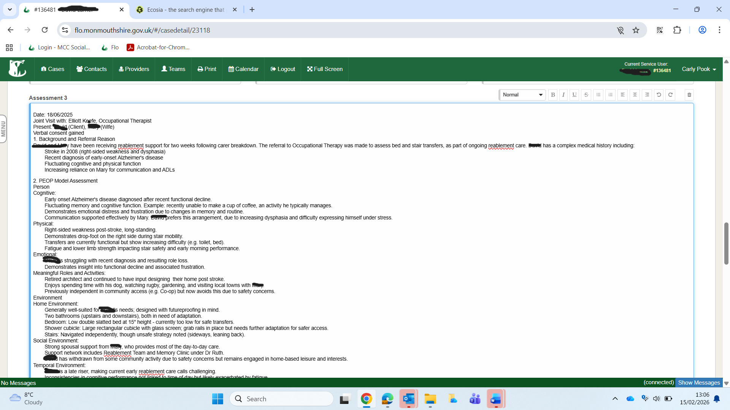
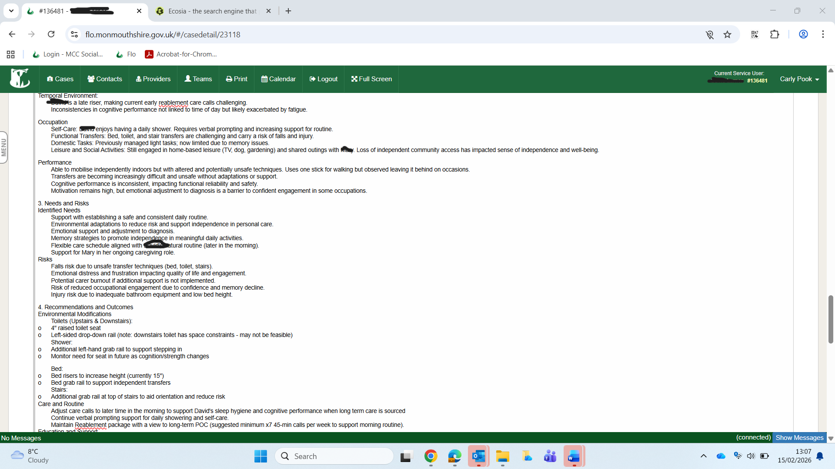

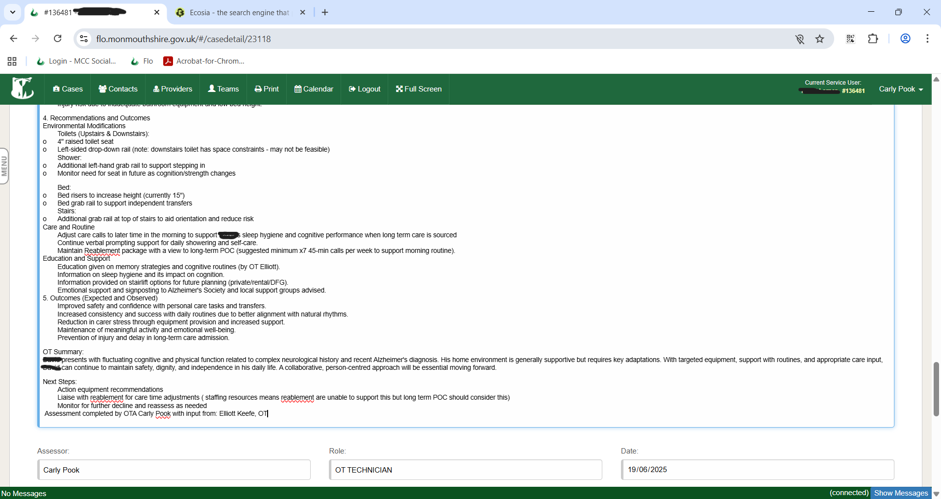

Appendix D2
Below is a screenshot of an assessment that corresponds with the second observation in appendix A.
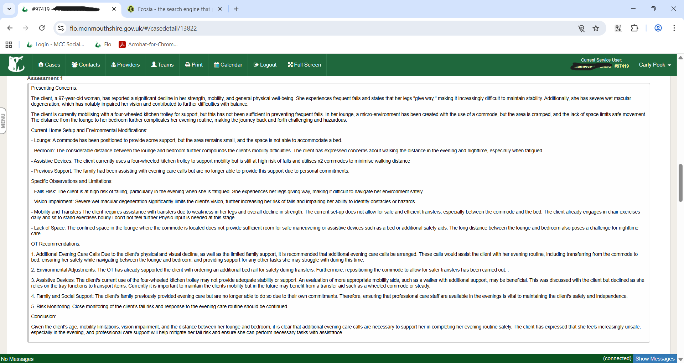
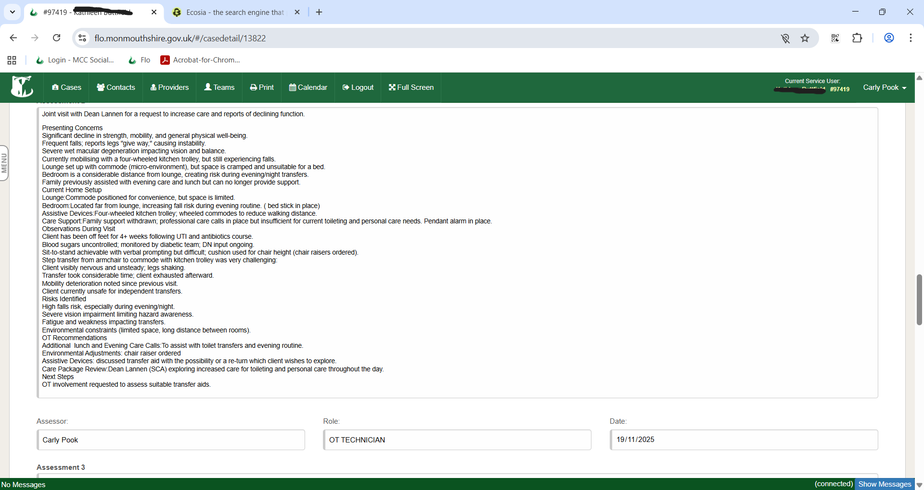

Appendix D3

Below is a screenshot of an assessment that corresponds with previous submitted reflection on caseload priority.

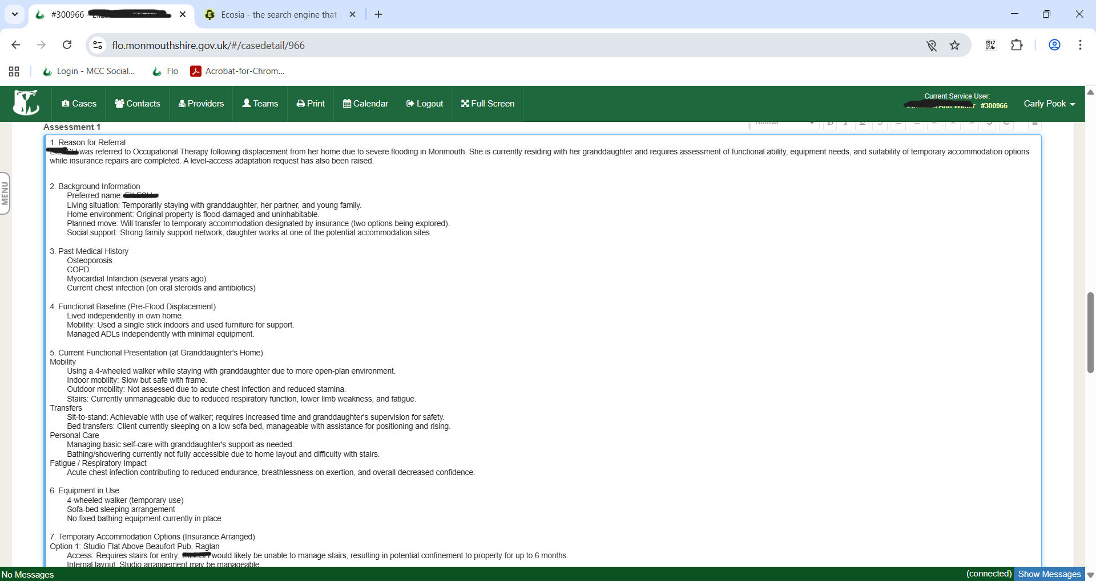
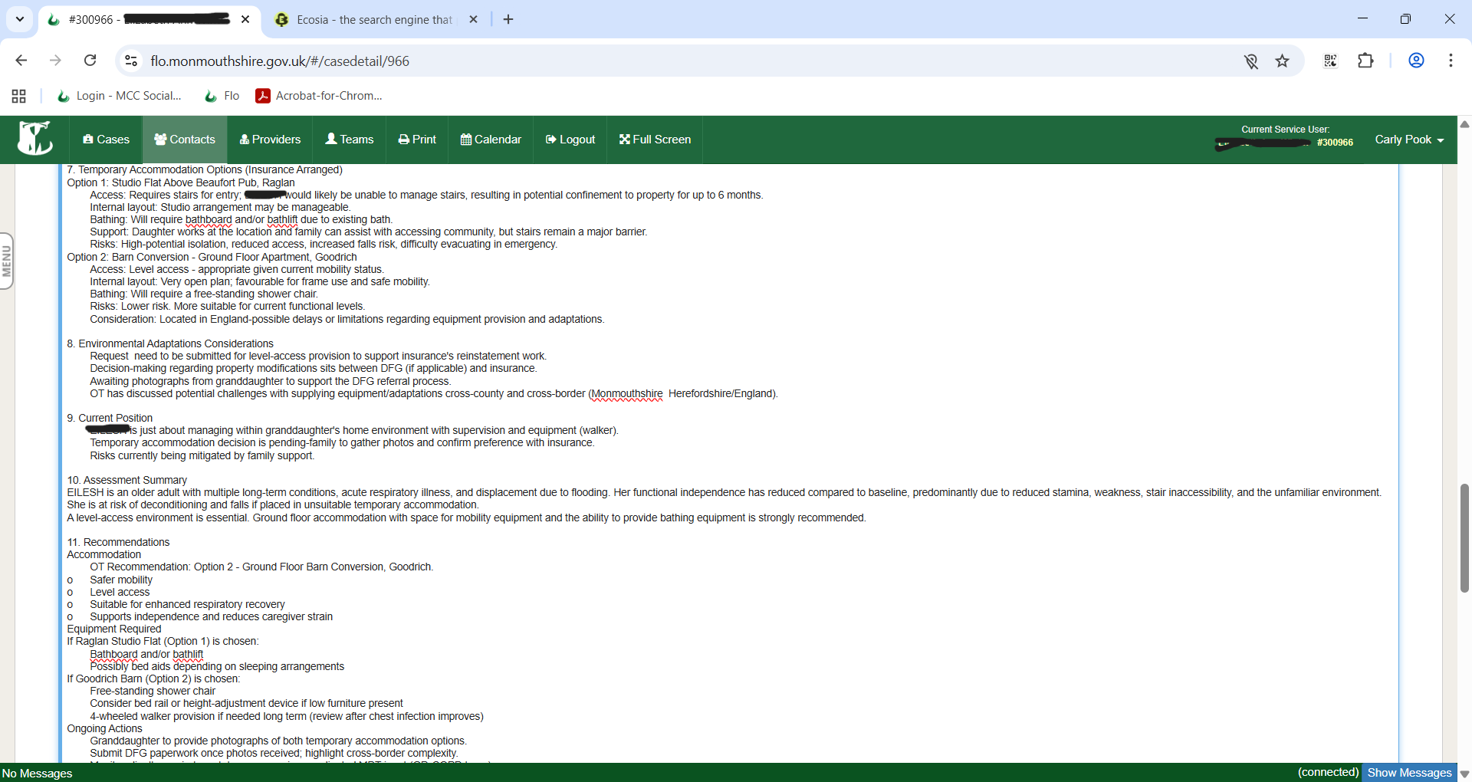

Appendix E
Below is a copy of The Monmouthshire County Council Check In Check Out (CICO) document which is an annual appraisal and is the equivalent of NHS PDAR documents.

Carly Pook Appraisal – 20.02.2025
Attendee’s
Carly Pook (Therapy Technician)
Kelly Davies (Integrated Team Manager)
Emily Lewis (Senior OT)

5 Questions and guidance notes to help your C.I.C.O Appraisal conversations
- What are the right skills, knowledge and behaviours required in your role?
Consider what's important, role profile and priorities
Carly manages her caseload independently; this was initially delegated by her supervisor Emily Lewis. Carly often takes the initiative and works well independently in her role as Therapy technician and is able to ask for help when needed.
Carly has a high degree of independent clinical reasoning and decision making and has modelled feeling confident and competent to make the decisions that she does, within her scope of practice. Carly clearly documents her clinical reasoning within her case recordings and referrals.
Carly creates and plans individualised, person centred, goal focussed OT plans for service users on her caseload. Within her scope of practice Carly is required to be able to adapt and develop her approach with clients utilising the various OT approaches to support clients to engage in assessment and intervention and promote health and wellbeing.
Carly is confident and competent in assessing for a range of equipment including bath lifts, chairs, riser recliners, wheelchairs.
Carly recognises areas that she wishes to develop further in. Carly is actively seeking opportunities through MCC to be able to complete the Trusted Assessor level 3 and 4 or training of the equivalent qualification. Carly is seeking to do this for herself and opportunities for her peers to attend this also. This will enable Carly to take on higher level work including assessing for adaptations.
Carly has recently completed an apprenticeship in level 4 Advice and Guidance and actively seeks opportunities to continue to develop and progress in her current role. Carly shared that she would like more responsibility and to be involved in creative OT related projects.
Monmouth Integrated Team are now based within our Multidisciplinary team room. Carly shared the positive aspects of this development with greater communication and collaboration. Carly viewed this as a supportive team atmosphere.
What should other people see that shows you have the right skills, knowledge and behaviours?
Consider experience, feedback, observation, data and stories
Carly is friendly, approachable and confident in her ability to complete visits independently and is able to clinically reason her assessment and interventions. Carly requests advice or assistance for more complex cases that may require input from a qualified OT or Physiotherapist where necessary.
Carly should be observed to be able to support with completing sessions on the ‘Duty desk’ which includes being able to gather sufficient information for referrals and signpost to other services when appropriate.
Carly has had positive feedback from colleagues demonstrating her ability to independently assess patients and problem solve under pressure.
Within supervision, Carly has discussed at length and completed a case study on a case she has recently been working with. Carly’s case study demonstrates her ability to adopt the different OT approaches and harness these through a reablement approach to increase patients’ independence and quality of life through engagement in meaningful occupations.

- What is your current progress?
Consider your, your managers, your teams and your customers' observations and feedback. Examples, short stories, illustrations of the way in which the core behaviours have been demonstrated and displayed in a positive sense. This requires the employee to demonstrate a clear understanding of the behaviours, their importance and how they are applied in the context of working examples.
Carly has demonstrated the ability to be able to complete a range of assessments including mobility assessments, transfer assessments, kitchen assessments, bathing assessments, assessments for adaptations etc. Carly has demonstrated that she has the appropriate skills, knowledge and experience to complete these to a high standard, demonstrating her clinical reasoning throughout.
Carly has also demonstrated the ability to create and implement a reablement programme with patients. She has demonstrated her ability to evaluate things as they change and review and reassess what patients’ goals are to ensure that her interventions remain patient focused.
Carly has been observed to be able to complete a duty visit with support of an OT colleague and has completed multiple duty visits with physiotherapy colleagues. Carly was observed to be able to complete a thorough assessment and clinically reason with the support of OT the reasons for joint decisions and next steps during the duty visit with OT.
Carly recognises areas that she wishes to develop further in. Carly is actively seeking opportunities through MCC to be able to complete the Trusted Assessor level 3 and 4. Carly is seeking to do this for herself and opportunities for her peers to attend this also. This will enable Carly to take on higher level work including assessing for adaptations.
Carly has recently completed an apprenticeship in level 4 Advice and Guidance and actively seeks opportunities to continue to develop and progress in her current role.
Within the team we have also had a new band 3 therapy technician start, Carly has taken an active role in taking the band 3 out on visits to support them with integrating into the team and helping them to gain an understanding into the role of OT technician within our area of practice.

- What's getting in the way of progress and how could it be better?
This is where the detail needed to make it happen is recorded. Identify gaps in skills, knowledge, behaviours. Consider solutions eg coaching, learning, development or other opportunities. Guidance and training will focus on how to identify what is real and relevant and what is not. Support on the proper identification of training needs will be provided.
At the time that Carly was successful in securing her post as a therapy technician within MCC, having been a band 3 within the same team for several years, there were therapy technician vacancies. At this time opportunities for Carly to support less experienced therapy technicians were unavailable. More recently, two new therapy technicians joined the team. Carly has taken the opportunity to support them in their induction, supporting with shadowing opportunities and supporting as a more experienced therapy technician.
Carly is also presently seeking support for funding through MCC for herself and colleagues to complete a trusted assessor course which would enable her and her therapy technician colleagues to be given the knowledge and skills in what to look for and consider when thinking about referring patients for adaptations.
Carly identified what she believed to be an area for further development such as when a patient may benefit from a riser recliner chair. Carly completed a joint visit with Senior OT and mentor, Emily Lewis to assess for this and Carly has since progressed to independently assess a patient for a riser recliner with support from Emily in actively reflecting on her clinical reasoning following the visit.

- What needs to happen next?
This should be specific, measureable and will link to SIPs and business outcomes. Record actions, agreements, resources and timescales. Follow through on your next steps quarterly.

1. Complete Level 4 Trusted Assessor Training
Goal:
Carly will continue to seek support to enrol on the Level 4 Trusted Assessor training to enable safe and timely assessment for basic equipment and minor adaptations, reducing demand on qualified OTs.
- Specific: Complete Level 4 Trusted Assessor course
- Measurable: Course certificate obtained
- Achievable: Training available via recognised provider
- Relevant: Supports service capacity and role development
- Time-bound: By December 2026

2. Enrol in Level 4 Assistant practitioner course
Goal:
Carly will enrol in and begin the Level 4 Assistant Practitioner course by September 2026 to support progression into an extended scope role and contribute to service resilience.
- Specific: Submit application and begin course
- Measurable: Enrolment confirmed by Q4
- Achievable: Part of career progression pathway
- Relevant: Links to workforce transformation priorities
- Time-bound: By September 2025

3. Develop and Maintain a CPD Portfolio
Goal:
Carly will build a CPD file with at least one entry per month, reviewing progress quarterly, to support HCPC readiness and continuous professional development.
- Specific: Create and maintain CPD file
- Measurable: 12 entries per year minimum
- Achievable: Supported with supervision and CPD time
- Relevant: Aligns with PDP, registration standards, and service learning culture
- Time-bound: Ongoing, reviewed quarterly

4. Set Up Peer Support Group for Therapy Technicians
Goal:
Carly will help launch a peer support group for Band 3–4 therapy technicians by January 2026, with at least three sessions trialled and feedback collected to inform long-term sustainability.
- Specific: Develop and trial peer support sessions
- Measurable: Minimum 3 sessions held and evaluated
- Achievable: Collaborative approach with peers and managers
- Relevant: Enhances peer development and staff wellbeing
- Time-bound: By January 2026

5. Progress Toward Completing Occupational Therapy Degree
Goal:
Carly will actively pursue enrolment of an Occupational Therapy degree by September 2028, starting with identifying entry requirements, funding options, and completing access or bridging modules if required.
- Specific: Complete OT degree
- Measurable: Evidence of yearly academic progress
- Achievable: Through Assistant Practitioner route and recognised university programme
- Relevant: Long-term goal aligned with service needs and personal development
- Time-bound: By September 2028, with annual progress reviews


Kelly Davies (ITM) Carly Pook (TT) Emily Lewis (OT)

Appendix F

Below is a copy of my most recent supervision record from January 2026.

Supervision Record
Supervisee Name |  | Carly Pook
Supervisor Name |  | Emily Lewis

Supervision information
Meeting date |  | 27.01.2026
Location |  | Usk Hub
People present at supervision |  | Carly Pook
Person responsible for taking supervision notes |  | Emily Lewis - Supervisor

Agenda
Guidance: All parties are able to add agenda items for supervision
Details:

- Well-Being
- Workstream
- Learning & Development
- Any Other business (AOB)
- Actions

Topic/area | Details of what was discussed &  decisions made
Well-being  (Work-life balance, any issues, etc.) | Carly feels that she is ok – traffic has been particularly bad today which causes some difficulties.  2 working days a week – Carly reports that she is fining this tough due to a pull in multiple directions. Worries that she isn’t able to fully commit to certain aspects due to being pulled in multiple directions.  Meeting with Nat, myself and Clare about their roles.  Long discussion about reablement – Carly feels really passionate about this but there are difficulties ongoing with reablement. We discussed that Annette and Nat are aware of this and are attending the MDT’s in the coming weeks.  Carly feels her wellbeing is low due to the current state of the service and having to plug gaps for other services.
Workstream  (Case discussion, projects, what’s going well, what could be done differently) | Renne Reynolds – Carly visiting today for bathing assessment. Swivel bather in place sits too high for her to transfer and struggles to sequence the task to use the swivel bather so Carly is going to take out a bath board and bath step  Ronald Doxey – Joint visit with Rosie completed, goal is to get back outside to go to the betting shop and WH Smiths, balance is poor so needs PT. Rosie has given PT exercises which Carly is visiting weekly to complete exercises. On DFG list for adaptation. Emily to raise this to Nat as this case should be sat with PT Team – previously involved with Paul Cox who issued walker and discharge.  Simon Foster-Jones – Deterioration in ankle, had a virus 2 years ago that took him to bed and has been doing commode transfers/ wheels himself around on the commode. Goal – to be out of bed more. Wants to be able to walk/ go downstairs/ go outside. Did walk back from the bathroom to the bed 2 weeks ago with Carly- good example of positive risk taking. Had wheeled commode for use if he needed to sit. Needs the right exercises for stamina and to build up his legs. Emily to raise this with Nat as this case should be sat with PT Team. Struggles with bed mobility at times so Carly is going to issue a set of in situ slide sheets.  Margaret Harper – Waiting for wheelchair to be delivered. Only outstanding OT input then will be discharged.  Diana Baxter – Need to call to check bed rail has been delivered, input is focusing around bed transfers and perfecting technique.  Grenville Burgess – To be discharged. Needs to go to a new PT in absence of Lucy.  Granville Walton – Awaiting a RR and adaptation through Melin. Once RR in place will go to adaptations list.  Elizabeth Ann Winter – Residing in a shed in the familys garden, housing are not being helpful. Carly is going to assess for DFG in her own home for when she moves back to her property.  Hugh Roger Floyd – On MV ward – monitoring how he is doing as DFG will be needed if returned home.  Edward Beavis – Carly going to visit tomorrow. Previously known to her.
Training and development  (Personal Development Plan, training attended, learning completed) | Carly to have a look at her mandatory training and other training that she may likes that she may wish to book onto.
AOB | We discussed the current state of the service – We discussed the staffing issues and concern for the impact on our work given that the PT team is depleted and the SW team is depleted and the likelihood is that we may absorb this. Discussed that Nat is due to meet with Jenny Jenkins in the coming weeks and that it is perhaps a good idea to feedback thoughts and feelings.

Actions
 | - Emily to discuss RD and SFJ with Nat |  |  | By when? |  | Completed date
 | - Emily to ask Nat if Carly needs to do Safeguarding B and C or just B
 | - Carly to look on Thinqui at training opportunities

Date of next supervision
Date and time
Location | Monnow Vale unless otherwise agreed

Confirmation and signatures
 | Name |  | Signature |  | Date
Supervisee | Carly Pook |  | Carly Pook |  | 27.01.2026
Supervisor | Emily Lewis |  | E.Lewis |  | 27.01.2026

Appendix G
Below is an additional copy of a supervision record from December 2025.

Supervision Record
Supervisee Name |  | Carly Pook
Supervisor Name |  | Emily Lewis

Supervision information
Meeting date |  | 17.12.2025
Location |  | Monnow Vale
People present at supervision |  | Carly Pook
Person responsible for taking supervision notes |  | Emily Lewis - Supervisor

Agenda
Guidance: All parties are able to add agenda items for supervision
Details:

- Well-Being
- Workstream
- Learning & Development
- Any Other business (AOB)
- Actions

Topic/area | Details of what was discussed &  decisions made
Well-being  (Work-life balance, any issues, etc.) | Carly feels that she is ok. Carly still feels she isn’t well or right and raised some current difficulties regarding her personal life. OT advised that we are here if she needs us but also understands if she does not want to discuss this.
Workstream  (Case discussion, projects, what’s going well, what could be done differently) | Caseload:  Grenville Burgess – Carly is concerned about his wife who is doing everything for him. Needs significant prompting to do things. Wife needs to cut up food as his swallow is affected. They have plates with a lip to support him with feeding himself. She is up 3-4 times a night with him. OT tech support is around bed transfers, utilising the hospital bed controls to support with this to reduce strain on her. Carly also supporting with installation of another rail in the bathroom. Wife is looking into adaptation privately because the DFG team were unable to support with this. Fire service visiting in January to do an assessment and an evacuation plan. Carly is writing this up to go to QALG next week.  Ronald Doxey- Visited today – assessment of outdoor mobility, was at risk of falls and would need a 4WW, there is one in the garage. Is more PT than OT tech. His priority is mobility, getting out onto the bus to go to the dentist. Needs balance, strength and stamina input. His goals aren’t around meals anymore as he has meals on wheels. Has given consent for installation of rails at the front door. Is going to speak to Rosie/ Lucy (PT) for provision of appropriate exercises. Microcarer has started – reablement likely to end. Tasks that he is not independent with are more microcarer type tasks, stripping bed, taking him out shopping etc.  Roger Floyd – Adaptation referral completed and sent for bathroom adaptation and wash/dry toilet. He has been weary about the adaptation and funding etc so Carly keeping open for now until this is completed and then to go onto the DFG list.  Caroline Millar – Carly unable to contact her. Husband has now been diagnosed with cancer, he has asked for shower calls to be reinstated, Carly has offered to visit but they have declined this. Finance are chasing things up as Caroline is in debt regarding her care and then Caroline advised that she didn’t want care. Discussed sending a letter out to her and closing the case.  Penny Thomas – Now does not want the dropdown cupboards – to discharge.  Granville Walton – Put through for Melin adaptation – Stephen Waygood wants to speak to Carly about this gent so only presently open whilst awaiting this.  Elizabeth Ann winter – Displaced in the flooding – Was in the premier inn but is now in a log cabin at the bottom of her familys garden. Has a chemical toilet in place which helps but is not ideal. In contact with Dale/ Naiomi Lovesay and QALG regarding options for her in the longer term. Presently has the flu. Sleeping on a sofa but which is ok at present but this wont be suitable if things deteriorate. Has OT needs but cant support really in the present environment. Carly is going to phone the housing officer to see what support can be given/ what the plan is.
Training and development  (Personal Development Plan, training attended, learning completed) | Carly has been completing the TAP course for nearly 3 months now. She has submitted her first assignment and is awaiting feedback on this. They accepted her presentation (which was video recorded) as Carly was not very well.  Carly played me a voice note of feedback given for her presentation including that “your contribution was quite profound” and fed back that she had “sound knowledge of strengths and drawbacks of systems of work discussed”. Further comments include that Carly is a “natural leader” and that she is calm in her approach.  Carly’s work for marking includes presentation, assignment, 2x group discussions and a reflection so far.  First module completed just starting second module, there are 3 a year.  Current module:  - Example of Communication – Elliots observation of practice demonstrated how Carly was really good with her communication skills on a visit  - Example of Prioritising caseload – Carly has examples of how she has had to prioritise urgent cases over others and her clinical reasoning behind this.  - Person centred care – SRB – Really good example of completing person centred care, grading and pacing technique, extended reablement.  Upcoming work to be completed by around Feb 2026:  - Presentation - Service improvement – Carly is going to follow on from our recent OT students presentation and look at either the set up calls for reablement or goal setting. Emily discussed previous service improvement where we looked at making an information gathering / assessment template to be used by reablement to better support goal setting and understand peoples baseline mobility- this was created and is presently part of a wider reablement transformation plan.  - Reading and learning related to the role – Carly feels she has things to reflect this  - 3 copies of assessments – Carly has this  - Copy of appraisal -Carly has this  - 2 copies of supervision – Carly has these  - Risk assessment – Gent who has DP – Really good assessment #382917  - Observation of practice – Carly has observations from myself, Elliot and Amy is also doing one.  - Training participated in – Carly has copies of training completed  - Mandatory training – Carly to look into this as she may be behind with this.
AOB

Actions
 |  |  |  | By when? |  | Completed date

Date of next supervision
Date and time | 27.01.2026
Location | Monnow Vale unless otherwise agreed

Confirmation and signatures
 | Name |  | Signature |  | Date
Supervisee | Carly Pook |  | Carly Pook |  | 17.12.2025
Supervisor | Emily Lewis |  | E.Lewis |  | 17.12.2025

Appendix H1
Below is an example of risk assessment within an Initial assessment. They contain a variety of different risks to support equipment needs, care needs or third sector support services.
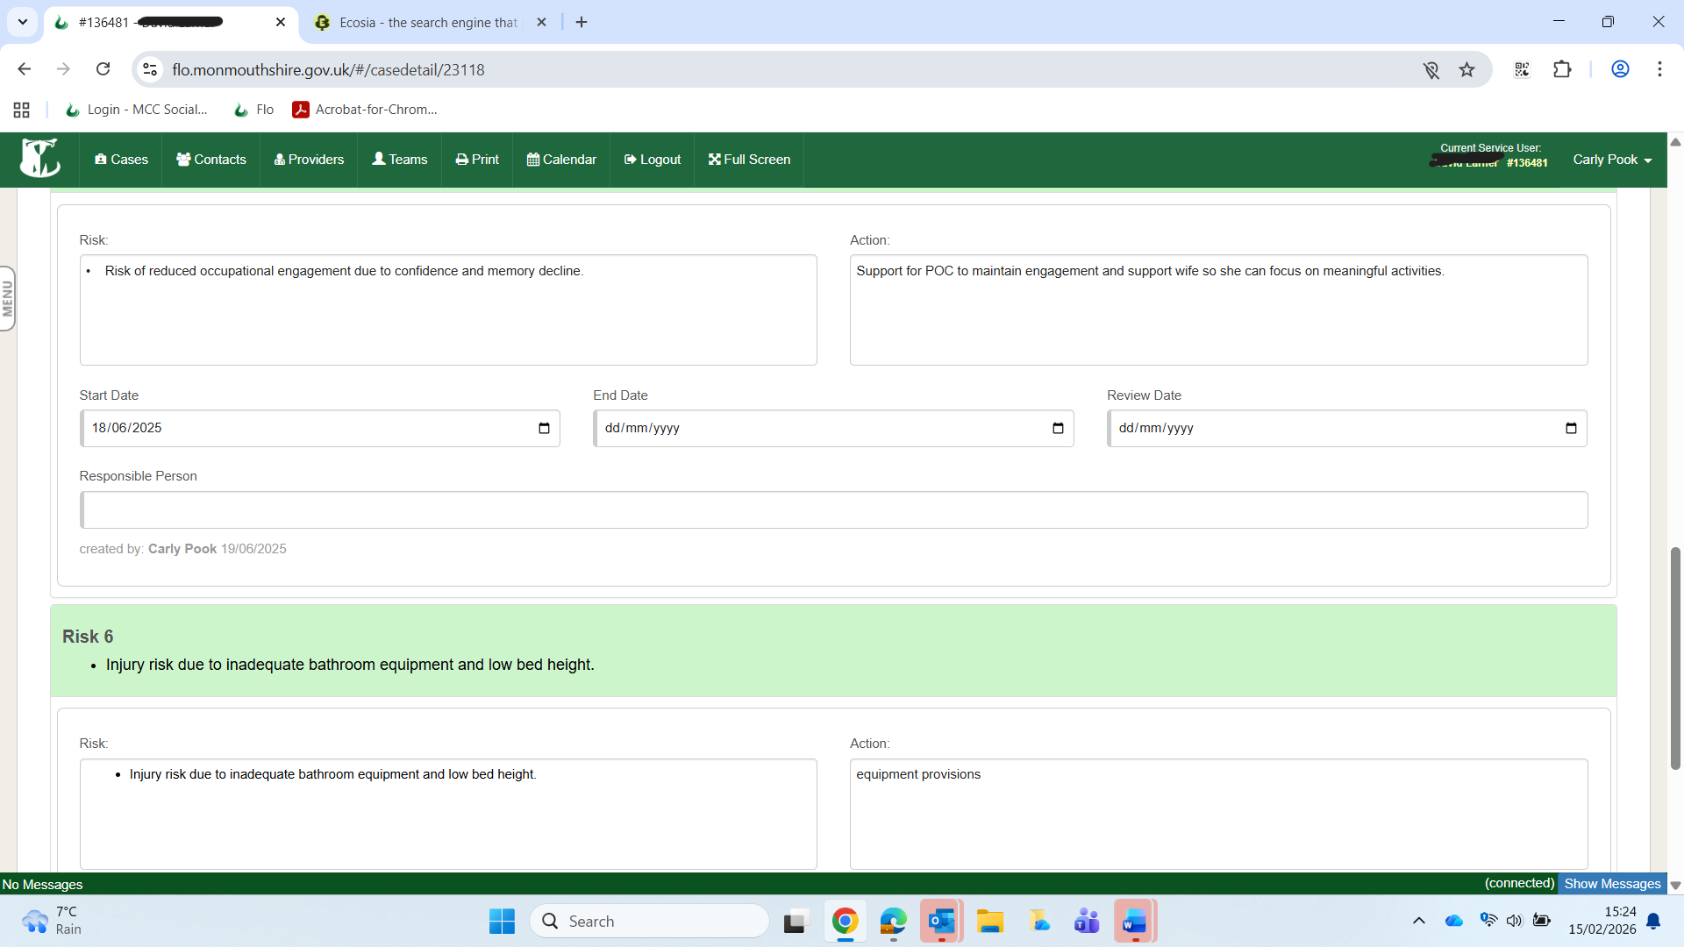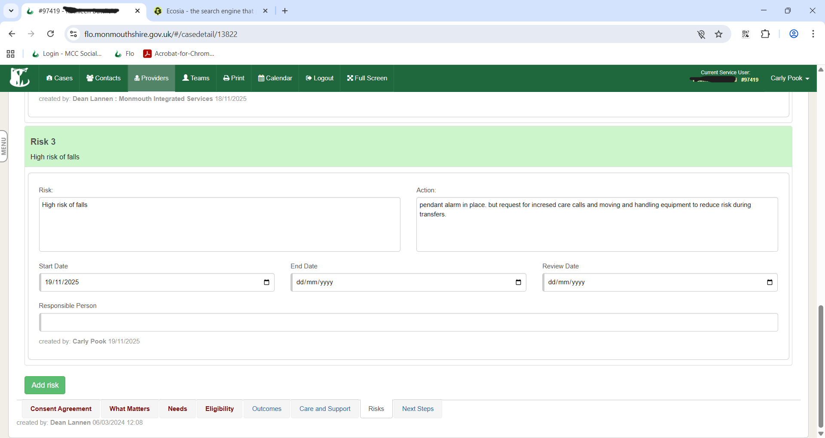

Appendix H2

Below is an example of a bedrail risk assessment in line with Aneurin Bevan University Health board Policy when issuing bed rails.

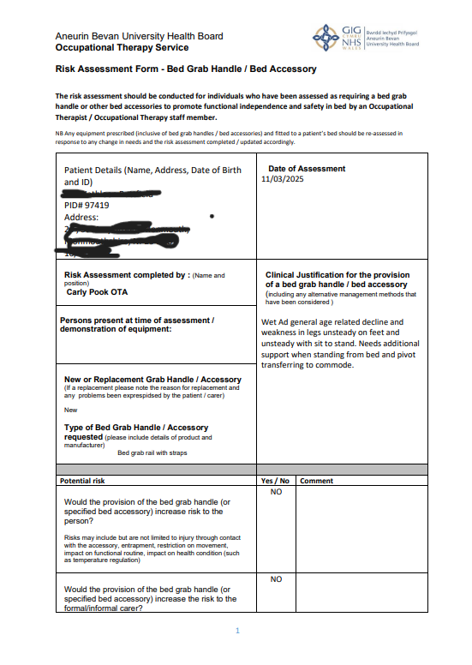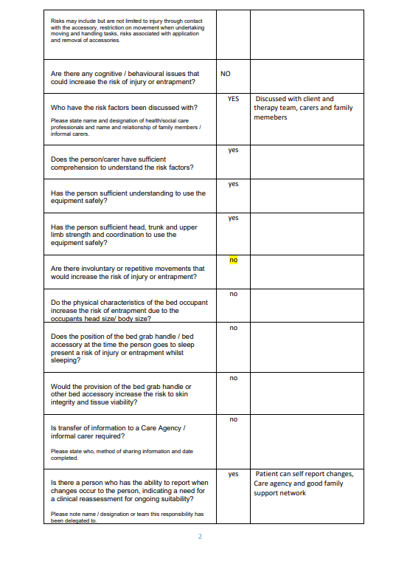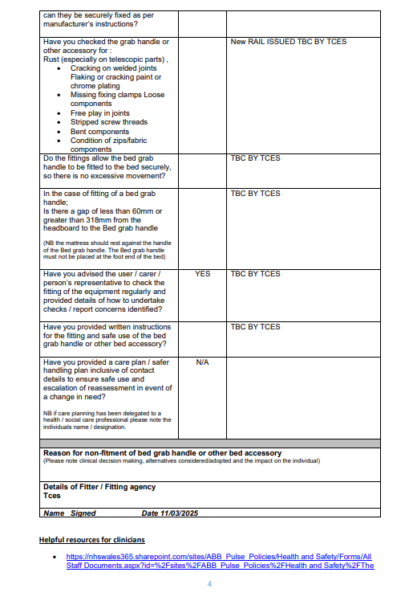
Appendix H3

Below is an example of a dynamic risk assessment of stair lift transfers considering an individual’s ability and environmental factors.
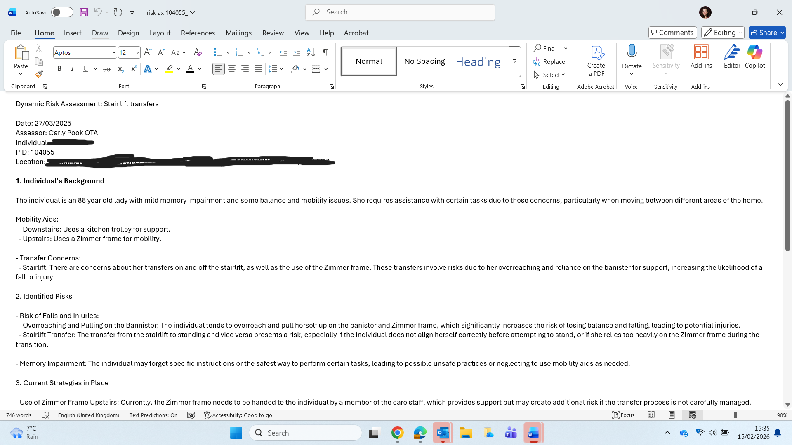
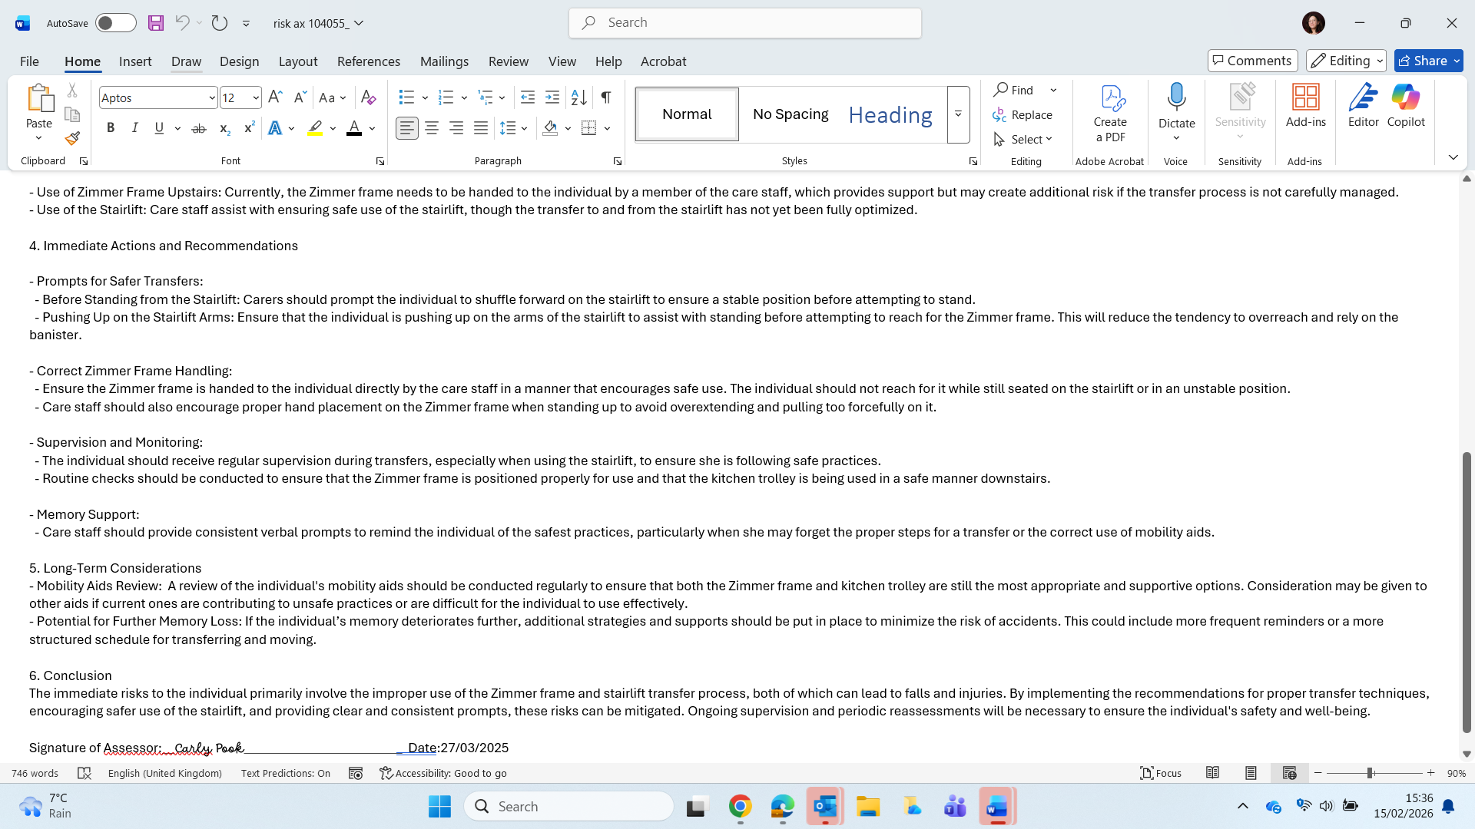

Appendix I

Below is a screenshot of my CPD record. 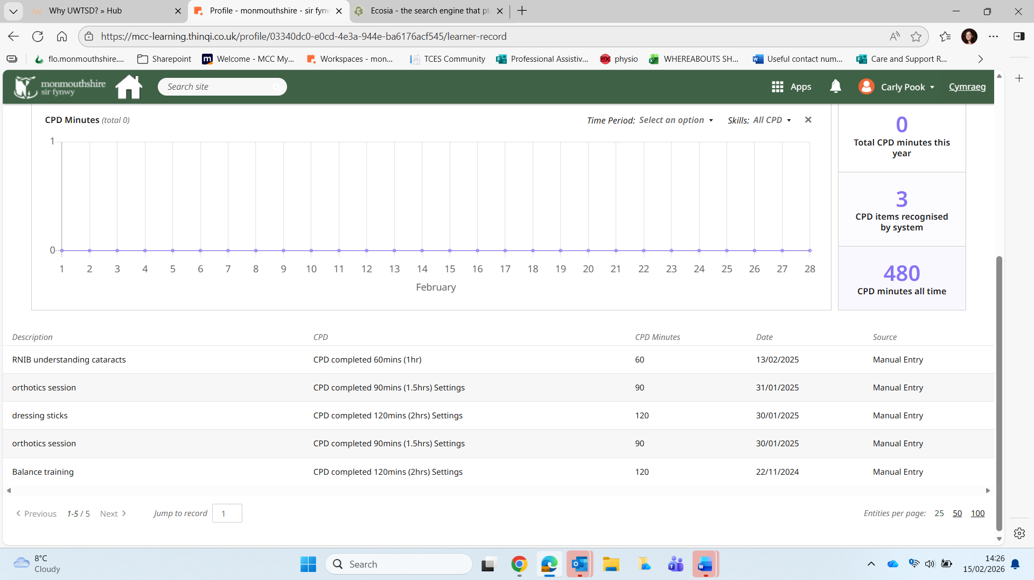

Appendix I2

Below is an example of two reflections where I supported new starters within the integrated team.

Supporting Band 3 and Band 5 colleagues allowed me to develop my leadership and teaching skills while making my clinical reasoning explicit. This experience highlighted the importance of adapting information delivery to avoid overload and ensure learning is meaningful. Teaching others reinforced my own understanding of equipment criteria, risk assessment, and pathway navigation. It also demonstrated my growing ability to contribute to workforce development and service resilience, aligning with my professional development goals.

Reflection 17/07/2025 – Teaching a Band 3 Reablement Technician About Bathing Equipment
This is a reflection on supporting new band 3 technicians using the Gibbs cycle of reflection.
Description
During this period of practice, I supported the development of a newly appointed Band 3 Reablement Technician through structured shadowing visits focused on bathing assessment and equipment provision. My intention was not only to demonstrate equipment use, but to make my clinical reasoning explicit, linking each equipment choice to functional ability, environmental context, and risk profile. During joint visits, I demonstrated and compared bathing equipment options including bath boards, bath lifts, and swivel bathers. I explained the functional criteria underpinning each selection, including sitting balance, upper limb strength, transfer method, fatigue levels, cognition, and sequencing ability. I also highlighted contraindications and safety considerations, ensuring that equipment provision was framed as a clinical decision rather than a task-based solution.
Feelings
I felt confident in demonstrating the equipment but also aware of the responsibility to translate clinical reasoning clearly for a newer colleague. I wanted to ensure I did not just show how equipment works, but why and when it should be chosen. I was mindful not to overload them with information while still modelling safe and evidence-based practice. I felt encouraged by their engagement and questions during the visits.
Evaluation
The shadowing experience worked well because it combined real assessments with practical demonstration. The Band 3 technician was able to see how decision-making changes depending on presentation. For example:
• A bath board was appropriate where the service user had good sitting balance and upper limb strength but reduced step-over ability.
• A bath lift was demonstrated where lower limb weakness or pain prevented safe transfers and controlled lowering was required.
• A swivel bather was discussed for users with limited hip movement or poor pivot ability but who could tolerate a seated rotation transfer.
What worked particularly well was linking each equipment choice to specific functional criteria rather than preference. What worked less well was time pressure during one visit, which limited deeper discussion.
Analysis
This experience reinforced that equipment provision is not task-based alone but person-environment-occupation based. Each item has clinical justifications:
• Bath board: promotes independence, low risk when balance and cognition are intact, minimal moving parts, suitable for reablement goals.
• Bath lift: reduces physical demand, manages fatigue and pain, appropriate when safe controlled descent is needed, but requires cognition and hand control for operation.
• Swivel bather: useful where lateral transfer is safer than step transfer, but requires trunk control and coordination.
Teaching in context allowed the Band 3 to connect theory with observation. It also highlighted the importance of explaining risk assessment, contraindications, and progression planning rather than presenting equipment as static solutions.
Conclusion
Joint visits are an effective way to build Band 3 clinical reasoning when paired with structured explanation. Demonstrating equipment alongside assessment findings improves understanding. I recognised the need to pace information and check understanding during visits. This experience highlighted the importance of translating tacit clinical reasoning into visible decision-making when supporting less experienced staff. I recognised that without structured explanation, equipment choice can appear preference-based rather than criteria-based. I therefore adapted my approach by pacing explanations, checking understanding, and encouraging the Band 3 technician to justify their own equipment recommendations using functional indicators.
This teaching activity reinforced my own clinical reasoning and strengthened my leadership and supervision skills within scope of practice. It also contributed to safer and more consistent equipment provision within the reablement pathway by improving shared understanding of assessment criteria.
As a result of this experience, I have adopted a more structured approach to peer teaching, including use of comparison criteria, pause-point debriefs, and guided reasoning questions. This supports workforce capability while maintaining person-centred and risk-aware practice.
Action Plan
On future shadowing sessions I will:
• Build in short pause points after visits for questions and recap
• Use a simple comparison checklist for equipment choice
• Ask the Band 3 to suggest equipment options and justify them
• Provide a short written summary guide for bathing equipment criteria
This teaching activity supports safer delegation, shared clinical reasoning, and workforce capability developed in line with local reablement- governance and competency expectations.

Reflection 20/06/2025– Supporting a New Band 5 Rotational OT on Joint Initial Assessments
This is a reflection on supporting rotational Band 5 using the Gibbs cycle of reflection.
Description
I supported a new Band 5 rotational Occupational Therapist by taking them on joint initial assessments. The aim was to demonstrate assessment structure, eligibility criteria for Disabled Facilities Grants (DFG), specialist seating indicators, and how to navigate referral pathways and documentation systems. During visits I modelled functional assessment, environmental analysis, and risk identification. I explained when cases meet DFG thresholds versus standard equipment provision, highlighted red flags for specialist seating referrals, and demonstrated completion of referral forms and pathway routing.
Feelings
I felt positive about contributing to the Band 5’s induction and professional development. I was aware they had theoretical knowledge but less exposure to local systems and thresholds. I felt a responsibility to present consistent, policy-aligned guidance. I also noticed I needed to slow my usual workflow to make my reasoning visible rather than assumed.
Evaluation
The joint visits were effective in demonstrating:
• How to structure an initial assessment
• How to identify when needs are adaptation-level vs equipment-level
• When to consider DFG referral criteria
• Indicators for specialist seating assessment
• How to navigate local referral systems and paperwork
The Band 5 engaged well and asked appropriate questions. Demonstrating real documentation and live pathway navigation was particularly useful. A challenge was that systems navigation is complex and can feel overwhelming when shown all at once.
Analysis
This experience highlighted that early-career clinicians often need operational knowledge as much as clinical reasoning. Key learning areas included:
DFG criteria demonstration included:
• Permanence of need
• Structural adaptation requirement
• Functional impact on essential activities
• Cost-benefit and proportionality considerations
Specialist seating indicators discussed included:
• Postural instability
• Skin integrity risk
• Complex neurological or musculoskeletal presentation
• Failure of standard seating solutions
Referral pathway teaching included:
• Correct service routing
• Required evidence for acceptance
• Documentation standards
• Consent and information governance steps
Seeing the process end-to-end helped connect assessment findings to system action.
Conclusion
Joint assessments are highly effective for onboarding rotational staff when paired with transparent reasoning and live system demonstration. However, information should be staged to avoid overload. Linking criteria directly to real cases improves retention.
Action Plan
For future Band 5 shadowing support I will:
• Break pathway teaching into stages across multiple visits
• Provide a quick reference guide for DFG and specialist seating criteria
• Encourage the Band 5 to complete draft referrals for feedback
• Use reflective questioning during visits to build reasoning confidence
• Schedule a short debrief after each joint assessment
Supporting induction and pathway understanding at this level contributes to service consistency, governance-aligned referral decisions, and safer system navigation across the integrated team.

Appendix I3
Below is a copy of minutes from a peer support group I sent up and chaired to provide a peer support forum for band 3 and 4 therapy staff.

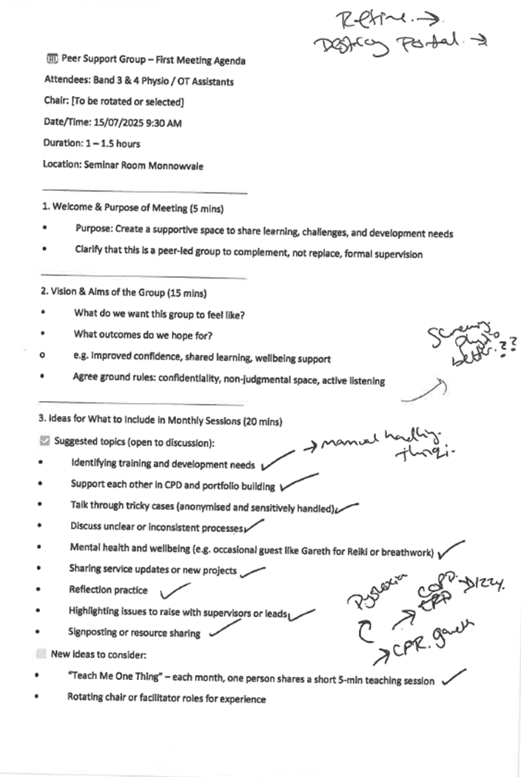
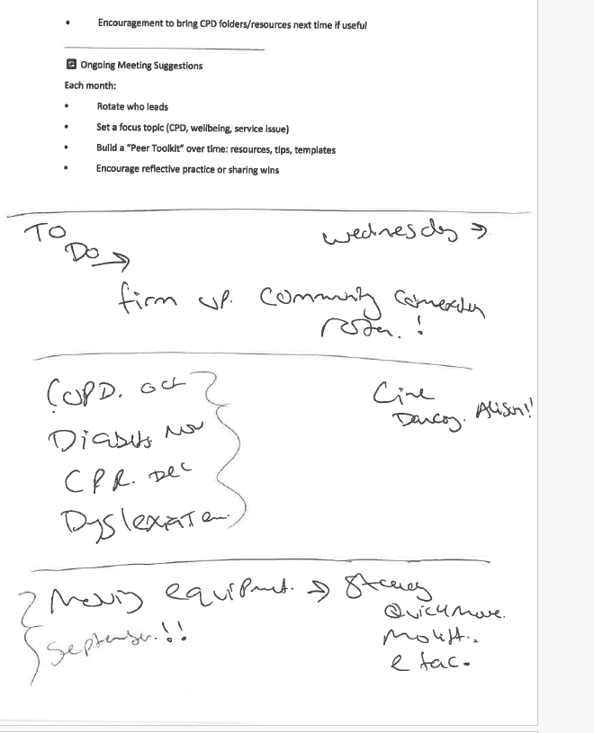

Appendix I4
Below are two certificates demonstrating presentations I have delivered to a cohort of students on the TAP course.

Presentation on the role of the

Therapy Assistant Practitioner
  - This certificate is awarded to

Carly Pook
  - For demonstration of leadership skills through a presentation
  - required within their role as a therapy assistant practitioner,
  - in response to an increased caseload
 | Awarded by:  Sarah Collins (Lecturer) |  | Date:  12th February 2026

Presentation of a quality improvement project
  - This certificate is awarded to

Carly Pook
  - For sharing their quality improvement project
  - using a Plan Do Study Act (PDSA) model.
 | Sarah Collins (Lecturer) |  | 12th February 2026
Appendix J

Below is a screenshot demonstrating compliance with mandatory training. 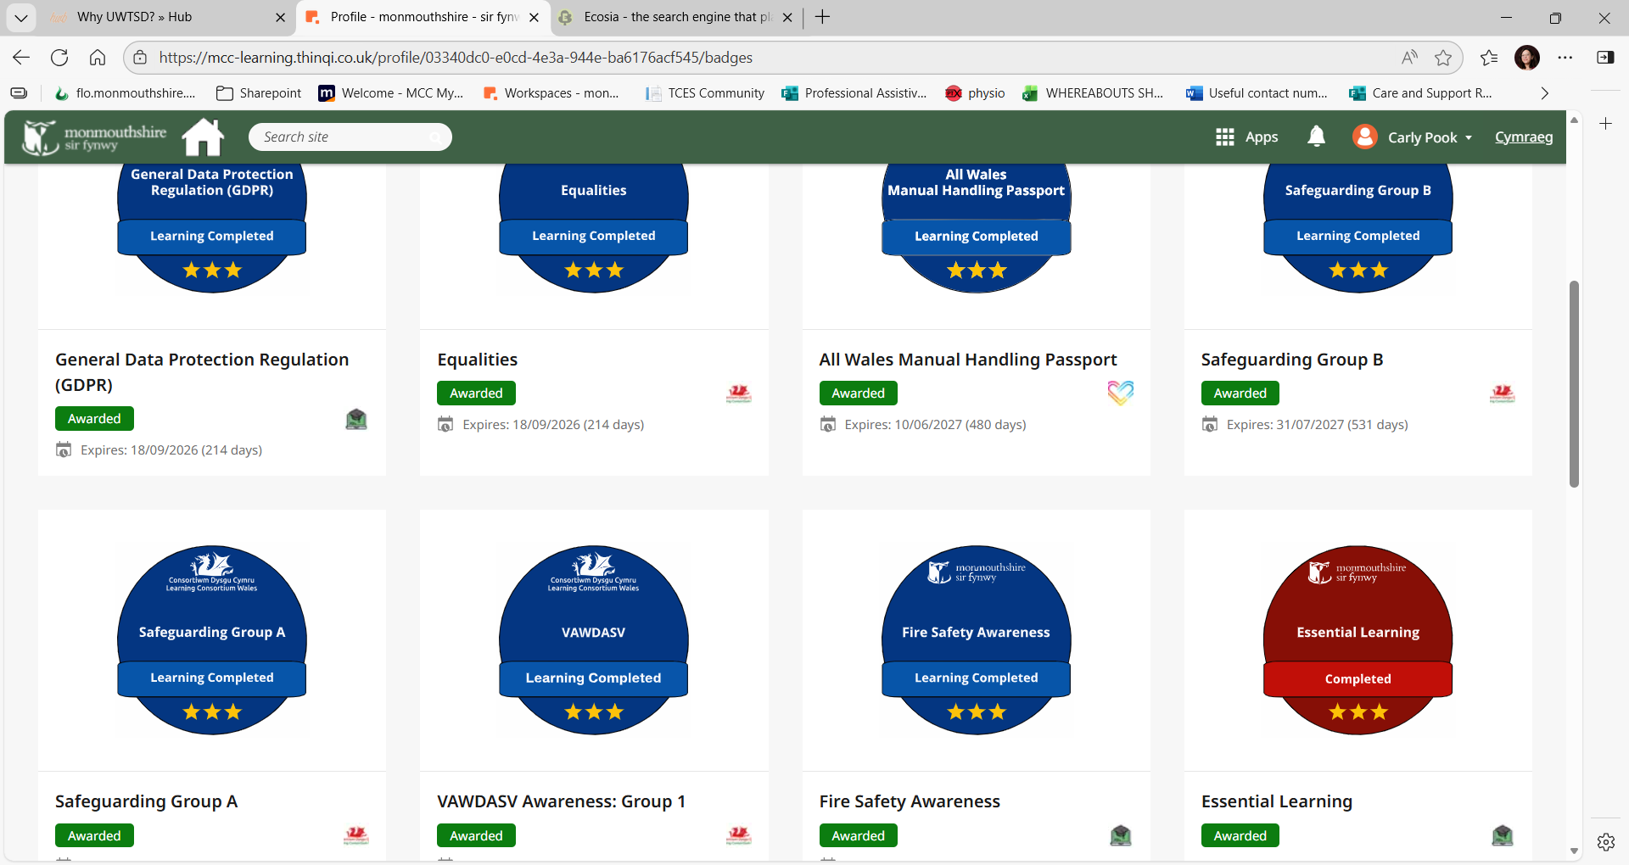

Appendix K

As part of my role within the integrated reablement pathway, I identified recurring gaps in consistent information gathering, staff confidence, and decision-making around basic equipment provision and referral into reablement. In response, I developed a set of practical reablement support documents and a competency framework to guide staff in key information collection, safe basic equipment provision, and appropriate referral processes.
These resources were designed to improve consistency, safety, and efficiency within reablement interventions and to support less experienced staff in applying enablement-focused practice. The documents were shared with cross-county service leads and have been accepted for incorporation into a wider service-level reablement update programme.
This work demonstrates my contribution to service development within scope of role, my ability to translate practice knowledge into usable workforce tools, and my commitment to improving quality and consistency of care delivery. Developing these resources strengthened my understanding of reablement governance, competency boundaries, and risk-managed delegation, and reinforced the importance of structured guidance in supporting safe enablement practice. Early informal feedback from staff and service leads indicates these tools improve clarity of referral information and confidence in safe basic equipment provision. This supports more consistent enablement practice and reduces avoidable escalation to qualified staff.

Competency Evaluation Form for Reablement Workers: Assessing and Fitting Equipment

Objective:
This form is designed to evaluate the competency of reablement workers in assessing needs, selecting, and properly fitting the following equipment:
- Free-Standing Toilet Frames
- Raised Toilet Seats
- Commodes
- Shower Stools
- Bath Boards

Competency Levels:
-1 - Needs Improvement: The worker is not yet able to perform this task competently and requires further training.
- 2 - Developing: The worker can perform the task with some support or guidance.
-3 - Competent: The worker can independently assess, select, and fit the equipment correctly.
- 4 - Expert: The worker demonstrates exceptional skill, shows advanced problem-solving, and can teach or supervise others.

Worker Information:

Name:__________________________________
Date of Evaluation:________________________
Evaluator Name:__________________________
Position: ________________________________

- Free-Standing Toilet Frames

Competency area | Date and Level | Date and Level | Date and Level | Date and Level
Assessing toilet height and space availability
Selecting the appropriate frame size based on user needs
Positioning the frame securely around the toilet
Adjusting the frame height to suit the user’s comfort
Ensuring the frame is stable and properly secured
Instructing the user on how to safely use the frame
Ensuring the frame does not obstruct movement

- Raised Toilet Seats

Competency area | Date and Level | Date and Level | Date and Level | Date and level
Assessing the user’s height and comfort requirements
Selecting the correct seat height and type

Positioning the raised seat securely on the toilet
Ensuring the seat fits snugly and is stable

Adjusting the seat for the user’s preferred height
Instructing the user on how to use the raised toilet seat safely

- Commodes

Competency area | Date and Level | Date and Level | Date and Level | Date and Level
Assessing the need for a commode (e.g., mobility challenges)
Selecting the appropriate type of commode (bedside, wheeled, etc.)
Positioning the commode in a safe and accessible location
Adjusting the height of the commode for comfort
Ensuring the commode is stable and secure (locking wheels, etc.)
Instructing the user on how to safely use the commode
Providing guidance on maintaining cleanliness and safety

- Shower Stool

Competency Area | Date and Level | Date and Level | Date and Level | Date and Level
Assessing the shower space and stool fit

Selecting the correct stool height based on user needs
Ensuring stool stability (checking non-slip feet)

Fitting the stool securely in the shower area
Instructing the user on how to safely use the stool
Ensuring the stool is easy to move or adjust if needed

- Bath Boards
Competency Area | Date and Level | Date Level | Date and Level | Date and Level
Assessing the user’s mobility and ability to transfer
Measuring the bath to ensure the board fits securely
Fitting the bath board securely across the tub
Ensuring the board is stable and safe for use
Ensuring the user can safely sit on the board and transfer in/out
Instructing the user on proper use of the bath board
Checking regularly for wear and damage

General Competency in Assessing and Fitting Equipment

Competency Area | Date and Level
Selecting the correct equipment based on individual needs

Ensuring equipment is securely fitted and stable

Providing clear, user-friendly instructions on using the equipment

Documenting the assessment, fitting process, and follow-ups

Conducting follow-up assessments to ensure effectiveness and safety

Evaluator’s Final Comments and Recommendations:

Strengths:
[List areas where the worker excels.]

Areas for Improvement:
[Identify areas requiring further training or development.]

Signature of Evaluator: _______________________
Date: _______________________

Signature of Worker:_______________________
Date: _______________________

This competency form helps reablement workers focus on assessing the correct equipment based on individual needs, fitting it safely and securely, and ensuring proper use by the person receiving care.

Appendix K2

Training Resource for Occupational Therapy and Reablement Support Workers: Reablement Techniques for Activities of Daily Living (ADLs)
Section 1: Introduction to Reablement
Objective: Understand the concept of reablement and its importance in occupational therapy.

What is Reablement?
- Reablement is a short-term, goal-oriented approach that focuses on supporting individuals to regain independence in their daily activities after illness, injury, or changes due to aging.
- It encourages the development of skills and confidence in performing ADLs (Activities of Daily Living), empowering individuals to maintain control over their lives.

Why Reablement Matters:
- Promotes functional independence.
- Reduces dependency on long-term care.
- Increases self-esteem and quality of life.
- Encourages active participation in rehabilitation.

Section 2: Understanding Activities of Daily Living (ADLs)
Objective: Learn about the key ADLs and how to support individuals in each activity.

1. Personal Care (e.g., grooming, dressing, bathing)
- Support workers should observe how the individual performs personal care tasks and provide minimal assistance where needed, focusing on promoting independence.

2. Mobility (e.g., walking, transfers)
- Encourage mobility techniques that help the individual navigate their environment safely.
- Provide support with transfers (e.g., from bed to chair) using proper body mechanics.

3. Meal Preparation and Feeding
- Facilitate independent meal preparation when possible, by modifying tasks to the individual’s abilities (e.g., using adapted tools or simple recipes).

4. Household Activities (e.g., cleaning, shopping, laundry)
- Encourage participation in household chores, adapting tasks based on the individual’s energy levels and capabilities.

5. Communication
- Assist with communication by ensuring the individual has access to adaptive tools (e.g., hearing aids, magnifying glasses, or communication boards).

Section 3: Reablement Techniques for Promoting Independence
Objective: Learn reablement strategies for promoting independence in ADLs.

1. Task Breakdown:
- Break down complex tasks into manageable steps to prevent overwhelm and encourage a sense of accomplishment. For example, when dressing, split the process into smaller steps: undressing, selecting clothes, putting on clothes, etc.

2. Adaptation of Environment:
- Modify the home or care setting to encourage independence. This could include installing grab bars in the bathroom or using brighter lighting to improve vision.

3. Use of Adaptive Equipment:
- Introduce tools that support independence, such as adapted utensils for eating or special footwear for mobility.
- Encourage the individual to use the equipment themselves rather than performing tasks for them.

4. Encouragement and Positive Reinforcement:
- Celebrate small successes, no matter how minor they seem. This boosts confidence and encourages continued participation.
- Create a supportive atmosphere where the individual feels safe to attempt tasks and make mistakes.

5. Goal Setting:
- Collaborate with the individual to set achievable goals. These goals should be SMART (Specific, Measurable, Achievable, Relevant, and Time-bound).
- Review goals regularly and adjust based on progress or setbacks.

Section 4: Assessing and Issuing Minor Adaptive Equipment
Objective: Develop the skills necessary to assess and issue minor adaptive equipment to enhance independence.

Competencies for Assessing and Issuing Minor Adaptive Equipment:

1. Conducting Assessments:
Observation: Observe the individual performing ADLs to identify areas where adaptive equipment could assist.
Communication: Discuss with the individual and their family members about challenges and preferences. This helps identify suitable equipment.
Assessing Needs: Assess the individual's physical, cognitive, and environmental needs. For example, does the person have limited mobility or arthritis that makes gripping hard?
Safety Considerations: Ensure the equipment will not create safety hazards (e.g., tripping hazards or using equipment that is too heavy for the individual).

2. Types of Minor Adaptive Equipment:
- Dressing Aids: Long-handled reachers, button hooks, and dressing sticks.
- Mobility Aids: Walking frames, sticks, or scooters.
- Eating Aids: Adaptive plates, utensils with built-up handles, cup holders.
- Bathing and Hygiene Aids: Grab bars, shower chairs, and non-slip mats.
- Cognitive Aids: Medication reminders, visual schedules, or simple tech devices like large-button phones.

3. Choosing the Right Equipment:
- Fit and Comfort: Ensure the equipment suits the individual’s body size and mobility level. It should be comfortable and easy to use.
- Durability: Ensure that the equipment is sturdy and made to last.
- User Preference: Always consider the individual’s preferences and choices. Personal comfort with the equipment will encourage its use.

4. Training in Use of Equipment:
- Demonstrate the use of the equipment with the individual. Offer step-by-step guidance on how to use it safely.
- Promote Independence: Encourage the individual to practice using the equipment, but provide ongoing support as needed.
- Safety Checks: Ensure that the equipment is safe, stable, and correctly fitted before the individual uses it alone.

5. Reviewing Effectiveness:
- Monitor the individual's progress with the equipment over time. Are they more independent? Are there any new challenges?
- Conduct regular follow-ups to determine if modifications or additional equipment are required.

Section 5: Documentation and Reporting
Objective: Understand the importance of documentation in tracking progress and reporting outcomes.

Why Documentation Matters:
- Provides a record of the individual’s progress and challenges.
- Ensures that goals are being met.
- Aids in decision-making for further interventions.

What to Document:
- Initial Assessments: Include details about the individual’s baseline abilities and any equipment issued.
- Progress Notes: Record changes in the individual’s independence and the effectiveness of adaptive equipment.
- Referrals: If additional services are needed (e.g., physiotherapy or a specialist assessment), make referrals as appropriate.

Section 6: Review and Evaluation
Objective: Reflect on the training content and assess personal understanding and readiness.

- Knowledge Check: A series of questions to test understanding of reablement techniques and adaptive equipment.
- Case Scenarios: Provide real-life case scenarios where the learner needs to apply the skills they've learned.
- Feedback: Encourage feedback from the support worker on their confidence in applying the techniques and competencies.

Conclusion
- This training provides the foundational knowledge and skills necessary for occupational therapy and Reablrment support workers to assist individuals with reablement and enhance independence in ADLs.
- By understanding reablement principles, using adaptive equipment effectively, and documenting progress, support workers can play a crucial role in empowering individuals to live more independently.
Appendix K3

Reablement Services Referral Form
Purpose: To assess the service user's needs and determine whether short-term assessment or a reablement plan is appropriate. This form includes baseline functions, goals, and considerations for long-term care or social work support.

1. Service User Details
- Full Name: ___________________________________________
- Date of Birth: ________________________________________
- Address: _____________________________________________
- Contact Number: ______________________________________
- NHS/Patient ID: ______________________________________
- Emergency Contact:
  - Name: ________________________________________________
  - Relationship: __________________________________________
  - Contact Number: _______________________________________

2. Referral Details
- Referrer Name: ________________________________________
- Role/Position: _________________________________________
- Organization: _________________________________________
- Contact Details: _______________________________________
- Date of Referral: ______________________________________

3. Assessment Type
(Select one based on service user needs)
- ☐ Short-Term Assessment Only
  - Purpose: Evaluate functional needs and develop recommendations.
  - Duration: _____________________________________________
- ☐ Reablement Plan
  - Purpose: Provide goal-oriented support for regaining independence.
  - Duration: _____________________________________________

4. Previous Baseline Function
(Describe the service user’s functional abilities before illness/injury)
- Mobility:
  - ☐ Fully independent indoors and outdoors.
  - ☐ Required minor aids or assistance (e.g., walking stick).
  - ☐ Dependent on assistance (specify): _______________________
  - Comments: ____________________________________________
- Personal Care:
  - ☐ Fully independent (e.g., dressing, bathing).
  - ☐ Required minor assistance (e.g., supervision).
  - ☐ Dependent on others for personal care (specify): ____________
  - Comments: ____________________________________________
- Household Activities:
  - ☐ Fully managed tasks independently (e.g., cooking, cleaning).
  - ☐ Required occasional support (e.g., heavy lifting).
  - ☐ Dependent on others for household tasks (specify): _________
  - Comments: ____________________________________________
- Social/Community Engagement:
  - ☐ Regularly participated in social or community activities.
  - ☐ Engaged occasionally or with assistance.
  - ☐ Was isolated or inactive prior to illness/injury.
  - Comments: ____________________________________________

5. Current Baseline Occupational Needs
(Identify current functional abilities and challenges for daily activities)
- Mobility:
  - ☐ Fully independent indoors and outdoors.
  - ☐ Requires equipment (e.g., walking frame, wheelchair).
  - ☐ Dependent on assistance (specify): _______________________
  - Challenges: ___________________________________________
- Personal Care:
  - ☐ Fully independent.
  - ☐ Requires partial assistance (e.g., bathing, dressing).
  - ☐ Fully dependent on others.
  - Challenges: ___________________________________________
- Household Tasks:
  - ☐ Manages independently.
  - ☐ Requires partial assistance (e.g., meal prep, cleaning).
  - ☐ Fully dependent on support.
  - Challenges: ___________________________________________
- Social/Community Engagement:
  - ☐ Active in community.
  - ☐ Requires assistance to engage.
  - ☐ Isolated or inactive.
  - Challenges: ___________________________________________

6. Social Work Needs
(Describe any specific social work requirements or considerations for long-term planning)
- Financial Assistance: ☐ Required ☐ Not Required
- Housing or Accessibility Issues: ☐ Yes ☐ No
  - Details: _______________________________________________
- Family or Caregiver Support Needs: ☐ Yes ☐ No
  - Details: _______________________________________________
- Safeguarding Concerns: ☐ Yes ☐ No
  - Details: _______________________________________________
- Likely to Need a Long-Term Care Package:
  - ☐ Yes – Specify anticipated needs: ________________________
  - ☐ No – Expected to regain full independence.

7. Service User Goals
(Define realistic and meaningful goals for reablement)
- Goal 1: _________________________________________________
- Goal 2: _________________________________________________
- Goal 3: _________________________________________________
- Barriers to Achieving Goals:
  - ☐ Physical Limitations
  - ☐ Cognitive Impairments
  - ☐ Lack of Support Networks
  - ☐ Environmental Barriers (e.g., inaccessible home)
  - ☐ Mental Health Challenges
  - Other: _______________________________________________

8. Recommended Support Plan
1. Frequency of Visits
- Recommended Daily Calls: ☐ Once ☐ Twice ☐ Other: ________
- Length of Visits: _________________________________________
2. Purpose of Visits (Select all that apply)
- ☐ Personal Care Support (e.g., bathing, dressing).
- ☐ Assistance with Mobility (e.g., transfers, walking).
- ☐ Household Activities (e.g., meal preparation, cleaning).
- ☐ Medication Reminders/Management.
- ☐ Social Engagement and Confidence Building.
- ☐ Environmental Adjustments (e.g., grab rails).
- Other: _______________________________________________
3. Specific Roles for Reablement Team
- Provide therapy for mobility and strength improvement.
- Develop routines and strategies for daily activities.
- Train in the use of assistive equipment or aids.
- Build confidence and motivation for independent living.
4. Desired Outcomes
- Outcome 1: ____________________________________________
- Outcome 2: ____________________________________________
- Outcome 3: ____________________________________________

9. Current Support Networks
- Family/Friends Providing Support:
  - Names/Relationships: ________________________________
  - Type of Support Provided: _____________________________
- Professional Support Services:
  - ☐ Home Care Services
  - ☐ Physiotherapy
  - ☐ Occupational Therapy
  - ☐ Social Worker
  - Other: _______________________________________________
- Gaps in Support: _____________________________________

10. Additional Information
- Medical Conditions: ____________________________________
- Relevant Risk Factors: (e.g., falls, social isolation)

- Other Considerations: (e.g., language barriers, cultural needs)

11. Consent and Agreement
- Service User Consent:
I, [Service User Name], consent to the sharing of my personal information with the reablement team to support the assessment of my needs and the development of a support plan.
  - Signature: ___________________________ Date: ____________
- Referrer Confirmation:
I confirm that the service user is aware of this referral and the goals for reablement have been discussed.
  - Signature: ___________________________ Date: ____________
Appendix K4
Email to reablement lead to introduce new form
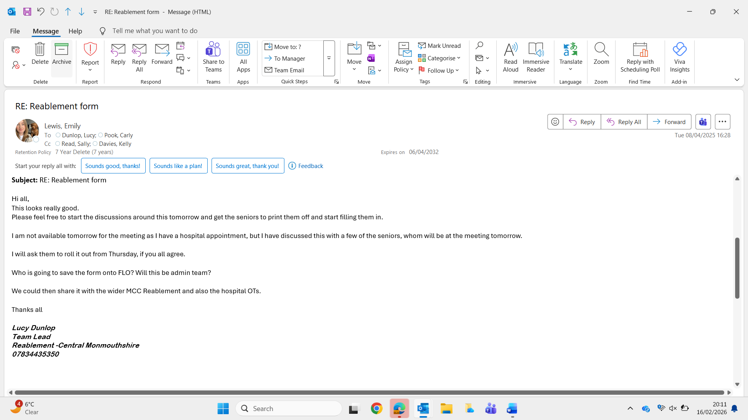

This portfolio demonstrates my development as a Therapy Assistant Practitioner who is reflective, person-centred, and committed to safe, effective practice. Through supervision, CPD, observation, and service development activities, I have strengthened my clinical reasoning, communication, and leadership skills. I have increasingly focused on outcome-driven practice, evidence-informed decision making, and collaborative working. This portfolio evidences my readiness to progress within an extended scope role and my commitment to continuous professional development aligned with service needs.

