5/17/2019

Joseph Law - 1704471

The Magstim co ltd

Group Working Reflective Essay
M5X00400 – Group Project

Reflective Essay on Project Managing.
This essay will discuss and reflect the time managing the development of the now known ‘Air Film Coil Cooling Module’.

Purpose of the Project
The Air Film Coil is prone to overheating due to its application. It is used continuously for 37-minute treatments consecutively. Clinicians usually purchase two Air Film Coils so when one coil is performing the 37-minute protocol, it allows the other to cool. After some research into this, it was noted that the coil did not have enough time to cool in the 37 minutes.
The reason for this is as follows. The overheating coil is unplugged from the power supply unit to allow the additional coil to be used and because of this the internal fan in the Air Film Coil would stop cooling the device. (Jali Medical, 2019)

The customer feedback and demands were to develop a device that the Air Film Coil could be plugged in to, allowing it to cool without having to be connected to the PSU thus, allowing an additional coil to be connected.

Project Objectives and Results
Using the marketing and product requirement specification, we can perform validation and verification on the product to see if we achieved our objectives and how successful the project was. The use of timescales met, and budgets not being overspent can be considered project objectives.

Overview objective
To develop a device that could be connected to a wall socket or power source that could power the internal fan of the Air Film Coil while not allowing any other features available on the coil.

Human Resource for the Project.
The human resource selected to carry out the work on this project is listed below. With a further brief of what is expected from each role.

Project Manager: Jonathan Jones/Joseph Law
Marketing: Audrey Alies
Engineering:
Electronic/electrical hardware design: Jonathan Jones.
Software design: N/A
Mechanical design: Andrew Clamp.
Verification testing: Jonathan Jones/Joseph Law
Labelling design: Jonathan Jones
Writing instructions for use: Jonathan Jones/Joseph Law.
Building prototypes: Joseph Law.

Manufacturing Engineering: Tim Facer.
Manufacturing: Paul Davies/Jason Davies-Wigley.
Materials: Nasko Todorov.
Quality Assurance: Kevyn Beard.
Regulatory Affairs: Tom Cambell.

Project Management (brief overview)
The Project Manager shall have overall responsibility for ensuring that the project's goals are properly established and met. This will include managing:
The allocation of resources to the project;
The activity of those resources;
Compliance of the realisation process to Magstim’s procedures;
The timeline;
The budget;
Approval of the Product Requirement specification;
Specification/selection of outside services (where appropriate).

Marketing
Marketing input is provided using Marketing Requirement Specification.

Engineering
Engineering resources are required for:
Electronic/electrical hardware design;
Mechanical design;
Verification testing;
Test specification;
Packaging design;
Selection of development tools;
Producing manufacturing jigs;
Generate manufacturing documentation;
Building prototypes.

Manufacturing Engineering
Manufacturing Engineering resources are required to:
Approve manufacturing documentation;
Identify/design/provide any specialised tooling or fixtures that may be required to manufacture the product;
Approve any new manufacturing process;
Co-ordinate with external assemblers.

Manufacturing
Manufacturing resource is required to:
Pilot build;
Manufacture the product.

Materials
Materials management resources are required to:
Source components, materials, etc;
Select/approve new vendors/outside services (where appropriate).

Quality Assurance
Quality assurance resource is required to:
Ensure the product realisation process complies with Magstim's quality system;
Modify/adapt/enhance the quality system, when necessary, to reflect any changes.

Regulatory Affairs
Regulatory affairs resource is required to:
Approve the product Requirement specification;
Ensure Risk Management has been adequately addressed;
Ensure the product realisation process complies with the current and foreseeable future regulatory requirements of the intended market(s).

Project Management Analysis
This section will detail the skills and personality traits needed to be a successful project manager. Due to the structure of the company and having resource from every department when a project is live, the project managers main role is to ensure timelines are met by ensuring planning and resource is met correctly. To do this effectively the following skills must be acquired:
- Leadership – John C. Maxwell sums up leadership well in a single quote. “A leader is one who knows the way, goes the way, and shows the way.” – John C. Maxwell
    - A good working environment – A good work environment is essential for the project’s growth and success, ensuring everyone is happy within their role and human relations are being considered throughout.
    - Motivation and confidence creating is important. This is done by giving clear instructions and details on actions needed, then motivating the team with economic and non-economic rewards.
    - Must take the lead and run the project looking at every aspect and ensuring all section of the project are running smoothly. (Juneja, 2018)
- Planning –
    - Duration – A good understanding is needed of how long every section of the project will or should take, this allowing a project manager to produce a timeline of the project and give an estimated date of launch. This is important as costing relies heavily on the duration of the project.
    - Resources – The project manager must look at how much resource is required to complete the project. If too little resource is acquired, deadlines will not be met. If too much resource is acquired it could potentially cause the project to go over budget.
- Communication
    - As the project manager you must show good communication skills. This could be internal or external. Communication throughout the company in regard to the project is important so that everyone understand where the project currently is. Externally, supplier and customer communication is important to receive feedback and potential ways the project could be improved. (Juneja, 2018)

Self-Perception Inventory
This section will analyse myself perception to look at my personality traits and if they benefit the role of a project manager. This analysis tool was developed by Dr R Meredith Belbin, it is used to look at your personality traits and your behaviours especially within a team. (Belbin 2010)

The breakdown of the scores in the table below can be found in the appendix.

To analyse the findings of myself perception inventory, I will look at the top scoring sections.
Coordinator (HIGH)– Belbin’s model says that the coordinator is essential for a focused team and ensuring the correct team members are taking responsibility of their roles but could possibly over delegate the work load including their own work. (Mostert 2015)

Team Worker (HIGH) – This allows the team to work well together as a whole, by listening to team members and prevents unnecessary confrontation. The team worker maybe lacking some leadership quality’s by not making difficult decisions or unpopular judgements

Complete Finisher (VERY HIGH) – This quality is the key quality of a perfectionist, looking for mistakes within the project and ensuring the standard of work is the best possible. The complete finisher may take on more work than necessary to ensure the work is perfect due to possible lack of confidence in their team.

Jonathan Jones, currently engineering manager of the Magstim company, explained that Joseph handled the project well and excelled in good time keeping. Although sometimes spending too much time on certain tasks and documents as he was not happy with the quality, although deemed acceptable. (Jonathan, 2019)
 | Milestone | Brief Description | Start Date | Finish Date
Project Authorisation |  | This allows the project to begin. The senior management team must discuss if this project is feasible and a necessary project for the company. | 06/11/2017 | 07/11/2017
Project Specification | 1 | All specification relating to this project need to be stated. A marketing specification is crucial, as this is the needs of the paying customer. Other specifications such as product specification as this is a way to measure how successful the project is and does it meet the requirements. | 07/11/2017 | 15/11/2017
Project Planning | 2 | The planning stage is to ensure a team/group is assembled with specific roles in place. It should clearly set out what roles is responsible for what tasks. | 07/11/2017 | 15/11/2017
Manufacturing Documentation | 3 | Documentation that needs to be in place to allow for the manufacturing process. Logistics will require work instructions for packaging and pre-dispatch checks. Production will need assembly drawings and test procedures with documentation in place to record and track products being manufactured | 15/11/2017 | 08/12/2017
Manuals | 4 | User, service and installation manuals need to be generated and is a requirement for medical devices. | 25/12/2017 | 01/01/2018
Risk Management & Usability | 5 | A risk management team must review the project and product and set out a list of potential risks and how they can be mitigated. Usability studies are also required to ensure the product is as user friendly as possible. | 04/12/2017 | 18/12/2017
Technical Specification | 6 | Technical specification must be put in place to ensure any crucial specifications are recorded. This could be for a multiple of reasons. For example, if a part becomes obsolete and a replacement is required. | 18/12/2017 | 24/12/2017
Product Testing | 7 | In house testing is done to ensure that the product is deemed fit for purpose and performance to its intended use with no risk issues. Verification and validation can then be performed on the product to ensure the marketing and product requirement specifications have been met. | 20/12/2017 | 06/01/2018
Compliance Testing | 8 | For a product to be on the market it requires to meet certain regulations. Test have to be done on the product to verify that the product meets these regulations | 08/01/2018 | 13/01/2018
Close out | 9 | A close out documentational pack is prepared to ensure all aspects of the project have been fulfilled and this will be signed off by the senior management team to certify the product as complete and ready for launch. | 13/01/2018 | 13/01/2018

Task List
Below was a brief list of tasks required to complete the project, these dates were given as targets.

Listed Gateways identified in the Gantt chart below.

Gateway objective
A gateway is a certain stage in the project which needs to be fulfilled before the project can continue. The gateway should be used to review if the project is on track and being completed successfully.

Gateway 4 – Validation and Verification.
Validation and verification is a good gateway to use as the objectives are clear as previously stated in the product requirement and marketing specification, set out at the start of the project. If these specifications are not met the project cannot continue.

Verification of the product requirement specification is listed within the appendix.
This can be considered a S.M.A.R.T objective (Doran, George T)

Specific – All specification within the requirement report is clear and is an essential task to be completed.

Measurable – By setting out objective via a market and product specification at the start of a project and using these documents to produce a validation and verification report and compare the project with each specification that needed to be fulfilled.

Achievable – The specifications listed on these reports requires the whole team and their specialist knowledge to complete this task.

Relevant – Validation & Verification is a requirement for all medical devices and part of the BSi and FDA process and they expect to see evidence of this during inspections.

Time-Bound – As stated above the Product testing stage was given a due date of 6th of January, a total of 2 weeks to complete these tasks. This is an aggressive estimate but more than achievable.

Areas of Concern:

FMEA was performed on the project to review the risks and mitigate. This was done in the form of a risk plan and risk analysis document. This can be reviewed in the appendix.

Regulatory Concern
Regulatory concern as to whether the product is to be considered a medical device or a medical accessory?

- Medical device – In this case, FDA states an instrument, apparatus, implement, machine, contrivance, implant, in vitro reagent, or other similar or related article, including a component part, or accessory which is intended for use in the diagnosis of disease or other conditions, or in the cure, mitigation, treatment, or prevention of disease, in man or other animals.

- Medical Accessory - FDA clarifies that an “accessory” is a separate, finished device intended to “support, supplement, and/or augment the performance” of at least one parent device.

This could have caused huge ramifications if we could not justify the product as a medical accessory. The product development could have taken at least three times the duration to release. This would have affected many factors; the cost of the project would have increased. The current customer demand was increasing and without this module, customers were unable to use the main system previously purchased from us economically.

Tom Campbell, regulatory manager, explains that projects like this are always difficult to regulate due to the rather grey area when deciding the classification of medical devices and getting this wrong could be dangerous and have legal ramifications.

Area of improvement
There was an oversight when this project was developing. The current range of coils all used a universal connector. There was an on-going project to improve and re design the connector to reduce pin burning. Once the AFC cooling module was complete and launched, the project had to be revisited due to the connector change. The project should have run concurrently and specified both connectors.
Doing this would have saved cost and resource.
.

Gantt Chart

Reference List
Unknown, Belbin, 2019, The Nine Belbin Team Roles
https://www.belbin.com/about/belbin-team-roles/

R. Meredith Belbin, 2010, Team Roles at Work, 2nd ed, by Routledge, Oxon

FDA (2019) ‘Is the Product A Medical Device?’ FDA Gov
https://www.fda.gov/medical-devices/classify-your-medical-device/product-medical-device

Jones, J. (2019). Project Managing – AFC Cooling Module. [jonathan.jones@magstim.com]

Zeeman, A. (2017). John C Maxwell. Retrieved [2019] from ToolsHero: https://www.toolshero.com/toolsheroes/john-c-maxwell/

Campbell, T. (2019) Regulatory Issue with the AFC Cooling Module. [tom.campbell@magstim.com]

Jali Medical Magstim Air Film Coil http://www.jalimedical.com/magstim-air-film-coil.html

Nel M. Mostert (2015) Belbin – the way forward for innovation teams, Journal of Creativity and Business Innovation, The Netherlands

Juneja, P (2015) Importance of Leadership Management Study Guide Content Team https://www.managementstudyguide.com/importance_of_leadership.htm

Doran, George T. here’s a S.M.A.R.T. way to write management’s goals and objectives. Management Business Source Corporate.

Appendix.
Logbook 98 - 30-32
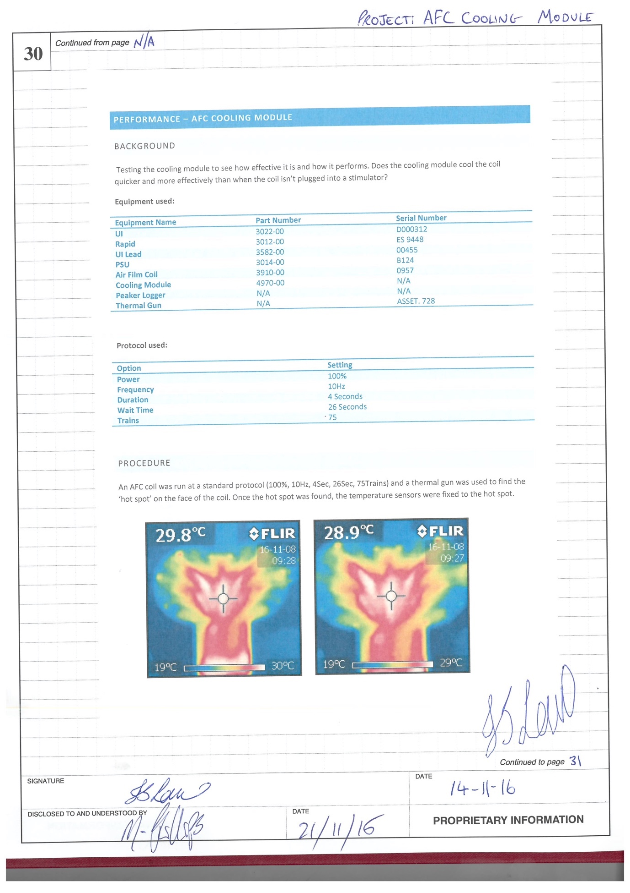
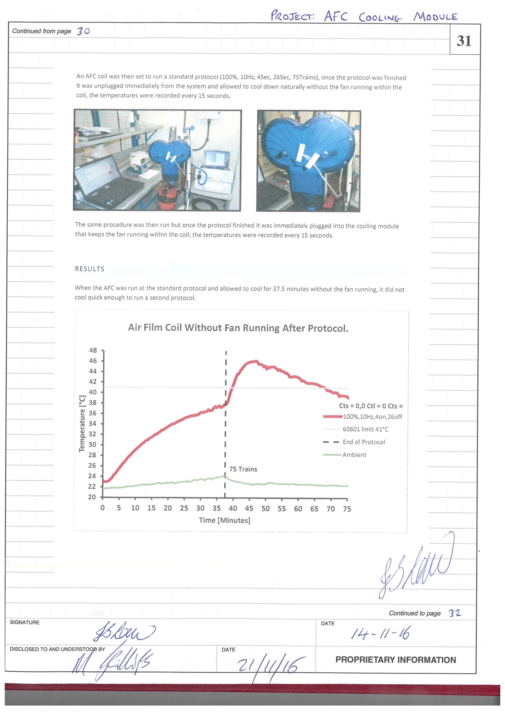
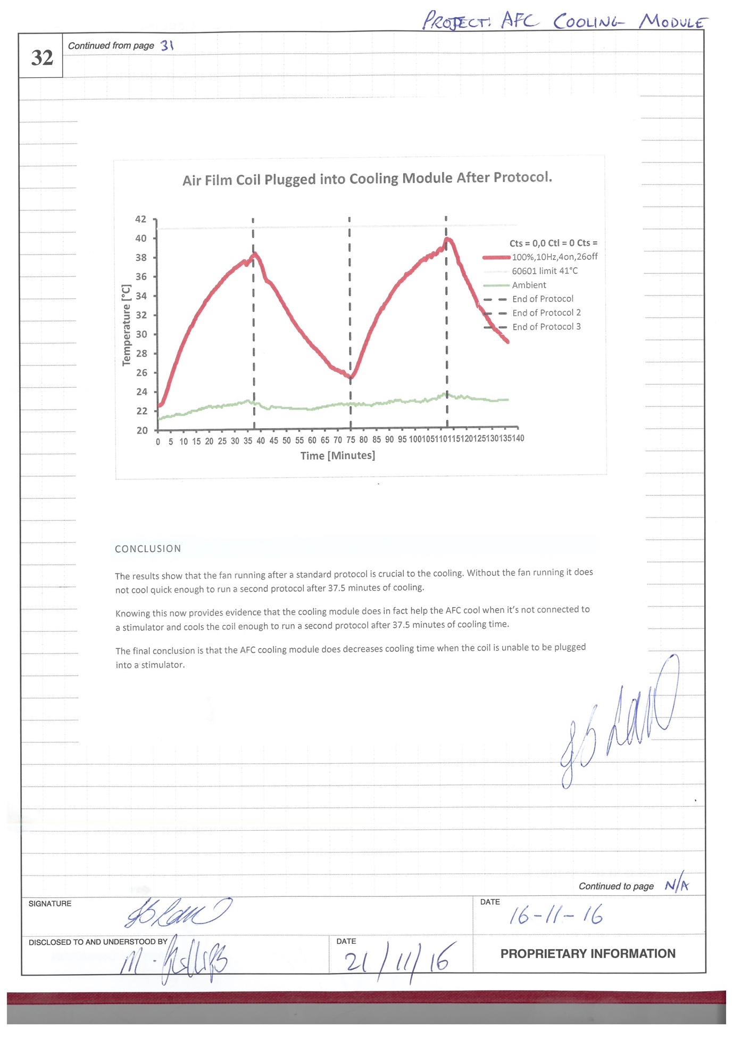

Logbook – 33-34
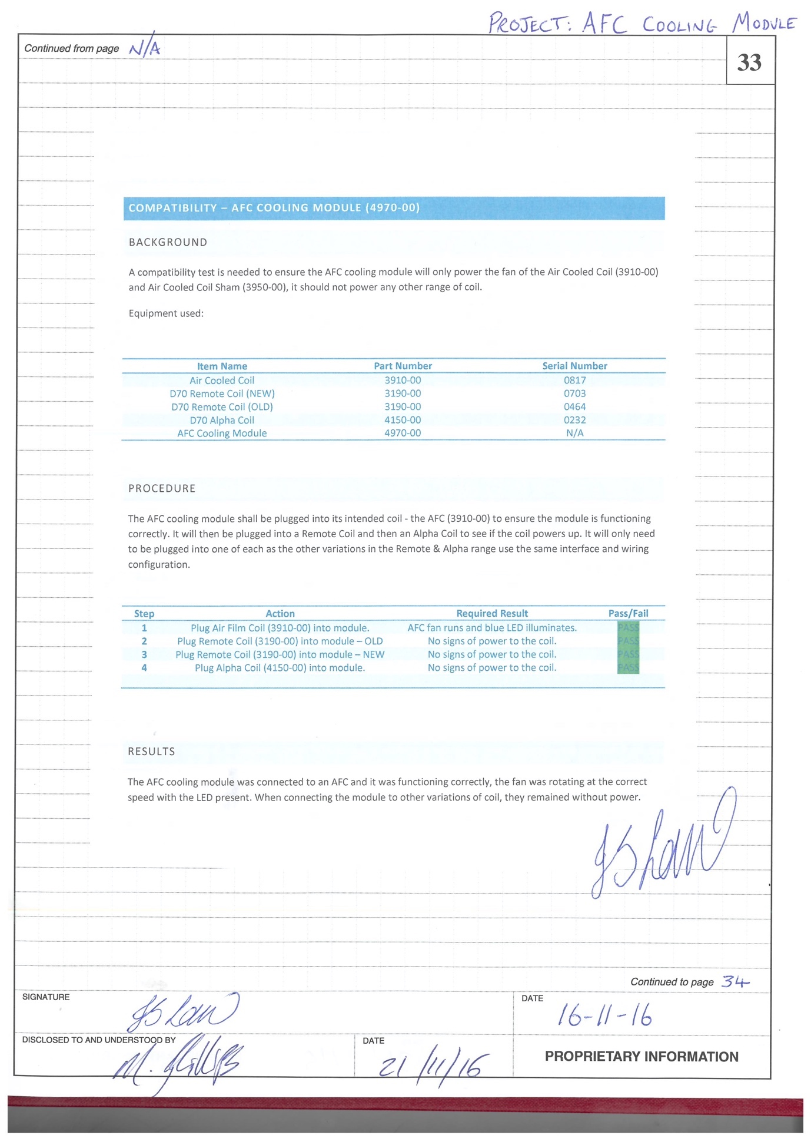
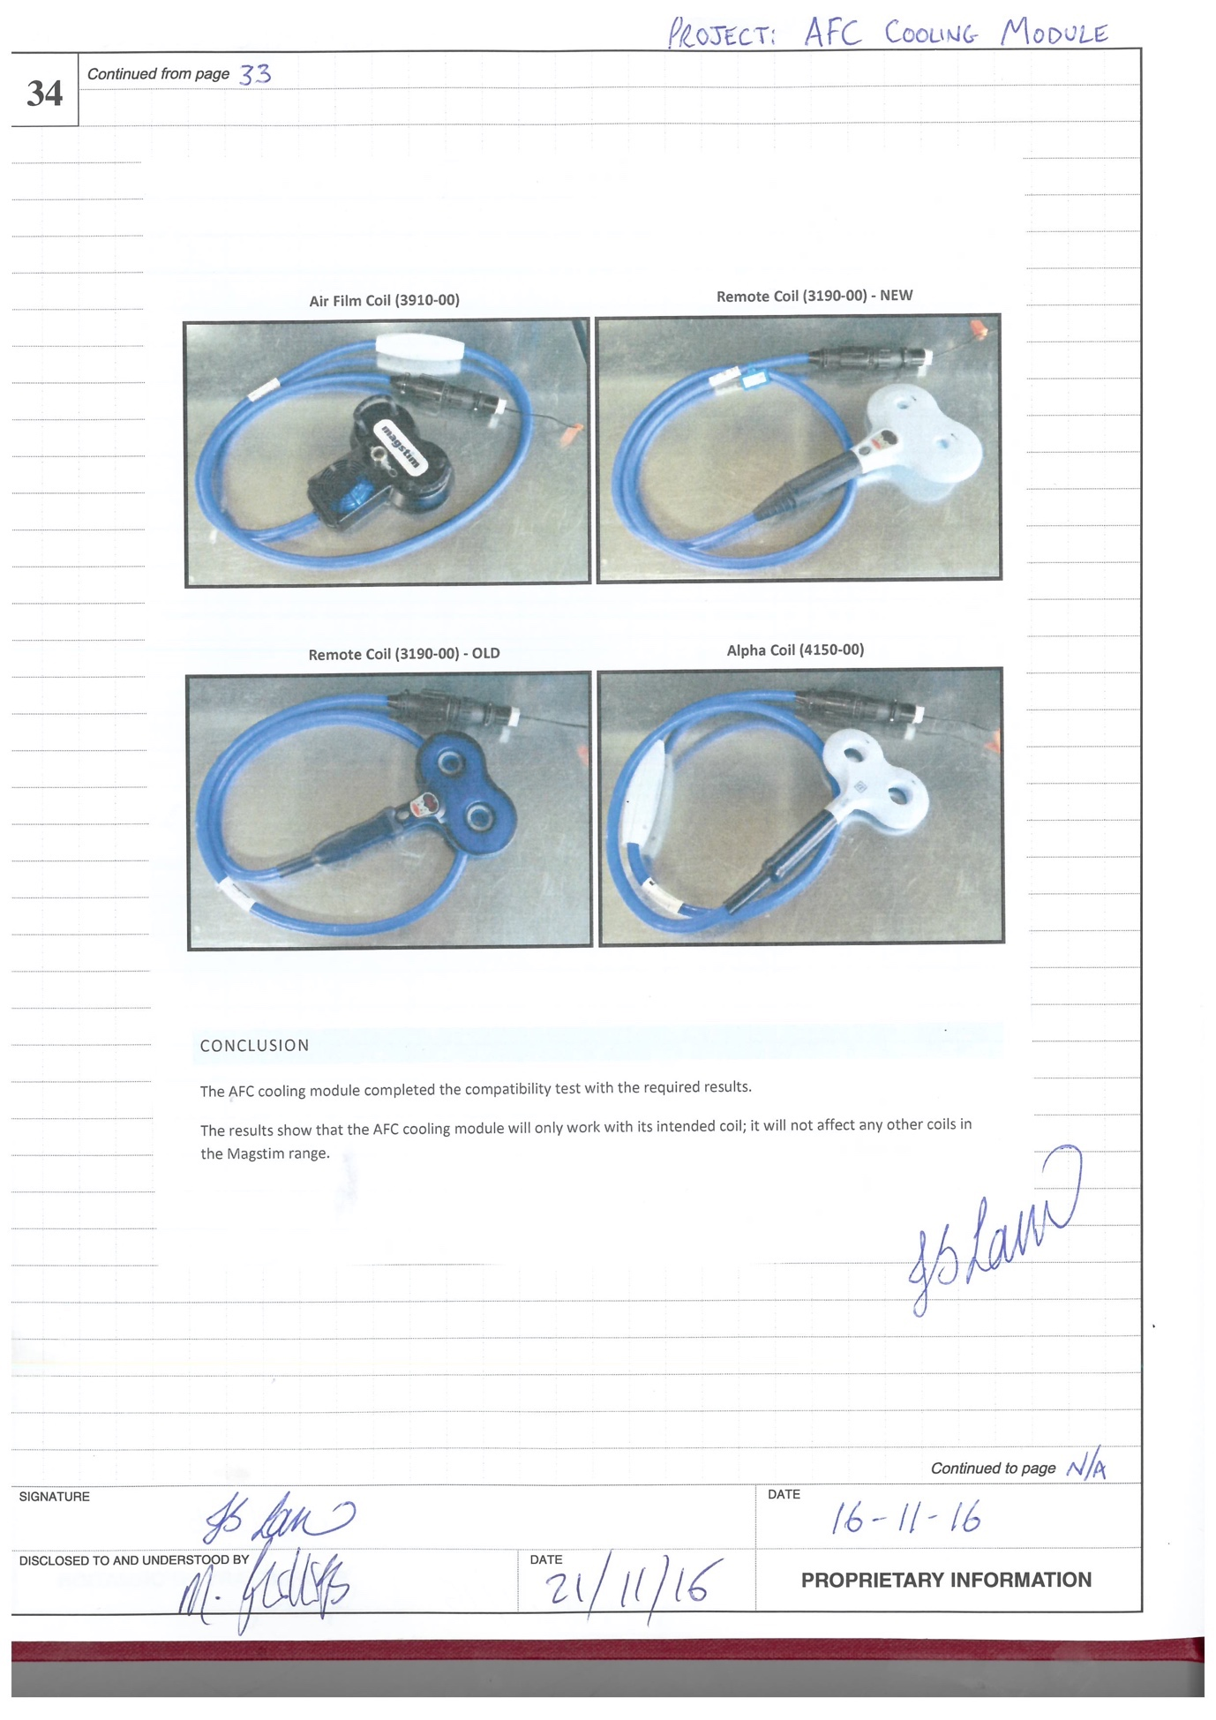

Logbook 98 – 47-53
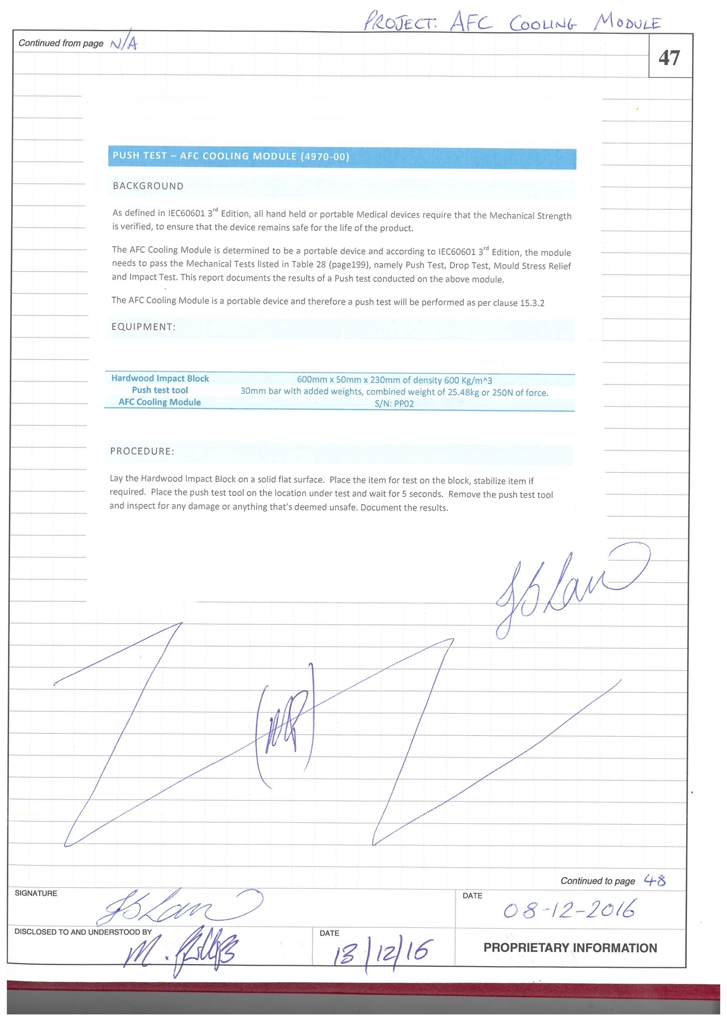
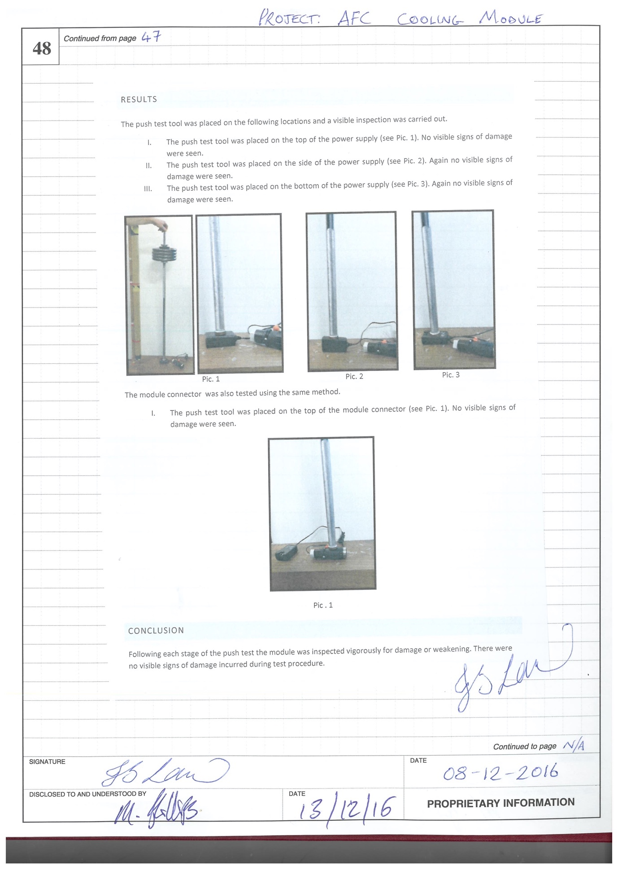
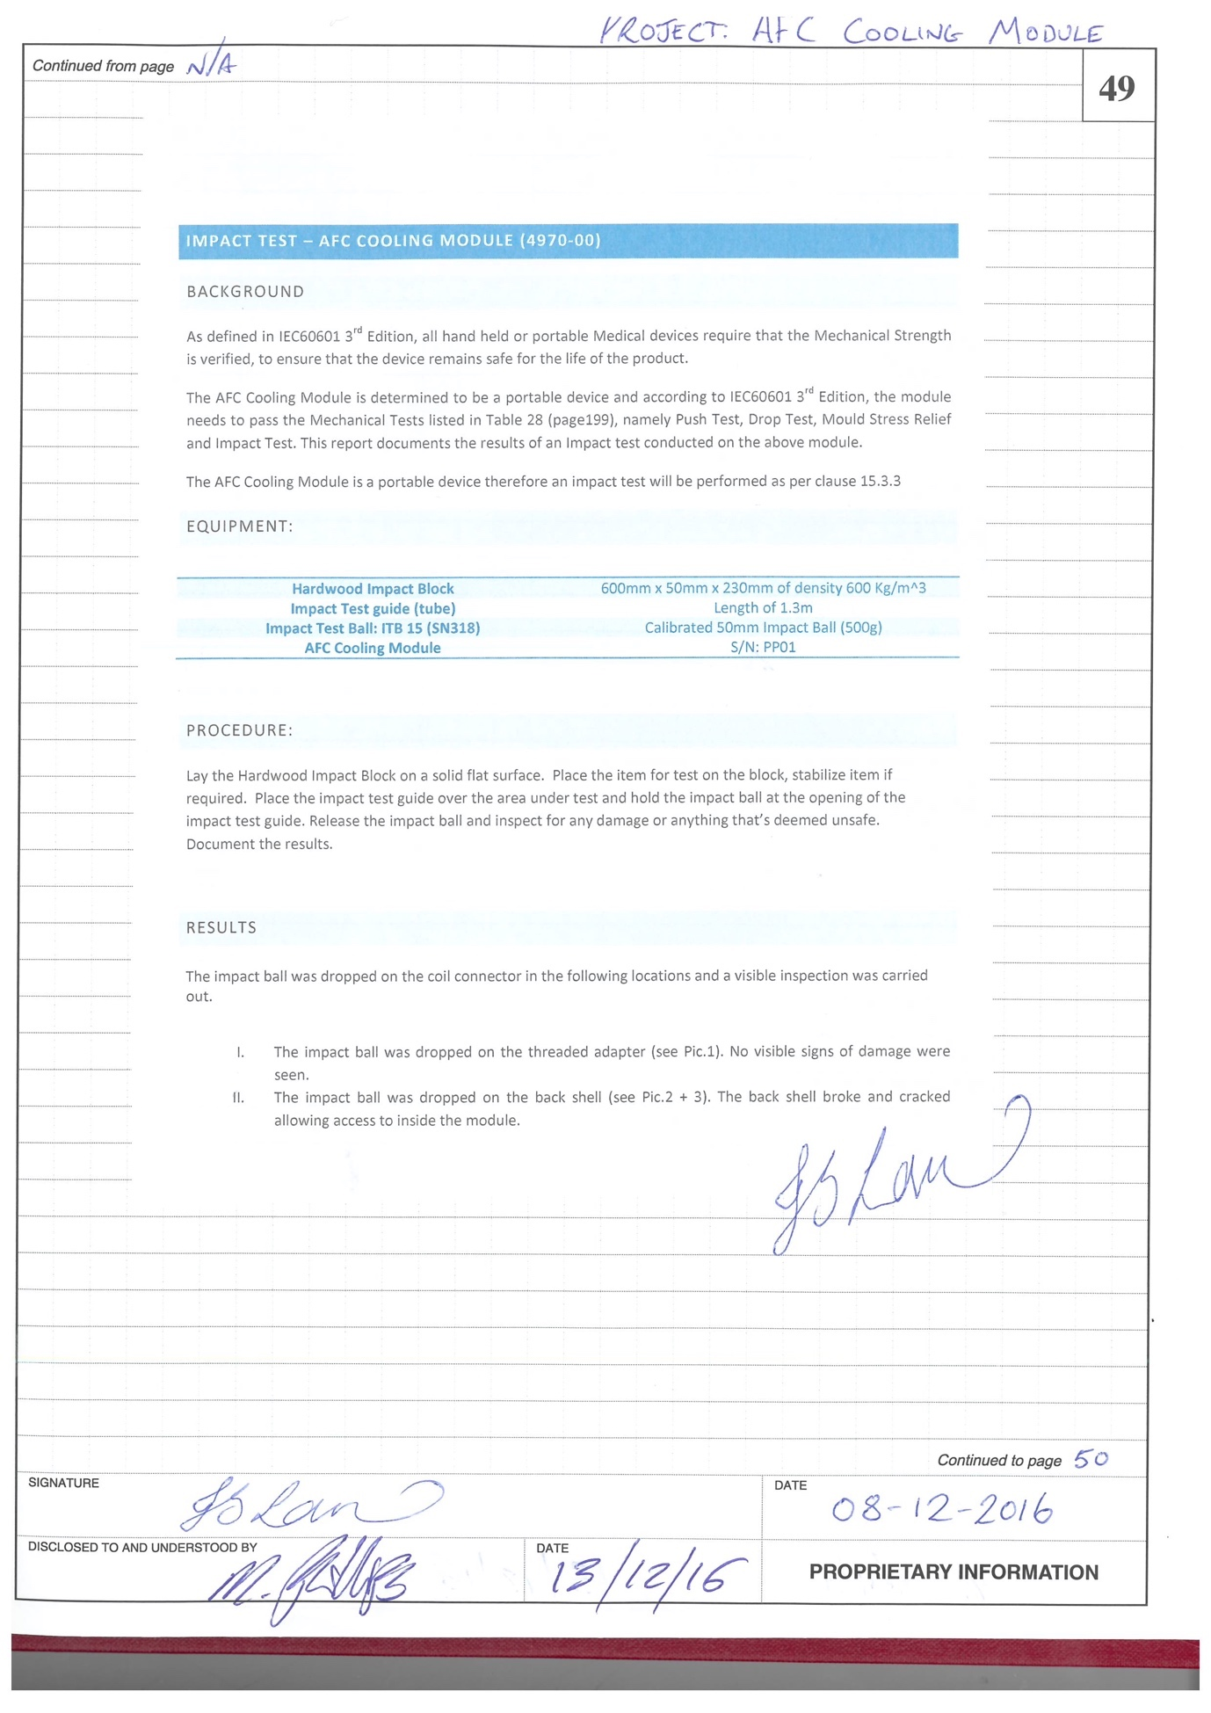
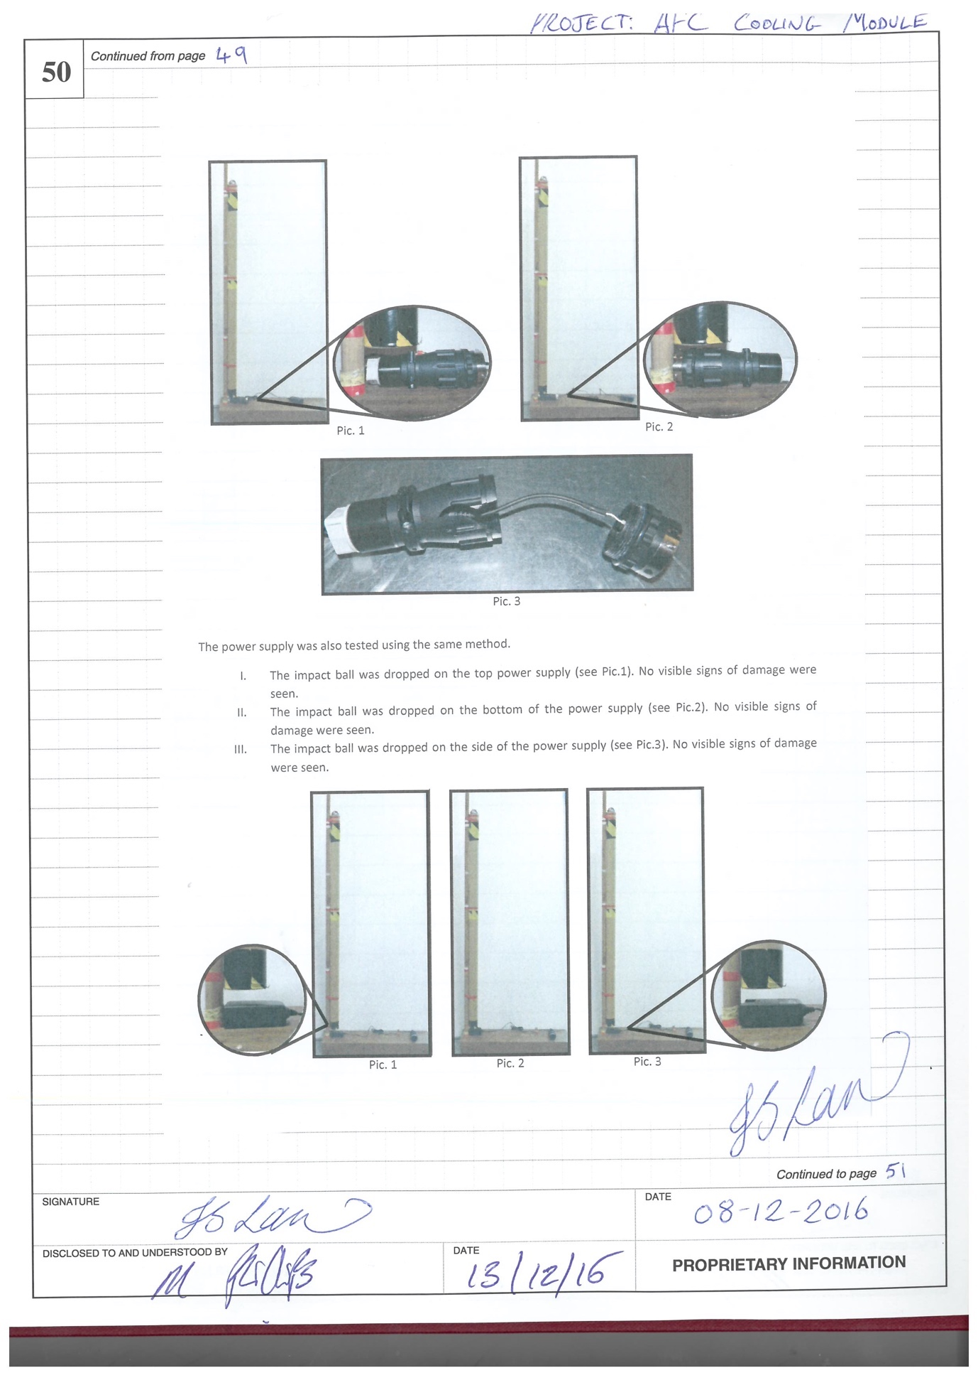
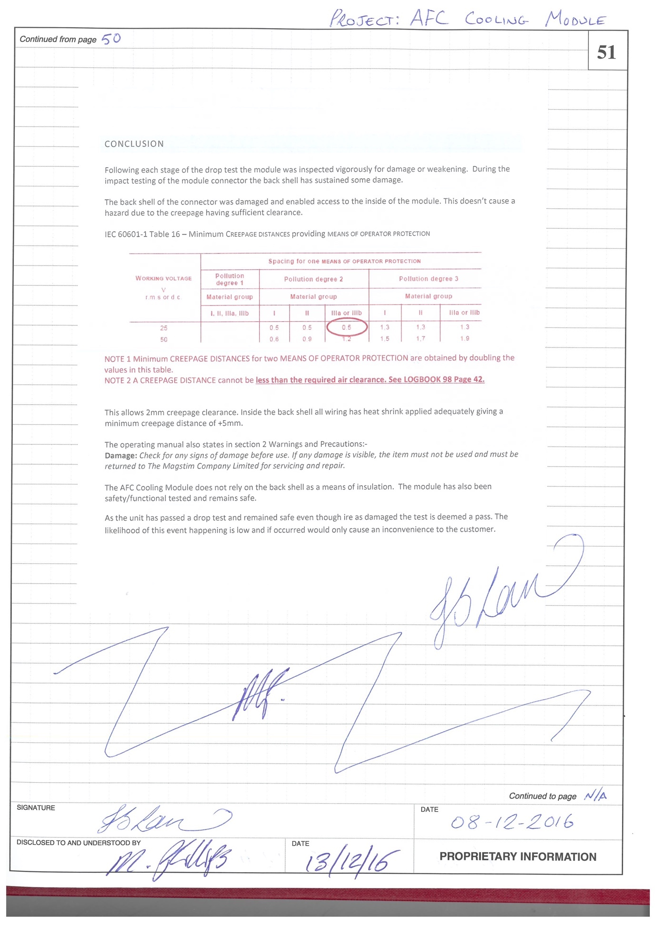
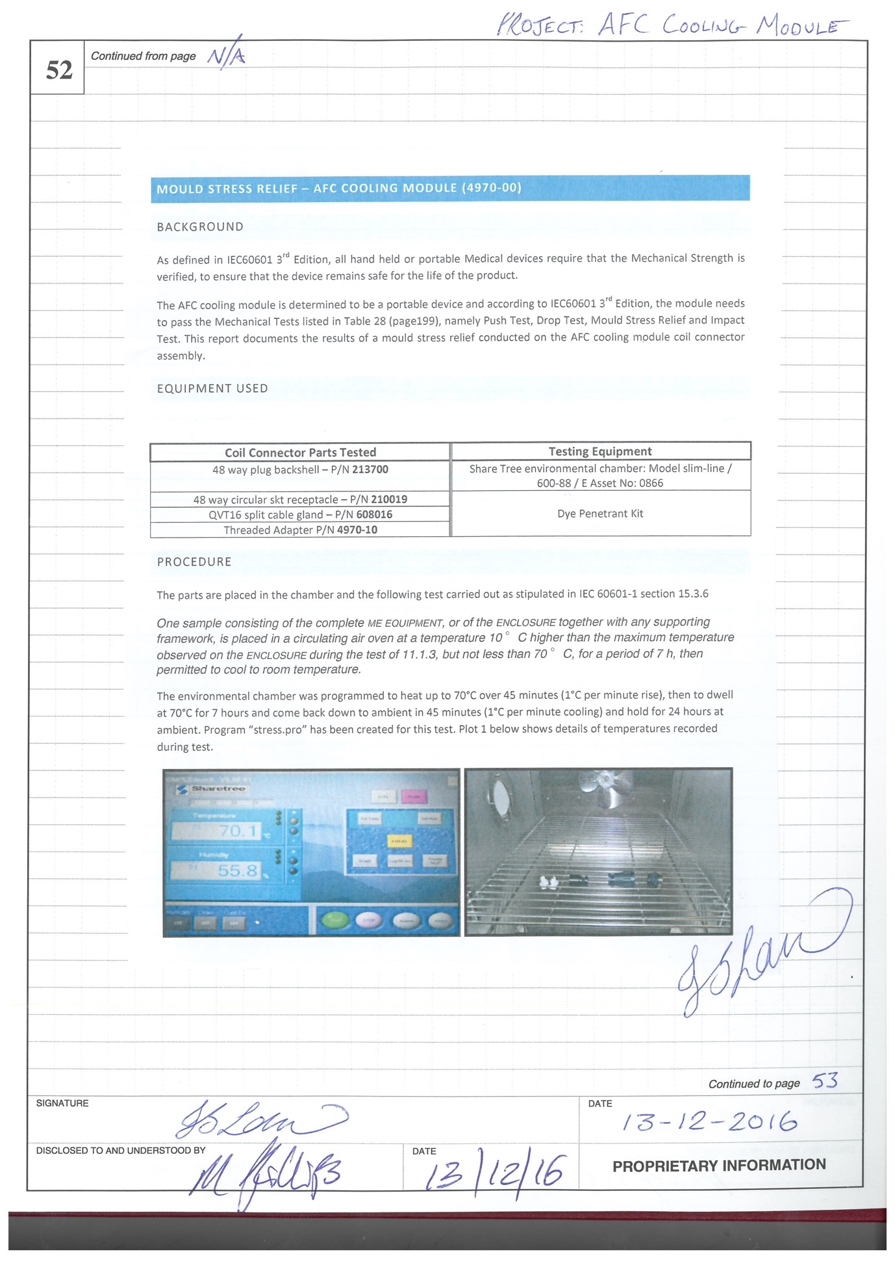
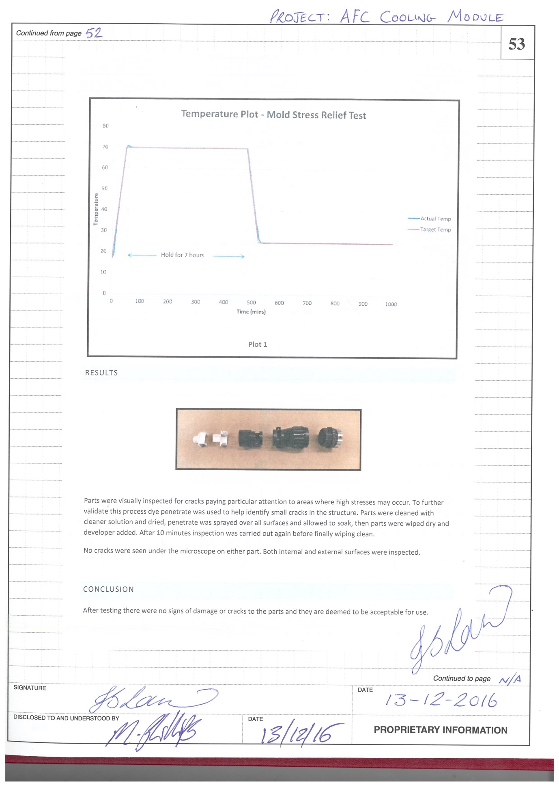

MOP29

Verification Report (Product Requirement Specification)
Requirement | Verification Reference

Regulatory Compliance
Quality System  The AFC Cooling Module will be developed in accordance with the requirements of the Design Planning and Control Procedure (004). | AFC Cooling Module Project File
Regulatory Requirements  The AFC Cooling Module shall be designed in accordance with the Regulatory requirements as documented in TD4970003. | See TD4970013

Design Requirements
Connectivity  Connector Type  The AFC Cooling module connection to an Air Film Coil shall be made using a 48 Way lockable connector, Magstim Part No: 210019  Connector Pinning  The module shall use a contact arrangement as defined in TDa3035RS “Coils/Stimulator Pinning Requirement Specification”. Stimulator arrangement, using only pins D – V+ & X GND only. | 4970-00 BOM Item 06  4970-00 Drawing Package Page 2

Physical Characteristics
General Design Requirements  No special provisions related to the ingress of dust or liquids are required. The power supply shall be rated IP20.  The total combined weight of the power supply, cable and connector shall be less than 0.5KG.  Power Supply Unit  The AFC Cooling Module must have a medical grade power supply unit.  The power supply unit must be able to function and adapt in UK, EU and US.  Cab le  The AFC Cooling Module shall have a cable length of 1.5m ± 0.2m  The cable from the power supply shall be unmodified. | See Section 9.5 (Material Specifications) of Project File.  Logbook 98 Page 54  See Section 9.5 of Project File  4970-00 BOM Item 21, 22 & 23  Logbook 98 Page 54  4970-00 Drawing Package Page 2

Electrical Characteristics
Voltage  The voltage should be within limits:  - Lower limit 11.40v  - Upper limit 12.60v.  The power supply unit voltage range should be within limits:  - Input range: 100 – 240v  - Output range: 12 ± 0.6v | Logbook 98 Page 35  Or  Control Sheet PP01 & PP02 Section 6.7 of Project File  171-6982 Data Sheet Section 9.5 of Project File

Operator Interface
Coil Connector  The AFC Cooling Module shall connect directly to an Air Film Coil.  Power Supply  The AFC Cooling Module shall connect directly to a mains power socket. | Logbook 98 Page 33  4970-00 BOM Item 11, 21, 22 & 23

Labelling
General  All labelling shall comply with the standards as defined in section 2.  CE Mark symbol shall appear on the AFC cooling module.  WEEE Mark symbol shall appear on the power supply.  Company name and address shall appear on the AFC Cooling Module, accompanied with the ‘Manufacturer’ symbol (ISO 7000-3082). | See section 5.1.1 to 5.1.4  BOM Item 20 P/N: 4970-32-00  Logbook 98 Page 54 also on P/N: 4970-32  BOM Item 20 P/N: 4970-32-00 also See Section 2.3 of TD4970011
Serial Number  Each AFC Cooling Module will be marked with a unique serial number label for identification and product reference, which will be accompanied with the ‘Serial Number’ symbol (ISO 7000-2498) | BOM Item 20  P/N: 4970-32-00

Performance of the Module
Cooling Performance  The AFC Cooling module must cool the AFC sufficiently, to allow another protocol to run within a maximum time of 45 minutes. | Logbook 98 Page 30

Packaging
Durability  The AFC Cooling Module shall be packaged in a suitable container to ensure no damage when dropped from a height of 1m onto any face, contacting a hard surface. | Logbook 98 Page 26
Labelling  The container shall be labelled with the CE mark.  The container shall be labelled with the storage and transportation environmental limits.  The container shall be labelled with, “Fragile Do Not Drop”  The container shall be labelled with, “This way up” indication | WI 234  WI 234  WI 234  WI 234

Environmental Conditions
Storage and Transport  Ambient Temperature Range: -19ºC to +60ºC  Relative Humidity Range: 10% to 80% Non-Condensing  Atmospheric Pressure Range: 50kPa to 106kPa | See TD4970009  See TD4970009  See TD4970009
Operating Conditions  Operating Temperature Range: +5°C to +40°C  Relative Humidity Range: 10% to 80% Non-Condensing  Atmospheric Pressure Range: 80kPa to 106kPa | See TD4970009  See TD4970009  See TD4970009

Operating Manual
Instructions  Detail the instructions for using the AFC Cooling Module along with any compatibility issue. | MOP29-EN
Warnings  Detail warnings and precautions related to the use of the AFC Cooling Module. | MOP29-EN Section 2.1
Maintenance  State that the AFC Cooling Module should be checked for signs of external damage before use.  State that AFC Cooling Module contacts (pins) should be checked before connecting to a coil.  State that all maintenance is to be performed by The Magstim Company Limited or an authorised service centre. | MOP29-EN Section 4.1  MOP29-EN Section 4.1  MOP29-EN Section 5.3
Disposal  Provide instructions for the user to follow for disposal in line with WEEE. | MOP29-EN Section 5.5
Language Requirements  Provide operating manuals in the following language  - English | MOP29-EN

Self-Perception Inventory

Basic FMEA
Reference | Hazardous Situation | Risk | Mitigation | Residual Risk
1 | The user inadvertently connects the Remote Therapy coil to the cooling module. | There is a risk that the Remote Therapy Coil is damaged. This results in delayed treatment. | All Tesla 2nd generation coils can be physically connected to the cooling module. However, the coil microprocessor does not power up until it receives a signal from the stimulator. This means that the Remote Therapy coil will not be activated when connected to the AFC Cooling Module (Logbook 98, pgs. 33-34 in appendix).  The IFU states that the cooling module is only intended for the Air Film Coil (reference MOP29 in appendix). | Negligible
2 | The Air Film Coil has not cooled sufficiently in time for use. | There is a risk of the patient being burned by the Air Film Coil. | Attempting to use a coil which has not sufficiently cooled results in the stimulator’s temperature monitoring functionality preventing use of the coil  The Air Film Coil will cool to ambient temperature within 45 minutes (reference logbook 98 pgs. 31-32 in appendix).  The IFU states to allow cooling for 45 minutes between uses (reference MOP29 in appendix). | Negligible
3 | The user forgets to switch the cooling module on at the mains and then attempts to use the Air Film Coil approximately 40 minutes later to treat, thinking that the coil has cooled down sufficiently. | There is a risk of the patient being burned by the Air Film Coil. | Attempting to use a coil which has not sufficiently cooled results in the stimulator’s temperature monitoring functionality preventing use of the coil  The IFU states that the user must check that they have switched on the cooling module at mains (reference MOP29 section 5 in appendix). | There may be a delay to treatment if the user forgets to switch on the cooling module.

Basic FMEA (continued)
Reference | Hazardous Situation | Risk | Mitigation | Residual Risk
4 | The user attempts to use a power supply which is not compatible with the cooling module (either because the user had lost the accompanying power supply or because the user replaced a faulty power supply themselves). | Using a non-medical grade power supply could result in electric shock to the user. | The cooling module has been designed so that the power supply is captured and therefore, it is not possible to replace the power supply without the use of a tool (reference 4970-00 AFC Cooling Module drawing package). | Negligible.
5 | The user forgets to switch off the cooling module at mains at the end of the day. This results in both the cooling module and the Air Film Coil’s fans operating overnight. | There is a risk that the cooling module and/or the Air Film Coil fail prematurely. This results in delayed treatment. | The power supply has an MTBF of 250 kHrs (reference PSU data sheet, project file section 9.5) and the Air Film Coil has a use life of more than 5 years in continuous use (reference MOP29 section 6.4). Therefore, the impact of this hazardous situation on lifetime is negligible. | Negligible.
6 | The user repeatedly connects and disconnects the Air Film Coil from the cooling module throughout the life of the module and the coil. | There is a risk that the cooling module may fail prematurely. This results in delayed treatment. | There is no further mitigation of this risk. | There is minimal risk of premature failure.
7 | The user accidentally drops or impacts the cooling module. | There is a risk that the cooling module is damaged. This results in delayed treatment. | The cooling module connector is made of a nylon (polyamide) material which has been demonstrated to withstand the mechanical strength testing as described in IEC 60601-1 (reference JL Log Book 98, pages 47-53). The power supply is an approved supply which also meets the requirements of IEC 60601-1. | There is minimal risk of damage.
8 | The user disconnects the coil from the cooling module while the power supply is plugged into mains and switched on. | There is a risk that the user may receive an electrical shock of 12V (at worst this is a tingling sensation). | The cooling module operating manual instructs the user to switch off at mains prior to connecting or disconnecting the coil (reference MOP29). | Negligible.

