

Student Name: Naitiksinh Pareshbhai Parmar

Student ID: 2525945

Module Name: International Business Concepts

Module Code: LCMB7034

Lecturer’s Name: Charles oham

Work Count: 5488

Term 2

Table of Contents
Section 1: International Market Entry Strategy for Walmart in New Zealand 8
1.0 Introduction 8
1.1 Background and Strategic Context 8
1.2 Selection of New Zealand as the Target Market 8
1.3 Scope, Evidence Base and Cut-Off Date 9
2.0 Organisational Classification and Global Strategy 9
2.1 Walmart as a Multinational Corporation 9
2.2 Classification Using Bartlett and Ghoshal’s Model 10
2.2.1 Global Integration and Cost-Efficiency Pressures 10
2.2.2 Local Responsiveness and Market Adaptation 11
2.2.3 Strategic Categorisation 11
2.3 Global Configuration and Value Creation 11
2.3.1 Geographic Footprint and Operational Network 11
2.3.2 Sources of International Competitive Advantage 12
2.3.3 Strategic Limitations and Lessons for New Zealand 13
3.0 Macro-Environmental Appraisal and Market 13
3.1 Political and Institutional Environment 13
3.1.1 Political Stability and Policy Predictability 13
3.1.2 Foreign Investment Policy and Regulatory Scrutiny 14
3.1.3 Government Policy Toward Retail Competition 14
3.1.4 Political Opportunities and Risks for Walmart 16
3.2 Economic Environment and Commercial Viability 16
3.2.1 Market Size, Income and Consumer Spending 16
3.2.2 Retail Industry Structure and Competitive Intensity 17
3.2.3 Cost Structure and Price-Leadership Feasibility 18
3.2.4 Geography, Logistics and Supply-Chain Economics 18
3.2.5 Currency and Macroeconomic Risks 19
3.3 Legal and Regulatory Environment 20
3.3.1 Competition and Commerce Regulation 20
3.3.2 Employment and Workplace Regulation 20
3.3.3 Consumer Protection and Product Standards 21
3.3.4 Environmental and Sustainability Requirements 22
3.3.5 Māori Rights and Stakeholder Responsibilities 23
3.4 Cultural and Consumer Environment 23
3.4.1 New Zealand Consumer Values and Shopping Behaviour 23
3.4.2 Cultural Distance from Walmart’s US Model 24
3.4.3 Attitudes Toward Foreign Retailers and Local Businesses 24
3.4.4 Localisation Requirements 24
3.5 Overall Market Attractiveness 25
3.5.1 Opportunity–Risk Assessment 25
3.5.2 Strategic Implications for Walmart 26
4.0 Dunning’s OLI Analysis of Walmart’s New Zealand Entry 27
4.1 Ownership Advantages 27
4.1.1 Tangible and Intangible Resources 27
4.1.2 Transferability to New Zealand 28
4.2 Location Advantages and Disadvantages 29
4.2.1 Market and Institutional Advantages 29
4.2.2 Structural Location Disadvantages 29
4.2.3 Net Location Attractiveness 30
4.3 Internalisation Advantages 30
4.3.1 Value of Maintaining Internal Control 30
4.3.2 Limits of Full Internalisation 31
4.4 OLI Synthesis and Entry Implications 31
5.0 Entry-Mode Strategy and Strategic Synthesis 32
5.1 Walmart’s Historical Entry-Mode Patterns 32
5.1.1 Greenfield and Wholly Owned Expansion 32
5.1.2 Acquisitions and Joint Ventures 32
5.1.3 Divestments and Market Withdrawal Lessons 33
5.2 Suitability of the Historical Modes for New Zealand 34
5.2.1 Greenfield Investment Assessment 34
5.2.2 Acquisition Assessment 35
5.2.3 Joint Venture or Strategic Partnership Assessment 35
5.2.4 Digital-First or Phased Entry Assessment 36
5.3 Comparative Entry-Mode Evaluation 36
5.4 Final Recommendation and Implementation Priorities 37
5.4.1 Recommended Entry Mode 37
5.4.2 Phased Implementation 37
5.4.3 Risk-Mitigation Measures and Success Indicators 38
Section 2: Reflective Account Using Gibbs’ Reflective Cycle 38
6.0 Gibbs’ Reflective Cycle 38
6.1 Description of the Experience 38
6.2 Feelings and Initial Assumptions 39
6.3 Evaluation of the Process 39
6.3.1 Effective Research Practices 39
6.3.2 Weaknesses and Difficulties 39
6.4 Analysis of Learning 40
6.4.1 Application of Course Theories 40
6.4.2 Development of Critical Analysis 40
6.4.3 Integration of Theory and Evidence 41
6.5 Conclusion of the Reflection 41
6.6 Action Plan 41
References 43

List of Tables
Table 1: Weighted Market Attractiveness Assessment for Walmart’s Entry 26
Table 2: Comparative Evaluation of Walmart’s New Zealand Entry Modes 37
Table 3: Personal Research and Analytical Development Action Plan 42

List of Figures
Figure 1: Walmart Logo 8
Figure 2: Walmart’s Key Financial and Operational Performance Indicators 9
Figure 3: Bartlett and Ghoshal’s Typology of International Strategies 10
Figure 4: Walmart’s Global Operational Presence 11
Figure 5: Walmart’s Integrated Retail and Supply-Chain Information System 13
Figure 6: New Zealand’s Governance Performance Indicators, 2020–2024 14
Figure 7: New Zealand Grocery Market Concentration 15
Figure 8: New Zealand Population Estimates 16
Figure 9:New Zealand Grocery Market Share, 2020–2025 17
Figure 10: New Zealand Minimum Wage Rates, 2022–2025 18
Figure 11: New Zealand Dollar–US Dollar Exchange Rate, 2024–2025 19
Figure 12: New Zealand Minimum Wage Increase in 2026 20
Figure 13: Consumer Rights under New Zealand’s Consumer Guarantees Act 21
Figure 14: Plastic Types and Recyclability in New Zealand 22
Figure 15: New Zealand E-Commerce Market Growth 24
Figure 16: Demand for Diverse Foods among New Zealand Consumers 25
Figure 17: Walmart’s Financial and Operational Performance 27
Figure 18: Walmart’s Omnichannel and Price-Leadership Strategy 28
Figure 19: New Zealand Population Density 30
Figure 20: Walmart’s Responsible Sourcing Process 31
Figure 21: Walmart’s Acquisition-Based Entry into Canada 33
Figure 22: Standardisation and Adaptation in Foreign Markets 33
Figure 23: New Zealand’s Horticultural Supply-Chain Network 35
Figure 24: Advantages and Disadvantages of Joint Ventures 36

Section 1: International Market Entry Strategy for Walmart in New Zealand

1.0 Introduction

1.1 Background and Strategic Context

Figure 1: Walmart Logo
Source: (Wikimedia Commons, 2025)
Walmart is a U.S.-based multinational retail giant that leverages its cost leadership, achieved by scale, in procurement and supply chain management alongside its growing digital capabilities (Walmart Inc., 2025a; Durand et al., 2024). International expansion enables Walmart to diversify revenues, transfer retail capabilities and access new customer markets.

1.2 Selection of New Zealand as the Target Market
New Zealand is chosen as an attractive opportunity to enter as its stable institutions, developed consumer economy and policy interest in enhancing supermarket competition provide a conducive environment for entry into the market. It may also serve as a platform for WMT to develop throughout the Pacific region. It is however small and geographically isolated and needs critical assessment.

1.3 Scope, Evidence Base and Cut-Off Date
Using public evidence available by 1 June 2026, the report finds no significant Walmart subsidiary, store network or production facility in New Zealand. Thus, any Walmart product available via third-party sellers or cross-border channels can be classified as indirect trade, as opposed to formal entry (Walmart Inc., 2025a).

2.0 Organisational Classification and Global Strategy

2.1 Walmart as a Multinational Corporation
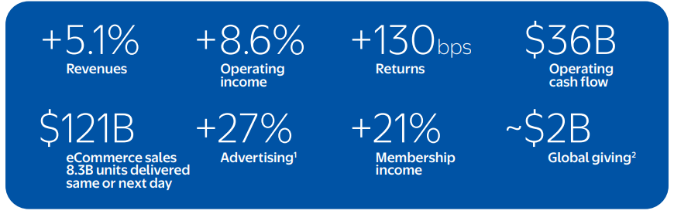
Figure 2: Walmart’s Key Financial and Operational Performance Indicators
Source: (Walmart Inc., 2025)
Walmart can be considered an MNC because it manages subsidiaries, stores, e-commerce websites, people, and supply chains internationally. It had reported revenue of about US$681 billion in FY2025, and served around 270 million customers per week across over 10,750 stores, as well as various eCommerce platforms, in 19 countries, and employed 2.1 million associates. Walmart International contributed almost 18% or US$121.9 billion to consolidated net sales (Walmart Inc., 2025a).

2.2 Classification Using Bartlett and Ghoshal’s Model
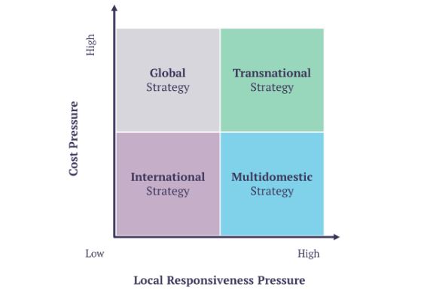
Figure 3: Bartlett and Ghoshal’s Typology of International Strategies
Source: (Chegg, 2023)

2.2.1 Global Integration and Cost-Efficiency Pressures
Bartlett and Ghoshal model places firms based on pressures for global integration and local responsiveness. Walmart is under strong integration pressures since the “everyday low prices” strategy relies on “scale, pressure on suppliers, standardisation of processes and logistics”. Market forecasting, replenishment and cost control are enhanced through centralised information systems, automated inventory management and customer analytics. Walmart has also made a digital investment, which further connects physical store fulfilment systems with online channels, despite the fact that the financial outcomes of retail digitalization have been varied (Durand et al., 2024; Brunda et al., 2025).

2.2.2 Local Responsiveness and Market Adaptation
Yet, Walmart is flexible with formats, brands, partnerships and product lines. Its businesses include Walmart, Sam's Club, and well-known local brands bought or built in markets like Mexico, Canada, China and India. This adaptation is needed, as the performance of international retailers requires taking market-specific conditions into account while balancing digitalisation and internationalisation (Batsakis et al., 2023).

2.2.3 Strategic Categorisation
Therefore, Walmart's transnational strategy is considered to be mostly transnational, that is, it draws on global capabilities to create efficiency, but it also reacts selectively to local demand through the subsidiaries. The balance, however, varies depending on the market and does not guarantee success (Šilenskytė et al., 2022).

2.3 Global Configuration and Value Creation

2.3.1 Geographic Footprint and Operational Network
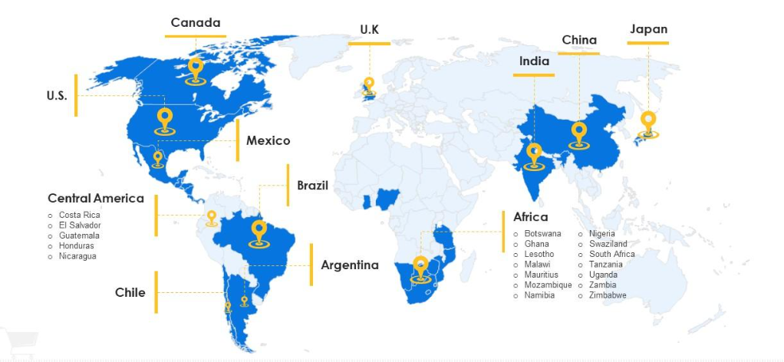
Figure 4: Walmart’s Global Operational Presence
Source: (SlideTeam, 2023)
Walmart's presence, however, is not spread evenly around the world, but is centered in the U.S. and certain markets, including Mexico, Canada, China, and India. It withdrew from Germany and South Korea and divested from Britain's Asda, showing active portfolio restructuring (Faithfull, 2020; Ji, 2025).

2.3.2 Sources of International Competitive Advantage
This set up leads to economies of scale, global procurement leverage, logistics knowledge and technology transfer. It also facilitates the cross-subsidiary sharing of successful innovations in data analytics, fulfilment and omnichannel retailing (Brunda et al., 2025).
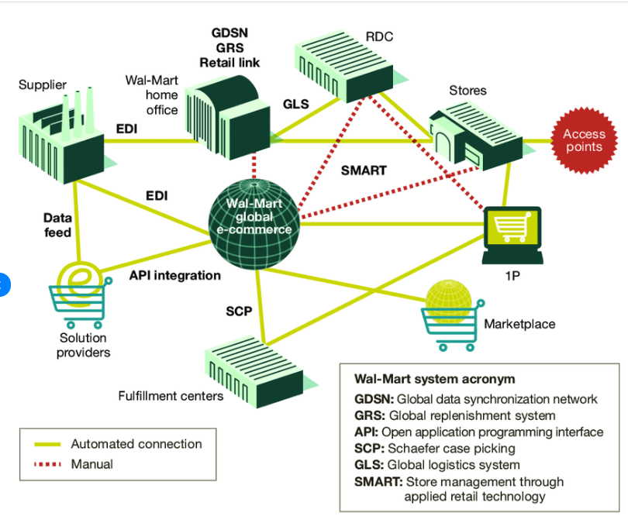
Figure 5: Walmart’s Integrated Retail and Supply-Chain Information System
Source: (ResearchGate, 2018)

2.3.3 Strategic Limitations and Lessons for New Zealand
However, Walmart’s exits show that scale cannot overcome entrenched competitors, regulatory constraints or cultural misalignment. The New Zealand entry must therefore become efficient on a global scale whilst also incorporating local sourcing, appropriate store format and customer propositions that resonate with the local culture, rather than simply being a copy of the US model.

3.0 Macro-Environmental Appraisal and Market

3.1 Political and Institutional Environment

3.1.1 Political Stability and Policy Predictability
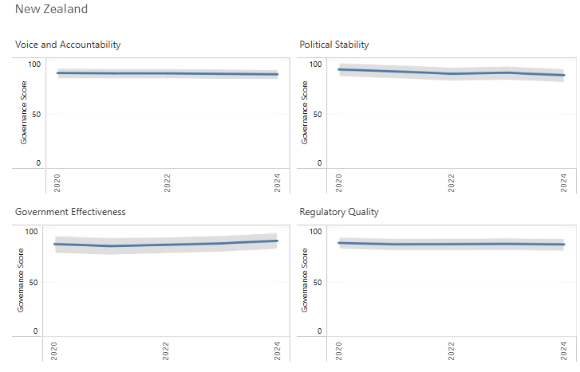
Figure 6: New Zealand’s Governance Performance Indicators, 2020–2024
Source: (World Bank, 2025)
The stability of New Zealand's democracy, its open government and relatively consistent government decision-making minimise the risk of arbitrary government interference, expropriation of assets, and radical policy swings. These conditions would favour Walmart's long-term capital planning, contractual relationships and investment on its supply chain. However, productivity and competitiveness issues continue, so that institutional stability is not necessarily correlated with sound commercial returns (OECD, 2026a).

3.1.2 Foreign Investment Policy and Regulatory Scrutiny
Investments are open to people overseas, but investment in land or business assets that are sensitive or investment in any strategically important infrastructure may require consent under New Zealand's overseas-investment regime. Government guidance applies a national-interest assessment for proposed investments that have the potential to impact economic security, competition, taxation or national capability (The Treasury, 2024). A greenfield Walmart investment, involving a large amount of land or the acquisition of a large retailer, may thus receive more attention than a limited digital or partnership-based investment. Political issues may involve foreign control, profit repatriation and the displacement of domestic retailers.

3.1.3 Government Policy Toward Retail Competition
New Zealand policy is currently focused on increasing grocery market competition, as the market is still dominated by incumbent groups. The market study done by the Commerce Commission found issues of weak competition and recommended actions in relation to wholesale access, land restrictions and supplier relationships (Commerce Commission New Zealand, 2022). Later government policies have been directed at enhancing market contestability, price transparency and regulatory oversight (MBIE, 2026). Walmart could consequently be viewed as a credible challenger capable of increasing consumer choice and price pressure.
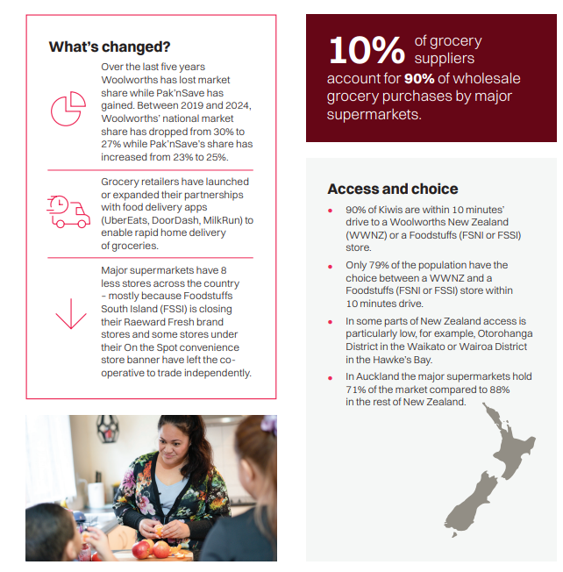
Figure 7: New Zealand Grocery Market Concentration
Source: (Commerce Commission New Zealand, 2025)

3.1.4 Political Opportunities and Risks for Walmart
The low-price model may be able to help the government meet its goals around affordability, especially during cost-of-living pressures. Its influence, however, may lead to worries related to reliance on suppliers, local-business closures, employment standards and profits moved overseas. Political legitimacy would therefore require early regulatory engagement, fair supplier contracts, local procurement commitments and measurable employment benefits. A phased approach to a partnership-led entry would de-risk political resistance and prove that Walmart adds value to New Zealand's retail economy (The Treasury, 2024).

3.2 Economic Environment and Commercial Viability

3.2.1 Market Size, Income and Consumer Spending
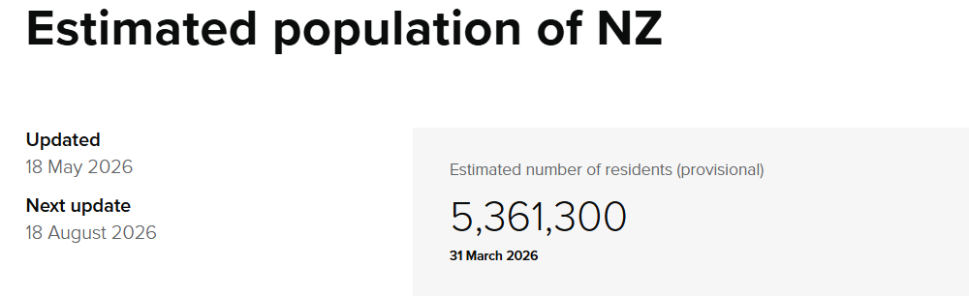
Figure 8: New Zealand Population Estimates
Source: (Stats NZ, 2026)
New Zealand brings the developed-market purchasing power with a population that is around 5.36 million people in March 2026. It has a high-income population base that backs demand for quality, convenience and omnichannel retailing; but it also has a small population, which means it does not have enough sales volume to cover Walmart's fixed distribution, technology and store-development expenses. Further, annual inflation was 3.1% in March 2026, limiting real household expenditure amid a nascent economic recovery (OECD, 2026a; Reserve Bank of New Zealand, 2026).

3.2.2 Retail Industry Structure and Competitive Intensity
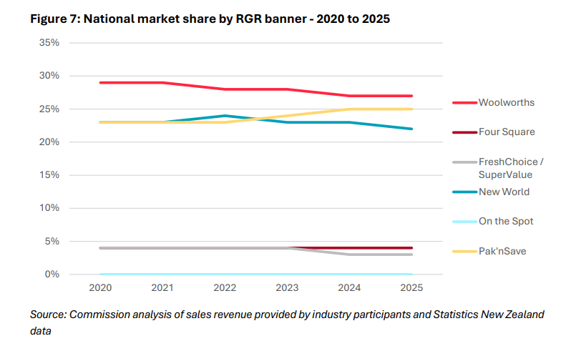
Figure 9:New Zealand Grocery Market Share, 2020–2025
Source: (Commerce Commission New Zealand, 2026)
The grocery market is dominated by Foodstuffs’ Pak’nSave, New World and Four Square brands and Woolworths New Zealand, alongside Costco, The Warehouse, Chemist Warehouse and specialised online retailers. In 2024, major supermarket groups captured about 82% of national grocery sales, indicating concentration and significant barriers to entry. The Commerce Commission determined that competition is lacking, and that on average grocery prices and profits are high (Commerce Commission New Zealand, 2022). Walmart may take advantage of this dissatisfaction but would struggle against existing stores, supplier agreements and customer preference to quickly gain market share.

3.2.3 Cost Structure and Price-Leadership Feasibility
Walmart's buying power and merchandise technology would lower the cost of merchandise, while New Zealand's wages, commercial property costs, utilities and regulatory compliance would increase operating costs.
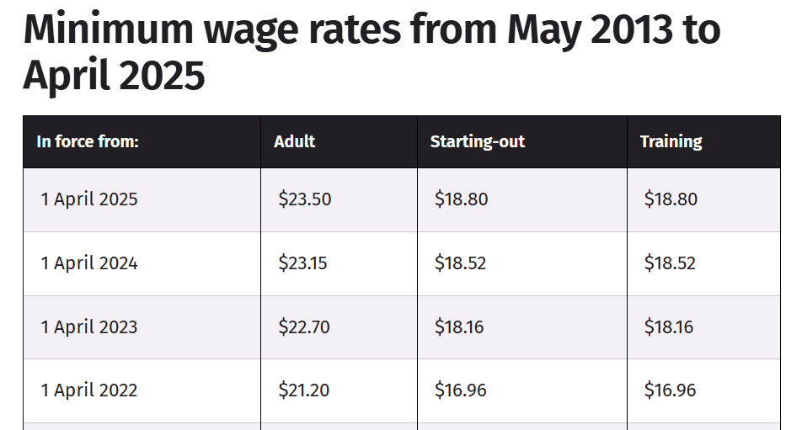
Figure 10: New Zealand Minimum Wage Rates, 2022–2025
Source: (Employment New Zealand, 2025)
Its everyday-low-price model would thus be more viable in the high-density areas of Auckland, Christchurch and Wellington, than in smaller communities. While a large nationwide store rollout could lead to a dilution of scale advantages, local sourcing and automated fulfilment could lead to a decrease in cost (Brunda et al., 2025).

3.2.4 Geography, Logistics and Supply-Chain Economics
New Zealand is geographically isolated from the key Walmart sourcing and distribution hubs, port bound and split between two main islands. Long shipping routes add to lead times, inventory buffers and vulnerability to disruption and dispersed settlements add to last-mile costs. Resilient sourcing involves an optimization of efficiency and supplier diversification and capacity, resulting in inevitable cost trade-offs (Cajal-Grossi et al., 2023; Alem Fonseca et al., 2026).

3.2.5 Currency and Macroeconomic Risks
Walmart's imported inventory would be vulnerable to the depreciation of the New Zealand dollar, while appreciation of that currency could limit the amount of US-dollar profits being repatriated. In May 2026 the Official Cash Rate (OCR) remained unchanged at 2.25%, with the Reserve Bank seeing inflation pressure to return, reflecting uncertain financing and consumption conditions (Reserve Bank of New Zealand, 2026). Walmart should therefore take measures like currency hedging, local procurement and staged investment to keep margins protected and maintain flexibility.
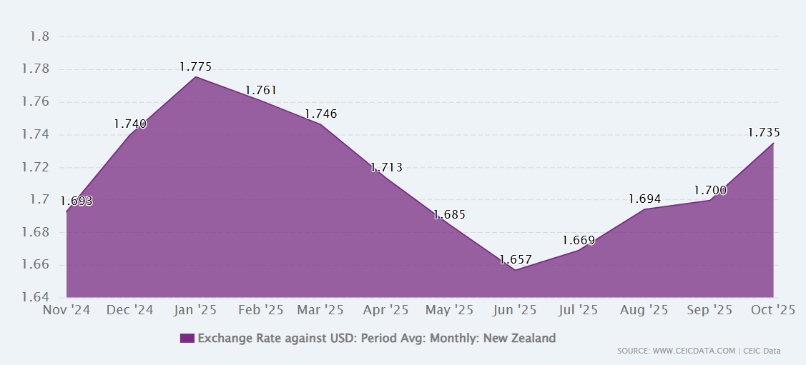
Figure 11: New Zealand Dollar–US Dollar Exchange Rate, 2024–2025
Source: (CEIC Data, 2025)

3.3 Legal and Regulatory Environment

3.3.1 Competition and Commerce Regulation
Walmart would operate under the Commerce Act 1986, which prohibits anti-competitive agreements, misuse of substantial market power and acquisitions that substantially lessen competition. The grocery market in New Zealand is very concentrated, and an acquisition of a large supermarket would be closely eyed by the Commerce Commission. In contrast, a greenfield Walmart may be policy-friendly in its ability to create competition on prices. However, the practice of selling at below cost in order to drive out the competition, or of using unfair supplier terms or land deals would be regarded as a regulatory risk. The Grocery Industry Competition Act 2023, Grocery Supply Code and wholesale-access regime also require transparent and good-faith dealings with suppliers (Commerce Commission New Zealand, 2022; MBIE, 2026).

3.3.2 Employment and Workplace Regulation
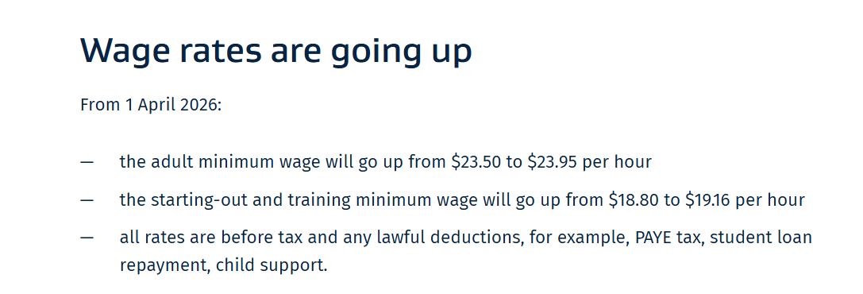
Figure 12: New Zealand Minimum Wage Increase in 2026
Source: (Business.govt.nz, 2026)
Walmart's labour-intensive approach has to follow the Employment Relations Act 2000, Holidays Act 2003, minimum-wage regulations and health-and-safety laws. The adult minimum wage has gone up to NZ$23.95 per hour from 1st April 2026, which will increase the costs compared to lower paid sourcing markets. There are also rights for employees with regards to written agreements, leave, union membership, collective bargaining and against unjustified dismissal. If these would reduce the protections already in place in New Zealand, Walmart could not simply import US employment practices. For compliance, and for employers to be legitimate, this would require competitive wages, and predictability in scheduling and worker consultation (Links International, 2026; OECD, 2026b).

3.3.3 Consumer Protection and Product Standards
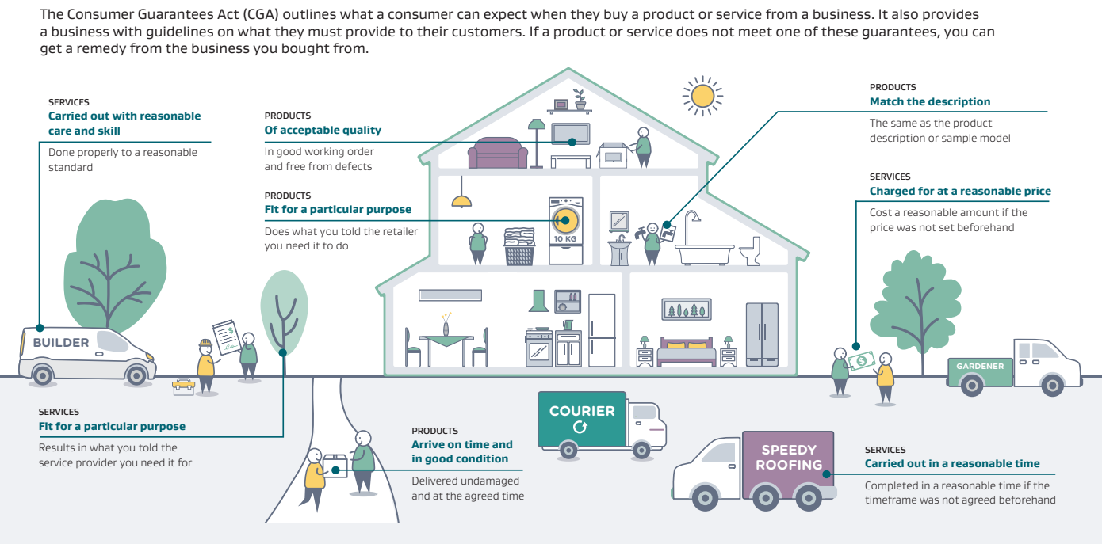
Figure 13: Consumer Rights under New Zealand’s Consumer Guarantees Act
Source: (Consumer Protection New Zealand, 2026)
The Fair-Trading Act 1986 prohibits misleading prices, false representations and unfair practices, while the Consumer Guarantees Act 1993 requires goods to be safe, durable and fit for purpose. Walmart would require accurate promotional pricing, country-of-origin and food labelling, effective product recalls and accessible refunds. Its use of customer data and AI-driven personalisation must also comply with privacy obligations, because digital convenience can create risks involving surveillance, consent and remedies for privacy harm (Opland, 2026; Brunda et al., 2025).

3.3.4 Environmental and Sustainability Requirements
The costs of compliance and supplier-monitoring would go up due to packaging recovery, waste minimisation, emissions reduction and responsible sourcing. However, credible environmental commitments could help to distinguish Walmart and support its corporate environmental, social and governance (ESG) goals, instead of being symbolic statements (Walmart Inc., 2025b).
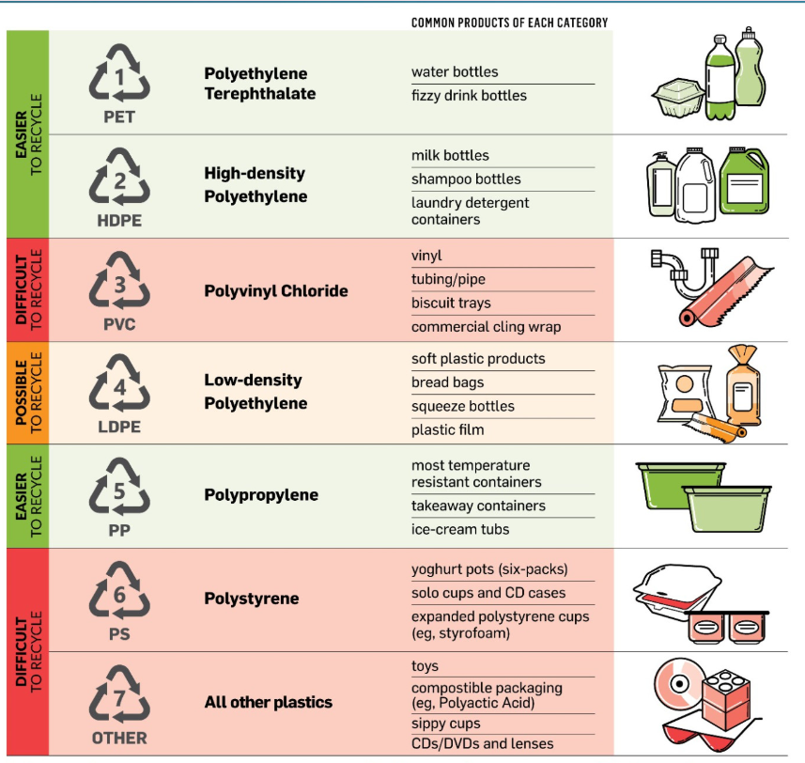
Figure 14: Plastic Types and Recyclability in New Zealand
Source: (Ministry for the Environment, 2026)

3.3.5 Māori Rights and Stakeholder Responsibilities
While not all retail decisions need to involve Māori consultation, land-based, employment, sourcing and community impacts must be engaged with in a culturally responsible manner. Social legitimacy could be enhanced through partnership with iwi and Māori enterprises, bilingual communication, and utilizing Māori products. Collective wellbeing and guardianship of the environment are key Māori values that should underpin governance, not simply be used for marketing (Askarany et al., 2025).

3.4 Cultural and Consumer Environment

3.4.1 New Zealand Consumer Values and Shopping Behaviour
New Zealand consumers are price conscious and want quality, convenience, ethical behavior and environmental care. Grocery spending is a necessity and value and promotions are top-of-mind as a result of inflation. However, universalism, achievement and enjoyment indicate that sustainability needs to be tied to customer experience and affordability (Hasan et al., 2025). Pandemic related changes also boosted the need for online ordering, contactless payment and home delivery, favoring an omnichannel entrant (Tang et al., 2021).
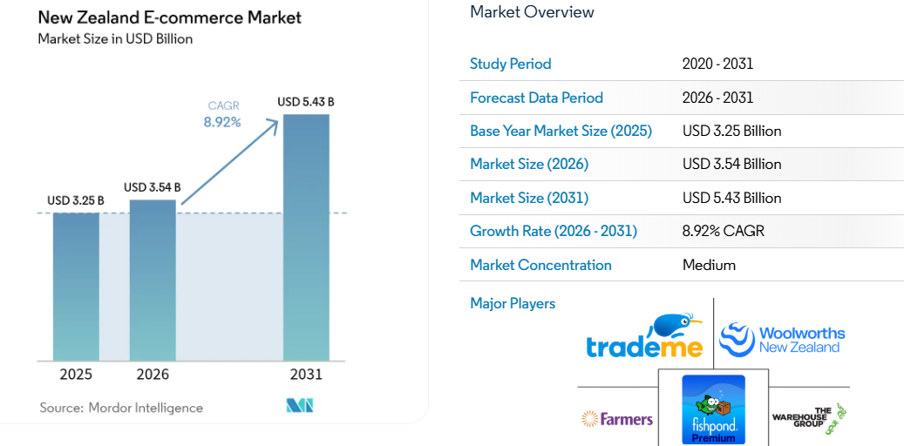
Figure 15: New Zealand E-Commerce Market Growth
Source: (Mordor Intelligence, 2026)

3.4.2 Cultural Distance from Walmart’s US Model
Walmart's supercentre format, which is large and out of town, might not be easily adapted to the NZ format. The country has a spread-out population, smaller urban centres, and an existing neighbourhood shopping pattern which makes uniformly large stores less economically feasible. A uniform and cheap product might also clash with the preference for locally trusted brands and fresh food items, as well as for responsible business. This is evidenced by Walmart's withdrawal from Germany and South Korea, where the lack of cultural sensitivity and format adaptations outweighed the positive effects of the retail giant's buying power.

3.4.3 Attitudes Toward Foreign Retailers and Local Businesses
Walmart could be a competitor to Foodstuffs and Woolworths, and that could be good news for consumers currently facing high grocery prices. Grocery competition was identified as not working well by the Commerce Commission (Commerce Commission New Zealand, 2022), which also supports this opportunity. However, acceptance could decline if Walmart were perceived as displacing independent retailers, pressuring farmers, offering insecure employment or transferring profits overseas. Its British experience similarly shows that foreign ownership does not ensure long-term strategic acceptance or performance (Faithfull, 2020).

3.4.4 Localisation Requirements
Walmart's approach should be to choose smaller urban stores, selected types of warehouses and digital fulfilment rather than trying to replicate the supercentre of the USA. Visible shelf space needs to be allocated and long-term supplier arrangements be in place for local food, Māori and Pacific produce. The focus of branding needs to be on cost, community and cultural respect, not tokenism. Ethical expectations would be met by packaging reduction, renewable-energy use and transparency of sourcing.
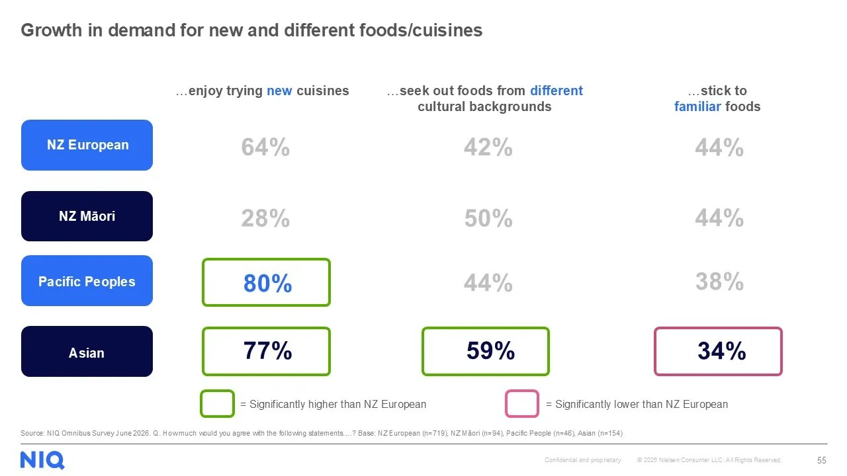
Figure 16: Demand for Diverse Foods among New Zealand Consumers
Source: (NielsenIQ, 2026)
Lastly, an integrated app, click-and-collect and regional delivery partnerships might enable Walmart to gain convenience while also testing demand without a national brick-and-mortar network. This would give Walmart an advantage in cost and technology, and give them local responsiveness for sustainable entry (Tang et al., 2021).

3.5 Overall Market Attractiveness

3.5.1 Opportunity–Risk Assessment
Factor | Weight | Score /5 | Weighted score | Strategic evidence
Political and institutional stability | 20% | 4.0 | 0.80 | Predictable institutions, but foreign-investment scrutiny
Economic conditions | 25% | 2.5 | 0.63 | High purchasing power, but small population and rising costs
Retail competition | 20% | 4.0 | 0.80 | Concentrated market creates demand for a price challenger
Legal and regulatory environment | 20% | 3.5 | 0.70 | Transparent rules, but strong employment and supplier protection
Cultural and consumer fit | 15% | 3.5 | 0.53 | Value-conscious consumers, but localisation is essential
Total | 100% |  | 3.46/5 | Moderately attractive
Table 1: Weighted Market Attractiveness Assessment for Walmart’s Entry
Source: (Author, 2026)

3.5.2 Strategic Implications for Walmart
New Zealand is definitely appealing and attractive for controlled entry, though not for a nationwide supercentre rollout at the moment. The opportunity arising from a concentration is where Walmart's low price can exploit a situation of least investment risk because of institutional stability (Commerce Commission New Zealand, 2022; OECD, 2026a). Phased investment, local sourcing, smaller formats, digital fulfilment and regulatory cooperation are key for commercial viability. Entry should only occur when there are indications of an ability to support sustainable logistics costs in pilot operations, supplier acceptance as well as demand beyond Auckland.

4.0 Dunning’s OLI Analysis of Walmart’s New Zealand Entry

4.1 Ownership Advantages

4.1.1 Tangible and Intangible Resources
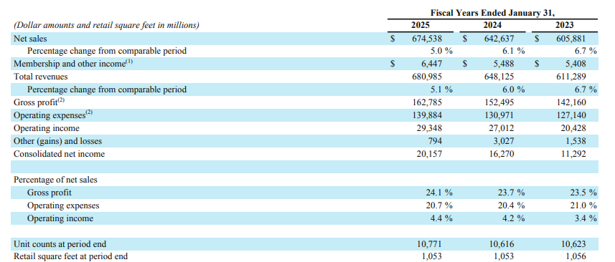
Figure 17: Walmart’s Financial and Operational Performance
Source: (Walmart Inc., 2025a)
Walmart has significant ownership advantages in terms of financial resources, international brand and operating size. The firm reported revenues of US$681 billion and had an estimated 270 million customers per week in FY2025, spanning across more than 10,750 stores and various e-commerce platforms (Walmart Inc., 2025a). This scale provides Walmart greater purchasing power and facilitates them to negotiate better prices, build its own brands and spread technology investment over a huge revenue stream.
Its intangible resources include retail knowledge, supplier relationships, demand-forecasting systems, inventory analytics and the “everyday low price” proposition. The incorporation of artificial intelligence in Walmart enables automated replenishment and personalised marketing and operational choices, while also introducing workforce, privacy and moral-governance concerns (Brunda et al., 2025). Its stores can serve as fulfilment centres, connecting with click and collect and delivery options. This omnichannel capability is relevant because digitalisation can significantly boost performance of international retailers with complementary physical and organisational resources (Batsakis et al., 2023).
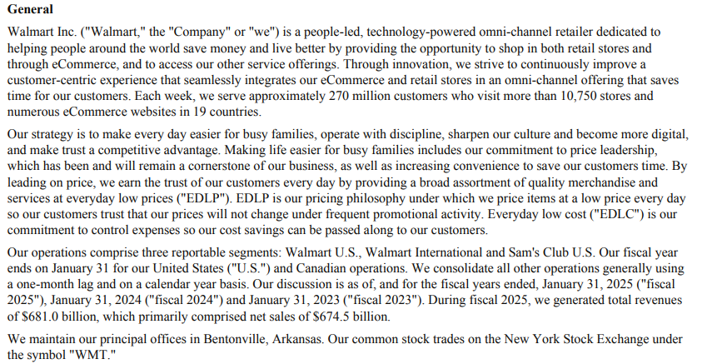
Figure 18: Walmart’s Omnichannel and Price-Leadership Strategy
Source: (Walmart Inc., 2025a)

4.1.2 Transferability to New Zealand
The benefits are partly transferable. The size of procurement, and data analytics, could reduce purchasing and inventory expenses, whilst volume economies would be limited in New Zealand due to its small market size. Walmart may not be able to replicate the price benefits it enjoys in the United States due to high wages, transport costs and local compliance. While its brand may spark interest, the local market may prefer smaller sizes, ethical sourcing, and well-known brands. Ownership benefits need to be adjusted via local sourcing, regional mixes and flexible delivery (Bowden et al., 2026).

4.2 Location Advantages and Disadvantages

4.2.1 Market and Institutional Advantages
New Zealand has political stability, clear rules, established transportation and technology systems, and a relatively strong consumer spending power. These features decrease uncertainties associated with contracts, capital expenditure and long-term planning (OECD 2026a). More important, the grocery business is consolidated. The Commerce Commission found that competition was not working well for consumers, and that there were significant barriers to entry and relatively high prices (Commerce Commission New Zealand, 2022). This means Walmart might come on as a price competitor with a greater selection and omnichannel convenience. Competition in the supermarket sector may be further boosted by government initiatives to promote competition (MBIE, 2026).

4.2.2 Structural Location Disadvantages
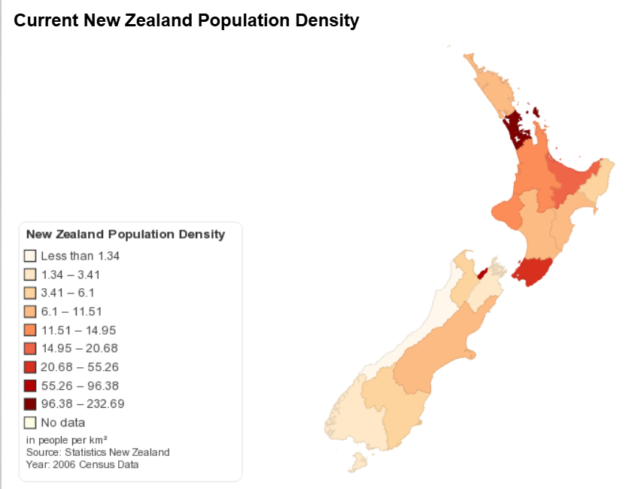
Figure 19: New Zealand Population Density
Source: (ChartsBin, 2006)
However, approximately 5.36 million residents provide a limited customer base for Walmart’s volume-driven model. Geographic isolation adds to import lead times, port dependency and safety stocks, and separation between the North and South Islands adds to domestic distribution costs. Resilience in supply chain would need other suppliers and extra capacity, which would have a trade-off between cost efficiency and reliability (Alem Fonseca et al., 2026). Foodstuffs and Woolworths also have existing retail locations, supplier networks and customer base. Compliance costs would be added in rules on employment, environment, consumer and overseas-investment (Garton et al., 2026).

4.2.3 Net Location Attractiveness
New Zealand offers moderate rather than high attractiveness. There is a real opportunity with institutional quality and a lack of grocery competition, but with limited scale and logistics costs there is no strong argument for immediate investment in large formats. These weaknesses could only be countered by location advantages if Walmart first focuses on the dense urban markets, where they can develop local sourcing.

4.3 Internalisation Advantages

4.3.1 Value of Maintaining Internal Control
An internalisation would enable Walmart to safeguard procurement systems, data analytics and retail knowledge while gaining control of inventory, pricing, customer data, service quality and brand standards. Direct coordination has the potential to better link stores with online ordering and fulfilment than licensing. Control would also enable Walmart to maintain the low-price strategy and keep check on the responsible sourcing.
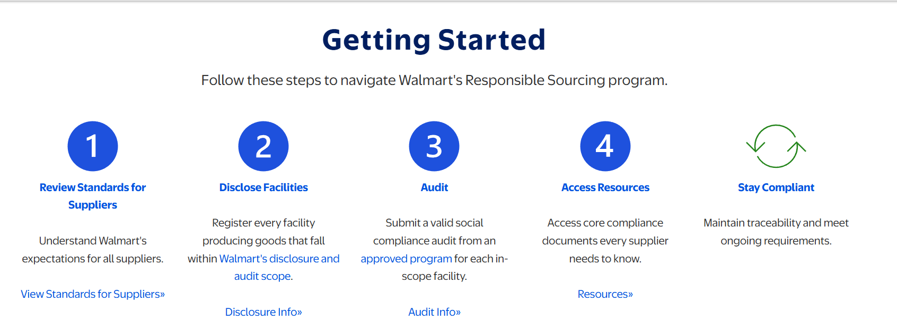
Figure 20: Walmart’s Responsible Sourcing Process
Source: (Walmart Inc., 2026)
The disparity in digitalisation results achieved by large retailers suggests that digitalisation needs to be combined with the organisation's capabilities instead of being transferred on its own (Durand et al., 2024).

4.3.2 Limits of Full Internalisation
Full ownership would nevertheless require substantial investment in stores, distribution centres, technology and regulatory compliance before demand was proven. It also would focus exchange-rate, political and operating risks on Walmart. Lacks of understanding of local culture, suppliers and planning processes may also result in the weaknesses found in the previous foreign entries (Ji, 2025). There is potential for a local partner to help narrow these gaps in knowledge, and shared ownership might decrease operational control.

4.4 OLI Synthesis and Entry Implications
Walmart has a good ownership advantage, while the location advantages of New Zealand are offset by a lack of scale and logistics costs. Internalisation is valuable for technology, pricing and brand control, yet full ownership would create disproportionate commitment. The OLI analysis hence indicates a gradual approach that entails a digital-first entry via strategic logistics and supplier partnerships, followed by company-controlled pilot stores. Expansion should be based on the demonstration of demand, cost effectiveness, and regulatory approval.

5.0 Entry-Mode Strategy and Strategic Synthesis

5.1 Walmart’s Historical Entry-Mode Patterns

5.1.1 Greenfield and Wholly Owned Expansion
Walmart has practiced greenfield investment when market conditions were favourable to erecting stores and distribution networks to its existing business model. Wholly owned investment offers significant pricing, technology, buying and customer experience benefits. It also safeguards firm-specific expertise and serves to execute a uniform approach to the brand. But the building of organics is capital intensive and slow, especially when land, planning permission, supplier infrastructure needs to be built in tandem. Wholly owned foreign investment is most appropriate when firms have high digital and operation capacities and can deal with host-country uncertainty on their own (Mueller et al., 2025).

5.1.2 Acquisitions and Joint Ventures
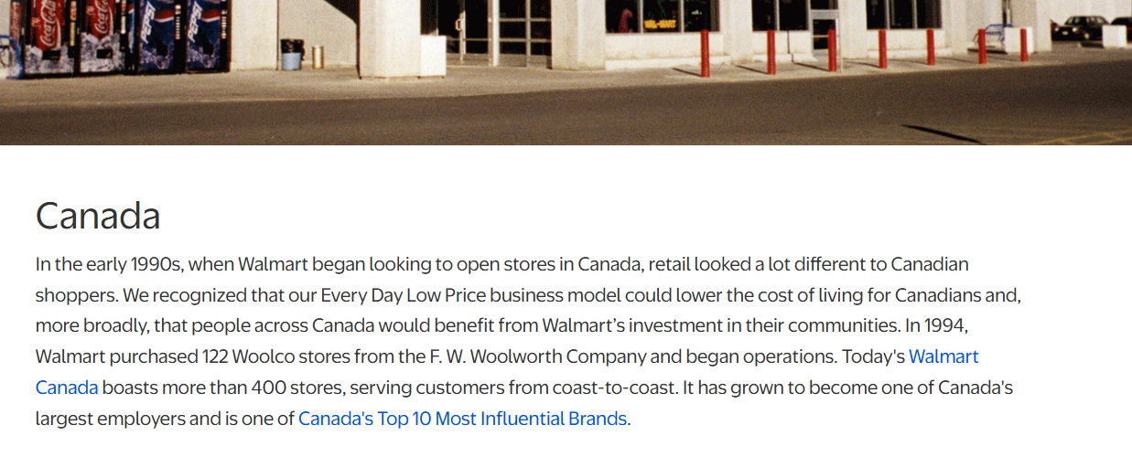
Figure 21: Walmart’s Acquisition-Based Entry into Canada
(Walmart Inc., 2026)
For Walmart, acquisitions and joint ventures have played a significant role in internationalisation. In Canada, Walmart acquired 122 Woolco stores and in Britain, Walmart acquired Asda. In Mexico, initially it worked with the local retailer, Cifra, and acquired local knowledge before taking over ownership. The restriction in the Indian regulatory environment pushed the companies to partner with Bharti Enterprises and Walmart even took a controlling stake in Flipkart to get its hands-on e-commerce prowess and an existing customer base. These channels allowed stores to have access to their markets and customers and also to suppliers, while sometimes integration proved problematic (Ji, 2025).

5.1.3 Divestments and Market Withdrawal Lessons
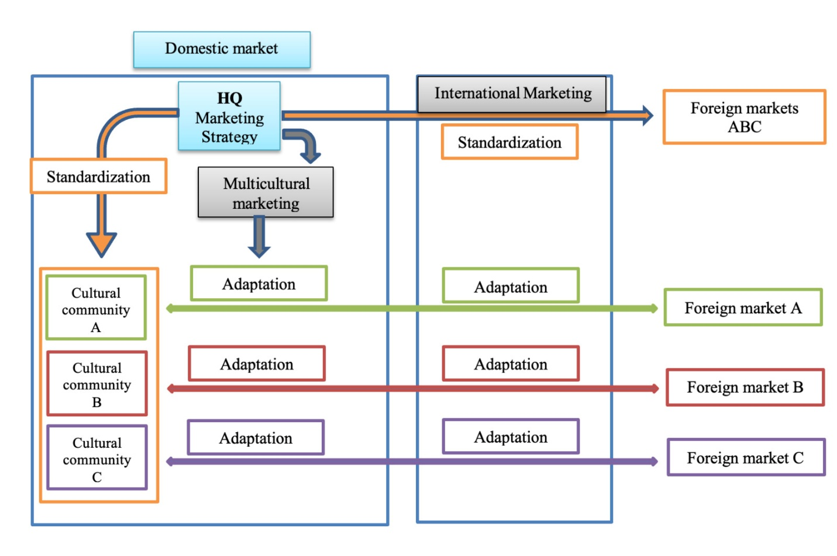
Figure 22: Standardisation and Adaptation in Foreign Markets
Source: (AIB Insights, 2024)
Walmart withdrew from Germany and South Korea after its formats, employment practices and product propositions failed to align sufficiently with local conditions. It also sold off Asda, which it faced difficulties as it competed with the bigger market-leading British rivals and as customer attitudes changed (Faithfull, 2020). These results indicate that cultural distance cannot be overcome by ownership control and financial size, and that strong localisation or low competition may be as important as larger actors in achieving results.

5.2 Suitability of the Historical Modes for New Zealand

5.2.1 Greenfield Investment Assessment
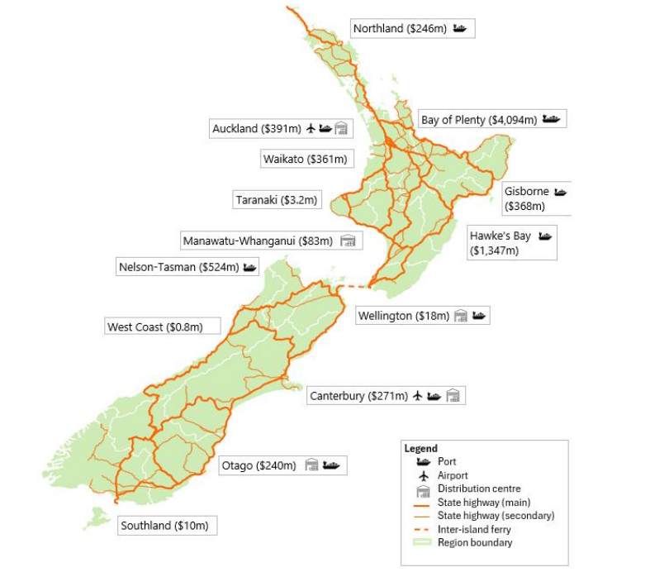
Figure 23: New Zealand’s Horticultural Supply-Chain Network
(Horticulture New Zealand, 2023)
A greenfield investment would enable Walmart to structure its stores, distribution centers and digital systems according to its cost leadership approach. However, the cost and time to acquire suitable land, plan, and to establish a two-island supply network would be significant. Immediate large-format development, in particular, would be very risky given that New Zealand has a small population and a yet to be proven demand for US-style supercentres (OECD, 2026a).

5.2.2 Acquisition Assessment
Purchasing an existing retail business may offer stores, staff, clients and suppliers right away. However, there are few acquisition targets of sufficient scale. Buying a big stake in New Zealand's biggest supermarket, Foodstuffs, or department-store chain, Woolworths, would be structurally challenging and could raise a number of competition and overseas-investment objections. A smaller buy would provide local expertise, but may not have the assets to support Walmart's national cost advantage. Expected returns may also be dampened by high valuations (MBIE, 2026).

5.2.3 Joint Venture or Strategic Partnership Assessment
To reduce the investment risk and enhance the understanding of regulations, suppliers and consumer preferences, a joint venture with a local logistics, technology or retail organisation would be preferable. It might also enhance political legitimacy via the participation of domestic actors. But price, sourcing and employment and expansion pace differences may diminish Walmart's control. The implementation of strategy in transnational companies can be quite complex due to the differences in objectives and practices of the organisational units (Šilenskytė et al., 2022).
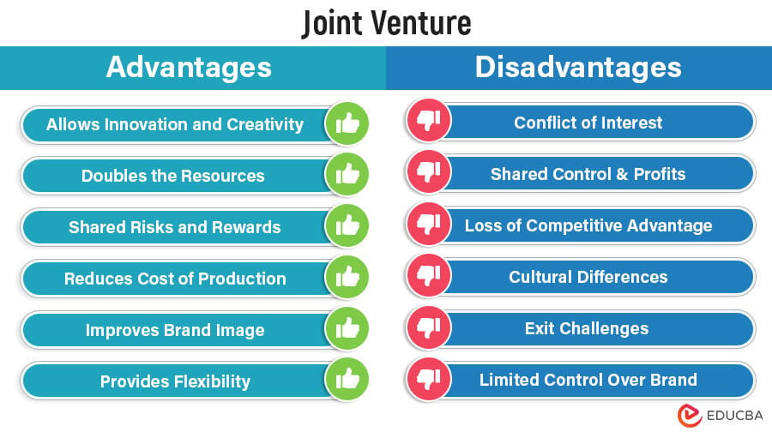
Figure 24: Advantages and Disadvantages of Joint Ventures
Source: (EDUCBA, 2026)

5.2.4 Digital-First or Phased Entry Assessment
Retailer Walmart would be able to gauge the demand for products via a New Zealand marketplace, local fulfilment centre and delivery partnerships before building stores with a digital-first entry. Such is a fairly reversible strategy and aligns with the increasing omnichannel behaviour of users (Batsakis et al., 2023). However, cross-border shipping would not be quick enough and cheap enough to provide everyday-low prices. Digital entry has to thus encompass area stock, providers, and fulfilment capability.

5.3 Comparative Entry-Mode Evaluation
Evaluation factor | Greenfield | Acquisition | Joint venture | Digital-first entry
Political and regulatory risk | High | High | Medium | Low
Financial commitment | Very high | High | Medium | Low–medium
Operational control | Very high | High | Shared | High
Speed of entry | Slow | Fast | Medium | Fast
Local market knowledge | Low initially | High | High | Medium
Flexibility and reversibility | Low | Low | Medium | High
Long-term strategic fit | Medium | Medium | High | High
Table 2: Comparative Evaluation of Walmart’s New Zealand Entry Modes
Source: (Author, 2026)

5.4 Final Recommendation and Implementation Priorities

5.4.1 Recommended Entry Mode
Walmart should implement a staged approach to digital-first with contractual relationships with New Zealand logistics providers and local suppliers. It should not immediately form an equity joint venture with the various entities involved and should keep the control over its brand, platform, customer data, pricing systems and merchandise standards. This balances Walmart’s ownership advantages with New Zealand’s limited scale and uncertain physical-store demand (Askarany et al., 2025).

5.4.2 Phased Implementation
The first stage should be to test demand and involve the Commerce Commission, authorities for overseas investments, suppliers, unions and iwi and community representatives. Walmart should then work on local sourcing, third party logistics, launching a marketplace and an Auckland fulfilment pilot. The third stage should test click-and-collect and delivery performance. Smaller stores could then be trialled in Auckland and Christchurch. Expansion of the nation should only be done following a formal performance review.

5.4.3 Risk-Mitigation Measures and Success Indicators
Through long-term supplier contracts, transparency on employment practices, culturally-resonant branding and credible commitments to packaging and emissions, environmental and regulatory risks can be mitigated (Askarany et al., 2025; Walmart Inc., 2025b). Customer-acquisition cost, repeat-purchase rate, delivery cost per order, fulfilment accuracy, local-sourcing percentage, sales per square metre, market share and operating margin should be used to assess performance. Capital and strategic flexibility should be maintained by halting expansion if predetermined thresholds are not reached.

Section 2: Reflective Account Using Gibbs’ Reflective Cycle

6.0 Gibbs’ Reflective Cycle

6.1 Description of the Experience
I first broke down the assessment into four interrelated activities: identifying the international strategy at Walmart, analysing the environment in NZ, implementing the Dunning's OLI paradigm and suggesting the entry mode. Walmart was chosen, as it has a wide global presence, with examples of successful expansion, adaption and market withdrawal. New Zealand was chosen because Walmart did not have any major formal business establishment in the country at 1 June 2026 and the country had a highly concentrated grocery market, which offered an opportunity to enter.
I created a research plan which focused on Walmart's corporate reports, New Zealand government publications, regulatory evidence and peer-reviewed literature. I then categorized the evidence according to political, economic, legal and cultural themes before relating this to the strategic frameworks.

6.2 Feelings and Initial Assumptions
First, I thought that New Zealand would be very appealing because it was a politically stable, economically advanced country that might be open to more competition from supermarkets. I also believed that Walmart's size and the widespread brand would give them a competitive edge right off the bat. However, I became uncertain after recognising the country’s small population, geographic isolation and high operating costs. Even confirming that Walmart was absent proved difficult as products with the company's name could also be sold on third party online platforms or through cross-border channels, which do not amount to a store or formal market entry via a subsidiary.

6.3 Evaluation of the Process

6.3.1 Effective Research Practices
The most successful practice adopted was source triangulation. The evidence of Walmart's revenue, employees, geographic location, and its size of operations was provided in the annual report of Walmart (Walmart Inc., 2025a). New Zealand government and regulatory sources were found to be valuable, by providing market-specific evidence regarding competition, foreign investment and monetary conditions. For instance, the Commerce Commission New Zealand (2022) showed that grocery competition was not sufficiently effective for consumers, and the Reserve Bank of New Zealand (2026) explained inflation and interest-rate risks. Academic studies subsequently helped clarify the nature of Walmart's moves into various nations, their technological and online capabilities, and their trade-offs in supply chains (Ji, 2025; Alem Fonseca et al., 2026).

6.3.2 Weaknesses and Difficulties
Some market reports were paywalled, while other sources contained outdated or conflicting market-share estimates. Corporate sources provided up-to-date information on the operations, but they were able to make Walmart look good. Media evidence offered practical examples, but was not as detailed or in-depth as peer-reviewed studies. I tried to overcome the shortcomings by relying on official and academic evidence, verifying publication dates and steering clear of unhelpful precision. I further disclaimed formal operational presence from product availability indirectly.

6.4 Analysis of Learning

6.4.1 Application of Course Theories
Bartlett and Ghoshal's model altered my perception of Walmart and transformed it from a standardised global retailer to a transnational organisation that was predominantly integrated with selective local responsiveness. Centralised procurement, technology and logistics of Walmart provides the efficiency; however, its international operations need to be adapted. A study on strategy implementation in transnational MNCs revealed that tensions might emerge between the requirements of global consistency and local needs (Šilenskytė et al., 2022).
The OLI paradigm by Dunning helped me to differentiate Walmart's ownership advantages from the more moderate location advantages that New Zealand offers. Walmart had a capital resources, data, procurement systems and omnichannel capabilities, but these strengths were not necessarily the answer to whether or not full ownership was the right move. The Internalisation provided control, but increased the capital exposure and knowledge risk in the local market.

6.4.2 Development of Critical Analysis
The main improvement in my reasoning was moving from identifying environmental conditions to evaluating their strategic consequences. For instance, in a politically stable country, investment uncertainty would be minimized but foreign investment screening may hinder an acquisition. Demand was boosted because purchasing power was high, while population was limited, which resulted in reduced economies of scale. In the same way grocery-market concentration presented an opportunity for a price challenger, but also indicated strong incumbents and barriers to entry. This allowed the environmental analysis to be avoided and prevented it becoming a descriptive list.

6.4.3 Integration of Theory and Evidence
I compared each theoretical proposition with market evidence before making a recommendation. Walmart's failure was an illustration of how scale and control could not overcome cultural and competitive misalignment (Faithfull, 2020; Ji, 2025). In parallel, the evidence in the field of digital internationalisation was in favour of a low commitment approach for testing demand (Batsakis et al., 2023). This integration made me suggest phased digital entry rather than on the basis of the historically dominant mode of Walmart when considering New Zealand.

6.5 Conclusion of the Reflection
I was taught that choosing an international market is not based on just favourable economic indicators. Strong institutions and unmet consumer needs are not enough to make a market commercially attractive if there are logistics, regulatory and scale barriers. I have also learned that theoretical frameworks are used to ease complex decisions and must be applied critically and not mechanically. Most crucially, the evidence indicated that entry mode recommendations have to account for the interplay of firm capabilities and host country conditions. Walmart's global strengths provided opportunity, but the ability to localise, establish regulatory legitimacy, and commit limited resources were the differentiators.

6.6 Action Plan
Development area | Planned action | Intended improvement
Source selection | Establish criteria covering authority, currency, relevance and potential bias before collecting evidence. | Improve source reliability and reduce time spent on unsuitable material.
Evidence management | Create a matrix linking each claim, source, framework and strategic implication. | Strengthen synthesis and prevent descriptive writing.
Market verification | Confirm the company’s operational presence and evidence cut-off date at the beginning. | Avoid uncertainty between indirect sales and formal entry.
Quantitative analysis | Compare market size, costs, competition and entry modes using weighted scoring and sensitivity analysis. | Produce more transparent recommendations.
Academic writing | Review paragraph structure, critical language and Harvard referencing systematically. | Improve clarity, consistency and evidential support.
Reflective practice | Record assumptions, difficulties and decisions throughout the project. | Produce deeper reflection based on actual learning rather than retrospective description.
Table 3: Personal Research and Analytical Development Action Plan
Source: (Author, 2026)

References
Alem Fonseca, M., Tsolakis, N. and Kumar, M. (2026) ‘Managing supply chain resilience and cost trade-offs: Aligning resources, competencies and capabilities’, Production Planning & Control, 37(11), pp. 1117–1160. Available at: https://doi.org/10.1080/09537287.2026.2618640.
Askarany, D. and Lam, J. (2025) ‘The role of Māori values in corporate culture and CSR: A comparative study in Aotearoa-New Zealand’s fishing industry’, SSRN Electronic Journal. Available at: https://doi.org/10.2139/ssrn.5236275.
Batsakis, G., Theoharakis, V., Li, C. and Konara, P. (2023) ‘Internationalization and digitalization: Their differing role on grocer and non-grocer retailer performance’, Journal of Retailing, 99(3), pp. 400–419. Available at: https://doi.org/10.1016/j.jretai.2023.07.005.
Bowden, R. and Lorimer, D. (2026) ‘Monetary policy and the exchange rate: The Kiwi that had to fly’, Working Paper Series, No. 33474. Wellington: Victoria University of Wellington, School of Economics and Finance. Available at: https://ideas.repec.org/p/vuw/vuwecf/33474.html.
Brunda, C., Devadiga, D. and Aithal, P.S. (2025) ‘Strategic analysis of Walmart Inc.: Innovation, ethical challenges, and the future of AI-driven services’, Poornaprajna International Journal of Management, Education & Social Science, 2(2), pp. 74–108. Available at: https://doi.org/10.5281/zenodo.17101233.
Cajal-Grossi, J., Del Prete, D. and Macchiavello, R. (2023) ‘Supply chain disruptions and sourcing strategies’, International Journal of Industrial Organization, 90, 103004. Available at: https://doi.org/10.1016/j.ijindorg.2023.103004.
Commerce Commission New Zealand (2022) Market study into the retail grocery sector. Available at: https://www.comcom.govt.nz/regulated-industries/projects/market-study-into-retail-grocery-sector/.
Durand, C. and Baud, C. (2024) ‘Profit-making, costs, and investments in the digitalization of retailing—The uneven trajectories of Carrefour, Amazon and Walmart (1995–2019)’, Competition & Change, 28(2), pp. 318–339.
Faithfull, M. (2020) ‘Whatever happened to Walmart’s British invasion?’, Forbes, 2 October. Available at: https://www.forbes.com/sites/markfaithfull/2020/10/02/whatever-happened-to-walmarts-british-invasion/.
Garton, K., da Cruz, G.L. and Swinburn, B. (2026) ‘Ultra-processed foods and their inputs increasingly dominate New Zealand’s food and beverage imports: A retrospective analysis’, Globalization and Health, 22, Article 39. Available at: https://doi.org/10.1186/s12992-026-01203-1.
Hasan, S., Wooliscroft, B. and Ganglmair-Wooliscroft, A. (2025) ‘New Zealand ethical consumption driven by universalism and personal achievement; can it also be fun?’, Kōtuitui: New Zealand Journal of Social Sciences Online, 20(4), pp. 1338–1347. Available at: https://doi.org/10.1080/1177083X.2024.2418485.
Ji, Y. (2025) ‘Walmart’s international market entry strategies: Benefits and challenges’, Advances in Economics, Management and Political Sciences, 165, pp. 108–113. Available at: https://doi.org/10.54254/2754-1169/2025.21596.
Links International (2026) Minimum wage in New Zealand. Available at: https://linksinternational.com/minimum-wage-in-new-zealand/.
Ministry of Business, Innovation and Employment (2026) Supermarket competition. New Zealand Government. Available at: https://www.mbie.govt.nz/business-and-employment/business/competition-regulation-and-policy/supermarket-competition.
Mueller, M. and Swoboda, B. (2025) ‘Determinants of wholly owned foreign direct investments in e-commerce firms: A hierarchical country- and firm-level analysis’, Management International Review, 65, pp. 699–736. Available at: https://doi.org/10.1007/s11575-025-00575-7.
OECD (2026a) Foundations for growth and competitiveness 2026: New Zealand. Paris: OECD Publishing. Available at: https://www.oecd.org/en/publications/2026/04/foundations-for-growth-and-competitiveness-2026_f68a156b/full-report/new-zealand_c6b7a0e7.html.
OECD (2026b) OECD Employment Outlook 2026. Paris: OECD Publishing. Available at: https://www.oecd.org/en/publications/oecd-employment-outlook-2026_7e710f54-en/full-report/component-5.html.
Opland, R. (2026) ‘Consumer protection law in New Zealand: A means of redress for privacy harms?’, SSRN Electronic Journal. Available at: https://doi.org/10.2139/ssrn.6523818.
Reserve Bank of New Zealand (2026) Monetary Policy Statement: May 2026. Wellington: Reserve Bank of New Zealand. Available at: https://www.rbnz.govt.nz/monetary-policy/monetary-policy-statement/monetary-policy-statement-filtered-listing-page/2026/may-270/monetary-policy-statement-may-2026/web-version.
Šilenskytė, A., Kohtamäki, M. and Dhanaraj, C. (2022) ‘Strategy implementation in the transnational MNC: A critical realist investigation of European and Indian unit collaboration’, Journal of Business Research, 152, pp. 276–289. Available at: https://doi.org/10.1016/j.jbusres.2022.07.041.
Tang, W. and Kularatne, I. (2021) ‘Change of customer behaviour during the COVID-19 pandemic: New Zealand supermarket retail industry’, Rere Āwhio – The Journal of Applied Research and Practice, pp. 146–157. Available at: https://doi.org/10.34074/rere.00114.
The Treasury (2024) Foreign investment policy and national interest guidance. New Zealand Government. Available at: https://www.treasury.govt.nz/publications/guide/foreign-investment-policy-and-national-interest-guidance.
Walmart Inc. (2025a) 2025 annual report. Bentonville, AR: Walmart Inc. Available at: https://stock.walmart.com/_assets/_5813cf69129ed45d080396680f549a44/walmart/db/950/9949/annual_report/Walmart+2025+Annual+Report.pdf.
Walmart Inc. (2025b) Environmental, social and governance reporting. Available at: https://corporate.walmart.com/purpose/esgreport.
Zámborský, P., Sullivan-Taylor, B., Tisch, D. and Branicki, L. (2022) ‘Antecedents of risk and uncertainty management capabilities: Insights from multinational enterprises in New Zealand’, Journal of Management & Organization, 28(3), pp. 632–658. Available at: https://doi.org/10.1017/jmo.2022.18

