
The potential benefits to the organisation and the individual of developing individuals in the workplace Essay
Verginica Caracas (1906795) | 2/26/21 | Developing Relationships and Workplace Achievement

Table of Contents

Introduction…………………………………………………….3

Main finding………………………………………………….…4

Motivation………………………………………………….….…4

Definition………………………………………………….……...4

Motivation Theories…………………………………….…....4

Performance Management…………………………………….…...5

Definition………………………………………………………….…5

Performance Management Theories………………….6

Employees Engagement………………………………………….……8

Definition……………………………………………………….……8

Employees Engagement Theories………………….…….8

Training…………………………………………………………………………11

Definition………………………………………………………….…11

Training Theories…………………………………………………11

Conclusion…………………………………………………….….14

References……………………………………………………….15
5.0 Personal Development Plan……………………….….…16

- Introduction
To analyse what benefits both the organisation and the employee can have by developing the individual at workplace, it is necessary to make an analysis of the vehicles that are necessary for personal development. This means identifying how an employee can be best motivated to perform at the workplace, as well as a properly training they need to be fully engaged in their role. As Warren Buffet said: “The best investment you can make is in yourself.”
This paper aims to explain management theories to find the best choice to improve the productivity and performance of the organisation and at the same time to provide benefits for the employee, as an individual, such as flexible work, professional recognition, development of skills in communication, collaboration, creativity.” Personal growth alongside business growth is a recipe for multiple levels of success.” (Dudharejia, M. 2018)

- Main findings
  - Motivation
    - Definition
A classic definition of motivation is given by Mullins (2002): “Motivation is a driving force through which people strive to achieve their goals and fulfil a need or uphold a value.”
Today, in the third decade of the 21st century, the approach to motivate an employee or a team must be thought in line with the changes that are taking place. Last year alone there were two major changes in the business environment: the pandemic of Covid 19 and the Brexit.
“Although the status quo throughout the 20th century, performance reviews may have been influenced by the Industrial Revolution’s focus on worker productivity, now annual performance analysis can occur as an outdated method of motivation the team.” (Hall, 2020)
To have highly motivated and involved employees to be inspired by their work and believe in their organization, it must design a friendly work environment where everyone feels inspired and loves what they did every day.” (Skilbeck, 2019) They do exist these kinds of organisations such as: Netflix, Google, their leadership constantly motivates and inspires employees.
    - Motivation Theories
In 1943 Abraham Maslow, an American psychologist defined a theory which suggests that people are motivated by a `hierarchy of needs`. This theory divides needs in five levels first level means the basic needs for physical satisfaction: food, working condition, salary, etc. He argued that once a level of need is met the next level takes over.
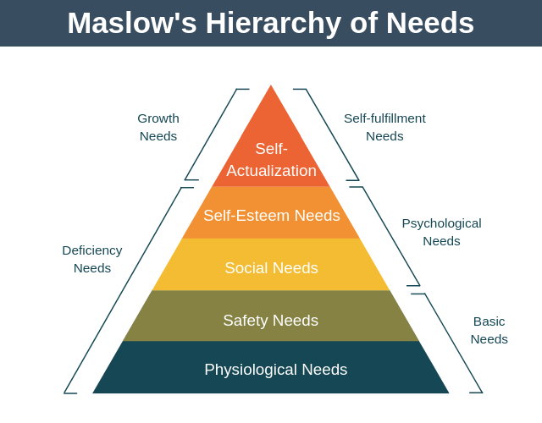
This theory is recognised by many leaders and managers and is applied for their organisation. For example, Nuclear Decommissioning Authority provide to employees a pension schemes that help to meet their safety needs.
In 1959 Frederick Herzberg described another theory, Theory or Two Factor Theory. This theory wants to reach to the roots of motivation in the workplace. The two factors are:
- Motivating factors which increase employees job satisfaction.
- Hygiene factors which decrease employees job satisfaction.

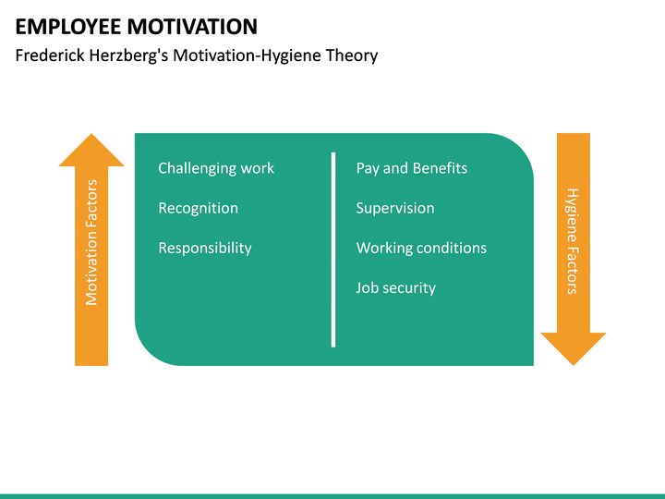

According to Herzberg theory managers must provide good and safe work conditions for the employees to make them satisfied and at the same time to ensure that their work is stimulating and rewarding. By far Google, Netflix, are the companies which offer to employees the best and the most innovative conditions at work, as well as a challenging and rewarding job.
Therefore, the potential benefits for organisation and employees might be:
Organisation Employees
- Increase productivity. - Job satisfaction
- Growth the business. - Less stress
- Reduce staff turnover - Recognition.
- Higher standards - Rewards
- Satisfied customers - Flexible work
- More efficiency workforce - Achieve personal goals.

  - Performance Management
    - Definition
Performance Management is another vehicle used for analysing a business. It was defined by Michael Armstrong and Angela Baron in 2005:
“The continuous process of improving performance by setting individual and team goals which are aligned to the strategic goals of the organisation, planning performance to achieve the goals, reviewing and assessing progress and developing the knowledge, skills and abilities of people. “
It is about `aligning individual effort to support organisational priorities`, as Aquinis said.
The Performance Management Cycle
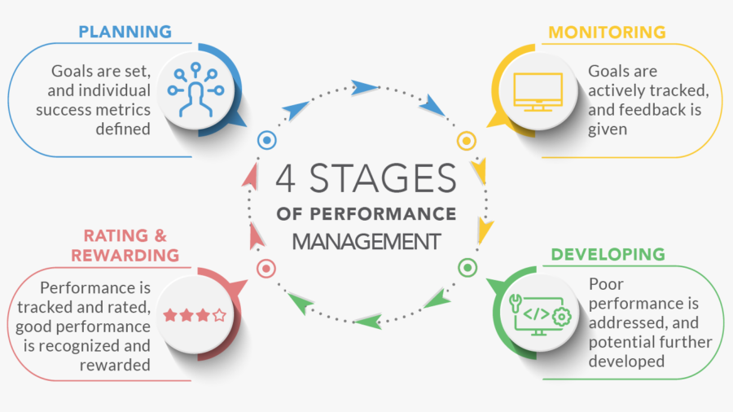
The aim of Performance Management Cycle is to establish the organisation`s objectives, to do all diligences to accomplish them and rewarded as well as evaluate and correct poor performance and improve employee’s performance.
There are four stages:
- Planning – define objectives, job description.
- Monitoring – implement personal development plan, carry out role and achieve objectives.
- Developing – track progress, continue feedback, minimize obstacle and coaching.
- Rating & Rewarding – review achievements, identify learning and rewarding.

    - Performance Management Theories
Improving Performance Management into organisation can be obtained using the framework of The AMO theory. This theory was first proposed by Bailey in 1993 and means to look to three factors: employee`s Abilities and Motivation as well as Opportunities which the organisation offers to them.
AMO theory suggests the interaction of these three elements can help predict a large of performance outcomes.
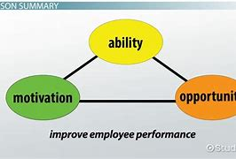
Abilities represent necessary skills and knowledge that employees must demonstrate to successful implement in their work.
Motivation means what the employees desire: flexible work, better work environment, training and developing, career, rewards and recognition.
Opportunities are represented by environmental or contextual mechanisms that enable action. (Siemsen et al., 2008) That means that even individuals have abilities and are motivated to perform in the workplace, the employers must offer them the opportunity to demonstrate their contribution to the organisation to succeed in its objectives.
To measure the performance of an organisation there are Key Performance Indicators (KPI`s)
KPIs are performance measures. used to set targets and evaluate their success.
“KPI`s provide a way to measure how well companies, business units, projects or individuals are.
performing in relation to their strategic goals and objectives.” (Marr, 2020)
“KPI`s are your guide to understanding every moving part in your business and might be the most important part of management” (Forbes, 2019)
The KPI`s are:

- Sales targets
- Absenteeism i.e., number of workers who miss work.
- Labour turnover i.e., rate at which individuals leave the organisation.
- Footfall i.e., number of customers for organisation.
Performance Management was disputed due the time consuming, and the rewards were not commensurate with employee`s performance. This is causing dissatisfaction to employees and managers. Despite all these Performance Management still matters. Evaluating the elements of Performance Management Systems aimed at a simplification of the entire process.
-Simplified systems with a singular focus on improving performance.
-Flexible goal setting that allows for format and timing to be tailored to the work; alignment to organizational goals by linking up instead of cascading down.
-Emphasis on performance measurement and streamlining administrative requirements and eliminating unnecessary documentation.
-Major emphasis on coaching and feedback.
Defining performance requirements need not involve an extensive job or occupational analysis. However, at minimum the organization should identify:
• The critical job roles.
• The work activities performed by each.
• The standards to which these activities need to be performed to meet organizational goals.
Sika Group, an international company which manufacturing chemical products in 100 countries around the world and in the UK it has over 850 employees, could be an example of an organisation that used an old Performance Management System and has invested in a new one, much simpler.
Revaluing the old performance Management System, they identified four main needs:
- Capability
- Culture. Because Sika Group has acquired a number, of other companies within the sector in many countries around the world that had resulted in multiple organisational culture.
- Communication
- Constraints
They designed and implemented a new system, and the benefits are:

Sika Group Employees
- A simpler PM process (one page instead five) - The employees were involved.
- The document easier accessed -Staff felt engaged and valued.
-Improved communication between managers and employees.
"An employee's motivation is a direct result of the sum of interactions with his or her manager. “(Nelson, 2018)

  - Employee Engagement
    - Definition
Employee engagement is more than motivation and simple job satisfaction, it is a combination of commitment to the organisation and its values and a willingness to help colleagues. (CIPD, 2021) In the scientific research employee engagement is clearly identify as a psychological state. All definitions were grouped into four categories:
- Personal role engagement means employees’ ability to express their selves in their work, both cognitively, emotionally and physically.
- Work engagement, named task or job engagement focuses on psychological employee`s state.
- Multidimensional engagement incorporates cognitive, emotional and behavioural aspects.
- Self-engagement with performance is a very rare definition based on how importantly employees regard high performance.

According to MacLeod and Clarke (2009) ’Employee engagement strategies enable people to be the best they can at work, recognising that this can only happen if they feel respected, involved, heard, well led and valued by those they work for and with.’’
    - Employee Engagement Theories

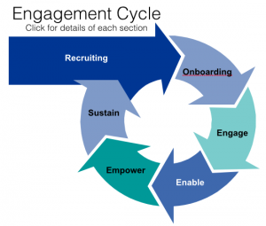

This cycle shows the stages of strategy for recruitment, engage and maintain employees into an organisation:

-Recruiting is the process to select people depending on vacancies within the organisation

-Onboarding is the first process of assimilating new hires into an organisation. A good onboarding program creates, encourages, and keeps employee engagement.

To engage and empower the employees rewarding them and giving a voice. Everybody loves to be rewarded for its efforts.

There are companies which encourage the employees to have a voice, such as: John Lewis Partnership which has stipulated in their Constitution the Voice of the partners, because in this case the employees are co-owners. Virgin Media encourages the employees to speak up, to have a voice in the organisation, also.

“By understanding employees’ values and motivations, bosses can have a revelatory effect on their teams”, said Lazarus (2019) in his article `Managers are the key to unlocking engagement`.
According to the MacLeod report on employee engagement published in 2008 but, people join organisations but leave managers. In other words, line managers play a key role in employee engagement.
Psychological contract
According to CIPD “'psychological contract' refers to individuals’ expectations, beliefs, ambitions and obligations, as perceived by the employer and the worker. The concept emerged in the early 1960s and is core to understanding the employment relationship. This contract is different from the legal employment contract. It describes a commitment between the parties as well as their expectations as they establish and understand their relationship. It is an unwritten set of expectations between the employee and the employer.
The psychologic contract is dynamic, it changes permanently, for example when new colleagues join the team, or when they leave.
Stevenson, (2019) highlighted several pros and cons of psychological contract.
Pros:
-Agility- it is so easily changed means it is difficult to “enforce”.

- Loyalty -This is a `big pro` for employees. When an employee offers loyalty to the company gains more benefits.

- Empathy- a positive work environment it creates when it is empathy when there is a good understanding between employer and employee.

- Communication- where there is empathy there is a good communication and an honest environment.

Cons:

-unwritten- it is not on-paper and it is very difficult to execute,

-Inconsistent- it is different for each employee because every single employee develops their own contract with the organisation.

- Redundant some people consider this contract redundant, even old.

However, the psychological contract is in force for each employee. Ignoring it will have negative effects for company by losing money if the employee leave or, decrease productivity if he stays, because this contract is created by employee, not by employer.

In 2014 the University of Warwick experienced in laboratory the effectiveness of an employee when he was happy. The result was amazing, productivity was increased by 12%. Therefore, the employee`s happiness makes the company more successful.

A strong Employee Engagement brings a set of benefits for organisation, as well as for employees.

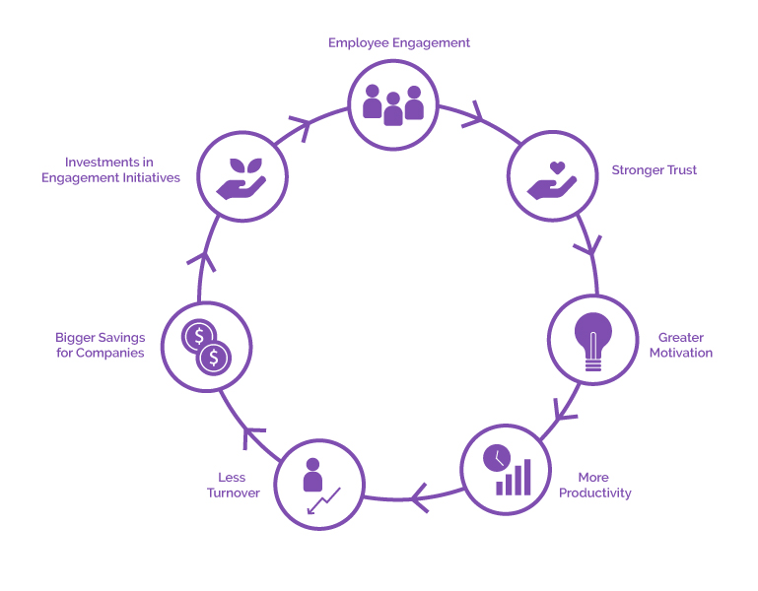

Organisation: Employees
-More productivity -Strong trust
-Less turnover - Greater motivation
-Bigger saving - Investments in engagement initiatives
2.4 Training
2.4.1 Definition
Conforming to Collins dictionary “training means to improve the performance or knowledge of the employees or workforce or a company.”
In accordance with Armstrong 1988): “Training is the systematic development of knowledge, skills and attitudes required by an individual to perform adequately a given task or job.”
Quoting Robert Kiyosaki:” Confidence comes from discipline and training.”
In the last three decades the need to improve workplace performance led to the emergence of employees training and development.
A new employee into a company needs to be teach and train to perform and become productive. He needs the knowledge, skills, attitudes, and behaviour that will enable him to de his work correctly.

2.4.2 Training Theories
Training is a systematic process begins training needs identification and ends with evaluation. This is how the Systematic Training Cycle appeared, a model which helps managers to develop their workforce.
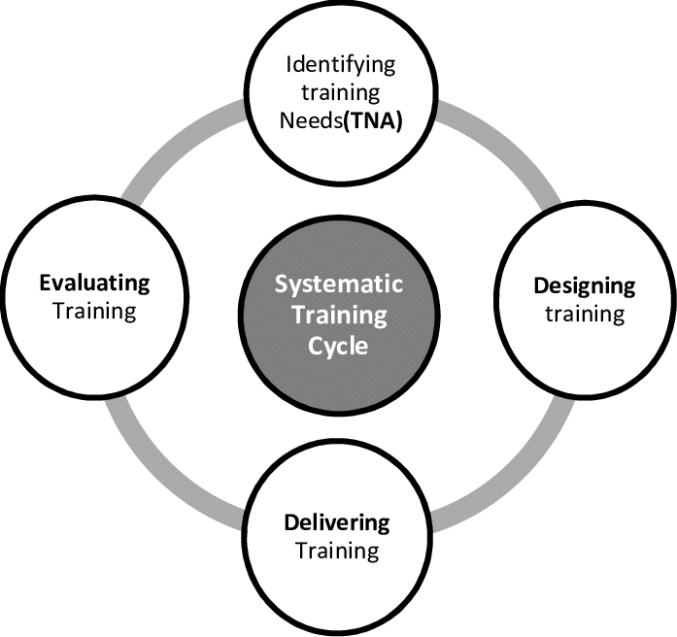
The four stages of Systematic Training Cycle are:
1.Identifying training needs. Training needs means required level of competence minus present level of competence.
2.Designing training. Training can be formal (classroom teaching) or informal (work-based learning):
3.Delivering training by creating a learning environment.
- On-the job: induction, coaching, mentoring, shadowing: quickly, cheaper, convenient
- Off-the-job: online courses@ time consuming, expensive but less distracted.

4.Evaluating training is the stage when the employer obtains information on the effectiveness of the training program.
One of the organisations which offers good programs for training is John Lewis Partnership. They stated: “We want all of our Partners to reach their potential and succeed. Whether that’s in the role they’re in currently or their future ambitions.” They have for their partners (employees) benefits package that containing learning subsidies and they truly empowered the employees. They invested significantly in leadership development, over than 8000 managers across the Partnership attending “Empowered Leadership” events. John Lewis Partnership grants support for their employees to satisfy all the needs from Maslow Model because: “The Partnership`s ultimate purpose is the happiness of all its Partners.”
The benefits of training:
Organisation Employees
-enhances performance - improved skills
-fewer complains - less mistakes
-happier customers -improved morale
-enhanced reputation -increased self-confidence

- Conclusion
In conclusion the organisation which consider all the development vehicles presented above and applied the theories and models are more successful than others. Giving to employees what they need: training, rewarding, sharing values, promoting, incentives, and other benefits make them happier and implicit more productive. These represent a great investment for organisations that make their business successful.

- References

- Armstrong, M. (1988). Handbook of human resource management. New York NY: Nicholas Publishing.Co.
- Armstrong, M., Baron, A. (2005) Managing Performance: Performance management in action London: CIPD House
- Aquintis, H. (2013) Performance management 3rd Edition, Boston: MA Pearson
- Buffet, W. Top 11 Warren Buffet Investment Quotes. Available at: http://www.carreirafinance.com (Accessed:16 February 2021)
- Dudharejia, M., (2018) Why Personal Growth is Important for Your Business 12 October. Available at: http://keap.com (Accessed: 18 February 2021)
- Forbes Human Resources Council (2020) 13 Strategies For Training New Employees Efficiently. Available at: hptts://www.forbes.com 4 November (Accessed 19 February 2021)
- Hall, J. (2020) 5 Ways To Truly Motivate Your Team in 2020. Available at: http://www.forbes.com 31 January 2020 (Accessed: 19 February 2021)
- Lazarus, J. (2019) Managers are the key to unlocking engagement. Available at: https://www,peoplemanagement.co.uk 25 March Accessed:14 February 2021)
- MacLeod, D. and Brady, C. (2008) The Extra Mile. How to Engage Your People to Win
Prentice Hall Financial Times: London.
- Marr, B. (2020) KPI`s can make a huge difference to the success of a business; 2020 Available at http:// www.bernardmarr.com (Accessed 12 February 2021).
- Mosca, L. (2019) `Key Performance Indicators 101&Why They`re Important`, Forbes, 18 June, Available at: http:// www.forbes.com/ (Accessed 12 February 2021)
- Mullins, L. J., (2002) Management and Organisational Behavior, 6th Edition: Financial Times Pitman Publishing: Essex
- Nelson, B. (2018) 1001 Ways to Engage Employees: Help People Do Better What They Do Best New York: Kindle
- Skilbeck, R. (2019) Six Strategies To Maintain Employee Motivation Available at: http://www.forbes.com 12 February 2019 (Accessed: 19 February 2021)
- Siemsen, E. et al, (2008) How motivation, opportunity, and ability drive knowledge sharing: The constraining-factor model Available at: https://www.sciencedirect.com (Accessed: 18 February 2021)
- Stevenson, M. (2019) Psychological Contract – The Pros and Cons. Available at: https://www. hrexchangenetwork.com/ 28 October (Accessed:20 February 2021)
- https://www.brainyquote.com
- www.cipd.co.uk Employee engagement 22 January 2021
- /www.collinsdictionary.com
- https://eric.ed.gov/
- www.johnlewispartnership.co.uk
- www.managementstudyguide.com Maslow's Hierarchy of Needs - Learning Theories
- A Guide to the Performance Management Cycle | AIHR Digital (digitalhrtech.com)
- https://study.com/academy/lesson/amo-theory-ability-motivation-opportunities
- https://warwick.ac.uk/New study shows we work harder when we are happy.

PERSONAL DEVELOPMENT PLAN
Team leader: John Wood (Head cook)
Organisation: Restaurant Familial
Location: Swansea
Objectives /  Area of Development | Measure | Priority | Support and Development  Internal/ External | Review  Dates | Other Comments
Updating knowledge and legislation in the field of health and safety of food and the public | Online courses / Training | High | Line manager  Newspapers  Laws | Monthly/  When is required | Very important to prevent any accidents
Developing communication, leadership and creativity skills | Online courses, meetings interactive sharing experience with master chefs | High | External/  Support from master chefs  And lecturers | Every year
Developing safety standards and improving food standards | Learning and innovation | High | Online research, courses | Every three month
Developing skills in dealing with consumers, especially those with allergies, diabetic, gluten-free, vegetarians | Permanent concern for improving knowledge in these areas | High | Self-learning and online research, | Permanent
IT knowledge for operate stock management system and software system | Training  Shadowing | Medium | Line manager  The specialist from suppliers | Annually/ any time it is required
Improving Time and Organisational Management skills | Courses online/  Meetings | High | Lecturer/  Managers from other organisations | Three months after completing the course

Supportive notes
Last year brought major changes in the companies` operational plans. Due to the Covid-19 global pandemic, managers had to adapt to the new conditions (long periods of inactivity, additional spending on disinfectants, fewer consumers due to the social distance, etc.)
Personal Development Plan presented here was designed in this context, of the global pandemic.
As the rules regarding hygiene, cleanliness, sanitation have been tightened, for the chosen employee the maximum importance is the first objective of the PDP. As can be seen from this development plan, five out of six objectives have high priority. That is why the Updating knowledge and legislation in the field of health and safety of food and the public is an emergency currently.
When establishing the objectives and the development area for the above employee, who is currently the chef, the strengths, and weaknesses, as well as the personal weaknesses were taken into account. To improve the performance of John Wood, it is necessary to train in the field of hygiene, health and safety of food and the environment, as the number 1 priority, but also the development of other skills such as time management, communication, solving problems that may occur among consumers.
As we can see there are many training courses to be done in several areas.
Most courses and research are online but there is also interactive meeting that will improve skills such as communication, creativity, raising the standards of menus and their safety.
Having all these objectives and activities our employee will be more motivated to improve his performance management and will become an example for his team.

