DS 1 Template

My Screenshots/Photos
- Please add 4–6 screenshots or photos of your digital life.
- You can use your phone or laptop.
- For each screenshot, write one or two sentences explaining what it shows.
Gino Victorian Tinca 2539736

Screenshot/Photo 1
[Insert Photo/Screenshot below]
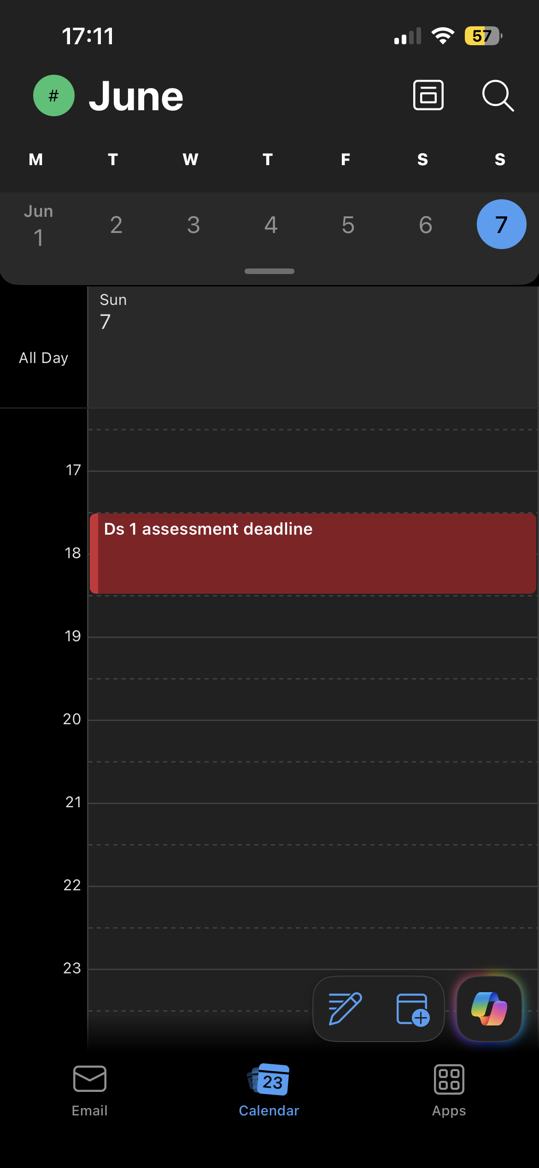
[Write what this shows of your digital life] I have added to my outlook calendar the deadline for my first assessment, this helps me to be more organized.

Screenshot/Photo 2
[Insert Photo/Screenshot below]
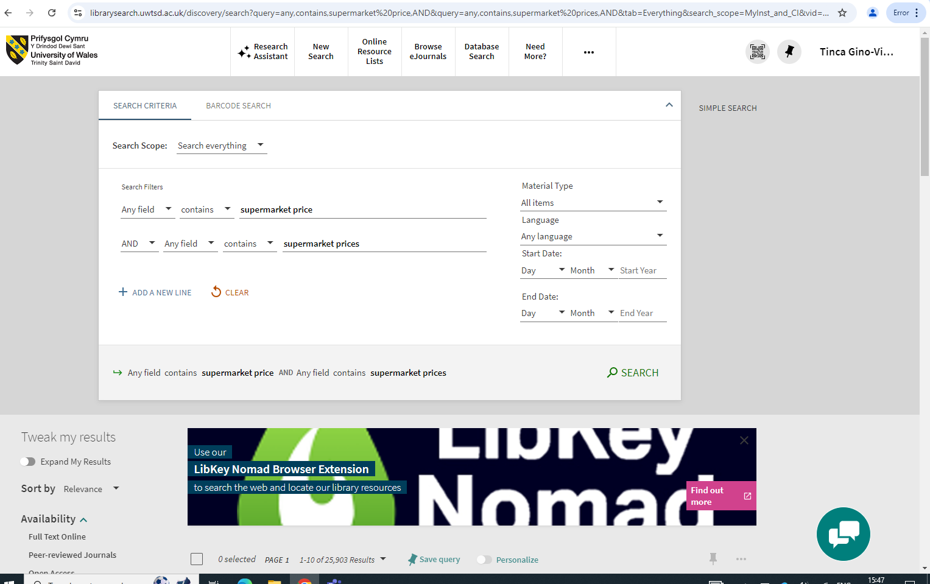
[Write what this shows of your digital life] In this screenshot I am using the uwtsd library that can be found on the Moodle when accessing the useful links and clicking online library to find articles about supermarket prices, this helps me to find information quicker and trusted sources.

Screenshot/Photo 3
[Insert Photo/Screenshot below]
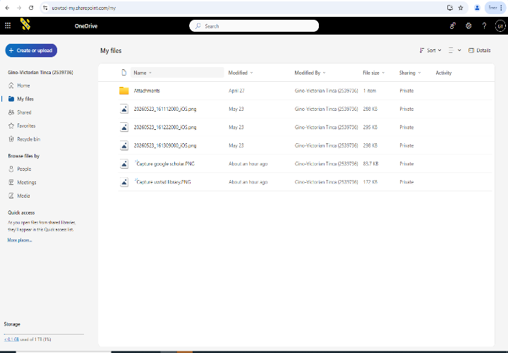
[Write what this shows of your digital life] In this screenshot I am using OneDrive where I have downloaded all the screenshots and the assessment template, this helps me to find my screenshots and template easier when having to complete my assessment.

Screenshot/Photo 4
[Insert Photo/Screenshot below]
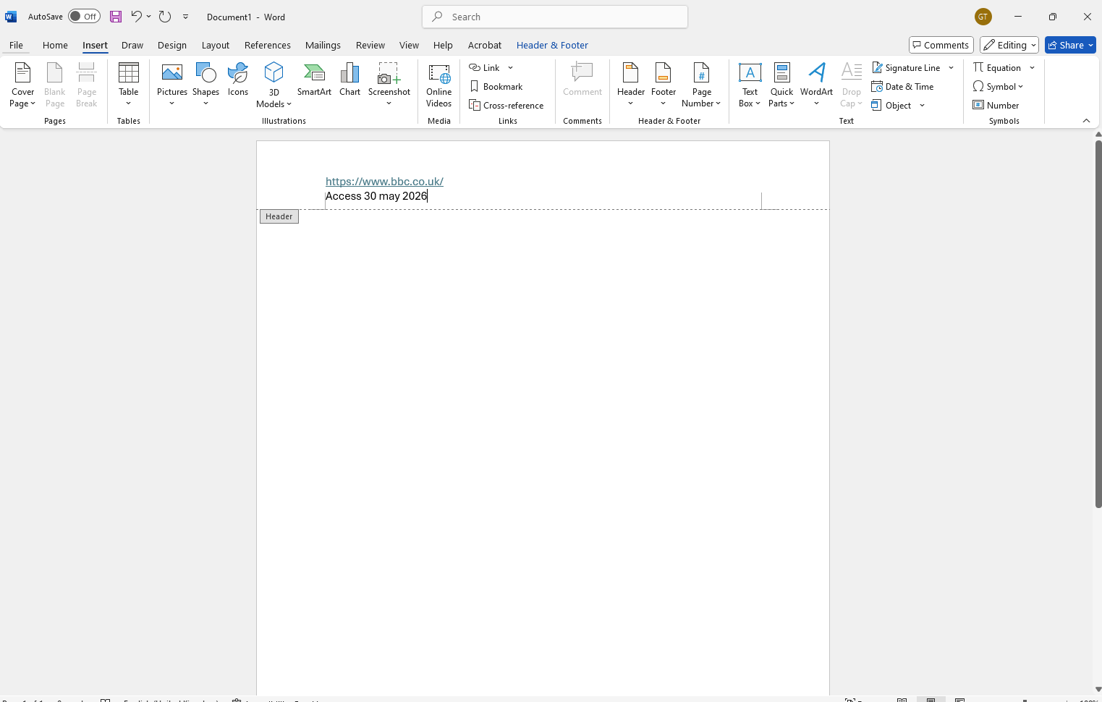
[Write what this shows of your digital life] In this screenshot I am using Word and a blank page, and I have inserted a direct link to the BBC website and the date that I have accessed the link.

Screenshot/Photo 5
[Insert Photo/Screenshot below]
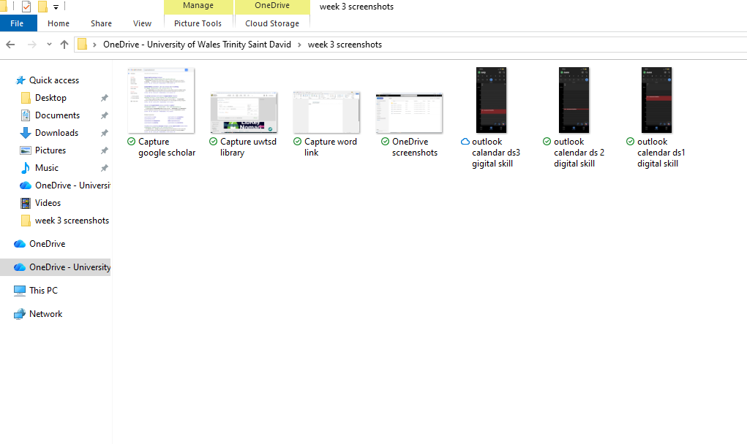
[Write what this shows of your digital life] In this screenshot I created a new file with all the screenshots from week 3, this helps me to have them organized and not confusing them with other screenshots.

Screenshot/Photo 6
[Insert Photo/Screenshot below]
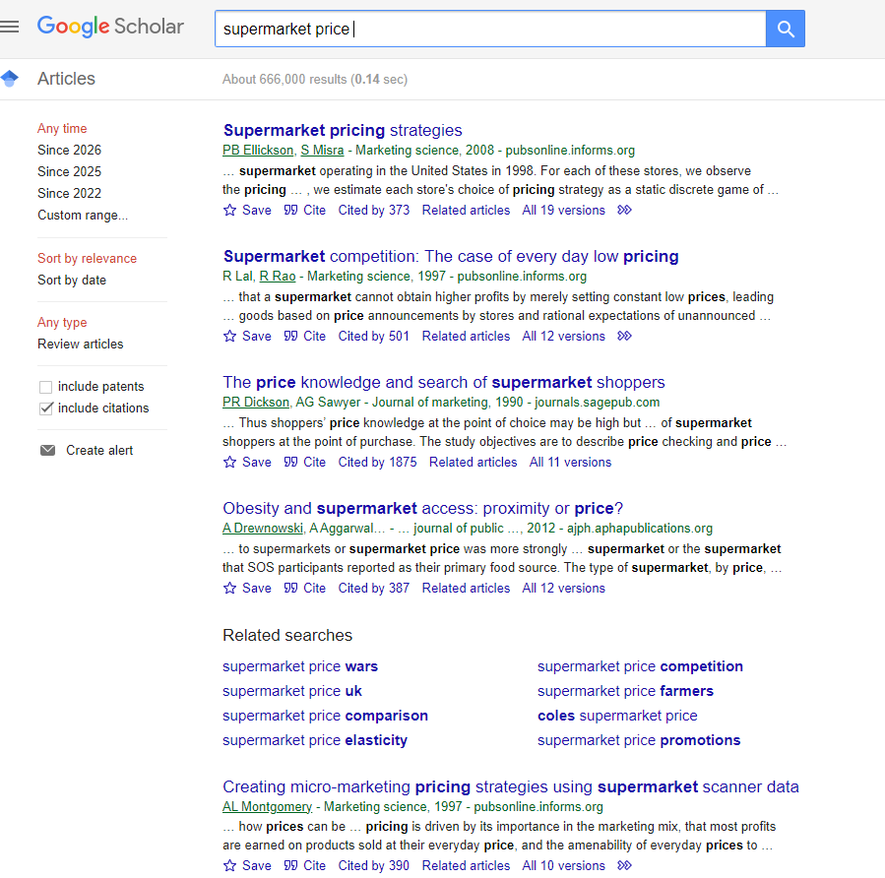
[Write what this shows of your digital life] In this screenshot I used google scholar to find articles or trusted sources about Supermarket prices, this helps me to find trusted sources and not false information.

My Short Reflection
- Write 5–8 simple sentences about your digital life.
- You can use the sentence starters below if helpful.
I want to improve my digital skills even more, because I want to start using the Word app without having any trouble when making my assessments or creating documents.
I use digital tools to edit and make my assessments for my course, to research information or articles.
I sometimes feel nervous about using a different app that it is not Word because I have not used other apps as much as Word to edit and create files.
I hope this module will help me to understand and improve my skills for other apps like Adobe to start creating things like posters.
I often use these tools, copy and paste to copy information from an article or a document and paste it to my own documents, I also use the insert tool to insert pictures to my document that I edit or create and to insert a document to be sent over by email to different users.

Sentence starters
- I use digital tools to …
- I feel confident when I …
- I want to improve …
- I often use these tools: …
- I sometimes feel nervous about …
- I hope this module will help me …
- Digital skills are important for me because …
You can write more if you want.

Submission Checklist
Before you submit, please check:
​​​ ☒ I added 4–6 screenshots
☒ I wrote short sentences for each screenshot
☒ I wrote my short reflection
☒ My work is my own
☒ My file opens correctly
​​☒ My file opens correctly

