
Applied Computing

Wales Institute of Science and Art (WISA)

Networks and Cybersecurity Essentials (ACCA4024)

Lab 3: Design a Simple hybrid (wired and wireless) Network and configure IP Address.


n.kaliyamurthy@uwtsd.ac.uk 1

Warm-up
Based on your acquired skills from previous lab works, complete the following.
Build a Simple Network using Cisco Packet Tracer as per the topology given below

Topology:
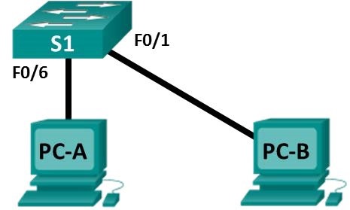
LAB Objectives
After building a simple network, we have to connect the network and make a successful network and make it a viable and scalable network.

- Using Windows Calculator to determine the IP address of the hosts in the network.
- Configure a Wireless Router to the network with DHCP, basic security and remote access.
- Observe the conversion of URL to an IP Address. Use nslookup command.

Requirements
  - Use Packet Tracer to create the above recommended topology Additional:
  - PC running Windows 10 with at least one Ethernet network interface card (NIC).
  - Connectivity to the Internet

Task 1: Calculate the IP address of the hosts using the below details. Addressing Table 1.1
Device | Interface | IP Address | Subnet Mask
PC-A | NIC | 11000000.10101000.00000001 .00001010 | /24
PC-B | NIC | 11000000.10101000.00000001 .00001011 | /24
Open the Windows Calculator application. Click Start, type Calculator. Select Calculator in the results.
Practice switching between calculator modes to see which options
they provide.
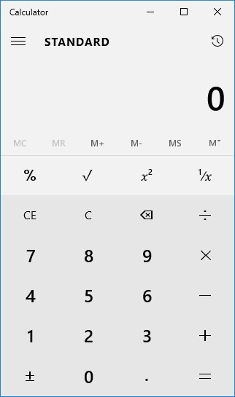
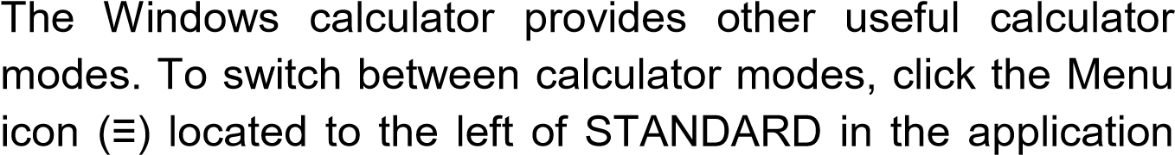
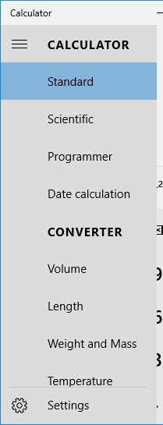
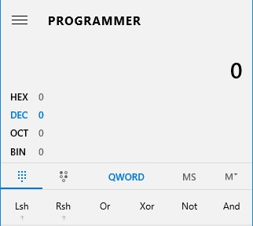
The Windows calculator supports different types of calculators. In the previous figure, the Standard mode is displayed. The standard mode calculator is useful for most basic tasks. If your calculator screen looks different, it may be because you opened in a different mode.
window.

The calculator displays the other modes supported. Clicking a calculator option displays a customized calculator intended for a specific function.
Convert between number systems. Select the Programmer mode calculator.
The Programmer calculator supports four numbering systems HEX (Hexadecimal), DEC (Decimal), OCT (Octal), and BIN (Binary).

Select each number system and record which numbers are active in the following modes.
Decimal Mode | DEC | 0, 1, 2, 3, 4, 5, 6, 7
Binary Mode | BIN | 0,1
Hexadecimal Mode | HEX | 0,1,2,3,4,5,6,7,8,9,A,B,C,D,E,F
Octal Mode | OCT | 0,1,2,3,4,5,6,7,8,9,

Why do you think the other numbers are greyed out?

The numbers are greyed out because they are not available in that number system
Click DEC. Using your mouse, click on the number 8 followed by the number 6 on the number pad. The decimal number 86 has now been entered.
Now click on BIN. What happened to the number 86 listed in the textbox at the top of the window?
The number changes to 101 0110

Enter the number 150 and select BIN.
What is the binary equivalent of 150?
1001 0110
Clear the binary value in the window. From Binary mode, type in the following binary number: 10001010. Select the DEC.
What is the decimal equivalent to the binary number of 10001010?
138
Convert the following decimal numbers to binary.
Decimal | Binary
52 | 0011 0100
78 | 0100 1110
129 | 1000 0001
242 | 1111 0010
Convert the following binary numbers to decimal.
Binary | Decimal
1100 0010 | 194
0011 1111 | 63
1011 0011 | 179
1011 1001 | 185

Convert host IP addresses.
Computer hosts usually have two addresses, an Internet Protocol (IP) address and an Ethernet Media Access Control (MAC) address. For the benefit of humans, the IP address is normally represented as a dotted decimal notation, such as 192.168.10.2. Each of the decimal octets in the address or a mask can be converted to 8 binary bits. Remember that the computer only understands binary bits. If all 4 octets were converted to binary,
How many bits would there be?
IP addresses are normally shown with four decimal numbers ranging from 0 to 255 and separated by a period.
As per the above addressing table (1.1), convert the binary to decimal
11000000.10101000.00000001 .00001010 | 192.168.1.10
11000000.10101000.00000001 .00001011 | 192.168.1.11

Convert host IP subnet masks.
Subnet masks, such as 255.255.255.0, are also represented as dotted decimal. A subnet mask will always consist of four 8-bit octets, each one represented as a decimal number. With the exception of decimal 0 (all 8 binary zeros) and decimal 255 (all 8 binary ones), each octet will have some number of ones on the left and some number of zeros on the right. Convert the 8 possible decimal subnet octet values to binary.
Notation | Network | Host | Binary
/24 | 24 | 8 | 11111111.11111111.11111111.00000000

  Decimal | Binary
  0 | 0
  128 | 1000 0000
  192 | 1100 0000
  224 | 1110 0000
  240 | 1111 0000
  248 | 1111 1000
  252 | 1111 1010
  254 | 1111 1110
  255 | 1111 1111
  Binary | Decimal
  11111111 | 255
  11111111 | 255
  11111111 | 255
  00000000 | 0

Manipulate powers of 2 to determine the number of hosts on a network
Binary numbers use two digits, 0 and 1. When you calculate how many hosts can be on a subnetwork, you use powers of two because binary is being used. As an example, we have a subnet mask that leaves six bits in the host portion of the IP address. In this case, the number of hosts on that network is 2 to the 6th power minus 2 (because you need a number to represent the network and a number that can be used to reach all the hosts—the broadcast address). The number 2 is always used because we are working in binary. The number 6 is the number of bits that are used for the host bits.
Change the calculator view to scientific mode. Input the number 2. Select the x^{y} key on the calculator, the key which raises a number to a power. Input the number 6. To compete the operation, click on the = key, press Enter on the keyboard, or press the = key on the keyboard. The number 64 appears in the output. To subtract two, click on the minus (-) key and then the 2 key followed by the = key. The number 62 appears in the output. This means 62 hosts could be utilized.
Using the previously described process, determine the number of hosts if the following number of bits are used for host bits.
No. of Bits Used for Hosts | No. of Hosts
3 | 727
8 | 262,142
12 | 2,985,982
17 | 24,137,567

Use the above techniques and covert the below values to a readable IP address and Subnet mask
 |  | IP Address | Subnet Mask
PC-A | NIC | 11000000.10101000.00000001 .00001010 | /24
PC-A | NIC | 192.168.1.10 | 255.255.255.0
PC-B | NIC | 11000000.10101000.00000001 .00001011 | /24
PC-B | NIC | 192.168.1.11 | 255.255.255.0

Use the above IP Address and subnet mask to configure the PC’s in the topology.
Is the Ping between PC- A and PC- B Successful?
yes

Task 2: Configure Wireless Router to the network with DHCP, basic security and remote access.
Add a laptop and a wireless router to your existing topology (For this lab, we are using WRT300 N Wireless Router)
Click on Network Devices → Wireless Devices and drag and drop the above device
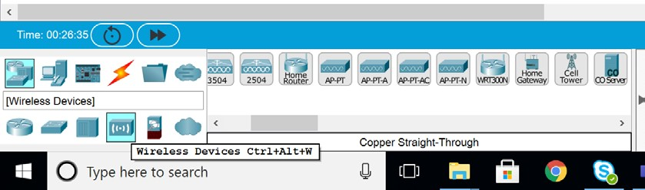

Follow the Step by Step Instructions
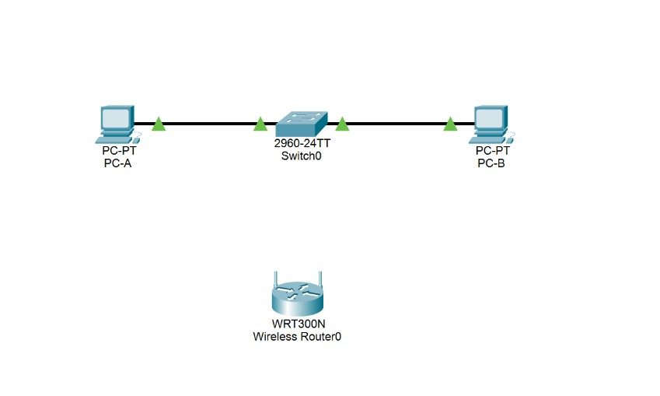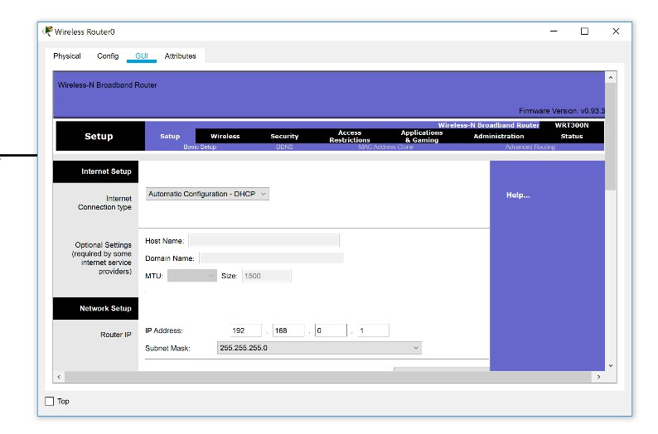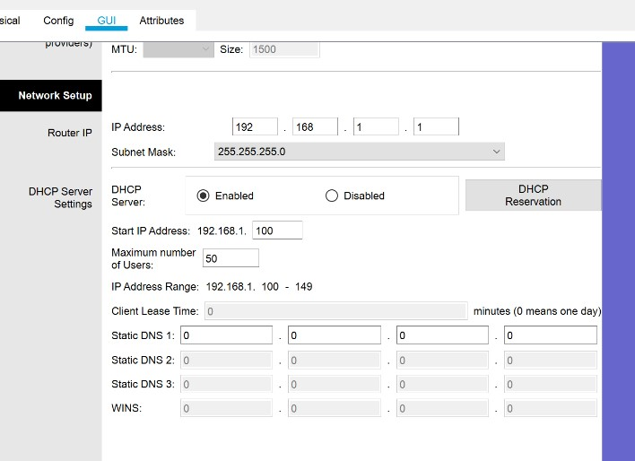

Click on the Router
→
Select

GUI

Change the Router IP from

192.168.0.1
to 192.168.1.1

Select Wireless
→
Change the Network Name
(SSID) to My_Class and SSID Broadcast to Enabled.
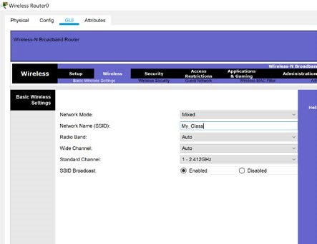

Don’t forget to “Save Settings” all the time. (It will be at the bottom)

Select Wireless → Wireless Security → Change the Security Mode to WPA2
Personal and assign the password as cisco@123
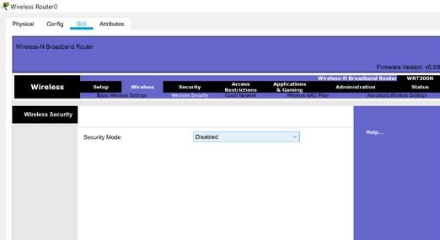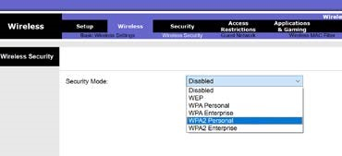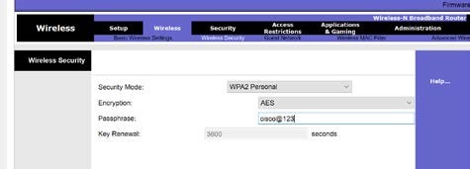

Select Administration → Change the Router password to password123 and enable remote management

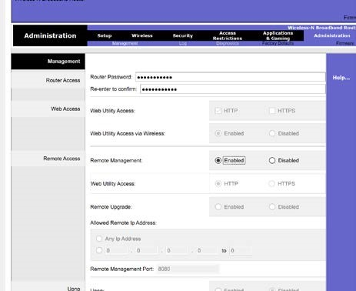

Save the configurations (at the bottom) and close the Wireless Router.
Add a laptop in the topology. Click on the Laptop and in the Physical Settings, Power Off → Drag and remove the NIC and add WPC300N (Wireless Adapter/ Receiver)
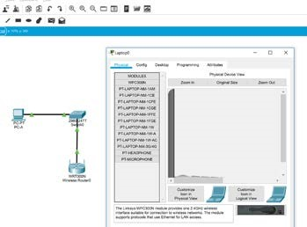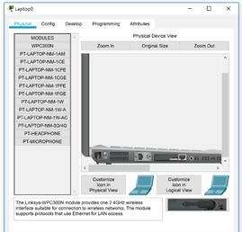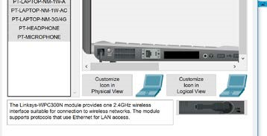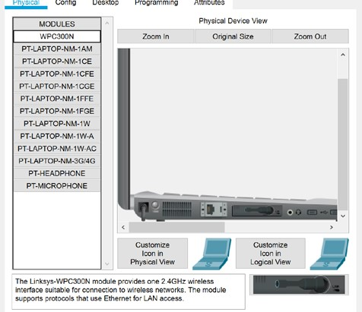

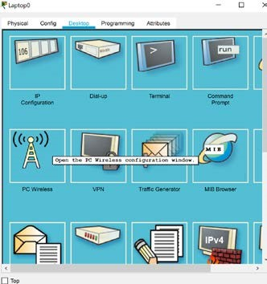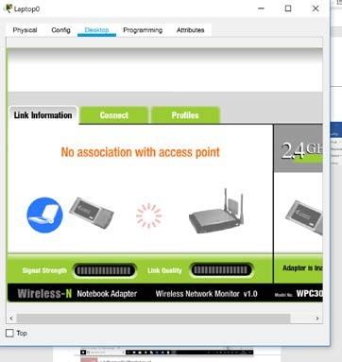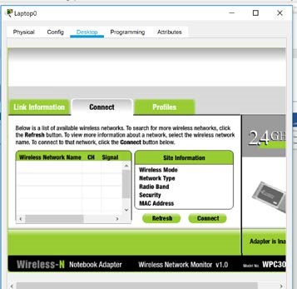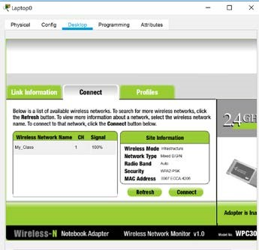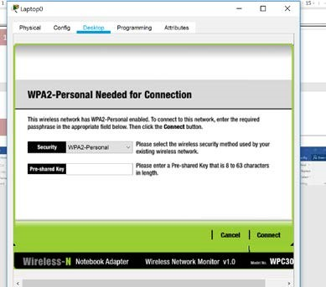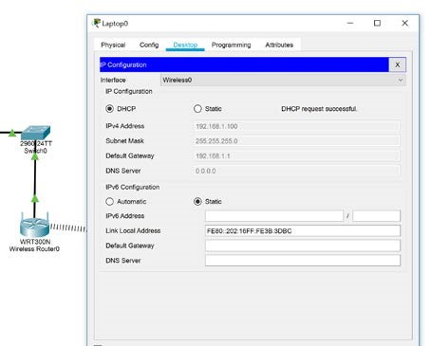

After doing these steps, you should see the IP address, Subnet mask and default gateway is configured using DHCP successfully.
Record the following from the Laptop:
IP Address 192.168.1.2
Subnet Mask 255.255.255.0
Default Gateway
Was the Ping from your Laptop to the Wireless Router (Default Gateway) successful? _yes____________________
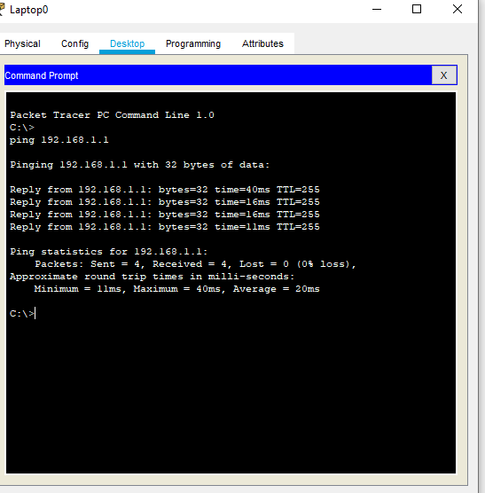
For your understanding: Follow the same steps and configure Wireless connection
(as per the topology below) in PC-B and record the following
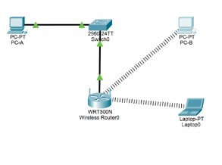

Record the following from PC- B:
IP Address 192.168.1.3
Subnet Mask 255.255.255.0
Default Gateway 192.168.1.1
Was the Ping from your PC_B to the Wireless Router (Default Gateway) successful? _Yes____________________
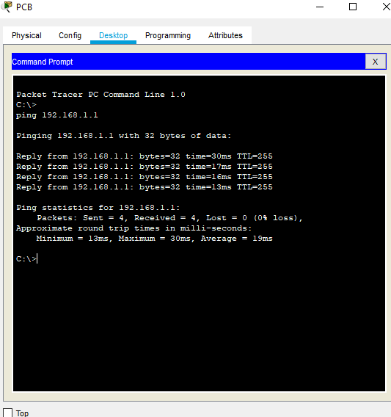
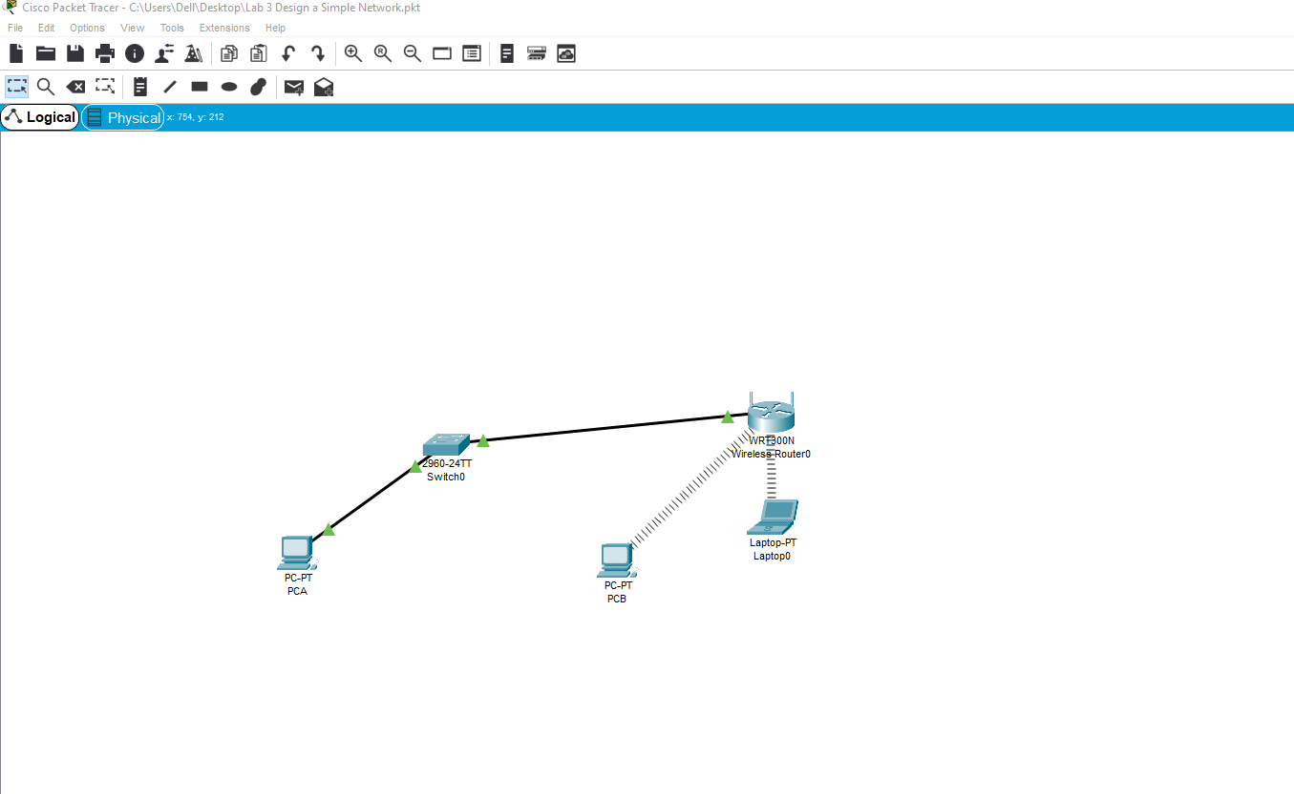

Task 3: Observe the conversion of URL to an IP Address.

Domain Name System (DNS) is invoked when you type a Uniform Resource Locator (URL), such as http://www.cisco.com, into a web browser. The first part of the URL describes which protocol is being used. Common protocols are HTTP (Hypertext Transfer Protocol), HTTPS (Hypertext Transfer Protocol over Secure Socket Layer), and FTP (File Transfer Protocol).
DNS uses the second part of the URL, which in this example is www.cisco.com. DNS translates the domain name (like www.cisco.com) to an IP address to allow the source host to reach the destination host.
Use your PC/Laptop with Internet Connection for this task Right-click Start and select Command Prompt.
At the command prompt, type ping google.com and press enter. The computer needs to translate google.com into an IP address so it knows where to send the Internet Control Message Protocol (ICMP) packets. Ping is a type of ICMP packet.
The first line of the output shows google.com converted to an IP address by DNS. You should be able to see the effect of DNS even if your school has a firewall that prevents pinging, or if google has prevented people from pinging their web server.
Then, type ping cisco.com and press enter. The computer needs to translate cisco.com into an IP address so it knows where to send the Internet Control Message Protocol (ICMP) packets. Ping is a type of ICMP packet.
The first line of the output shows cisco.com converted to an IP address by DNS. You should be able to see the effect of DNS even if your school has a firewall that prevents pinging, or if Cisco has prevented people from pinging their web server.
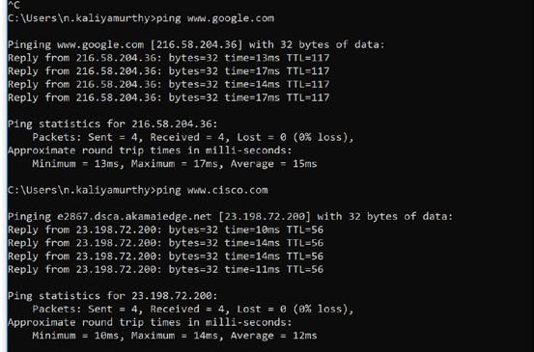

Which IP address is shown on your screen?
Domain Name: google.com
IP Address: 216.58.198.174
2a00:1450:4009:814::200e
Domain Name: cisco.com
IP Address: 72.163.4.185
2001:420:1101:1::185

Is it the same as the one shown in the figure? No

At the command prompt, type the nslookup command and press enter.
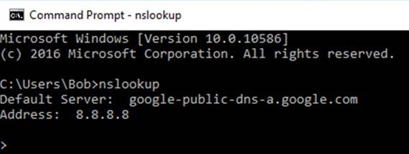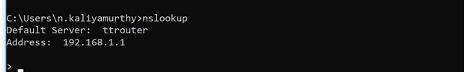

The two images shows the Default DNS Server was configured to use a Google DNS server in the first and ttrouter in the second.
What is your Default Server listed as? bthub

After issuing the previous nslookup command, notice how the command prompt changed to a single >. This is the nslookup program’s prompt. From this prompt, you can enter commands related to DNS.
At the prompt, type ? to see a list of all the available commands that you can use in nslookup mode.
At the nslookup prompt, type google.com.
What is the translated IP address? 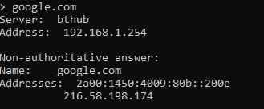
Is the IP address an IPv4 address or an IPv6 address? both
Is it the same as the IP address shown with the ping command? yes
Reflection
How is a DNS useful to connect to a network service or to browse a webpage?
It converts the IP addresses into readable domains. Without DNS everyone would have to remember random strings of numbers to access different websites. Would be hard to remember strings of numbers every time you tried to access google

Learnings from this lab:
- Build a Simple Network
- Understand and configure IP Address
- Use Ping/ Trace route Utility to check the connection status
- Use ipconfig /all command to determine the MAC address of a Windows computer on an Ethernet network.
- Analyze a MAC address to determine the manufacturer.
- Analyze the Wired and Wireless Network connection.
- Analyze Address Resolution Protocol (ARP).
- Connect to a Wireless Router and configure the basic settings in a wireless router
- Use nslookup command to understand the url to ip conversion

