Jack Holland (P149473)
Website Development
Module Tutor: Dr Kemi Ademoye
Website Development (Assignment 2)
Contents
Introduction 2
Implementation 2
About the Web Application 2
Requirements of the Web Application 2
Screenshots of the completed Web Application 3
Songs Page 4
Albums Page 6
New Entries Page 7
Form Validation 8
Reviewing the Requirements Analysis 9
Evaluation 10
Testing the Web Application 10
Problems encountered during the creation of the Web Application 10
Evaluation 11
Future Improvements 11
References 12

Introduction
This report is for the second part of the Website Development module; the aim of this assignment is to create a web application using the ASP.NET Programming Language. The web application is also created using MVC and was designed using the Bootstrap framework.

Implementation
In this section of the report, the creation of the web application will be discussed and how it is relevant to others.

About the Web Application
The web application created is called MusicHub. MusicHub is a web application built for those who enjoy music. The website offers the latest chart for both Albums and Songs. The website also displays brand new music that MusicHub thinks will do well in the upcoming charts.
The target audience for MusicHub is anyone ranging from teenagers to the elderly. This is as these ages are known to take an interest in music. The website is relevant to this demographic as it is one simple place where they can see this week’s chart.

Requirements of the Web Application
To make a successful Web Application, a requirements analysis must be completed. If the web application is not properly planned, it could cause problems once creation has started. The requirements analysis for MusicHub was created using the MoSCoW method.
The MoSCoW acronym stands for “must have, should have, could have and would like” [1]. It is a popular method for requirements analysis for projects.
The MoSCoW requirements analysis for MusicHub is:
Must Have
- A web application using the ASP.NET programming language with MVC
- An SQL Server Express Local Database to store the data used
- Form validation
- Data displayed appropriately
- The ability to search certain aspects of the website
- Data manipulation using CRUD operations (create new, update and delete)
Should Have
- Bootstrap integration
- Three or more tables
- A user login/registration
- Admin roles that can use the CRUD operations
- Albums, Chart and New Entries pages
Could Have
- A contact us form
- A news section updating users of the latest music news
- A user comment system

Would Like
- A web application that looks atheistically pleasing
- A web application that is accessible on all devices

Screenshots of the completed Web Application
Homepage (Index)
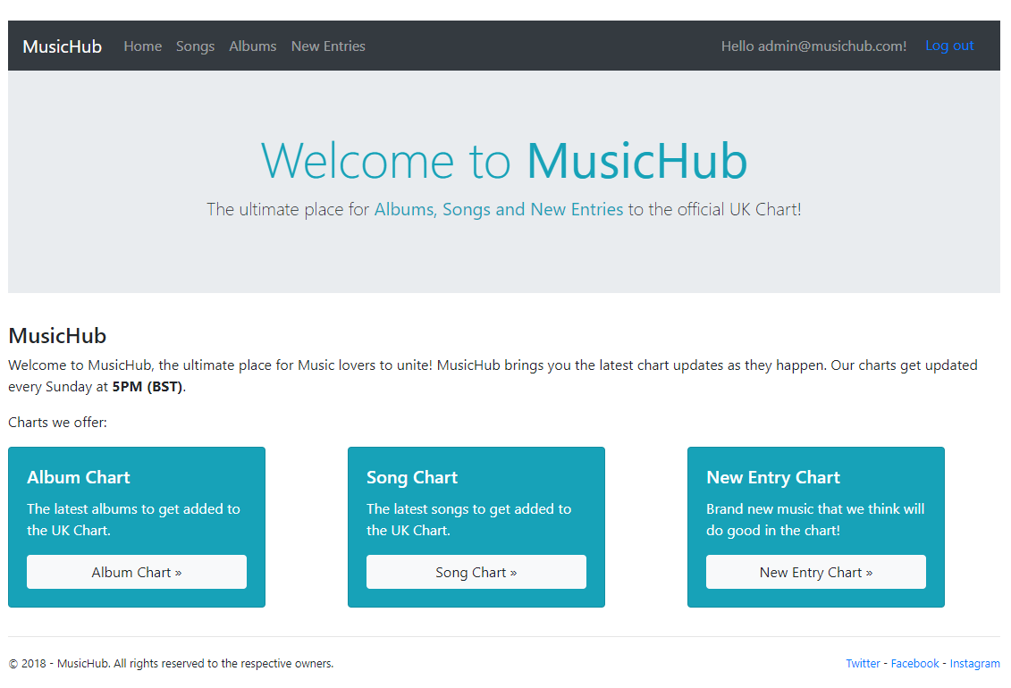
This is the homepage of the web application, it is the first page that is loaded. It is a simple introduction page that gives the user an overview to what the web application is about.
Navigation bar
If a user is logged in, the navigation bar will say “Hello [E-mail Address]!” next to a log out button, if the user is not logged in the navigation bar will say “Register/Login”.

Songs Page
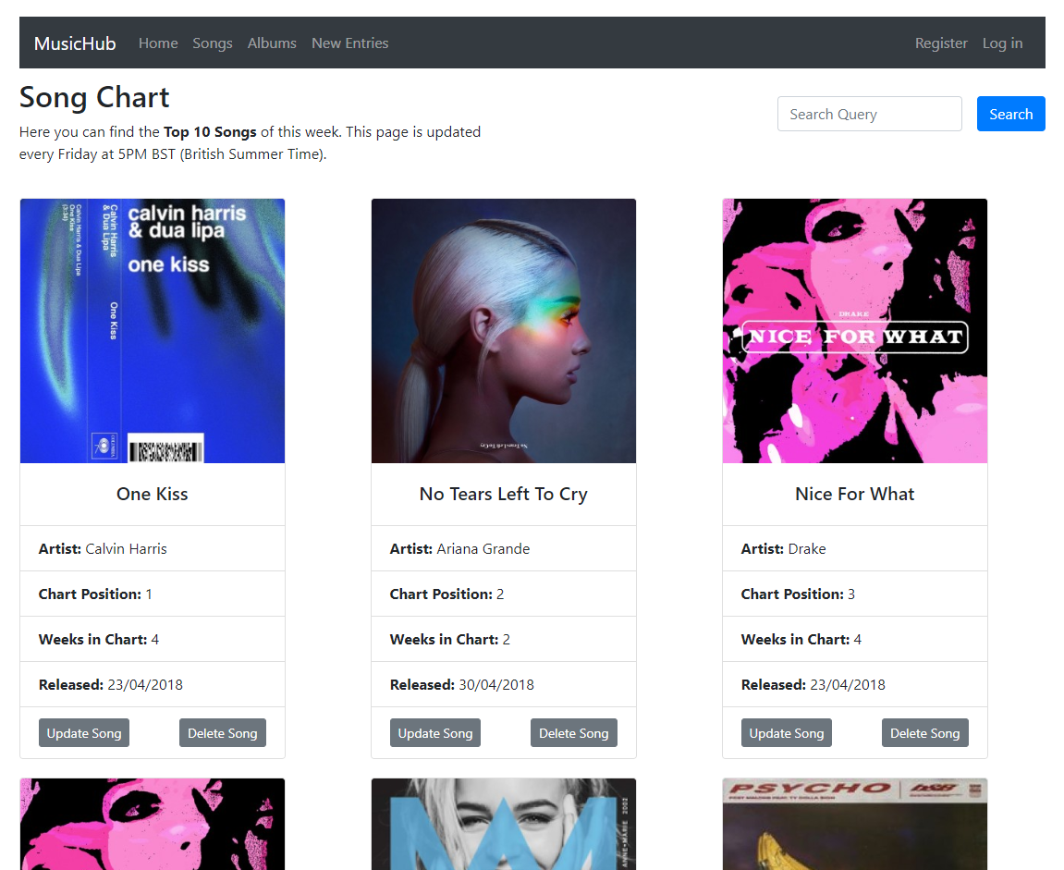
This is the Songs page, it displays the top 10 songs in the United Kingdom chart. The information and images were sourced from the Official Charts company [2]. The information for this page is stored in the local database, the table used is called “Song”.
The page also allows users to search for different songs, in the top right of the page there is a search box. The user can enter a song name and the web application will return matching results.
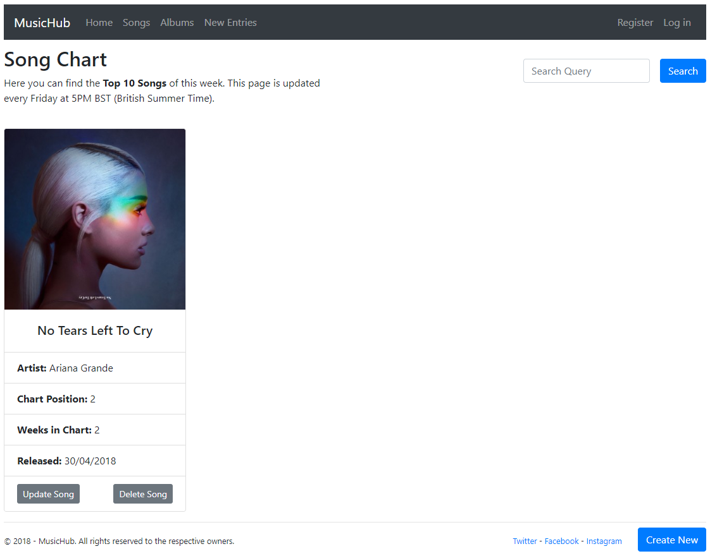

The administrator of the website can also update, delete and create a new song. This can be done by clicking on either one of the buttons found within the page.
Update Song
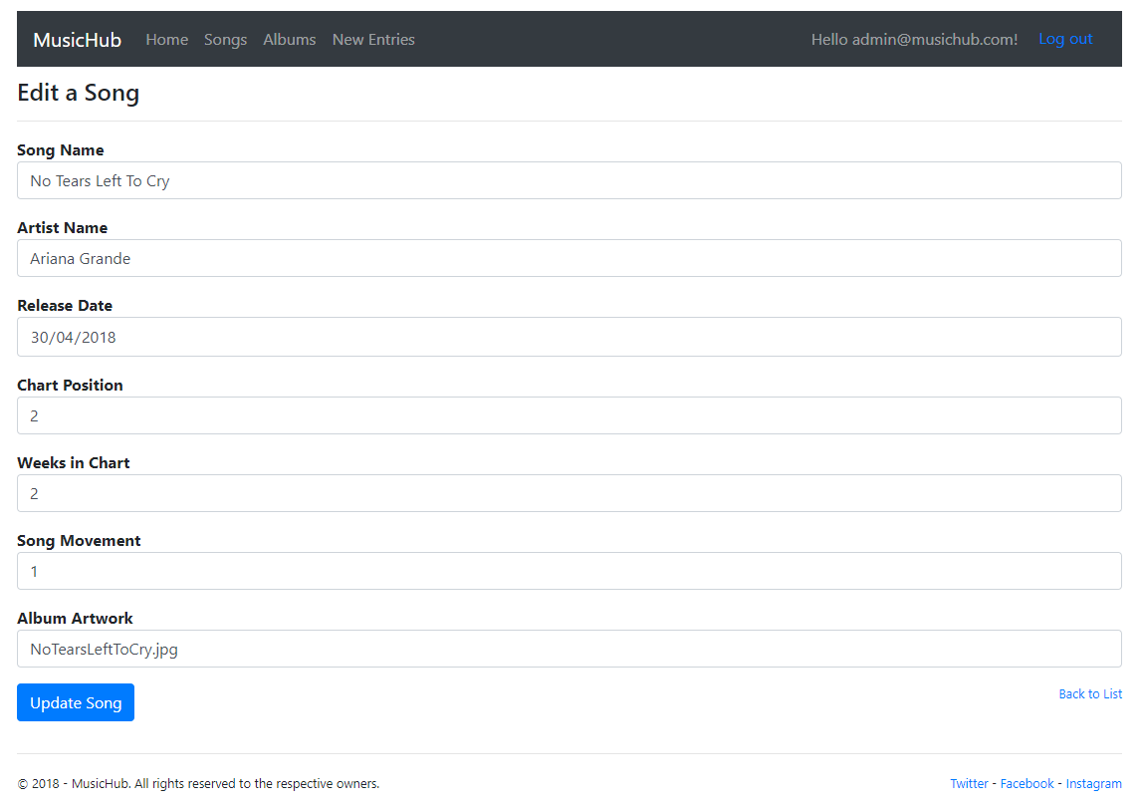
The screenshot above shows what will be displayed when the user tries to edit a song. They will be presented with a form allowing them to change every detail of the song.
Delete Song
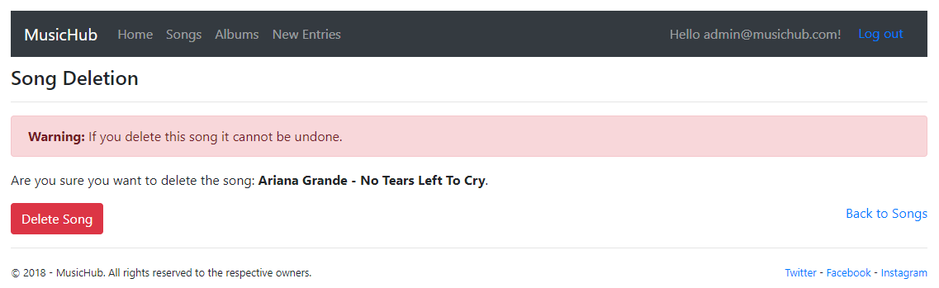
The delete song page allows the user to delete a song. There is a warning message saying “Warning: If you delete this song it cannot be undone.” The administrator then must click “Delete Song” to confirm their choice.

Create Song
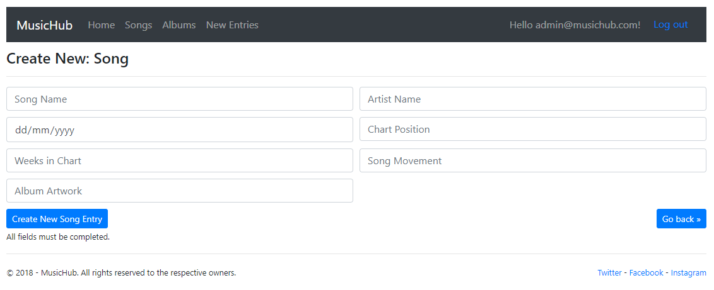
This is what is presented when the administrator clicks on “Create New”. Each field of the form must be completed otherwise an error message is shown.
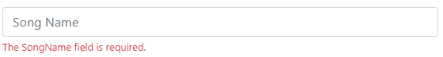

Albums Page
The Albums page is designed like the Songs page, it uses the card layout designed by Bootstrap. The information for this page is from the “Albums” table stored in the database. Like the Song page, the user can search for an album by using the form on the right.
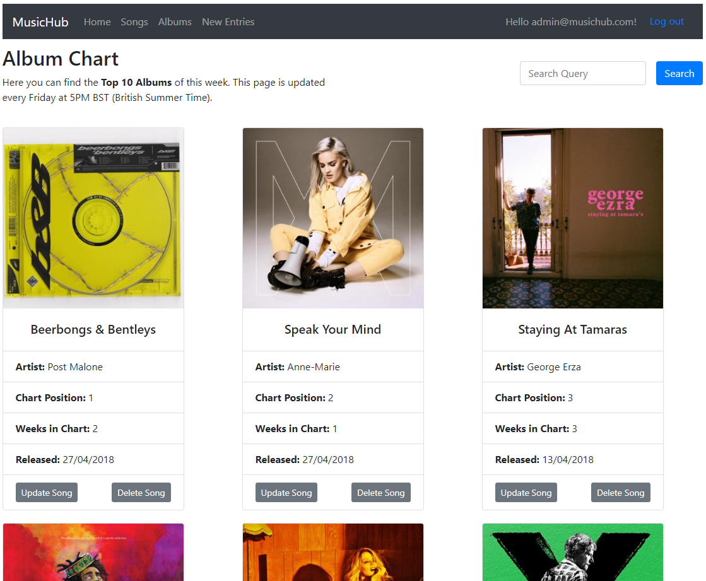

To edit the page, the website administrator can click either “Update Song”, “Delete Song” or “Create New” buttons. This will open a web page where the data can be either edited, deleted or a new album can be added.
If a user who is not logged in tries to access the page, the web application will redirect them to an unauthorised page:
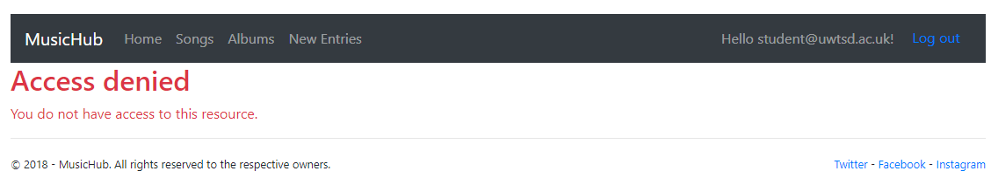

New Entries Page
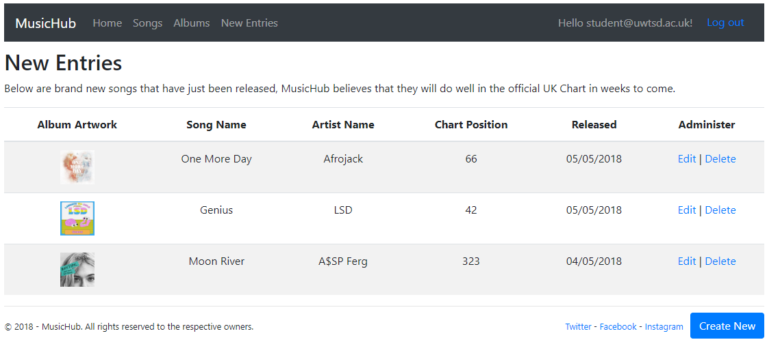
The “New Entries” page is the latest songs that MusicHub thinks will chart well. The data for this page is from the “NewEntries” table found in the database. The data is shown in a table showing the album artwork and information about the song.
Like the song and album pages, it allows the website administrator to manipulate the data by creating new records or editing and deleting existing records.

Form Validation
Form Validation is used when data is being manipulated, if any fields are left blank the administrator will receive an error message like below:
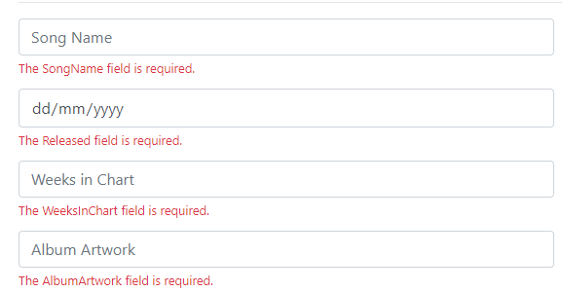

Reviewing the Requirements Analysis
After completing the web application, the following have been completed from the requirements analysis:
Must Have
- A web application using the ASP.NET programming language with MVC
- An SQL Server Express Local Database to store the data used
- Form validation
- Data displayed appropriately
- The ability to search certain aspects of the website
- Data manipulation using CRUD operations (create new, update and delete)
Should Have
- Bootstrap integration
- Three or more tables
- A user login/registration
- Admin roles that can use the CRUD operations
- Albums, Chart and New Entries section
Could Have
- A contact us form
- A news section updating users of the latest music news
- A user comment system
Would Like
- A web application that looks atheistically pleasing
- A web application that is accessible on all devices
The sections that are marked green have been completed, but the sections in red are yet to be completed.
In the would like, the “A web application that is accessible on all devices” is partially complete, by using Bootstrap it offers responsive components, but certain elements of the web application look poor on mobile and tablet devices.
The could have section was not a priority, this is because they are additional features that was not required for the assignment. If there was time to complete them then they would have been added but due to having errors in other areas, they were not completed.

Evaluation

Testing the Web Application
To ensure the web application is working as expected, a numerous amount of testing was done.
Test Name | Expected Result | Passed
Compiling the web application | Visual Studio will compile the code into web pages which can then be accessed using the IIS web server. | ✔
Users can login/register | Users will be able to login to the web application once they have registered | ✔
Songs page load | The song page will load and the data will be displayed from the database | ✔
Album page load | The album page will load and the data will be displayed from the database | ✔
New Entry page load | The new entry page will load and the data will be displayed from the database | ✔
Only Admins can use CRUD operations | Only the admins (admin@musichub.com) will be able to use the create, update and delete options of each page | ✔
Users can log out | The users can log out of the web application by clicking the log out button | ✔
Admins can create new entries | The admins of the website can create new songs, albums and new entries | ✔
Admins can edit existing records | The admins of the website can edit existing songs, albums and new entries | ✔
Admins can delete existing records | The admins of the website will be able to delete existing songs, albums and new entries | ✔
Testing data validation | If an admin enters incorrect data/no data an error message will be displayed | ✔
Testing responsiveness | Certain elements of the web application looks poor on mobile and tablet devices | ❌

Problems encountered during the creation of the Web Application
There were several problems that occurred when creating the web application, below they will be described and how they were resolved.
Incorrect Table Names
When creating the AssignmentContext file, the table names were wrong. This meant once the views for the web page was generated, no data was shown. To solve this the table names had to be fixed and the views and database regenerated.
Popper Not Included
When attempting to use the Bootstrap dropdown menu, a JavaScript error occurred in the console saying, “Bootstrap 4 Error: Dropdown requires Popper.js”. The error could not be resolved so an alternative design was used.
Changing the Navigation Bar
To make the website look nicer, the plan was to change the navigation bar from saying “Welcome [Email Address]!” to “Welcome [Username]!”. After trying to change it, the original e-mail address was displayed as no solution was found.

Evaluation
The web application turned out decent, it completed most of the requirements analysis. The web application was built using ASP.NET and MVC with Bootstrap for the styling. If the website was to be expanded further, it would be better to create a theme for the website and implement it. This would give the web application its own identity rather than using Bootstraps theme.
The website is very functional, it allows music fans to browse what they want to see by an easy to use navigation and search functions. If the website was expanded further, there could be additional songs making it a top 100 chart rather than just having 10 test data per page.

Future Improvements
To improve the website further, the following improvements could be made:
Complete Requirements Analysis
Although most of the requirements analysis was completed, some additional features were missed. The website would be better there being a contact us form, news section and comment system.
If the web application was made completely responsive the website would also appeal to a larger audience, this is because some users will use their mobile or table devices to browse the Internet.
Creating Own Theme
As mentioned in the evaluation, if the web application had its own theme it would look better. This is because the web application would have its own identity, making it recognisable for its users.
Hiding CRUD Operations in Views for users
The CRUD operation links are currently showing in the Index views, it would look more professional if they were hidden for users but not for admins.
Changing Name in Navigation Bar to First Name
The navigation bar would look nicer if it contained the first name of the user, as mentioned in the problems encountered section. During the creation of the Web Application, it was not possible for myself to change the e-mail to First Name so it was reverted.

References

[1] | “ MoSCoW Method,” [Online]. Available: https://www.projectsmart.co.uk/moscow-method.php. [Accessed 07 05 2018].
[2] | “Official Singles Chart Top 40,” [Online]. Available: http://www.officialcharts.com/charts/uk-top-40-singles-chart/. [Accessed 07 05 2018].

marking criteria and Student FEEDBACK

This section details the assessment criteria. The extent to which these are demonstrated by you determines your mark. The marks available for each criterion are shown. Lecturers will use the space provided to comment on the achievement of the task(s), including those areas in which you have performed well and areas that would benefit from development/improvement.

Common Assessment Criteria Applied (Assignment 1) | Marks available | Marks  awarded
1. Research-informed Literature
Extent of research and/or own reading, selection of credible sources, application of appropriate referencing conventions.
There is some basic evidence of references consulted. Expand the scope of references consulted to improve the quality of your work. (Grade mark: 30.00%) | 5 | 1.5
2. Knowledge and Understanding of Subject
Extent of knowledge and understanding of concepts and underlying principles associated with the discipline.
Demonstrates a fairly good understanding of server-side coding with ASP.NET, but there is room for improvement. Your database was too simple as it was not really a normalised database and had no relationships. For the CRUD editing operations, you have relied too much on the default scaffolding functionality provided by VS with no real enhancements. (Grade mark: 53.33%) | 15 | 8
3. Analysis
Analysis, evaluation and synthesis; logic, argument and judgement; analytical reflection; organisation of ideas and evidence
A good set of generic requirements have been identified, with good use of the MoSCoW prioritisation technique. However, I would have liked to see more features relating to this specific web application's functionality. A good, detailed discussion of the testing strategy applied and errors and challenges encountered has been provided. The evaluation is fair, but needs to provide a more critical review of the implemented application. (Grade mark: 64.00%) | 25 | 16
4. Practical Application and Deployment
Deployment of methods, materials, tools and techniques; application of concepts; formulation of innovative and creative solutions to solve problems.
A good attempt featuring a simple application. Very use of Bootstrap to format the views, but I would have liked to see more functionality beyond the basic functionality VS provides via the scaffolding tool. (Grade mark: 62.00%) | 50 | 31
5. Skills for Professional Practice
Attributes in professional practice: individual and collaborative working; deployment of appropriate media; presentation and organisation.
The report is well-written and presented. (Grade mark: 80.00%) | 5 | 4

Assignment Mark (Assessment marks are subject to ratification at the Exam Board. These comments and marks are to give feedback on module work and are for guidance only until they are confirmed. ) | Late Submission Penalties (tick if appropriate) |  | 60.5%
 | Up to one week late |  | 60.5%
 | 1st/2nd/3rd attempt? |  | 60.5%

